Supplemental Materials for: A new lineage of Galapagos giant tortoises identified from museum samples

Authors: Evelyn L. Jensen, Maud C. Quinzin, Joshua M. Miller, Michael A. Russello, Ryan C. Garrick, Danielle L. Edwards, Scott Glaberman, Ylenia Chiari, Nikos Poulakakis, Washington Tapia, James P. Gibbs, Adalgisa Caccone

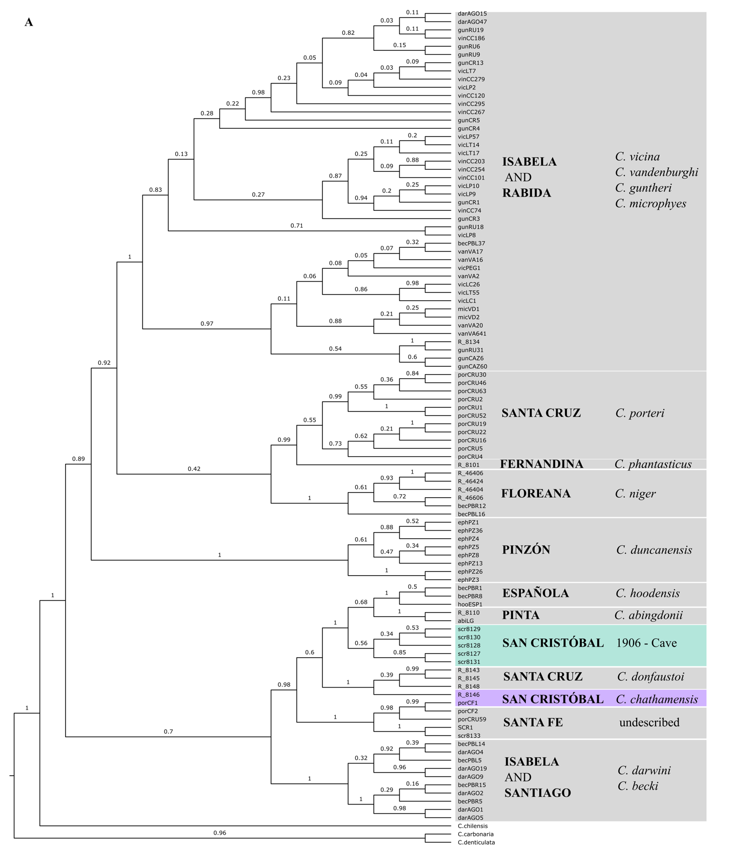
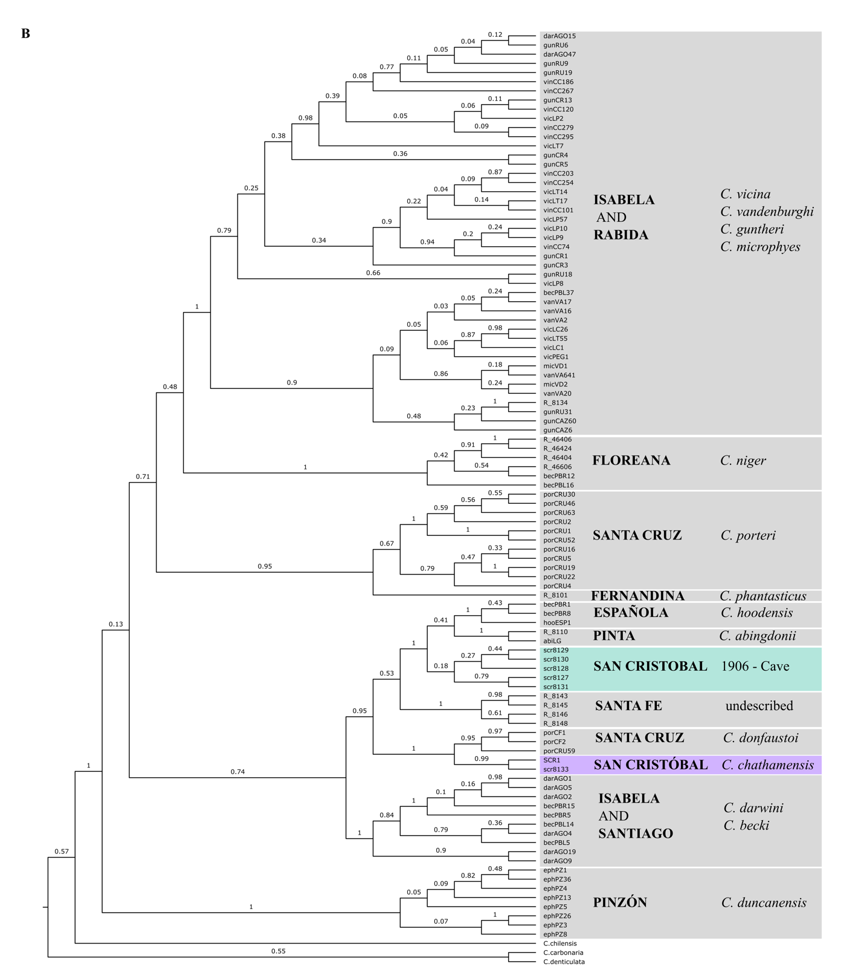
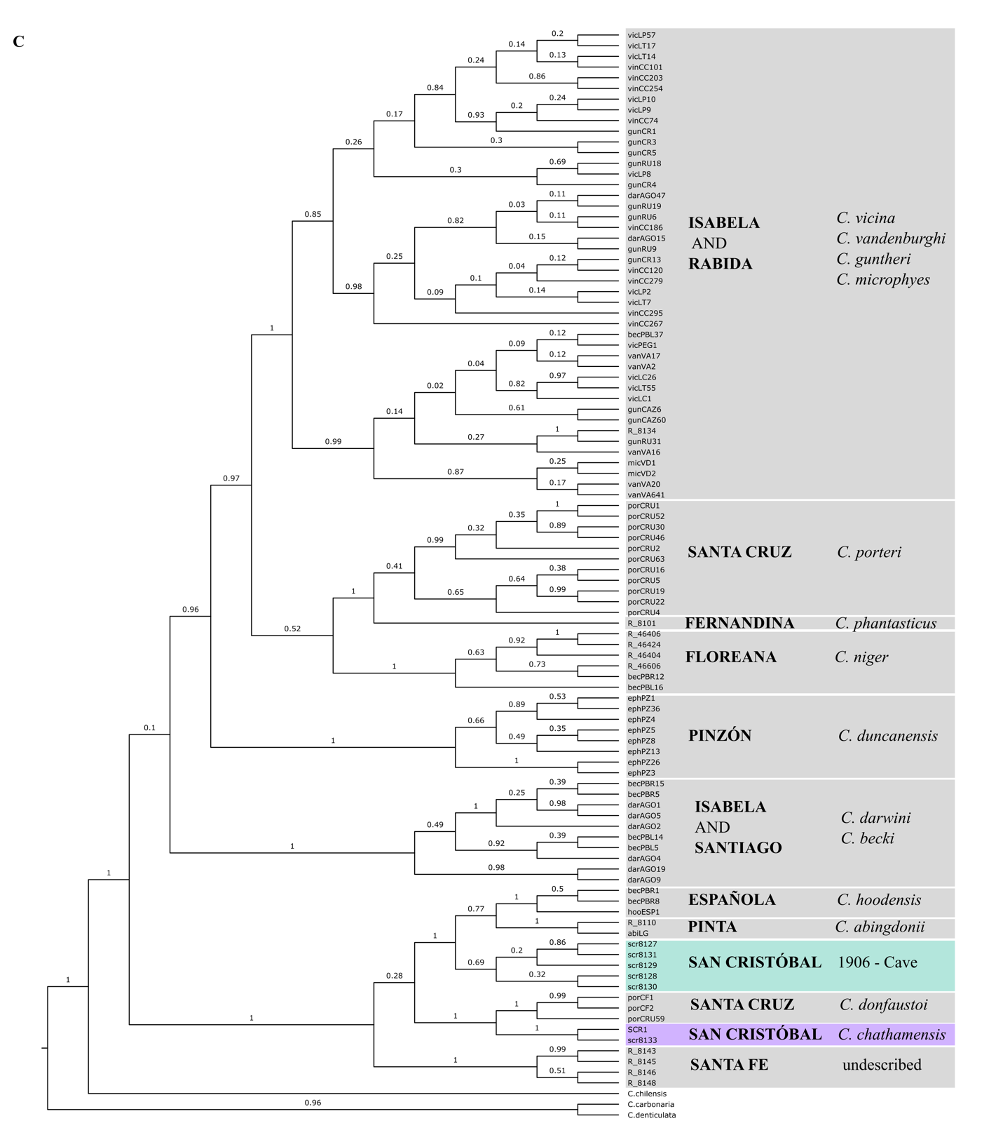Supplemental Figure 1. Bayesian Inference maximum clade credibility cladograms showing relationships among the San Cristobal historical samples from the cave and collected alive in 1906, and a reference dataset of 93 Galapagos giant tortoise haplotypes and three outgroups based on the mitochondrial control region (alignment length 718 bp), estimated using BEAST with A. a relaxed log-normal clock and Birth Death tree, B. a relaxed log-normal and Yule tree, and C. a strict clock and Yule tree. The numbers on the branches are the posterior probability support values. The name of the island where each clade is found is in capitals, with current taxonomy in italics.

Supplemental Figure 2. Plot of ln P(K) from the Structure analysis of A) the SNP and B) the microsatellites genotypic data and C) the values of DeltaK for the SNP based analysis.

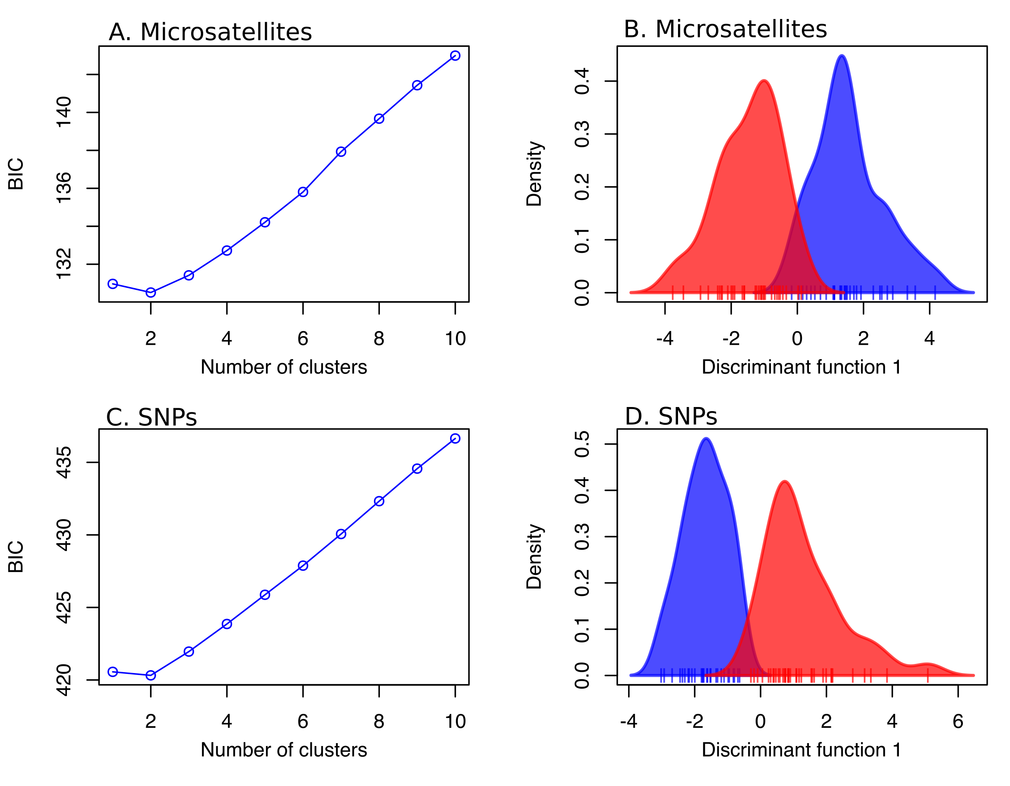
Supplemental Figure 3. Plot of Bayesian Information Criterion (BIC) from the Discriminant Analysis of Principal Components (DAPC) analysis of the contemporary San Cristobal population (n=64) depicting the support for each number of clusters evaluated for A) the microsatellite (21 loci) and C) the SNP (12 192 loci) genotypic data. Density plots showing the level of overlap between the clusters for B) the microsatellite and D) the SNP genotypic data.

Supplemental Figure 4. PCA of the 12 192 locus SNP dataset for the contemporary San Cristobal population (n=64) color coded by A) data collected in the present study versus by Miller et al (2018), illustrating that there is no batch effect due to data collected at different times being analyzed together; B) sampling location, where known; and C) structure cluster membership at K=2 based on the SNP dataset, with individuals with less than 70% membership to a single cluster considered to be mixed. For b, note that individuals sampled at the breeding center are of unknown origin, and “south” refers to any part of the island south of Punta Pitt. Each individual tortoise sampled is represented as a point, percentages correspond to the amount of variation explained by that axis.

Supplemental Table 1. Number of samples included for each marker type for each sampling period.
Sample Period | Mitochondrial  Control Region | Microsatellites and SNPs
Historical | 6 | -
1999 | 20 | 10
2012 | 37 | 11
2016 | 72 | 43
Total | 135 | 64

Supplemental Table 2. Genbank accession numbers for control region sequences. * indicates new sequences generated in this study.

Individual | Accession #
abiLG | AY098029
becPBL14 | AY098104
becPBL16 | AF548280
becPBL37 | AY098107
becPBL5 | AF548255
becPBR1 | AY098108
becPBR12 | AF548283
becPBR15 | AF548229
becPBR5 | AY098110
becPBR8 | AF548282
darAGO1 | AY097959
darAGO15 | AF548284
darAGO19 | AF548254
darAGO2 | AY097961
darAGO4 | AY097963
darAGO47 | AF548285
darAGO5 | AY097964
darAGO9 | AY097968
ephPZ1 | AY098053
ephPZ13 | AF548213
ephPZ26 | AF548214
ephPZ3 | AY098057
ephPZ36 | AF548215
ephPZ4 | AY098058
ephPZ5 | AY098060
ephPZ8 | AY098064
gunCAZ6 | AF548257
gunCAZ60 | AY097972
gunCR1 | AF548236
gunCR13 | AF548235
gunCR3 | AF548232
gunCR4 | AF548234
gunCR5 | AY097993
gunRU18 | AF548261
gunRU19 | AF548263
gunRU31 | AF548262
gunRU6 | AF548259
gunRU9 | AF548260
hooESP1 | AY098010
micVD1 | AF548230
micVD2 | AY098098
porCF1 | AY097977
porCF2 | AY956612
porCRU1 | AY097997
porCRU16 | AY098070
porCRU19 | AF548221
porCRU2 | AY097998
porCRU22 | AF548222
porCRU30 | AF548223
porCRU4 | AY098000
porCRU46 | AF548224
porCRU5 | AY098001
porCRU52 | AF548225
porCRU59 | AF548227
porCRU63 | AF548226
R-46404 | EU888933
R-46406 | EU888934
R-46424 | EU888943
R-46606 | AY956613
R-8101 | JN637234
R-8110 | JN637232
R-8134 | JN637233
R-8143 | JN637236
R-8145 | JN637237
R-8146 | JN637235
R-8148 | JN637238
SCR1 | AY098072
scr8127 * | MT899437
scr8128 * | MT899438
scr8129 * | MT899439
scr8130 * | MT899440
scr8131 * | MT899441
scr8133 * | MT899442
vanVA16 | AF548267
vanVA17 | AF548264
vanVA2 | AF548268
vanVA20 | AF548265
vanVA641 | AY098085
vicLC1 | AY098025
vicLC26 | AF548243
vicLP10 | AY098030
vicLP2 | AF548237
vicLP57 | AF548241
vicLP8 | AF548240
vicLP9 | AF548239
vicLT14 | AF548244
vicLT17 | AF548246
vicLT55 | AY098035
vicLT7 | AF548245
vicPEG1 | AF548248
vinCC101 | AF548270
vinCC120 | AF548271
vinCC186 | AF548272
vinCC203 | AF548273
vinCC254 | AF548274
vinCC267 | AF548275
vinCC279 | AF548276
vinCC295 | AF548277
vinCC74 | AY097975
C. carbonaria | AF351780
C. chilensis | AF346029
C. denticulata | AF346028

Supplemental Table 3. AICM values for the four parameter combinations of Birth Death or Yule tree, and strict or relaxed log-normal clock in the Bayesian Inference phylogenetic analysis, as calculated using the model comparison function in TRACER v1.6.
Parameter combination | AICM | Standard error
Birth death, Relaxed log-normal | 7062 | 0.18
Birth death, Strict | 7014 | 0.15
Yule, Relaxed log-normal | 7056 | 0.13
Yule, Strict | 7138 | 0.28

Supplemental Table 4. Diversity measures for each of the 21 microsatellite loci calculated within the contemporary population on San Cristóbal.
Locus | N_{A} | Effective N_{A} | H_{O} | H_{E} | G_{IS}
AC039 | 5 | 2.692 | 0.641 | 0.633 | -0.011
AC190 | 10 | 4.549 | 0.906 | 0.785 | -0.154
AC149 | 5 | 2.952 | 0.571 | 0.667 | 0.144
AC247 | 17 | 5.211 | 0.766 | 0.815 | 0.06
AC251 | 7 | 4.531 | 0.889 | 0.785 | -0.133
AGG68 | 2 | 1.1 | 0 | 0.092 | 1
GAL21 | 7 | 3.618 | 0.688 | 0.73 | 0.058
GAL158 | 4 | 1.599 | 0.286 | 0.378 | 0.245
GGA45 | 3 | 1.868 | 0.444 | 0.469 | 0.052
GAL45 | 12 | 5.45 | 0.828 | 0.823 | -0.006
Gal75 | 7 | 4.078 | 0.75 | 0.761 | 0.014
Gal263 | 15 | 6.365 | 0.672 | 0.851 | 0.21
Gal50 | 16 | 8.095 | 0.859 | 0.884 | 0.027
Gal159 | 5 | 1.828 | 0.469 | 0.456 | -0.027
Gal100 | 7 | 2.975 | 0.688 | 0.669 | -0.028
Gal94 | 4 | 2.847 | 0.688 | 0.654 | -0.052
Gal127 | 10 | 5.047 | 0.984 | 0.807 | -0.22
Gal136 | 7 | 4.582 | 0.578 | 0.79 | 0.268
Gal194 | 7 | 3.685 | 0.766 | 0.734 | -0.043
Gal288 | 8 | 5.337 | 0.688 | 0.82 | 0.162
AC063 | 6 | 4.139 | 0.797 | 0.764 | -0.043
N_{A}, mean number of alleles per locus; Effective N_{A}, the number of alleles that would be expected at a locus based on heterozygosity; H_{O}, observed heterozygosity; H_{E}, expected heterozygosity; G_{IS}, inbreeding coefficient

