Table S1. Description of the datasets used in this study.
Data set | Genotyping Array | Breed | No. samples (male)
Sadeghi et al., 2019 | Axiom Equine 670K | Turkemen | 11 (5)
Sadeghi et al., 2019 | Axiom Equine 670K | Caspian | 7 (4)
Sadeghi et al., 2019 | Axiom Equine 670K | Kurdish | 7 (4)
Sadeghi et al., 2019 | Axiom Equine 670K | Persian Arabians | 71 (23)
Cosgrove et al., 2020 | Axiom Equine 670K | Persian Arabians | 9 (2)
National Animal Breeding Center (ABC) | GGP Equine 70K | Turkemen | 34 (30)
National Animal Breeding Center (ABC) | GGP Equine 70K | Caspian | 22 (7)
National Animal Breeding Center (ABC) | GGP Equine 70K | Kurdish | 30 (28)
Animal Science Research Institute of IRAN (ASRI) | GGP Equine 70K | Turkemen | 2 (1)
Animal Science Research Institute of IRAN (ASRI) | GGP Equine 70K | Kurdish | 81 (51)
Animal Science Research Institute of IRAN (ASRI) | GGP Equine 70K | Persian Arabians | 1 (1)
Total |  |  | 275

Table S2. Information about the investigated horse breeds.
Breed | Origin (province) | Population in Iran¹ | Characteristics
Caspian | North of Iran (Mazandaran and Gilan) | 1006 | Short height; Talented for riding and excellent for training to children; They have a slim body with a graceful neck, sloping shoulders, straight back; For more details see Hosseini et al. (2016)
Turkmen | Russia, Turkmenistan and the North of Iran (Golestan and North Khorasan) | 5797 | Medium height; Talented for jumping and course performances; they are an endurance horse with a slender body; Having silky body surface hair with special luminosity; For more details see Hosseini et al. (2016) and Ghezelsoflou et al. (2018)
Kurdish | West of Iran (Kurdistan) | 7640 | Medium height; Talented for polo and dressage; very capable in mountain hiking; Bulged forehead, muscular body, short and strong legs and feet; for more details see Yousefi Mashouf et al. (2020) and Hosseini et al. (2016)
Persian Arabian | Southwest of Iran (Khuzestan) | 13080 | Medium height; Talented for course performance; They have a smooth forehead with an elongated and muscular body, and a very strong back; For more information about body characteristics see Mostafavi et al. (2019)
¹ Data were retrieved from the National Animal Breeding Center (ABC) of Iran in 2019.

Table S3. The average of monthly climate data (standard deviation) for the geographic regions of origin for the four Iranian horse populations for the years 1970-2000. This information was retrieved from the WorldClim version 2.1 climate database (https://www.worldclim.org/).
Breed | Origin in Iran | Annual mean temperature | Max temperature of warmest month | Min temperature of coldest month | Annual precipitation | Average altitude
Turkmen | Golestan/North Khorasan | 14.6 (3.02) | 33.4 (1.78) | -2.6 (4.51) | 27.8 (6.19) | 723.3
Caspian | Mazandaran/Gilan | 14 (2.97) | 30.3 (1.18) | 0 (4.88) | 74 (31.83) | 679.4
Kurdish | Kurdistan | 10.5 (1.46) | 32.9 (1.45) | -7.7 (1.56) | 50 (10.12) | 1869.5
Persian Arabian | Khuzestan | 24.5 (1.57) | 44.5 (1.52) | 6.4 (1.87) | 27.1 (8.31) | 145.1

Table S4. Information about the outliers detected based on the first three PCs using Local outlier factor (LOF) algorithm.
Breed | Dataset | No. of outlier (male)
Caspian | ABC | 1 (0)
Turkmen | ABC | 3 (2)
Kurdish | ASRI | 4 (2)
Kurdish | ABC | 7 (5)
Persian Arabian | Sadeghi et al., 2019 | 4 (0)

Table S5. Estimates of Runs of Homozygosity (ROH) for each breed using five different length categories.
Length category | Persian Arabian | Caspian | Kurdish | Turkmen
0-4 Mb | 18136 | 7248 | 23739 | 9634
4-8 Mb | 572 | 68 | 353 | 131
8-16 Mb | 166 | 48 | 68 | 51
16-32 Mb | 76 | 29 | 21 | 24
>32 Mb | 9 | 16 | 13 | 6
Sum | 18959 | 7409 | 24194 | 9846

Table S6. Position of ROHs that were shared in more than 70% of the horses within each population.
Breed | Start SNP | End SNP | Chr (start; length) | nSNP
Turkmen | MNEc.2.10.24531877.TBIEC2-116258 | MNEc.2.10.25515847.BIEC2-116627 | 10 (24965648; 986516) | 18
Turkmen | MNEc.2.14.59493316.BIEC2-260079 | MNEc.2.14.60346562.BIEC2-260188 | 14 (58823026; 1074820) | 12
Caspian | MNEc.2.1.34004616.TBIEC2-16253 | MNEc.2.1.34320315.BIEC2-15499 | 1 (34176679; 315785) | 7
Caspian | MNEc.2.10.24531877.TBIEC2-116258 | MNEc.2.10.24808945.BIEC2-116319 | 10 (24965648; 280792) | 7
Caspian | MNEc.2.11.33969533.BIEC2-149920 | MNEc.2.11.34022281.TBIEC2-157657 | 11 (34267072; 52741) | 3
Caspian | MNEc.2.11.36847420.BIEC2-150506 | MNEc.2.11.37260015.BIEC2-150682 | 11 (37142586; 413011) | 7
Caspian | MNEc.2.14.59493316.BIEC2-260079 | MNEc.2.14.59873032.BIEC2-260142 | 14 (58823026; 601392) | 4
Caspian | MNEc.2.14.60137821.BIEC2-260166 | MNEc.2.14.60221024.BIEC2-260173 | 14 (59689196; 83206) | 3
Caspian | MNEc.2.21.10002112.BIEC2-550941 | MNEc.2.21.10543538.BIEC2-551251 | 21 (10705149; 540726) | 18
Caspian | MNEc.2.23.52629401.BIEC2-627717 | MNEc.2.23.52629401.BIEC2-627717 | 23 (52438939; 1) | 1
Caspian | MNEc.2.24.2944087.BIEC2-629444 | MNEc.2.24.2954165.BIEC2-629450 | 24 (2809115; 10078) | 2
Caspian | MNEc.2.24.3323322.BIEC2-629493 | MNEc.2.24.3816426.BIEC2-629630 | 24 (3188208; 492909) | 9
Caspian | MNEc.2.28.17547381.BIEC2-732240 | MNEc.2.28.17630541.BIEC2-732339 | 28 (18581459; 83137) | 5
Caspian | MNEc.2.3.19281203.BIEC2-773762 | MNEc.2.3.19935347.BIEC2-813438 | 3 (19974289; 654085) | 15
Caspian | MNEc.2.5.48267461.BIEC2-908026 | MNEc.2.5.49689358.BIEC2-955929 | 5 (44816748; 1449285) | 15
Caspian | MNEc.2.7.54273371.BIEC2-1000611 | MNEc.2.7.54766143.TBIEC2-1055606 | 7 (56285871; 492593) | 7
Persian Arabian | MNEc.2.10.24763315.BIEC2-110900 | MNEc.2.10.25515847.BIEC2-116627 | 10 (25200902; 751262) | 13
Persian Arabian | MNEc.2.16.69542250.BIEC2-357595 | MNEc.2.16.70180289.BIEC2-357998 | 16 (71123941; 640015) | 16
Persian Arabian | MNEc.2.17.80218436.BIEC2-387812 | MNEc.2.17.80522744.BIEC2-387976 | 17 (80146011; 342014) | 7
Persian Arabian | MNEc.2.18.29608306.BIEC2-431061 | MNEc.2.18.29681659.BIEC2-409966 | 18 (29639520; 73353) | 2
Persian Arabian | MNEc.2.18.29763701.BIEC2-409977 | MNEc.2.18.29763701.BIEC2-409977 | 18 (29794915; 1) | 1
Persian Arabian | MNEc.2.3.34487758.BIEC2-776635 | MNEc.2.3.34499919.BIEC2-776644 | 3 (35179337; 12161) | 4
Persian Arabian | MNEc.2.4.87204839.BIEC2-872849 | MNEc.2.4.87204839.BIEC2-872849 | 4 (87320250; 1) | 1
Persian Arabian | MNEc.2.9.31682132.BIEC2-1085345 | MNEc.2.9.32111050.TBIEC2-1145214 | 9 (32537122; 429449) | 5

Table S7. SNPs and their nearby genes and QTLs as candidates for selective signals using the DCMS test on 31 horse autosomes for the six possible pairwise comparisons.
Pairwise comparison | SNP (chr: position) | DCMS | q-values | Gene stable ID (symbol) | QTL type (QTL ID)¹ | Associated with height in human (no. of studies)
Turkmen vs Caspian | MNEc.2.1.143354555.BIEC2-62658 (1: 144822337) | 11.58 | 0.0483 | - | chronic progressive lymphedema QTL (28316; 28297); Osteochondrosis QTL (27159) | -
Turkmen vs Caspian | MNEc.2.6.81216957.BIEC2-1024137 (6: 82381490) | 13.91 | 0.0027 | ENSECAG00000035175; ENSECAG00000034317; ENSECAG00000041572 | - | -
Turkmen vs Caspian | MNEc.2.6.81451782.BIEC2-1024200 (6: 82615517) | 14.59 | 0.0015 | ENSECAG00000040252 (HMGA2); ENSECAG00000026338 (eca-mir-763) | - | HMGA2 (22)
Turkmen vs Caspian | MNEc.2.6.81557294.BIEC2-1024233 (6: 82721096) | 12.7 | 0.0142 | - | - | -
Turkmen vs Caspian | MNEc.2.6.81643314.BIEC2-971389 (6: 82807129) | 11.71 | 0.0443 | ENSECAG00000006721; ENSECAG00000005815 (LLPH) | Alternate gaits QTL (172487; 172495); Withers height QTL (165888) | LLPH (2)
Turkmen vs Caspian | MNEc.2.6.81643501.BIEC2-971390 (6: 82807316) | 15.15 | 0.001 | ENSECAG00000006721; ENSECAG00000005815 (LLPH) | Alternate gaits QTL (172487*; 172495*); Withers height QTL (165888*) | LLPH (2)
Turkmen vs Caspian | MNEc.2.8.34988337.BIEC2-1043651 (8: 38017096) | 12 | 0.0303 | - | - | -
Turkmen vs Caspian | MNEc.2.8.35025281.BIEC2-1043683 (8: 38053942) | 12.93 | 0.0127 | - | - | -
Turkmen vs Caspian | MNEc.2.10.30642716.BIEC2-112411 (10: 31239758) | 12.67 | 0.0142 | ENSECAG00000019440 (IMPG1) | - | -
Turkmen vs Caspian | MNEc.2.11.31922134.BIEC2-149102 (11: 32220976) | 11.55 | 0.0483 | ENSECAG00000011435 (MSI2) | - | MSI2 (2)
Turkmen vs Caspian | MNEc.2.14.15169364.BIEC2-245869 (14: 14402678) | 13.91 | 0.0027 | - | - | -
Turkmen vs Caspian | MNEc.2.16.40673136.BIEC2-342810 (16: 42256149) | 12.45 | 0.0181 | ENSECAG00000002984 (XCR1); ENSECAG00000013718 (FYCO1); ENSECAG00000003105 (CXCR6) | - | -
Turkmen vs Caspian | MNEc.2.16.40704545.BIEC2-342840 (16: 42287571) | 12.04 | 0.0303 | ENSECAG00000013718 (FYCO1); ENSECAG00000003105 (CXCR6) | - | -
Turkmen vs Kurdish | MNEc.2.8.23472519.BIEC2-1036966 (8: 25935415) | 12.77 | 0.0075 | ENSECAG00000006191 (RILPL1); ENSECAG00000034285 (TMED2); ENSECAG00000011237 (DDX55); ENSECAG00000021362 (EIF2B1); ENSECAG00000023959 (GTF2H3) | - | TMED2 (1); DDX55 (1); GTF2H3 (1)
Turkmen vs Kurdish | MNEc.2.8.23619961.BIEC2-1037063 (8: 26082778) | 10.86 | 0.0491 | ENSECAG00000024587 (ATP6V0A2); ENSECAG00000008535 (DNAH10) | - | DNAH10 (1)
Turkmen vs Kurdish | MNEc.2.8.23699131.BIEC2-1037180 (8: 26163583) | 13 | 0.0075 | ENSECAG00000008535 (DNAH10); ENSECAG00000021239 (CCDC92) | - | DNAH10 (1)
Turkmen vs Kurdish | MNEc.2.8.34988337.BIEC2-1043651 (8: 38017096) | 12.26 | 0.0125 | - | - | -
Turkmen vs Kurdish | MNEc.2.8.35025281.BIEC2-1043683 (8: 38053942) | 12.28 | 0.0125 | - | - | -
Turkmen vs Kurdish | MNEc.2.8.35030511.BIEC2-1043694 (8: 38059178) | 11.7 | 0.02 | - | - | -
Turkmen vs Kurdish | MNEc.2.8.35100261.BIEC2-1043785 (8: 38128920) | 12.1 | 0.0125 | - | - | -
Turkmen vs Kurdish | MNEc.2.10.30595382.TBIEC2-117849 (10: 31192416) | 12.18 | 0.0125 | ENSECAG00000024053 (MYO6); ENSECAG00000019440 (IMPG1) | - | MYO6 (1)
Turkmen vs Kurdish | MNEc.2.10.30642716.BIEC2-112411 (10: 31239758) | 12.12 | 0.0125 | ENSECAG00000019440 (IMPG1) | - | -
Turkmen vs Kurdish | MNEc.2.10.30764949.BIEC2-112446 (10: 31361566) | 11.36 | 0.031 | - | - | -
Turkmen vs Kurdish | MNEc.2.10.30804423.BIEC2-112467 (10: 31401040) | 13.43 | 0.0075 | - | - | -
Turkmen vs Kurdish | MNEc.2.10.30864192.BIEC2-117944 (10: 31460844) | 11.13 | 0.0339 | - | - | -
Turkmen vs Kurdish | MNEc.2.10.31734972.BIEC2-112959 (10: 32332656) | 11.12 | 0.0339 | - | - | -
Turkmen vs Kurdish | MNEc.2.10.32064525.BIEC2-113117 (10: 32662170) | 13.98 | 0.0052 | ENSECAG00000007058 (MEI4) | Navicular bone morphology QTL (28450*; 28374*) | -
Turkmen vs Kurdish | MNEc.2.13.28590293.BIEC2-238283 (13: 29752054) | 12.9 | 0.0075 | ENSECAG00000006315 (XYLT1) | - | XYLT1 (3)
Turkmen vs Kurdish | MNEc.2.14.76753610.BIEC2-267205 (14: 76772476) | 11.16 | 0.0339 | ENSECAG00000042329; ENSECAG00000021057 (ADGRV1) | - | ADGRV1 (2)
Turkmen vs Kurdish | MNEc.2.15.75293369.BIEC2-320314 (15: 76561053) | 11.25 | 0.033 | - | - | -
Turkmen vs Kurdish | MNEc.2.15.75957967.BIEC2-320587 (15: 77228257) | 11.31 | 0.0318 | ENSECAG00000036887 | - | -
Turkmen vs Kurdish | MNEc.2.17.1621933.BIEC2-385010 (17: 1690467) | 11.41 | 0.0303 | ENSECAG00000038911; ENSECAG00000009365 (IFT88); ENSECAG00000018313 (EEF1AKMT1) | - | -
Turkmen vs Kurdish | MNEc.2.21.25351351.BIEC2-558248 (21: 26056902) | 11.18 | 0.0339 | ENSECAG00000012362 (C7); ENSECAG00000026905 (RPL37); ENSECAG00000026016 (SNORD72); ENSECAG00000022617 (PRKAA1) | - | C7 (14); RPL37 (1)
Turkmen vs Kurdish | MNEc.2.25.32343396.BIEC2-669906 (25: 32967287) | 12.34 | 0.0125 | ENSECAG00000041009; ENSECAG00000041650 | - | -
Turkmen vs Kurdish | MNEc.2.29.5894188.BIEC2-750654 (29: 6912492) | 12.74 | 0.0075 | ENSECAG00000000558 (KIF5B); ENSECAG00000027603 (U6) | - | U6 (16)
Turkmen vs Kurdish | MNEc.2.29.5990493.BIEC2-750672 (29: 7008768) | 12.84 | 0.0075 | ENSECAG00000014289 (ARHGAP12) | - | ARHGAP12 (1)
Turkmen vs Kurdish | MNEc.2.29.6118463.BIEC2-750687 (29: 7136579) | 12.01 | 0.0135 | ENSECAG00000014289 (ARHGAP12) | - | ARHGAP12 (1)
Turkmen vs Kurdish | MNEc.2.31.13765175.BIEC2-880660 (31: 13799706) | 11.9 | 0.0152 | ENSECAG00000035662 | - | -
Turkmen vs Persian Arabian | MNEc.2.2.81971837.BIEC2-493028 (2: 82157501) | 10.47 | 0.048 | ENSECAG00000007395 (FHIP1A) | Immunoglobulin E level QTL (28467*) | -
Turkmen vs Persian Arabian | MNEc.2.5.3969547.BIEC2-888633 (5: 3980039) | 10.5 | 0.048 | ENSECAG00000009395 (POU2F1) | - | -
Turkmen vs Persian Arabian | MNEc.2.5.53218124.BIEC2-909009 (5: 49794535) | 11.9 | 0.009 | ENSECAG00000021854 (CASQ2); ENSECAG00000008137 (VANGL1) | Osteochondrosis dissecans QTL (28235*); Osteochondrosis QTL (28236*) | -
Turkmen vs Persian Arabian | MNEc.2.5.70419034.BIEC2-917011 (5: 67306991) | 10.48 | 0.048 | - | - | -
Turkmen vs Persian Arabian | MNEc.2.5.73173928.BIEC2-918405 (5: 70065173) | 10.57 | 0.048 | ENSECAG00000022964 (CDC7) | - | CDC7 (1)
Turkmen vs Persian Arabian | MNEc.2.14.76753610.BIEC2-267205 (14: 76772476) | 10.41 | 0.0483 | ENSECAG00000042329; ENSECAG00000021057 (ADGRV1) | - | ADGRV1 (2)
Turkmen vs Persian Arabian | MNEc.2.16.70028768.BIEC2-357953 (16: 71612515) | 10.89 | 0.0354 | ENSECAG00000010318 (CEP63); ENSECAG00000012650 (KY) | - | CEP63 (3); KY (2)
Turkmen vs Persian Arabian | MNEc.2.16.70212536.BIEC2-358011 (16: 71796121) | 10.36 | 0.0486 | ENSECAG00000027337 (U6); ENSECAG00000013862 (EPHB1) | - | U6 (16); EPHB1 (1)
Turkmen vs Persian Arabian | MNEc.2.16.70239088.BIEC2-358020 (16: 71822673) | 11.29 | 0.0235 | ENSECAG00000013862 (EPHB1) | - | EPHB1 (1)
Turkmen vs Persian Arabian | MNEc.2.16.70243057.BIEC2-358021 (16: 71826643) | 13.08 | 0.0032 | ENSECAG00000013862 (EPHB1) | - | EPHB1 (1)
Turkmen vs Persian Arabian | MNEc.2.19.56387340.BIEC2-446984 (19: 59248439) | 11.05 | 0.0307 | ENSECAG00000001621 (GPR15); ENSECAG00000020656 (CLDND1); ENSECAG00000031333 (OR5K1) | - | -
Turkmen vs Persian Arabian | MNEc.2.27.36824424.BIEC2-720878 (27: 37027788) | 12.44 | 0.0041 | ENSECAG00000024680 (CSMD1) | - | CSMD1 (2)
Turkmen vs Persian Arabian | MNEc.2.27.36824548.BIEC2-720879 (27: 37027912) | 12.44 | 0.0041 | ENSECAG00000024680 (CSMD1) | - | CSMD1 (2)
Caspian vs Kurdish | MNEc.2.1.151785528.BIEC2-65046 (1: 153452775) | 11.48 | 0.015 | ENSECAG00000037535 | - | -
Caspian vs Kurdish | MNEc.2.2.80603809.BIEC2-492286 (2: 80788060) | 10.76 | 0.0323 | ENSECAG00000020605 (TRIM2) | - | TRIM2 (1)
Caspian vs Kurdish | MNEc.2.2.85137571.BIEC2-494354 (2: 85328820) | 10.61 | 0.0398 | ENSECAG00000016629 (ARHGAP10) | - | -
Caspian vs Kurdish | MNEc.2.4.85610917.BIEC2-872443 (4: 85725918) | 10.45 | 0.045 | ENSECAG00000024078 (MKLN1) | - | MKLN1 (1)
Caspian vs Kurdish | MNEc.2.6.81216957.BIEC2-1024137 (6: 82381490) | 12.97 | 0.0044 | ENSECAG00000035175; ENSECAG00000034317; ENSECAG00000041572 | - | -
Caspian vs Kurdish | MNEc.2.6.81451782.BIEC2-1024200 (6: 82615517) | 12.7 | 0.0048 | ENSECAG00000040252 (HMGA2); ENSECAG00000026338 (eca-mir-763) | - | HMGA2 (22)
Caspian vs Kurdish | MNEc.2.6.81643314.BIEC2-971389 (6: 82807129) | 11.55 | 0.0141 | ENSECAG00000006721; ENSECAG00000005815 (LLPH) | Withers height QTL (172487; 172495); Alternate gaits QTL (165888) | LLPH (2)
Caspian vs Kurdish | MNEc.2.6.81643501.BIEC2-971390 (6: 82807316) | 14.86 | 2.00E-04 | ENSECAG00000006721; ENSECAG00000005815 (LLPH) | Alternate gaits QTL (172487*; 172495*); Withers height QTL (165888*) | LLPH (2)
Caspian vs Kurdish | MNEc.2.7.40906478.BIEC2-996658 (7: 41944626) | 11.29 | 0.0162 | ENSECAG00000009233 (OPCML) | Navicular bone morphology QTL (28408) | OPCML (1)
Caspian vs Kurdish | MNEc.2.8.23472519.BIEC2-1036966 (8: 25935415) | 11.43 | 0.0153 | ENSECAG00000006191 (RILPL1); ENSECAG00000034285 (TMED2); ENSECAG00000011237 (DDX55); ENSECAG00000021362 (EIF2B1); ENSECAG00000023959 (GTF2H3) | - | TMED2 (1); DDX55 (1); GTF2H3 (1)
Caspian vs Kurdish | MNEc.2.9.79519370.BIEC2-1106542 (9: 81626613) | 11.98 | 0.0095 | ENSECAG00000024191 (TRAPPC9) | - | -
Caspian vs Kurdish | MNEc.2.11.19229909.BIEC2-149831 (11: 19292860) | 10.49 | 0.0445 | ENSECAG00000018046 (GRN); ENSECAG00000019870 (ITGA2B); ENSECAG00000017264 (FAM171A2); ENSECAG00000011004 (SLC25A39); ENSECAG00000021953 (RUNDC3A); ENSECAG00000000527 (SLC4A1) | - | GRN (1); SLC25A39 (1); SLC4A1 (1)
Caspian vs Kurdish | MNEc.2.11.23954865.BIEC2-144514 (11: 24029189) | 11.58 | 0.0141 | ENSECAG00000018160 (TBX21); ENSECAG00000019067 (OSBPL7) | - | TBX21 (1); OSBPL7 (1)
Caspian vs Kurdish | MNEc.2.11.23955436.BIEC2-144517 (11: 24029760) | 10.44 | 0.045 | ENSECAG00000018160 (TBX21); ENSECAG00000019067 (OSBPL7) | - | TBX21 (1); OSBPL7 (1)
Caspian vs Kurdish | MNEc.2.11.24017789.BIEC2-144570 (11: 24092051) | 11.3 | 0.0162 | ENSECAG00000019067 (OSBPL7); ENSECAG00000006884 (MRPL10); ENSECAG00000007543 (LRRC46); ENSECAG00000009826 (SCRN2); ENSECAG00000012853 (SP6); ENSECAG00000030150 (eca-mir-9103) | - | OSBPL7 (1)
Caspian vs Kurdish | MNEc.2.11.24103708.BIEC2-152106 (11: 24177108) | 10.5 | 0.0445 | ENSECAG00000012859 (SP2); ENSECAG00000014995 (PNPO); ENSECAG00000002658 (PRR15L); ENSECAG00000018688 (CDK5RAP3) | Hair density QTL (160243) | SP2 (8); PRR15L (1); CDK5RAP3 (3)
Caspian vs Kurdish | MNEc.2.11.28957576.BIEC2-147502 (11: 29172299) | 11.61 | 0.0141 | ENSECAG00000033785 | - | -
Caspian vs Kurdish | MNEc.2.11.29036233.BIEC2-147528 (11: 29250994) | 12.02 | 0.0095 | - | - | -
Caspian vs Kurdish | MNEc.2.11.29038958.BIEC2-147531 (11: 29253719) | 12.66 | 0.0048 | - | - | -
Caspian vs Kurdish | MNEc.2.11.29676488.BIEC2-148134 (11: 29937213) | 11.74 | 0.0132 | ENSECAG00000014174 (TOM1L1); ENSECAG00000015531 (COX11) | - | -
Caspian vs Kurdish | MNEc.2.11.29756053.TBIEC2-155812 (11: 30016785) | 10.8 | 0.0317 | ENSECAG00000016386 (STXBP4) | - | STXBP4 (1)
Caspian vs Kurdish | MNEc.2.11.29933173.BIEC2-148218 (11: 30193864) | 13.57 | 0.002 | ENSECAG00000040994; ENSECAG00000016953 (HLF) | - | -
Caspian vs Kurdish | MNEc.2.11.31978508.BIEC2-149127 (11: 32277358) | 11.29 | 0.0162 | ENSECAG00000011435 (MSI2) | Insect bite hypersensitivity QTL (29290; 37892) | MSI2 (2)
Caspian vs Kurdish | MNEc.2.11.42975749.BIEC2-154341 (11: 43296622) | 12.02 | 0.0095 | ENSECAG00000042180; ENSECAG00000020855 (MYO18A) | Withers height QTL (166105*; 165767*) | MYO18A (1)
Caspian vs Kurdish | MNEc.2.15.75293369.BIEC2-320314 (15: 76561053) | 12.04 | 0.0095 | - | - | -
Caspian vs Kurdish | MNEc.2.15.75360632.BIEC2-320329 (15: 76628289) | 11.03 | 0.0241 | - | - | -
Caspian vs Kurdish | MNEc.2.18.38539113.BIEC2-432432 (18: 38573637) | 10.92 | 0.0276 | ENSECAG00000019682 (ACVR1C) | - | -
Caspian vs Persian Arabian | MNEc.2.2.26464809.BIEC2-464675 (2: 26460411) | 10.16 | 0.034 | ENSECAG00000033994; ENSECAG00000043621; ENSECAG00000036712; ENSECAG00000029024 | - | -
Caspian vs Persian Arabian | MNEc.2.2.80603809.BIEC2-492286 (2: 80788060) | 10.38 | 0.0319 | ENSECAG00000020605 (TRIM2) | - | TRIM2 (1)
Caspian vs Persian Arabian | MNEc.2.2.82035073.BIEC2-493070 (2: 82224419) | 9.94 | 0.0404 | ENSECAG00000007395 (FHIP1A) | Immunoglobulin E level QTL (28467*) | -
Caspian vs Persian Arabian | MNEc.2.5.70326926.UKUL1297 (5: 67214673) | 9.85 | 0.0413 | ENSECAG00000021520 (SLC44A3) | - | -
Caspian vs Persian Arabian | MNEc.2.6.81216957.BIEC2-1024137 (6: 82381490) | 10.14 | 0.034 | ENSECAG00000035175; ENSECAG00000034317; ENSECAG00000041572 | - | -
Caspian vs Persian Arabian | MNEc.2.6.81451782.BIEC2-1024200 (6: 82615517) | 11.69 | 0.0067 | ENSECAG00000040252 (HMGA2); ENSECAG00000026338 (eca-mir-763) | - | HMGA2 (22)
Caspian vs Persian Arabian | MNEc.2.6.81643314.BIEC2-971389 (6: 82807129) | 10.44 | 0.0311 | ENSECAG00000006721; ENSECAG00000005815 (LLPH) | Withers height QTL (172487; 172495); Alternate gaits QTL (165888) | LLPH (2)
Caspian vs Persian Arabian | MNEc.2.6.81643501.BIEC2-971390 (6: 82807316) | 12.24 | 0.0028 | ENSECAG00000006721; ENSECAG00000005815 (LLPH) | Alternate gaits QTL (172487*; 172495*); Withers height QTL (165888*) | LLPH (2)
Caspian vs Persian Arabian | MNEc.2.7.93122365.BIEC2-1072361 (7: 95378767) | 10 | 0.0384 | ENSECAG00000008794 (ANO3); ENSECAG00000010612 (MUC15) | - | -
Caspian vs Persian Arabian | MNEc.2.7.93242401.BIEC2-1016804 (7: 95500946) | 10.04 | 0.0382 | ENSECAG00000008794 (ANO3); ENSECAG00000010920 (SLC5A12) | - | SLC5A12 (2)
Caspian vs Persian Arabian | MNEc.2.9.32503707.BIEC2-1085779 (9: 33359385) | 10.45 | 0.0311 | ENSECAG00000000087 (SNTG1) | - | -
Caspian vs Persian Arabian | MNEc.2.9.32508299.TBIEC2-1145480 (9: 33363988) | 9.87 | 0.0413 | ENSECAG00000000087 (SNTG1) | - | -
Caspian vs Persian Arabian | MNEc.2.11.28957576.BIEC2-147502 (11: 29172299) | 9.75 | 0.0452 | ENSECAG00000033785 | - | -
Caspian vs Persian Arabian | MNEc.2.11.29036233.BIEC2-147528 (11: 29250994) | 9.75 | 0.0452 | - | - | -
Caspian vs Persian Arabian | MNEc.2.11.29038958.BIEC2-147531 (11: 29253719) | 10.19 | 0.034 | - | - | -
Caspian vs Persian Arabian | MNEc.2.14.43407303.BIEC2-257386 (14: 42710981) | 10.82 | 0.0217 | ENSECAG00000024817 (P4HA2) | - | P4HA2 (3)
Caspian vs Persian Arabian | MNEc.2.15.75293369.BIEC2-320314 (15: 76561053) | 9.89 | 0.0413 | - | - | -
Caspian vs Persian Arabian | MNEc.2.15.75360632.BIEC2-320329 (15: 76628289) | 10.14 | 0.034 | - | - | -
Caspian vs Persian Arabian | MNEc.2.16.70028768.BIEC2-357953 (16: 71612515) | 10.84 | 0.0217 | ENSECAG00000010318 (CEP63); ENSECAG00000012650 (KY) | - | CEP63 (3); KY (2)
Caspian vs Persian Arabian | MNEc.2.16.70180289.BIEC2-357998 (16: 71763956) | 10.29 | 0.034 | ENSECAG00000027337 (U6); ENSECAG00000013862 (EPHB1) | - | U6 (16); EPHB1 (1)
Caspian vs Persian Arabian | MNEc.2.16.70239088.BIEC2-358020 (16: 71822673) | 13.21 | 5.00E-04 | ENSECAG00000013862 (EPHB1) | - | EPHB1 (1)
Caspian vs Persian Arabian | MNEc.2.16.70243057.BIEC2-358021 (16: 71826643) | 14.59 | 0 | ENSECAG00000013862 (EPHB1) | - | EPHB1 (1)
Caspian vs Persian Arabian | MNEc.2.23.22922059.BIEC2-651760 (23: 22313755) | 10.52 | 0.0311 | ENSECAG00000023412 (DMRT3) | Alternate gaits QTL (161283*); Equine sarcoids QTL (28920*); Immunoglobulin G level QTL (28475*) | -
Caspian vs Persian Arabian | MNEc.2.24.19344437.BIEC2-670713 (24: 19204360) | 11.07 | 0.0189 | ENSECAG00000009756 (ACOT4); ENSECAG00000016290 (ACOT6); ENSECAG00000033122 (DNAL1) | - | -
Kurdish vs Persian Arabian | MNEc.2.1.8158887.BIEC2-2930 (1: 8279684) | 10.04 | 0.0413 | ENSECAG00000023340 (ABRAXAS2) | - | ABRAXAS2 (1)
Kurdish vs Persian Arabian | MNEc.2.1.13486478.BIEC2-6441 (1: 13602630) | 11.84 | 0.0091 | - | - | -
Kurdish vs Persian Arabian | MNEc.2.1.102216763.BIEC2-43991 (1: 103128344) | 10.31 | 0.0361 | ENSECAG00000042949 | - | -
Kurdish vs Persian Arabian | MNEc.2.1.139856731.BIEC2-61431 (1: 140918006) | 10.56 | 0.032 | ENSECAG00000016926 (GABPB1) | - | GABPB1 (1)
Kurdish vs Persian Arabian | MNEc.2.2.39205199.BIEC2-473937 (2: 39422142) | 10.18 | 0.0361 | ENSECAG00000041880; ENSECAG00000013582 (DHRS3) | Guttural pouch tympany QTL (28265*) | -
Kurdish vs Persian Arabian | MNEc.2.4.25035459.BIEC2-856021 (4: 24971525) | 10.8 | 0.0241 | ENSECAG00000022762 (LANCL2) | - | -
Kurdish vs Persian Arabian | MNEc.2.5.70419034.BIEC2-917011 (5: 67306991) | 9.96 | 0.0425 | - | - | -
Kurdish vs Persian Arabian | MNEc.2.7.86988812.BIEC2-1067243 (7: 89190583) | 10.52 | 0.032 | ENSECAG00000043571; ENSECAG00000039541; ENSECAG00000001949; ENSECAG00000003099; ENSECAG00000030659 | - | -
Kurdish vs Persian Arabian | MNEc.2.8.49140171.BIEC2-1050293 (8: 52213951) | 12.17 | 0.0063 | ENSECAG00000041607 | Withers height QTL (165928*; 165763*; 165880*) | -
Kurdish vs Persian Arabian | MNEc.2.8.49140348.BIEC2-1050295 (8: 52214128) | 12.17 | 0.0063 | ENSECAG00000041607 | Withers height QTL (165928*; 165763*; 165880*) | -
Kurdish vs Persian Arabian | MNEc.2.8.49140411.BIEC2-1050296 (8: 52214191) | 12.17 | 0.0063 | ENSECAG00000041607 | Withers height QTL (165928; 165763; 165880) | -
Kurdish vs Persian Arabian | MNEc.2.9.27834001.BIEC2-1082719 (9: 28615695) | 11.07 | 0.0201 | ENSECAG00000000568 (TMEM68) | Withers height QTL (166232) | -
Kurdish vs Persian Arabian | MNEc.2.9.30651153.BIEC2-1084791 (9: 31504693) | 9.93 | 0.0434 | ENSECAG00000040951; ENSECAG00000017579 (RB1CC1) | - | -
Kurdish vs Persian Arabian | MNEc.2.9.79155548.BIEC2-1106480 (9: 81263217) | 10.98 | 0.0208 | ENSECAG00000024191 (TRAPPC9) | - | -
Kurdish vs Persian Arabian | MNEc.2.14.60137821.BIEC2-260166 (14: 59689196) | 10.43 | 0.032 | ENSECAG00000043642 (NREP) | - | NREP (1)
Kurdish vs Persian Arabian | MNEc.2.14.60141889.BIEC2-260170 (14: 59693264) | 10.43 | 0.032 | ENSECAG00000043642 (NREP) | - | NREP (1)
Kurdish vs Persian Arabian | MNEc.2.14.60221024.BIEC2-260173 (14: 59772402) | 10.43 | 0.032 | ENSECAG00000016183 (STARD4); ENSECAG00000016696 (CAMK4) | - | STARD4 (2)
Kurdish vs Persian Arabian | MNEc.2.16.27501762.TBIEC2-352650 (16: 28963908) | 11.73 | 0.0091 | ENSECAG00000027644 (eca-mir-1289) | - | -
Kurdish vs Persian Arabian | MNEc.2.21.34779955.BIEC2-561907 (21: 35802201) | 10.16 | 0.0361 | ENSECAG00000035462 | - | -
Kurdish vs Persian Arabian | MNEc.2.23.17719021.BIEC2-616222 (23: 17057101) | 10.28 | 0.0361 | ENSECAG00000024312 (RORB) | - | RORB (3)
Kurdish vs Persian Arabian | MNEc.2.27.36810230.BIEC2-720869 (27: 37013594) | 10.93 | 0.0208 | ENSECAG00000024680 (CSMD1) | - | CSMD1 (2)
Kurdish vs Persian Arabian | MNEc.2.27.36824424.BIEC2-720878 (27: 37027788) | 11.33 | 0.0148 | ENSECAG00000024680 (CSMD1) | - | CSMD1 (2)
Kurdish vs Persian Arabian | MNEc.2.27.36824548.BIEC2-720879 (27: 37027912) | 11.3 | 0.0148 | ENSECAG00000024680 (CSMD1) | - | CSMD1 (2)
Kurdish vs Persian Arabian | MNEc.2.29.21640418.BIEC2-758288 (29: 22723043) | 10 | 0.0417 | ENSECAG00000024146 (UCMA); ENSECAG00000024473 (MCM10); ENSECAG00000007747 (OPTN) | Navicular bone morphology QTL (28411) | -
Kurdish vs Persian Arabian | MNEc.2.29.21906028.BIEC2-797163 (29: 22987975) | 10.23 | 0.0361 | ENSECAG00000041042; ENSECAG00000019290 (CAMK1D) | Navicular bone morphology QTL (28411*) | CAMK1D (4)
Kurdish vs Persian Arabian | MNEc.2.29.22096419.BIEC2-758635 (29: 23178305) | 10.23 | 0.0361 | ENSECAG00000019290 (CAMK1D) | - | CAMK1D (4)
Kurdish vs Persian Arabian | MNEc.2.30.13297937.BIEC2-863515 (30: 13743491) | 10.16 | 0.0361 | ENSECAG00000035899; ENSECAG00000012523 (LYPLAL1) | - | LYPLAL1 (1)
Kurdish vs Persian Arabian | MNEc.2.30.13887627.BIEC2-821818 (30: 14333480) | 10.03 | 0.0413 | ENSECAG00000041678 (TGFB2) | - | TGFB2 (10)
¹ QTL IDs with * superscript mean that the respective significant SNP is located within the QTL.

Table S8. Allele frequencies for the Significant SNPs that were common in all the three Caspian’s comparisons identified by the DCMS test.
SNP (chr: position) | Gene stable ID (symbol) | Minor allele | Major allele | Minor allele frequency
 |  |  |  | Caspian | Turkmen | Kurdish | Arabian
MNEc.2.6.81216957.BIEC2-1024137 (6: 82381490) | ENSECAG00000035175; ENSECAG00000034317; ENSECAG00000041572 | G | A | 0.881 | 0.2414 | 0.2537 | 0.1923
MNEc.2.6.81451782.BIEC2-1024200 (6: 82615517) | ENSECAG00000040252 (HMGA2); ENSECAG00000026338 (eca-mir-763) | C | A | 0.9524 | 0.3276 | 0.3507 | 0.2308
MNEc.2.6.81643501.BIEC2-971390 (6: 82807316) | ENSECAG00000005815 (LLPH); ENSECAG00000006721 | G | A | 0.8571 | 0.2586 | 0.2537 | 0.1635
MNEc.2.6.81643314.BIEC2-971389 (6: 82807129) | ENSECAG00000005815 (LLPH); ENSECAG00000006721 | C | A | 0.8571 | 0.5345 | 0.5 | 0.3077

Table S9. Significant GO terms for selective signals for the six possible pairwise comparisons.
Pairwise comparison | ID | Description | GO domain | p-adjust
Kurdish vs. Persian Arabian | GO:0004683 | calmodulin-dependent protein kinase activity | Molecular function | 0.0025
Kurdish vs. Persian Arabian | GO:0031593 | polyubiquitin modification-dependent protein binding | Molecular function | 0.0062
Caspian vs. Persian Arabian | GO:0016790 | thiolester hydrolase activity | Molecular function | 0.001
Caspian vs. Persian Arabian | GO:0006637 | acyl-CoA metabolic process | Biological process | 0.0018
Caspian vs. Persian Arabian | GO:0006631 | fatty acid metabolic process | Biological process | 0.0249
Caspian vs. Persian Arabian | GO:0007548 | sex differentiation | Biological process | 0.0372
Caspian vs. Persian Arabian | GO:0060999 | positive regulation of dendritic spine development | Biological process | 0.0372
Caspian vs. Persian Arabian | GO:0060996 | dendritic spine development | Biological process | 0.0372
Caspian vs. Persian Arabian | GO:0060997 | dendritic spine morphogenesis | Biological process | 0.0372
Caspian vs. Persian Arabian | GO:1901214 | regulation of neuron death | Biological process | 0.0372
Caspian vs. Persian Arabian | GO:0031290 | retinal ganglion cell axon guidance | Biological process | 0.0372
Caspian vs. Persian Arabian | GO:0006629 | lipid metabolic process | Biological process | 0.0372
Caspian vs. Persian Arabian | GO:0019226 | transmission of nerve impulse | Biological process | 0.0372
Caspian vs. Persian Arabian | GO:0036158 | outer dynein arm assembly | Biological process | 0.0372
Caspian vs. Persian Arabian | GO:0046328 | regulation of JNK cascade | Biological process | 0.0372
Caspian vs. Persian Arabian | GO:0048593 | camera-type eye morphogenesis | Biological process | 0.0372
Caspian vs. Persian Arabian | GO:0031589 | cell-substrate adhesion | Biological process | 0.0372
Caspian vs. Persian Arabian | GO:0070372 | regulation of ERK1 and ERK2 cascade | Biological process | 0.0395
Caspian vs. Persian Arabian | GO:0007099 | centriole replication | Biological process | 0.0395
Caspian vs. Persian Arabian | GO:0007628 | adult walking behavior | Biological process | 0.0395
Caspian vs. Persian Arabian | GO:0030010 | establishment of cell polarity | Biological process | 0.0424
Turkmen vs. Persian Arabian | GO:0001618 | virus receptor activity | Molecular function | 0.0269
Turkmen vs. Persian Arabian | GO:0000979 | RNA polymerase II core promoter sequence-specific DNA binding | Molecular function | 0.0269
Turkmen vs. Persian Arabian | GO:0005003 | ephrin receptor activity | Molecular function | 0.0269
Turkmen vs. Persian Arabian | GO:0015026 | coreceptor activity | Molecular function | 0.0269
Turkmen vs. Persian Arabian | GO:0007194 | negative regulation of adenylate cyclase activity | Biological process | 0.0409
Turkmen vs. Persian Arabian | GO:0050953 | sensory perception of light stimulus | Biological process | 0.0409
Turkmen vs. Persian Arabian | GO:0051279 | regulation of release of sequestered calcium ion into cytosol | Biological process | 0.0409
Turkmen vs. Persian Arabian | GO:0060996 | dendritic spine development | Biological process | 0.0409
Turkmen vs. Persian Arabian | GO:0060997 | dendritic spine morphogenesis | Biological process | 0.0409
Turkmen vs. Persian Arabian | GO:1901214 | regulation of neuron death | Biological process | 0.0409
Turkmen vs. Persian Arabian | GO:0031290 | retinal ganglion cell axon guidance | Biological process | 0.0409
Turkmen vs. Persian Arabian | GO:0046328 | regulation of JNK cascade | Biological process | 0.0409
Turkmen vs. Persian Arabian | GO:0048593 | camera-type eye morphogenesis | Biological process | 0.0409
Turkmen vs. Persian Arabian | GO:0031589 | cell-substrate adhesion | Biological process | 0.0409
Turkmen vs. Persian Arabian | GO:0070372 | regulation of ERK1 and ERK2 cascade | Biological process | 0.0409
Turkmen vs. Persian Arabian | GO:0007099 | centriole replication | Biological process | 0.0409
Turkmen vs. Persian Arabian | GO:0010971 | positive regulation of G2/M transition of mitotic cell cycle | Biological process | 0.0409
Turkmen vs. Persian Arabian | GO:0002027 | regulation of heart rate | Biological process | 0.0416
Turkmen vs. Persian Arabian | GO:0030010 | establishment of cell polarity | Biological process | 0.0416
Turkmen vs. Persian Arabian | GO:0043473 | pigmentation | Biological process | 0.0416
Turkmen vs. Persian Arabian | GO:0060048 | cardiac muscle contraction | Biological process | 0.0416
Turkmen vs. Persian Arabian | GO:0046718 | viral entry into host cell | Biological process | 0.0421
Turkmen vs. Persian Arabian | GO:0045494 | photoreceptor cell maintenance | Biological process | 0.0425
Turkmen vs. Persian Arabian | GO:0048013 | ephrin receptor signaling pathway | Biological process | 0.0429
Turkmen vs. Persian Arabian | GO:0033674 | positive regulation of kinase activity | Biological process | 0.0453
Turkmen vs. Persian Arabian | GO:0050877 | nervous system process | Biological process | 0.0453
Turkmen vs. Persian Arabian | GO:0022008 | neurogenesis | Biological process | 0.0453
Turkmen vs. Persian Arabian | GO:0051965 | positive regulation of synapse assembly | Biological process | 0.0453
Turkmen vs. Persian Arabian | GO:0007154 | cell communication | Biological process | 0.0453
Turkmen vs. Kurdish | GO:0005929 | cilium | Cellular_component | 0.043
Turkmen vs. Kurdish | GO:0042995 | cell projection | Cellular_component | 0.043
Turkmen vs. Caspian | GO:0004950 | chemokine receptor activity | Molecular function | 1.00E-04
Turkmen vs. Caspian | GO:0006935 | chemotaxis | Biological process | 0.0042
Turkmen vs. Caspian | GO:0015026 | coreceptor activity | Molecular function | 0.015
Turkmen vs. Caspian | GO:0019957 | C-C chemokine binding | Molecular function | 0.015
Turkmen vs. Caspian | GO:0008266 | poly(U) RNA binding | Molecular function | 0.015
Turkmen vs. Caspian | GO:0016493 | C-C chemokine receptor activity | Molecular function | 0.015
Turkmen vs. Caspian | GO:0003727 | single-stranded RNA binding | Molecular function | 0.0299
Turkmen vs. Caspian | GO:0060999 | positive regulation of dendritic spine development | Biological process | 0.0311
Turkmen vs. Caspian | GO:0003712 | transcription coregulator activity | Molecular function | 0.038
Turkmen vs. Caspian | GO:0051209 | release of sequestered calcium ion into cytosol | Biological process | 0.0381
Turkmen vs. Caspian | GO:0034097 | response to cytokine | Biological process | 0.0381
Turkmen vs. Caspian | GO:0070098 | chemokine-mediated signaling pathway | Biological process | 0.0411
Turkmen vs. Caspian | GO:0019722 | calcium-mediated signaling | Biological process | 0.0411
Turkmen vs. Caspian | GO:0090305 | nucleic acid phosphodiester bond hydrolysis | Biological process | 0.0411
Turkmen vs. Caspian | GO:0060326 | cell chemotaxis | Biological process | 0.0411
Turkmen vs. Caspian | GO:0007204 | positive regulation of cytosolic calcium ion concentration | Biological process | 0.0411
Turkmen vs. Caspian | GO:0008201 | heparin binding | Molecular function | 0.0453

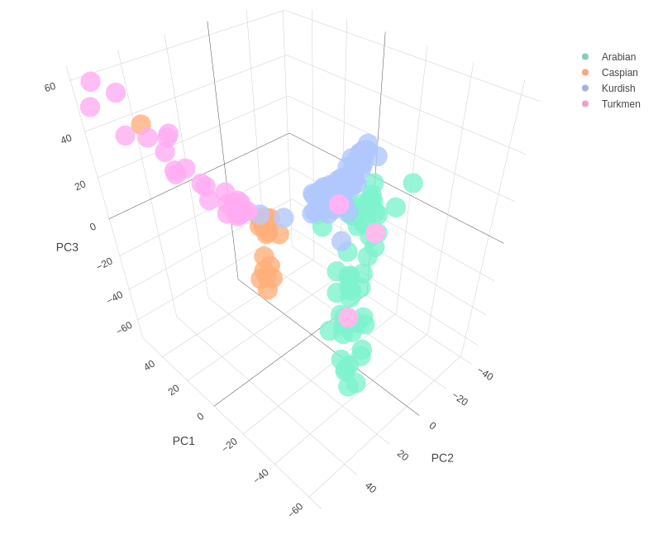

Figure S1. 3D PCA scatter plots of the first three principal components (PCs) for the studied breeds before removing outliers.

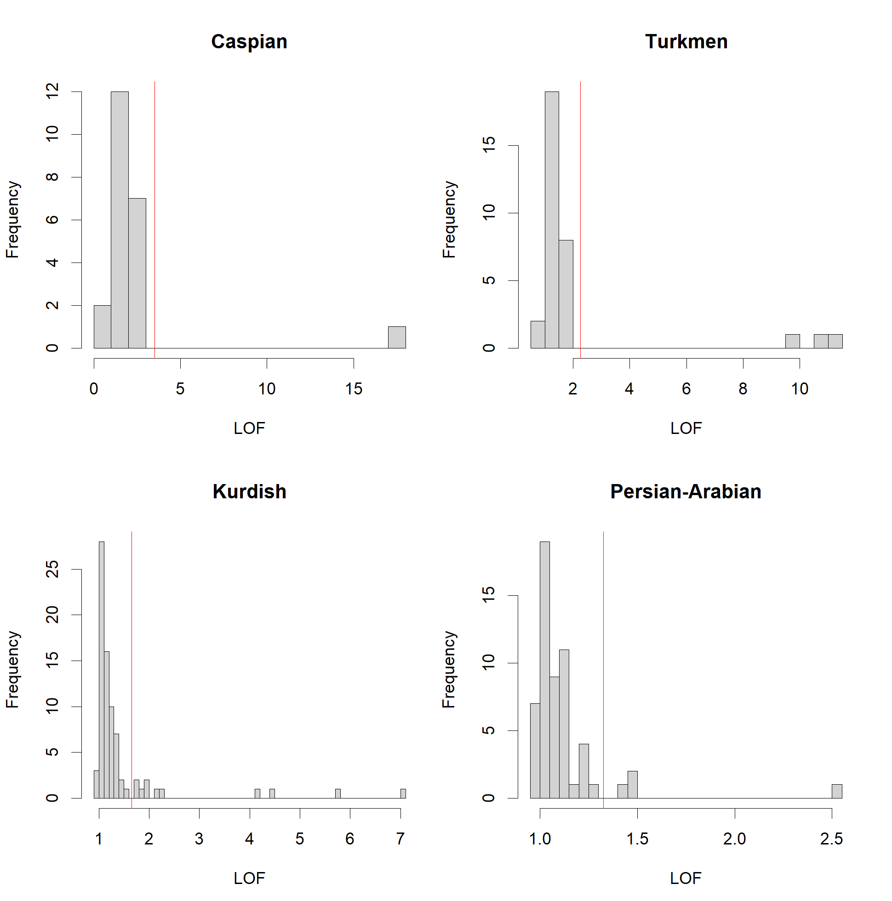 Figure S2. Histogram of calculated local outlier factor (LOF) score for each sample in four different breeds. The red vertical line represents the outlier threshold.

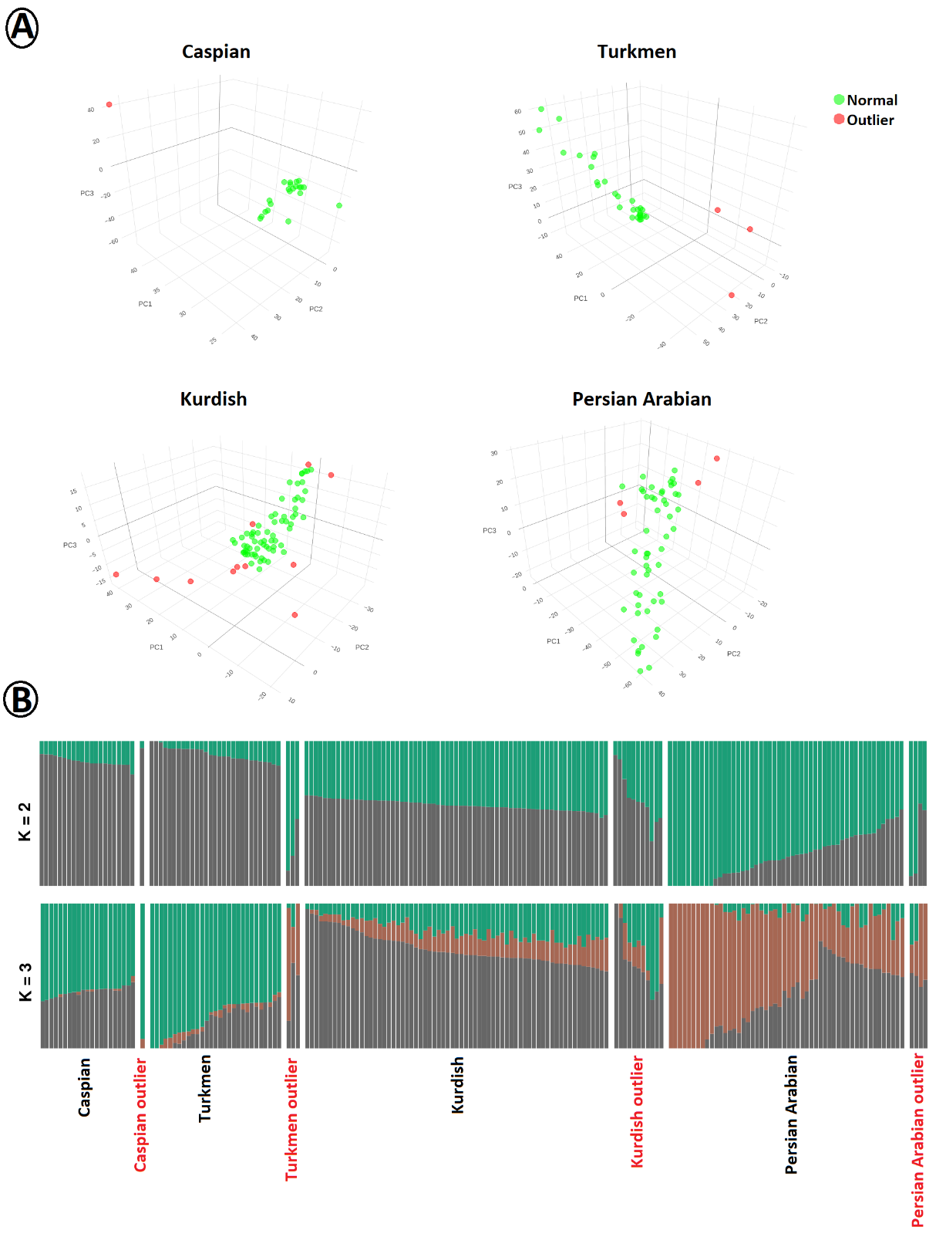
Figure S3. Plots of principle components (A) and Admixture analysis (B) for the detected outliers based on the first three PCs using local outlier factor (LOF) score calculation in four different breeds.

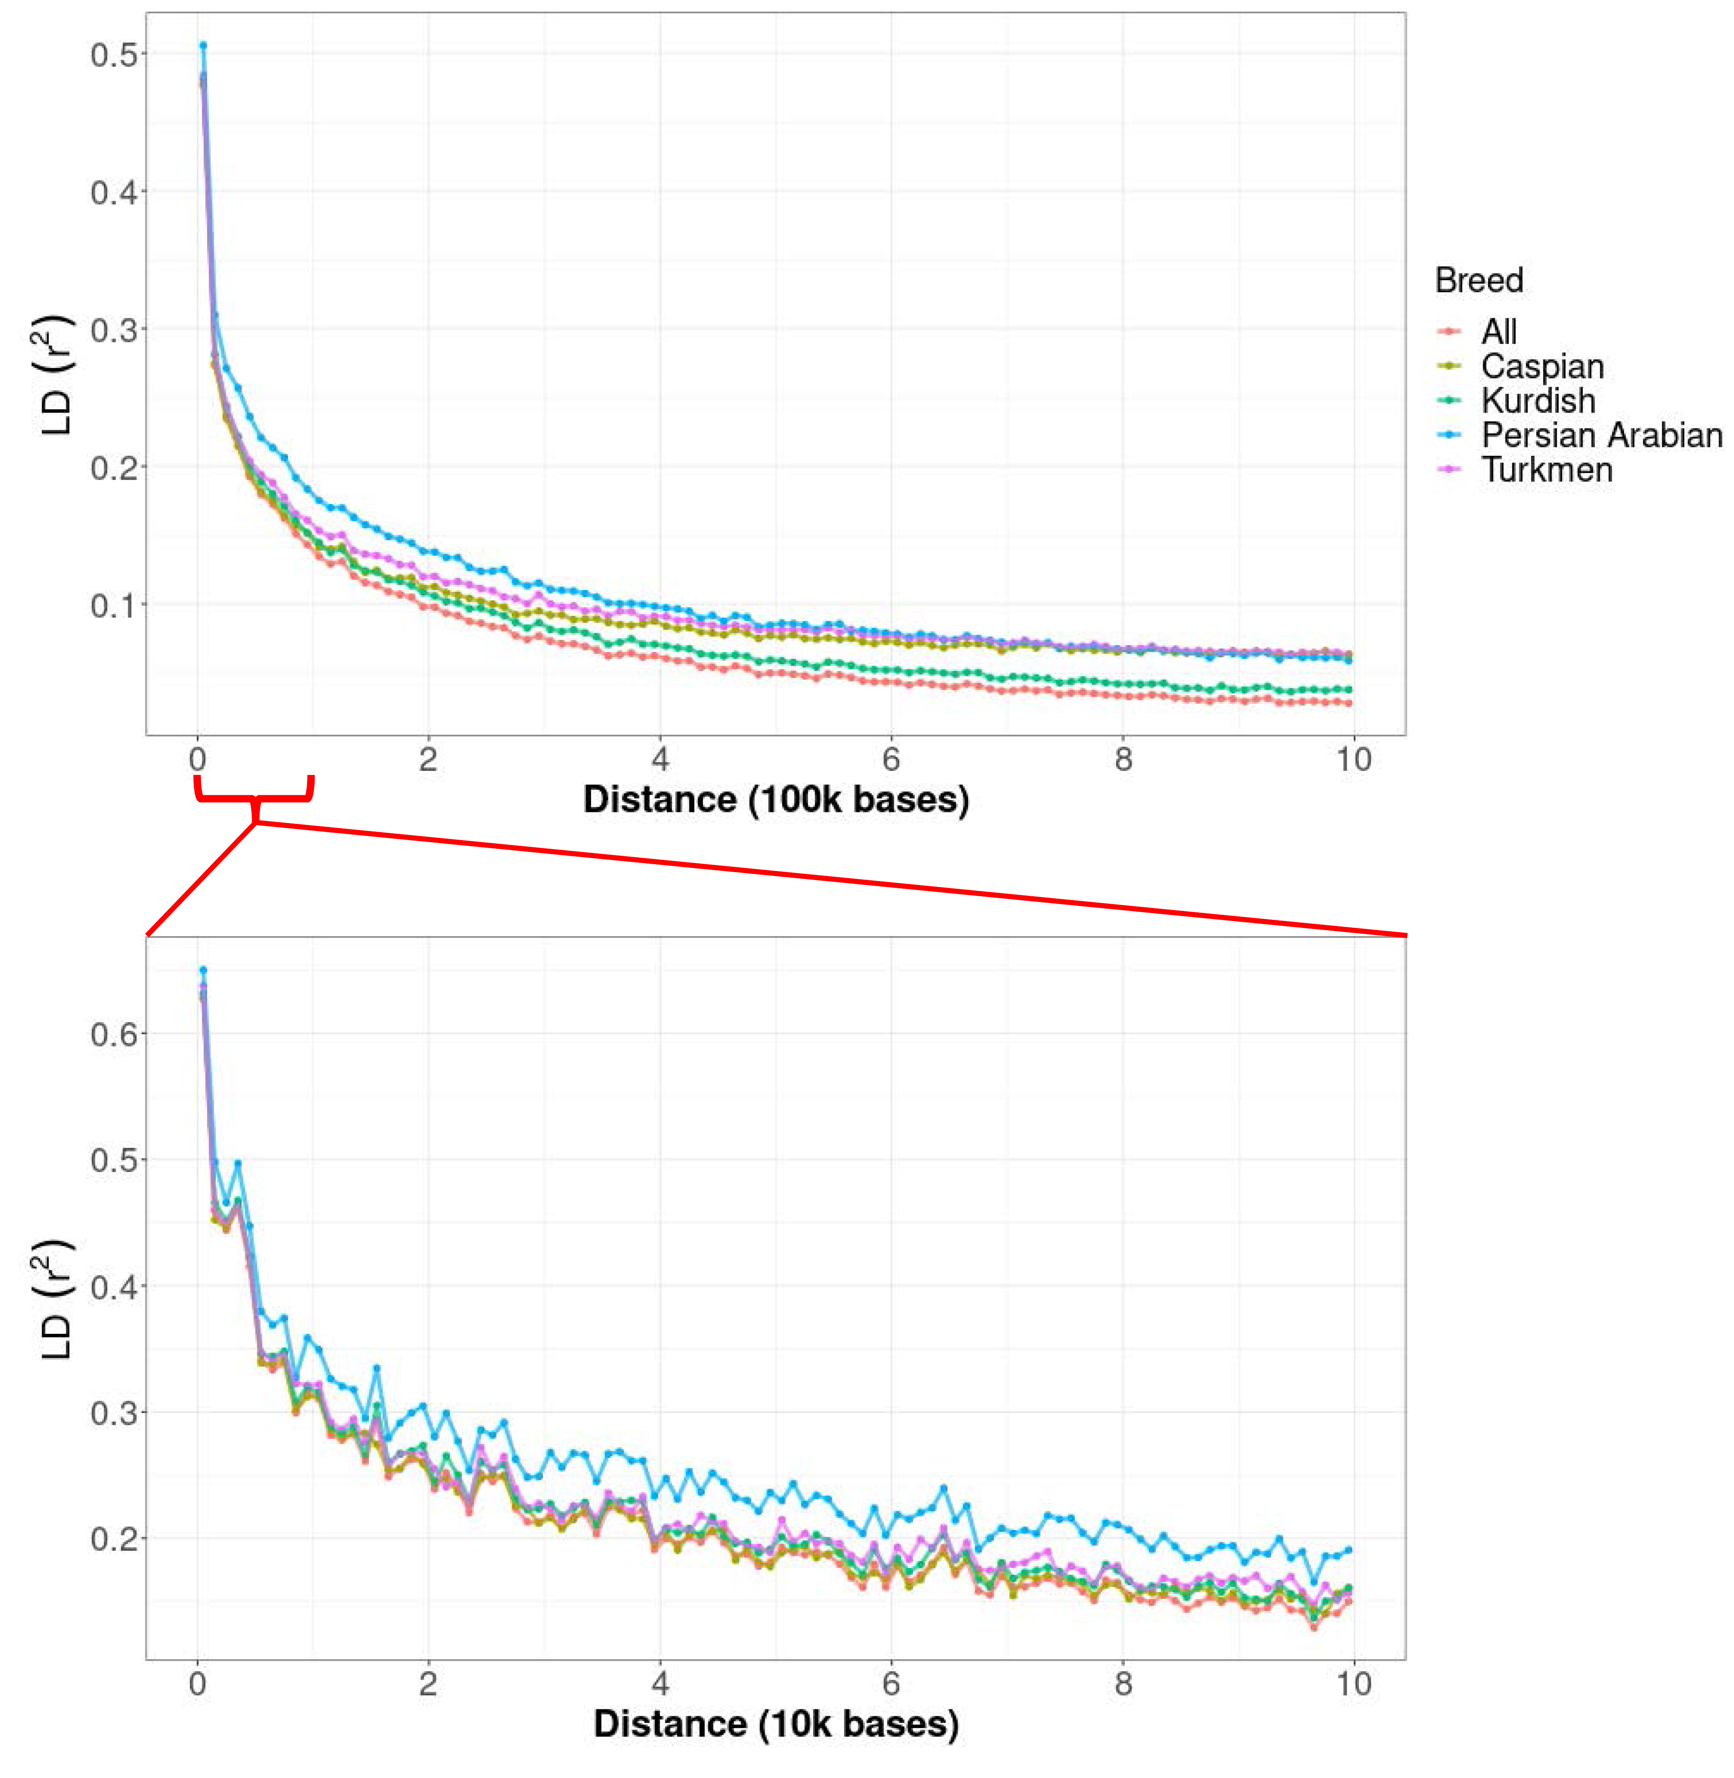
Figure S4. Linkage disequilibrium (LD) decay as a function of genomic distance in each population, using r² between pairs of markers in order to understand the pattern of linkage disequilibrium (LD) in the studied breeds.

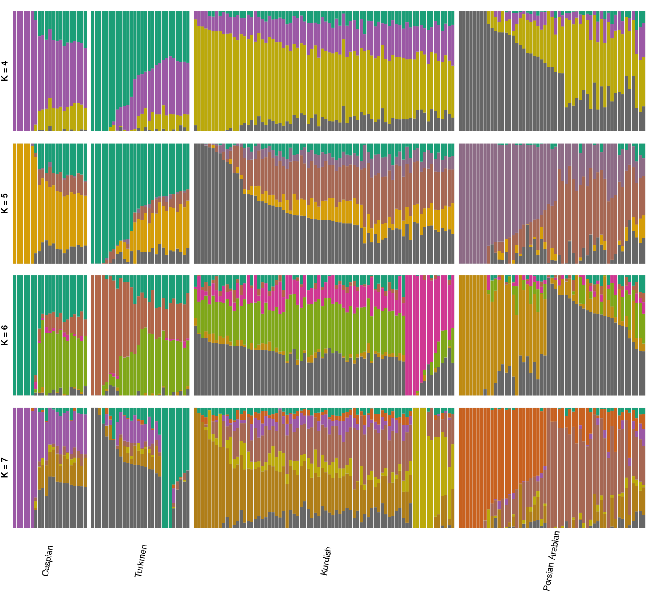
Figure S5. Model-based clustering of four Iranian breeds using admixture analysis with the assumed number of ancestries from 4 to 7.
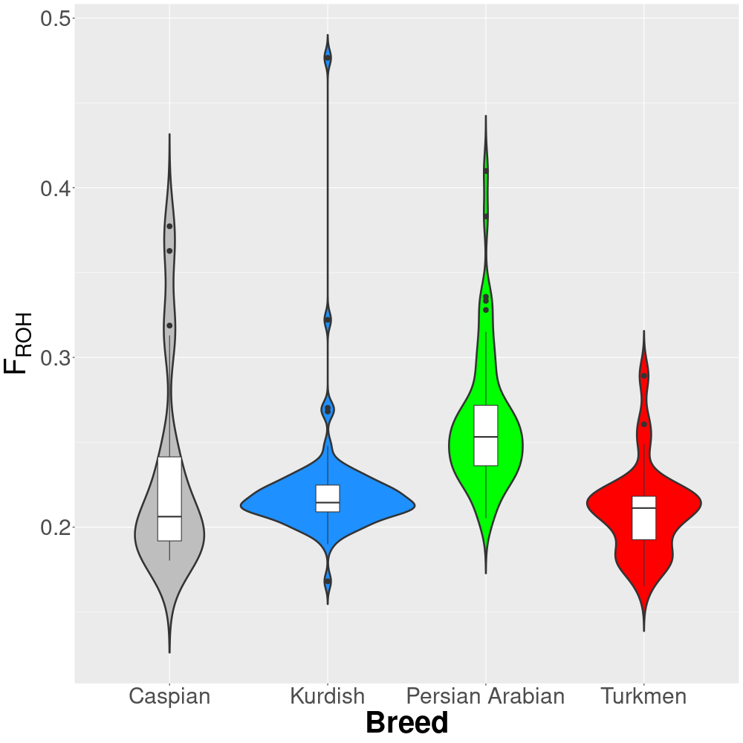
Figure S6. The boxplot of inbreeding coefficient base on the length distribution of ROH segments in four studied populations including Turkmen, Caspian, Persian Arabian and Kurdish horses.

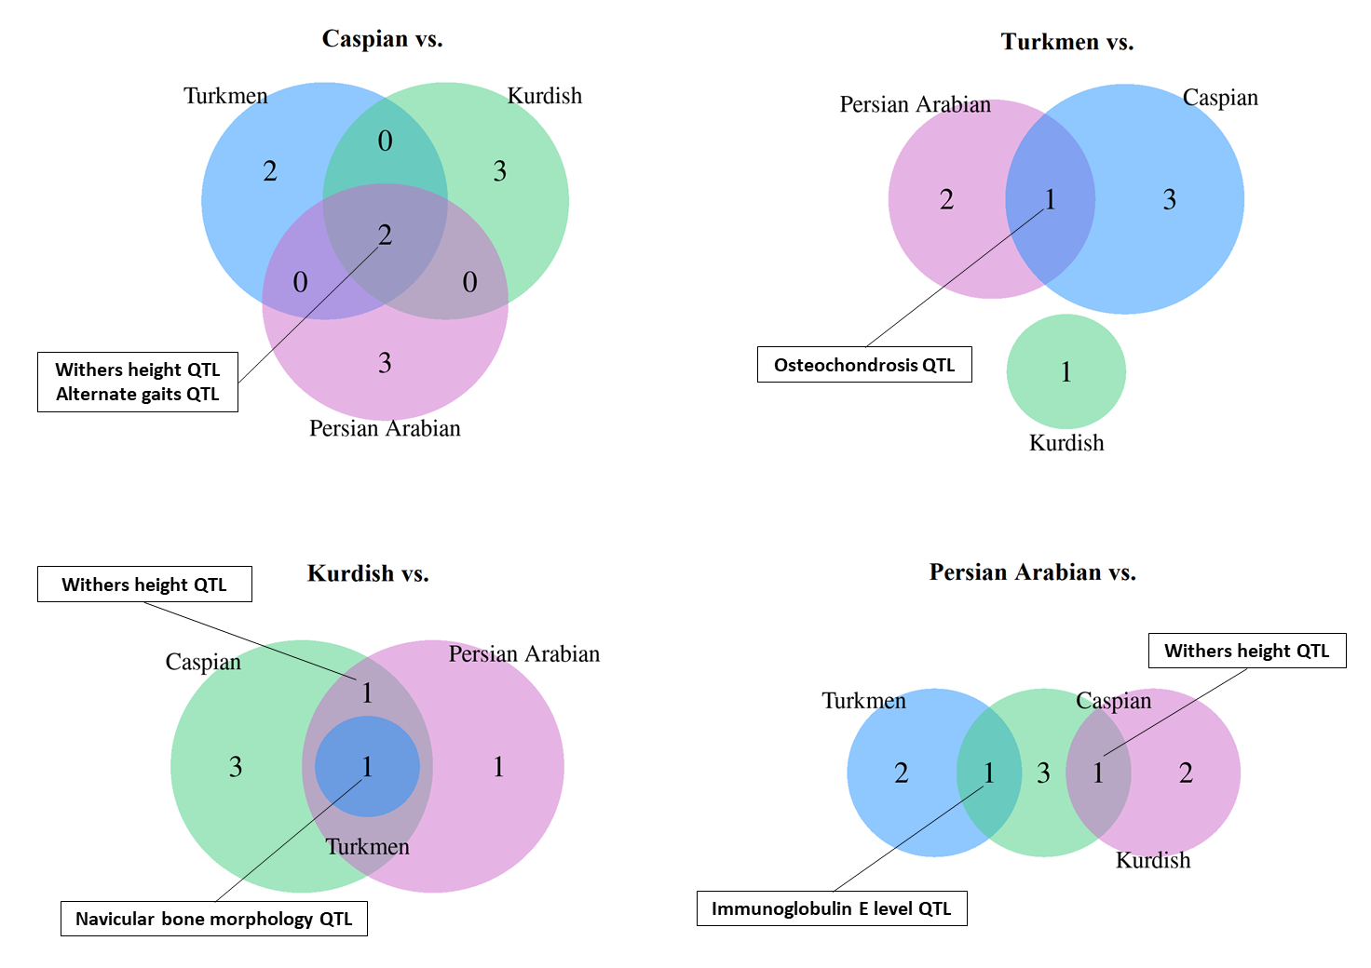
Figure S7. Venn diagrams summarizing number of overlapped QTL type under selection among different pairwise comparisons.

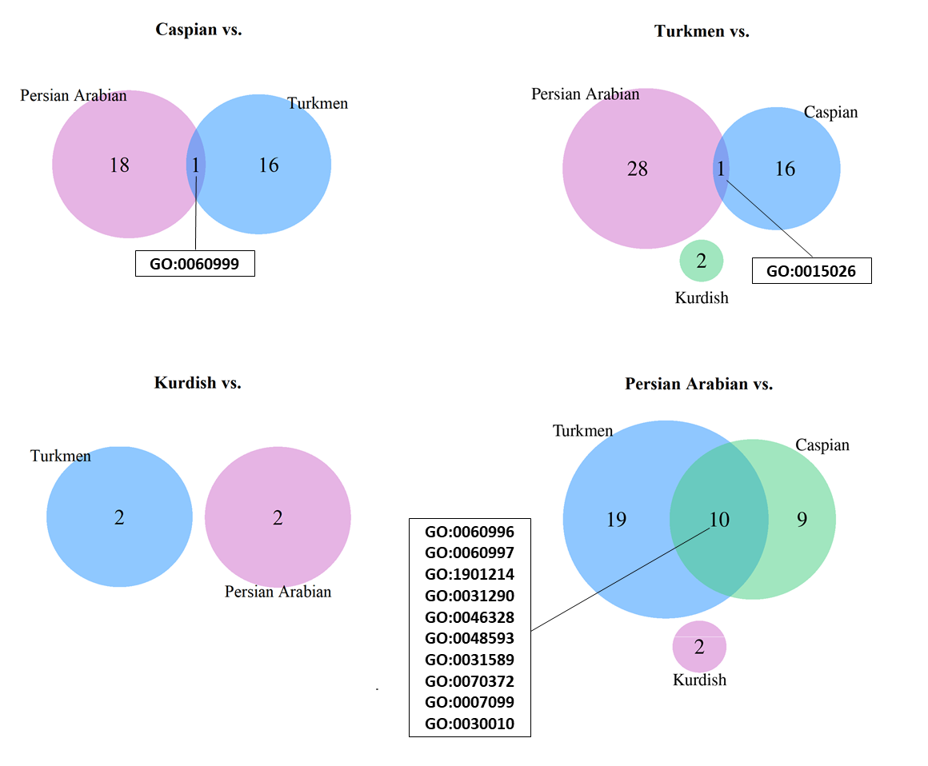
Figure S8. Venn diagrams summarizing number of overlapped candidate GOs under selection among different pairwise comparisons.

References:
Ghezelsoflou, H., P. Hamidi and S. Gharahveysi, 2018 Study of factors affecting the body conformation traits of Iranian Turkoman horses. Journal of equine science 29: 91-96.
Hosseini, M., H. M. Shahrbabak, M. B. Zandi and M. Fallahi, 2016 A Morphometric Survey Among Three Iranian Horse Breeds with Multivariate Analysis. Media Peternakan 39: 155-160.
Mostafavi, A., M. A. Fozi, A. E. Koshkooieh, M. Mohammadabadi, O. I. Babenko et al., 2019 Effect of LCORL gene polymorphism on body size traits in horse populations. Acta Scientiarum. Animal Sciences 42.
Yousefi Mashouf, N., H. Mehrabani Yeganeh, A. Nejati Javaremi and F. Maloufi, 2020 A Novel Approach to Establish Breed Type and Standards for an Equine Breed: Persian Kurdish Horse. Journal of Agricultural Science and Technology 22: 1219-1233.

