Genomic signals of local adaptation across climatically heterogenous habitats in an invasive tropical fruit fly (Bactrocera tryoni)
Elahe Parvizi¹, Amy L. Vaughan², Manpreet K. Dhami², Angela McGaughran^{1*}

¹ Te Aka Mātuatua/School of Science, University of Waikato, Hamilton, New Zealand
² Biocontrol and Molecular Ecology, Manaaki Whenua Landcare Research, Lincoln, New Zealand

Supplementary material

Contents
Table S1. 2
Table S2 3
Table S3 4
Table S4 5
Figure S1 12
Figure S2 13
Figure S3 14
References 15

Table S1. Sampling details of Bactrocera tryoni for the DarT sequences previously published in Popa-Báez et al. (2020). Locality numbers are used in Figure 1.
Population | Locality number | State | Coordinates  (latitude, longitude) | Historical status
Weipa | 1 | Queensland | −12.65, 141.85 | Native
Mapoon | 2 | Queensland | −11.87, 142.19 | Native
Cape York | 3 | Queensland | −10.70, 142.51 | Native
Coen | 4 | Queensland | −13.94, 143.20 | Native
Cooktown | 5 | Queensland | −15.48, 145.25 | Native
Cape Tribulation | 6 | Queensland | −16.09, 145.46 | Native
Mareeba | 7 | Queensland | −17.00, 145.44 | Native
Cairns | 8 | Queensland | −16.89, 145.74 | Native
Utchee Creek | 9 | Queensland | −17.63, 145.92 | Native
Townsville | 10 | Queensland | −19.28, 146.80 | Native
Bowen | 11 | Queensland | −20.02, 148.22 | Native
Rockhampton | 12 | Queensland | −23.38, 150.51 | Native
Brisbane | 13 | Queensland | −27.41, 152.94 | Native
Torrens Creek | 14 | Queensland | −20.77, 145.02 | Native
Hughenden | 15 | Queensland | −20.85, 144.20 | Native
Cloncurry | 16 | Queensland | −20.71, 140.51 | Invasive
Mt Isa | 17 | Queensland | −20.73, 139.49 | Invasive
Narrabri | 18 | New South Wales | −30.33, 149.78 | Invasive
Sydney | 19 | New South Wales | −33.87, 151.21 | Invasive
Canberra | 20 | New South Wales | −35.40, 149.10 | Invasive
Batemans Bay | 21 | New South Wales | −35.71, 150.18 | Invasive
Bega Valley | 22 | New South Wales | −36.62, 149.97 | Invasive
Ardlethan | 23 | New South Wales | −34.35, 146.90 | Invasive
Griffith | 24 | New South Wales | −34.28, 146.05 | Invasive
Shepparton | 25 | Victoria | −36.38, 145.40 | Invasive
Alice Springs | 26 | Northern Territory | −23.70, 133.88 | Invasive
Loyalty Island | 27 | Pacific Island | −21.01, 167.22 | Invasive
Tahiti | 28 | Pacific Island | −17.56, −149.56 | Invasive

Table S2. Estimates of population genetic indices based on 6,707 SNPs in native and introduced ranges of Bactrocera tryoni. Locality numbers are used in Figure 1. Native populations are highlighted in yellow and introduced populations are highlighted in blue. n: number of individuals; HO: average observed heterozygosity; HE: average expected heterozygosity; π: average nucleotide diversity; F_{IS}: inbreeding coefficient; S.E.: standard error.
Population | Locality number | n | HO | S.E. | HE | S.E. | π | S.E. | F_{IS} | S.E.
Weipa | 1 | 5 | 0.25392 | 0.00271 | 0.20265 | 0.0019 | 0.22575 | 0.00212 | -0.06331 | 0.00375
Mapoon | 2 | 8 | 0.25597 | 0.00241 | 0.20953 | 0.00171 | 0.2238 | 0.00183 | -0.08431 | 0.00492
Cape York | 3 | 11 | 0.25493 | 0.00217 | 0.21202 | 0.00158 | 0.22247 | 0.00166 | -0.09414 | 0.00715
Coen | 4 | 8 | 0.25141 | 0.00243 | 0.20517 | 0.00173 | 0.21992 | 0.00185 | -0.08137 | 0.00747
Cooktown | 5 | 8 | 0.25429 | 0.00234 | 0.20839 | 0.00167 | 0.22252 | 0.00178 | -0.08474 | 0.00444
Cape Tribulation | 6 | 7 | 0.25686 | 0.00252 | 0.20425 | 0.00175 | 0.2206 | 0.00189 | -0.09057 | 0.00584
Mareeba | 7 | 4 | 0.25198 | 0.00308 | 0.19258 | 0.00209 | 0.22497 | 0.00246 | -0.05284 | 0.00661
Cairns | 8 | 21 | 0.25195 | 0.00191 | 0.21029 | 0.00137 | 0.21564 | 0.0014 | -0.11912 | 0.01466
Utchee Creek | 9 | 9 | 0.25777 | 0.00237 | 0.20807 | 0.00165 | 0.22062 | 0.00175 | -0.0998 | 0.00561
Townsville | 10 | 8 | 0.25192 | 0.00237 | 0.20627 | 0.00169 | 0.22027 | 0.0018 | -0.08396 | 0.00459
Bowen | 11 | 8 | 0.25638 | 0.00238 | 0.20979 | 0.0017 | 0.22408 | 0.00181 | -0.08544 | 0.0048
Rockhampton | 12 | 12 | 0.25182 | 0.00215 | 0.20669 | 0.00152 | 0.21624 | 0.00159 | -0.10432 | 0.01272
Brisbane | 13 | 22 | 0.25165 | 0.0019 | 0.21036 | 0.00137 | 0.21552 | 0.0014 | -0.1192 | 0.01783
Torrens Creek | 14 | 8 | 0.25622 | 0.00235 | 0.20766 | 0.00166 | 0.22191 | 0.00177 | -0.09102 | 0.00561
Hughenden | 15 | 8 | 0.25503 | 0.00238 | 0.20628 | 0.00166 | 0.22037 | 0.00178 | -0.09096 | 0.00495
Cloncurry | 16 | 8 | 0.2537 | 0.00278 | 0.19851 | 0.00188 | 0.21209 | 0.00201 | -0.10135 | 0.00584
Mt Isa | 17 | 8 | 0.25253 | 0.00259 | 0.20094 | 0.00179 | 0.21468 | 0.00191 | -0.09583 | 0.00556
Narrabri | 18 | 9 | 0.25556 | 0.00233 | 0.20725 | 0.00163 | 0.21974 | 0.00173 | -0.09721 | 0.00534
Sydney | 19 | 15 | 0.25235 | 0.00209 | 0.20825 | 0.00149 | 0.21595 | 0.00155 | -0.11108 | 0.01328
Canberra | 20 | 16 | 0.25506 | 0.00207 | 0.21072 | 0.00148 | 0.21774 | 0.00153 | -0.11538 | 0.00969
Batemans Bay | 21 | 9 | 0.25004 | 0.00236 | 0.20296 | 0.00167 | 0.21525 | 0.00177 | -0.09444 | 0.00631
Bega Valley | 22 | 13 | 0.25037 | 0.00225 | 0.20472 | 0.0016 | 0.21329 | 0.00166 | -0.10752 | 0.01012
Ardlethan | 23 | 8 | 0.25773 | 0.00253 | 0.20586 | 0.00175 | 0.2199 | 0.00187 | -0.09688 | 0.00497
Griffith | 24 | 10 | 0.25296 | 0.00249 | 0.20281 | 0.00172 | 0.21379 | 0.00182 | -0.10434 | 0.00681
Shepparton | 25 | 9 | 0.25247 | 0.00246 | 0.20291 | 0.00171 | 0.21517 | 0.00181 | -0.09847 | 0.00598
Alice Springs | 26 | 31 | 0.25626 | 0.00262 | 0.20261 | 0.00179 | 0.20606 | 0.00182 | -0.14266 | 0.023
Loyalty Island | 27 | 10 | 0.25758 | 0.00293 | 0.1986 | 0.00196 | 0.20963 | 0.00207 | -0.11667 | 0.00953
Tahiti | 28 | 8 | 0.25653 | 0.0035 | 0.1861 | 0.00221 | 0.19929 | 0.00238 | -0.12388 | 0.00991

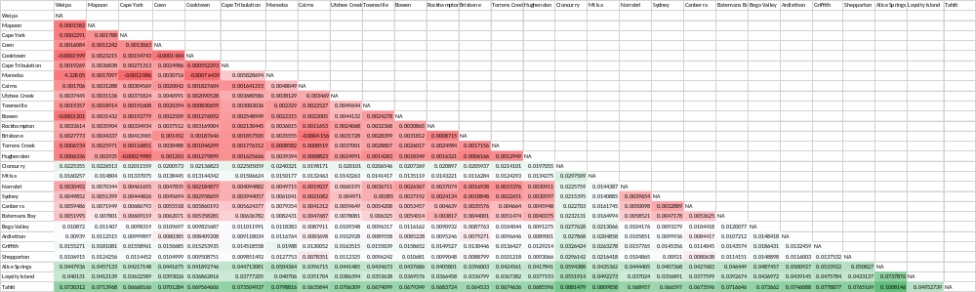
Table S3. Pairwise population F_{ST} values showing genetic distances between native and introduced populations of Bactrocera tryoni based on 6,707 SNPs. Red colour represents lower genetic differentiation while green shows higher population isolation.

Table S4. Full list of candidate genes located at close proximity (10 kb) to BayPass outlier SNPs identified by comparing native populations versus all invasive populations, as well as native populations versus southern expanded ranges, Alice Springs, and the Pacific Islands in Bactrocera tryoni. Outliers highlighted in blue are common between different contrast analyses.
Pairwise comparison | SNP outlier position | Candidate gene ID | Candidate gene position | Candidate gene description | Candidate gene function (from studies on Drosophila or other species) | Reference
Native vs. all invasive | NC_052499.1:9538889 | no exons | NA | NA | NA
Native vs. all invasive | NC_052499.1:43308649 | LOC120771228 | NC_052499.1 (43050120..43464343) | mediator of RNA polymerase II transcription subunit 15-like | controls transcription from class II genes; development & reproduction | (Blazek et al., 2005); flybase
Native vs. all invasive | NC_052499.1:51371013 | LOC120775806 | NC_052499.1 (51376881..51526588) | sodium-coupled monocarboxylate transporter 1 | up-regulated in response to fluralaner insecticide in the common cutworm Spodoptera litura; down-regulated at lower temperatures in in the red imported fire ant (Solenopsis invicta) | (Jia et al., 2020; Vatanparast et al., 2021)
Native vs. all invasive | NC_052499.1:56530119 | LOC120782568 | NC_052499.1 (56224854..56720530) | protein timeless homolog | production of circadian rhythms including mating behaviour and diapause, involved in adaptation of such processes in response to changes in light and temperature | (Tauber et al., 2007)
Native vs. all invasive | NC_052500.1:17036657 | LOC120769096 | NC_052500.1 (17022685..17069149 | homeotic protein spalt-major | Required for the establishment of the posterior-most head and the anterior-most tail segments of the embryo in Drosophila. | flybase
Native vs. all invasive | NC_052500.1:76636749 | LOC120769762 | NC_052500.1 (76539399..76724385) | protein FAM102B | involved in dsRNA transport | flybase
Native vs. all invasive | NC_052501.1:83441072 | no exons | NA | NA | NA
Native vs. all invasive | NC_052501.1:86202350 | LOC120772156 | NC_052501.1 (86173787..86197464) | COP9 signalosome complex subunit 7 | involved in social behaviour, immunity, and adult physiology | (Tong et al., 2015; Zhang et al., 2019)
Native vs. all invasive | NC_052502.1:36640935 | LOC120774554 | NC_052502.1 (36636794..36651833) | ubiquitin-conjugating enzyme E2 H | involved in protein ubiquitination, a process which is essential for recovery of cellular activities after heat shock (in vitro experiment) | Flybase; (Maxwell et al., 2021)
Native vs. all invasive | NC_052502.1:40677125 | LOC120775878 | NC_052502.1 (40665184..40677161) | extensin-2-like | NA
Native vs. all invasive | NC_052502.1:53034145 | LOC120774360 | NC_052502.1 (53042562..53047202) | uncharacterized | NA
Native vs. all invasive | NC_052502.1:68285560 | LOC120774364 | NC_052502.1 (68074338..68289322) | homeobox protein cut | regulates cell proliferation and patterning | (Pitsouli & Perrimon, 2013)
Native vs. all invasive | NC_052502.1:71987739 | no exons | NA | NA | NA
Native vs. all invasive | NC_052503.1:22794084 | no exons | NA | NA | NA
Native vs. all invasive | NC_052503.1:31352727 | no exons | NA | NA | NA
Native vs. all invasive | NW_024395342.1:8297 | no exons | NA | NA | NA
Native vs. southern expanded | NC_052503.1:31352727 | no exons | NA | NA | NA
Native vs. southern expanded | NW_024395342.1:8297 | no exons | NA | NA | NA
Native vs. Alice Springs | NC_052499.1:27573071 | LOC120766489 LOC120782476 | NC_052499.1 (27491592..27630121) NC_052499.1 (27556610..27580906) | ras-like protein family member 10B odorant receptor (OR) coreceptor | development, cell proliferation and differentiation localization of ORs to dendritic membranes and odorant detection | (Ogura et al., 2009; Stengl & Funk, 2013)
Native vs. Alice Springs | NC_052499.1:43308649 | LOC120771228 | NC_052499.1 (43050120..43464343) | mediator of RNA polymerase II transcription subunit 15-like | controls transcription from class II genes; development & reproduction | (Blazek et al., 2005); flybase
Native vs. Alice Springs | NC_052499.1:48889636 | no exons | NA | NA | NA
Native vs. Alice Springs | NC_052499.1:50494563 | no exons | NA | NA | NA
Native vs. Alice Springs | NC_052499.1:51371013 | LOC120775806 | NC_052499.1 (51376881..51526588) | sodium-coupled monocarboxylate transporter 1 | up-regulated in response to fluralaner insecticide in the common cutworm Spodoptera litura; down-regulated at lower temperatures in in the red imported fire ant (Solenopsis invicta) | (Jia et al., 2020; Vatanparast et al., 2021)
Native vs. Alice Springs | NC_052499.1:53821686 | no exons | NA | NA | NA
Native vs. Alice Springs | NC_052499.1:56113393 | LOC120771435 | NC_052499.1 (55959550..56153912) | acetylcholinesterase | insecticide-targeted gene; its expression was induced under temperature (heat) stress in honey bee workers | (Jia et al., 2020; Kim et al., 2019)
Native vs. Alice Springs | NC_052499.1:56530119 | LOC120782568 | NC_052499.1 (56224854..56720530) | protein timeless homolog | production of circadian rhythms including mating behaviour and diapause, involved in adaptation of such processes in response to changes in light and temperature | (Tauber et al., 2007)
Native vs. Alice Springs | NC_052499.1:61062936 | LOC120766280 | NC_052499.1 (61039057..61116531) | pituitary homeobox homolog Ptx1 | control physiological cell functions during development | flybase
Native vs. Alice Springs | NC_052499.1:62164506 | LOC120766782 | NC_052499.1 (62048211..62368441) | homeobox protein homothorax | regulates expression of photoreceptors as light-sensing structures; involves in development, proximal appendages patterning, and cell division promotion | (Mishra et al., 2021); flybase
Native vs. Alice Springs | NC_052499.1:62547367 | no exons | NA | NA | NA
Native vs. Alice Springs | NC_052499.1:65597876 | no exons | NA | NA | NA
Native vs. Alice Springs | NC_052499.1:67491876 | LOC120774377 | NC_052499.1 (67493283..67494029) | uncharacterized | NA
Native vs. Alice Springs | NC_052499.1:67796025 | LOC120768537 | NC_052499.1 (67672038..67809873) | uncharacterized | NA
Native vs. Alice Springs | NC_052499.1:74549310 | LOC120776053 | NC_052499.1 (74382668..74586475) | hemicentin-1 | cell adhesion; involved in adaptation to thermal stress in corals | (Kirk et al., 2018; Vargas et al., 2022)
Native vs. Alice Springs | NC_052499.1:75487809 | LOC120782773 | NC_052499.1 (75461797..75482598) | AN1-type zinc finger protein 6-like | important role in growth, aging and responses to biotic and abiotic stresses (e.g. environmental stresses that cause oxidative damage in vivo, such as heat, cold, UV light, and pesticides in Apis cerana) | (Guo et al., 2021)
Native vs. Alice Springs | NC_052499.1:75635351 | LOC120777560 | NC_052499.1 (75570372..75641059) | cadherin-99C | promotes cell adhesion and enhances cellular stability and integrity as a protective mechanism against heat stress in the thermophilic ant genus Cataglyphis; confers resistance to Bt toxin in transgenic cotton | (Gao et al., 2018; Perez et al., 2021)
Native vs. Alice Springs | NC_052499.1:76576632 | LOC120777855 | NC_052499.1 (76404074..76627390) | uncharacterized | NA
Native vs. Alice Springs | NC_052499.1:76831959 | LOC120779132 | NC_052499.1 (76671311..76872645) | uncharacterized | NA
Native vs. Alice Springs | NC_052499.1:80769784 | no exons | NA | NA | NA
Native vs. Alice Springs | NC_052499.1:85346290 | LOC120766738 LOC120766736 LOC120779175 | NC_052499.1 (85330178..85358999) NC_052499.1 (85334294..85547645) NC_052499.1 (85341260..85352664) | caspase-3-like collagen alpha chain CG42342 uncharacterized | important role in apoptosis and inflammation, associated with immune system response to salinity stress in mosquitoes; muscle structure and function (e.g. insect flight activity) | (Jones et al., 2015; Uyhelji et al., 2016)
Native vs. Alice Springs | NC_052499.1:87473054 | LOC120774297 | NC_052499.1 (87398130..87516097) | uncharacterized | NA
Native vs. Alice Springs | NC_052499.1:87473514 | LOC120774297 | NC_052499.1 (87398130..87516097) | uncharacterized | NA
Native vs. Alice Springs | NC_052499.1:88812046 | LOC120767072 | NC_052499.1 (88758331..88864521) | guanylate cyclase soluble subunit beta-1 | involves in neuronal development (e.g. photoreceptors) and response to hypoxia | (Morton & Vermehren, 2007)
Native vs. Alice Springs | NC_052499.1:89170604 | no exons | NA | NA | NA
Native vs. Alice Springs | NC_052500.1:977719 | LOC120767682 | NC_052500.1 (956681..985312) | probable ATP-dependent permease | transports various molecules including bioamines, neurotransmitters and metabolic intermediates | flybase
Native vs. Alice Springs | NC_052500.1:16608169 | no exons | NA | NA | NA
Native vs. Alice Springs | NC_052500.1:18467508 | LOC120768270 LOC120767202 | NC_052500.1 (18456542..18457851) NC_052500.1 (18459100..18475526) | protein YIPF6 trehalose-phosphate phosphatase B | transmembrane protein located in Golgi apparatus and ER likely involved in thermotolerance in soldier flies (Stratiomyidae) larvae | flybase (Garbuz et al., 2008)
Native vs. Alice Springs | NC_052500.1:21050807 | LOC120767328 | NC_052500.1 (21048044..21116411) | uncharacterized | NA
Native vs. Alice Springs | NC_052500.1:34298632 | no exons | NA | NA | NA
Native vs. Alice Springs | NC_052500.1:46309826 | no exons | NA | NA | NA
Native vs. Alice Springs | NC_052500.1:51137017 | LOC120769259 | NC_052500.1 (51135788..51303832) | protein outspread | involved in cell organization and cytoskeletal binding | flybase
Native vs. Alice Springs | NC_052500.1:52006698 | no exons | NA | NA | NA
Native vs. Alice Springs | NC_052500.1:60188524 | no exons | NA | NA | NA
Native vs. Alice Springs | NC_052500.1:74805999 | no exons | NA | NA | NA
Native vs. Alice Springs | NC_052500.1:76636749 | LOC120769762 | NC_052500.1 (76539399..76724385) | protein FAM102B | involved in dsRNA transport | flybase
Native vs. Alice Springs | NC_052500.1:78091361 | LOC120769090 LOC120769120 | NC_052500.1 (78015222..78088808) NC_052500.1 (78096485..78097837) | protein obstructor-E uncharacterized | chitin-binding protein important for expandability of the larval cuticle (maybe a better protect for body under harsh environmental conditions), also, involved in carbohydrate metabolism | flybase, (von Wyschetzki et al., 2015)
Native vs. Alice Springs | NC_052501.1:2626717 | no exons | NA | NA | NA
Native vs. Alice Springs | NC_052501.1:7386215 | LOC120773042 | NC_052501.1 (7037466..7401997) | uncharacterized | NA
Native vs. Alice Springs | NC_052501.1:9002087 | LOC120770590 | NC_052501.1 (8979288..9080363) | ion transport peptide-like | encodes thirst-promoting and anti-diuretic hormone in Drosophila and involves in response to osmotic and desiccation stress in Drosophila, also, encodes neuropeptides in the CNS controlling the evening peak of locomotor activity of the fly | (Gáliková et al., 2018), flybase
Native vs. Alice Springs | NC_052501.1:10419921 | LOC120772869 | NC_052501.1 (10368266..10482459) | uncharacterized | NA
Native vs. Alice Springs | NC_052501.1:12026571 | LOC120771606 | NC_052501.1 (12034612..12055362) | aquaporin AQPAe.a | water-selective transmemberane channel that plays a role in desiccation and maintaining osmotic balance (also in cold hardiness in freeze-tolerant insects) | (Chown et al., 2011)
Native vs. Alice Springs | NC_052501.1:14700025 | LOC120771906 | NC_052501.1 (14690247..14693654) | endoplasmic reticulum junction formation protein lunapark-A | involved in network formation and organization of endoplasmic reticulum | flybase
Native vs. Alice Springs | NC_052501.1:14990223 | LOC120770991 | NC_052501.1 (14819287..15098585) | protein Shroom | mediates cell organization and biogenesis and embryonic morphogenesis | flybase
Native vs. Alice Springs | NC_052501.1:15106302 | LOC120770991 | NC_052501.1 (14819287..15098585) | protein Shroom | mediates cell organization and biogenesis and embryonic morphogenesis | flybase
Native vs. Alice Springs | NC_052501.1:17974111 | LOC120772702 | NC_052501.1 (17974011..18258836) | sodium channel protein 60E | involves in membrane excitability and is the target of neurotoxins, including several classes of insecticides | (Dong, 2007)
Native vs. Alice Springs | NC_052501.1:61156793 | LOC120770074 | NC_052501.1 (61098675..61485710) | mucin-19 | reported to be downregulated in response to heat stress in Bactrocera dorsalis, also, cell adhesion | (Gu et al., 2019), flybase
Native vs. Alice Springs | NC_052501.1:66038002 | no exons | NA | NA | NA
Native vs. Alice Springs | NC_052501.1:74657842 | no exons | NA | NA | NA
Native vs. Alice Springs | NC_052501.1:83441072 | no exons | NA | NA | NA
Native vs. Alice Springs | NC_052501.1:83731408 | no exons | NA | NA | NA
Native vs. Alice Springs | NC_052501.1:84431403 | no exons | NA | NA | NA
Native vs. Alice Springs | NC_052501.1:85634730 | LOC120770802 LOC120770528 | NC_052501.1 (85615112..85636192) NC_052501.1 (85643322..85644766) | pro-resilin uncharacterized | provides elasticity and involved in storing energy for jumping or flying of insects (specifically, involved in elastic energy conversion with high efficiency during mechanical stress in Drosophila) | (Qin et al., 2012)
Native vs. Alice Springs | NC_052501.1:86078491 | LOC120770152 LOC120770153 | NC_052501.1 (86040271..86081443) NC_052501.1 (86081444..86083781) | metabotropic glutamate receptor 2 maltase A1-like | involved in cold sensing behaviour (in C. elegans) mediates hydrolysis and carbohydrate metabolism, potentially involved in long-distance flight (was upregulated in migratory forms of hoverflies) | (Gong et al., 2019) (Doyle et al., 2022)
Native vs. Alice Springs | NC_052501.1:86202350 | LOC120772156 | NC_052501.1 (86173787..86197464) | COP9 signalosome complex subunit 7 | involved in social behaviour, immunity, and adult physiology | (Tong et al., 2015; Zhang et al., 2019)
Native vs. Alice Springs | NC_052501.1:86320812 | LOC120770414 | NC_052501.1 (86261172..86415449) | hormone receptor 4 | involved in steroid hormone mediated mating behaviour by mediating the timing and expression of steroid hormone 20-hydroxyecdysone during the onset of metamorphosis | (Ma et al., 2021)
Native vs. Alice Springs | NC_052501.1:86940797 | LOC120772107 LOC120770816 | NC_052501.1 (86905296..86933624)  NC_052501.1 (86939701..86941868) | neuropeptide CCHamide-2 receptor  putative gustatory receptor 36b | mediates feeding behaviour and an important factor for controlling developmental timing in Drosophila, also, reported to be downregulated under temperature stresses in Silverleaf whitefly Bemisia tabaci chemosensory receptor mediating acceptance or avoidance behaviour (behavioural avoidance has been suggested to be associated with insecticide resistance, see Crossley et al., 2017) | (Li et al., 2021; Ren et al., 2015); flybase
Native vs. Alice Springs | NC_052502.1:5273 | LOC120773539 | NC_052502.1 (502..91446) | plectin | involved in cytoskeleton organization and dynamics, also, controls osmoregulation in fish | (Dennenmoser et al., 2017; Wiche, 1998)
Native vs. Alice Springs | NC_052502.1:45723 | LOC120773539 | NC_052502.1 (502..91446) | plectin | involved in cytoskeleton organization and dynamics, also, controls osmoregulation in fish | (Dennenmoser et al., 2017; Wiche, 1998)
Native vs. Alice Springs | NC_052502.1:2150024 | LOC120774292 | NC_052502.1 (2128021..2158814) | uncharacterized | NA
Native vs. Alice Springs | NC_052502.1:4482247 | no exons | NA | NA | NA
Native vs. Alice Springs | NC_052502.1:5231348 | LOC120773595 LOC120775219 LOC120773392 | NC_052502.1 (5221518..5226538) NC_052502.1 (5230292..5231559) NC_052502.1 (5235187..5297385) | uncharacterized E3 ubiquitin-protein ligase MARCHF7 titin | NA involved in protein turnover and removal (e.g. under thermal stress in corals) muscle specific protein involved in insect locomotion, also, interacts with heat shock proteins to protect myofibrils under stress (e.g. heat) conditions in fish | (Mayfield et al., 2014; Tucker & Shelden, 2009)
Native vs. Alice Springs | NC_052502.1:5547405 | no exons | NA | NA | NA
Native vs. Alice Springs | NC_052502.1:5797246 | LOC120774319 | NC_052502.1 (5779357..5826519) | uncharacterized | NA
Native vs. Alice Springs | NC_052502.1:6588121 | no exons | NA | NA | NA
Native vs. Alice Springs | NC_052502.1:6612417 | LOC120775870 | NC_052502.1 (6615051..6677061) | uncharacterized | NA
Native vs. Alice Springs | NC_052502.1:6687972 | no exons | NA | NA | NA
Native vs. Alice Springs | NC_052502.1:9468688 | LOC120773614 | NC_052502.1 (9478012..9493497) | insulin-like growth factor-binding protein complex acid labile subunit | possible role in immunity and development | flybase
Native vs. Alice Springs | NC_052502.1:9569629 | LOC120775626  LOC120774218  LOC120774217 | NC_052502.1 (9572288..9574494)  NC_052502.1 (9574673..9576827)  NC_052502.1 (9576818..9580157) | N-acetylglucosamine-6-phosphate deacetylase  uncharacterized protein F54F2.9  anaphase-promoting complex subunit 4 | involved in catabolic processes related to N-acetylglucosamine regulates mitotic metaphase/anaphase transition, also, has been reported to actively participates in the heat shock response in vitro | flybase; (Ahlskog et al., 2010)
Native vs. Alice Springs | NC_052502.1:13304475 | no exons | NA | NA | NA
Native vs. Alice Springs | NC_052502.1:16397273 | LOC120775337 | NC_052502.1 (16161423..16538299) | platelet binding protein GspB | mediates the binding of bacteria and human platelets | UniProt
Native vs. Alice Springs | NC_052502.1:20248230 | LOC120776055 | NC_052502.1 (20190519..20291517) | ras-related protein Rap-2a | enables GTP binding and GTPase activity, also, ras proteins are involved in development, cell proliferation and differentiation | Flybase; (Ogura et al., 2009)
Native vs. Alice Springs | NC_052502.1:21787575 | LOC120776065  LOC120774860 | NC_052502.1 (21678844..21784807)  NC_052502.1 (21795139..21964793) | uncharacterized  uncharacterized | NA
Native vs. Alice Springs | NC_052502.1:22000285 | no exons | NA | NA | NA
Native vs. Alice Springs | NC_052502.1:36640935 | LOC120774554 | NC_052502.1 (36636794..36651833) | ubiquitin-conjugating enzyme E2 H | involved in protein ubiquitination, a process which is essential for recovery of cellular activities after heat shock (in vitro experiment) | Flybase; (Maxwell et al., 2021)
Native vs. Alice Springs | NC_052502.1:49154112 | LOC120774945 | NC_052502.1 (49157048..49158468) | odorant receptor 7a-like | enables detection of volatile chemicals | flybase
Native vs. Alice Springs | NC_052502.1:53034145 | LOC120774360 | NC_052502.1 (53042562..53047202) | uncharacterized | NA
Native vs. Alice Springs | NC_052502.1:67915209 | no exons | NA | NA | NA
Native vs. Alice Springs | NC_052502.1:68285560 | LOC120774364 | NC_052502.1 (68074338..68289322) | homeobox protein cut | regulates cell proliferation and patterning | (Pitsouli & Perrimon, 2013)
Native vs. Alice Springs | NC_052502.1:75107408 | LOC120774195 | NC_052502.1 (75065188..75142600) | calcitonin gene-related peptide type 1 receptor | regulates calcium homeostasis and osmoregulatory adaptation in fish | (Garcia-Elfring et al., 2021; Kusakabe et al., 2017)
Native vs. Alice Springs | NC_052502.1:77675855 | LOC120773626  LOC120773448 | NC_052502.1 (77640416..77670049)  NC_052502.1 (77673548..77706381) | carboxypeptidase D  arginase-1 | mediates neuropeptide processing important for locomotor activity and survival rates in Drosophila involved in development and insect flight metabolism | (Pauls et al., 2019; Raghupathi Reddy & Campbell, 1969)
Native vs. Alice Springs | NC_052503.1:8653278 | LOC120778742 | NC_052503.1 (8640807..8645435) | uncharacterized | NA
Native vs. Alice Springs | NC_052503.1:13126971 | LOC120776683 | NC_052503.1 (13113127..13215810) | putative uncharacterized protein DDB_G0282129 | NA
Native vs. Alice Springs | NC_052503.1:15918209 | LOC120779190 | NC_052503.1 (15913262..15951995) | myb-like protein Q | enables DNA binding and is involved in regulation of cell cycle. In plants, some members of MYB protein family are involved in regulation of cell death and stress tolerance. | Flybase; (De Vos et al., 2006)
Native vs. Alice Springs | NC_052503.1:20878714 | LOC120776680 | NC_052503.1 (20886753..20961256) | solute carrier organic anion transporter family member 74D | regulates transportation of organic anions in excreting tissues, also, involved in elimination of insecticides (e.g., in the red flour beetle, Tribolium castaneum) | (Rösner et al., 2021)
Native vs. Alice Springs | NC_052503.1:22794084 | no exons | NA | NA | NA
Native vs. Alice Springs | NC_052503.1:24153057 | no exons | NA | NA | NA
Native vs. Alice Springs | NC_052503.1:31352727 | no exons | NA | NA | NA
Native vs. Alice Springs | NC_052503.1:32164053 | no exons | NA | NA | NA
Native vs. Alice Springs | NC_052503.1:38617279 | no exons | NA | NA | NA
Native vs. Alice Springs | NC_052503.1:39926419 | LOC120778234  LOC120778236 | NC_052503.1 (39784682..39943102)  NC_052503.1 (39913751..39926853) | serine/threonine-protein kinase pakD  putative gustatory receptor 77a | involved in regulating cytoskeleton, cell organization and development chemosensory receptor mediating acceptance or avoidance behaviour (behavioural avoidance has been suggested to be associated with insecticide resistance, see Crossley et al., 2017) | (Garcia et al., 2014); flybase
Native vs. Alice Springs | NC_052503.1:40252145 | LOC120776567 | NC_052503.1 (39976327..40264030) | cyclin-dependent kinase 14 | involved in the regulation of cell cycle | flybase
Native vs. Alice Springs | NC_052503.1:63027269 | LOC120777402 | NC_052503.1 (62806204..63041737) | uncharacterized | NA
Native vs. Alice Springs | NC_052503.1:68462596 | LOC120776608  LOC120778592 | NC_052503.1 (68436687..68456979)  NC_052503.1 (68459482..68465792) | SRSF protein kinase 1  heat shock 70 kDa protein cognate 1 | enables protein serine/threonine kinase activity and involves in mRNA splicing regulation critical physiological products under abiotic stress (heat, cold, crowding, and anoxia) & up-regulated by cold and heat stress (hsp is considered as a general stress marker) | flubase; (Bustos et al., 2020; Kim et al., 2019; King & MacRae, 2015; Vatanparast et al., 2021)
Native vs. Alice Springs | NC_052503.1:69431136 | LOC120778228  LOC120777567  LOC120777565 | NC_052503.1 (69420293..69425331)  NC_052503.1 (69432619..69433712)  NC_052503.1 (69437200..69438850) | uncharacterized  uncharacterized  transcription factor Adf-1-like | NA NA regulates the expression of Adh (alcohol dehydrogenase) and other genes | flybase
Native vs. Alice Springs | NC_052503.1:69720163 | LOC120777228 | NC_052503.1 (69445489..69778709) | mucin-17 | reported to be downregulated in response to heat stress in the oriental fruit fly Bactrocera dorsalis, also, cell adhesion | (Gu et al., 2019); flybase
Native vs. Alice Springs | NC_052503.1:75305442 | no exons | NA | NA | NA
Native vs. Alice Springs | NC_052503.1:75329191 | LOC120776669 | NC_052503.1 (75319124..75323038) | uncharacterized | NA
Native vs. Alice Springs | NW_024395342.1:8297 | no exons | NA | NA | NA
Native vs. Alice Springs | NW_024395977.1:21674826 | LOC120780798  LOC120780339 | NW_024395977.1 (21644681..21690549)  NW_024395977.1 (21668945..21669460) | protein unc-13 homolog 4B  uncharacterized | involved in synaptic vesicle exocytosis NA | flybase
Native vs. Alice Springs | NW_024396193.1:81243 | no exons | NA | NA | NA
Native vs. Alice Springs | NW_024396313.1:109657 | LOC120781358 | NW_024396313.1 (20527..117811) | discoidin domain-containing receptor 2-like | enables collagen binding | flybase
Native vs. Alice Springs | NW_024396573.1:540274 | no exons | NA | NA | NA
Native vs. Pacific Islands | NC_052499.1:43308649 | LOC120771228 | NC_052499.1 (43050120..43464343) | mediator of RNA polymerase II transcription subunit 15-like | controls transcription from class II genes; development & reproduction | (Blazek et al., 2005); flybase
Native vs. Pacific Islands | NC_052499.1:50494563 | no exons | NA | NA | NA
Native vs. Pacific Islands | NC_052499.1:51371013 | LOC120775806 | NC_052499.1 (51376881..51526588) | sodium-coupled monocarboxylate transporter 1 | up-regulated in response to fluralaner insecticide in the common cutworm Spodoptera litura; down-regulated at lower temperatures in in the red imported fire ant (Solenopsis invicta) | (Jia et al., 2020; Vatanparast et al., 2021)
Native vs. Pacific Islands | NC_052499.1:59142301 | LOC120773468 | NC_052499.1 (59097281..59161930) | mucin-2-like | reported to be downregulated in response to heat stress in Bactrocera dorsalis, also, cell adhesion | (Gu et al., 2019); flybase
Native vs. Pacific Islands | NC_052499.1:75635351 | LOC120777560 | NC_052499.1 (75570372..75641059) | cadherin-99C | promotes cell adhesion and enhances cellular stability and integrity as a protective mechanism against heat stress in the thermophilic ant genus Cataglyphis; confers resistance to Bt toxin in transgenic contton | (Gao et al., 2018; Perez et al., 2021)
Native vs. Pacific Islands | NC_052500.1:18467508 | LOC120768270  LOC120767202 | NC_052500.1 (18456542..18457851)  NC_052500.1 (18459100..18475526) | protein YIPF6  trehalose-phosphate phosphatase B | transmemberane protein located in Golgi apparatus and ER likely involved in thermotolerance in soldier flies (Stratiomyidae) larvae | flybase (Garbuz et al., 2008)
Native vs. Pacific Islands | NC_052500.1:46309826 | no exons | NA | NA | NA
Native vs. Pacific Islands | NC_052500.1:60188524 | no exons | NA | NA | NA
Native vs. Pacific Islands | NC_052501.1:14700025 | LOC120771906 | NC_052501.1 (14690247..14693654) | endoplasmic reticulum junction formation protein lunapark-A | involved in network formation and organization of ER | flybase
Native vs. Pacific Islands | NC_052501.1:29609593 | LOC120771668  LOC120771468  LOC120772200  LOC120771738  LOC120771736 | NC_052501.1 (29597629..29601158)  NC_052501.1 (29601740..29607598)  NC_052501.1 (29608398..29610980)  NC_052501.1 (29611085..29612889)  NC_052501.1 (29613795..29672282) | ARF GTPase-activating protein GIT2  mannosylglucosyl-3-phosphoglycerate phosphatase  conserved oligomeric Golgi complex subunit 7  uncharacterized  transcription factor GAGA | regulates intracellular traffic and involved in vesicle formation hydrolase activity involved in glycosylation (the process of sugar molecules to proteins) and retrograde vesicular trafficking involved in cell division and gametogenesis | (Spang et al., 2010); UniProt; (Quental et al., 2010); flybase
Native vs. Pacific Islands | NC_052501.1:86078491 | LOC120770152  LOC120770153 | NC_052501.1 (86040271..86081443)  NC_052501.1 (86081444..86083781) | metabotropic glutamate receptor 2  maltase A1-like | involved in cold sensing behaviour (in C. elegans) mediates hydrolysis and carbohydrate metabolism, potentially involved in long-distance flight (was upregulated in migratory forms of hoverflies) | (Doyle et al., 2022; Gong et al., 2019)
Native vs. Pacific Islands | NC_052501.1:86202350 | LOC120772156 | NC_052501.1 (86173787..86197464) | COP9 signalosome complex subunit 7 | involved in social behaviour, immunity, and adult physiology | (Tong et al., 2015; Zhang et al., 2019)
Native vs. Pacific Islands | NC_052502.1:24557499 | LOC120775939 | NC_052502.1 (24375180..24831193) | low-density lipoprotein receptor-related protein 2 | up-regulated in response to fluralaner insecticide | (Jia et al., 2020)
Native vs. Pacific Islands | NC_052502.1:49154112 | LOC120774945 | NC_052502.1 (49157048..49158468) | odorant receptor 7a-like | enables detection of volatile chemicals | flybase
Native vs. Pacific Islands | NC_052502.1:53034145 | LOC120774360 | NC_052502.1 (53042562..53047202) | uncharacterized | NA
Native vs. Pacific Islands | NW_024395342.1:8297 | no exons | NA | NA | NA
Native vs. Pacific Islands | NW_024396573.1:540274 | no exons | NA | NA | NA

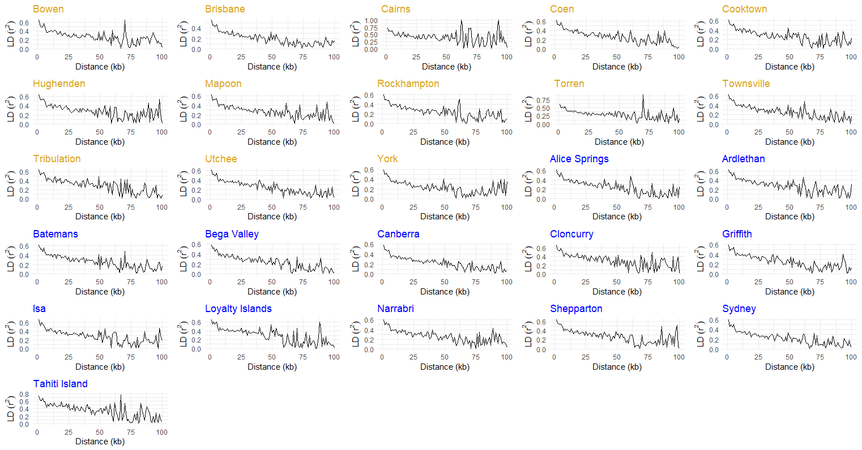
Figure S1. Patterns of linkage disequilibrium decay across the studied SNPs for native (yellow) and invasive (blue) populations of Bactrocera tryoni. This analysis was performed only on samples with n > 5.

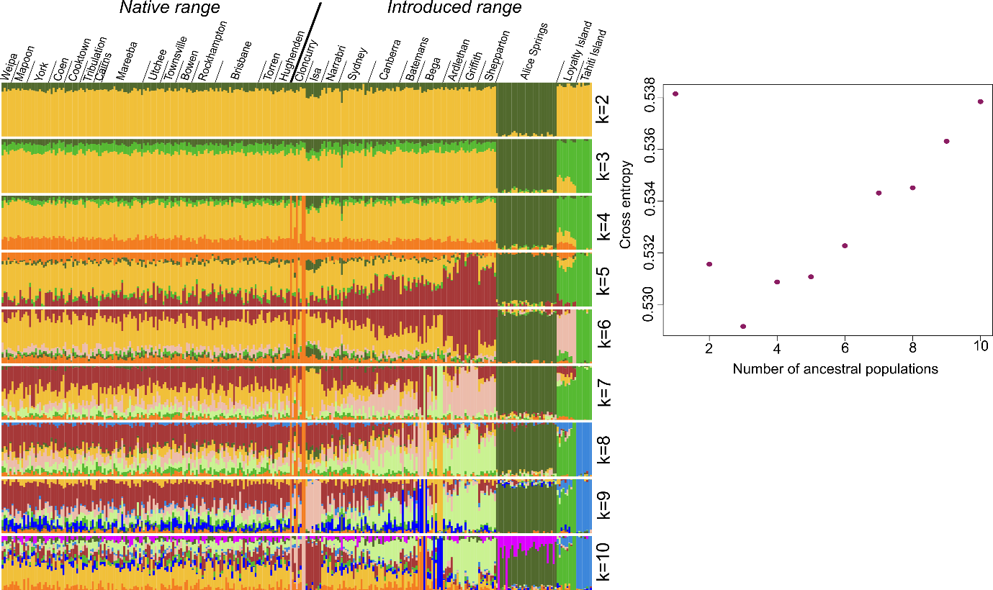

Figure S2. (a) Admixture plots obtained from sNMF analysis of native and introduced populations of Bactrocera tryoni based on 6,707 SNPs. Ancestry coefficients were estimated for k=1-10 and results are shown for k=2-10; (b) Cross-entropy results from sNMF analyses showing the optimal number of ancestral populations (i.e. k=3).

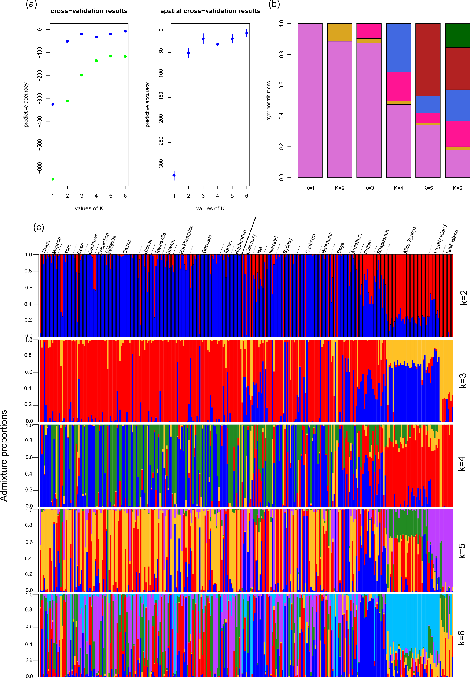
Figure S3. Inferring continuous and discrete population structure using conStruct analysis in Bactrocera tryoni based on 6,707 SNPs. (a) Cross-validation results under k=1-6, comparing the spatial (blue) and non-spatial (green) conStruct models. The spatial model showed better model fit at every value of k (i.e., predictive accuracy closer to zero); (b) Layer contribution results for k=1-6 of the spatial model. At k > 3, the smallest layer contribution was smaller than 2%; (c) Admixture proportions estimated using the spatial model for k=1-6.

References
Ahlskog, J. K., Björk, J. K., Elsing, A. N., Aspelin, C., Kallio, M., Roos-Mattjus, P., & Sistonen, L. (2010). Anaphase-Promoting Complex/Cyclosome Participates in the Acute Response to Protein-Damaging Stress. Molecular and Cellular Biology, 30(24), 5608–5620. https://doi.org/10.1128/MCB.01506-09
Blazek, E., Mittler, G., & Meisterernst, M. (2005). The Mediator of RNA polymerase II. Chromosoma, 113(8), 399–408. https://doi.org/10.1007/s00412-005-0329-5
Bustos, F., Segarra-Fas, A., Nardocci, G., Cassidy, A., Antico, O., Davidson, L., Brandenburg, L., Macartney, T. J., Toth, R., Hastie, C. J., Moran, J., Gourlay, R., Varghese, J., Soares, R. F., Montecino, M., & Findlay, G. M. (2020). Functional Diversification of SRSF Protein Kinase to Control Ubiquitin-Dependent Neurodevelopmental Signaling. Developmental Cell, 55(5), 629-647.e7. https://doi.org/10.1016/j.devcel.2020.09.025
Chown, S. L., Sørensen, J. G., & Terblanche, J. S. (2011). Water loss in insects: An environmental change perspective. Journal of Insect Physiology, 57(8), 1070–1084. https://doi.org/10.1016/j.jinsphys.2011.05.004
Crossley, M. S., Chen, Y. H., Groves, R. L., & Schoville, S. D. (2017). Landscape genomics of Colorado potato beetle provides evidence of polygenic adaptation to insecticides. Molecular Ecology, 26(22), 6284–6300. https://doi.org/10.1111/mec.14339
De Vos, M., Denekamp, M., Dicke, M., Vuylsteke, M., Van Loon, L., Smeekens, S. C., & Pieterse, C. (2006). The Arabidopsis thaliana Transcription Factor AtMYB102 Functions in Defense Against The Insect Herbivore Pieris rapae. Plant Signaling & Behavior, 1(6), 305–311. https://doi.org/10.4161/psb.1.6.3512
Dennenmoser, S., Vamosi, S. M., Nolte, A. W., & Rogers, S. M. (2017). Adaptive genomic divergence under high gene flow between freshwater and brackish-water ecotypes of prickly sculpin (Cottus asper) revealed by Pool-Seq. Molecular Ecology, 26(1), 25–42. https://doi.org/10.1111/mec.13805
Dong, K. (2007). Insect sodium channels and insecticide resistance. Invertebrate Neuroscience : IN, 7(1), 17–30. https://doi.org/10.1007/s10158-006-0036-9
Doyle, T., Jimenez-Guri, E., Hawkes, W. L. S., Massy, R., Mantica, F., Permanyer, J., Cozzuto, L., Hermoso Pulido, T., Baril, T., Hayward, A., Irimia, M., Chapman, J. W., Bass, C., & Wotton, K. R. (2022). Genome-wide transcriptomic changes reveal the genetic pathways involved in insect migration. Molecular Ecology, 31(16), 4332–4350. https://doi.org/10.1111/mec.16588
Gáliková, M., Dircksen, H., & Nässel, D. R. (2018). The thirsty fly: Ion transport peptide (ITP) is a novel endocrine regulator of water homeostasis in Drosophila. PLOS Genetics, 14(8), e1007618. https://doi.org/10.1371/journal.pgen.1007618
Gao, M., Wang, X., Yang, Y., Tabashnik, B. E., & Wu, Y. (2018). Epistasis confers resistance to Bt toxin Cry1Ac in the cotton bollworm. Evolutionary Applications, 11(5), 809–819. https://doi.org/10.1111/eva.12598
Garbuz, D. G., Zatsepina, O. G., Przhiboro, A. A., Yushenova, I., Guzhova, I. V., & Evgen’ev, M. B. (2008). Larvae of related Diptera species from thermally contrasting habitats exhibit continuous up-regulation of heat shock proteins and high thermotolerance. Molecular Ecology, 17(21), 4763–4777. https://doi.org/10.1111/j.1365-294X.2008.03947.x
Garcia, M., Ray, S., Brown, I., Irom, J., & Brazill, D. (2014). PakD, a Putative p21-Activated Protein Kinase in Dictyostelium discoideum, Regulates Actin. Eukaryotic Cell, 13(1), 119–126. https://doi.org/10.1128/EC.00216-13
Garcia-Elfring, A., Paccard, A., Thurman, T. J., Wasserman, B. A., Palkovacs, E. P., Hendry, A. P., & Barrett, R. D. H. (2021). Using seasonal genomic changes to understand historical adaptation to new environments: Parallel selection on stickleback in highly-variable estuaries. Molecular Ecology, 30(9), 2054–2064. https://doi.org/10.1111/mec.15879
Gong, J., Liu, J., Ronan, E. A., He, F., Cai, W., Fatima, M., Zhang, W., Lee, H., Li, Z., Kim, G.-H., Pipe, K. P., Duan, B., Liu, J., & Xu, X. Z. S. (2019). A Cold-Sensing Receptor Encoded by a Glutamate Receptor Gene. Cell, 178(6), 1375-1386.e11. https://doi.org/10.1016/j.cell.2019.07.034
Gu, X., Zhao, Y., Su, Y., Wu, J., Wang, Z., Hu, J., Liu, L., Zhao, Z., Hoffmann, A. A., Chen, B., & Li, Z. (2019). A transcriptional and functional analysis of heat hardening in two invasive fruit fly species, Bactrocera dorsalis and Bactrocera correcta. Evolutionary Applications, 12(6), 1147–1163. https://doi.org/10.1111/eva.12793
Guo, H., Wang, L., Wang, C., Guo, D., Xu, B., Guo, X., & Li, H. (2021). Identification of an Apis cerana zinc finger protein 41 gene and its involvement in the oxidative stress response. Archives of Insect Biochemistry and Physiology, 108(1), e21830. https://doi.org/10.1002/arch.21830
Jia, Z.-Q., Liu, D., Peng, Y.-C., Han, Z.-J., Zhao, C.-Q., & Tang, T. (2020). Identification of transcriptome and fluralaner responsive genes in the common cutworm Spodoptera litura Fabricius, based on RNA-seq. BMC Genomics, 21(1), 120. https://doi.org/10.1186/s12864-020-6533-0
Jones, C. M., Papanicolaou, A., Mironidis, G. K., Vontas, J., Yang, Y., Lim, K. S., Oakeshott, J. G., Bass, C., & Chapman, J. W. (2015). Genomewide transcriptional signatures of migratory flight activity in a globally invasive insect pest. Molecular Ecology, 24(19), 4901–4911. https://doi.org/10.1111/mec.13362
Kim, S., Kim, K., Lee, J. H., Han, S. H., & Lee, S. H. (2019). Differential expression of acetylcholinesterase 1 in response to various stress factors in honey bee workers. Scientific Reports, 9(1), 1. https://doi.org/10.1038/s41598-019-46842-0
King, A. M., & MacRae, T. H. (2015). Insect heat shock proteins during stress and diapause. Annual Review of Entomology, 60, 59–75. https://doi.org/10.1146/annurev-ento-011613-162107
Kirk, N. L., Howells, E. J., Abrego, D., Burt, J. A., & Meyer, E. (2018). Genomic and transcriptomic signals of thermal tolerance in heat-tolerant corals (Platygyra daedalea) of the Arabian/Persian Gulf. Molecular Ecology, 27(24), 5180–5194. https://doi.org/10.1111/mec.14934
Kusakabe, M., Ishikawa, A., Ravinet, M., Yoshida, K., Makino, T., Toyoda, A., Fujiyama, A., & Kitano, J. (2017). Genetic basis for variation in salinity tolerance between stickleback ecotypes. Molecular Ecology, 26(1), 304–319. https://doi.org/10.1111/mec.13875
Li, J.-J., Shi, Y., Lin, G.-L., Yang, C.-H., & Liu, T.-X. (2021). Genome-wide identification of neuropeptides and their receptor genes in Bemisia tabaci and their transcript accumulation change in response to temperature stresses. Insect Science, 28(1), 35–46. https://doi.org/10.1111/1744-7917.12751
Ma, W.-J., Pannebakker, B. A., Li, X., Geuverink, E., Anvar, S. Y., Veltsos, P., Schwander, T., van de Zande, L., & Beukeboom, L. W. (2021). A single QTL with large effect is associated with female functional virginity in an asexual parasitoid wasp. Molecular Ecology, 30(9), 1979–1992. https://doi.org/10.1111/mec.15863
Maxwell, B. A., Gwon, Y., Mishra, A., Peng, J., Nakamura, H., Zhang, K., Kim, H. J., & Taylor, J. P. (2021). Ubiquitination is essential for recovery of cellular activities after heat shock. Science, 372(6549), eabc3593. https://doi.org/10.1126/science.abc3593
Mayfield, A. B., Wang, Y.-B., Chen, C.-S., Lin, C.-Y., & Chen, S.-H. (2014). Compartment-specific transcriptomics in a reef-building coral exposed to elevated temperatures. Molecular Ecology, 23(23), 5816–5830. https://doi.org/10.1111/mec.12982
Mishra, A. K., Fritsch, C., Voutev, R., Mann, R. S., & Sprecher, S. G. (2021). Homothorax controls a binary Rhodopsin switch in Drosophila ocelli. PLOS Genetics, 17(7), e1009460. https://doi.org/10.1371/journal.pgen.1009460
Morton, D. B., & Vermehren, A. (2007). Soluble guanylyl cyclases in invertebrates: Targets for NO and O2. In B. Tota & B. Trimmer (Eds.), Advances in Experimental Biology (Vol. 1, pp. 65–82). Elsevier. https://doi.org/10.1016/S1872-2423(07)01003-4
Ogura, T., Tan, A., Tsubota, T., Nakakura, T., & Shiotsuki, T. (2009). Identification and Expression Analysis of Ras Gene in Silkworm, Bombyx mori. PLOS ONE, 4(11), e8030. https://doi.org/10.1371/journal.pone.0008030
Pauls, D., Hamarat, Y., Trufasu, L., Schendzielorz, T. M., Gramlich, G., Kahnt, J., Vanselow, J. T., Schlosser, A., & Wegener, C. (2019). Drosophila carboxypeptidase D (SILVER) is a key enzyme in neuropeptide processing required to maintain locomotor activity levels and survival rate. European Journal of Neuroscience, 50(9), 3502–3519. https://doi.org/10.1111/ejn.14516
Perez, R., de Souza Araujo, N., Defrance, M., & Aron, S. (2021). Molecular adaptations to heat stress in the thermophilic ant genus Cataglyphis. Molecular Ecology, 30(21), 5503–5516. https://doi.org/10.1111/mec.16134
Pitsouli, C., & Perrimon, N. (2013). The Homeobox Transcription Factor Cut Coordinates Patterning and Growth During Drosophila Airway Remodeling. Science Signaling, 6(263), ra12–ra12. https://doi.org/10.1126/scisignal.2003424
Popa-Báez, Á.-D., Catullo, R., Lee, S. F., Yeap, H. L., Mourant, R. G., Frommer, M., Sved, J. A., Cameron, E. C., Edwards, O. R., Taylor, P. W., & Oakeshott, J. G. (2020). Genome-wide patterns of differentiation over space and time in the Queensland fruit fly. Scientific Reports, 10(1), 10788. https://doi.org/10.1038/s41598-020-67397-5
Qin, G., Hu, X., Cebe, P., & Kaplan, D. L. (2012). Mechanism of resilin elasticity. Nature Communications, 3(1), 1. https://doi.org/10.1038/ncomms2004
Quental, R., Azevedo, L., Matthiesen, R., & Amorim, A. (2010). Comparative analyses of the Conserved Oligomeric Golgi (COG) complex in vertebrates. BMC Evolutionary Biology, 10(1), 212. https://doi.org/10.1186/1471-2148-10-212
Raghupathi Reddy, S. R., & Campbell, J. W. (1969). Arginine metabolism in insects. Role of arginase in proline formation during silkmoth development. The Biochemical Journal, 115(3), 495–503. https://doi.org/10.1042/bj1150495
Ren, G. R., Hauser, F., Rewitz, K. F., Kondo, S., Engelbrecht, A. F., Didriksen, A. K., Schjøtt, S. R., Sembach, F. E., Li, S., Søgaard, K. C., Søndergaard, L., & Grimmelikhuijzen, C. J. P. (2015). CCHamide-2 Is an Orexigenic Brain-Gut Peptide in Drosophila. PLOS ONE, 10(7), e0133017. https://doi.org/10.1371/journal.pone.0133017
Rösner, J., Tietmeyer, J., & Merzendorfer, H. (2021). Organic anion-transporting polypeptides are involved in the elimination of insecticides from the red flour beetle, Tribolium castaneum. Journal of Pest Science, 94(4), 1427–1437. https://doi.org/10.1007/s10340-020-01317-4
Spang, A., Shiba, Y., & Randazzo, P. A. (2010). ArfGAPs: Gatekeepers of vesicle generation. FEBS Letters, 584(12), 2646–2651. https://doi.org/10.1016/j.febslet.2010.04.005
Stengl, M., & Funk, N. W. (2013). The role of the coreceptor Orco in insect olfactory transduction. Journal of Comparative Physiology A, 199(11), 897–909. https://doi.org/10.1007/s00359-013-0837-3
Tauber, E., Zordan, M., Sandrelli, F., Pegoraro, M., Osterwalder, N., Breda, C., Daga, A., Selmin, A., Monger, K., Benna, C., Rosato, E., Kyriacou, C. P., & Costa, R. (2007). Natural Selection Favors a Newly Derived timeless Allele in Drosophila melanogaster. Science, 316(5833), 1895–1898. https://doi.org/10.1126/science.1138412
Tong, X.-W., Chen, B., Huang, L.-H., Feng, Q.-L., & Kang, L. (2015). Proteomic analysis reveals that COP9 signalosome complex subunit 7A (CSN7A) is essential for the phase transition of migratory locust. Scientific Reports, 5(1), 1. https://doi.org/10.1038/srep12542
Tucker, N. R., & Shelden, E. A. (2009). Hsp27 associates with the titin filament system in heat-shocked zebrafish cardiomyocytes. Experimental Cell Research, 315(18), 3176–3186. https://doi.org/10.1016/j.yexcr.2009.06.030
Uyhelji, H. A., Cheng, C., & Besansky, N. J. (2016). Transcriptomic differences between euryhaline and stenohaline malaria vector sibling species in response to salinity stress. Molecular Ecology, 25(10), 2210–2225. https://doi.org/10.1111/mec.13609
Vargas, S., Zimmer, T., Conci, N., Lehmann, M., & Wörheide, G. (2022). Transcriptional response of the calcification and stress response toolkits in an octocoral under heat and pH stress. Molecular Ecology, 31(3), 798–810. https://doi.org/10.1111/mec.16266
Vatanparast, M., Puckett, R. T., Choi, D.-S., & Park, Y. (2021). Comparison of gene expression in the red imported fire ant (Solenopsis invicta) under different temperature conditions. Scientific Reports, 11(1), 1. https://doi.org/10.1038/s41598-021-95779-w
von Wyschetzki, K., Rueppell, O., Oettler, J., & Heinze, J. (2015). Transcriptomic Signatures Mirror the Lack of the Fecundity/Longevity Trade-Off in Ant Queens. Molecular Biology and Evolution, 32(12), 3173–3185. https://doi.org/10.1093/molbev/msv186
Wiche, G. (1998). Role of plectin in cytoskeleton organization and dynamics. Journal of Cell Science, 111(17), 2477–2486. https://doi.org/10.1242/jcs.111.17.2477
Zhang, J., Zhang, Z., Zhang, R., Zhang, W., Li, H., Li, T., Zhang, H., & Zheng, W. (2019). Identification of COP9 Signalosome Subunit Genes in Bactrocera dorsalis and Functional Analysis of csn3 in Female Fecundity. Frontiers in Physiology, 10, 162. https://doi.org/10.3389/fphys.2019.00162

