Supplementary Information

Fig. S1 Venn diagram showing SNP overlaps among the three studied Interior spruce traits (HT: height; DBH: diameter; WD: wood density) for the 3,288 SNPs sampled from each trait-GWAS.
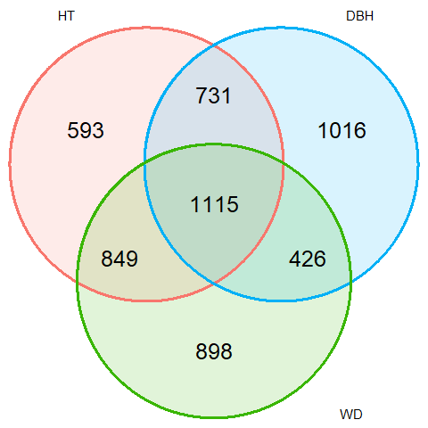

Fig. S2 Correlations between tree height (HT), diameter (DBH), and wood density (WD) for 1,101 Interior spruce individuals.

