Supplementary information

FISH mapping in Xenopus pygmaeus refines understanding of genomic rearrangements and reveals jumping NORs in African clawed frogs

Bergelová Barbora¹, Gvoždík Václav^{2,3}, Knytl Martin^{1,4*}

¹Department of Cell Biology, Faculty of Science, Charles University, Viničná 7, Prague 128 43, Czech Republic
²Institute of Vertebrate Biology of the Czech Academy of Sciences, Brno, Czech Republic
³National Museum of the Czech Republic, Department of Zoology, Prague, Czech Republic
⁴Department of Biology, McMaster University, 1280 Main Street West, Hamilton, Ontario, L8S 4K1, Canada

*Corresponding author. E-mail: martin.knytl@natur.cuni.cz

Table S1. Minimum (Q₁) and maximum (Q₃) values, and interquartile range (IQR) of l values for each individual chromosome of Xenopus pygmaeus.
Chromosome | Q1 | Q3 | IQR
1L | 3.955738 | 4.463265 | 0.5075276
1S | 3.649400 | 3.842003 | 0.1926032
2L | 3.390865 | 3.571240 | 0.1803745
2S | 2.924742 | 3.264351 | 0.3396088
3L | 2.833916 | 3.115425 | 0.2815092
3S | 2.553159 | 2.883527 | 0.3303675
4L | 2.736651 | 2.875490 | 0.1388392
4S | 2.299303 | 2.520150 | 0.2208472
5L | 2.794647 | 3.132713 | 0.3380656
5S | 2.690328 | 2.903655 | 0.2133265
6L | 2.891630 | 3.114590 | 0.2229600
6S | 2.546554 | 2.801107 | 0.2545521
7L | 2.349426 | 2.532770 | 0.1833438
7S | 1.865308 | 1.990232 | 0.1249241
8L | 2.409116 | 2.580302 | 0.1711858
8S | 1.640418 | 1.818812 | 0.1783939
9_10L | 2.245852 | 2.573759 | 0.3279078
9_10S | 2.096166 | 2.235920 | 0.1397536

Table S2. Minimum (Q₁) and maximum (Q₃) values, and IQR of i values for each individual chromosome of X. pygmaeus.
Chromosome | Q1 | Q3 | IQR
1L | 40.82840 | 42.47758 | 1.649179
1S | 38.77390 | 41.12829 | 2.354390
2L | 36.23433 | 38.89834 | 2.664012
2S | 32.76803 | 37.51315 | 4.745116
3L | 18.49333 | 24.81203 | 6.318697
3S | 18.73691 | 23.75911 | 5.022201
4L | 20.00000 | 28.88610 | 8.886097
4S | 18.34563 | 23.38334 | 5.037712
5L | 36.99605 | 42.43417 | 5.438123
5S | 35.17231 | 41.46136 | 6.289053
6L | 46.14982 | 49.49495 | 3.345127
6S | 40.38147 | 44.08976 | 3.708286
7L | 41.07051 | 43.66062 | 2.590116
7S | 41.83428 | 44.75138 | 2.917097
8L | 20.20423 | 22.48062 | 2.276386
8S | 41.48809 | 48.18653 | 6.698435
9_10L | 19.84471 | 22.91469 | 3.069977
9_10S | 20.19870 | 25.77606 | 5.577352

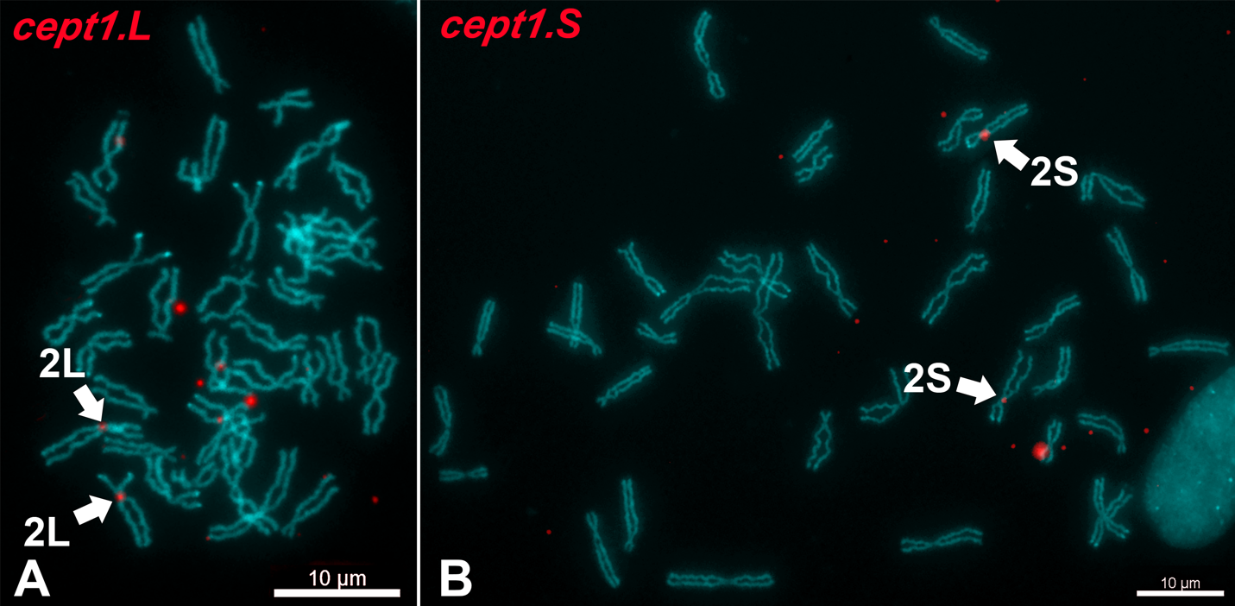
Fig S1. FISH-TSA with positive red signals on the X. pygmaeus metaphase spreads. (A) The cept1.L and (B) cept1.S genes were localized on the short (p) arm of X. pygmaeus chromosome 2L (XPY 2L) and long (q) arm of XPY 2S, respectively. Chromosomes were counterstained with DAPI (blue-green). Scale bars represent 10 µm.

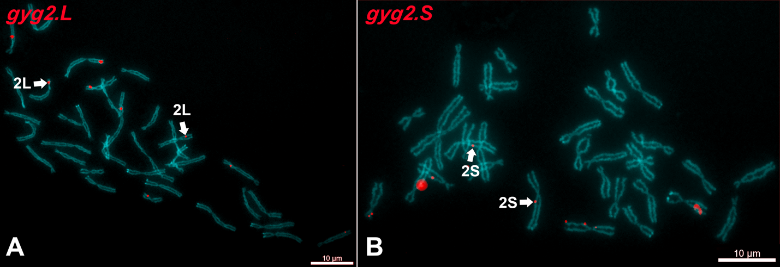
Fig S2. FISH-TSA with positive red signals on the X. pygmaeus metaphase spreads. (A) The gyg2.L and (B) gyg2.S genes were localized on the p arm of XPY 2L and q arm of XPY 2S, respectively. Chromosomes were counterstained with DAPI (blue-green). Scale bars represent 10 µm.

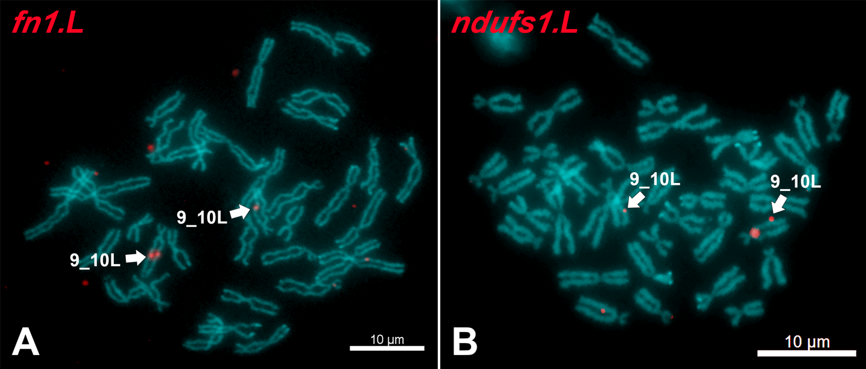
Fig S3. FISH-TSA with positive red signals on the X. pygmaeus metaphase spreads. (A) The fn1.L and (B) ndufs1.L genes were localized on the q arm of XPY 9_10L. Chromosomes were counterstained with DAPI (blue-green). Scale bars represent 10 µm.

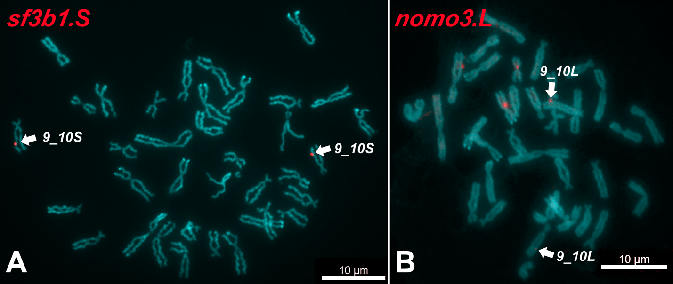
Fig S4. FISH-TSA with positive red signals on the X. pygmaeus metaphase spreads. (A) The sf3b1.S and (B) nomo3.L genes were localized on the q arm of XPY 9_10S and 9_10L, respectively. Chromosomes were counterstained with DAPI (blue-green). Scale bars represent 10 µm.

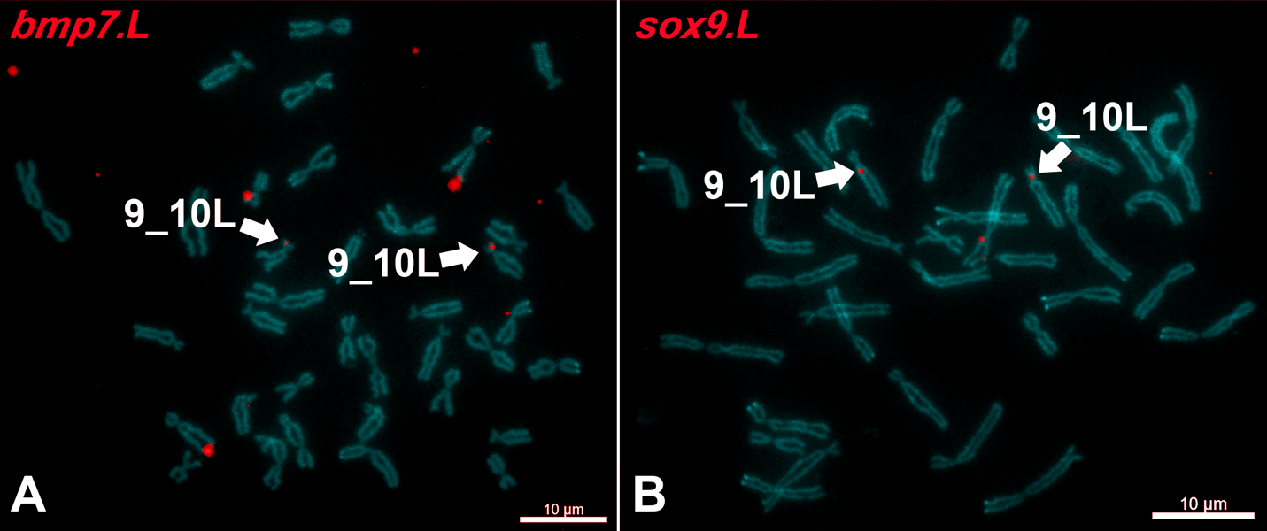
Fig S5. FISH-TSA with positive red signals on the X. pygmaeus metaphase spreads. (A) The bmp7.L and (B) sox9.L genes were localized on the p arm of XPY 9_10L. Chromosomes were counterstained with DAPI (blue-green). Scale bars represent 10 µm.

