Balancing selection maintains intraspecific diversity in a deep-sea fish
A. Rus Hoelzel, John Carlos Garza, Anthony Clemento, Georgios A. Gkafas, Natasha Steeds, Michelle Gaither, Harry Peachment, Thomas Regnier and Fiona Gibb

Supplement

Range |  | ROCK1_110 | EGFR1_87 | EEF1D_115 | ATG9_60 | OBSL1_58 | CAC1E_111 | b4galt2_84 | adgrl2_36
750-1250 | χ² | 6.47 | 6.74 | 3.06 | 0 | 4.32 | 0.08 | 0.05 | 0.63
 | p | 0.039 | 0.034 | 0.21 | 1 | 0.11 | 0.96 | 0.97 | 0.72
1700-1900 | χ² | 0.72 | 0.03 | 0.06 | 0 | 0.69 | 1.29 | 0.41 | 2.32
 | p | 0.7 | 0.86 | 0.97 | 1 | 0.71 | 0.52 | 0.81 | 0.31
All | χ² | 29.35 | 24.9 | 11.9 | 3.78 | 27.9 | 0.04 | 0.36 | 0.13
 | p | <0.00001 | <0.00001 | 0.002 | 0.15 | <0.00001 | 0.98 | 0.83 | 0.93
Table S1: Tests for compliance with the Hardy Weinberg Equilibrium at different depth ranges. Test results shown in bold are significant past the Bonferroni correction.

Table S2: Putative gene functions (from UniProt and Gene Card). Loci in italics are controls.
Locus | Functions
ROCK1 | Involved in regulation of smooth muscle contraction, actin cytoskeleton organization, stress fiber and focal adhesion formation, neurite retraction, cell adhesion and motility via phosphorylation. Also thought to be involved in fish migration.
EGFR1 | Transmembrane protein that is a receptor for members of the epidermal growth factor family (EGF family) of extracellular protein ligands.
EEF1D | Part of the EEF1 protein complex, translation elongation factors involved in development and overexpressed in tumors.
ATG9 | Cycles between the preautophagosomal structure/phagophore assembly site (PAS) and the cytoplasmic vesicle pool and supplies membrane for the growing autophagosome.
OBSL1 | Cytoskeletal adaptor proteins function in linking the internal cytoskeleton of cells to the cell membrane. This gene encodes a cytoskeletal adaptor protein, which is a member of the Unc-89/obscurin family. Also involved in structural regulation of the M-band in muscles.
b4galt2 | membrane-bound glycoproteins that appear to have exclusive specificity for the donor substrate UDP-galactose
adgrl2 | Member of the latrophilin subfamily of G-protein coupled receptors. The proprotein is thought to be further cleaved within a cysteine-rich G-protein-coupled receptor proteolysis site into two chains that are non-covalently bound at the cell membrane.
CAC1E | Involved in a variety of calcium-dependent processes, including muscle contraction, hormone or neurotransmitter release, gene expression, cell motility, cell division and cell death.
Grid1a | Receptor for glutamate that functions as a ligand-gated ion channel in the central nervous system and plays an important role in excitatory synaptic transmission.
LRRTM4 | May play a role in the development and maintenance of the vertebrate nervous system. Exhibits strong synaptogenic activity, restricted to excitatory presynaptic differentiation (By similarity).
PKMYT1 | Acts as a negative regulator of entry into mitosis (G2 to M transition) by phosphorylation of the CDK1 kinase specifically when CDK1 is complexed to cyclins.

Table S2: Sampling for genotyping analysis (for 1000m, parenthetical range combines 750m and 1000m).
Sampling Depth (m) | Number | Age Range | Mean Age & s.d.
750 | 6 | 2.8 – 17 | 9.6 ± 5.36
1000 | 50 | 8 – 25.6 | 16.35 ± 4.35 (15.63 ± 4.89)
1250 | 41 | 1 – 29.4 | 14.52 ± 8.53
1500 | 37 | 9.4 – 27.2 | 18.2 ± 4.47
1600 | 50 | 5.2 – 28 | 17.49 ± 6.45
1700 | 38 | 9.2 – 25.2 | 17.07 ± 4.18
1800 | 37 | 8 – 27.6 | 19.11 ±4.99
1900 | 31 | 7.4 – 29.2 | 18.73 ± 5.19

Figure S1: Proportion of genotypes homozygous for the ‘depth’ allele in relation to habitat depth.

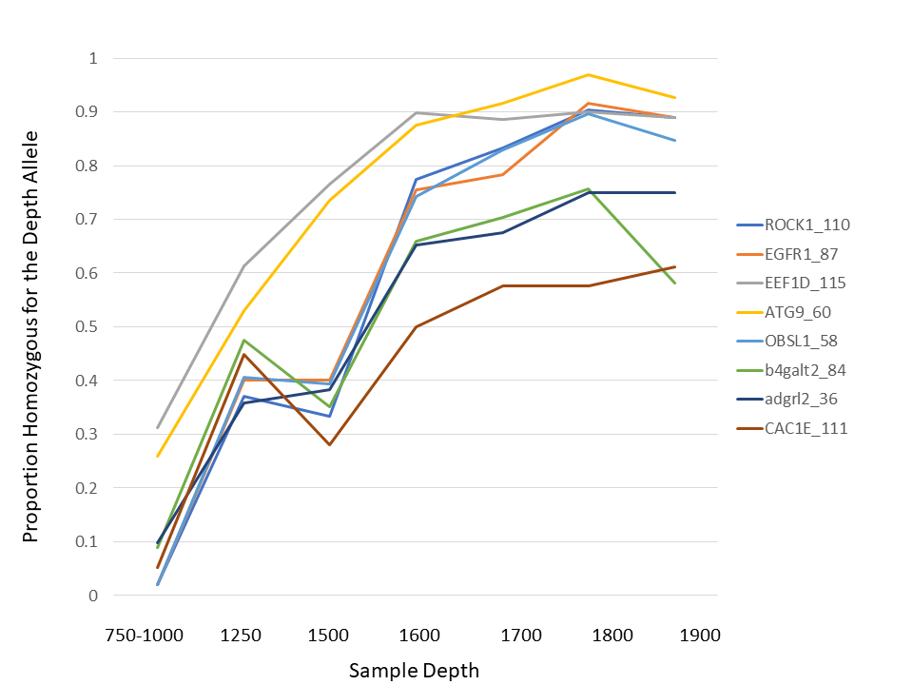
Figure S2: Relationship between sample depth and average age estimate.

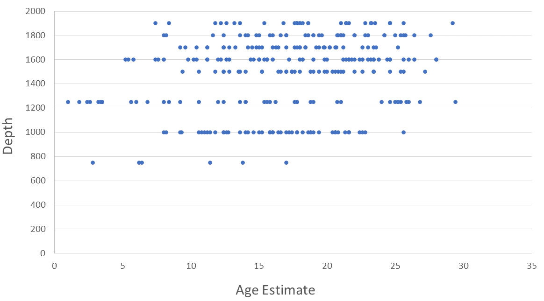

Figure S3: Regression between Pre-anal fin length (PFAL) and the first age estimate from otoliths.

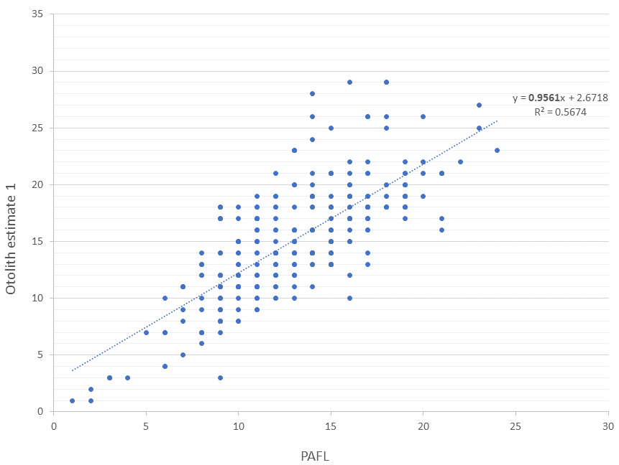
Figure S4: Regression between Pre-anal fin length (PFAL) and the two further age estimates from otoliths.

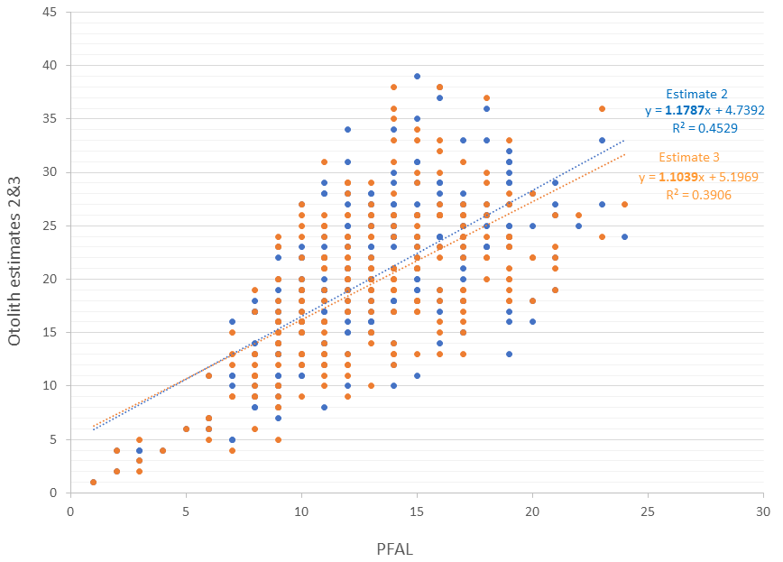
Figure S5: Correction factor between otolith weight (mg) and otolith ‘class’ used as the age metric.

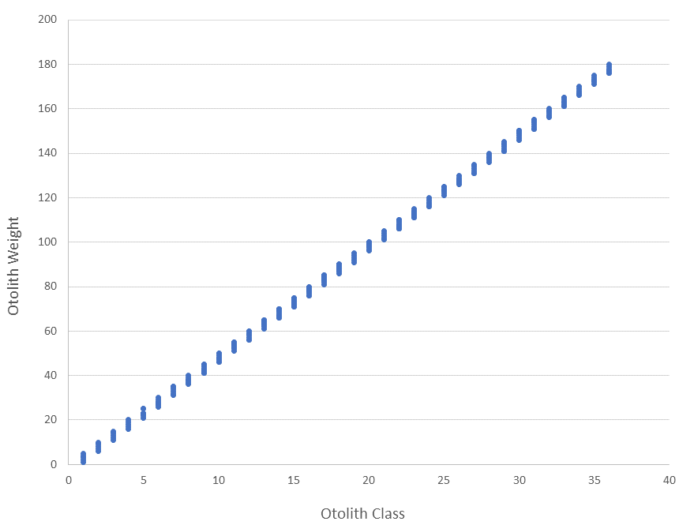
Figure S6: Relationship between the average and each composite age estimate.

