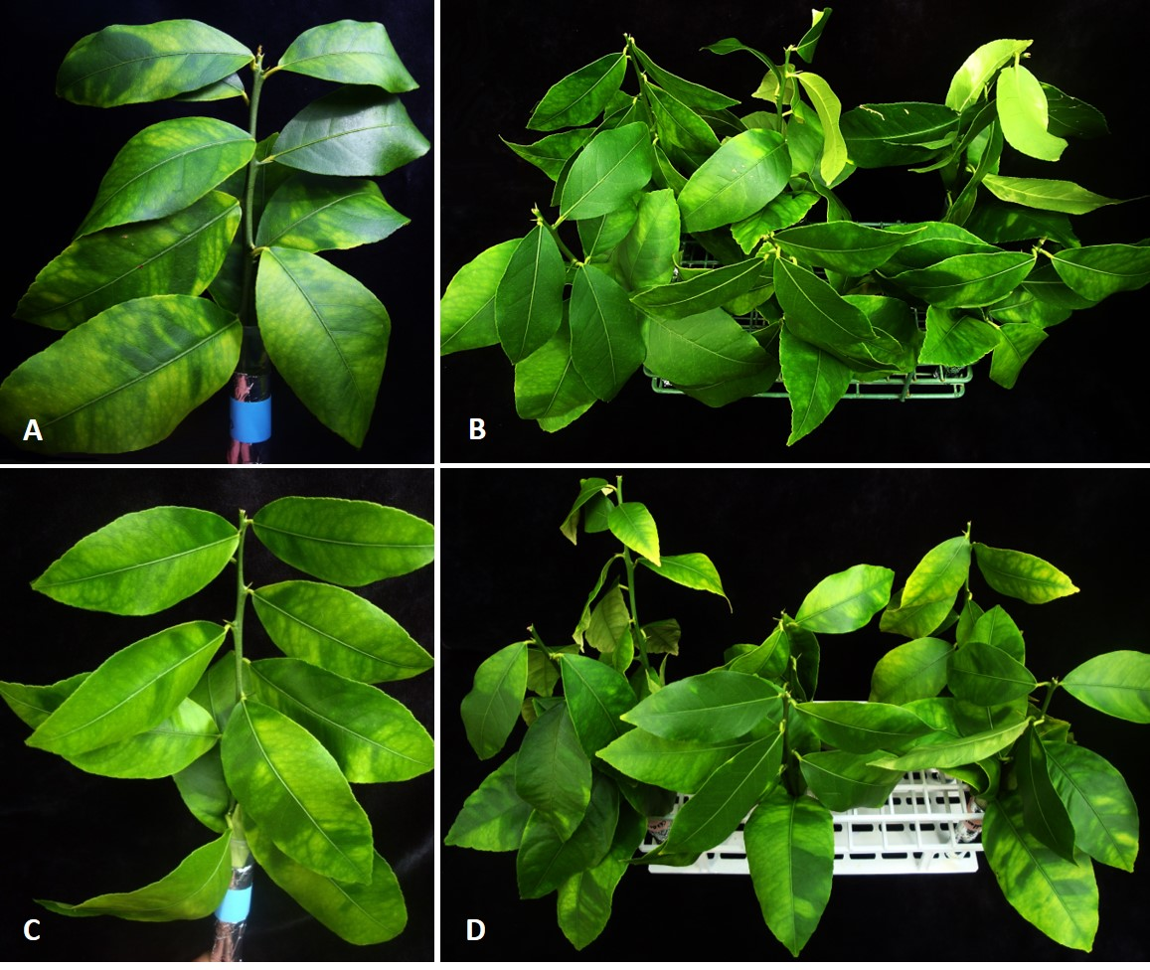
Fig.S1. Lemon (Citrus limon) branches with typical blotchy mottle symptom used in this study for tetracycline treatment. A and C show the individual branches dipped into tubes contain tetracycline covered with aluminum foil paper. B and D show lemon branches treated by different concentrations of tetracycline.

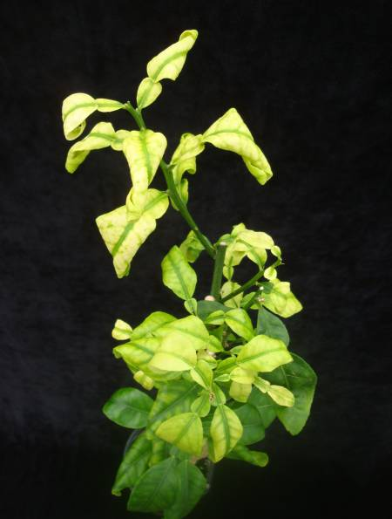
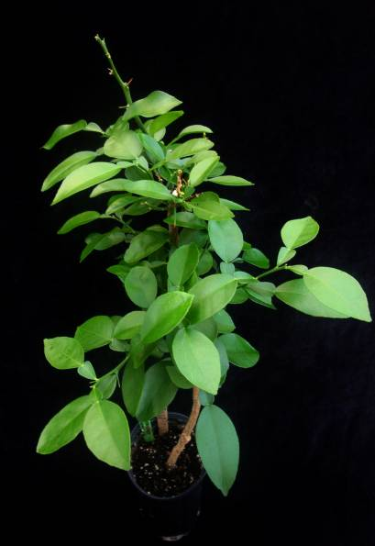
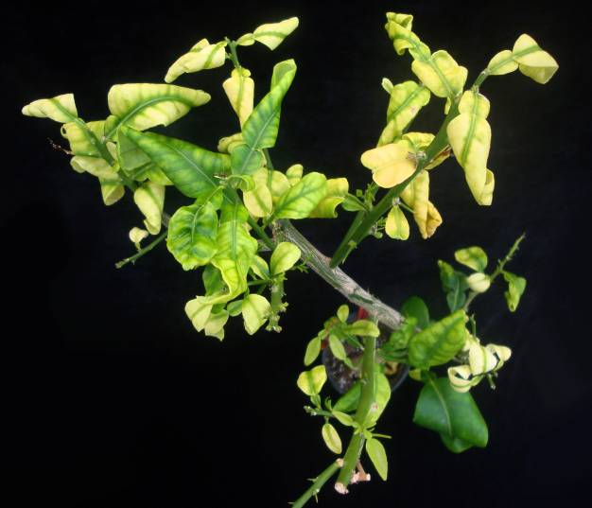
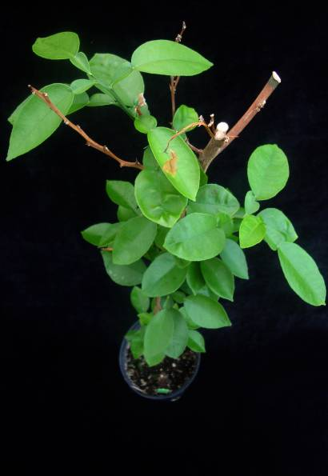
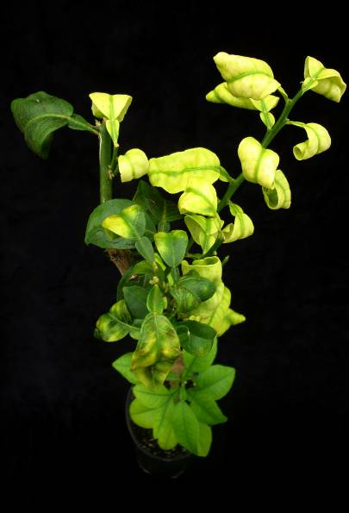
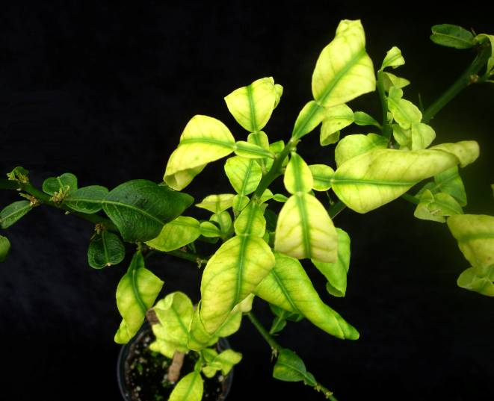
A1
A2
B1
B2
C1
C2

Figure S2. HLB-affected grapefruit (Citrus paradisi) samples before and after heat treatment. A, Heat treatment at 42°C for 10d (A1: before; A2: 3M after); B, Heat treatment at 45°C for 3d (B1: before; B2: 3M after). C, No heat treatment control (C1: before; C2: 3M after).

S3A. 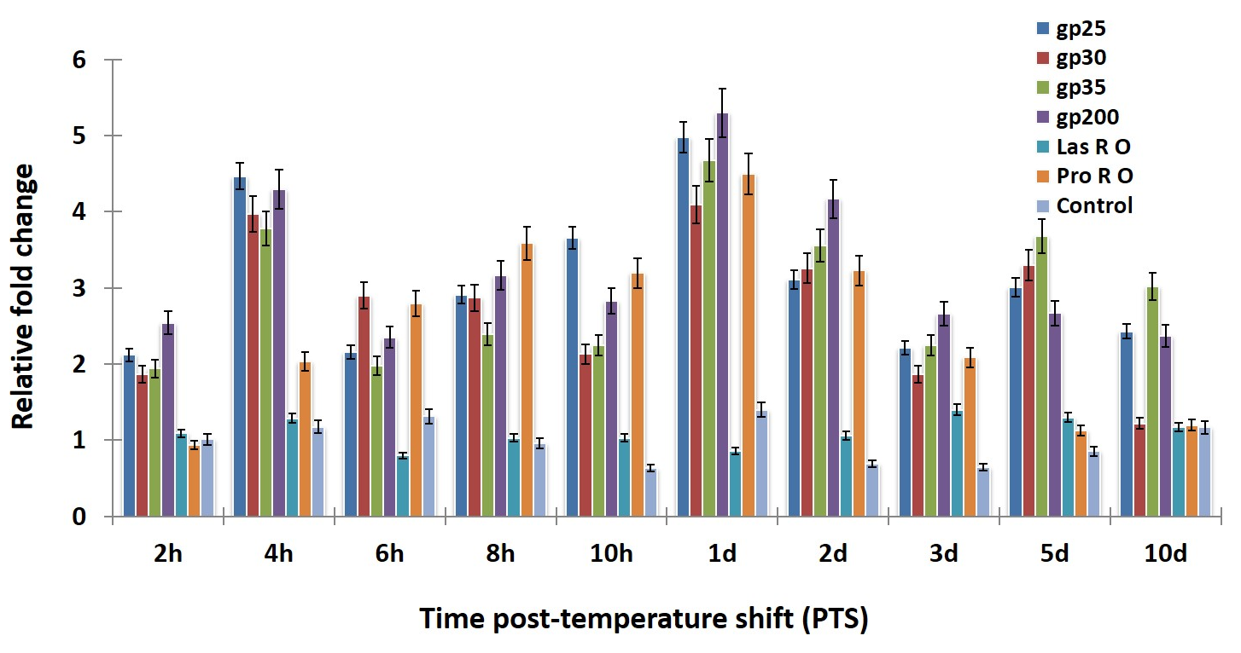
S3B.
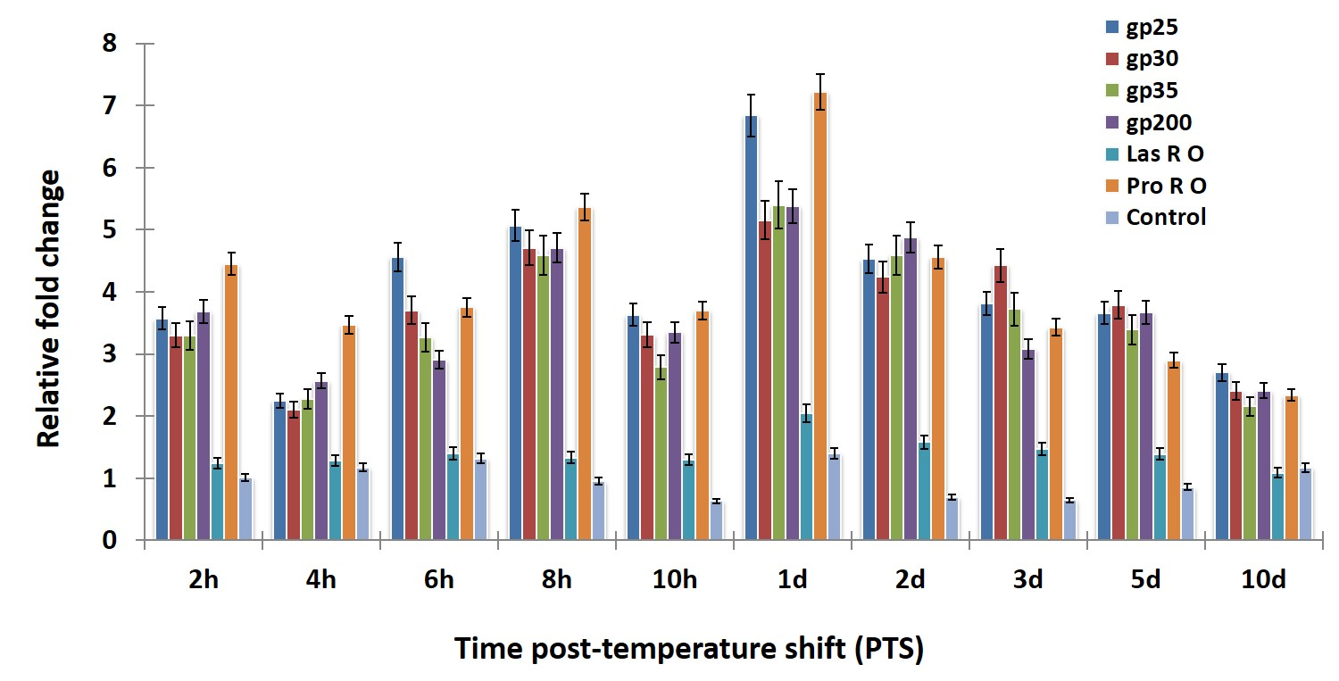
S3C.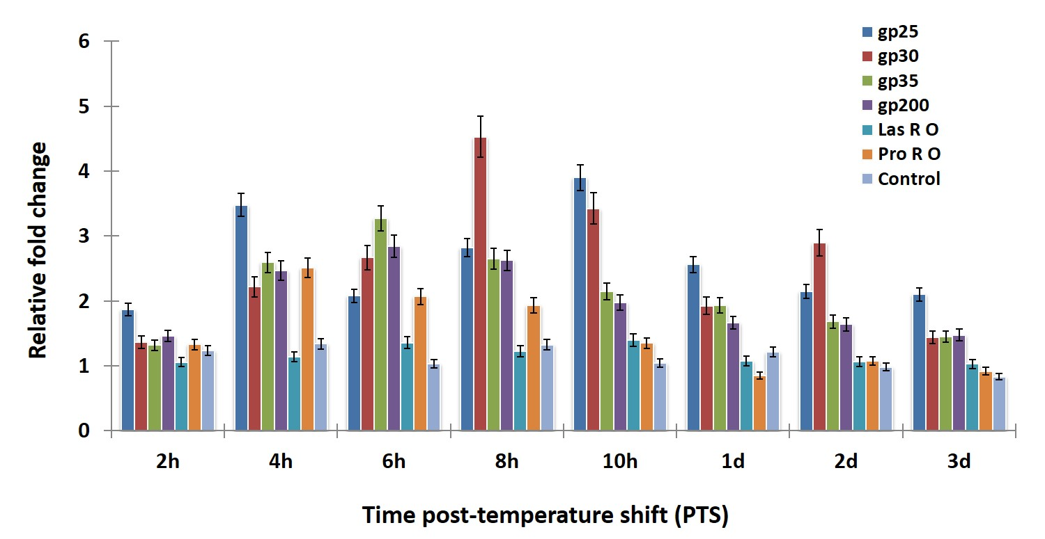
Figure S3. Relative copy number of phage structural and putative functional genes following different stress heat treatment. Relative abundance of FP1 and FP2 phage structural genes (gp-25 and gp-30), endolysin gene (gp-35), putative antirepressor gene (gp-200), Las origin of replication (Las R O), and prophage origin of replication (Pro R O) were quantified in the same manner after heat treatment at A, 37°C, B, 42°C, and C, 45°C. Control bars represent the average fold-change of all genes for untreated trees at 23°. Data is presented as mean ± S.E.M. (n=3).

S4A.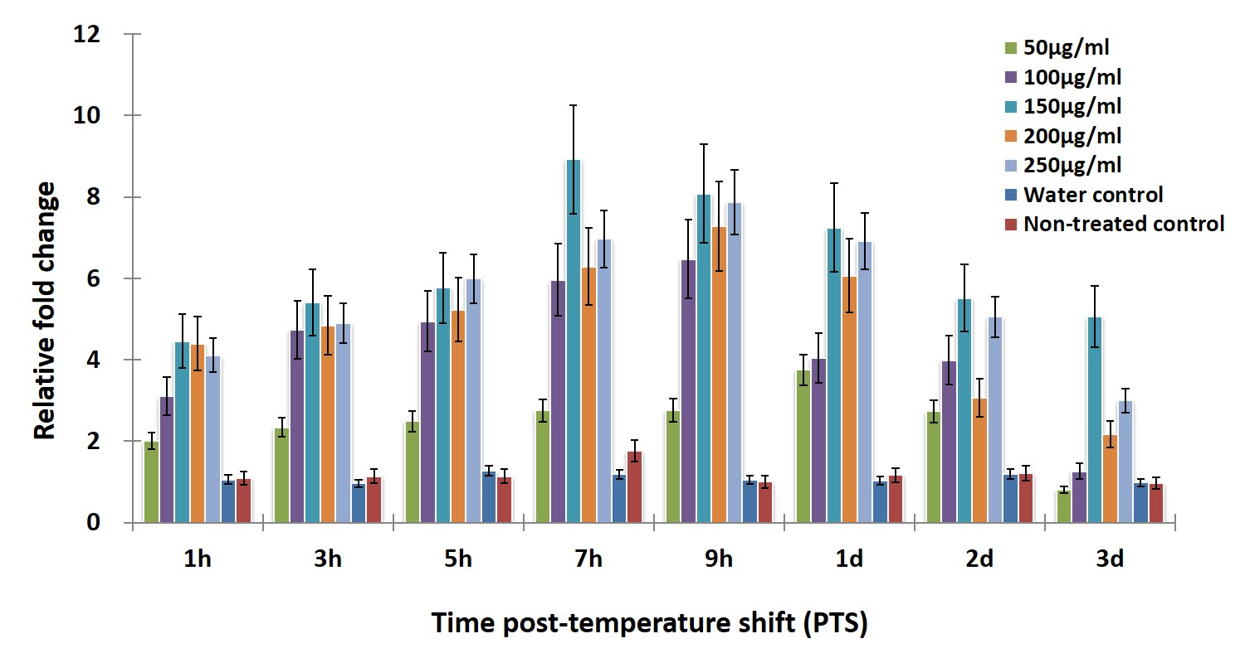
S4B.
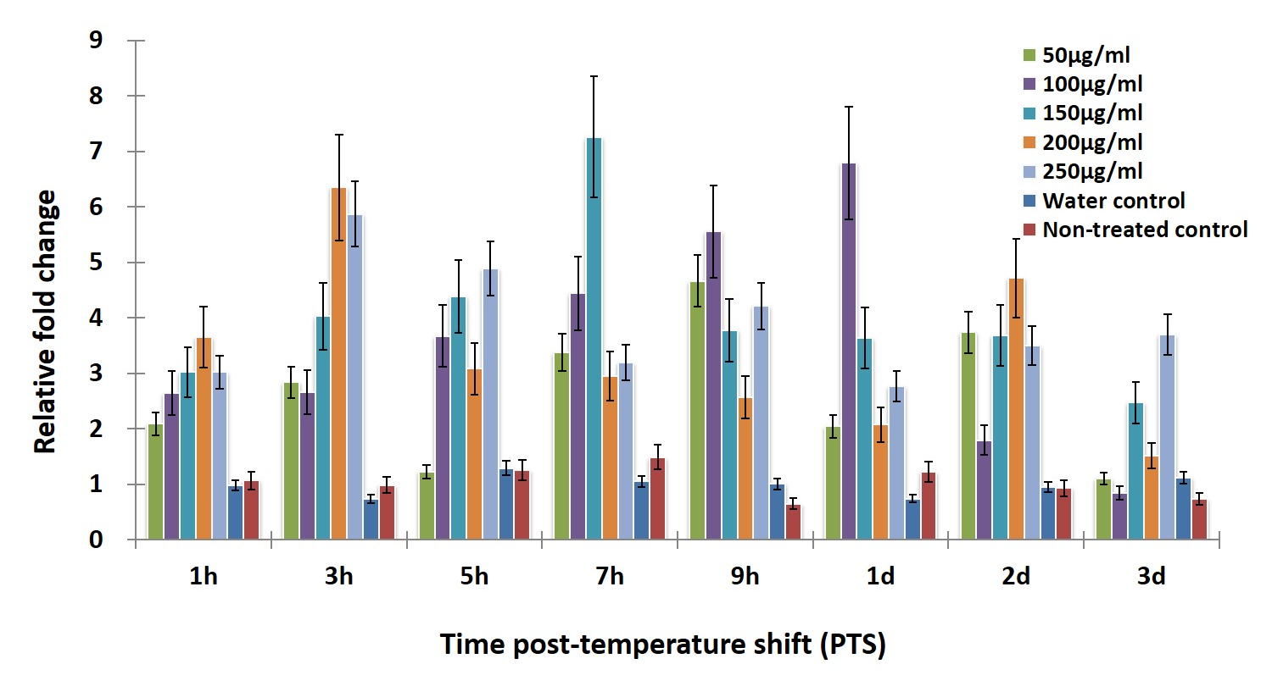
S4C.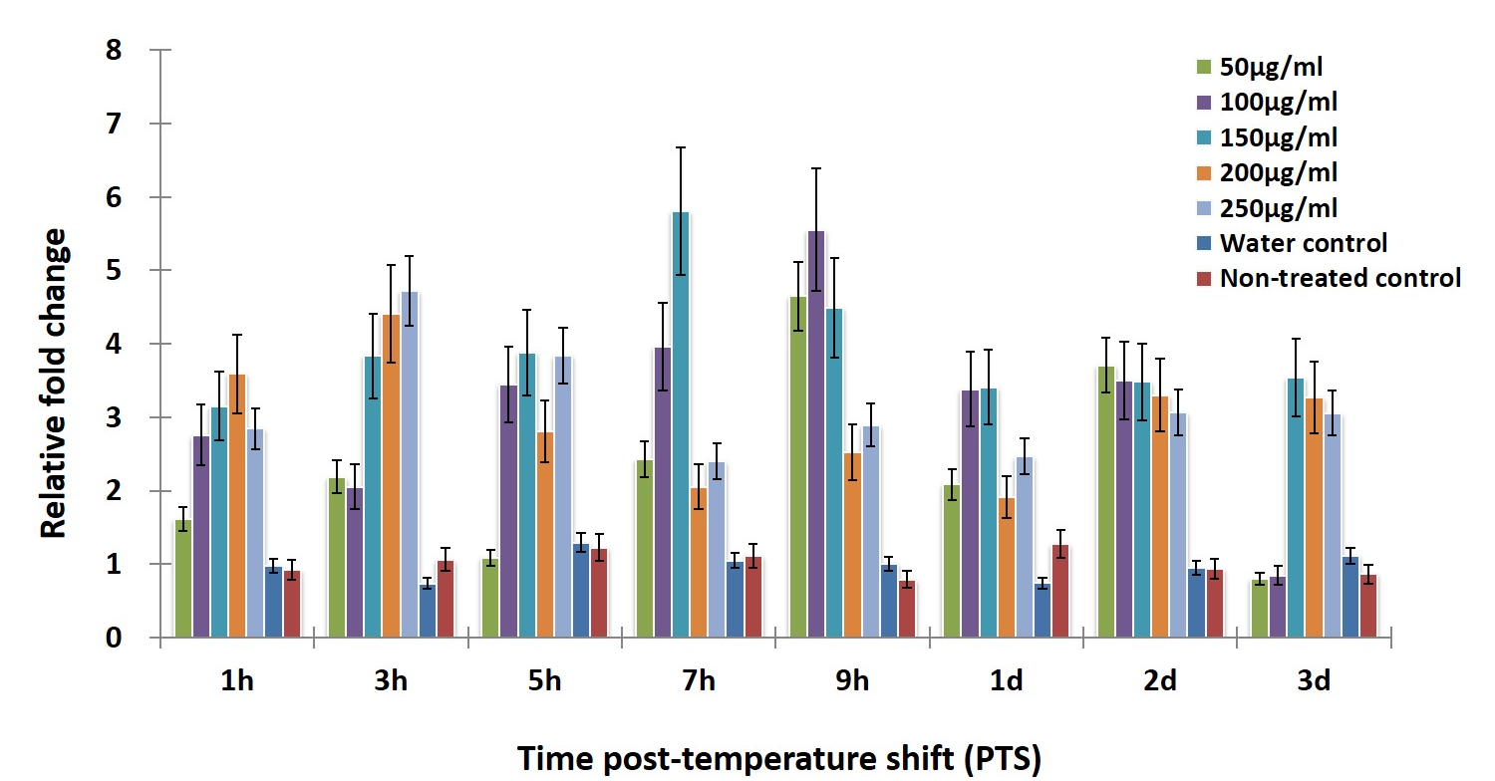
S4D.
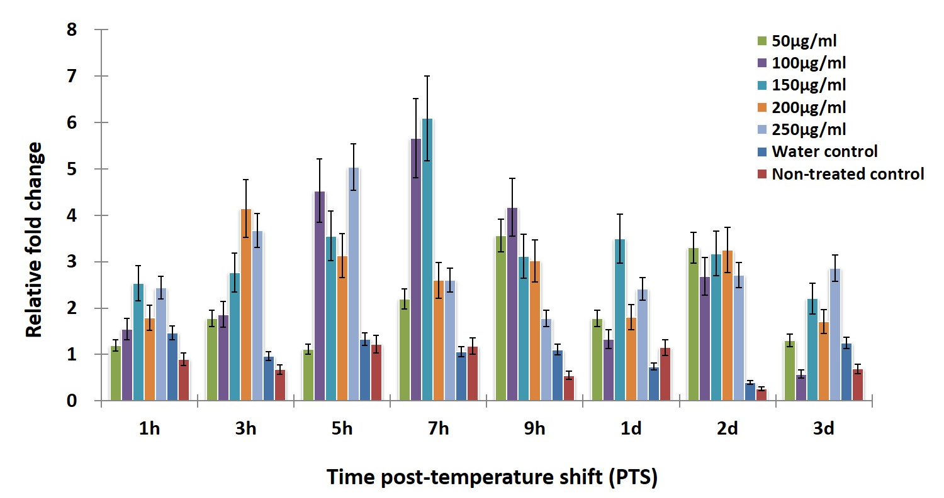
S4E.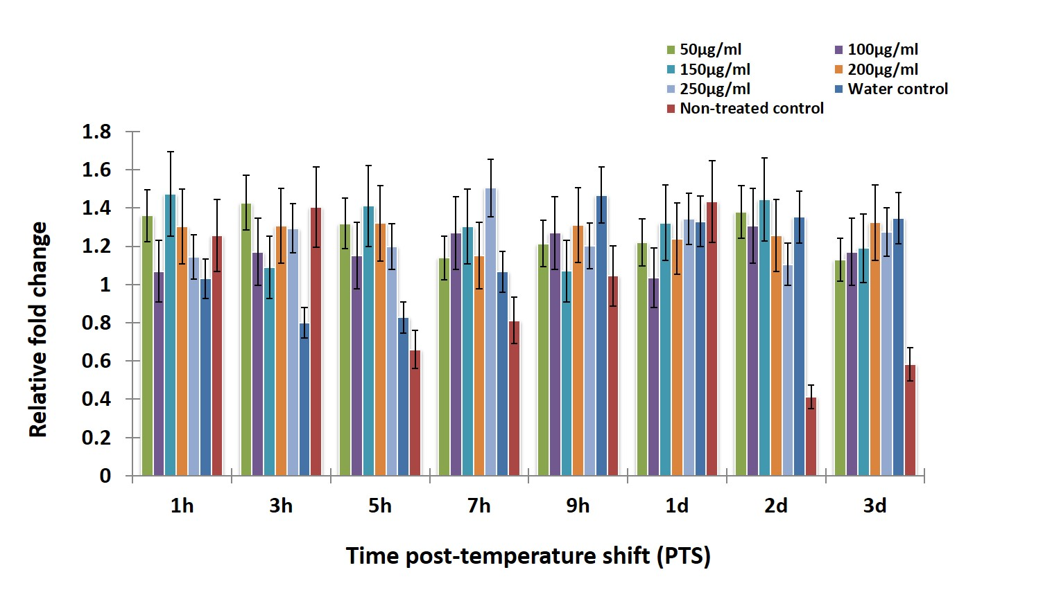
S4F.
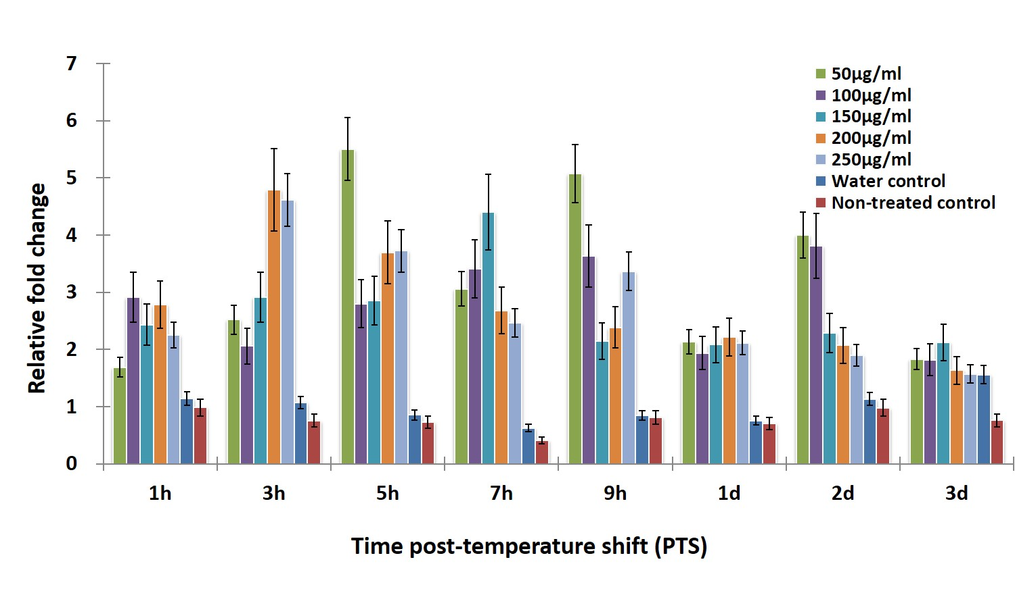
Figure S4. Relative copy number of phage structural and putative functional genes following tetracycline treatment. Total DNA was isolated from plant tissues and subjected to real time PCR analysis. The relative abundance of phage-specific or Las-specific genes was quantified and normalized to Las 16S ribosomal DNA after tetracycline treatment with 50, 100, 150, 200, or 250 µg/mL concentrations. A, FP1 and FP2 structural gene gp-25; B, FP1 and FP2 structural gene gp-30; C, putative endolysin gene gp-35; D, putative antirepressor gene gp-200; E, Las origin of replication; F, phage origin of replication. Data is presented as mean ± S.E.M. (n=3).

D
C

