Supporting Information

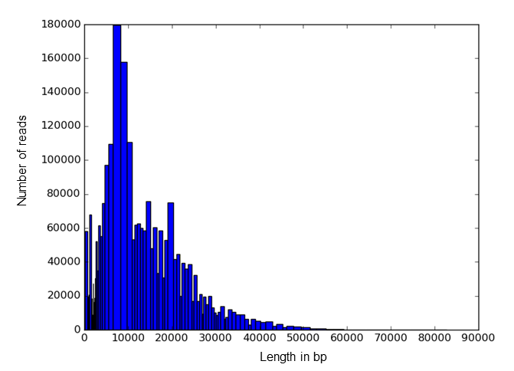
Fig. S1. Pacific Biosciences WGS reads. Numbers of reads (vertical axis) of indicated lengths produced by sequencing 58 SMRT cells of hybrid MS1-56 (horizontal axis).

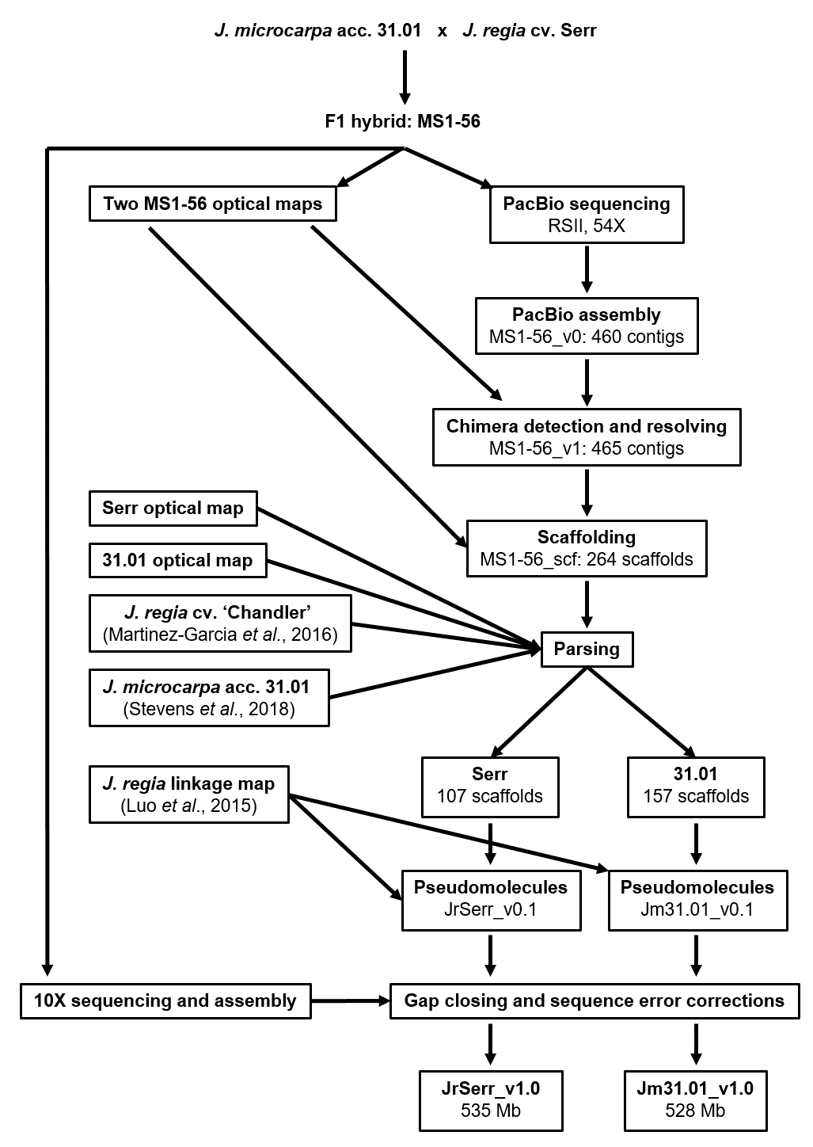
Fig. S2. Sequence assembly flowchart. MS1-56 hybrid sequence assembly, scaffolding, scaffold allocation to parental genomes, pseudomolecule construction, and gap closing.

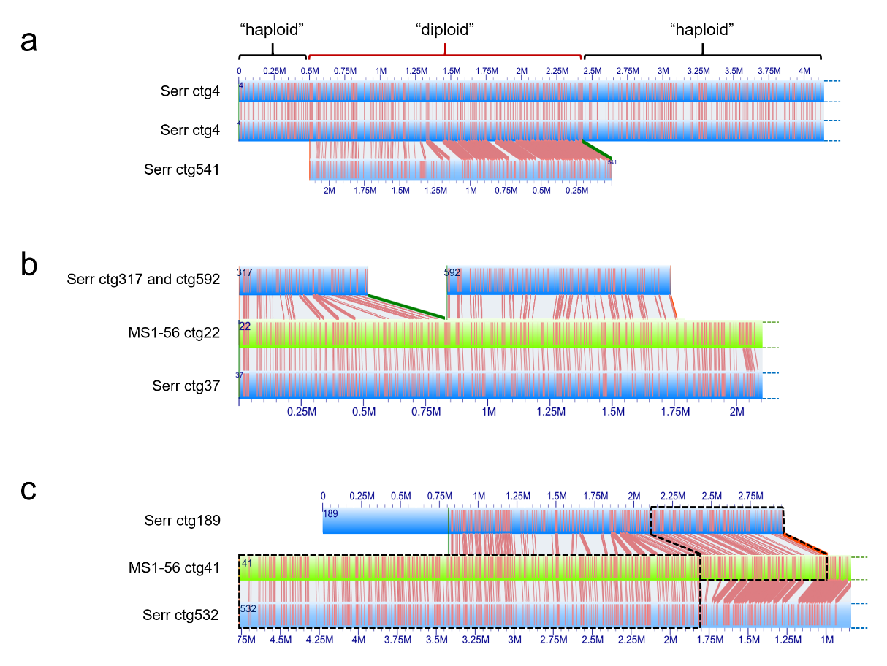
Fig. S3. Optical map self-alignments and haplotype phasing (a) Phased contigs in self-aligned Serr optical map showing two “haploid” regions in contig ctg4, in which the two Serr haplotypes were collapsed, and a “diploid” region, in which the Serr haplotypes were phased into separated contigs (ctg4 and ctg541) during optical map assembly. (b,c) Alignments of phased Serr haplotypes (blue) on the optical map of the MS1-56 hybrid (green) and identification of haplotypes that were transmitted from Serr to MS1-56 for editing of the Serr optical map. In b, Serr haplotype in contig ctg37 was transmitted to contig MS1-56 ctg22. Redundant homologous haplotypes in contigs Serr ctg317 and 592 were disregarded during editing of the Serr optical map. In c, a Serr recombined haplotype of contigs ctg532 and ctg189 was transmitted to contig MS1-56 ctg41. Redundant portions of Serr haplotypes in contigs ctg189 and ctg532 were disregarded during editing of the Serr optical map, as shown.

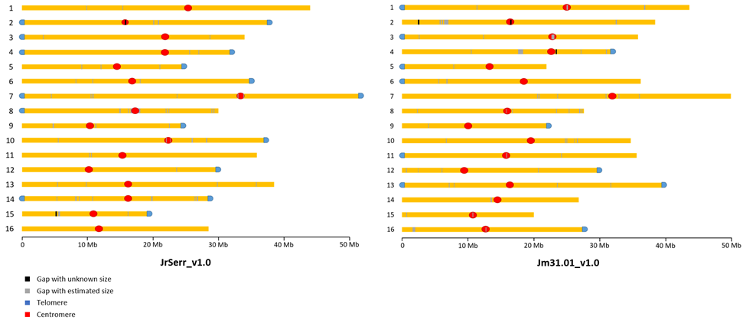
Fig. S4. Ideograms of Juglans regia Serr (JrSerr_v1.0) and J. microcarpa 31.01 (Jm31.01_v1.0) pseudomolecules. The gray bars indicate the locations of gaps of lengths estimated with the aid of the optical map and the black bars indicate the locations of gaps of unknown lengths. The locations of centromeres and sequenced telomeres are indicated.

Fig. S5. Circular plots of the J. microcarpa pseudomolecules. Circles from outside to inside are: pseudomolecule coordinates in Mb, density of all types of LTR-RTs, density of Gypsy LTR-RTs, density of Copia LTR-RTs, and gene density. Central lines connect syntenic blocks across chromosomes. Different colors represent different homoeologous chromosome pairs derived from the Juglandoid WGD.

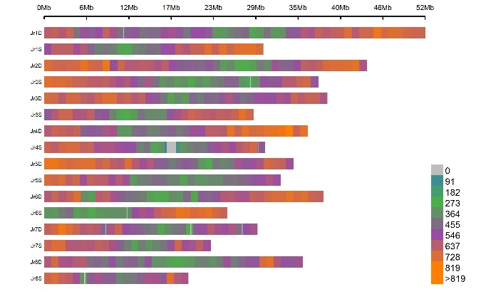
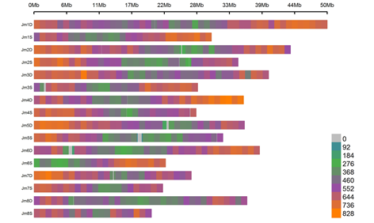
Fig. S6. SSR density along Juglans regia and J. microcarpa chromosomes. Heat maps show the numbers of SSRs per 1Mb nonoverlapping window along the JrSerr_v1.0 pseudomolecules (left panel) and along the Jm3101_v1.0 pseudomolecules (right panel). The starting nucleotides of the pseudomolecules are to the left.
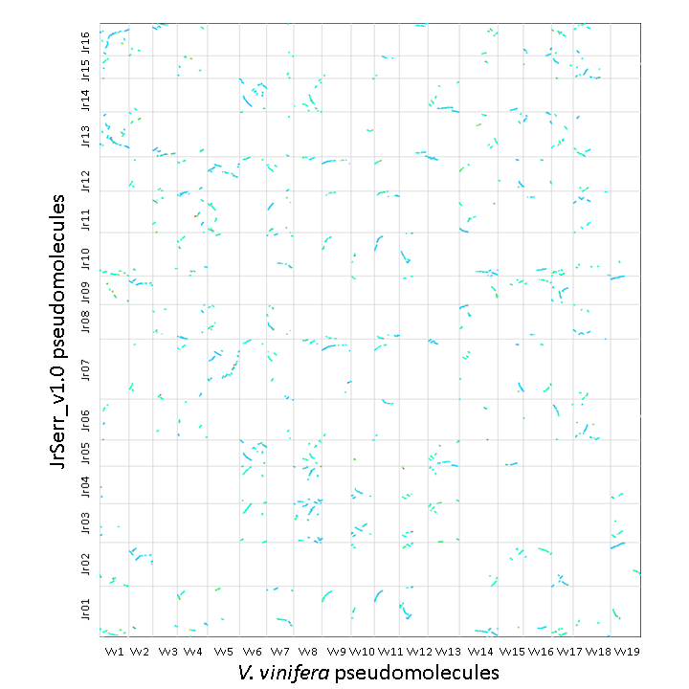
Fig. S7. Synteny of Juglans regia (JrSerr_v1.0) pseudomolecules with those of grape (Vitis vinifera). The starting nucleotides of the J. regia and V. vinifera pseudomolecules are to the left (grape) and bottom (J. regia). In many cases, a single synteny block in V. vinifera is homoeologous to two synteny blocks in J. regia due to the Juglandoid WGD. Some J. regia regions are homoeologous to two or three synteny blocks in V. vinifera due to the γWGT.

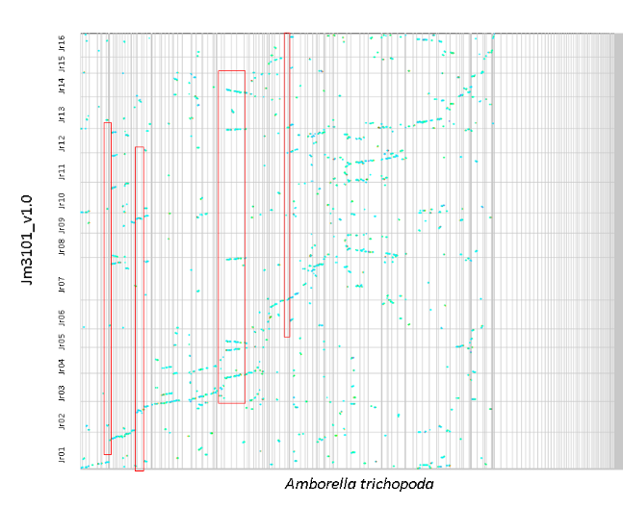
Fig. S8. Synteny between Juglans regia (JrSerr_v1.0) pseudomolecules and Amborella trichopoda scaffolds. Starting nucleotides of J. regia pseudomolecules are at the bottom. Some single A. trichopoda scaffolds (horizontal axis) are homoeologous to six synteny blocks in J. regia Serr (boxed in red). However, no J. regia pseudomolecule appears to be homoeologous to more than one A. trichopoda scaffold. This pattern is due to the γWGT and the Juglandoid WGD, which both occurred after the divergence of the J. regia and Amborella lineages.
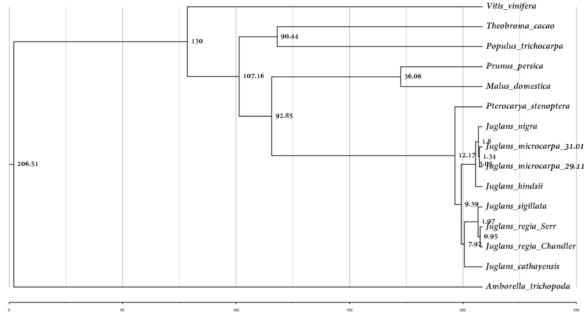
Fig. S9. Chronogram of 15 genomes of woody perennials. The phylogenetic tree was constructed from alignment of 809 orthologous, single-copy genes shared by the 15 genomes. Genome divergence times were estimated using MEGA X¹ using a grape-poplar divergence time set at 110 MYA-130 MYA, which is similar to our grape-Juglans divergence time estimated in Table S13. Scale is in MY.

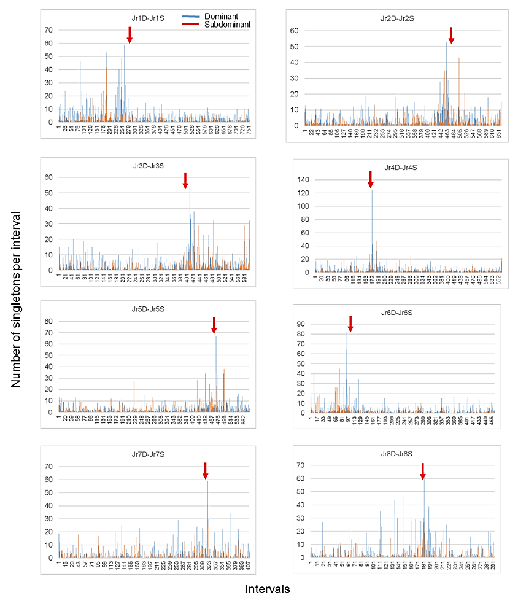

Fig. S10. Asymmetric gene fractionation of the Juglandoid WGD. Each pair of homoeologous pseudomolecules in the JrSerr_v1.0 genome sequence was subdivided into intervals delimited by successive pairs of paralogous genes in collinear locations on the homoeologues. The noncollinear genes (singletons) were counted in each interval (histogram bars) in the dominant pseudomolecule and homoeologous subdominant pseudomolecule. The starting nucleotides of the pseudomolecules are to the left. Arrows indicate the locations of the centromeres in the dominant pseudomolecules.

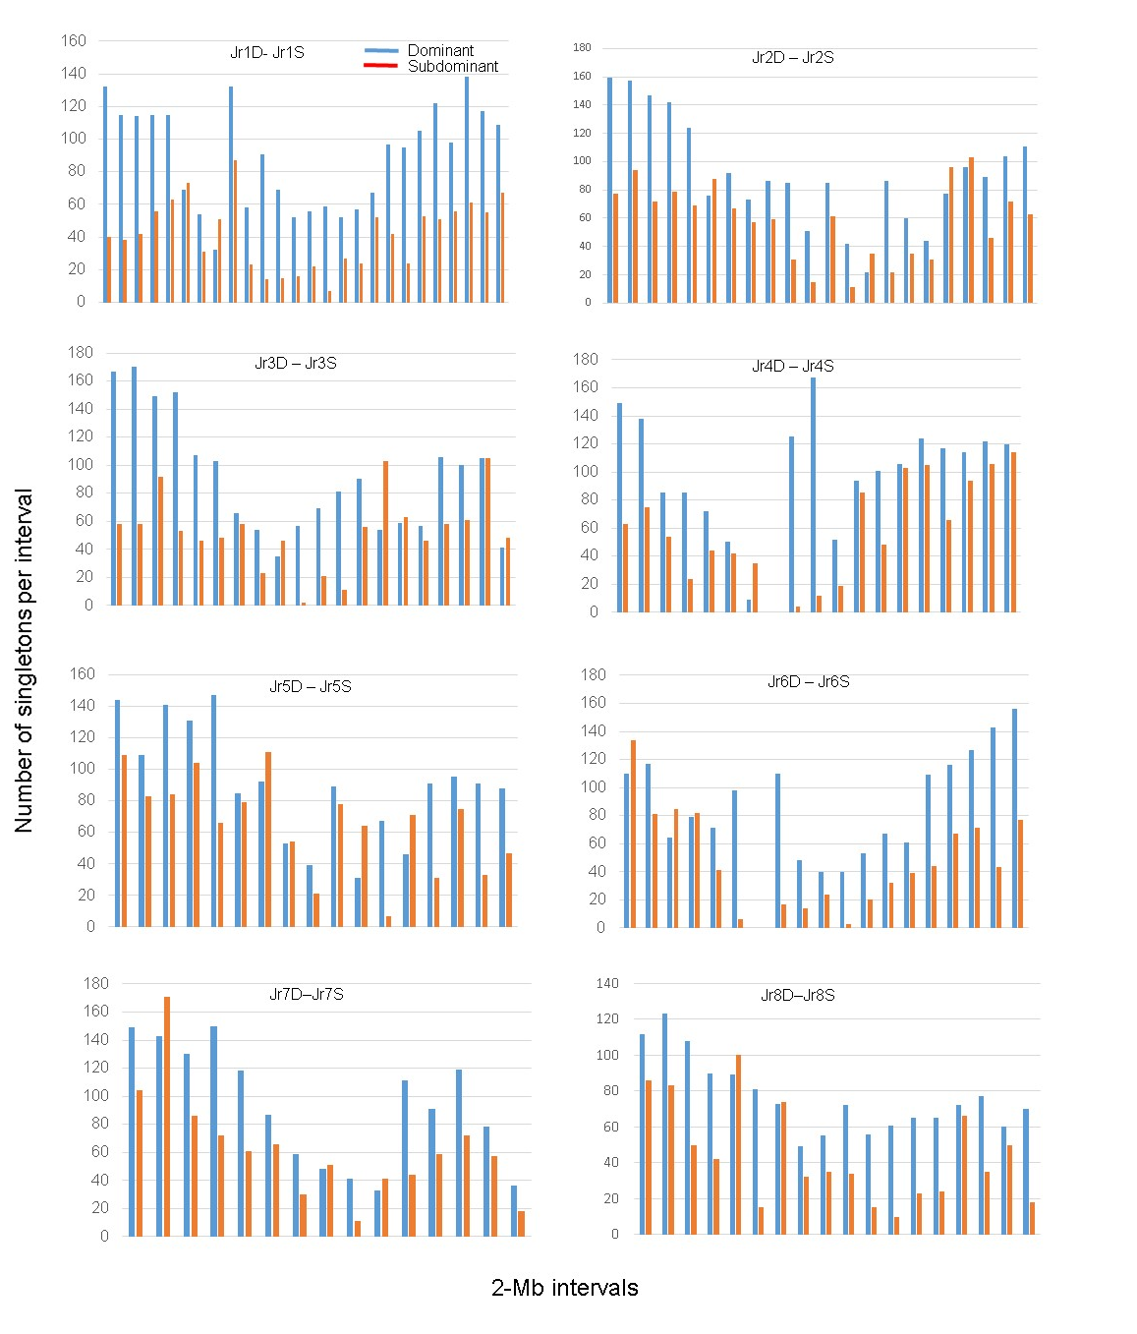
Fig. S11. Gene loss from Juglans regia dominant and subdominant homoeologous pseudomolecules. Each bar represents the number of singleton genes per 2-Mb non-overlapping window (the last window may be less than 2 Mb). Blue bars are the dominant chromosomes and the red bars are subdominant chromosomes. The starts of the pseudomolecules are to the left in each histogram.

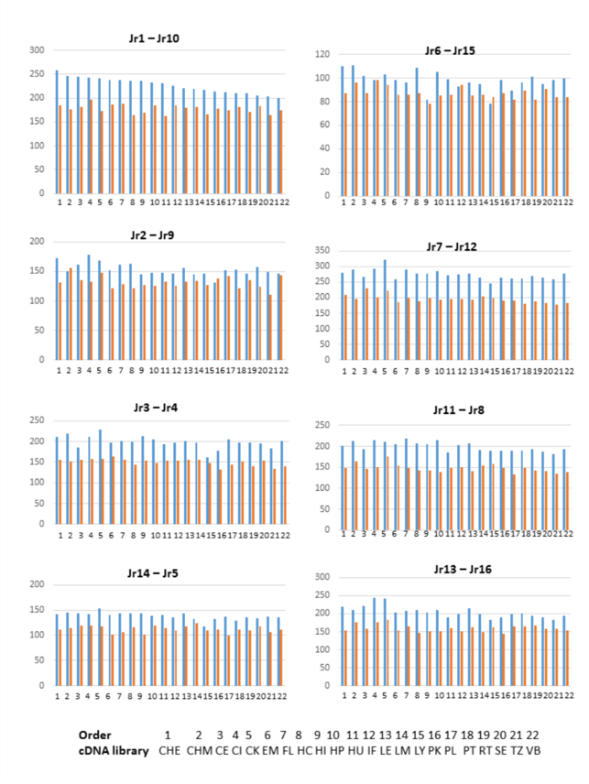
Fig. S12. Numbers of genes on dominant (blue) and subdominant (red) homoeologous chromosomes with a dominant expression in 22 different J. regia RNAseq datasets. We define dominant expression as two-fold difference in expression. The description of the RNAseq datasets (coded at the bottom of graphs) is in Table S20.
Fig. S13. The array of the 18S-5.8S-26S rRNA gene units on Juglans regia chromosome Jr4S. The pseudomolecule (green rectangle) is on top and optical map contig is on the bottom (blue rectangle). The pseudomolecule coordinates of the array are given in Mb above the pseudomolecule. The coordinates below the optical map contig are relevant only to the optical map. The black vertical lines connect corresponding restriction sites in the pseudomolecule and the optical contig. Note the periodicity of the restriction sites along the optical map contig which are present as a gap of estimated length in the pseudomolecule. Only a single 18S-5.8S-26S rRNA unit was present in the pseudomolecule.

Fig. S14. The distribution of genes (red) and transposable elements (blue) along the 16 Juglans regia pseudomolecules. A 1-Mb sliding window was used to compute the gene and TE densities along each pseudomolecule. The gene density declined gradually in the distal to proximal direction, while the TE density increased in the distal to proximal direction.

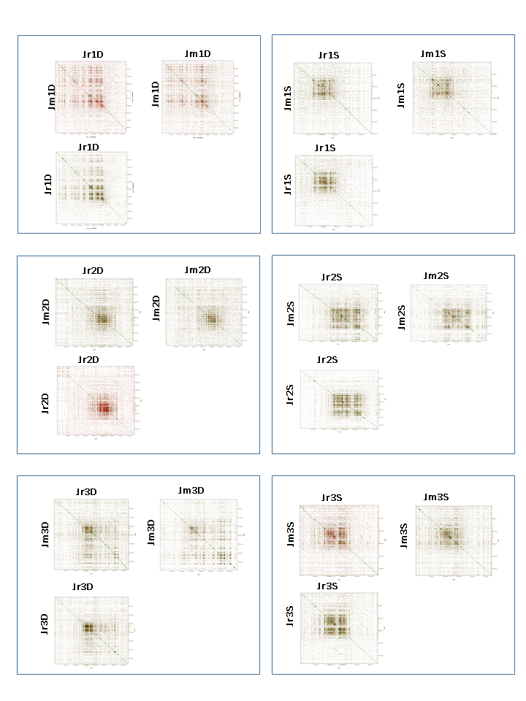
Fig. S15. Dot-plot alignments of the JrSerr_v1.0 and Jm31.01_v1.0 pseudomolecules. Shown are dot-plots of the JrSerr_v1.0 and Jm31.01_v1.0 self-aligned pseudomolecules and JrSerr_v1.0 aligned against Jm31.01_v1.0 pseudomolecules. The alignments show the locations of centromeric regions and provide evidence that the same repeated sequences are located in those regions in the corresponding Juglans regia and J. microcarpa chromosomes.

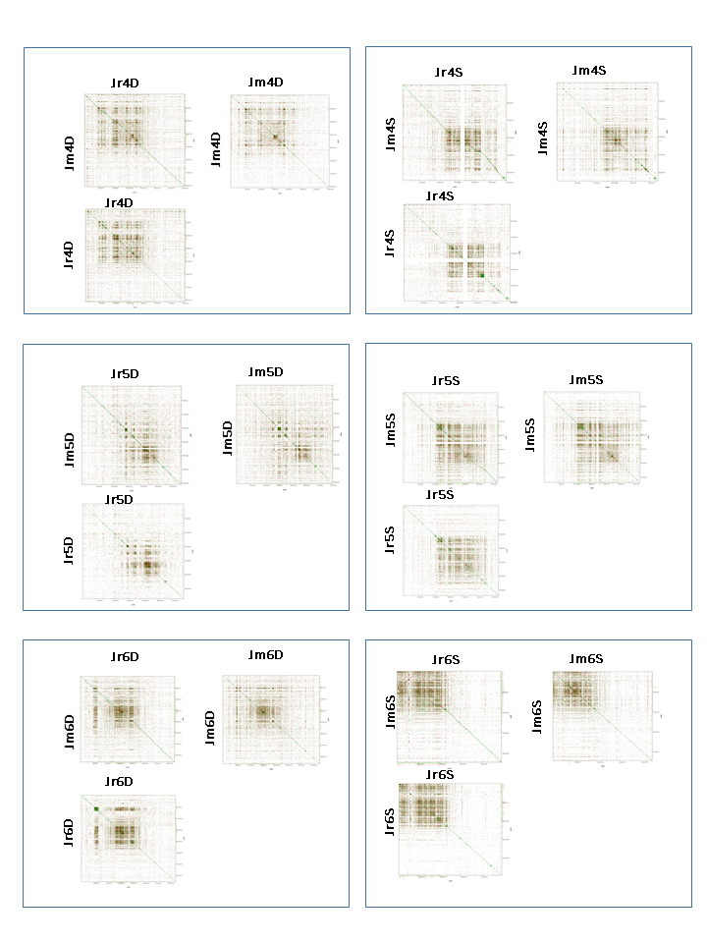
Fig. S15 cont.

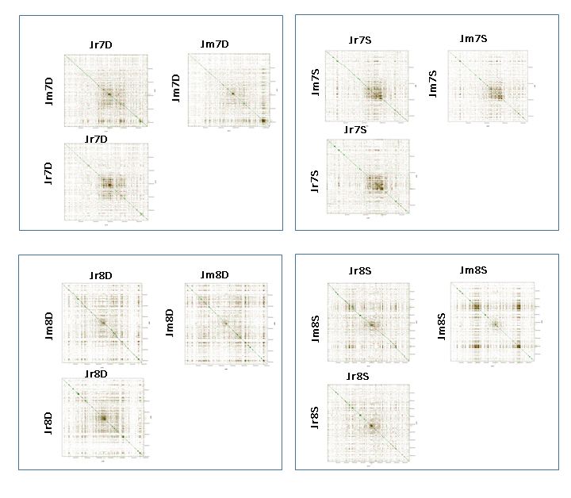
Fig. S15 cont.

Fig. S16. Alignment of centromeric regions on six pairs of homoeologous pseudomolecules in Juglans regia. We employed selected collinear paralogous genes (connected by thin lines) located in the vicinity or within of a 5-Mb interval surrounding the JCR centromeric array on homoeologous pseudomolecules to align the dot-plots of the 5-Mb regions relative to each other. More such genes existed (File S1) but only some were used here. Each dot-plot is a self-alignment of a 5-Mb region surrounding the JCR array. Forward matches are in green and reverse matches are in red in the dot-plots. Inversions (red double-head arrows) relevant to repositioning of a JCR array are indicated. Note that pseudomolecule 3S is inverted relative to 3D and pseudomolecule 4S is inverted relative to 4D.

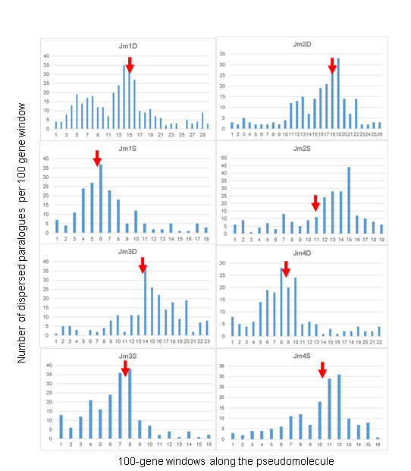
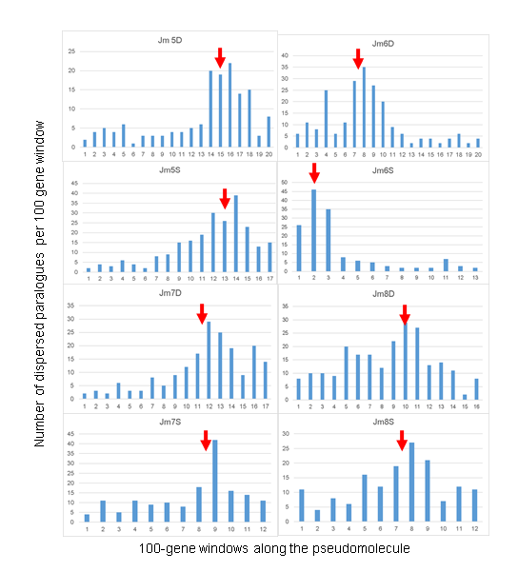
Fig. S17. The distribution of dispersed paralogous genes along the Juglans microcarpa chromosomes. The chromosome locations of top hits from BLASTP searches with genes annotated on the JrSerr_v1.0 pseudomolecules (query) against the genes annotated in the Jm31.01_v1.0 pseudomolecules (targets) were recorded and those that were on pseudomolecules other than the corresponding (orthologous) pseudomolecule in Jm31.01_v1.0 were considered as dispersed paralogous genes and counted. Their numbers per non-overlapping windows of 100 query genes were used to construct a histogram. The vertical axis in each histogram is the count of dispersed paralogous genes and the horizontal axis are the 100-gene intervals. The starts of the pseudomolecules are to the left. The red arrows indicate the locations of the centromeric JCR arrays. The lengths of the subdominant chromosomes were expanded to equal the length of the dominant chromosome to make the comparison of homoeologues meaningful.

Table S1. Reads produced with the PacBio SMRT cell and 10X Genomics sequencing platforms for hybrid MS1-56
 | PacBio |  | 10X Genomics
 | Raw reads | Qualified reads | Raw reads
Reads (no.) | 4.47 M | 2.05 M | 680.53 M
Total length (Gb) | 57.2 | 43.8
Mean read length (bp) | 12,791 | 21,322 | 138
Reads N50 (bp) | 19,293 | 22,462
Longest read (bp) | 82,702 | 82,702
Shortest read (bp) | 35 | 12,000
Coverage | 54x | 41x | 89x

Table S2. MS1-56 PacBio sequence assembly and scaffolding
 | MS1-56_v0 | MS1-56_v1 | MS1-56_scf
Contig/scaffold (no.) | 460 | 465 | 264
Contig/scaffold N50 (bp) | 7,963,037 | 7,904,778 | 34,776,948
Contig/scaffold max length (bp) | 25,445,311 | 25,445,311 | 52,000,337
Contig/scaffold min length (bp) | 5,379 | 5,379 | 5,379
Assembly total length (bp) | 1,056,053,408 | 1,056,053,408 | 1,066,408,726
N% | 0 | 0 | 0.97
GC% | 36.20 | 36.20 | 35.85

Table S3. Characteristics of raw molecules and optical maps assemblies of Juglans regia Serr, J. microcarpa 31.01, and their hybrid MS1-56
 | MS1-56 | MS1-56 | Serr | 31.01
Nickase | Nt.BspQI | Nb.BssSI | Nt.BspQI | Nt.BspQI
Molecules (no.) | 529,621 | 537,593 | 474,899 | 550,870
Molecule N50 (Kb) | 297 | 283 | 280 | 321
Molecule min. length (Kb) | 180 | 180 | 180 | 180
Molecule total length (Gb) | 157 | 153 | 134 | 175
Coverage | 135x | 131x | 186x | 295x
Contigs (no.) | 624 | 1,276 | 392 | 638
Map total length (Mb) | 1,058 | 1,022 | 642 | 558
Map N50 (Mb) | 2.73 | 1.14 | 2.90 | 1.31

Table S4. The lengths across the optical maps of Juglans regia Serr and J. microcarpa 31.01 and the length of the optical map of their hybrid MS1-56
Optical map | Total length  (Mb) | Length of redundant (homologous) contigs (Mb) | Actual length* (Mb)
Serr | 642 | 108 | 534
31.01 | 558 | 33 | 525
Serr + 31.01 | 1,200 | 141 | 1,059
MS1-56 | 1,058 | N/A | 1,058
*Actual length is the total optical map length (column 2) minus the sum of the redundant (homologous) contigs in regions in which the optical map was diploid (column 3)

Table S5. Summary of final assemblies JrSerr_v1.0 and Jm31.01_v1.0
Chromosome | JrSerr_v1.0 |  |  | Jm31.01_v1.0
Chromosome | Length (bp) | No. of gaps | Ns | Length (bp) | No. of gaps | Ns
chr1 | 43,955,564 | 2 | 0.338% | 43,614,719 | 3 | 0.726%
chr2 | 37,991,177 | 3 | 0.282% | 38,364,941 | 6 | 1.785%
chr3 | 33,932,481 | 2 | 0.113% | 35,798,223 | 3 | 1.495%
chr4 | 32,184,663 | 2 | 0.122% | 32,113,588 | 5 | 2.829%
chr5 | 22,705,590 | 3 | 0.640% | 21,889,424 | 1 | 0.302%
chr6 | 35,197,335 | 3 | 0.208% | 36,225,362 | 2 | 0.374%
chr7 | 51,893,103 | 6 | 0.469% | 49,856,174 | 6 | 0.429%
chr8 | 30,027,985 | 7 | 5.380% | 27,577,207 | 7 | 0.910%
chr9 | 24,894,756 | 3 | 0.738% | 22,373,256 | 1 | 0.140%
chr10 | 37,319,954 | 5 | 0.788% | 34,707,362 | 5 | 0.888%
chr11 | 35,878,018 | 2 | 0.064% | 35,629,462 | 2 | 0.136%
chr12 | 29,818,788 | 1 | 0.226% | 30,169,828 | 4 | 0.453%
chr13 | 38,540,051 | 4 | 0.128% | 39,900,371 | 4 | 0.209%
chr14 | 29,017,359 | 7 | 2.394% | 26,765,518 | 1 | 0.606%
chr15 | 19,617,009 | 3 | 1.684% | 19,962,766 | 2 | 0.116%
chr16 | 28,458,890 | 0 | 0 | 27,832,763 | 2 | 1.457%
Un | 3,239,443 | 1 | 0.02% | 5,115,089 | 0 | 0
Total | 534,672,166 | 54 | 0.76% | 527,896,053 | 54 | 0.82%

Table S6. Repeated DNA in the final assemblies JrSerr_v1.0 and Jm31.01_v1.0
 | JrSerr_v1.0 |  |  | Jm31.01_v1.0
 | Length (bp) | % of the genome | Length (bp) |  | % of the genome
Class I
LTR/Gypsy | 41,269,639 | 7.72 | 46,971,081 |  | 8.90
LTR/Copia | 30,025,367 | 5.62 | 31,919,518 |  | 6.05
Non-LTR/LINE | 36,776,324 | 6.88 | 30,071,668 |  | 5.70
Non-LTR/SINE | 745,329 | 0.14 | 697,079 |  | 0.13
Other | 18,493,111 | 3.45 | 20,003,962 |  | 3.78
Class II
CMC-EnSpm | 9,709,302 | 1.82 | 12,182,151 |  | 2.31
hAT-Ac | 7,768,873 | 1.45 | 6,967,092 |  | 1.32
MULE-MuDR | 2,879,928 | 0.54 | 1,619,945 |  | 0.31
Other | 18,824,118 | 3.52 | 17,485,686 |  | 3.31
Unclassified | 52,843,247 | 9.88 | 47,762,358 |  | 9.05
Total interspersed repeats | 219,335,238 | 41.02 | 215,680,540 |  | 40.86
Satellites | 156,631 | 0.03 | 149,506 |  | 0.03
Simple repeats | 15,598,146 | 2.92 | 14,003,109 |  | 2.65
Low complexity | 1,810,417 | 0.32 | 1,837,563 |  | 0.35
Total | 236,055,467 | 44.15 | 231,618,788 |  | 43.88

Table S7. Simple sequence repeats (SSRs) in the final assemblies JrSerr_v1.0 and Jm3101_v1.0
SSR motif | Minimum repeats | JrSerr_v1.0 |  | Jm3101_v1.0
SSR motif | Minimum repeats | SSR (no.) | % | SSR (no.) | %
Mononucleotide | 10 | 207,790 | 59.14 | 209,883 | 59.98
Dinucleotide | 6 | 118,376 | 33.69 | 115,948 | 33.13
Trinucleotide | 5 | 18,218 | 5.19 | 17,947 | 5.13
Tetranucleotide | 5 | 3,809 | 1.08 | 3,701 | 1.06
Pentanucleotide | 5 | 2,539 | 0.72 | 2,038 | 0.58
Hexanucleotide | 5 | 627 | 0.18 | 434 | 0.12
Total (no.) |  | 351,359 |  | 349,951
Total (bp) |  | 661.15 |  | 669.40

Table S8. Characteristics of high-confidence genes annotated in the final JrSerr_v1.0 and Jm3101_v1.0 assemblies
Category | JrSerr_v1.0 | Jm3101_v1.0
Genes (no.) | 31,425 | 29,496
Exons (no.) | 170,804 | 165,316
CDS (no.) | 164,444 | 161,065
Five prime UTRs (no.) | 15,290 | 9,827
Three prime UTRs (no.) | 15,920 | 11,379
Average gene length(bp) | 4,226 | 4,391
Exons per gene (no.) | 5.44 | 5.60
CDSs per gene (no.) | 5.23 | 5.46
CDS length per gene (bp) | 1,173.00 | 1,240.00
CDS length (bp) | 224.14 | 227.05
Exon length (bp) | 258.64 | 249.38

Table S9. High-confidence genes in the pseudomolecules and unassigned (Un) scaffolds in the Serr assembly JrSerr_v1.0 and 31.01 assembly Jm31.01_v1.0
JrSerr_v1.0 |  |  |  | Jm31.01_v1.0
Pseudomol. | Genes (no.) | Pseudomol. length (bp) | Gene density (genes/Mb) | Pseudomol. | Genes (no.) | Pseudomol. length (bp) | Gene density (genes/Mb)
Jr1 | 2,662 | 43,955,564 | 60.56 | Jm1 | 2,581 | 43,614,719 | 59.18
Jr2 | 2,088 | 37,991,167 | 54.96 | Jm2 | 1,922 | 38,364,907 | 50.10
Jr3 | 2,120 | 33,932,481 | 62.48 | Jm3 | 2,069 | 35,798,223 | 57.80
Jr4 | 1,792 | 32,184,663 | 55.68 | Jm4 | 1,654 | 32,113,326 | 51.51
Jr5 | 1,401 | 22,705,590 | 61.70 | Jm5 | 1,267 | 21,889,424 | 57.88
Jr6 | 1,678 | 35,197,335 | 47.67 | Jm6 | 1,543 | 36,225,362 | 42.59
Jr7 | 3,076 | 51,893,103 | 59.28 | Jm7 | 2,788 | 49,856,174 | 55.92
Jr8 | 1,722 | 30,027,985 | 57.35 | Jm8 | 1,617 | 27,577,207 | 58.64
Jr9 | 1,420 | 24,894,769 | 57.04 | Jm9 | 1,293 | 22,373,256 | 57.79
Jr10 | 1,995 | 37,319,718 | 53.46 | Jm10 | 1,913 | 34,707,362 | 55.12
Jr11 | 2,294 | 35,878,018 | 63.94 | Jm11 | 2,187 | 35,629,462 | 61.38
Jr12 | 1,885 | 29,818,788 | 63.22 | Jm12 | 1,839 | 30,169,828 | 60.95
Jr13 | 2,437 | 38,540,051 | 63.23 | Jm13 | 2,360 | 39,900,371 | 59.15
Jr14 | 1,824 | 29,017,359 | 62.86 | Jm14 | 1,643 | 26,765,518 | 61.38
Jr15 | 1,135 | 19,617,005 | 57.86 | Jm15 | 1,073 | 19,962,766 | 53.75
Jr16 | 1,757 | 28,458,890 | 61.74 | Jm16 | 1,648 | 27,832,763 | 59.21
JrUn | 139 |  | NA | JmUn | 99 |  | NA
Total | 31,425 |  |  | Total | 29,496

Table S10. Assessment of completeness of gene annotation in our Juglans genome assemblies and a published assembly (Chandler) with the BUSCO v3.0 gene set
BUSCO gene status | JrSerr_v1.0 | Jm31.01_v1.0 | J. regia Chandler*
Complete and single-copy (S) | 1,201 (83.4%) | 1,201 (83.4%) | 1,167 (81.0%)
Complete and duplicated (D) | 160 (11.1%) | 148 (10.3%) | 199 (13.8%)
Fragmented (F) | 22 (1.5%) | 22 (1.5%) | 17 (1.2%)
Missing (M) | 57 (4.0%) | 69 (4.8%) | 57 (4.0%)
Total | 1,440 | 1,440 | 1,440
*From ².

Table S11. Transcription factors (TFs) annotated in the final JrSerr_v1.0 and Jm31.01_v1.0 assemblies
Category of TF | JrSerr_v1.0 | Jm31.01_v1.0
MYB | 181 | 154
bHLH | 154 | 160
AP2/ERF-ERF | 147 | 140
C2H2 | 143 | 147
NAC | 120 | 134
MYB-related | 106 | 111
WRKY | 83 | 81
bZIP | 74 | 77
GRAS | 74 | 74
C3H | 73 | 63
FAR1 | 56 | 48
GARP-G2-like | 52 | 54
HB-HD-ZIP | 48 | 50
LOB | 46 | 48
Trihelix | 44 | 44
C2C2-Dof | 43 | 47
B3 | 39 | 45
C2C2-GATA | 31 | 30
SBP | 31 | 32
TCP | 29 | 29
B3-ARF | 26 | 26
MADS-MIKC | 26 | 23
OFP | 25 | 23
HSF | 23 | 14
MADS-M-type | 23 | 27
Tify | 19 | 19
NF-YB | 18 | 21
PLATZ | 18 | 20
HB-WOX | 17 | 17
AP2/ERF-AP2 | 16 | 17
HB-BELL | 16 | 19
HB-other | 14 | 15
NF-YC | 13 | 11
C2C2-CO-like | 12 | 11
NF-YA | 12 | 12
TUB | 12 | 12
zf-HD | 12 | 13
RWP-RK | 11 | 11
SRS | 11 | 13
BBR-BPC | 10 | 9
C2C2-YABBY | 10 | 10
GARP-ARR-B | 10 | 10
BES1 | 9 | 10
HB-KNOX | 9 | 5
E2F-DP | 8 | 7
EIL | 8 | 7
LIM | 8 | 6
CAMTA | 7 | 5
CPP | 7 | 7
GRF | 7 | 8
Alfin-like | 6 | 8
GeBP | 6 | 6
DBB | 5 | 7
DBP | 5 | 5
AP2/ERF-RAV | 4 | 6
C2C2-LSD | 4 | 4
ULT | 4 | 2
HB-PHD | 3 | 2
VOZ | 3 | 3
Whirly | 3 | 2
CSD | 2 | 1
NF-X1 | 2 | 2
S1Fa-like | 2 | 2
BSD | 1 | 1
HRT | 1 | 1
LFY | 1 | 1
NOZZLE | 1 | 1
SAP | 1 | 1
STAT | 1 | 1

Table S12. Ka and Ks values between paralogous genes identified by bidirectional BLASTP on the homoeologous chromosomes within the Juglans regia and J. microcarpa genomes
Homoeologous pair* | Jr genes | Jm genes | Jr Ka | Jm Ka | Jr Ks | Jm Ks
Jr1- Jr10 | 613 | 634 | 0.0735 | 0.0781 | 0.3218 | 0.3226
Jr2-Jr9 | 442 | 430 | 0.0629 | 0.0722 | 0.3245 | 0.3301
Jr3-Jr4 | 523 | 482 | 0.0702 | 0.0696 | 0.3342 | 0.3257
Jr14-Jr5 | 372 | 371 | 0.0774 | 0.0776 | 0.3249 | 0.3297
Jr6-Jr15 | 261 | 255 | 0.0817 | 0.0724 | 0.3403 | 0.3319
Jr7-Jr12 | 697 | 667 | 0.0639 | 0.0635 | 0.3227 | 0.3296
Jr11-Jr8 | 491 | 487 | 0.0884 | 0.0839 | 0.3346 | 0.3335
Jr13-Jr16 | 571 | 550 | 0.0697 | 0.0687 | 0.3298 | 0.3208
Mean (total) | (3,970) | (3,876) | 0.0735 | 0.0733 | 0. 3291 | 0.3280
Standard error |  |  | 0.0169 | 0.0124 | 0.0130 | 0.0871
*The first chromosome in a pair is the dominant chromosome.

Table S13 Ks and Ka values between orthologous Juglans regia, J. microcarpa, and grape (Vitis vinifera) genes and paralogous genes within the J. regia and V. vinifera genomes that evolved by the Juglandoid WGD and the γWGT, respectively, and the estimation of divergence times
Compared genomes | Genes | Ka | Divergence (MY)* | Ks | Divergence (MY)*
J. regia - J. microcarpa* | Orthologs | 0.0089 | 8.0 (6.9-9.7) | 0.0299 | 6.0 (5.8-6.1)
J. regia - J. microcarpa** | Orthologs | 0.0076 | 6.8 (5.7-8.4) | 0.0304 | 6.1 (5.9-6.3)
J. regia - J. regia* | Paralogs | 0.0735 | 66 (55.3-81.7) | 0.3291 | 66 (63.9-68.3)
J. microcarpa - J. microcarpa* | Paralogs | 0.0733 | 66.0  (57.8-76.9.2) | 0.3280 | 66.0  (64.6-67.5)
J. regia - V. vinifera | Orthologs | 0.1529 | 137.3  (115.0-169.9) | 0.7039 | 141.2  (136.7-146.1)
V. vinifera - V. vinifera | Paralogs | 0.1931 | 173.4  (145.3-214.6) | 0.89 | 179.0  (175.1-183.1)
J. regia – A. trichopoda | Orthologs | 0.2536 | 227.7  (191.0-282.0) | 1.3767 | 276.1  (267.2-285.5)
*These values are from Table S12.
**Based on analyses of the sequences of 1077 J. regia Chandler and J. microcarpa acc. DJUG 29.11 orthologues genes ³.

Table S14. Numbers of major chromosome rearrangements and the rates of their accumulation per MY in the phylogenetic branches of since the Juglandoid WGD to the present
Branch | Abbrev. | Time (MY) | Major rear. (no) | Rate (rear./MY)
Prior to Jr-Jm divergence | RM | 57 | 25 | 0.4
J. regia (Jr) | R | 9 | 5 | 0.6
J. microcarpa (Jm) | M | 9 | 13 | 1.4

Table S15. Correspondence of the Juglans regia chromosomes to grape (Vv) synteny blocks
Chromosome | Synteny blocks in the grape genome
1D | Vv7, Vv4, (Vv13)*, Vv4, Vv15, (Vv9), Vv15, Vv5(cen)**, Vv9, Vv15, Vv13
1S | Vv7, Vv4, Vv15, cen***, Vv5, Vv9, Vv15, Vv13
2D | Vv14, Vv16, Vv14, Vv12(cen), Vv11, Vv7, Vv12
2S | Vv14, Vv16, Vv3, Vv7, (Vv4), Vv7, Vv12, cen, Vv11, Vv7
3D# | Vv12, Vv3, Vv12, Vv3, Vv1(cen), Vv16, (Vv18), Vv16, (Vv1), Vv16
3S# | Vv16, (Vv1), Vv16, (Vv18), Vv16, Vv1(cen), Vv3, (Vv12), Vv3, Vv12
4D# | Vv7, Vv4, Vv14, (Vv4), Vv14, Vv1, Vv4(cen), Vv7, Vv18, Vv11, (Vv4), Vv11, Vv4
4S# | Vv4, Vv11, Vv18, Vv7, cen, Vv4, (Vv14), Vv4, (Vv7), Vv4
5D | Vv8, Vv10, (Vv1), Vv10, (Vv1), Vv10, Vv8(cen)
5S | Vv8, Vv10, (Vv1), Vv10, Vv1, cen, Vv8, (Vv12), Vv8, Vv12
6D | Vv17, Vv19, cen, Vv2, Vv19
6S | Vv17(cen), Vv2, Vv19
7D | Vv13, (Vv15), Vv13, Vv6(cen)
7S | Vv13, (Vv15), Vv13, Vv3, Vv6(cen)
8D | Vv10, Vv1, Vv18, (Vv4), Vv18, (Vv1), Vv18, Vv4, cen Vv16, Vv19, Vv17, Vv1, Vv18, Vv11, Vv7
8S | Vv10, Vv1, Vv18, (Vv4), Vv18, (Vv1), Vv18, Vv4(cen), Vv16, Vv19, Vv17, (Vv1), Vv17, Vv1, Vv18, Vv11, Vv7. Vv11, Vv7
*Synteny blocks in parentheses are interstitial translocations.
**Indicates centromeres located within a synteny block.
***Indicates centromere located between synteny blocks.
#Homoeologous pseudomolecules are inverted relative to each other.

Table S16. Percentages of collinear genes in comparisons of genomes in woody perennials and grasses
Divergence | Time (MY) | Collinear genes (%)
Juglans regia vs Juglans microcarpa | 8 | 88.4
J. regia vs Vitis vinifera | 137 | 43.7
Aegilops tauschii vs wheat A genome | 3 | 50.0
Ae. tauschii vs Oryza sativa | 47 | 34.6
O. sativa vs Ae. tauschii | 47 | 32.2
O. sativa vs Brachypodium distachyon | 47 | 40.1
O. sativa vs Sorghum bicolor | 55 | 39.3

Table S17. Renaming of Juglans regia and J. microcarpa dominant and subdominant chromosomes based on homoeologous relationships and the number of genes annotated in the dominant chromosome
Dominant chromosome* | J. regia | J. microcarpa | Subdominant homoeologue | J. regia | J. microcarpa
7 | Jr1D | Jm1D | 12 | Jr1S | Jm1S
1 | Jr2D | Jm2D | 10 | Jr2S | Jm2S
13 | Jr3D | Jm3D | 16 (inverted)* | Jr3S | Jm3S
11 | Jr4D | Jm4D | 8 (inverted)* | Jr4S | Jm4S
3 | Jr5D | Jm5D | 4 | Jr5S | Jm5S
2 | Jr6D | Jm6D | 9 | Jr6S | Jm6S
14 | Jr7D | Jm7D | 5 | Jr7S | Jm7S
6 | Jr8D | Jm8D | 15 | Jr8S | Jm8S
*The homoeologous pseudomolecules are inverted relative to each other.

Table S18. Numbers of genes on the JrSerr_v1.0 and Jm31.01_v1.0 dominant and subdominant pseudomolecules
Dominant | Serr | 31.01 | Subdominant | Serr | 31.01
Jr1 | 2,662 | 2,581 | Jr10 | 1,995 | 1,913
Jr2 | 2,088 | 1,922 | Jr9 | 1,420 | 1,293
Jr3 | 2,120 | 2,069 | Jr4 | 1,792 | 1,654
Jr14 | 1,824 | 1,643 | Jr5 | 1,401 | 1,267
Jr6 | 1,678 | 1,543 | Jr15 | 1,135 | 1,073
Jr7 | 3,076 | 2,788 | Jr12 | 1,885 | 1,839
Jr11 | 2,294 | 2,187 | Jr8 | 1,722 | 1,617
Jr13 | 2,437 | 2,360 | Jr16 | 1,757 | 1,648
Total | 18,179 | 17,093 |  | 13,107 | 12,304
Mean* | 2,272 | 2,137 |  | 1,638 | 1,538
*P=0.0002 and 3.9E-05 for the mean number of genes in the dominant and subdominant chromosomes in Serr and 31.01, respectively.

Table S19. Numbers of singleton genes in the intervals between successive collinear gene pairs in dominant and subdominant homoeologous pseudomolecules in the JrSerr_v1.0 genome sequence
Homoeologous pair* | Collinear gene pairs | Singletons in dominant pseud. | Singletons in subdominant pseud. | P
Jr1D-Jr1S | 752 | 2,320 | 1,090 | 4.2E-16
Jr2D- Jr2S | 640 | 2,008 | 1,283 | 8.8E-10
Jr3D-Jr3S | 596 | 1,839 | 1,056 | 2.9E-08
Jr4D-Jr4S | 562 | 1,705 | 1,089 | 4.7E-04
Jr5D-Jr5S | 569 | 1,539 | 1,128 | 6.8E-04
Jr6D-Jr6S | 472 | 1,609 | 880 | 2.4E-06
Jr7D-Jr7S | 409 | 1,393 | 943 | 5.7E-05
Jr8D-Jr8S | 293 | 1,378 | 792 | 1.9E-06
Total | 4,293 | 13,791 | 8,261 | 1.2E-04
*The first chromosome in the pair is the dominant chromosome.

Table S20. Tissues, developmental stages, and sources of cDNA libraries used for RNAseq analyses of gene expression on dominant and subdominant homoeologues in the walnut genome
cDNA library serial number | Tissue | Developmental stage/Source | Abbreviation
1 | Pellicle | Early stage/Chandler | CHE
2 | Pellicle | Middle stage/Chandler | CHM
3 | Callus exterior | Vegetative/Chandler | CE
4 | Callus interior | Vegetative/Chandler | CI
5 | Catkins | Immature/Chandler | CK
6 | Embryo | Mature/Mixed | EM
7 | Pistillate flower | Vegetative/Chandler | FL
8 | Hull cortex | Mature/Chandler | HC
9 | Hull | Immature/Chandler | HI
10 | Hull peel | Mature/Chandler | HP
11 | Hull – dehiscing | Senescent/Chandler | HU
12 | Fruit | Immature/Mixed | IF
13 | Leaves | Vegetative/Chandler | LE
14 | Leaf – mature | Vegetative/Chandler | LM
15 | Leaf – early | Vegetative/Chandler | LY
16 | Packing tissue | Mature/Chandler | PK
17 | Pellicle | Mature/Chandler | PL
18 | Packing tissue | Immature/Chandler | PT
19 | Root | Vegetative/Chandler | RT
20 | Somatic embryo | Immature/Chandler | SE
21 | Transition wood | Transition zone/J. nigra | TZ
22 | Vegetative bud | Vegetative/Chandler | VB

Table S21. Numbers of telomeric repeats in the most distal 10 Kb of a chromosome arm and the length of the missing telomeric region inferred from the optical maps of Serr and 31.01
Serr chrom. arm | Telom. repeats (present?) | Repeats (no.) | Missing (bp) | 31.01 chrom.arm | Telom. repeats (present?) | Repeats (no.) | Missing (bp)
Jr1Dp | Y | 739 |  | Jm1Dp | N | - | 6,590
Jr1Dq | Y | 487 |  | Jm1Dq | N | - | -
Jr2Dp | N | - | 12,709 | Jm2Dp | Y | 898
Jr2Dq | N | - | 17,930 | Jm2Dq | N | - | -
Jr3Dp | N | - | 23,936 | Jm3Dp | Y | 1,211
Jr3Dq | N | - | 3,183 | Jm3Dq | Y | 1,051
Jr4Dp | N | - |  | Jm4Dp | Y | 1,028
Jr4Dq | N | - | 10,028 | Jm4Dq | N | - | 2,943
Jr5Dp | Y | 770 |  | Jm5Dp | Y | 649
Jr5Dq | N | - | 14,612 | Jm5Dq | N | - | 2,457
Jr6Dp | Y | 520 |  | Jm6Dp | N | - | 862
Jr6Dq | Y | 496 |  | Jm6Dq | N | - | -
Jr7Dp | Y | 618 |  | Jm7Dp | N | - | 12,859
Jr7Dq | Y | 784 |  | Jm7Dq | N | - | -
Jr8Dp | N | - | - | Jm8Dp | Y | 926
Jr8Dq | Y | 594 |  | Jm8Dq | N | - | 12,771
Jr1Sp | N | - | 12,292 | Jm1Sp | N | - | 8,851
Jr1Sq | Y | 1,050 |  | Jm1Sq | Y | 914
Jr2Sp | N | - | 8,466 | Jm2Sp | N | - | 12,404
Jr2Sq | Y | 810 |  | Jm2Sq | N | -
Jr3Sp | N | - | 3,555 | Jm3Sp | N | - | 50
Jr3Sq | N | - | 4,785 | Jm3Sq | Y | 1,224
Jr4Sp | Y | 883 |  | Jm4Sp | N | - | -
Jr4Sq | N | - | 8,839 | Jm4Sq | N | - | 5,701
Jr5Sp | Y | 1,012 |  | Jm5Sp | N | - | 3,904
Jr5Sq | Y | 895 |  | Jm5Sq | Y | 787
Jr6SS | N | - | - | Jm6SS | N | - | 19,664
Jr6Sq | Y | 2,051 |  | Jm6Sq | Y | 929
Jr7Sp | N | - | 33,900 | Jm7Sp | Y | 1,186
Jr7Sq | Y | 793 |  | Jm7Sq | N | - | 53,154
Jr8Sp | N | - | 950 | Jm8Sp | N | - | 5,123
Jr8Sq | Y | 862 |  | Jm8Sq | N | - | -

Table S22. Summary of RGA identification results for J. regia and J. microcarpa
R category |  | JrSerr_v1.0 | Jm31.01_v1.0
NBS encoding | NBS | 10 | 8
NBS encoding | CNL | 32 | 27
NBS encoding | TNL | 3 | 16
NBS encoding | CN | 8 | 9
NBS encoding | TN | 1 | 3
NBS encoding | NL | 22 | 18
NBS encoding | TX | 13 | 17
NBS encoding | Others | 3 | 5
RLP |  | 78 | 68
RLK |  | 585 | 528
TM-CC |  | 187 | 204
Total |  | 942 | 903
CC: Coiled-coil; CN: CC-NBS; LRR: Leucine rich repeat; NBS: Nucleotide-binding site; RLK: Receptor like kinase; RLP: Receptor like protein; STK: Serine-threonine kinase; TIR: Toll/interleukin-1 receptor; TM: Transmembrane; CNL: CC-NBS-LRR; NL: NBS-LRR; TN: TIR-NBS; TNL: TIR-NBS-LRR; TX: TIR-unknown domain.

SI References

1. Kumar, S., Stecher, G., Li, M., Knyaz, C. & Tamura, K. MEGA X: Molecular Evolutionary Genetics Analysis across computing platforms. Mol. Biol. Evol. 35, 1547-1549 (2018).
2. Martinez-Garcia, P.J. et al. The walnut (Juglans regia) genome sequence reveals diversity in genes coding for the biosynthesis of non-structural polyphenols. Plant J. 87, 507-532 (2016).
3. Stevens, K.A. et al. Genomic variation among and within six Juglans species. G3: Genes|Genomes|Genetics 8, doi:10.1534/g3.118.200030 (2018).

