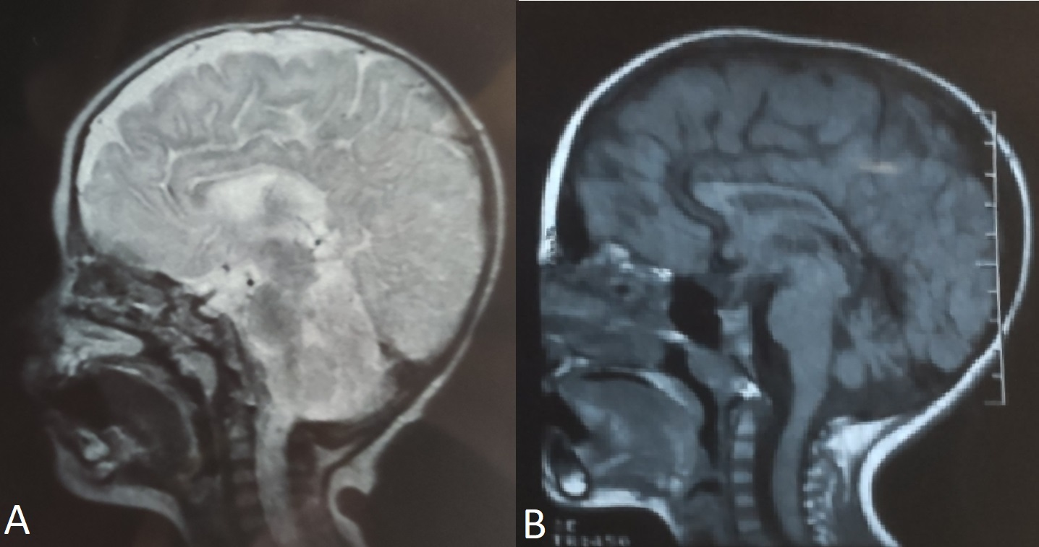
Supplementary Figure 2. Magnetic resonance imaging of the proband of family 2. A; Prominence of cerebrospinal fluid and brain atrophy are not present. B; The body and splenium of the corpus callosum are mildly hypoplastic.

