(A)
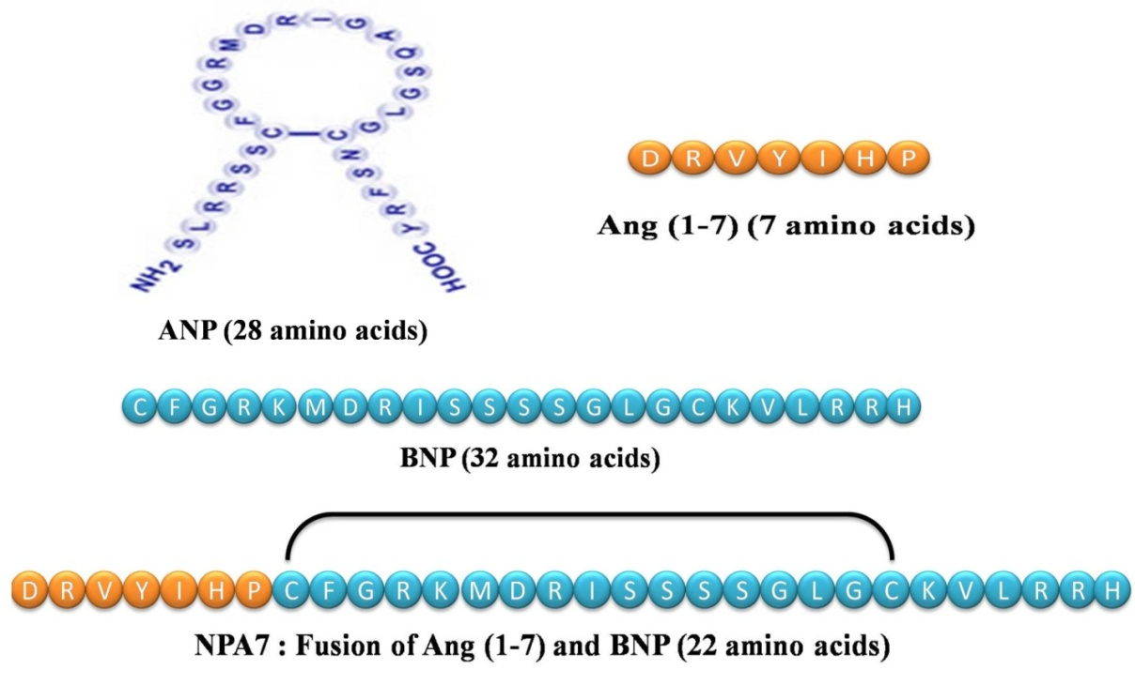
(B)
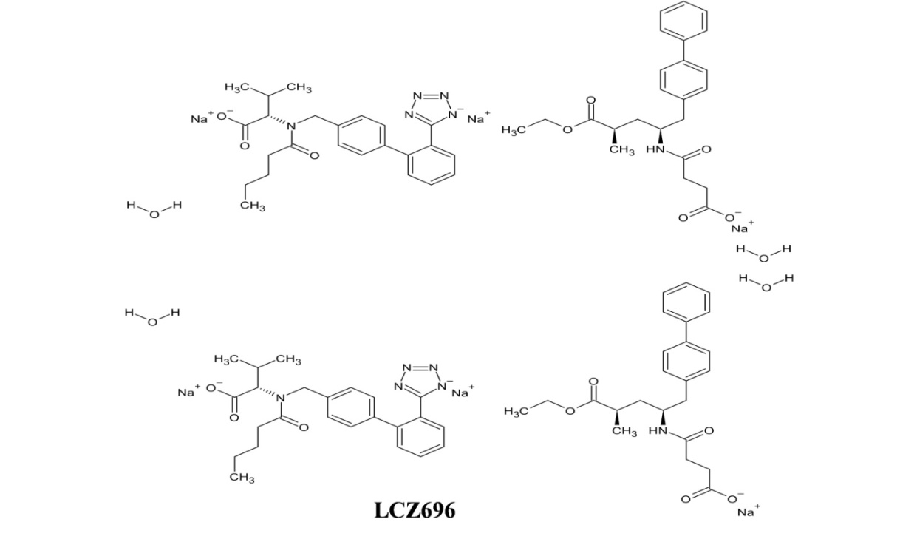

Supplementary Figure 1: Structure of peptide and non-peptide therapeutic A) Peptide structure of ANP, BNP, Ang (1-7), NPA7⁴⁴ (B) Chemical structure of non-peptide LCZ696⁴⁴

