SUPPLEMENTAL MATERIAL

Catheter-based ultrasound renal denervation in patients with resistant hypertension: the randomized, controlled REQUIRE trial

Kazuomi Kario¹, Yoshiaki Yokoi², Keisuke Okamura³, Masahiko Fujihara², Yukako Ogoyama¹, Eiichiro Yamamoto⁴, Hidenori Urata³, Jin-Man Cho⁵, Chong-Jin Kim⁶, Seung-Hyuk Choi⁷, Keisuke Shinohara⁸, Yasushi Mukai⁹, Tomokazu Ikemoto¹⁰, Masato Nakamura¹¹, Shuichi Seki¹², Satoaki Matoba¹³, Yoshisato Shibata¹⁴, Shigeo Sugawara¹⁵, Kazuhiko Yumoto¹⁶, Kouichi Tamura¹⁷, Fumiki Yoshihara¹⁸, Satoko Nakamura¹⁹, Woong Chol Kang²⁰, Taro Shibasaki²¹, Keigo Dote²², Hiroyoshi Yokoi²³, Akiko Matsuo²⁴, Hiroshi Fujita²⁵, Toshiyuki Takahashi²⁶, Hyun-Jae Kang²⁷, Yasushi Sakata²⁸, Kazunori Horie²⁹, Naoto Inoue³⁰, Ken-ichiro Sasaki³¹, Takafumi Ueno³², Hirofumi Tomita³³, Yoshihiro Morino³⁴, Yuhei Nojima³⁵, Chan Joon Kim³⁶, Tomoaki Matsumoto³⁷, Hisashi Kai³⁸ and Shinsuke Nanto³⁹

¹Division of Cardiovascular Medicine, Department of Medicine, Jichi Medical University School of Medicine, Tochigi, Japan; ²Department of Cardiology, Kishiwada Tokushukai Hospital, Osaka, Japan; ³Department of Cardiovascular Diseases, Fukuoka University Chikushi Hospital, Fukuoka, Japan; ⁴Department of Cardiovascular Medicine, Kumamoto University Graduate School of Medical Science, Kumamoto, Japan; ⁵Division of Cardiology, Department of Internal Medicine, KyungHee University Hospital at Gangdong, Seoul, South Korea; ⁶Division of Cardiology, Department of Internal Medicine, CHA Gangnam Medical Center, Seoul, South Korea; ⁷Division of Cardiology Heart Vascular and Stroke Institute, Department of Medicine, Samsung Medical Center, Sungkyunkwan University School of Medicine, Seoul, South Korea; ⁸Department of Cardiovascular Medicine, Kyushu University Hospital, Fukuoka, Japan; ⁹Division of Cardiology, Fukuoka Red Cross Hospital, Fukuoka, Japan; ¹⁰Division of Cardiology, Kumamoto Red Cross Hospital, Kumamoto, Japan; ¹¹Division of Cardiovascular Medicine, Toho University Ohashi Medical Center, Tokyo, Japan; ¹²Department of Cardiology, Chikamori Hospital, Kochi, Japan; ¹³Department of Cardiovascular Medicine, Graduate School of Medical Science, Kyoto Prefectural University of Medicine, Kyoto, Japan; ¹⁴Department of Cardiology, Miyazaki Medical Association Hospital, Miyazaki, Japan; ¹⁵Department of Cardiology, Nihonkai General Hospital, Yamagata, Japan; ¹⁶Department of Cardiology, Yokohama Rosai Hospital, Kanagawa, Japan; ¹⁷ Department of Medical Science and Cardiorenal Medicine Yokohama City University Medical Center, Kanagawa, Japan; ¹⁸Division of Nephrology and Hypertension, National Cerebral and Cardiovascular Center, Osaka, Japan; ¹⁹Department of Nutritional Science for Well-being, Kansai University of Welfare Sciences, Osaka, Japan; ²⁰Department of Cardiology, Gil Medical Center, Gachon University College of Medicine, Incheon, South Korea; ²¹Department of Cardiology, Saitama Sekishinkai Hospital, Saitama, Japan; ²²Department of Cardiology, Hiroshima City Asa Hospital, Hiroshima, Japan; ²³Cardiovascular Center, Fukuoka Sanno Hospital, Fukuoka, Japan; ²⁴Department of Cardiology, Japanese Red Cross Kyoto Daini Hospital, Kyoto, Japan; ²⁵Department of Cardiology, North Medical Center, Kyoto Prefectural University of Medicine, Kyoto, Japan; ²⁶Department of Cardiology, Saiseikai Central Hospital, Tokyo, Japan; ²⁷Department of Internal Medicine, Seoul National University Hospital and University College of Medicine, Seoul National University, Seoul, South Korea; ²⁸Department of Cardiovascular Medicine, Osaka University Graduate School of Medicine, Osaka, Japan; ²⁹Department of Cardiovascular Medicine, Sendai Kousei Hospital, Miyagi, Japan; ³⁰Cardiovascular Center, Tokyo Kamata Hospital, Tokyo, Japan; ³¹Division of Cardiovascular Medicine, Department of Internal Medicine, Kurume University School of Medicine, Fukuoka, Japan; ³²Division of Cardiology, Fukuoka Kinen Hospital, Fukuoka, Japan; ³³Department of Cardiology, Hirosaki University Graduate School of Medicine, Aomori, Japan; ³⁴Division of Cardiology, Department of Internal Medicine, Iwate Medical University, Iwate, Japan; ³⁵Department of Cardiovascular Medicine, Nishinomiya Municipal Central Hospital, Hyogo, Japan; ³⁶Division of Cardiology, Department of Internal Medicine, Uijeongbu St Mary's Hospital, College of Medicine, The Catholic University of Korea, Seoul, South Korea; ³⁷Department of Cardiology, Oji General Hospital, Hokkaido, Japan; ³⁸Department of Cardiology, Kurume University Medical Center, Fukuoka, Japan; ³⁹Department of Cardiovascular Medicine, Nishinomiya Municipal Central Hospital, Hyogo, Japan

SUPPLEMENTARY METHODS
Study Sites and Principal Investigators
Site | Principal investigator
Division of Cardiology, Caress Sapporo Tokeidai Memorial Hospital, Hokkaido, Japan | Kazushi Urasawa
Division of Cardiology, Tonan Hospital, Hokkaido, Japan | Yutaka Matsui
Department of Cardiology, KKR Sapporo Medical Center Hospital, Hokkaido, Japan | Mitsunori Kamigaki
Department of Cardiology, Nayoro City General Hospital, Hokkaido, Japan | Masaru Yamaki
Department of Cardiology, Oji General Hospital, Hokkaido, Japan | Tomoaki Matsumoto
Department of Cardiology, Hirosaki University Graduate School of Medicine, Aomori, Japan | Hirofumi Tomita
Division of Cardiology, Department of Internal Medicine, Iwate Medical University, Iwate, Japan | Yoshihiro Morino
Department of Cardiovascular Medicine, Sendai Kousei Hospital, Miyagi, Japan | Naoto Inoue (Former Principal Investigator)
 | Kazunori Horie
Department of Cardiovascular Medicine, Tohoku University Graduate School of Medicine, Miyagi, Japan | Kei Takase
Department of Cardiology, Nihonkai General Hospital, Yamagata, Japan | Shigeo Sugawara
Division of Cardiovascular Medicine, Department of Medicine, Jichi Medical University School of Medicine, Tochigi, Japan | Kazuomi Kario
Department of Cardiology, Saitama Sekishinkai Hospital, Saitama, Japan | Taro Shibasaki
Department of Cardiology, Tokyo Bay Urayasu-Ichikawa Medical Center, Chiba, Japan | Tatsuya Nakama
Department of Cardiology, Nishiarai Heart Center Hospital, Tokyo, Japan | Katsumi Saito
Division of Cardiology, Mitsui Memorial Hospital, Tokyo, Japan | Jiro Aoki
Division of Cardiovascular Medicine, Toho University Ohashi Medical Center, Tokyo, Japan | Masato Nakamura
Department of Cardiology, Toranomon Hospital, Tokyo, Japan | Takahide Kodama
Department of Cardiology, Saiseikai Central Hospital, Tokyo, Japan | Toshiyuki Takahashi
Department of Cardiology, Minamino Cardiovascular Hospital, Tokyo, Japan | Yoshiki Hata
Department of Cardiology, Japanese Red Cross Musashino Hospital, Tokyo, Japan | Takashi Ashikaga
Department of Medical Science and Cardiorenal Medicine Yokohama City University Medical Center, Kanagawa, Japan | Kouichi Tamura
Department of Cardiology, Yokohama Rosai Hospital, Kanagawa, Japan | Kazuhiko Yumoto
Department of Cardiology, Yokohama Sakae Kyosai Hospital, Kanagawa, Japan | Ichiro Michishita
Department of Cardiology, Niigata City General Hospital, Niigata, Japan | Keiichi Tsuchida
Department of Cardiology, Kanazawa Medical University, Ishikawa, Japan | Michihiko Kitayama
Department of Cardiology, Kanazawa University Graduate School of Medicine, Ishikawa, Japan | Masayuki Takamura
Department of Cardiology, Chuno Kosei Hospital, Gifu, Japan | Tomohiko Iwata
Department of Cardiology, Suzuka Chuo General Hospital, Mie, Japan | Tetsuya Kitamura
Department of Cardiology, Japanese Red Cross Kyoto Daini Hospital, Kyoto, Japan | Hiroshi Fujita (Former Principal Investigator)
 | Akiko Matsuo
Department of Cardiovascular Medicine, Graduate School of Medical Science, Kyoto Prefectural University of Medicine, Kyoto, Japan | Satoaki Matoba
Cardiovascular Center, Kyoto Katsura Hospital, Kyoto, Japan | Shigeru Nakamura
Department of Cardiology, Kishiwada Tokushukai Hospital, Osaka, Japan | Yoshiaki Yokoi
Division of Cardiology, Osaka Rosai Hospital, Osaka, Japan | Masami Nishino
Division of Nephrology and Hypertension, National Cerebral and Cardiovascular Center, Osaka, Japan | Satoko Nakamura (Former Principal Investigator)
 | Fumiki Yoshihara
Department of Cardiovascular Medicine, Osaka University Graduate School of Medicine, Osaka, Japan | Yasushi Sakata
Division of Cardiovascular Medicine, Department of Internal Medicine, Kobe University Graduate School of Medicine, Hyogo, Japan | Toshiro Shinke (Former Principal Investigator)
 | Hidekazu Tanaka
Department of Cardiology, Cardiovascular Center, Kansai Rosai Hospital, Hyogo, Japan | Masaaki Uematsu (Former Principal Investigator)
 | Toshiaki Mano
Department of Cardiovascular Medicine, Nishinomiya Municipal Central Hospital, Hyogo, Japan | Yuhei Nojima
Department of Cardiology, The Sakakibara Heart Institute of Okayama, Okayama, Japan | Atushi Hirohata
Department of Cardiology Okayama Rosai Hospital, Okayama, Japan | Seiji Namba
Department of Cardiology, Hiroshima City Asa Hospital, Hiroshima, Japan | Keigo Dote
Department of Cardiology, Pulmonology, Hypertension and Nephrology, Ehime University Graduate School of Medicine, Ehime, Japan | Takafumi Okura (Former Principal Investigator)
 | Osamu Yamaguchi
Department of Cardiology, Chikamori Hospital, Kochi, Japan | Shuichi Seki
Department of Cardiovascular Medicine, Kyushu University Hospital, Fukuoka, Japan | Yasushi Mukai (Former Principal Investigator)
 | Keisuke Shinohara
Cardiovascular Center, Fukuoka Sanno Hospital, Fukuoka, Japan | Hiroyoshi Yokoi
Department of Cardiovascular Diseases, Fukuoka University Chikushi Hospital, Fukuoka, Japan | Hidenori Urata
Department of Cardiovascular Medicine, Fukuoka Tokushukai Medical Center, Fukuoka, Japan | Hideki Shimomura
Department of Cardiology, Kokura Memorial Hospital, Fukuoka, Japan | Kenji Ando
Division of Cardiovascular Medicine, Department of Internal Medicine, Kurume University School of Medicine, Fukuoka, Japan | Takafumi Ueno (Former Principal Investigator)
 | Ken-ichiro Sasaki
Department of Cardiovascular Medicine, Saga University, Saga, Japan | Yutaka Hikichi (Former Principal Investigator)
 | Machiko Asaka
Department of Cardiovascular Medicine, Kumamoto University Graduate School of Medical Science, Kumamoto, Japan | Eiichiro Yamamoto
Division of Cardiology, Kumamoto Red Cross Hospital, Kumamoto, Japan | Tomokazu Ikemoto
Department of Cardiology, Miyazaki Medical Association Hospital, Miyazaki, Japan | Yoshisato Shibata
Department of Cardiovascular Medicine and Hypertension, Graduate School of Medical and Dental Sciences, Kagoshima University, Kagoshima, Japan | Mitsuru Ohishi
Department of Cardiovascular Medicine, Nephrology and Neurology, University of the Ryukyus, Okinawa, Japan | Hidekazu Ikemiyagi
Division of Cardiology, Department of Internal Medicine, KyungHee University Hospital at Gangdong, Seoul, South Korea. | Chong-Jin Kim (Former Principal Investigator)
 | Jin-Man Cho
Division of Cardiology, Department of Internal Medicine, Gangnam Severance Hospital, Yonsei University College of Medicine, Seoul, South Korea. | Pil-Ki Min
Division of Cardiology Heart Vascular and Stroke Institute, Department of Medicine, Samsung Medical Center, Sungkyunkwan University School of Medicine, Seoul, South Korea. | Seung-Hyuk Choi
Department of Internal Medicine, Cardiovascular Center, Guro Hospital, Korea University, Seoul, South Korea. | Chang-gyu Park
Department of Internal Medicine, Seoul National University Hospital and  University College of Medicine, Seoul National University, Seoul, South Korea. | Hyun-Jae Kang
Division of Cardiology, Department of Internal Medicine, Seoul St. Mary's Hospital, College of Medicine, The Catholic University of Korea, Seoul, South Korea. | Woo-Baek Chung
Division of Cardiology, Department of Internal Medicine, Severance Cardiovascular Hospital, Yonsei University Health System, Yonsei University College of Medicine, Seoul, South Korea. | Byeong-Keuk Kim
Division of Cardiology, Department of Internal Medicine, Cardiovascular Center, Seoul National University Bundang Hospital, Seongnam, South Korea. | Cheol-Ho Kim
Division of Cardiology, Department of Internal Medicine, Uijeongbu St Mary's Hospital, College of Medicine, The Catholic University of Korea, Seoul, South Korea. | Chan Joon Kim
Department of Cardiology, Gil Medical Center, Gachon University College of Medicine, Incheon, South Korea. | Woong Chol Kang
Department of Cardiology, Gangneung Asan Hospital, University of Ulsan College of Medicine, Gangneung, South Korea. | Sang-Yong Yoo
Division of Cardiology, Department of Internal Medicine, Wonju Severance Christian Hospital, Yonsei University Wonju College of Medicine, Wonju, South Korea. | Sung-Gyun Ahn
Division of Cardiology, Department of Internal Medicine, Chungnam National University Hospital, Chungnam National University College of Medicine, Daejeon, South Korea. | Jin-Ok Jeong
Division of Cardiology, Department of Internal Medicine, Chonnam National University Hospital, Chonnam National University Medical School, Gwangju, South Korea. | Young-keun Ahn
Division of Cardiology, Department of Internal Medicine, Pusan National University Hospital, Busan, South Korea. | Han-Cheol Lee
Division of Cardiology, Department of Internal Medicine, Keimyung University Dongsan Hospital, Daegu, South Korea. | Seung-Ho Hur
Division of Cardiology, Department of Internal Medicine, Pusan National University Yangsan Hospital, Yangsan, South Korea. | Kook-Jin Chun

Administrative Structure
Role and Name | Institute
Coordinating Investigators:
Shinsuke Nanto, MD, PhD | Department of Cardiovascular Medicine, Nishinomiya Municipal Central Hospital, Hyogo, Japan
Kazuomi Kario, MD, PhD | Division of Cardiovascular Medicine, Department of Medicine, Jichi Medical University School of Medicine, Tochigi, Japan
Medical Experts:
Hisahi Kai, MD, PhD | Department of Cardiology, Kurume University Medical Center, Fukuoka, Japan
Satoshi Hoshide, MD, PhD | Division of Cardiovascular Medicine, Department of Medicine, Jichi Medical University School of Medicine, Tochigi, Japan
Advisor on Renal Artery Access:
Yoshiaki Yokoi, MD, PhD | Department of Cardiology, Kishiwada Tokushukai Hospital, Osaka, Japan
Advisory Team for Ablation Sites:
Shinsuke Nanto, MD, PhD | Department of Cardiovascular Medicine, Nishinomiya Municipal Central Hospital, Hyogo, Japan
Ryoji Koshida, MD | Department of Cardiology, Toyohashi Heart Center, Toyohashi, Aichi, Japan
Keisuke Okamura, MD, PhD | Department of Cardiovascular Diseases, Fukuoka University Chikushi Hospital, Fukuoka, Japan
Masahiko Fujihara, MD | Department of Cardiology, Kishiwada Tokushukai Hospital, Osaka, Japan
Yukako Ogoyama, MD | Division of Cardiovascular Medicine, Department of Medicine, Jichi Medical University School of Medicine, Tochigi, Japan

SUPPLEMENTARY TABLES
Supplementary table 1. Procedural details
 | Renal denervation  (n=72) | Sham control  (n=71)
Proportion of patients with ≥2 sonication on each renal artery | 71 (98.6) | -
Total number of sonications at both arteries | 5.5 ± 1.2 | -
Subjects with treated accessory renal arteries | 8 (11.1) | -
Procedure time, min* | 86.7 ± 54.0 | 40.2 ± 11.6
Renal denervation procedure time, min† | 35.5 ± 23.8 | -
Contrast volume, mL | 147.8 ± 85.8 | 54.1 ± 36.5
X-ray fluoroscopy time, min | 23.6 ± 12.8 | 5.2 ± 5.1
Mean ± SD, or number of patients (%)
*Time from sheath insertion to removal.
†Time from first Paradise™ catheter insertion to the last removal of the Paradise™ catheter.

Supplementary table 2. Change from baseline in blood pressure between the renal denervation and sham control groups at 3 months
Variables | Renal denervation  (mmHg) |  | Sham control  (mmHg) |  | Between-group difference (mmHg)
 | N | LS mean ± SE | n | LS mean ± SE | LS mean ± SE | p-value
Office SBP | 69 | –11.0 ± 2.1 | 66 | –9.0 ± 2.1 | –2.0 ± 3.0 | 0.511
Office DBP | 69 | –4.9 ± 1.5 | 66 | –5.0 ± 1.5 | 0.1 ± 2.1 | 0.946
24-hour ambulatory SBP | 69 | –6.6 ± 1.9 | 67 | –6.5 ± 1.9 | –0.1 ± 2.7 | 0.971
24-hour ambulatory DBP | 69 | –3.6 ± 1.0 | 67 | –3.3 ± 1.0 | –0.4 ± 1.4 | 0.806
Daytime ambulatory SBP | 61 | –8.4 ± 2.0 | 66 | –7.2 ± 1.9 | –1.2 ± 2.8 | 0.672
Daytime ambulatory DBP | 61 | –4.8 ± 1.1 | 66 | –4.0 ± 1.0 | –0.8 ± 1.5 | 0.585
Nighttime ambulatory SBP | 68 | –4.2 ± 2.4 | 67 | –4.7 ± 2.4 | 0.5 ± 3.3 | 0.883
Nighttime ambulatory DBP | 68 | –1.4 ± 1.3 | 67 | –2.0 ± 1.3 | 0.6 ± 1.9 | 0.770
Home SBP | 60 | –8.7 ± 1.8 | 59 | –6.9 ± 1.8 | –1.8 ± 2.6 | 0.488
Home DBP | 60 | –3.6 ± 1.1 | 59 | –3.7 ± 1.1 | 0.1 ± 1.6 | 0.949
Morning home SBP | 60 | –9.1 ± 1.8 | 59 | –6.6 ± 1.8 | –2.5 ± 2.5 | 0.319
Morning home DBP | 60 | –3.7 ± 1.2 | 59 | –3.1 ± 1.2 | –0.7 ± 1.7 | 0.684
ANCOVA model included procedure as a factor and baseline value as a covariate.
DBP, diastolic blood pressure; LS, least squares; SBP, systolic blood pressure; SE, standard error.

Supplementary table 3. Medication changes
Period | Renal denervation |  |  |  | Sham control
Period | Number of antihypertensive medications |  | Antihypertensive load index* |  | Number of antihypertensive  medications |  | Antihypertensive load index*
Period | N | Mean ± SD | N | Mean ± SD | N | Mean ± SD | N | Mean ± SD
Informed consent | 69 | 4.2 ± 1.6 | - | - | 67 | 4.0 ± 1.1 | - | -
Baseline | 62 | 4.2 ± 1.7 | 69 | 2.6 ± 1.7 | 62 | 3.9 ± 1.2 | 67 | 2.4 ± 1.2
1 month | 59 | 4.1 ± 1.6 | - | - | 57 | 3.9 ± 1.2 | - | -
2 month | 60 | 4.2 ± 1.6 | - | - | 60 | 3.9 ± 1.1 | - | -
3 month | 60 | 4.3 ± 1.7 | 69 | 2.5 ± 1.7 | 59 | 3.9 ± 1.1 | 67 | 2.4 ± 1.2
*Antihypertensive load index is the sum of (daily dose/maximum daily dose) for each antihypertensive drug.
SD, standard deviation.

Table S4. Change from baseline in blood pressure between the renal denervation and sham control groups at 3 months in patients without any change of antihypertensive drugs
Variables | Renal denervation  (mmHg) |  | Sham control  (mmHg) |  | Between-group difference (mmHg)
 | N | LSmean ± SE | n | LSmean ± SE | LSmean ± SE | p-value
Office SBP | 60 | –10.5 ± 2.1 | 60 | –7.8 ± 2.1 | –2.7 ± 2.9 | 0.370
Office DBP | 60 | –4.3 ± 1.5 | 60 | –3.8 ± 1.5 | –0.5 ± 2.1 | 0.795
24-hour ambulatory SBP | 60 | –6.2 ± 1.9 | 61 | –5.7 ± 1.9 | –0.5 ± 2.7 | 0.844
24-hour ambulatory DBP | 60 | –3.2 ± 1.0 | 61 | –2.6 ± 1.0 | –0.6 ± 1.5 | 0.699
Daytime ambulatory SBP | 53 | –7.8 ± 2.0 | 60 | –6.6 ± 1.9 | –1.2 ± 2.7 | 0.667
Daytime ambulatory DBP | 53 | –4.4 ± 1.1 | 60 | –3.5 ± 1.0 | –0.9 ± 1.5 | 0.537
Nighttime ambulatory SBP | 59 | –3.3 ± 2.5 | 61 | –3.5 ± 2.5 | 0.2 ± 3.6 | 0.952
Nighttime ambulatory DBP | 59 | –0.8 ± 1.4 | 61 | –1.2 ± 1.4 | 0.4 ± 2.0 | 0.852
Home SBP | 53 | –8.3 ± 1.8 | 55 | –5.9 ± 1.8 | –2.4 ± 2.5 | 0.347
Home DBP | 53 | –3.6 ± 1.1 | 55 | –3.3 ± 1.1 | –0.4 ± 1.6 | 0.816
Morning home SBP | 53 | –8.5 ± 1.8 | 55 | –5.8 ± 1.7 | –2.8 ± 2.5 | 0.268
Morning home DBP | 53 | –3.8 ± 1.2 | 55 | –2.7 ± 1.2 | –1.1 ± 1.7 | 0.518
ANCOVA model included procedure as a factor and baseline value as a covariate.
DBP, diastolic blood pressure; LS, least squares; SBP, systolic blood pressure; SE, standard error.

SUPPLEMENTARY FIGURES
Supplementary figure 1. Between-group differences in 24-hour ambulatory systolic blood pressure in patient subgroups. The ANCOVA model included procedure and baseline value. The interaction p-value was calculated using an ANCOVA model including procedure, baseline value, baseline characteristics, and interaction between procedure and baseline characteristics. CI, confidence interval.
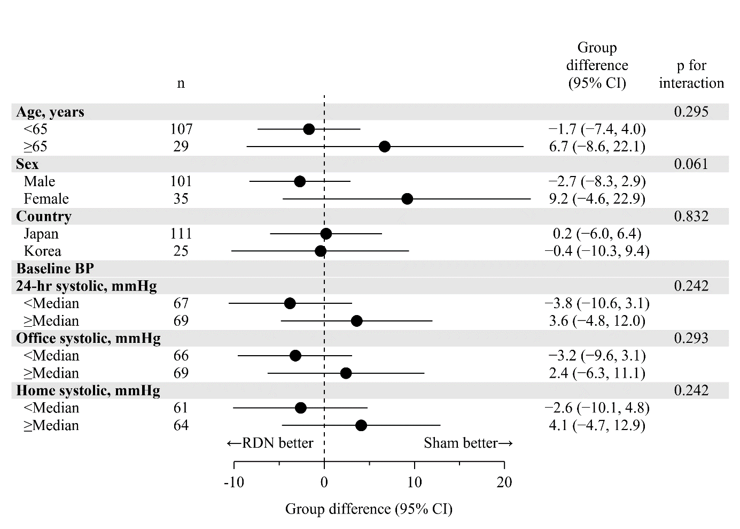

Supplementary figure 2. Individual patient changes in twenty-four-hour ambulatory systolic blood pressure (ABP) from baseline at 3 months post-procedure in the renal denervation (A) and sham control (B) groups. ABP, ambulatory blood pressure.
A. Renal denervation group
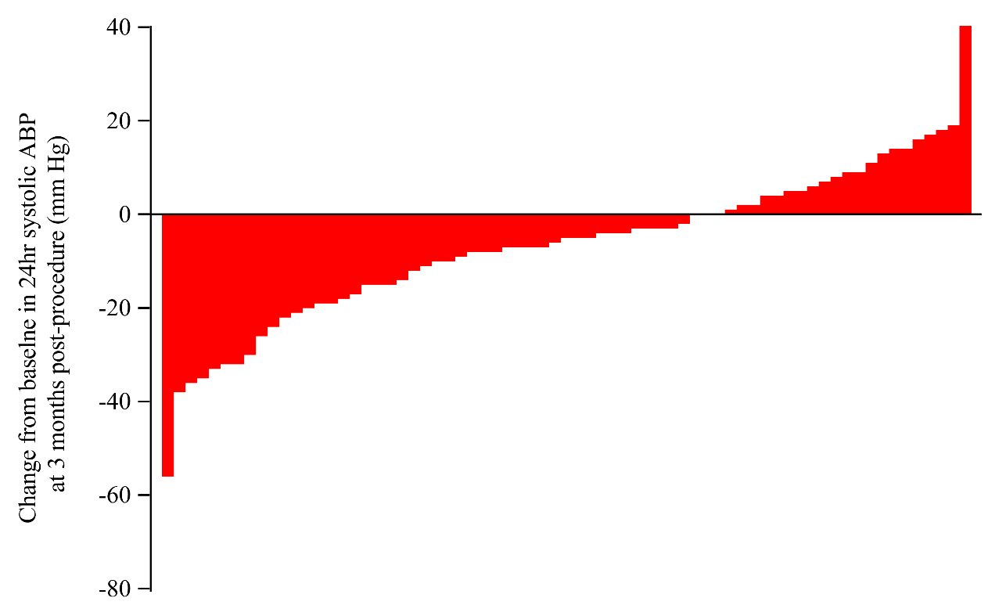
B. Sham control group
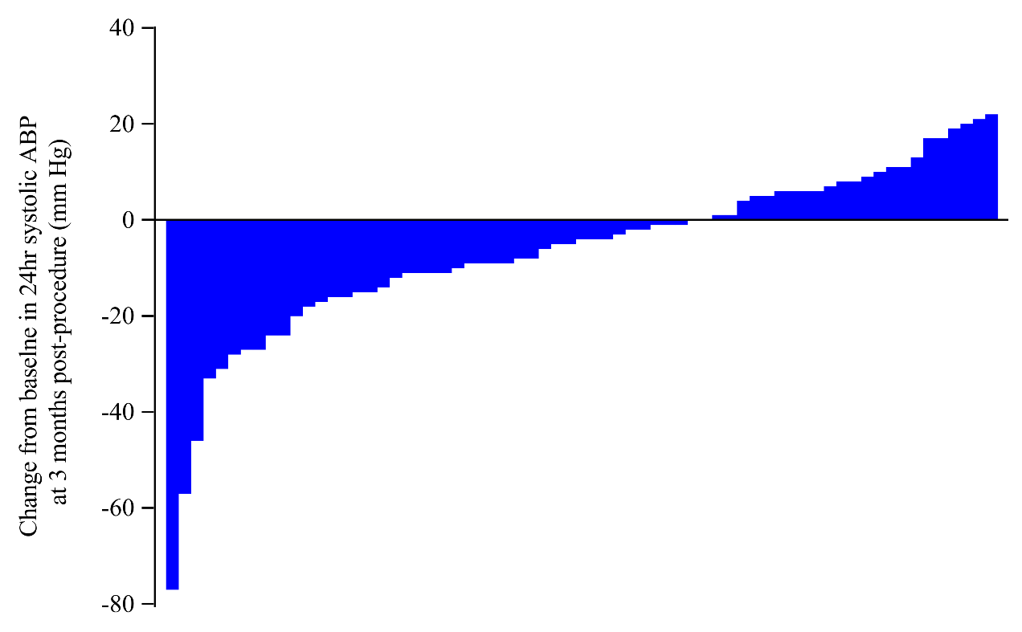

Supplementary figure 3. Twenty-four-hour ambulatory blood pressure profiles at baseline (empty dot) and at 3 months post-procedure (filled dot) in the renal denervation (A) and sham control (B) groups. Values are mean (dots) and standard error (SE; bars).
A. Renal denervation group
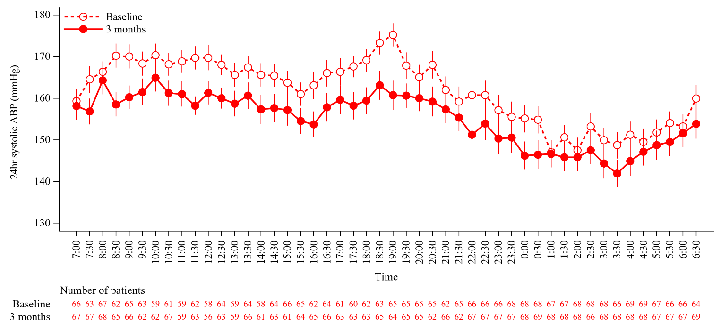
B. Sham control group
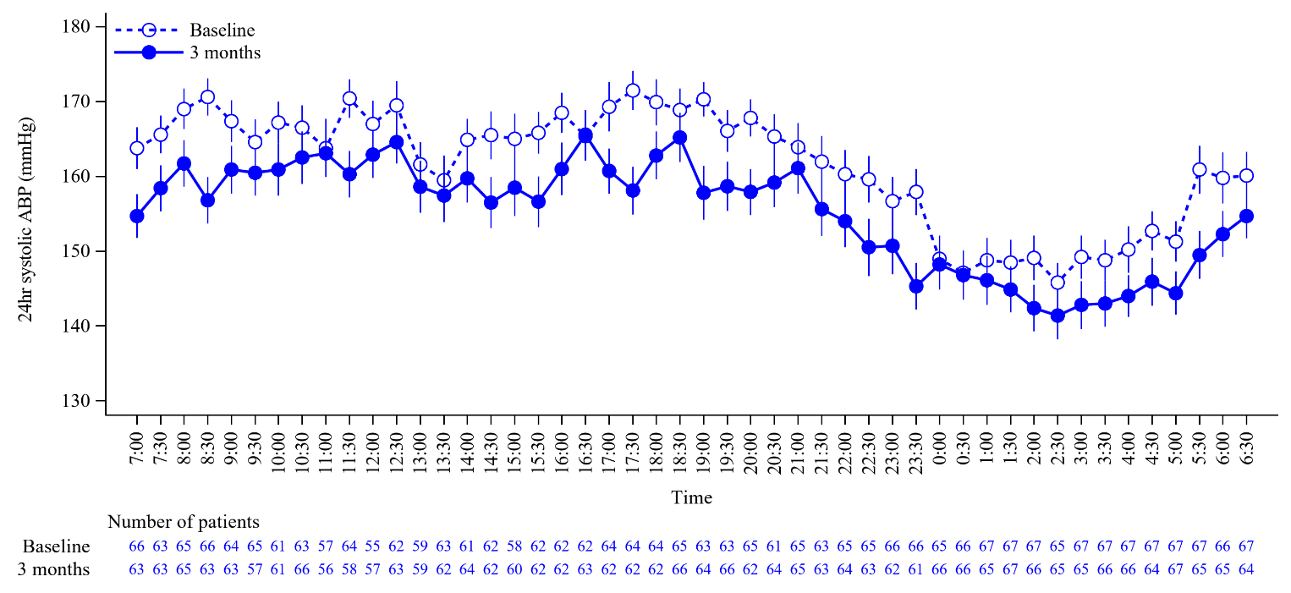

Supplementary figure 4. Change in home systolic blood pressure (SBP) over time after the procedure in patients without any change of antihypertensive drugs. Dots and error bars show least squares mean ± standard errors.


