Supplementary Materials

Supplementary Figures

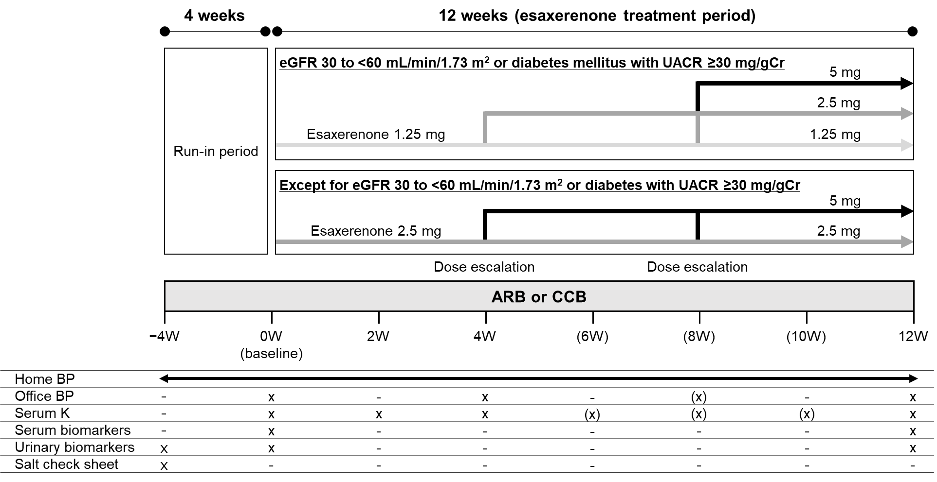
Figure S1. Study design
ARB angiotensin receptor blocker, BP blood pressure, CCB calcium channel blocker, eGFR creatinine-based estimated glomerular filtration rate, K potassium, UACR urinary albumin-to-creatinine ratio.

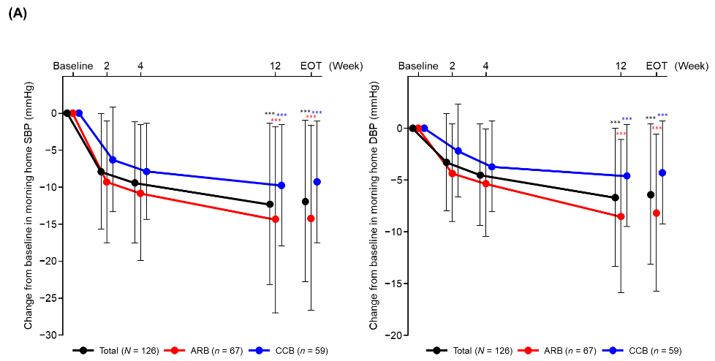
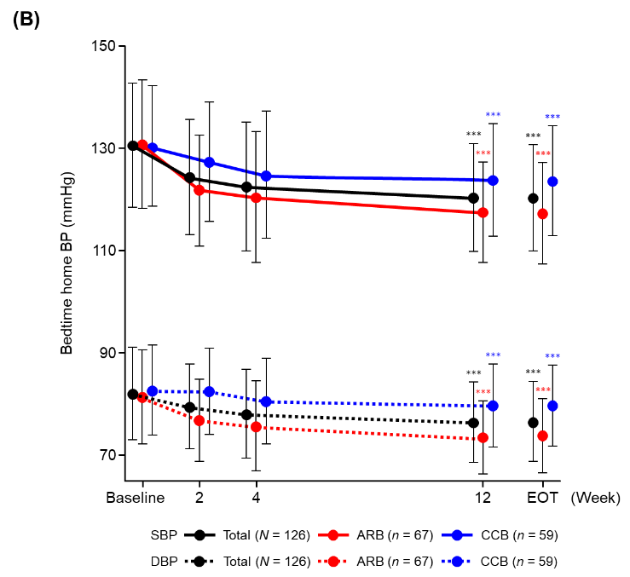

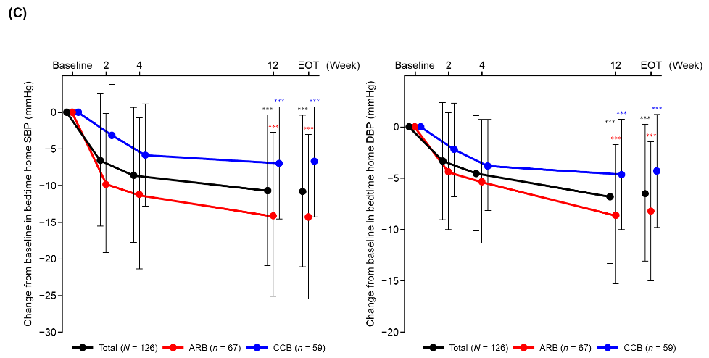

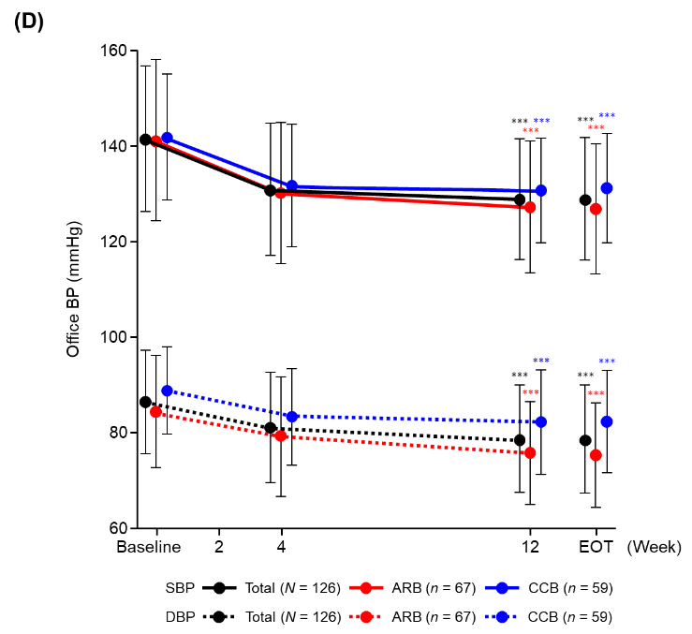

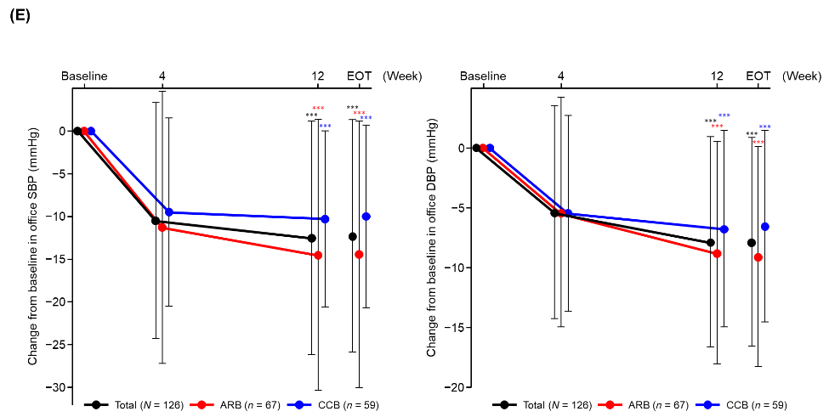
Figure S2. Time course change and changes from baseline in morning home BP (A), bedtime home BP (B, C), and office BP (D, E) (full analysis set).
Changes from baseline are shown in panels A, C, and E.
Time course changes are shown in panels B and D.
Data are mean ± SD.
***p <0.001 vs baseline, paired t-test.
ARB angiotensin receptor blocker, BP blood pressure, CCB calcium channel blocker, DBP diastolic blood pressure, EOT end of treatment, SBP systolic blood pressure.

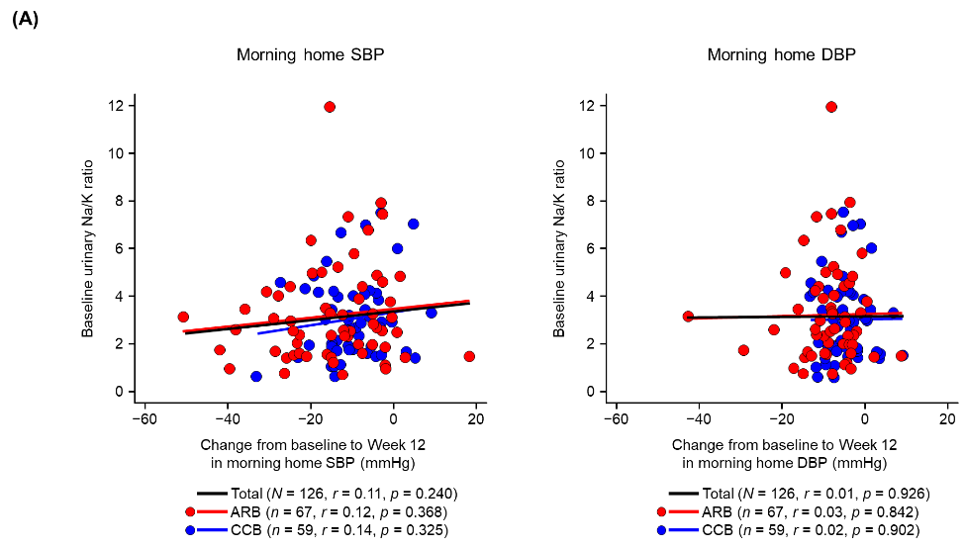

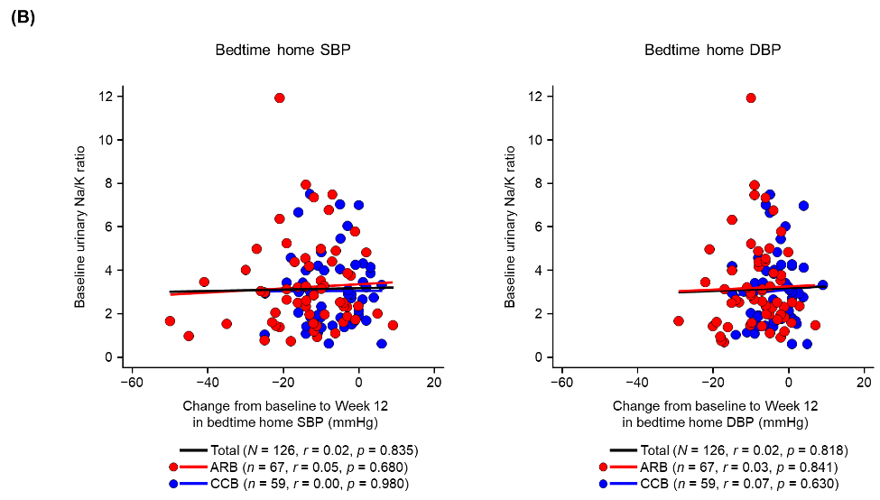

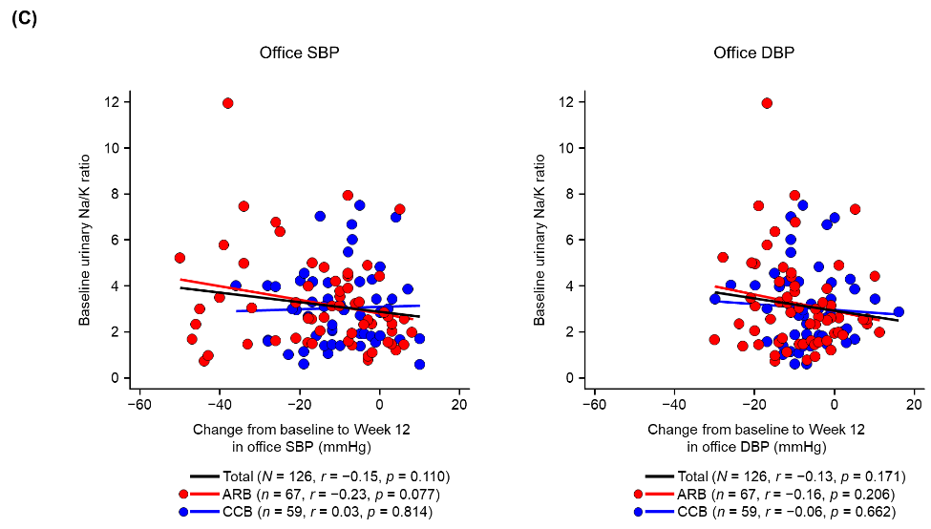

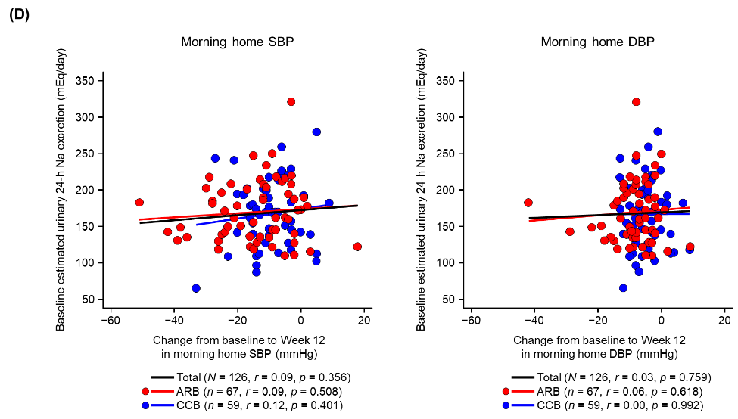

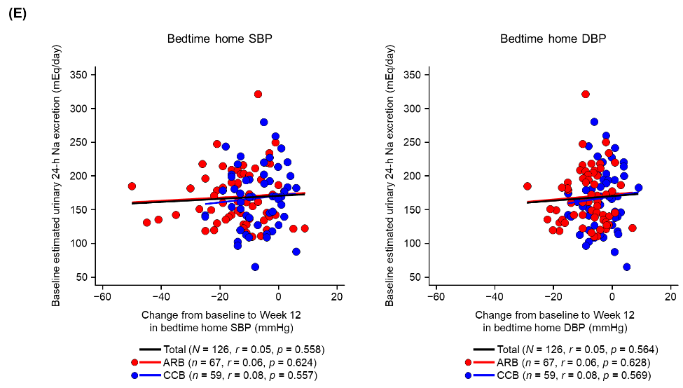

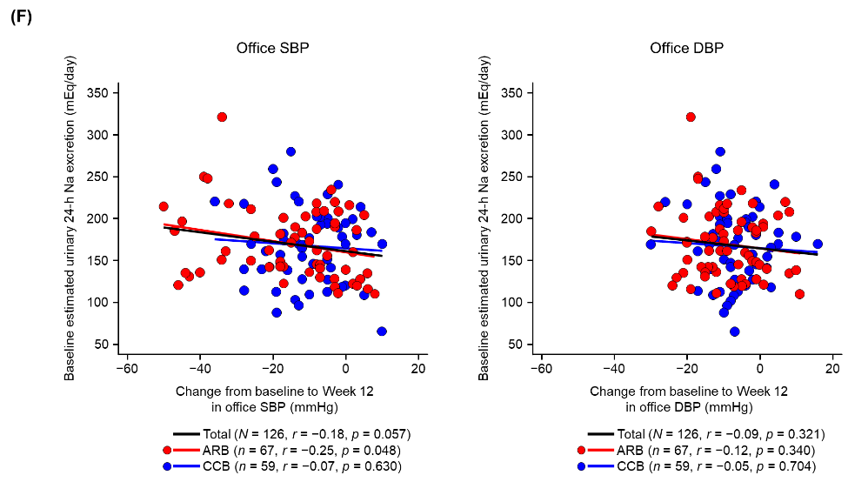
Figure S3. Correlation of change in BP from baseline to Week 12 with baseline urinary Na/K ratio (A, B, C: pre-specified analysis) and estimated 24-h urinary Na excretion (D, E, F: post hoc analysis) (full analysis set).
A, D: morning home BP. B, E: bedtime home BP. C, F: office BP.
r, Pearson’s correlation coefficient.
ARB angiotensin receptor blocker, BP blood pressure, CCB calcium channel blocker, DBP diastolic blood pressure, K potassium, Na sodium, SBP systolic blood pressure.

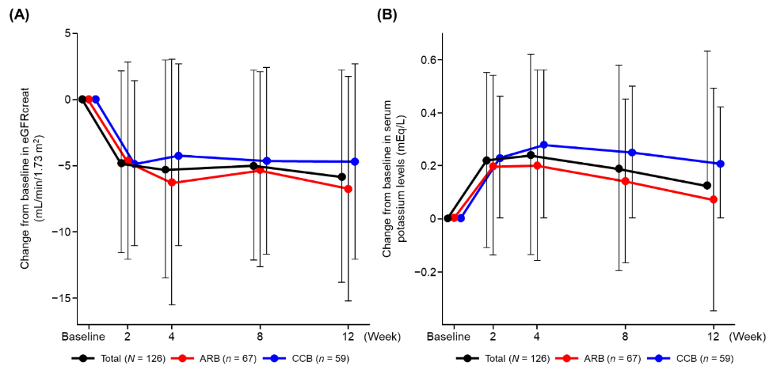Figure S4. Change from baseline in eGFR (A) and serum K levels (B) during the study period in the total population and ARB and CCB subcohorts (safety analysis set).
Data are mean ± SD.
ARB angiotensin receptor blocker, CCB calcium channel blocker, eGFR creatinine-based estimated glomerular filtration rate, K potassium.

