Supplementary Table 1: Participant inclusion and exclusion criteria
Inclusion criteria
- Age ≥18 years on the index date*
- Diagnosed with essential hypertension; ICD-10 codes: I10 on the index date
- Patients for whom data for the 6 months prior to the index date can be extracted as baseline data
- Patients for whom BP data can be extracted between 8 and 12 weeks after the index date
- Patients whose BP data can be extracted on the index date
- Patients whose BP value on the index date was ≥140/90 mmHg
- Patients with the prescription of 100 mg or 200 mg once daily by 100-mg or
200-mg tablets of Sac/Val on the index date
Exclusion criteria
- Women with a record of pregnancy-related diagnoses, drugs, or medical procedures before or after the index date, or a record of delivery- or abortion-related diagnoses, drugs, or medical procedures after the index date
- Prescription of concomitant ACEi (ATC code: C09A) is present from 2 days before the index date on ward
- Patients who are diagnosed with angioedema(ICD-10: D84.1) under prescription of ACEi or ARBs; ATC code: C09C
- Patients who are diagnosed with diabetes and under treatment with aliskiren fumarate on index date
- Patients with severe impaired liver functions with Child-Pugh classification C
*The index date for Sac/Val group will be the date of initial prescription of Sac/Val; the index date for conventional drug-control groups will be the date of initial treatment defined as active-comparators.
ACEi, angiotensin-converting enzyme inhibitors; ATC, anatomical therapeutic chemical; ARB, angiotensin receptor blocker; BP, blood pressure; ICD, international classification of diseases; Sac/Val, sacubitril/valsartan.

Supplementary Table 2: Definition of extracting variables (ACT and ICD-10 codes)
Antihypertensive medications
- CCB [C08C]
- ACEi [C09A]
- ARB [C09C]
- Diuretic [C03A, C03B, C03C]
- β-blocker [C07AB]
- α-blocker [C02CA]
- αβ-blocker [C07AG]
- Aldosterone antagonist [C03DA, C03DB]
- Renin blocker [09XA]
- Single pill combination [C02N, C02L, C07BB, C07BG, C07CB, C07CG, C07D, C03E, C07FB, C07FX01, C08G, C09B, C09D, C09XA52, C09XA53, C09XA54]
- Sacubitril/valsartan [D10226]
Cerebrovascular disease
- Cerebrovascular disorder [I60-I69]
- Vertebral artery thrombosis* [I650]
- Vertebral artery occlusive disease* [I650]
- Basilar artery thrombosis* [I651]
- Basilar artery occlusion* [I651]
- Internal carotid artery thrombosis* [I652]
- Internal carotid artery occlusion* [I652]
- Middle cerebral artery thrombosis* [I660]
- Middle cerebral artery occlusion* [I660]
- Anterior cerebral artery thrombosis* [I661]
- Anterior cerebral artery occlusion* [I661]
- Posterior cerebral artery thrombosis* [I662]
- Posterior cerebral artery occlusion* [I662]
* Defined as occlusion of the main cerebral artery
Heart disease
- Rheumatic fever with cardiac complications [I01]
- Chronic rheumatic heart disease [I05-I09]
- Angina pectoris* [I20]
- Acute myocardial infarction* [I21]
- Recurrent myocardial infarction* [I22]
- Other acute ischemic heart disease* [I24]
- Chronic ischemic heart disease* [I25]
- Other types of heart disease [I30-I52]
*Defined as coronary artery disease
Diabetes mellitus
- Type 1 insulin-dependent diabetes mellitus (IDDM) [E10]
- Type 2 insulin-independent diabetes mellitus (NIDDM) [E11]
Dyslipidemia
- Lipoprotein metabolism disorders and other lipemia [E78]
Renal disease
- Glomerular diseases [N00-N08]
- Renal tubulointerstitial disease [N10-N16]
- Acute renal failure [N17]
- Chronic kidney disease (CKD) [N18],
  - eGFR <60, UACR ≥30 mg/gCr (with spot urine)*, or UPCR ≥0.15 g/gCr (with spot urine)*
- Renal failure of unknown details [N19]
- Hypertensive renal disease [I12]
- Hypertensive cardio-renal disease [I13]
*Defined as proteinuria
Renal outcomes
- If any of the following apply after Day 0, included in renal outcome counts:
  - Renal diseases
  - CKD
  - ∆eGFR (percent decrease from baseline) ≥40%
Hypotension-related events
- Orthostatic hypotension [I951]
- Postural hypotension [I951]
- Secondary orthostatic hypotension [I951]
- Hypertension due to the drugs [I952]
- Episodic hypotension [I959]
- Hypotension [I959]
Dehydration-related events
- Dehydration [E86]
- Isotonic dehydration [E86]
Diuresis-related events
- Polyuria [R35]
- Idiopathic polyuria [R35]
- Frequent urination [R35]
- Nocturnal polyuria [R35]
- Nocturia [R35]
Angioedema-related events
- Angioneurotic edema [T783]
- Quincke's edema [T783]
ACEi, angiotensin-converting enzyme inhibitor; ATC, anatomical therapeutic chemical; ARB, angiotensin receptor blocker; CCB, calcium channel blocker; CKD, chronic kidney disease; eGFR, estimated glomerular filtration rate; ICD, international classification of diseases; UACR, urine albumin-creatinine ratio; UPCR, urine protein-creatinine ratio.

Supplementary Table 3. Comorbidities and BP category of patients who experienced safety event per season (eligible population)
Safety Event | Season | Patients with event, n | Concomitant diuretic use per patient,  n (%) | Comorbidity at baseline, n (%) |  |  |  |  |  | BP category, n (%)
 |  |  |  | CeVD | Heart disease | Diabetes | Dyslipidemia | Renal disease | CKD | Grade  I | Grade  II | Grade III
Hypotension | All year | 118 | 38  (32.2) | 36  (30.5) | 63  (53.4) | 24  (20.3) | 73  (61.9) | 30  (25.4) | 20  (16.9) | 66 (55.9) | 34 (28.8) | 18 (15.3)
Hypotension | Spring | 29 | 9  (31.0) | 9  (31.0) | 17  (58.6) | 7  (24.1) | 20  (69.0) | 7  (24.1) | 4  (13.8) | 19 (65.5) | 8  (27.6) | 2  (6.9)
Hypotension | Summer | 38 | 12  (31.6) | 12  (31.6) | 21  (55.3) | 10  (26.3) | 21  (55.3) | 9  (23.7) | 7  (18.4) | 18 (47.4) | 15 (39.5) | 5  (13.2)
Hypotension | Autumn | 30 | 12  (40.0) | 8  (26.7) | 15  (50.0) | 5  (16.7) | 17  (56.7) | 8  (26.7) | 5  (16.7) | 18 (60.0) | 6  (20.0) | 6  (20.0)
Hypotension | Winter | 21 | 5  (23.8) | 7  (33.3) | 10  (47.6) | 2  (9.5) | 15  (71.4) | 6  (28.6) | 4  (19.0) | 11 (52.4) | 5  (23.8) | 5  (23.8)
Dehydration | All year | 50 | 20  (40.0) | 13  (26.0) | 24  (48.0) | 7  (14.0) | 26  (52.0) | 18  (36.0) | 15  (30.0) | 29 (58.0) | 18 (36.0) | 3  (6.0)
Dehydration | Spring | 10 | 4  (40.0) | 2  (20.0) | 5  (50.0) | 0  (0.0) | 5  (50.0) | 3  (30.0) | 2  (20.0) | 7  (70.0) | 3  (30.0) | 0  (0.0)
Dehydration | Summer | 26 | 10  (38.5) | 7  (26.9) | 11  (42.3) | 4  (15.4) | 15  (57.7) | 11  (42.3) | 9  (34.6) | 13 (50.0) | 11 (42.3) | 2  (7.7)
Dehydration | Autumn | 10 | 5  (50.0) | 2  (20.0) | 5  (50.0) | 2  (20.0) | 5  (50.0) | 3  (30.0) | 3  (30.0) | 7 (70.0) | 3  (30.0) | 0  (0.0)
Dehydration | Winter | 4 | 1  (25.0) | 2  (50.0) | 3  (75.0) | 1  (25.0) | 1  (25.0) | 1  (25.0) | 1  (25.0) | 2 (50.0) | 1  (25.0) | 1  (25.0)
Polyuria | All year | 59 | 28  (47.5) | 13  (22.0) | 31  (52.5) | 9  (15.3) | 38  (64.4) | 13  (22.0) | 11  (18.6) | 28 (47.5) | 24 (40.7) | 7  (11.9)
Polyuria | Spring | 18 | 9  (50.0) | 5  (27.8) | 10  (55.6) | 2  (11.1) | 11  (61.1) | 5  (27.8) | 5  (27.8) | 8  (44.4) | 7  (38.9) | 3  (16.7)
Polyuria | Summer | 16 | 8  (50.0) | 2  (12.5) | 9  (56.3) | 3  (18.8) | 9  (56.3) | 3  (18.8) | 2  (12.5) | 6  (37.5) | 8  (50.0) | 2  (12.5)
Polyuria | Autumn | 15 | 6  (40.0) | 4  (26.7) | 8  (53.3) | 3  (20.0) | 10  (66.7) | 4  (26.7) | 3  (20.0) | 7  (46.7) | 7  (46.7) | 1  (6.7)
Polyuria | Winter | 10 | 5  (50.0) | 2  (20.0) | 4  (40.0) | 1  (10.0) | 8  (80.0) | 1  (10.0) | 1  (10.0) | 7  (70.0) | 2  (20.0) | 1  (10.0)
Spring: March to May, Summer: June to August, Autum: September to November, Winter: December to February. BP, blood pressure; CeVD, cerebrovascular disease; CKD, chronic kidney disease.

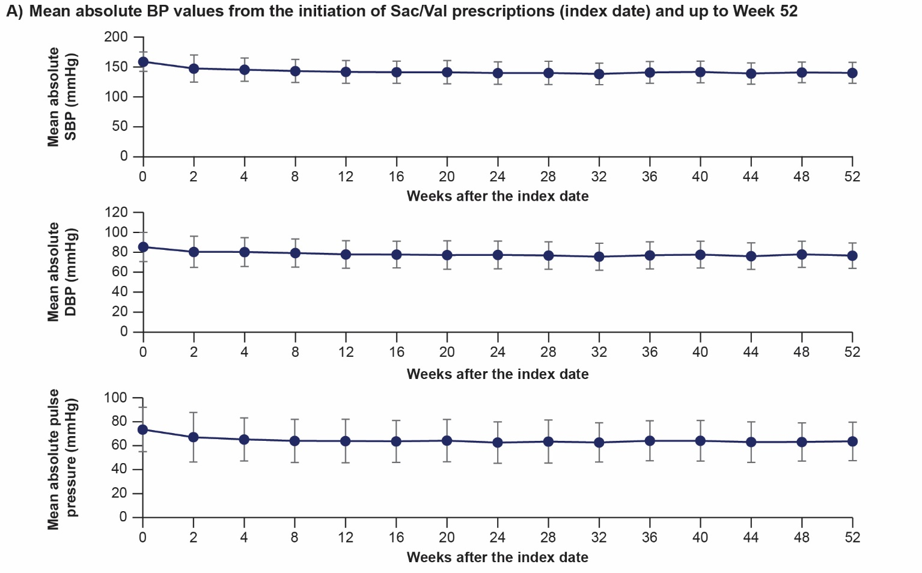
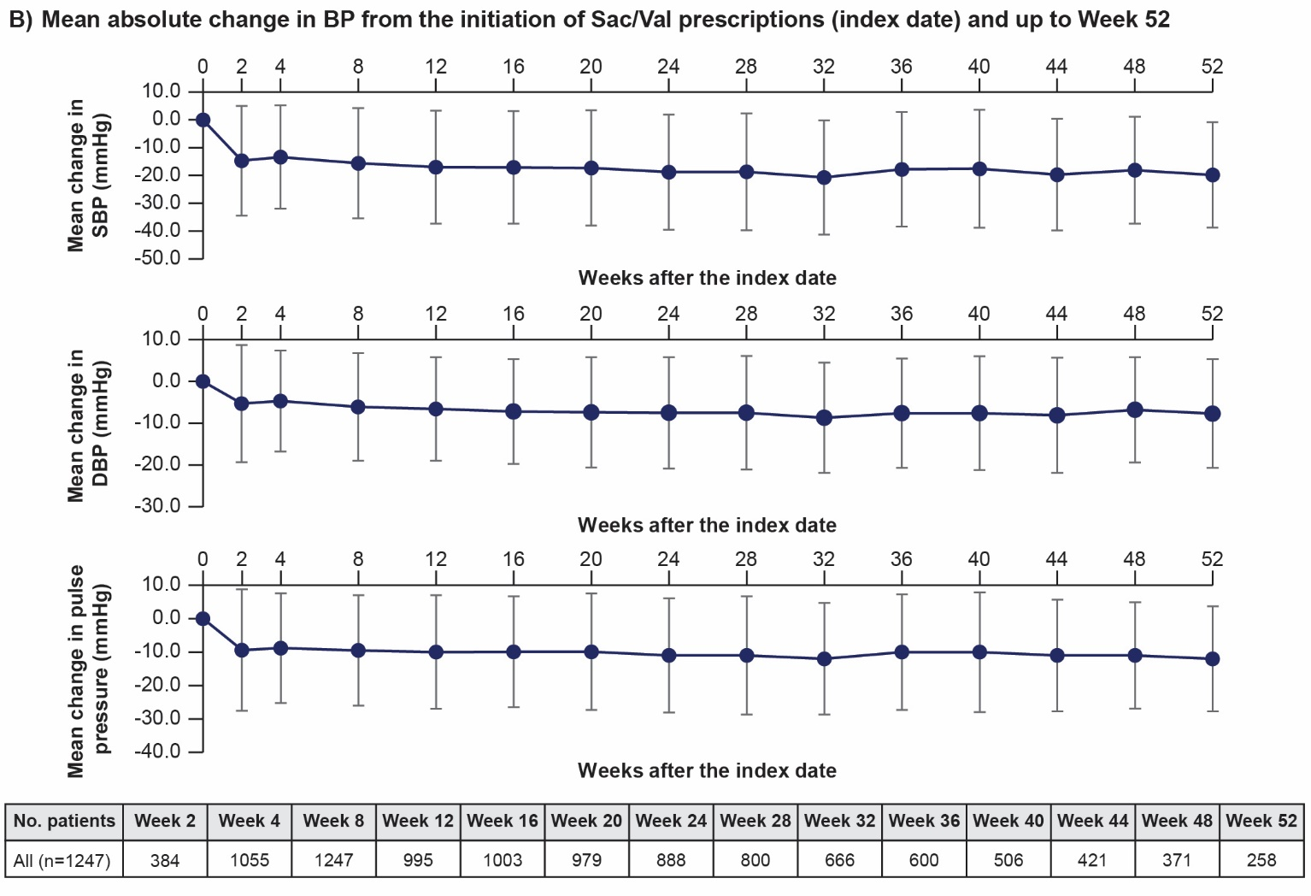
Supplementary Figure 1. Change in BP over time in effectiveness analysis population from the initiation of Sac/Val prescriptions (index date) and up to Week 52. A) Mean absolute BP values from index date and up to Week 52; B) Mean absolute change in BP from index date and up to Week 52. Abbreviations: BP, blood pressure, DBP, diastolic blood pressure; Sac/Val, sacubitril/valsartan; SBP, systolic blood pressure.
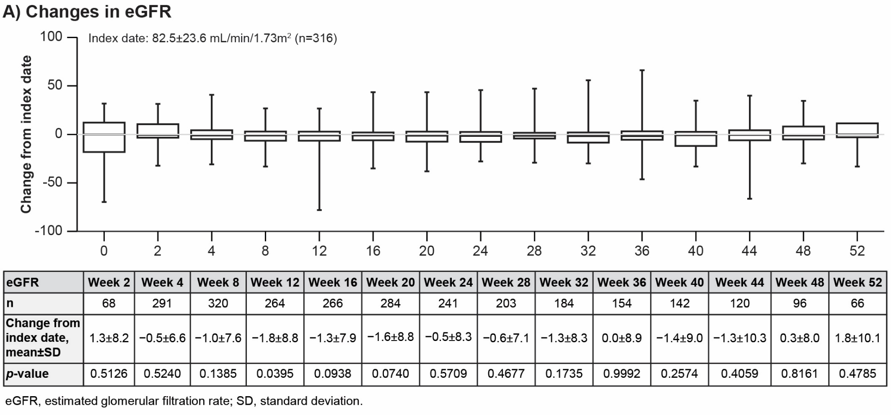
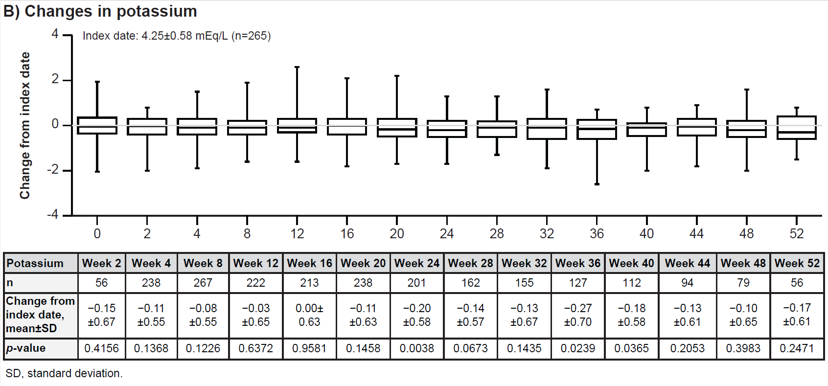
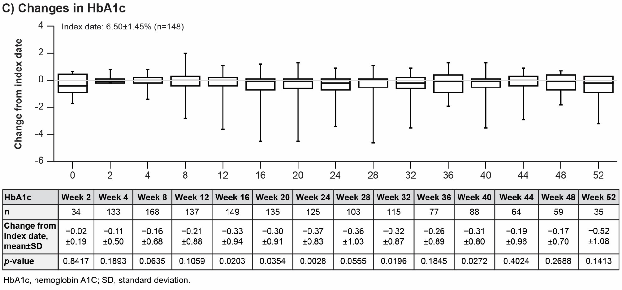
Supplementary Figure 2. Changes in laboratory measures in eligible population from the initiation of Sac/Val prescriptions (index date). A) Changes in eGFR; B) Changes in potassium; C) Changes in HbA1c.

