Supplemental Table 1 Responses of the acceptability questionnaire
Questions from questionnaire | Agree [n (%)]
Overall exercise program
The exercise program was engaging and useful | 5 (83.33)
The exercise program was beneficial for my health | 6 (100)
The exercise program provided helpful exercises I will continue using after it ended | 6 (100)
I enjoyed the combination of in-person, live Zoom, and pre-recorded sessions | 6 (100)
The combination of session types helped me stay active and engaged throughout the program | 5 (83.33)
Specific session
In-person
The format of session was easy to follow | 6 (100)
The format of session was demanding | 2 (33.33)
The format of session was time-consuming | 2 (33.33)
Virtual
The format of session was easy to follow | 6 (100)
The format of session was demanding | 2 (33.33)
The format of session was time-consuming | 2 (33.33)
Pre-recorded
The format of session was easy to follow | 6 (100)
The format of session was demanding | 2 (33.33)
The format of session was time-consuming | 2 (33.33)

Supplemental Table 2 Perceived benefits and barriers to physical activity before and after the rehabilitation program
 | Pre-training |  |  | Post-training
 | Average score  mean ± SD | Agree  n (%) | Disagree  n (%) | Average score  mean ± SD | Agree  n (%) | Disagree  n (%)
Perceived Benefits Item
Life enhancement subscale
My disposition is improved by exercise | 3.50 ± 0.55 | 6 (100.00) | 0 (0.00) | 3.50 ± 0.55 | 6 (100.00) | 0 (0.00)
Exercising helps me sleep better at night | 3.50 ± 0.84 | 5 (83.33) | 1 (16.67) | 3.17 ± 0.75 | 5 (83.33) | 1 (16.67)
Exercise helps me decrease fatigue | 2.67 ± 1.03 | 4 (66.67) | 2 (33.33) | 3.33 ± 0.82 | 5 (83.33) | 1 (16.67)
Exercising improves my self-concept | 3.00 ± 1.10 | 5 (83.33) | 1 (16.67) | 3.33 ± 0.82 | 5 (83.33) | 1 (16.67)
Exercising increases my mental alertness | 3.17 ± 0.75 | 5 (83.33) | 1 (16.67) | 3.17 ± 1.17 | 5 (83.33) | 1 (16.67)
Exercise allows me to carry out normal activities without becoming tired | 3.17 ± 0.75 | 5 (83.33) | 1 (16.67) | 3.17 ± 0.75 | 5 (83.33) | 1 (16.67)
Exercise improves the quality of my work | 3.33 ± 0.52 | 6 (100.00) | 0 (0.00) | 3.17 ± 1.17 | 5 (83.33) | 1 (16.67)
Exercise improves overall body functioning for me | 2.83 ± 1.17 | 3 (50.00) | 3 (50.00) | 3.50 ± 0.84 | 4 (66.67) | 2 (33.33)
Physical performance subscale
Exercise increases my muscle strength | 3.50 ± 0.55 | 6 (100.00) | 0 (0.00) | 3.67 ± 0.52 | 6 (100.00) | 0 (0.00)
Exercising increases my level of physical fitness | 3.50 ± 0.55 | 6 (100.00) | 0 (0.00) | 3.67 ± 0.52 | 6 (100.00) | 0 (0.00)
My muscle tone is improved with exercise | 3.00 ± 1.26 | 4 (66.67) | 2 (33.33) | 3.67 ± 0.52 | 6 (100.00) | 0 (0.00)
Exercising improves functioning of my cardiovascular system | 3.33 ± 0.82 | 5 (83.33) | 1 (16.67) | 3.83 ± 0.41 | 6 (100.00) | 0 (0.00)
Exercise increases my stamina | 3.33 ± 0.82 | 5 (83.33) | 1 (16.67) | 3.67 ± 0.52 | 6 (100.00) | 0 (0.00)
Exercise improves my flexibility | 3.17 ± 1.17 | 5 (83.33) | 1 (16.67) | 3.50 ± 0.55 | 6 (100.00) | 0 (0.00)
My physical endurance is improved by exercising | 3.17 ± 1.17 | 5 (83.33) | 1 (16.67) | 3.67 ± 0.52 | 6 (100.00) | 0 (0.00)
Exercise improves the way my body looks | 3.00 ± 0.63 | 5 (83.33) | 1 (16.67) | 3.50 ± 0.84 | 5 (83.33) | 1 (16.67)
Psychological outlook subscale
I enjoy exercise | 2.83 ± 0.98 | 5 (83.33) | 1 (16.67) | 3.50 ± 0.55 | 6 (100.00) | 0 (0.00)
Exercise decreases feelings of stress and tension for me | 3.00 ± 0.63 | 5 (83.33) | 1 (16.67) | 4.00 ± 0.00 | 6 (100.00) | 0 (0.00)
Exercise improves my mental health | 3.50 ± 0.55 | 6 (100.00) | 0 (0.00) | 4.00 ± 0.00 | 6 (100.00) | 0 (0.00)
Exercise gives me a sense of personal accomplishment | 3.67 ± 0.52 | 6 (100.00) | 0 (0.00) | 3.67 ± 0.52 | 6 (100.00) | 0 (0.00)
Exercising makes me feel relaxed | 3.33 ± 0.52 | 6 (100.00) | 0 (0.00) | 3.00 ± 1.10 | 5 (83.33) | 1 (16.67)
I have improved feelings of well-being from exercise | 3.33 ± 0.82 | 5 (83.33) | 1 (16.67) | 3.33 ± 0.82 | 5 (83.33) | 1 (16.67)
Social interaction subscale
Exercising lets me have contact with friends and persons I enjoy | 2.83 ± 0.98 | 5 (83.33) | 1 (16.67) | 3.00 ± 1.26 | 4 (66.67) | 2 (33.33)
Exercising is a good way for me to meet new people | 2.33 ± 0.82 | 3 (50.00) | 3 (50.00) | 3.17 ± 0.75 | 5 (83.33) | 1 (16.67)
Exercise is good entertainment for me | 3.00 ± 1.10 | 5 (83.33) | 1 (16.67) | 3.67 ± 0.52 | 6 (100.00) | 0 (0.00)
Exercising increases my acceptance by others | 3.00 ± 1.10 | 5 (83.33) | 1 (16.67) | 2.83 ± 1.17 | 4 (66.67) | 2 (33.33)
Preventative health subscale
I will prevent heart attacks by exercising | 3.17 ± 1.17 | 5 (83.33) | 1 (16.67) | 3.67 ± 0.52 | 6 (100.00) | 0 (0.00)
Exercising will keep me from having high blood pressure | 3.17 ± 0.75 | 5 (83.33) | 1 (16.67) | 3.50 ± 1.22 | 5 (83.33) | 1 (16.67)
I will live longer if I exercise | 3.67 ± 0.82 | 5 (83.33) | 1 (16.67) | 3.50 ± 0.84 | 5 (83.33) | 1 (16.67)
Perceived Barriers Item
Exercise environment subscale
Places for me to exercise are too far away | 3.00 ± 1.10 | 5 (83.33) | 1 (16.67) | 3.67 ± 0.52 | 6 (100.00) | 0 (0.00)
I am too embarrassed to exercise | 3.17 ± 1.17 | 5 (83.33) | 1 (16.67) | 3.67 ± 0.52 | 6 (100.00) | 0 (0.00)
It costs too much money to exercise | 3.67 ± 0.52 | 6 (100.00) | 0 (0.00) | 3.33 ± 0.82 | 5 (83.33) | 1 (16.67)
Exercise facilities do not have convenient schedules for me | 3.17 ± 0.75 | 5 (83.33) | 1 (16.67) | 3.50 ± 0.55 | 6 (100.00) | 0 (0.00)
I think people in exercise clothes look funny | 3.17 ± 1.33 | 4 (66.67) | 2 (33.33) | 3.67 ± 0.52 | 6 (100.00) | 0 (0.00)
There are too few places for me to exercise | 3.00 ± 1.10 | 5 (83.33) | 1 (16.67) | 3.67 ± 0.52 | 6 (100.00) | 0 (0.00)
Time expenditure subscale
Exercising takes too much of my time | 3.00 ± 0.00 | 6 (100.00) | 0 (0.00) | 3.33 ± 0.82 | 5 (83.33) | 1 (16.67)
Exercise takes too much time from family relationships | 3.00 ± 0.63 | 5 (83.33) | 1 (16.67) | 3.50 ± 0.55 | 6 (100.00) | 0 (0.00)
Exercise takes too much time from my family responsibilities | 3.17 ± 0.75 | 5 (83.33) | 1 (16.67) | 3.33 ± 0.82 | 5 (83.33) | 1 (16.67)
Physical exertion subscale
Exercise tires me | 2.67 ± 1.03 | 4 (66.67) | 2 (33.33) | 3.50 ± 0.55 | 6 (100.00) | 0 (0.00)
I am fatigued by exercise | 3.17 ± 0.75 | 5 (83.33) | 1 (16.67) | 3.50 ± 0.55 | 6 (100.00) | 0 (0.00)
Exercise is hard work for me | 2.50 ± 0.84 | 4 (66.67) | 2 (33.33) | 3.00 ± 0.89 | 4 (66.67) | 2 (33.33)
Family discouragement subscale
My spouse (or significant other) doesn’t encourage exercising | 3.50 ± 1.22 | 5 (83.33) | 1 (16.67) | 3.00 ± 1.10 | 5 (83.33) | 1 (16.67)
My family members do not encourage me to exercise | 3.50 ± 0.84 | 5 (83.33) | 1 (16.67) | 3.17 ± 1.17 | 5 (83.33) | 1 (16.67)
Assessed by a 4-point Likert Exercise Benefits and Barrier Scale (EBBS).

Supplemental Table 3 Participant perceptions of barriers and facilitators in cardiac rehabilitation
 | Average score  mean ± SD | Agree  n (%) | Disagree  n (%)
Barriers Item
Health status perception
I didn't know about cardiac rehabilitation | 1.33 ± 0.52 | 0 (0.00) | 6 (100.00)
I don't need cardiac rehabilitation | 1.50 ± 0.55 | 0 (0.00) | 6 (100.00)
I already exercise at home or in my community | 2.33 ± 1.75 | 2 (33.33) | 4 (66.67)
My doctor didn't feel it was necessary | 1.33 ± 0.52 | 0 (0.00) | 6 (100.00)
Many people with heart problems don't go, and they are fine | 1.33 ± 0.52 | 0 (0.00) | 6 (100.00)
I can manage my heart problem on my own | 1.67 ± 0.82 | 0 (0.00) | 6 (100.00)
I think I was referred, but the rehab program didn't contact me | 1.17 ± 0.41 | 0 (0.00) | 6 (100.00)
It took too long to get referred and into the program | 1.33 ± 0.52 | 0 (0.00) | 6 (100.00)
I prefer to take care of my health alone, not in a group | 2.00 ± 1.10 | 1 (16.67) | 5 (83.33)
Logistic factors
Distance | 1.33 ± 0.52 | 0 (0.00) | 6 (100.00)
Cost | 1.83 ± 1.17 | 1 (16.67) | 5 (83.33)
Transportation | 1.67 ± 1.21 | 1 (16.67) | 5 (83.33)
Family responsibilities | 2.83 ± 1.72 | 3 (50.00) | 3 (50.00)
Severe weather | 1.33 ± 0.52 | 0 (0.00) | 6 (100.00)
Travel | 1.33 ± 0.52 | 0 (0.00) | 6 (100.00)
Work/time conflicts
Time constraints | 3.17 ± 0.75 | 2 (33.33) | 4 (66.67)
Work responsibilities | 2.00 ± 1.10 | 1 (16.67) | 5 (83.33)
Functional status
I find exercise tiring and/or painful | 1.83 ± 1.17 | 1 (16.67) | 5 (83.33)
I don't have energy | 1.50 ± 0.55 | 0 (0.00) | 6 (100.00)
Other health problems prevent me from going | 1.83 ± 0.75 | 0 (0.00) | 6 (100.00)
I am too old | 1.50 ± 0.55 | 0 (0.00) | 6 (100.00)
Facilitators Item
Accessibility
Having the cardiac rehabilitation program closer to my home | 4.33 ± 0.82 | 5 (83.33) | 1 (16.67)
Receiving the sessions in tele-health/web-based format | 3.67 ± 1.86 | 5 (83.33) | 1 (16.67)
Receiving financial aid to cover the transport fees | 3.83 ± 1.60 | 4 (66.67) | 2 (33.33)
Support
Receiving encouragement from hospital nurse/physician to attend this program | 3.67 ± 1.97 | 4 (66.67) | 2 (33.33)
Motivation
Starting the program within 2 weeks after my discharge from the hospital | 2.67 ± 1.51 | 3 (50.00) | 3 (50.00)
Receiving rewards for completing a given number of sessions | 2.83 ± 1.60 | 2 (33.33) | 4 (66.67)
Program Content
Receiving nutritional assessment and "how-to-cook" classes | 3.83 ± 1.94 | 5 (83.33) | 1 (16.67)
Receiving psychological assessment and specific counselling | 3.33 ± 1.97 | 3 (50.00) | 3 (50.00)
Receiving stress management classes | 3.83 ± 1.60 | 4 (66.67) | 2 (33.33)
Having received dance classes as exercise interventions | 2.33 ± 1.63 | 1 (16.67) | 5 (83.33)
Assessed by a 5-point Likert Cardiac Rehabilitation Barriers Scale (CRBS) and Cardiac Rehabilitation Facilitators Scale (CRFS).

(a) 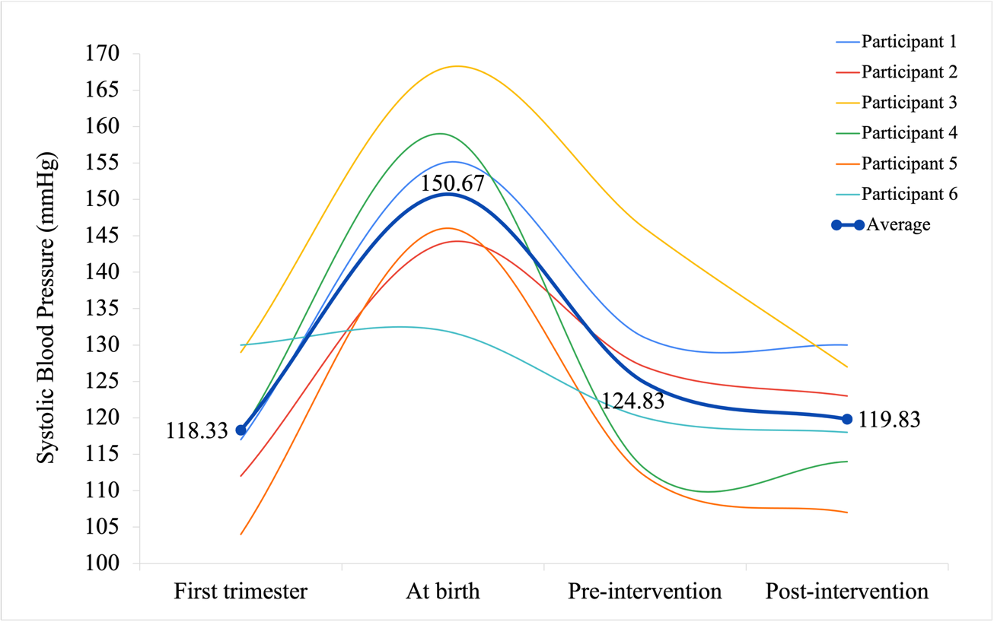
(b) 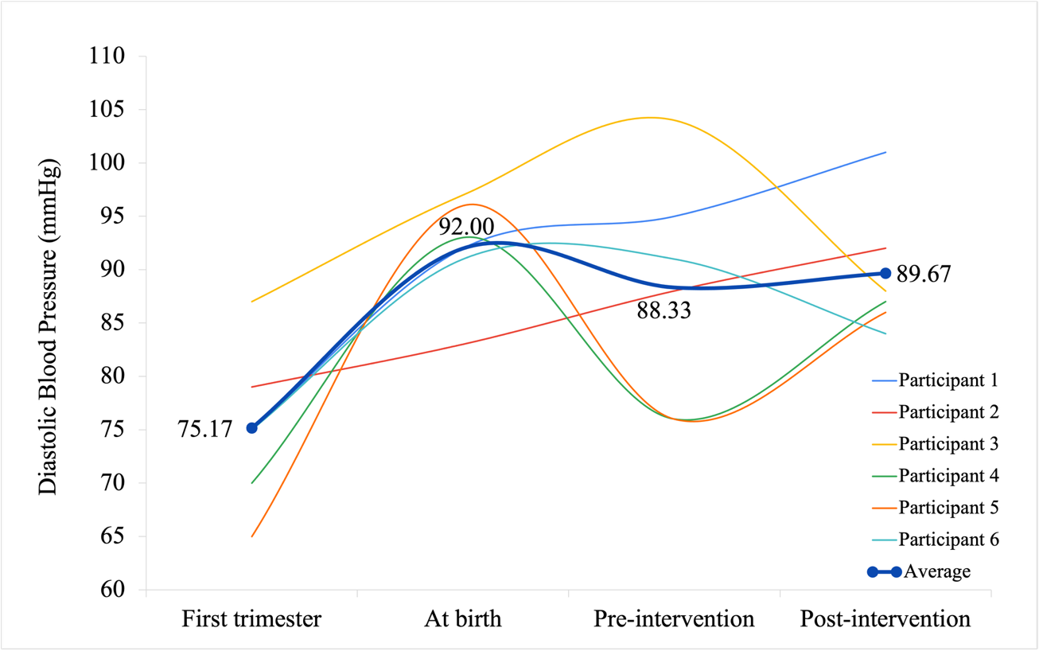

Supplemental Figure 1 Individual trajectories of (a) systolic and (b) diastolic blood pressure

