Supplementary material
Table S1. Search strategy for each database.
Table S2. Qualitative analysis of included publications.
Table S3. Sensitivity analyses and publication-bias statistics by outcome.
Figure S1. Traffic light plot.
Figure S2. Summary plot.
Figure S3. Funnel plot of effect sizes for office SBP.
Figure S4. Funnel plot of effect sizes for office DBP.
Figure S5. Funnel plot of effect sizes for 24h ASBP.
Figure S6. Funnel plot of effect sizes for daytime ASBP.
Figure S7. Funnel plot of effect sizes for nighttime ASBP.
Figure S8. Funnel plot of effect sizes for 24h ADBP.
Figure S9. Funnel plot of effect sizes for daytime ADBP.
Figure S10. Funnel plot of effect sizes for nighttime ADBP.
Figure S11. Funnel plot of effect sizes for body weight.
Figure S12. Funnel plot of effect sizes for BMI.
Figure S13. Funnel plot of effect sizes for total cholesterol.
Figure S14. Funnel plot of effect sizes for HDL-c.
Figure S15. Funnel plot of effect sizes for LDL-c.
Figure S16. Funnel plot of effect sizes for triglycerides.
Figure S17. Funnel plot of effect sizes for VO₂peak relative.
Figure S18. Meta-regression examining the association between percentage of participants taking ACE inhibitors and effect sizes for office DBP.
Figure S19. Forest plot of effect sizes for office MAP.
Figure S20. Forest plot of effect sizes for 24h ASBP.
Figure S21. Forest plot of effect sizes for daytime ASBP.
Figure S22. Forest plot of effect sizes for nighttime ASBP.
Figure S23. Forest plot of effect sizes for 24h ADBP.
Figure S24. Forest plot of effect sizes for daytime ADBP.
Figure S25. Forest plot of effect sizes for nighttime ADBP.
Figure S26. Meta-regression examining the association between percentage of participants taking diuretics and effect sizes for 24h ADBP.
Figure S27. Meta-regression examining the association between percentage of participants taking CCBs and effect sizes for 24h ADBP.
Figure S28. Forest plot of effect sizes for 24h MAP.
Figure S29. Forest plot of effect sizes for daytime MAP.
Figure S30. Forest plot of effect sizes for nighttime MAP.
Figure S31. Forest plot of effect sizes for body weight.
Figure S32. Forest plot of effect sizes for BMI.
Figure S33. Forest plot of effect sizes for body fat percentage.
Figure S34. Forest plot of effect sizes for waist circumference.
Figure S35. Forest plot of effect sizes for HDL-c.
Figure S36. Forest plot of effect sizes for triglycerides.
Figure S37. Forest plot of effect sizes for total cholesterol.
Figure S38. Forest plot of effect sizes for LDL-c.
Figure S39. Forest plot of effect sizes for fasting glucose.
Figure S40. Forest plot of effect sizes for HbA1c.
Figure S41. Forest plot of effect sizes for VO₂peak relative.

Table S1. Search strategy for each database.
Database | Search strategy
Pubmed | (exercise[Title] OR "physical activity"[Title] OR training[Title] OR rehabilitation[Title]) AND (hypertens*[Title] OR antihypertens*[Title] OR "blood pressure"[Title]) AND (random*[Title/Abstract] OR control*[Title/Abstract]).
Web of Science | TI=(exercise OR “physical activity” OR training OR rehabilitation) AND TI=(hypertens* OR antihypertens* OR “blood pressure”) AND (TI=(random* OR control*) OR AB=(random* OR control*))
Scopus | TITLE(exercise OR “physical activity” OR training OR rehabilitation) AND TITLE(hypertens* OR antihypertens* OR “blood pressure”) AND TITLE-ABS(random* OR control*)

Table S2. Qualitative analysis of included publications.
Study information | Publications | Participants | Pharmacological treatment | Intervention (FITT principle) | Measurement methods | Outcomes
Egypt | Abd Elwahaab et al., 2019 | N(M/F): 50(50/0)  Age: 60.88 ± 2.27  IG/CG: 25/25 | Not reported | IG: 8-week aerobic training at moderate intensity (3x/wk, 30-40’/session).  CG: usual care. | Auscultatory method (mercury sphygmomanometer) / mean of 3 readings | ↓ office SBP, ↓ office DBP
Brazil | Abrahin et al., 2022 | N(M/F): 41(10/31)  Age: 66.52 ± 5.71  IG1/IG2/CG: 10/10/21 | 71% ARBs, 32% diuretics, 27% β-blockers, 15% ACEi, 10% CCBs | IG1: 12-week supervised resistance training (3x/wk, 30-40’/session).  IG2: 12-week supervised aerobic training at 60-75% HRpeak (3x/wk, 30-40’/session).  CG: usual care. | Automated oscillometric device/ mean of 2 readings, blood analysis | ↓ office SBP, ↔ office DBP, ↔ total cholesterol, ↔ HDL-c, ↔ LDL-c, ↔ triglycerides, ↔ ratio triglycerides/HDL-c, ↔ fasting glucose, ↔ HbA1c
Brazil | Abrahin et al., 2024 | N(M/F): 52(13/39)  Age: 66.11 ± 5.52  IG/CG: 27/25 | 72% ARBs, 35% ACEi, 25% β-blockers, 15% diuretics, 10% CCBs | IG: 12-week supervised progressive resistance training at 70-85% 1RM (3x/wk, 30-40’/session).  CG: usual care. | Automated oscillometric device/ mean of 2 readings, blood analysis | ↓ office SBP, ↔ office DBP, ↔ total cholesterol, ↔ HDL-c, ↔ LDL-c, ↔ triglycerides, ↔ total cholesterol/HDL-c, ↔ LDL-c/HDL-c, ↔ triglycerides/HDL-c, ↔ fasting glucose
NCT03791307  Brazil | Almeida et al., 2022a  Almeida et al., 2022b | N(M/F): 60(0/60)  Age: 50.1 ± 6.2  IG1/IG2/CG: 20/20/20 | 70% ARBs, 63% diuretics, 28% β-blockers, 23% CCBs, 8% ACEi | IG1: 16-week pilates exercises at 11-15 Borg scale and aerobic training at 80-95% of the VT2 (2x/wk, 40-50’/session).  IG2: 16-week pilates exercises at 11-15 Borg scale (2x/wk, 40-50’/session).  CG: usual care. | Automated oscillometric device/ mean of 3 readings, 24-h ambulatory oscillometric monitoring, sit and reach test, hand dynamometer, CPET | ↔ SBP, ↔ DBP, ↔ mean BP, ↔ 24h SBP, ↔ 24h DBP, ↔ 24h mean BP, ↔ awake SBP, ↔ awake DBP, ↔ awake mean BP, ↔ asleep SBP, ↔ asleep DBP, ↔ asleep mean BP, ↔ body weight, ↔ BMI, ↔ waist circumference, ↔ hip circumference, ↔ waist-to-hip ratio, ↔ relative VO₂peak
ISRCTN50726324  Saudi Arabia | Alzahrani et al., 2023 | N(M/F): 24(19/5)  Age: 74.4 ± 8.4  IG/CG: 12/12 | Not reported | IG: 8-week supervised aerobic training at 50% HRpeak (3x/wk, 45’/session).  CG: usual care. | Auscultatory method (mercury sphygmomanometer, mean of 2 readings), scale, blood analysis | ↓ office SBP, ↓ office DBP, ↓ BMI, ↓ total cholesterol, ↔ HDL-c, ↓ LDL-c
Egypt | Ammar et al., 2015 | N(M/F): 45(0/45)  Age: 52.87 ± 1.87  IG1/IG2/CG: 15/15/15 | 100% ACEi | IG1: 3-month supervised morning aerobic training at 60-75% HRpeak (3x/wk, 30’/session).  IG2: 3-month supervised afternoon aerobic training at 60-75% HRpeak (3x/wk, 30’/session).  CG: usual care. | Auscultatory method (mercury sphygmomanometer, mean of 2 readings), blood analysis | ↓ office SBP, ↓ office DBP, ↓ total cholesterol, ↑ HDL-c, ↓ LDL-c, ↓ triglycerides
Iran | Arazi et al., 2020 | N(M/F): 20(0/20)  Age: 58.55 ± 3.31  IG/CG: 10/10 | Not reported | IG: 8-week water-based aerobic training at 60-75% HRpeak (2x/wk, 50-60’/session).  CG: usual care. | Auscultatory method (mercury sphygmomanometer, mean of 3 readings), skinfold calipers, Rockport 1-mile walk test | ↓ office SBP, ↔ office DBP, ↔ office MAP, ↔ body weight, ↔ BMI, ↓ body fat percentage, ↔ fat-free mass, ↑ VO₂peak relative
Brazil | Arca et al., 2014 | N(M/F): 52(0/52)  Age: 64 ± 7  IG1/IG2/CG: 19/19/14 | Not reported | IG1: 12-week aerobic training at 50-60% HRR (3x/wk, 50’/session).  IG2: 12-week water exercises (3x/wk, 50’/session).  CG: usual care. | Auscultatory method (mercury sphygmomanometer)/ mean of 2 readings, blood analyses | ↔ office SBP, ↔ office DBP, ↔ body weight, ↔ BMI, ↔ hip circumference, ↔ waist circumference, ↔ waist to hip ratio, ↔ total cholesterol, ↔ HDL-C, ↔ LDL-c, ↔VLDL, ↔ triglycerides
U1111-1242–4972  Brazil | Azêvedo et al., 2025 | N(M/F): 54(34/20)  Age: 66.96 ± 5.67  IG1/IG2/CG: 19/18/17 | 74% ARBs, 19% ACEi, 33% CCBs, 48% diuretics | IG1: 10-week morning aerobic training at moderate intensity (3x/wk, 30-45’/session).  IG2: 10-week evening aerobic training at moderate intensity (3x/wk, 30-45’/session).  CG: passive stretching. | Auscultatory method (mercury sphygmomanometer)/ mean of 3 readings, scale, CPET | ↔ office SBP, ↔ office DBP, ↔ office MAP, ↔ BMI, ↑ VO₂peak relative
Iran | Bahmanbeglou et al., 2019 | N(M/F): 30(30/0)  Age: 47.93 ± 4.33  IG1/IG2/CG: 10/10/10 | ARBs or CCBs | IG1: 8-week short-duration HIIT at 80-100% of VO₂peak (3x/wk).  IG2: 8-week long-duration HIIT at 75-90% of VO₂peak (3x/wk).  CG: usual care. | Automated oscillometric device, blood analysis | ↓ office SBP, ↓ office DBP, ↔ body weight, ↔ total cholesterol, ↔ HDL-c, ↔ LDL-c, ↓ triglycerides
Brazil | Baruki et al., 2022 | N(M/F): 29(1/28)  Age: 56.06 ± 10.3  IG1/IG2/CG: 10/10/9 | Not reported | IG1: 16-week aerobic training at 40-70% HRR and resistance exercises in circuit (3x/wk, 50-60’/session).  IG2: 16-week aerobic training at 40-70% HRR and resistance exercises in sets (3x/wk, 50-60’/session).  CG: usual care. | Not reported | ↔ office SBP, ↓ office DBP, ↓ body weight, ↓ BMI, ↔ waist circumference, ↔ hip circumference
Brazil | Bertani et al., 2018 | N(M/F): 61(20/41)  Age: 67.43 ± 5.55  IG1/IG2/IG3/CG: 15/15/16/15 | Not reported | IG1: 12-week continuous aerobic training at 70% HRpeak (3x/wk, 30’/session).  IG2: 12-week interval aerobic training at 60-80% HRpeak (3x/wk, 30’/session).  IG3: 12-week resistance training at 75% 1RM (3x/wk).  CG: usual care. | 24-h ambulatory oscillometric monitoring | ↔ 24h ASBP, ↔ daytime ASBP, ↔ nighttime ASBP, ↔ 24h ADBP, ↔ daytime ADBP, ↔ nighttime ADBP, ↔ fall in SBP during nighttime compared with daytime, ↔ fall in DBP during nighttime compared with daytime
NCT03282942  Brazil | Boeno et al., 2020 | N(M/F): 42(19/23)  Age: 45.5 ± 7.2  IG1/IG2/CG: 15/15/12 | Mean of AH: 1.5  60% ARBs, 40% diuretics, 26% ACEi, 21% β-blockers, 5% CCBs | IG1: 12-week supervised aerobic training 60-80% HRR (3x/wk).  IG2: 12-week supervised resistance training (3x/wk).  CG: usual care. | Automated oscillometric device, 24-h ambulatory oscillometric monitoring, ultrasound images, CPET, blood analysis | ↓ office SBP, ↓ office DBP, ↓ 24h ASBP, ↔ 24h ADBP, ↓ daytime ASBP, ↓ daytime ADBP, ↔ nighttime ASBP, ↔ nighttime ADBP, ↔ body weight, ↔ BMI, ↔ waist circumference, ↔ biceps thickness, ↑ quadriceps thickness, ↓ total cholesterol, ↔ HDL-c, ↓ LDL-c, ↑ triglycerides, ↔ fasting glucose, ↔ VO₂peak relative
U1111-1182-4500  Brazil | Brito et al., 2018  Brito et al., 2021 | N(M/F): 50(50/0)  Age: 50 ± 8.2  IG1/IG2/CG: 15/15/20 | 48% ARBs, 40% ACEi, 22% CCBs, 24% diuretics | IG1: 10-week morning aerobic training at moderate intensity (3x/wk, 45’/session).  IG2: 10-week evening aerobic training at moderate intensity (3x/wk, 45’/session).  CG: stretching exercises. | Auscultatory method (mercury sphygmomanometer), 24-h ambulatory oscillometric monitoring, CPET | ↓ office SBP, ↓ office DBP, ↓ office MAP, ↔ 24h ASBP, ↔ daytime ASBP, ↔ nighttime ASBP, ↓ 24h ADBP, ↔ daytime ADBP, ↔ nighttime ADBP, ↔ body weight, ↑ VO₂peak relative
NCT02348138  Brazil | Cahu Rodrigues et al., 2019 | N(M/F): 33(11/22)  Age: 61 ± 2  IG/CG: 17/16 | 76% ARBs, 49% diuretics, 21% β-blocker, 16% CCBs, 15% ACEi | IG: 12-week isometric handgrip training (IHT) at 30% MVC (3x/wk).  CG: usual care. | Automated oscillometric device/mean of 2 measurements, CPET | ↓ office SBP, ↓ office DBP
Brazil | Cardoso et al., 2014 | N(M/F): 43(0/43)  Age: 49.05 ± 8.71  IG/CG: 20/23 | ACEi, β-blockers or diuretics | IG: 12-week resistance training at 50-80% of 10RM.  CG: usual care. | Auscultatory method | ↔ office SBP, ↔ office DBP
Brazil | Cezar et al., 2016 | N(M/F): 23(0/23)  Age: 60.1 ± 11.1  IG1/IG2/CG: 8/8/7 | Not reported | IG1: 8-week supervised high intensity resistance training at 80% 1RM (2x/wk).  IG2: 8-week supervised low-intensity resistance training with occlusion at 30% 1RM (2x/wk).  CG: usual care. | Auscultatory method (mercury sphygmomanometer) | ↓ office SBP, ↓ office DBP, ↓ office MAP
HEx trial  NCT01863082  Italy | Cruz et al., 2017 | N(M/F): 44(23/21)  Age: 53.3 ± 0.9  IG/CG: 28/16 | 100% diuretics, 78% CCBs, 62% ACEIs, 27% ARBs, 63% β-blockers, 42% vasodilators, 28% central sympatholytics | IG: 12-week water-based exercise (3x/wk).  CG: usual care. | Automated oscillometric device/ mean of 3 readings, 24-h ambulatory oscillometric monitoring, CPET | ↓ office SBP, ↓ office DBP, ↓ 24h ASBP, ↓ daytime ASBP, ↓ nighttime ASBP, ↓ 24h ADBP, ↓ daytime ADBP, ↓ nighttime ADBP, ↑ VO₂peak relative
Ethiopia | Daimo et al., 2020 | N(M/F): 24(24/0)  Age: 38.01 ± 4.15  IG/CG: 12/12  All of them on monotherapy | Not reported | IG: 16-week supervised aerobic training at 30-60% HRR (3x/wk, 30-45’/session).  CG: usual care. | Automated oscillometric device/ mean of 3 readings | ↓ office SBP, ↓ office DBP
RBR-5CGP6H.  Brazil | De Oliveira et al., 2019 | N(M/F): 23(15/8)  Age: 62.76 ± 5.69  IG/CG: 13/10 | 50% diuretics, 50% ARBs, 50% ACEi | IG: 8-week supervised aerobic training at 70-85% HRR and resistance training at RPE 5-7 (3x/wk, 70’/session).  CG: usual care. | Automated oscillometric device/ mean of 3 readings, DXA, CPET | ↓ office SBP, ↔ office DBP, ↔ office MAP, ↑ VO₂peak relative
Brazil | Dos Santos et al., 2015 | N(M/F): 34(not reported)  Age: 47.94 ± 8.19  IG1/IG2/CG: 12/12/10 | Not reported | IG1: 8-week aerobic training at 65-70% HRR (3x/wk, 40’/session).  IG2: 8-week aerobic training at 80-85% HRR (3x/wk, 40’/session).  CG: usual care. | 24-h ambulatory oscillometric monitoring | ↔ daytime ASBP, ↔ nighttime ASBP, ↔ daytime ADBP, ↓ nighttime ADBP
NCT02348138  Brazil | Farah et al., 2018 | N(M/F): 48(14/34)  Age: 59.42 ± 2.67  IG1/IG2/CG: 14/18/16 | 35% ARBs, 26% diuretics, 17% ACEi, 11% beta-blockers, 10% CCBs | IG1: 12-week supervised isometric handgrip training at 30% MVC (3x/wk).  IG2: 12-week home-based isometric handgrip training at 30% MVC (3x/wk).  CG: usual care. | Automated oscillometric device, 24-h ambulatory oscillometric monitoring | ↓ office SBP, ↓ office DBP, ↔ 24h ASBP, ↔ 24h ADBP, ↔ 24h MAP, ↔ daytime ASBP, ↔ daytime ADBP, ↔ daytime MAP, ↔ nighttime ASBP, ↔ nighttime ADBP, ↔ nighttime MAP
RBR-4fgknb  Brazil | Fecchio et al., 2023  Silva de Sousa et al, 2024 | N(M/F): 62(62/0)  Age: 52.76 ± 8.91  IG1/IG2/IG3/CG: 16/15/15/16 | 71% ARBs, 37% CCBs, 34% diuretics, 18% ACEi | IG1: 10-week dynamic resistance training at >50% 1RM (3x/wk).  IG2: 10-week isometric handgrip training at 30% MVC (3x/wk).  IG3: 10-week IG1 + IG2 (3x/wk).  CG: stretching exercises (3x/wk, 30’/session). | Auscultatory method (aneroid sphygmomanometer), 24-h ambulatory oscillometric monitoring | ↓ office SBP, ↔ office DBP, ↔ 24h ASBP, ↔ 24h ADBP, ↔ daytime ASBP, ↔ daytime ADBP, ↔ nighttime ASBP, ↔ nighttime ADBP
RBR-3xnqxs8  Brazil | Ferreira et al., 2024 | N(M/F): 65(0/65)  Age: 58.24 ± 6.2  IG/CG: 51/14 | Not reported | IG: 12-week supervised aerobic training at 60-70% HRR (3x/wk, 50’/session).  CG: usual care. | Scale, plethysmography, auscultatory method, CPET | ↔ office SBP, ↔ office DBP, ↔ office MAP, ↔ body weight, ↔ BMI, ↔ body fat percentage, ↔ total cholesterol, ↔ LDL-c, ↔ HDL-c, ↔ triglycerides, ↓ fasting glucose, ↑ VO₂peak relative
Iran | Ghardashi-Afousi et al., 2025 | N(M/F): 80(46/34)  Age: 59.81 ± 6.17  IG/CG: 40/40 | 54% diuretics, 40% ACEi or ARBs, 34% β-blockers, 29% CCBs | IG: 12-week supervised HIIT at 85-90% HRR(3x/wk).  CG: usual care. | Automated oscillometric device/ mean of 3 readings, CPET | ↓ office SBP, ↓ office DBP, ↓ body weight, ↓ BMI, ↑ VO₂peak relative
Brazil | Guimarães et al., 2010 | N(M/F): 43(13/30)  Age: 47.4 ± 8.1  IG1/IG2/CG: 16/16/11 | 59% diuretics, 40% ACEi, 34% β-blockers, 4% CCBs | IG1: 16-week semi-supervised continuous aerobic (60% HRR) and resistance training (3x/wk, 80’/session).  IG1: 16-week semi-supervised interval (50-80% HRR) and resistance training (3x/wk, 80’/session).  CG: usual care. | Automated oscillometric device, 24-h ambulatory oscillometric monitoring, CPET | ↔ office SBP, ↔ office DBP, ↔ 24h ASBP, ↔ daytime ASBP, ↔ nighttime ASBP, ↔ 24h ADBP, ↔ daytime ADBP, ↔ nighttime ADBP, ↔ BMI, ↔ waist circumference
China | He et al., 2018 | N(M/F): 42(0/42)  Age: 57.5 ± 2  IG/CG: 20/22 | Not reported | IG: 12-week brisk walking (3x/wk, 60’/session).  CG: usual care. | Automated oscillometric device, CPET | ↓ office SBP, ↔ office DBP, ↓ body weight, ↓ BMI, ↓ body fat percentage, ↑ VO₂peak relative
IRCT2016092823002N3  Iran | Izadi et al., 2018 | N(M/F): 30(17/13)  Age: 61.7 ± 5.8  IG/CG: 15/15 | 57% diuretics, 37% ACEi, 30% β-blockers, 20% CCB | IG: 6-week supervised HIIT at 85-90% HRR (3x/wk).  CG: usual care. | Automated oscillometric device, BIA, CPET, blood analysis | ↓ office SBP, ↓ office DBP, ↑ VO₂peak relative
Thailand | Janmoon et al., 2020 | N(M/F): 20(0/20)  Age: 50.8 ± 3.3  IG/CG: 10/10 | Not reported | IG: 6-week ball exercises (3x/wk, 55’/session).  CG: usual care. | Automated oscillometric device/ mean of 2 readings | ↓ office SBP, ↓ office DBP
Korea | Jo et al., 2025 | N(M/F): 75(20/55)  Age: 61.14 ± 10.64  IG1/IG2/CG: 22/29/24 | Mean of AH: 1  100% ARBs | IG1: 3-month supervised treadmill walking at 60-80% HRR (50’/session).  IG2: 3-month supervised exergame (40’/session).  CG: usual care. | Blood analysis | ↔ office SBP, ↔ office DBP, ↔ BMI, ↔ total cholesterol, ↔ HDL-c, ↔ LDL-c, ↔ triglycerides, ↔ fasting glucose, ↔ HbA1c
CTRI/2022/11/047530  India | Kumar et al., 2025 | N(M/F): 40 (not reported)  Age, median (IQR): 27 (4)  IG1/IG2/IG3/CG: 10/10/10/10 | Not reported | IG1: 6-week aerobic training at 60-80% of HRpeak (4x/wk, 30’/session).  IG2: 6-week isometric handgrip exercise at 30% of MVC (4x/wk).  IG3: 6-week yoga therapy (30’/session).  CG: usual care. | Not reported | ↓ office SBP, ↓ office DBP
367/CEP/CSEFMRP-  USP  Brazil | Lima et al., 2015  Lima et al., 2017 | N(M/F): 44(5/39)  Age: 68.5 ± 5.1  IG1/IG2/CG: 15/15/14 | Diuretics, ACEi, ARBs | IG1: 10-week supervised aerobic training (3x/wk, 30’/session).  IG2: 10-week supervised resistance (50-60% 1RM) and aerobic training (3x/wk, 30’/session).  CG: usual care. | BIA, 24-h ambulatory oscillometric monitoring, OGTT with insulin determination | ↓ 24h ASBP, ↓ 24h ADBP, ↓ daytime ASBP, ↓ daytime ADBP, ↓ nighttime ASBP, ↓ nighttime ADBP, ↓ BMI, ↓ fat mass, ↔ lean mass, ↓ abdominal circumference, ↔ waist circumference, ↔ AUC glucose, ↔ AUC insulin, ↔ HOMA-IR, ↔ HOMA beta, ↔ IS-OGTT
EnRicH trial  NCT03090529  Portugal | Lopes et al., 2021  Lopes et al., 2023 | N(M/F): 53(29/24)  Age: 60.1 ± 8.7  IG/CG: 26/27 | Mean of AH: 4.65 ± 0.75  100% diuretics, 100% vasodilators, 98% ACEi or ARBs, 98% CCBs, 60% β-blockers | IG: 12-week supervised aerobic training at 50-70% of VO₂peak (3x/wk, 60’/session).  CG: usual care. | 24-h ambulatory oscillometric monitoring, automated oscillometric device (mean of 2 readings), Chester Step Test, BIA, blood analysis | ↓ office SBP, ↔ office DBP, ↓ office MAP, ↓ 24h ASBP, ↓ 24h ADBP, ↓ 24h MAP, ↓ daytime ASBP, ↓ daytime ADBP, ↓ daytime MAP, ↔ nighttime ASBP, ↔ nighttime ADBP, ↔ nighttime MAP, ↓ central systolic BP, ↔ BP variability, ↔ weight, ↔ BMI, ↔ body fat percentage, ↔ fat free mass percentage, ↔ total cholesterol, ↔ HDL-c, ↔ LDL-c, ↔ triglycerides, ↔ fasting glucose, ↔ HbA1c, ↑ VO₂peak relative
China | Lu et al., 2024 | N(M/F): 70(52/18)  Age: 45.79 ± 2.17  IG/CG: 35/35 | Mean of AH: 2.4 ± 0.93 | IG: 12-week walking at 40-60% of VO₂peak (5x/wk, 40’/session).  CG: usual care. | 24-h ambulatory oscillometric monitoring, CPET, blood analyses | ↓ office SBP, ↔ office DBP, ↑ 24h ASBP, ↓ 24h ADBP, ↑ daytime ASBP, ↓ daytime ADBP, ↓ nighttime ASBP, ↓ nighttime ADBP, ↔ BMI, ↓ total cholesterol, ↓ LDL-c, ↓ triglycerides, ↔ VO₂peak relative
IRCT20160317027092N2  Iran | Masoudi et al., 2022 | N(M/F): 46(46/0)  Age: 48 ± 9  IG1/IG2/CG: 16/15/15 | Not reported | IG1: 10-week gym-based moderate-intensity resistance training at 60-80% 1RM and aerobic training at 40-60% HRR (4x/wk).  IG2: 10-week home-based moderate-intensity resistance and aerobic training (4x/wk).  CG: usual care. | Blood analysis | ↓ total cholesterol, ↔ HDL-c, ↓ LDL-c, ↔ triglycerides
China | Mengzhen et al., 2021 | N(M/F): 60(41/19)  Age: not reported  IG/CG: 30/30 | Not reported | IG: 12-week aerobic training at 40-60% VO₂peak and resistance training at 60-80% 1RM (3-5x/wk, 30-60’/day).  CG: usual care. | 24-h ambulatory oscillometric monitoring, CPET | ↓ office SBP, ↓ office DBP, ↓ 24h ASBP, ↓ 24h ADBP, ↓ daytime ASBP, ↓ daytime ADBP, ↓ nighttime ASBP, ↓ nighttime ADBP, ↓ BMI, ↑ VO₂peak relative
Germany | Pagonas et al., 2014  Dimeo et al., 2012 | N(M/F): 72(31/41)  Age (median and range): 66.5 (42-79)  IG/CG: 36/36 | Median of AH: 4(1-7)  60% CCBs, 60% diuretics, 58% β-blocker, 50% ARBs, 35% ACEi | IG: 8-12 week supervised aerobic training (3x/wk, 30’/session).  CG: usual care. | Mean of 3 readings, 24-h ambulatory oscillometric monitoring, CPET | ↔ office SBP, ↔ office DBP, ↓ 24h ASBP, ↓ 24h ADBP, ↓ daytime ASBP, ↓ daytime ADBP, ↔ nighttime ASBP, ↔ nighttime ADBP, ↔ body weight, ↔ BMI, ↑ VO₂peak relative
NCT03216317  Brazil | Palmeira et al., 2021 | N(M/F): 31(9/22)  Age: 53.6 ± 2.2  IG/CG: 15/16 | 73% ARBs, 64% diuretics, 18% ACEi, 15% β-blocker, 3% CCBs | IG: 12-week isometric handgrip training at 30% of MVC (3x/wk).  CG: encouragement to increase physical activity level. | Oscillometric automated device, 24-h ambulatory oscillometric monitoring | ↓ office SBP, ↔ office DBP, ↔ 24h ASBP, ↔ 24h ADBP, ↔ daytime ASBP, ↔ daytime ADBP, ↔ nighttime ASBP, ↔ nighttime ADBP
RBR-867mysf  Brazil | Pinheiro et al., 2024 | N(M/F): 15(2/13)  Age: 70.1 ± 6.3  IG/CG: 8/7 | Antihypertensives (mean ± SD): (3.34 ± 0.46)  100% diuretics, 100% CCB, 80% ARBs, 40% adrenergic inhibitors, 20% ACEi | IG: 8-week mobility and resistance training (3x/wk, 60’/session).  CG: usual care. | Senior Fitness Test | ↓ 24h SBP, ↓ 24h DBP, ↓ daytime SBP, ↓ daytime DBP, ↓ nighttime SBP, ↓ nighttime DBP, ↔ flexibility, ↑ 6MWD
Brazil | Polito et al., 2020 | N(M/F): 38(17/21)  Age: 57.23 ± 2  IG1/IG2/CG: 14/12/12 | 58% ARBs, 42% ACEi | IG1: 12-week one-set resistance training at 5-7 OMNI scale (3x/wk,  IG2: 12-week three-set resistance training at 5-7 OMNI scale (3x/wk,  CG: passive low-intensity stretching exercises. | Scale, automated oscillometric device (mean of 3 readings) | ↓ office SBP, ↓ office DBP, ↔ body weight
India | Saini & Malhotra, 2025 | N(M/F): 30(0/30)  Age: 44.3  IG1/IG2/CG: 10/10/10 | Not reported | IG1: 6-week aerobic training at moderate intensity (3x/wk, 30-40’/session).  IG2: 6-week HIIT (3x/wk, 30-40’/session).  CG: usual care. | Not reported | ↓ office SBP, ↓ office DBP, ↓ BMI
RBR-3h5394  Brazil | Sócrates et al., 2020 | N(M/F): 32(0/32)  Age: 64.4 ± 3.6  IG/CG: 15/17 | 75% ARBs, 35% diuretics, 23% β-blocker, 20% ACEi, 10% CCBs | IG: 8-week aerobic training at self-selected intensity (3x/wk, 30-50’/session).  CG: health education meetings once per week. | 24-h ambulatory oscillometric monitoring | ↔ 24h ASBP, ↔ daytime ASBP, ↔ nighttime ASBP, ↔ 24h ADBP, ↔ daytime ADBP, ↔ nighttime ADBP
Canada | Stiller-Moldovan et al., 2012  Bartol et al., 2012 | N(M/F): 20(10/10)  Age: 61.22 ± 7.46  IG/CG: 11/9 | Mean of AH: 2.6  45% diuretics, 35% ACEi, 35% ARBs, 35% β-blockers, 20% CCBs | IG: 8-week semi-supervised isometric handgrip training at 30% MVC (3x/wk).  CG: usual care. | Automated oscillometric device (mean of 3 readings), 24-h ambulatory oscillometric monitoring | ↔ office SBP, ↔ office DBP, ↔ 24h ASBP, ↔ daytime ASBP, ↔ nighttime ASBP, ↔ 24h ADBP, ↔ daytime ADBP, ↔ nighttime ADBP, ↔ 24h MAP, ↔ daytime MAP, ↔ nighttime MAP
NCT04862754  Egypt | Taha et al., 2023 | N(M/F): 60(0/60)  Age: 48.64 ± 4.01  IG/CG: 30/30 | 53% ACEI/ARBs, 37% β-blockers, 10% CCBs | IG: 12-week supervised HIIT with bouts at 85-90% or HRpeak (3x/wk).  CG: usual care. | Automated oscillometric device, blood analysis | ↓ office SBP, ↓ office DBP, ↓ total cholesterol, ↑ HDL-c, ↓ LDL-c, ↓ triglycerides
NCT03551119  Canada | Thompson et al., 2022 | N(M/F): 44(28/16)  Age: 69 [56, 73]  IG/CG: 21/23 | Median of AH: 2 (1 – 3.54) | IG: 24-week semi-supervised aerobic training at 30-59% HRR (3x/wk).  CG: usual care. | 24-h ambulatory oscillometric monitoring, automated oscillometric device (mean of 3 readings), CPET | ↔ office SBP, ↔ office DBP, ↔ 24h ASBP, ↔ daytime ASBP, ↔ nighttime ASBP, ↔ 24h ADBP, ↔ daytime ADBP, ↔ nighttime DBP, ↔ BMI, ↔ fat free mass, ↔ total cholesterol, ↔ LDL-c, ↔ HDL-c, ↔ triglycerides, ↔ VO₂peak relative
NCT04763005  Switzerland | Twerenbold et al., 2023  Müller et al., 2023 | N(M/F): 38(24/14)  Age: 57.5 ± 6.5  IG/CG: 19/19 | 74% ACEi or ARBs, 18% CCBs, 8% β-blockers | IG: 8-week supervised HIIT at 80-9% HRpeak (3x/wk, 45’/session).  CG: standard physical activity recommendations. | Automated oscillometric device, 24-h ambulatory oscillometric monitoring, BIA, blood analysis, CPET | ↔ office SBP, ↔ office DBP, ↔ 24h ASBP, ↔ 24h ADBP, ↔ body weight, ↔ BMI, ↔ body fat percentage, ↔ visceral fat area, ↔ muscle mass, ↔ HDL-c, ↔ LDL-c, ↔ triglycerides, ↓ fasting glucose, ↑ VO₂peak relative
NCT00315224  Germany | Westhoff et al., 2007a  Westhoff et al., 2007b | N(M/F): 54(26/28)  Age: 68.05 ± 5  IG/CG: 27/27 | Median of AH: 3 (1-5) | IG: 12-week aerobic training (3x/wk, 30’/session).  CG: usual care. | 24-h ambulatory oscillometric monitoring, CPET | ↓ 24h ASBP, ↓ 24h ADBP, ↔ BMI
PACTR201902490588010  Nigeria | Yakasai et al., 2020 | N(M/F): 39 (not reported)  Age: 40.89 ± 8.23  IG/CG: 17/19 | Not reported | IG: 6-week aerobic training at 50-65% HRR (3x/wk, 30’/session).  CG: usual care. | Automated oscillometric device (mean of 3 readings) | ↓ office SBP, ↓ office DBP
Abbreviations: 6MWT, 6-minute walking test; ACEi, angiotensin-converting enzyme inhibitors; AH, antihypertensives; ARBs, angiotensin II receptor blockers; ASBP/ADBP, ambulatory systolic/diastolic blood pressure; AUC, area under the curve; BIA, bioelectrical impedance analysis; BMI, body mass index; BP, blood pressure; CCBs, calcium channel blockers; CG, control group; CPET, cardiopulmonary exercise testing; DXA, dual-energy X-ray absorptiometry; F, female; FITT: frequency, intensity, time and type; HbA1c, glycated haemoglobin; HDL-c/LDL-c, high-/low-density lipoprotein cholesterol; HIIT, high-intensity interval training; HOMA, homeostatic model assessment; HRpeak, peak heart rate; HRR, heart rate reserve; IG, intervention group; M, male; MAP, mean arterial pressure; MVC: maximum voluntary contraction; N: number of participants; OGTT, oral glucose tolerance test; RM: repetition maximum; RPE, rating of perceived exertion; SBP/DBP, systolic/diastolic blood pressure; VO₂peak, peak oxygen uptake; VT2, second ventilatory threshold; x/wk, times per week.
Table S3. Sensitivity analyses and publication-bias statistics by outcome.
Outcome (unit) | k | Primary MD (95% CI) | Sensitivity analysis (r = 0.2) |  |  |  |  | Sensitivity analysis (r = 0.8) |  |  |  | Publication bias
Outcome (unit) | k | Primary MD (95% CI) | MD (95% CI) | I² | τ² | 95% PI | MD (95% CI) |  | I² | τ² | 95% PI | Egger p | Selec-tion p | Trim- and-fill
Office SBP (mmHg) | 32 | −7.932 (−10.299, −5.565); p<0.001 | −7.960 (−10.282, −5.639); p<0.001 | 63.45% | 20.78 | −17.542, 1.622 | −7.914 (−10.322, −5.506); p<0.001 |  | 91.90% | 35.69 | −20.333, 4.505 | 0.725 | 0.190 | —
Office DBP (mmHg) | 32 | −4.443 (−5.760, −3.126); p<0.001 | −4.553 (−5.887, −3.219); p<0.001 | 49.56% | 5.79 | −9.637, 0.531 | −4.394 (−5.769, −3.019); p<0.001 |  | 86.69% | 11.21 | −11.360, 2.572 | 0.629 | 0.845 | —
Office MAP (mmHg) | 6 | −3.687 (−6.347, −1.026); p=0.016 | −3.706 (−6.402, −1.009); p=0.017 | 0% | 0 | −6.402, −1.009 | −3.756 (−6.607, −0.905); p=0.020 |  | 39.70% | 2.27 | −8.564, 1.052 | NA (k<10) | — | —
24h ASBP (mmHg) | 17 | −1.427 (−5.958, 3.104); p=0.514 | — | — | — | — | — |  | — | — | — | 0.038 | 0.015 | 7 studies imputed → 2.779 (−1.263, 6.822); p=0.178
Daytime ASBP (mmHg) | 18 | −2.873 (−6.442, 0.696); p=0.108 | −2.681 (−6.328, 0.967); p=0.139 | 71.39% | 43.23 | −17.024, 11.663 | −3.143 (−6.623, 0.337); p=0.074 |  | 90.19% | 44.18 | −17.592, 11.306 | 0.026 | 0.435 | —
Nighttime ASBP (mmHg) | 18 | −3.621 (−5.104, −2.138); p<0.001 | −3.265 (−4.847, −1.683); p<0.001 | 0% | 0 | — | −3.544 (−4.977, −2.112); p<0.001 |  | 14.76% | 1.09 | — | 0.914 | 0.973 | —
24h ADBP (mmHg) | 17 | −2.596 (−3.679, −1.514); p<0.001 | −2.640 (−3.663, −1.617); p<0.001 | 31.44% | 1.25 | −5.223, −0.057 | −2.684 (−3.739, −1.629); p<0.001 |  | 31.54% | 1.17 | −5.207, −0.161 | 0.936 | 0.474 | —
Daytime ADBP (mmHg) | 18 | −3.119 (−4.243, −1.995); p<0.001 | −2.934 (−4.100, −1.768); p<0.001 | 0% | 0 | — | −3.305 (−4.466, −2.145); p<0.001 |  | 26.90% | 1.106 | −5.809, −0.801 | 0.578 | 0.492 | —
Nighttime ADBP (mmHg) | 18 | −2.826 (−4.130, −1.522); p<0.001 | −2.657 (−4.018, −1.296); p<0.001 | 0% | 0 | — | −2.937 (−4.300, −1.574); p<0.001 |  | 48.56% | 3.072 | −6.878, 1.004 | 0.769 | 0.955 | —
24h MAP (mmHg) | 3 | −3.322 (−9.468, 2.824); p=0.146 | −3.291 (−9.487, 2.906); p=0.150 | 0% | 0 | — | −3.258 (−9.594, 3.078); p=0.157 |  | 45.52% | 2.65 | −12.698, 6.182 | NA (k<10) | — | —
Daytime MAP (mmHg) | 3 | −4.045 (−11.023, 2.934); p=0.130 | −3.962 (−11.111, 3.186); p=0.140 | 0% | 0 | — | −3.987 (−11.284, 3.309); p=0.143 |  | 45.93% | 3.30 | −14.680, 6.705 | NA (k<10) | — | —
Nighttime MAP (mmHg) | 3 | −3.183 (−4.036, −2.330); p=0.004 | −3.182 (−4.030, −2.335); p=0.004 | 0% | 0 | — | −3.184 (−4.055, −2.312); p=0.004 |  | 0% | 0 | — | NA (k<10) | — | —
Body weight (kg) | 14 | −3.292 (−4.862, −1.722); p<0.001 | −3.674 (−5.252, −2.096); p<0.001 | 7.47% | 1.40 | −6.676, −0.672 | −2.520 (−3.981, −1.059); p=0.003 |  | 45.31% | 3.72 | −6.937, 1.897 | <0.001 | 0.252 | —
BMI (kg/m²) | 19 | −1.175 (−1.794, −0.556); p<0.001 | −1.298 (−1.922, −0.675); p<0.001 | 57.39% | 0.76 | −3.233, 0.637 | −1.021 (−1.618, −0.423); p=0.002 |  | 86.62% | 1.17 | −3.367, 1.326 | 0.005 | 0.295 | —
Body fat (%) | 5 | −1.507 (−3.166, 0.152); p=0.065 | −1.813 (−3.351, −0.274); p=0.031 | 9.26% | 0.41 | −4.158, 0.533 | −1.133 (−2.800, 0.533); p=0.132 |  | 53.26% | 1.18 | −4.580, 2.313 | NA (k<10) | — | —
Waist circumference (cm) | 5 | −1.388 (−3.262, 0.485); p=0.109 | −1.388 (−3.262, 0.486); p=0.109 | 0% | 0 | — | −1.400 (−3.266, 0.476); p=0.107 |  | 0% | 0 | — | NA (k<10) | — | —
Total cholesterol (mg/dL) | 13 | −7.767 (−17.375, 1.841); p=0.104 | −7.695 (−17.048, 1.659); p=0.098 | 26.57% | 59.47 | −26.925, 11.535 | −8.039 (−17.859, 1.781); p=0.100 |  | 79.48% | 178.59 | — | 0.768 | 0.391 | —
HDL-c (mg/dL) | 13 | 2.434 (0.098, 4.769); p=0.042 | 2.713 (0.318, 5.108); p=0.030 | 33.17% | 7.298 | −3.642, 9.067 | 2.106 (−0.128, 4.341); p=0.062 |  | 71.95% | 10.858 | −5.413, 9.625 | 0.002 | 0.500 | —
LDL-c (mg/dL) | 14 | −7.555 (−16.958, 1.848); p=0.106 | −7.572 (−16.963, 1.819); p=0.105 | 55.87% | 138.56 | −34.681, 19.537 | −7.606 (−16.976, 1.764); p=0.103 |  | 85.26% | 192.05 | −38.977, 23.765 | 0.310 | 0.270 | —
Triglycerides (mg/dL) | 13 | −16.631 (−31.790, −1.472); p=0.034 | −18.037 (−33.611, −2.463); p=0.027 | 50.40% | 422.10 | −65.433, 29.359 | −14.994 (−29.602, −0.385); p=0.045 |  | 80.58% | 461.39 | −64.021, 34.034 | 0.018 | 0.466 | —
Fasting glucose (mg/dL) | 7 | −4.930 (−7.676, −2.184); p=0.005 | −4.948 (−7.704, −2.192); p=0.005 | 0% | 0 | — | −4.873 (−7.591, −2.156); p=0.005 |  | 0% | 0 | — | NA (k<10) | — | —
HbA1c (%) | 3 | −0.044 (−0.169, 0.082); p=0.273 | −0.045 (−0.171, 0.082); p=0.268 | 0% | 0 | — | −0.039 (−0.159, 0.081); p=0.299 |  | 0% | 0 | — | NA (k<10) | — | —
VO₂peak (mL·kg⁻¹·min⁻¹) | 15 | 2.944 (2.279, 3.610); p<0.001 | 2.924 (2.259, 3.588); p<0.001 | 28.97% | 0.53 | 1.225, 4.622 | 2.974 (2.288, 3.659); p<0.001 |  | 68.85% | 0.85 | 0.877, 5.070 | 0.742 | 0.831 | —
Abbreviations: k, number of studies; MD, mean difference; CI, confidence interval; I², Higgins inconsistency statistic; τ², between-study variance; PI, prediction interval; SBP/DBP, systolic/diastolic blood pressure; ASBP/ADBP, ambulatory systolic/diastolic blood pressure; MAP, mean arterial pressure; BMI, body mass index; HDL-c/LDL-c, high-/low-density lipoprotein cholesterol; VO₂peak, peak oxygen uptake.
Sensitivity analyses re-estimated each pooled effect using assumed change-score correlations of r = 0.2 and r = 0.8. Funnel-plot inspection, Egger’s test and selection models were performed only for outcomes with ≥ 10 studies, in line with Cochrane guidance; “NA (k<10)” denotes outcomes below this threshold. Trim-and-fill was applied only where small-study effects were detected (24h ASBP). —, not applicable / not reported. Primary-analysis I², τ² and 95% PI are reported in Table S2 and the forest plots (Figs 2, 3, S6–S41).

Figure S1. Traffic light plot.
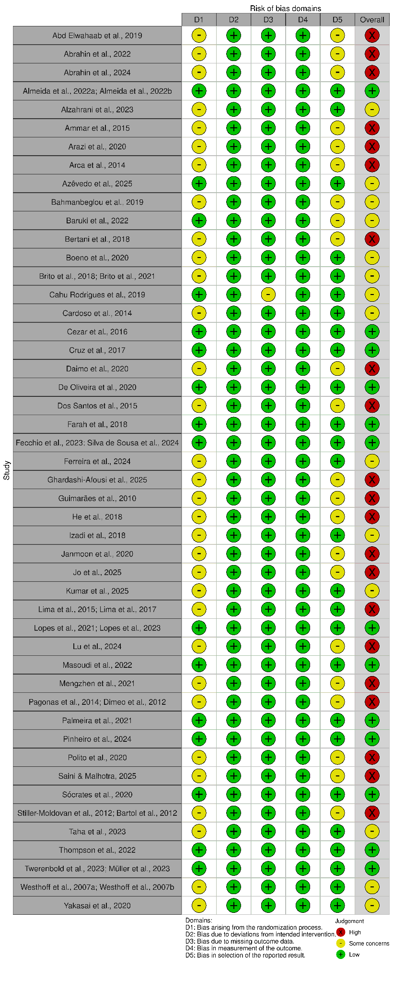
Figure S2. Summary plot.
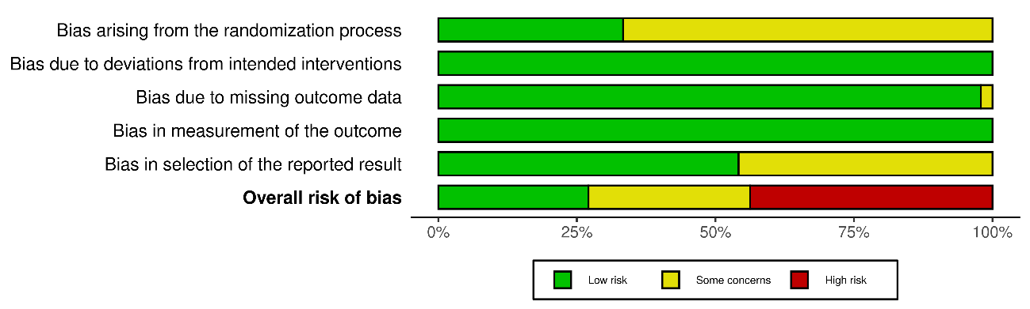
Figure S3. Funnel plot of effect sizes for office SBP.
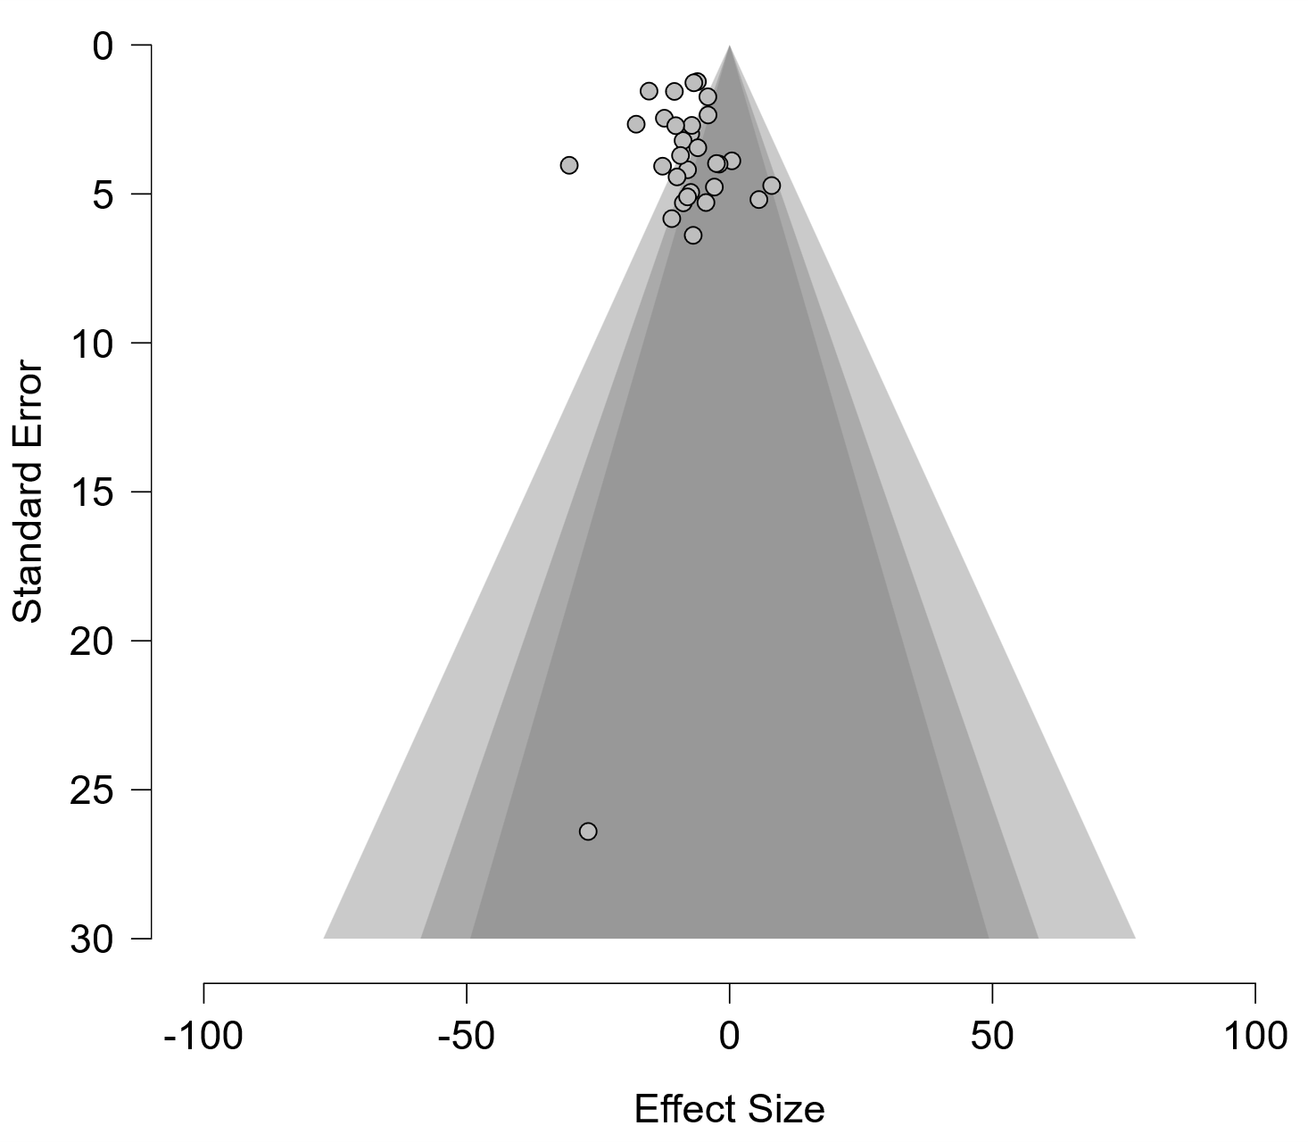
Figure S4. Funnel plot of effect sizes for office DBP.
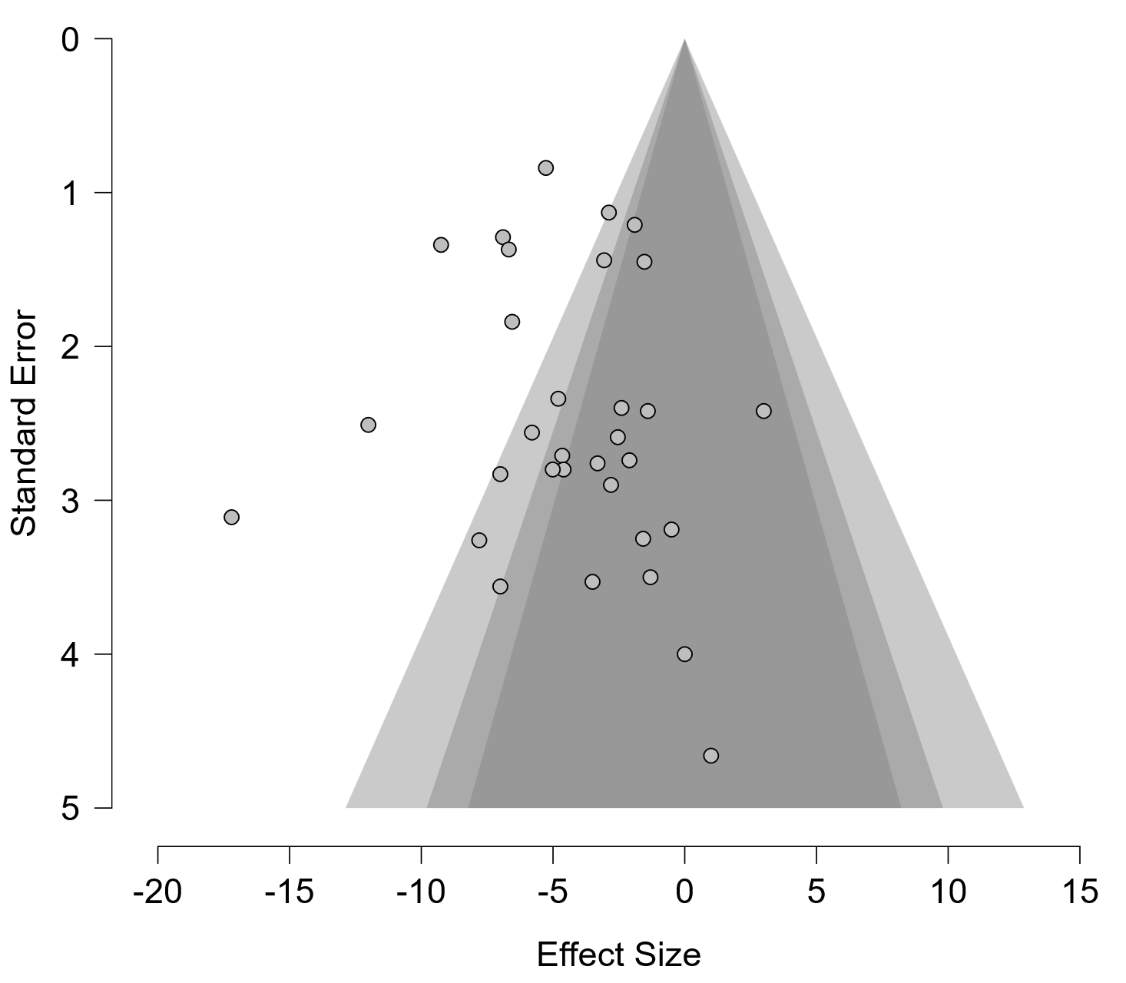
Figure S5. Funnel plot of effect sizes for 24h ASBP.
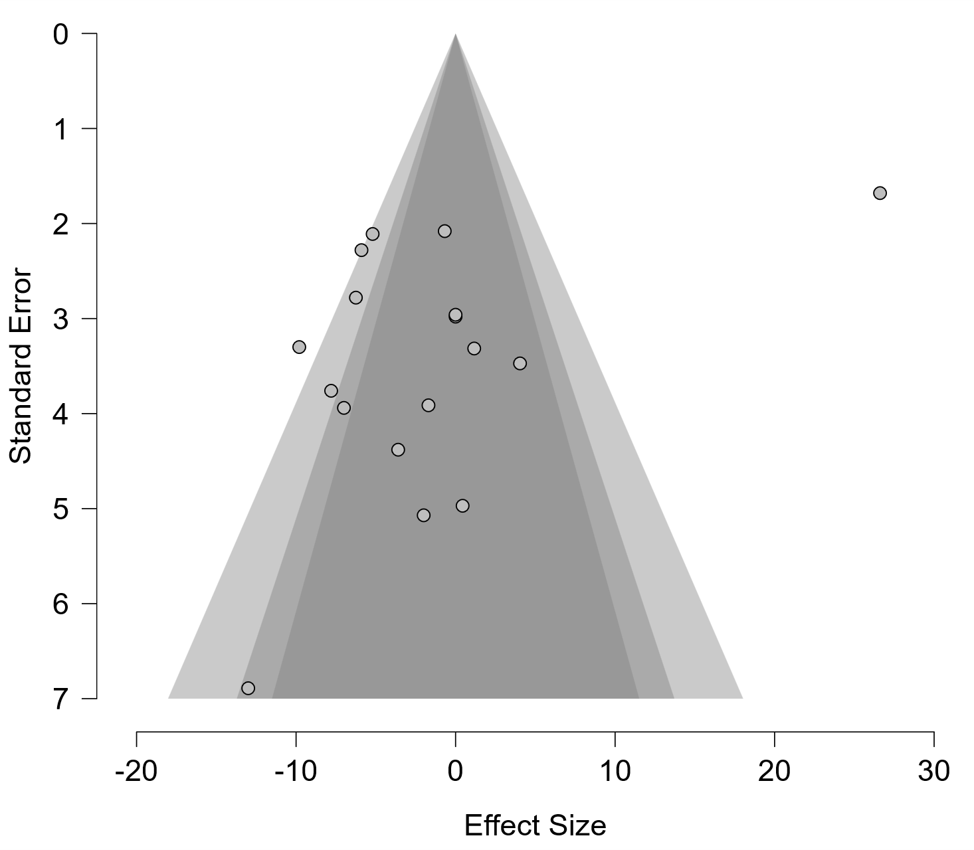
Figure S6. Funnel plot of effect sizes for daytime ASBP.
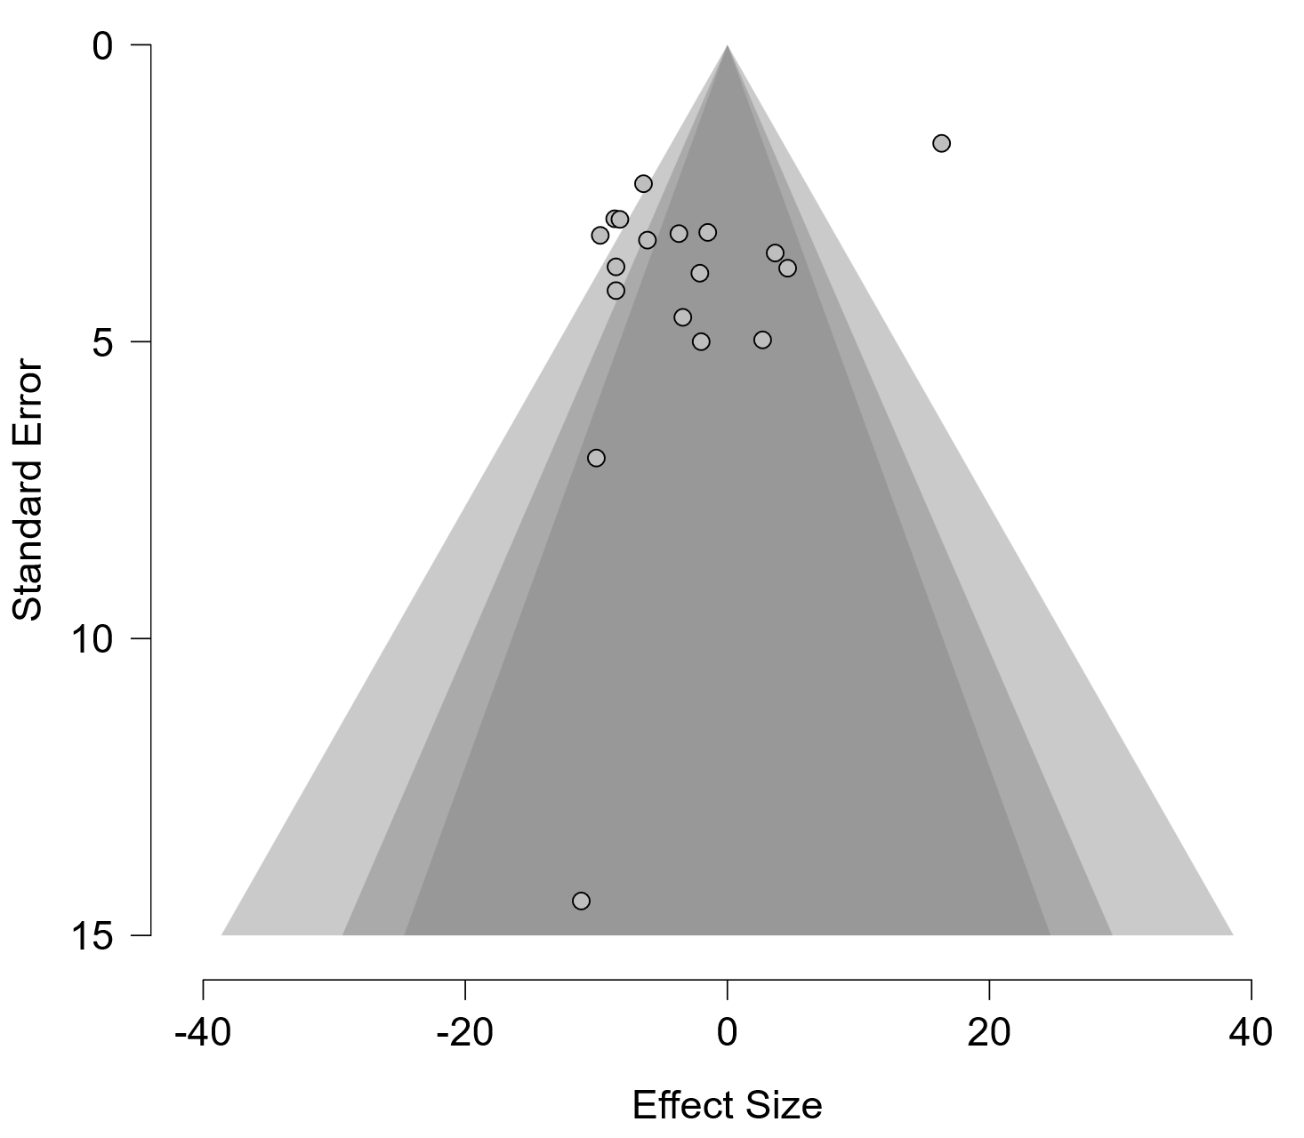
Figure S7. Funnel plot of effect sizes for nighttime ASBP.
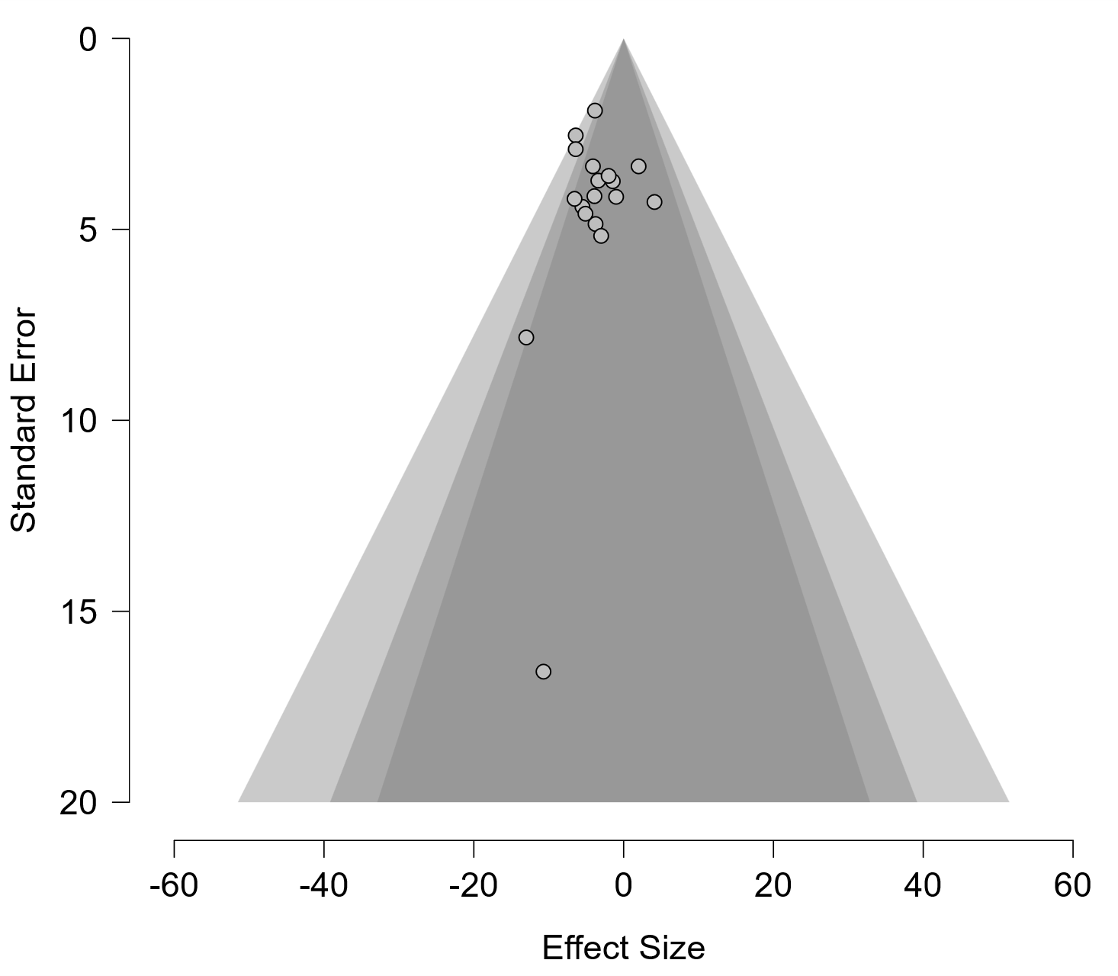
Figure S8. Funnel plot of effect sizes for 24h ADBP.
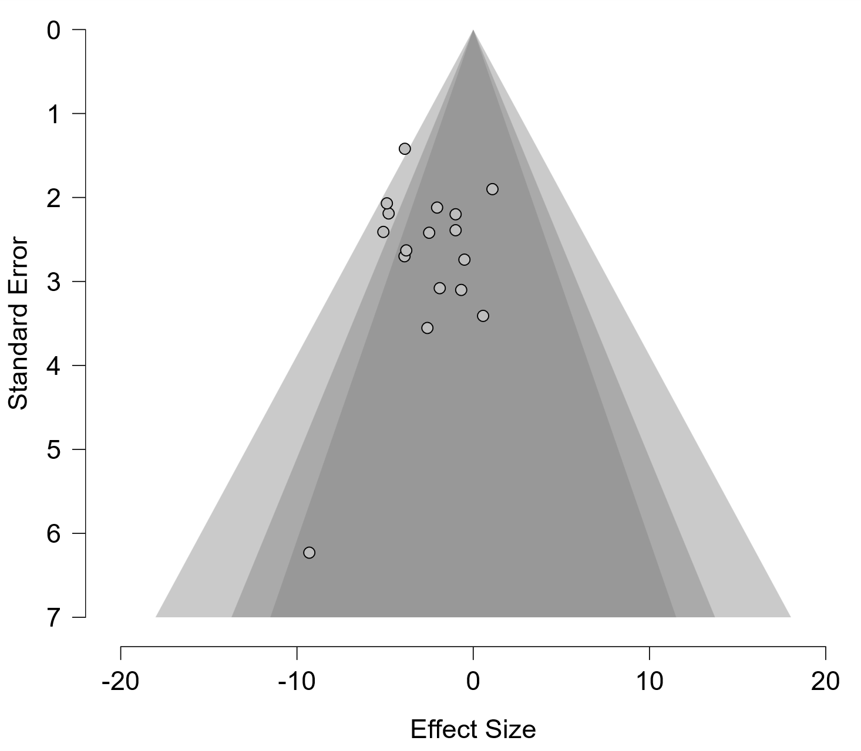
Figure S9. Funnel plot of effect sizes for daytime ADBP.
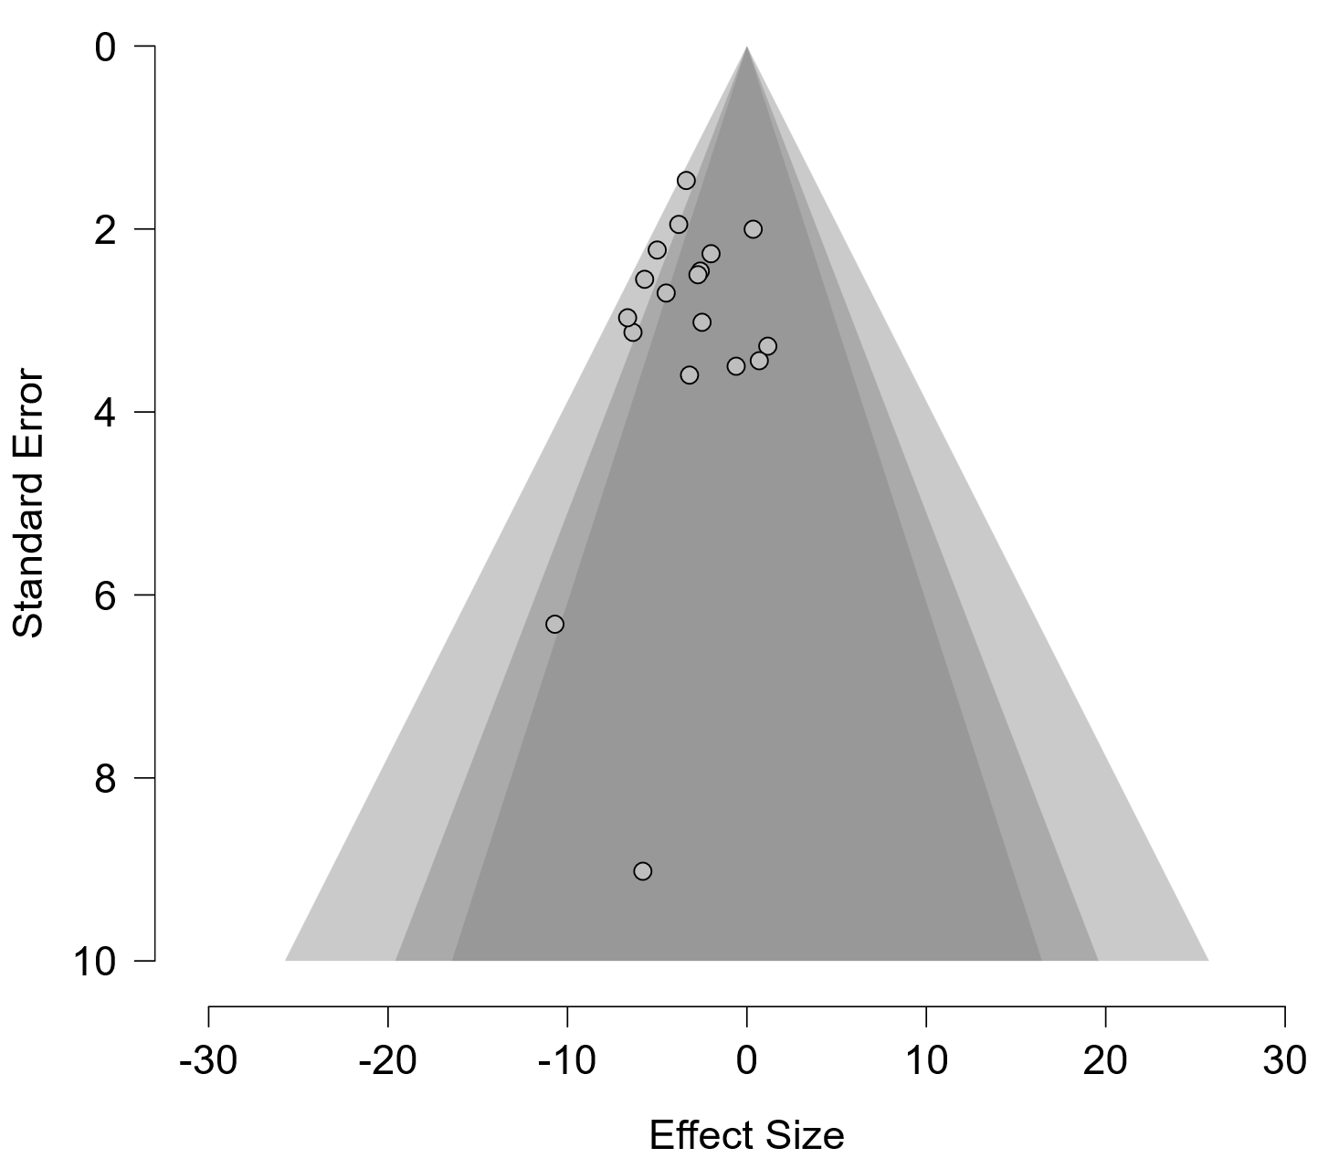
Figure S10. Funnel plot of effect sizes for nighttime ADBP.
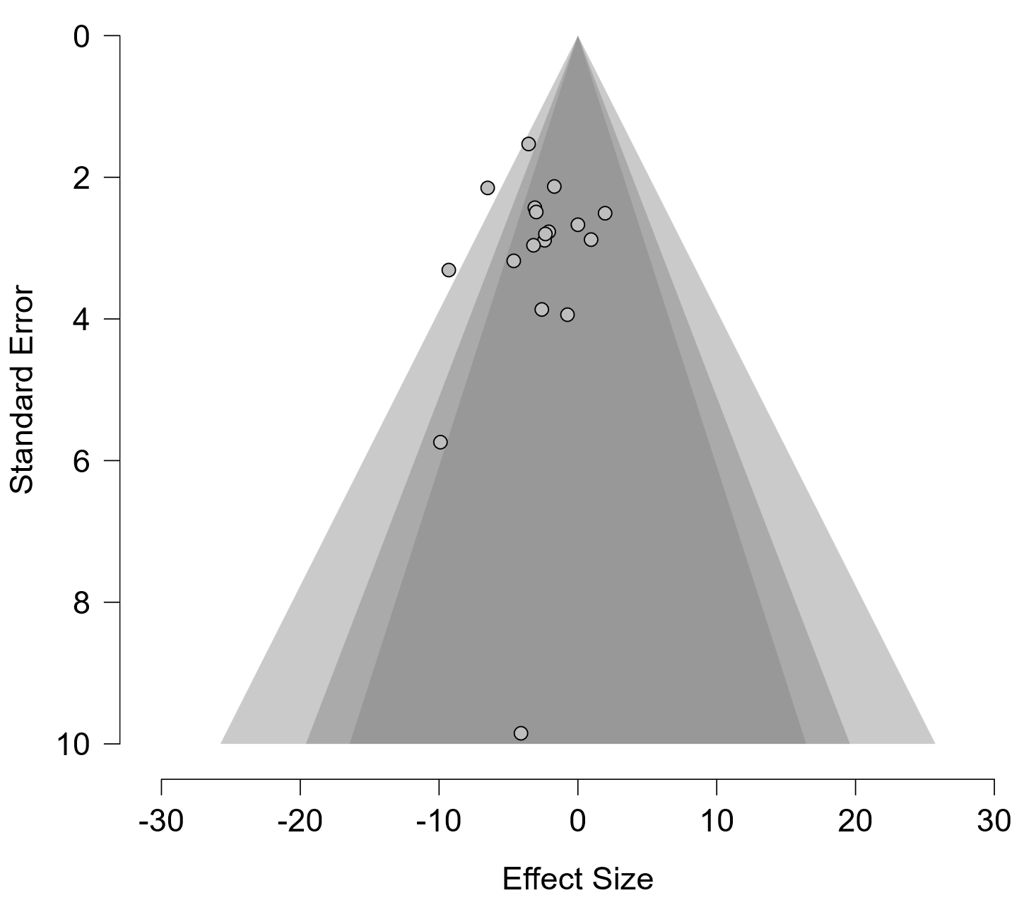

Figure S11. Funnel plot of effect sizes for body weight.
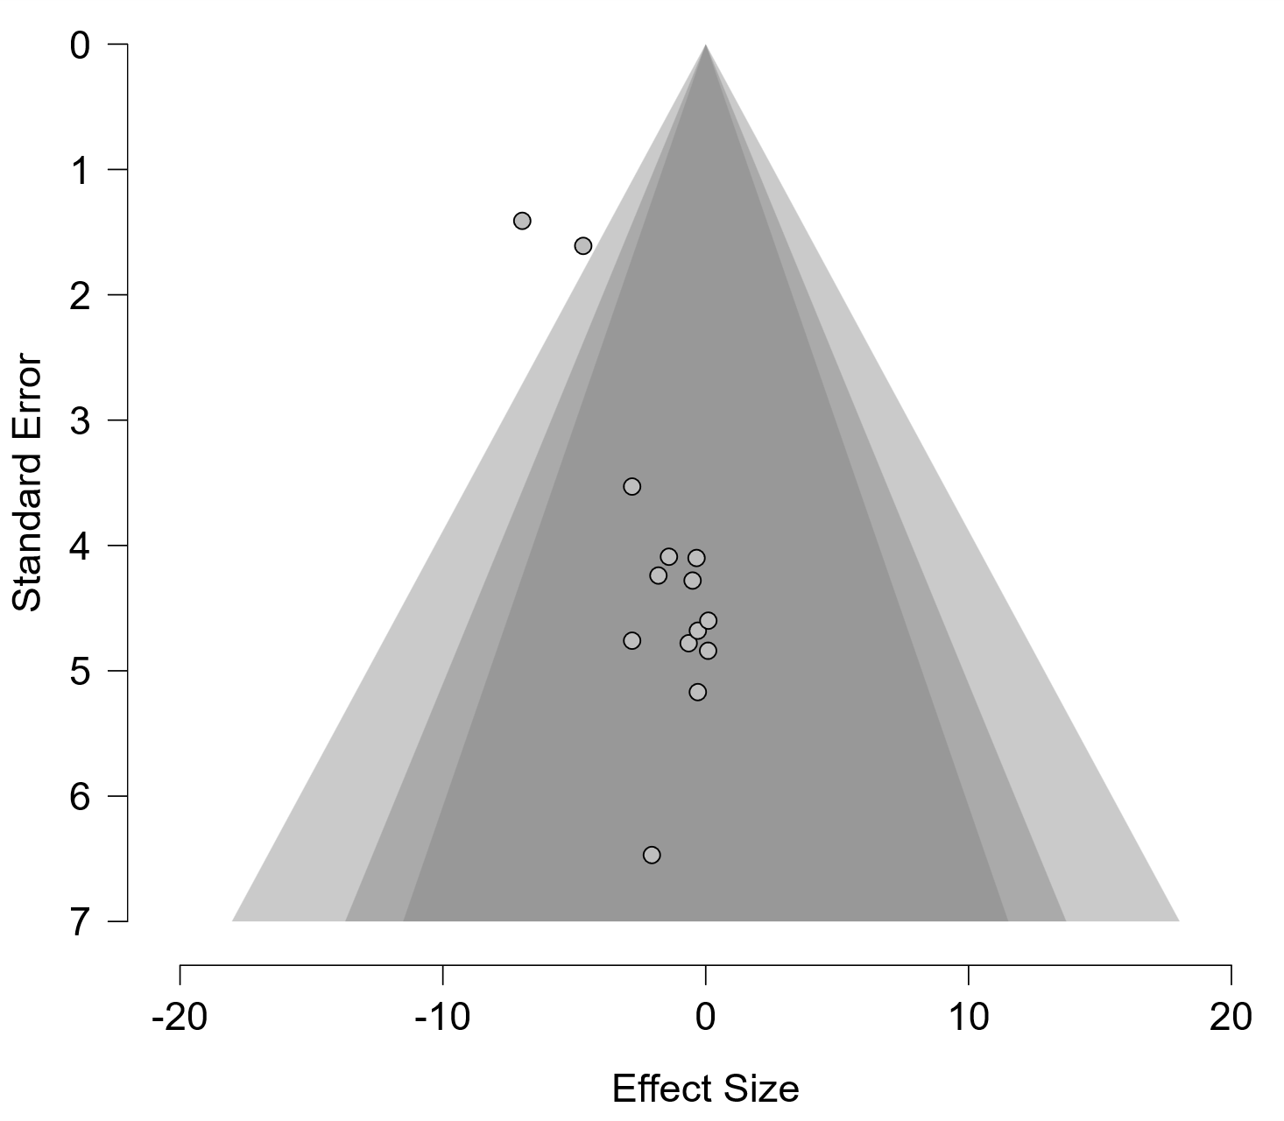
Figure S12. Funnel plot of effect sizes for BMI.
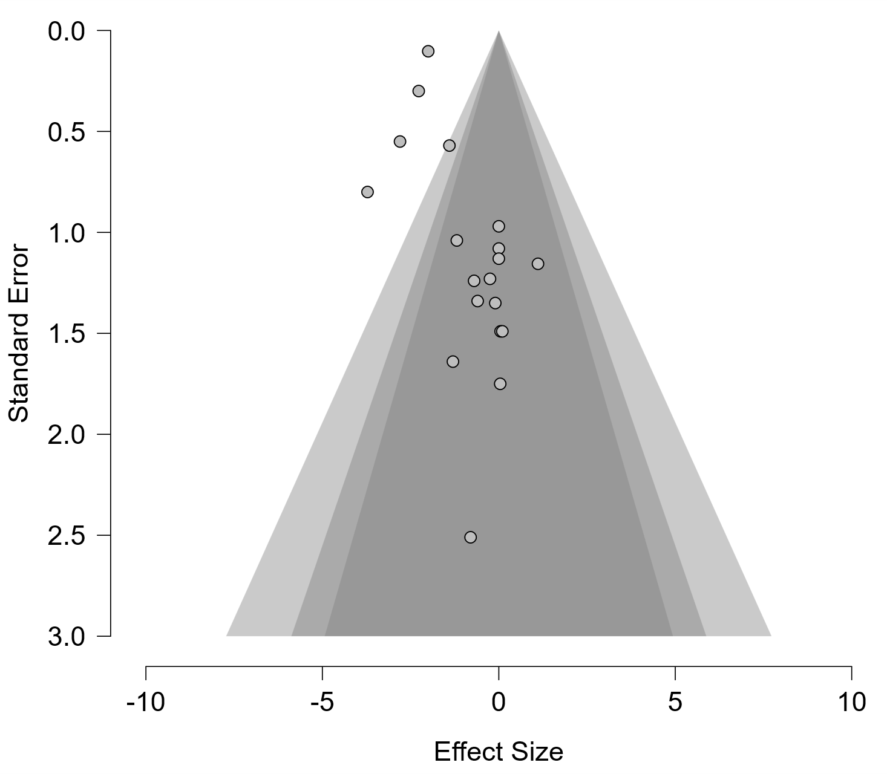
Figure S13. Funnel plot of effect sizes for total cholesterol.
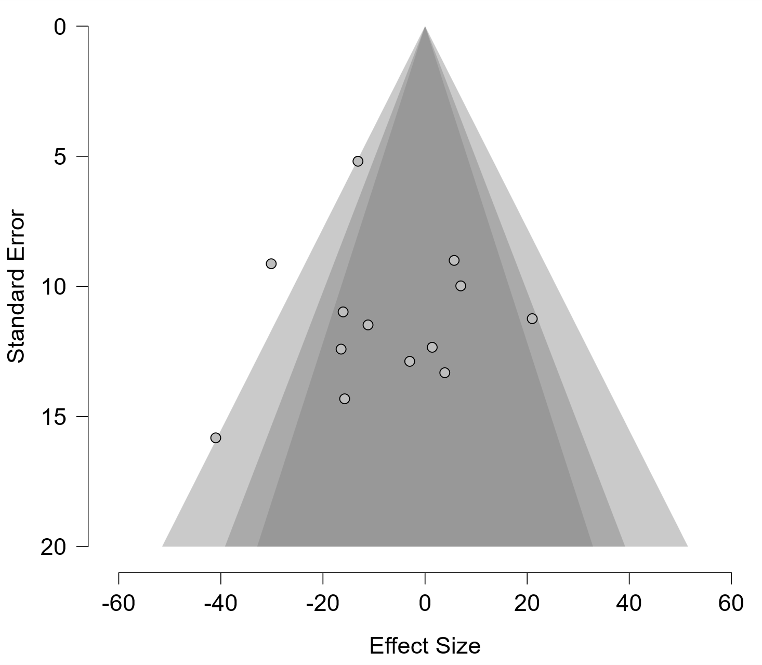
Figure S14. Funnel plot of effect sizes for HDL-c.
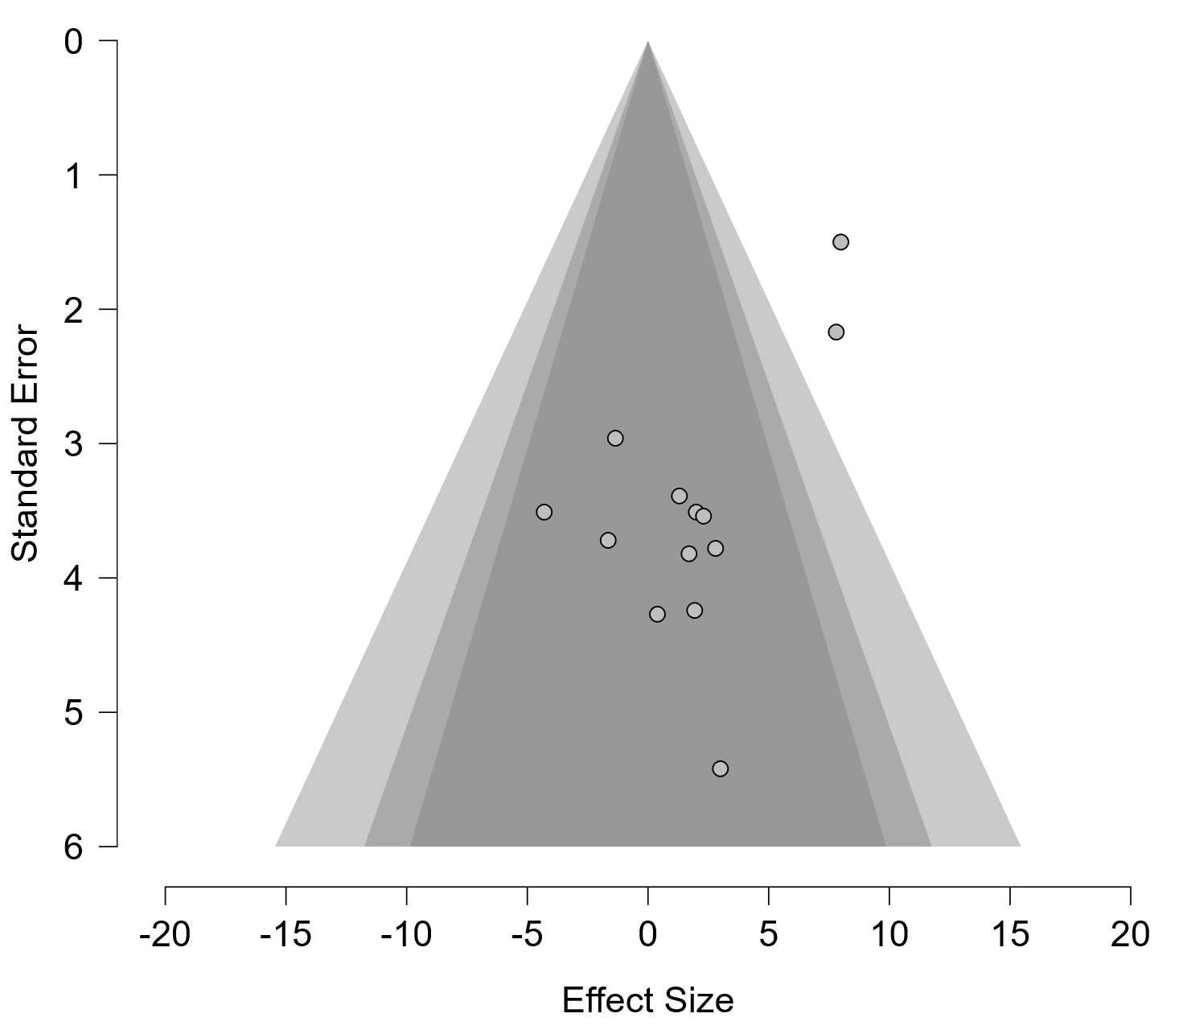
Figure S15. Funnel plot of effect sizes for LDL-c.
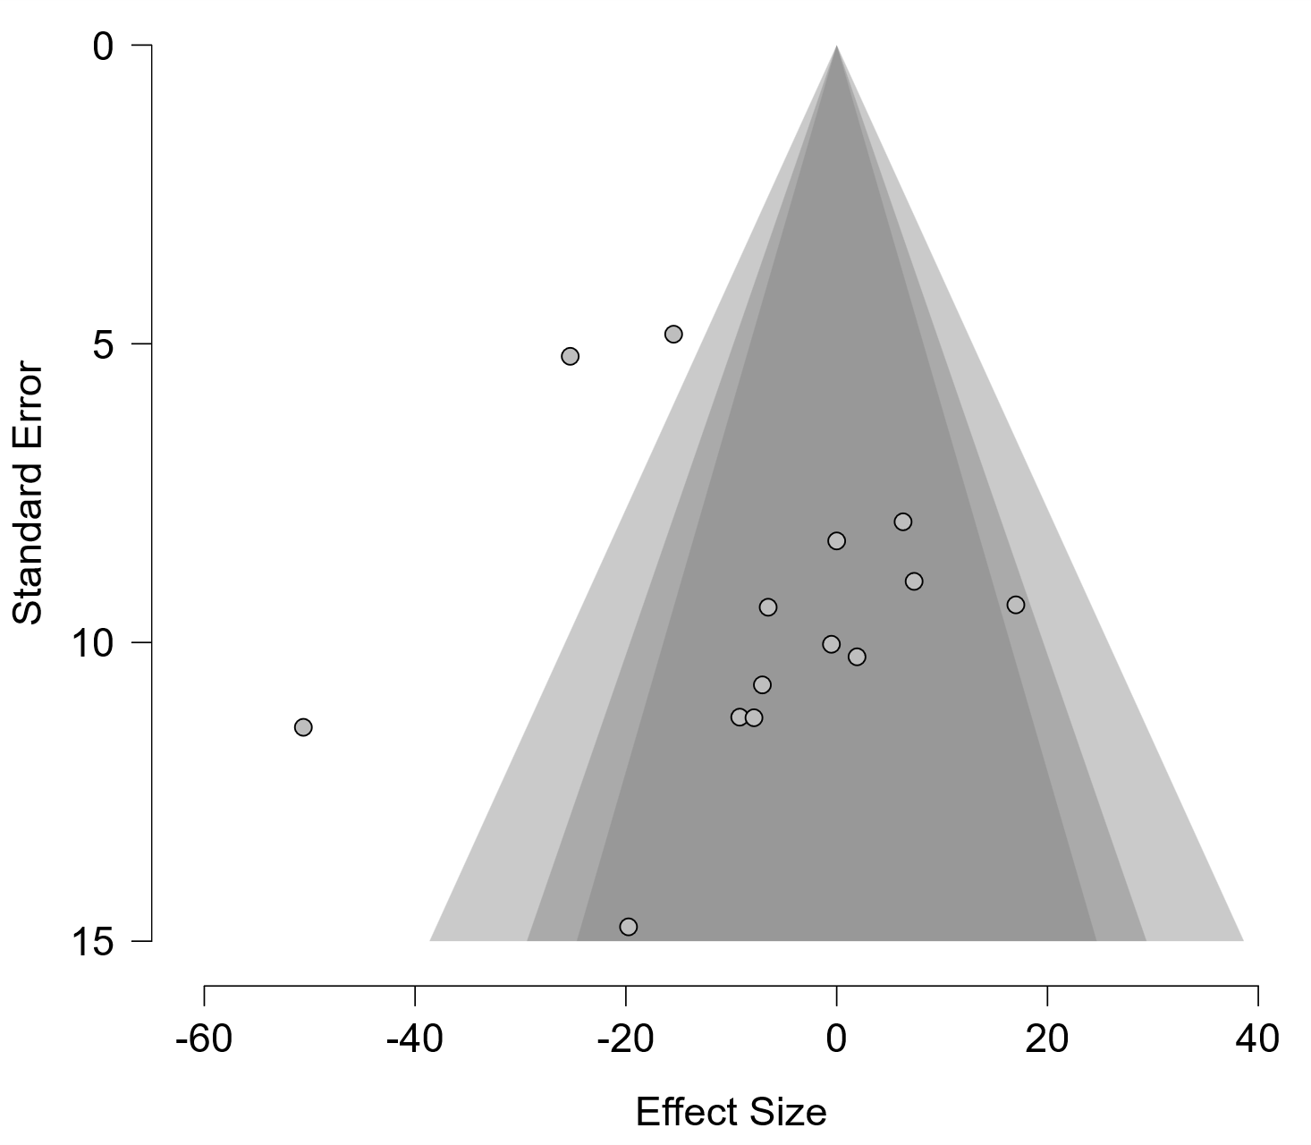
Figure S16. Funnel plot of effect sizes for triglycerides.
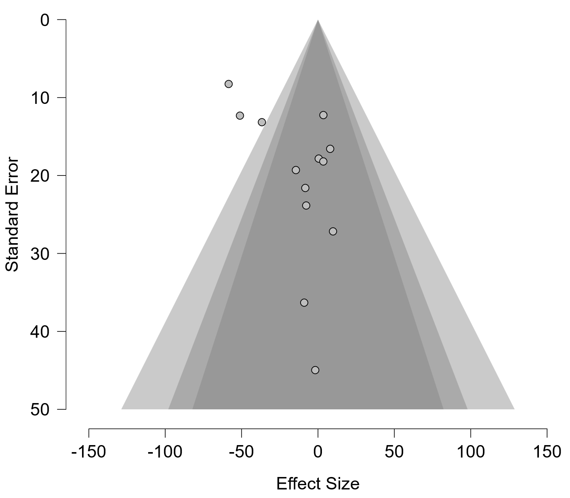
Figure S17. Funnel plot of effect sizes for VO₂peak relative.
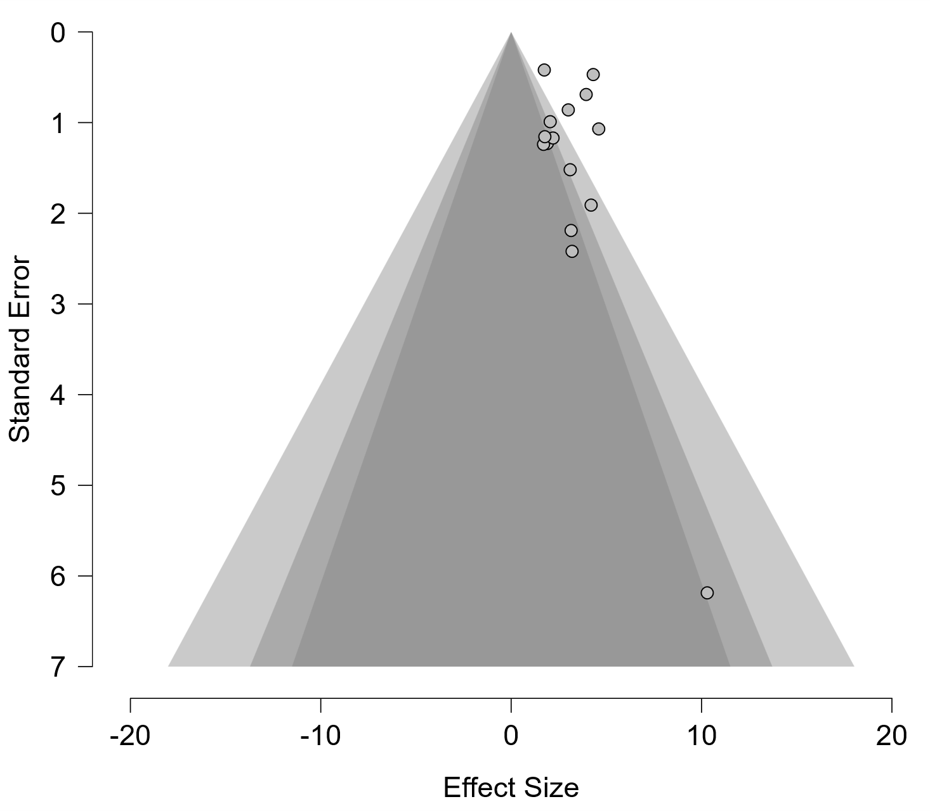

Figure S18. Meta-regression examining the association between percentage of participants taking ACE inhibitors and effect sizes for office DBP.
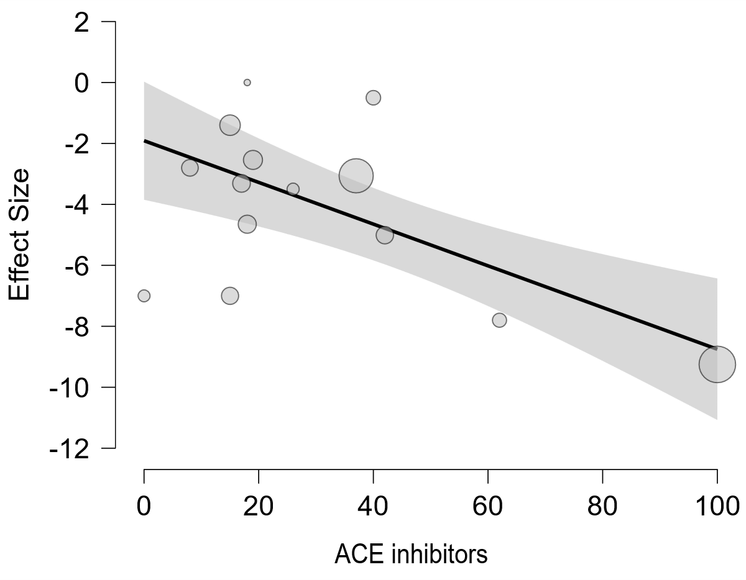
Figure S19. Forest plot of effect sizes for office MAP.
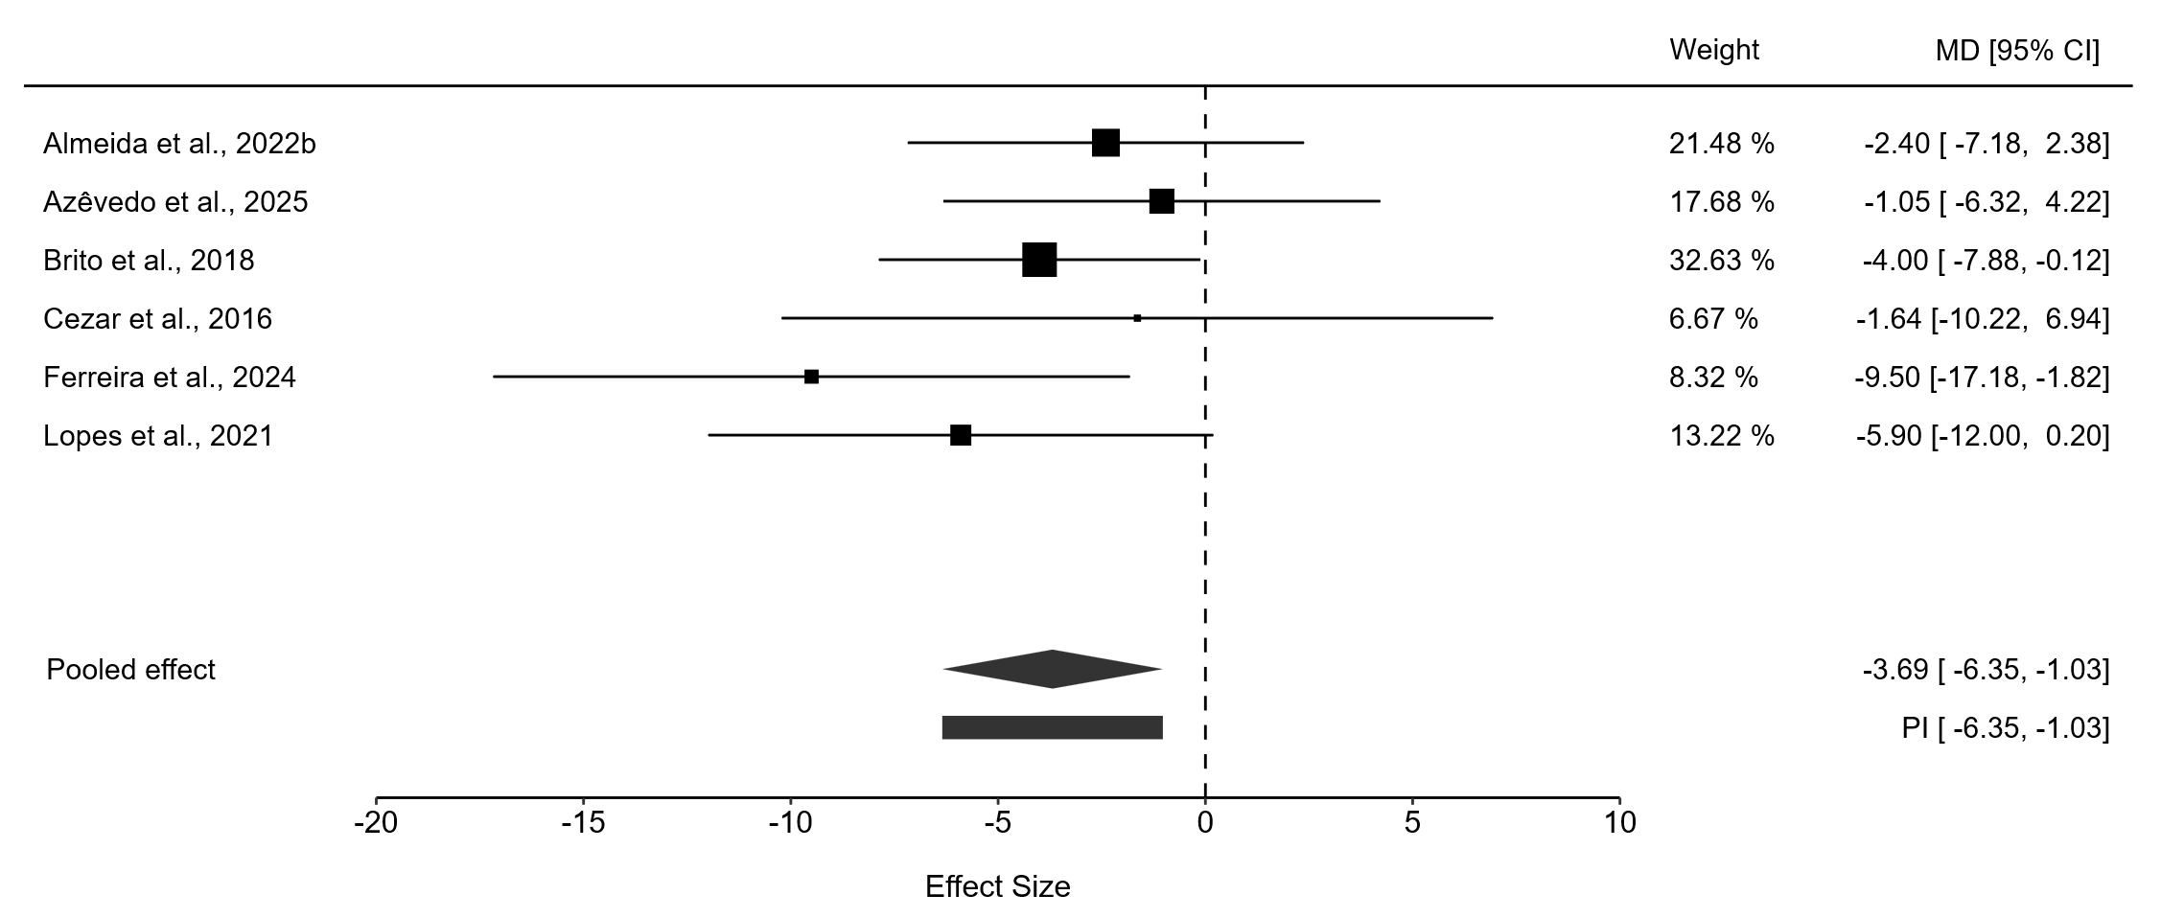
Figure S20. Forest plot of effect sizes for 24h ASBP.
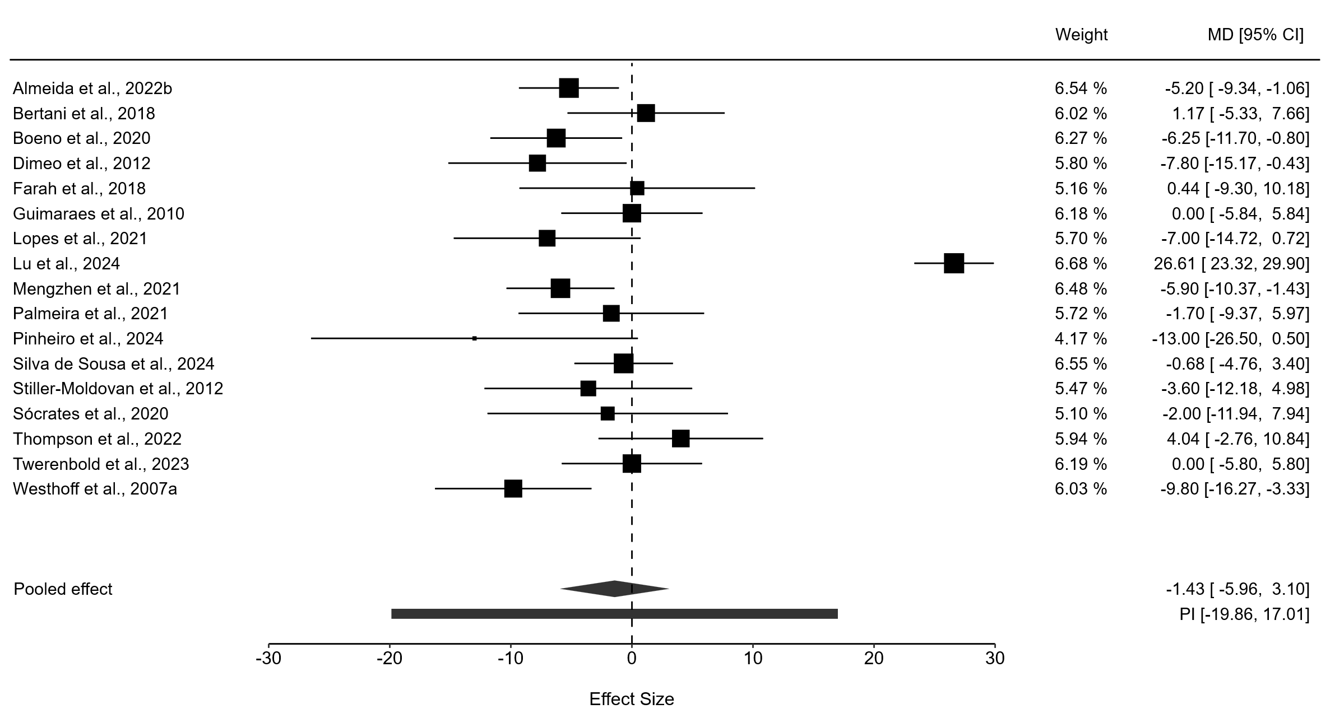
Figure S21. Forest plot of effect sizes for daytime ASBP.
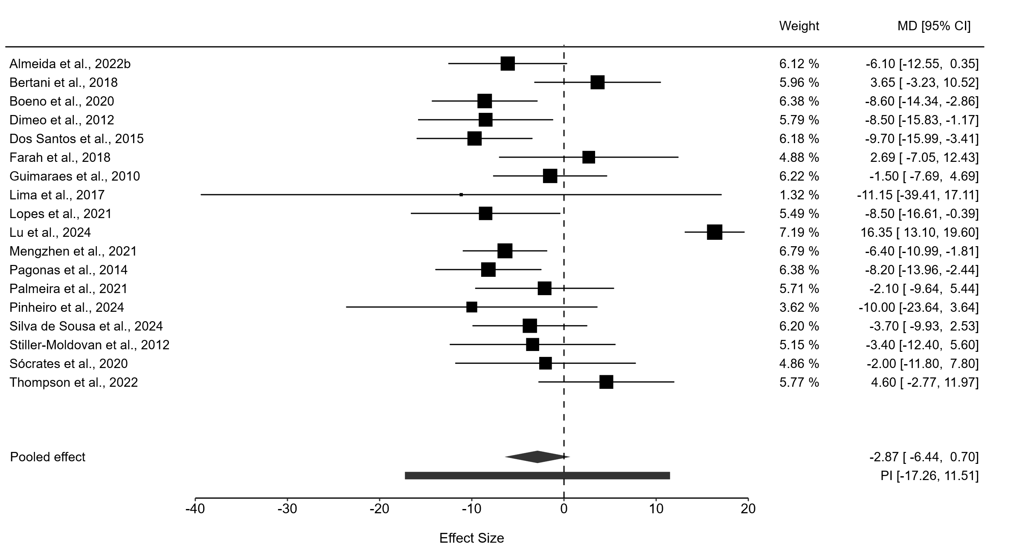
Figure S22. Forest plot of effect sizes for nighttime ASBP.
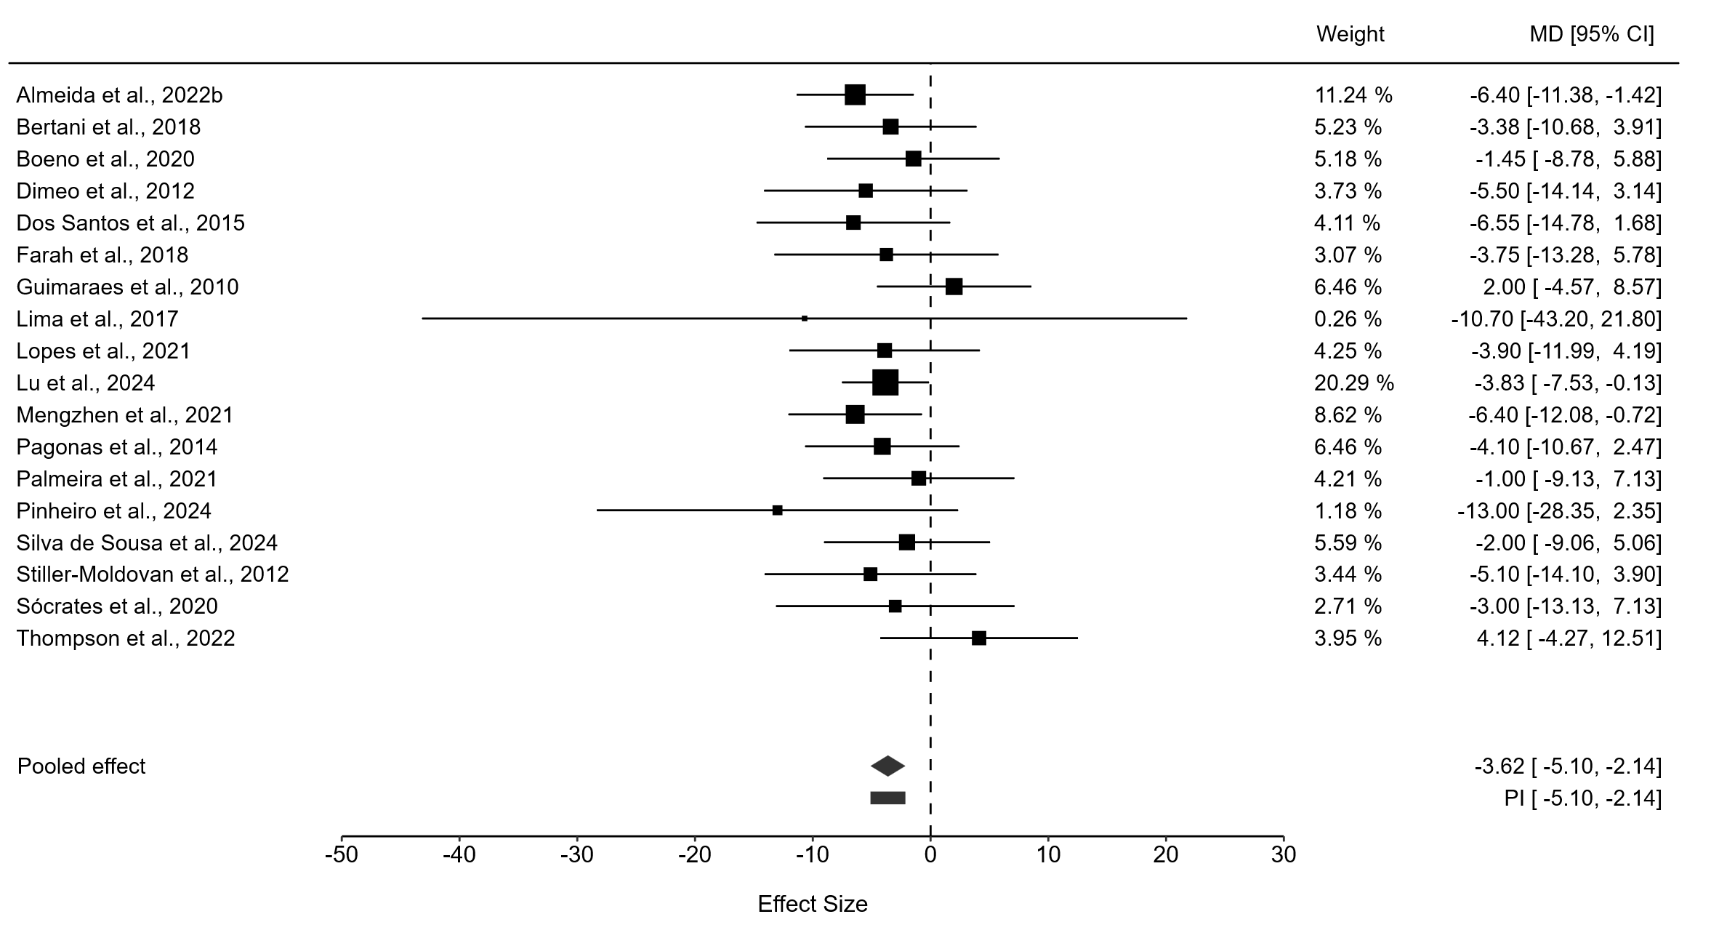
Figure S23. Forest plot of effect sizes for 24h ADBP.
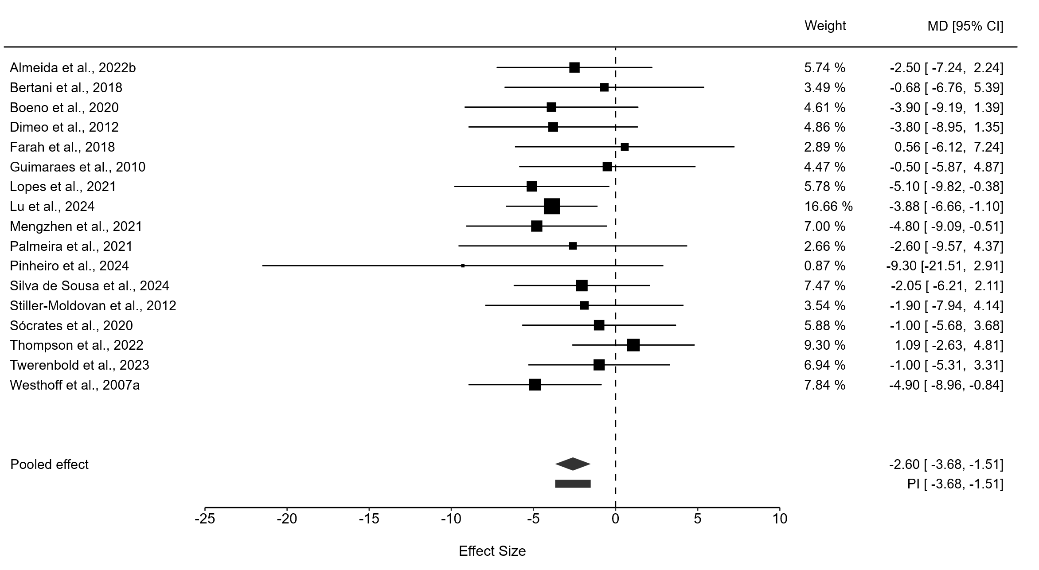
Figure S24. Forest plot of effect sizes for daytime ADBP.
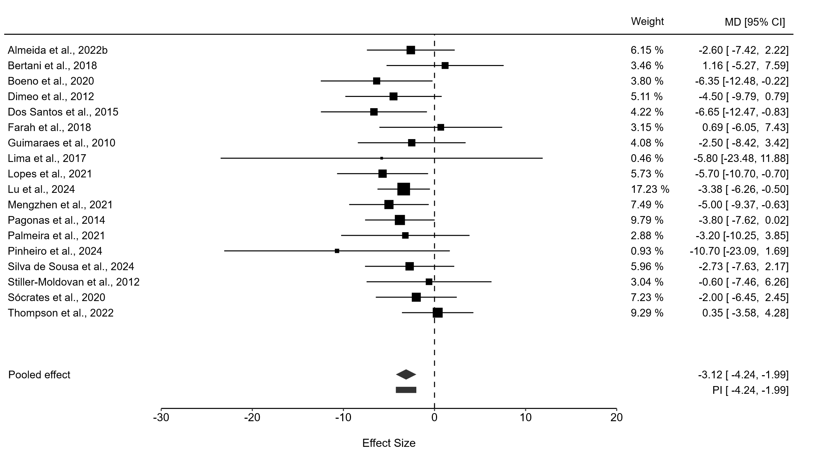
Figure S25. Forest plot of effect sizes for nighttime ADBP.
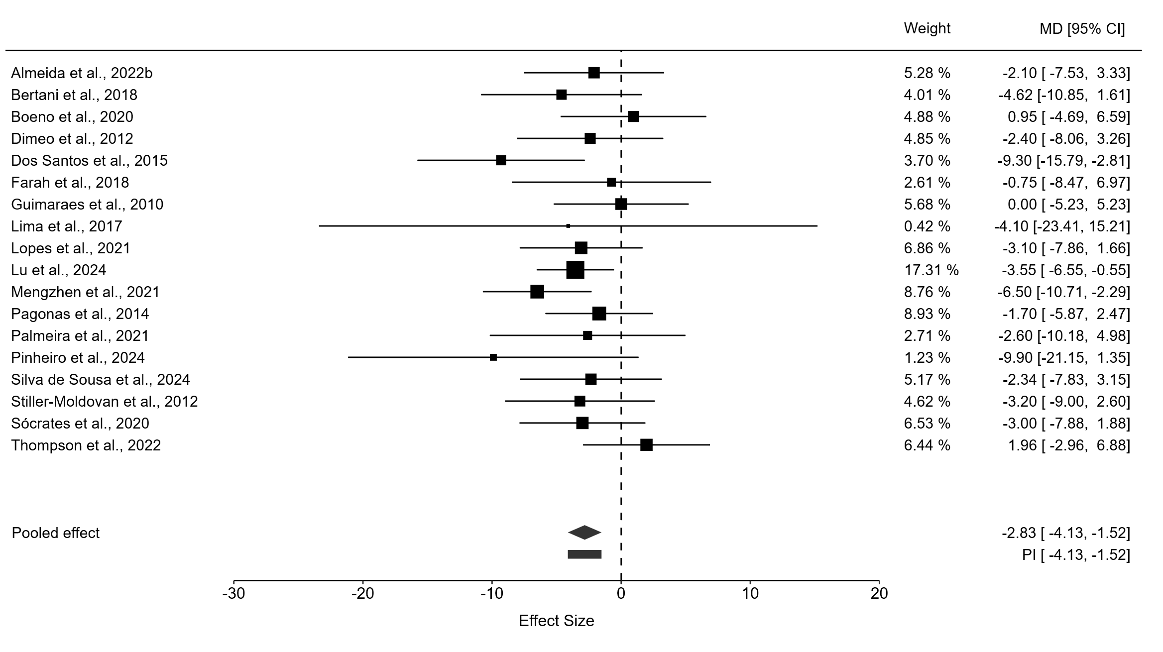Figure S26. Meta-regression examining the association between percentage of participants taking diuretics and effect sizes for 24h ADBP.
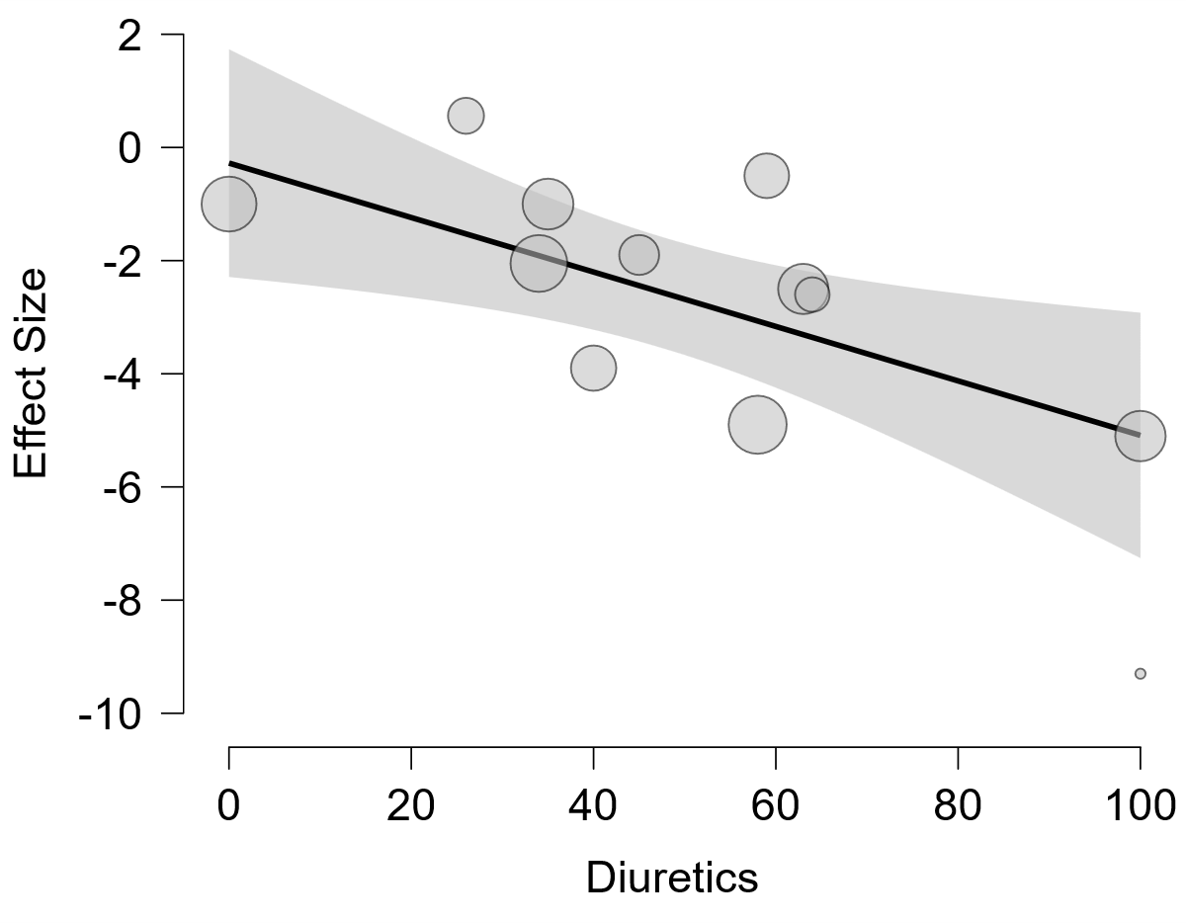
Figure S27. Meta-regression examining the association between percentage of participants taking CCBs and effect sizes for 24h ADBP.
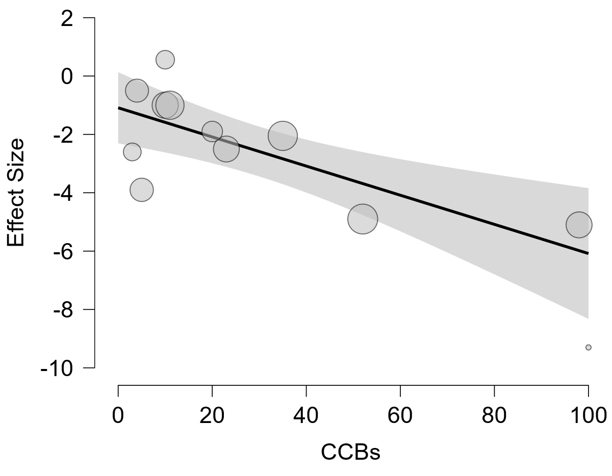
Figure S28. Forest plot of effect sizes for 24h MAP.
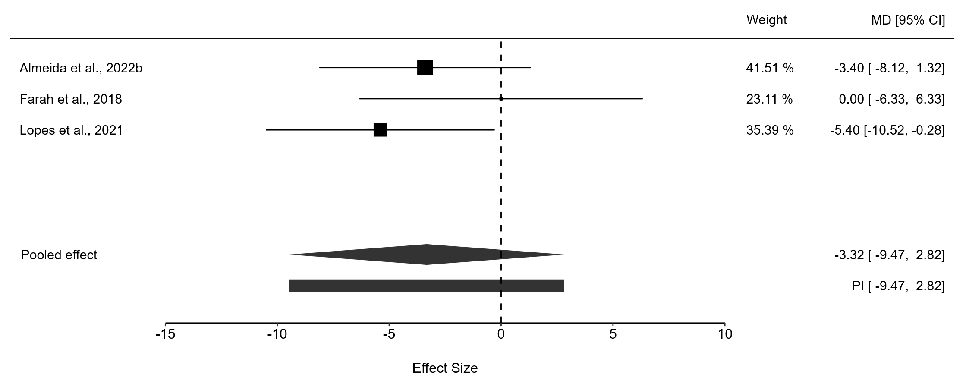
Figure S29. Forest plot of effect sizes for daytime MAP.
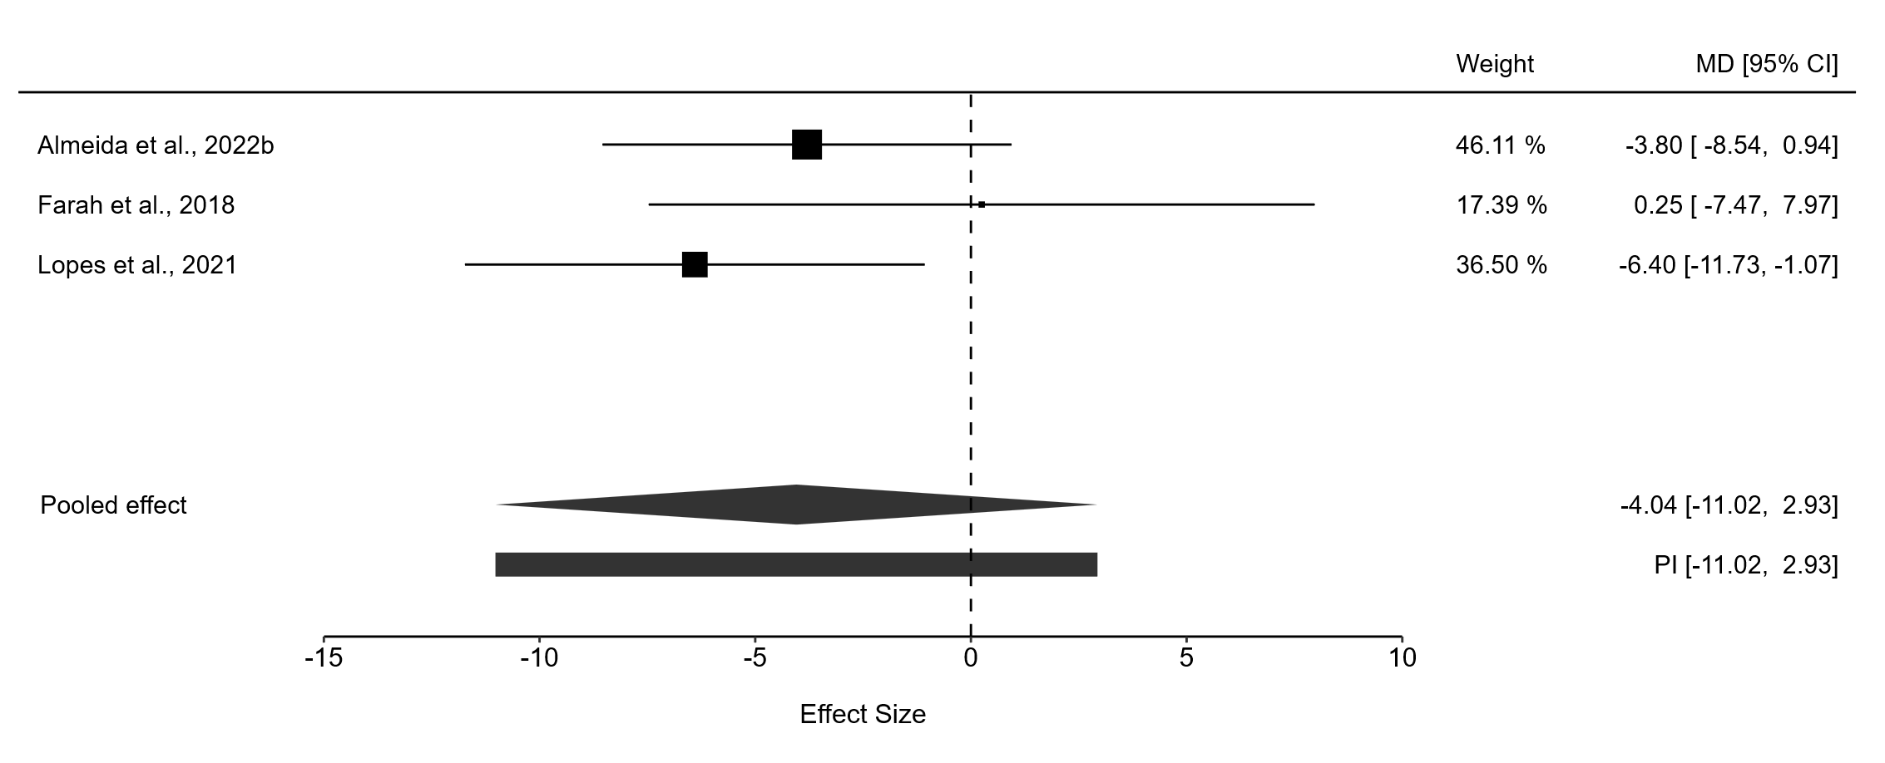
Figure S30. Forest plot of effect sizes for nighttime MAP.
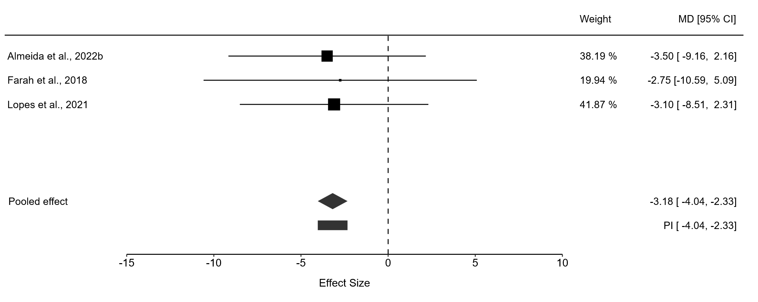
Figure S31. Forest plot of effect sizes for body weight.

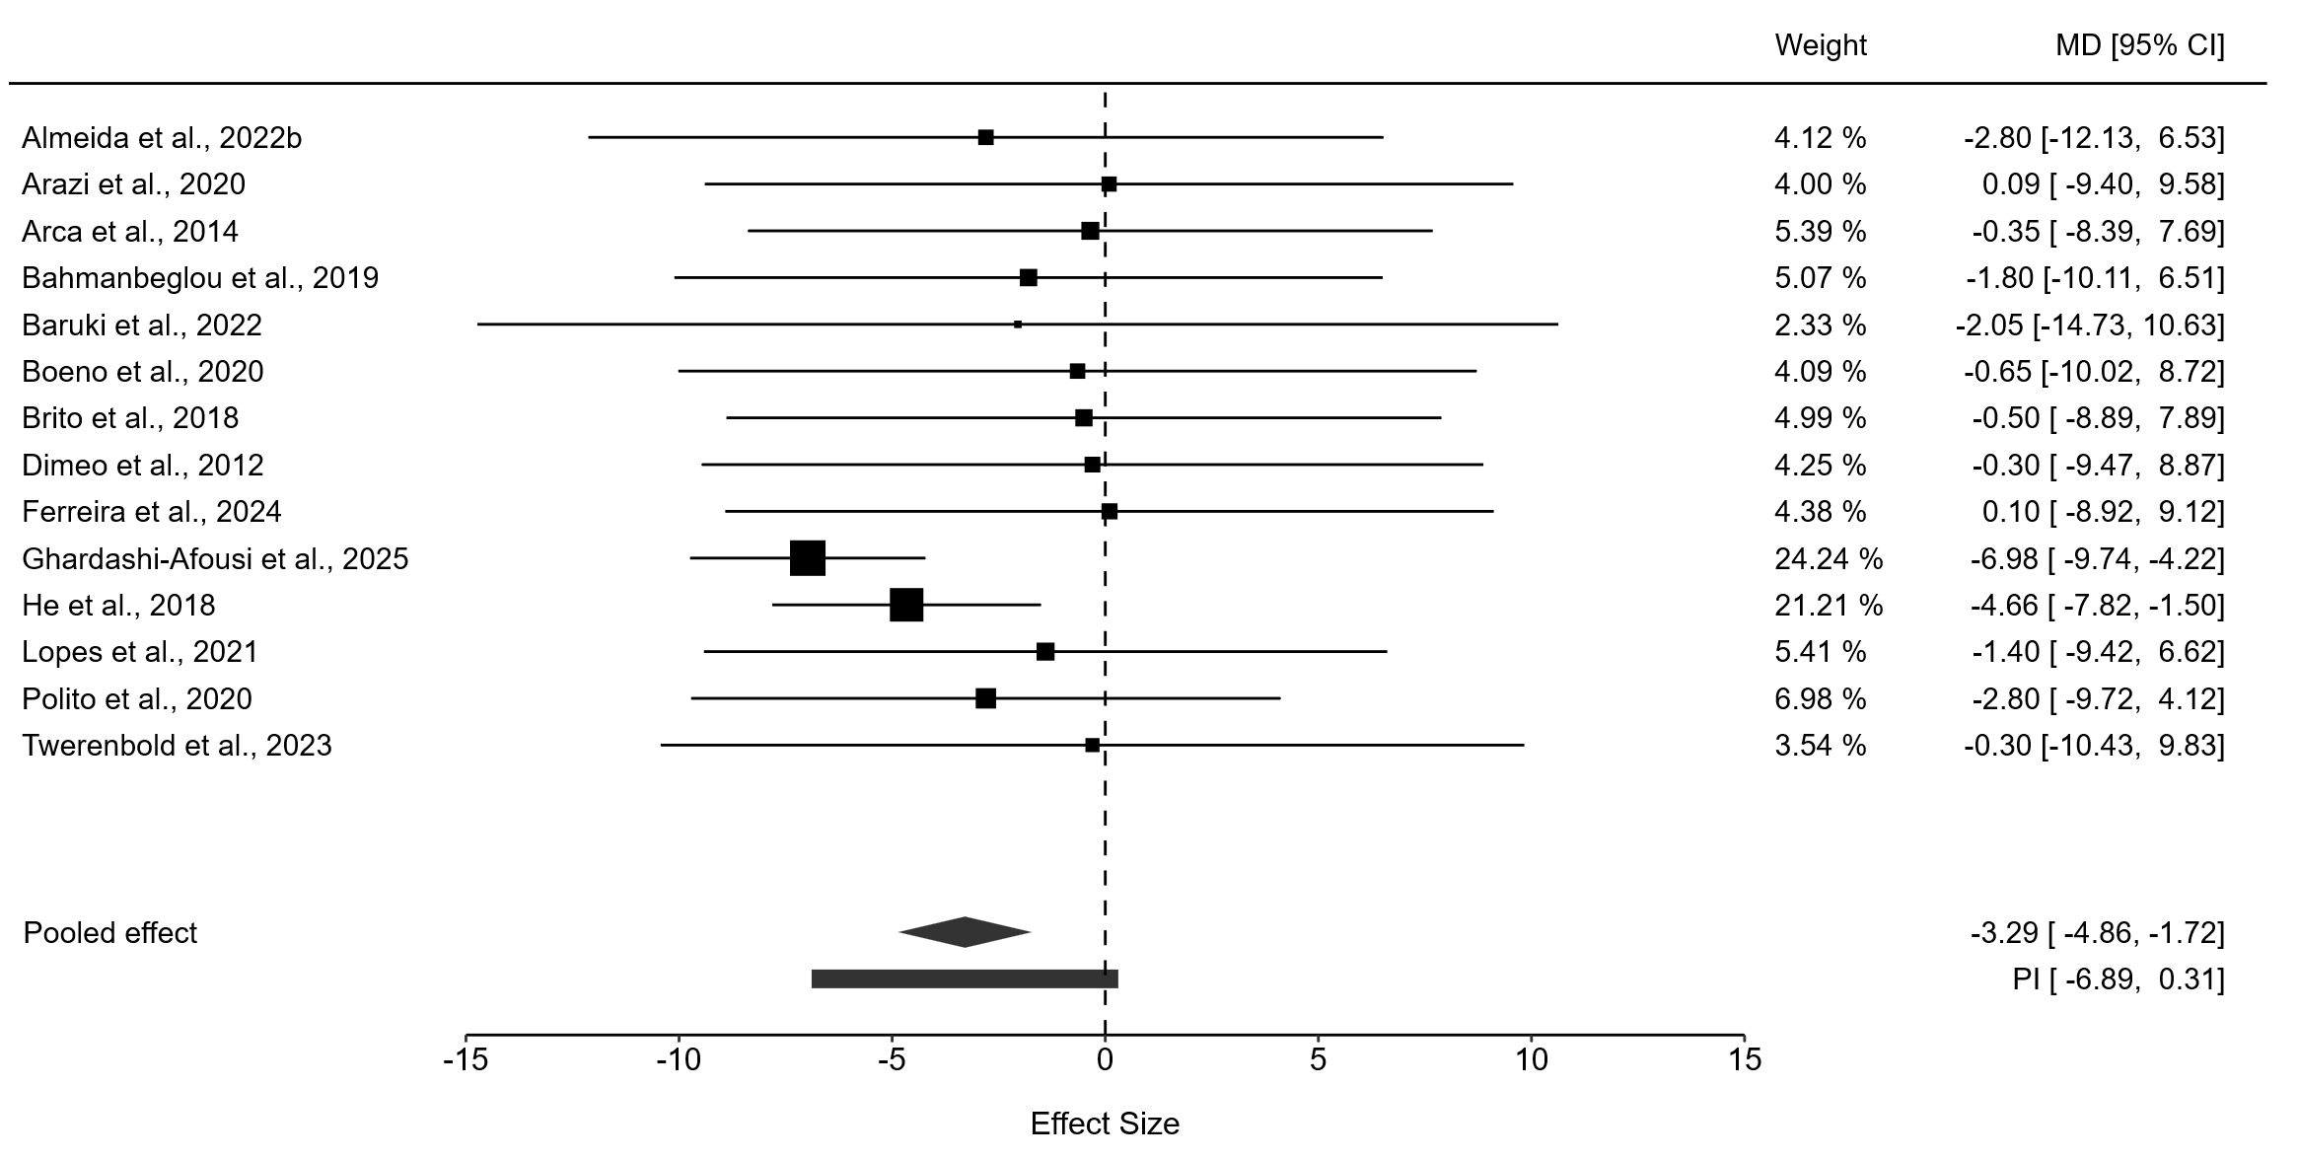
Figure S32. Forest plot of effect sizes for BMI.
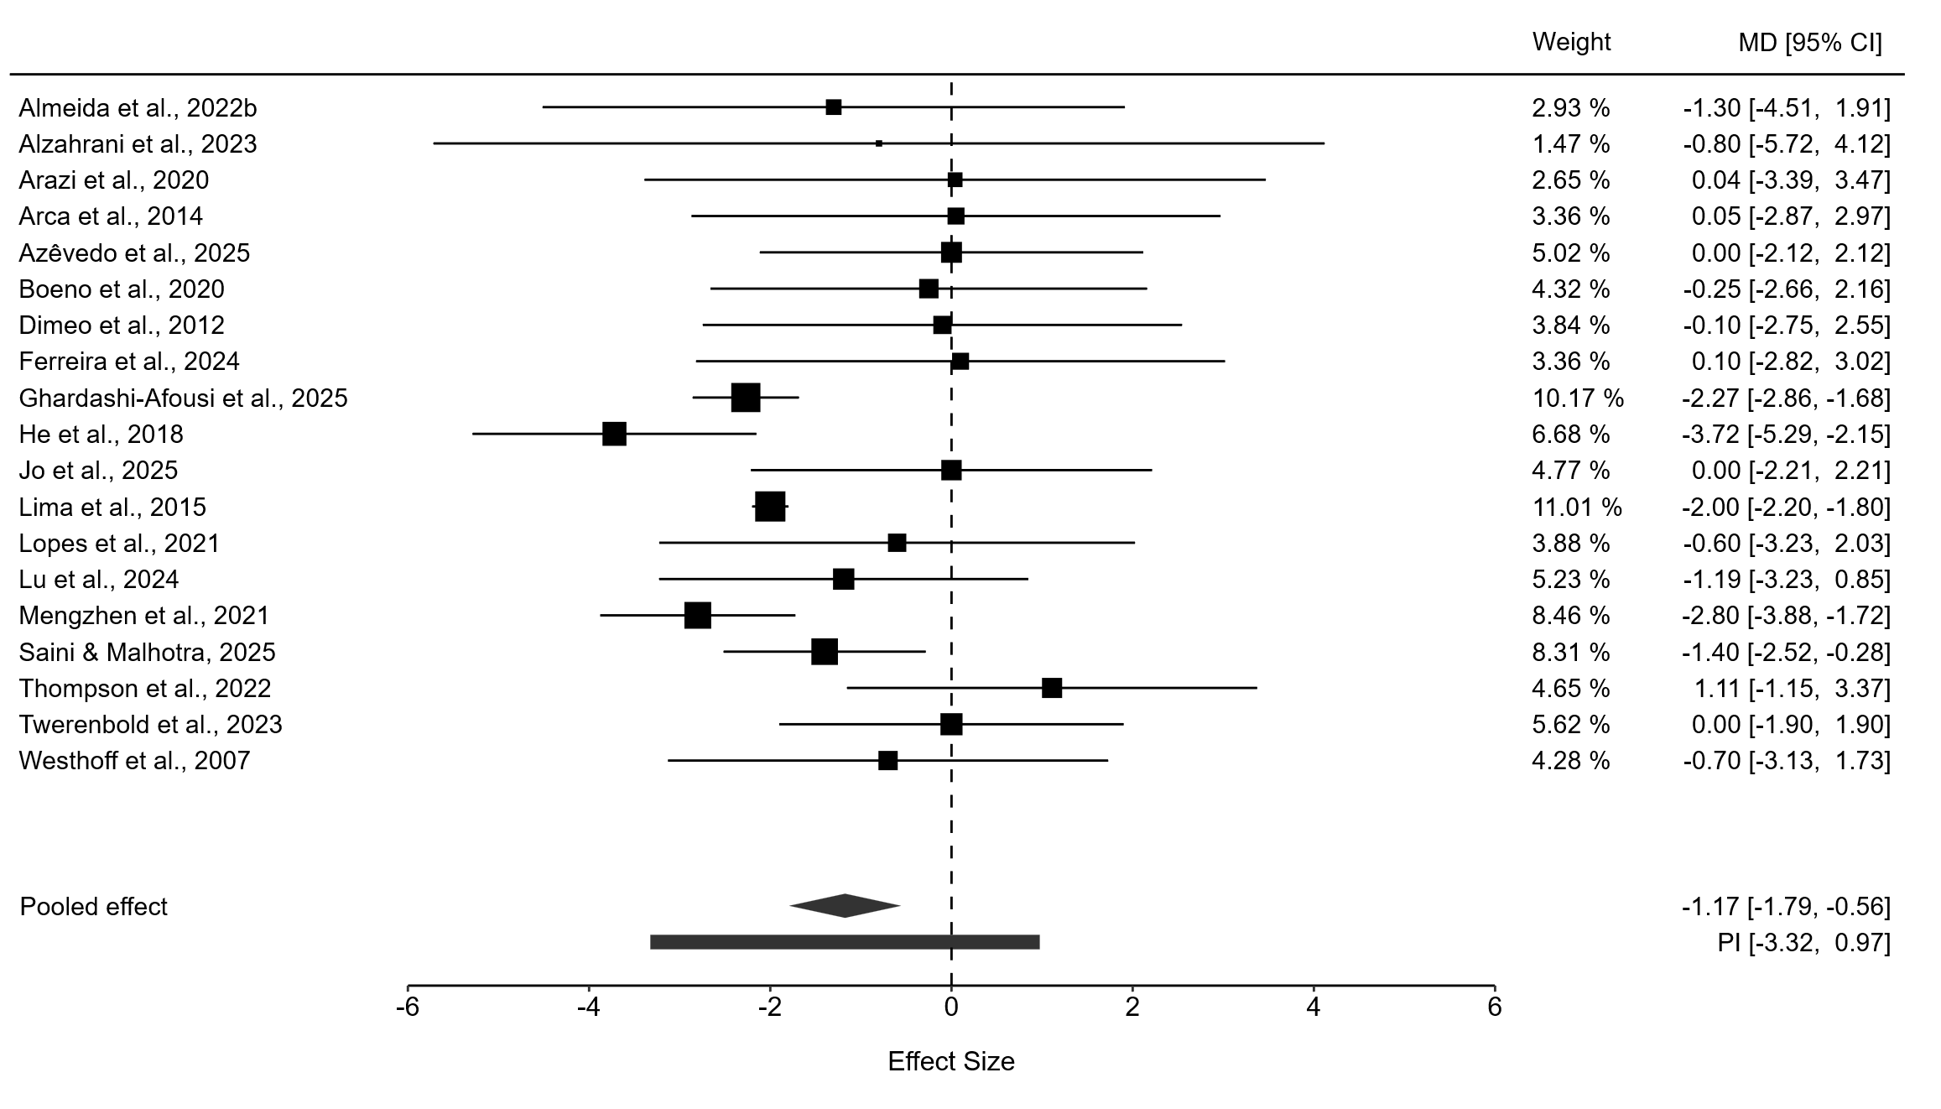
Figure S33. Forest plot of effect sizes for body fat percentage.
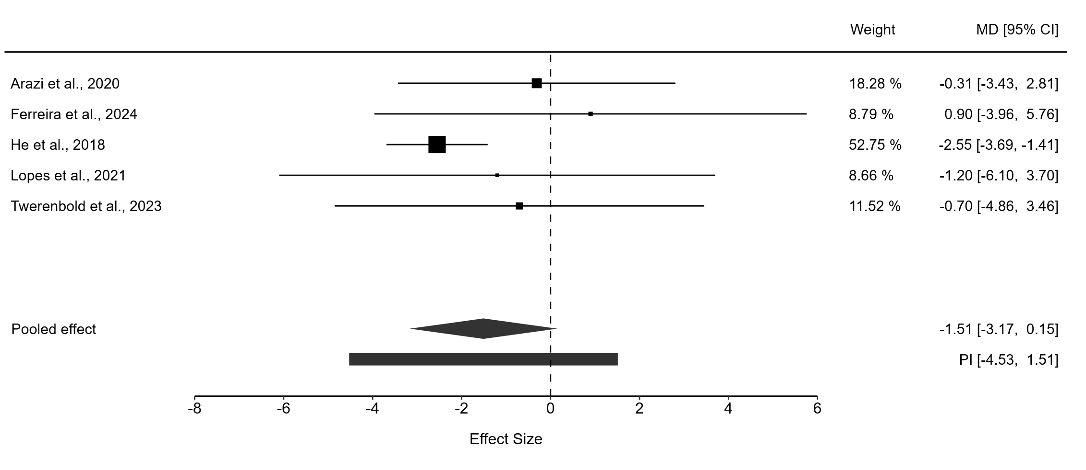
Figure S34. Forest plot of effect sizes for waist circumference.
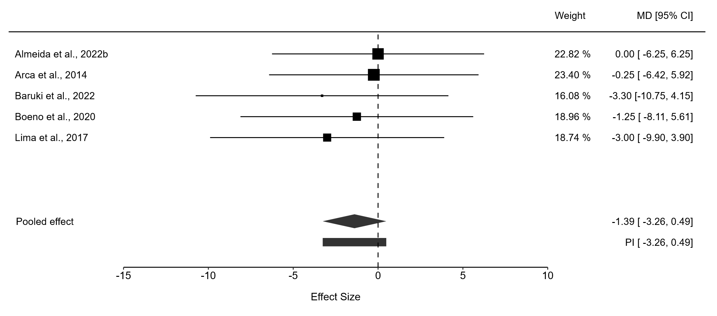
Figure S35. Forest plot of effect sizes for HDL-c.
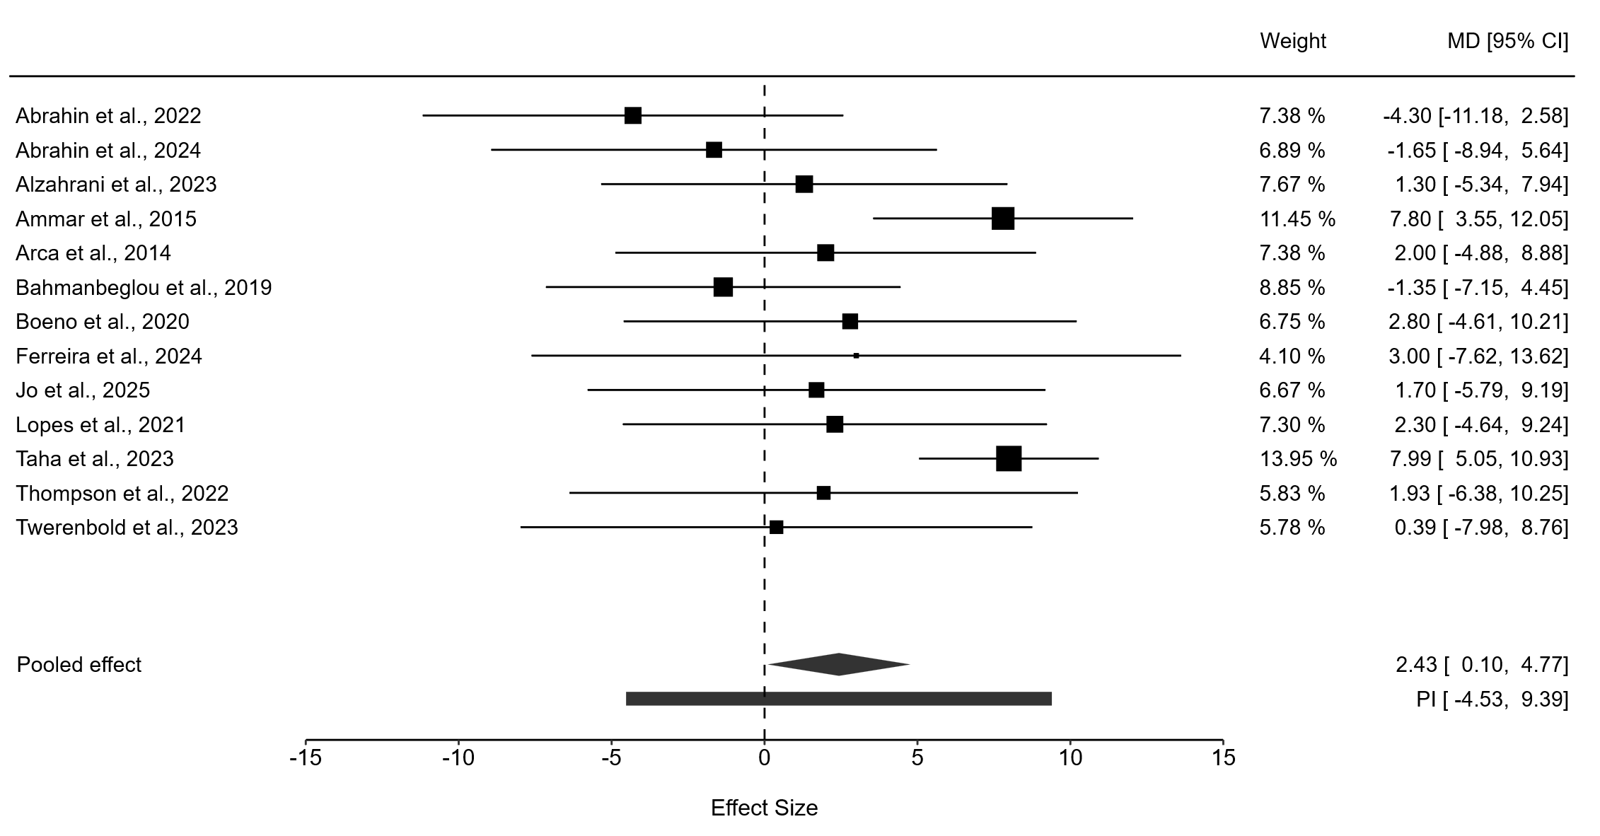
Figure S36. Forest plot of effect sizes for triglycerides.
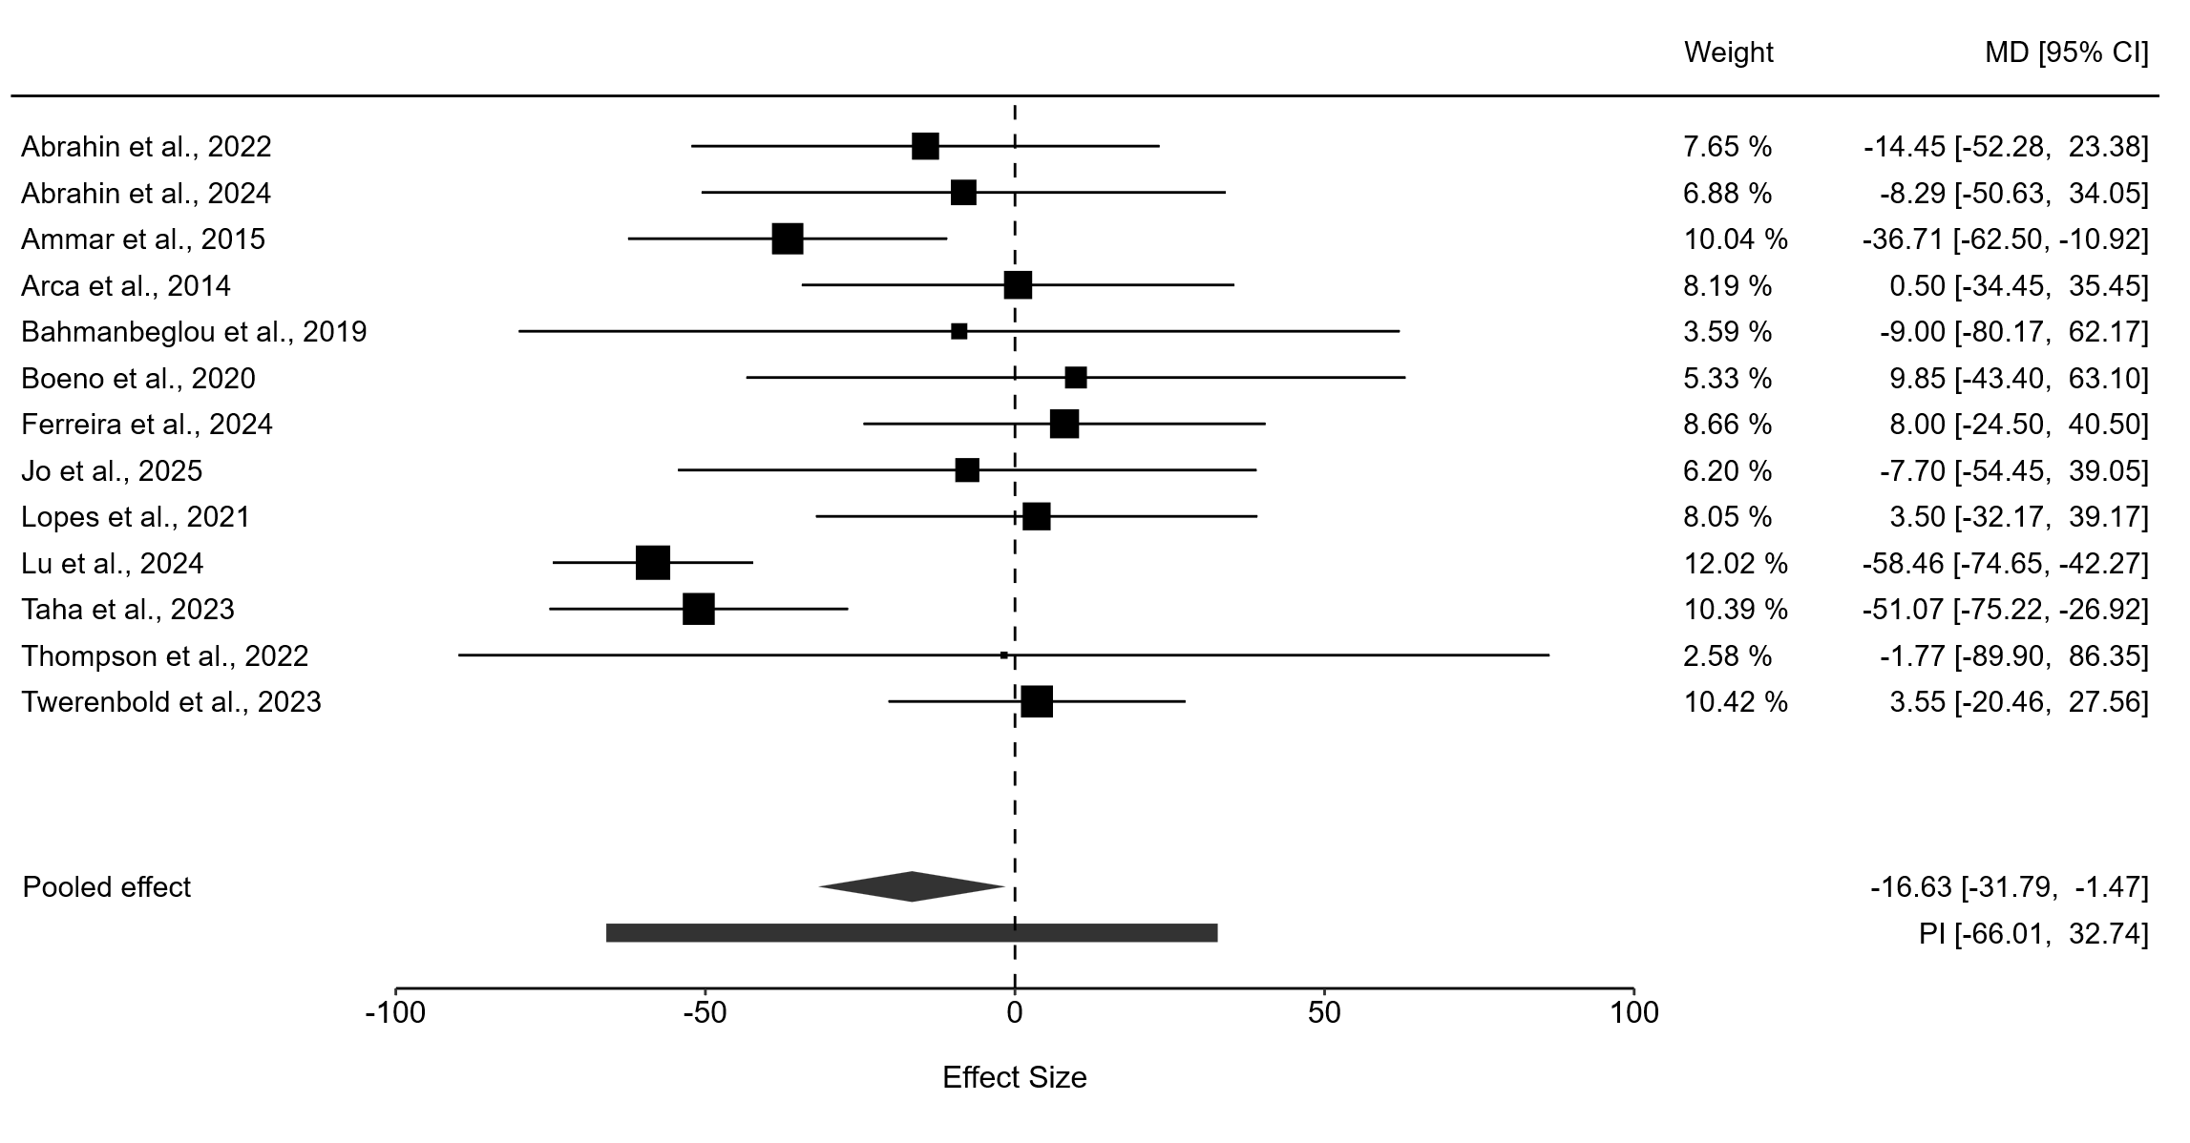
Figure S37. Forest plot of effect sizes for total cholesterol.
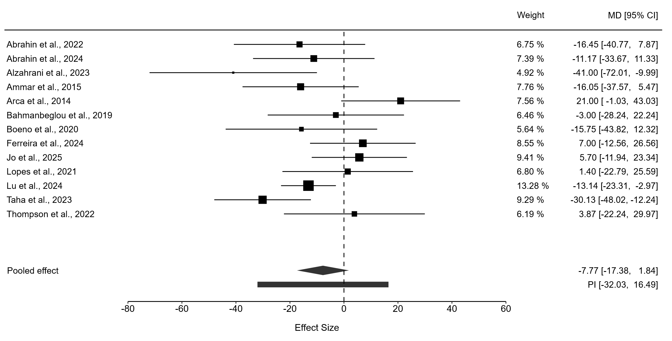
Figure S38. Forest plot of effect sizes for LDL-c.
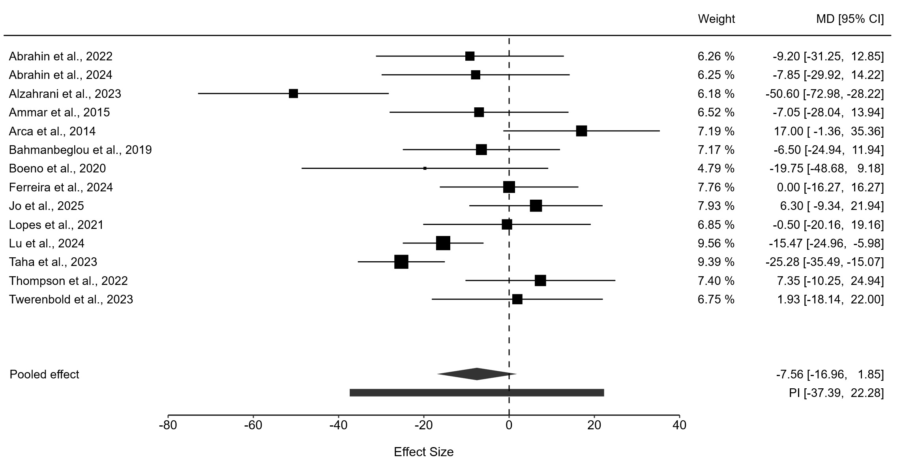
Figure S39. Forest plot of effect sizes for fasting glucose.
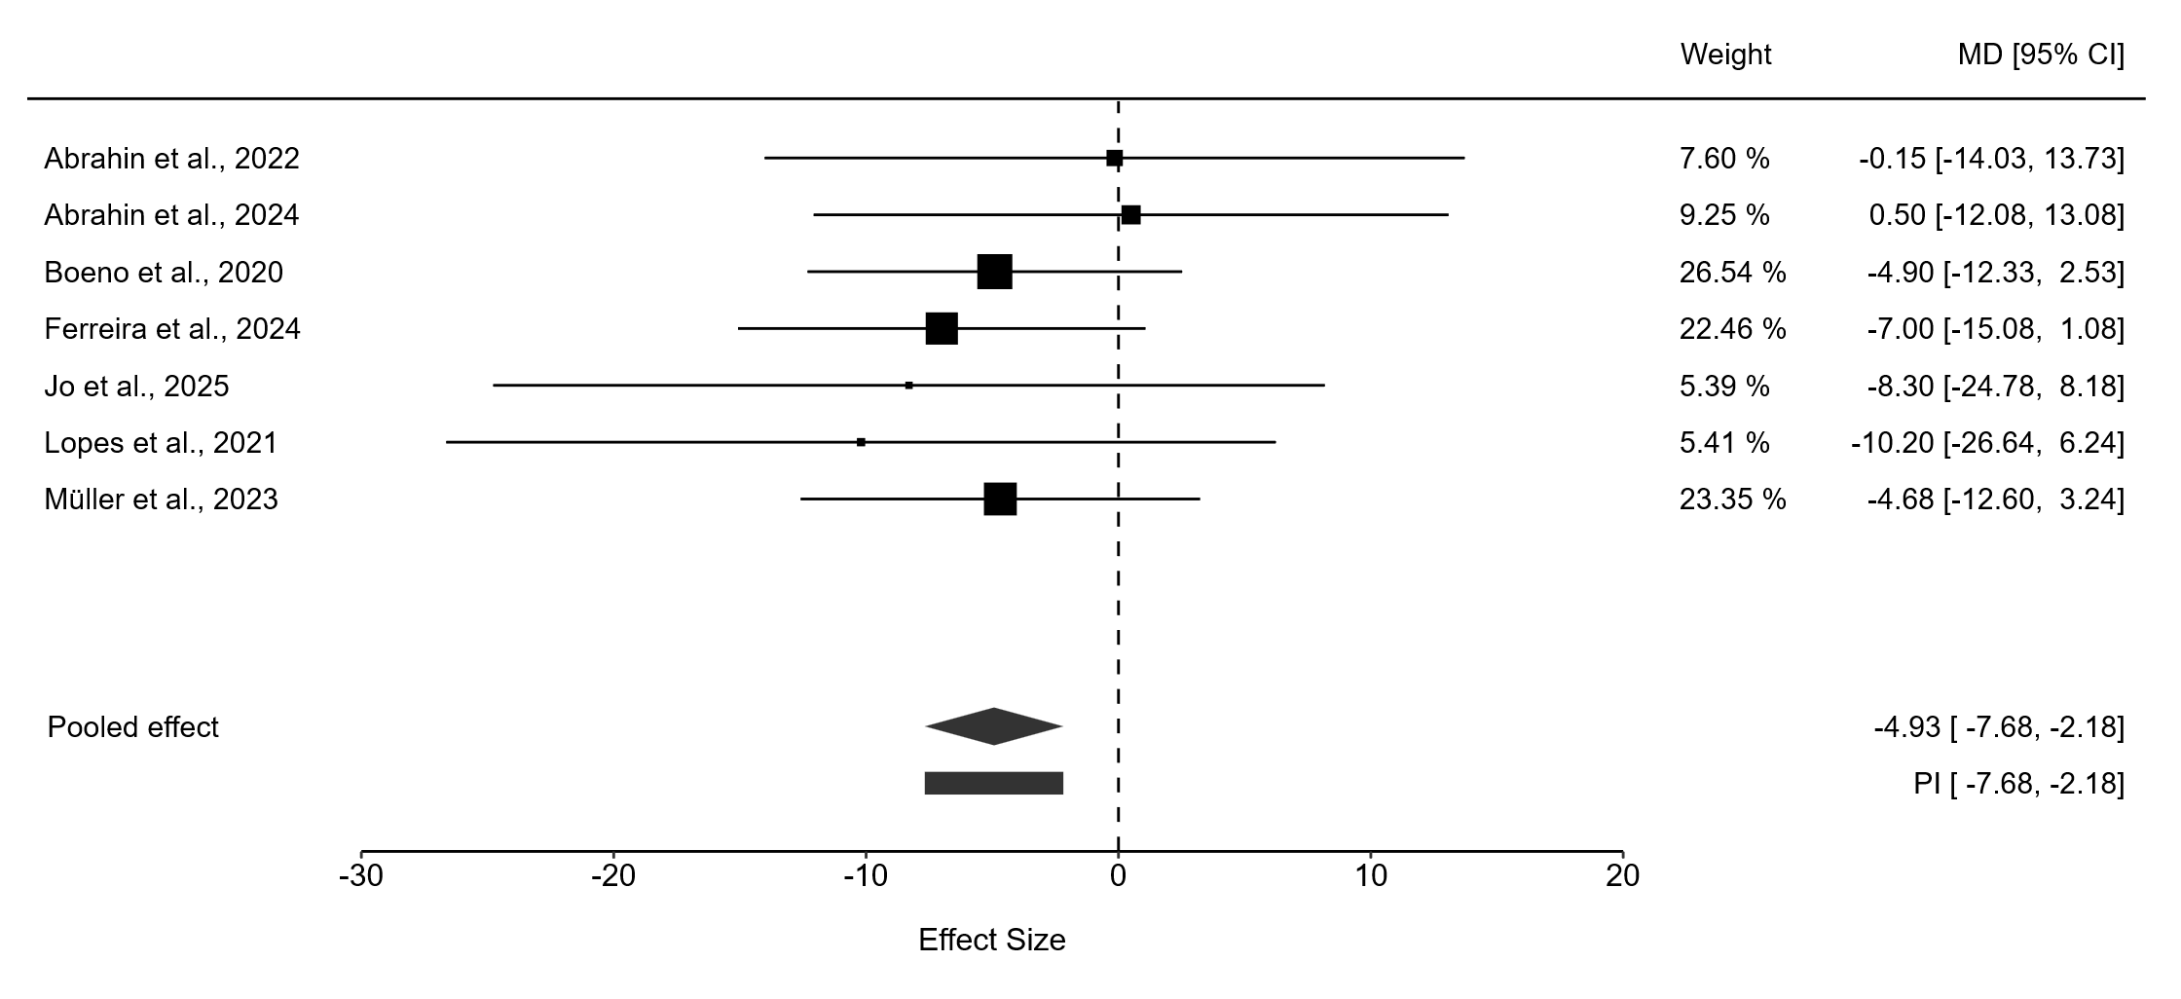
Figure S40. Forest plot of effect sizes for HbA1c.
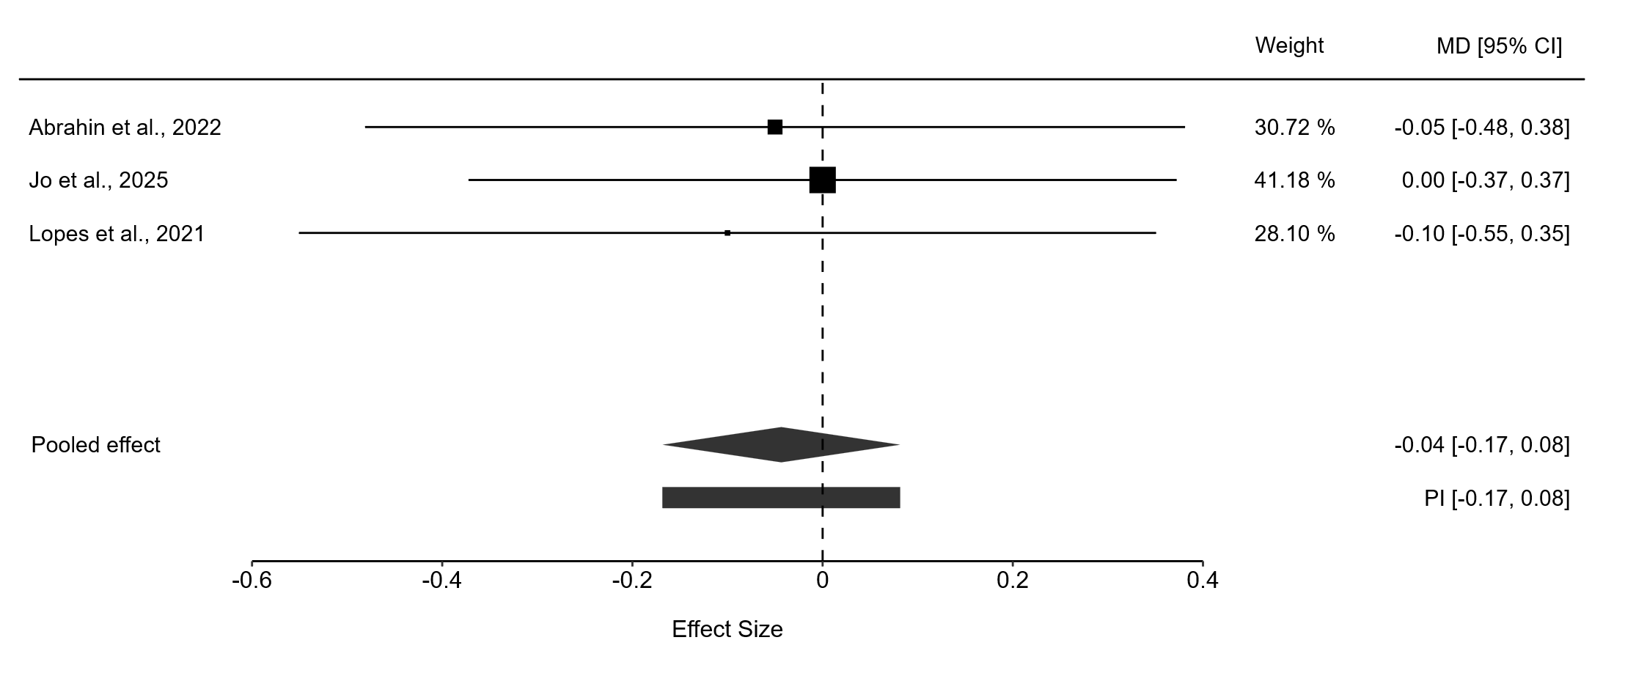
Figure S41. Forest plot of effect sizes for VO₂peak relative.
