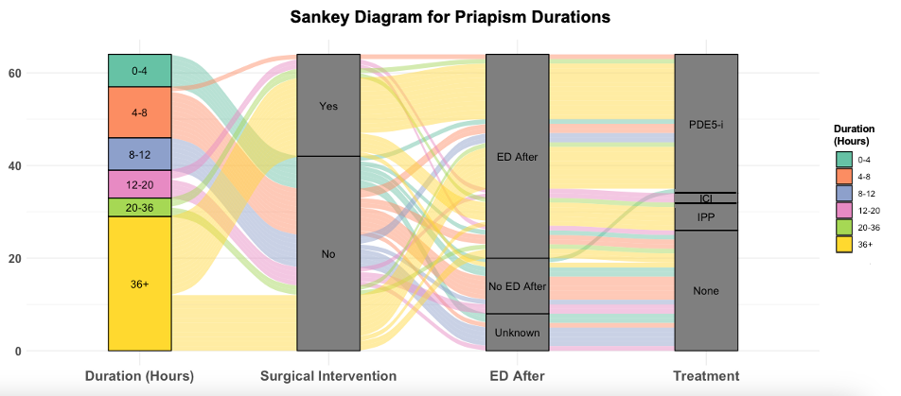
Abbreviations: ED: Erectile Dysfunction, PDE5-i: Phosphodiesterase 5 inhibitor; ICI: Intracavernosal Injection; IPP: Inflatable Penile Prothesis

