Supplementary Figures:

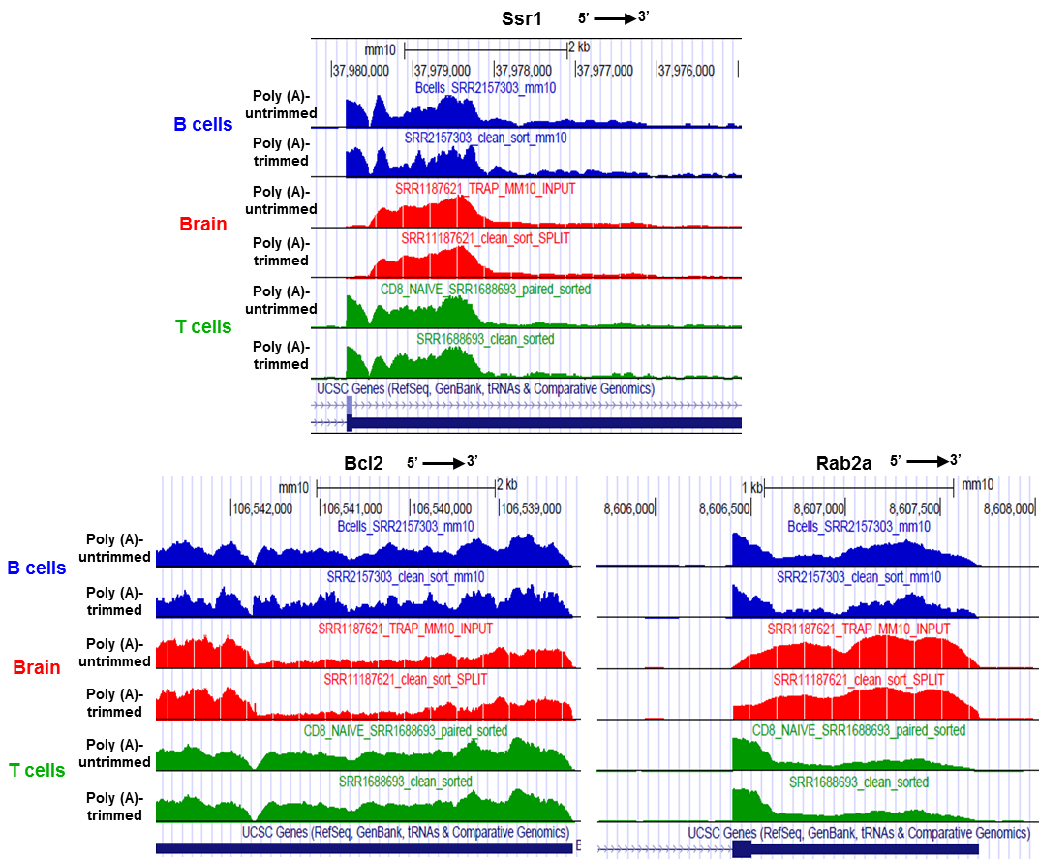
Supplementary Fig. 1 RNA-seq read coverage for Ssr1, Bcl2, and Rab2a in mouse T cells, B cells, and brain tissue. To exclude the possibility that observed gaps in coverage are due to poor mapping following RNA polyadenylation, we compared the coverage without (top) or with (bottom) trimming of poly(A) runs at read ends.

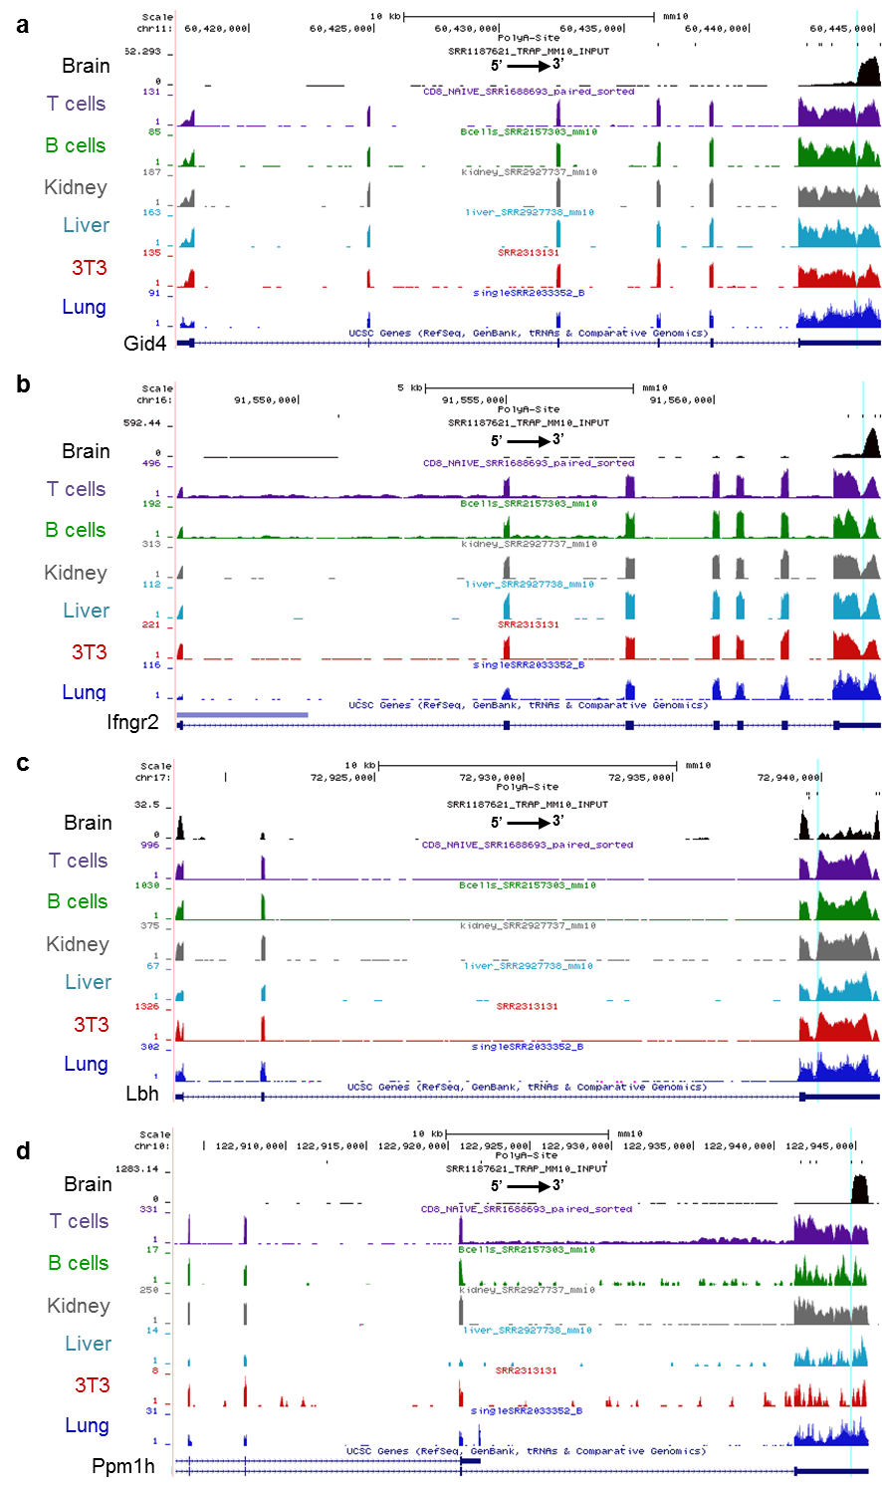

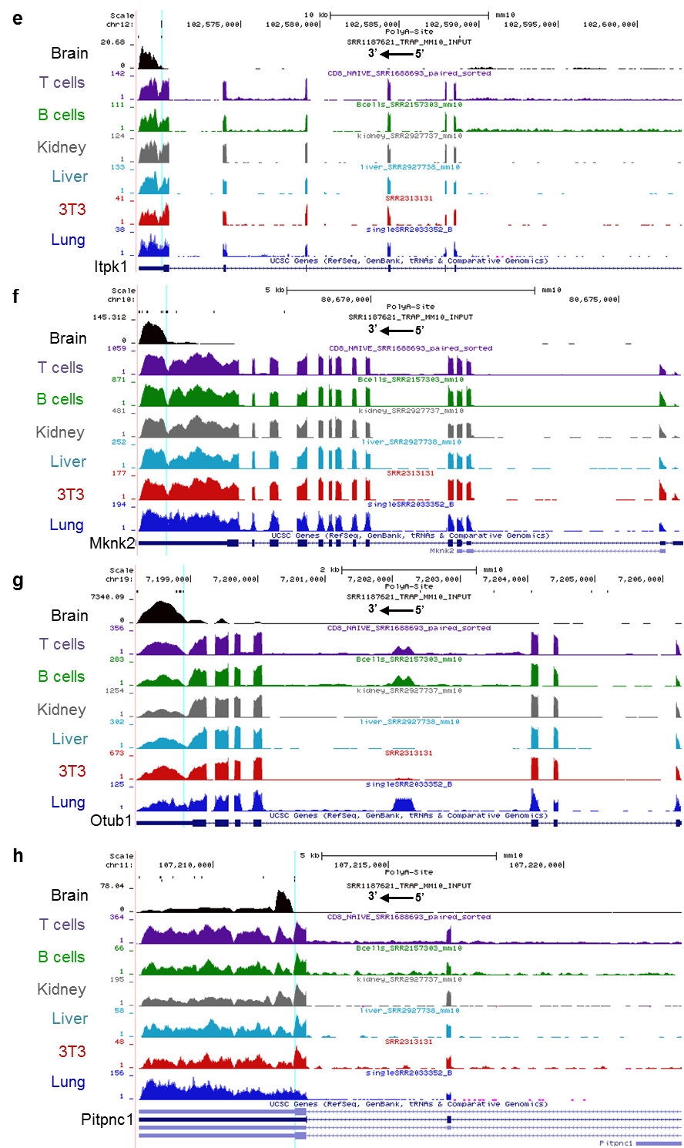

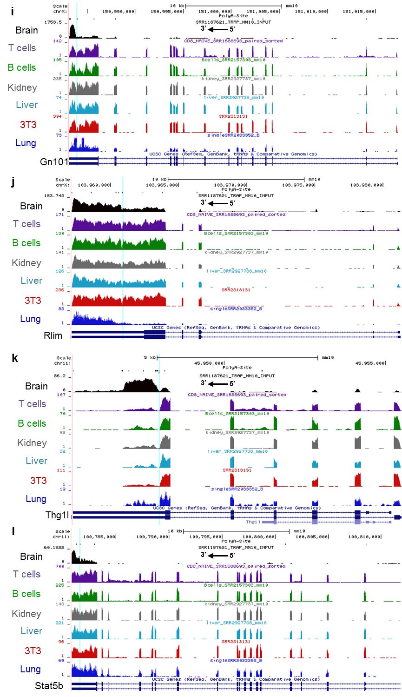

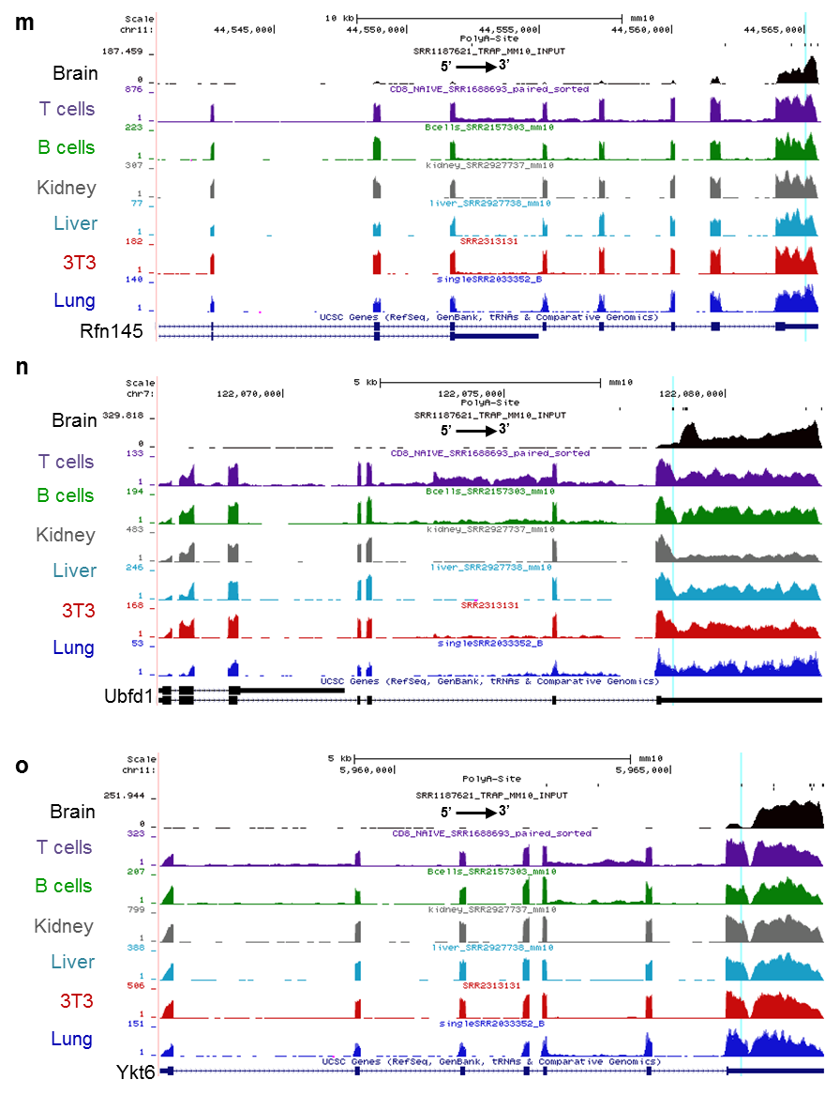
Supplementary Fig. 2 RNA-seq read coverage for Itpk1, Mknk2, Otub1, Pitpnc1, Gid4, Infgr2, Lbh, Ppm1h, Gn101, Rlim, Thg1l, Stat5b, Rfn145, Ubfd1 and Ykt6 in mouse brain tissue (SRX484869), T cells (SRX793419), B cells (SRX1144018), Kidney (SRX1421800), liver (SRX142180), 3T3-NIH (SRX1210977) and lung (SRX1033584), demonstrating a gap in the 3’UTR (marked by light blue line), as well as uneven levels of RNA upstream and downstream of the gap site.

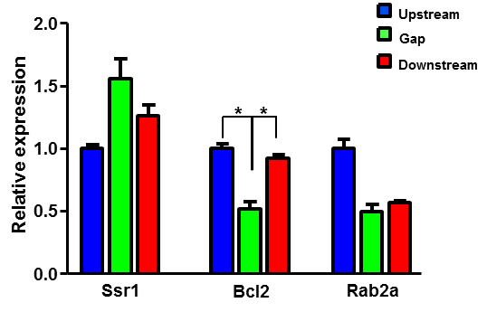
Supplementary Fig. 3 qRT-PCR analysis of upstream, gap and downstream regions from total RNA extraction from naïve T cells of Ssr1, Bcl2 and Rab2a genes. *P<0.05, (two-tailed Student’s t-test). Results are representative of three independent experiments. Error bars, s.d.

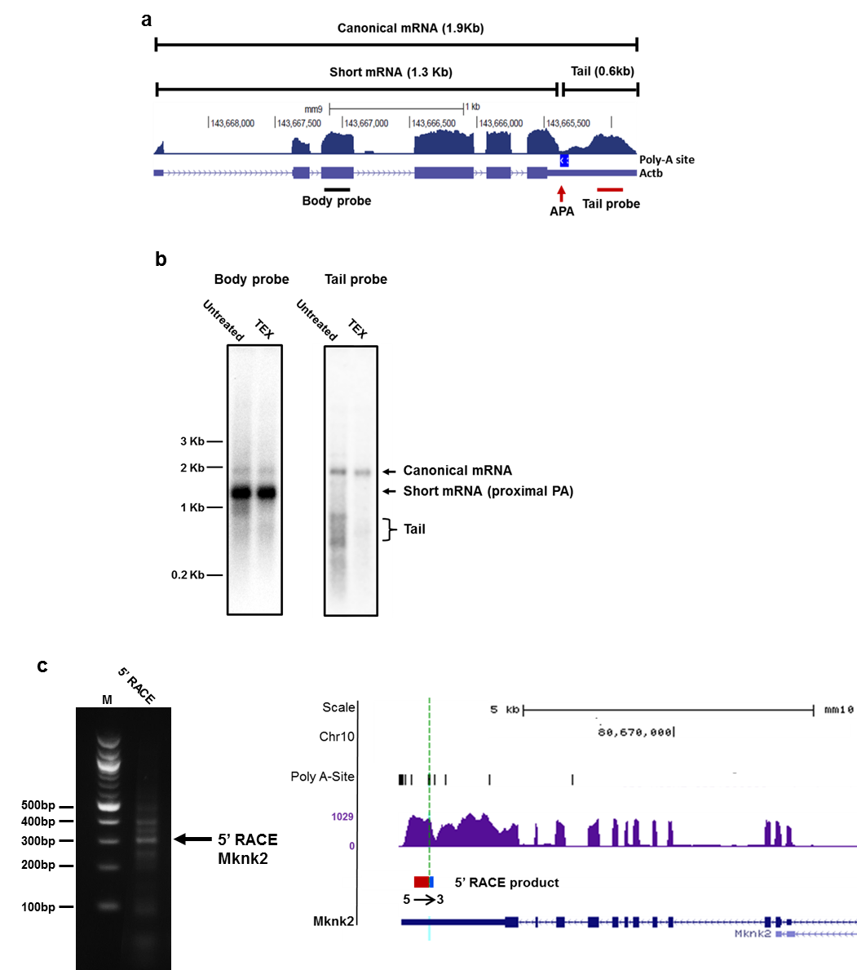

Supplementary Fig. 4 Northern blot analysis of Actb RNA (a-b) and 5’RACE analysis of Mknk2 RNA (c). a Actb presented APA site corresponds to a cleavage in RNA-seq data from mouse heart (SRX1421799). b Northern blot of Actb. 0.5µg of PolyA+ RNA separated on 1.6% agarose from mouse heart. Riboprobes for CDS (body) and 3’UTR (tail) were used in control RNA samples and after TEX treatment. c. 5’RACE: Sequencing PCR product of 5’ Rapid amplification of cDNA ends of Mknk2 identified the 5’ end of 3’UTR tail fragment is in correspondence with APA site. Red box: mapped sequence to the corresponding gene. Blue box: 5' RACE annealed oligonucleotide. See Supplementary Data 2 for the sequences of the 5’RACE product.

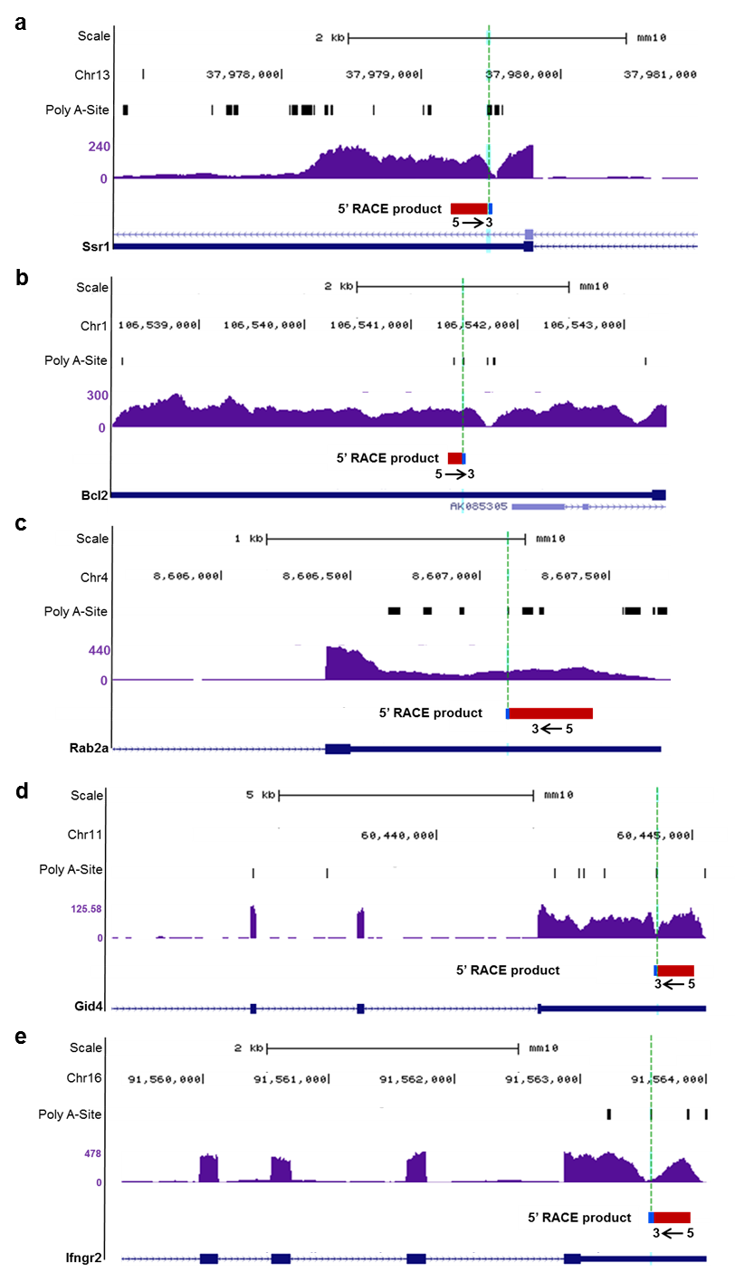

Supplementary Fig. 5 a-f 5’RACE: PCR products of 5’ Rapid amplification of cDNA ends of Ssr1, Bcl2, Rab2a, Gid4 and Ifngr2 were sequenced. 5’ end of 3’UTR tail fragment is mapped adjacently to APA site. Red box: mapped sequence to the corresponding gene. Blue box: 5’ RACE annealed oligonucleotide. See Supplementary Data 2 for the sequences of the 5’RACE products.

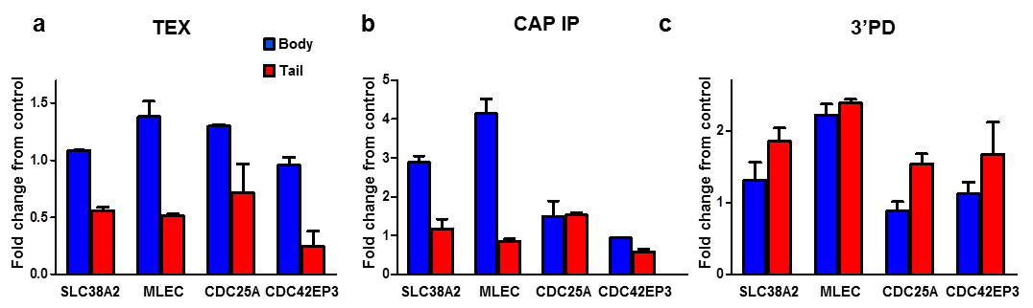
Supplementary Fig. 6 a qRT-PCR measurements of body and tail after polyA selection and treatment with TEX. b qRT-PCR measurements of body and tail after polyA selection and immunoprecipitation with anti-CAP antibody. c Vaccinia Capping System was used to cap an uncapped RNA with an addition of biotinylated GTP. qRT-PCR measurements of body and tail after polyA selection and pulldown with Streptavidin beads for a biotinylated capped RNA. Expression levels were normalized to Ubc and the body fragment was used as a reference to expression level. *P < 0.05, **P < 0.01 and ***P < 0.001 (two-tailed Student’s t-test). Results are representative of three independent experiments. Error bars, s.d.

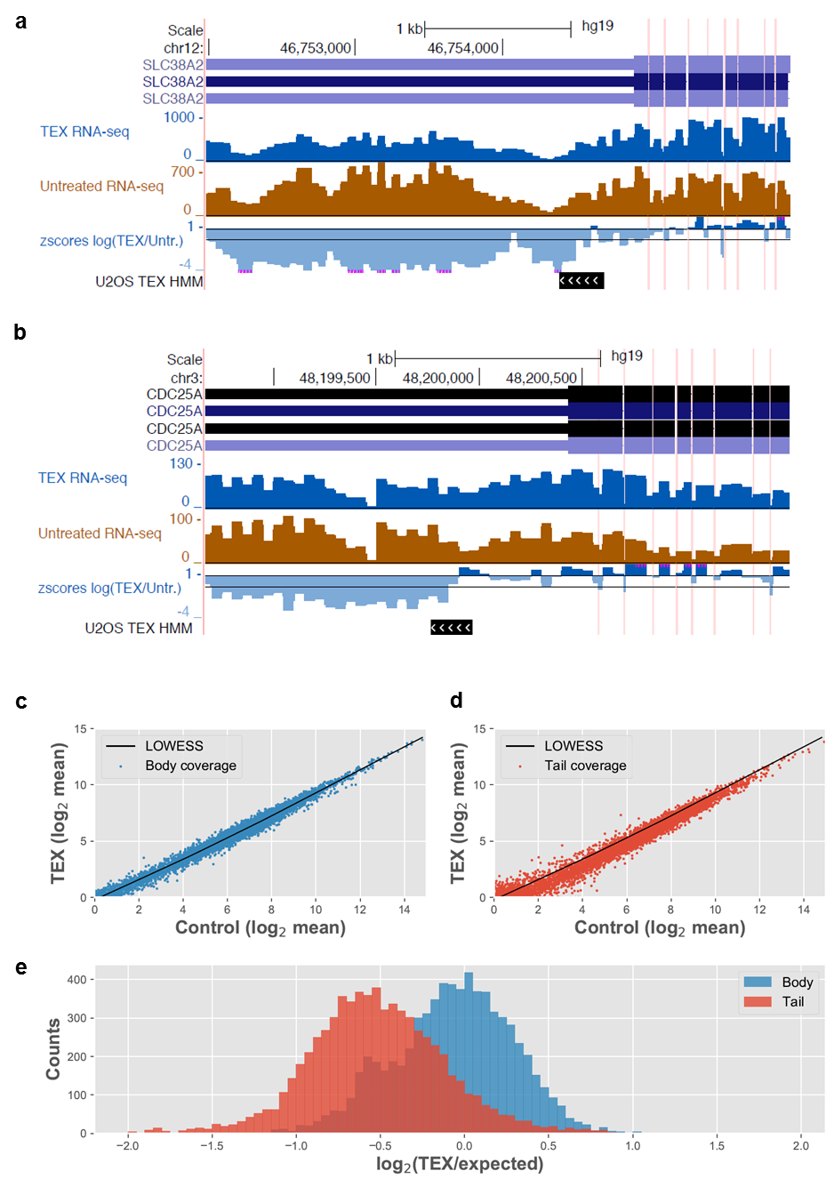
Supplementary Fig. 7 a-b RNA-seq read coverage following TEX treatment (blue) or untreated (brown) for SLC38A2 (a) and CDC25A (b) genes in U2OS cells. Introns are hidden (marked by vertical pink lines). Also shown (bottom of each plot) are the z scores of the log ratio between the two conditions (calculated based on body). Horizontal lines mark +/- 1 s.d.. A black rectangle marks the predicted position of cleavage point, following which the z scores tend to deviate away. c-d Gaussian HMM was used to evaluate TEX/RNA-seq ratio along the transcript to determine cleavage point by which difference in the TEX compared to RNA-seq in U2OS cells was observed. Then transcripts in which the breakpoints fall upstream of the coding end site were filtered. By breaking the transcript to body and tail segments, before and after the cleavage point respectively, we note the difference in the TEX/RNA-seq: (c) TEX compared to control in the body segment. d TEX compared to control in the tail segment. e Comparing the expected TEX according to the control to the actual TEX in body and tail segments.

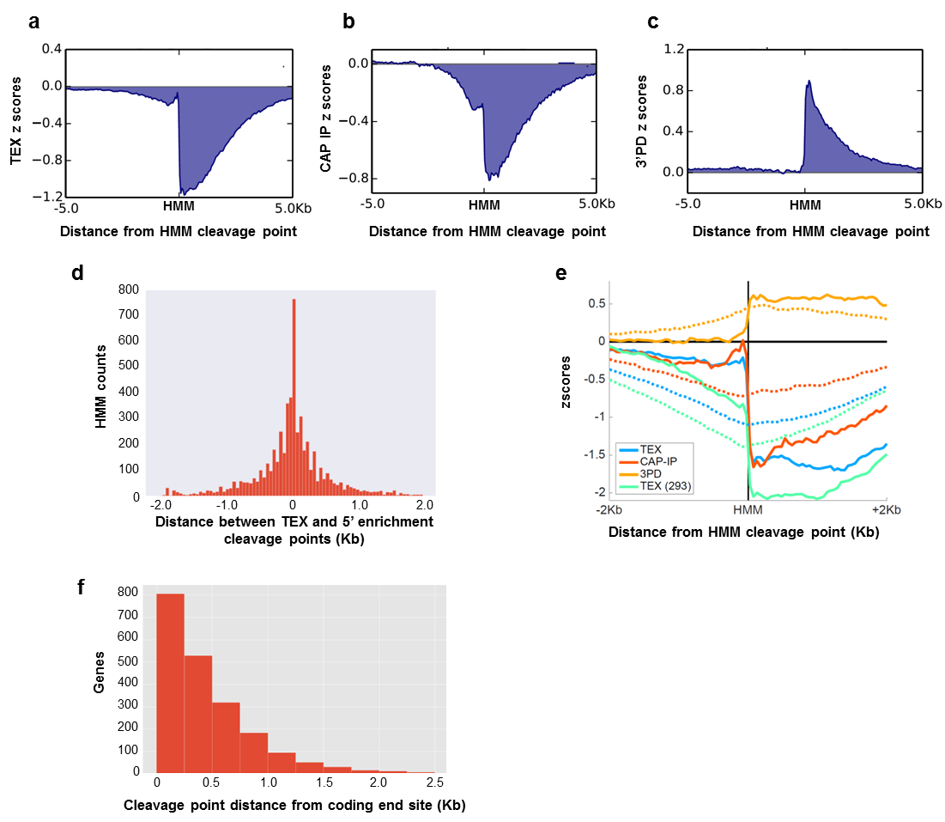
Supplementary Fig. 8 a-c Meta-gene analysis of normalized read coverage ratio (standard deviations from “body”) of cells treated with TEX (a), CAP IP (b), or 3’PD (c), centered around HMM predicted cleavage site in TEX treated cells. Tail units (right) show reduced coverage relative to body in TEX and CAP IP, or increased coverage in 3’PD. d Distance between TEX and 5’ enrichment HMM points. e For each of the four treatments (TEX, CAP IP, 3’PD in U2OS cells, and TEX in HEK-293 cells), we aligned all statistically significant UTRs (longer than 2Kb) by the predicted HMM cleavage point, and computed the average z scores in +/-2Kb windows. As shown, all treatments tend to show near average signal (z score ~ 0) upstream, with sharp deviations following the predicted cleavage point. These include elevated RNA-seq coverage following 3’PD, or weaker RNA-seq coverage following TEX and CAP IP. Dotted lines correspond to similar analysis using random positions in random UTRs (longer than 2Kb). f Distribution of distances of TEX HMM points from coding end site.

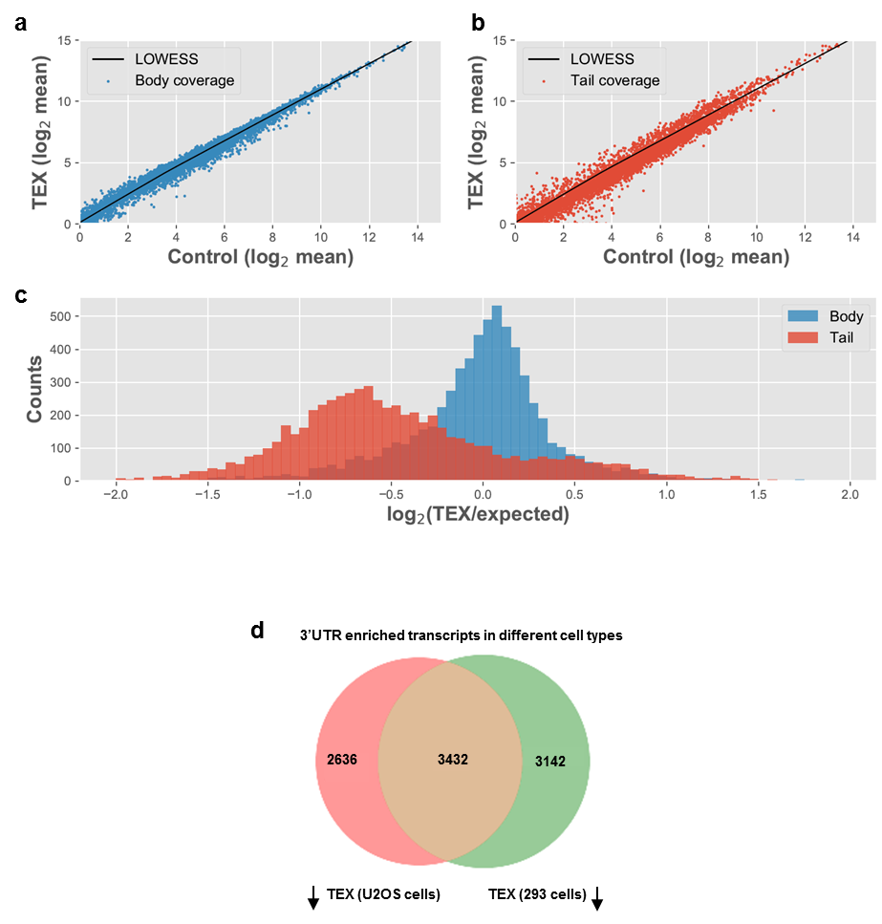
Supplementary Fig. 9 a-b Gaussian HMM was used to evaluate TEX/RNA-seq ratio along the transcript to determine cleavage point by which difference in the TEX compared to RNA-seq in HEK293 cells was observed. Then transcripts in which the breakpoints fall upstream of the coding end site were filtered. By breaking the transcript to body and tail segments, before and after the cleavage point, respectively, we note the difference in the TEX/RNA-Seq: a TEX compared to control in the body segment. b TEX compared to control in the tail segment. c Comparing the expected TEX according to the control to the actual TEX in body and tail segments. d Venn diagram comparison of genes found to differ (p < 0.01 with FDR correction) in their body/tail coverage distribution for TEX relative to the control in U2OS and HEK293 cells.

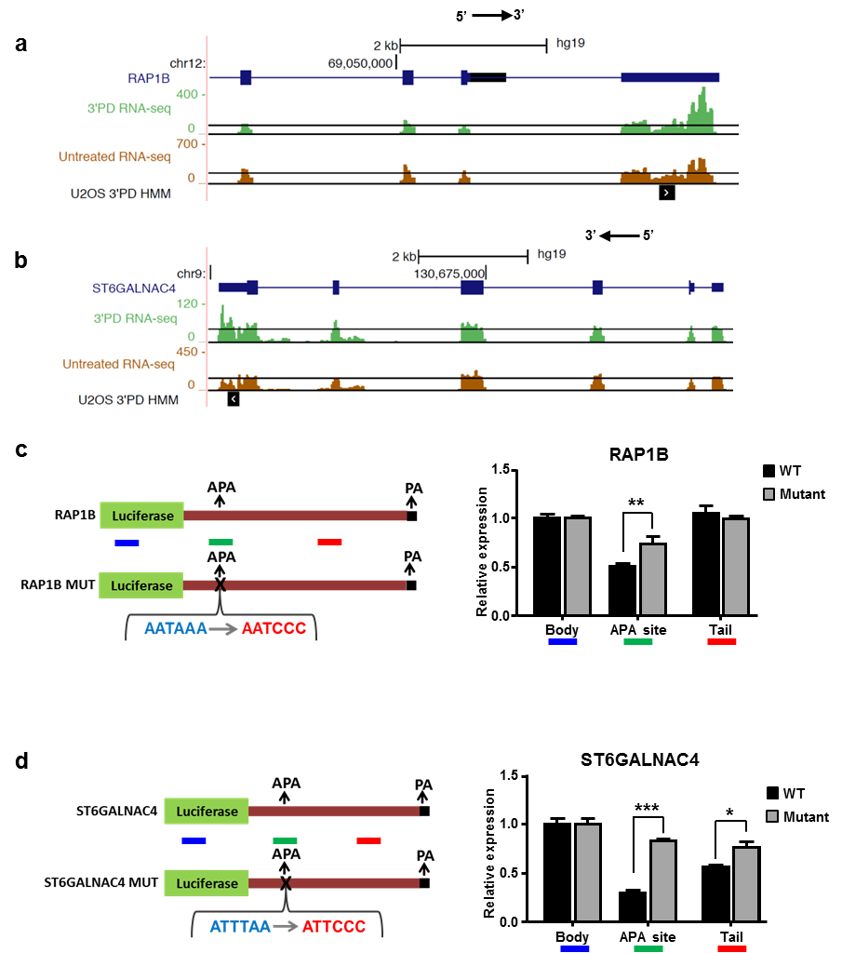
Supplementary Fig. 10 3’UTR of RAP1B (a) and ST6GALNAC4 (b) was cloned into pGL3 promoter luciferase reporter system. For each clone, we mutated the APA site and used 3 sets of primers for qRT-PCR analysis for amplifying body, tail and the APA site. c-d Relative expression of the APA indicates a significant decrease in expression in the cytoplasm RNA fraction in the WT 3’UTR (black bars) compared to the mutated clones (gray bars). Data are normalized to the first sample (Body of WT). *P < 0.05, **P < 0.01 and ***P < 0.001 (two-tailed Student’s t-test). Error bars represent s.d. of three independent experiments (c, d).

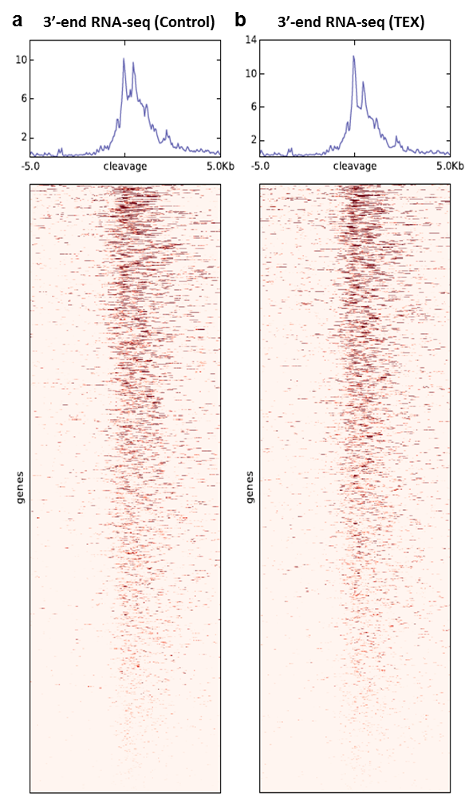
Supplementary Fig. 11 a-b Meta-gene analysis and heatmaps showing 3’-end RNA-seq read coverage around HMM predicted cleavage points for untreated (a) and TEX treated cells (b). Note relative decrease in strength of distal 3’-end peak following TEX.

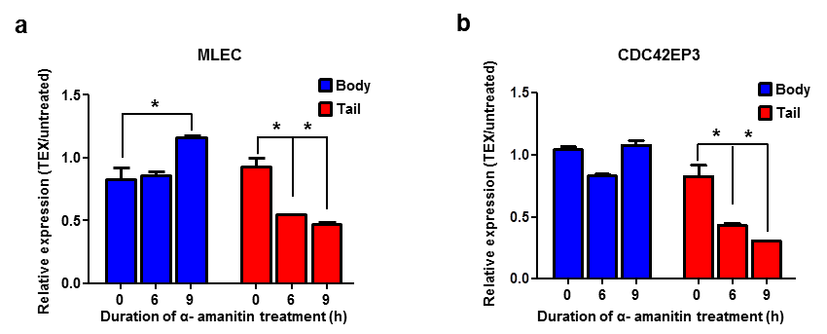
Supplementary Fig. 12 a-b U2OS cells were treated with α-amanitin (10µg/ml) for 6 or 9 hours or left untreated. Cytoplasmic RNA was then treated with TEX and subjected to qRT-PCR analysis using two sets of primers for the body or the tail of MALC (a) and CDC42EP3 (b). Histograms represent relative expression in the TEX treated RNA versus relative expression in TEX-untreated RNA. Expression levels were normalized to UBC. *P<0.05 (two-tailed Student’s t-test). Results are representative of three independent experiments. Error bars, s.d.

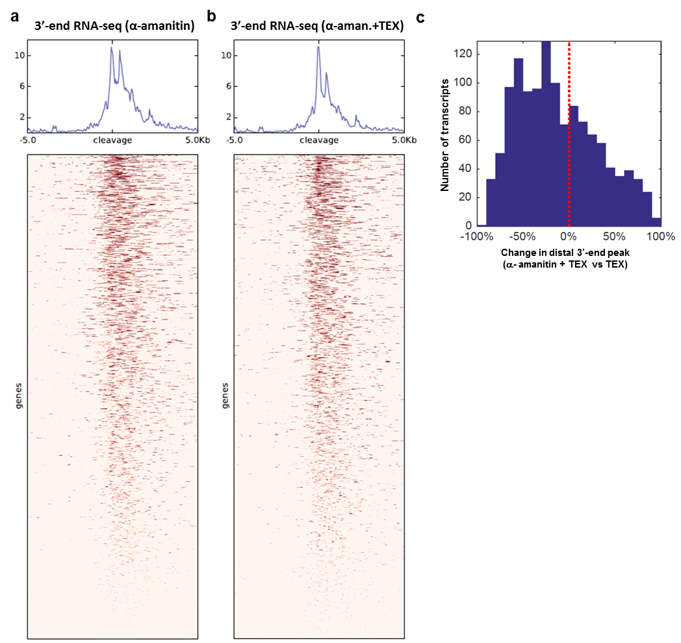
Supplementary Fig. 13 a-b Meta-gene analysis and heatmaps showing 3’-end RNA-seq read coverage around HMM predicted cleavage points for RNA from α-amanitin treated cells; TEX-untreated (a) and TEX-treated (b). Note relative decrease in strength of distal 3’-end peak following TEX in α-amanitin treated cells. c Histogram showing the relative change of distal peak heights (3’-end RNA-seq) of TEX treated RNA from cells treated by α-amanitin for 9 hr vs TEX treated RNA from cells not treated with α-amanitin (p< 4.8e-6, 1484 transcripts).

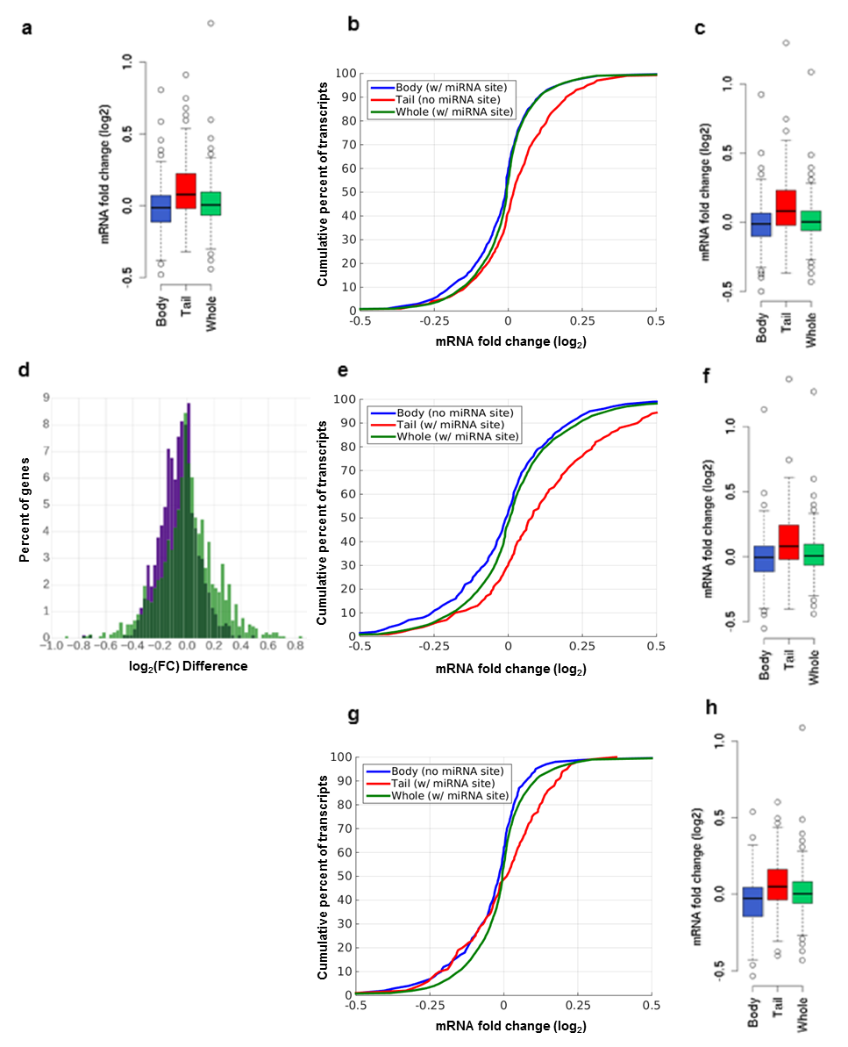
Supplementary Fig. 14 HEK293 transfection experiments. a Boxplot of expression changes (log₂ fold change) in transcripts with miR-92a 7-mer seed binding sites in the body, corresponding to figure 4c. b Cells were transfected with synthetic let-7a/control double-stranded RNA (dsRNA), and total RNA was extracted 40 h after transfection. Cumulative frequency distributions of expression changes in transcripts with let-7a 7-mer seed binding sites in the body are shown (log₂ expression fold change, log₂(FC), values are presented). Comparisons were conducted by a two-sided Kolmogorov–Smirnov test. c Boxplot of log₂ fold change values of the data presented in b. d Histograms of log₂ fold change differences between the body and corresponding tail transcript region in transcripts where a cleavage site was identified (purple), between the coding sequence (CDS) and its corresponding 3′ untranslated region (3′UTR) in transcripts where no cleavage site was found (light green), and in the overlap between them (dark green). In all transcripts, a let-7a binding site was located exclusively in either the body/CDS of the transcript, or in the tail/3′UTR. e-h Cumulative frequency distributions (e and g) and corresponding boxplots (f and h) of expression changes in transcripts with miR-92a (e, f) and let-7a (g,h) 7-mer seed binding sites in the tail, in which results were considered to be inconclusive. In both e and g the distribution of log₂ fold change between the body and the tail was statistically significant (p ≤ 2.9e-11 and p ≤ 5.3e-7, respectively). In both (e) and (f), the tail did not show a larger decrease in expression than the body, as would be expected, whereas in (g) and (h) the distribution of down-regulation between the body and tail was similar. Potential inconsistencies could be attributed to several sources: Firstly, mammalian genes have more than one APA site, such that it is difficult to predict the intactness of the RNA fragment. Our analysis was based on the first cleavage point found computationally following TEX treatment. However, if multiple cleavages occur, it could be that the actual tail begins downstream of the putative cleavage point. Hence the predicted miRNA binding site might not be within the actual tail transcript, such that down-regulation would not be expected, which could explain the discrepancy observed. Moreover, our analysis cannot discern if reads upstream or downstream of the cleavage site are body/tail transcripts or belong to transcripts that were not cleaved and remain whole, and always assumes the former. When the miRNA binding sites were found in the tail region down-regulation of the un-cleaved, whole transcript is expected, as the miRNA site occurs in its 3’UTR, but since our analysis considers these reads to be part of the body, we observe the expression of the body to be decreasing relative to the tail as a result of the miRNA transfection, despite the body having no miRNA binding site (blue versus red plot).

Supplementary Note 1:
Sequence of cloned 3’UTRs
ST6GALNAC4 UTR:
CTTCCGTCGTCCTGCCAGTCGCCATGCCGTTGCGAGGCCTCCGGGATGTC
CCATCCCAAGCCATCACACTCCACAAAAACATTTAATTTATGGATCCTGC
CTCCTGCCACGTGCTGGGTGGACCTAAGGTTCCTTCCCGCCCCATTCTGG
CGACACTTGGAGCCATCTCAGGCCTCATGACTTGAAGGGGAGTGGAGGGG
GGAGCCGTGTCTCCCCCCTCCACTCCCTGAGTAATTCACGGCATTTGGGG
GCTCACCCCACCTCCAGGTCTGTCAAGTGGCCTTTGTCCCTGGGGCTGAT
GGCCCCCAACTCACCAGCATCATGACCTTGTGCCAGTCCTGGTCCTCCCT
CCCCAGCCGCTCCTACCACCTTTTGGTGCCACACTTCTCAGGCTGGCCGC
CCTGGTTGGGGCAGCCGAGAGCCTGGGGTTCATTGGTGAAGGGGCCTTGG
AGTTGTGACTGCCGGGGCCGTATCAGGAACGTACGGGTAAACGTGTGTTT
TCTGGA

ST6GALNAC4 mutant UTR:
CTTCCGTCGTCCTGCCAGTCGCCATGCCGTTGCGAGGCCTCCGGGATGTC
CCATCCCAAGCCATCACACTCCACAAAAACATTCCCTTTATGGATCCTGC
CTCCTGCCACGTGCTGGGTGGACCTAAGGTTCCTTCCCGCCCCATTCTGG
CGACACTTGGAGCCATCTCAGGCCTCATGACTTGAAGGGGAGTGGAGGGG
GGAGCCGTGTCTCCCCCCTCCACTCCCTGAGTAATTCACGGCATTTGGGG
GCTCACCCCACCTCCAGGTCTGTCAAGTGGCCTTTGTCCCTGGGGCTGAT
GGCCCCCAACTCACCAGCATCATGACCTTGTGCCAGTCCTGGTCCTCCCT
CCCCAGCCGCTCCTACCACCTTTTGGTGCCACACTTCTCAGGCTGGCCGC
CCTGGTTGGGGCAGCCGAGAGCCTGGGGTTCATTGGTGAAGGGGCCTTGG
AGTTGTGACTGCCGGGGCCGTATCAGGAACGTACGGGTAAACGTGTGTTT
TCTGGA

RAP1B UTR:
TATACTAAATGCATTGTAGCTCTGAGCCAGGTCTGAAGAACTGTTGCCCA
ATTCAACAGTGCCAGCATTCCAACTTTGTTAAACCTACCAACATCTTAAA
TGGACTTTCCTGTGGTGGTACCCTTTAAGAGGCGGATGAAAGCTACTATA
TCAGTTTGCACATTCTAATCACTTTCCAGTATCACAAGAGAGATTTTTAC
TTATATAATAGTCCTAGAGTTTGCAGCTGGTAAAACCAGAGGCTACATCC
AGTATTACTGCTAAGAGACATTCTTCATCCACCAATGTTGTACATGTATG
AAAATGGTGTACTGTATACTTTAACATGCCCCATACTTTGTATTGGAGAG
TACAATAATGTAAATCCTAAAAGCACCACTATTTTAGCATAATAAAAGAA
AGTCCAAAGAGCTCCTATATAGACTACTCCAGATAACTTCGCTTCTTTGA
TACTTGTAGCTTATTGTAATTTTTTTTAAGAAATTCAAGGTCATTATTAT
TGTACAAAATAAGCGCTTTGATTAACACAGCTATATAGTTTTTTTAATTT
TTAAAAAACCTGTGGAGACGGTGATCTTGTCTTTAAAACATGATAGTCCT
TTCAGTATAATGTCTTAGATTAAAGACGTTGCCTTTAATATCTGTTGGGA
AGGAAATGTCCAGACTTTTCAAATCTCTTATTATATGTTTCCTTTTTTTG
TTTACATAGGGAACAATGTTTATAGTCGTGTGTACAGTGGGGGTCTACAA
CAAGAAGTGTATATTTTCAAACAATTTTTTAATGATTTAACAATTTTTGT
AAATCATTTTCAGGCTTCTGCAGCTGTAGATTCTCACTGTGAATCCCTTG
CTTGCTCATGCATAAGTGTATTTGCAATACCAAATATACAGGTTTAGTAT
TTTTGCCTGTTAGTGATTGTTTCACATGTGTAACGTTTTGGTTGAGATGT
TAAATGGTGGACGAGTACTGTGGATGTGAATGTGGGAAGTAATTTTAATC
ATATGTAATTGGTCACAAGGCCTAATTTGCAGTAACTATTGCTGTTTTAT
TTAACAATGCCTTGTTGCTTTGTATGCATTAATGTTTGGATGTAAAGATT
GTGTGTCTATCCAACAGGGAGCCACAGTATTTAAATTGACCAACCTAATG
TTACAACTACTTTGAGGTGGCCAAATGTAAACTAAAAGCCTTAATTAAAG
TGGTGCAATTTTGTATAACTTAGCATCAGTAGTTCAATAAATTTGGATTG
CCATGCAAGGGCTTGCATTATAA

RAP1B mutant UTR:
TATACTAAATGCATTGTAGCTCTGAGCCAGGTCTGAAGAACTGTTGCCCA
ATTCAACAGTGCCAGCATTCCAACTTTGTTAAACCTACCAACATCTTAAA
TGGACTTTCCTGTGGTGGTACCCTTTAAGAGGCGGATGAAAGCTACTATA
TCAGTTTGCACATTCTAATCACTTTCCAGTATCACAAGAGAGATTTTTAC
TTATATAATAGTCCTAGAGTTTGCAGCTGGTAAAACCAGAGGCTACATCC
AGTATTACTGCTAAGAGACATTCTTCATCCACCAATGTTGTACATGTATG
AAAATGGTGTACTGTATACTTTAACATGCCCCATACTTTGTATTGGAGAG
TACAATAATGTAAATCCTAAAAGCACCACTATTTTAGCATAATCCCAGAA
AGTCCAAAGAGCTCCTATATAGACTACTCCAGATAACTTCGCTTCTTTGA
TACTTGTAGCTTATTGTAATTTTTTTTAAGAAATTCAAGGTCATTATTAT
TGTACAAAATAAGCGCTTTGATTAACACAGCTATATAGTTTTTTTAATTT
TTAAAAAACCTGTGGAGACGGTGATCTTGTCTTTAAAACATGATAGTCCT
TTCAGTATAATGTCTTAGATTAAAGACGTTGCCTTTAATATCTGTTGGGA
AGGAAATGTCCAGACTTTTCAAATCTCTTATTATATGTTTCCTTTTTTTG
TTTACATAGGGAACAATGTTTATAGTCGTGTGTACAGTGGGGGTCTACAA
CAAGAAGTGTATATTTTCAAACAATTTTTTAATGATTTAACAATTTTTGT
AAATCATTTTCAGGCTTCTGCAGCTGTAGATTCTCACTGTGAATCCCTTG
CTTGCTCATGCATAAGTGTATTTGCAATACCAAATATACAGGTTTAGTAT
TTTTGCCTGTTAGTGATTGTTTCACATGTGTAACGTTTTGGTTGAGATGT
TAAATGGTGGACGAGTACTGTGGATGTGAATGTGGGAAGTAATTTTAATC
ATATGTAATTGGTCACAAGGCCTAATTTGCAGTAACTATTGCTGTTTTAT
TTAACAATGCCTTGTTGCTTTGTATGCATTAATGTTTGGATGTAAAGATT
GTGTGTCTATCCAACAGGGAGCCACAGTATTTAAATTGACCAACCTAATG
TTACAACTACTTTGAGGTGGCCAAATGTAAACTAAAAGCCTTAATTAAAG
TGGTGCAATTTTGTATAACTTAGCATCAGTAGTTCAATAAATTTGGATTG
CCATGCAAGGGCTTGCATTATAA

Supplementary Note 2:

5’RACE product sequencing data:
RED – APA site
BLUE – 5’RACE sequence

Mknk2 3’UTR:
5'……GGGTGGGGGCCTGGGACACCCACTGCCCAGCATCCTCCACCCTCCT
CCCTAGTCTCATAGGATCGTCACAGTGGAGGTGACATGCCTTCTCCAGTC
CTGCCCCACCTGCCTCTGTGGACACATTTCCAAAGAACCCCTGGGGGTGG
GACCTCCTCCATCAGTATGACTCAGCTGTTGGCCACCTGAGGACTCGGCC
CCCCTGCAGGTTCCTGAAGCAACCTGACTGGGCAGTGAGCAGCATTGACC
CCCACTCACCCCCAAAACAGGGCTGTGATTTCCTTAGTCCTTCCAA……3'

Ssr1 3’UTR:

5'……TTTTTTTTTTTAAAAAACCATTAAACTGTGTGGGTGTGGATGTCTG
TGAGCAGTTGTCTTACCAGAATCAATGTTAAACTACCTGAAACACACCTT
TAGCATACTCAGCAAAACGCTCTCGCCACTTCCCTTATGCTAGTTTCCTG
TTTTGACCCCAAGTTCAATTAATATTTTTTTCCCAGTGTGGTTTTAGGTG
AATTGTTTTGAGGGAATAATTTGTTTATTTCTTGGAATCGATCAAATCCA
AACTGAGGGCACAAGCCGGCCTTCTGCTTGCTGTCTGTCCCAGCTTGTAT
CTAACTGCACAGCAGGGGTGGCTGCTGTGAGCATCAGAGGCATGCT……3'

Bcl2 3’UTR:
5'……GCTTTCAAAAAGAATCCATGCATCTCAGCATTGTTTAAATTGTATT
TAGTTATGACCTCTAGAATGTTTGTTAGTCACACAAACAGAAAAAGATAC
TTTTTCCATTTGAGGTATTTGTCTCTTGATTCTTCAAAAGCATTTCTGAA
AAGGTGGGAACAGCTTTAGAGAGATGCGAGGAACCGATGGAGCTGG……3'

Rab2a 3’UTR:
5'……AAGCATTGTTAGGAATTGCTTGGACACTGACTTTTCAACTTTTTGA
CATCGTTAACGAGCATGTTCATCTTTTCTTGTCACTAGTCCAAGAAAACT
ACGCTTCCTGTGTATTACTAAAGGCTGTGTGTGTGTTAACCTGTTTTAAT
GCCAAAAGCTATTTGTCCACAAGTTCTTGAGACCGCTTCACAAAAGGATT
TGTTTGCCTTAATGAGTGCTGTTGGGTAAAACACAGTGTAATGAGTGGGA
CGGGCAGAAACAGAAACTCCAACACTACACAACTCCCAAGAGCAAGGCCC
ACTCGGAGAAGGCACGCCATGCCACTTACTCTTCCCTTAGACACAATAAT
GGTCCCTTTTCTTCACACAGTTTCTAAGTATATTTTCTTGCAGGGC……3'

Gid4 3’UTR:
5'……ATCTCTTTGTCTTCAGGGTCTCACTTTGTAACTCTAGCTGGCCTGG
AGCTCACTTTGTAGATCAGGCTGACCTTGAACTCACTGAGATCCACCTGA
CTACTCAGAGCGAGTACTAGGACTAAAGGTGTGAGCCACCACACCCTGCT
TTTTTTTTTTTTTTTTTTCTTAGCTAGGGAAGTGTTCCAGCTCTACTTAG
AAAGATGAGGGAAGGATGCCTTTAGCAGACAGACTTCAGACCTACCTGAA
GACTTGCTGCTTAGAAGTCTGCCCCTGAACACTGGGCAGGAATAAACATG
TTCCACTTCTTAGTAACTCCTAGCTGGTGGACAGTGACTTCTTTTCCTTT
TCTGTCCCTGGAGGACCTCTGGGACTTGTCTCCATTGGTAGCTCTTTAAC
CAGCTGCTCAGTGGCTTGCATGCCTCTGGTCCTGTGTGCAATATCTTTGC
CTGGCACTTGTATCTAACATTGAAAAATAGGTGCAGACTGCAAATGTCCT
ACTGTTCTCTACTCCAACGAGCCAACCCCCAGGCAGGGACTAGAGGTCTG
GCTGCTCTTCTCTTACCCTCCACTCAGAAGGCTCCACTGCTGTGGCCAGC
TGTGGCCCTCTCGTTCCCTGCTTTACCAGTCTACCCACCTATCTCCTTTA
AGATGGCCTAGCATGTCAGCTGCAGTCCAAAAGTAAGTAGACAAAGCCTC
ATGTTAAGTAGACAGTCAGGGTGGACTGGCCCTGTTAGCAGTGTTGGAGT
CAGATTCCAGTGGAACAAAGGGGTTTCTCAATGTCTTTTGCTTTCA……3'

Ifngr2 3’UTR:
5'……GTAATTTAAGTCTTTTTTTTTTTTTTTTAATCTAGAGATAAAAGAT
TGTATGTTAAACTTTTTTTTTTTTTAAGTCTATCTGCCGGGTGGTGGTGG
TGCACACCTTTACTCCTGGCACTTGGGAGGCAGAGGCAGGAGGATCTCTG
TGAGTTCGAGGCCAGCCTGGTCTAGAGTCCTGGTCTAGGACAGCCAAGGC
TACACAGAGAAACCCTGTCTGGTAAACAAAACAGGAAAAAGAAGTGCACG
TGTTTCTTCTTTTCTTGTCCCTTACCACGTCGCCTTCTTTGCCTGTTTTC
CGTAAAGTATTGACTTGTGAAAAGTCTTAGCCAGGCATGGTGACACATGC
CTTTATTCCCAGCACTTGAAAGCAGAGGCCAGTAGATTTCTGTGAG……3'

Supplementary Note 3:

miRNAs sequence:
Negative control:
rCrGrUrUrArArUrCrGrCrGrUrArUrArArUrArCrGrCrGrUAT
rArUrArCrGrCrGrUrArUrUrArUrArCrGrCrGrArUrUrArArCrGrArC
has-miR-92a-3p:
Sense: /5Phos/rUrArUrUrGrCrArCrUrUrGrUrCrCrCrGrGrCrCmUmGrU
Anti-sense: mAmGrGmCrCmGrGmGrAmCrAmArGmUrGmCrAmArUA
has-let-7e-5p:
Sense: /5Phos/rUrGrArGrGrUrArGrGrArGrGrUrUrGrUrArUrAmGmUrU
Anti-sense: mCmUrAmUrAmCrAmArCmCrUmCrCmUrAmCrCmUrCA

Supplementary Tables:

Supplementary Table 1: Primers list for qRT-PCR from mouse cells
 | Forward | Reverse | Amplicon
Bcl2 5’ | AGGAGCAGGTGCCTACAAGA | GCATTTTCCCACCACTGTCT | 166bp
Bcl2 cleavage | TTTGGTTCTATTTGAAAATCTGACA | TGAACTTGGGGAAAAAGTGG | 197bp
Bcl2 3’ | TGGGTGTGGCCTTTATTCAT | TGGGTACTGCCACCCATTAT | 177bp
Rab2A 5’ | TACCAACGCATCTCATGGAA | GCTGAGCATGAGGAAAGAGG | 129bp
Rab2A cleavage | TGAAATGGCTTTATGTCACAGG | TTGACCTAGAAATCAAATGCAAA | 136bp
Rab2A 3’ | GAGACCGCTTCACAAAAGGA | GGGAAGAGTAAGTGGCATGG | 158bp
Ssr1 5’ | ATGTTGTGTGTGCCGCAGT | ATCGTATGGCCACAGACTCC | 147bp
Ssr1 cleavage | TGCACTGCATTGCTTTTCTAA | TGCTAAAGGTGTGTTTCAGGT | 149bp
Ssr1 3’ | AAGAGGCTTCCTTCCCTCTG | GTGTGTGGAAGGGATTGGAC | 135bp
Ubc | GCCCAGTGTTACCACCAAGA | CCCATCACACCCAAGAACA | 104bp

Supplementary Table 2: Primers list for qRT-PCR from human cells
 | Forward | Reverse | Amplicon
MLEC 5’ | CAATAAGAACCGGGTGCAGT | AGGCAGAAGAGGGTTGGAAT | 120bp
MLEC 3’ | GGCAGCCTCTTCAACCATTA | GCCTCCACAGAGAGAGGATG | 169bp
SLC38A2 5’ | TACTGGTGATGACCGGAAGC | CAACACTGGCATCAGATGGA | 120bp
SLC38A2 3’ | CATGAAATCTTGGTACAAATTCAGA | CACCCAGGTTCTCAAAGGTC | 144bp
CDC42EP3 5’ | TTCCAAACAGGAGTCCTTCG | GTGTCTCCCTGGTGGACTGT | 123bp
CDC42EP3 5’ | TTCATCCAGCAAGCTTTTCA | CCACATGATGCTTTTTGCAG | 136bp
CDC25A 5’ | ACAACCGATGCAAGCTGTTT | CTCATGGGCCTTCTCTGGAT | 173bp
CDC25A 3’ | TCAACTTCTTGGGGTGGGAA | GAATCTGTCTCAATGCGCGT | 145bp
Luciferase | TTGTGCCAGAGTCCTTCGAT | TAGGATCTCTGGCATGCGAG | 135bp
RAP1B 3’ | ACTGTGAATCCCTTGCTTGC | TCCACAGTACTCGTCCACCA | 159bp
ST6GALNAC4 3’ | CCACCTCCAGGTCTGTCAAG | GAAGTGTGGCACCAAAAGGT | 130bp
ST6GALNAC4 APA site | TTTATGGATCCTGCCTCCTG | CCCAAATGCCGTGAATTACT | 163bp
RAP1B APA site | CCTAAAAGCACCACTATTTTAGCA | TGTTAATCAAAGCGCTTATTTTGT | 162bp
UBC | ATTTGGGTCGCAGTTCTTG | TGCCTTGACATTCTCGATGGT | 133bp

Supplementary Table 3: Primers list for 5’ RACE experiments
 | Reverse
Mknk2 | GGTCGGGCTTGGAAGGACTAAGGAA
Gid4 | CCCTGCTTCTGAAAGCAAAAGACATTG
Ifngr2 | GCCTCTGCTTTCAAGTGCTGGGAAT
Ssr1 | CCCAGCATGCCTCTGATGCTCAC
Rab2a | TCAAGGTTGACAAACTGCCCTGCAA
Bcl2 | TCCATCGGTTCCTCGCATCTCTCTA

Supplementary Table 4: Primers list for riboprobes
 | Forward | Reverse | Amplicon
Actb CDS | GACGAGGCCCAGAGCAAGAGAGGTA | T7(TAATACGACTCACTATAGGG)GCTACGTACATGGCTGGGGTGTTGA | 233bp
Actb tail (3’UTR) | GGGGAAGGTGACAGCATTGCTTCTG | T7(TAATACGACTCACTATAGGG)TCCCAGGGAGACCAAAGCCTTCATA | 170bp

Supplementary Table 5: Primers list cloning of 3’UTRs into pGL3 Luciferase Reporter Vector
 | Forward | Reverse
ST6GALNAC4 UTR | GAATCTAGACTTCCGTCGTCCTGCCAGTC | GAATCTAGATCCAGAAAACACACGTTTACCCGT
ST6GALNAC4 MUT UTR | CCCTTTATGGATCCTGCCTCCT | GGGAATGTTTTTGTGGAGTGTGATG
ST6GALNAC4 MUT OL | TCACACTCCACAAAAACATTGGGTTTATGGATCCTGCCTCCT | AGGAGGCAGGATCCATAAAGGGAATGTTTTTGTGGAGTGTGA
RAP1B UTR | CCCAGAAAGTCCAAAGAGCTCCTATATAGACTACCC | GAATCTAGATTATAATGCAAGCCCTTGCATGGC
RAP1B MUT UTR | AGAAAGTCCAAAGAGCTCCTATATAGACTACCC | GGGATTATGCTAAAATAGTGGTGCTTTTAGGATTTAC
RAP1B MUT OL |  | ATATAGGAGCTCTTTGGACTTTCTGGGATTATGCTAAAATAGTGGTGCTTTTAGG

