Supplementary Appendix
Somatic Activating Mutations in MAP2K1 Cause Melorheostosis
Kang et al.

Supplementary Table 1. Clinical Features of Melorheostosis Patients
Patient | Age | Gender | Affected Side | Affected Extremity | Site of Affected Bone Biopsy | Site of Unaffected Bone Biopsy | Mutation Status
Melo 1 | 25 | Female | Left | Lower | left tibia | right tibia | Negative
Melo 2 | 42 | Male | Right | Lower | right tibia | left tibia | Positive
Melo 4 | 42 | Female | Right | Lower | right ankle | left tibia | Positive
Melo 6 | 50 | Female | Right | Lower | right tibia | left tibia | Positive
Melo 8 | 53 | Female | Left | Lower | left first metatarsal | right tibia | Negative
Melo 9 | 59 | Female | Right | Upper | right humerus | left ulna | Positive
Melo 10 | 49 | Female | Right | Lower | right tibia | left iliac crest | Positive
Melo 11 | 66 | Male | Left | Lower | left proximal tibia | right iliac crest | Negative
Melo 12 | 29 | Female | Left | Lower | left proximal tibia | right iliac crest | Negative
Melo 13 | 56 | Female | Right | Lower | right femur | left tibia | Negative
Melo 16 | 28 | Female | Left | Lower | left middle cuneiform | right tibia | Positive
Melo 17 | 40 | Male | Right | Upper | right radius | left ulna | Negative
Melo 18 | 45 | Female | Left | Upper | left clavicle | right iliac crest | Positive
Melo 19 | 42 | Male | Right | Upper | right radius | right iliac crest | Positive
Melo 24 | 60 | Male | Left | Upper | left tibia | right iliac crest | Negative

Supplementary Table 2. Experimental Evaluation of Patient Samples

Subject | Gene variation | WES | ddPCR | Western Blot | FACS | Proliferation | Immunohistochemistry | Bone Histology | Histomorphometry
Melo-4 | MAP2K1 P.Q56P | Yes | Yes | Yes | No | No | Yes | Yes | Yes*
Melo-9 | MAP2K1 P.Q56P | Yes | Yes | Yes | Yes | Yes | No | Yes | Yes
Melo-19 | MAP2K1 P.Q56P | Yes | Yes | Yes | Yes | Yes | No | Yes | Yes
Melo-10 | MAP2K1 P.K57E | Yes | Yes | Yes | Yes | Yes | No | Yes | Yes
Melo-2 | MAP2K1 P.K57N | Yes | Yes | Yes | Yes | Yes | No | Yes | Yes
Melo-6 | MAP2K1 P.K57N | Yes | Yes | Yes | No | No | No | Yes | No
Melo-16 | MAP2K1 P.K57N | Yes | Yes | No | No | No | No | Yes | No
Melo-18 | MAP2K1 P.K57N | Yes | Yes | Yes | Yes | Yes | Yes | Yes | Yes

* Two samples of affected bone were available for Melo 4. Both were used.

Supplementary Table 3. Conditions Where MAP2K1 Mutations Previously Identified
Mutation | Conditions Associated
K57N | Primary non-small cell lung cancer¹, melanoma², IGHV4-34-expressing hairy cell leukemia³, Langerhans cell histiocytosis⁴
Q56P | IGHV4-34 expressing hairy cell leukemia³, lung adenocarcinoma⁵, Langerhans cell histiocytosis⁶, extracranial arteriovenous malformations⁷
K57E | IGHV4-34-expressing hairy cell leukemia³, resistance to Vemurafenib in metastatic melanoma⁸, Langerhans cell histiocytosis⁴, extracranial arteriovenous malformations⁷

Supplementary Table 4. Read Counts from the MAP2K1 Amplicon Sequencing for Position 66727451

Sample | Ref | Coverage | A | T | C | G | a | t | c | g | Sub | Ins | Del | VAF
melo10-aff | A | 11775 | 5866 | 6 | 20 | 1 | 5877 | 0 | 2 | 3 | 32 | 0 | 0 | 0.27%
melo11-aff | A | 3729 | 1851 | 4 | 11 | 0 | 1861 | 0 | 1 | 1 | 17 | 0 | 0 | 0.46%
melo12-aff | A | 7026 | 3508 | 2 | 3 | 0 | 3513 | 0 | 0 | 0 | 5 | 0 | 0 | 0.07%
melo13-aff | A | 7855 | 3918 | 1 | 4 | 3 | 3929 | 0 | 0 | 0 | 8 | 0 | 0 | 0.10%
melo16-aff | A | 6104 | 3049 | 0 | 3 | 1 | 3046 | 3 | 2 | 0 | 9 | 0 | 0 | 0.15%
melo17-aff | A | 5133 | 2561 | 1 | 3 | 2 | 2565 | 0 | 0 | 1 | 7 | 0 | 0 | 0.14%
melo18-aff | A | 3750 | 1871 | 0 | 5 | 0 | 1874 | 0 | 0 | 0 | 5 | 0 | 0 | 0.13%
melo19-aff | A | 14181 | 5110 | 2 | 1977 | 2 | 5111 | 0 | 1979 | 0 | 3960 | 0 | 0 | 27.92%
melo1-aff | A | 23177 | 11533 | 10 | 46 | 3 | 11578 | 1 | 1 | 5 | 66 | 0 | 0 | 0.28%
melo24-aff | A | 6504 | 3250 | 0 | 1 | 2 | 3249 | 0 | 0 | 2 | 5 | 0 | 0 | 0.08%
melo2-aff | A | 8476 | 4223 | 2 | 14 | 3 | 4229 | 0 | 0 | 5 | 24 | 0 | 0 | 0.28%
melo6-aff | A | 4750 | 2373 | 1 | 0 | 1 | 2372 | 1 | 0 | 1 | 4 | 0 | 0 | 0.08%
melo8-aff | A | 5805 | 2894 | 3 | 1 | 4 | 2900 | 1 | 0 | 1 | 10 | 0 | 0 | 0.17%
melo10-ctl | A | 12621 | 6294 | 4 | 12 | 5 | 6299 | 3 | 2 | 2 | 28 | 0 | 0 | 0.22%
melo18-ctl | A | 6219 | 3103 | 1 | 4 | 2 | 3108 | 0 | 0 | 1 | 8 | 0 | 0 | 0.13%
melo24-ctl | A | 7528 | 3758 | 2 | 1 | 3 | 3762 | 0 | 1 | 1 | 8 | 0 | 0 | 0.11%
melo2-ctl | A | 12028 | 5992 | 6 | 19 | 0 | 6006 | 3 | 0 | 2 | 30 | 0 | 0 | 0.25%
Upper case letters: read counts from plus strand
Lower case letters: read counts from minus strand

Supplementary Table 5. Read Counts from the MAP2K1 Amplicon Sequencing 66727453

Sample | Ref | Coverage | A | T | C | G | a | t | c | g | Sub | Ins | Del | VAF
melo10-aff | A | 11776 | 4893 | 6 | 10 | 984 | 4905 | 1 | 0 | 977 | 1978 | 0 | 0 | 16.80%
melo11-aff | A | 3729 | 1847 | 5 | 11 | 3 | 1859 | 1 | 0 | 3 | 23 | 0 | 0 | 0.62%
melo12-aff | A | 7026 | 3496 | 7 | 6 | 4 | 3509 | 2 | 0 | 2 | 21 | 0 | 0 | 0.30%
melo13-aff | A | 7855 | 3909 | 5 | 7 | 5 | 3926 | 2 | 0 | 1 | 20 | 0 | 0 | 0.25%
melo16-aff | A | 6104 | 3049 | 0 | 1 | 3 | 3051 | 0 | 0 | 0 | 4 | 0 | 0 | 0.07%
melo17-aff | A | 5133 | 2563 | 1 | 3 | 0 | 2565 | 0 | 0 | 1 | 5 | 0 | 0 | 0.10%
melo18-aff | A | 3750 | 1867 | 3 | 5 | 1 | 1873 | 1 | 0 | 0 | 10 | 0 | 0 | 0.27%
melo19-aff | A | 14181 | 7085 | 1 | 4 | 1 | 7090 | 0 | 0 | 0 | 6 | 0 | 0 | 0.04%
melo1-aff | A | 23175 | 11529 | 19 | 29 | 13 | 11567 | 4 | 1 | 13 | 79 | 0 | 0 | 0.34%
melo24-aff | A | 6504 | 3242 | 3 | 5 | 3 | 3250 | 1 | 0 | 0 | 12 | 0 | 0 | 0.18%
melo2-aff | A | 8476 | 4223 | 2 | 11 | 6 | 4229 | 1 | 1 | 3 | 24 | 0 | 0 | 0.28%
melo6-aff | A | 4750 | 2374 | 0 | 2 | 0 | 2373 | 1 | 0 | 0 | 3 | 0 | 0 | 0.06%
melo8-aff | A | 5805 | 2893 | 2 | 5 | 3 | 2900 | 0 | 0 | 2 | 12 | 0 | 0 | 0.21%
melo10-ctl | A | 12622 | 6290 | 5 | 17 | 3 | 6301 | 1 | 0 | 5 | 31 | 0 | 0 | 0.25%
melo18-ctl | A | 6219 | 3107 | 1 | 1 | 1 | 3107 | 1 | 0 | 1 | 5 | 0 | 0 | 0.08%
melo24-ctl | A | 7528 | 3754 | 3 | 6 | 1 | 3760 | 1 | 3 | 0 | 14 | 0 | 0 | 0.19%
melo2-ctl | A | 12027 | 5984 | 6 | 20 | 6 | 6002 | 1 | 1 | 7 | 41 | 0 | 0 | 0.34%
Upper case letters: read counts from plus strand
Lower case letters: read counts from minus strand

Supplementary Table 6. Read Counts from the MAP2K1 Amplicon Sequencing 66727455

Sample | Ref | Coverage | A | T | C | G | a | t | c | g | Sub | Ins | Del | VAF
melo10-aff | G | 11776 | 3 | 6 | 0 | 5884 | 7 | 3 | 0 | 5873 | 19 | 0 | 0 | 0.16%
melo11-aff | G | 3729 | 0 | 2 | 1 | 1863 | 1 | 0 | 0 | 1862 | 4 | 0 | 0 | 0.11%
melo12-aff | G | 7026 | 2 | 1 | 2 | 3508 | 1 | 2 | 2 | 3508 | 10 | 0 | 0 | 0.14%
melo13-aff | G | 7855 | 1 | 0 | 0 | 3925 | 1 | 2 | 0 | 3926 | 4 | 0 | 1 | 0.05%
melo16-aff | G | 6104 | 1 | 82 | 0 | 2970 | 0 | 81 | 0 | 2970 | 164 | 0 | 0 | 2.69%
melo17-aff | G | 5133 | 1 | 1 | 0 | 2565 | 0 | 0 | 0 | 2566 | 2 | 0 | 0 | 0.04%
melo18-aff | G | 3749 | 0 | 647 | 0 | 1229 | 0 | 642 | 0 | 1231 | 1289 | 0 | 0 | 34.38%
melo19-aff | G | 14181 | 0 | 3 | 0 | 7088 | 1 | 1 | 0 | 7088 | 5 | 0 | 0 | 0.04%
melo1-aff | G | 23175 | 2 | 6 | 2 | 11579 | 11 | 7 | 1 | 11567 | 29 | 0 | 0 | 0.13%
melo24-aff | G | 6504 | 0 | 2 | 1 | 3250 | 0 | 1 | 1 | 3249 | 5 | 0 | 2 | 0.08%
melo2-aff | G | 8477 | 0 | 306 | 2 | 3934 | 4 | 306 | 0 | 3925 | 618 | 0 | 0 | 7.29%
melo6-aff | G | 4750 | 2 | 114 | 0 | 2260 | 2 | 114 | 0 | 2258 | 232 | 0 | 0 | 4.88%
melo8-aff | G | 5804 | 1 | 0 | 0 | 2901 | 1 | 2 | 0 | 2899 | 4 | 0 | 0 | 0.07%
melo10-ctl | G | 12623 | 2 | 6 | 2 | 6304 | 8 | 1 | 1 | 6299 | 20 | 0 | 0 | 0.16%
melo18-ctl | G | 6219 | 0 | 1 | 0 | 3109 | 0 | 2 | 0 | 3107 | 3 | 0 | 0 | 0.05%
melo24-ctl | G | 7528 | 0 | 0 | 0 | 3764 | 2 | 3 | 0 | 3759 | 5 | 0 | 0 | 0.07%
melo2-ctl | G | 12028 | 0 | 0 | 2 | 6014 | 5 | 5 | 0 | 6002 | 12 | 0 | 0 | 0.10%
Upper case letters: read counts from plus strand
Lower case letters: read counts from minus strand

Supplementary Table 7. Probes Used for ddPCR
Mutation | Forward primer | Reverse primer | Mutant probe (FAM) | Wildtype probe (HEX)
MAP2K1 Q56P | CGAAAGCGCCTTGAG | AAGTCGTCATCCTTCAGTT | TCTGCTTCGGGGTAAGA | TCTGCTTCTGGGTAAGAAA
MAP2K1 K57N | CGAAAGCGCCTTGAG | AAGTCGTCATCCTTCAGT | CCCAGAATCAGAAGGTGG | CCCAGAAGCAGAAGGTG
MAP2K1 K57E | CGAAAGCGCCTTGAG | AAGTCGTCATCCTTCAGTT | TCTTACCCAGGAGCAGA | TCTTACCCAGAAGCAGAAG

All ddPCR mutation probe assays were custom-designed. Sequences for forward primer, reverse primer, mutant-binding probe, and wildtype-binding probe are

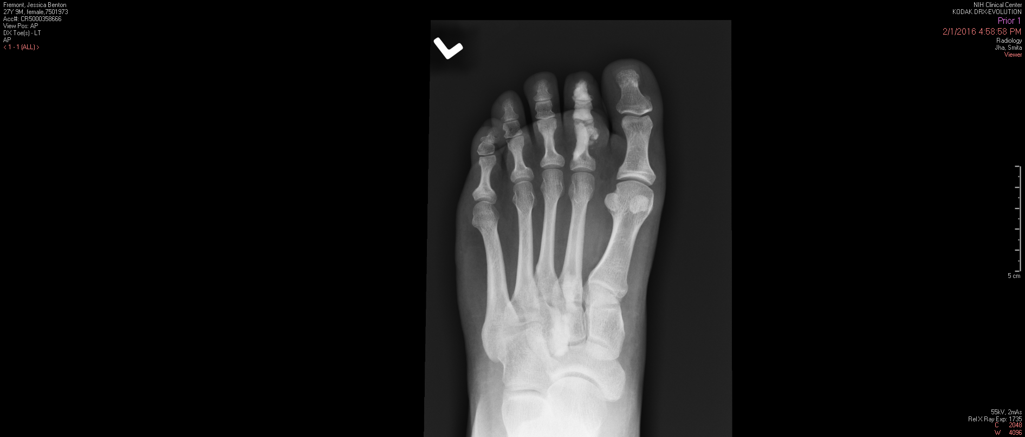
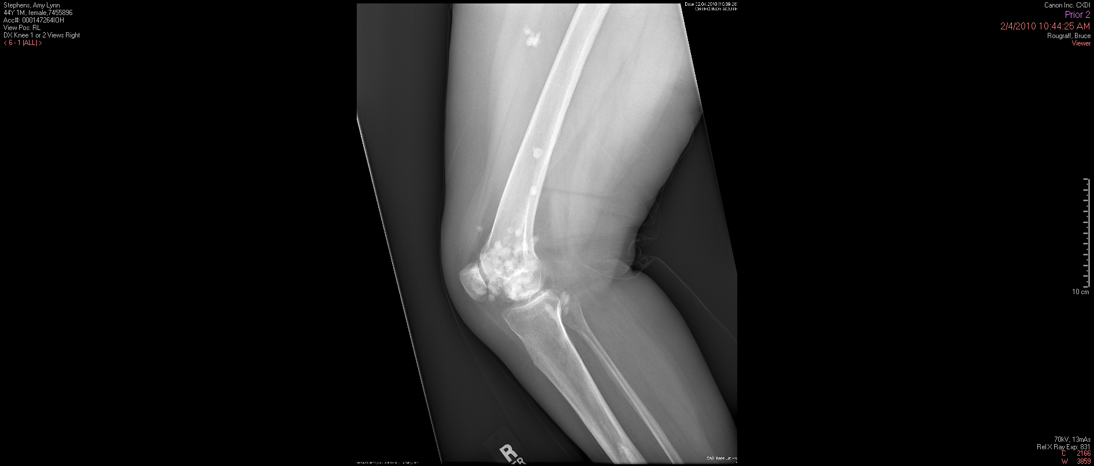
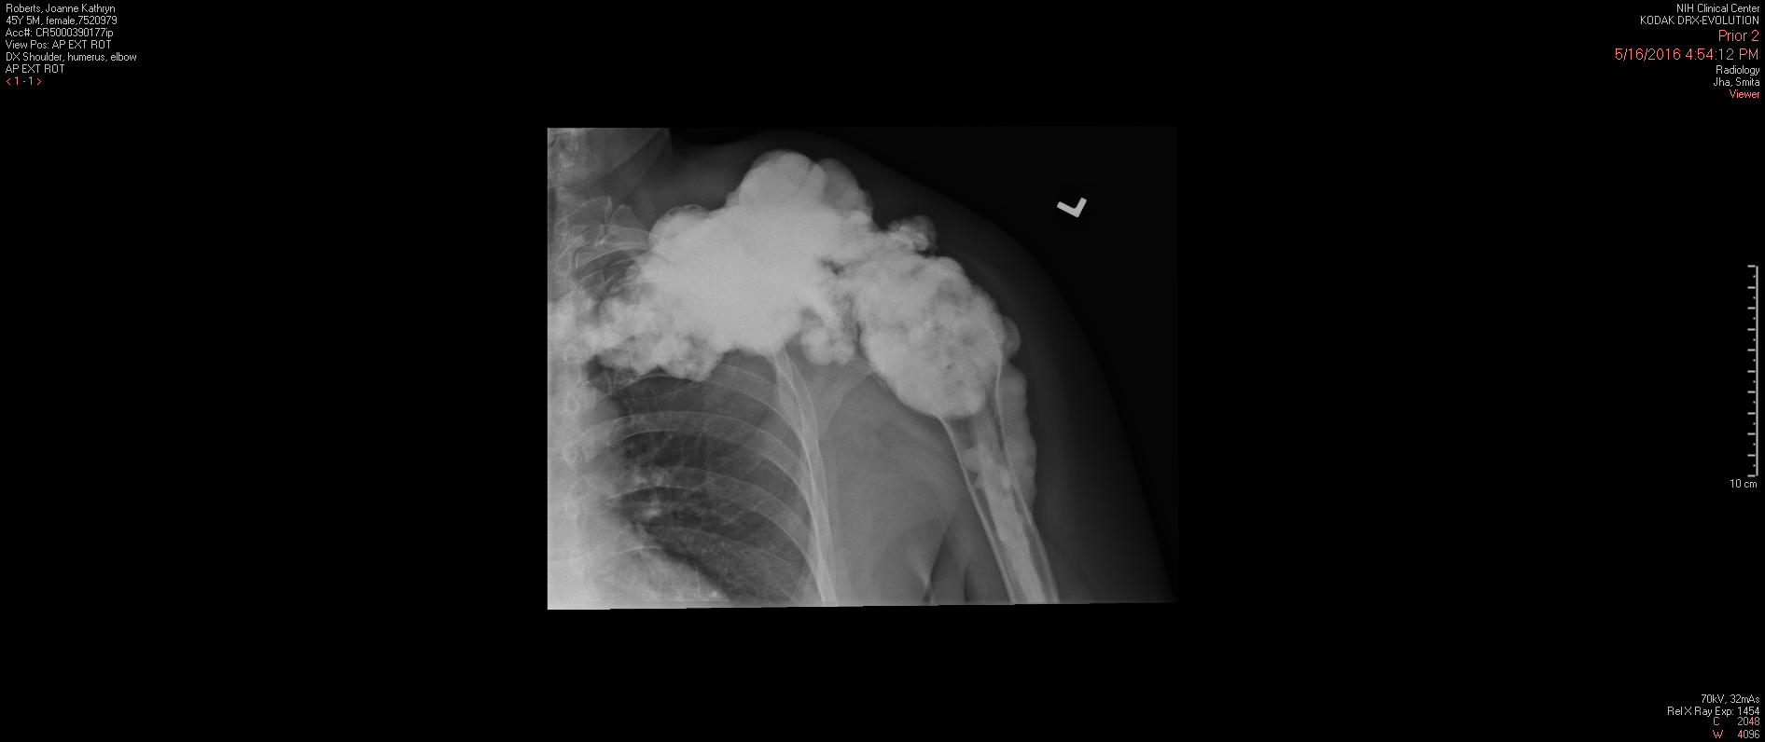
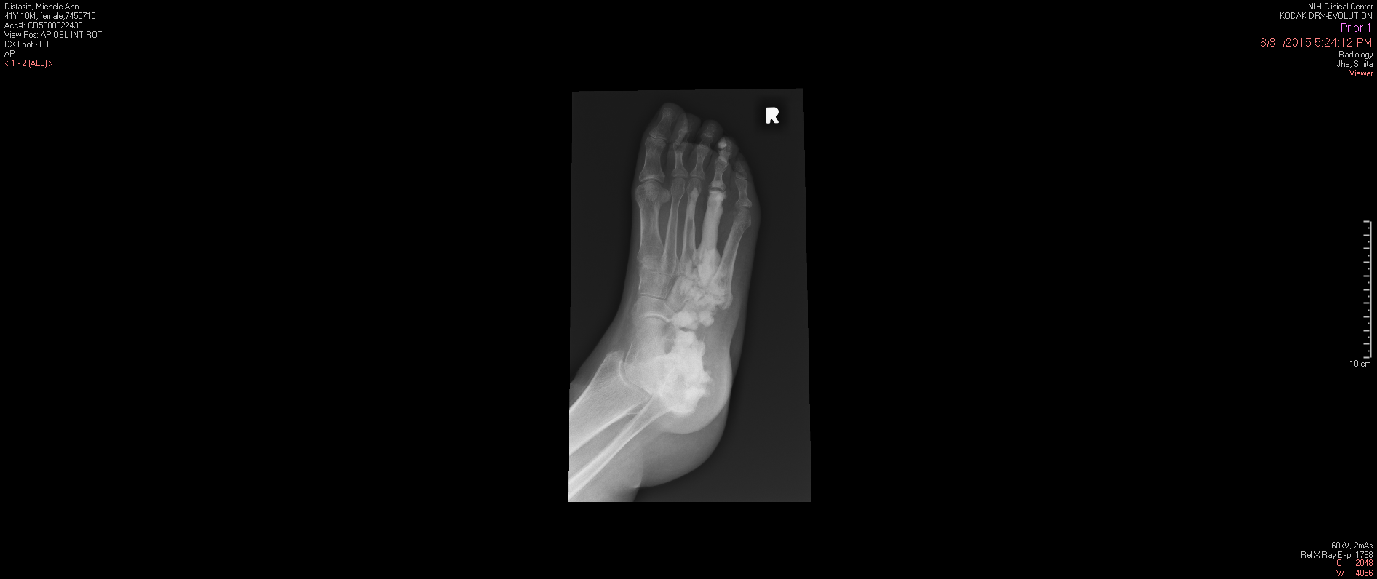
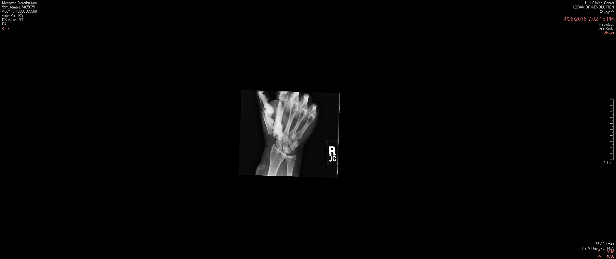
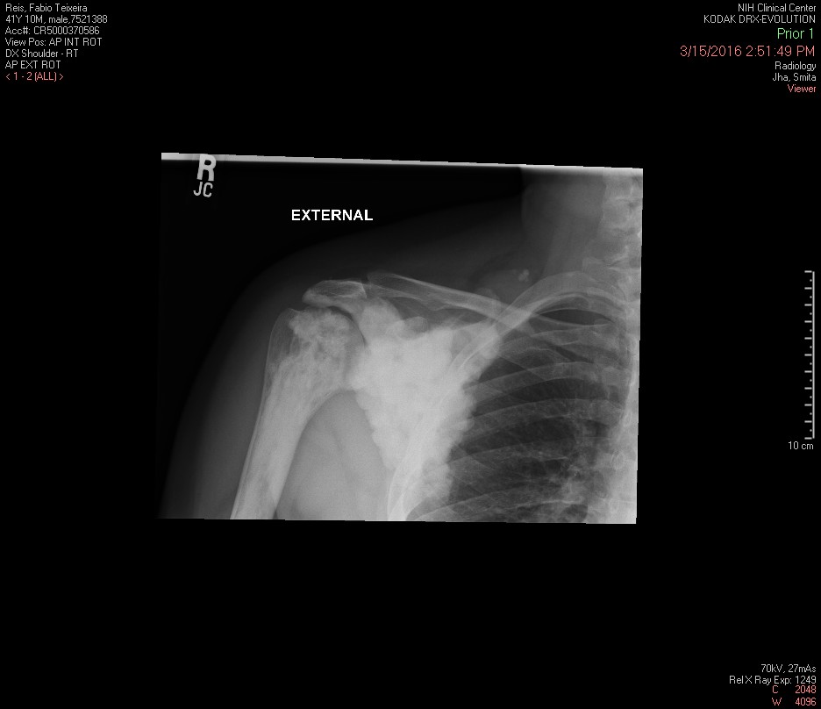
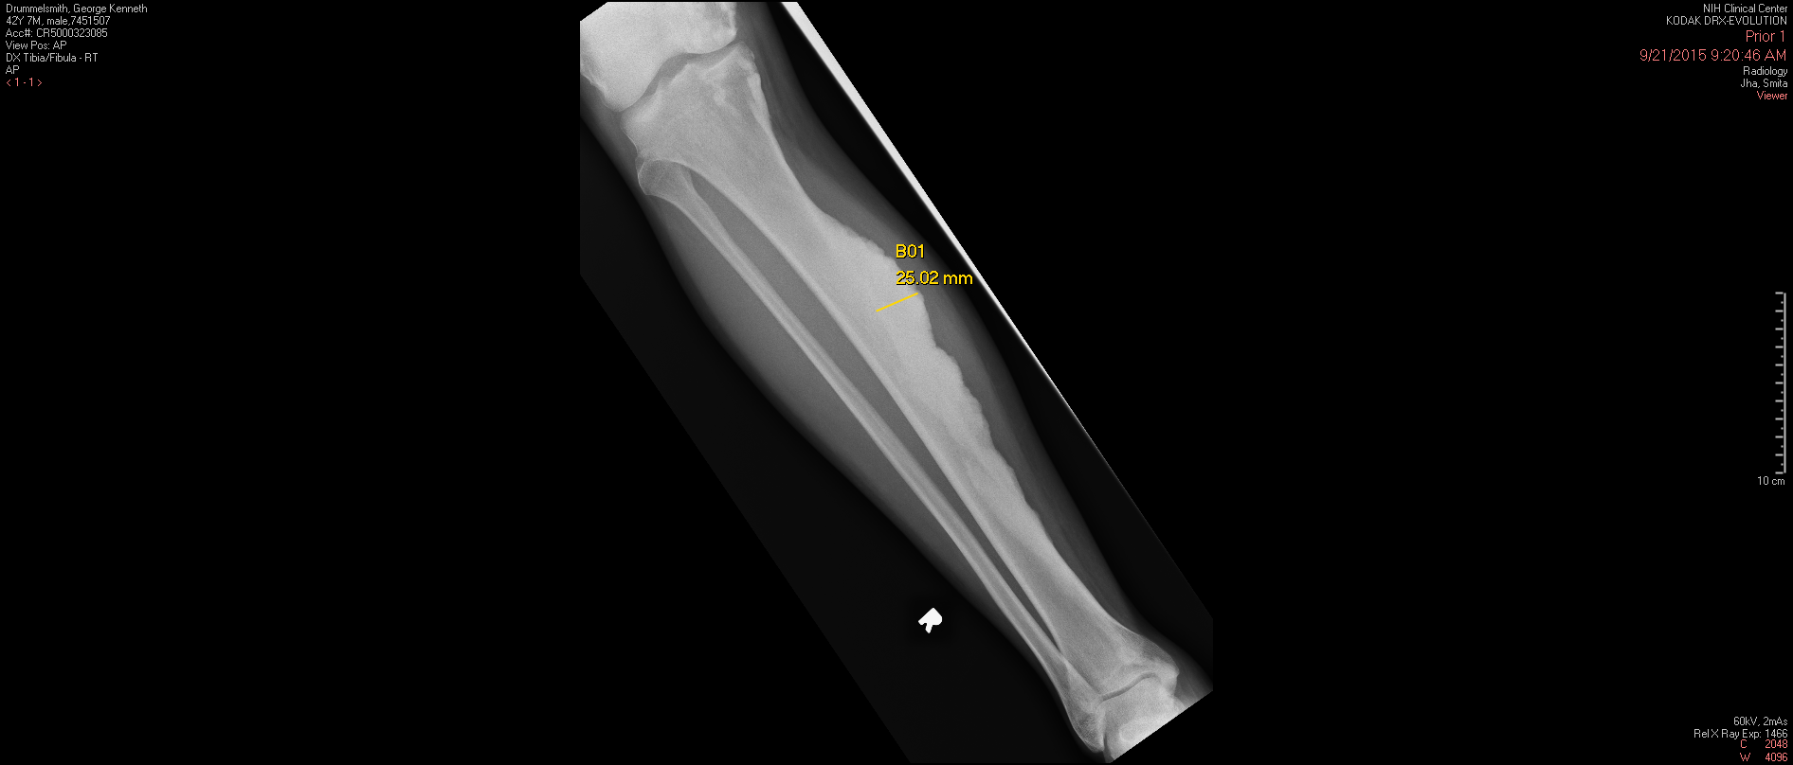
Supplementary Figure 1. Radiographs of Patients with MAP2K1 Mutations
b
C
A
D
E
F
G
B
(A-B) Classic candle wax appearance of Melo-2 and Melo-4, respectively. (C) Myositis-ossificans like pattern of melorheostosis of Melo-9. (D-G) Classic candle wax appearance of Melo-9, Melo-16, Melo-18 and Melo-19, respectively. Note all but one patient has classic candle-wax appearance on radiographs.
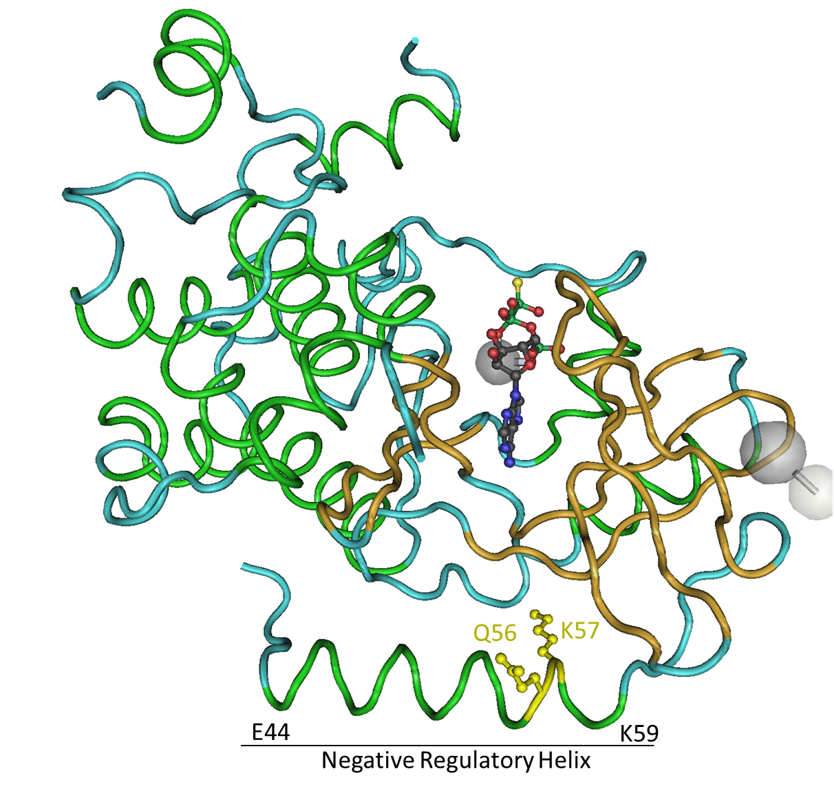
Supplementary Figure 2. Molecular Model of MEK1 with Melorheostosis Associated Mutations Shown. The crystal structure of human MEK1⁹ rendered using Cn3D¹⁰ with the protein backbone in tube worm mode. Alpha helical structures are shown in green, beta sheet structures in gold, and disordered regions in cyan. The negative regulatory helix (amino acids 44-59) is marked, and the mutated amino acid residues in melorheostosis shown in yellow with side-chains rendered in ball-and-stick format.
Supplementary Figure 3. Immunohistochemistry of SW48 cells.
p-ERK1/2
IgG Isotype Control

SW48 cells, a colon cancer cell line known to harbor MAP2K1 mutation p.K56P, were grown in culture and then a cell pellet was embedded in paraffin. Left panels shows SW48 cells stained with hematoxylin and the IgG isotype control antibody. Right panel shows SW48 cells stained with p-ERK1/2 antibody for activated ERK1/2 followed by HRP-conjugated secondary antibody. Brown staining indicates cells with p-ERK1/2.

Supplementary Figure 4. Activation of MEK1-ERK1/2 Pathway by MAP2K1 Mutations.
Starv.
U0126
DMSO
MAP2K1 p.K57N (Melo-18)
Baseline
FBS stim.
Starv.
U0126
DMSO
Baseline
FBS stim.
p-ERK1/2
Tot ERK1/2
GAPDH
Unaffected Affected

Melo-18 |  | Unaffected |  |  |  | Affected
 | Baseline | No stim. | DMSO | U0126 | Baseline | No stim. | DMSO | U0126
p-ERK1/2 | 1.00 | 0.53 | 5.88 | 1.22 | 4.12 | 2.42 | 11.74 | 2.54
Starv.
U0126
DMSO
MAP2K1 p.K57E (Melo-10)
Baseline
FBS stim.
Starv.
U0126
DMSO
Baseline
FBS stim.
p-ERK1/2
GAPDH
Unaffected Affected
Tot ERK1/2

Melo-10 |  | Unaffected |  |  |  | Affected
 | Baseline | No stim. | DMSO | U0126 | Baseline | No stim. | DMSO | U0126
p-ERK1/2 | 1.00 | 0.35 | 3.53 | 0.91 | 1.02 | 0.46 | 3.45 | 0.78

Western blot analysis of osteoblast lysates from affected and unaffected bone of patients, Melo-18 (MAP2K1 p.K57N, VAF 46%) and Melo-10 (MAP2K1 p.K57E, VAF 10%). Band intensity of p-ERK1/2 was normalized against total ERK1/2 and shown in the tables.

Supplementary Figure 5. Similarity Between Melorheostosis and Injection Studies of Developing Limb.

On the left, a patient with melorheostosis in the hand travels along the ulna and the long finger ray. Some melorheostosis is seen in the ring finger. On the right a developing mouse embryo has been genetically modified to produce LacZ reporter only in clones of developing cells¹¹. Note the similar pattern. (Photograph curtesy Miguel Torres.)

Supplementary Figure 6. Original Images of All Western Blots

Supplementary Figure 6-1. Original images of Western blots for Fig. 4c
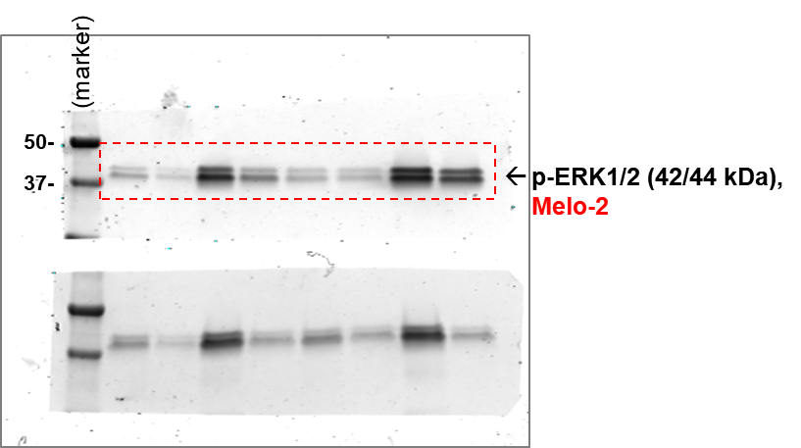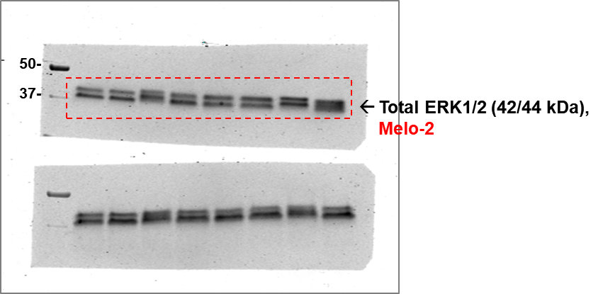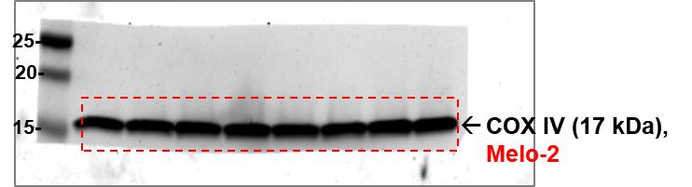

Supplementary Figure 6-2. Original images of Western blots for Fig. 5b
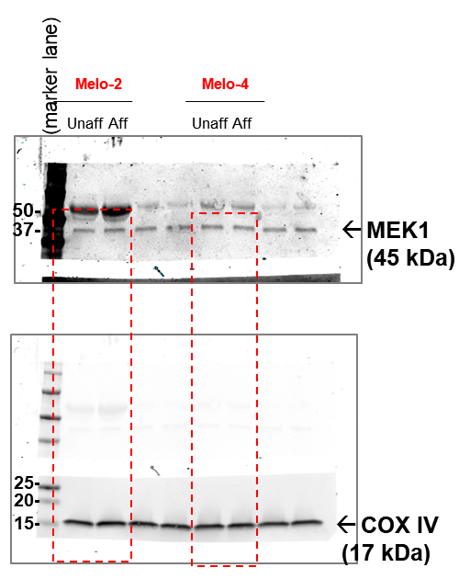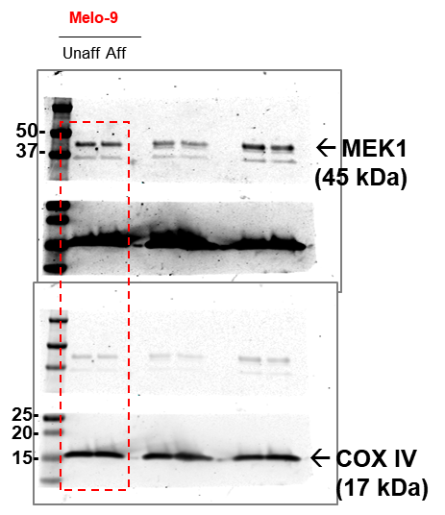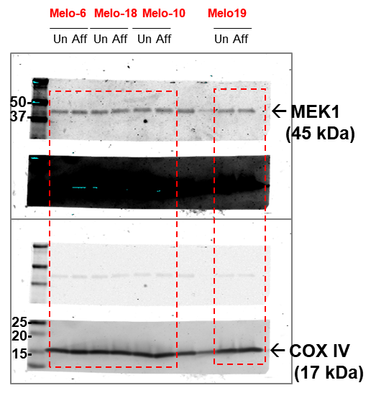

Supplementary Figure 6-3. Original images of Western blots for Fig. 5d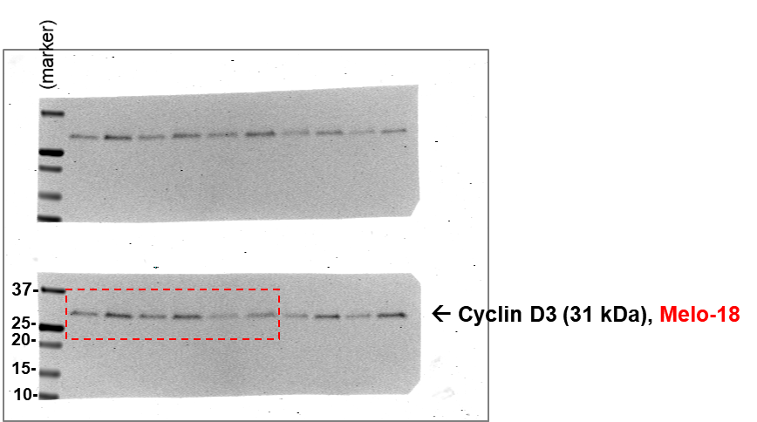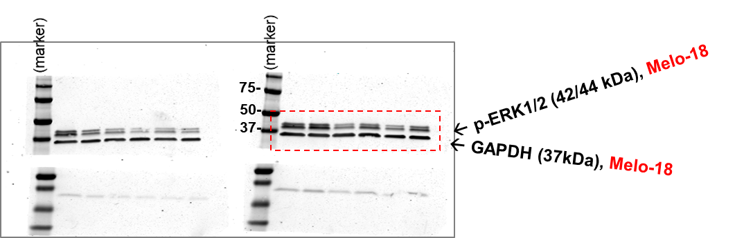

Supplementary Figure 6-4. Original images of Western blots for Supplementary Fig. 4a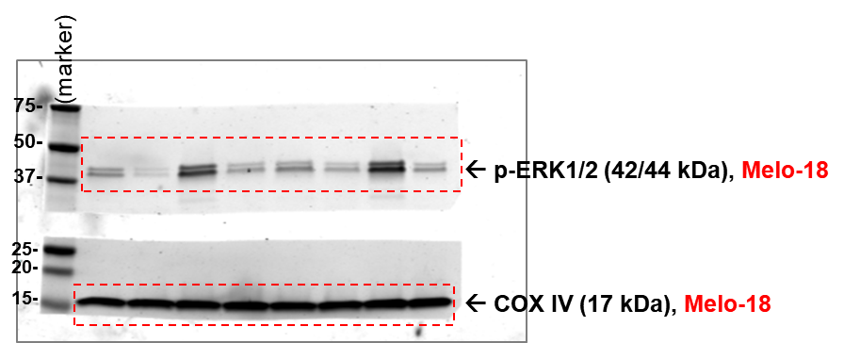
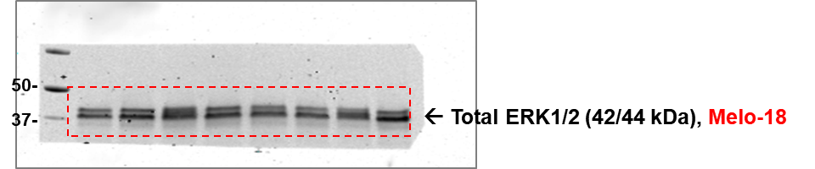

Supplementary Figure 6-5. Original images of Western blots for Supplementary Fig. 4b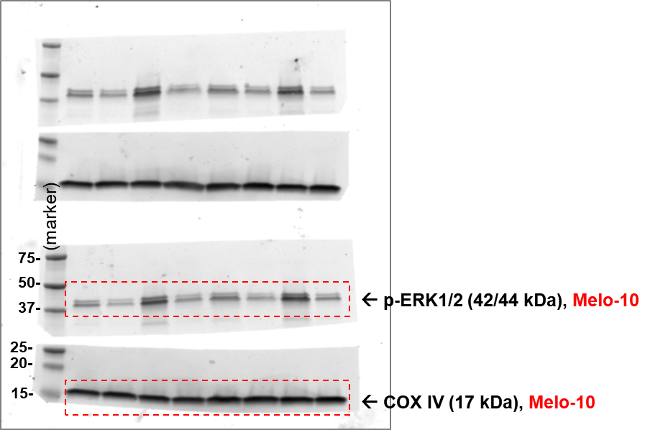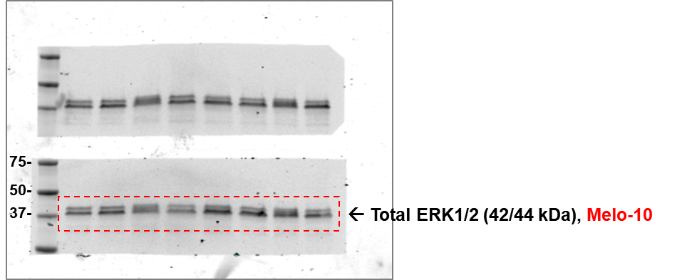

Supplementary Figure 7. Gating strategy used for flow cytometry for pERK1/2 detection

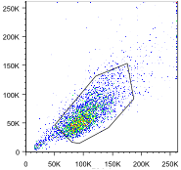
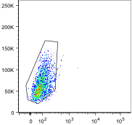
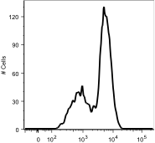
SSC
-
A
SSC
-
A
Example of pERK1/2
FSC/SSC
Live cells
FSC-A LiveDead pERK1/2

Supplemental References

1. Marks JL, Gong Y, Chitale D, et al. Novel MEK1 mutation identified by mutational analysis of epidermal growth factor receptor signaling pathway genes in lung adenocarcinoma. Cancer research 2008;68:5524-8.
2. Murugan AK, Dong J, Xie J, Xing M. MEK1 mutations, but not ERK2 mutations, occur in melanomas and colon carcinomas, but none in thyroid carcinomas. Cell Cycle 2014;8:2122-4.
3. Waterfall JJ, Arons E, Walker RL, et al. High prevalence of MAP2K1 mutations in variant and IGHV4-34-expressing hairy-cell leukemias. Nature genetics 2014;46:8-10.
4. Diamond EL, Durham BH, Haroche J, et al. Diverse and Targetable Kinase Alterations Drive Histiocytic Neoplasms. Cancer discovery 2016;6:154-65.
5. Arcila ME, Drilon A, Sylvester BE, et al. MAP2K1 (MEK1) Mutations Define a Distinct Subset of Lung Adenocarcinoma Associated with Smoking. Clinical cancer research : an official journal of the American Association for Cancer Research 2015;21:1935-43.
6. Chakraborty R, Hampton OA, Shen X, et al. Mutually exclusive recurrent somatic mutations in MAP2K1 and BRAF support a central role for ERK activation in LCH pathogenesis. Blood 2014;124:3007-15.
7. Couto JA, Huang AY, Konczyk DJ, et al. Somatic MAP2K1 Mutations Are Associated with Extracranial Arteriovenous Malformation. Am J Hum Genet 2017.
8. Trunzer K, Pavlick AC, Schuchter L, et al. Pharmacodynamic effects and mechanisms of resistance to vemurafenib in patients with metastatic melanoma. J Clin Oncol 2013;31:1767-74.
9. Fischmann TO, Smith CK, Mayhood TW, et al. Crystal Structures of MEK1 Binary and Ternary Complexes with Nucleotides and Inhibitors. Biochemistry-Us 2009;48:2661-74.
10. Wang Y, Geer LY, Chappey C, Kans JA, Bryant SH. Cn3D: sequence and structure views for Entrez. Trends Biochem Sci 2000;25:300-2.
11. Arques CG, Doohan R, Sharpe J, Torres M. Cell tracing reveals a dorsoventral lineage restriction plane in the mouse limb bud mesenchyme. Development 2007;134:3713-22.

