Synthesis of a Molecularly Defined Single Active Site Heterogeneous Catalyst for Selective Oxidation of N-Heterocycles

Zhang et.al

I. Characterization results of the catalysts
Supplementary Figure 1 ¹³C NMR spectra of PMMI (a), PPMI (b) and PPMI (c).

Supplementary Figure 2 XPS spectra of PMMI and PPMI. (a) C1s of PMMI, (b) N1s of PMMI, (c) O1s of PMMI, (d) C1s of PPMI, (e) N1s of PPMI and (f) O1s of PPMI.
Supplementary Figure 3 XPS spectra of PMI before use (black) and after use (red). (a) C1s, (b) N1s and (c) O1s.

Supplementary Figure 4 XPS survey scans of PMI (a), PMI used three times (b), PMMI (c) and PPMI (d).

Supplementary Figure 5 Ion selective MS of the addition products of tetrahydroquinoline and maleimide (m/z = 230 and 232)

Supplementary Figure 6 FT-IR spectra of maleimide (a), N-methylmaleimide (b), N-phenylmaleimide (c), PPMI (d) and PPMI (e).

Supplementary Figure 7 FT-IR spectra of fresh PMI (a) and PMI after being used for 5 times (b).

Supplementary Figure 8 Uv-Vis absorption spectra of the standard solutions (a) and the control reaction (b).

Supplementary Figure 9 B3PW91 thermodynamics between tetrahydroquinoline and 1H-pyrrole-2,5-dione.

II. DFT Computational details
Supplementary Table 1 B3PW91 optimized Cartesian Coordinates.
H,0,-1.5414882137,0.142086892,-2.3838236648  C,0,-1.5373951148,0.1252319116,-1.2975050354  C,0,-1.5155529953,0.0713367771,1.4601107588  C,0,-0.3136432162,0.0390003281,-0.6417350468  C,0,-2.7398789001,0.1926153073,-0.6074305415  C,0,-2.7184619613,0.1671578831,0.7827730901  C,0,-0.3010809256,0.0060966043,0.7643672681  H,0,-3.6783145314,0.2623832671,-1.1446489206  H,0,-3.6446536317,0.2181004701,1.3449592637  H,0,-1.5049431182,0.0396451563,2.5457920892  N,0,0.8898404982,-0.1406781846,1.4596413833  H,0,0.8504888245,0.1251185499,2.4302146763  C,0,0.9838830923,-0.0035127381,-1.4131206219  H,0,1.2433814931,1.0099048358,-1.7441366187  H,0,0.8528580171,-0.5956853235,-2.3234906463  C,0,2.1291975859,-0.5661834058,-0.5764324338  H,0,3.0860358596,-0.4107184928,-1.0811970178  H,0,2.0008633898,-1.6441304254,-0.439910684  C,0,2.1514241991,0.1004909023,0.7906536111  H,0,2.3547800572,1.1767347048,0.6677852826  H,0,2.9526595404,-0.3149950205,1.4071337544 | H,0,-1.4181628763,0.033271906,-2.2371842193  C,0,-1.381110692,0.0824584015,-1.1529380045  C,0,-1.2937985829,0.2140963149,1.6164145788  C,0,-0.1484757175,0.1233527068,-0.5152510477  C,0,-2.5633147834,0.0953157904,-0.4203770803  C,0,-2.5184289256,0.1587672879,0.9671665333  C,0,-0.1075949789,0.1917992065,0.8861757276  H,0,-3.5175888703,0.0565302618,-0.9338141534  H,0,-3.437501219,0.1706996459,1.5422384025  H,0,-1.2286590002,0.2744181758,2.6966437357  C,0,1.1604422644,0.1421781086,-1.2555491729  H,0,1.4541692161,1.1851491698,-1.4343342237  H,0,1.0576142466,-0.3276217265,-2.2361510253  C,0,2.2390206373,-0.5475815,-0.4275010088  H,0,3.2355800904,-0.3736682369,-0.8394197696  H,0,2.0844766647,-1.636028346,-0.4302432087  N,0,1.1065592293,0.2626732357,1.6018374196  C,0,2.1754652174,-0.0742073523,0.99841665  H,0,3.101308028,-0.03160305,1.5738698666
H,0,1.8194266137,-2.2196592073,-0.9069768218  C,0,0.8601051426,-1.7184499892,-0.9924897264  C,0,-1.5798779827,-0.4147082336,-1.1908110396  C,0,0.3602880048,-1.0415819737,0.1165998376  C,0,0.1592924012,-1.7587588981,-2.1905940492  C,0,-1.0609014814,-1.0987551148,-2.2813569703  C,0,-0.8823274544,-0.3787568024,0.0179779402  H,0,0.5605733237,-2.2931849815,-3.0432644901  H,0,-1.6205831137,-1.1176025,-3.2102214854  H,0,-2.5326148231,0.0994591806,-1.2749192337  C,0,1.0782464033,-0.9439886171,1.3774176536  H,0,2.1043568934,-1.2972319853,1.4102035139  C,0,0.5031406545,-0.4335496454,2.4680079558  H,0,1.0373272891,-0.3740471848,3.409745518  N,0,-1.3330273585,0.3541056391,1.0977501782  H,0,-2.2699832978,0.713212754,1.0090356538  C,0,-0.928705554,0.0129998123,2.4516694104  H,0,-1.5652960092,-0.7792246815,2.8907345531  H,0,-1.0567696445,0.8976894337,3.0829404901 | H,0,2.3579309285,0.,-1.1772589665  C,0,1.2726554863,0.,-1.1647413209  C,0,-1.5274076198,0.,-1.1224980564  C,0,0.6020567449,0.,0.0798515712  C,0,0.5616034682,0.,-2.3358821966  C,0,-0.8491893203,0.,-2.3130994143  C,0,-0.8228910793,0.,0.1029635752  H,0,1.0814940694,0.,-3.2872743807  H,0,-1.3974900427,0.,-3.2485822652  H,0,-2.6101245648,0.,-1.0808353666  N,0,-1.5341945314,0.,1.2619181602  C,0,-0.8672797233,0.,2.3892250774  H,0,-1.4614228457,0.,3.300409868  C,0,1.273350493,0.,1.3226554278  H,0,2.3586218793,0.,1.3440248681  C,0,0.5421627507,0.,2.4783302426  H,0,1.0201323752,0.,3.4508202689
C,0,-0.2243212043,-0.0718304834,1.0528258025  H,0,-0.4161973756,0.8174340998,1.6425410552  C,0,0.3879876905,-1.2150962334,1.692676974  H,0,0.6431119176,-1.1440875453,2.7447134223  C,0,-0.5384599131,-0.1022416584,-0.2569094571  H,0,-0.9748258624,0.7624880443,-0.7470679286  C,0,0.6328463276,-2.3545066776,1.0167753768  H,0,1.0678172858,-3.2257343188,1.4920388245  C,0,-0.2594363638,-1.2733508644,-1.0589604908  C,0,0.2573923799,-2.4917071531,-0.3806356706  C,0,-0.3479834388,-1.287758862,-2.4047414497  H,0,-0.6465051363,-0.3921567255,-2.9431195398  N,0,0.3554207193,-3.6441878453,-0.9458136627  C,0,0.0743299675,-2.5038033218,-3.1599198895  H,0,1.1373666065,-2.4010876905,-3.4305732981  H,0,-0.4705776606,-2.5955304496,-4.1033139358  C,0,-0.1480909026,-3.7437548729,-2.3053652971  H,0,0.3004067673,-4.6213996227,-2.7757782493  H,0,-1.2291633044,-3.9478684194,-2.2373026862 | O2-Triplet  O,0,0.,0.,0.834371757  O,0,0.,0.,-0.366371757  H2O  H,0,0.,0.0004967663,-0.0000732467  O,0,0.,-0.0007050158,0.9605449511  H,0,0.,0.9274962495,1.207994294  H2O2  O,0,-0.1456779207,0.1056603005,0.9633472096  H,0,0.381594754,0.8552482316,1.2683044737  O,0,-0.0250422265,0.2669220776,-0.4653702631  H,0,-0.9537432531,0.3758907549,-0.7073159253
H,0,0.0600533118,-0.0059137149,-0.0776568862  N,0,0.0168285638,-0.0023054076,0.9289611921  C,0,0.0198285196,1.151379403,1.7056390062  C,0,-0.0530931987,-1.1504037324,1.7107586419  C,0,-0.0564272114,0.6704189513,3.1239744201  H,0,-0.0706066498,1.3576552268,3.9574816874  C,0,-0.0985528709,-0.6592827456,3.1269319482  H,0,-0.1560866789,-1.3405325564,3.963483008  O,0,-0.0718075578,-2.2861628074,1.3122260867  O,0,0.0729859789,2.2842632434,1.3020605258 | H,0,0.5811406402,-0.3838932193,-2.0052964948  N,0,0.2441175745,-0.313638795,-1.059272378  C,0,0.0189236745,-1.4369489274,-0.2931254183  C,0,0.0113341103,0.3888634224,1.1103049708  H,0,-0.0644177725,1.0696634743,1.947697829  C,0,-0.1803362854,-0.9254116694,1.0978904944  H,0,-0.4352126856,-1.5802340144,1.9186526556  O,0,-0.0053808673,-2.5826946474,-0.6808359328  C,0,0.3449365823,0.8933860407,-0.276328982  H,0,1.3575403293,1.3098305411,-0.3096196084  O,0,-0.4813657137,1.9408879116,-0.7252832165  H,0,-1.3912796924,1.6201898829,-0.7247839718
C,0,0.0122772827,-1.2584898236,1.9639661315  O,0,0.0633357941,-1.3425085456,3.1413571182  N,0,-0.0105467461,-2.4007646352,1.0604644553  H,0,0.0152458867,-3.3699233286,1.3589659701  O,0,-0.0996730817,-2.7858616935,-1.1647577638  H,0,-0.1423677295,-2.3536744744,-2.0335729909  C,0,-0.0423971197,-0.0678210428,1.0550833502  H,0,-0.0402039537,0.9458284768,1.4308704149  C,0,-0.0901671544,-0.4946904598,-0.2080754503  H,0,-0.1366576119,0.0873951012,-1.1184956583  C,0,-0.0689111525,-1.9657458865,-0.1770279811 | H,0,3.4661189904,1.4919179897,-1.9962678456  C,0,2.7963916296,1.5018594539,-1.1413578023  C,0,1.0569148747,1.5304648248,0.9968773876  C,0,1.7534964781,0.5873160697,-1.1140854551  C,0,3.0060148568,2.4122666979,-0.1130313472  C,0,2.1219405837,2.4187194963,0.9545644501  C,0,0.8620147068,0.5829215781,-0.0195467602  H,0,3.8342429025,3.1094077611,-0.1533599538  H,0,2.2445357341,3.1318811604,1.7624389906  H,0,0.3660049579,1.5997570936,1.827786116  N,0,-0.1788404143,-0.3396644126,0.0246431924  C,0,1.52753752,-0.380006309,-2.2406993927  H,0,2.0052500085,-1.3430285165,-2.0206149642  H,0,1.988157064,-0.0005675479,-3.1559392132  C,0,-0.5631412197,-1.1325152015,-1.1393213593  H,0,-1.6583728361,-1.1368624619,-1.2148050226  H,0,-0.2479766913,-2.1724379696,-0.9971928624  C,0,0.0310920458,-0.5927933975,-2.4263883545  H,0,-0.176026595,-1.3018102207,-3.2315731465  H,0,-0.442041564,0.3569706005,-2.6942527146  C,0,-0.9568085666,-0.521807903,1.2120941916  H,0,-0.3505707017,-0.2202172873,2.0708767532  C,0,-2.3255842665,0.1854370204,1.2773169564  H,0,-2.3247574156,1.1148869884,1.8464347018  H,0,-2.6939806901,0.4186937651,0.2749895142  C,0,-1.2870256026,-1.9971858581,1.513907687  O,0,-0.5586631973,-2.9496105713,1.4251328378  N,0,-2.5953061543,-2.0269108444,1.9636256386  H,0,-3.0296260707,-2.8719903421,2.3084112004  C,0,-3.271596509,-0.8147435709,1.9092237432  O,0,-4.3993937512,-0.6403480866,2.2901129934
H,0,-1.3929967779,0.1209776001,-3.9076754289  C,0,-1.0748702677,0.7198852437,-3.0611272248  C,0,-0.2450229255,2.2629354672,-0.9200473099  C,0,-0.3600729311,0.0973551962,-2.0333473596  C,0,-1.3723649326,2.0705154421,-3.025958075  C,0,-0.9476084187,2.8517844192,-1.9557071052  C,0,0.0243266998,0.898617023,-0.9652980664  H,0,-1.9273278313,2.5217140645,-3.8397580381  H,0,-1.1568537203,3.9140122766,-1.9304039023  H,0,0.1037114544,2.86950208,-0.0896618683  C,0,0.0230495131,-1.3534127077,-2.1448546338  H,0,0.8278521171,-1.436645463,-2.8844234483  H,0,-0.8158546442,-1.9256237678,-2.5463588131  C,0,0.4798011241,-1.9423570191,-0.8199867048  H,0,1.0054582118,-2.8860924251,-0.9797685551  H,0,-0.3725190272,-2.1643175374,-0.1764831953  N,0,0.7751501729,0.3314635147,0.1818259699  H,0,1.549724931,0.9818131782,0.383834711  C,0,1.4249646713,-0.9997154037,-0.1091992766  H,0,2.2979772001,-0.7775009655,-0.7260811985  H,0,1.7701380013,-1.3982755532,0.8444826483  C,0,0.004727312,0.3715358359,1.5052756821  H,0,-0.576938029,1.2958821069,1.4562142062  C,0,-0.7998923064,-0.7865949113,1.9656485817  H,0,-1.7290642448,-1.1200042762,1.5312458384  C,0,-0.3654025962,-1.0853022318,3.2074817781  C,0,1.096017274,0.522885845,2.58806994  O,0,2.0826428676,1.2062711763,2.4681188032  N,0,0.7375999579,-0.3180074038,3.5955419802  H,0,1.2846824077,-0.4896645845,4.427640517  O,0,-0.7936073948,-1.9250739974,4.1342506586  H,0,-1.5574279766,-2.428562011,3.8265087323 | H,0,3.4898426509,1.126548941,-1.9835838472  C,0,2.869763264,1.207687495,-1.0966551301  C,0,1.2855437847,1.4073625456,1.1460434031  C,0,1.654900737,0.5305476611,-1.0798334675  C,0,3.3017494413,1.9792125848,-0.0293697686  C,0,2.5002203185,2.0730549223,1.0972471053  C,0,0.83410369,0.6473674375,0.0595117963  H,0,4.2535554411,2.4938935224,-0.0746899175  H,0,2.8199599541,2.6556071048,1.9530706631  H,0,0.7178477753,1.4802572542,2.0647386253  N,0,-0.4410057528,0.0289317776,0.0507596447  C,0,1.2576889931,-0.3012976214,-2.2736031424  H,0,1.8353698839,-1.2332142536,-2.2646352997  H,0,1.5398347836,0.2193088899,-3.1913377595  C,0,-0.6586574091,-1.0617701383,-0.8982427966  H,0,-1.719092952,-1.3211458205,-0.9051829381  H,0,-0.0984940147,-1.9625816825,-0.6039156935  C,0,-0.226602998,-0.6262317211,-2.2871212117  H,0,-0.4445796211,-1.4209623778,-3.0035331027  H,0,-0.8112058973,0.249965351,-2.5806759805  C,0,-1.3040077185,0.1268566726,1.1903394389  H,0,-1.0521297995,1.027143422,1.7492565257  C,0,-2.8131449521,0.0802260039,0.8915340468  H,0,-3.3550920506,0.8332288098,1.4700100566  H,0,-3.0536729554,0.2480707173,-0.1569274659  N,0,-2.1709662112,-1.8731740776,2.0675815468  H,0,-2.2592448943,-2.7936569776,2.4885390481  C,0,-3.294559569,-1.2754484723,1.3401446746  O,0,-4.326295201,-1.8385371991,1.2149365687  C,0,-1.1129061763,-1.0931342579,2.0701720751  O,0,0.0248291215,-1.3408326869,2.6267604712  H,0,0.097583334,-2.2096428262,3.0544358311
Singlet State | Triplet state
H,0,3.1068851734,1.7575670478,-2.0509008765  C,0,2.6232416145,1.4701594215,-1.1238678126  C,0,1.4352695375,0.6892002758,1.2526690543  C,0,1.5297598755,0.6039487634,-1.1855798109  C,0,3.112667802,1.9394945925,0.0812574258  C,0,2.5286133428,1.5321492708,1.2771927114  C,0,0.9216900461,0.2688864234,0.0256098685  H,0,3.967283636,2.6054971109,0.0935483847  H,0,2.9310775545,1.8610869917,2.2271385155  H,0,1.0091166698,0.3380645261,2.1844415016  N,0,-0.2531548501,-0.6314454972,0.047489974  C,0,1.0822603325,0.0507047739,-2.5086905327  H,0,1.9581165479,-0.1368631761,-3.1320663591  H,0,0.4826498376,0.8012914864,-3.0379082403  C,0,-0.8183841175,-0.9449897246,-1.3094508016  H,0,-1.3948157731,-0.0675206609,-1.6073800781  H,0,-1.4903476754,-1.7894639565,-1.1602256485  C,0,0.2723217001,-1.2175706443,-2.31406718  H,0,0.9003665913,-2.0457807773,-1.9782331491  H,0,-0.2034602908,-1.5310585146,-3.2452801535  C,0,-1.3282643092,-0.2530810129,1.0860277989  H,0,-0.9419204082,0.5998070735,1.6301095439  C,0,-2.766941277,-0.0283759535,0.6396827751  H,0,-3.0801123563,1.0068949259,0.7689544563  H,0,-2.9904211993,-0.307798124,-0.3873078043  N,0,-2.7365309121,-1.7438235684,2.2456046893  H,0,-3.0733928511,-2.4037772339,2.9321164588  C,0,-3.6106889341,-0.9391108326,1.5370433403  O,0,-4.8027514588,-0.9628290704,1.6070632086  C,0,-1.3743416901,-1.4977374853,2.0099731816  O,0,-0.8567049903,-2.5369491493,1.1418184856  O,0,-0.5757083694,-1.3063929655,3.1079221188  H,0,-0.4566983264,-2.1320885689,3.5957500055  O,0,0.2842113276,-1.9181681671,0.5971220489 | H,0,3.3838276795,1.5021739442,-1.9048022548  C,0,2.7622598886,1.3439171209,-1.030802431  C,0,1.210611965,0.930355533,1.2525329284  C,0,1.5811068983,0.6436633446,-1.1739542127  C,0,3.1736064589,1.8383753218,0.2036598827  C,0,2.3928397433,1.6123352224,1.3473534761  C,0,0.7542003323,0.4474272326,-0.0111732951  H,0,4.1064129311,2.3839959498,0.2840441775  H,0,2.7301921253,1.9678080334,2.3131995372  H,0,0.6544563346,0.7196470945,2.1541118615  N,0,-0.4451072431,-0.1798426876,-0.1321818614  C,0,1.1566003508,0.1042577507,-2.5019159365  H,0,2.037227134,-0.1115760172,-3.1090601091  H,0,0.5896304552,0.8745913038,-3.0417961888  C,0,-0.8700037035,-0.7868008532,-1.4073652034  H,0,-1.5395502319,-0.0732388674,-1.902751281  H,0,-1.4488880297,-1.6764821635,-1.1635340842  C,0,0.2957892881,-1.1298079396,-2.3051417009  H,0,0.8817745457,-1.9413813556,-1.8648198371  H,0,-0.0978879528,-1.4935918722,-3.255401035  C,0,-1.4060351863,-0.2061725517,0.9682338408  H,0,-1.1836283532,0.6346784866,1.6219312828  C,0,-2.8886822405,-0.1247836215,0.6034823264  H,0,-3.2572653465,0.8956410233,0.5097836586  H,0,-3.1540874935,-0.6682680886,-0.3037014783  N,0,-2.5924754556,-1.5543856553,2.4319313971  H,0,-2.7994975548,-2.1307067197,3.2365716349  C,0,-3.5734523085,-0.835683988,1.7679858599  O,0,-4.7328228284,-0.797374093,2.0574813696  C,0,-1.3071009466,-1.4583378049,1.9019895839  O,0,-1.0824554828,-2.6938591796,0.9752445938  O,0,-0.3012446621,-1.4474352198,2.7958630405  H,0,0.3077039264,-2.1811316902,2.5341444494  O,0,0.0528363624,-3.2780794931,1.1964332083
Singlet state | Triplet state
H,0,3.7260576546,0.9167190118,-1.6541475037  C,0,2.9479857236,1.0961231868,-0.9206990615  C,0,0.9494650133,1.5793255064,0.9479066655  C,0,1.7415798023,0.4206481162,-1.0391105908  C,0,3.1626420406,2.0009837543,0.1106684848  C,0,2.1578350731,2.2531262938,1.0342726005  C,0,0.7565421662,0.6529943261,-0.0720076164  H,0,4.1101301094,2.5211943427,0.1835503814  H,0,2.307896917,2.9789725234,1.8237792184  H,0,0.1712116036,1.8155075559,1.6617664809  N,0,-0.4890192659,-0.0718804146,-0.1931235768  C,0,1.4525967411,-0.5368072099,-2.1581701902  H,0,1.673981591,-1.563666194,-1.8456399723  H,0,2.0838061515,-0.3216641336,-3.02017381  C,0,-0.8622401556,-0.5404673377,-1.3381035016  C,0,-0.0189685257,-0.4174408881,-2.543311096  H,0,-0.3270809494,-1.1660134137,-3.2742592874  H,0,-0.2223850173,0.5656591401,-2.9961057169  C,0,-1.2832617501,-0.3587602691,1.0235091492  H,0,-0.8243798987,0.2051570931,1.8274355376  C,0,-2.7751247017,-0.066358977,0.9856066113  H,0,-3.0315261894,0.9587461459,1.2501834518  H,0,-3.2408194767,-0.2905793917,0.0231856017  N,0,-2.3354545112,-1.9396143475,2.3312597081  H,0,-2.5468509308,-2.7937231696,2.8302327747  C,0,-3.3449719229,-1.0483348222,2.0117801721  O,0,-4.4567700681,-1.0539918647,2.4569444009  C,0,-1.1811658602,-1.8502554673,1.4957625339  O,0,-1.2600678385,-2.6301315823,0.3227700081  O,0,0.0001489002,-2.158800351,2.1328981361  H,0,-0.1036272917,-2.0647337384,3.0862981864  O,0,-1.3468540672,-4.0103009332,0.7169743825  H,0,-2.1715396369,-4.2672330485,0.2778100313  H,0,-1.8122651294,-1.0577693424,-1.370442994 | H,0,3.41209713,1.4875235017,-1.9626278922  C,0,2.8090934073,1.2934402341,-1.0828481289  C,0,1.286975615,0.8349234433,1.2200517392  C,0,1.635551959,0.5776560406,-1.2238389598  C,0,3.2315295148,1.7673060272,0.1550190144  C,0,2.4639206624,1.5226875863,1.3085375447  C,0,0.8290281916,0.3599542162,-0.0448336453  H,0,4.1597641507,2.3211145292,0.2322517471  H,0,2.8127562039,1.8700317934,2.2733156462  H,0,0.7349570882,0.5977862451,2.1182606754  N,0,-0.3647413149,-0.2711961914,-0.1697149922  C,0,1.2133957777,0.0668535658,-2.5659259542  H,0,1.728300947,-0.882783697,-2.7545049915  H,0,1.5357066334,0.7605392903,-3.34537249  C,0,-0.6929806578,-0.9072522199,-1.4110305885  C,0,-0.3057182466,-0.1800360435,-2.6316390215  H,0,-0.5660124003,-0.7568324969,-3.5183593667  H,0,-0.8263497587,0.7827006197,-2.6941119511  C,0,-1.3638472016,-0.3018185932,0.8963422388  H,0,-1.1740538818,0.5385014654,1.5614473937  C,0,-2.8135675555,-0.2420291186,0.4226609819  H,0,-3.1814139194,0.7705397505,0.2664949808  H,0,-2.9747380021,-0.81391346,-0.4946980105  N,0,-2.655830832,-1.6528304845,2.2771499101  H,0,-2.900242282,-2.0825870083,3.1574281126  C,0,-3.5763656189,-0.9201920193,1.5578795042  O,0,-4.7498557286,-0.8349832688,1.788120415  C,0,-1.3101366679,-1.5617612435,1.8144162246  O,0,-0.942868992,-2.6456110442,0.9695028441  O,0,-0.3879473843,-1.3901281433,2.8253790909  H,0,-0.1344408199,-2.2611885403,3.163277021  O,0,-0.8521415158,-3.8111945383,1.801243256  H,0,-1.6528371447,-4.2972796079,1.5511720531  H,0,-0.8194810563,-1.9813104903,-1.3511449011
C,0,-0.149202422,-1.148905925,1.8984161248  O,0,-0.3581492179,-1.2349042702,3.0549261731  N,0,-0.4822287086,-2.2224338278,0.9541421195  H,0,-0.8229567097,-3.1318535133,1.2583462607  C,0,-0.2143194125,-1.8914592863,-0.2774591691  O,0,-0.2909532747,-2.7044978924,-1.2593491871  H,0,0.0446633644,-2.262975026,-2.0773464556  O,0,1.371637214,-0.3213989886,-1.1638797638  O,0,0.913666712,-0.6668025459,-2.5005070152  H,0,1.6834581814,-0.4136550995,-3.034836752  C,0,0.2157414202,-0.4380455633,-0.3780501443  C,0,0.4922833457,-0.0535484909,1.0709655433  H,0,0.1034850615,0.9231492066,1.3533769075  H,0,1.568778601,-0.0640476512,1.2711827095  H,0,-0.607842255,0.1408087738,-0.8167696513 | C,0,0.1387463807,-1.235559242,1.8458083078  O,0,0.1900365411,-1.4439585324,3.0273359716  N,0,0.2533109063,-2.0875933113,0.7814395911  H,0,0.387299518,-3.0856433947,0.8958608024  C,0,0.1650370128,-1.4955338118,-0.5179288265  O,0,-0.9428551514,-1.9360428779,-1.1865017132  H,0,-0.821143844,-1.7683544982,-2.1345181655  O,0,1.3741452849,-1.8091279071,-1.1585362287  O,0,1.2630632093,-1.181003167,-2.4585156097  H,0,1.859313958,-1.7440168727,-2.9767807754  C,0,0.0746376166,0.039349543,-0.1798649947  H,0,1.0866452263,0.486711069,-0.3576719752  H,0,-0.5938205804,0.6730842121,-0.7768999172  C,0,-0.0973746138,0.1053935575,1.2178489748  H,0,-0.3730553485,0.9766565864,1.8111034964
H,0,-1.5414882137,0.142086892,-2.3838236648  C,0,-1.5373951148,0.1252319116,-1.2975050354  C,0,-1.5155529953,0.0713367771,1.4601107588  C,0,-0.3136432162,0.0390003281,-0.6417350468  C,0,-2.7398789001,0.1926153073,-0.6074305415  C,0,-2.7184619613,0.1671578831,0.7827730901  C,0,-0.3010809256,0.0060966043,0.7643672681  H,0,-3.6783145314,0.2623832671,-1.1446489206  H,0,-3.6446536317,0.2181004701,1.3449592637  H,0,-1.5049431182,0.0396451563,2.5457920892  N,0,0.8898404982,-0.1406781846,1.4596413833  H,0,0.8504888245,0.1251185499,2.4302146763  C,0,0.9838830923,-0.0035127381,-1.4131206219  H,0,1.2433814931,1.0099048358,-1.7441366187  H,0,0.8528580171,-0.5956853235,-2.3234906463  C,0,2.1291975859,-0.5661834058,-0.5764324338  H,0,3.0860358596,-0.4107184928,-1.0811970178  H,0,2.0008633898,-1.6441304254,-0.439910684  C,0,2.1514241991,0.1004909023,0.7906536111  H,0,2.3547800572,1.1767347048,0.6677852826  H,0,2.9526595404,-0.3149950205,1.4071337544 | H,0,-1.4181628763,0.033271906,-2.2371842193  C,0,-1.381110692,0.0824584015,-1.1529380045  C,0,-1.2937985829,0.2140963149,1.6164145788  C,0,-0.1484757175,0.1233527068,-0.5152510477  C,0,-2.5633147834,0.0953157904,-0.4203770803  C,0,-2.5184289256,0.1587672879,0.9671665333  C,0,-0.1075949789,0.1917992065,0.8861757276  H,0,-3.5175888703,0.0565302618,-0.9338141534  H,0,-3.437501219,0.1706996459,1.5422384025  H,0,-1.2286590002,0.2744181758,2.6966437357  C,0,1.1604422644,0.1421781086,-1.2555491729  H,0,1.4541692161,1.1851491698,-1.4343342237  H,0,1.0576142466,-0.3276217265,-2.2361510253  C,0,2.2390206373,-0.5475815,-0.4275010088  H,0,3.2355800904,-0.3736682369,-0.8394197696  H,0,2.0844766647,-1.636028346,-0.4302432087  N,0,1.1065592293,0.2626732357,1.6018374196  C,0,2.1754652174,-0.0742073523,0.99841665  H,0,3.101308028,-0.03160305,1.5738698666
H,0,1.8194266137,-2.2196592073,-0.9069768218  C,0,0.8601051426,-1.7184499892,-0.9924897264  C,0,-1.5798779827,-0.4147082336,-1.1908110396  C,0,0.3602880048,-1.0415819737,0.1165998376  C,0,0.1592924012,-1.7587588981,-2.1905940492  C,0,-1.0609014814,-1.0987551148,-2.2813569703  C,0,-0.8823274544,-0.3787568024,0.0179779402  H,0,0.5605733237,-2.2931849815,-3.0432644901  H,0,-1.6205831137,-1.1176025,-3.2102214854  H,0,-2.5326148231,0.0994591806,-1.2749192337  C,0,1.0782464033,-0.9439886171,1.3774176536  H,0,2.1043568934,-1.2972319853,1.4102035139  C,0,0.5031406545,-0.4335496454,2.4680079558  H,0,1.0373272891,-0.3740471848,3.409745518  N,0,-1.3330273585,0.3541056391,1.0977501782  H,0,-2.2699832978,0.713212754,1.0090356538  C,0,-0.928705554,0.0129998123,2.4516694104  H,0,-1.5652960092,-0.7792246815,2.8907345531  H,0,-1.0567696445,0.8976894337,3.0829404901 | H,0,2.3579309285,0.,-1.1772589665  C,0,1.2726554863,0.,-1.1647413209  C,0,-1.5274076198,0.,-1.1224980564  C,0,0.6020567449,0.,0.0798515712  C,0,0.5616034682,0.,-2.3358821966  C,0,-0.8491893203,0.,-2.3130994143  C,0,-0.8228910793,0.,0.1029635752  H,0,1.0814940694,0.,-3.2872743807  H,0,-1.3974900427,0.,-3.2485822652  H,0,-2.6101245648,0.,-1.0808353666  N,0,-1.5341945314,0.,1.2619181602  C,0,-0.8672797233,0.,2.3892250774  H,0,-1.4614228457,0.,3.300409868  C,0,1.273350493,0.,1.3226554278  H,0,2.3586218793,0.,1.3440248681  C,0,0.5421627507,0.,2.4783302426  H,0,1.0201323752,0.,3.4508202689
C,0,-0.2243212043,-0.0718304834,1.0528258025  H,0,-0.4161973756,0.8174340998,1.6425410552  C,0,0.3879876905,-1.2150962334,1.692676974  H,0,0.6431119176,-1.1440875453,2.7447134223  C,0,-0.5384599131,-0.1022416584,-0.2569094571  H,0,-0.9748258624,0.7624880443,-0.7470679286  C,0,0.6328463276,-2.3545066776,1.0167753768  H,0,1.0678172858,-3.2257343188,1.4920388245  C,0,-0.2594363638,-1.2733508644,-1.0589604908  C,0,0.2573923799,-2.4917071531,-0.3806356706  C,0,-0.3479834388,-1.287758862,-2.4047414497  H,0,-0.6465051363,-0.3921567255,-2.9431195398  N,0,0.3554207193,-3.6441878453,-0.9458136627  C,0,0.0743299675,-2.5038033218,-3.1599198895  H,0,1.1373666065,-2.4010876905,-3.4305732981  H,0,-0.4705776606,-2.5955304496,-4.1033139358  C,0,-0.1480909026,-3.7437548729,-2.3053652971  H,0,0.3004067673,-4.6213996227,-2.7757782493  H,0,-1.2291633044,-3.9478684194,-2.2373026862 | O2-Triplet  O,0,0.,0.,0.834371757  O,0,0.,0.,-0.366371757  H2O  H,0,0.,0.0004967663,-0.0000732467  O,0,0.,-0.0007050158,0.9605449511  H,0,0.,0.9274962495,1.207994294  H2O2  O,0,-0.1456779207,0.1056603005,0.9633472096  H,0,0.381594754,0.8552482316,1.2683044737  O,0,-0.0250422265,0.2669220776,-0.4653702631  H,0,-0.9537432531,0.3758907549,-0.7073159253
H,0,0.0600533118,-0.0059137149,-0.0776568862  N,0,0.0168285638,-0.0023054076,0.9289611921  C,0,0.0198285196,1.151379403,1.7056390062  C,0,-0.0530931987,-1.1504037324,1.7107586419  C,0,-0.0564272114,0.6704189513,3.1239744201  H,0,-0.0706066498,1.3576552268,3.9574816874  C,0,-0.0985528709,-0.6592827456,3.1269319482  H,0,-0.1560866789,-1.3405325564,3.963483008  O,0,-0.0718075578,-2.2861628074,1.3122260867  O,0,0.0729859789,2.2842632434,1.3020605258 | H,0,0.5811406402,-0.3838932193,-2.0052964948  N,0,0.2441175745,-0.313638795,-1.059272378  C,0,0.0189236745,-1.4369489274,-0.2931254183  C,0,0.0113341103,0.3888634224,1.1103049708  H,0,-0.0644177725,1.0696634743,1.947697829  C,0,-0.1803362854,-0.9254116694,1.0978904944  H,0,-0.4352126856,-1.5802340144,1.9186526556  O,0,-0.0053808673,-2.5826946474,-0.6808359328  C,0,0.3449365823,0.8933860407,-0.276328982  H,0,1.3575403293,1.3098305411,-0.3096196084  O,0,-0.4813657137,1.9408879116,-0.7252832165  H,0,-1.3912796924,1.6201898829,-0.7247839718
C,0,0.0122772827,-1.2584898236,1.9639661315  O,0,0.0633357941,-1.3425085456,3.1413571182  N,0,-0.0105467461,-2.4007646352,1.0604644553  H,0,0.0152458867,-3.3699233286,1.3589659701  O,0,-0.0996730817,-2.7858616935,-1.1647577638  H,0,-0.1423677295,-2.3536744744,-2.0335729909  C,0,-0.0423971197,-0.0678210428,1.0550833502  H,0,-0.0402039537,0.9458284768,1.4308704149  C,0,-0.0901671544,-0.4946904598,-0.2080754503  H,0,-0.1366576119,0.0873951012,-1.1184956583  C,0,-0.0689111525,-1.9657458865,-0.1770279811 | H,0,3.4661189904,1.4919179897,-1.9962678456  C,0,2.7963916296,1.5018594539,-1.1413578023  C,0,1.0569148747,1.5304648248,0.9968773876  C,0,1.7534964781,0.5873160697,-1.1140854551  C,0,3.0060148568,2.4122666979,-0.1130313472  C,0,2.1219405837,2.4187194963,0.9545644501  C,0,0.8620147068,0.5829215781,-0.0195467602  H,0,3.8342429025,3.1094077611,-0.1533599538  H,0,2.2445357341,3.1318811604,1.7624389906  H,0,0.3660049579,1.5997570936,1.827786116  N,0,-0.1788404143,-0.3396644126,0.0246431924  C,0,1.52753752,-0.380006309,-2.2406993927  H,0,2.0052500085,-1.3430285165,-2.0206149642  H,0,1.988157064,-0.0005675479,-3.1559392132  C,0,-0.5631412197,-1.1325152015,-1.1393213593  H,0,-1.6583728361,-1.1368624619,-1.2148050226  H,0,-0.2479766913,-2.1724379696,-0.9971928624  C,0,0.0310920458,-0.5927933975,-2.4263883545  H,0,-0.176026595,-1.3018102207,-3.2315731465  H,0,-0.442041564,0.3569706005,-2.6942527146  C,0,-0.9568085666,-0.521807903,1.2120941916  H,0,-0.3505707017,-0.2202172873,2.0708767532  C,0,-2.3255842665,0.1854370204,1.2773169564  H,0,-2.3247574156,1.1148869884,1.8464347018  H,0,-2.6939806901,0.4186937651,0.2749895142  C,0,-1.2870256026,-1.9971858581,1.513907687  O,0,-0.5586631973,-2.9496105713,1.4251328378  N,0,-2.5953061543,-2.0269108444,1.9636256386  H,0,-3.0296260707,-2.8719903421,2.3084112004  C,0,-3.271596509,-0.8147435709,1.9092237432  O,0,-4.3993937512,-0.6403480866,2.2901129934
H,0,-1.3929967779,0.1209776001,-3.9076754289  C,0,-1.0748702677,0.7198852437,-3.0611272248  C,0,-0.2450229255,2.2629354672,-0.9200473099  C,0,-0.3600729311,0.0973551962,-2.0333473596  C,0,-1.3723649326,2.0705154421,-3.025958075  C,0,-0.9476084187,2.8517844192,-1.9557071052  C,0,0.0243266998,0.898617023,-0.9652980664  H,0,-1.9273278313,2.5217140645,-3.8397580381  H,0,-1.1568537203,3.9140122766,-1.9304039023  H,0,0.1037114544,2.86950208,-0.0896618683  C,0,0.0230495131,-1.3534127077,-2.1448546338  H,0,0.8278521171,-1.436645463,-2.8844234483  H,0,-0.8158546442,-1.9256237678,-2.5463588131  C,0,0.4798011241,-1.9423570191,-0.8199867048  H,0,1.0054582118,-2.8860924251,-0.9797685551  H,0,-0.3725190272,-2.1643175374,-0.1764831953  N,0,0.7751501729,0.3314635147,0.1818259699  H,0,1.549724931,0.9818131782,0.383834711  C,0,1.4249646713,-0.9997154037,-0.1091992766  H,0,2.2979772001,-0.7775009655,-0.7260811985  H,0,1.7701380013,-1.3982755532,0.8444826483  C,0,0.004727312,0.3715358359,1.5052756821  H,0,-0.576938029,1.2958821069,1.4562142062  C,0,-0.7998923064,-0.7865949113,1.9656485817  H,0,-1.7290642448,-1.1200042762,1.5312458384  C,0,-0.3654025962,-1.0853022318,3.2074817781  C,0,1.096017274,0.522885845,2.58806994  O,0,2.0826428676,1.2062711763,2.4681188032  N,0,0.7375999579,-0.3180074038,3.5955419802  H,0,1.2846824077,-0.4896645845,4.427640517  O,0,-0.7936073948,-1.9250739974,4.1342506586  H,0,-1.5574279766,-2.428562011,3.8265087323 | H,0,3.4898426509,1.126548941,-1.9835838472  C,0,2.869763264,1.207687495,-1.0966551301  C,0,1.2855437847,1.4073625456,1.1460434031  C,0,1.654900737,0.5305476611,-1.0798334675  C,0,3.3017494413,1.9792125848,-0.0293697686  C,0,2.5002203185,2.0730549223,1.0972471053  C,0,0.83410369,0.6473674375,0.0595117963  H,0,4.2535554411,2.4938935224,-0.0746899175  H,0,2.8199599541,2.6556071048,1.9530706631  H,0,0.7178477753,1.4802572542,2.0647386253  N,0,-0.4410057528,0.0289317776,0.0507596447  C,0,1.2576889931,-0.3012976214,-2.2736031424  H,0,1.8353698839,-1.2332142536,-2.2646352997  H,0,1.5398347836,0.2193088899,-3.1913377595  C,0,-0.6586574091,-1.0617701383,-0.8982427966  H,0,-1.719092952,-1.3211458205,-0.9051829381  H,0,-0.0984940147,-1.9625816825,-0.6039156935  C,0,-0.226602998,-0.6262317211,-2.2871212117  H,0,-0.4445796211,-1.4209623778,-3.0035331027  H,0,-0.8112058973,0.249965351,-2.5806759805  C,0,-1.3040077185,0.1268566726,1.1903394389  H,0,-1.0521297995,1.027143422,1.7492565257  C,0,-2.8131449521,0.0802260039,0.8915340468  H,0,-3.3550920506,0.8332288098,1.4700100566  H,0,-3.0536729554,0.2480707173,-0.1569274659  N,0,-2.1709662112,-1.8731740776,2.0675815468  H,0,-2.2592448943,-2.7936569776,2.4885390481  C,0,-3.294559569,-1.2754484723,1.3401446746  O,0,-4.326295201,-1.8385371991,1.2149365687  C,0,-1.1129061763,-1.0931342579,2.0701720751  O,0,0.0248291215,-1.3408326869,2.6267604712  H,0,0.097583334,-2.2096428262,3.0544358311
Singlet State | Triplet state
H,0,3.1068851734,1.7575670478,-2.0509008765  C,0,2.6232416145,1.4701594215,-1.1238678126  C,0,1.4352695375,0.6892002758,1.2526690543  C,0,1.5297598755,0.6039487634,-1.1855798109  C,0,3.112667802,1.9394945925,0.0812574258  C,0,2.5286133428,1.5321492708,1.2771927114  C,0,0.9216900461,0.2688864234,0.0256098685  H,0,3.967283636,2.6054971109,0.0935483847  H,0,2.9310775545,1.8610869917,2.2271385155  H,0,1.0091166698,0.3380645261,2.1844415016  N,0,-0.2531548501,-0.6314454972,0.047489974  C,0,1.0822603325,0.0507047739,-2.5086905327  H,0,1.9581165479,-0.1368631761,-3.1320663591  H,0,0.4826498376,0.8012914864,-3.0379082403  C,0,-0.8183841175,-0.9449897246,-1.3094508016  H,0,-1.3948157731,-0.0675206609,-1.6073800781  H,0,-1.4903476754,-1.7894639565,-1.1602256485  C,0,0.2723217001,-1.2175706443,-2.31406718  H,0,0.9003665913,-2.0457807773,-1.9782331491  H,0,-0.2034602908,-1.5310585146,-3.2452801535  C,0,-1.3282643092,-0.2530810129,1.0860277989  H,0,-0.9419204082,0.5998070735,1.6301095439  C,0,-2.766941277,-0.0283759535,0.6396827751  H,0,-3.0801123563,1.0068949259,0.7689544563  H,0,-2.9904211993,-0.307798124,-0.3873078043  N,0,-2.7365309121,-1.7438235684,2.2456046893  H,0,-3.0733928511,-2.4037772339,2.9321164588  C,0,-3.6106889341,-0.9391108326,1.5370433403  O,0,-4.8027514588,-0.9628290704,1.6070632086  C,0,-1.3743416901,-1.4977374853,2.0099731816  O,0,-0.8567049903,-2.5369491493,1.1418184856  O,0,-0.5757083694,-1.3063929655,3.1079221188  H,0,-0.4566983264,-2.1320885689,3.5957500055  O,0,0.2842113276,-1.9181681671,0.5971220489 | H,0,3.3838276795,1.5021739442,-1.9048022548  C,0,2.7622598886,1.3439171209,-1.030802431  C,0,1.210611965,0.930355533,1.2525329284  C,0,1.5811068983,0.6436633446,-1.1739542127  C,0,3.1736064589,1.8383753218,0.2036598827  C,0,2.3928397433,1.6123352224,1.3473534761  C,0,0.7542003323,0.4474272326,-0.0111732951  H,0,4.1064129311,2.3839959498,0.2840441775  H,0,2.7301921253,1.9678080334,2.3131995372  H,0,0.6544563346,0.7196470945,2.1541118615  N,0,-0.4451072431,-0.1798426876,-0.1321818614  C,0,1.1566003508,0.1042577507,-2.5019159365  H,0,2.037227134,-0.1115760172,-3.1090601091  H,0,0.5896304552,0.8745913038,-3.0417961888  C,0,-0.8700037035,-0.7868008532,-1.4073652034  H,0,-1.5395502319,-0.0732388674,-1.902751281  H,0,-1.4488880297,-1.6764821635,-1.1635340842  C,0,0.2957892881,-1.1298079396,-2.3051417009  H,0,0.8817745457,-1.9413813556,-1.8648198371  H,0,-0.0978879528,-1.4935918722,-3.255401035  C,0,-1.4060351863,-0.2061725517,0.9682338408  H,0,-1.1836283532,0.6346784866,1.6219312828  C,0,-2.8886822405,-0.1247836215,0.6034823264  H,0,-3.2572653465,0.8956410233,0.5097836586  H,0,-3.1540874935,-0.6682680886,-0.3037014783  N,0,-2.5924754556,-1.5543856553,2.4319313971  H,0,-2.7994975548,-2.1307067197,3.2365716349  C,0,-3.5734523085,-0.835683988,1.7679858599  O,0,-4.7328228284,-0.797374093,2.0574813696  C,0,-1.3071009466,-1.4583378049,1.9019895839  O,0,-1.0824554828,-2.6938591796,0.9752445938  O,0,-0.3012446621,-1.4474352198,2.7958630405  H,0,0.3077039264,-2.1811316902,2.5341444494  O,0,0.0528363624,-3.2780794931,1.1964332083
Singlet state | Triplet state
H,0,3.7260576546,0.9167190118,-1.6541475037  C,0,2.9479857236,1.0961231868,-0.9206990615  C,0,0.9494650133,1.5793255064,0.9479066655  C,0,1.7415798023,0.4206481162,-1.0391105908  C,0,3.1626420406,2.0009837543,0.1106684848  C,0,2.1578350731,2.2531262938,1.0342726005  C,0,0.7565421662,0.6529943261,-0.0720076164  H,0,4.1101301094,2.5211943427,0.1835503814  H,0,2.307896917,2.9789725234,1.8237792184  H,0,0.1712116036,1.8155075559,1.6617664809  N,0,-0.4890192659,-0.0718804146,-0.1931235768  C,0,1.4525967411,-0.5368072099,-2.1581701902  H,0,1.673981591,-1.563666194,-1.8456399723  H,0,2.0838061515,-0.3216641336,-3.02017381  C,0,-0.8622401556,-0.5404673377,-1.3381035016  C,0,-0.0189685257,-0.4174408881,-2.543311096  H,0,-0.3270809494,-1.1660134137,-3.2742592874  H,0,-0.2223850173,0.5656591401,-2.9961057169  C,0,-1.2832617501,-0.3587602691,1.0235091492  H,0,-0.8243798987,0.2051570931,1.8274355376  C,0,-2.7751247017,-0.066358977,0.9856066113  H,0,-3.0315261894,0.9587461459,1.2501834518  H,0,-3.2408194767,-0.2905793917,0.0231856017  N,0,-2.3354545112,-1.9396143475,2.3312597081  H,0,-2.5468509308,-2.7937231696,2.8302327747  C,0,-3.3449719229,-1.0483348222,2.0117801721  O,0,-4.4567700681,-1.0539918647,2.4569444009  C,0,-1.1811658602,-1.8502554673,1.4957625339  O,0,-1.2600678385,-2.6301315823,0.3227700081  O,0,0.0001489002,-2.158800351,2.1328981361  H,0,-0.1036272917,-2.0647337384,3.0862981864  O,0,-1.3468540672,-4.0103009332,0.7169743825  H,0,-2.1715396369,-4.2672330485,0.2778100313  H,0,-1.8122651294,-1.0577693424,-1.370442994 | H,0,3.41209713,1.4875235017,-1.9626278922  C,0,2.8090934073,1.2934402341,-1.0828481289  C,0,1.286975615,0.8349234433,1.2200517392  C,0,1.635551959,0.5776560406,-1.2238389598  C,0,3.2315295148,1.7673060272,0.1550190144  C,0,2.4639206624,1.5226875863,1.3085375447  C,0,0.8290281916,0.3599542162,-0.0448336453  H,0,4.1597641507,2.3211145292,0.2322517471  H,0,2.8127562039,1.8700317934,2.2733156462  H,0,0.7349570882,0.5977862451,2.1182606754  N,0,-0.3647413149,-0.2711961914,-0.1697149922  C,0,1.2133957777,0.0668535658,-2.5659259542  H,0,1.728300947,-0.882783697,-2.7545049915  H,0,1.5357066334,0.7605392903,-3.34537249  C,0,-0.6929806578,-0.9072522199,-1.4110305885  C,0,-0.3057182466,-0.1800360435,-2.6316390215  H,0,-0.5660124003,-0.7568324969,-3.5183593667  H,0,-0.8263497587,0.7827006197,-2.6941119511  C,0,-1.3638472016,-0.3018185932,0.8963422388  H,0,-1.1740538818,0.5385014654,1.5614473937  C,0,-2.8135675555,-0.2420291186,0.4226609819  H,0,-3.1814139194,0.7705397505,0.2664949808  H,0,-2.9747380021,-0.81391346,-0.4946980105  N,0,-2.655830832,-1.6528304845,2.2771499101  H,0,-2.900242282,-2.0825870083,3.1574281126  C,0,-3.5763656189,-0.9201920193,1.5578795042  O,0,-4.7498557286,-0.8349832688,1.788120415  C,0,-1.3101366679,-1.5617612435,1.8144162246  O,0,-0.942868992,-2.6456110442,0.9695028441  O,0,-0.3879473843,-1.3901281433,2.8253790909  H,0,-0.1344408199,-2.2611885403,3.163277021  O,0,-0.8521415158,-3.8111945383,1.801243256  H,0,-1.6528371447,-4.2972796079,1.5511720531  H,0,-0.8194810563,-1.9813104903,-1.3511449011
C,0,-0.149202422,-1.148905925,1.8984161248  O,0,-0.3581492179,-1.2349042702,3.0549261731  N,0,-0.4822287086,-2.2224338278,0.9541421195  H,0,-0.8229567097,-3.1318535133,1.2583462607  C,0,-0.2143194125,-1.8914592863,-0.2774591691  O,0,-0.2909532747,-2.7044978924,-1.2593491871  H,0,0.0446633644,-2.262975026,-2.0773464556  O,0,1.371637214,-0.3213989886,-1.1638797638  O,0,0.913666712,-0.6668025459,-2.5005070152  H,0,1.6834581814,-0.4136550995,-3.034836752  C,0,0.2157414202,-0.4380455633,-0.3780501443  C,0,0.4922833457,-0.0535484909,1.0709655433  H,0,0.1034850615,0.9231492066,1.3533769075  H,0,1.568778601,-0.0640476512,1.2711827095  H,0,-0.607842255,0.1408087738,-0.8167696513 | C,0,0.1387463807,-1.235559242,1.8458083078  O,0,0.1900365411,-1.4439585324,3.0273359716  N,0,0.2533109063,-2.0875933113,0.7814395911  H,0,0.387299518,-3.0856433947,0.8958608024  C,0,0.1650370128,-1.4955338118,-0.5179288265  O,0,-0.9428551514,-1.9360428779,-1.1865017132  H,0,-0.821143844,-1.7683544982,-2.1345181655  O,0,1.3741452849,-1.8091279071,-1.1585362287  O,0,1.2630632093,-1.181003167,-2.4585156097  H,0,1.859313958,-1.7440168727,-2.9767807754  C,0,0.0746376166,0.039349543,-0.1798649947  H,0,1.0866452263,0.486711069,-0.3576719752  H,0,-0.5938205804,0.6730842121,-0.7768999172  C,0,-0.0973746138,0.1053935575,1.2178489748  H,0,-0.3730553485,0.9766565864,1.8111034964

Supplementary Table 2 B3PW91 computed energetic data [total electronic energy, E_{tot}, in Hartree; Zero-point energy, ZPE, in kcal/mol; number of imaginary frequencies, NImag; as well as sum of electronic and thermal enthalpy, H_{tot}, in Hartree, and sum of electronic and thermal free energy, G_{tot}, in Hartree).

 | E_{tot}=-404,3178873  ZPE=114,09830  NImag=0 | H_{tot}=-404,127140  G_{tot}= -404,168524
 | E_{tot}=-403,0919357  ZPE=99,11662  NImag=0 | H_{tot}=-402,925675  G_{tot}= -402,965857
 | E_{tot}=-401,8952482  ZPE=84,82509  NImag=0 | H_{tot}=-401,752362  G_{tot}= -401,791267
 | E_{tot}=-403,0881373  ZPE=99,18848  NImag=0 | H_{tot}=-402,921520  G_{tot}= -402,962158
 | E_{tot}=-403.0522151  ZPE=98.67151  NImag=0 | H_{tot}=-402.886501  G_{tot}=-402,926919
O₂-Triplet | E_{tot}=-150,3222601  ZPE=2,37844  NImag=0 | H_{tot}=-150,315163  G_{tot}= -150,338427
H₂O | E_{tot}=-76,4309618  ZPE=13,40154  NImag=0 | H_{tot}=-76,405825  G_{tot}= -76,427244
H₂O₂ | E_{tot}=-151.5512043  ZPE=16.69142  NImag=0 | H_{tot}=-151.520418  G_{tot}= -151,546254
 | E_{tot}=-359,4167242  ZPE=42,75284  NImag=0 | H_{tot}=-359,342160  G_{tot}= -359,377277
 | E_{tot} =-763.7567474  ZPE= 159.58174  NImag=0 | H_{tot}=-763.487511  G_{tot}= -763,544773
 | E_{tot}=-360,6140646  ZPE=57,55050  NImag=0 | H_{tot}=-360,515381  G_{tot}= -360,552187
 | E_{tot}=-359.7311796  ZPE=50.54978  NImag=0 | H_{tot}=-359.644022  G_{tot}= -359,679991
 | E_{tot}=-764.095968  ZPE=168.58324  NImag=0 | H_{tot}=-763.812478  G_{tot}= -763,868321
 | E_{tot}=-764.0821811  ZPE=167.16690  NImag=0 | H_{tot}=-763.800661  G_{tot}= -763,857862
 | Singlet state  E_{tot}=-914.3997607  ZPE=173.10556  NImag=0 | H_{tot}=-914.107889  G_{tot}= -914,165620
 | Triplet state  E_{tot}=-914.4033131  ZPE=171.23303  NImag=0 | H_{tot}=-914.113319  G_{tot}= -914,175410
 | Singlet state  E_{tot}=-914.450505  ZPE=171.92192  NImag=0 | H_{tot}= -914.158922  G_{tot}= -914,221179
 | Triplet state  E_{tot}=-914.3785903  ZPE=169.68402  NImag=0 | H_{tot}=-914.090235  G_{tot}= -914,153696
 | E_{tot}=-511.3242959  ZPE= 70.59269  NImag=0 | H_{tot}= -511.202657  G_{tot}= -511,244788
 | E_{tot}=-511.2233489  ZPE= 66.73019  NImag=0 | H_{tot}= -511.106915  G_{tot}= -511.151498

III. NMR data of products
(1, 95% ) Substrate: 63.6 mg, Product: 60.4 mg.¹H NMR (400.1 MHz, CDCl₃) δ 8.96 – 8.89 (m, 1H), 8.13 (m, J = 11.0, 9.1 Hz, 2H), 7.81 (d, J = 8.1 Hz, 1H), 7.75 – 7.68 (m, 1H), 7.54 (t, J = 7.5 Hz, 1H), 7.39 (m, J = 8.2, 4.2 Hz, 1H). ¹³C NMR (101 MHz, CDCl₃) δ 150.43, 148.33, 136.05, 129.50, 129.46, 128.30, 127.80, 126.55, 121.08.¹

(2, 92% ), Substrate: 72.4 mg, Product: 66.6 mg. ¹H NMR (400.1 MHz, CDCl₃) δ 8.79 (d, J = 4.0 Hz, 1H), 8.06 (d, J = 8.2 Hz, 1H), 8.01 (d, J = 8.5 Hz, 1H), 7.51 (d, J = 10.7 Hz, 2H), 7.34 (m, J = 8.2, 4.2 Hz, 1H), 2.47 (s, 3H). ¹³C NMR (101 MHz, CDCl₃) δ 148.67, 145.76, 136.86, 136.36, 132.27, 128.35, 128.23, 126.63, 121.06, 21.58.²

(3, 91%) Substrate: 70.8 mg, Product: 64.4 mg. ¹H NMR (400.1 MHz, CDCl₃) δ 8.29 (d, J = 8.5 Hz, 1H), 8.22 (d, J = 8.4 Hz, 1H), 7.82 (d, J = 8.1 Hz, 1H), 7.73 (t, J = 7.2 Hz, 1H), 7.54 (t, J = 7.4 Hz, 1H), 7.36 (d, J = 8.4 Hz, 1H), 2.85 (s, 3H). ¹³C NMR (101 MHz, CDCl₃) δ 158.25, 144.43, 139.24, 131.15, 127.72, 127.00, 126.61, 126.06, 122.35, 23.64.³

(4, 76%) Substrate: 81.3 mg, Product: 61.8 mg. ¹H NMR (400.1 MHz, CDCl₃) δ 8.74 (d, J = 3.1 Hz, 1H), 8.07 (m, J = 20.3, 8.7 Hz, 2H), 7.46 – 7.30 (m, 2H), 7.07 (d, J = 2.7 Hz, 1H), 3.91 (s, 3H). ¹³C NMR (101 MHz, CDCl₃) δ 157.97, 147.08, 143.37, 135.70, 130.05, 129.45, 122.87, 121.38, 105.12, 55.60.^{2,4}
(5, 96%) Substrate: 72.3 mg, Product: 69.4 mg. ¹H NMR (400.1 MHz, CDCl₃) δ 8.87 (m, J = 4.2, 1.3 Hz, 1H), 8.13 (m, J = 8.9, 5.3 Hz, 2H), 7.56 – 7.37 (m, 3H). ¹³C NMR (101 MHz, CDCl₃) δ 161.70, 159.23, 149.28 (J = 3.03 MHz), 136.02 (J = 6.06 MHz), 131.54 (J = 9.09 MHz), 128.96 (J = 10.1 MHz), 121.83, 120.09 (J = 26.26 MHz), 110.79 (J = 21.21MHz).

(6, 83%) Substrate: 96.3 mg, Product: 79.9 mg. ¹H NMR (400.1 MHz, CDCl₃) δ 8.94 (d, J = 3.3 Hz, 1H), 8.13 (d, J = 8.2 Hz, 1H), 8.05 (d, J = 9.0 Hz, 1H), 7.98 (d, J = 2.0 Hz, 1H), 7.79 (m, J = 9.0, 2.1 Hz, 1H), 7.47 (m, J = 8.3, 4.2 Hz, 1H). ¹³C NMR (101 MHz, CDCl₃) δ 149.86, 145.57, 136.17, 133.52, 130.25, 129.86, 129.36, 121.96, 120.95.¹

(7, 93%) Substrate: 70.0 mg, Product: 65.1 mg. ¹H NMR (400.1 MHz, CD₃OD) δ 8.61 (m, J = 4.4, 1.2 Hz, 1H), 8.19 (d, J = 8.3 Hz, 1H), 7.87 (d, J = 9.1 Hz, 1H), 7.44 (m, J = 8.4, 4.4 Hz, 1H), 7.37 (m, J = 9.1, 2.6 Hz, 1H), 7.15 (d, J = 2.6 Hz, 1H). ¹³C NMR (101 MHz, CD₃OD) δ 157.74, 147.06, 142.59, 137.92, 131.55, 129.35, 124.29, 122.59, 109.74.¹

(8, 89%) Substrate: 74.6 mg, Product: 66.4 mg. ¹H NMR (400.1 MHz, CD₃OD) δ 8.58 (m, J = 4.8, 1.6 Hz, 1H), 8.27 (d, J = 8.2 Hz, 1H), 7.73 (d, J = 8.9 Hz, 1H), 7.27 (m, J = 8.2, 4.8 Hz, 1H), 7.19 – 7.04 (m, 2H). ¹³C NMR (101 MHz, CD₃OD) δ 162.19, 149.06, 148.03, 140.92, 131.17, 124.88, 121.83, 119.47, 107.71.
(9, 85%) Substrate: 75.0 mg, Product: 63.8 mg. ¹H NMR (400.1 MHz, CDCl₃) δ 8.79 – 8.70 (m, 1H), 8.14 (d, J = 8.3 Hz, 1H), 7.45 – 7.38 (m, 2H), 7.31 (d, J = 8.1 Hz, 1H), 7.19 (d, J = 7.6 Hz, 1H). ¹³C NMR (101 MHz, CDCl₃) δ 152.16, 147.80, 138.09, 136.37, 128.57, 127.82, 121.81, 117.92, 110.29.¹

(10, 90%) Substrate: 77.0 mg, Product: 69.3 mg. ¹H NMR (400.1 MHz, CDCl₃) δ 8.11 (m, J = 9.2, 5.2 Hz, 1H), 8.04 (d, J = 8.5 Hz, 1H), 7.48 – 7.41 (m, 1H), 7.38 (m, J = 8.7, 2.8 Hz, 1H), 7.31 (d, J = 8.5 Hz, 1H), 2.75 (s, 3H). ¹³C NMR (101 MHz, CDCl₃) δ 161.39, 158.92, 158.03 (J = 2.02 MHz), 136.77 (J = 5.05 MHz), 129.98 (J = 9.09 MHz), 127.57 (J = 10.1 MHz), 122.95, 120.18 (J = 25.25 MHz), 110.70 (J = 22.22 MHz), 24.45.

(11, 79%) Substrate: 58.0 mg, Product: 45.8 mg. ¹H NMR (400.1 MHz, CDCl₃) δ 8.35 (s, 1H), 7.36 (m, J = 7.0, 2.2 Hz, 1H), 7.31 – 7.27 (m, 2H), 7.17 (d, J = 7.2 Hz, 1H), 3.78 (t, J = 7.0 Hz, 2H), 2.85 – 2.67 (m, 2H). ¹³C NMR (101 MHz, CDCl₃) δ 160.49, 136.36, 131.20, 127.46, 127.34, 127.13, 47.25, 25.03.

(12, 87%) Substrate: 72.7 mg, Product: 63.2 mg. ¹H NMR (400.1 MHz, CD₃OD) δ 8.06 (s, 1H), 7.19 (d, J = 8.5 Hz, 1H), 6.43 (m, J = 8.5, 2.2 Hz, 1H), 6.35 (s, 1H), 3.50 (t, J = 7.7 Hz, 2H), 2.70 (t, J = 7.8 Hz, 2H). ¹³C NMR (101 MHz, CD₃OD) δ 161.44, 141.58, 135.71, 118.09, 117.96, 44.25, 26.73.

(13, 81%) Substrate: 84.0 mg, Product: 68.0 mg. ¹H NMR (400.1 MHz, CDCl₃) δ 8.29 (s, 1H), 7.48 (m, J = 8.0, 2.0 Hz, 1H), 7.41 (d, J = 1.9 Hz, 1H), 7.05 (d, J = 8.0 Hz, 1H), 3.78 (m, J = 11.1, 4.2 Hz, 2H), 2.74 – 2.66 (m, 2H). ¹³C NMR (101 MHz, CDCl₃) δ 158.97, 143.47, 135.07, 133.90, 130.09, 129.15, 120.45, 47.20, 24.46.

(14, 62%) Substrate: 84.9 mg, Product: 52.6 mg. ¹H NMR (400.1 MHz, CDCl₃) δ 7.48 (d, J = 7.5 Hz, 1H), 7.37 – 7.26 (m, 2H), 7.18 (d, J = 7.7 Hz, 1H), 3.64 (t, J = 7.4 Hz, 2H), 2.70 (t, J = 7.3 Hz, 2H), 2.39 (s, 3H). ¹³C NMR (101 MHz, CDCl₃) δ 164.74, 137.33, 130.79, 129.40, 127.44, 126.93, 125.44, 46.60, 25.96, 23.09.

(15, 76%) Substrate: 93.8 mg, Product: 71.3 mg. ¹H NMR (400.1 MHz, CDCl₃) δ 7.62 – 7.56 (m, 2H), 7.45 – 7.34 (m, 4H), 7.27 – 7.21 (m, 3H), 3.87 – 3.77 (t, 2H), 2.83 – 2.72 (t, 2H). ¹³C NMR (101 MHz, CDCl₃) δ 167.39, 138.85, 130.77, 129.38, 128.84, 128.18, 128.01, 127.44, 126.61, 47.56, 26.33.

(16, 92%) Substrate: 51.8 mg, Product: 47.7 mg. ¹H NMR (400.1 MHz, CDCl₃) δ 8.06 (s, 1H), 7.65 (d, J = 7.8 Hz, 1H), 7.37 (m, J = 8.1, 0.8 Hz, 1H), 7.22 – 7.16 (m, 2H), 7.13 (m, J = 10.5, 4.0 Hz, 1H), 6.63 – 6.46 (m, 1H).¹³C NMR (101 MHz, CDCl₃) δ 135.79, 127.87, 124.18, 122.02, 120.77, 119.85, 111.06, 102.64. ⁵

(17, 89%) Substrate: 56.0 mg, Product: 49.8 mg. ¹H NMR (400.1 MHz, CD₃OD) δ 7.41 (d, J = 7.7 Hz, 1H), 7.26 (d, J = 8.0 Hz, 1H), 7.05 – 6.91 (m, 3H), 2.38 (s, 3H). ¹³C NMR (101 MHz, CD₃OD) δ 137.96, 128.93, 121.24, 121.06, 120.15, 119.86, 111.40, 111.21, 13.57.³

(18, 83%) Substrate: 53.2 mg, Product: 44.2 mg. ¹H NMR (400.1 MHz, CD₃OD) δ 7.53 – 7.44 (m, 1H), 7.36 – 7.23 (m, 1H), 7.11 – 7.06 (m, 1H), 7.03 – 6.94 (m, 2H), 2.31 (d, J = 1.1 Hz, 3H). ¹³C NMR (101 MHz, CD₃OD) δ 138.12, 129.58, 123.07, 122.10, 119.30, 119.19, 111.98, 111.24, 9.76.

(19, 94%) Substrate: 57.6 mg, Product: 54.1 mg. ¹H NMR (400.1 MHz, CDCl₃) δ 8.22 (s, 1H), 7.24 (d, J = 8.2 Hz, 1H), 7.21 – 7.17 (m, 1H), 7.14 – 7.09 (m, 1H), 6.93 (d, J = 7.1 Hz, 1H), 6.58 (s, 1H), 2.58 (s, 3H). ¹³C NMR (101 MHz, CDCl₃) δ 135.47, 130.23, 127.78, 123.55, 122.08, 119.90, 108.66, 101.06, 18.86.

(20, 63%) Substrate: 70.0 mg, Product: 44.1 mg. ¹H NMR (400.1 MHz, CD₃OD) δ 7.54 – 7.42 (m, 1H), 7.32 (dt, J = 8.1, 0.8 Hz, 1H), 7.11 – 7.06 (m, 1H), 7.03 – 6.95 (m, 2H), 2.31 (d, J = 1.1 Hz, 3H). ¹³C NMR (101 MHz, CD₃OD) δ 155.14, 132.95, 129.82, 126.16, 112.73, 112.56, 103.08, 102.19, 56.26.

(21, 88%) Substrate: 99.7 mg, Product: 87.7 mg. ¹H NMR (400.1 MHz, CDCl₃) δ 8.36 (s, 1H), 7.32 (m, J = 10.5, 7.9 Hz, 2H), 7.25 – 7.21 (m, 1H), 7.09 – 7.02 (m, 1H), 6.61 (t, J = 2.3 Hz, 1H). ¹³C NMR (101 MHz, CDCl₃) δ 136.03, 128.68, 124.78, 122.92, 122.76, 114.74, 110.31, 103.00.⁶

(22, 68%) Substrate: 76.3 mg, Product: 51.9 mg. ¹H NMR (400.1 MHz, CDCl₃) δ 8.99 (s, 1H), 8.61 (d, J = 2.1 Hz, 1H), 8.10 (m, J = 9.0, 2.2 Hz, 1H), 7.46 (d, J = 9.0 Hz, 1H), 7.42 – 7.35 (m, 1H), 6.73 (d, J = 2.2 Hz, 1H). ¹³C NMR (101 MHz, CDCl₃) δ 141.82, 138.93, 129.16, 127.26, 117.98, 117.58, 111.19, 104.92.⁶

(23, 73%) Substrate: 66.4 mg, Product: 48.5 mg. ¹H NMR (400.1 MHz, CDCl₃) δ 8.86 (s, 2H), 8.12 (m, J = 6.4, 3.5 Hz, 2H), 7.79 (m, J = 6.4, 3.4 Hz, 2H). ¹³C NMR (101 MHz, CDCl₃) δ 144.99, 143.04, 130.13, 129.52.¹

IV. NMR spectra of the products 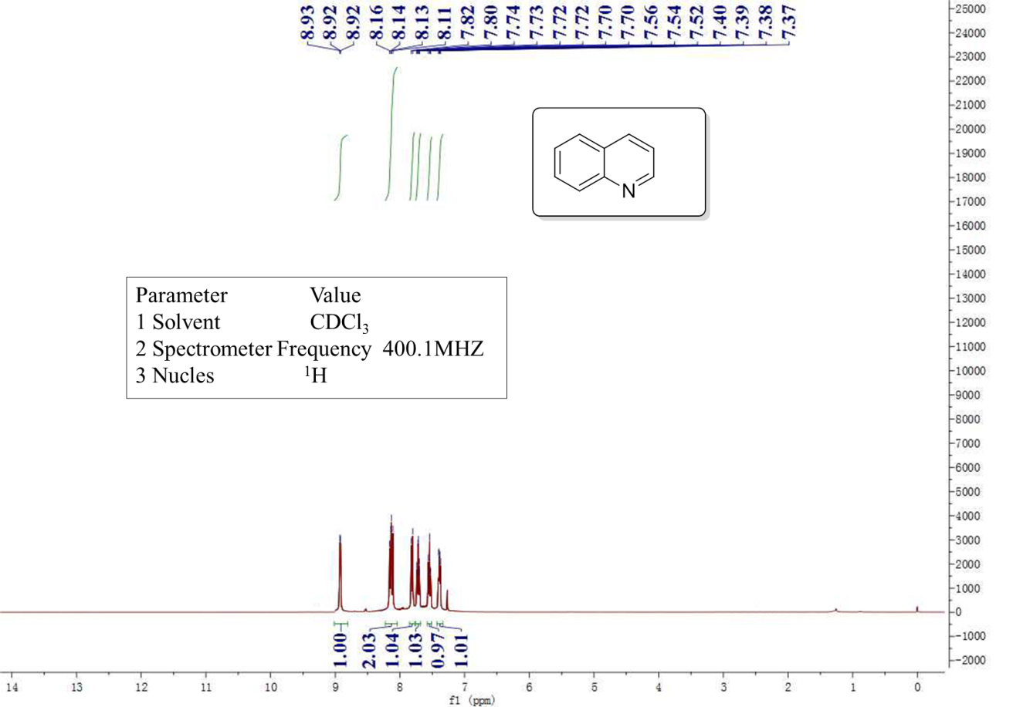
Supplementary Figure 10 ¹H NMR spectra of the quinoline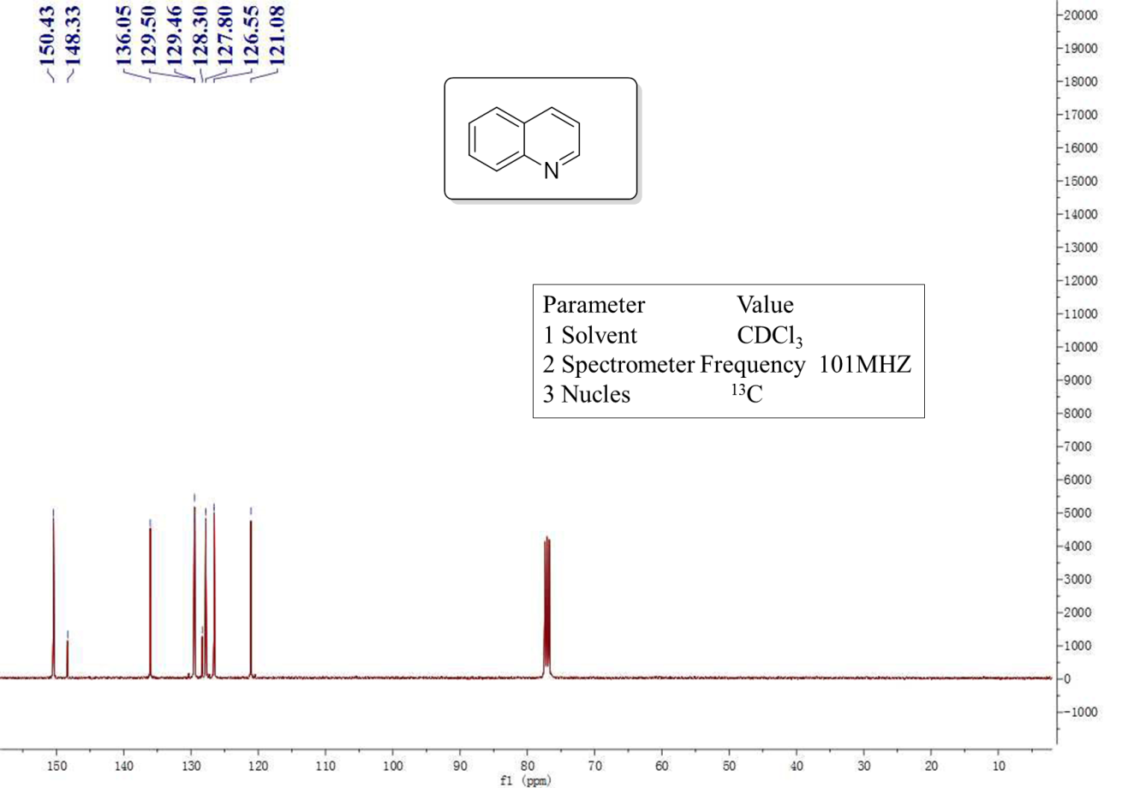
Supplementary Figure 11 ¹³C NMR spectra of the quinoline

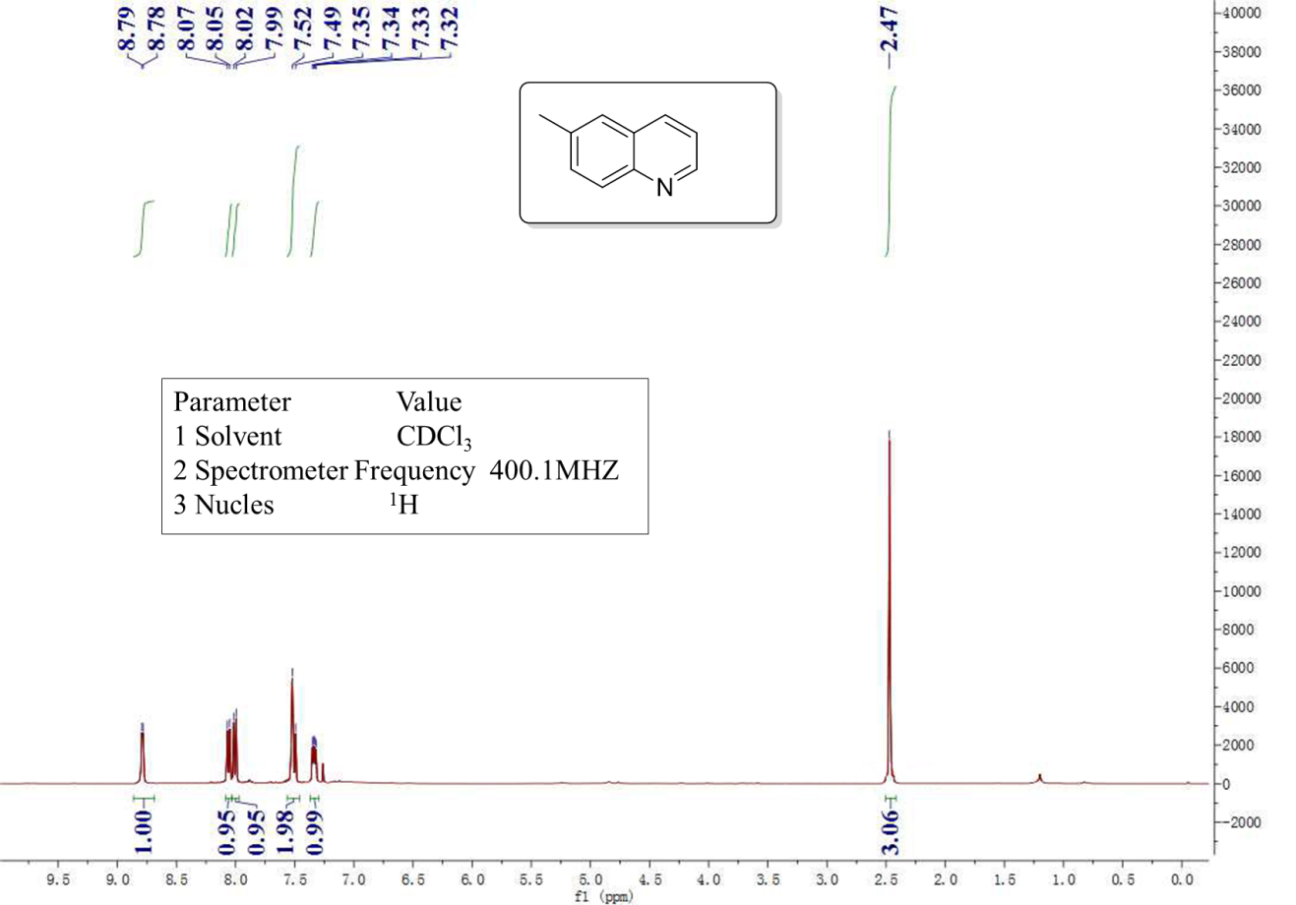
Supplementary Figure 12 ¹H NMR spectra of the 6-methylquinoline

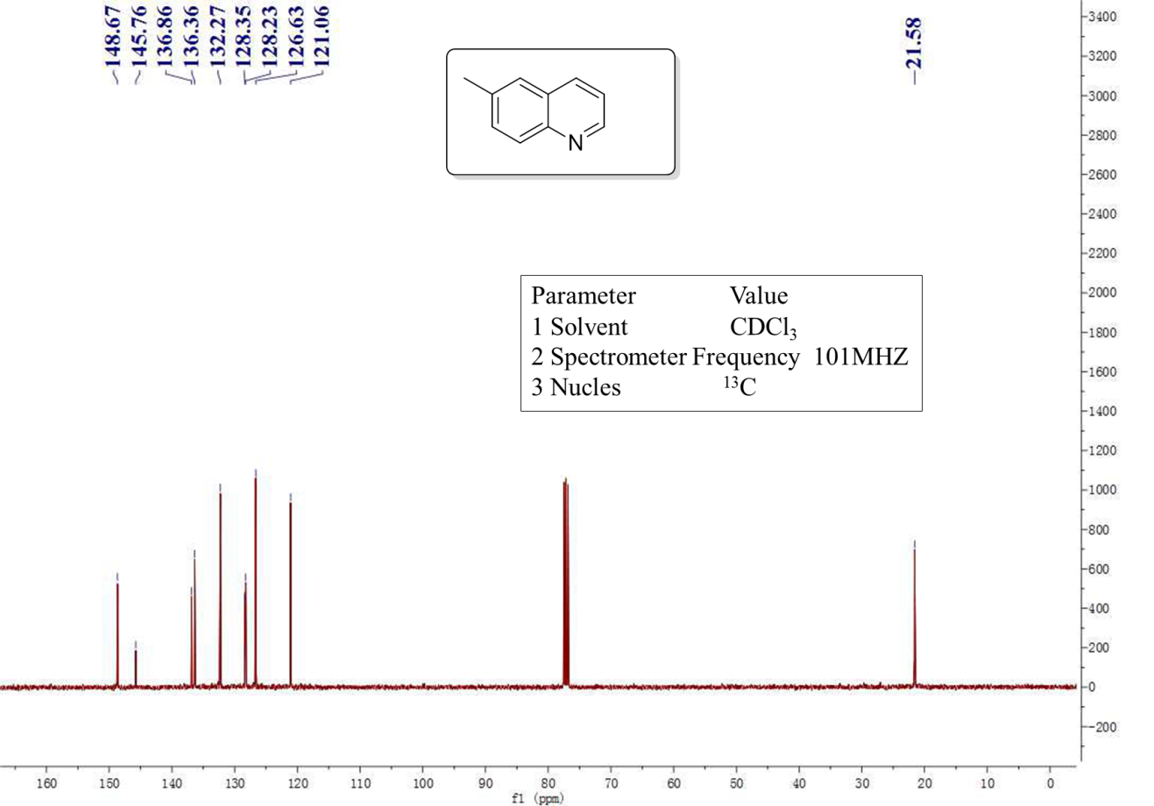
Supplementary Figure 13 ¹³C NMR spectra of the 6-methylquinoline
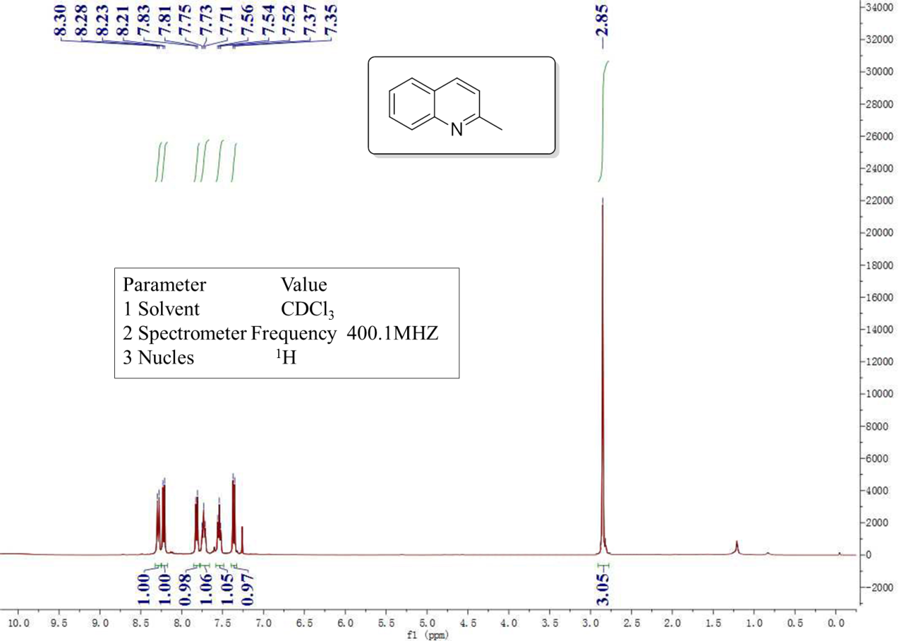
Supplementary Figure 14 ¹H NMR spectra of the 2-methylquinoline

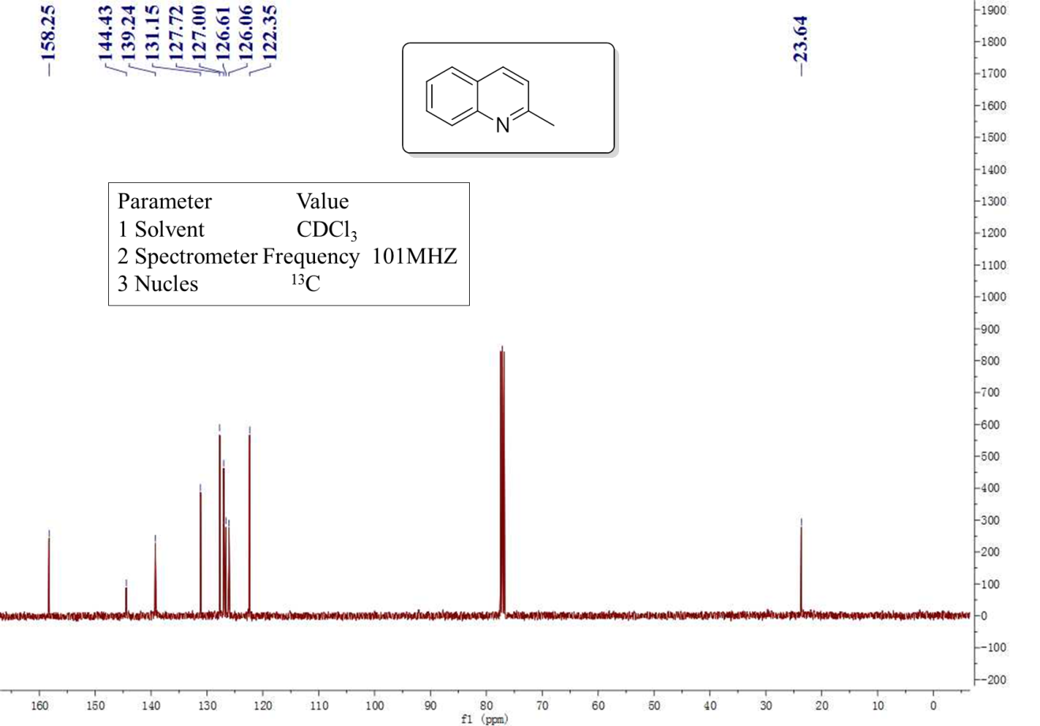
Supplementary Figure 15 ¹³C NMR spectra of the 2-methylquinoline

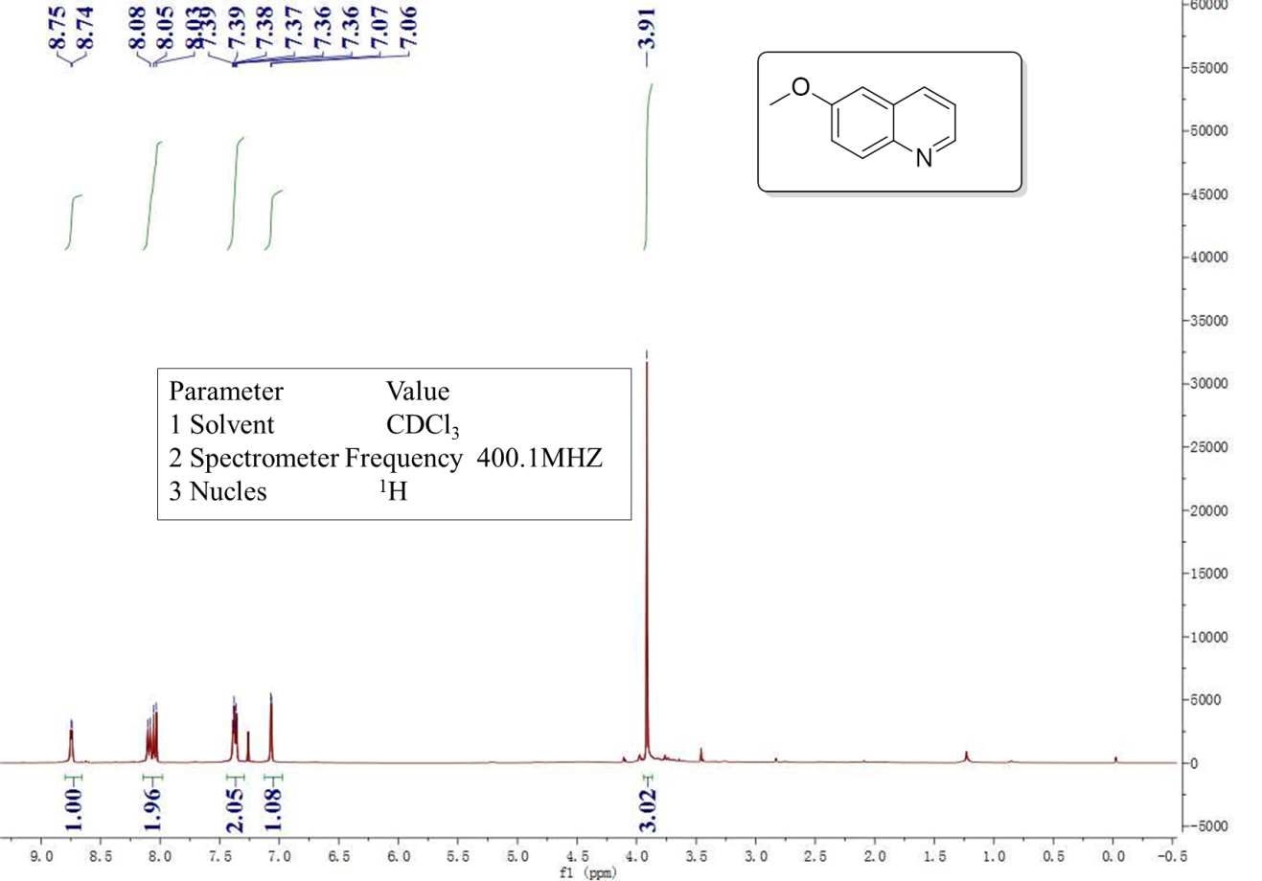
Supplementary Figure 16 ¹H NMR spectra of the 6-methoxyquinoline

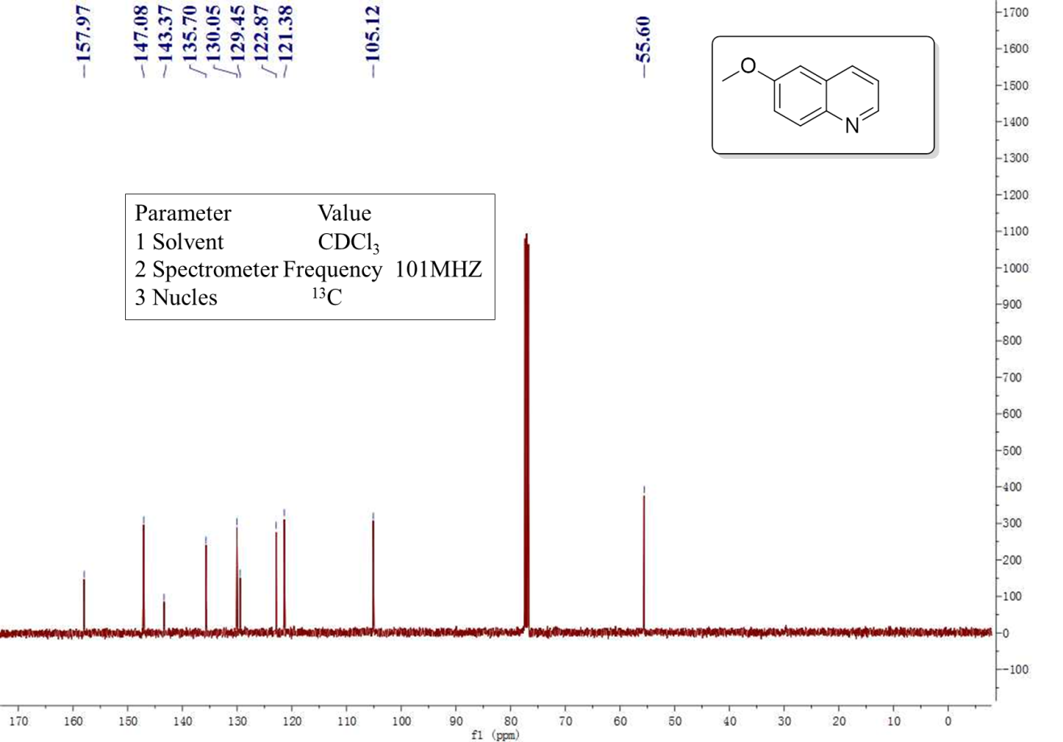
Supplementary Figure 17 ¹³C NMR spectra of the 6-methoxyquinoline

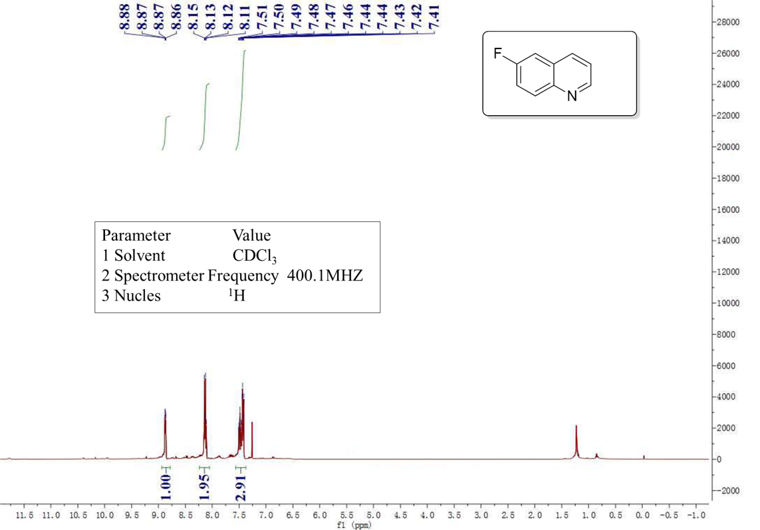
Supplementary Figure 18 ¹H NMR spectra of the 6-fluoroquinoline

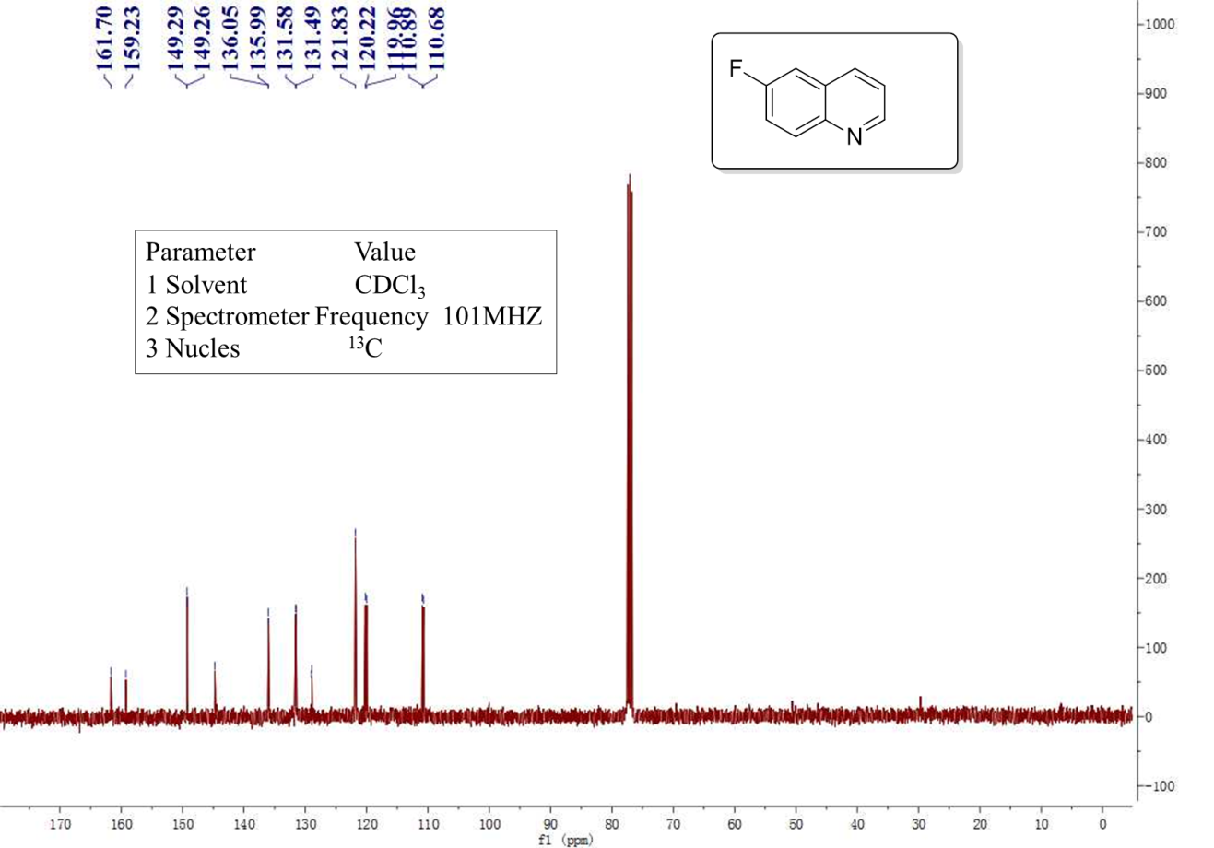
Supplementary Figure 19 ¹³C NMR spectra of the 6-fluoroquinoline

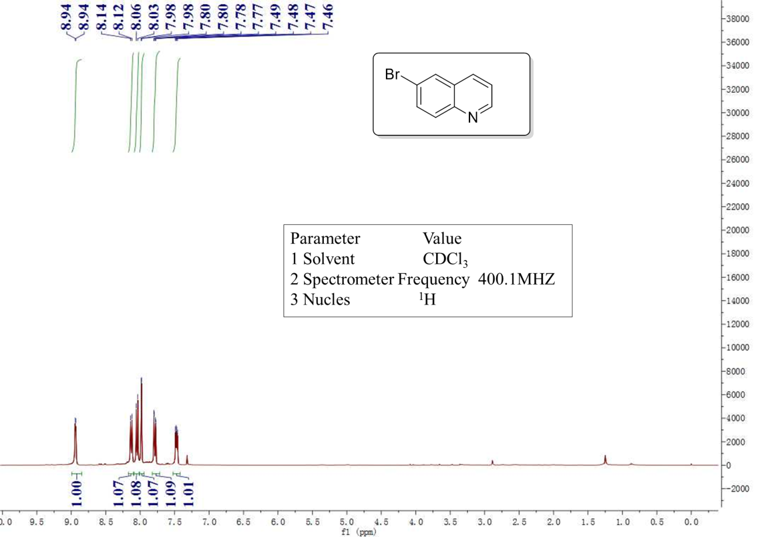
Supplementary Figure 20 ¹H NMR spectra of the 6-bromoquinoline

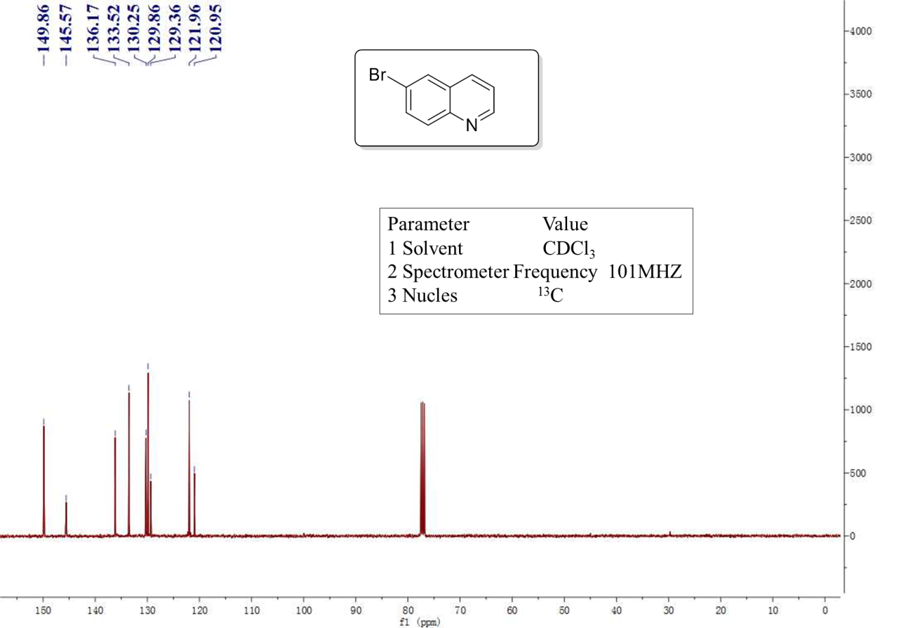
Supplementary Figure 21¹³C NMR spectra of the 6-bromoquinoline

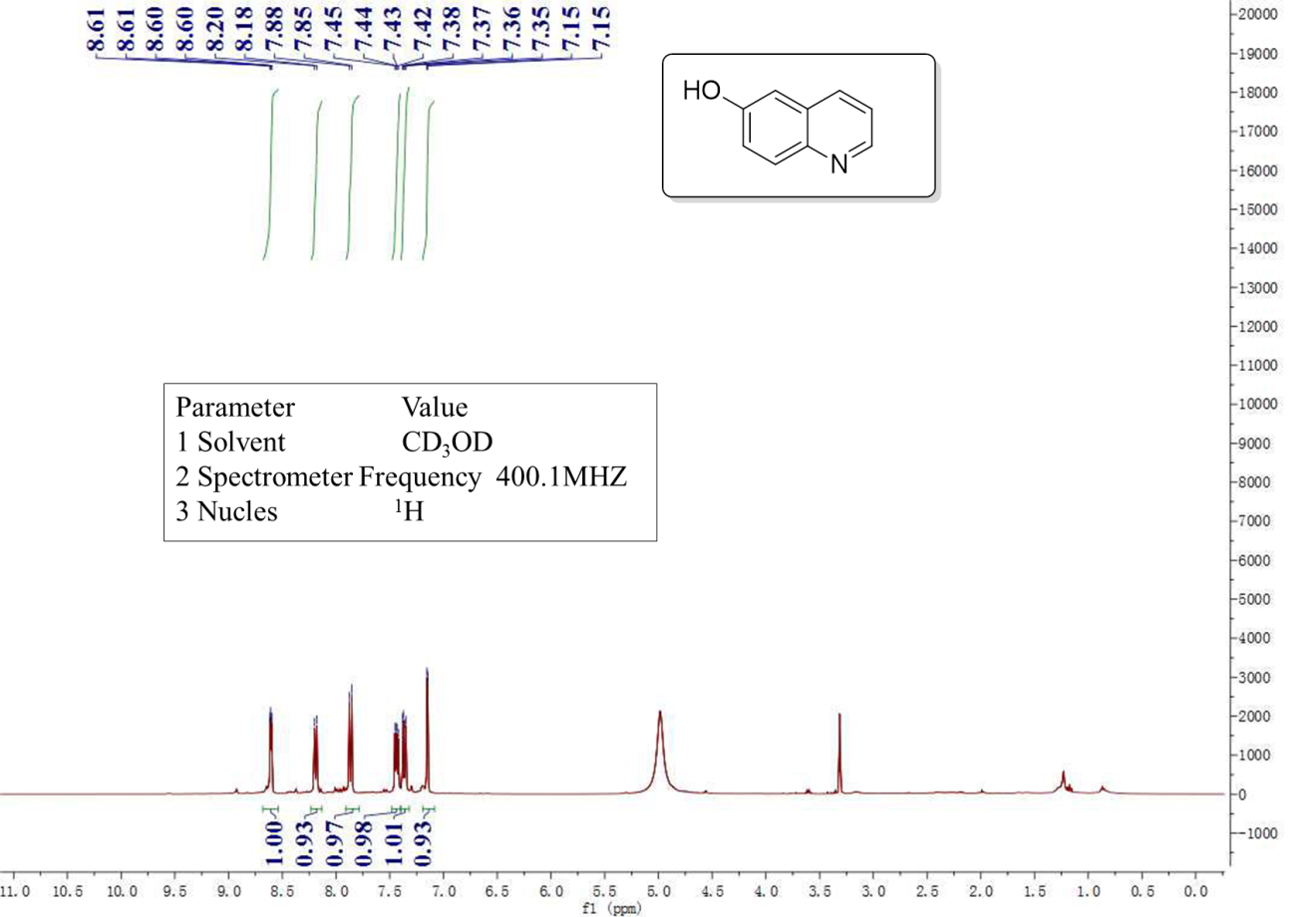
Supplementary Figure 22 ¹H NMR spectra of the quinolin-7-ol

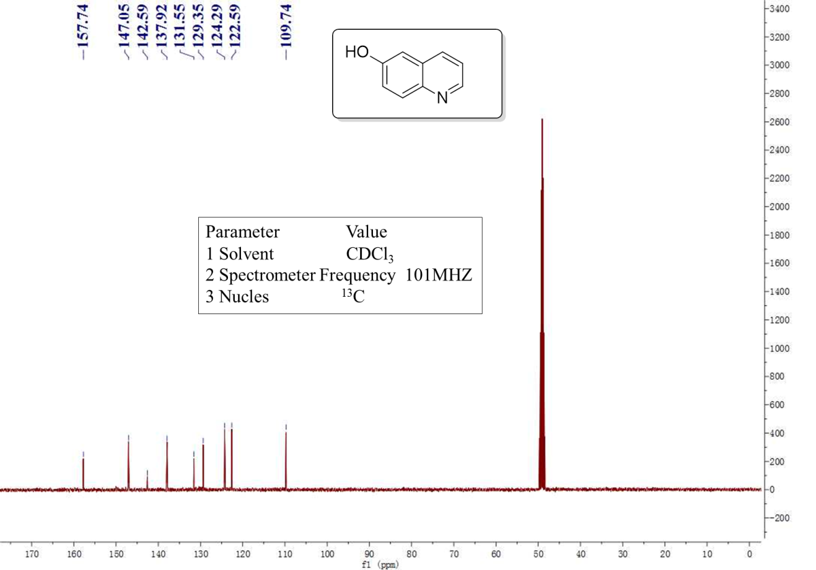
Supplementary Figure 23 ¹³C NMR spectra of the quinolin-7-ol

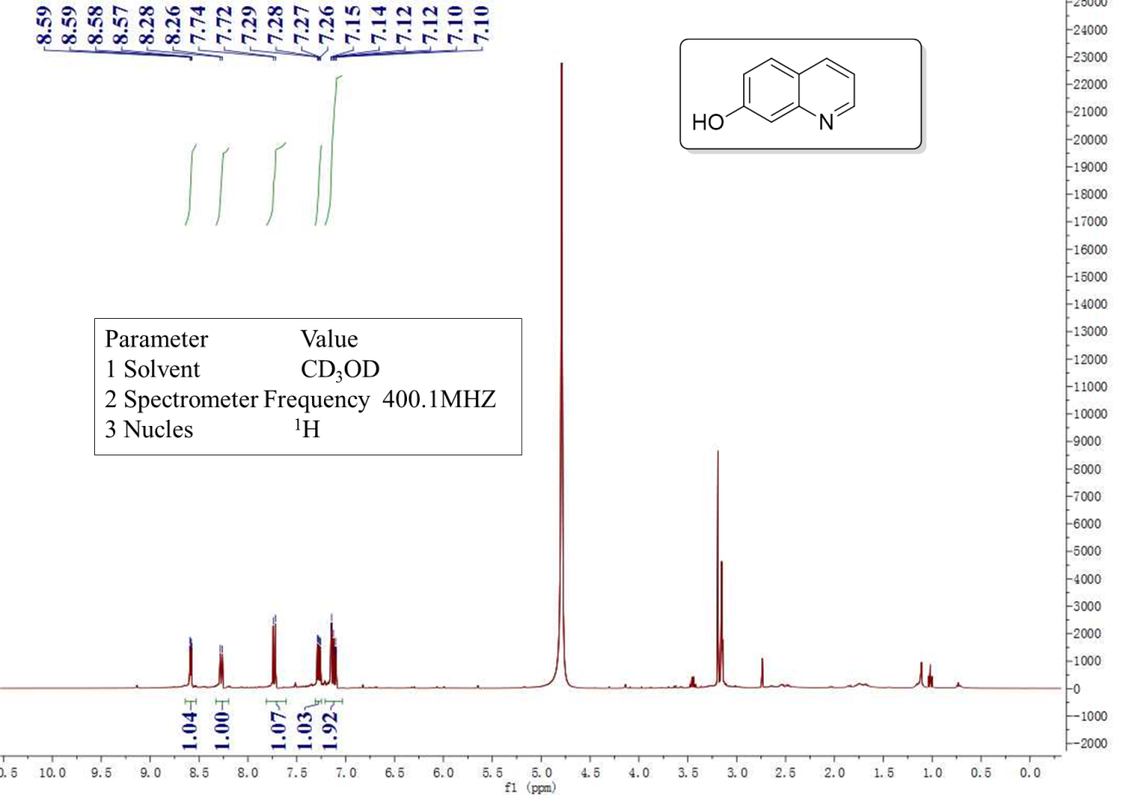
Supplementary Figure 24 ¹H NMR spectra of the quinolin-7-ol

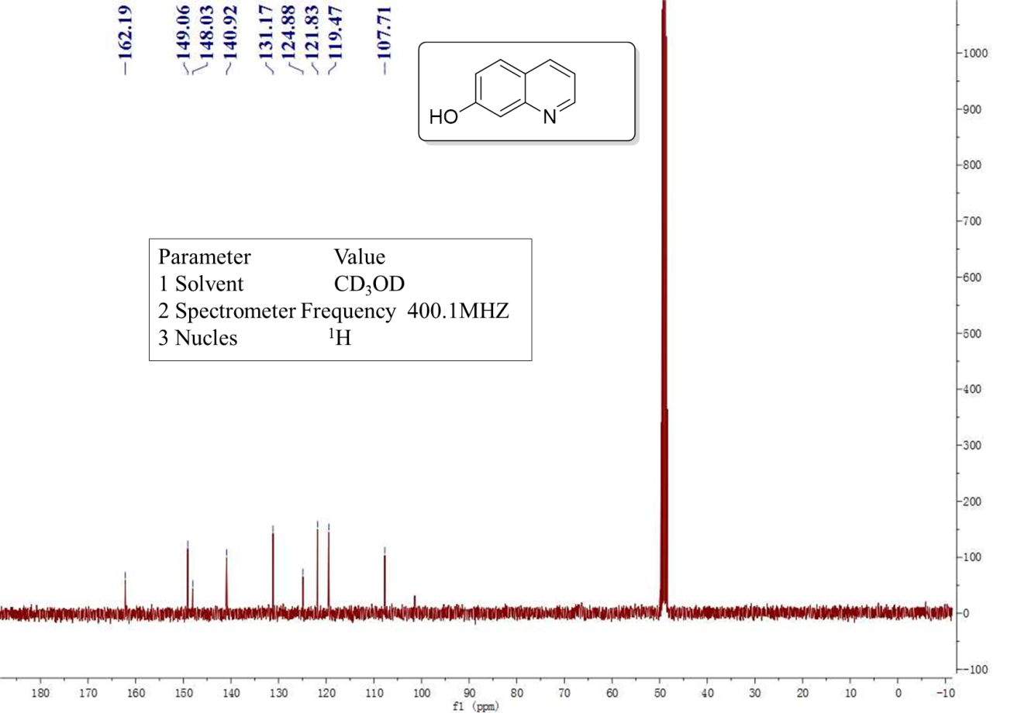
Supplementary Figure 25 ¹³C NMR spectra of the quinolin-8-ol

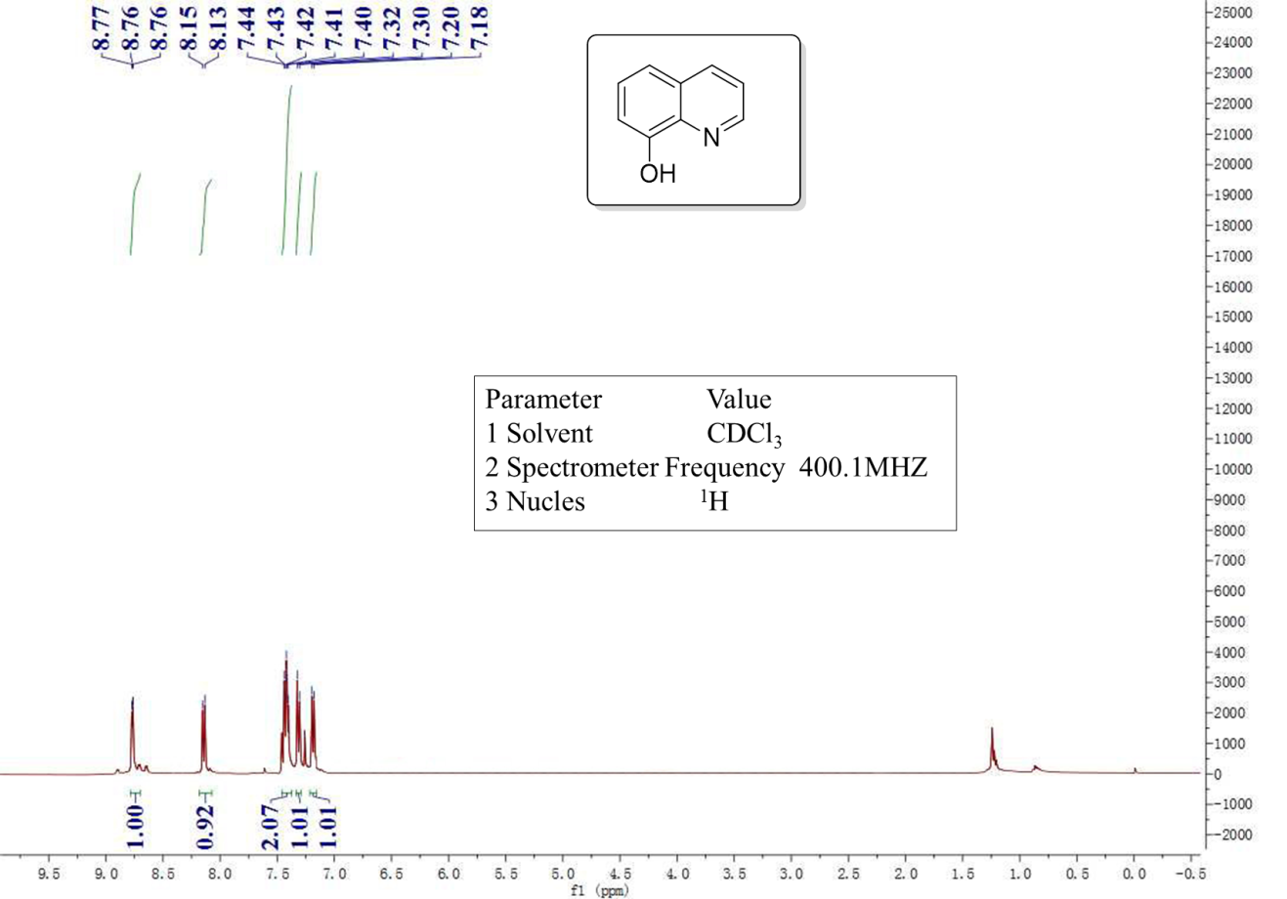
Supplementary Figure 26 ¹H NMR spectra of the quinolin-8-ol

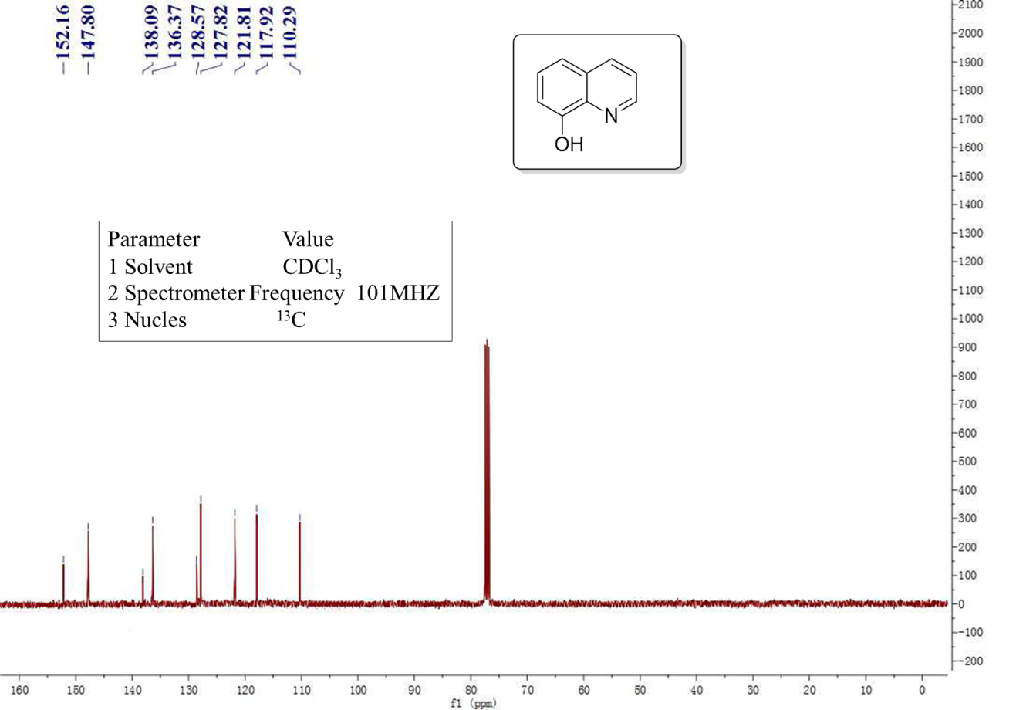
Supplementary Figure 27 ¹³C NMR spectra of the 6-fluoro-2-methylquinoline

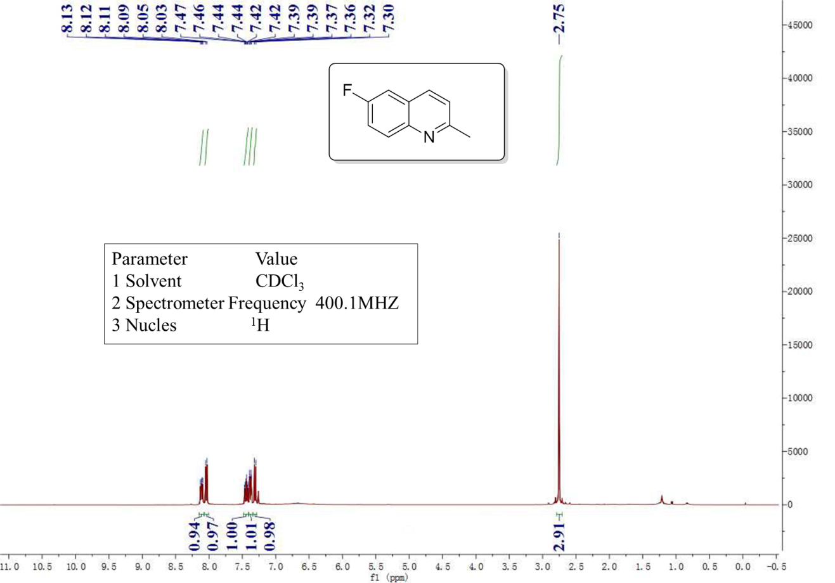
Supplementary Figure 28 ¹H NMR spectra of the 6-fluoro-2-methylquinoline

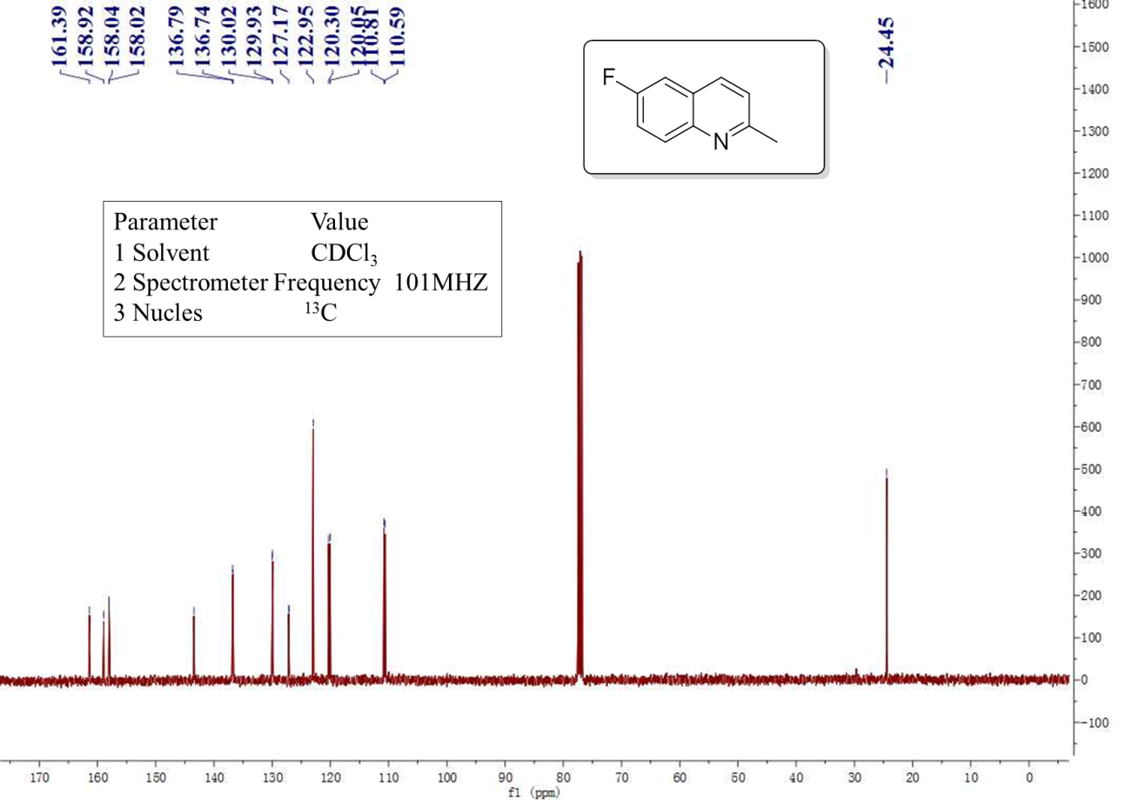
Supplementary Figure 29 ¹³C NMR spectra of the 6-fluoro-2-methylquinoline

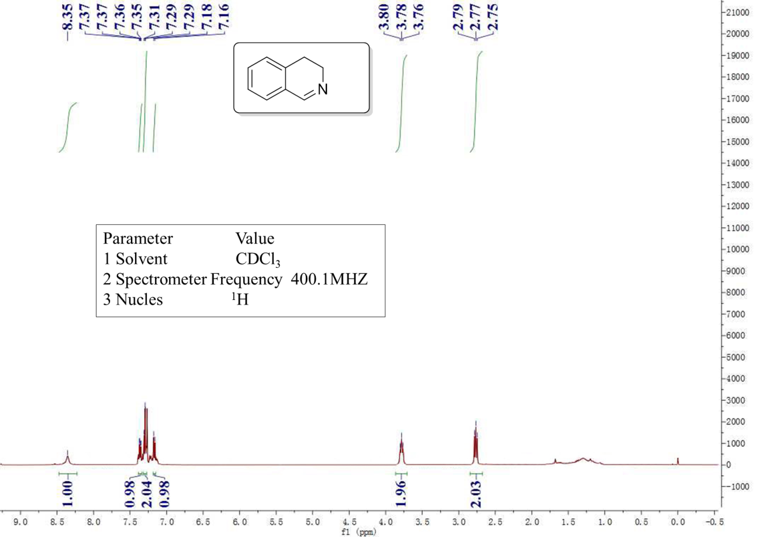
Supplementary Figure 30 ¹H NMR spectra of the 3,4-dihydroisoquinoline

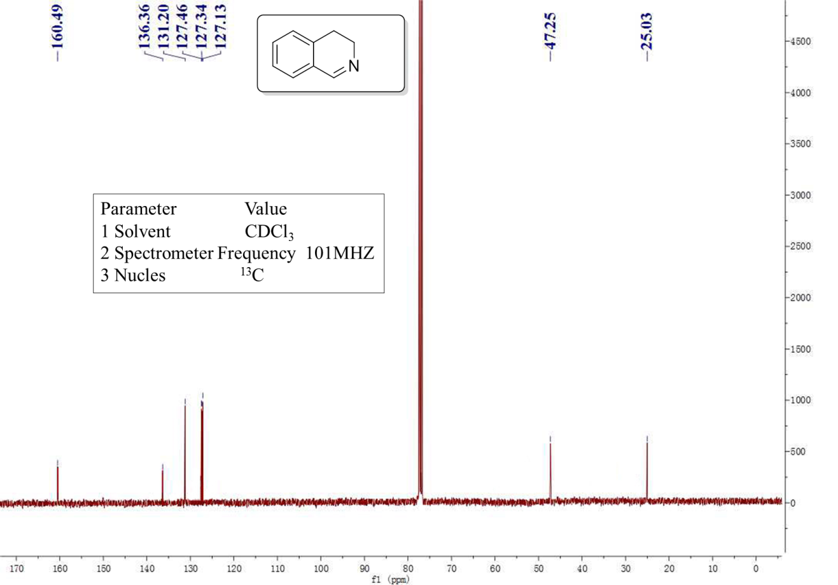
Supplementary Figure 31 ¹³C NMR spectra of the 3,4-dihydroisoquinoline

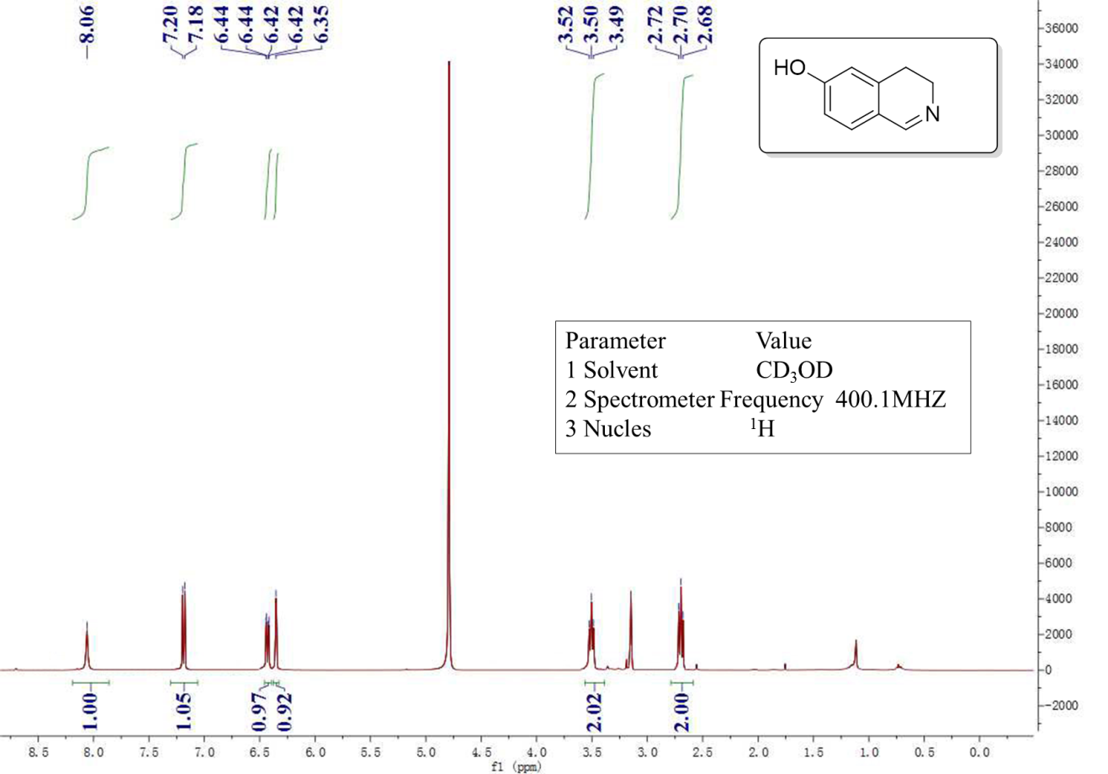
Supplementary Figure 32 ¹H NMR spectra of the 3,4-dihydroisoquinolin-6-ol

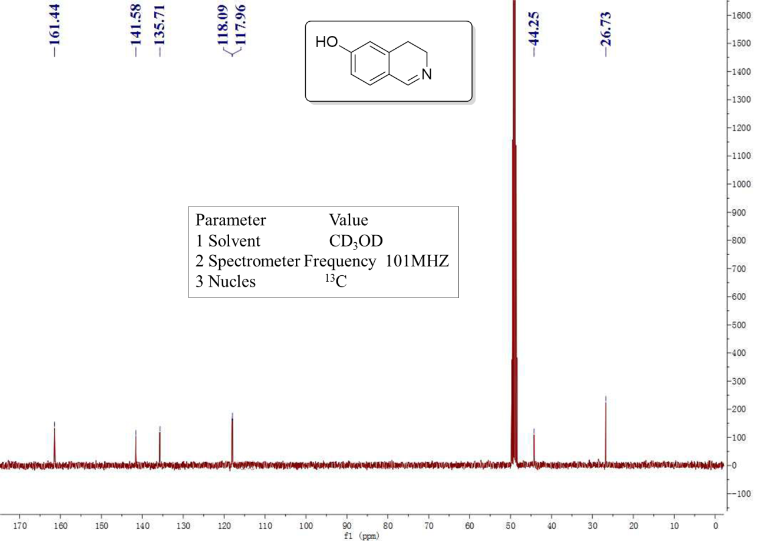
Supplementary Figure 33 ¹³C NMR spectra of the 3,4-dihydroisoquinolin-6-ol
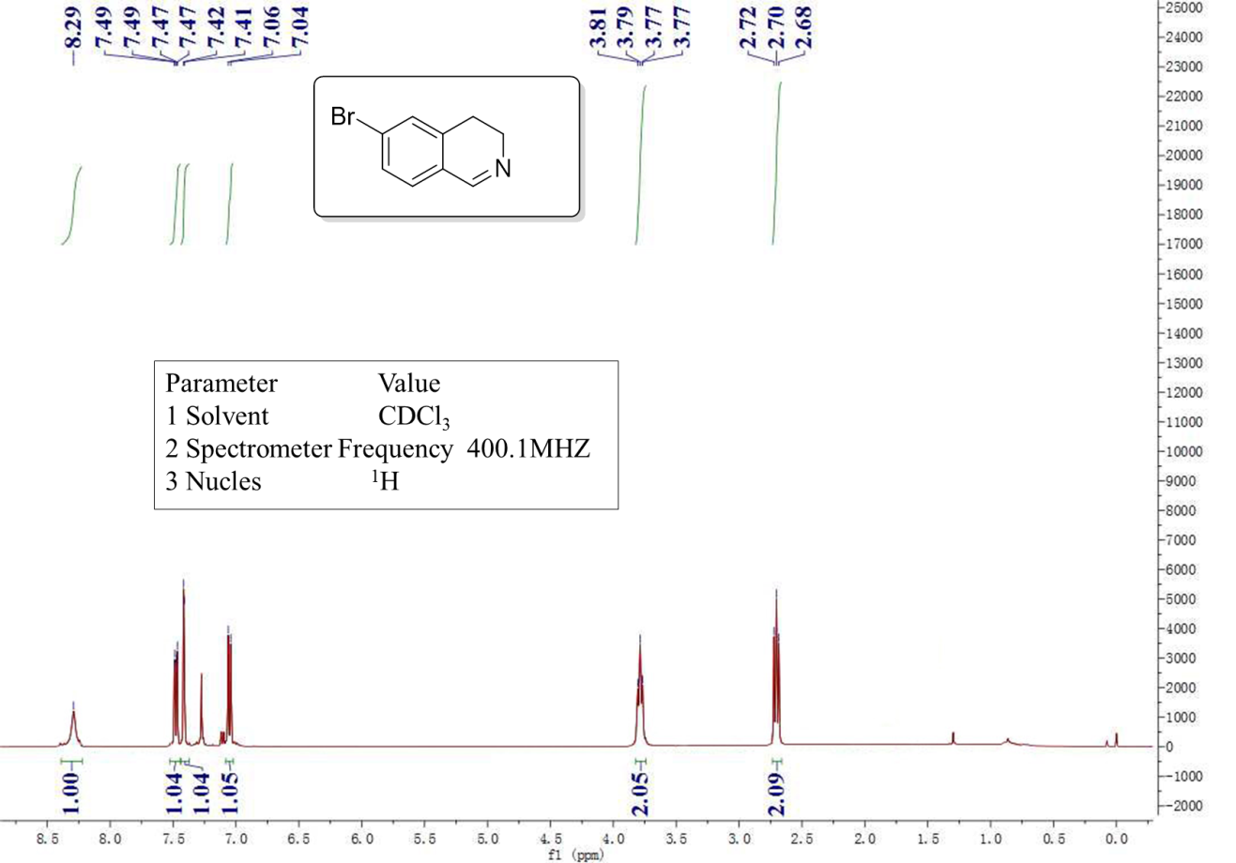
Supplementary Figure 34 ¹H NMR spectra of the 6-bromo-3,4-dihydroisoquinoline
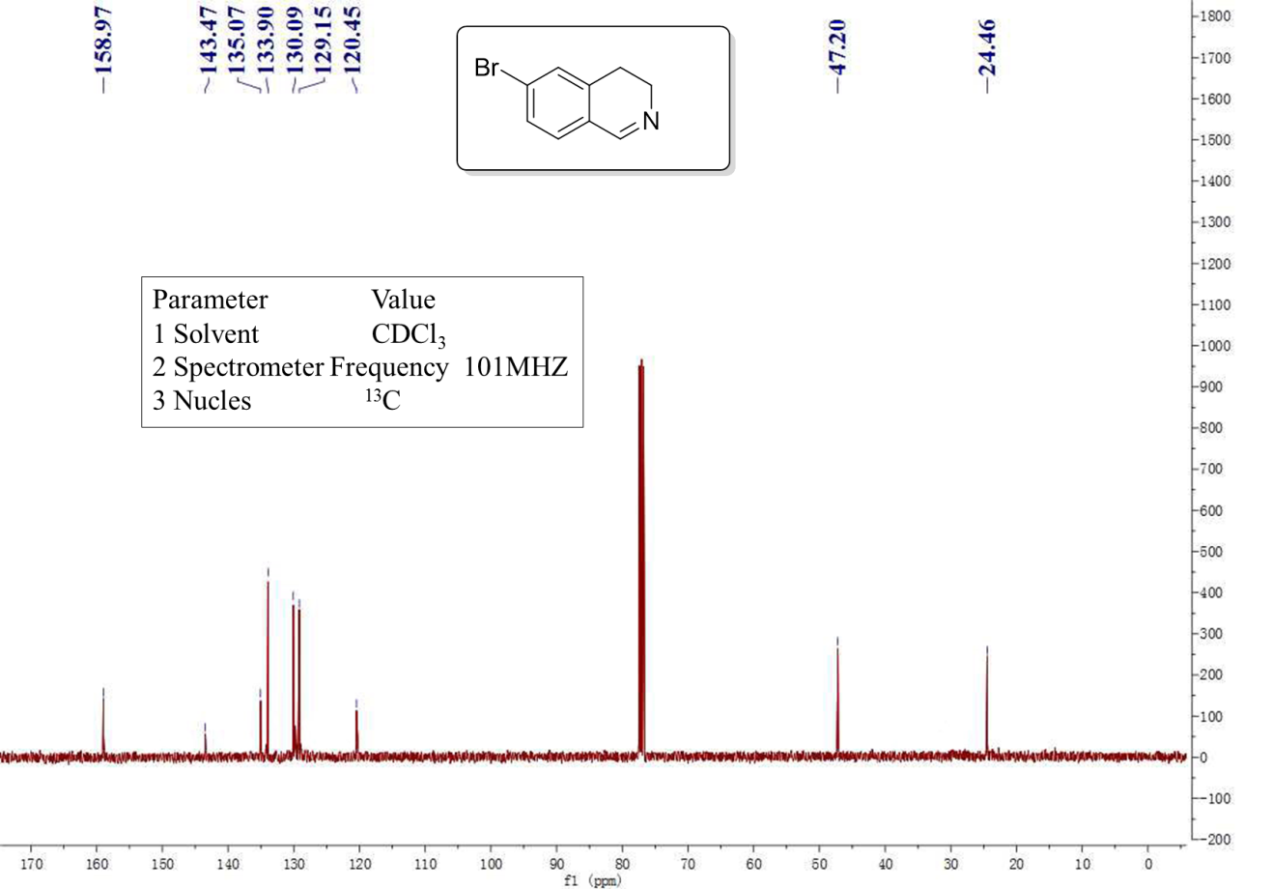
Supplementary Figure 35 ¹³C NMR spectra of the 6-bromo-3,4-dihydroisoquinoline
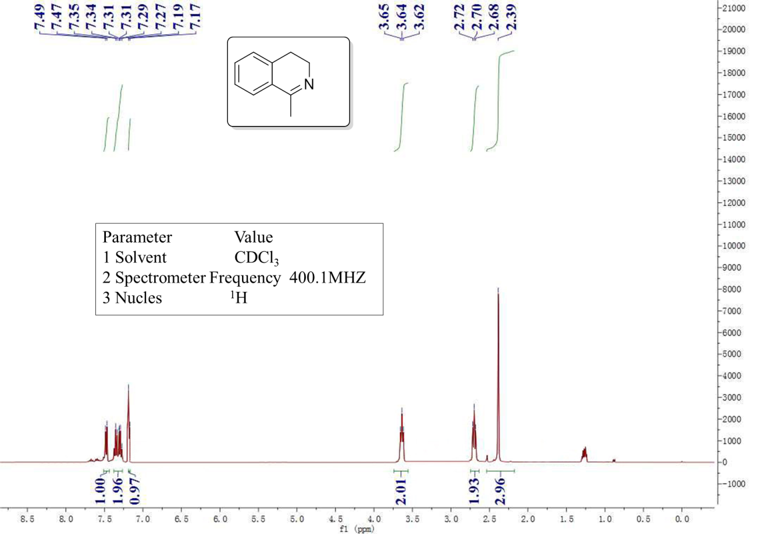
Supplementary Figure 36 ¹H NMR spectra of the 1-methyl-3,4-dihydroisoquinoline
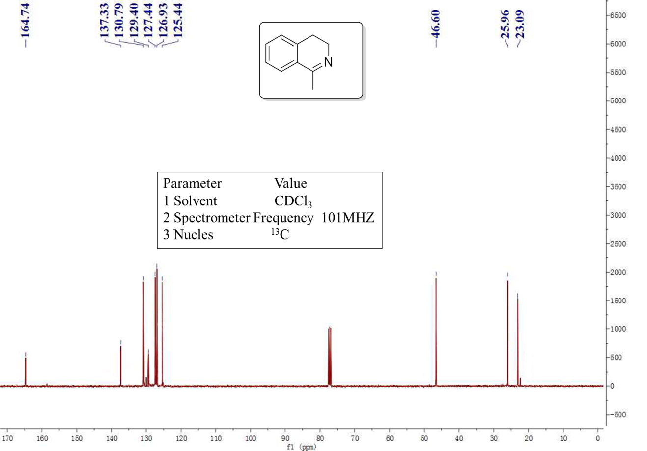
Supplementary Figure 37 ¹³C NMR spectra of the 1-methyl-3,4-dihydroisoquinoline
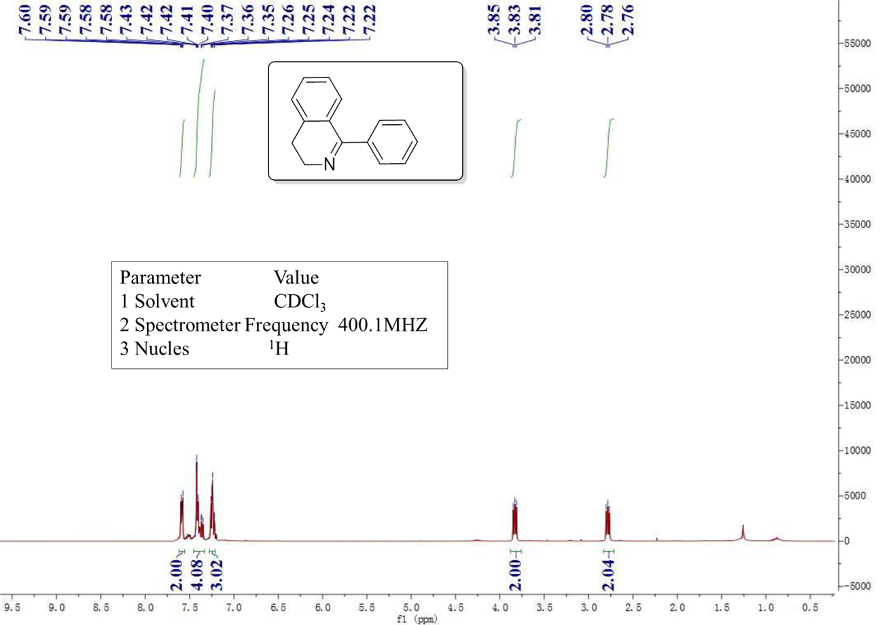
Supplementary Figure 38 ¹H NMR spectra of the 1-phenyl-3,4-dihydroisoquinoline
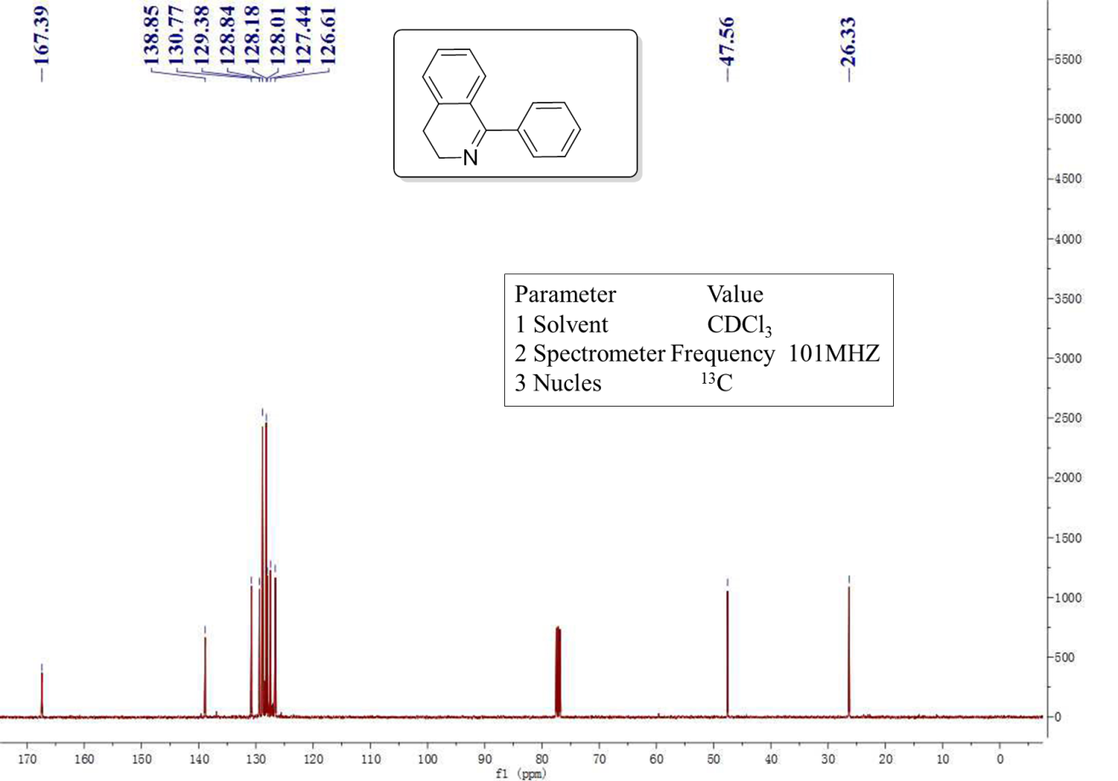
Supplementary Figure 39 ¹³C NMR spectra of the 1-phenyl-3,4-dihydroisoquinoline
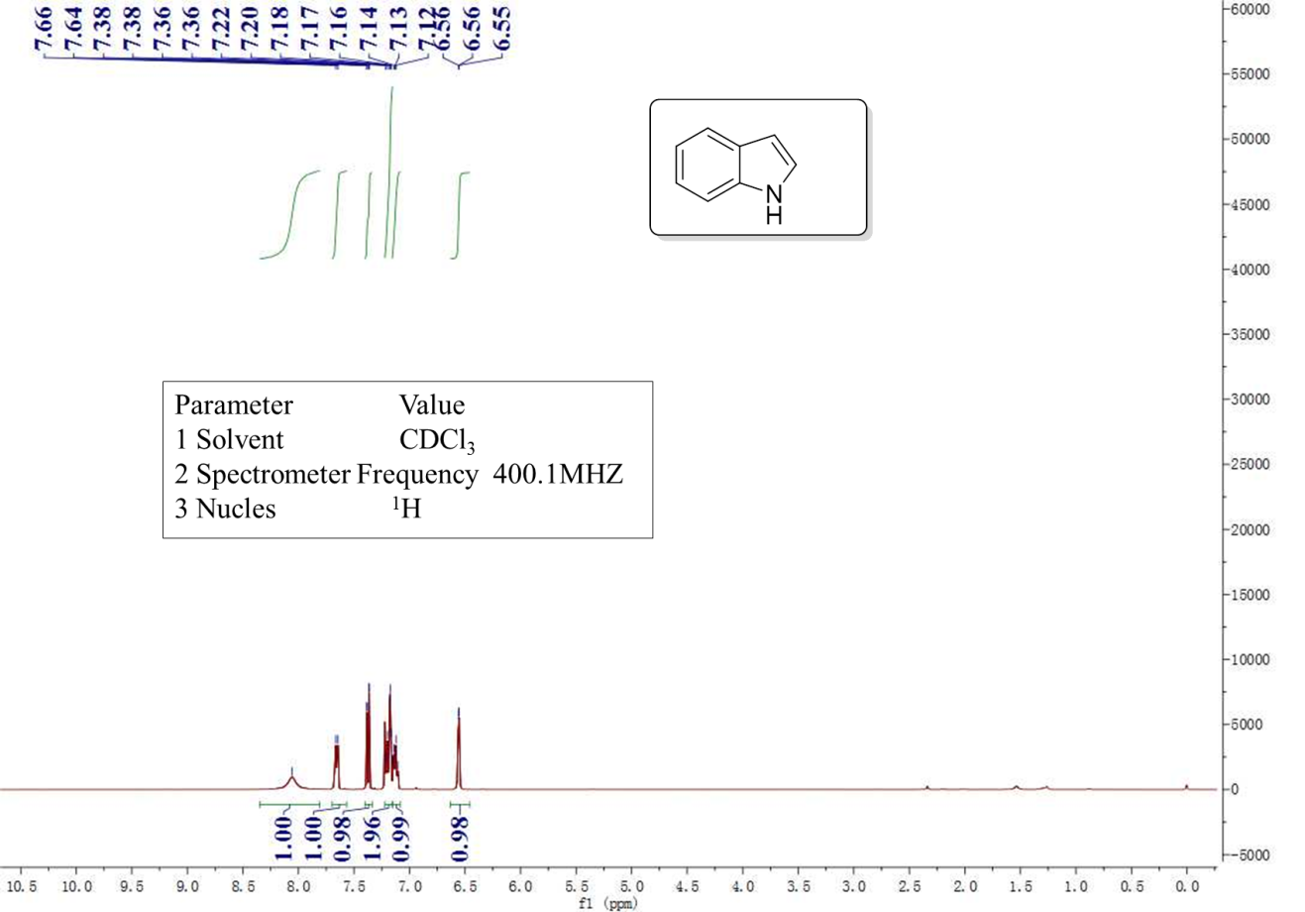
Supplementary Figure 40 ¹H NMR spectra of the indole

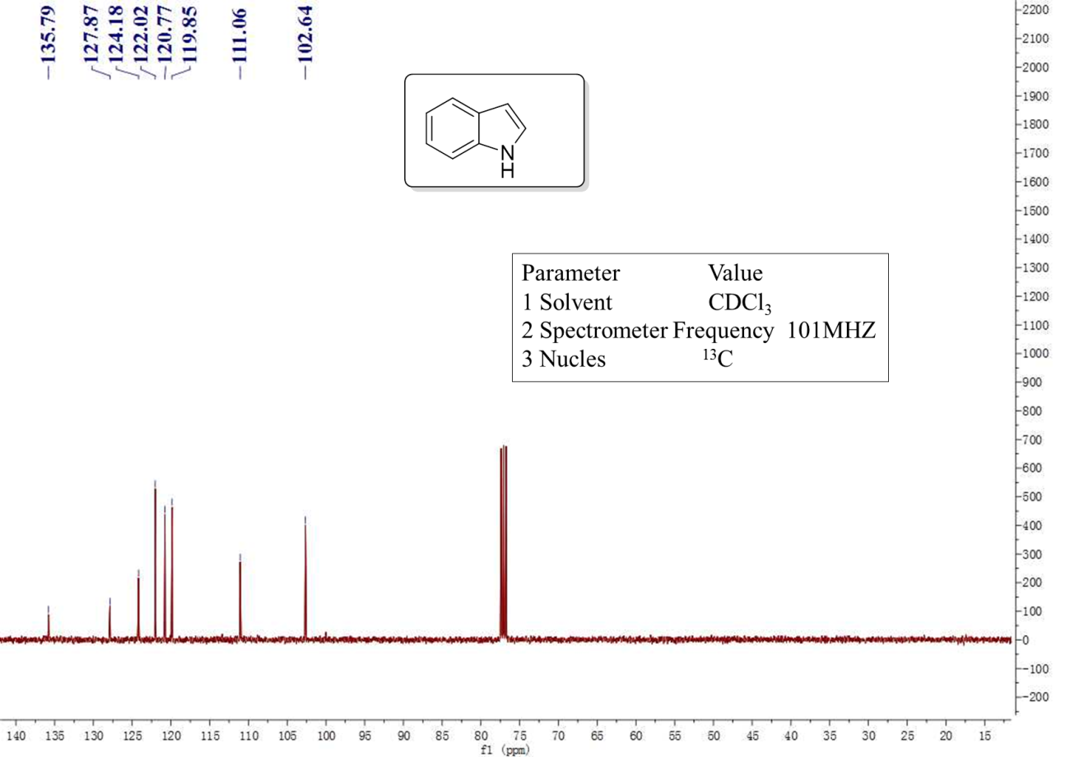
Supplementary Figure 41 ¹³C NMR spectra of the indole

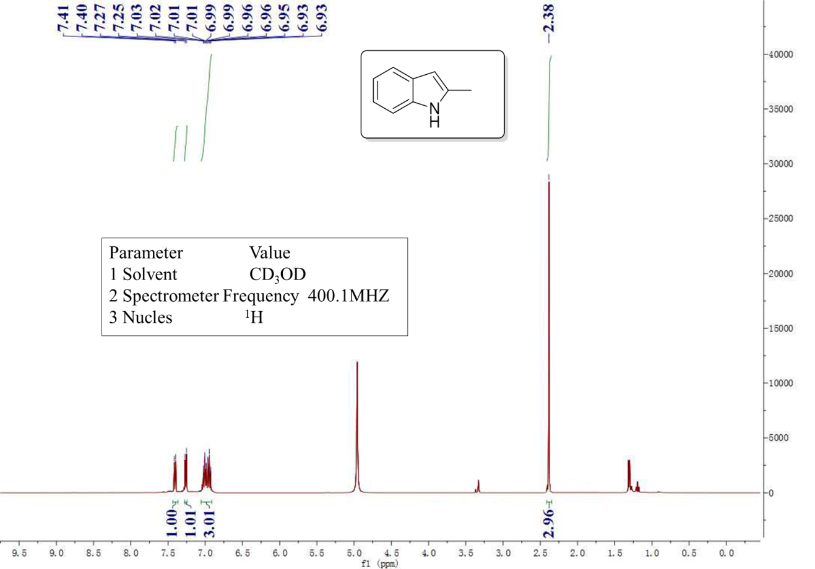
Supplementary Figure 42 ¹H NMR spectra of the 2-methyl-1H-indole

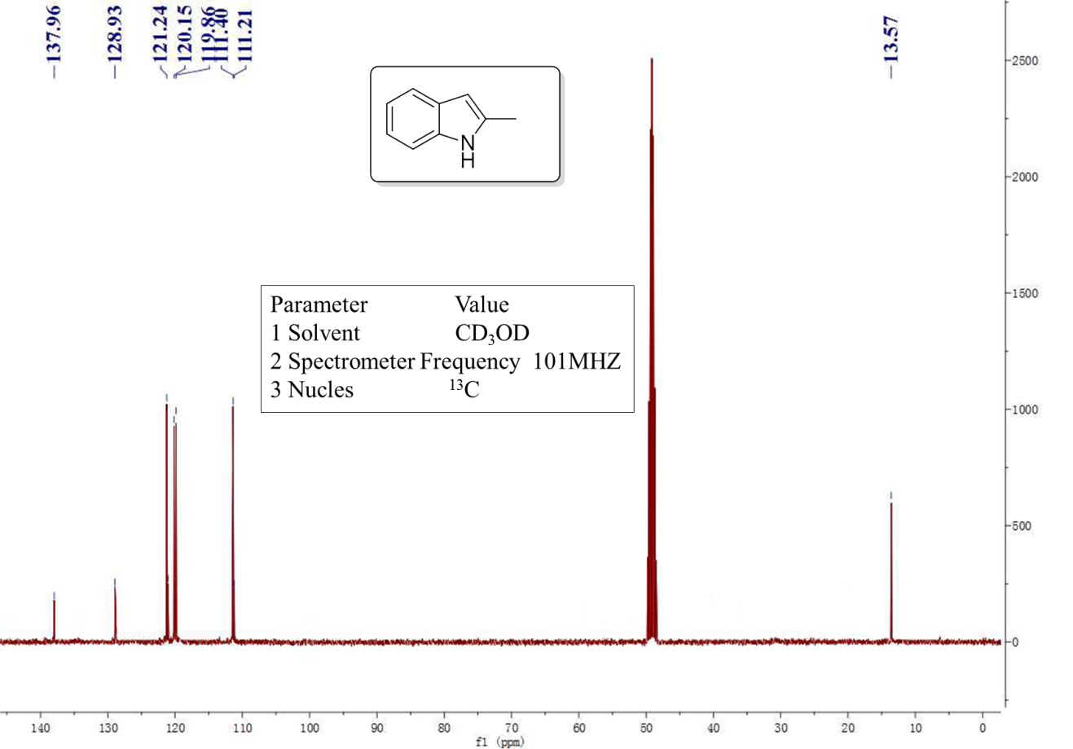
Supplementary Figure 43 ¹³C NMR spectra of the 2-methyl-1H-indole

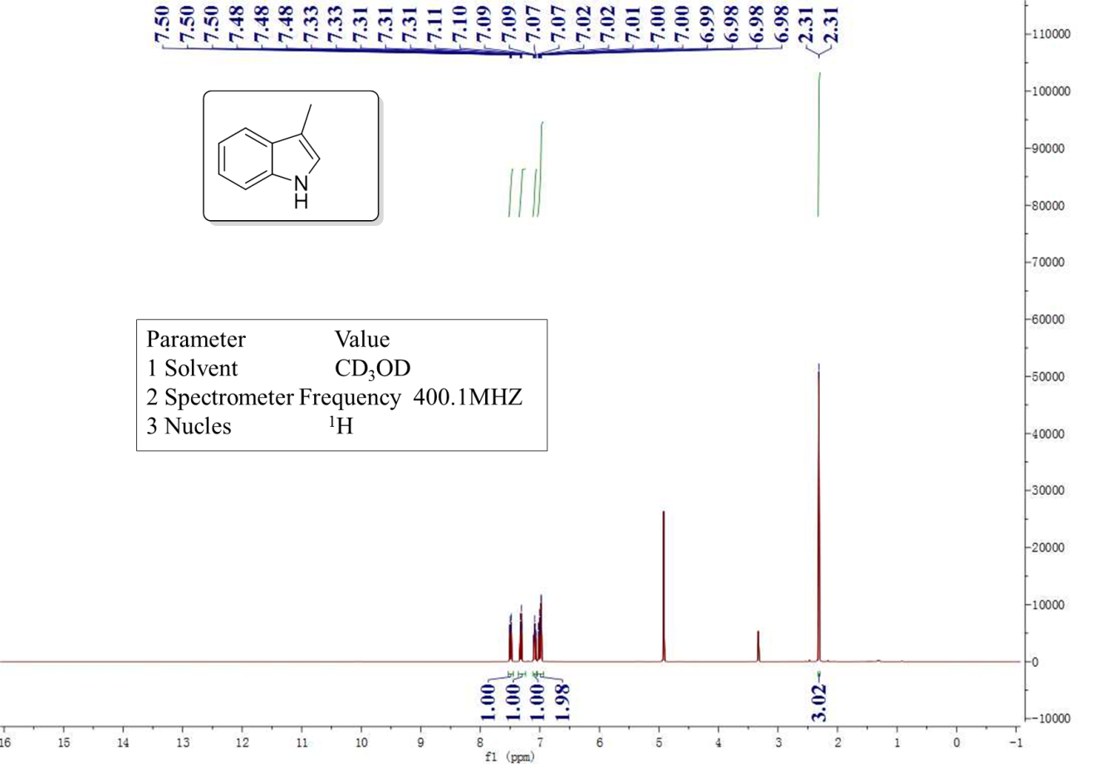
Supplementary Figure 44 ¹H NMR spectra of the 3-methyl-1H-indole

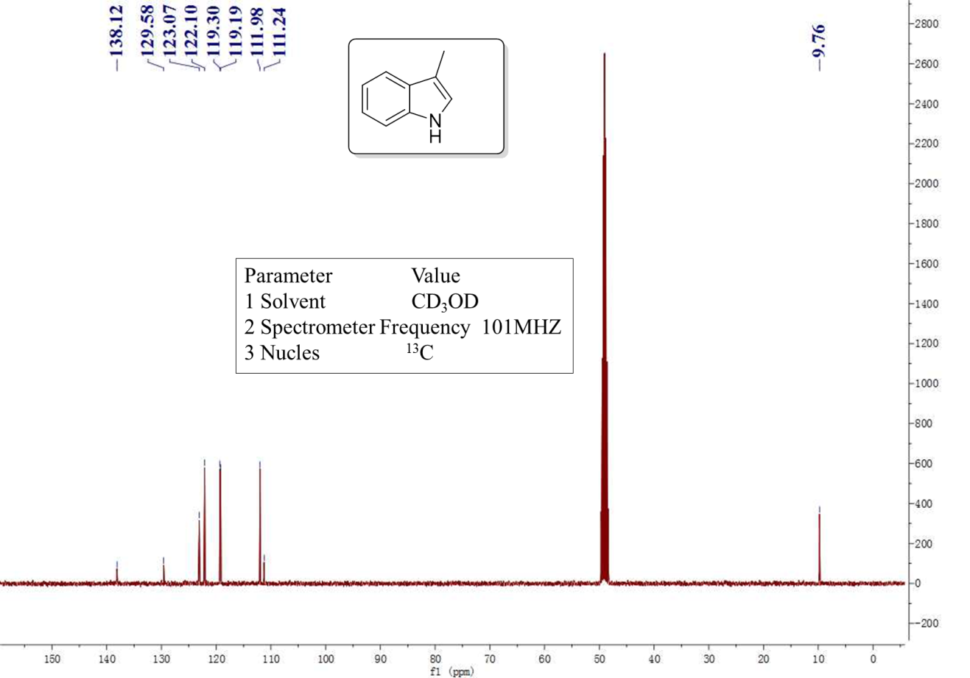
Supplementary Figure 45 ¹³C NMR spectra of the 3-methyl-1H-indole

Supplementary Figure 46 ¹H NMR spectra of the 5-bromo-1H-indole

Supplementary Figure 47 ¹³C NMR spectra of the 5-bromo-1H-indole

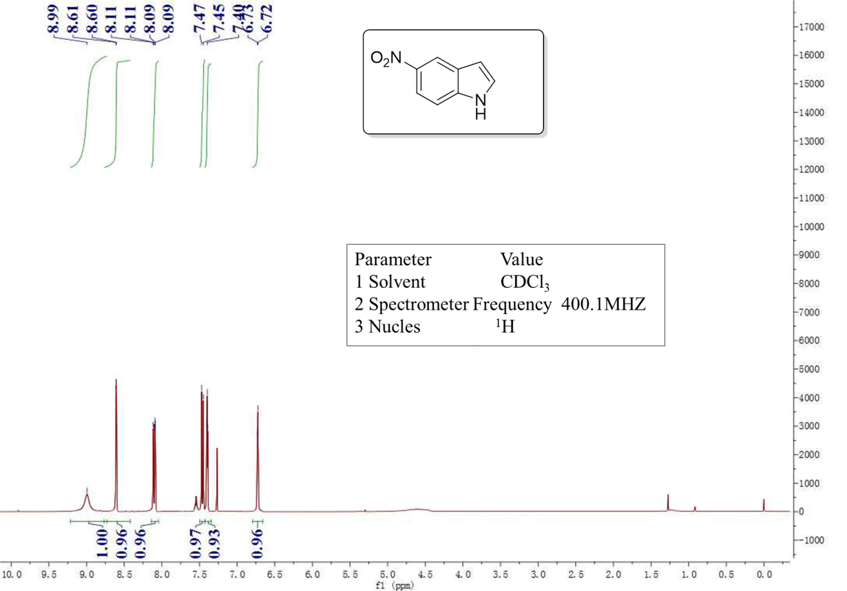
Supplementary Figure 48 ¹H NMR spectra of the 5-nitro-1H-indole

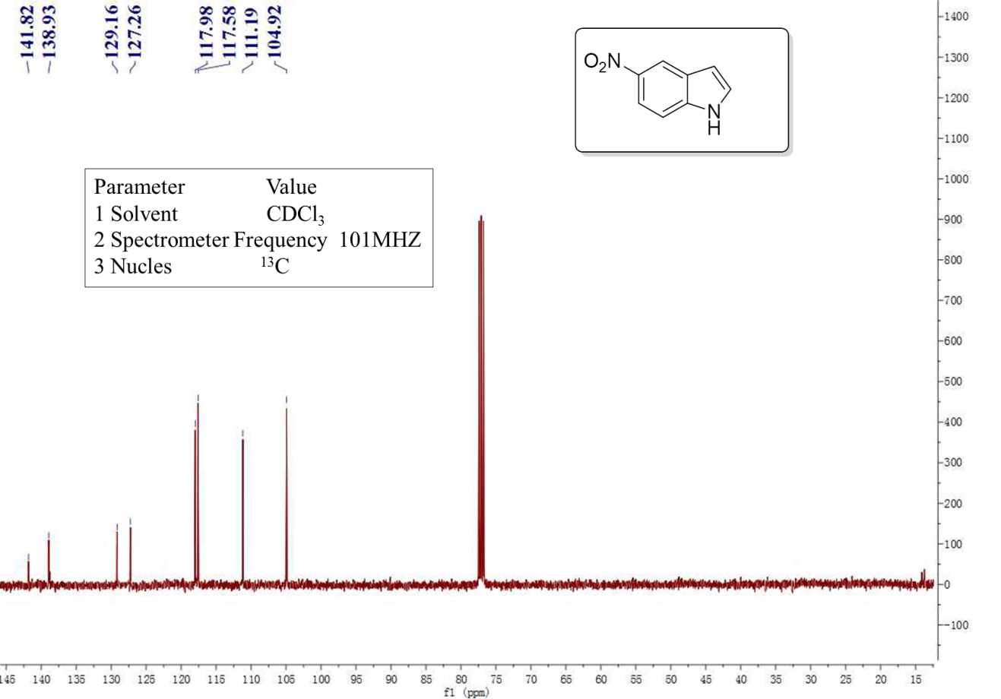
Supplementary Figure 49 ¹³C NMR spectra of the 5-nitro-1H-indole

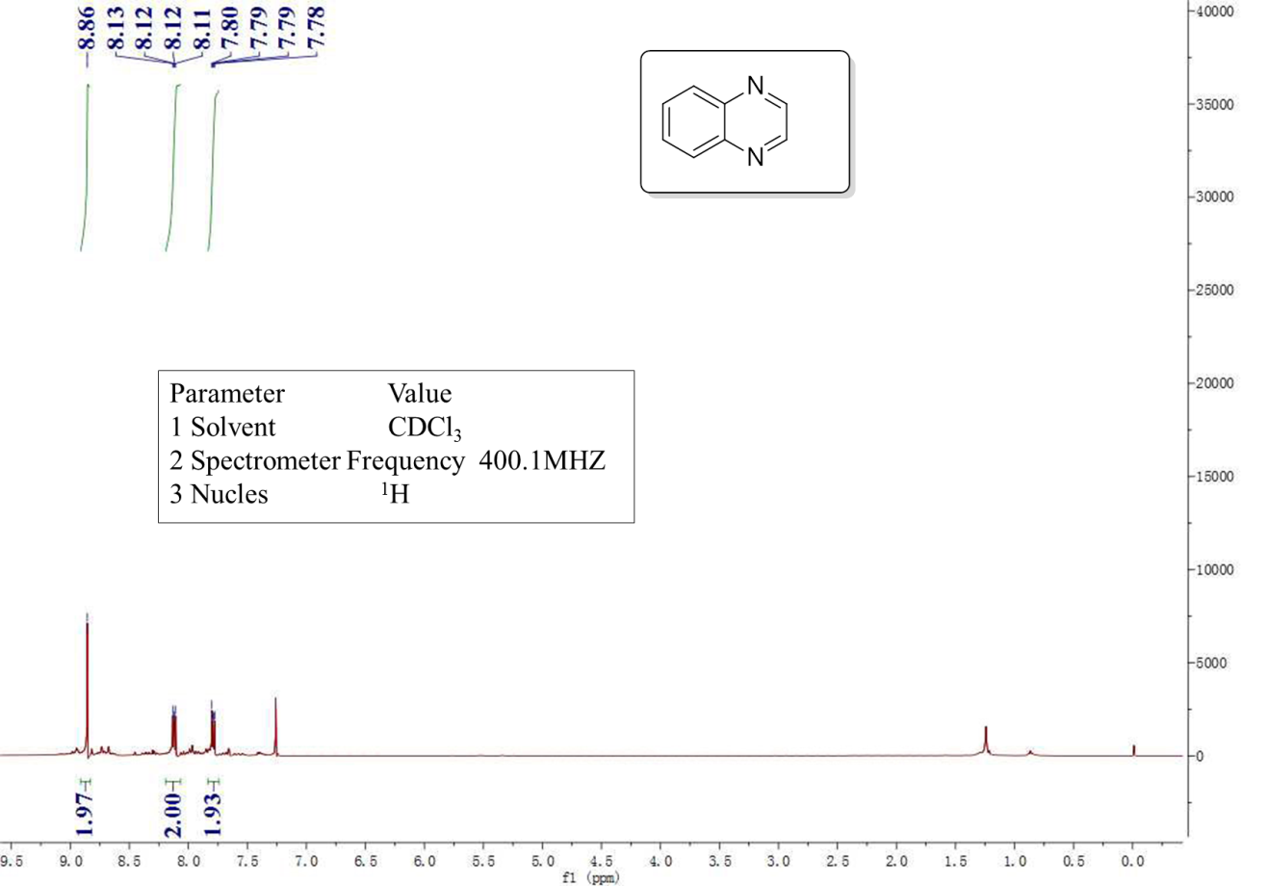
Supplementary Figure 50 ¹H NMR spectra of the quinoxaline

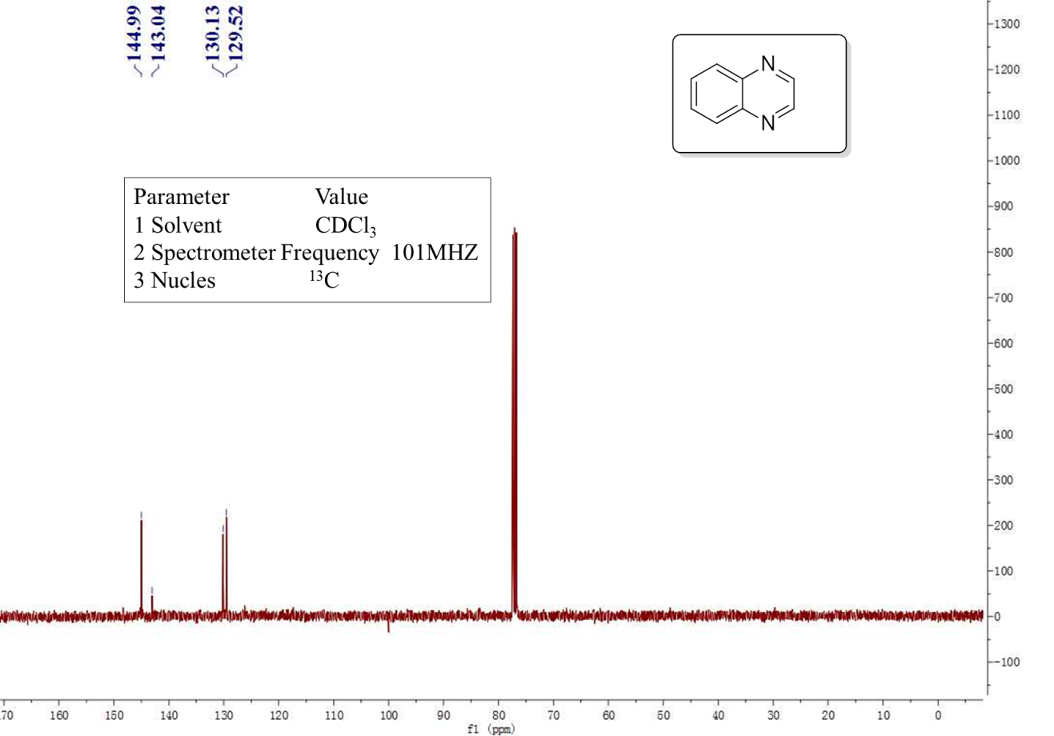
Supplementary Figure 51 ¹³C NMR spectra of the quinoxaline

Supplementary References
[1] Cui, X. et al. Synthesis and characterization of iron–nitrogen-doped graphene/core–shell catalysts: Efficient oxidative dehydrogenation of N-heterocycles. J. Am. Chem. Soc. 137, 10652–10658 (2015).
[2] Tanaka, T.; Okunaga, K.-i.; Hayashi, M. Dehydrogenation of 1,2,3,4-tetrahydroquinoline and its related compounds: comparison of Pd/C–ethylene system and activated carbon–O₂ system. Tetrahedron Lett. 2010, 51, 4633-4635 (2010).
[3] Chakraborty, S.; Brennessel, W. W.; Jones, W. D. A Molecular iron ctalyst for the acceptorless dehydrogenation and hydrogenation of N-heterocycles. J. Am. Chem. Soc. 136, 8564-8567 (2014).
[4] Mullick, K.; Biswas, S.; Angeles-Boza, A. M.; Suib, S. L. Heterogeneous mesoporous manganese oxide catalyst for aerobic and additive-free oxidative aromatization of N-heterocycles. Chem. Commun. 53, 2256-2259 (2017).
[5] Muthaiah, S.; Hong, S. H. Acceptorless and base-free dehydrogenation of alcohols and amines using tuthenium-hydride complexes. Adv. Synth. Catal. 354, 3045–3053 (2012).
[6] Sahoo, M. K.; Jaiswal, G.; Rana, J.; Balaraman, E. Organo-photoredox catalyzed oxidative dehydrogenation of N-heterocycles. Chem. Eur. J. 23, 14167–14172 (2017).

