Supplementary Information

Ancient DNA study reveals HLA susceptibility locus for leprosy in medieval Europeans

Krause-Kyora et al.

Supplementary Notes

Note 1. Archaeological sites and specimens analyzed in this study
In the current study, human skeletal specimens were obtained from five medieval cemeteries in Denmark and present-day northern Germany (see cemetery descriptions below). Osteological information (sex, age at death, leprosy status) of the individuals was collected for Odense/St. Jørgen, Revshale and Tirup, whereas data was already available for Ribe and Schleswig/Rathausmarkt from previously published or currently ongoing studies^{1,2}.
Leprosy is a slowly evolving chronic disease which leaves distinct lesions on the skeleton that can be reliably diagnosed^{3,4}. Extensive osteological analyses have provided considerable evidence for leprosy in skeletal remains from both leprosaria and ordinary parish cemeteries in Denmark. The skeletal sampling strategy used in this study was based upon such work: individuals who suffered from LL and were buried at the leprosarium cemetery of St. Jørgen in Odense are considered cases in our study. Given the high infection prevalence, people interred at ordinary cemeteries might also have been infected. However, if this was the case, they were affected with a milder form of the disease, as evidenced from osteological analysis. These individuals were here regarded as controls. They were selected from the four sites Ribe, Revshale, Tirup and Schleswig/Rathausmarkt that were geographically close and dated earlier or contemporaneous to Odense/St. Jørgen (see below). The remains of the controls showed no osteological evidence of LL and were all M. leprae DNA-negative in the PCR-based pathogen screening.

Cemetery description
Odense, St. Jørgen (Denmark)
This cemetery was associated with the leprosarium of the St. Jørgen church in Odense. It was used for the burial of leprosarium patients between AD 1270 and 1550⁵ (Fig. 1). Using the arm positions of the skeletons as an indicator of relative dating, it has been estimated that most burials took place in the 13th and 14th centuries². Radiocarbon dating was performed on samples from 9 skeletons (C14 dates in 2 sigma range listed in (Supplementary Data 1)). Of the 1127 excavated St. Jørgen skeletons, 85 remains with severe lesions of LL were considered cases in the ancient association study. We processed one tooth per individual and in addition one petrous bone from 17 individuals (Supplementary Data 1).
Ribe (Denmark)
This collection includes skeletons from three different parish cemeteries - Grey Friars^{6,7}, Black Friars⁸ and Ribe Cathedral^{9,10} (Fig. 1). The burials were dated to medieval and post-medieval periods. About 1500 skeletons were available, of which 42 (archaeologically dated between AD 1050 and 1600) were examined in this study. One tooth per individual was processed.
Revshale (Denmark)
This rural parish cemetery^{11,12} was used between AD 1100 and 1400 (Fig. 1). Of the 204 excavated remains, 45 specimens were investigated in this study. One tooth per individual was processed.
Tirup (Denmark)
This rural parish cemetery¹³ was in use between c. AD 1150 and 1350 (Fig. 1). About 620 skeletons were available, of which 57 were examined in this study. From this cemetery, one petrous bone per individual was sampled and processed.
Rathausmarkt (Schleswig, Germany)
This parish cemetery in the city of Schleswig¹⁴ was used from the 11th to 13th centuries (Fig. 1). Of the 259 excavated remains, 79 skeletons were analyzed in this study. One tooth per individual was processed.

Osteological analyses
Osteological analyses were performed by Jesper Boldsen, Dorthe Pedersen and Peter Tarp (ABDOU, Odense, Denmark). Sex determination was made on the basis of morphological differences in the skull, the pelvis and in the remaining post cranial skeleton¹⁵. Age estimation was performed using the ’experience based method’¹⁶. Leprosy-specific lesions (characteristic patterns of inflammation and deformation) were recorded on the rhinomaxilla (nasal spine, nasal aperture, alveolar process of the maxilla, palate) and the postcranium (fibula, 5th metatarsal). The lesions are described in detail in Boldsen, 2007¹⁷.

Note 2. PCR-based experiments
Detailed results are available in Supplementary Data 1.
PCR-based pathogen screening
In total, 40 samples from the St. Jørgen cemetery were found positive for M. leprae DNA. None of the 223 tested medieval controls showed PCR products for M. leprae (Supplementary Data 1).
PCR-based SNP analysis
Sixty-nine of the analysed 85 samples from St. Jørgen and 152 of the 223 controls yielded genotypes. The frequency of the T allele is 28.3% in St Jørgen and 18.4% in the controls (Supplementary Data 1).
PCR-based human mitochondrial DNA analysis
Of the tested 308 skeletons, 297 samples were successfully haplotyped using PCR (success rate = 96.7%) (Supplementary Data 1).

Note 3. Genome-wide analysis of M. leprae and metagenome screening
High-throughput sequencing produced between 31 and 1,149 million reads per individual-specific dataset based on UDG-treated libraries (Supplementary Table 2). The quality control criteria were met by 96.4% - 98.9% of the reads during pre-processing. Between 63% and 94.3% of these reads could be merged, indicating presence of small DNA fragments that produced overlapping reads. The 1,048 – 35,561,167 reads per dataset that mapped to the M. leprae reference genome TN (0.002% – 9.9% endogenous DNA) had a mean length between 39 and 101 bases. Following the alignment, duplicate reads were identified and removed. We observed a high variability in the proportion of duplicate reads per dataset, ranging from 3.2% to 80.4%, with an average of 23.5%. In ten of our datasets (G34, G154, G404, G427, G507, G533, G722, G749, G1083 and G1149), the TN reference genome was covered to 100% with an average read depth of at least 10-fold, after the removal of duplicates. The coverage in the remaining 60 datasets ranged from 0.2% to 99.7%, with an average read depth of the covered regions ranging from 1.2-fold to 44.6-fold. The damage patterns showed mis-incorporation frequencies of up to 2.6% in the datasets based on UDG-treated libraries (Supplementary Table 5), while the datasets based on non-UDG-treated libraries showed frequencies of up to 12.9% (Supplementary Table 6). The maximal pairwise difference in mis-incorporation frequencies of UDG-treated and non-UDG-treated datasets per individual ranged between 2.88% and 8.78%, indicating that all reads mapping to the TN reference are based on ancient DNA fragments.
Following the duplicate removal, we identified a total of 663 variable positions in all our UDG datasets. The evaluation of the SNP effects showed that no SNP clearly correlated with a possible change in M. leprae virulence. Amongst the 663 SNPs identified, 126 were annotated as intergenic, 221 as pseudogenes or unidentified proteins and 155 as located in a stable RNA sequence (Supplementary Data 2). Non-synonymous variants accounted for 51% (339) of all annotated SNPs. Only 20% (67) of the non-synonymous variants fell into the functional categories of information pathways, intermediary metabolism and respiration and cell wall and cell processes.
The de novo assembly of mapped reads showed similar results for all datasets with respect to the contig number (113 - 289), the minimal contig size (122b – 212b), the maximal contig size (69,059b – 222,852b), mean contig length (11,209b – 28,379b) and N50 values (17,443b – 47,897b) (Supplementary Table 10). The median number of contigs per dataset showed more variability, ranging from 355b in G507 to 19,598b in G34 (Supplementary Table 10). The length of the generated sequence per dataset was at least 3.19 million bases.
Despite the large differences in quality metrics, the contig reordering relative to the TN reference genome led to a high genome coverage (≥ 97%) for all ten samples (Supplementary Table 11). The number of contigs used in the reordering was very similar for all but one dataset, ranging from 103 – 151, while G1083 was the only outlier with 269 contigs. Nearly all gaps in between the ancient contigs fell in repetitive regions of the modern reference
The descriptive metrics of the de novo assembly of shotgun sequence data using megahit showed great variability among all datasets with regard to the number of contigs, contig size and contig length. The number of contigs ranged from 52,084 to 880,484, the maximal contig size from 179,644b to 511,145b, the mean contig length from 537b – 1,164b, the N50 values from 485b to 2424b and the total length of generated sequences from 50.9×106b - 725.7×106b (Supplementary Table 12). Only the minimal contig size of 200b was identical in all ten samples. The described differences in the de novo assembly among the datasets did not influence the reordering process. All ten samples covered at least 97% of the reference genome (Supplementary Table 13). The number of used contigs ranged from 120 in G154 to 571 in G507. This difference may be due to sample composition and varying content of M. leprae reads.
The metagenome analysis revealed no co-infection in any of the 68 tested tooth samples with available shotgun data. CSV files with taxonomic content were extracted using Megan. The composition of bacterial families was visualized (Supplementary Fig. 2, 3). In all datasets, the relative abundance of endogenous bacteria (e.g. oral bacteria) depended on the number of exogenous bacteria (e.g. soil, plant and water bacteria) in the sample. During sample preparation, the DNA fragments of these contaminants were more likely to be amplified, as their fragments were less degraded than the endogenous aDNA fragments. Thus, exogenous bacteria could be overrepresented, making it difficult to assess the actual composition of the microbiome that was present in the individual while still alive. This observation was expected since teeth were used as starting material and environmental bacteria penetrate them to reach the nutrient source inside (dental pulp and blood vessels). We detected M. leprae specific sequences in all 68 tooth samples with the available shotgun data, using both the comparative mapping approach (Malt, Supplementary Table 3) and the direct mapping approach (bowtie2, Supplementary Table 2).

Note 4. Phylogenetic analysis
Phylogenetic analyses were performed using multiple methods to construct trees, revealing a consistent topology for the four major SNP-types (Fig. 4, Supplementary Fig. 4-7) supported by bootstrap values of >90% on all major nodes. Nine of our ten ancient strains grouped together according to their SNP-types (Fig. 4, Supplementary Fig. 4-7). Only G507 clustered with the modern strains S9 and S10 outside the four major SNP-types, forming the recently described branch 0¹⁸. In the rooted maximum parsimony tree, the strains S9 and S10 fell closest to the out-group M. avium 104 and strains of the same SNP type clustered together, analogous to the unrooted trees (Supplementary Fig. 6, Supplementary Data 3).

Note 5. Identification of HLA allele combinations
The 68 aDNA samples used in HTS represented 136 alleles per locus. For the three classical class II HLA loci, we were able to call between 46 (33%) and 96 (70%) alleles at the 2-digit level (roughly representing different serotypes) and between 46 (33%) and 79 (57%) alleles at the 4-digit level (representing distinct protein sequences) (Supplementary Table 14, 15)

Note 6. DKMS control samples
DKMS is a non-profit organization recruiting potential volunteer donors for hematopoietic stem cell transplantation. Currently, more than 4.9 million people are registered with DKMS in Germany. Since 2013 donors have been routinely typed at high resolution for HLA-A, -B, -C, -DRB1, -DQB1, and -DPB1 upon registration. DKMS also records self-assessed parentage, categorized by country of origin. The frequency of HLA-DRB1*15:01 was estimated based on donors who identified themselves as ‘German’ and were registered in post code areas starting with 23, 24, or 25. This corresponds roughly to the area of the federal state of Schleswig-Holstein. Frequencies of DRB1~DQB1 haplotypes were obtained from the same sample using Hapl-O-Mat¹⁹. For the purpose of this analysis, any personal data of respective donors was anonymized.

Note 7. Genome-wide analysis of H. sapiens and population genetics
In the alignment, the number of reads per dataset that could be mapped to the human reference genome ranged from 215,766 - 157,386,794, representing an endogenous DNA content of 1.25 - 70.8% (Supplementary Table 7). The mean length of these ranged from 47 - 101 bases. Duplicate reads were identified and removed after the alignment. We observed a high variability in the proportion of duplicate reads per dataset, ranging from 3.0% - 68.2%, with an average of 31.7%. Depending on the size of the dataset and the endogenous DNA content, the coverage of the human reference ranged from 0.4% to 81.1% with an average read depth of up to 5x in the covered regions. The comparison of damage patterns revealed mis-incorporation frequencies of up to 2.6% in UDG- treated and up to 21.9% in non-UDG-treated datasets, indicating that all reads mapping to the human reference originate from ancient DNA fragments (Supplementary Table 8, 9).
The sex of each individual could be estimated based on sequencing data using read densities on the X and Y chromosome. The ratio r=d_{Y} /d_{X} is expected to be close to 0 for females and close to 1 for males. We observed a bimodal distribution of r for the 68 samples from St. Jørgen. Samples with 0.10 ≤ r ≤ 0.24 (median 0.17) were assigned female sex, whereas samples with 0.55 ≤ r ≤ 1.38 (median 0.78) were considered to be males (Supplementary Table 16).
During the estimation of IBD sharing, 2,732,873 non-monomorphic SNPs remained for analysis. Almost all (2,333; 99.4%) of the 2,346 pairs of individuals were un- or very distantly related (π ̂≤0.05), while another three pairs had values of 0.108 - 0.133, which would be consistent with e.g. a first-cousin’s relationship, and another 9 pairs with values between 0.05 and 0.10. A first-degree relationship could thus be excluded with varying degrees of certainty for all (π ̂ median = 0.004, stdev = 0.007) (Supplementary Data 4).

Supplementary Figures

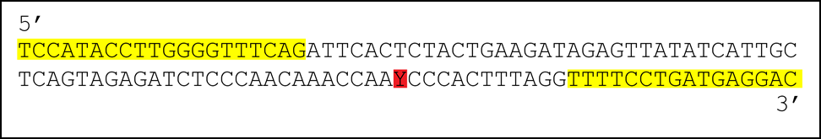

Fig. 1: Sequence surrounding SNP rs3135388
SNP rs3135388 (CT) is marked in red; the primer sequences are highlighted in yellow.
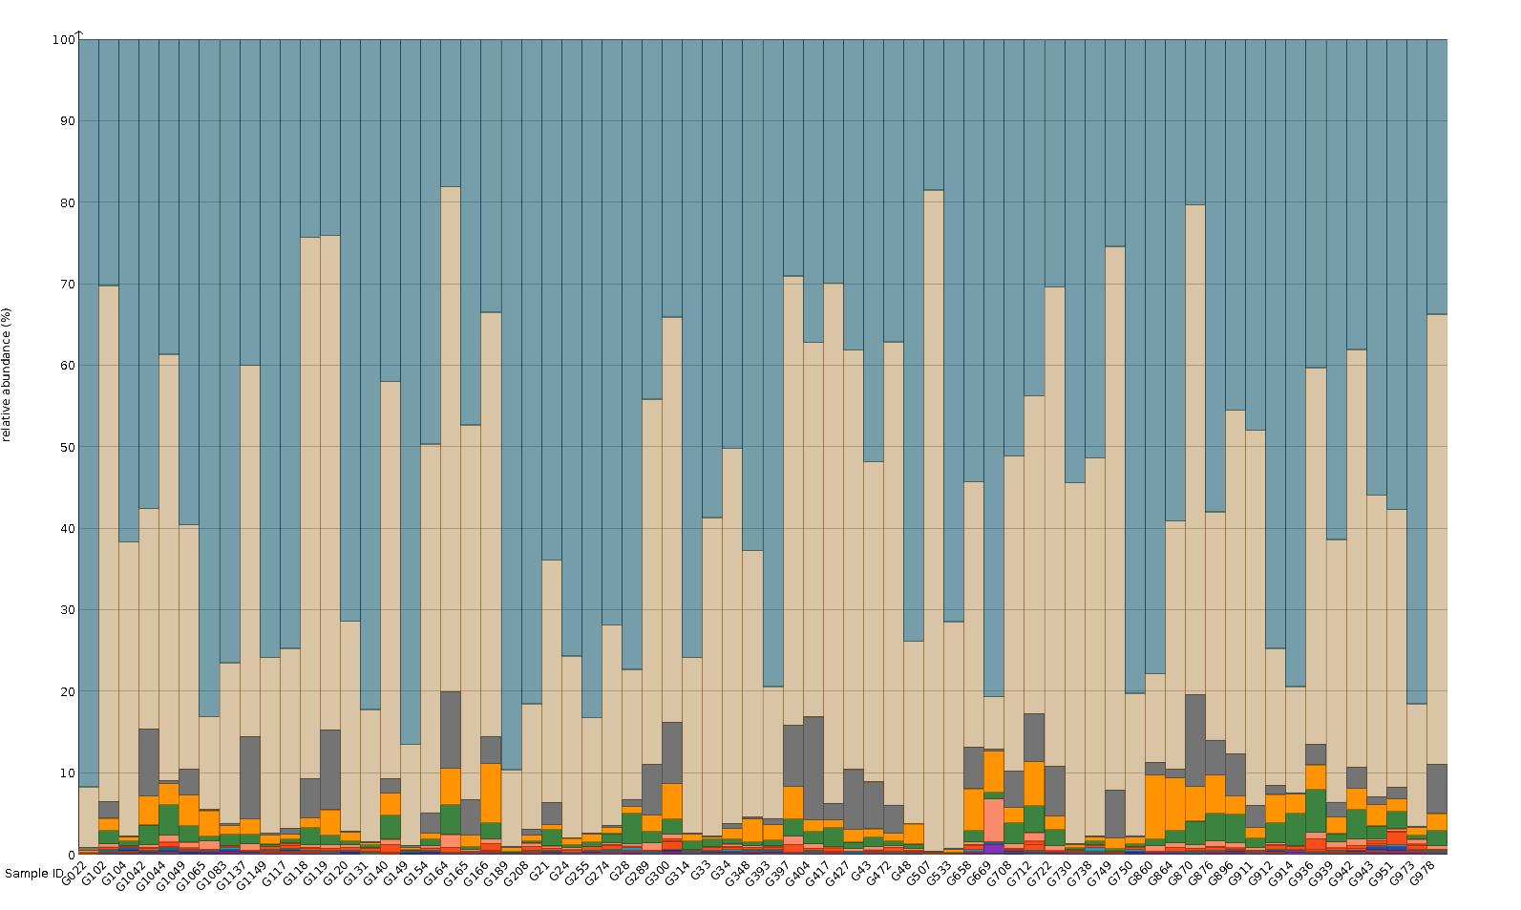

Fig. 2: Bacteria composition of the 68 tooth samples from St. Jørgen
Stacked barplot of the bacterial composition. The relative abundance (in %) of bacterial phyla is represented by different colors. Figure was generated with MEGAN²⁰.

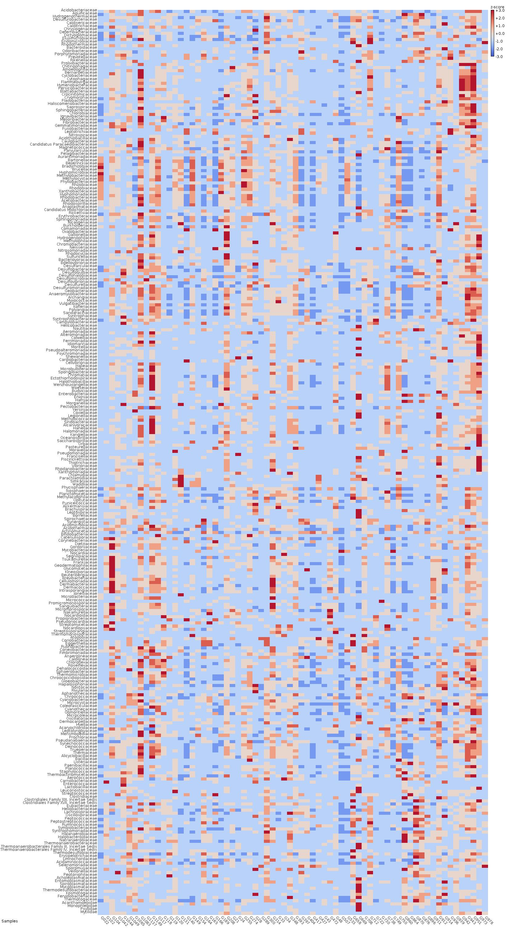

Fig. 3: Bacterial composition of 68 tooth samples from St. Jørgen
Bacterial taxonomic assignments are indicated to the left of the heatmap at the family level. The relative abundance of each bacterial family is color coded as indicated by the key on the right upper corner - Z-scores are centered and normalized, so the color can be interpreted as standard deviations from the mean. Figure was generated with MEGAN²⁰.

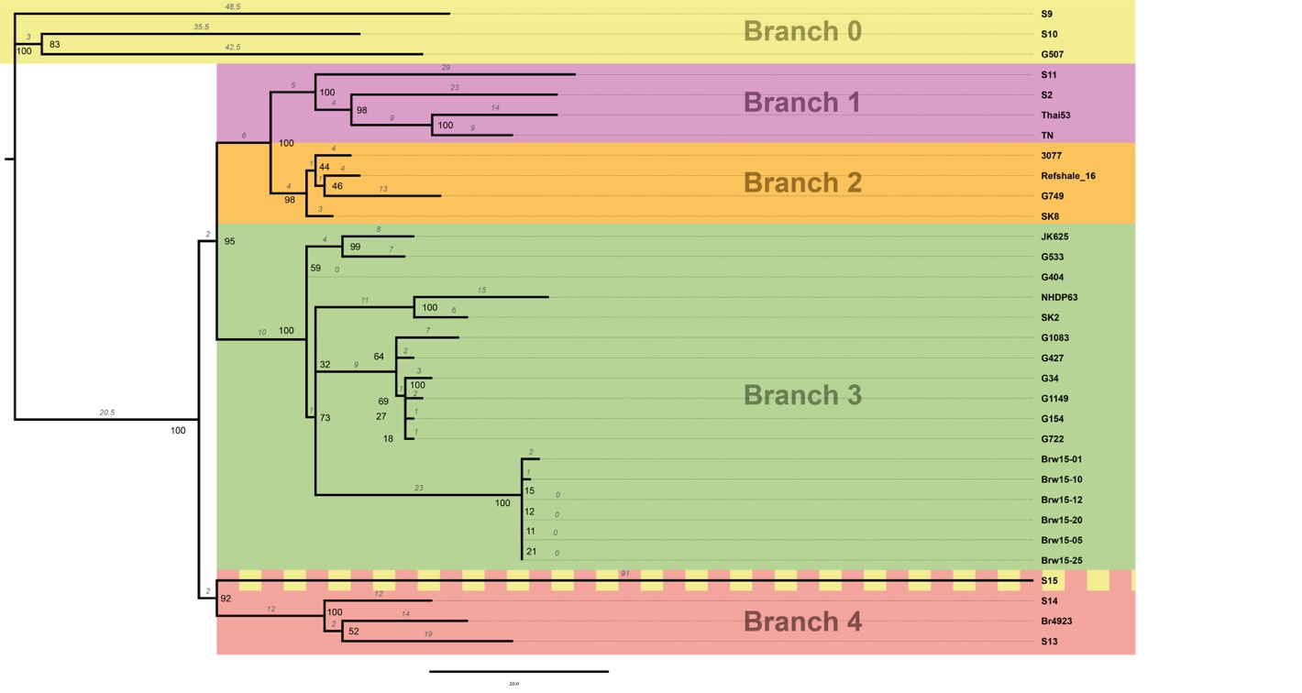

Fig. 4: Maximum parsimony analysis of taxa without outgroup
The evolutionary history was inferred using the maximum parsimony (MP) method. Tree #1 out of 10 most parsimonious trees (length = 547) is shown. The consistency index is (0.912752), the retention index is (0.974806), and the composite index is 0.951639 (0.889756) for all sites and parsimony-informative sites (in parentheses). The percentage of replicate trees in which the associated taxa clustered together in the bootstrap test (500 replicates) is shown next to the branches²¹. The MP tree was obtained using the Subtree-Pruning-Regrafting (SPR) algorithm²² with search level 1 in which the initial trees were obtained by the random addition of sequences (10 replicates). The analysis involved 32 nucleotide sequences. All positions containing gaps and missing data were eliminated. There was a total of 534 positions in the final dataset. Evolutionary analyses were conducted in MEGA7²³.
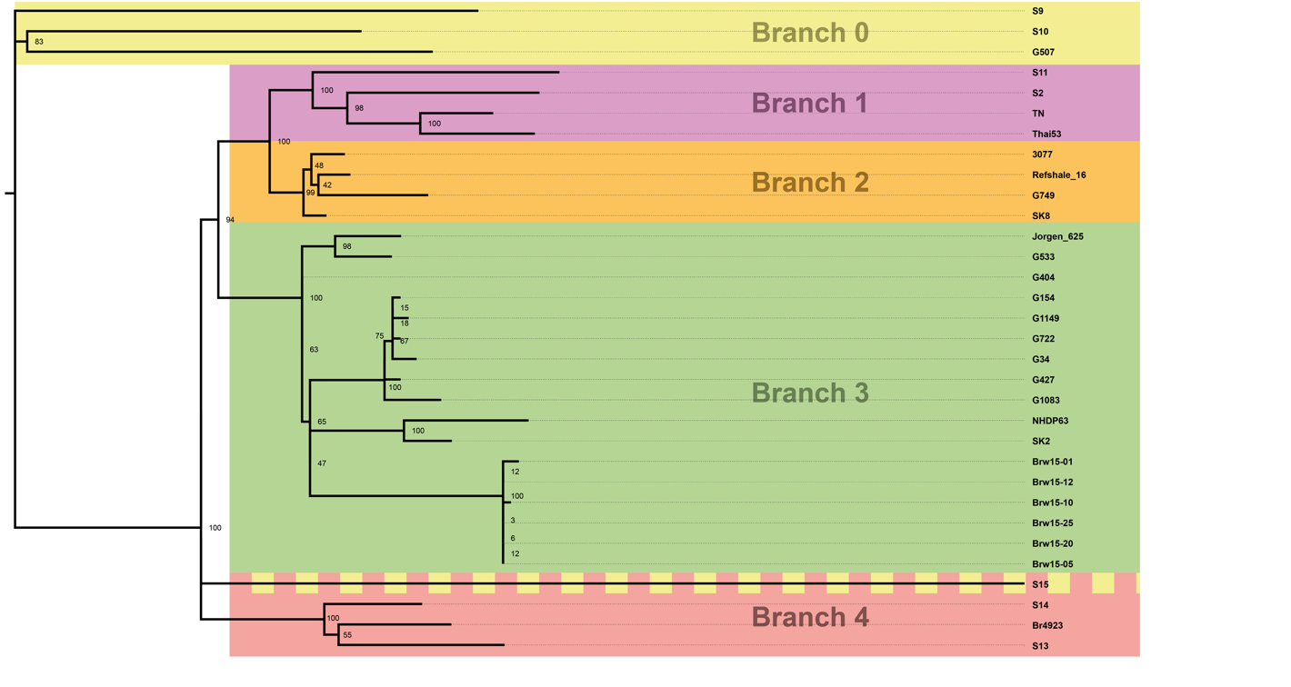

Fig. 5: Molecular phylogenetic analysis by maximum likelihood method
The evolutionary history was inferred by using the maximum likelihood method based on the Tamura 3-parameter model²⁴. The tree with the highest log-likelihood (-3394.7419) is shown. The percentage of trees in which the associated taxa clustered together is shown next to the branches. Initial tree(s) for the heuristic search were obtained automatically by applying neighbor-joining and BioNJ algorithms to a matrix of pairwise distances estimated using the maximum composite likelihood (MCL) approach, and then selecting the topology with superior log likelihood value. The tree is drawn to scale, with branch lengths measured in the number of substitutions per site. The analysis involved 32 nucleotide sequences. All positions containing gaps and missing data were eliminated. There was a total of 534 positions in the final dataset. Evolutionary analyses were conducted in MEGA7²³.
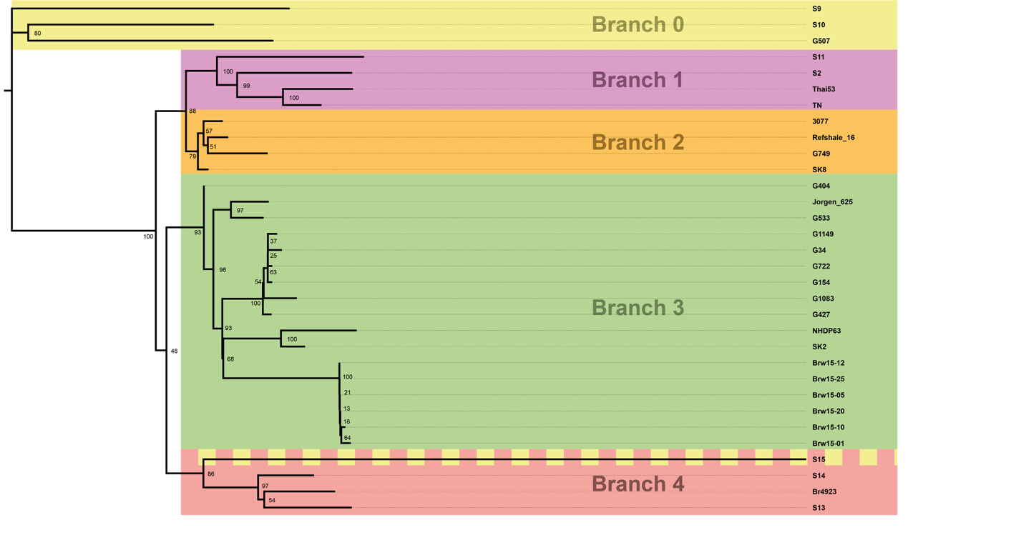

Fig. 6: Evolutionary relationships of taxa
The evolutionary history was inferred using the neighbor-joining method²⁵. The optimal tree with the sum of branch length = 1.22434217 is shown. The percentage of replicate trees in which the associated taxa clustered together in the bootstrap test (500 replicates) is shown next to the branches²¹. The tree is drawn to scale, with branch lengths in the same units as those of the evolutionary distances used to infer the phylogenetic tree. The evolutionary distances were computed using the Tamura 3-parameter method²⁴ and are in the units of the number of base substitutions per site. The analysis involved 32 nucleotide sequences. All positions containing gaps and missing data were eliminated. There was a total of 534 positions in the final dataset. Evolutionary analyses were conducted in MEGA7²³.
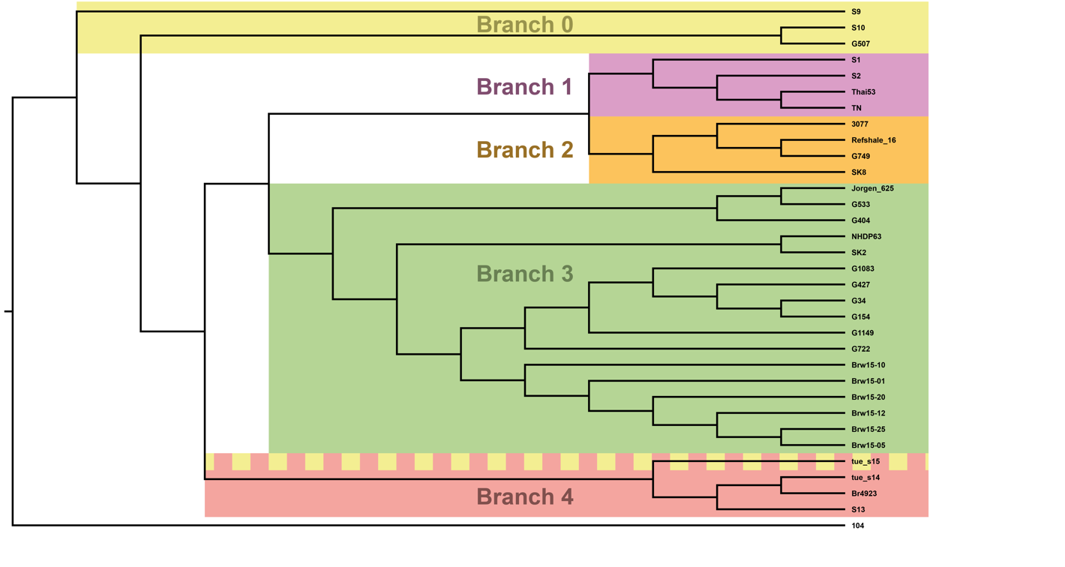

Fig. 7: Maximum parsimony analysis of taxa including outgroup
The evolutionary history was inferred using the maximum parsimony method. Tree #8 out of 9 most parsimonious trees (length = 336616) is shown. The consistency index is (0.771930), the retention index is (0.912752), and the composite index is 0.912646 (0.704580) for all sites and parsimony-informative sites (in parentheses). The percentage of replicate trees in which the associated taxa clustered together in the bootstrap test (500 replicates) is shown next to the branches²¹. The MP tree was obtained using the Subtree-Pruning-Regrafting (SPR) algorithm²² with search level 1 in which the initial trees were obtained by the random addition of sequences (10 replicates). The analysis involved 33 nucleotide sequences. All positions containing gaps and missing data were eliminated. There was a total of 336,534 positions in the final dataset. Evolutionary analyses were conducted in MEGA7²³.
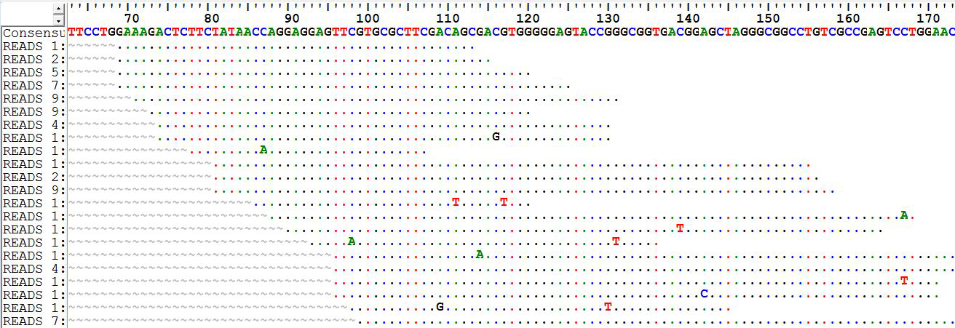

Fig. 8: Manual sorting and filtering of extracted HLA sequences
Visual representation of a sorted group of aligned sequences for a given HLA region in BioEdit²⁶, including several reads with PCR/sequencing errors.
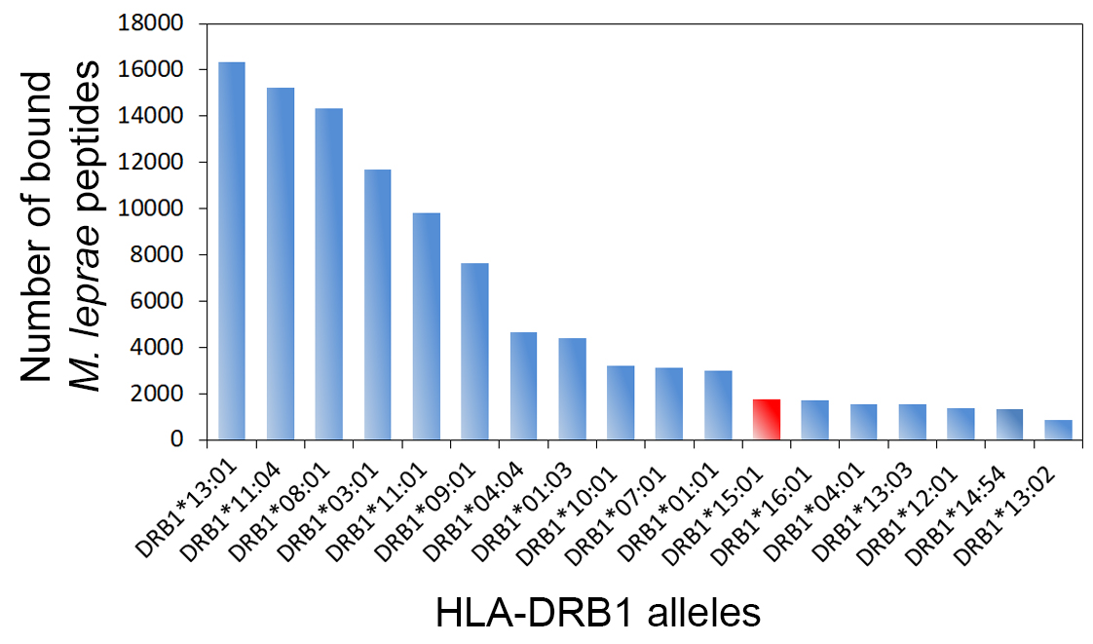

Fig 9: Prediction of M. leprae peptide binding by HLA-DRB1
Computational prediction of those 15mer peptides of the entire M. leprae proteome (N = 516,303 peptides; Ensembl accession: ASM19585v1) that bind to common HLA-DRB1 alleles revealed that DRB1*15:01 (red bar) presents one of the smallest M. leprae antigen repertoires. Binding predictions were run for the 18 HLA-DRB1 alleles with an allele frequency of >1% in representative contemporary samples from Schleswig-Holstein/Germany (N = 129,336) and a Danish Minority population from northern Germany (N = 918).

Supplementary Tables

Table 1: PCR products and primer details
Target organism | Target region | Amplicon length | Forward primer  5’ – 3’ | Reverse primer  5’ – 3’
Human nuclear | rs3135388 | 108 bp | TCC ATA CCT TGG GGT TTC AG | GTC CTC ATC AGG AAA ACC TAA A
Human mt | nt 16106-16256 (HV I) | 150 bp | GCC AGC CAC CAT GAA TAT TGT | GCT TTG GAG TTG CAG TTG ATG TGT
Human mt | nt 15975-16185 (HV I) | 183 bp | CTC CAC CAT TAG CAC CCA AAG C | TAC TAC AGG TGG TCA AGT AT
Human mt | nt 34-287  (HV II) | 253 bp | GGG AGC TCT CCA TGC ATT TGG | TTG TTA TGA TGT CTG TGT GG
M. leprae | RLEP | 130 bp | TGC ATG TCA TGG CCT TGA GG | CAC CGA TAC CAG CGG CAG AA
M. leprae | 18kDa | 98 bp | GAG CTG CTC ACC ACA ACA AA | TGT GTC TCC GTT GCA CCT GT
HV I: hypervariable region I; HV II: hypervariable region II.

Table 2: M. leprae alignment of UDG datasets
IID | # reads aln | read length aln | endogenous  DNA [%] |  | duplicate proportion [%] |  | # reads, duplicates  removed | rmdup cov>=1x [%] | rmdup cov>=4x [%] | DP cov | DP all
G022 | 15,870 | 91 (63-116) | 0.08 | 10.7 |  | 14,171 |  | 31.9 | 0.3 | 1.26 | 0.40
G102 | 5,335 | 45 (35-60) | 0.01 | 14.2 |  | 4,575 |  | 1.0 | 0.1 | 6.75 | 0.07
G104 | 3,443 | 48 (38-64) | 0.01 | 15.6 |  | 2,907 |  | 2.5 | 0.1 | 1.89 | 0.05
G1042 | 3,119 | 44 (35-61) | 0.01 | 30.8 |  | 2,159 |  | 0.3 | 0.1 | 10.28 | 0.03
G1044 | 2,456 | 43 (35-58) | 0.01 | 13.9 |  | 2,114 |  | 1.1 | 0.1 | 2.91 | 0.03
G1049 | 2,566 | 43 (35-56) | 0.00 | 26.9 |  | 1,876 |  | 0.5 | 0.1 | 5.16 | 0.03
G1065 | 2,097 | 44 (35-56) | 0.00 | 17.3 |  | 1,734 |  | 0.3 | 0.1 | 8.14 | 0.03
G1083 | 847,073 | 58 (42-76) | 0.20 | 23.7 |  | 646,304 |  | 100.0 | 99.4 | 12.19 | 12.19
G1137 | 125,425 | 77 (53-109) | 0.05 | 29.8 |  | 88,075 |  | 87.3 | 16.9 | 2.65 | 2.31
G1149 | 840,703 | 68 (47-76) | 0.17 | 9.8 |  | 758,151 |  | 100.0 | 99.9 | 15.42 | 15.42
G117 | 1,048 | 45 (37-59) | 0.00 | 25.1 |  | 785 |  | 0.3 | 0.1 | 3.87 | 0.01
G118 | 7,443 | 55 (42-76) | 0.02 | 19.2 |  | 6,012 |  | 6.8 | 0.1 | 1.65 | 0.11
G119 | 14,015 | 46 (36-62) | 0.01 | 52.7 |  | 6,623 |  | 3.1 | 0.1 | 3.33 | 0.10
G120 | 2,651 | 46 (38-58) | 0.00 | 23.2 |  | 2,037 |  | 0.3 | 0.1 | 9.11 | 0.03
G131 | 10,875 | 80 (56-102) | 0.04 | 7.1 |  | 10,098 |  | 21.0 | 0.1 | 1.23 | 0.26
G140 | 5,971 | 42 (35-53) | 0.01 | 25.8 |  | 4,429 |  | 0.4 | 0.1 | 16.14 | 0.06
G149 | 5,349 | 79 (54-101) | 0.01 | 41.0 |  | 3,154 |  | 6.2 | 0.1 | 1.29 | 0.08
G154 | 4,638,029 | 76 (55-76) | 1.53 | 29.3 |  | 3,276,845 |  | 100.0 | 100.0 | 71.83 | 71.83
G164 | 20,515 | 52 (40-74) | 0.05 | 29.7 |  | 14,416 |  | 16.9 | 0.2 | 1.53 | 0.26
G165 | 12,883 | 56 (42-76) | 0.02 | 22.8 |  | 9,945 |  | 13.6 | 0.2 | 1.40 | 0.19
G166 | 14,830 | 45 (35-62) | 0.03 | 42.9 |  | 8,465 |  | 2.2 | 0.2 | 5.84 | 0.13
G189 | 77,462 | 82 (59-111) | 0.08 | 36.2 |  | 49,453 |  | 69.7 | 6.2 | 1.91 | 1.33
G208 | 354,675 | 58 (43-76) | 0.10 | 11.4 |  | 314,168 |  | 99.6 | 82.3 | 5.99 | 5.97
G21 | 2,627 | 44 (35-58) | 0.00 | 17.8 |  | 2,159 |  | 1.8 | 0.1 | 1.79 | 0.03
G24 | 6,707 | 55 (43-76) | 0.01 | 15.1 |  | 5,693 |  | 5.3 | 0.1 | 2.08 | 0.11
G255 | 1,819 | 47 (40-61) | 0.00 | 25.9 |  | 1,348 |  | 0.9 | 0.1 | 2.26 | 0.02
G274 | 1,810 | 47 (38-64) | 0.01 | 17.6 |  | 1,492 |  | 1.1 | 0.1 | 2.12 | 0.02
G28 | 1,933 | 46 (38-61) | 0.00 | 25.9 |  | 1,432 |  | 0.2 | 0.1 | 9.05 | 0.02
G289 | 5,233 | 65 (47-96) | 0.02 | 5.8 |  | 4,928 |  | 7.7 | 0.1 | 1.44 | 0.11
G300 | 3,134 | 42 (34-53) | 0.00 | 10.5 |  | 2,804 |  | 0.6 | 0.1 | 6.76 | 0.04
G314 | 1,719 | 43 (35-56) | 0.00 | 9.0 |  | 1,565 |  | 0.4 | 0.1 | 5.35 | 0.02
G33 | 173,963 | 71 (47-76) | 0.06 | 9.0 |  | 158,242 |  | 94.7 | 36.0 | 3.44 | 3.26
G34 | 2,043,996 | 73 (48-76) | 0.47 | 11.5 |  | 1,808,104 |  | 100.0 | 100.0 | 37.73 | 37.73
G348 | 6,583 | 54 (41-75) | 0.02 | 14.0 |  | 5,659 |  | 7.2 | 0.1 | 1.49 | 0.11
G393 | 3,078 | 42 (33-53) | 0.00 | 23.0 |  | 2,370 |  | 0.6 | 0.1 | 4.98 | 0.03
G397 | 5,219 | 45 (37-61) | 0.01 | 20.5 |  | 4,147 |  | 2.0 | 0.1 | 3.27 | 0.06
G404 | 566,204 | 88 (61-102) | 0.20 | 12.6 |  | 494,583 |  | 100.0 | 99.7 | 13.33 | 13.33
G417 | 13,527 | 41 (34-52) | 0.02 | 40.1 |  | 8,101 |  | 0.4 | 0.1 | 26.27 | 0.11
G427 | 11,623,054 | 101 (80-115) | 2.46 | 77.8 |  | 2,578,406 |  | 100.0 | 100.0 | 74.02 | 74.02
G43 | 3,302 | 44 (35-60) | 0.00 | 14.5 |  | 2,822 |  | 1.9 | 0.1 | 2.29 | 0.04
G472 | 362,963 | 75 (55-101) | 0.11 | 29.6 |  | 255,451 |  | 99.7 | 84.0 | 6.27 | 6.25
G48 | 2,583 | 43 (37-52) | 0.01 | 18.4 |  | 2,107 |  | 0.3 | 0.1 | 10.31 | 0.03
G507 | 35,561,167 | 95 (66-106) | 9.88 | 37.3 |  | 22,283,858 |  | 100.0 | 100.0 | 632.30 | 632.30
G533 | 933,382 | 98 (68-125) | 1.21 | 25.9 |  | 691,444 |  | 100.0 | 100.0 | 20.59 | 20.59
G658 | 118,991 | 67 (47-94) | 0.02 | 24.0 |  | 90,468 |  | 82.9 | 11.6 | 2.54 | 2.10
G669 | 23,946 | 52 (40-72) | 0.02 | 25.3 |  | 17,887 |  | 23.1 | 0.2 | 1.37 | 0.32
G708 | 3,543 | 44 (35-58) | 0.00 | 17.3 |  | 2,930 |  | 0.4 | 0.1 | 11.92 | 0.04
G712 | 7,297 | 39 (31-50) | 0.01 | 14.7 |  | 6,227 |  | 0.4 | 0.1 | 21.84 | 0.08
G722 | 1,288,683 | 80 (57-116) | 0.28 | 28.7 |  | 918,421 |  | 100.0 | 100.0 | 25.07 | 25.07
G730 | 8,003 | 41 (33-54) | 0.01 | 14.2 |  | 6,866 |  | 4.2 | 0.1 | 2.30 | 0.10
G738 | 6,976 | 49 (40-66) | 0.01 | 17.0 |  | 5,791 |  | 0.9 | 0.1 | 11.01 | 0.10
G749 | 4,111,522 | 94 (65-119) | 6.00 | 35.9 |  | 2,635,897 |  | 100.0 | 100.0 | 76.58 | 76.58
G750 | 1,230 | 41 (32-51) | 0.01 | 6.3 |  | 1,152 |  | 0.4 | 0.1 | 4.02 | 0.02
G860 | 2,475 | 49 (40-60) | 0.00 | 20.2 |  | 1,974 |  | 1.0 | 0.0 | 3.32 | 0.03
G864 | 1,602 | 40 (31-49) | 0.00 | 10.9 |  | 1,428 |  | 0.3 | 0.1 | 7.06 | 0.02
G870 | 4,126 | 39 (31-49) | 0.01 | 23.1 |  | 3,172 |  | 0.4 | 0.1 | 11.01 | 0.04
G876 | 2,149 | 43 (34-54) | 0.00 | 12.5 |  | 1,880 |  | 0.3 | 0.1 | 10.42 | 0.03
G896 | 13,649 | 52 (39-76) | 0.02 | 24.9 |  | 10,246 |  | 10.2 | 0.1 | 1.75 | 0.18
G911 | 2,201 | 46 (36-69) | 0.01 | 27.0 |  | 1,607 |  | 0.4 | 0.1 | 6.51 | 0.02
G912 | 1,527 | 50 (40-67) | 0.00 | 6.1 |  | 1,434 |  | 1.4 | 0.1 | 1.83 | 0.03
G914 | 2,700 | 49.5 (38-70) | 0.00 | 24.8 |  | 2,031 |  | 0.3 | 0.1 | 9.52 | 0.03
G936 | 6,464 | 42 (35-54) | 0.01 | 31.8 |  | 4,406 |  | 1.2 | 0.1 | 5.19 | 0.06
G939 | 1,904 | 41 (34-53) | 0.00 | 15.9 |  | 1,602 |  | 0.5 | 0.1 | 4.86 | 0.02
G942 | 3,892 | 42 (35-54) | 0.01 | 29.2 |  | 2,756 |  | 0.5 | 0.1 | 8.76 | 0.04
G943 | 242,400 | 69 (48-76) | 0.13 | 25.2 |  | 181,305 |  | 96.8 | 49.5 | 3.93 | 3.80
G951 | 2,056 | 46 (38-58) | 0.01 | 13.4 |  | 1,780 |  | 0.3 | 0.1 | 9.90 | 0.03
G973 | 3,160 | 42 (34-52) | 0.00 | 20.7 |  | 2,505 |  | 0.5 | 0.1 | 7.57 | 0.04
G978 | 1,308,555 | 92 (65-101) | 0.35 | 80.4 |  | 256,929 |  | 98.7 | 70.4 | 6.98 | 6.88
IID: individual ID; aln: aligned; read length: median (1st quartile – 3rd quartile); rmdup: duplicates removed;
cov: coverage; DP cov: read depth over covered bases; DP all: read depth over complete reference.

Table 3: M. leprae reads from Malt analysis
SID | #reads M. leprae | #reads total | M. leprae proportion [%]
G022 | 6,874 | 6,992,436 | 0.098
G102 | 331 | 17,688,112 | 0.002
G104 | 888 | 16,762,492 | 0.005
G1042 | 45 | 25,953,583 | 0.000
G1044 | 430 | 11,939,954 | 0.004
G1049 | 75 | 19,490,520 | 0.000
G1065 | 88 | 18,989,844 | 0.000
G1083 | 26,795 | 12,823,578 | 0.209
G1137 | 7,397 | 9,491,196 | 0.078
G1149 | 16,639 | 8,543,002 | 0.195
G117 | 97 | 10,235,336 | 0.001
G118 | 2,891 | 12,907,976 | 0.022
G119 | 860 | 14,841,003 | 0.006
G120 | 38 | 18,132,253 | 0.000
G131 | 6,871 | 17,278,424 | 0.040
G140 | 48 | 16,450,945 | 0.000
G149 | 741 | 7,921,056 | 0.009
G154 | 140,683 | 9,564,519 | 1.471
G164 | 6,505 | 16,248,305 | 0.040
G165 | 5,852 | 19,328,959 | 0.030
G166 | 1,014 | 28,018,881 | 0.004
G189 | 209 | 36,179,899 | 0.001
G208 | 20,692 | 15,799,820 | 0.131
G21 | 719 | 6,964,677 | 0.010
G24 | 1,271 | 30,498,430 | 0.004
G255 | 341 | 13,384,857 | 0.003
G274 | 404 | 14,859,656 | 0.003
G28 | 71 | 47,701,300 | 0.000
G289 | 2,578 | 16,927,524 | 0.015
G300 | 89 | 15,645,987 | 0.001
G314 | 75 | 14,889,641 | 0.001
G33 | 5,697 | 8,313,032 | 0.069
G34 | 87,695 | 19,710,929 | 0.445
G348 | 2,719 | 16,754,756 | 0.016
G393 | 114 | 14,001,015 | 0.001
G397 | 764 | 12,425,806 | 0.006
G404 | 52,858 | 21,352,057 | 0.248
G417 | 60 | 44,527,684 | 0.000
G427 | 181,858 | 28,508,113 | 0.638
G43 | 695 | 17,074,447 | 0.004
G472 | 12,531 | 9,623,786 | 0.130
G48 | 27 | 21,187,364 | 0.000
G507 | 2,624,974 | 19,464,646 | 13.486
G533 | 424,828 | 28,125,125 | 1.510
G611 | 5,571 | 26,768,800 | 0.021
G658 | 10,150 | 81,916,162 | 0.012
G669 | 6,462 | 20,146,302 | 0.032
G708 | 34 | 15,488,225 | 0.000
G712 | 6 | 13,565,885 | 0.000
G722 | 78,211 | 24,755,930 | 0.316
G730 | 2,130 | 12,976,982 | 0.016
G738 | 218 | 36,353,460 | 0.001
G749 | 1,868,106 | 22,577,271 | 8.274
G750 | 131 | 16,027,731 | 0.001
G860 | 262 | 20,727,017 | 0.001
G864 | 59 | 18,458,498 | 0.000
G870 | 49 | 17,782,756 | 0.000
G876 | 13 | 16,529,456 | 0.000
G896 | 5,225 | 47,824,741 | 0.011
G911 | 56 | 12,122,972 | 0.000
G912 | 751 | 16,458,021 | 0.005
G914 | 196 | 52,374,396 | 0.000
G936 | 372 | 18,568,653 | 0.002
G939 | 146 | 14,134,206 | 0.001
G942 | 95 | 18,190,020 | 0.001
G943 | 29,633 | 25,978,356 | 0.114
G951 | 41 | 16,358,004 | 0.000
G973 | 56 | 16,256,715 | 0.000
G978 | 17,548 | 22,021,382 | 0.080
SID: sample ID.

Table 4: Raw data, pre-processing and QC of UDG datasets
IID | # reads raw | # reads merged | QC proportion [%] | merged proportion [%]
G022 | 30,940,834 | 18,719,919 | 98.22 | 91.36
G102 | 137,752,212 | 78,346,278 | 97.64 | 82.31
G104 | 64,773,586 | 35,058,852 | 98.53 | 89.84
G1042 | 66,529,964 | 37,455,713 | 97.83 | 84.57
G1044 | 64,698,698 | 42,130,966 | 97.79 | 63.34
G1049 | 107,712,188 | 62,069,503 | 98.37 | 82.02
G1065 | 176,912,136 | 101,902,722 | 98.23 | 81.90
G1083 | 770,645,748 | 427,854,448 | 97.77 | 86.34
G1137 | 444,240,476 | 238,536,795 | 98.28 | 94.27
G1149 | 887,506,230 | 499,982,897 | 97.25 | 83.85
G117 | 43,310,544 | 25,937,330 | 98.01 | 75.81
G118 | 65,155,022 | 42,167,892 | 98.05 | 65.35
G119 | 227,050,610 | 132,024,094 | 97.89 | 80.91
G120 | 130,859,124 | 81,667,917 | 98.40 | 72.03
G131 | 49,267,746 | 29,316,317 | 98.07 | 88.92
G140 | 79,083,200 | 47,839,848 | 98.21 | 75.23
G149 | 85,213,296 | 51,532,146 | 98.36 | 91.33
G154 | 524,900,604 | 302,927,227 | 97.81 | 81.64
G164 | 80,225,662 | 44,899,250 | 98.24 | 86.03
G165 | 112,600,952 | 65,084,926 | 98.63 | 82.25
G166 | 92,582,562 | 51,453,626 | 97.78 | 85.96
G189 | 160,762,140 | 91,904,986 | 98.27 | 86.45
G208 | 607,542,372 | 342,750,214 | 97.67 | 84.22
G21 | 140,118,210 | 73,602,276 | 97.61 | 91.95
G24 | 139,875,166 | 87,972,862 | 98.53 | 69.16
G255 | 68,617,716 | 42,105,641 | 98.24 | 73.02
G274 | 49,850,574 | 29,889,767 | 98.26 | 74.41
G28 | 100,553,030 | 60,441,387 | 97.66 | 76.55
G289 | 49,726,866 | 29,313,354 | 97.94 | 89.34
G300 | 115,357,416 | 71,147,275 | 97.91 | 69.25
G314 | 121,117,564 | 70,473,087 | 98.34 | 80.17
G33 | 488,857,644 | 284,464,170 | 97.59 | 80.48
G34 | 799,544,686 | 430,921,244 | 97.54 | 89.23
G348 | 61,323,054 | 34,863,984 | 98.48 | 83.41
G393 | 180,728,072 | 99,459,731 | 97.49 | 86.35
G397 | 63,283,818 | 38,089,772 | 98.22 | 75.95
G404 | 493,618,248 | 286,726,388 | 98.06 | 92.32
G417 | 130,525,388 | 69,432,608 | 97.84 | 91.10
G427 | 760,562,012 | 472,194,157 | 98.04 | 89.46
G43 | 196,198,708 | 112,242,084 | 98.17 | 82.72
G472 | 579,200,126 | 345,256,592 | 98.35 | 91.80
G48 | 83,999,240 | 46,556,337 | 98.94 | 87.29
G507 | 617,672,020 | 360,109,310 | 98.31 | 93.26
G533 | 126,463,738 | 77,389,431 | 98.06 | 87.06
G658 | 1,148,892,432 | 624,163,521 | 98.53 | 92.83
G669 | 224,364,814 | 123,218,314 | 98.20 | 87.94
G708 | 143,142,880 | 78,603,465 | 97.66 | 87.05
G712 | 96,660,500 | 54,150,249 | 96.41 | 81.80
G722 | 859,339,596 | 458,475,384 | 98.13 | 93.67
G730 | 122,309,144 | 63,145,152 | 96.71 | 93.08
G738 | 144,795,996 | 91,838,989 | 98.36 | 66.44
G749 | 120,782,402 | 68,511,590 | 98.09 | 92.74
G750 | 41,475,780 | 21,524,070 | 97.23 | 92.97
G860 | 126,024,086 | 74,135,890 | 98.54 | 79.70
G864 | 69,116,130 | 38,025,739 | 98.06 | 87.25
G870 | 71,143,658 | 41,070,437 | 96.86 | 78.69
G876 | 123,654,436 | 72,242,271 | 98.04 | 78.96
G896 | 133,833,908 | 77,575,165 | 97.59 | 80.72
G911 | 62,019,916 | 38,500,056 | 97.88 | 71.46
G912 | 54,518,512 | 34,333,648 | 98.32 | 67.47
G914 | 118,118,308 | 67,433,796 | 97.87 | 83.25
G936 | 156,957,074 | 102,869,340 | 98.18 | 67.50
G939 | 100,032,586 | 61,932,630 | 97.95 | 72.83
G942 | 119,015,656 | 72,399,849 | 98.17 | 75.08
G943 | 340,850,762 | 189,639,267 | 98.29 | 85.70
G951 | 66,378,072 | 40,912,665 | 98.24 | 71.35
G973 | 163,751,118 | 96,735,567 | 98.04 | 76.88
G978 | 631,852,292 | 370,246,332 | 97.87 | 92.79
IID: individual ID.

Table 5: M. leprae damage patterns of UDG datasets
IID | DMG 1st base 5' [%] | DMG 2nd base 5' [%] | DMG 3rd base 5' [%] | DMG 4th base 5' [%] | DMG 5th base 5' [%] | DMG 1st base 3' [%] | DMG 2nd base 3' [%] | DMG 3rd base 3' [%] | DMG 4th base 3' [%] | DMG 5th base 3' [%]
G022 | 0.56 | 0.14 | 0.08 | 0.09 | 0.12 | 0.48 | 0.15 | 0.20 | 0.09 | 0.12
G102 | 1.41 | 1.94 | 1.42 | 0.89 | 1.11 | 1.51 | 2.51 | 1.65 | 1.18 | 2.17
G104 | 1.39 | 1.63 | 1.22 | 0.45 | 0.40 | 0.86 | 0.91 | 2.02 | 0.00 | 0.88
G1042 | 1.81 | 2.53 | 0.92 | 1.95 | 1.77 | 1.21 | 4.16 | 1.27 | 1.00 | 2.85
G1044 | 2.56 | 2.33 | 2.27 | 2.13 | 2.50 | 2.27 | 0.00 | 0.00 | 0.00 | 0.00
G1049 | 5.93 | 1.87 | 1.36 | 1.79 | 0.90 | 3.91 | 3.81 | 3.55 | 1.00 | 0.93
G1065 | 1.67 | 5.96 | 3.21 | 4.25 | 3.73 | 3.27 | 3.01 | 4.24 | 4.29 | 3.39
G1083 | 0.22 | 0.05 | 0.31 | 0.05 | 0.17 | 0.31 | 0.10 | 0.14 | 0.13 | 0.04
G1137 | 0.41 | 0.34 | 0.32 | 0.33 | 0.25 | 0.49 | 0.37 | 0.28 | 0.31 | 0.30
G1149 | 0.33 | 0.11 | 0.08 | 0.08 | 0.08 | 0.26 | 0.13 | 0.06 | 0.14 | 0.08
G117 | 3.03 | 0.00 | 5.41 | 8.82 | 0.00 | 0.00 | 0.00 | 0.00 | 0.00 | 2.94
G118 | 0.00 | 0.44 | 0.78 | 1.81 | 0.83 | 0.85 | 0.85 | 0.00 | 0.00 | 1.33
G119 | 1.56 | 1.59 | 1.98 | 1.12 | 1.53 | 2.70 | 1.63 | 1.24 | 2.18 | 2.29
G120 | 0.77 | 0.00 | 0.00 | 2.31 | 2.01 | 0.00 | 2.94 | 1.05 | 2.13 | 2.04
G131 | 0.90 | 0.47 | 0.16 | 0.25 | 0.15 | 0.64 | 0.37 | 0.36 | 0.32 | 0.34
G140 | 1.82 | 2.51 | 1.56 | 3.45 | 1.61 | 0.42 | 3.46 | 1.67 | 2.26 | 1.69
G149 | 1.30 | 0.29 | 0.93 | 0.68 | 0.13 | 1.14 | 0.88 | 0.41 | 0.68 | 0.68
G154 | 0.24 | 0.07 | 0.06 | 0.04 | 0.04 | 0.21 | 0.06 | 0.06 | 0.08 | 0.05
G164 | 1.35 | 1.15 | 0.28 | 0.44 | 0.85 | 1.85 | 1.24 | 0.53 | 0.66 | 0.45
G165 | 0.65 | 0.91 | 0.20 | 0.86 | 0.20 | 1.21 | 0.23 | 0.41 | 0.44 | 0.21
G166 | 1.45 | 2.31 | 1.37 | 2.27 | 2.53 | 1.69 | 3.44 | 1.48 | 2.01 | 2.59
G189 | 0.98 | 0.13 | 0.07 | 0.04 | 0.09 | 0.43 | 0.18 | 0.09 | 0.13 | 0.05
G208 | 0.22 | 0.11 | 0.17 | 0.15 | 0.06 | 0.23 | 0.09 | 0.13 | 0.15 | 0.13
G21 | 1.36 | 0.52 | 0.70 | 0.00 | 1.52 | 1.09 | 1.45 | 0.23 | 0.82 | 2.41
G24 | 1.78 | 1.47 | 1.24 | 1.59 | 1.28 | 1.66 | 1.38 | 1.06 | 1.05 | 0.17
G255 | 1.64 | 0.00 | 0.00 | 0.00 | 0.00 | 1.85 | 1.35 | 1.59 | 1.85 | 5.26
G274 | 2.22 | 0.00 | 2.04 | 5.88 | 0.00 | 0.00 | 0.00 | 1.82 | 0.00 | 1.79
G28 | 2.48 | 2.72 | 1.85 | 2.75 | 1.31 | 1.42 | 2.30 | 2.01 | 1.85 | 2.27
G289 | 1.40 | 0.71 | 0.51 | 0.57 | 0.55 | 0.47 | 1.15 | 0.99 | 0.88 | 0.38
G300 | 1.88 | 3.44 | 3.19 | 1.90 | 2.15 | 3.44 | 3.52 | 2.32 | 2.66 | 2.71
G314 | 3.72 | 3.93 | 2.95 | 3.33 | 3.06 | 1.32 | 1.22 | 2.54 | 1.00 | 2.22
G33 | 0.53 | 0.17 | 0.32 | 0.65 | 0.10 | 0.68 | 0.72 | 0.31 | 0.05 | 0.42
G34 | 0.15 | 0.05 | 0.07 | 0.11 | 0.12 | 0.26 | 0.14 | 0.07 | 0.09 | 0.03
G348 | 0.93 | 0.00 | 1.19 | 2.20 | 0.94 | 1.01 | 1.52 | 1.79 | 1.03 | 0.98
G393 | 3.14 | 2.84 | 2.36 | 1.35 | 0.00 | 2.16 | 1.92 | 1.73 | 2.59 | 2.24
G397 | 1.14 | 2.22 | 1.86 | 2.70 | 0.97 | 1.96 | 1.19 | 1.85 | 0.99 | 1.69
G404 | 0.32 | 0.15 | 0.10 | 0.11 | 0.09 | 0.37 | 0.17 | 0.11 | 0.12 | 0.11
G417 | 2.37 | 2.51 | 2.05 | 1.93 | 1.70 | 2.89 | 2.58 | 1.90 | 1.85 | 1.52
G427 | 0.40 | 0.14 | 0.25 | 0.10 | 0.08 | 0.46 | 0.20 | 0.16 | 0.15 | 0.12
G43 | 2.27 | 1.31 | 1.31 | 1.54 | 0.57 | 1.90 | 2.65 | 0.72 | 1.62 | 1.88
G472 | 0.56 | 0.18 | 0.15 | 0.13 | 0.11 | 0.59 | 0.21 | 0.18 | 0.13 | 0.14
G48 | 3.00 | 3.34 | 2.30 | 1.88 | 2.39 | 3.95 | 1.87 | 3.00 | 3.40 | 3.49
G507 | 0.24 | 0.06 | 0.05 | 0.05 | 0.04 | 0.26 | 0.11 | 0.08 | 0.08 | 0.07
G533 | 0.41 | 0.10 | 0.04 | 0.06 | 0.06 | 0.36 | 0.15 | 0.13 | 0.12 | 0.09
G658 | 0.82 | 0.65 | 0.37 | 0.40 | 0.44 | 0.90 | 0.68 | 0.46 | 0.45 | 0.41
G669 | 0.69 | 0.26 | 0.52 | 0.35 | 0.45 | 1.04 | 0.46 | 0.62 | 0.39 | 0.41
G708 | 3.25 | 2.04 | 2.73 | 1.25 | 2.42 | 3.83 | 2.94 | 2.36 | 2.48 | 1.35
G712 | 1.56 | 0.93 | 0.78 | 1.37 | 0.89 | 1.62 | 1.39 | 0.76 | 1.56 | 1.49
G722 | 0.41 | 0.12 | 0.11 | 0.09 | 0.09 | 0.39 | 0.19 | 0.14 | 0.13 | 0.13
G730 | 2.09 | 1.03 | 1.25 | 1.42 | 0.72 | 2.26 | 1.05 | 1.49 | 1.19 | 1.25
G738 | 1.30 | 2.40 | 1.83 | 1.64 | 2.29 | 1.96 | 2.32 | 1.86 | 1.31 | 1.62
G749 | 0.21 | 0.07 | 0.08 | 0.06 | 0.04 | 0.30 | 0.15 | 0.11 | 0.11 | 0.09
G750 | 0.00 | 0.00 | 0.00 | 0.00 | 3.57 | 3.13 | 0.00 | 0.00 | 0.00 | 0.00
G860 | 4.05 | 2.87 | 4.02 | 1.36 | 2.55 | 5.63 | 5.26 | 4.24 | 5.71 | 3.73
G864 | 0.00 | 4.44 | 0.00 | 1.92 | 3.70 | 2.04 | 1.92 | 2.08 | 0.00 | 0.00
G870 | 2.78 | 1.82 | 1.05 | 3.57 | 2.27 | 0.98 | 2.08 | 2.04 | 2.47 | 0.00
G876 | 3.27 | 4.56 | 1.38 | 2.50 | 2.22 | 3.83 | 3.86 | 2.06 | 3.70 | 2.30
G896 | 1.29 | 1.60 | 0.82 | 1.03 | 1.11 | 1.42 | 1.88 | 0.80 | 1.38 | 1.32
G911 | 0.00 | 2.00 | 3.70 | 2.22 | 0.00 | 0.00 | 3.70 | 2.04 | 0.00 | 0.00
G912 | 7.14 | 0.00 | 0.00 | 0.00 | 0.00 | 0.00 | 11.11 | 0.00 | 0.00 | 0.00
G914 | 2.90 | 5.33 | 2.10 | 1.99 | 2.42 | 2.09 | 2.72 | 4.02 | 3.06 | 1.84
G936 | 2.38 | 2.05 | 0.66 | 0.76 | 0.69 | 1.06 | 1.31 | 2.93 | 0.72 | 1.37
G939 | 2.92 | 2.41 | 2.40 | 0.92 | 2.11 | 2.82 | 1.75 | 2.34 | 0.89 | 0.90
G942 | 0.99 | 2.03 | 1.79 | 0.99 | 2.42 | 2.93 | 3.65 | 1.90 | 0.00 | 1.83
G943 | 0.15 | 0.23 | 0.13 | 0.17 | 0.13 | 0.23 | 0.21 | 0.21 | 0.25 | 0.08
G951 | 5.05 | 2.06 | 1.85 | 3.92 | 2.86 | 1.05 | 4.00 | 2.26 | 1.89 | 1.30
G973 | 2.56 | 3.30 | 2.45 | 2.37 | 3.02 | 2.23 | 3.07 | 2.21 | 0.98 | 1.30
G978 | 0.68 | 0.52 | 0.54 | 0.42 | 0.44 | 0.81 | 0.58 | 0.47 | 0.48 | 0.40
Shown are the frequencies of cytosine to thymine mutations per position from the 5'-ends and the frequencies of guanine to adenine mutations per position from the 3'-ends. IID: individual ID; DMG: damage

Table 6: M. leprae damage patterns of non-UDG datasets
IID | DMG 1st base 5' [%] | DMG 2nd base 5' [%] | DMG 3rd base 5' [%] | DMG 4th base 5' [%] | DMG 5th base 5' [%] | DMG 1st base 3' [%] | DMG 2nd base 3' [%] | DMG 3rd base 3' [%] | DMG 4th base 3' [%] | DMG 5th base 3' [%]
G022 | 3.685 | 3.360 | 1.367 | 0.653 | 0.553 | 3.096 | 3.243 | 1.061 | 0.708 | 0.310
G102 | 3.141 | 4.867 | 2.424 | 2.194 | 1.990 | 2.952 | 4.994 | 3.141 | 2.888 | 2.123
G104 | 7.222 | 4.801 | 2.682 | 1.925 | 1.808 | 6.685 | 4.790 | 3.781 | 2.174 | 2.430
G1042 | 6.915 | 4.020 | 3.704 | 2.235 | 4.023 | 6.857 | 8.284 | 4.918 | 4.615 | 4.420
G1044 | 9.697 | 6.164 | 3.419 | 2.570 | 4.328 | 7.520 | 7.237 | 3.191 | 2.954 | 3.695
G1049 | 11.047 | 2.362 | 4.861 | 5.056 | 2.395 | 5.650 | 5.682 | 4.268 | 5.660 | 4.110
G1065 | 8.654 | 6.030 | 5.025 | 4.846 | 2.210 | 10.288 | 5.348 | 3.721 | 3.211 | 4.639
G1083 | 8.998 | 8.086 | 3.235 | 2.036 | 1.580 | 8.987 | 8.188 | 3.262 | 2.238 | 1.462
G1137 | 3.326 | 2.566 | 1.364 | 0.981 | 1.169 | 2.817 | 3.004 | 1.290 | 0.986 | 0.689
G1149 | 6.724 | 6.452 | 3.052 | 2.186 | 1.291 | 6.700 | 6.417 | 3.041 | 2.239 | 1.423
G117 | 6.077 | 5.978 | 2.762 | 1.724 | 1.714 | 4.762 | 3.977 | 0.532 | 5.056 | 5.233
G118 | 7.182 | 5.825 | 2.739 | 1.564 | 1.519 | 7.197 | 5.040 | 2.149 | 1.954 | 1.348
G119 | 6.134 | 4.447 | 2.495 | 2.529 | 1.741 | 5.627 | 5.176 | 2.300 | 2.670 | 2.545
G120 | 5.350 | 2.740 | 4.724 | 2.844 | 2.174 | 6.931 | 6.122 | 2.811 | 2.899 | 2.252
G131 | 4.953 | 5.085 | 2.188 | 1.251 | 0.927 | 4.405 | 5.370 | 1.917 | 1.365 | 1.193
G140 | 11.111 | 8.173 | 4.835 | 5.155 | 4.656 | 9.957 | 7.551 | 5.192 | 5.814 | 3.712
G149 | 3.270 | 3.662 | 1.411 | 1.098 | 0.683 | 3.361 | 3.559 | 1.532 | 1.071 | 0.910
G154 | 5.068 | 3.774 | 1.825 | 1.459 | 1.140 | 4.842 | 3.877 | 1.846 | 1.323 | 1.140
G164 | 8.156 | 5.873 | 3.445 | 2.924 | 2.087 | 7.832 | 6.195 | 3.450 | 2.565 | 2.002
G165 | 6.684 | 4.873 | 2.706 | 1.482 | 1.722 | 5.434 | 5.311 | 3.050 | 2.575 | 1.870
G166 | 8.575 | 7.287 | 4.743 | 4.545 | 3.529 | 10.971 | 5.874 | 5.860 | 4.586 | 2.914
G189 | 3.543 | 3.521 | 1.327 | 0.928 | 0.695 | 3.376 | 3.649 | 1.351 | 1.027 | 0.734
G208 | 5.469 | 5.138 | 2.362 | 1.773 | 5.242 | 6.182 | 4.898 | 2.137 | 3.042 | 4.701
G21 | 7.592 | 6.051 | 2.116 | 2.383 | 1.339 | 5.753 | 5.710 | 3.033 | 1.561 | 1.235
G24 | 5.263 | 7.500 | 5.022 | 3.481 | 1.667 | 5.890 | 4.915 | 2.723 | 2.665 | 2.742
G255 | 4.872 | 3.311 | 4.190 | 3.303 | 1.582 | 4.651 | 4.950 | 2.695 | 3.170 | 1.412
G274 | 12.868 | 6.355 | 6.230 | 2.069 | 3.546 | 7.278 | 4.194 | 2.222 | 1.767 | 2.703
G28 | 6.452 | 7.663 | 2.048 | 2.439 | 2.083 | 5.435 | 5.674 | 2.482 | 3.929 | 2.105
G289 | 5.435 | 5.479 | 6.410 | 5.882 | 2.469 | 6.667 | 2.632 | 0.000 | 6.098 | 2.564
G300 | 3.409 | 4.290 | 1.878 | 0.957 | 0.897 | 3.384 | 4.843 | 1.372 | 1.021 | 0.642
G314 | 7.366 | 8.740 | 4.857 | 3.433 | 2.517 | 8.617 | 6.631 | 3.233 | 4.082 | 3.555
G33 | 3.448 | 6.250 | 4.615 | 3.947 | 2.500 | 6.607 | 5.351 | 3.323 | 3.072 | 1.899
G34 | 7.098 | 6.931 | 3.339 | 2.761 | 1.593 | 6.961 | 7.434 | 3.512 | 3.049 | 1.856
G348 | 5.987 | 4.984 | 1.933 | 1.324 | 0.936 | 5.695 | 4.583 | 1.771 | 1.270 | 0.931
G393 | 8.148 | 5.217 | 3.279 | 5.263 | 1.754 | 10.738 | 8.000 | 6.202 | 3.906 | 6.667
G397 | 7.457 | 5.271 | 3.380 | 2.378 | 2.476 | 6.061 | 4.090 | 3.889 | 3.605 | 2.219
G404 | 0.000 | 3.030 | 0.000 | 2.439 | 0.000 | 0.000 | 2.439 | 0.000 | 0.000 | 0.000
G417 | 8.840 | 8.023 | 4.816 | 4.457 | 4.533 | 6.793 | 9.440 | 5.385 | 5.615 | 3.692
G427 | 3.806 | 4.087 | 1.393 | 0.765 | 0.610 | 3.652 | 3.761 | 1.229 | 0.911 | 0.579
G43 | 6.473 | 4.404 | 1.980 | 2.331 | 2.743 | 4.440 | 5.275 | 3.474 | 2.804 | 1.587
G472 | 3.181 | 3.310 | 1.097 | 0.724 | 0.487 | 3.220 | 3.291 | 1.142 | 0.738 | 0.516
G48 | 5.769 | 4.196 | 2.941 | 4.651 | 3.378 | 6.863 | 4.545 | 4.324 | 4.785 | 2.454
G507 | 7.182 | 6.685 | 2.460 | 1.743 | 1.211 | 7.291 | 6.506 | 2.248 | 1.560 | 1.015
G533 | 4.681 | 4.987 | 1.630 | 1.024 | 0.727 | 4.859 | 4.908 | 1.710 | 1.079 | 0.751
G658 | 3.769 | 3.946 | 1.713 | 1.415 | 1.871 | 4.017 | 3.953 | 1.386 | 1.603 | 1.063
G669 | 5.894 | 6.809 | 4.697 | 2.558 | 1.784 | 6.563 | 7.558 | 4.019 | 2.372 | 2.021
G708 | 5.085 | 5.833 | 2.278 | 3.333 | 2.400 | 6.954 | 9.264 | 3.646 | 2.676 | 3.904
G712 | 7.184 | 7.640 | 6.138 | 5.413 | 5.433 | 7.225 | 6.408 | 6.383 | 4.977 | 3.814
G722 | 3.377 | 3.154 | 1.209 | 0.860 | 0.646 | 3.407 | 3.579 | 1.304 | 0.928 | 0.695
G730 | 5.106 | 5.497 | 4.006 | 2.450 | 2.428 | 5.180 | 5.582 | 3.809 | 2.735 | 2.163
G738 | 2.752 | 3.927 | 2.475 | 1.458 | 2.145 | 1.609 | 7.261 | 3.030 | 3.804 | 3.561
G749 | 4.278 | 4.599 | 1.564 | 0.930 | 0.582 | 4.171 | 4.482 | 1.567 | 0.884 | 0.617
G750 | 3.243 | 3.659 | 4.571 | 3.226 | 1.852 | 4.545 | 6.040 | 1.163 | 1.170 | 2.410
G860 | 11.712 | 4.843 | 5.250 | 4.071 | 5.674 | 7.416 | 6.767 | 6.863 | 3.571 | 3.947
G864 | 6.803 | 2.963 | 2.857 | 5.926 | 5.085 | 10.625 | 4.412 | 5.556 | 5.960 | 5.109
G870 | 8.428 | 4.595 | 4.296 | 4.487 | 4.630 | 6.430 | 5.926 | 2.592 | 4.009 | 2.331
G876 | 5.460 | 5.993 | 1.840 | 2.167 | 1.701 | 3.416 | 6.478 | 2.647 | 2.000 | 1.068
G896 | 7.558 | 5.189 | 2.673 | 2.548 | 2.336 | 8.121 | 5.482 | 3.759 | 2.219 | 2.950
G911 | 2.806 | 3.911 | 1.667 | 1.289 | 2.732 | 3.684 | 3.958 | 3.535 | 3.684 | 4.393
G912 | 6.489 | 5.941 | 4.396 | 1.916 | 3.600 | 4.029 | 4.215 | 4.498 | 3.584 | 3.019
G914 | 3.788 | 2.586 | 4.878 | 1.449 | 3.478 | 4.348 | 4.032 | 4.545 | 3.008 | 0.847
G936 | 7.239 | 6.271 | 5.325 | 2.228 | 3.333 | 8.101 | 3.630 | 3.416 | 3.966 | 2.215
G939 | 7.759 | 5.941 | 6.612 | 0.000 | 7.368 | 8.197 | 6.000 | 2.703 | 0.855 | 5.882
G942 | 7.430 | 8.664 | 5.523 | 4.673 | 4.965 | 5.431 | 6.646 | 3.324 | 2.500 | 1.899
G943 | 3.639 | 2.699 | 1.900 | 1.440 | 1.353 | 3.482 | 3.018 | 1.449 | 1.639 | 1.123
G951 | 4.317 | 5.067 | 2.703 | 3.788 | 2.663 | 4.478 | 6.000 | 5.277 | 2.145 | 3.958
G973 | 8.025 | 2.414 | 5.921 | 4.310 | 2.847 | 5.028 | 7.904 | 6.291 | 2.367 | 1.087
G978 | 3.482 | 3.564 | 1.045 | 0.737 | 0.645 | 3.257 | 3.387 | 1.425 | 0.678 | 0.465
Shown are the frequencies of cytosine to thymine mutations per position from the 5'-ends and the frequencies of guanine to adenine mutations per position from the 3'-ends. IID: individual ID; DMG: damage.
Table 7: H. sapiens alignments
IID | # reads aligned | read length | endogenous  DNA [%] | duplicate  proportion [%] | # reads, duplicates  removed | rmdup cov >= 1x [%] | rmdup  cov >= 4x [%] | DP  cov | DP  all
G022 | 215,766 | 77 (57-101) | 1.2 | 21.4 | 169,618 | 0.40 | 0.00 | 1.06 | 0.00
G102 | 23,579,580 | 54 (42-72) | 30.1 | 26.5 | 17,334,404 | 18.51 | 1.08 | 1.62 | 0.30
G104 | 6,605,438 | 51 (41-66) | 18.8 | 22.8 | 5,102,603 | 6.92 | 0.09 | 1.22 | 0.08
G1042 | 701,195 | 47 (39-61) | 1.9 | 33.6 | 465,462 | 0.62 | 0.01 | 1.14 | 0.01
G1044 | 13,622,623 | 75 (61-76) | 32.3 | 51.3 | 6,630,800 | 8.32 | 0.69 | 1.74 | 0.14
G1049 | 23,481,725 | 61 (47-76) | 37.8 | 35.8 | 15,067,095 | 15.38 | 1.13 | 1.83 | 0.28
G1065 | 67,645,323 | 62 (45-76) | 66.4 | 17.7 | 55,684,519 | 44.95 | 6.10 | 2.41 | 1.08
G1083 | 19,687,515 | 67 (48-76) | 4.6 | 25.6 | 14,641,297 | 23.76 | 0.19 | 1.27 | 0.30
G1137 | 23,228,448 | 84 (61-109) | 9.7 | 48.9 | 11,859,028 | 24.40 | 0.36 | 1.35 | 0.33
G1149 | 109,397,923 | 68 (48-76) | 21.9 | 19.9 | 87,660,017 | 67.90 | 12.12 | 2.67 | 1.81
G117 | 1,124,488 | 68 (50-76) | 4.3 | 47.7 | 587,917 | 0.81 | 0.02 | 1.40 | 0.01
G118 | 1,126,737 | 74 (54-76) | 2.7 | 39.0 | 687,234 | 1.16 | 0.01 | 1.24 | 0.01
G119 | 35,280,597 | 58 (46-75) | 26.7 | 48.7 | 18,085,956 | 13.96 | 1.64 | 2.31 | 0.32
G120 | 31,932,003 | 55 (44-71) | 39.1 | 34.0 | 21,066,283 | 17.89 | 1.76 | 2.05 | 0.37
G131 | 430,351 | 76 (55-101) | 1.5 | 13.8 | 370,943 | 0.88 | 0.00 | 1.05 | 0.01
G140 | 5,279,932 | 64 (48-76) | 11.0 | 40.5 | 3,139,567 | 4.06 | 0.14 | 1.47 | 0.06
G149 | 7,448,353 | 87 (66-107) | 14.5 | 66.4 | 2,502,967 | 5.63 | 0.07 | 1.25 | 0.07
G154 | 126,215,593 | 68 (49-76) | 41.7 | 32.3 | 85,401,727 | 73.36 | 13.23 | 2.43 | 1.78
G164 | 1,826,283 | 67 (49-76) | 4.1 | 32.2 | 1,237,956 | 2.16 | 0.02 | 1.16 | 0.03
G165 | 27,121,754 | 62 (48-76) | 41.7 | 40.7 | 16,077,731 | 15.02 | 1.43 | 2.02 | 0.30
G166 | 2,458,635 | 76 (56-77) | 4.8 | 57.4 | 1,047,607 | 2.04 | 0.01 | 1.09 | 0.02
G189 | 19,398,801 | 74 (55-94) | 21.1 | 43.6 | 10,944,833 | 18.97 | 0.36 | 1.34 | 0.25
G208 | 107,762,330 | 60 (45-76) | 31.4 | 18.7 | 87,608,468 | 67.89 | 11.40 | 2.48 | 1.69
G21 | 48,361,116 | 48 (38-62) | 65.7 | 22.1 | 37,649,723 | 32.30 | 2.36 | 1.84 | 0.60
G24 | 23,152,458 | 55 (44-69) | 26.3 | 9.3 | 21,005,863 | 24.47 | 0.87 | 1.53 | 0.38
G255 | 4,057,061 | 73 (54-76) | 9.6 | 51.5 | 1,969,444 | 2.54 | 0.08 | 1.55 | 0.04
G274 | 1,505,461 | 71 (51-76) | 5.0 | 34.3 | 988,664 | 1.64 | 0.02 | 1.23 | 0.02
G28 | 7,415,638 | 76 (59-78) | 12.3 | 41.6 | 4,327,130 | 8.46 | 0.04 | 1.13 | 0.10
G289 | 405,863 | 85 (61-113) | 1.4 | 12.2 | 356,382 | 0.93 | 0.00 | 1.06 | 0.01
G300 | 30,649,672 | 59 (44-76) | 43.1 | 10.7 | 27,356,603 | 30.48 | 1.68 | 1.69 | 0.52
G314 | 38,748,493 | 60 (45-76) | 55.0 | 16.2 | 32,489,459 | 33.38 | 2.60 | 1.85 | 0.62
G33 | 27,530,338 | 58 (43-76) | 9.7 | 17.1 | 22,814,256 | 28.72 | 0.98 | 1.49 | 0.43
G34 | 157,386,794 | 54 (41-74) | 36.5 | 11.3 | 139,603,058 | 81.10 | 26.14 | 3.13 | 2.53
G348 | 6,470,911 | 70 (49-76) | 18.6 | 24.4 | 4,894,059 | 8.17 | 0.13 | 1.25 | 0.10
G393 | 48,039,012 | 49 (38-65) | 48.3 | 24.0 | 36,530,592 | 30.18 | 2.51 | 1.90 | 0.57
G397 | 5,969,861 | 75 (60-76) | 15.7 | 49.1 | 3,037,770 | 4.54 | 0.16 | 1.46 | 0.07
G404 | 25,385,167 | 85 (61-107) | 8.9 | 30.4 | 17,658,726 | 32.54 | 1.00 | 1.47 | 0.48
G417 | 10,482,705 | 75 (52-77) | 15.1 | 50.0 | 5,238,362 | 9.08 | 0.08 | 1.18 | 0.11
G427 | 21,881,009 | 91 (64-109) | 4.6 | 42.6 | 12,567,597 | 26.10 | 0.45 | 1.34 | 0.35
G43 | 68,786,622 | 62 (46-76) | 61.3 | 23.5 | 52,600,160 | 43.27 | 5.69 | 2.38 | 1.03
G472 | 50,728,779 | 74 (56-96) | 14.7 | 47.9 | 26,446,750 | 39.22 | 1.69 | 1.61 | 0.63
G48 | 23,566,885 | 55 (44-71) | 50.6 | 13.5 | 20,395,812 | 25.32 | 0.76 | 1.46 | 0.37
G507 | 156,000,511 | 80 (58-102) | 43.3 | 40.5 | 92,778,696 | 77.12 | 24.49 | 3.10 | 2.39
G533 | 13,130,183 | 93 (68-123) | 17.0 | 41.4 | 7,691,397 | 17.68 | 0.20 | 1.26 | 0.22
G658 | 53,805,598 | 78 (59-107) | 8.6 | 21.6 | 42,180,864 | 59.43 | 4.42 | 1.87 | 1.11
G669 | 74,989,553 | 57 (42-75) | 60.9 | 23.0 | 57,763,833 | 44.44 | 5.62 | 2.36 | 1.05
G708 | 24,763,743 | 55 (43-71) | 31.5 | 25.6 | 18,436,347 | 20.41 | 1.07 | 1.58 | 0.32
G712 | 18,369,162 | 59 (44-76) | 33.9 | 12.9 | 16,000,054 | 18.22 | 0.92 | 1.62 | 0.30
G722 | 66,654,787 | 82 (61-112) | 14.5 | 28.7 | 47,526,461 | 65.66 | 5.94 | 1.98 | 1.30
G730 | 25,385,975 | 50 (39-65) | 40.2 | 23.3 | 19,477,058 | 19.28 | 1.02 | 1.64 | 0.32
G738 | 4,158,513 | 64 (48-76) | 4.5 | 14.9 | 3,540,589 | 6.18 | 0.05 | 1.17 | 0.07
G749 | 21,350,469 | 97 (67-125) | 31.2 | 50.8 | 10,513,514 | 23.54 | 0.28 | 1.31 | 0.31
G750 | 2,145,646 | 53 (41-71) | 10.0 | 12.7 | 1,873,731 | 2.82 | 0.03 | 1.16 | 0.03
G860 | 52,503,851 | 63 (49-76) | 70.8 | 20.2 | 41,906,970 | 35.71 | 4.65 | 2.32 | 0.83
G864 | 26,626,110 | 58 (43-75) | 70.0 | 14.4 | 22,802,010 | 24.91 | 1.38 | 1.70 | 0.42
G870 | 6,025,073 | 66 (48-76) | 14.7 | 43.5 | 3,401,596 | 4.38 | 0.17 | 1.48 | 0.06
G876 | 36,938,203 | 60 (45-76) | 51.1 | 12.6 | 32,293,745 | 31.87 | 2.64 | 1.92 | 0.61
G896 | 22,595,083 | 76 (66-80) | 29.1 | 45.6 | 12,294,011 | 21.22 | 0.48 | 1.33 | 0.28
G911 | 17,959,426 | 76 (62-78) | 46.6 | 49.3 | 9,112,255 | 13.36 | 0.79 | 1.56 | 0.21
G912 | 6,981,697 | 73 (53-76) | 20.3 | 37.6 | 4,360,023 | 6.21 | 0.24 | 1.44 | 0.09
G914 | 9,197,212 | 61 (48-76) | 13.6 | 31.3 | 6,322,908 | 10.09 | 0.09 | 1.19 | 0.12
G936 | 31,887,982 | 58 (46-75) | 31.0 | 42.7 | 18,281,076 | 12.90 | 2.05 | 2.52 | 0.33
G939 | 31,101,522 | 74 (52-76) | 50.2 | 42.4 | 17,909,657 | 21.91 | 1.67 | 1.71 | 0.38
G942 | 25,149,579 | 75 (62-76) | 34.7 | 55.2 | 11,264,001 | 13.92 | 1.20 | 1.79 | 0.25
G943 | 2,528,822 | 55 (43-76) | 1.3 | 19.6 | 2,033,321 | 3.34 | 0.01 | 1.12 | 0.04
G951 | 4,408,246 | 61 (48-76) | 10.8 | 18.1 | 3,610,547 | 5.36 | 0.10 | 1.29 | 0.07
G973 | 49,117,138 | 66 (48-76) | 50.8 | 23.2 | 37,719,032 | 37.08 | 3.79 | 2.05 | 0.76
G978 | 9,591,242 | 101 (73-115) | 2.6 | 46.8 | 5,098,219 | 12.70 | 0.09 | 1.20 | 0.15
IID: individual ID; aln: aligned; read length: median (1st quartile – 3rd quartile); rmdup: duplicates removed;
cov: coverage; DP cov: read depth over covered bases; DP all: read depth over complete reference.

Table 8: H. sapiens damage patterns of UDG datasets
IID | DMG 1st base 5' [%] | DMG 2nd base 5' [%] | DMG 3rd base 5' [%] | DMG 4th base 5' [%] | DMG 5th base 5' [%] | DMG 1st base 3' [%] | DMG 2nd base 3' [%] | DMG 3rd base 3' [%] | DMG 4th base 3' [%] | DMG 5th base 3' [%]
G022 | 1.49 | 0.74 | 0.51 | 0.43 | 0.36 | 1.49 | 0.86 | 0.63 | 0.51 | 0.45
G102 | 1.49 | 0.81 | 0.57 | 0.42 | 0.35 | 1.54 | 0.82 | 0.56 | 0.43 | 0.34
G104 | 1.57 | 0.85 | 0.59 | 0.44 | 0.38 | 1.51 | 0.82 | 0.58 | 0.44 | 0.39
G1042 | 0.97 | 0.82 | 0.54 | 0.42 | 0.43 | 0.92 | 0.84 | 0.54 | 0.49 | 0.41
G1044 | 1.25 | 0.70 | 0.52 | 0.37 | 0.35 | 1.17 | 0.68 | 0.46 | 0.37 | 0.33
G1049 | 1.69 | 1.05 | 0.82 | 0.64 | 0.56 | 1.55 | 0.97 | 0.77 | 0.62 | 0.57
G1065 | 1.39 | 0.79 | 0.61 | 0.48 | 0.40 | 1.45 | 0.79 | 0.61 | 0.48 | 0.40
G1083 | 1.18 | 0.59 | 0.51 | 0.36 | 0.32 | 1.09 | 0.58 | 0.45 | 0.35 | 0.33
G1137 | 1.28 | 0.73 | 0.48 | 0.38 | 0.32 | 1.35 | 0.76 | 0.49 | 0.40 | 0.34
G1149 | 1.68 | 0.91 | 0.69 | 0.56 | 0.44 | 1.74 | 0.91 | 0.69 | 0.56 | 0.46
G117 | 0.94 | 0.48 | 0.41 | 0.30 | 0.33 | 0.83 | 0.48 | 0.35 | 0.31 | 0.24
G118 | 0.91 | 0.59 | 0.45 | 0.37 | 0.31 | 0.85 | 0.51 | 0.42 | 0.34 | 0.26
G119 | 1.01 | 0.68 | 0.60 | 0.45 | 0.41 | 0.93 | 0.63 | 0.57 | 0.43 | 0.39
G120 | 1.40 | 0.87 | 0.68 | 0.47 | 0.43 | 1.29 | 0.82 | 0.63 | 0.45 | 0.42
G131 | 1.74 | 0.69 | 0.49 | 0.42 | 0.38 | 1.61 | 0.77 | 0.55 | 0.44 | 0.39
G140 | 1.32 | 0.83 | 0.64 | 0.43 | 0.40 | 1.16 | 0.74 | 0.55 | 0.45 | 0.37
G149 | 1.30 | 0.65 | 0.46 | 0.35 | 0.32 | 1.40 | 0.69 | 0.50 | 0.40 | 0.34
G154 | 1.73 | 0.91 | 0.65 | 0.53 | 0.44 | 1.65 | 0.85 | 0.63 | 0.51 | 0.42
G164 | 1.03 | 0.61 | 0.54 | 0.38 | 0.31 | 1.01 | 0.59 | 0.45 | 0.37 | 0.33
G165 | 1.09 | 0.87 | 0.66 | 0.50 | 0.44 | 1.02 | 0.80 | 0.62 | 0.46 | 0.43
G166 | 1.03 | 1.07 | 0.50 | 0.47 | 0.37 | 0.99 | 1.05 | 0.49 | 0.50 | 0.39
G189 | 1.97 | 0.67 | 0.43 | 0.33 | 0.27 | 1.57 | 0.74 | 0.47 | 0.36 | 0.30
G208 | 1.51 | 0.78 | 0.56 | 0.45 | 0.36 | 1.56 | 0.78 | 0.55 | 0.44 | 0.35
G21 | 1.83 | 1.04 | 0.79 | 0.64 | 0.51 | 1.90 | 1.04 | 0.79 | 0.63 | 0.50
G24 | 1.54 | 0.91 | 0.66 | 0.53 | 0.46 | 1.48 | 0.91 | 0.67 | 0.53 | 0.47
G255 | 1.17 | 0.67 | 0.45 | 0.34 | 0.32 | 0.99 | 0.62 | 0.44 | 0.33 | 0.29
G274 | 1.23 | 0.67 | 0.56 | 0.37 | 0.31 | 1.20 | 0.58 | 0.42 | 0.35 | 0.28
G28 | 0.85 | 0.92 | 0.46 | 0.42 | 0.32 | 0.88 | 0.88 | 0.45 | 0.41 | 0.32
G289 | 1.28 | 0.66 | 0.42 | 0.32 | 0.30 | 1.17 | 0.70 | 0.44 | 0.39 | 0.36
G300 | 1.59 | 0.74 | 0.58 | 0.47 | 0.38 | 1.63 | 0.76 | 0.58 | 0.47 | 0.37
G314 | 1.56 | 0.82 | 0.59 | 0.48 | 0.39 | 1.60 | 0.83 | 0.60 | 0.48 | 0.38
G33 | 1.60 | 0.90 | 0.67 | 0.54 | 0.43 | 1.64 | 0.91 | 0.67 | 0.53 | 0.42
G34 | 1.76 | 0.91 | 0.61 | 0.49 | 0.40 | 1.79 | 0.91 | 0.60 | 0.48 | 0.39
G348 | 1.21 | 0.75 | 0.50 | 0.41 | 0.34 | 1.15 | 0.69 | 0.45 | 0.41 | 0.35
G393 | 1.48 | 0.80 | 0.54 | 0.41 | 0.33 | 1.51 | 0.80 | 0.54 | 0.41 | 0.32
G397 | 1.13 | 0.70 | 0.50 | 0.35 | 0.33 | 1.08 | 0.57 | 0.46 | 0.34 | 0.31
G404 | 2.57 | 1.18 | 0.78 | 0.62 | 0.51 | 2.63 | 1.20 | 0.80 | 0.64 | 0.52
G417 | 1.11 | 0.67 | 0.41 | 0.33 | 0.27 | 1.10 | 0.66 | 0.41 | 0.33 | 0.28
G427 | 1.84 | 0.86 | 0.59 | 0.44 | 0.37 | 1.85 | 0.90 | 0.58 | 0.46 | 0.37
G43 | 1.32 | 0.69 | 0.54 | 0.43 | 0.36 | 1.35 | 0.70 | 0.54 | 0.43 | 0.36
G472 | 1.37 | 0.68 | 0.51 | 0.39 | 0.33 | 1.41 | 0.72 | 0.54 | 0.42 | 0.36
G48 | 1.07 | 0.71 | 0.52 | 0.41 | 0.35 | 1.07 | 0.69 | 0.50 | 0.40 | 0.35
G507 | 2.06 | 0.93 | 0.61 | 0.49 | 0.39 | 2.12 | 0.98 | 0.63 | 0.51 | 0.41
G533 | 1.95 | 0.93 | 0.61 | 0.52 | 0.41 | 1.85 | 0.97 | 0.66 | 0.56 | 0.45
G658 | 0.90 | 0.55 | 0.36 | 0.31 | 0.27 | 0.97 | 0.58 | 0.40 | 0.32 | 0.28
G669 | 0.92 | 0.73 | 0.45 | 0.45 | 0.37 | 0.96 | 0.74 | 0.44 | 0.44 | 0.37
G708 | 1.79 | 0.95 | 0.64 | 0.49 | 0.38 | 1.79 | 0.94 | 0.62 | 0.49 | 0.38
G712 | 1.53 | 1.01 | 0.72 | 0.60 | 0.52 | 1.59 | 1.01 | 0.74 | 0.61 | 0.52
G722 | 1.07 | 0.50 | 0.37 | 0.28 | 0.24 | 1.05 | 0.56 | 0.40 | 0.32 | 0.27
G730 | 1.97 | 1.10 | 0.83 | 0.67 | 0.53 | 1.99 | 1.10 | 0.83 | 0.66 | 0.52
G738 | 1.18 | 0.77 | 0.53 | 0.43 | 0.34 | 1.15 | 0.72 | 0.55 | 0.44 | 0.37
G749 | 1.30 | 0.66 | 0.50 | 0.40 | 0.34 | 1.44 | 0.75 | 0.53 | 0.44 | 0.37
G750 | 1.11 | 0.80 | 0.53 | 0.45 | 0.37 | 0.99 | 0.72 | 0.49 | 0.38 | 0.37
G860 | 1.64 | 1.03 | 0.78 | 0.65 | 0.59 | 1.50 | 0.97 | 0.75 | 0.62 | 0.58
G864 | 1.22 | 0.78 | 0.58 | 0.49 | 0.42 | 1.17 | 0.75 | 0.57 | 0.47 | 0.41
G870 | 1.10 | 0.63 | 0.49 | 0.35 | 0.31 | 1.00 | 0.58 | 0.43 | 0.31 | 0.30
G876 | 1.41 | 0.89 | 0.70 | 0.55 | 0.47 | 1.45 | 0.89 | 0.68 | 0.55 | 0.47
G896 | 0.80 | 0.55 | 0.37 | 0.30 | 0.26 | 0.75 | 0.55 | 0.37 | 0.29 | 0.26
G911 | 1.36 | 0.69 | 0.55 | 0.38 | 0.32 | 1.25 | 0.67 | 0.48 | 0.36 | 0.31
G912 | 1.18 | 0.67 | 0.62 | 0.40 | 0.36 | 1.04 | 0.63 | 0.56 | 0.37 | 0.35
G914 | 1.06 | 1.17 | 0.66 | 0.58 | 0.49 | 1.05 | 1.16 | 0.67 | 0.59 | 0.50
G936 | 1.09 | 0.70 | 0.65 | 0.48 | 0.42 | 0.97 | 0.64 | 0.61 | 0.45 | 0.42
G939 | 0.98 | 0.55 | 0.38 | 0.29 | 0.24 | 0.95 | 0.54 | 0.37 | 0.29 | 0.24
G942 | 1.18 | 0.66 | 0.49 | 0.36 | 0.30 | 1.12 | 0.64 | 0.44 | 0.34 | 0.30
G943 | 1.63 | 0.88 | 0.72 | 0.55 | 0.45 | 1.60 | 0.96 | 0.65 | 0.51 | 0.45
G951 | 1.38 | 0.72 | 0.61 | 0.41 | 0.37 | 1.21 | 0.65 | 0.57 | 0.42 | 0.37
G973 | 1.40 | 0.69 | 0.49 | 0.37 | 0.30 | 1.46 | 0.69 | 0.47 | 0.38 | 0.31
G978 | 1.25 | 0.67 | 0.48 | 0.38 | 0.33 | 1.35 | 0.70 | 0.50 | 0.41 | 0.35
Shown are the frequencies of cytosine to thymine mutations per position from the 5'-ends and the frequencies of guanine to adenine mutations per position from the 3'-ends. IID: individual ID; DMG: damage

Table 9: H. sapiens damage patterns of non-UDG datasets
IID | DMG 1st base 5' [%] | DMG 2nd base 5' [%] | DMG 3rd base 5' [%] | DMG 4th base 5' [%] | DMG 5th base 5' [%] | DMG 1st base 3' [%] | DMG 2nd base 3' [%] | DMG 3rd base 3' [%] | DMG 4th base 3' [%] | DMG 5th base 3' [%]
G022 | 7.02 | 5.15 | 3.62 | 2.96 | 2.49 | 6.85 | 4.94 | 3.40 | 2.92 | 2.41
G102 | 17.77 | 10.80 | 8.14 | 6.93 | 5.57 | 17.67 | 10.65 | 8.01 | 6.81 | 5.48
G104 | 17.39 | 9.84 | 7.66 | 6.48 | 5.51 | 17.41 | 9.81 | 7.54 | 6.42 | 5.49
G1042 | 19.59 | 12.60 | 10.80 | 10.04 | 8.72 | 19.73 | 13.04 | 10.47 | 10.10 | 9.05
G1044 | 10.92 | 6.72 | 4.63 | 3.91 | 3.31 | 10.91 | 6.59 | 4.56 | 3.83 | 3.32
G1049 | 18.12 | 10.81 | 8.68 | 7.82 | 7.14 | 18.28 | 10.67 | 8.57 | 7.83 | 7.09
G1065 | 13.54 | 8.20 | 6.38 | 5.63 | 4.58 | 13.58 | 8.16 | 6.26 | 5.53 | 4.50
G1083 | 11.40 | 6.78 | 4.92 | 4.13 | 3.54 | 11.34 | 6.80 | 4.89 | 4.07 | 3.49
G1137 | 7.28 | 4.92 | 3.30 | 2.77 | 2.35 | 7.38 | 5.11 | 3.36 | 2.81 | 2.41
G1149 | 19.07 | 13.68 | 10.63 | 9.05 | 6.71 | 18.96 | 13.42 | 10.41 | 8.90 | 6.58
G117 | 15.80 | 9.32 | 7.44 | 6.24 | 5.10 | 16.16 | 9.41 | 7.25 | 5.90 | 5.01
G118 | 9.38 | 5.89 | 4.25 | 3.49 | 2.99 | 9.54 | 5.68 | 4.15 | 3.45 | 2.99
G119 | 12.26 | 7.69 | 6.57 | 6.21 | 5.41 | 11.97 | 7.43 | 6.35 | 6.03 | 5.22
G120 | 20.72 | 11.36 | 9.27 | 8.32 | 7.37 | 20.84 | 11.36 | 9.21 | 8.32 | 7.35
G131 | 8.03 | 5.44 | 3.97 | 3.45 | 2.89 | 8.17 | 5.41 | 3.81 | 3.39 | 2.85
G140 | 15.22 | 9.05 | 7.20 | 6.19 | 5.42 | 15.60 | 8.95 | 7.19 | 6.19 | 5.56
G149 | 8.42 | 4.92 | 3.23 | 2.59 | 2.13 | 8.71 | 5.13 | 3.30 | 2.67 | 2.12
G154 | 17.64 | 10.57 | 7.93 | 6.82 | 5.90 | 17.65 | 10.49 | 7.76 | 6.77 | 5.81
G164 | 10.89 | 6.77 | 5.30 | 4.50 | 3.96 | 11.13 | 6.90 | 5.25 | 4.57 | 3.99
G165 | 13.41 | 7.67 | 6.33 | 5.71 | 5.08 | 13.49 | 7.71 | 6.41 | 5.73 | 5.07
G166 | 16.92 | 10.17 | 7.98 | 6.81 | 6.05 | 16.97 | 9.88 | 7.66 | 6.90 | 6.02
G189 | 8.72 | 5.22 | 3.40 | 2.75 | 2.13 | 8.65 | 5.11 | 3.31 | 2.72 | 2.14
G208 | 9.82 | 5.36 | 3.83 | 3.28 | 2.85 | 9.72 | 5.26 | 3.71 | 3.24 | 2.80
G21 | 16.25 | 10.34 | 7.19 | 6.04 | 4.75 | 16.13 | 10.15 | 7.04 | 5.97 | 4.65
G24 | 7.41 | 1.64 | 1.08 | 0.95 | 0.72 | 7.32 | 1.64 | 1.08 | 0.94 | 0.72
G255 | 14.25 | 8.02 | 6.78 | 6.25 | 5.37 | 14.02 | 7.88 | 6.57 | 6.15 | 5.19
G274 | 14.43 | 8.38 | 6.25 | 5.40 | 4.67 | 14.60 | 8.43 | 6.34 | 5.38 | 4.64
G28 | 11.28 | 6.52 | 4.82 | 4.11 | 3.43 | 11.50 | 6.45 | 4.75 | 4.13 | 3.60
G289 | 13.34 | 7.94 | 6.00 | 5.00 | 4.36 | 13.17 | 7.85 | 5.94 | 5.12 | 4.46
G300 | 5.50 | 4.10 | 2.77 | 2.22 | 1.62 | 5.19 | 4.00 | 2.64 | 2.23 | 1.76
G314 | 15.56 | 9.86 | 7.07 | 5.97 | 4.66 | 15.49 | 9.72 | 6.96 | 5.83 | 4.56
G33 | 15.57 | 10.01 | 7.29 | 6.28 | 5.01 | 15.07 | 9.64 | 6.97 | 6.06 | 4.83
G34 | 21.94 | 15.14 | 11.53 | 9.74 | 7.38 | 21.89 | 14.84 | 11.22 | 9.51 | 7.16
G348 | 19.46 | 11.59 | 8.54 | 7.30 | 6.09 | 19.30 | 11.48 | 8.37 | 7.13 | 5.97
G393 | 19.61 | 11.90 | 8.52 | 6.91 | 5.34 | 19.65 | 11.78 | 8.35 | 6.72 | 5.20
G397 | 11.63 | 6.86 | 5.22 | 4.38 | 3.89 | 11.69 | 6.79 | 5.07 | 4.42 | 3.84
G404 | 14.08 | 9.09 | 3.53 | 2.53 | 0.00 | 12.05 | 1.27 | 3.41 | 2.02 | 2.35
G417 | 13.19 | 7.50 | 5.20 | 4.39 | 3.86 | 13.13 | 7.48 | 5.30 | 4.42 | 3.74
G427 | 10.09 | 7.33 | 4.73 | 3.74 | 2.89 | 10.18 | 7.18 | 4.64 | 3.71 | 2.96
G43 | 11.27 | 6.93 | 4.65 | 3.92 | 3.25 | 11.19 | 6.82 | 4.53 | 3.85 | 3.19
G472 | 13.86 | 9.13 | 5.98 | 4.88 | 3.77 | 13.84 | 9.02 | 5.91 | 4.84 | 3.84
G48 | 11.10 | 6.85 | 5.32 | 4.77 | 3.99 | 10.94 | 6.71 | 5.15 | 4.67 | 3.92
G507 | 9.23 | 6.56 | 4.67 | 3.93 | 3.05 | 9.37 | 6.56 | 4.65 | 3.87 | 3.08
G533 | 15.10 | 9.63 | 6.46 | 5.27 | 4.14 | 15.04 | 9.50 | 6.40 | 5.28 | 4.29
G658 | 5.32 | 4.10 | 2.79 | 2.31 | 1.78 | 5.25 | 4.02 | 2.78 | 2.25 | 1.89
G669 | 14.49 | 10.38 | 7.32 | 6.79 | 5.30 | 14.51 | 10.27 | 7.17 | 6.70 | 5.21
G708 | 20.90 | 13.04 | 9.87 | 8.26 | 6.50 | 20.63 | 12.84 | 9.65 | 8.11 | 6.33
G712 | 17.89 | 13.29 | 11.49 | 10.46 | 8.77 | 17.77 | 13.16 | 11.28 | 10.44 | 8.66
G722 | 4.62 | 3.26 | 2.15 | 1.74 | 1.51 | 4.71 | 3.35 | 2.19 | 1.81 | 1.49
G730 | 8.25 | 2.48 | 1.77 | 1.54 | 1.21 | 8.11 | 2.45 | 1.73 | 1.56 | 1.19
G738 | 10.26 | 7.22 | 5.80 | 5.08 | 3.97 | 9.90 | 6.93 | 5.41 | 4.94 | 3.94
G749 | 9.34 | 6.30 | 3.99 | 3.33 | 2.63 | 9.24 | 6.11 | 3.88 | 3.28 | 2.65
G750 | 13.80 | 8.73 | 7.05 | 6.49 | 5.57 | 13.70 | 8.66 | 6.89 | 6.47 | 5.47
G860 | 13.02 | 7.58 | 6.30 | 5.94 | 5.52 | 13.01 | 7.56 | 6.24 | 5.92 | 5.45
G864 | 11.44 | 6.91 | 5.53 | 4.95 | 4.29 | 11.20 | 6.73 | 5.34 | 4.85 | 4.22
G870 | 12.15 | 6.91 | 5.26 | 4.58 | 3.73 | 11.83 | 6.64 | 4.99 | 4.36 | 3.64
G876 | 10.12 | 5.62 | 4.39 | 4.01 | 3.12 | 10.00 | 5.47 | 4.28 | 3.91 | 3.03
G896 | 8.35 | 4.58 | 3.36 | 2.91 | 2.55 | 8.23 | 4.60 | 3.36 | 2.92 | 2.55
G911 | 11.46 | 5.93 | 4.19 | 3.41 | 2.86 | 11.53 | 5.92 | 4.20 | 3.46 | 2.90
G912 | 13.66 | 7.43 | 6.10 | 5.34 | 4.68 | 13.87 | 7.53 | 6.12 | 5.37 | 4.71
G914 | 17.21 | 10.57 | 8.97 | 8.72 | 8.06 | 17.14 | 10.50 | 8.93 | 8.81 | 7.95
G936 | 14.68 | 8.30 | 7.00 | 6.24 | 5.71 | 14.60 | 8.30 | 6.93 | 6.28 | 5.67
G939 | 9.32 | 5.25 | 3.68 | 3.13 | 2.47 | 9.19 | 5.25 | 3.62 | 3.10 | 2.46
G942 | 11.79 | 6.37 | 4.31 | 3.54 | 2.98 | 11.68 | 6.34 | 4.31 | 3.52 | 3.01
G943 | 14.24 | 9.69 | 7.34 | 6.82 | 5.33 | 14.35 | 9.23 | 7.37 | 6.64 | 5.16
G951 | 12.33 | 7.10 | 5.74 | 4.92 | 4.42 | 12.43 | 7.19 | 5.75 | 5.06 | 4.41
G973 | 15.61 | 9.37 | 6.51 | 5.32 | 4.34 | 15.32 | 9.15 | 6.32 | 5.20 | 4.23
G978 | 6.14 | 4.12 | 2.86 | 2.24 | 1.78 | 5.72 | 4.15 | 2.74 | 2.26 | 1.83
Shown are the frequencies of cytosine to thymine mutations per position from the 5'-ends and the frequencies of guanine to adenine mutations per position from the 3'-ends. IID: individual ID; DMG: damage.

Table 10: Results of the de novo assembly using SPAdes
IID | N | min | median | mean | N50 | max | sum
G34 | 113 | 124 | 19598 | 28379 | 47448 | 215826 | 3206892
G154 | 142 | 122 | 12198 | 22628 | 47897 | 189875 | 3213235
G404 | 210 | 122 | 7266 | 15309 | 35643 | 124759 | 3214970
G427 | 227 | 122 | 666 | 14217 | 44864 | 194626 | 3227419
G507 | 269 | 122 | 355 | 12032 | 47293 | 194642 | 3236675
G533 | 228 | 122 | 1511 | 14146 | 39078 | 220125 | 3225464
G722 | 204 | 122 | 3035 | 15800 | 47146 | 194633 | 3223209
G749 | 289 | 122 | 234 | 11209 | 44864 | 222852 | 3239506
G1083 | 272 | 124 | 8439 | 11747 | 17443 | 69059 | 3195389
G1149 | 141 | 212 | 16465 | 22712 | 39682 | 133277 | 3202523
IID: individual ID; N: number of assembled contigs; min: shortest contig; median: median of assembled contigs; mean: mean of assembled contigs; N50: N50 value for all assembled contigs; max: longest contig; sum: total length of produced bases.

Table 11: Coverage calculation using Mauve
IID | coverage [%] | number of contigs used
G34 | 97.75 | 103
G154 | 97.93 | 102
G404 | 97.90 | 151
G427 | 97.79 | 112
G507 | 97.47 | 112
G533 | 97.88 | 119
G722 | 97.83 | 114
G749 | 97.76 | 113
G1083 | 97.68 | 269
G1149 | 97.80 | 136
IID: individual ID; coverage: percent of the reference genome covered by the assembled contigs; number of contigs used: total number of contigs used from the assembly to achieve the coverage stated in column two.

Table 12: De novo assembly using Megahit
IID | N | min | median | mean | N50 | max | sum
G34 | 692210 | 200 | 381 | 707 | 806 | 192307 | 489.5e6
G154 | 487860 | 200 | 381 | 698 | 780 | 179644 | 340.5e6
G404 | 658240 | 200 | 446 | 878 | 1229 | 511145 | 578.4e6
G427 | 417175 | 200 | 481 | 1154 | 2424 | 430602 | 481.5e6
G507 | 1350424 | 200 | 387 | 537 | 485 | 264560 | 725.7e6
G533 | 97001 | 200 | 400 | 827 | 1288 | 276622 | 80.27e6
G722 | 880484 | 200 | 389 | 740 | 878 | 437126 | 651.6e6
G749 | 52084 | 200 | 457 | 978 | 1432 | 307085 | 50.97e6
G1083 | 363033 | 200 | 502 | 1164 | 2298 | 306664 | 422.6e6
G1149 | 378579 | 200 | 468 | 1022 | 1709 | 493357 | 387.2e6
IID: individual ID; N: Number of assembled contigs; min: shortest contig; median: Median of assembled contigs; mean: Mean of assembled contigs; N50: N50 Value for all assembled contigs; max: longest contig; sum: total length of produced bases.

Table 13: Coverage calculation using Mauve based on pre-processed data
IID | coverage [%] | number of contigs used
G34 | 97.78 | 134
G154 | 97.67 | 120
G404 | 97.72 | 278
G427 | 97.67 | 128
G507 | 97.24 | 571
G533 | 97.27 | 280
G722 | 97.59 | 136
G749 | 97.52 | 133
G1083 | 97.17 | 1137
G1149 | 97.71 | 416
IID: individual ID; coverage: Percent of the reference genome covered by the assembled contigs; number of contigs used: total number of contigs used from the assembly to achieve the coverage stated in column two.
Table 14: Allele call success per locus for 68 aDNA samples
Allele resolution | HLA-DRB1 | HLA-DQB1 | HLA-DPB1
2-digit (serotype level) | 82 | 96 | 46
- of these 4-digit (amino acid level) | 57 | 79 | 46
NA (no call possible) | 56 | 41 | 92

NA = no data available
Table 15: Individual allele call at HLA class II genes
IID | HLA-DRB1_1 | HLA-DRB1_2 | HLA-DQB1_1 | HLA-DQB1_2 | HLA-DPB1_1 | HLA-DPB1_2
G21 | DRB1*04:01 | DRB1*13:01 | DQB1*06:03 | DQB1*03:02 | DPB1*131:01 | NA
G022 | NA | NA | NA | NA | NA | NA
G24 | DRB1*07:01 | DRB1*08:01 | DQB1*04 | DQB1*03:03 | NA | NA
G28 | NA | NA | DQB1*06:02 | NA | DPB1*04:01 | NA
G33 | DRB1*13:01 | DRB1*15 | DQB1*06:02 | DQB1*06:03 | NA | NA
G34 | DRB1*13:01 | DRB1*16:02 | DQB1*06:03 | DQB1*05:02 | DPB1*54:01 | DPB1*57:01
G43 | DRB1*04:04 | DRB1*15:01 | DQB1*03:02 | DQB1*06:02 | DPB1*03:01 | DPB1*46:01
G48 | DRB1*01:01 | DRB1*07:01 | DQB1*05:01 | DQB1*03:03 | DPB1*04:01 | DPB1*04:02
G102 | DRB1*04:03 | DRB1*11 | DQB1*03:01 | DQB1*03:02 | DPB1*04:02 | NA
G104 | DRB1*04 | NA | NA | NA | DPB1*422:01 | NA
G117 | NA | NA | NA | NA | NA | NA
G118 | NA | NA | NA | NA | NA | NA
G119 | DRB1*15:01 | DRB1*15:01 | DQB1*06:02 | DQB1*06:02 | DPB1*04:01 | DPB1*240:01
G120 | DRB1*13 | DRB1*15:01 | DQB1*06:02 | DQB1*06:04 | DPB1*03:01 | NA
G131 | NA | NA | NA | NA | NA | NA
G140 | NA | NA | NA | NA | NA | NA
G149 | NA | NA | NA | NA | NA | NA
G154 | DRB1*04 | DRB1*15 | DQB1*06:02 | DQB1*03:02 | NA | NA
G164 | NA | NA | NA | NA | NA | NA
G165 | DRB1*04:01 | DRB1*15 | DQB1*06:02 | DQB1*03:02 | NA | NA
G166 | NA | NA | NA | NA | NA | NA
G189 | DRB1*04 | DRB1*07:01 | NA | NA | NA | NA
G208 | DRB1*01:01 | DRB1*04 | DQB1*03:02 | DQB1*05:01 | DPB1*04:01 | NA
G255 | NA | NA | NA | NA | NA | NA
G274 | NA | NA | NA | NA | NA | NA
G289 | NA | NA | NA | NA | NA | NA
G300 | DRB1*03:01 | DRB1*15:01 | DQB1*02:01 | DQB1*06:02 | DPB1*04:01 | NA
G314 | DRB1*04:01 | DRB1*09:01 | DQB1*03:02 | DQB1*03:03 | DPB1*04:01 | DPB1*258:01
G348 | DRB1*01 | DRB1*15 | DQB1*05:01 | DQB1*06:02 | DPB1*52:01 | DPB1*442:01
G393 | DRB1*03:01 | DRB1*04:01 | DQB1*03:01 | DQB1*02:01 | DPB1*04:01 | DPB1*20:01
G397 | DRB1*04:01 | DRB1*10 | DQB1*03:02 | DQB1*05:01 | NA | NA
G404 | NA | NA | DQB1*02:01 | DQB1*03:02 | NA | NA
G417 | NA | NA | DQB1*06 | NA | NA | NA
G427 | NA | NA | NA | NA | NA | NA
G472 | NA | NA | NA | NA | NA | NA
G507 | DRB1*11 | DRB1*13:02 | DQB1*03:01 | DQB1*06:04 | NA | NA
G533 | DRB1*04 | DRB1*15 | DQB1*03:02 | DQB1*06 | NA | NA
G658 | NA | NA | DQB1*02 | DQB1*06:02 | DPB1*02:02 | NA
G669 | DRB1*15:01 | DRB1*16:01 | DQB1*06:02 | DQB1*05:02 | DPB1*04:01 | NA
G708 | DRB1*04:01 | DRB1*07 | DQB1*03:02 | DQB1*03:02 | DPB1*04:01 | DPB1*234:01
G712 | DRB1*03:01 | DRB1*15:01 | DQB1*02:01 | DQB1*06:02 | DPB1*16:01 | NA
G722 | DRB1*15 | NA | DQB1*03 | DQB1*06:02 | NA | NA
G730 | DRB1*01:01 | DRB1*15:01 | DQB1*05:01 | DQB1*06:02 | DPB1*04:01 | NA
G738 | NA | NA | DQB1*03 | DQB1*06 | NA | NA
G749 | DRB1*15 | NA | DQB1*06 | NA | DPB1*169:02 | NA
G750 | DRB1*01 | NA | DQB1*05:01 | DQB1*06 | NA | NA
G860 | DRB1*03 | DRB1*03 | DQB1*02:01 | DQB1*02:01 | DPB1*04:01 | DPB1*04:02
G864 | DRB1*03:01 | DRB1*13:02 | DQB1*02:01 | DQB1*06:04 | DPB1*03:01 | NA
G870 | NA | NA | DQB1*02:01 | DQB1*06:02 | NA | NA
G876 | DRB1*04:01 | DRB1*14:01 | DQB1*03:02 | DQB1*05:03 | DPB1*90:01 | NA
G896 | DRB1*03:01 | DRB1*15:01 | DQB1*02:01 | DQB1*06:02 | DPB1*138:01 | NA
G911 | DRB1*04:01 | DRB1*04:01 | DQB1*03:01 | DQB1*03 | DPB1*04:01 | NA
G912 | DRB1*07 | DRB1*09 | DQB1*02:01 | DQB1*03:03 | DPB1*11:01 | NA
G914 | NA | NA | DQB1*02 | DQB1*05:01 | DPB1*109:01 | DPB1*136:01
G936 | DRB1*04:04 | DRB1*15:01 | DQB1*03:02 | DQB1*06:02 | DPB1*04:01 | NA
G939 | DRB1*01:01 | DRB1*01:01 | NA | NA | DPB1*04:01 | NA
G942 | DRB1*04:03 | DRB1*15:01 | DQB1*03:10 | DQB1*06:02 | DPB1*16:01 | DPB1*442:01
G943 | NA | NA | NA | NA | NA | NA
G951 | DRB1*04:01 | DRB1*04:01 | DQB1*03:01 | DQB1*03:02 | NA | NA
G973 | DRB1*13:01 | DRB1*13:01 | DQB1*06:03 | DQB1*06:04 | DPB1*03:01 | NA
G978 | NA | NA | DQB1*02 | DQB1*06 | NA | NA
G1042 | NA | NA | NA | NA | NA | NA
G1044 | NA | NA | DQB1*03:02 | DQB1*06 | DPB1*03:01 | NA
G1049 | DRB1*14:01 | DRB1*15:01 | DQB1*05:03 | DQB1*06:02 | DPB1*452:01 | NA
G1065 | DRB1*01:01 | DRB1*04:01 | DQB1*03:01 | DQB1*05:01 | DPB1*04:01 | NA
G1083 | DRB1*01 | DRB1*08 | DQB1*04 | DQB1*05 | NA | NA
G1137 | NA | NA | DQB1*02 | NA | NA | NA
G1149 | DRB1*04:01 | DRB1*15:01 | DQB1*03:01 | DQB1*06:02 | DPB1*04:01 | NA

NA = no data available

Table 16: Assignment of genetic sex
IID | Reads on chrX | Reads on chrY | d_{X} | d_{Y} | r | HTS Sex | osteological sex
G34 | 6667128 | 283808 | 4.27E-02 | 4.96E-03 | 0.12 | f | f
G102 | 846300 | 56433 | 5.42E-03 | 9.86E-04 | 0.18 | f | f
G104 | 243133 | 15516 | 1.56E-03 | 2.71E-04 | 0.17 | f | f
G117 | 30109 | 2437 | 1.93E-04 | 4.26E-05 | 0.22 | f | f
G119 | 861981 | 75634 | 5.52E-03 | 1.32E-03 | 0.24 | f | f
G120 | 1042127 | 76520 | 6.68E-03 | 1.34E-03 | 0.20 | f | f
G131 | 16010 | 645 | 1.03E-04 | 1.13E-05 | 0.11 | f | f
G140 | 153980 | 11962 | 9.87E-04 | 2.09E-04 | 0.21 | f | f
G149 | 110611 | 5157 | 7.09E-04 | 9.01E-05 | 0.13 | f | f
G164 | 60145 | 4567 | 3.85E-04 | 7.98E-05 | 0.21 | f | f
G165 | 791826 | 65051 | 5.07E-03 | 1.14E-03 | 0.22 | f | m
G166 | 51182 | 2955 | 3.28E-04 | 5.16E-05 | 0.16 | f | f
G189 | 339550 | 17590 | 2.18E-03 | 3.07E-04 | 0.14 | f | f
G255 | 106688 | 8490 | 6.84E-04 | 1.48E-04 | 0.22 | f | f
G274 | 49796 | 3286 | 3.19E-04 | 5.74E-05 | 0.18 | f | f
G300 | 1308094 | 73356 | 8.38E-03 | 1.28E-03 | 0.15 | f | f
G314 | 1564905 | 89448 | 1.00E-02 | 1.56E-03 | 0.16 | f | f
G393 | 1749118 | 124011 | 1.12E-02 | 2.17E-03 | 0.19 | f | f
G397 | 159951 | 11863 | 1.03E-03 | 2.07E-04 | 0.20 | f | f
G417 | 257560 | 14832 | 1.65E-03 | 2.59E-04 | 0.16 | f | f
G427 | 589705 | 20555 | 3.78E-03 | 3.59E-04 | 0.10 | f | f
G472 | 1207645 | 51168 | 7.74E-03 | 8.94E-04 | 0.12 | f | f
G507 | 4410208 | 154628 | 2.83E-02 | 2.70E-03 | 0.10 | f | f
G533 | 359853 | 13038 | 2.31E-03 | 2.28E-04 | 0.10 | f | f
G750 | 89239 | 5293 | 5.72E-04 | 9.25E-05 | 0.16 | f | f
G870 | 168146 | 13396 | 1.08E-03 | 2.34E-04 | 0.22 | f | f
G876 | 1490309 | 87957 | 9.55E-03 | 1.54E-03 | 0.16 | f | f
G914 | 296151 | 18122 | 1.90E-03 | 3.17E-04 | 0.17 | f | ?
G939 | 917890 | 61064 | 5.88E-03 | 1.07E-03 | 0.18 | f | f
G942 | 607380 | 45333 | 3.89E-03 | 7.92E-04 | 0.20 | f | ?
G951 | 174825 | 10062 | 1.12E-03 | 1.76E-04 | 0.16 | f | m
G973 | 1860624 | 107088 | 1.19E-02 | 1.87E-03 | 0.16 | f | f
G1042 | 22146 | 1357 | 1.42E-04 | 2.37E-05 | 0.17 | f | f
G1044 | 361311 | 28402 | 2.32E-03 | 4.96E-04 | 0.21 | f | f
G1049 | 696059 | 51460 | 4.46E-03 | 8.99E-04 | 0.20 | f | f
G1065 | 2576933 | 158586 | 1.65E-02 | 2.77E-03 | 0.17 | f | f
G1137 | 545693 | 21679 | 3.50E-03 | 3.79E-04 | 0.11 | f | f
G1149 | 4254650 | 220118 | 2.73E-02 | 3.85E-03 | 0.14 | f | f
G21 | 1166860 | 298748 | 7.48E-03 | 5.22E-03 | 0.70 | m | m
G22 | 4075 | 1425 | 2.61E-05 | 2.49E-05 | 0.95 | m | f
G24 | 557680 | 192628 | 3.57E-03 | 3.37E-03 | 0.94 | m | m
G28 | 130012 | 41157 | 8.33E-04 | 7.19E-04 | 0.86 | m | m
G33 | 679470 | 189406 | 4.35E-03 | 3.31E-03 | 0.76 | m | m
G43 | 1607687 | 404617 | 1.03E-02 | 7.07E-03 | 0.69 | m | f
G48 | 551461 | 173806 | 3.53E-03 | 3.04E-03 | 0.86 | m | f
G118 | 24170 | 4834 | 1.55E-04 | 8.45E-05 | 0.55 | m | f
G154 | 2426939 | 721380 | 1.56E-02 | 1.26E-02 | 0.81 | m | ?
G208 | 2538587 | 679671 | 1.63E-02 | 1.19E-02 | 0.73 | m | m
G289 | 8517 | 3115 | 5.46E-05 | 5.44E-05 | 1.00 | m | f
G348 | 151389 | 46843 | 9.70E-04 | 8.19E-04 | 0.84 | m | m
G404 | 440919 | 141731 | 2.83E-03 | 2.48E-03 | 0.88 | m | m
G658 | 1102587 | 480343 | 7.07E-03 | 8.39E-03 | 1.19 | m | m
G669 | 1755037 | 508688 | 1.12E-02 | 8.89E-03 | 0.79 | m | m
G708 | 578913 | 147204 | 3.71E-03 | 2.57E-03 | 0.69 | m | m
G712 | 470615 | 110958 | 3.02E-03 | 1.94E-03 | 0.64 | m | m
G722 | 1305254 | 483536 | 8.36E-03 | 8.45E-03 | 1.01 | m | m
G730 | 618527 | 147258 | 3.96E-03 | 2.57E-03 | 0.65 | m | m
G738 | 100679 | 27665 | 6.45E-04 | 4.83E-04 | 0.75 | m | m
G749 | 278145 | 100123 | 1.78E-03 | 1.75E-03 | 0.98 | m | f
G860 | 1175340 | 308061 | 7.53E-03 | 5.38E-03 | 0.71 | m | ?
G864 | 641931 | 176195 | 4.11E-03 | 3.08E-03 | 0.75 | m | m
G896 | 365680 | 105145 | 2.34E-03 | 1.84E-03 | 0.78 | m | m
G911 | 329532 | 77762 | 2.11E-03 | 1.36E-03 | 0.64 | m | m
G912 | 154908 | 35725 | 9.93E-04 | 6.24E-04 | 0.63 | m | m
G936 | 666639 | 145033 | 4.27E-03 | 2.53E-03 | 0.59 | m | m
G943 | 63424 | 13175 | 4.06E-04 | 2.30E-04 | 0.57 | m | M
G978 | 129595 | 52728 | 8.31E-04 | 9.21E-04 | 1.11 | m | M
G1083 | 403229 | 133174 | 2.58E-03 | 2.33E-03 | 0.90 | m | ?
IID: individual ID; m: male; f: female; ?: sex determination was not possible

References
- Pedersen, D. D. The presence of tuberculosis in Danish skeletons AD 800-1800 – from skeletal data to paleoepidemiological analyses. (2016).
- Boldsen, J. L., Rasmussen, K. L., Riis, T., Dittmar, M. & Weise, S. Schleswig: medieval leprosy on the boundary between Germany and Denmark. Anthropol. Anzeiger 70, 273–87 (2013).
- Boldsen, J. L. Leprosy in Medieval Denmark—Osteological and epidemiological analyses. Anthropol. Anz. 67, 407-425 (2009).
- Boldsen, J. L. & Mollerup, L. Outside St. Jørgen: Leprosy in the medieval Danish city of Odense. Am. J. Phys. Anthropol. 130, 344-351 (2006).
- Arentoft, E. De spedalskes hospital : udgravninger af Sankt Jørgensgården i Odense. (Odense Bys Museer, 1999).
- Jantzen, C., Madsen, P. K. & Kieffer-Olsen, J. De små brødre - Udgravning af gråbrødrekloster i Ribe. Skalk 2, 11–16 (1995).
- Andersen, L. Ribe Gråbrødrekloster - det sidste kapitel. Mark og montre 39, 23–40 (2003).
- Madsen, P. K., Jørgensen, J. B. & Petersen, S. G. Udgravninger på Sct. Catharinæ kloster i Ribe. Mark og montre 20, 59–69 (1984).
- Madsen, H. A. & Søvsø, M. Liv og død i Ribe omkring år 1700 – de gravlagte i processionsgangen syd for Ribe Domkirke. By, Marsk og Geest 22, 56–75 (2010).
- Søvsø, M. I hjertet af Ribe. Skalk 4, 3–9 (2009).
- Kieffer-Olsen, J. Grav og gravskik i det middelalderlige Danmark: 8 Kirkegårdsudgravninger. (1993).
- Kieffer-Olsen, J., Boldsen, J. & Pentz, P. En nyfunden kirke ved Bygholm. (Vejle Amts Årbog, 1986).
- Boldsen, J. L. Leprosy and mortality in the Medieval Danish village of Tirup. Am. J. Phys. Anthropol. 126, 159–168 (2005).
- Lüdtke, H. in Ausgrabungen in Schleswig. Berichte und Studien Band 12 9–84 (Wachholtz Verlag, 1997).
- White, T. D. & Folkens, P. A. The Human Bone Manual. (Academic Press, 2005).
- Milner, G. R. & Boldsen, J. L. Humeral and femoral head diameters in recent white American skeletons. J. Forensic Sci. 57, 35–40 (2012).
- Boldsen, J. L. Leprosy in medieval Denmark: A comprehensive analysis. (2007).
- Schuenemann, V. J., et al. Genome-wide comparison of medieval and modern Mycobacterium leprae. Science 341, 179-183 (2013).
- Schäfer, C., Schmidt, A. H. & Sauter, J. Hapl-O-mat: A versatile software for haplotype frequency estimation. HLA 87, 236–320 (2016).
- Huson, D. H., Auch, A. F., Qi, J. & Schuster, S. C. MEGAN analysis of metagenomic data. Genome Res. 17, 377-386 (2007).
- Felsenstein, J. Confidence Limits on Phylogenies: An Approach Using the Bootstrap. Evolution (N. Y). 39, 783 (1985).
- Nei, M. & Kumar, S. Molecular Evolution and Phylogenetics. (Oxford University Press, 2000).
- Kumar, S., Stecher, G. & Tamura, K. MEGA7: Molecular Evolutionary Genetics Analysis Version 7.0 for bigger datasets. Mol. Biol. Evol. 33, 1870-1874 (2016).
- Tamura, K. Estimation of the number of nucleotide substitutions when there are strong transition-transversion and G+C-content biases. Mol. Biol. Evol. 9, 678–87 (1992).
- Saitou, N. & Nei, M. The neighbor-joining method: a new method for reconstructing phylogenetic trees. Mol. Biol. Evol. 4, 406–25 (1987).
- Hall, T. A. BioEdit: a user-friendly biological sequence alignment editor and analysis program for Windows 95/98/NT. Nucleic Acids Symp. Ser. 41, 95-98 (1999).

