A Moisture Function of Soil Heterotrophic Respiration that Incorporates Microscale Processes

Yan et al.

Supplementary Information

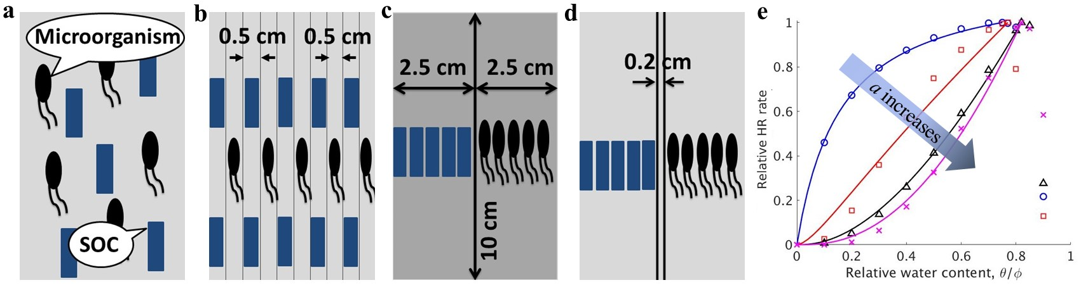
Supplementary Figure 1. Effects of the collocation between soil-adsorbed organic carbon (SOC) and microorganisms on the SOC-microorganism collocation factor, $a$, in the simulated soil cores with different porosity values and organic carbon contents. (a-d), Different distributions of SOC and microorganisms in the homogenous soil cores with different porosity values $ϕ$ ($ϕ$ = 0.58 in a, b, d and 0.42 in c) and SOC contents C_{SOC} (C_{SOC} = 0.02 g g⁻¹ in a, c, d and 0.04 g g⁻¹ in b). (e) The relative heterotrophic respiration (HR) rates change with the relative water content for the different allocations of SOC and microorganisms in (a)-(d). The blue circles (○), red squares (□), black triangles (△), and pink crosses (×) represent the simulated HR rates obtained by the microscale model for the different collocations in (a)-(d). The solid curves represent the moisture function, f_{m}, with fitted a, a =0, 0.38, 0.76 and 0.98, via the linear least square regression.

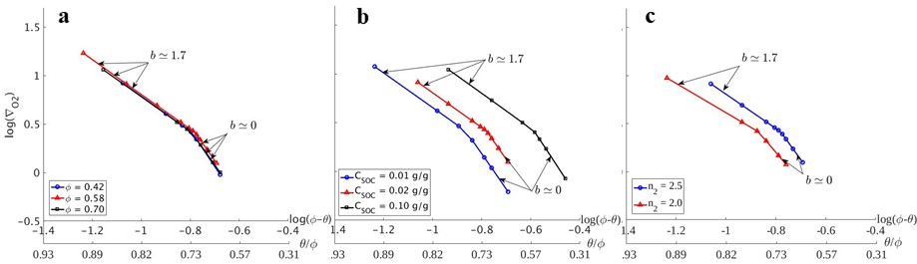
Supplementary Figure 2. Effects of soil properties on the O₂ supply restriction factor b. (a-c) Change of $b$ with water content for the simulated homogenous soil cores with different (a) porosity values $ϕ$, (b) soil-adsorbed organic carbon (SOC) contents $C_{SOC}$, and (c) saturation exponents $n_{g}$. The value of b was calculated using $b=n_{g}+1+ω$ , where parameter ω is the slope of log(∇_{O2})-log(ϕ-θ) curves (see Eq. 8 in Methods section). The gradient of O₂ at the soil-atmosphere interface, ∇_{O2}, was calculated using the atmospheric O₂ concentration and the simulated O₂ concentration in the top numerical voxels of the soil cores. $ϕ$ = 0.58, $C_{SOC}$ = 0.02 g g⁻¹, and $n_{g}$ = 2.5 were used in the simulations, unless they were changed as indicated by the legends.

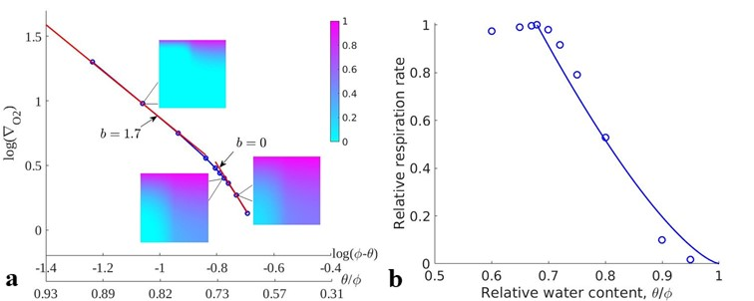
Supplementary Figure 3. Effects of O₂ distribution on the O₂ supply restriction factor, b, in a simulated heterogenous soil core. (a) Change of $b$ with water content, $b=ω+3.5$ where parameter ω is the slope of log(∇_{O2})-log(ϕ-θ) curves (see Eq. 8 in Methods section). The gradient of O₂ at the soil-atmosphere interface, ∇_{O2}, was calculated using the atmospheric O₂ concentration and the simulated O₂ concentration in the top numerical voxels of the homogenous soil cores. The inset plots show the distributions of the relative O₂ concentration with respect to the atmospheric O₂ concentration under different relative water contents ($θ/ϕ$ = 0.85, 0.71, and 0.68). The porosity, $ϕ$, is 0.42 in the left half and 0.76 in the right half of the soil core. (b) Comparisons between the fitted moisture function, f_{m}, and the simulated heterotrophic respiration (HR)-moisture relationship. The blue circles (○) represent the simulation results obtained by the microscale model, and the solid line represents f_{m} with $b$ = 1.4, which was fitted via the linear least square regression.
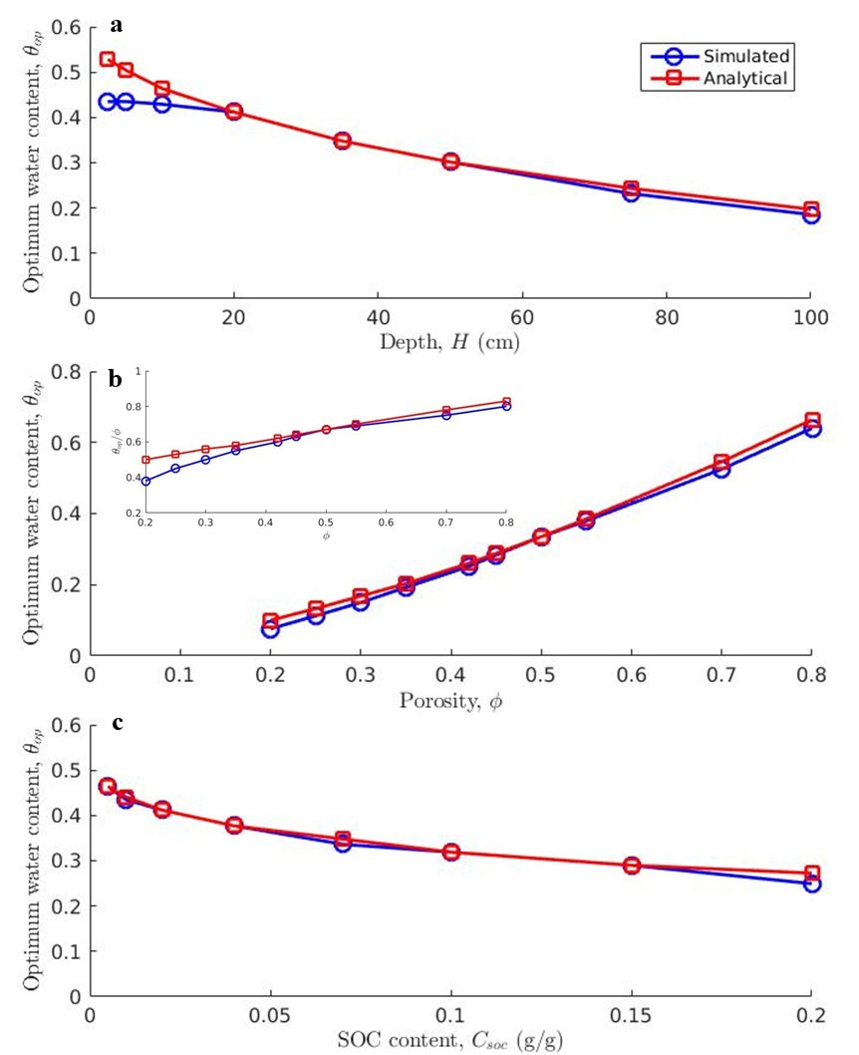
Supplementary Figure 4. Comparisons between values of the analytical and the simulated optimum water content, $θ_{op}$, for the simulated homogenous soil cores with different properties: (a) depths, (b) porosity values, and (c) soil-adsorbed organic carbon (SOC) contents. The subplot in (b) represents the comparisons of the relative water content, $θ_{op}/ϕ$, for different porosity values. The values of the simulated $θ_{op}$ were derived from the simulated heterotrophic respiration (HR)-moisture relationship obtained by the microscale model; the values of the analytical $θ_{op}$ were calculated using Eq. (11) in Methods section. The base values were $H=20$ cm, $ϕ=0.58$, and $C_{SOC}$ = 0.02 g g⁻¹ in the simulations.
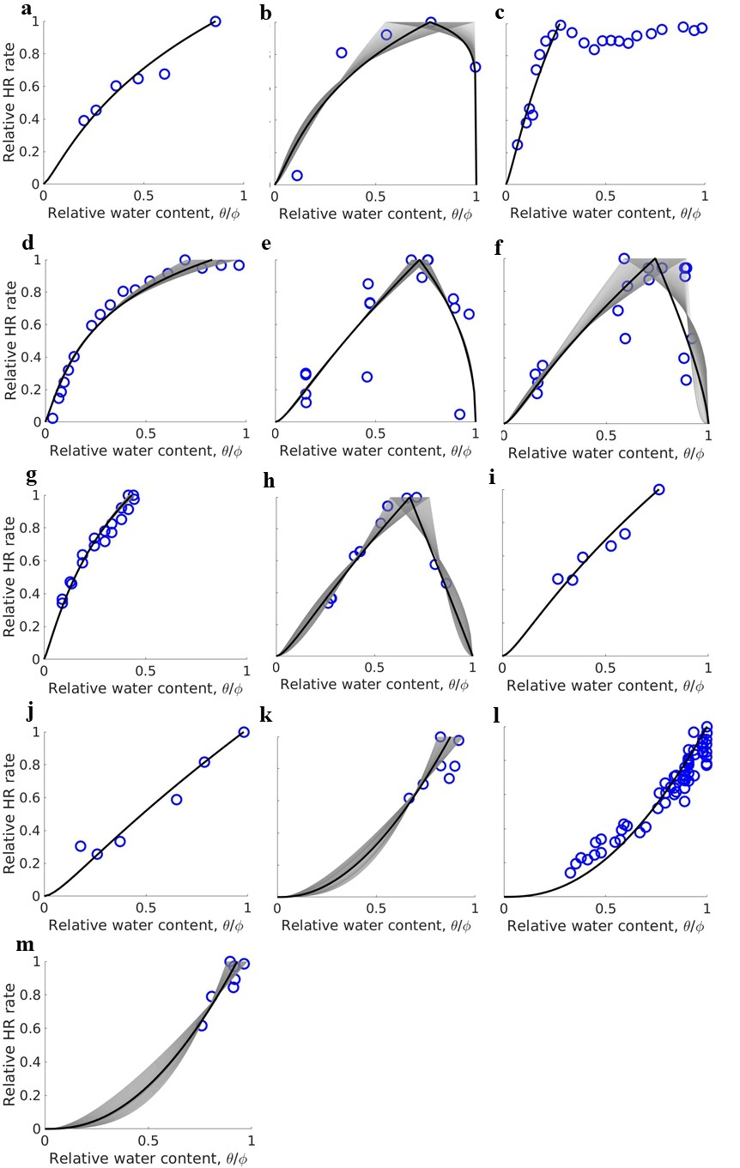
Supplementary Figure 5. Calibration of the moisture function, f_{m}, using a wide range of soil types. Blue circles (○) are experimental data for different soil types: (a) Sand (Gleyic Cambisol, undisturbed) ¹, (b) Sand ², (c) Sandy loam (mineral soil) ³, (d) Sandy loam (forest floor litter soil) ³, (e) Sandy loam (mineral soil) ⁴, (f) Sandy loam (Forest soil) ⁴, (g) Sandy loam ⁵, (h) Silt loam ⁶, (i) Silt loam (Selhausen, undisturbed) ¹, (j) Silt loam (Merzenhausen, undisturbed) ¹, (k) Sandy clay loam ⁷, (l) Clay loam ⁸, (m) Clay ⁷. Gray ranges represent the fitted f_{m} with respect to different optimum water contents, $θ_{op}$, whose values were allowed to vary in a range. The black lines represent the best-fitted f_{m} using the averaged values of a, b, and $θ_{op}$ corresponding to the gray ranges (see Supplementary Data 1).
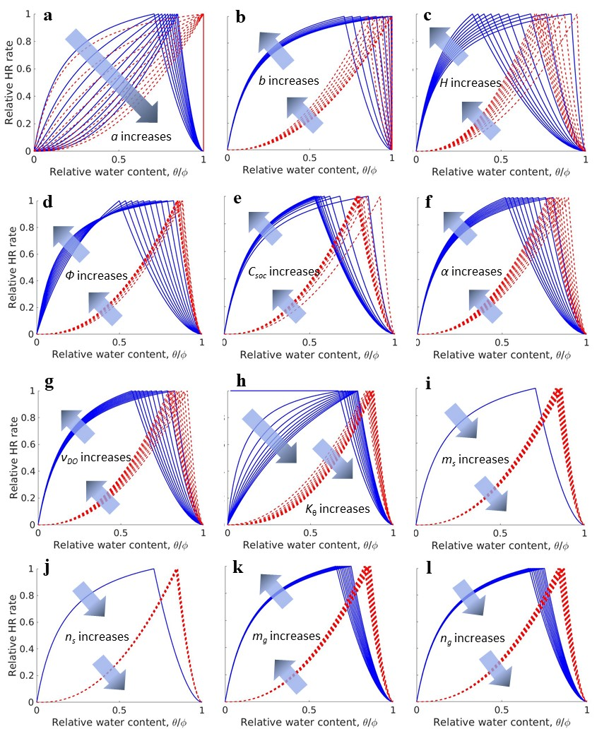
Supplementary Figure 6. Sensitivities of the moisture function, f_{m}, to soil properties: (a) soil-adsorbed organic carbon (SOC)-microorganism collocation factor a (0 $≤$ a $≤$ 1, corresponding to 0.016 $≤$ c_{c} $≤$ 0.37 g g⁻¹ where c_{c} is clay content); (b) O₂ supply restriction factor b (0 $≤$ b $≤$ 1.7); (c) depth H (2.5 $≤$ H $≤$ 100 cm); (d) porosity $ϕ$ ($0.2≤ϕ≤0.8$); (e) SOC content $C_{SOC}$ ($0.005≤C_{SOC}≤0.2$ g g⁻¹); (f) mass transfer coefficient $α$ ($1×{10}^{-8}≤α≤5×{10}^{-8}$ s⁻¹); (g) stoichiometric coefficient $υ_{DO}$ ($1≤υ_{DO}≤5$ g g⁻¹); (h) moisture constant $K_{θ}$ ($0≤K_{θ}≤0.5$ m³ m⁻³); (i) cementation exponent for dissolved organic carbon (DOC) diffusion $m_{s}$ ($1≤m_{s}≤2$); (j) saturation exponent for DOC diffusion $n_{s}$ ($1.5≤n_{s}≤2$.5); (k) cementation exponent for O₂ diffusion $m_{g}$ ($1≤m_{g}≤2$); (l) saturation exponent for O₂ diffusion $n_{g}$ ($2≤n_{g}≤3$). $a=0$ and 1 in the blue solid and red dash curves, respectively, in all plots except in (a), in which a changes from 0 to 1 with $b=1.7$ in the blue solid curves and $b=0$ in the red dash curves. $b=1.7$ in all plots except in (a) and (b). The base values are H = 20 cm, $ϕ$ = 0.58, $C_{SOC}$ = 0.02 g g⁻¹, $α=2×{10}^{-8}$ s⁻¹, $υ_{DO}$ = 2.45 g g⁻¹, $K_{θ}$ = 0.1 m³ m⁻³, $m_{s}$ = 1.5, $n_{s}$ = 2, $m_{g}$ = 1.5, and $n_{g}$ = 2.5.

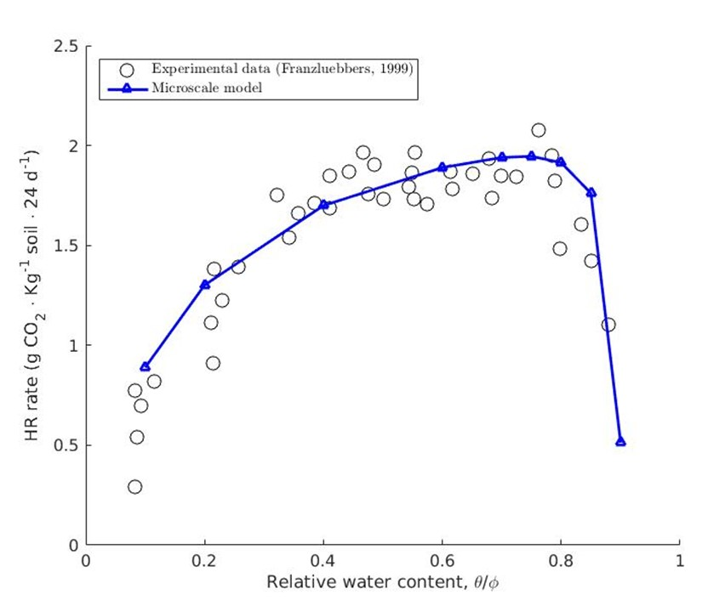
Supplementary Figure 7. Calibration of the microscale model using experimental data. The heterotrophic respiration (HR) rates were estimated by measuring the total CO₂ produced in the canning jars in the experiments ⁹; the HR rates were calculated by averaging the CO₂ flux at the top surface of the simulated soil core in the simulations.

Symbols | Descriptions | Values | Units | Sources and notes
$$ρ_{s}$$ | Density of soil mineral | 2.65×10³ | kg m⁻³ | ⁹
$$K_{c}$$ | Adsorption/desorption equilibrium constant | 0.039 | l g⁻¹ | ¹⁰
$$K_{θ}$$ | Moisture constant | 0.1 | m³ m⁻³ | ¹¹
$$α$$ | Mass transfer coefficient | 2×10⁻⁸ | s⁻¹ | ¹²
$$D_{DOC,0}$$ | Diffusion coefficient of DOC | 1.9×10⁻¹⁰ | m² s⁻¹ | ¹³
$$D_{DO,0}$$ | Diffusion coefficient of DO | 2.1×10⁻⁹ | m² s⁻¹ | ¹⁴
$$D_{GO,0}$$ | Diffusion coefficient of gaseous O₂ | 2.1×10⁻⁵ | m² s⁻¹ | ¹⁵
$$D_{DIC,0}$$ | Diffusion coefficient of DIC | 1.92×10⁻⁹ | m² s⁻¹ | ¹⁴
$$D_{GIC,0}$$ | Diffusion coefficient of gaseous CO₂ | 1.92×10⁻⁵ | m² s⁻¹ | ¹⁵
$$m_{s}$$ | Cementation exponent for solute diffusion | 1.5 | - | ¹⁶
$$n_{s}$$ | Saturation exponent for solute diffusion | 2 | - | ¹⁶
$$m_{g}$$ | Cementation exponent for gas diffusion | 1.5 | - | ¹⁶
$$n_{g}$$ | Saturation exponent for gas diffusion | 2.5 | - | ¹⁶
$$Y$$ | Yield coefficient | 0 | g g⁻¹ | Assumed
$$k_{b}$$ | Decay rate | 0 | s⁻¹ | Assumed
$$k_{DOC}$$ | Maximum reaction rate of DOC | 1.97×10⁻⁵ | g g⁻¹ s⁻¹ | ¹⁷
$$ν_{DO}$$ | Stoichiometric coefficient of DO | 2.45 | g g⁻¹ | ¹⁸
$$ν_{DIC}$$ | Stoichiometric coefficient of DIC | 3.43 | g g⁻¹ | ¹⁸
$$K_{DOC}$$ | Half-saturation coefficient of DOC | 1.3×10⁻⁴ | g l⁻¹ | ¹⁷
$$K_{DO}$$ | Half-saturation coefficient of DO | 1.0×10⁻⁴ | g l⁻¹ | ¹⁷
$$K_{h,o}$$ | Henry constant for O₂ | 3.181×10⁻² | - | ¹⁹
$$K_{h,c}$$ | Henry constant for CO₂ | 0.2137 | - | ¹⁹
$$K_{a1}$$ | Equilibrium constant between carbonic acid and bicarbonate | 10^{-6.3} | mole m⁻³ | ²⁰
$$K_{a2}$$ | Equilibrium constant between bicarbonate and carbonate | 10^{-10.25} | mole m⁻³ | ²⁰
$$C_{DO,0}$$ | Initial concentration of DO | 8.3×10⁻³ | g l⁻¹ | ²¹
$$C_{GO,0}$$ | Initial concentration of gaseous O₂ | 0.2609 | g l⁻¹ | ²²
$$C_{B,0}$$ | Initial concentration of microorganism | 4.53x10⁻⁴ | g g⁻¹ | ²³
$$C_{DIC,0}$$ | Initial concentration of DIC | 2.93×10⁻³ | g l⁻¹ | ²¹
$$C_{GIC,0}$$ | Initial concentration of gaseous CO₂ | 7.91×10⁻⁴ | g l⁻¹ | ²²
Supplementary Table 1. Parameter and initial values used in the study

Function | $f(\frac{θ}{ϕ})$ = | Sources
Candy | $4\frac{θ}{ϕ}\left(1-\frac{θ}{ϕ}\right)$, $\frac{θ}{ϕ}≪0.5$  1, $\frac{θ}{ϕ}>0.5$ | ²⁴
Century | $$\frac{1}{1+30exp⁡(-8.5θ/ϕ)}$$ | ²⁵
Daycent | ($\frac{θ/ϕ-b}{a-b})^{d(\frac{b-a}{a-c})}(\frac{θ/ϕ-c}{a-c})^{d}$ | ²⁶
Demeter | $$0.25+0.75\frac{θ}{ϕ}$$ | ²⁷
Gompertz | $$exp⁡(-\exp\left(a-b\frac{θ}{ϕ}\right))$$ | ²⁸
Moyano | $$3.11\frac{θ}{ϕ}-2.42{\left(\frac{θ}{ϕ}\right)}^{2}$$ | ²⁹
Myers | $$b\frac{θ}{ϕ}+(1-b){\left(\frac{θ}{ϕ}\right)}^{2}$$ | ²⁸
Patcis | 0, $\frac{θ}{ϕ}<0.01$  $1-exp⁡(-11.07\frac{θ}{ϕ}+0.11)$, $\frac{θ}{ϕ}≫0.01$ | ²⁴
Rothc | 0.2+1.44$\frac{θ}{ϕ}$, $\frac{θ}{ϕ}≪0.556$  $1$, $\frac{θ}{ϕ}>0.556$ | ²⁴
Skopp | $min⁡[α(\frac{θ}{ϕ})^{f},β(1-\frac{θ}{ϕ})^{g}$] | ²⁸
Standcarb | $$1-exp⁡(-3/(\frac{θ}{ϕ})_{min}\left(\frac{θ}{ϕ}+a\right))^{b}\exp{{(-\left(\frac{θ}{ϕ\left(M_{max}+c\right)}\right)}^{d})}$$ | ²⁸
Supplementary Table 2. Empirical moisture functions used in Earth system models (ESMs)

Supplementary References

1. Herbst, M., Tappe, W., Kummer, S. & Vereecken, H. The impact of sieving on heterotrophic respiration response to water content in loamy and sandy topsoils. Geoderma 272, 73-82 (2016).

2. Wickland, K. P. & Neff, J. C. Decomposition of soil organic matter from boreal black spruce forest: environmental and chemical controls. Biogeochemistry 87, 29-47 (2008).

3. Lee, X., Wu, H.-J., Sigler, J., Oishi, C. & Siccama, T. Rapid and transient response of soil respiration to rain. Global Change Biol 10, 1017-1026 (2004).

4. Bowden, R. D., Newkirk, K. M. & Rullo, G. M. Carbon dioxide and methane fluxes by a forest soil under laboratory-controlled moisture and temperature conditions. Soil Biology and Biochemistry 30, 1591-1597 (1998).

5. Liu, W., Zhang, Z. H. E. & Wan, S. Predominant role of water in regulating soil and microbial respiration and their responses to climate change in a semiarid grassland. Global Change Biol 15, 184-195 (2009).

6. Skopp, J., Jawson, M. D. & Doran, J. W. Steady-State Aerobic Microbial Activity as a Function of Soil Water Content. Soil Science Society of America Journal 54, 1619-1625 (1990).

7. Schjønning, P., Thomsen, I. K., Moldrup, P. & Christensen, B. T. Linking Soil Microbial Activity to Water- and Air-Phase Contents and Diffusivities. Soil Science Society of America Journal 67, 156-165 (2003).

8. Cook, F. J., Orchard, V. A. & Corderoy, D. M. Effects of lime and water content on soil respiration. New Zealand Journal of Agricultural Research 28, 517-523 (1985).

9. Franzluebbers, A. J. Microbial activity in response to water-filled pore space of variably eroded southern Piedmont soils. Applied Soil Ecology 11, 91-101 (1999).

10. Jardine, P. M., McCarthy, J. F. & Weber, N. L. Mechanisms of Dissolved Organic Carbon Adsorption on Soil. Soil Science Society of America Journal 53, 1378-1385 (1989).

11. Yan, Z., Liu, C., Todd-Brown, K. E., Liu, Y., Bond-Lamberty, B. & Bailey, V. L. Pore-scale investigation on the response of heterotrophic respiration to moisture conditions in heterogeneous soils. Biogeochemistry 131, 121-134 (2016).

12. Zarnetske, J. P., Haggerty, R., Wondzell, S. M., Bokil, V. A. & González-Pinzón, R. Coupled transport and reaction kinetics control the nitrate source-sink function of hyporheic zones. Water Resources Research 48, (2012).

13. Hendry, M. J., Ranville, J. R., Boldt-Leppin, B. E. J. & Wassenaar, L. I. Geochemical and transport properties of dissolved organic carbon in a clay-rich aquitard. Water Resources Research 39, WR001943 (2003).

14. Cussler, E. L. Diffusion. Cambridge University Press (1997).

15. Weast, R. C. CRC Handbook of Chemistry and Physics. CRC Press (1997).

16. Hamamoto, S., Moldrup, P., Kawamoto, K. & Komatsu, T. Excluded-volume expansion of Archie's law for gas and solute diffusivities and electrical and thermal conductivities in variably saturated porous media. Water Resources Research 46, 6514 (2010).

17. Borden, R. C. & Bedient, P. B. Transport of dissolved hydrocarbons influenced by oxygen-limited biodegradation: 1. Theoretical development. Water Resources Research 22, 1973-1982 (1986).

18. Yan, Z., Liu, C., Todd-Brown, K. E., Liu, Y., Bond-Lamberty, B. & Bailey, V. L. Pore-scale investigation on the response of heterotrophic respiration to moisture conditions in heterogeneous soils. Biogeochemistry, 1-14.

19. Sander, R. Compilation of Henry's law constants (version 4.0) for water as solvent. Atmos Chem Phys 15, 4399-4981 (2015).

20. Stumm, W. & Morgan, J. J. Aquatic chemistry: chemical equilibria and rates in natural waters. Wiley (1996).

21. Colt, J. Front-matter. In: Computation of Dissolved Gas Concentration in Water as Functions of Temperature, Salinity and Pressure (Second Edition). Elsevier (2012).

22. Wallace, J. M. & Hobbs, P. V. Atmospheric Science: An Introductory Survey. Academic Press (1977).

23. Powlson, D. & Jenkinson, D. A comparison of the organic matter, biomass, adenosine triphosphate and mineralizable nitrogen contents of ploughed and direct-drilled soils. The Journal of Agricultural Science 97, 713-721 (1981).

24. Bauer, J., Herbst, M., Huisman, J. A., Weihermüller, L. & Vereecken, H. Sensitivity of simulated soil heterotrophic respiration to temperature and moisture reduction functions. Geoderma 145, 17-27 (2008).

25. Parton, W., Morgan, J., Kelly, R. & Ojima, D. Modeling soil C responses to environmental change in grassland systems. The potential of US grazing lands to sequester carbon and mitigate the greenhouse effect Lewis Publ, New York, 371-398 (2000).

26. Kelly, R. H., Parton, W. J., Hartman, M. D., Stretch, L. K., Ojima, D. S. & Schimel, D. S. Intra-annual and interannual variability of ecosystem processes in shortgrass steppe. Journal of Geophysical Research: Atmospheres 105, 20093-20100 (2000).

27. Foley, J. A. An equilibrium model of the terrestrial carbon budget. Tellus B 47, 310-319 (1995).

28. Sierra, C. A., Trumbore, S. E., Davidson, E. A., Vicca, S. & Janssens, I. Sensitivity of decomposition rates of soil organic matter with respect to simultaneous changes in temperature and moisture. Journal of Advances in Modeling Earth Systems 7, 335-356 (2015).

29. Moyano, F. E., Manzoni, S. & Chenu, C. Responses of soil heterotrophic respiration to moisture availability: An exploration of processes and models. Soil Biology and Biochemistry 59, 72-85 (2013).

