Supplementary Information
for
“A Gate-free Monolayer WSe₂ pn Diode”

Chen et al.

Supplementary Note 1: P-V hysteresis loops with varied measurement frequency of a BFO (001) film
The macroscopic P-V hysteresis loop with different measuring frequency on BFO (001) films. From Supplementary Figure 1, we can obtain the saturation polarization on BFO film in value of P_{s}~ 60 μC cm⁻².
Supplementary Figure 1: Macroscopic electric P-V hysteresis loops with varied measurement frequency of a BFO (001) film^{[1]}.

Supplementary Note 2: Photoluminescence of WSe₂ on BFO
To confirm that the intensity attenuation did not originate from destruction by the tip on scanning with an AFM, we investigated the P_{up} and P_{down} regions upon BFO layer. We scanned the naturally downward polarization area (probe voltage set to +8 V) and another upward (probe voltage set to -8 V) with the AFM tip. In Supplementary Figure 2, the PL measurement reveals decreased photon-energy emission and intensity attenuation in the P_{up} region, compared with the P_{down} region. These results confirm that there is no destruction in the poled region of either morphology or piezoelectricity.
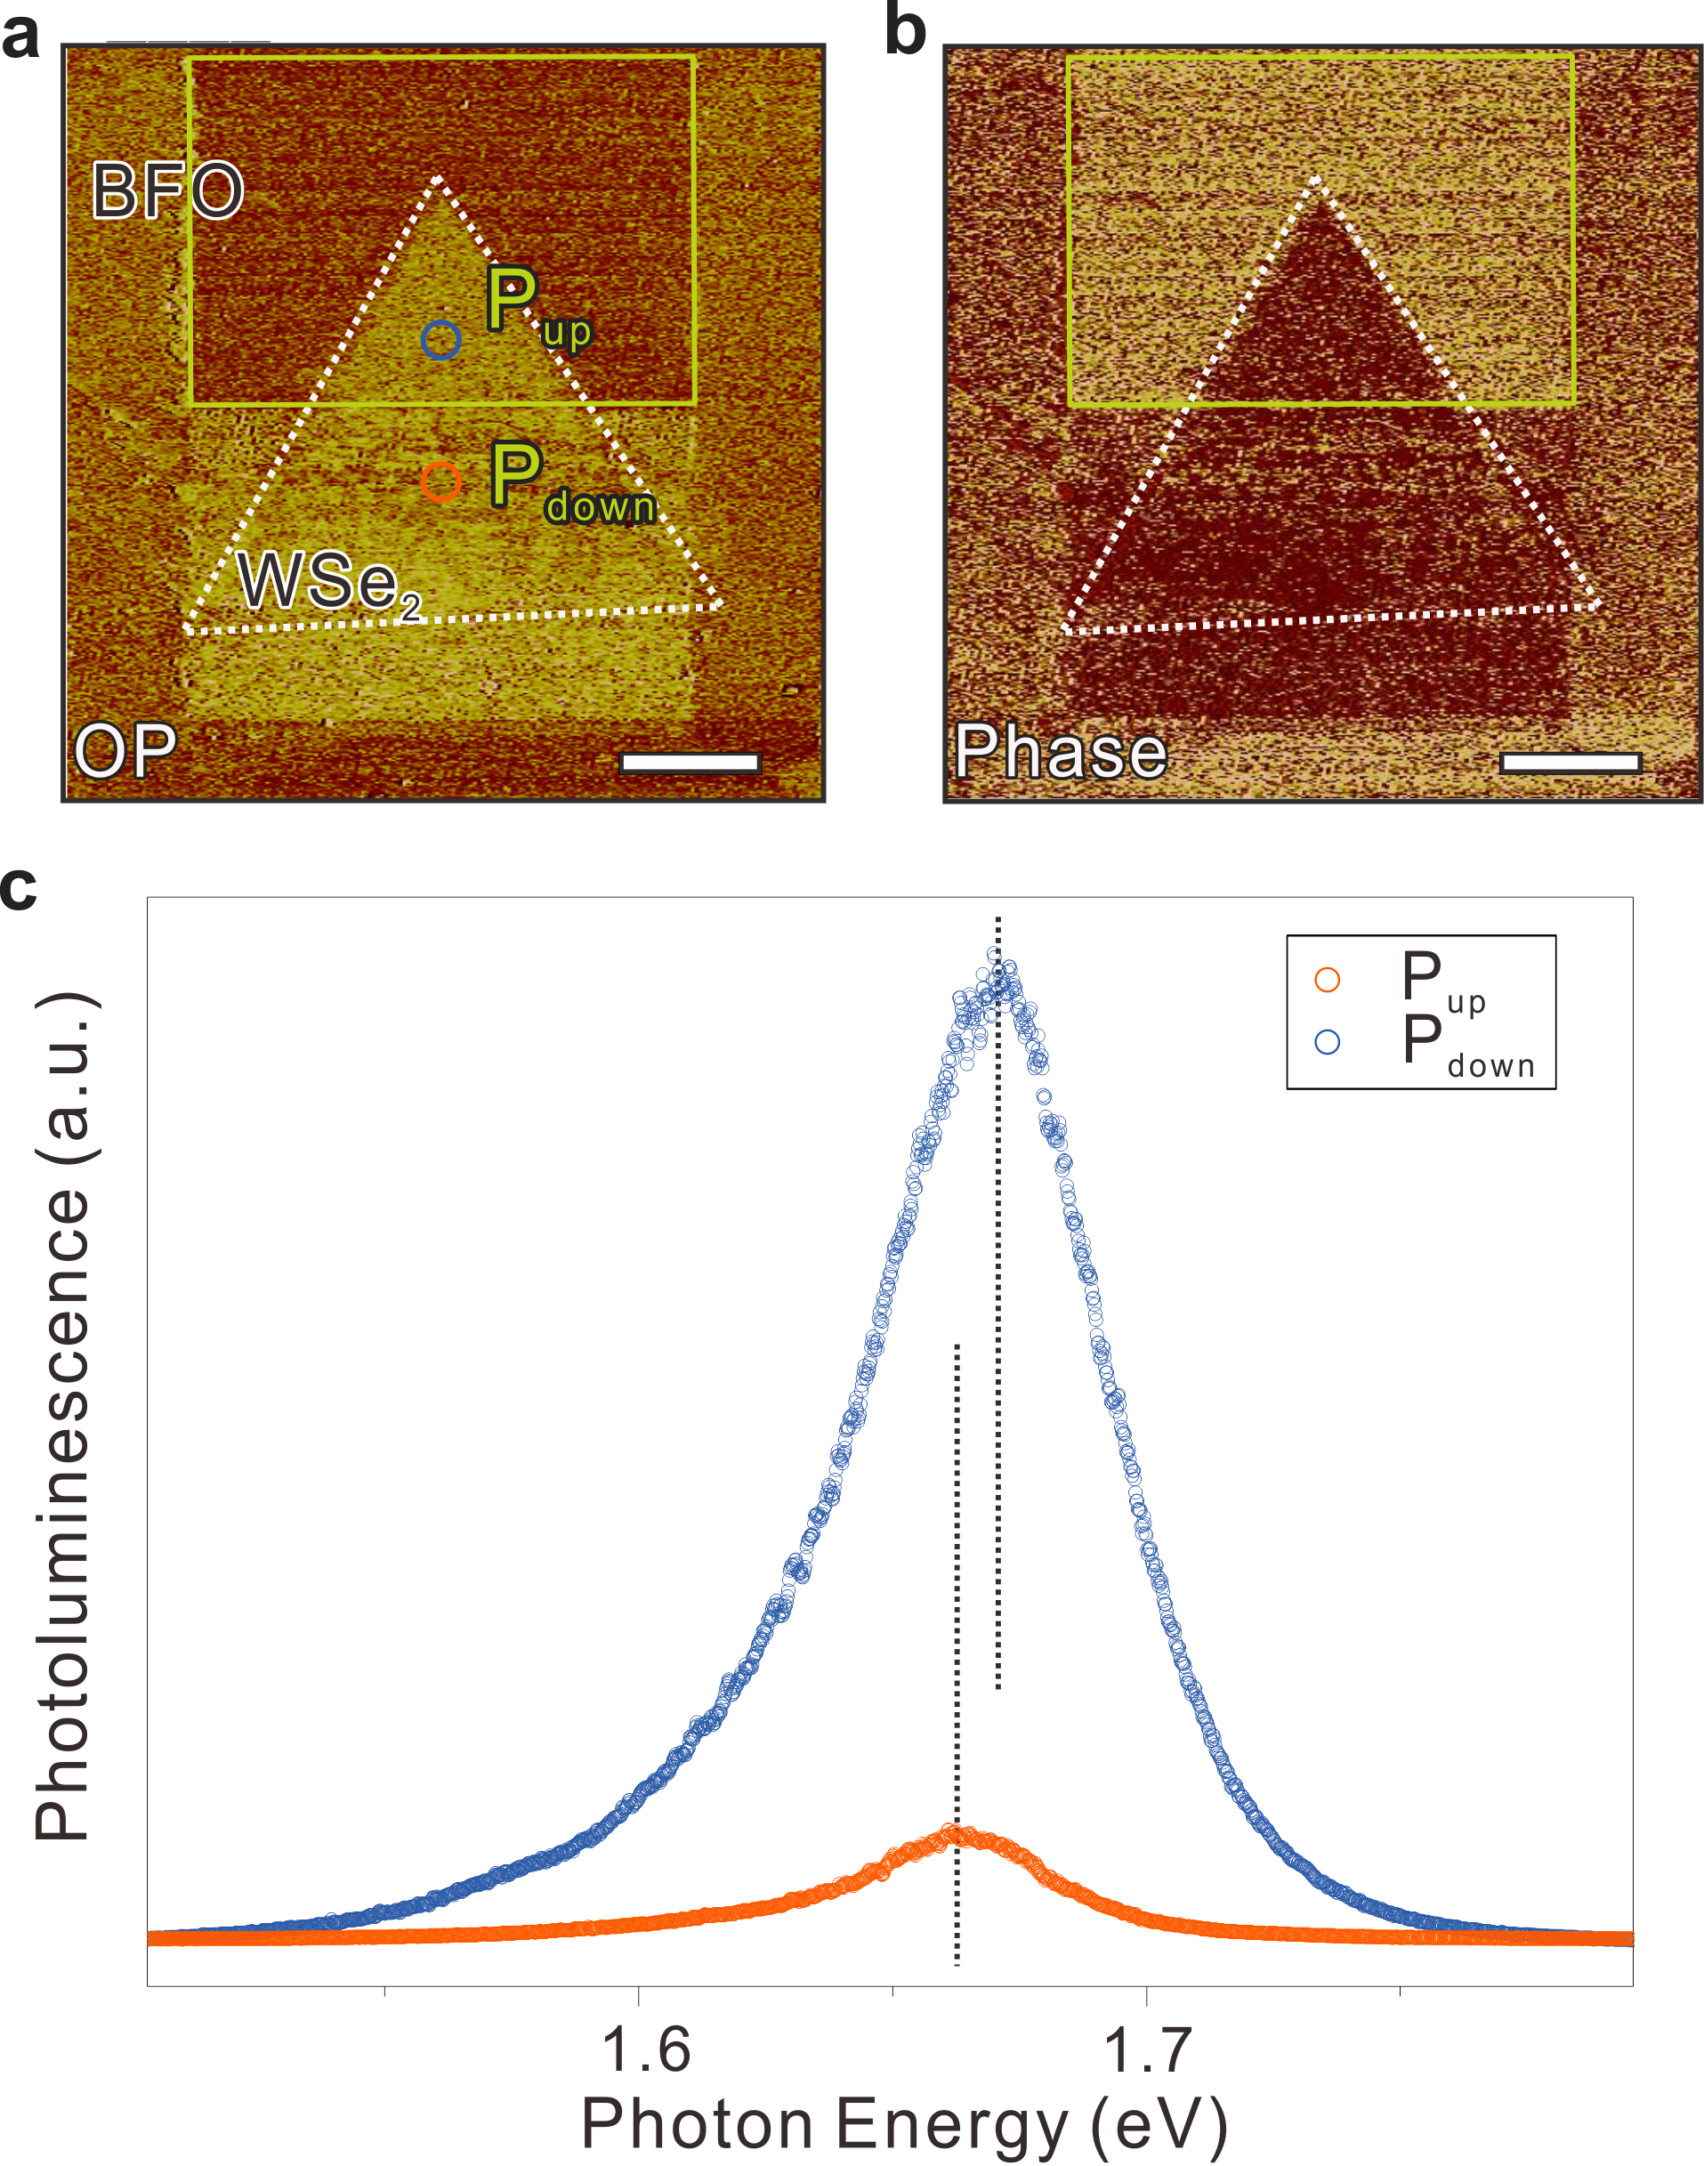
Supplementary Figure 2: (a)-(b) Piezoelectric-force microscope measured morphology, out-of-plane phase, and (c) photoluminescence from P_{up} and P_{down} regions of a WSe₂/BFO system. Both scale bars in the figures are 5 μm.

Supplementary Note 3: Band diagrams of a WSe₂/BFO homojunction with polarization states upward (P_{up}) and downward (P_{down})
Bare WSe₂ and BFO
To determine the valence-band offset ${∆E}_{v}$of the WSe₂-BFO homojunctions, we require to know the respective core-level (CL) position relative to the valence-band maximum (E_{VBM}), which was measured from the epitaxial layers on WSe₂ and BFO, respectively. The value ${(E_{VBM}^{{WSe}_{2}}-E_{W 4f_{7/2}}^{{WSe}_{2}})}_{{WSe}_{2}}=31.8$^{[2]} from the WSe₂ layer and the obtained value ${\left(E_{VBM}^{BFO}-E_{Bi 4f}^{BFO}\right)}_{BFO}=157.8 eV$ from BFO layer in Supplementary Figure 3.
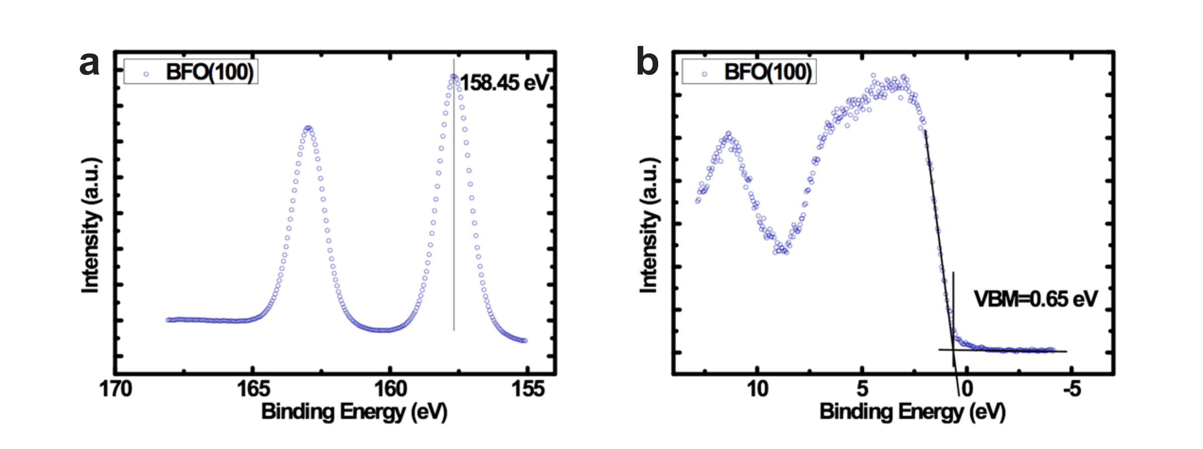
Supplementary Figure 3: (a)-(b) Bi 4f core-level and valence-band maximum in a bare BFO layer.

WSe₂ on BFO with polarization states P_{up} and P_{down}
As referred to in Fig. 3, the photoelectron emission spectra measured with SPEM of states P_{up} and P_{down} of a WSe₂-BFO homojunction is shown in the following Supplementary Figure 4; the energy separations of the Bi 4f and W 4f core levels are summarized in Supplementary Table 1. The relation between the valence-band offset and the PES measurement is
$${∆E}_{v}={(E_{VBM}^{{WSe}_{2}}-E_{W 4f_{7/2}}^{{WSe}_{2}})}_{{WSe}_{2}}-{\left(E_{VBM}^{BFO}-E_{Bi 4f}^{BFO}\right)}_{BFO}+{\left(∆E_{CL}\right)}_{{WSe}_{2}-BFO} (1)$$
in which ${\left(∆E_{CL}\right)}_{{WSe}_{2}-BFO}$ is the energy separation between$Bi 4f_{7/2}$ and $W 4f_{7/2},$and the two epitaxial layers are ${(E_{VBM}^{{WSe}_{2}}-E_{W 4f_{7/2}}^{{WSe}_{2}})}_{{WSe}_{2}}$ and ${\left(E_{VBM}^{BFO}-E_{Bi 4f}^{BFO}\right)}_{BFO}$
On combining the valence-band maximum (VBM) to the core-level value from bare WSe₂ and BFO epilayers, we measured the apparent valence-band offset (VBO) values of P_{up} and P_{down} samples to be 0 and 1.0 eV, respectively. The band gap of WSe₂ is known to be 1.6 eV^{[3,4]}. We compared the value between W 4f core-level to valence-band maximum from Bare WSe₂ layer (31.8 eV) and W 4f core-level positions from WSe₂-BFO homojunction (32.2 eV for state P_{down}, 33.2 eV for state P_{up}), which reveals the Fermi level to be at 0.4 eV above the valence-band maximum for state P_{down} and 0.2 eV below the conduction-band minima for state P_{up}. This pn junction formed for WSe₂ placed on a BFO layer is shown in Supplementary Figures 4 (d) and (e).
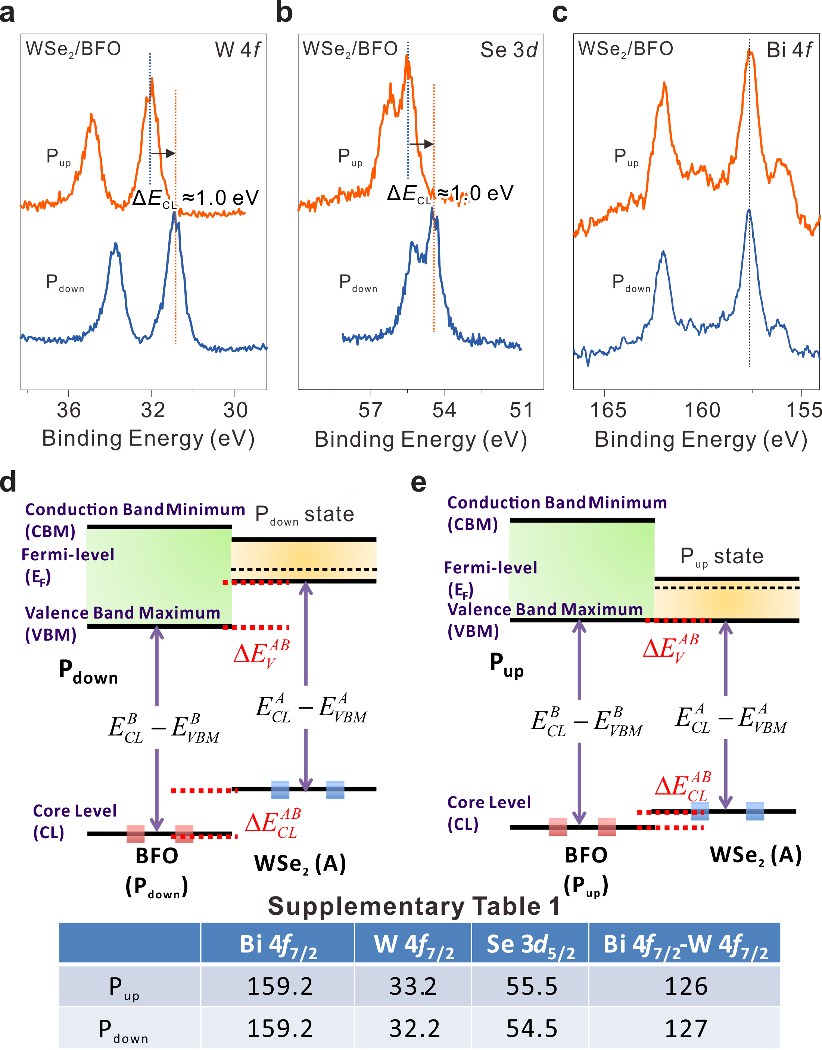
Supplementary Figure 4: (a)-(c) W 4f, Se 3d and Bi 4f core-level photoelectron spectra in regions P_{up} and P_{down} of a WSe₂/BFO homojunction. (d)-(e) Band diagrams for regions P_{up} and P_{down} of a WSe₂/BFO homojunction; E_{F} denotes the Fermi level, E_{C} is the conduction-band minimum, E_{V} is the valence-band maximum, E_{CL}-E_{VBM} is the energy separation from the core-level to the valence-band maximum (VBM). Supplementary Table 1 shows a summary of the Bi 4f_{7/2}, W 4f_{7/2} and Se 3d_{5/2} core-level positions and energy difference between Bi 4f _{7/2} to W 4f_{7/2} in various polarized WSe₂/BFO samples.
Supplementary Note 4: Effect of the substrate revealed in current-to-voltage and valence-band maxima for a WSe₂/BFO homojunction
Supplementary Figure 5 shows the substrate effect from a BFO layer in the transport electrical contact and XPS measurement. To reveal the pn junction with substrate effect, the sample was placed in a SEM chamber and transport measurement was performed with a conducting probe as shown in the inset of Supplementary Figure 5 (a). We measured a pn junction and BFO layer, but the current signal is obviously affected significantly by the BFO substrate in a region of negative bias. In addition, XPS measured valence band maxima pinning with respect to P_{up}, P_{down} and bare BFO samples, respectively, which also revealed the substrate effect resulting from bare BFO layer.
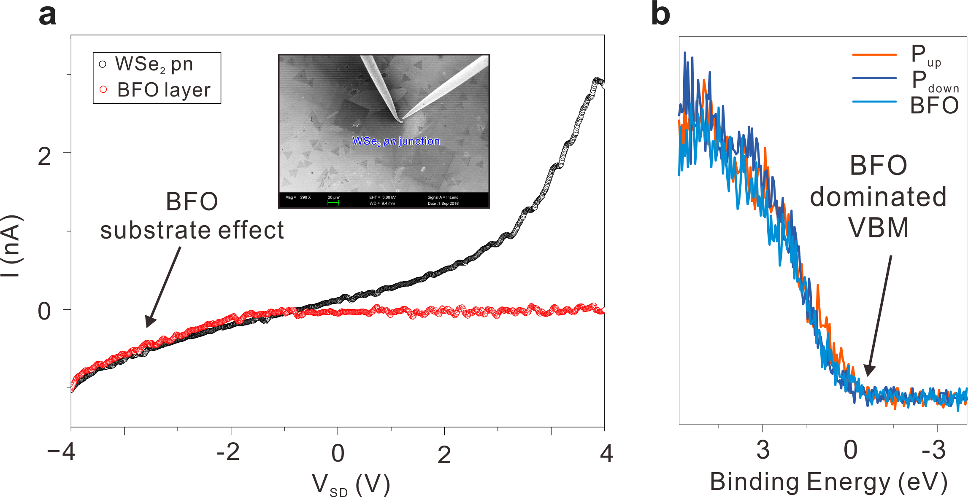
Supplementary Figure 5: (a) Current vs. voltage measured for the pn junction and a bare BFO layer. (b) XPS measurement of valence-band maxima pinning for P_{up}, P_{down} and bare BFO layer.

Supplementary Note 5: Transport behavior of pp, nn and pn junctions revealed in current-to-voltage for a WSe₂/BFO homojunction (Diode-H)
Figure 6 shows a current measurement for pp, nn and pn WSe₂ junctions in the transport electrical contact measurement. We combine band structure in SPEM and electron affinity of WSe₂^{[5]}, and the resulting work function of Pd and WSe₂ are values of about Φ_{Pd} = 5.2~5.6 eV, Φ_{p-type} = 5.3 ± 0.1 eV and Φ_{n-type} = 4.3 ± 0.1 eV. Thus, the pp and nn junctions show ohmic contact and Schottky contact behavior in Supplementary Figure 6, respectively. This transport result is not only consistent with our band structure prediction in SPEM, but also confirms the functionality of WSe₂ homojunction.
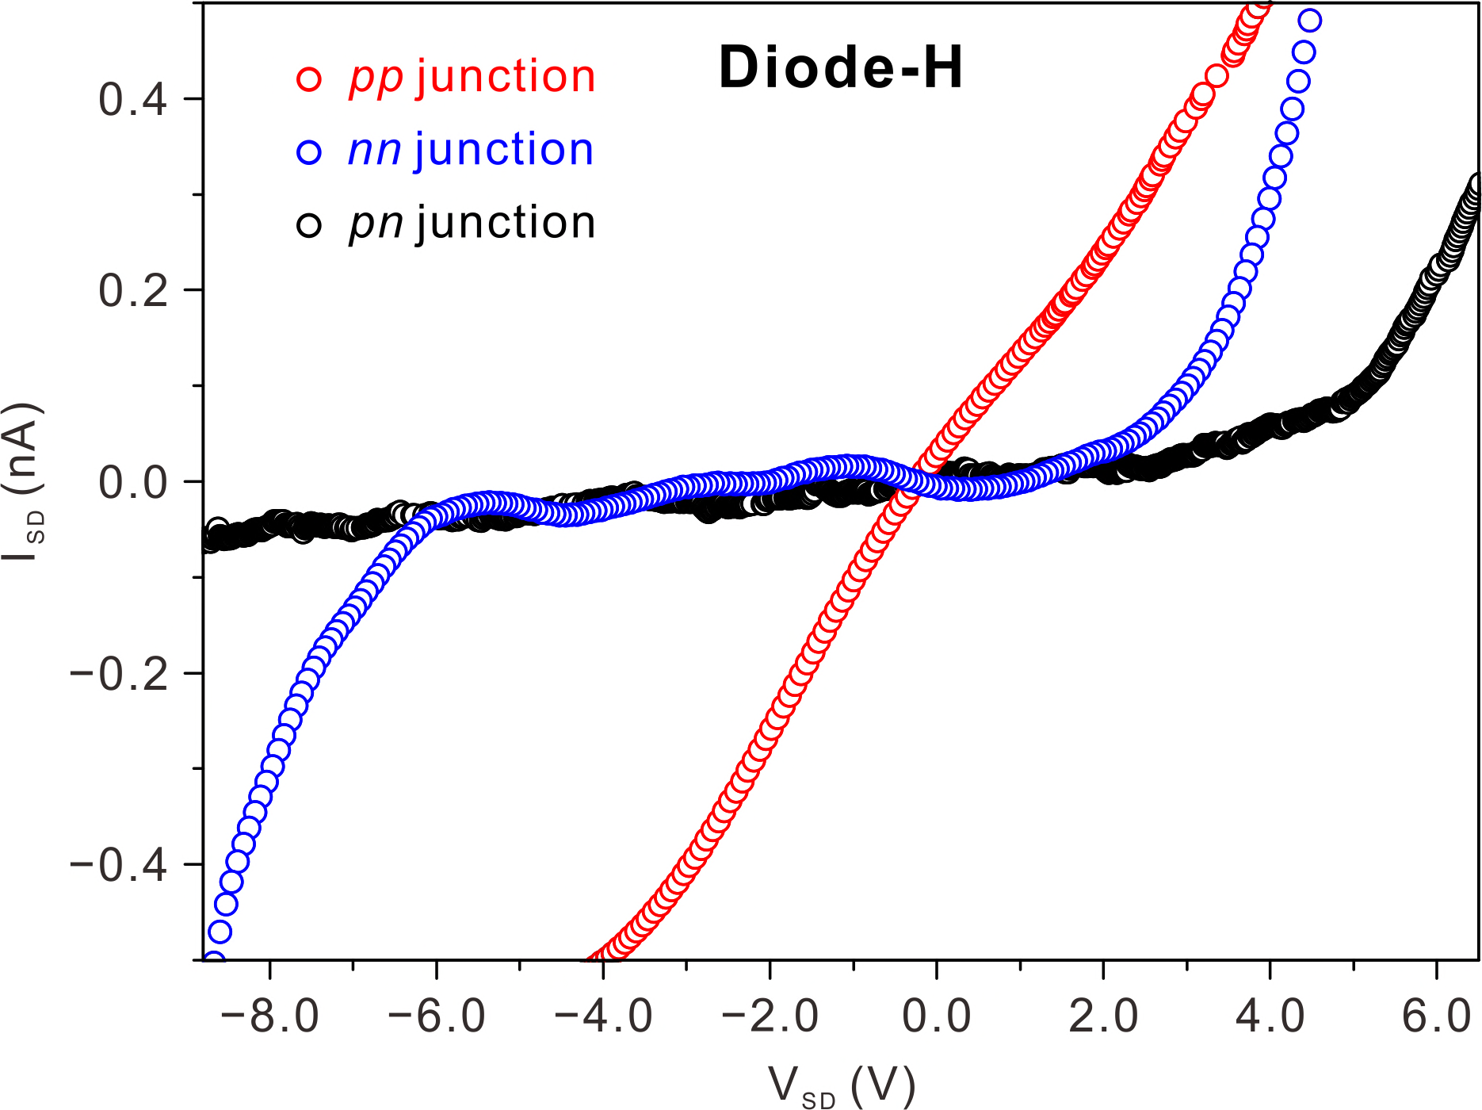
Supplementary Figure 6: Current vs. voltage measured in pp, nn and pn junctions in WSe₂/BFO system.

Supplementary Note 6: Carrier densities calculations
Estimation of carrier density from band alignment in SPEM
- We consider the electron density in conduction band and valence band^{[6]}
σ_{n} =(g_{2D}k_{B}T)ln{1+exp[(E_{F}-E_{C})/ k_{B}T]} (2)
σ_{p} =(g_{2D}k_{B}T)ln{1+exp[-(E_{F}-E_{V})/ k_{B}T]} (3)
in which g_{2D} =(4πm_{e/h}*/h²) is 2D density of states in TMD semiconductor (m_{e/h}* effective electron/hole mass, E_{F}-E_{C} and E_{F}-E_{V} are the separation from Fermi level to conduction band minima (CBM) and valence band maxima (VBM) measured with a SPEM, respectively
- To estimate the electron/hole density of states, the effective mass of electron m_{e,WSe2}*=0.33m₀ and hole m_{h,WSe2}*=0.46 m₀ from WSe₂ are used to estimate^{[7]}
g_{2D} =(4πm_{e/h}*/h²) (4)
=(4πm_{e/h}*/(6.626×10⁻³⁴)²)
- Then we can get n of WSe₂
σ_{n} =(g_{2D}k_{B}T)ln{1+exp[(E_{F}-E_{C})/ k_{B}T]}
=(4π ×0.33×9.11×10⁻³¹ ×1.38×10⁻²³×300/(6.626×10⁻³⁴)²) ln{1+exp[-0.2/0.0257 ]}
= 3.56×10¹⁶ cm⁻²× 4.17×10⁻⁴
~ 1.48×10¹³ cm⁻²
σ_{p} =(g_{2D}k_{B}T)ln{1+exp[-(E_{F}-E_{V})/ k_{B}T]}
=(4π ×0.46×9.11×10⁻³¹ ×1.38×10⁻²³×300/(6.626×10⁻³⁴)²) ln{1+exp[-0.4/0.0257 ]}
= 4.96×10¹⁶ cm⁻²× 1.74×10⁻⁷
~ 8.63×10⁹ cm⁻²

Estimation of intrinsic carrier density from band alignment
To illustrate how different types of carrier densities change in semiconductor, we have to introduce the intrinsic carrier density. By using mass action law in semiconductor, we can get the intrinsic carrier densities (σ_{i}) as,
σ_{i} =(g_{2D,h}k_{B}T g_{2D,e}k_{B}T)^{0.5} exp[-E_{g}/ 2k_{B}T]
=(4.96×10¹⁶×3.56×10¹⁶)^{0.5} exp[-1.6/ 0.0514]
=4.20×10¹⁶ cm⁻²×3×10⁻¹⁴
=1.26×10³ cm⁻²
The change of carrier density corresponds to the Fermi-level tuning in the band structure from SPEM, which shows 2D material can tune from intrinsic (~10³ cm⁻²) into p-type (~10¹⁰ cm⁻²) or n-type (~10¹³ cm⁻²) semiconductor. This reveals the carrier density manipulation is fully affected by BFO layer, which shows that a huge range of carrier density tuning is achievable.

Supplementary References
- Y. –H. Chu, Q. Zhan, L. W. Martin, M. P. Cruz, P. –L. Yang, G. –W. Pabst, F. Zavaliche, S. –Y. Yang, J. –X. Zhang, L. –Q. Chen, D. G. Schlom, I. –N. Lin, T. –B. Wu and R. Ramesh, Advanced Materials 2006, 18, 2307.
- M. –H. Chiu, C. Zhang, H. –W. Shiu, C. –P. Chuu, C. –H. Chen, C. –Y. S. Chang, C. –H. Chen, M. –Y. Chou, C. –K. Shih and L. –J. Li, Nature Communications 2015, 6, 7666.
- B. Liu, Y. Ma, A. Zhang, A. N. Abbas, Y. Liu, C. Shen, H. Wan and C. Zhou, ACS Nano 2016, 10(5), 5153.
- W. Liu, J. Kang, D. Sarkar, Y. Khatami, D. Jena and K. Banerjee, Nano Lett. 2013, 13, 1983.
- Christopher M. Smyth, R. Addou, S. McDonnell, Christopher L Hinkle, Robert M Wallace, 2D Materials 2017, 4, 025084
- N. Ma and D. Jena, 2D Materials 2015, 2, 015003.
- W. Liu, W. Cao, J. Kang and K. Banerjee, ECS Transactions 2013, 58(7), 281.

