Utilization of rare codon-rich markers for screening amino acid overproducers
Zheng et al.

Supplementary Note 1
To generalize the strategy, the spec^{R} that encodes the aminoglycoside adenylyltransferase was used for the establishment of L-serine selection marker (Supplementary Data 2). The rare codon AGG could be used for selecting L-arginine overproducers in both E. coli and C. glutamicum. Perhaps due to the Shine-Dalgarno-like feature of the rarest arginine codon AGG¹, having 16 arginine codon AGG in the kan^{R} gene could cause irreversible inhibition on Kan^{R} expression, as reflected by ceased cell growth in 1 × LB medium even when L-arginine was added. Thus, only a subset of the arginine codons on kan^{R} was replaced. For the wild-type kan^{R}, the second arginine codon happens to be the rare one AGG. To avoid confusion between the introduced and the native rare codons, the replacement was performed from the 3’-end of the kan^{R} gene (Supplementary Data 2).

Supplementary Note 2
The increase in amino acid productions depends on the characteristics of the initial strain, the approach and round of mutagenesis, the size of the mutation library and the fermentation conditions. In this study, only one round of mutagenesis was employed on the wild-type E. coli strain. Thus, it would be impractical to expect a dramatic increase in yield that outcompetes the industrial strains, which have been engineered extensively for amino acid overproductions.

Supplementary Note 3
The replacement of leucine rare codon CTA in kan^{R} maintains the protein sequence, but not the mRNA sequence. The secondary structure of mRNA could be predicted by its minimum free energy (MFE)². The replacement of leucine common codons by CTA has little effects on the GC content of kan^{R} nucleic acid sequence, and the change in MFE is less than 7%. This variation is not big enough to disrupt the function of mRNA for translation, but could lead to a significant change of the secondary structure of the mRNA (Supplementary Fig. 8). The secondary structures of the mRNAs of kan^{R}-RC6, kan^{R}-RC16, kan^{R}-RC26 and kan^{R}-RC29 were similar, but are different from the one of the wild-type kan^{R}. This may contribute to the phenomenon that the growth retardation caused by 6–29 rare codon replacement could only be partially restored to a similar level below that of the wild-type control (Fig. 3a).

Supplementary Note 4
Alanine aminotransferase (encoded by alaA) catalyzes the reversible transfer of an amino group from L-alanine to 2-ketoglutaric acid, producing pyruvate and L-glutamate. The pyruvate is the precursor of L-leucine, and L-glutamate serves as the amino group donor for most amino acids including L-leucine. The alanine aminotransferase activity was determined by a coupled enzymatic reaction converting pyruvate to L-lactate at the expense of one molecule of NADH. The consumed NADH was detected by the decrease in absorbance at 340 nm. The decreasing rate of absorbance is proportional to the activity of alanine aminotransferase.

Supplementary Figure 1. Growth curves of strains harboring rare codon-rich kan^{R}. The E. coli DH5α, ZB-5 and TOP10 strains harboring kan^{R} genes with 6 to 29 of rare leucine codon CTA (kan^{R}-RC6, kan^{R}-RC16, kan^{R}-RC26, kan^{R}-RC29) were cultured in diluted culture medium (0.2 × LB). Values and error bars represent the mean and the s.d. (n=3).

Supplementary Figure 2. Growth restorations by feeding the corresponding L-amino acids. Feeding L-arginine could restore the ODs of E. coli (a) or C. glutamicum (b) strains harboring kan^{R} which was rich in arginine rare codon AGG (encoded by pAKR-RC8 or pKan-CG-RC8). Feeding L-serine (c) could restore the ODs of E. coli strains harboring spec^{R} which was rich in serine rare codon TCC (encoded by pSSer-RC17). The fluorescence microscopy images (d) of cells harboring the wild-type gfp and the rare codon-rich gfp (gfp-RC) after the addition of L-leucine. Scale bar, 20 μm. Values and error bars represent the mean and s.d. (n=3).

Supplementary Figure 3. Effects of promoter strength on the selection stringency. The OD₆₀₀ of E coli strains harboring kan^{R} genes rich in either leucine rare codon CTA (a) or arginine rare codon AGG (b) driven by either constitutive or inducible promoters. The constitutive promoters used here were the kan^{R} promoter from vector pET-28a (in pKan, pKan-RC29 for L-leucine and pZB-32 for L-arginine), the strong promoter P_{J23100} (in pZB-23 and pZB-33) and the weak promoter P_{J23118} (in pZB-24 and pZB-34). The P_{L}lacO₁ promoter used here was induced by 0–1.0 mM IPTG (in pZB-25 and pZB-35). Values and error bars represent the mean and s.d. (n=3).

Supplementary Figure 4. Changes in fluorescence intensity. Replacing the leucine codons in gfp with the rare alternative CTA (gfp-RC) decreased the fluorescence intensity, which could be restored by extra feeding of L-leucine. Values and error bars represent the mean and the s.d. (n=3).

Supplementary Figure 5. Growth of mutants selected by rare codon-rich markers. The E. coli mutants were selected by a kan^{R} gene which was rich in leucine rare codon CTA or arginine rare codon AGG, or a spec^{R} gene which was rich in serine rare codon TCC. The C. glutamicum mutants were also selected by a kan^{R} gene which was rich in arginine rare codon AGG.

Supplementary Figure 6. The L-leucine produced by the selected mutants. The enhanced L-leucine productions by both LP-4 and LP-7 were verified with (left) and without (right) the rare codon-rich selection plasmids. Values and error bars represent the mean and s.d. (n=3).

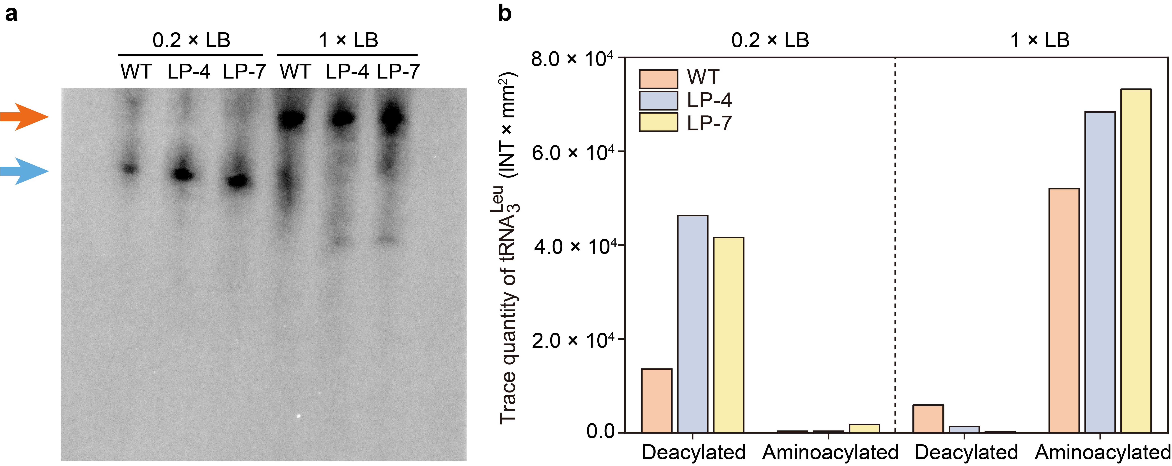
Supplementary Figure 7. The amount and charging levels of ${\text{tRNA}}_{\text{3}}^{\text{Leu}}$. The total tRNA of LP-4, LP-7 and the wild-type strains was extracted from cells grown in both 0.2 × LB and 1 × LB media. The charged (red arrow) and uncharged (blue arrow) forms of ${\text{tRNA}}_{\text{3}}^{\text{Leu}}$ were separated by acid gel (a) and quantified (b).

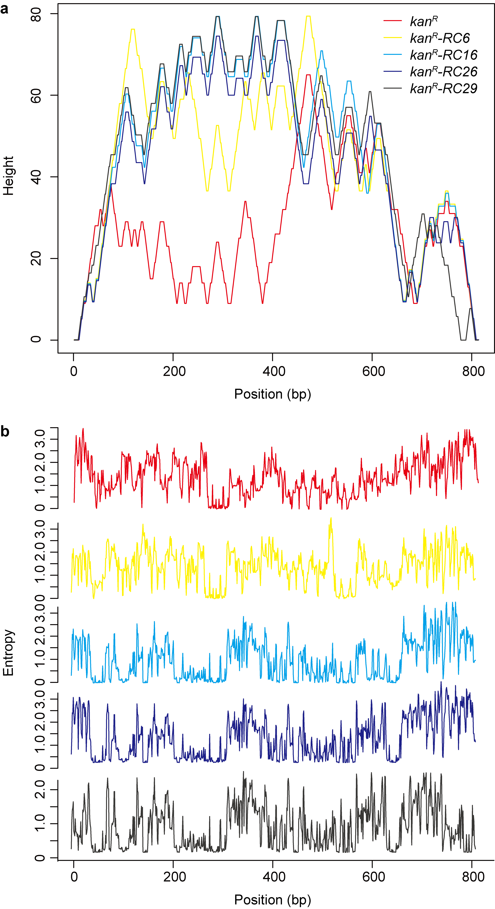
Supplementary Figure 8. Potential secondary structures of the mRNA transcribed from the wild-type kan^{R} and kan^{R}-RCs. The mountain plots represent minimum free energy (MFE) structure³⁻⁵. The heights represent the number of potential base pairs in a defined position, where plateaus, peaks and slopes represent loops, hairpin loops and helices, respectively (a). The positional entropy for each position is presented in (b).
Supplementary Figure 9. The activities of alanine aminotransferase. Values and error bars represent the mean and s.d. (n=3).

Supplementary Table 1 Candidate key mutations related to L-leucine accumulations in the selected mutants
Selected mutants | LP-4 | LP-7
leuE | V79I, S104N, A158T | V79I, S104N, A158T
avtA | P97A, N328D, K353E | P97A, N328D, K353E
ivbL | L6F, P15L | L6F, P15L
ilvC | I103V, G310S, G456A | I103V, G310S, G456A

Supplementary Table 2 The tolerances of the wild-type strain and the selected L-leucine overproducers to the L-leucine analogue L-2-aminobutyric acid
Strains | L-2-aminobutyric acid (g l^{–1})
Strains | 0 | 0.1 | 0.2 | 0.4 | 0.6 | 0.8 | 1.0 | 1.2 | 1.5
WT | + | + | + | + | + | + | + | – | –
LP-4 | + | + | + | + | + | + | + | + | +
LP-7 | + | + | + | + | + | + | + | + | +
"+" indicates cell growth, "–" indicates no growth.

Supplementary References
1. Li G-W, Oh E, Weissman JS. The anti-Shine–Dalgarno sequence drives translational pausing and codon choice in bacteria. Nature 484, 538 (2012).
2. Zuker M, Stiegler P. Optimal computer folding of large RNA sequences using thermodynamics and auxiliary information. Nucleic Acids Res 9, 133-148 (1981).
3. Mathews DH, et al. Incorporating chemical modification constraints into a dynamic programming algorithm for prediction of RNA secondary structure. Proc Natl Acad Sci USA 101, 7287-7292 (2004).
4. Lorenz R, et al. ViennaRNA Package 2.0. Algorithms Mol Biol 6, 26 (2011).
5. Gruber AR, Lorenz R, Bernhart SH, Neuböck R, Hofacker IL. The vienna RNA websuite. Nucleic Acids Res 36, W70-W74 (2008).

