Supplementary Information
An alternative pathway of enteric PEDV dissemination from nasal cavity to intestinal mucosa in swine
Li, et al.
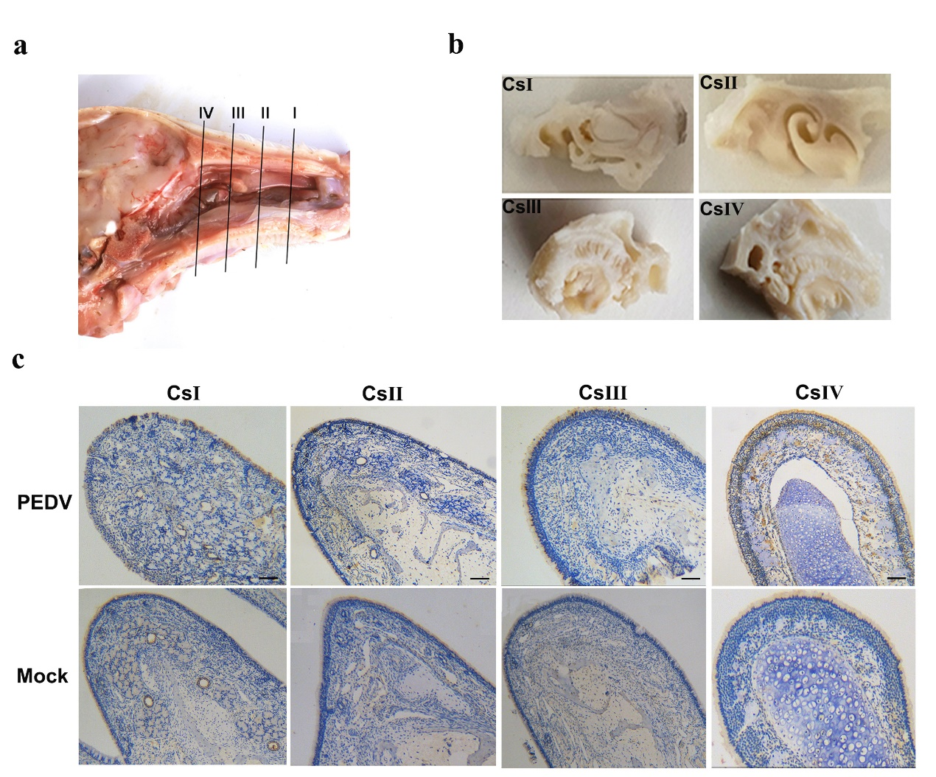
Supplementary Figure 1. PEDV positive epithelial cells were observed in four cross-sections of middle nasal concha. a Diagrams of the four selected cross-sections (I±IV) of the piglet’s nasal cavity. Four cross-sectional blocks were choosed according to structure of pig nasal cavity: the vestibular region (I), regio respiratoria (II, III), and regio olfactoria (IV). b The anatomical structure of the four cross-sections. c Distribution pattern of PEDV in middle nasal concha of piglets’ nasal cavity at low magnifications. Bars: 200 μm.

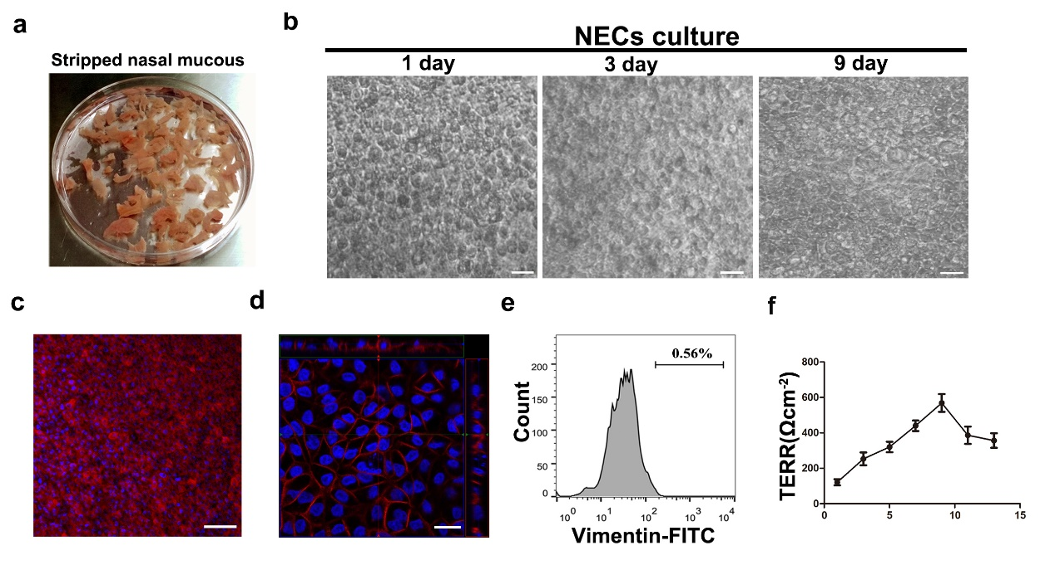
Supplementary Figure 2. Evaluation of NECM establishment. a Stripped nasal mucous. b Air liquid interface was establishing and observing on 1, 3, 9 days after seeding. c Epithelial cells in NECM was staining and observed by CLSM. Keratin 18 was shown in red. Cell nuclei were stained with DAPI (blue). d The cross-sectional images obtained by CLSM showed the distribution of PEDV receptor APN in NECM. APN was shown in red. Cell nuclei were stained with DAPI (blue). e Dissociated cells from NECM detected by the fibroblast cell marker vimentin. Bars: 20 μm. f The transepithelial electrical resistance (TEER) of NECM after seeding. Data express mean ± SD from three samples.

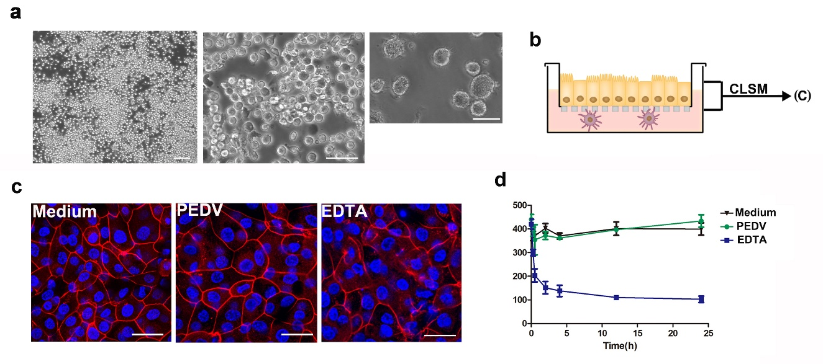
Supplementary Figure 3. Barrier integrity of NMEs monolayer after co-culturing with DCs and PEDV. a Morphology of clusters DCs cells (left), immature (Middle) and mature DCs (right) were analyzed via microscopy after 6 days of culture. b, d After DCs seeding, the co-cultured model was incubated with medium, PEDV, and EDTA (12.5mM). c Tight junction protein ZO-1 (Red) was detected by Immunofluorescence. d TEER was measured using a voltohmmeter at different times. Bars: 20 μm. Data express mean ± SD from three samples.

Supplementary Figure 4. Full western blots. Blots for Figures 1 d(a), and 5e (b).

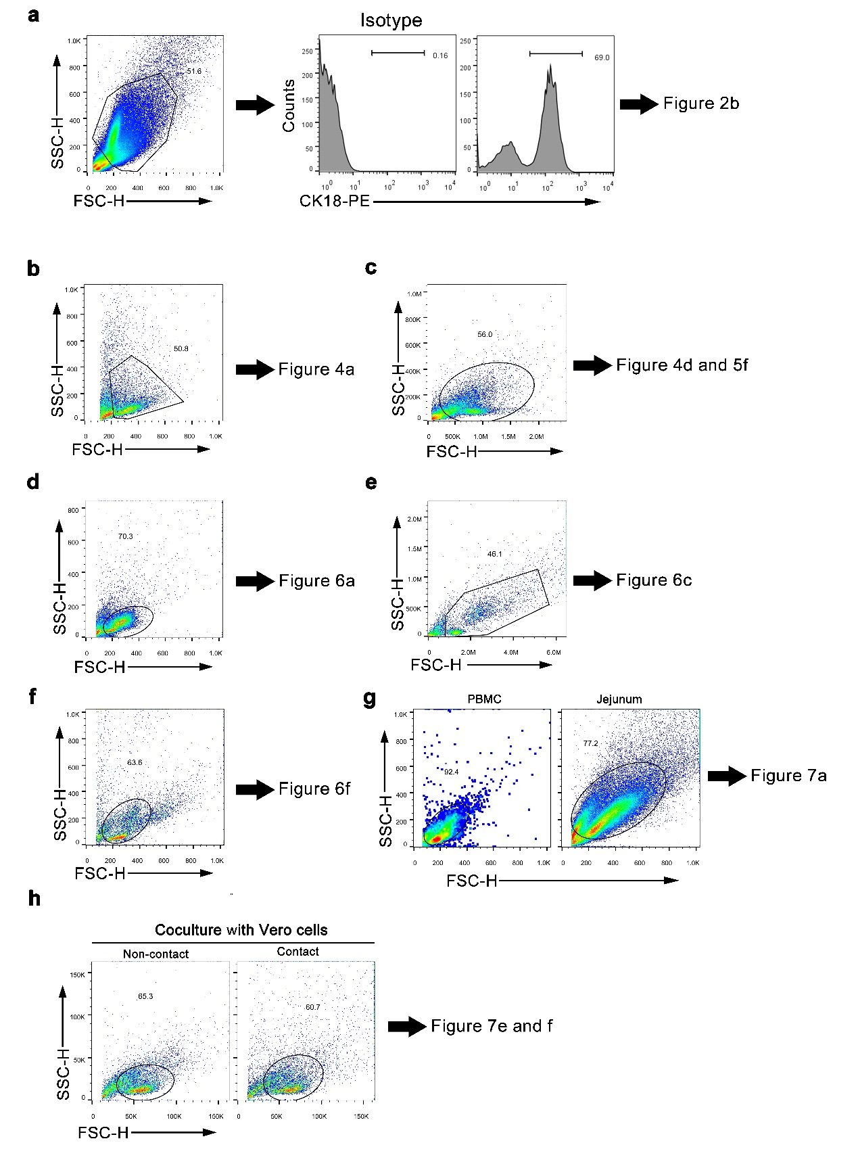
Supplementary Figure 5. Schematic gating strategy of flow cytometry. Gating strategies used for cell sorting. a Relates to Fig. 2b. b Relates to Fig. 4a. c Relates to Fig. 4d and 5f. d Relates to Fig. 6a. e Relates to Fig. 6c. f Relates to Fig. fc. g Relates to Fig. 7a. h Relates to Fig. 7e.
Supplementary Table 1 Primer sequences used for qRT-PCR.
Target genes | Primer sense (5’-3’) | Primer antisense (5’-3’)
PEDV-M | ATGCATGGGCTAGCTTCCAG | GTAGTGAGAAGCGCGTCAGT
CCL4 | GCAAGACCATGAAGCTCTGC | AAGCTTCCGCACGGTGTATG
CXCL2 | CCGTGCAAGGAATTCACCTC | TGCGGGGTTGAGACAAACTT
CCL25 | GCCTACCACAGCCACATTAAG | GCTTCCCGCACACCATCTT
CCL20 | GGTGCTGCTGCTCTACCTCT | GCTGTGTGAAGCCCATGATA
CCL5 | ATCAGCCTCCCCATATGCCT | CCGCACCCATTTCTTCTCTG
CCL3L1 | CTTCCTCGCAAATTCGTAGC | GCATTCAGCTCCAGGTCAG
CCL22 | TTACAGCTGCTCCCTGACAC | TGGATTGGAAGGGTAAGAGG
CCL2 | GCGGCTGATGAGCTACAGAAG | CCGCGATGGTCTTGAAGATC
GAPDH | TCATCATCTCTGCCCCTTCT | GTCATGAGTCCCTCCACGAT

