Supplementary Information

DUSP10 constrains innate IL-33-mediated cytokine production in ST2^{hi} memory-type pathogenic Th2 cells

Yamamoto and Endo et.al

Supplementary Figures
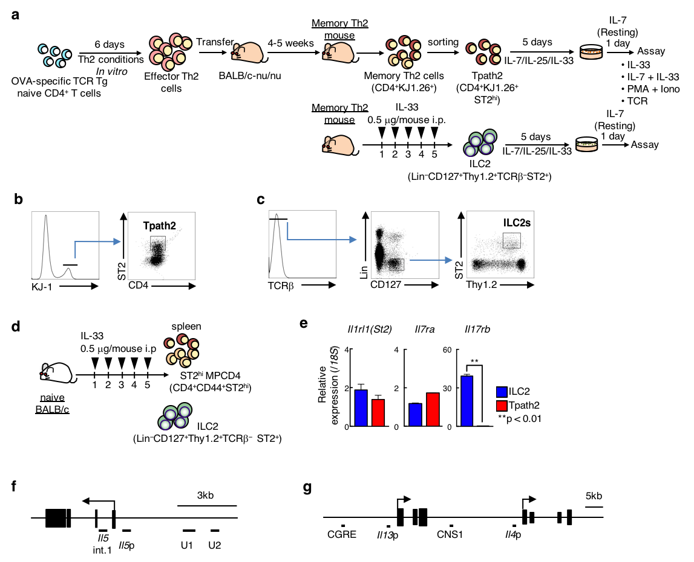

Supplementary Fig. 1. Experimental protocol of ST2^{hi} memory-type pathogenic Th2 cells and ILC2s.
(a) Experimental protocols for the generation of Tpath2 cells and ILC2s. (See also Cell Preparation section in the Methods). After isolation, Tpath2 cells and ILC2s were cultured with IL-7, IL-25 and IL-33 for 5 days, and then with IL-7 alone for 24 hours before assays were performed. (b) The gating strategy of Tpath2 cells is shown. Splenic cells recovered from memory Th2 mice were stained with anti-CD4-APC, anti-KJ1-FITC and anti-ST2-Bv421 antibodies. CD4⁺KJ1⁺ST2⁺ cells were purified as Tpath2 cells by fluorescence activated cell sorting (FACS). (c) The gating strategy of ILC2s cells is shown. After pre-sorting by autoMACS, splenic CD4-negavite cells from IL-33-treated-BALB/c or -memory Th2 mice were stained with anti-TCRβ-PE, anti-Lineage cocktail (containing FITC-conjugated antibodies specific for CD3, Gr-1, CD11b, B220, or Ter119, anti-CD127-APC, anti-Thy1.2-PE/Cy7 and anti-ST2-Bv421 antibodies). Consequently, Lin⁻CD127⁺Thy1.2⁺ST2⁺TCRβ⁻ cells were then isolated as ILC2s by FACS. (d) Experimental protocol of generation of ST2^{hi} Memory phenotype CD4⁺ T (ST2^{hi} MPCD4) cells and ILC2s from naïve BALB/c mice. Recombinant mouse IL-33 0.5 μg was injected intraperitoneally to each mouse for consecutive 5 days. Then, ILC2s and ST2^{hi} MPCD4 cells were simultaneously isolated from the spleen. (e) Quantitative RT-PCR analysis of surface molecules in ILC2s and Tpath2 cells. Relative expression (normalized to 18S) is shown with standard deviations. (f) Schematic representation of the murine Il5 gene loci. The locations of primers and probes (upstream region 2 [U2] to Il5 intron 1 [Il5 int .1]) and exons are indicated. (g) Schematic representation of the murine CGRE, Il13p, CNS1 and Il4p locus. More than five independent experiments were performed and showed similar results (e).

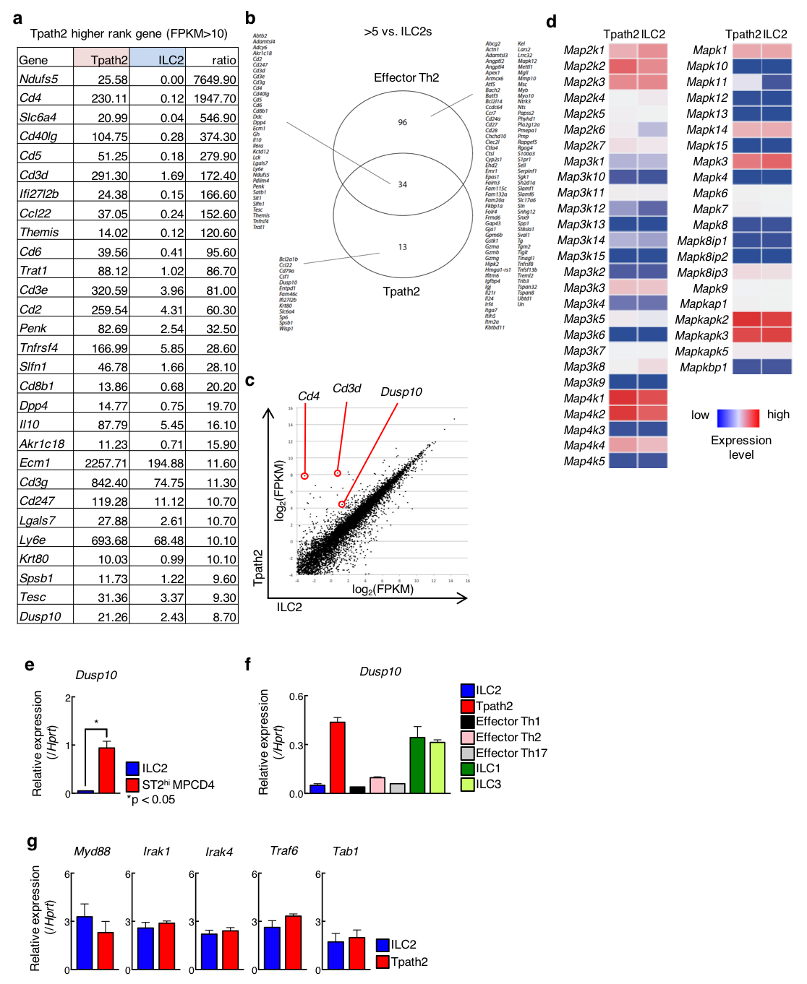

Supplementary Fig. 2. Selected gene expression profiles from RNA-seq dataset in Tpath2, ILC2s and Effector Th2 cells.
(a) The table shows top ranked genes expressed more highly in Tpath2 cells than ILC2s. Transcripts expressed above 10 FPKM in Tpath2 cells were used. (b) Venn diagram shows the overlap of genes in Tpath2 cells and effector Th2 cells at the steady state. Genes expressed more than 5 fold higher in Tpaht2 cells and effector Th2 cells as compared to ILC2s are shown. (c) Scatter plot of RNA-seq expression analysis showing a comparison of read counts between Tpath2 cells (Y axis) and ILC2s (X axis) with logarithmic scales. (d) A heatmap of the genes encoding members of MAP kinase family in Tpath2 cells and ILC2s. (e) Quantitative RT-PCR analysis of Dusp10 in ST2^{hi} MPCD4 T cells and ILC2s from naïve BALB/c mice. Cell preparation protocol was same as shown in Supplementary Fig. 1d. (f) Quantitative RT-PCR analysis of Dusp10 in ILCs and effector Th cells. (See also Cell Preparation in the Methods). (g) Quantitative RT-PCR analysis of indicated genes of intracellular molecules related to IL-33–ST2 signaling pathway in ILC2s and Tpath2 cells. (e-g) More than three independent experiments were performed and showed similar results. (*p<0.05). Three technical replicates were included in quantitative RT-PCR analysis.

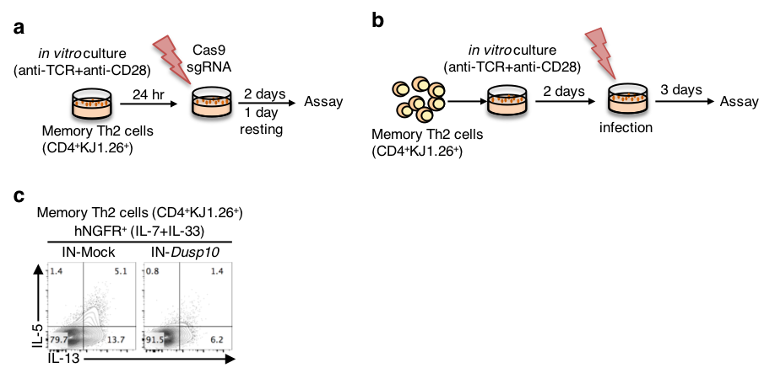

Supplementary Fig. 3. DUSP10 specifically and negatively regulates IL-33–induced IL-5 production in Tpath2 cells.
(a) Experimental protocol of CRISPR/Cas9-mediated gene editing of Dusp10 in memory Th2 cells. Whole memory Th2 cells were stimulated with anti-CD3 and anti-CD28 and cultured with IL-7, IL-25 and IL-33. After 24 hrs of stimulation, we performed electroporation-based strategy to deliver Cas9/sgRNA. Then, cells were cultured with IL-7, IL-25 and IL-33 for 2 days and after 1day resting with only IL-7, assays were performed. (b) Experimental schema of the overexpression of Dusp10 in memory Th2 cells. Whole memory Th2 cells were stimulated with anti-CD3 and anti-CD28 and cultured with IL-2. On day 2, retroviral vector transfections were performed. Cells were transfected with MOCK and DUSP10. (c) Intracellular-staining profiles of IL-5 and IL-13 of hNGFR⁺-infected memory Th2 cells after stimulation with IL-7 plus IL-33 for 6 hrs on day5.

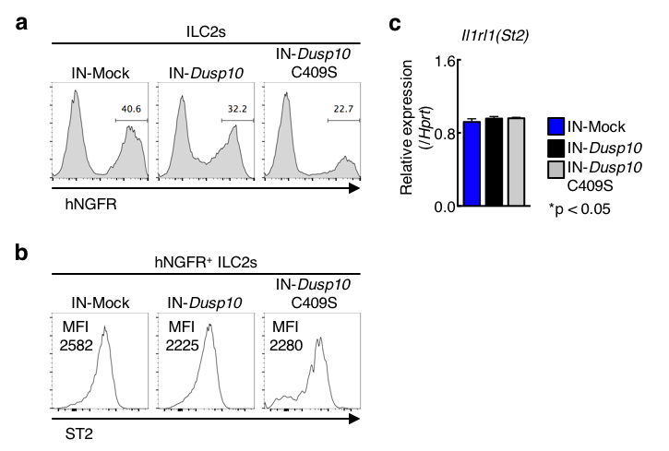

Supplementary Figure 4. Dusp10 suppresses IL-5 production in ILC2s.
(a-c) Freshly prepared ILC2s from normal BALB/c mice (cell preparation protocol is shown in Supplementary Fig 1c) were infected with a Mock (empty vector), Dusp10, or C409S mutant-IRES-hNGFR-containing retrovirus and then cultured with IL-7, IL-25 and IL-33. Five days after infection, hNGFR expression was analyzed (a). The hNGFR-positive, Dusp10-overexpressing ILC2s were enriched by cell sorting. Cell surface ST2 expression (b) and mRNA expression of Il1rl1 (c) were analyzed. Three independent experiments were performed with similar results.
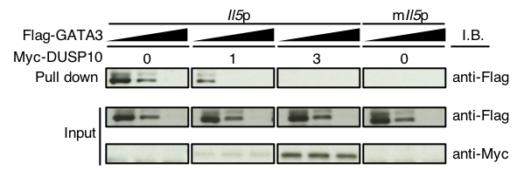

Supplementary Fig. 5. DUSP10 suppresses the DNA binding activity of GATA3.
293 T cells were transfected with Myc-tagged DUSP10 and Flag-tagged GATA3, and total extracts were subjected to a pull-down assay using WT or mutant Il5 promoter oligonucleotide as described in the Methods. Immunoblotting of total cell lysates is also shown (Input). Band intensities were measured with a densitometer and arbitrary densitometric units are shown. Two independent experiments were performed with similar results.

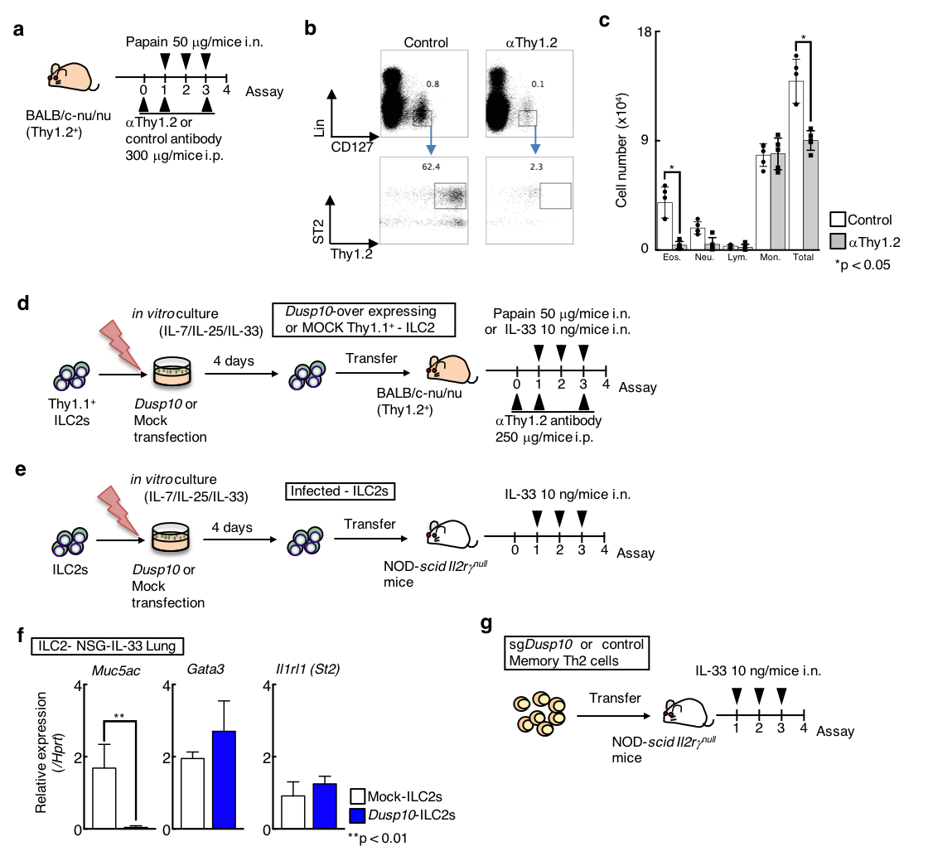

Supplementary Fig. 6. IL-33-induced airway inflammation model.
(a) Experimental protocols for the depletion of intrinsic ILC2 in papain-induced airway inflammation mouse model using Thy1.2 antibody. (b) Cell surface expression profiles of Thy1.2 and ST2 on Lin⁻CD127⁺ cells from the lung of isotype control antibody (Control) or anti-Thy1.2 antibody groups (αThy1.2). Two independent experiments were performed and showed similar results. (c) The absolute cell number of eosinophils (Eos.), neutrophils (Neu.), lymphocytes (Lym.), and monocytes (Mon.) in the BAL fluid from BALB/c nu/nu mice shown in Supplementary Fig. 6a. Mean values (5 mice per group) are shown with standard deviations (*p<0.05). (d and e) Experimental protocols for papain and IL-33–induced airway inflammation models (See also In vivo Experiment section in the Methods). (f) Quantitative RT-PCR analysis of Muc5ac, Gata3 and Il1rl1 in the lung from Mock-ILC2s and Dusp10-ILC2s transferred NSG mice. (g) Experimental protocols for IL-33–induced, Tpath2 cell-dependent airway inflammation model. CRISPR/Cas9-mediated Dusp10 deficient Tpath2 cells were transferred into NOD-SCID Il2rg^{null} (NSG) mice. These mice received IL-33 intranasally three times (See also In vivo Experiment section in the Methods).
Supplementary Fig. 7
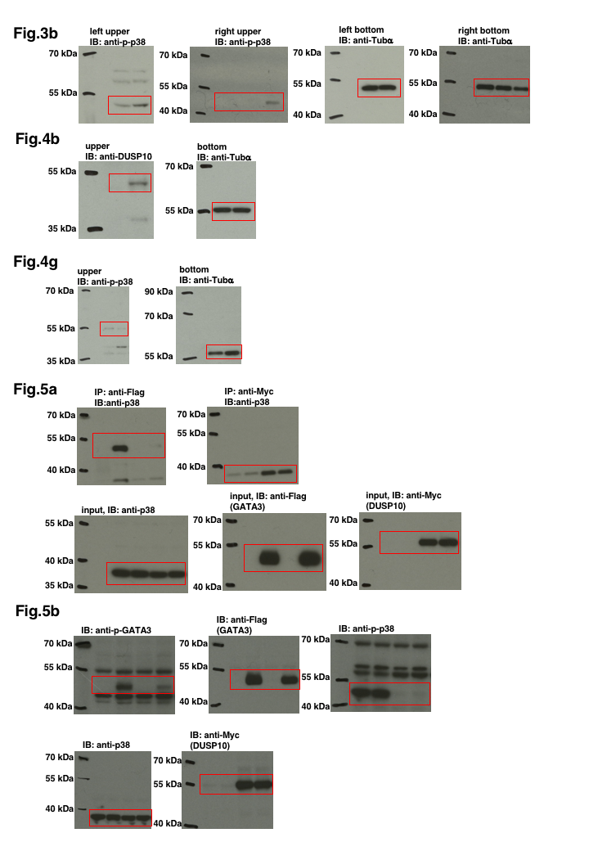
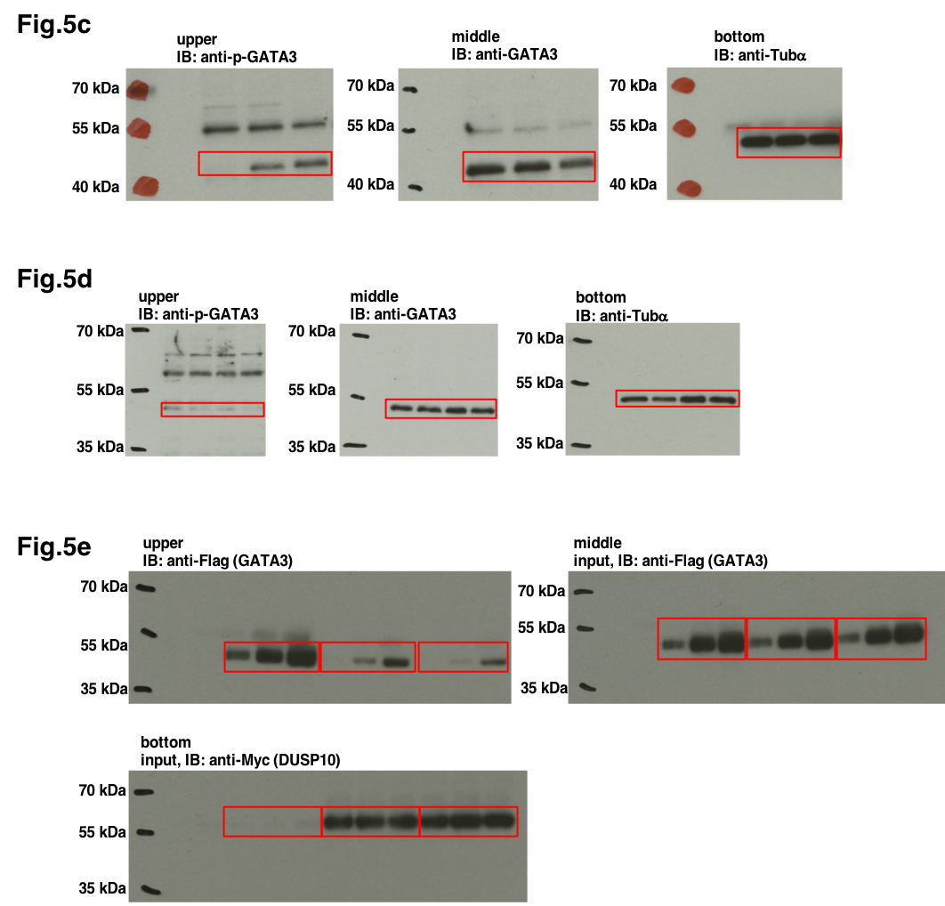
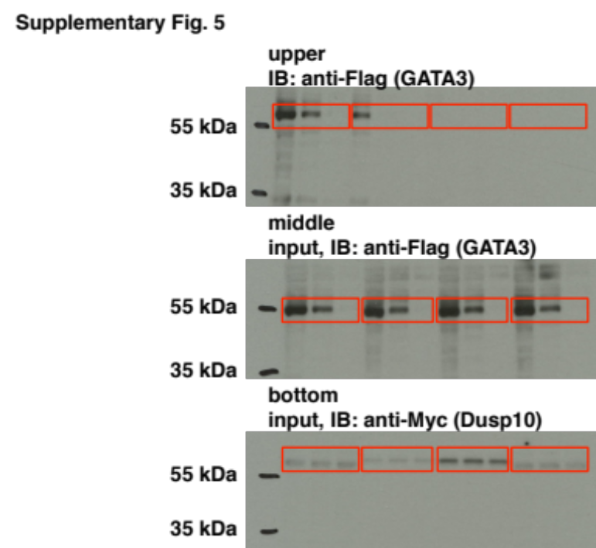

Uncropped scans of western blots are shown with labeled and molecular weight ladder.

Supplementary Table 1. Mouse quantitative RT-PCR primer sequences
Specific primers and Roche Universal Probes used in quantitative reverse transcriptase PCR for mouse genes were as follows.
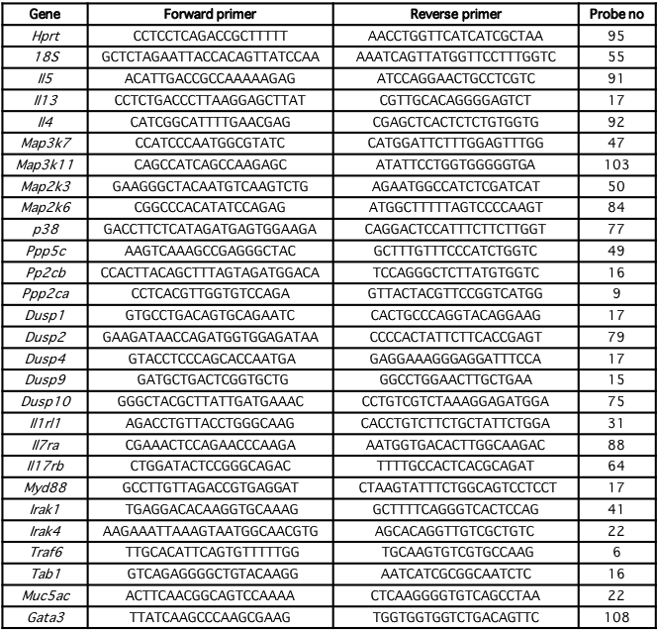

Supplementary Table 2. ChIP-qPCR primer sequences
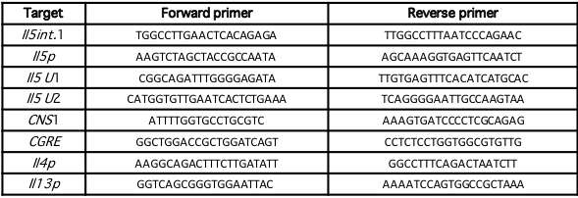

Supplementary Table 3. Primers used for DNA pull-down assay

GATA3 consensus: 5’ CACTTGATAACAGAAAGTGATAACTCT 3’
Wt Il5p: 5’ CCTCTATCTGATTGTTAGCA 3’
MutIl5p: 5′CCTCTATCTGATTAATAGCA 3′

Supplementary Table 4. List of Commercial antibodies

