Megadomains and superloops form dynamically but are dispensable for X-chromosome inactivation and gene escape

Froberg et al.,

SUPPLEMENTARY FIGURES

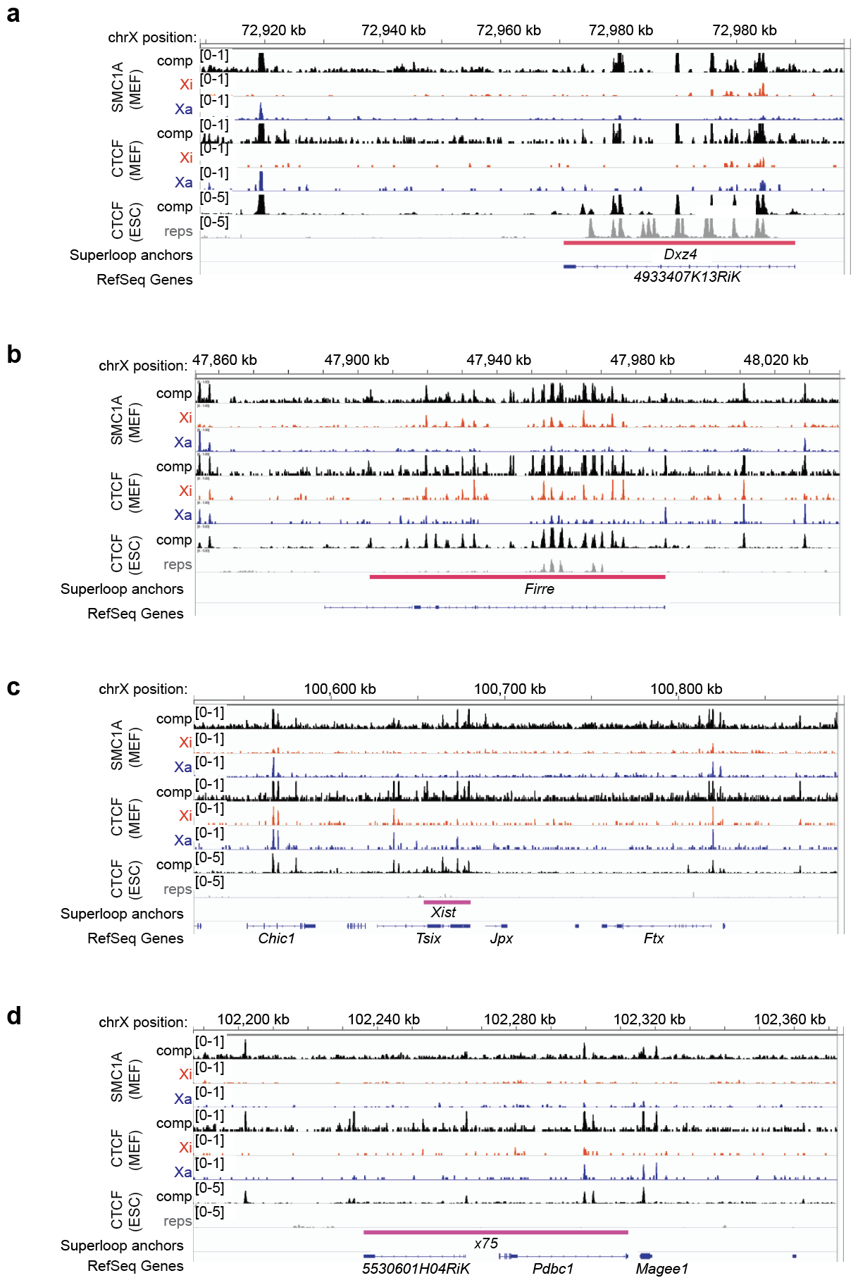
Supplementary Figure 1: Superloop anchors are tandem repeats that bind CTCF and SMC1A on the mouse Xi.
SMC1A and CTCF ChIP-seq coverage across the superloop anchors in mouse (a) Dxz4, (b) Firre, (c) The X-Inactivation Center, and (d) x75. From top to bottom within a panel: SMC1A ChIP-seq in MEF, black=comp (all unique reads including neutral, cas, and mus), blue=Xa, red=Xi, CTCF ChIP-seq in MEF (same color scheme), CTCF ChIP-seq in mESCs, black=comp, grey=repetitive alignments.

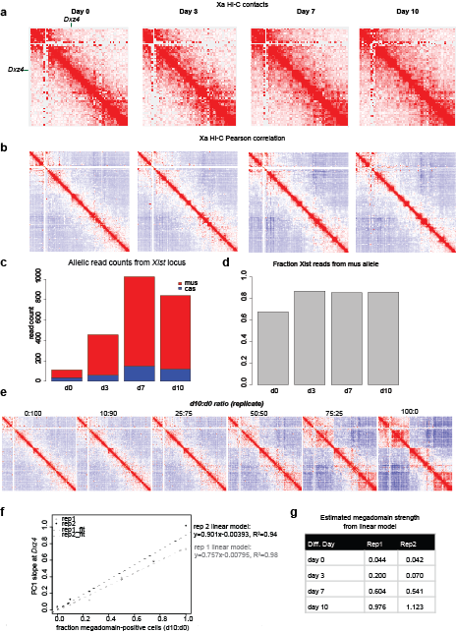
Supplementary Figure 2: Megadomains are not present on the Xa and allelic RNA-seq shows Xist upregulation is highly skewed to Xi.
a KR-normalized Hi-C matrices on future Xa (cas) on days 0, 3, 7,10 of differentiation (2.5 Mb resolution). b Pearson correlation of Hi-C matrix on future Xa (cas) on days 0, 3, 7, 10 of differentiation (1Mb resolution). c Numbers of Xist reads expressed from the mus (red) or cas (blue) during differentiation. d Fraction of allelic Xist reads expressed from X^{mus} (carrying the Tsix^{TST} allele) during differentiation, in two biological replicates. e Replicate mixing experiment. Pearson correlation of Hi-C matrices at 1 Mb (bottom) for the Xi from data sets generated by mixing an indicated ratio of day 0 (d0, megadomain-negative) and day 10 (d10, megadomain-positive) datasets. This mixing experiment uses data from replicate 1 of the timecourse experiments. f Slope of the PC1 score curve at Dxz4 for Hi-Cs generated with varying ratios of d10:d0 reads. Grey: mixing experiment performed with replicate 1 of the timecourse Hi-Cs; black: mixing experiment performed with replicate 2 of the timecourse Hi-Cs. Dashed lines represent linear best fits; linear model (slope ~ fraction megadomain positive) parameters are included. g Estimated megadomain strength for each day in each replicate from the linear models generated in Fig. S2f.

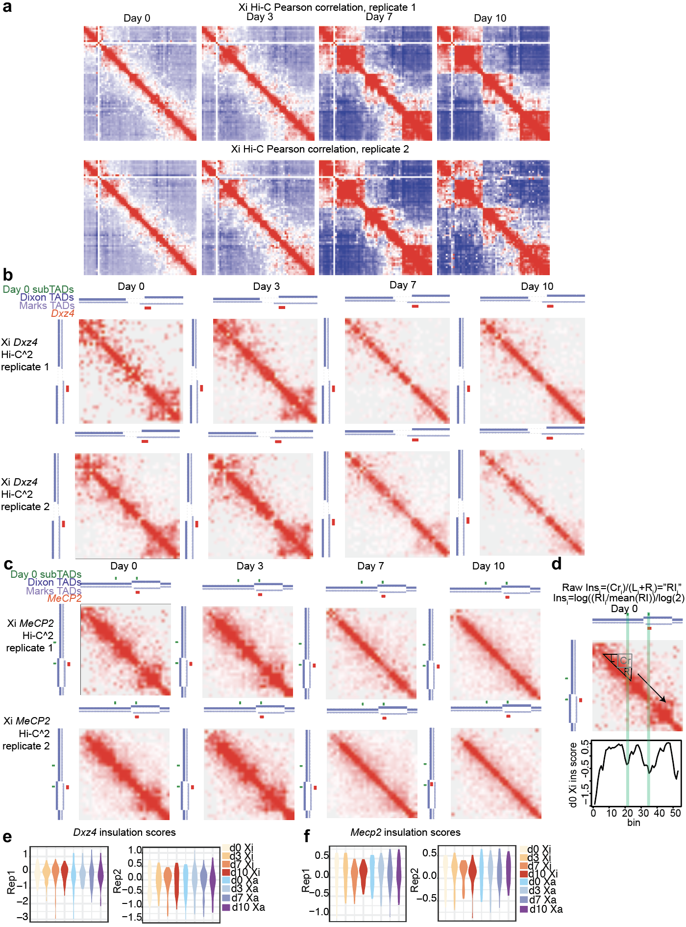
Supplementary Figure 3: Biological replicates of the time course Hi-C and Hi-C^2 experiments.
a Pearson correlation matrices at 2.5 Mb resolution for the Xi (right) days 0, 3, 7, 10 of differentiation in two biological replicate Hi-C experiments. b Hi-C^2 contact maps around Dxz4 (mm9 coordinates chrX:71,832,976-73,511,687) and on the Xi on days 0, 3, 7, 10 of differentiation (50 kb resolution) in two biological replicates. c Hi-C^2 contact maps around Mecp2 (mm9 coordinates chrX:70,370,161-71,832,975) and on the future Xi on days 0, 3, 7, 10 of differentiation (50 kb resolution) in two biological replicates. In b and c, Green bars indicate positions of domain borders determined from 25 kb d0 comp Hi-C^2 matrices; dark blue track shows Dixon et al. TAD calls in mESCs, light blue track shows Marks et al. TAD calls in mESCs, red bars indicate positions of either Dxz4 or Mecp2. (d) Conceptual diagram of insulation score. Top: formula for calculating insulation score at region i. R_{i} refers to the sum of interactions within the region to the right of i, L_{i} refers to the sum of interactions within the region to the left of i, and Cr_{i} represents the sum of interactions that “cross over” i. Middle: diagram of the window used to calculate insulation score for an example (non-border) i in the day 0 Xi Mecp2 contact map. Bottom: plot of insulation score across the day 0 Xi Mecp2 region. The shaded green bars indicate the positions of the borders of the Mecp2 sub-TADs across all diagrams. e, f Violin plots showing the distributions of insulation scores across the Dxz4 region (e) and Mecp2 region (f) in both biological replicates. Note: to generate violin plots and evaluate the significance of differences in variance between timepoints we excluded the 6 bins on each edge of the Hi-C^2 region because the regions needed to calculate insulation score fall partly outside the Hi-C^2 region and have far lower read counts than sequences targeted by the capture probes.

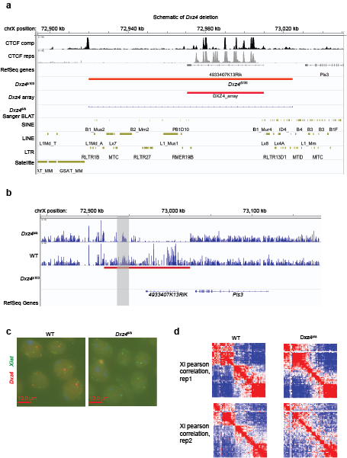
Supplementary Figure 4: Validation of Dxz4 deletion and replicate Hi-C.
a Scheme of the Dxz4 deletion. The large red bar shows the region deleted in this study; the smaller red bar shows the coordinates of the Dxz4 tandem repeat array. Interspersed repeats are shown in gold, and CTCF ChIP-seq in mESCs is shown in black for all unique reads and grey for all repetitive reads. The “∆Dxz4 Sanger BLAT” track is the BLAT result for Sanger sequencing result from the PCR product generated with primers flanking the deleted region. b Hi-C coverage over the Dxz4 deletion region for Dxz4∆/∆ clone E5 (top) and WT (bottom). The near-absence of reads in Dxz4∆/∆ over the deletion implies a biallelic deletion. Note: we observed reads in Dxz4∆/∆ within the left end of the deletion (grey box), roughly chrX:72,940,913-72,948,483. BLAT analysis of this region indicates that it is repeated several times elsewhere in the genome (data not shown), thus reads within this region are to be expected even in Dxz4∆/∆. c DNA FISH in WT (left) and Dxz4∆/∆ (right) using either Dxz4 (red) or Xist (green) probes. d Pearson correlation matrices at 2.5 Mb resolution for the wild-type (left) and Dxz4∆/∆ Xi (right) in two biological replicate Hi-C experiments. Note: the WT control Hi-C in replicate 2 in this figure also serves as the replicate 2 day 10 timepoint in FigS3a, thus this Pearson correlation matrix is present in both FigS3a and this figure.

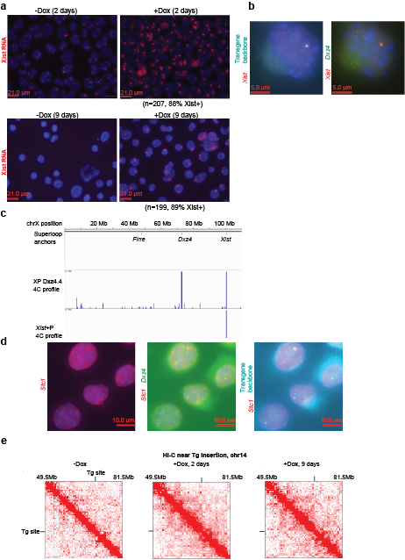Supplementary Figure 5: Generation of a Xist+Dxz4 transgene.
a Xist RNA FISH in Xist+Dxz4 Tg cells (clone XPDxz4.4) +/-Dox after either 2 days of induction (top) or 9 days of induction (bottom panels). The total number of cells and percentage of Xist-positive cells are listed. b Co-localization between transgenic Xist and Dxz4. Left, DNA FISH for the transgene’s P1 backbone (cyan)+Xist (red). Right: DNA FISH for Xist (red) and Dxz4 (green). c 4C contact profiles in XPDxz4.4 or a separate Xist-only transgenic cell line (XY X+P) on chrX from a viewpoint within the backbone of the Xist construction. The positions of Firre, Dxz4 and Xist are indicated on the X-chromosome. d Co-localization between Xist and Dxz4 and the candidate insertion region (Stc1, chr14) obtained from 4C. Left: DNA FISH for Stc1 (red). Middle: overlap between DNA FISH for Stc1 (red) and Dxz4 (green). Right: overlap between DNA FISH for Stc1 (red) and the Xist transgene’s P1 backbone (cyan). e Contact maps in the vicinity of the transgene insertion site on chr14 (500kb resolution).

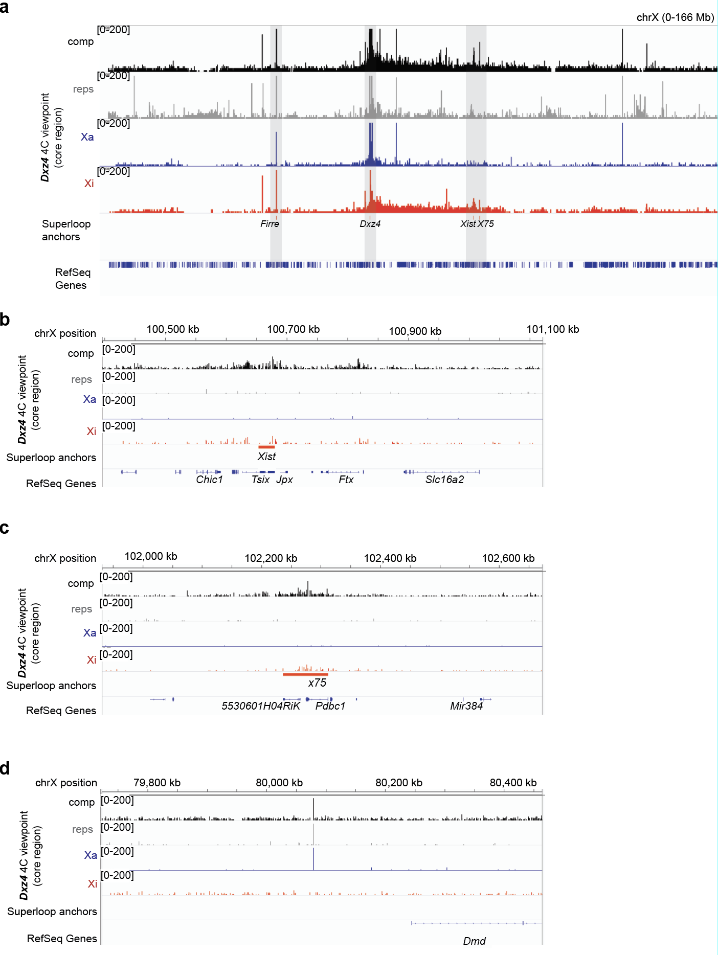
Supplementary Figure 6: A conserved network of superloop interactions involving Dxz4 on the mouse Xi.
a 4C coverage from the Dxz4 viewpoint over the whole X in mus Xi MEFs. Black=comp, grey=reps, blue=Xa, red=Xi. The positions of putative superloop anchors Firre, Dxz4, Xist and x75 are shown. b 4C coverage from the Dxz4 viewpoint over the Xist region. c 4C coverage from the Dxz4 viewpoint over the region homologous to human x75 in mouse. d 4C coverage from the Dxz4 viepoint over a putative singleton artifact near Dmd. Many of the other large peaks on the X or elsewhere are “singletons”, amplified sequences likely due to mispriming, this is an example of a singleton.

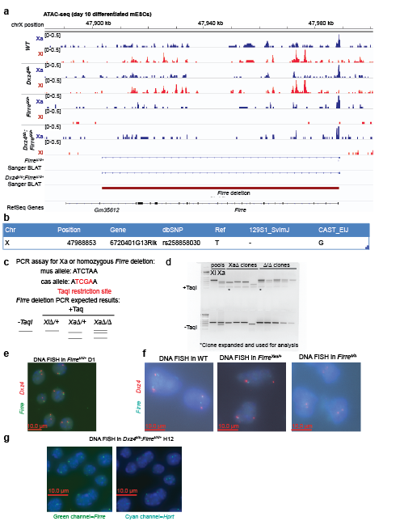

Supplementary Figure 7: Validation of Firre deletions.
a Allele-specific ATAC-seq coverage over Firre. The coordinates of the Firre deletion are shown by the dark red bar, and the two “Sanger BLAT” tracks represent the coordinates of the BLAT alignment of the PCR products flanking Firre generated from Firre^{Xi∆/+} clone D1 and Dxz4∆/∆:Firre^{Xi∆/+} clone H12. b SNP information from the Mouse Genomes Project⁵⁷ for the SNP that falls within the Firre deletion amplicon. c Scheme of restriction assay to determine which allele of Firre is deleted. d Results of restriction assay in Xa- and Xi- Firre targeted pools and Firre^{Xa∆/+} and Firre∆/∆ candidate clones. e DNA FISH in Firre^{Xi∆/+} clone D1 for Dxz4 (red), and Firre (green). f DNA FISH for Dxz4 (red) and Firre (cyan) in WT, Firre^{Xa∆/+} and Firre∆/∆ clones. In Firre^{Xi∆/+} and Firre^{Xa∆/+} most cells exhibit one Firre spot but two Dxz4 spots, consistent with a heterozygous Firre deletion, whereas Firre∆/∆ does not exhibit Firre spots, consistent with a homozygous Firre deletion. g DNA FISH in Dxz4∆/∆:Firre^{Xi∆/+}. Left, Firre (green). Right, X-linked gene Hprt (Cyan). Most cells exhibit one Firre spot but two Hprt spots, consistent with a heterozygous Firre deletion.

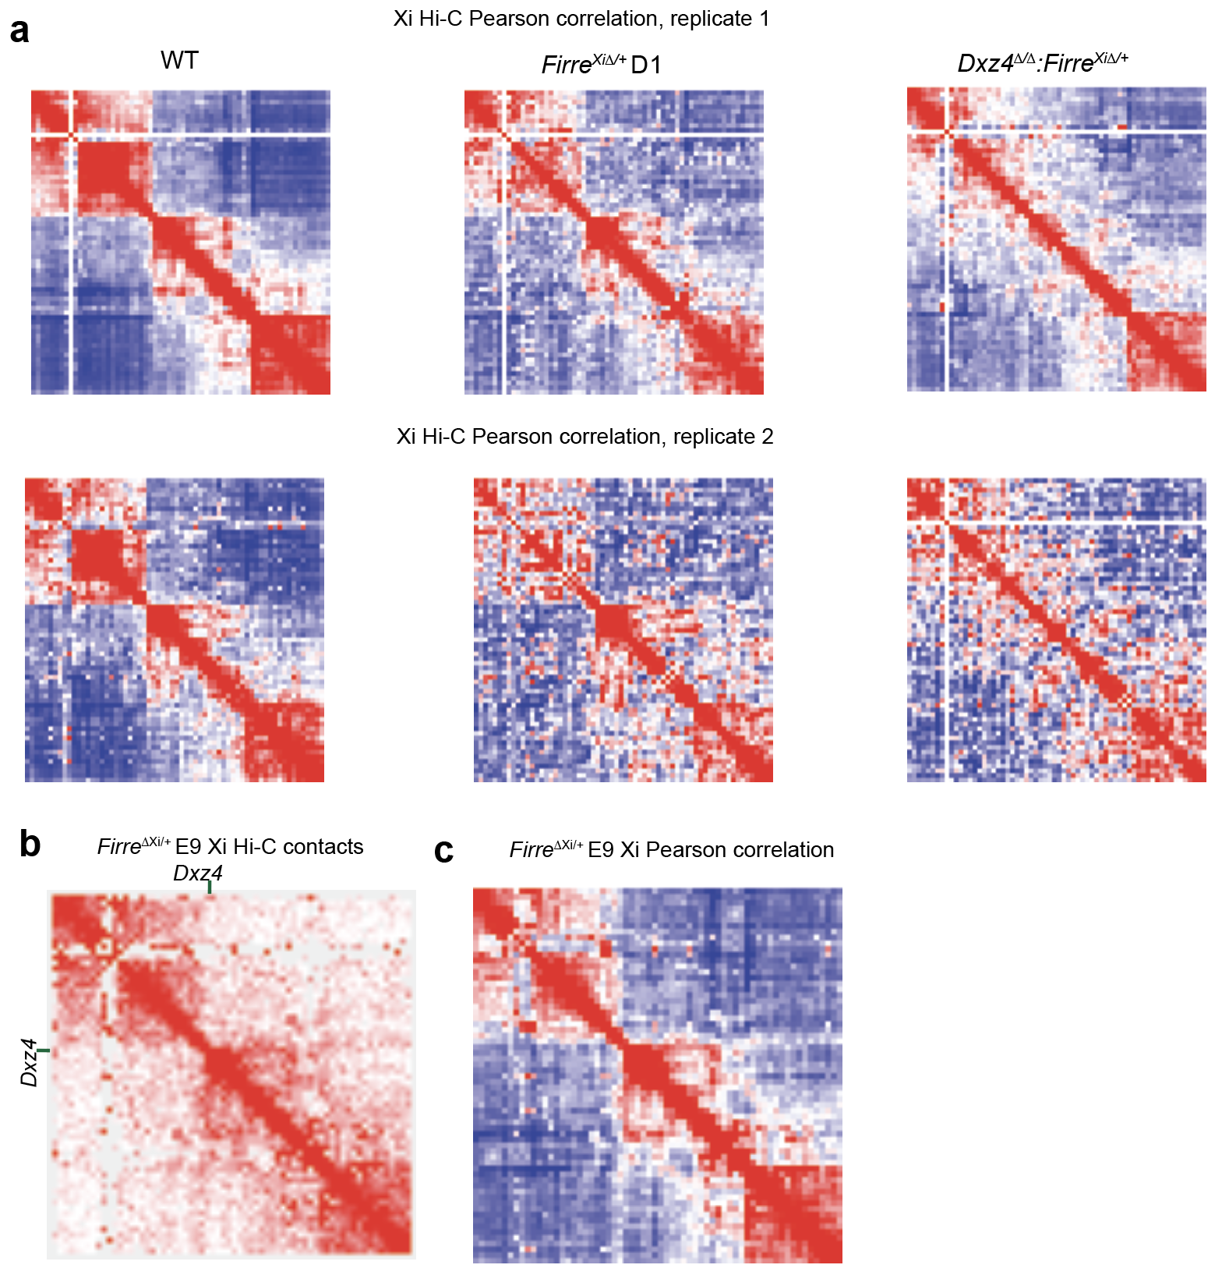

Supplementary Figure 8: Replicate Hi-Cs in Firre deletions.
a Pearson correlation matrices at 2.5 Mb resolution for the wild-type (left) and Firre^{Xi∆/+} (middle, clone D1) and Dxz4∆/∆:Firre^{Xi∆/+} Xi (right) in two biological replicate Hi-C experiments. Note: the WT control Hi-C in replicates 1 and 2 in this figure also serve as the replicates 1 and 2 day 10 timepoints in Fig. S3a, thus these Pearson correlation matrices are present in both FigS2a and the current figure. b KR-normalized Hi-C matrix for the independently derived Firre^{Xi∆/+} clone (E9) at 2.5 Mb resolution. c Pearson correlation matrix for the independently derived Firre^{Xi∆/+} clone (E9) at 2.5 Mb resolution.

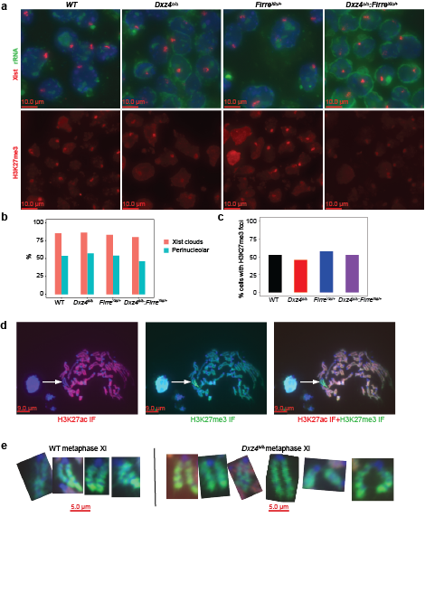Supplementary Figure 9: Further analysis of Xist localization and H3K27me3 distribution in Dxz4 and Firre deletions.
a Xist RNA FISH (red) combined with rRNA FISH (green) (top), H3K27me3 IF (red, bottom) in WT and Dxz4∆/∆ Firre^{Xi∆/+} and Dxz4∆/∆:Firre^{Xi∆/+} cells on day 10. b Fraction of cells with Xist clouds (red) and fraction of Xist clouds in the perinucleolar space (cyan) on day 10. c Fraction of cells with an H3K27me3 focus on day 10. d Immunoflourescence for H3K27ac (red, left) or H3K27me3 (green, middle) on metaphase spreads from WT cells after 10 days of differentiation. The Xi is readily detectable as the one chromosome in the spread depleted of H3K27ac and enriched in H3K27me3 (merge, right). e Coating of H3K27me3 on several metaphase inactive Xs in WT (left) or Dxz4∆/∆ (right) on day 10.

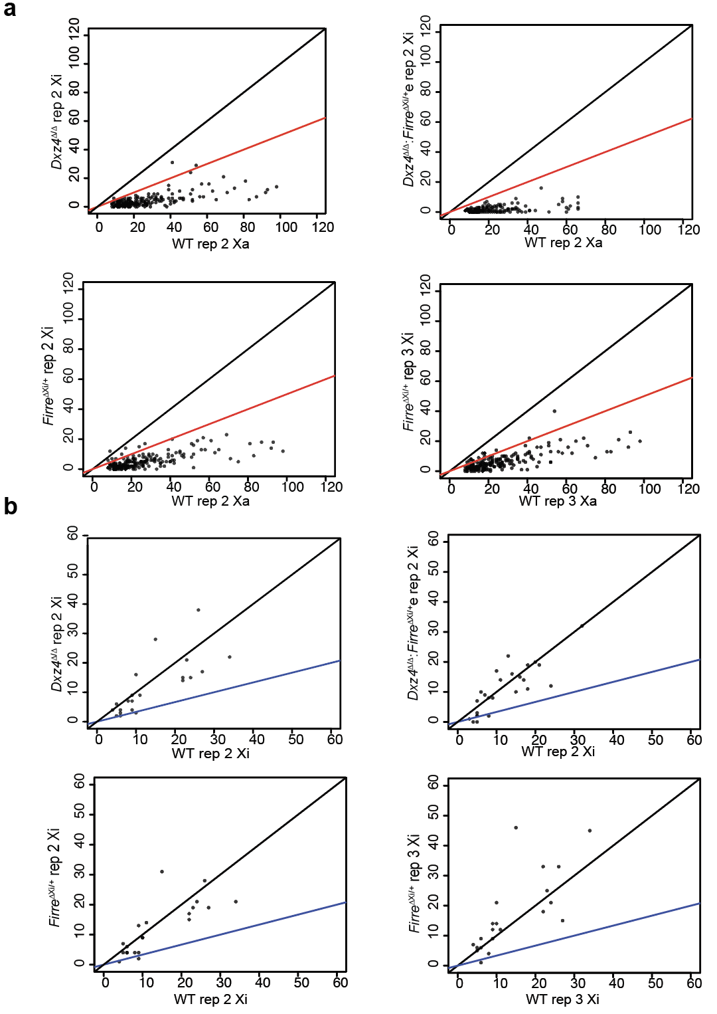Supplementary Figure 10: Replicate ATAC-seq analysis in FirreXi^{∆/+} and Dxz4∆/∆:Firre^{Xi∆/+}.
a Comparison between WT Xa and mutant Xi for ATAC coverage for peaks that are Xa-specific in wild-type for replicate ATAC-seqs. Top left: Dxz4∆/∆ Xi vs WT Xa, top right: Dxz4∆/∆:Firre^{Xi∆/+} Xi vs WT Xa, Bottom left: Firre^{Xi∆/+} Xi vs WT Xa, replicate 2, Bottom left: Firre^{Xi∆/+} Xi vs WT Xa, replicate 3. Black lines corresponds to a Dxz4∆/∆ Xi:WT Xa ratio of 1:1, red lines corresponds to a ratio of 1:2. b Comparison between WT Xa and mutant Xi ATAC coverage for peaks that are Xi-specific in wild-type for replicate ATAC-seqs. Top left: Dxz4∆/∆ Xi vs WT Xi, top right: Dxz4∆/∆:FirreXi^{∆/+} Xi vs WT Xi, Bottom left: Firre^{Xi∆/+} Xi vs WT Xi, replicate 2, Bottom left: Firre^{Xi∆/+} Xi vs WT Xi, replicate 3. Black lines correspond to a Dxz4∆/∆ Xi:WT Xi ratio of 1:1, blue lines correspond to a ratio of 1:2.

Supplementary Table 1: guide RNAs used in this study.

Name | Sequence | mm9 Coordinates | Target
Firre_mus_right | TCCTAGAGACGCCCTcACGG | chrX:47988639-47988658 | Firre, 129/mus allele, upstream of Firre promoter
Firre_mus_left | AAACACTAGCACGGACgCTC | chrX:47903516-47903531 | Firre, 129/mus allele, downstream of Firre 3' UTR
Firre_cas_right | TCCTAGAGACGCCCTgACGG | chrX:47988639-47988658 | Firre, 129/mus allele, upstream of Firre promoter
Firre_cas_left | AAACACTAGCACGGACaCTC | chrX:47903516-47903531 | Firre, 129/mus allele, downstream of Firre 3' UTR
Dxz4∆100_left | GGTGGGTGCTTTTACCCACG | chrX:72919855-72919874 | Dxz4, adjacent to large CTCF peak DS-TR
Dxz4∆100_right | GCTAGCTCCACTCCTATTGGT | chrX:73024482-73024501 | Dxz4, upstream of Dxz4

Note: Lowercase letters represent allele-specific positions of Firre gRNAs.

Supplementary Table 2: DNA FISH probes

Target | Type | Source | BAC or fosmid ID | mm9 coordinates
Dxz4 | fosmid | CHORI | WIBR1-0428I12 | chrX:72972712-73013287
Firre | fosmid | CHORI | WIBR1-0755K22 | chrX:47917649-47961442
Stc1 | BAC | CHORI | RP24-340H12 | chr14:69487669-69694814
Xist | plasmid | Lee Lab (Erwin et al., 2012, PMID: 22942124) | Sx9, available from Lee Lab | chrX:100679268-100650410
Tg backbone | plasmid | Lee Lab (Chu et al., 2017, PMID: 28692038) | P1-puromycin plasmid, available from Lee Lab | NA (derived against P1 backbone)

Supplementary Table 3: 4C oligonucleotides used in this study.

 |  | 4C viewpoint primers
Name | Viewpoint | Sequence | 1st enzyme | 2nd enzyme
p706-Dpn2 | Dxz4 core | /5Biosg/CCT ACA CGA CGC TCT TCC GAT CTT GGG TGG AGT GCA GTG TTG AGA CA | DpnII | FatI
p711-Dpn2 | Sphinx core | /5Biosg/CCT ACA CGA CGC TCT TCC GAT CTC TKC TCC TCA GCC ATT TTG AAG C | DpnII | FatI
p710-Dpn2 | Sphinx 3' | /5Biosg/CCT ACA CGA CGC TCT TCC GAT CTC AGA GGC CAA TGT GTA GGC | DpnII | FatI
Hygro_4C_DpnIIprimer | Hygro marker in Xist Tg backbone | /5Biosg/ccctacacgacgctcttccgatctNNNNGAGCAGCAGACGCGCTACTT | DpnII | FatI
 |  | 4C adaptors and primers for ligation-mediated PCR
Name | Description | Sequence
p637-FatI6N-TSad2 | adaptor top strand for FatI-digested libraries | /5Phos/CAT GNN NNN NAG ATC GGA AGA GCA CAC GTC TGA ACT C
p640-rc6N-TSad2 | adaptor bottom strand for 4C adaptors | GCT CTT CCG ATC TNN NNN N/3Phos/
p521-TruSeq2rc | Library primer for ligation-mediated PCR; to be used with the biotinylated viewpoint primer | GAG TTC AGA CGT GTG CTC TTC CGA TCT

Supplementary Table 4: qRT-PCR primers used in this study.

Name | Amplicon | Sequence
JR_Firre1_F | JR1 | GGAGAAAGGCAGAAATGCAG
JR_Firre1_R | JR1 | CAGTGTTCCAGCTCCAGTGA
JR_Firre2_F | JR2 | AGGTATGCTTCACCTCTCCT
JR_Firre2_R | JR2 | CAAATTCAAGCAGGCAAGGG
JR_Firre4_F | JR4 | TTTTTCATGCAGGGTGATTG
JR_Firre4_R | JR4 | AACAGTGCCCATTTCAGTCC
Disteche_Firre_F | CD | ACCAGGTACCGTGAGCAATC
Disteche_Firre_R | CD | TTCCTCATTCCCCTTCTCCT
Firre_int_set1_F | Firre_intronic | CCTGCCTACACATGCTACAA
Firre_int_set1_R | Firre_intronic | CAGGTCTTTGGGTCTTCCTATC
Xist_ex1-3_F | Xist_exon1-3 | GCTGGTTCGTCTATCTTGTGGG
Xist_ex1-3_R | Xist_exon1-3 | CAGAGTAGCGAGGACTTGAAGAG
Gapdh_F | Gapdh | ATGAATACGGCTACAGCAACAGG
Gapdh_R | Gapdh | GAGATGCTCAGTGTTGGGGG

