SUPPLEMENTAL INFORMATION
Defect Engineered Bioactive Transition Metals Dichalcogenides Quantum Dots

Defect Engineered Bioactive Transition Metals Dichalcogenides Quantum Dots
Xianguang Ding^{1,2}, Fei Peng¹, Zhou Jun³, Wenbin Gong⁵, Garaj Slaven^{2,3}, Kian Ping Loh^{2,6}, Chwee Teck Lim^{2,4,7,8}* and David Tai Leong¹*
¹Department of Chemical and Biomolecular Engineering, National University of Singapore, Singapore 117585, Singapore
²Centre for Advanced 2D Materials, Graphene Research Centre, National University of Singapore, Singapore 117546, Singapore
³Department of Physics, National University of Singapore, Singapore 117542, Singapore
⁴Department of Biomedical Engineering, National University of Singapore, Singapore 117575, Singapore
⁵Division of Advanced Nanomaterials, Suzhou Institute of Nano-Tech and Nano-Bionics, Chinese Academy of Sciences, Suzhou 215123, China
⁶Department of Chemistry, National University of Singapore, Singapore 117543, Singapore
⁷Mechanobiology Institute, Mechanobiology Institute, Singapore 117411, Singapore
⁸Biomedical Institute for Global Health Research and Technology, Singapore 117599, Singapore
*Correspondence: cheltwd@nus.edu.sg (D.T.L.)
*Correspondence: ctlim@nus.edu.sg (C.T.L.)

Supplementary Figure 1. MoCl₅ and MoO₃ dissolve to a colorless stable MoO₄²⁻ solution at high pH. Red circle demarcates insoluble MoO₃ at pH 6.8.

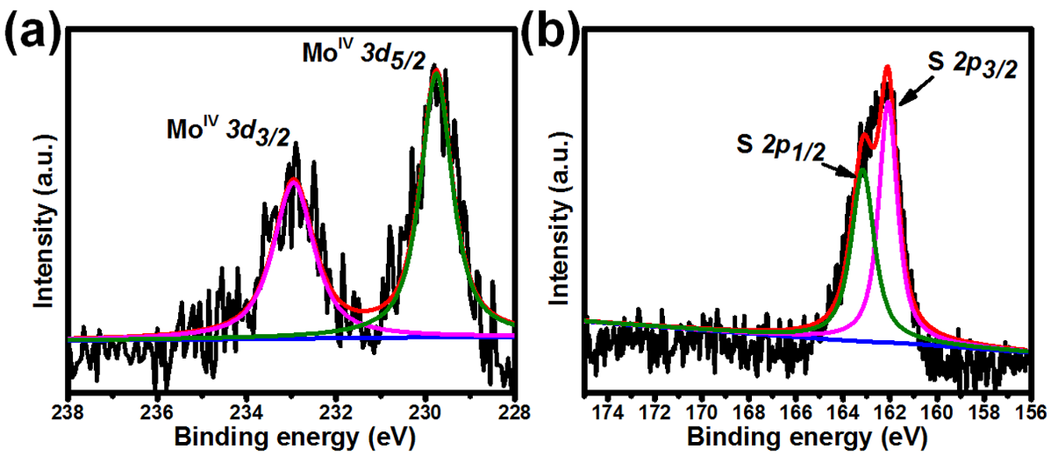

Supplementary Figure 2. XPS spectra of as-prepared MoS₂ QDs: (a) Mo and (b) S.

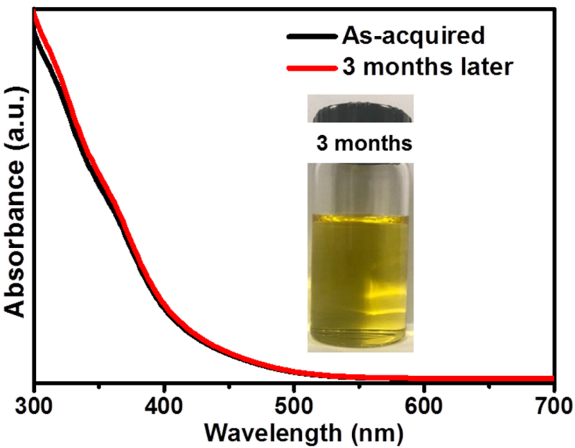
Supplementary Figure 3. High storage stability of aqueous dispersion of MoS₂ QDs.

Supplementary Figure 4. TEM image of MoS₂ sheet exfoliated by using BSA. Scale bar: 100 nm.

Supplementary Figure 5. TGA of BSA-coated MoS₂ QDs performed under inert nitrogen atmosphere.

Analyzing the result from TGA curves, three stages was observed: weight loss below 100 ºC can be assigned to water; the weight loss from 200 ºC to 450 ºC is mainly due to the thermal decomposition of decomposed of BSA. The weight loss from 450 ºC is correspond to the thermal decomposition of MoS₂ (Composites Part A: Applied Science and Manufacturing 94 (2017): 1-9.). The incompletely decomposed carbonaceous product under N² atmosphere at 450 ºC was about 20 % of the total BSA amount according to the previous BSA report (Journal of colloid and interface science 389.1 (2013): 31-41). Then the total amount of BSA and MoS₂ was calculated to be around 7.1 mg and 2.4 mg, separately.
The mass of per 3.9 nm MoS₂ QDs (based on TEM results) and BSA molecule were further calculated:
$m_{MoS_{2}}$= $\frac{4}{3}πr^{3}$ x $ρ_{MoS_{2}}$ = $\frac{4}{3}π{(1.95 nm)}^{3}$ x 5.06 g/cm³ = 1.5 x 10⁻¹⁹ g MoS₂/QD
$m_{BSA}$ = $\frac{{MW}_{BSA}}{6.022 x {10}^{23} }$ = 1.1 x 10⁻¹⁹ g BSA/Molecule
Then the ratio of $N_{BSA}$ to $N_{MoS_{2}}$ was calculated as:
$\frac{N_{BSA}}{N_{MoS_{2}}}$ = $\frac{{7.1}/{m_{BSA}}}{{7.4}/{m_{MoS_{2}}}}$ = 4.03
The ratio estimated from TGA result (4.03) was slightly greater than the DLS measurements but still at the same order of magnitude. Considering that the simple calculation above is based on a single size QDs average diameter, the actual QDs size distribution may also affect the number of BSA ligand binding on the surface.

Group | -OH | -NH₂ | -COOH | -C₆H₅ | -S-S- | -SH
$E_{{MoS}_{2}+group}$ (Ha) | -21730.435 | -21730.572 | -21843.732 | -21886.118 | -22490.650 | -22053.312
$E_{Group}$ (Ha) | -115.614 | -95.746 | -228.903 | -271.260 | -875.809 | -438.485
$E_{{MoS}_{2}}$ (Ha) | -21614.81 | -21614.810 | -21614.810 | -21614.810 | -21614.810 | -21614.810
$E_{ad}$ (Ha) | -0.011 | -0.017 | -0.019 | -0.047 | -0.031 | -0.017
$E_{ad}$ (eV) | -0.304 | -0.453 | -0.510 | -1.29 | -0.835 | -0.455
Supplementary Table 1. Calculated binding affinities of the major functional groups in BSA to MoS₂ QDs.

$$E_{ad}= E_{{MoS}_{2}+group}- E_{group}- E_{{MoS}_{2}}$$

where $E_{group}$,${ E}_{{MoS}_{2}}$ and $E_{{MoS}_{2 }+group }$are the energies of the bound functional group, the MoS₂ surface and the complex of MoS₂ and functional group respectively.
The oxygen adsorption energies on the pristine and oxygen-atom doped MoS₂ were also calculated. The oxygen-doped MoS₂ was modeled by substituting oxygen atom for sulfur. The nearest three sulfur atoms around the oxygen adsorption site were replaced one by one to describe the doping level. All the structures were optimized by using the conjugate gradient method, in which the convergence for total energy and interaction force was set to be 10⁻⁵ eV and 2×10⁻³ eV/Å, respectively.

Supplementary Figure 6. TEM images and size distribution of MoS₂ QDs synthesized with dBSA. Scale bar: 100 nm.

Supplementary Figure 7. TEM images and size distribution of MoS₂ QDs synthesized with DBA. Scale bar: 100 nm.

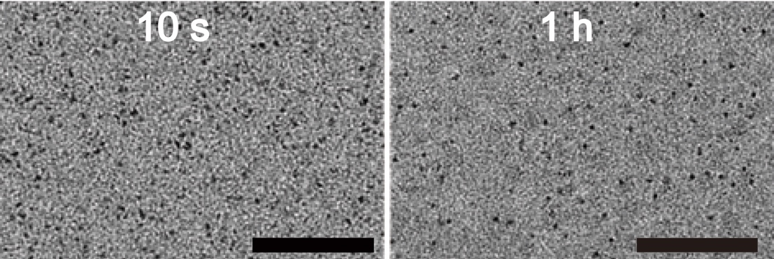

Supplementary Figure 8. TEM images of MoS₂ QDs sampled at the reaction of 10 s and 1 h showing in-discernible differences even with extended reaction time. Scale bar: 100 nm.
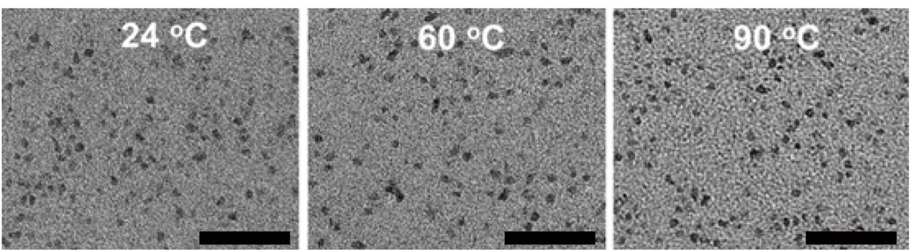

Supplementary Figure 9. TEM images of MoS₂ QDs synthesized at the 24 ºC, 60 ºC and 90 ºC showing in-discernible differences even with elevated reaction temperature. Scale bar: 50 nm.

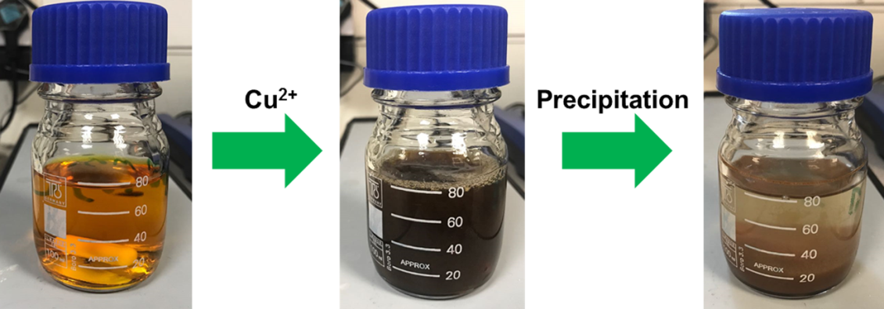

Supplementary Figure 10. Schematic illustration of the purification process of MoS₂ QDs by adding Cu²⁺.

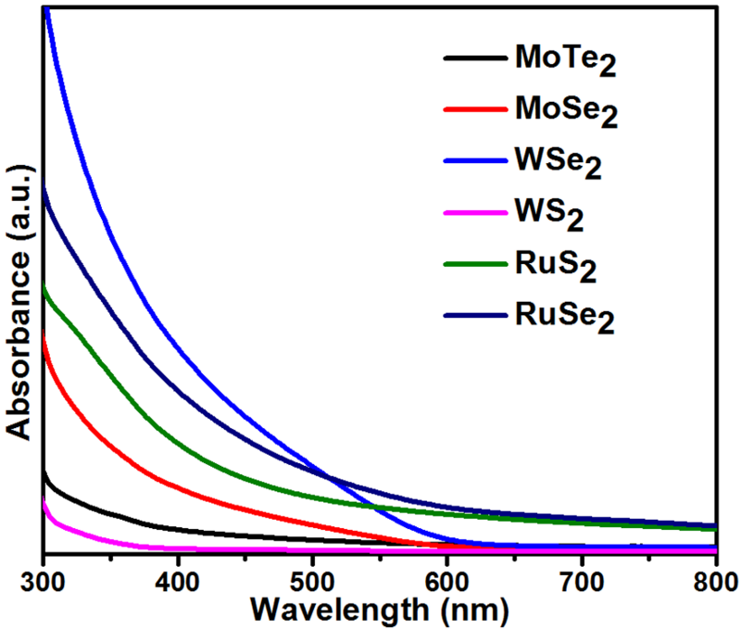

Supplementary Figure 11. UV-vis spectra of MoTe₂, MoSe₂, WSe₂, WS₂, RuS₂ and RuSe₂ in aqueous condition.

Supplementary Figure 12. The excitation-dependent PL behaviors of the MoS₂-D_{H}, MoS₂-D_{M} and MoS₂-D_{L} QDs.

 | Atomic ratio of Mo/S by XPS
MoS₂-D_{H} | 1: 1.8
MoS₂-D_{M} | 1: 2.29
MoS₂-D_{L} | 1: 2.34

Supplementary Figure 13. Elemental analyses of the MoS₂-D_{H}, MoS₂-D_{M} and MoS₂-D_{L} QDs.

Supplementary Figure 14. Absorption spectra of three kinds of MoS₂ QDs in the presence of ABDA without light irradiation: (a) MoS₂-D_{H}, (b) MoS₂-D_{M} and (c) MoS₂-D_{L}

Supplementary Figure 15. ¹H-NMR (a) and HPLC (b) spectrums of ABDA before and after irradiation for 8 mins.

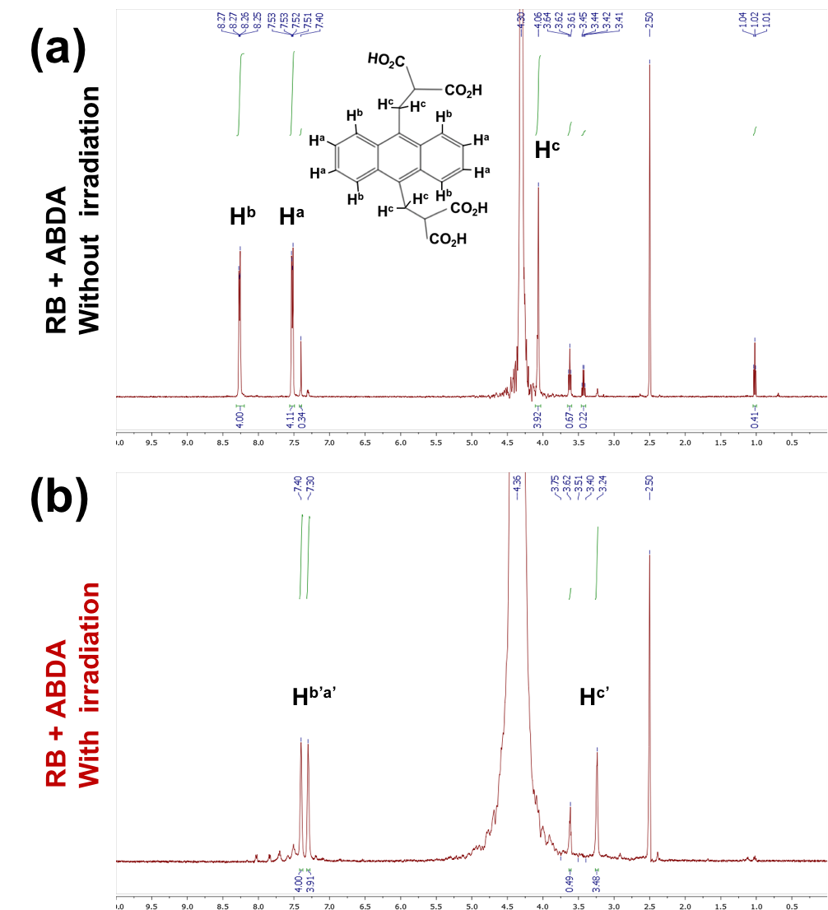

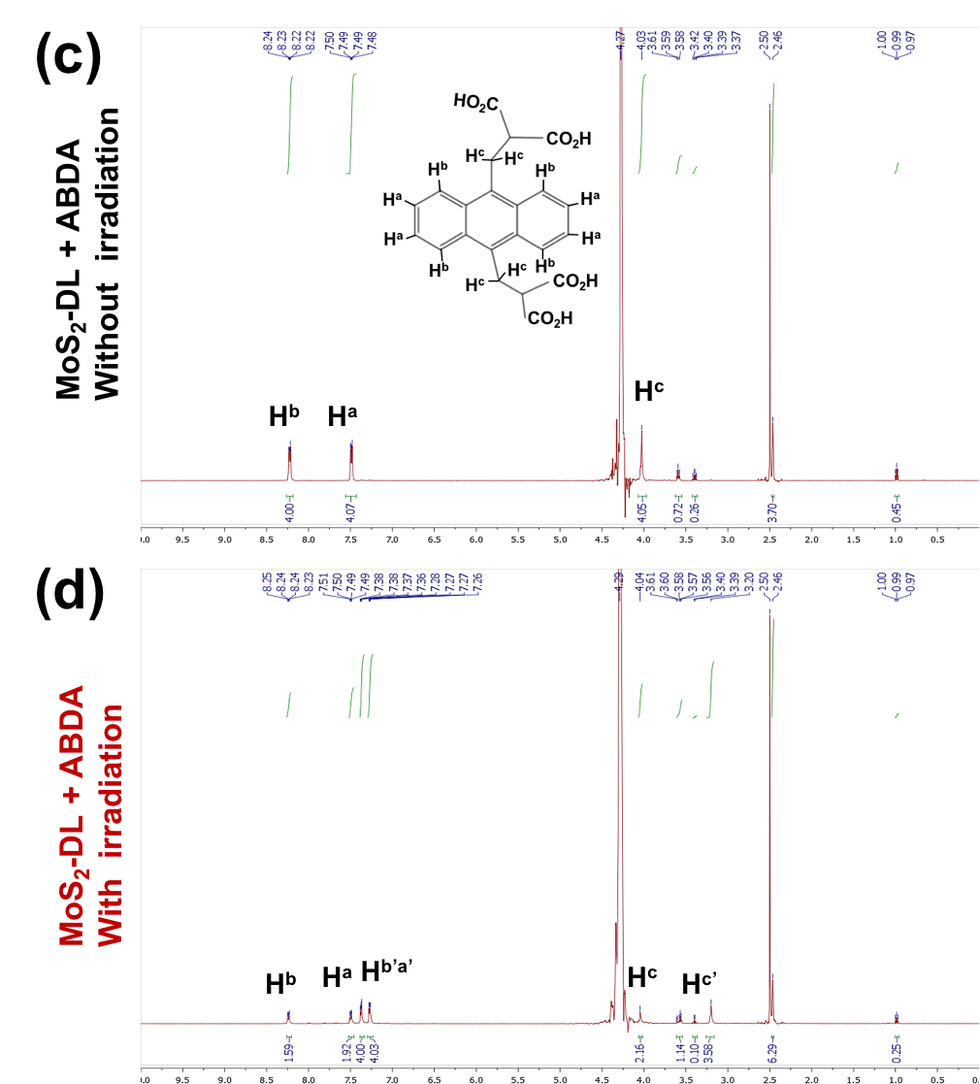

Supplementary Figure 16. 1H-NMR spectrum of the product of ABDA with and without light irradiation: (a) Incubated with Rose Bengal (RB) without irradiation, (b) Incubated with RB with irradiation, (c) Incubated with MoS₂ QDs without irradiation and (d) Incubated with MoS₂ QDs with irradiation. For the MoS₂ QDs incubation group, the MoS₂ QDs were removed by using centrifugal filters (MWCO 10K) before 1H-NMR testing.

Supplementary Figure 17. Absorption spectrum of the mixture solution of MoS₂-D_{L} QDs and ABDA in dH₂O (black curve) and D₂O (blue curve) before and after 8 min of light exposure.

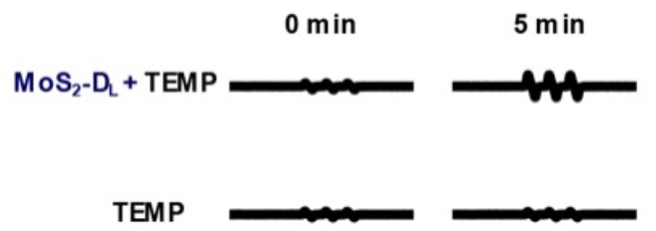

Supplementary Figure 18. ESR spectrum of MoS₂ QDs in the presence of TEMP.

Supplementary Figure 19. Decomposition rate of the photosensitizing process of MoS₂-D_{H} (a), MoS₂-D_{M} (b) and MoS₂-D_{L} (c) samples, where A₀ is the absorbance of initial absorbance of ABDA and A is the absorbance of ABDA under light irradiation at different time points.

Supplementary Figure 20. (a) The quantification curve for BSA using the Bicinchoninic acid (BCA) reagent (37 ºC/30 min incubation);（b）There is insignificant difference between the BSA amounts on three MoS₂ QDs defect types.

Supplementary Figure 21. Tauc plot αhν = A(hν-E_{g})^{1/2}. Here α is the absorption coefficient, h is the Plank constant, ν is the photon frequency.

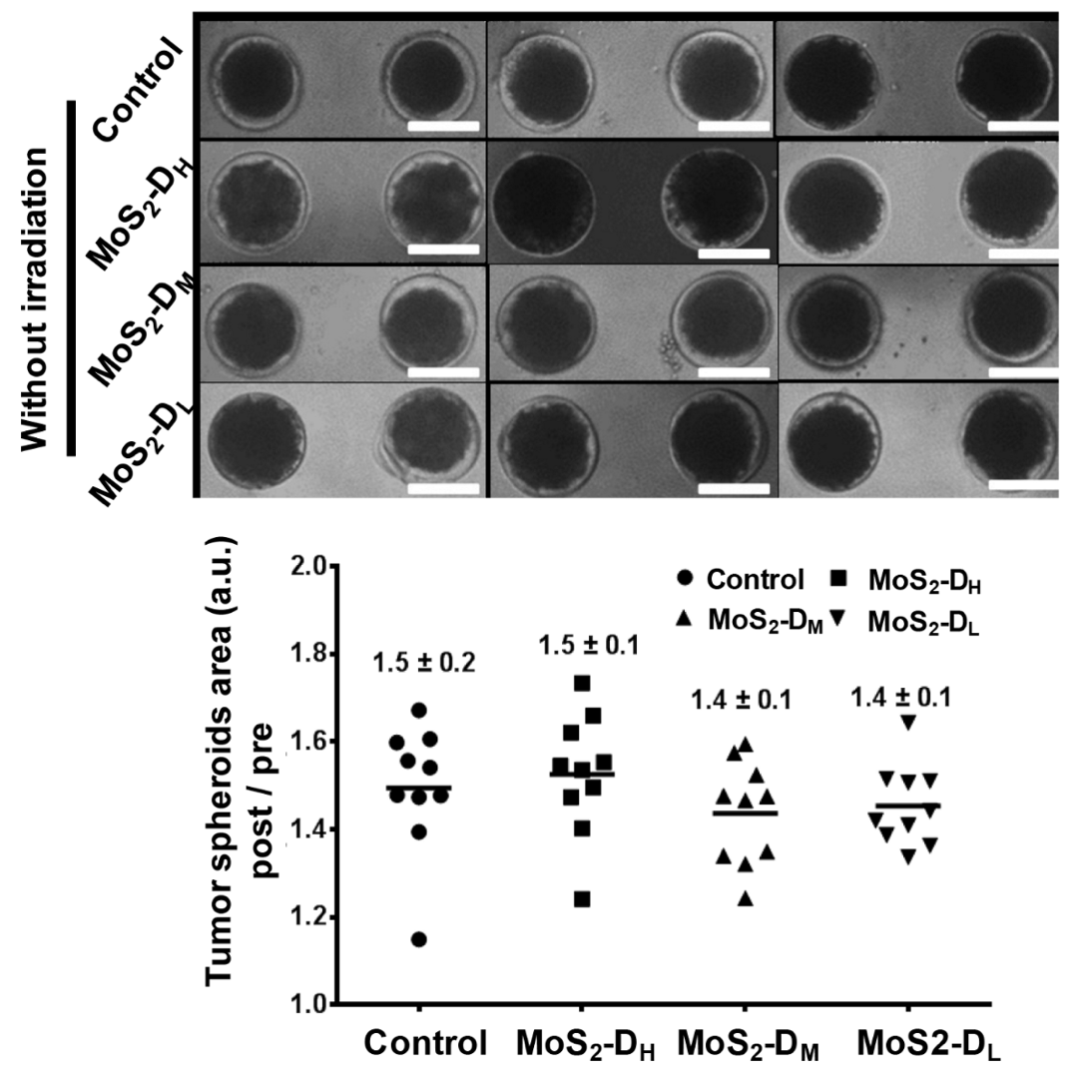

Supplementary Figure 22. 3D tumor spheroids were used to check the in vitro toxicity of defective MoS₂ QDs without light irradiation. Mean ± SD, n=10, Scale bar: 100 μm.

