Retrotranspositional landscape of Asian rice revealed by 3000 genomes

Carpentier et al.

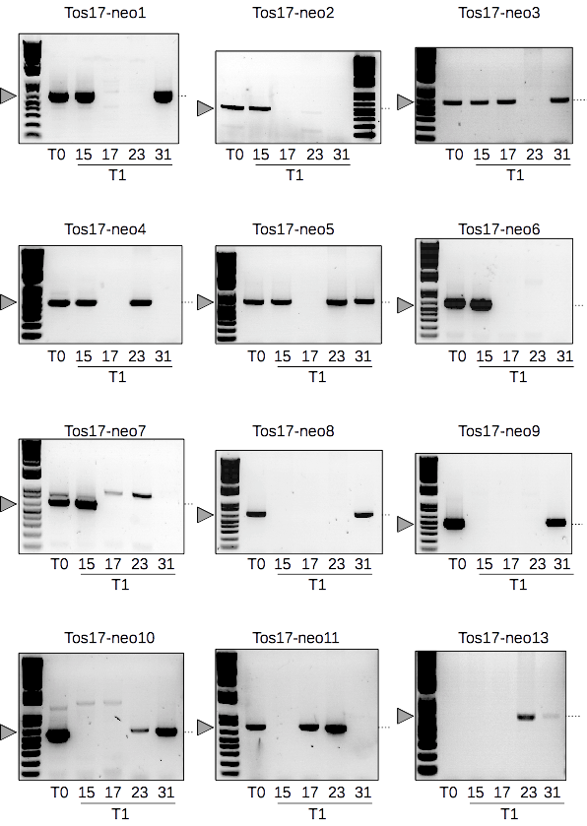

Supplementary Figure 1. Gels PCR Validation of Tos17 insertions.
A set of independently identified Tos17 insertions in a pedigree of four rice plants has been used as validation data for trackposon. T0 has been regenerated from callus after transformation by A. tumefasciens, conditions that allow Tos17 mobilization. T1-15, T1-17, T1-23 and T1-31 were obtained by selfing of the T0. After Illumina sequencing, reads have been mapped against the reference genome of Oryza sativa cv. nipponbare. Based on the position of its unique active copy, new insertions loci of Tos17 could be identified by visual analysis in a browser (IGV), of the discordantly aligned pairs, one mate of which matches the native TE copy : the discordant mates indicated the insertion position of the new copy.
Agarose gels obtained after PCR. The arrow and the dashed line indicate the position of the fragments of the expected size. Other bands are the result of random non specific amplifications. Size markers are at the extreme left or right of the gels. Colors were inverted for readability.
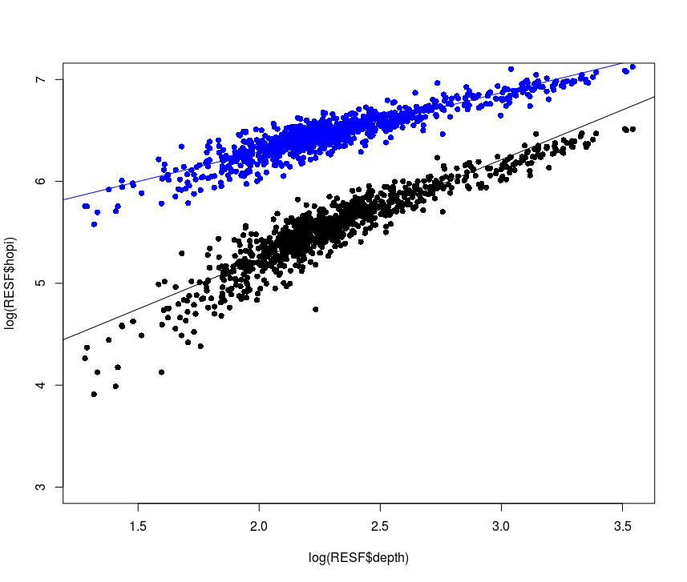
Supplementary Figure 2. The effect of the third step (threshold 2) on TIP detection.
In the TRACKPOSON pipeline, the third step was added to decrease the number of false negative TE insertions.In x axis, the depth coverage for the 3000 genomes was represented in log scale, and in y axis the number of Hopi insertions also in log scale.
In black, the result only the first pass at a threshold of 5 and in blue the result with the additional pass at a the threshold of 2. The lines correpond to the linear regression for the 2 representations.

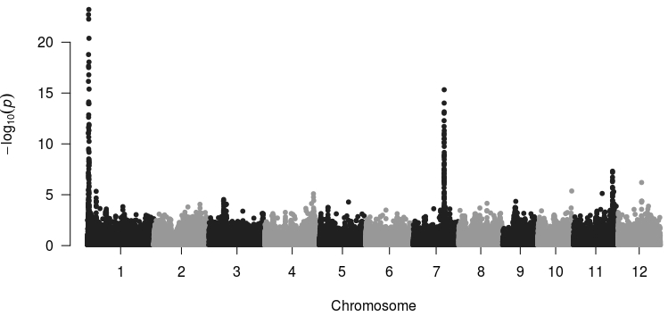
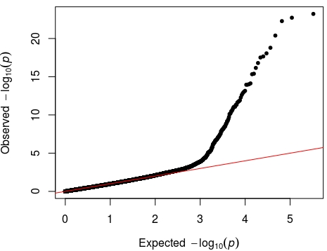

TE family | GWAS interval | TE overlapping or candidate genes | % mappability
Tos17 | Chr1: 734611-1063997 | Overlap with Tos17 | 66
Tos17 | Chr7: 19995068-20201905 | Overlap with Tos17 | 72
Tos17 | Chr11:25393543-25431911 | No Tos17 | 61

Supplementary Figure 3. GWAS results for Tos17 retrotransposons family:
The Manhattan plot represents the association peaks. A Qqplot is also provided.
The table provides the exact localization of the peak region, together with the percentage of mappability of the region, computed using the method described in the manuscript.

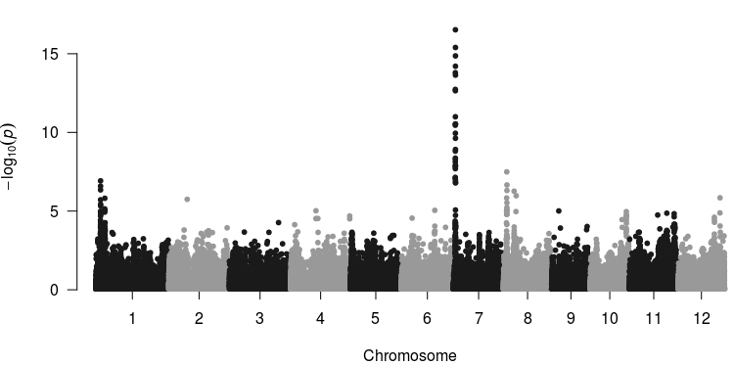
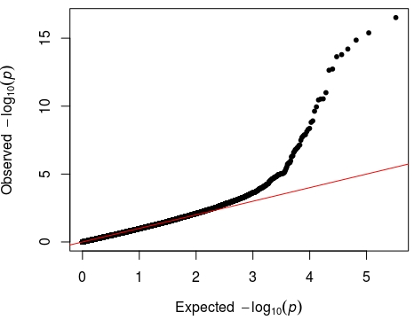

TE family | GWAS interval | Candidate TE or genes | % mappability
Karma | Chr1: 2761585-2763810 | Overlap with karma copy | 95
Karma | Chr7: 1043983-1159959 | Overlap with karma copy | 87
Karma | Chr8: 1870881-1988117 | Overlap with karma copy | 28.5

Supplementary Figure 4. GWAS results for Karma retrotransposons family:
The Manhattan plot represents the association peaks. A Qqplot is also provided.
The table provides the exact localization of the peak region, together with the percentage of mappability of the region, computed using the method described in the manuscript.

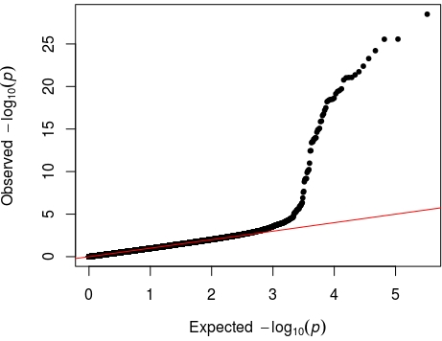
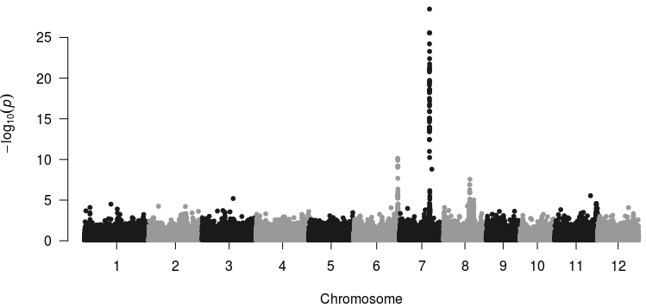

TE family | GWAS interval | Candidate TE or genes | % mappability
Fam90 | Chr6: 29839249-29948887 | Overlap with Fam90 copy | 64
Fam90 | Chr7: 19999141-20110067 | Overlap with Fam90 copy | 72F
Fam90 | Chr8: 17428187-17558707 | Overlap with Fam90 copy | 58

Supplementary Figure 5. GWAS results for Fam90 retrotransposons family:
The Manhattan plot represents the association peaks. A Qqplot is also provided.
The table provides the exact localization of the peak region, together with the percentage of mappability of the region, computed using the method described in the manuscript.

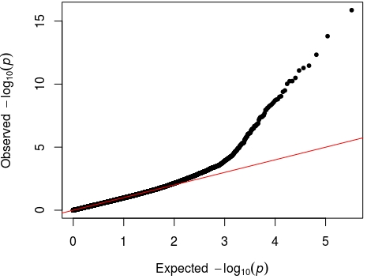
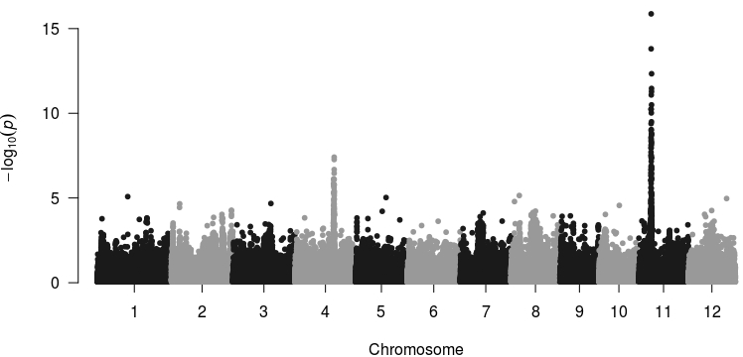

TE family | GWAS interval | Candidate TE or genes | % mappability
Fam124 | Chr4: 22837141-22848622 | Overlap with Fam 124 | 87
Fam124 | Chr11: 7012603-7530068 | No overlap with Fam 124 | 57

Supplementary Figure 6. GWAS results for Fam124 retrotransposons family:
The Manhattan plot represents the association peaks. A Qqplot is also provided.
The table provides the exact localization of the peak region, together with the percentage of mappability of the region, computed using the method described in the manuscript.

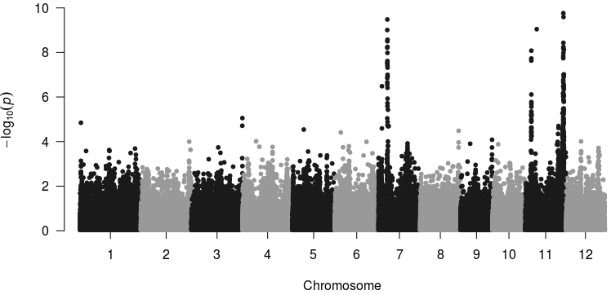
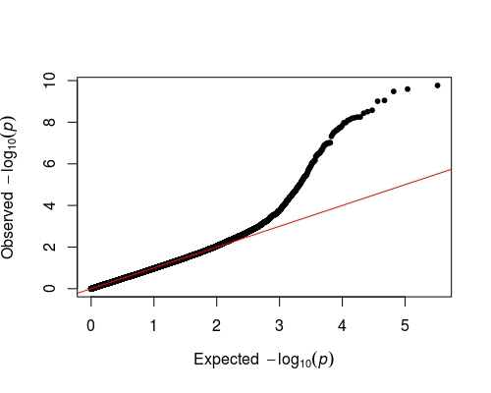

TE family | GWAS interval | Candidate TE or genes | % mappability
Fam106 | Chr7: 6170573-6363341 | Overlap with fam106 copy | 41
Fam106 | Chr11: 4316562-4375485 | Overlap with fam106 copy | 67
Fam106 | Chr11: 27008905-27445698 | Overlap with fam106 copy | 62

Supplementary Figure 7. GWAS results for Fam106 retrotransposons family:
The Manhattan plot represents the association peaks. A Qqplot is also provided.
The table provides the exact localization of the peak region, together with the percentage of mappability of the region, computed using the method described in the manuscript.

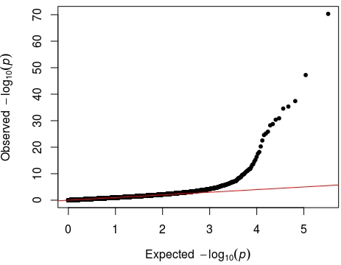
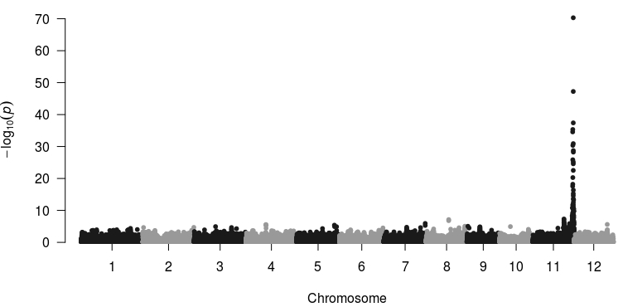

TE family | GWAS interval | Candidate TE or genes | % mappability
Lullaby | Chr11: 28186914-28477992 | Overlap with lullaby copy | 68

Supplementary Figure 8. GWAS results for Lulabby retrotransposons family:
The Manhattan plot represents the association peaks. A Qqplot is also provided.
The table provides the exact localization of the peak region, together with the percentage of mappability of the region, computed using the method described in the manuscript.

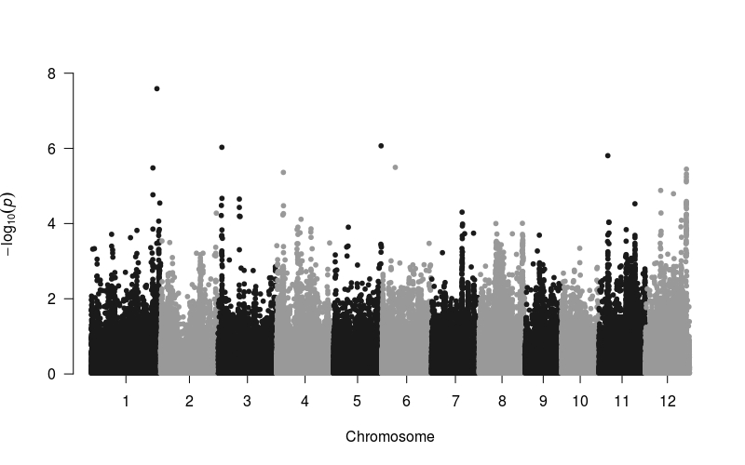
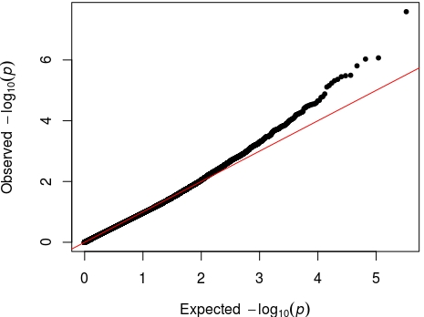

TE family | GWAS interval | Candidate TE or genes | Mappability
Dasheng | Chr1:40946066 | Overlap with dasheng | 76
Dasheng | Chr3:2251217-2312182 | Overlap with dasheng | 58

Supplementary Figure 9. GWAS results for Dasheng retrotransposons family:
The Manhattan plot represents the association peaks. A Qqplot is also provided.
The table provides the exact localization of the peak region, together with the percentage of mappability of the region, computed using the method described in the manuscript.

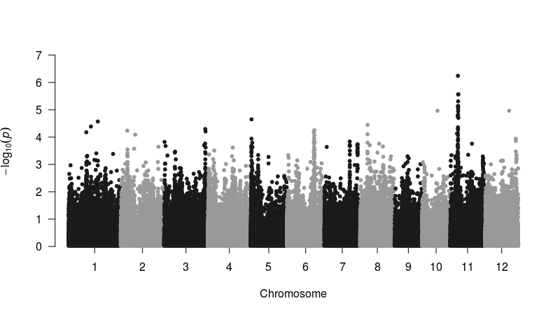
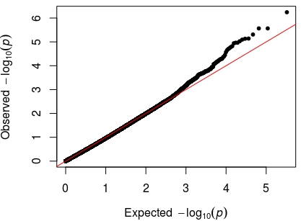

TE family | GWAS interval | Candidate TE or genes | % mappability
Fam89 | Chr11: 6481747-6602990 | No overlap with Fam89 | 56

Supplementary Figure 10. GWAS results for Fam89 retrotransposons family:
The Manhattan plot represents the association peaks. A Qqplot is also provided.
The table provides the exact localization of the peak region, together with the percentage of mappability of the region, computed using the method described in the manuscript.

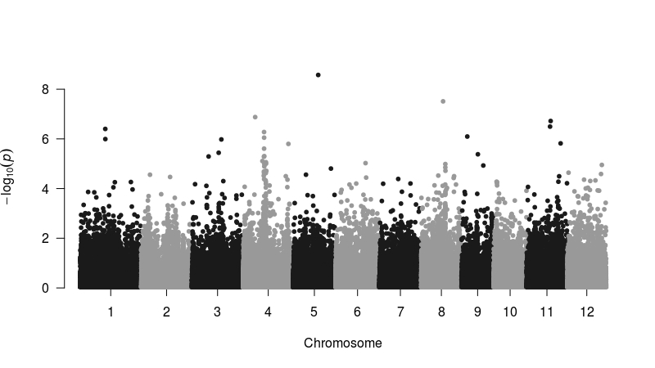
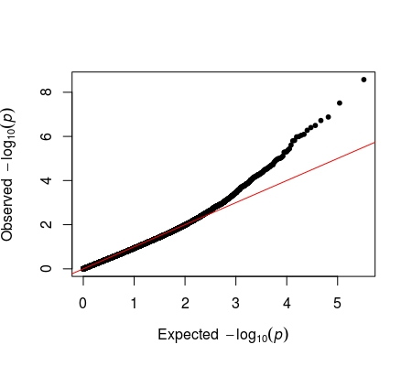

TE family | GWAS interval | Candidate TE or genes | % mappability
Houba | Chr01: 17769540-17811498 | Centromere no overlap with Houba | 47
Houba | Chr04: 14769176-14819944 | No overlap with Houba | 56

Supplementary Figure 11. GWAS results for Houba retrotransposons family:
The Manhattan plot represents the association peaks. A Qqplot is also provided.
The table provides the exact localization of the peak region, together with the percentage of mappability of the region, computed using the method described in the manuscript.

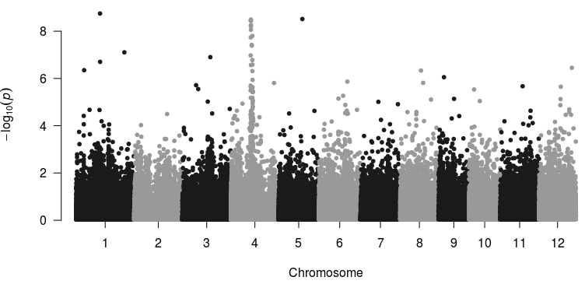
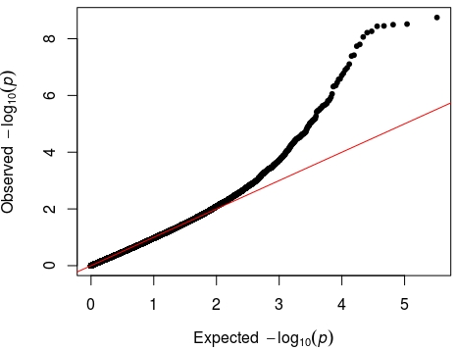

TE family | GWAS interval | Candidate TE or genes | % mappability
Fam86 | Chr01: 17769540-17811498 | No overlap with Fam86 | 47
Fam86 | Chr4:14599121-14827052 | No overlap with Fam86 | 53

Supplementary Figure 12. GWAS results for Fam86 retrotransposons family:
The Manhattan plot represents the association peaks. A Qqplot is also provided.
The table provides the exact localization of the peak region, together with the percentage of mappability of the region, computed using the method described in the manuscript.

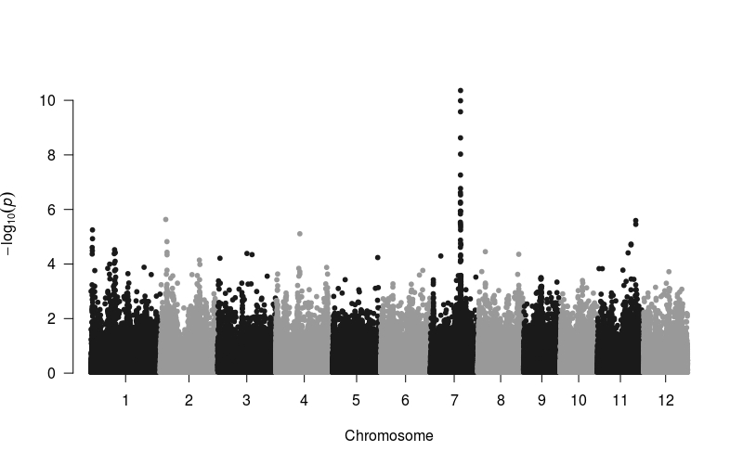
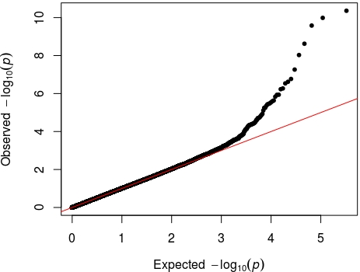

TE family | GWAS interval | Candidate TE or genes | % mappability
rn304 | Chr07: 18726085-18820090 | Overlap with rn304 copy | 55

Supplementary Figure 13. GWAS results for Rn304 retrotransposons family:
The Manhattan plot represents the association peaks. A Qqplot is also provided.
The table provides the exact localization of the peak region, together with the percentage of mappability of the region, computed using the method described in the manuscript.

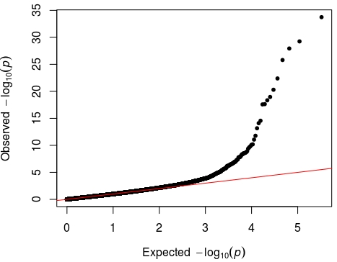
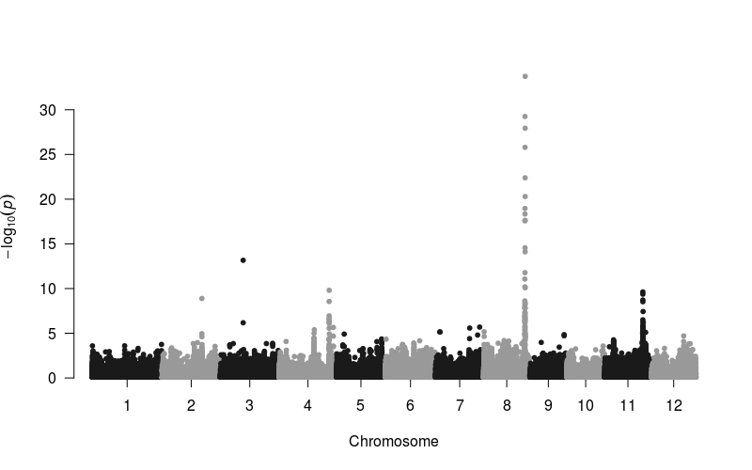

TE family | GWAS interval | Candidate TE or genes | % mappability
Scaff3 | Chr04: 30805389-30819182 | Overlap with scaff3 copy | 49
Scaff3 | Chr08: 25480885-25631114 | Overlap with scaff3 copy | 55
Scaff3 | Chr11: 23710053-23731730 | Overlap with scqff3 copy | 31

Supplementary Figure 14. GWAS results for Scaff3 retrotransposons family:
The Manhattan plot represents the association peaks. A Qqplot is also provided.
The table provides the exact localization of the peak region, together with the percentage of mappability of the region, computed using the method described in the manuscript.

Supplementary Table 1. The summary of Tos17 insertions results

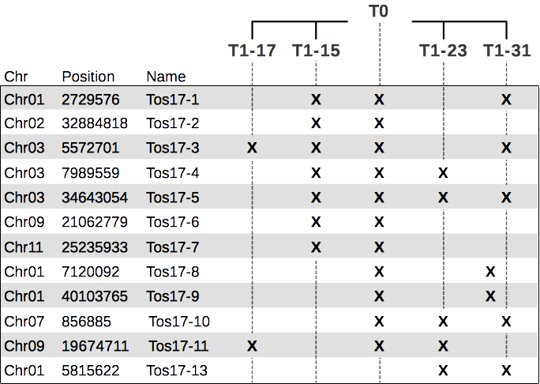
The summary of results, where a X indicates that the insertion is present.
All these insertions have been confirmed by PCR (see Supplementary Figure 1).

Supplementary Table 2. The list of primers for Tos17 insertions validation

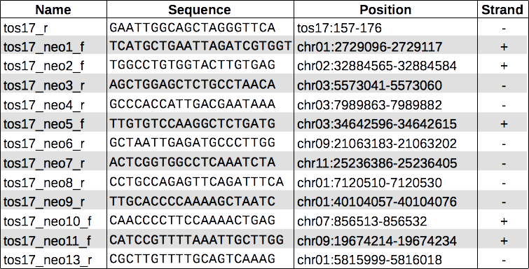
The list of name, sequence, position and strand of each primer used for validation.The first in the list, tos17_r, has been used with each other primer to check for the presence of each insertion

Supplementary Table 3. Gypsy and Copia TIPs localisation

 | 1st quantile | Median | Mean | 3th quantile
Copia | 182 nt | 11,296 nt | 22,888 nt | 32,064 nt
Gypsy | 432 nt | 11,665 nt | 23,459 nt | 32,733 nt

We determinated for all the TIPs, the distance in nucleotides with the closest gene
(see Methods). We performed a Whelch t-test between these two dsitributions with
p.value of 1.6e-07. The Copia and Gypsy distribution are significativly different and
the Copia TIPs are closer to the genes.

