Supplementary Information

Electron correlation driven non-adiabatic relaxation in molecules excited by an ultrashort XUV pulse
A. Marciniak¹, V. Despré², V. Loriot¹, G. Karras¹, M. Hervé¹, L. Quintard⁴, F. Catoire⁴, C. Joblin³, E. Constant^{1,4}, A. I. Kuleff² & F. Lépine¹
¹ Institut Lumière Matière, Université Lyon 1, CNRS, UMR 5306, 10 rue Ada Byron, 69622 Villeurbanne Cedex, France
² Theoretische Chemie, PCI, Universität Heidelberg, Im Neuenheimer Feld 229, D-69120 Heidelberg, Germany
³ IRAP - Université de Toulouse [UPS] / CNRS 9 Av. du Colonel Roche BP 44346 31028 Toulouse cedex 04 France
⁴ Université Bordeaux, CEA, CNRS, CELIA, UMR5107, F-33400 Talence, France
This Supplementary Information contains 2 Supplementary Tables, 8 Supplementary Figures

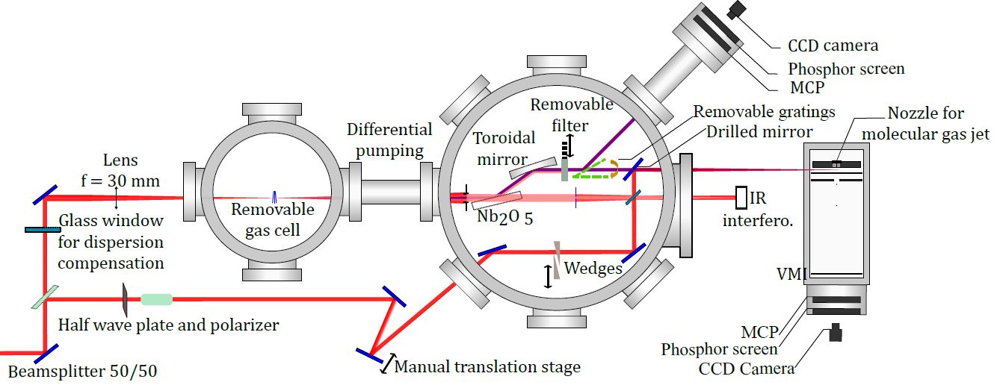
Supplementary Figure 1: Schematic of the experimental set-up

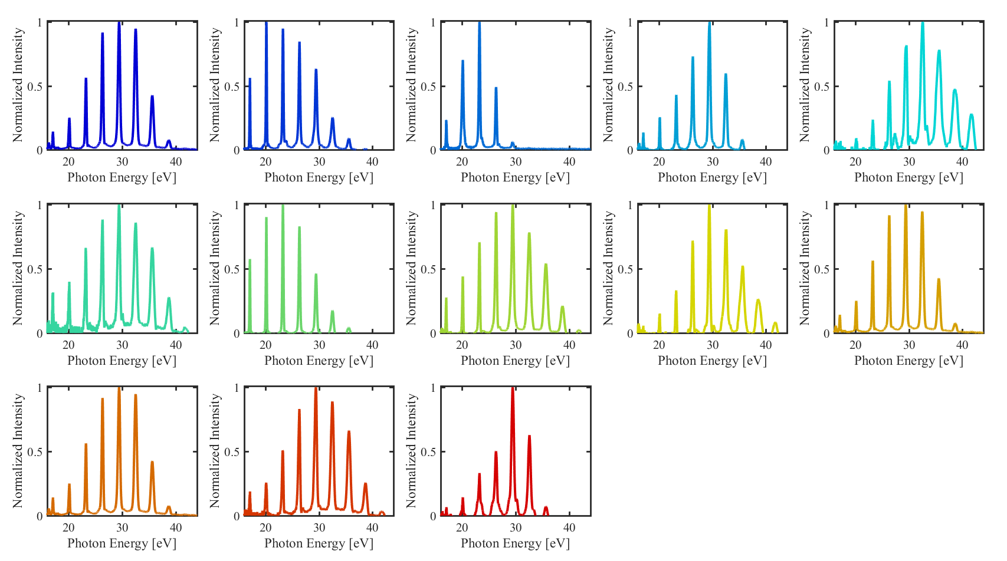
Supplementary Figure 2: Typical XUV spectra used in the experiment. These spectra have been acquired using an Al filter with a transmission threshold that allows for transmitting only harmonics above 15eV.

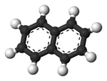 | 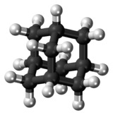
Supplementary Figure 3: (left) Naphtalene (C₁₀H₈) molecular planar structure. (right) Adamantane (C₁₀H₁₆) molecular 3D structure.

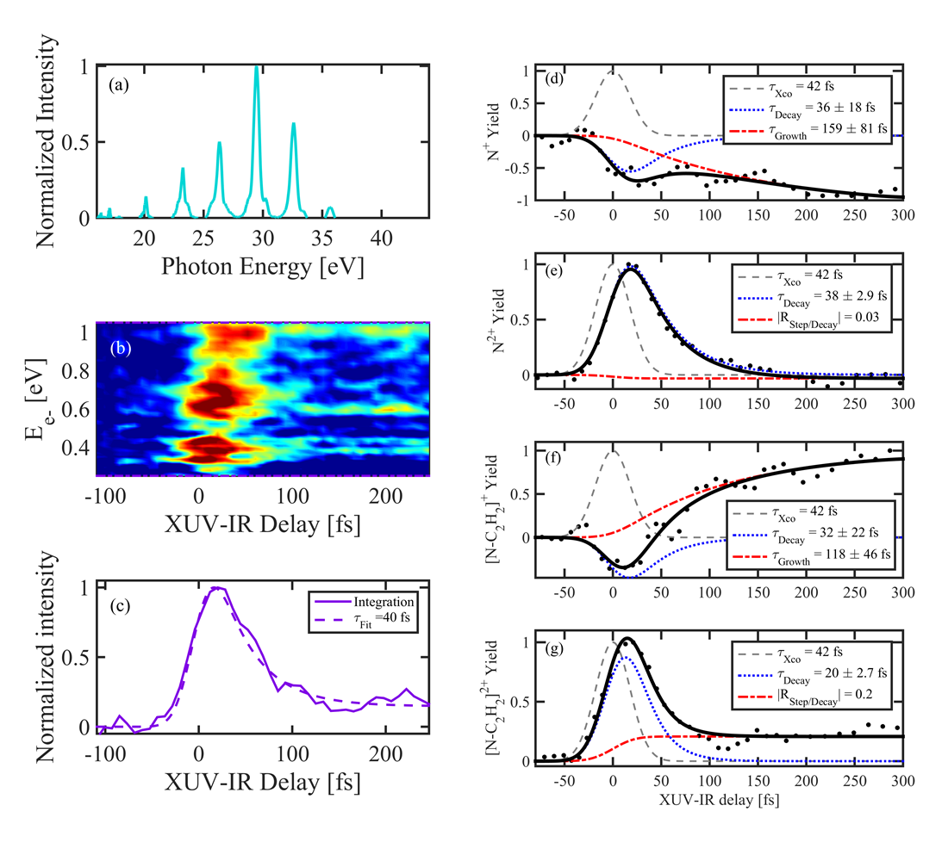
Supplementary Figure 4: a HHG spectrum used in the measurement, b Transient two-color photoelectron map measured under the same experimental conditions as of (a), c The averaged electron dynamics is obtained by integrating the transient photoelectron map over the kinetic energy from 0 to 1 eV and its extracted lifetime is 40 ±7 fs.
Transient ion signal, using the same XUV-IR pump-probe scheme for d Naph⁺, e Naph²⁺, f Naph⁺ after C₂H₂ loss, and g Naph²⁺ after C₂H₂ loss. The overall extracted decay time is 38 ± 3 fs.

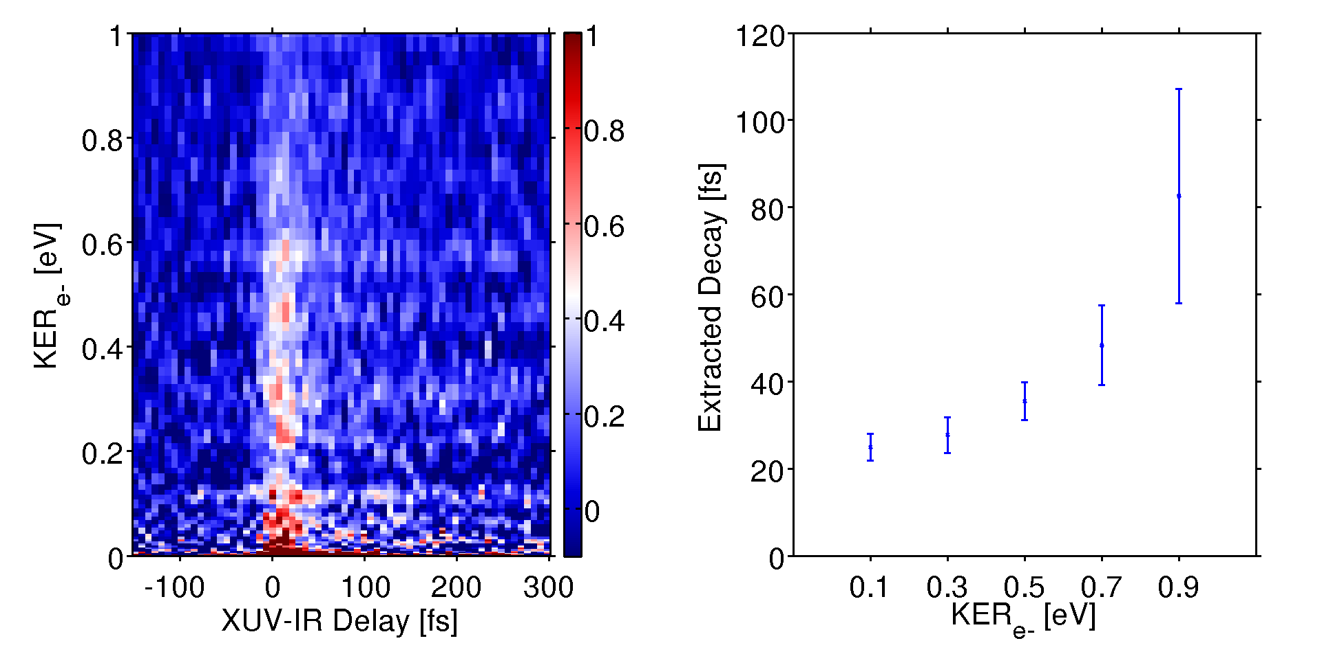

Supplementary Figure 5. a Two-color time-dependent electron kinetic energy spectrum obtained in the case of Adamantane. b Decay time as a function of the electron kinetic energy for Adamantane. Like in the case of Naphthalene, the decay time globally increases with the electron kinetic energy.

Supplementary Table 1: States included in the vibronic-coupling Hamiltonian.

number | symmetry | Energy [eV] | Spectral intensity [%]
1 | 1b_{2u} | 19.02 | 4.2
2 | 1b_{1u} | 19.1 | 1
3 | 1a_{g} | 19.14 | 1.8
4 | 2b_{1u} | 19.26 | 7.5
5 | 3b_{1u} | 19.34 | 7.9
6 | 2b_{2u} | 19.37 | 1
7 | 2a_{g} | 19.42 | 3.3
8 | 3b_{2u} | 19.44 | 1.9
9 | 4b_{1u} | 19.52 | 4
10 | 3a_{g} | 19.54 | 39
11 | 4b_{2u} | 19.54 | 1.1
12 | 4a_{g} | 19.61 | 2
13 | 5b_{1u} | 19.62 | 2.4
14 | 6b_{1u} | 19.63 | 4.5
15 | 7b_{1u} | 19.74 | 21.9
16 | 5a_{g} | 19.75 | 2.9
17 | 5b_{2u} | 19.84 | 6.2
18 | 6b_{2u} | 19.99 | 6.1
19 | 8b_{1u} | 20.02 | 1.1
20 | 9b_{1u} | 20.05 | 4.9
21 | 7b_{2u} | 20.1 | 32
22 | 10b_{1u} | 20.11 | 1.1
23 | 11b_{1u} | 20.21 | 3.4

Supplementary Table 2: Normal modes included in the vibronic-coupling Hamiltonian.

Symmetry | Frequency [cm⁻¹]
a_{g} | 514.30
a_{g} | 771.15
a_{g} | 1050.83
a_{g} | 1170.08
a_{g} | 1458.28
a_{g} | 1490.03
a_{g} | 1624.66
b_{1u} | 355.71
b_{1u} | 802.70
b_{1u} | 1138.49
b_{1u} | 1276.94
b_{1u} | 1406.41
b_{1u} | 1637.04
b_{2u} | 618.03
b_{2u} | 1042.13
b_{2u} | 1169.70
b_{2u} | 1254.82
b_{2u} | 1494.72
b_{2u} | 1561.41
b_{3g} | 505.72
b_{3g} | 930.99
b_{3g} | 1160.98
b_{3g} | 1254.73
b_{3g} | 1484.04
b_{3g} | 1688.56

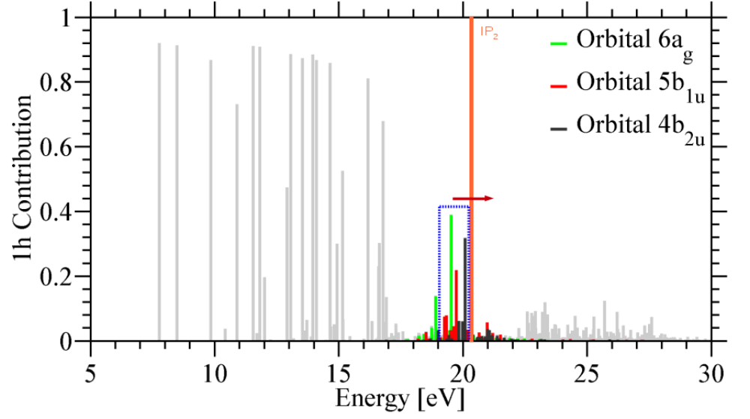
Supplementary Figure 6: Ionization spectrum of the naphthalene molecule computed with the ab initio nd-ADC(3) method. The states populated by the removal of an electron from orbitals 6a_{g}, 5b_{1u}, and 4b_{2u} are depicted in green, red, and black, respectively. The vibronic-coupling model is constructed from 23 of those states in the range 19.02 – 20.21 eV. This region of the spectrum is highlight by a blue box. The computed double-ionization threshold (IP₂) is marked by an orange line. Note that the computed IP₂ is about 1 eV lower than the measured value of 21.5 eV.

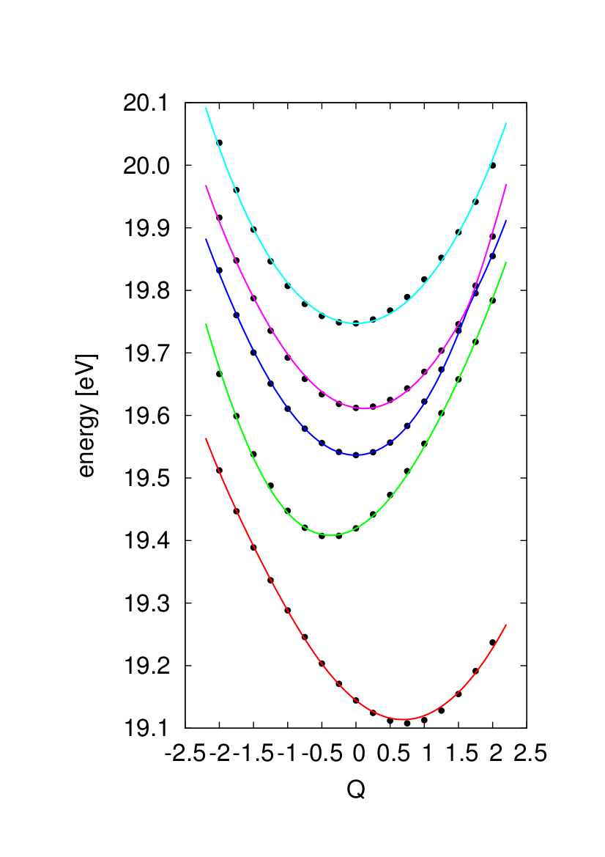
Supplementary Figure 7: The five states of a_{g} symmetry along the normal vibrational mode of a_{g} symmetry at 1170.08 cm⁻¹ computed with the ab initio nd-ADC(3) methods (points) and reproduced by the vibronic-coupling model (solid lines).

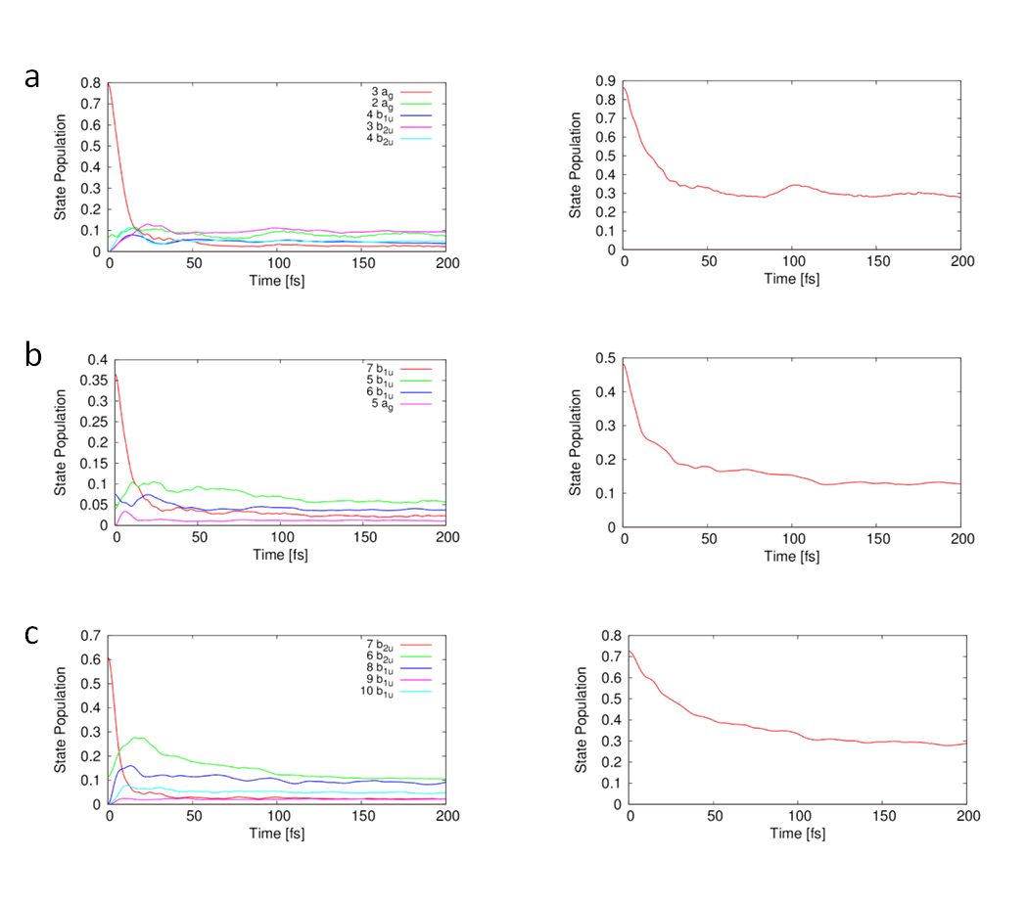
Supplementary Figure 8: Time-dependent state populations following the initial ionization out of a orbitals 6a_{g}, b orbital 5b_{1u} and c orbital 4b_{2u}.
Left: Individual populations of the states lying within an energy interval of 150 meV.
Right : Sum of the populations of all the states in the corresponding energy range.
The state labeling see Supplementary Table 1.

