Supplementary Information

Correspondence between cerebral glucose metabolism and BOLD reveals relative power and cost in human brain

Shokri-Kojori et al.

Supplementary Results
Generalizability of rPWR and rCST
We tested whether rPWR and rCST are generalizable to alternative measures of neuronal activity (i.e., fALFF) and metabolic supply (i.e., CBF) in cohort-1. We used cerebral blood flow (CBF) as an alternative proxy of cerebral metabolic supply¹. Consistent with prior reports (Supplementary Fig. 5a), CMRglc and CBF (indexed by perfusion-weighted imaging: PWI) (see Methods) showed a good correspondence across brain networks in our study (Supplementary Fig. 5b). lFCD and fALFF were also highly correlated across networks (Supplementary Fig. 5c), but neither were significantly correlated with CMRglc or with CBF (PWI) across networks (Supplementary Fig. 5d–f). There was an excellent agreement between rPWR of different networks when estimated using lFCD-CMRglc and when estimated using fALFF-CBF (PWI) (intraclass correlation: ICC(3, 1) = 0.8, Supplementary Fig. 6a). Only using CBF (PWI) instead of CMRglc also showed strong agreement in rPWR estimates (ICC(3, 1) = 0.85, Supplementary Fig. 6c). The lFCD threshold had minimal impact on rPWR estimates (ICC(3, 1) = 0.99, Supplementary Fig. 6d). Similarly, there was an excellent agreement between rCST of different networks when estimated using lFCD-CMRglc and when estimated using fALFF-CBF (PWI) (ICC(3, 1) = 0.87, Supplementary Fig. 7a). Changing lFCD to fALFF had minimal impact on rCST estimates (ICC(3, 1) = 0.99, Supplementary Fig. 7b), so did using CBF (PWI) instead of CMRglc (ICC(3, 1) = 0.85, Supplementary Fig. 7c). The lFCD threshold had minimal impact on rCST estimates, as well (ICC(3, 1) = 0.99, Supplementary Fig. 7d).
Brain morphometry and temporal signal to noise ratio
In 34 bilateral ROIs in cohort-1 (see Methods), we studied how lFCD, CMRglc, rPWR, and rCST (Supplementary Table 8, also see Supplementary Fig. 1) were associated with brain morphometry (i.e., cortical thickness and cortical distance) and temporal signal to noise ratio (tSNR) of fMRI and FDG-PET, within and between subjects. Supplementary Tables 9–12 show these correlations across subjects for each ROI, while also reporting the level of significance for the trend of correlations across ROIs. Across ROIs, there was a positive trend of correlations between cortical thickness and lFCD (p < 0.0001) and between cortical thickness and CMRglc (p < 0.0001), but not with rPWR nor with rCST (Supplementary Table 9). rPWR in superior frontal ROI was associated with cortical thickness (p < 0.05, Bonferroni). Cortical distance (average geometrical distance between an ROI to other ROIs, see Methods) showed a significant trend of negative correlations across ROIs with CMRglc (Supplementary Table 10). Cortical distance was significantly associated with rCST in entorhinal, lateral orbitofrontal, and inferior temporal ROIs and with rPWR in pars triangularis (p < 0.05, Bonferroni).
For fMRI, tSNR (see Methods) was negatively associated with lFCD (p = 0.005) and positively with CMRglc (p = 0.0004) across ROIs (Supplementary Table 11), but not with rPWR nor with rCST. For FDG-PET, tSNR (see Methods) was negatively associated with lFCD (p = 0.02) and positively with CMRglc (p < 0.0001) (Supplementary Table 12). FDG-PET tSNR was significantly associated with rPWR (p = 0.02) and rCST (p = 0.03), but to a weaker extent than the associations between FDG-PET tSNR and CMRglc (p < 0.0001, Supplementary Table 12). While temporal pole and entorhinal ROIs both had the lowest tSNR in FDG-PET and fMRI, their rPWR and rCST were not associated with tSNRs (Supplementary Tables 11, 12). In fact, rPWR and rCST in none of the ROIs were associated with tSNRs after correction for multiple comparisons. We also used fMRI tSNR and FDG-PET tSNR maps to compute SNR-based rPWR and rCST maps and performed cortical segmentation with k-means clustering (k = 4, Supplementary Fig. 8) and found that the clusters differed from those based on lFCD-CMRglc.
Supplementary Methods
MRI and PET data preprocessing
For cohort-1, MRI data were processed using the minimal preprocessing pipeline of the Human Connectome Project². FreeSurfer v5.3 (Martinos Center for Biomedical Imaging, Charlestown, Massachusetts, USA; https://surfer.nmr.mgh.harvard.edu/) was used for anatomical segmentation, anatomical parcellation³, and measuring surface-based cortical thickness⁴. In addition, each fMRI session data underwent gradient distortion correction, rigid body realignment, field map processing, spatial normalization to the stereotactic space of the Montreal Neurological Institute (MNI) with 2-mm isotropic resolution, and brain masking using routines from University of Oxford's Center for Functional Magnetic Resonance Imaging of the Brain Software Library (FSL) release 5.0 (http://www.fmrib.ox.ac.uk/fsl). CMRglc is theoretically a composite measure of apparent influx rate (K₁), efflux rate (k₂), phosphorylation rate (k₃), and dephosphorylation rate (k₄), glucose concentration in plasma (C_{p}) and the lumped constant (LC)^{5, 6}. Voxel-level CMRglc (μmol×min⁻¹×100 g⁻¹) was computed in PMOD v3.4 (PMOD Technologies, Zurich, Switzerland), based on an autoradiographic solution for the 2-tissue compartment model⁶ up to the mid-time of the summary image (55 min). Gray matter parameters were K₁ = 0.102 min⁻¹, k₂ = 0.130 min⁻¹, k₃ = 0.062 min⁻¹, k₄ = 0.0068 min⁻¹, and LC = 0.52. CMRglc and CBF (PWI) maps were aligned to individual subject’s anatomical space and were normalized to MNI space using FSL parameters.
For cohort-2, fMRI time series were realigned and normalized to the MNI space with 3-mm isotropic voxels in SPM8 (Wellcome Trust Centre for Neuroimaging, London)⁷. There were no significant main effects of Group or Alcohol, or a significant interaction effect on motion estimates (p > 0.05)⁸. CMRglc images were computed using the Sokoloff’s model^{9, 10}. CMRglc maps were normalized to the MNI space in SPM8.
Supplementary Discussion
FDG-PET is a reliable method for measuring CMRglc in the human brain. In comparison, there are many metrics available to assess voxel-level functional activity during resting-state fMRI. While some metrics focus on regional synchrony in slow (< 0.1 Hz) BOLD fluctuations as a marker of neuronal activity (e.g., lFCD¹² or regional homogeneity measures¹³), others focus on the amplitude of low frequency fluctuations (e.g., ALFF or fALFF) during resting state^{14, 15}. Synchrony-based and amplitude-based measures appear to capture overlapping and nonoverlapping aspects of brain activity. For example, they have shown good correspondence at rest¹⁶ and between different subject groups¹⁷. Our results indicated an excellent agreement between lFCD-based and fALFF-based rPWR estimates and between lFCD-based and fALFF-based rCST estimates, across major brain networks (Supplementary Figs. 6c and 7c). However, there are indications that synchrony-based measures may be more sensitive to changes in functional activity (e.g., eyes open versus closed) than amplitude-based measures¹⁸. These observations are consistent with the relatively high spatial spread of neuronal activity with respect to the stimulation locus^{19, 20} that could be captured with synchrony-based measures of brain activity.

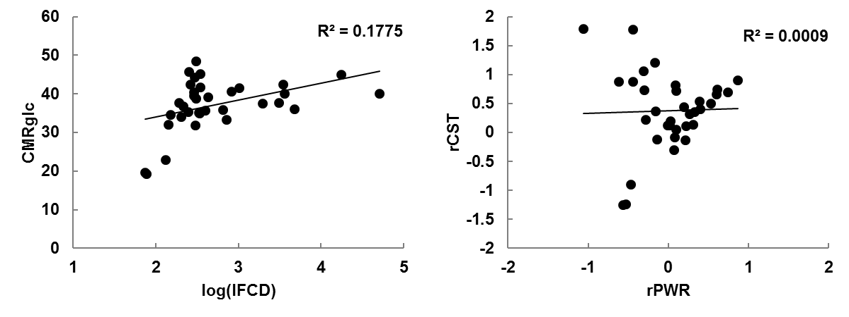
b
a

Supplementary Figure 1. Correlation between lFCD and CMRglc across 34 bilateral cortical parcellations (see Methods) (r(32) = 0.42, p = 0.01) (a), and between rPWR and rCST (r(32) = 0.03, p = 0.87) (b) in cohort-1. Across the 34 bilateral ROIs the coefficient of variation of lFCD was 23% and coefficient of variation of CMRglc was 18%.

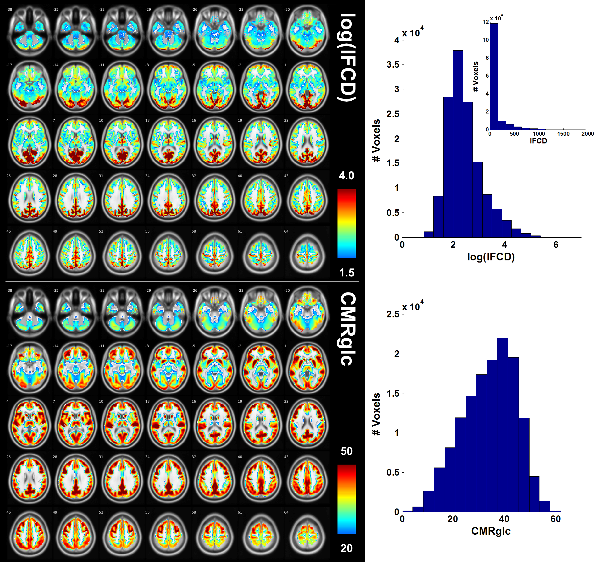

Supplementary Figure 2. Regional distribution of log(lFCD) (top row) and CMRglc (bottom row) in cohort-1 (n = 28), along with their voxelwise histograms (15 bins) in gray matter (averaged across subjects). The histogram of lFCD (without log transformation) is also shown (in top right corner of the log(lFCD) histogram) with a heavily skewed distribution (skewness = 3.22). In comparison, log(lFCD) had lower skewness (skewness = 0.90), closer to a normal distribution. The MNI z-coordinate is displayed next to each slice.

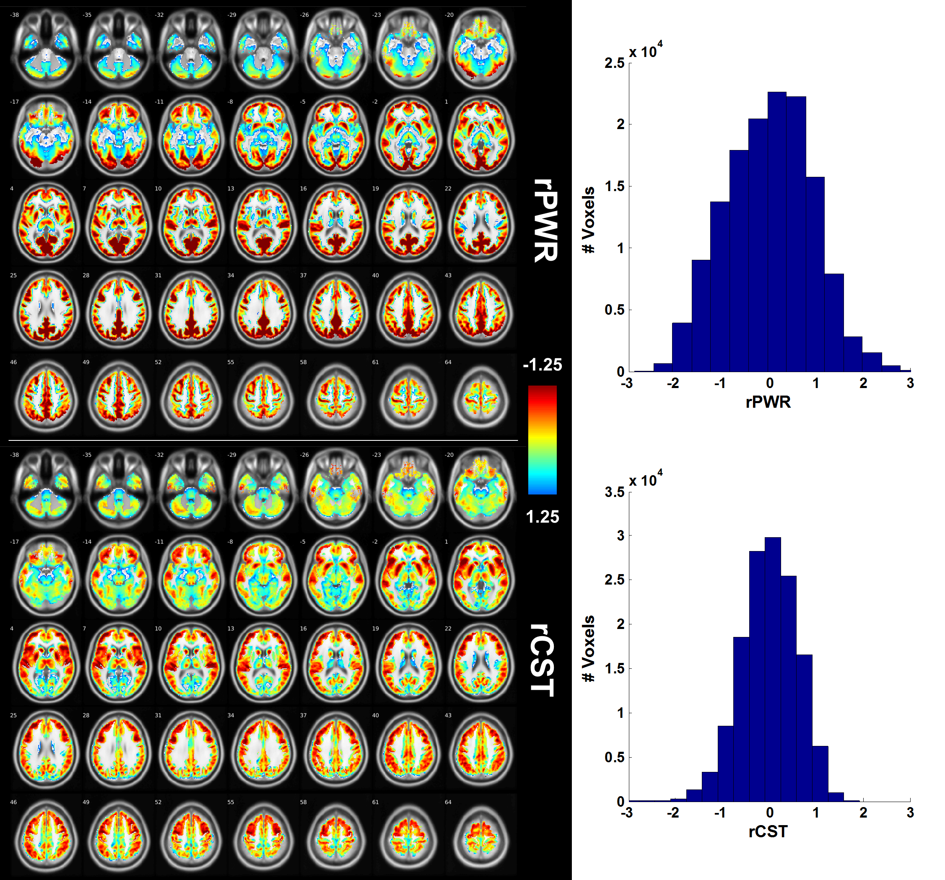

Supplementary Figure 3. Regional distribution of rPWR (top row) and rCST (bottom row) in cohort-1 (n = 28), along with their voxelwise histograms (15 bins) in the gray matter (averaged across subjects). The MNI z-coordinate is displayed next to each slice.

Supplementary Figure 4. Calinski-Harabasz clustering evaluation criterion²¹. Clustering was performed on gray matter voxels based on across-subject average (cohort-1, n = 28) of rPWR and rCST measures (2 × n data points; n = 139267 voxels). While cluster count = 2 achieved the highest criteria score, there was a local maximum at 4 clusters. These 4 clusters were 100% reproducible with repeated execution (n = 100) of k-means algorithm (with 1000 maximum interactions for convergence of each k-means execution).

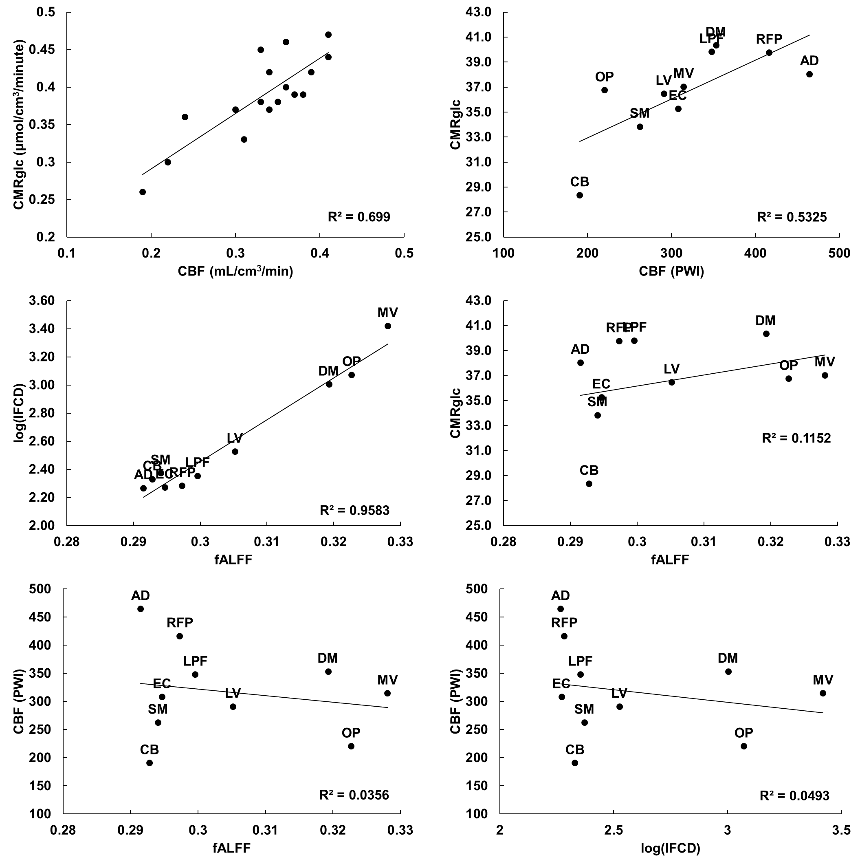
e
f
c
d
b
a

Supplementary Figure 5. Associations between CMRglc, CBF (PWI), lFCD, and fALFF. (a) Correlation between CBF and CMRglc of gray matter structures reported in an independent publication²² (r(8) = 0.84, p < 0.001). (b) Correlation between CBF (PWI) and CMRglc of 10 brain networks in cohort-1 (r(8) = 0.73, p = 0.017). (c) Correlation between fALFF and log(lFCD) in cohort-1 (r(8) = 0.98, p < 0.001). (d) Correlation between fALFF and CMRglc in cohort-1 (r(8) = 0.34, p = 0.34). (e) Correlation between fALFF and CBF (PWI) in cohort-1 (r(8) = -0.19, p = 0.60). (f) Correlation between log(lFCD) and CBF (PWI) in cohort-1 (r(8) = -0.22, p = 0.54). Each point represents across-subject average for medial visual (MV), occipital pole (OP), lateral visual (LV), default mode (DM), cerebellum (CB), sensorimotor (SM), auditory (AD), executive control (EC), right and left frontoparietal (RFP & LFP) networks.

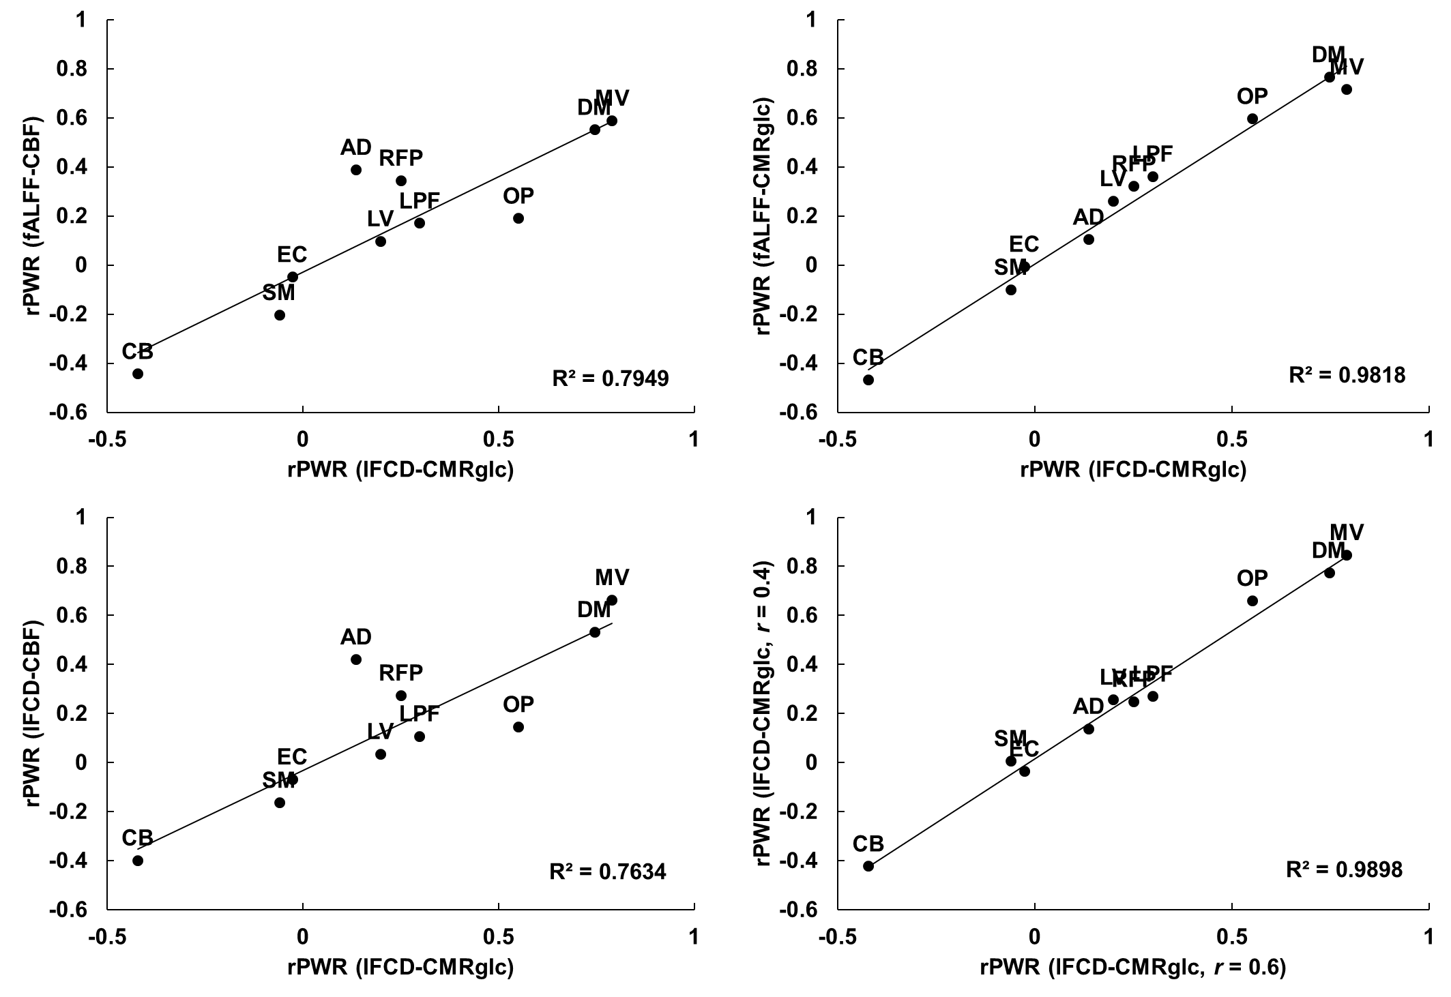
d
c
b
a

Supplementary Figure 6. Generalizability of rPWR in cohort-1. (a) Correlation between lFCD-CMRglc based rPWR and fALFF-CBF based rPWR (r(8) = 0.89, p < 0.001). (b) Correlation between lFCD-CMRglc based rPWR and fALFF-CMRglc based rPWR (r(8) = 0.99, p < 0.001). (c) Correlation between lFCD-CMRglc based rPWR and lFCD-CBF based rPWR (r(8) = 0.87, p < 0.001). (d) Correlation between lFCD-CMRglc based rPWR with r = 0.6 lFCD threshold (default) and lFCD-CMRglc based rPWR with r = 0.4 lFCD threshold (r(8) = 0.99, p < 0.001). Each point represents across-subject average for medial visual (MV), occipital pole (OP), lateral visual (LV), default mode (DM), cerebellum (CB), sensorimotor (SM), auditory (AD), executive control (EC), right and left frontoparietal (RFP & LFP) networks.

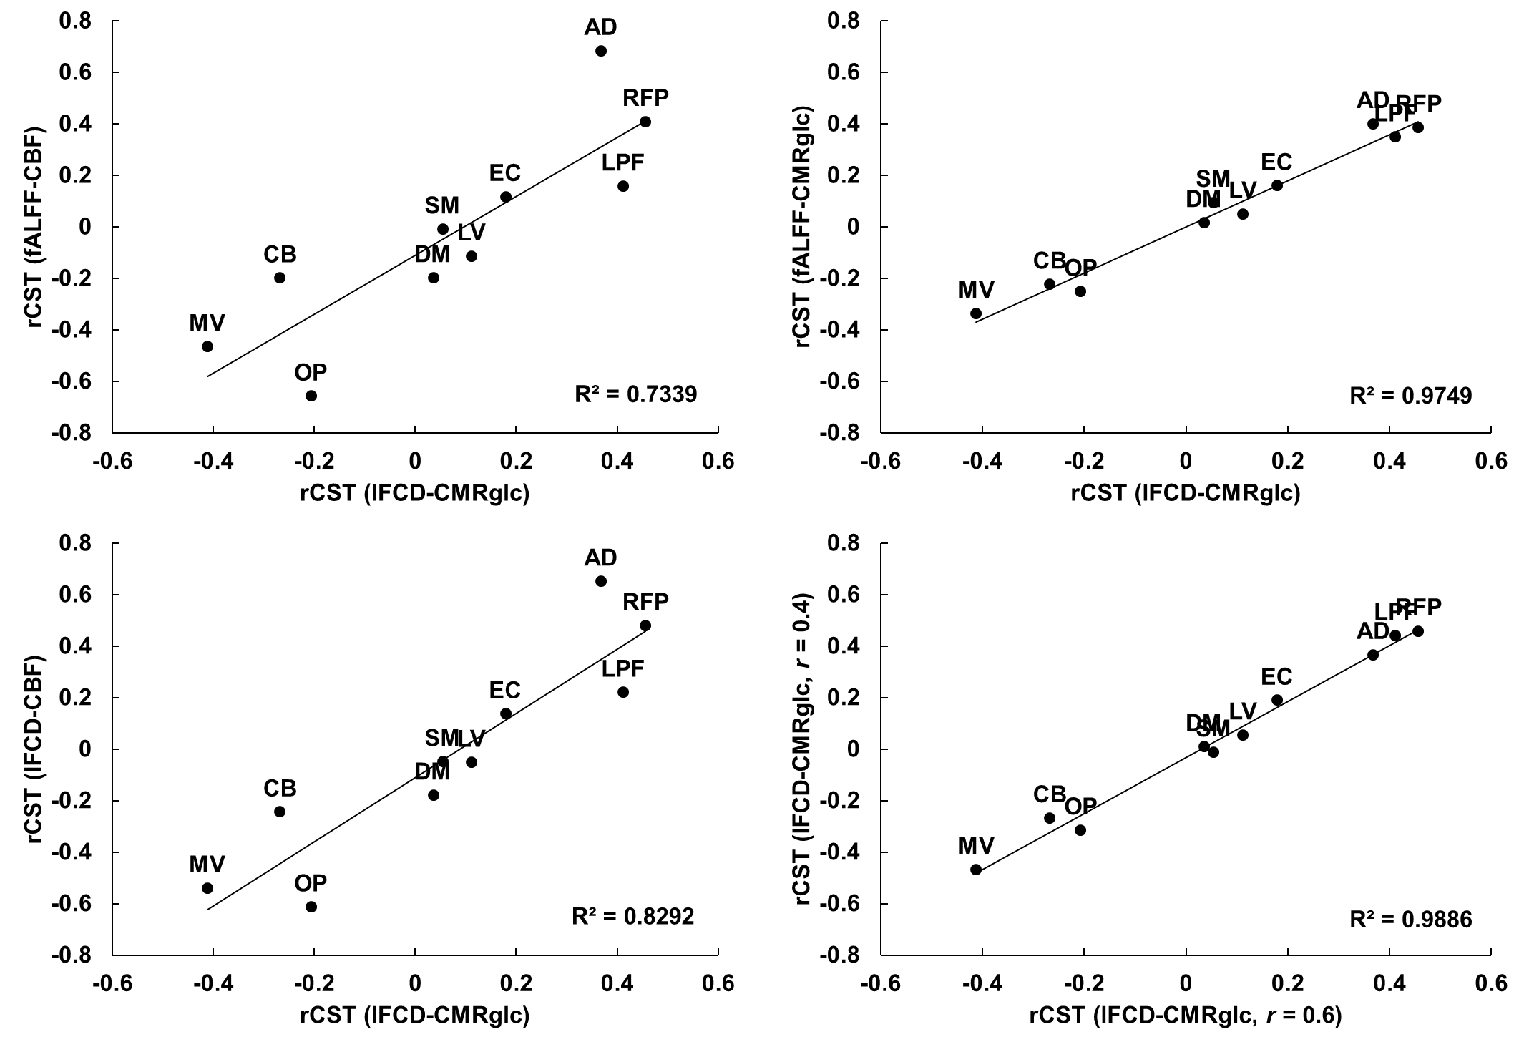
d
c
b
a

Supplementary Figure 7. Generalizability of rCST in cohort-1. (a) Correlation between lFCD-CMRglc based rCST and fALFF-CBF based rCST (r(8) = 0.89, p < 0.001). (b) Correlation between lFCD-CMRglc based rCST and fALFF-CMRglc based rCST (r(8) = 0.99, p < 0.001). (c) Correlation between lFCD-CMRglc based rCST and lFCD-CBF based rCST (r(8) = 0.87, p < 0.001). (d) Correlation between lFCD-CMRglc based rCST with r = 0.6 lFCD threshold (default) and lFCD-CMRglc based rCST with r = 0.4 lFCD threshold (r(8) = 0.99, p < 0.001). Each point represents across-subject average for medial visual (MV), occipital pole (OP), lateral visual (LV), default mode (DM), cerebellum (CB), sensorimotor (SM), auditory (AD), executive control (EC), right and left frontoparietal (RFP & LFP) networks.

b
a

Supplementary Figure 8. Effect of tSNR on segmentation (cohort-1, n = 28). (a) Original segmentation (4 clusters) of the brain based on rPWR and rCST computed with lFCD-CMRglc then projected back into the lFCD-CMRglc space (also shown in Fig. 3b). (b) Segmentation (4 clusters) of brain based on rPWR and rCST calculated for tSNR_{fMRI}-tSNR_{FDG-PET} then projected back into the lFCD-CMRglc space. Colors are arbitrary.

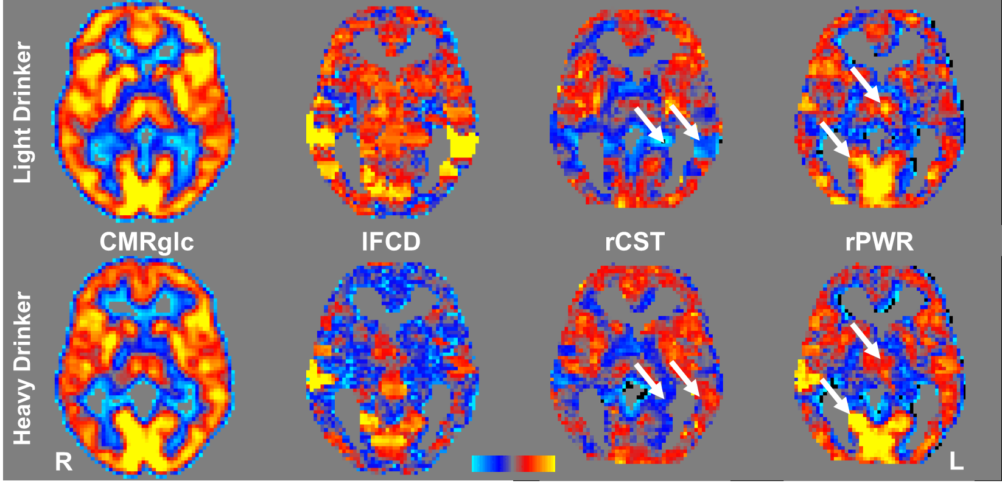

Supplementary Figure 9. Maps of CMRglc, lFCD, rCST, and rPWR for a representative light drinker (LD) (top row) and a representative heavy drinker (HD) (bottom row) of cohort-2 for the same cross section of the brain in the MNI space (z = 0 mm). The same color scale was used for the top and bottom images in each column. The arrows highlight some of the group differences in rCST and rPWR reported in Supplementary Tables 15, 16. Images are shown in radiological convention (right is left). The color scale blue to yellow indicate low to high values in the maps, respectively.

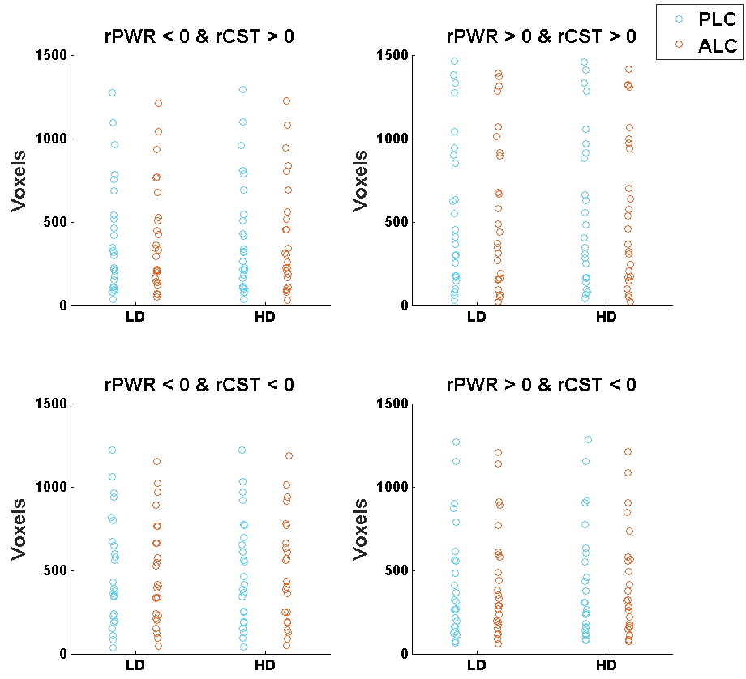
a
b

Supplementary Figure 10. Raw data used to generate bar plots in Fig. 4g. (a) Two-dimensional histograms of rPWR versus rCST measures for light (LD) and heavy (HD) drinkers under placebo (PLC) and alcohol (ALC) conditions. (b) Each data point shows the number of voxels (aggregated across subjects and normalized by number of subjects per group) falling into one of 25 (5 × 5) partitions (divided by the 0 axes) of rPWR and rCST that were used to estimate the 2-dimensional histograms shown in (a). Regional rPWR and rCST were computed from whole brain normalized log(lFCD) and CMRglc, thus they had zero-mean and unit variance for each participant and condition (see Fig. 4g).

Supplementary Table 1. One sample t-test on rPWR (p < 10⁻⁷, uncorrected, p_{FWE} < 0.01, |t| > 6, corrected at voxel-level, k > 400). Coordinates are in MNI space (voxel size = 2-mm isotropic).

Region(s) | L/R | Contrast | Brodmann area(s) | Cluster size | Peak coordinates (x, y, z)_{mm} |  |  | Peak t-value
Limbic Lobe  Posterior Cingulate  Occipital Lobe  Calcarine  Cuneus  Lingual Gyrus  Middle Occipital Gyrus  Parietal Lobe  Angular Gyrus  Precuneus  Temporal Lobe  Middle Temporal Gyrus | L/R  L/R  L/R  L/R | rPWR > 0 | 7, 17, 18, 19, 23, 30, 31, 39 | 9677 | -1 | -45 | 33 |  | 23.57
Frontal Lobe  Inferior Frontal Gyrus  Middle Frontal Gyrus  Precentral Gyrus  Superior Frontal Gyrus  Insula  Parietal Lobe  Inferior Parietal Lobule  Temporal Lobe  Superior Temporal Gyrus | R  R  R  R | rPWR > 0 | 9, 10, 13, 11, 41, 46 | 2323 | 25 | 58 | -1 |  | 18.48
Temporal Lobe  Superior Temporal Gyrus  Insula  Parietal Lobe  Inferior Parietal Lobule | L  L  L | rPWR > 0 | 13, 40, 41 | 698 | -41 | -29 | 11 |  | 16.38
Frontal Lobe  Inferior Frontal Gyrus  Middle Frontal Gyrus  Precentral Gyrus  Superior Frontal Gyrus  Insula | L  L | rPWR > 0 | 9, 10, 11, 47, 46 | 2099 | -33 | 36 | -13 |  | 18.93
Putamen  Caudate | L | rPWR > 0 | - | 584 | -27 | 6 | 1 |  | 24.23
Putamen  Caudate | R | rPWR > 0 | - | 522 | 27 | 2 | 5 |  | 21.87
Cerebellum (Anterior and Posterior Lobe)  Cerebellar Tonsil  Culmen  Declive  Frontal lobe  Medial Frontal Gyrus  Inferior Frontal Gyrus  Precentral Gyrus  Insula  Limbic Lobe  Cingulate Gyrus  Hippocampus  Parahippocampal Gyrus  Midbrain  Medulla  Pons  Thalamus*  Ventral Anterior Nucleus  Ventral Lateral Nucleus  Temporal Lobe  Fusiform Gyrus  Superior Temporal Gyrus  Inferior Temporal Gyrus | L/R  L/R  L/R  L/R  L/R  L/R  L/R  L/R  L/R | rPWR < 0 | 13, 20, 21, 24, 36, 38 | 34587 | -11 | -43 | 9 |  | -60.86
*Bilateral medial dorsal nucleus of the thalamus also had significantly high rPWR (k = 184, p_{FWE} < 0.01, cluster-size corrected).

Supplementary Table 2. One sample t-test on rCST (p < 10⁻⁷, uncorrected, p_{FWE} < 0.01, |t| > 6, corrected at voxel-level, k > 400). Coordinates are in MNI space (voxel size = 2-mm isotropic).

Region(s) | L/R | Contrast | Brodmann area(s) | Cluster size | Peak coordinates (x, y, z)_{mm} |  |  | Peak t-value
Frontal Lobe  Inferior Frontal Gyrus  Middle Frontal Gyrus  Precentral Gyrus  Superior Frontal Gyrus  Insula  Parietal Lobe  Inferior Parietal Lobule  Postcentral Gyrus  Putamen  Temporal Lobe  Middle Temporal Gyrus  Superior Temporal Gyrus | L  L  L  L  L | rCST > 0 | 6, 9, 10, 13, 40, 47 | 8671 | -43 | -53 | 47 |  | 28.30
Frontal Lobe  Inferior Frontal Gyrus  Middle Frontal Gyrus  Precentral Gyrus  Superior Frontal Gyrus  Insula  Putamen  Temporal Lobe  Superior Temporal Gyrus  Middle Temporal Gyrus | R  R  R  R | rCST > 0 | 6, 9, 10, 22, 13, 47 | 5632 | 37 | -5 | 53 |  | 28.76
Caudate  Cerebellum (Anterior and Posterior Lobe)  Culmen  Declive  Limbic Lobe  Amygdala  Anterior Cingulate  Hippocampus  Parahippocampal Gyrus  Midbrain  Occipital Lobe  Fusiform Gyrus  Lingual Gyrus  Pons  Temporal Lobe  Superior Temporal Gyrus  Thalamus*  Ventral Anterior Nucleus  Ventral Lateral Nucleus | L/R  L/R  L/R  L/R  L/R  L/R  L/R  L/R | rCST < 0 | 25, 28, 34, 38 | 15316 | -23 | -31 | -40 |  | 42.85
*Bilateral medial dorsal nucleus of the thalamus also had significantly higher rCST (k = 199, p_{FWE} < 0.01, cluster-size corrected).

Supplementary Table 3. Paired t-test between rCST and rPWR (p < 10⁻⁷, uncorrected, p_{FWE} < 0.01, |t| > 6, corrected at voxel-level, k > 400). Coordinates are in MNI space (voxel size: 2-mm isotropic).

Region(s) | L/R | Contrast | Brodmann area(s) | Cluster size | Peak coordinates (x, y, z)_{mm} |  |  | Peak t-value
Cerebellum (Anterior and Posterior Lobes)  Culmen  Devlive  Frontal Lobe  Inferior Frontal Gyrus  Limbic Lobe  Amygdala  Hippocampus  Parahippocampal Gyrus  Globus Pallidus  Insula  Medulla  Midbrain  Pons  Putamen  Temporal Lobe  Fusiform Gyrus  Inferior Temporal Gyrus  Middle Temporal Gyrus  Superior Temporal Gyrus  Thalamus*  Ventral Anterior Nucleus  Ventral Lateral Nucleus | L/R  L/R  L/R  L/R  L/R  L/R  L/R  L/R  L/R  L/R  L/R | rCST > rPWR | 13, 20, 21, 22, 28, 36, 38 | 8671 | -43 | -53 | 47 |  | 28.30
Limbic Lobe  Middle Cingulate  Frontal Lobe  Medial Frontal Gyrus  Precentral Gyrus  Superior Frontal Gyrus  Parietal Lobe  Inferior Parietal Lobule  Postcentral Gyrus  Precuneus | L  L  L | rCST > rPWR | 6, 4, 7 | 817 | -39 | -13 | 35 |  | 17.24
Limbic Lobe  Middle Cingulate  Frontal Lobe  Medial Frontal Gyrus  Precentral Gyrus | R  R | rCST > rPWR | 6 | 438 | 9 | -19 | 63 |  | 14.69
Limbic Lobe  Posterior Cingulate  Occipital Lobe  Calcarine  Cuneus  Middle Occipital Gyrus  Lingual Gyrus  Parietal Lobe  Angular Gyrus  Precuneus  Temporal Lobe  Middle Temporal Gyrus | L/R  L/R  L/R  L/R  L/R | rPWR > rCST | 7, 18, 17, 19, 30, 31 | 8173 | 9 | -71 | 15 |  | -18.41
*Medial dorsal nucleus of the thalamus had significantly higher rPWR than rCST (k = 73, p_{FWE} < 0.01, cluster-size corrected).

Supplementary Table 4. Anatomy of the sensorimotor cluster as identified by the k-means clustering approach (k > 400). In addition to sensorimotor areas, this cluster also included a range of regions such as limbic and visual areas.

Region(s) | L/R | Brodmann area(s) | Cluster size | Cluster Mean rPWR | Cluster Mean rCST
Caudate  Cerebellum (Anterior and Posterior Lobe)  Culmen  Declive  Uvula  Frontal Lobe  Inferior Frontal Gyrus  Medial Frontal Gyrus  Middle Frontal Gyrus  Paracentral Lobule  Precentral Gyrus  Superior Frontal Gyrus  Insula  Limbic Lobe  Anterior Cingulate  Parahippocampal Gyrus  Occipital Lobe  Cuneus  Lingual Gyrus  Middle Occipital Gyrus  Parietal Lobe  Inferior Parietal Lobule  Postcentral Gyrus  Precuneus  Supramarginal Gyrus  Putamen  Temporal Lobe  Fusiform Gyrus  Inferior Temporal Gyrus  Middle Temporal Gyrus  Superior Temporal Gyrus | L/R  L/R  L/R  L/R  L/R  L/R  L/R  L/R  L/R | 3, 4, 6, 7, 10, 11, 13, 20, 21, 22, 24, 32, 37, 38, 40, 47, | 44185 | -0.27 | 0.01

Supplementary Table 5. Anatomy of the cerebellar-limbic cluster as identified by the k-means clustering approach (k > 400). In addition to cerebellar-limbic areas, this cluster also included a range of regions such as frontal and temporal areas.

Region(s) | L/R | Brodmann area(s) | Cluster size | Cluster Mean rPWR | Cluster Mean rCST
Caudate  Cerebellum (Anterior and Posterior Lobe)  Culmen  Declive  Frontal Lobe  Medial Frontal Gyrus  Inferior Frontal Gyrus  Globus Pallidus  Insula  Limbic Lobe  Amygdala  Anterior Cingulate  Hippocampus_  Parahippocampal Gyrus  Medulla  Midbrain  Occipital Lobe  Cuneus  Lingual Gyrus  Pons  Putamen  Thalamus  Ventral Anterior Nucleus  Ventral Lateral Nucleus  Temporal Lobe  Fusiform Gyrus  Inferior Temporal Gyrus  Middle Temporal Gyrus  Superior Temporal Gyrus | L/R  L/R  L/R  L/R  L/R  L/R  L/R  L/R  L/R  L/R  L/R  L/R  L/R | 13, 20, 21, 24, 28, 34, 36, 38 | 27780 | -1.25 | -0.59
Frontal Lobe  Medial Frontal Gyrus  Limbic Lobe  Middle Cingulate  Parietal Lobe  Precuneus | L  L  L | 6, 31 | 765 | -1.12 | -0.33

Supplementary Table 6. Anatomy of the visual cluster as identified by the k-means clustering approach (k > 400). In addition to visual areas, this cluster also included a range of regions such as frontal and parietal areas. Medial dorsal nucleus of the thalamus was also identified as a part of this network (k = 159).

Region(s) | L/R | Brodmann area(s) | Cluster size | Cluster Mean rPWR | Cluster Mean rCST
Cerebellum (Posterior Lobe)  Declive  Limbic Lobe  Middle Cingulate  Posterior Cingulate  Occipital Lobe  Cuneus  Inferior Occipital Gyrus  Lingual Gyrus  Middle Occipital Gyrus  Superior Occipital Gyrus  Parietal Lobe  Angular Gyrus  Inferior Parietal Lobule  Precuneus  Superior Parietal Lobule  Temporal Lobe  Fusiform Gyrus  Inferior Temporal Gyrus  Middle Temporal Gyrus | L/R  L/R  L/R  L/R  L/R | 5, 6, 7, 17, 18, 19, 23, 30, 31, 37, 39 | 18628 | 1.25 | -0.07
Frontal Lobe  Medial Frontal Gyrus  Superior Frontal Gyrus | L/R | 9, 10 | 476 | 0.88 | -0.07
Frontal Lobe  Precentral Gyrus  Insula  Parietal Lobe  Inferior Parietal Lobule  Postcentral Gyrus | R  R  R | 4, 6, 13, 40 | 652 | 0.92 | -0.21
Frontal Lobe  Precentral Gyrus  Parietal Lobe  Inferior Parietal Lobule | L  L | 3, 4, 6 | 457 | 1.01 | -0.19

Supplementary Table 7. Anatomy of the frontoparietal cluster as identified by the k-means clustering approach (k > 400). In addition to frontoparietal areas, this cluster also included a range of regions such as occipital and temporal areas.

Region(s) | L/R | Brodmann area(s) | Cluster size | Cluster Mean rPWR | Cluster Mean rCST
Caudate  Frontal Lobe  Medial Frontal Gyrus  Middle Frontal Gyrus  Inferior Frontal Gyrus  Precentral Gyrus  Superior Frontal Gyrus  Insula  Limbic Lobe  Anterior Cingulate  Occipital Lobe  Cuneus  Middle Occipital Gyrus  Parietal Lobe  Angular Gyrus  Inferior Parietal Lobule  Postcentral Gyrus  Precuneus  Supramarginal Gyrus  Superior Parietal Lobule  Putamen  Temporal Lobe  Fusiform Gyrus  Inferior Temporal Gyrus  Middle Temporal Gyrus  Superior Temporal Gyrus  Transverse Temporal Gyrus | L  L/R  L/R  L/R  L/R  L/R  L  L/R | 3, 4, 6, 7, 8, 9, 10, 11, 13, 19, 21, 22, 24, 31, 32, 37, 39, 40, 41, 44, 45, 46, 47 | 39314 | 0.61 | 0.61
Caudate  Pallidum  Putamen | R  R  R | - | 873 | 0.64 | 0.76
Thalamus  Medial Dorsal Nucleus  Ventral Lateral Nucleus | L/R |  | 430 | 0.46 | 0.50

Supplementary Table 8. Across-subject mean (M) and standard deviation (SD) of lFCD, CMRglc, rCST, and rPWR highlighting individual differences (cohort-1, n = 28).

Region | log(lFCD)  (M, SD) |  | CMRglc  (M, SD) |  | rCST  (M, SD) |  | rPWR  (M, SD)
bankssts | 2.46 | 0.34 | 40.36 | 5.04 | 0.40 | 0.15 | 0.40 | 0.20
caudalanteriorcingulate | 2.52 | 0.33 | 35.12 | 5.78 | 0.02 | 0.22 | 0.12 | 0.20
caudalmiddlefrontal | 2.47 | 0.36 | 44.30 | 6.81 | 0.60 | 0.22 | 0.66 | 0.26
cuneus | 4.24 | 0.93 | 44.96 | 7.16 | -0.44 | 0.29 | 1.78 | 0.44
entorhinal | 1.89 | 0.24 | 19.21 | 3.22 | -0.56 | 0.18 | -1.25 | 0.16
fusiform | 2.48 | 0.36 | 31.83 | 4.22 | -0.14 | 0.13 | -0.12 | 0.14
inferiorparietal | 3.01 | 0.38 | 41.42 | 5.72 | 0.09 | 0.16 | 0.82 | 0.20
inferiortemporal | 2.31 | 0.23 | 34.04 | 5.01 | 0.08 | 0.17 | -0.08 | 0.13
isthmuscingulate | 3.49 | 0.52 | 37.66 | 6.49 | -0.44 | 0.20 | 0.88 | 0.23
lateraloccipital | 3.56 | 0.67 | 39.99 | 5.10 | -0.31 | 0.21 | 1.06 | 0.27
lateralorbitofrontal | 2.28 | 0.16 | 37.65 | 5.88 | 0.31 | 0.22 | 0.13 | 0.13
lingual | 3.68 | 0.82 | 36.01 | 4.73 | -0.62 | 0.29 | 0.88 | 0.31
medialorbitofrontal | 2.53 | 0.21 | 34.83 | 5.51 | -0.01 | 0.19 | 0.12 | 0.19
middletemporal | 2.33 | 0.19 | 36.69 | 5.52 | 0.22 | 0.18 | 0.11 | 0.14
parahippocampal | 2.12 | 0.25 | 22.78 | 3.28 | -0.47 | 0.10 | -0.90 | 0.14
paracentral | 2.86 | 0.62 | 33.23 | 4.26 | -0.28 | 0.28 | 0.22 | 0.34
parsopercularis | 2.40 | 0.27 | 45.76 | 7.00 | 0.74 | 0.14 | 0.69 | 0.23
parsorbitalis | 2.54 | 0.30 | 41.66 | 7.52 | 0.39 | 0.29 | 0.53 | 0.24
parstriangularis | 2.42 | 0.32 | 42.48 | 6.93 | 0.53 | 0.23 | 0.50 | 0.22
pericalcarine | 4.71 | 1.03 | 39.98 | 6.96 | -1.06 | 0.47 | 1.79 | 0.45
postcentral | 2.60 | 0.39 | 35.73 | 4.51 | 0.03 | 0.20 | 0.20 | 0.22
posteriorcingulate | 2.92 | 0.35 | 40.62 | 5.80 | 0.10 | 0.15 | 0.72 | 0.24
precentral | 2.49 | 0.35 | 38.76 | 4.99 | 0.27 | 0.18 | 0.32 | 0.19
precuneus | 3.54 | 0.52 | 42.47 | 6.00 | -0.17 | 0.16 | 1.21 | 0.13
rostralanteriorcingulate | 2.39 | 0.20 | 35.24 | 5.27 | 0.10 | 0.19 | 0.05 | 0.16
rostralmiddlefrontal | 2.54 | 0.27 | 45.09 | 6.99 | 0.61 | 0.11 | 0.74 | 0.19
superiorfrontal | 2.46 | 0.27 | 39.53 | 5.95 | 0.33 | 0.09 | 0.35 | 0.18
superiorparietal | 3.29 | 0.64 | 37.45 | 4.93 | -0.30 | 0.21 | 0.73 | 0.23
superiortemporal | 2.18 | 0.23 | 34.54 | 4.79 | 0.21 | 0.14 | -0.13 | 0.14
supramarginal | 2.63 | 0.27 | 39.05 | 5.07 | 0.20 | 0.14 | 0.44 | 0.16
frontalpole | 2.81 | 0.54 | 35.79 | 6.37 | -0.16 | 0.40 | 0.36 | 0.39
temporalpole | 1.87 | 0.22 | 19.64 | 3.82 | -0.53 | 0.19 | -1.24 | 0.18
transversetemporal | 2.49 | 0.42 | 48.42 | 6.82 | 0.87 | 0.19 | 0.90 | 0.28
insula | 2.15 | 0.16 | 32.01 | 4.82 | 0.07 | 0.12 | -0.31 | 0.12

Supplementary Table 9. Columns 2–5 show correlations between regional cortical thickness and regional lFCD, CMRglc, rCST, and rPWR across subjects (cohort-1, n = 28). Regions are sorted by their mean cortical thickness (last column) (*p< 0.05, **p< 0.05 Bonferroni). Mean and SD and significance levels are reported for the Fisher’s z-transformed correlations across regions.

Region | lFCD | CMRglc | rCST | rPWR | Mean Thickness (mm)
pericalcarine | 0.276 | -0.176 | -0.294 | 0.027 | 1.62
cuneus | 0.239 | 0.109 | -0.194 | 0.029 | 1.87
lingual | 0.276 | 0.076 | -0.089 | 0.069 | 1.99
postcentral | *0.412 | 0.014 | -0.017 | 0.146 | 2.15
lateraloccipital | *0.451 | 0.124 | -0.220 | *0.498 | 2.22
superiorparietal | *0.502 | 0.146 | -0.329 | 0.265 | 2.23
isthmuscingulate | 0.273 | -0.037 | -0.230 | -0.133 | 2.35
precuneus | *0.462 | 0.010 | -0.335 | *-0.557 | 2.46
transversetemporal | 0.278 | 0.150 | -0.121 | 0.238 | 2.49
rostralmiddlefrontal | *0.509 | *0.451 | 0.351 | *0.509 | 2.51
paracentral | 0.133 | 0.095 | -0.076 | -0.230 | 2.51
parahippocampal | -0.188 | 0.007 | 0.287 | 0.037 | 2.57
posteriorcingulate | 0.300 | 0.210 | 0.153 | -0.229 | 2.58
inferiorparietal | *0.401 | 0.349 | 0.089 | 0.100 | 2.59
caudalanteriorcingulate | 0.233 | *0.387 | 0.071 | 0.056 | 2.59
parstriangularis | 0.045 | *0.528 | *0.464 | -0.006 | 2.61
supramarginal | **0.623 | 0.302 | -0.132 | -0.080 | 2.63
bankssts | 0.212 | -0.042 | -0.039 | -0.029 | 2.68
frontalpole | 0.013 | 0.105 | 0.181 | 0.039 | 2.69
medialorbitofrontal | 0.364 | 0.257 | 0.056 | -0.002 | 2.71
precentral | 0.302 | 0.167 | -0.005 | 0.132 | 2.71
caudalmiddlefrontal | *0.46 | 0.346 | 0.026 | 0.289 | 2.72
fusiform | 0.161 | 0.013 | -0.039 | -0.106 | 2.78
lateralorbitofrontal | 0.039 | 0.206 | 0.285 | 0.153 | 2.79
parsopercularis | 0.247 | *0.424 | *0.483 | 0.154 | 2.80
superiorfrontal | **0.747 | *0.462 | 0.246 | **0.618 | 2.82
parsorbitalis | 0.287 | 0.083 | -0.045 | 0.160 | 2.86
inferiortemporal | -0.184 | -0.008 | 0.368 | *-0.422 | 2.91
superiortemporal | 0.068 | 0.140 | 0.280 | -0.087 | 2.93
rostralanteriorcingulate | 0.205 | *0.486 | 0.200 | -0.084 | 2.99
middletemporal | -0.041 | 0.047 | *0.440 | *-0.436 | 3.06
insula | -0.053 | 0.357 | *0.567 | -0.072 | 3.11
entorhinal | 0.063 | -0.141 | -0.247 | 0.067 | 3.31
temporalpole | 0.240 | -0.004 | -0.074 | 0.115 | 3.74
Mean | 0.27 | 0.17 | 0.07 | 0.04 | 2.63
SD | 0.25 | 0.20 | 0.27 | 0.27 | 0.40
p-value | < 0.0001 | < 0.0001 | 0.1523 | 0.4108

Supplementary Table 10. Columns 2–5 show correlations between mean cortical distance and regional lFCD, CMRglc, rCST, and rPWR across subjects (cohort-1, n = 28). Regions are sorted by their mean cortical distance (last column) (*p< 0.05, **p< 0.05 Bonferroni). Mean and SD and significance levels are reported for the Fisher’s z-transformed correlations across regions.

Region | lFCD | CMRglc | rCST | rPWR | Mean Distance (mm)
posteriorcingulate | 0.241 | -0.371 | *-0.545 | -0.020 | 83.75
isthmuscingulate | 0.150 | -0.365 | -0.221 | -0.235 | 85.56
caudalanteriorcingulate | -0.119 | -0.345 | -0.060 | -0.230 | 88.46
insula | -0.038 | -0.177 | 0.176 | *0.413 | 90.31
parahippocampal | -0.136 | -0.179 | 0.060 | -0.076 | 91.06
transversetemporal | 0.212 | -0.127 | -0.275 | 0.291 | 93.38
paracentral | 0.063 | -0.349 | -0.211 | 0.078 | 96.28
entorhinal | *-0.558 | 0.019 | **0.583 | -0.222 | 97.85
precuneus | 0.199 | -0.241 | -0.266 | -0.052 | 98.04
rostralanteriorcingulate | -0.196 | -0.100 | 0.130 | 0.026 | 98.83
precentral | 0.020 | -0.204 | -0.100 | 0.193 | 99.33
superiorfrontal | -0.133 | -0.293 | -0.087 | -0.293 | 101.26
fusiform | 0.111 | -0.048 | 0.148 | 0.269 | 101.27
superiortemporal | -0.069 | -0.150 | 0.240 | *0.485 | 102.09
medialorbitofrontal | -0.302 | -0.018 | 0.125 | -0.221 | 102.52
parsopercularis | 0.045 | -0.146 | 0.143 | 0.244 | 102.52
postcentral | 0.094 | -0.084 | -0.094 | *0.406 | 102.52
lingual | 0.136 | -0.202 | 0.069 | 0.117 | 103.21
lateralorbitofrontal | *-0.506 | 0.124 | **0.596 | *0.507 | 103.36
caudalmiddlefrontal | -0.366 | -0.226 | 0.293 | -0.358 | 104.12
temporalpole | *-0.455 | -0.042 | *0.461 | 0.031 | 107.54
bankssts | 0.229 | -0.044 | -0.145 | 0.346 | 107.67
supramarginal | 0.292 | -0.114 | *-0.376 | 0.284 | 108.24
middletemporal | -0.328 | -0.109 | *0.502 | 0.239 | 108.51
inferiortemporal | -0.357 | -0.088 | **0.597 | -0.017 | 108.99
cuneus | 0.020 | *-0.376 | 0.056 | -0.256 | 110.56
superiorparietal | -0.099 | -0.284 | 0.083 | -0.327 | 111.56
parstriangularis | *0.406 | -0.164 | -0.299 | **0.580 | 111.63
pericalcarine | 0.044 | -0.317 | 0.182 | -0.235 | 112.17
rostralmiddlefrontal | -0.142 | -0.040 | 0.237 | 0.089 | 114.88
inferiorparietal | 0.140 | -0.080 | -0.173 | 0.117 | 115.75
parsorbitalis | -0.089 | 0.018 | 0.175 | 0.236 | 118.77
lateraloccipital | 0.156 | 0.029 | 0.070 | *0.457 | 125.14
frontalpole | -0.078 | 0.193 | 0.179 | 0.013 | 129.26
Mean | -0.05 | -0.15 | 0.07 | 0.09 | 104.01
SD | 0.25 | 0.15 | 0.31 | 0.29 | 10.36
p-value | 0.2914 | < 0.0001 | 0.1721 | 0.069

Supplementary Table 11. Columns 2–5 show correlations between fMRI tSNR and regional lFCD, CMRglc, rCST, and rPWR across subjects (cohort-1, n = 28). Regions are sorted by their mean fMRI tSNR (last column) (*p< 0.05, **p< 0.05 Bonferroni). Mean and SD and significance levels are reported for the Fisher’s z-transformed correlations across regions.

Region | lFCD | CMRglc | rCST | rPWR | Mean fMRI tSNR
temporalpole | -0.143 | 0.120 | 0.201 | 0.325 | 12.91
entorhinal | -0.266 | 0.156 | 0.265 | 0.134 | 17.51
frontalpole | 0.177 | -0.185 | -0.082 | 0.114 | 18.23
medialorbitofrontal | -0.004 | -0.089 | -0.127 | 0.299 | 20.32
lateralorbitofrontal | *-0.547 | 0.142 | *0.438 | *0.374 | 24.07
inferiortemporal | -0.311 | 0.255 | *0.521 | -0.050 | 26.11
parsorbitalis | -0.265 | 0.231 | *0.528 | *0.490 | 27.10
middletemporal | -0.210 | 0.132 | 0.323 | 0.129 | 31.88
parahippocampal | -0.066 | 0.170 | 0.364 | 0.118 | 31.94
fusiform | -0.216 | 0.006 | 0.143 | -0.142 | 34.42
superiortemporal | -0.076 | 0.306 | 0.156 | 0.163 | 37.84
lateraloccipital | -0.141 | -0.149 | -0.141 | -0.073 | 42.22
lingual | -0.254 | -0.088 | -0.023 | -0.203 | 43.48
parstriangularis | 0.179 | -0.113 | -0.183 | *0.389 | 43.51
rostralanteriorcingulate | -0.030 | 0.052 | -0.157 | 0.125 | 44.73
transversetemporal | -0.317 | 0.326 | 0.352 | -0.126 | 45.56
insula | -0.231 | *0.387 | *0.451 | 0.116 | 48.37
rostralmiddlefrontal | 0.183 | 0.065 | -0.339 | *0.392 | 49.10
bankssts | 0.019 | 0.196 | -0.178 | -0.065 | 49.43
parsopercularis | 0.182 | 0.144 | -0.060 | *0.477 | 49.58
postcentral | -0.204 | -0.006 | -0.232 | -0.357 | 49.76
precentral | -0.060 | 0.130 | -0.291 | -0.110 | 51.78
supramarginal | 0.002 | 0.154 | *-0.455 | -0.045 | 52.60
isthmuscingulate | -0.084 | 0.200 | -0.016 | 0.203 | 54.27
pericalcarine | *-0.449 | 0.069 | 0.159 | -0.110 | 54.72
inferiorparietal | 0.155 | 0.114 | -0.366 | *0.382 | 55.81
cuneus | *-0.459 | -0.100 | 0.228 | *-0.410 | 56.90
caudalmiddlefrontal | 0.307 | 0.238 | -0.334 | *0.515 | 57.29
superiorfrontal | 0.260 | 0.209 | -0.288 | *0.489 | 57.51
caudalanteriorcingulate | 0.039 | 0.232 | 0.192 | 0.276 | 59.08
posteriorcingulate | -0.134 | *0.401 | 0.177 | 0.062 | 59.25
paracentral | -0.361 | 0.034 | 0.097 | *-0.502 | 59.30
superiorparietal | -0.144 | -0.213 | -0.348 | -0.305 | 61.26
precuneus | -0.271 | 0.108 | -0.174 | -0.079 | 63.31
Mean | -0.12 | 0.11 | 0.03 | 0.09 | 43.86
SD | 0.23 | 0.16 | 0.30 | 0.29 | 14.40
p-value | 0.0051 | 0.0004 | 0.602 | 0.0703

Supplementary Table 12. Columns 2–5 show correlations between FDG-PET tSNR and regional lFCD, CMRglc, rCST, and rPWR across subjects (cohort-1, n = 28). Regions are sorted by their mean FDG-PET tSNR (last column) (*p< 0.05, **p< 0.05 Bonferroni). Mean and SD and significance levels are reported for the Fisher’s z-transformed correlations across regions.

Region | lFCD | CMRglc | rCST | rPWR | Mean FDG-PET tSNR
entorhinal | 0.066 | *0.494 | 0.026 | 0.124 | 2.31
temporalpole | 0.245 | *0.495 | -0.069 | 0.338 | 2.37
parahippocampal | 0.051 | *0.554 | -0.026 | 0.046 | 2.50
fusiform | -0.055 | *0.504 | -0.130 | -0.193 | 2.70
inferiortemporal | -0.056 | **0.611 | 0.133 | 0.172 | 2.77
paracentral | -0.239 | 0.237 | *0.387 | -0.109 | 2.78
insula | -0.152 | *0.546 | 0.302 | -0.105 | 2.82
caudalanteriorcingulate | -0.125 | *0.554 | *0.517 | 0.326 | 2.84
superiortemporal | -0.036 | *0.492 | 0.015 | -0.093 | 2.88
isthmuscingulate | -0.111 | **0.600 | 0.343 | *0.488 | 2.88
lingual | -0.054 | *0.437 | -0.185 | -0.050 | 2.89
postcentral | -0.252 | 0.117 | 0.133 | *-0.396 | 2.89
rostralanteriorcingulate | -0.088 | **0.574 | 0.203 | 0.220 | 2.92
middletemporal | -0.037 | *0.561 | 0.052 | 0.097 | 2.93
precentral | -0.197 | 0.257 | 0.207 | -0.238 | 2.93
posteriorcingulate | -0.258 | *0.394 | *0.501 | 0.061 | 2.94
medialorbitofrontal | 0.201 | **0.641 | 0.027 | *0.441 | 2.95
lateralorbitofrontal | -0.073 | **0.580 | 0.153 | 0.234 | 2.95
superiorfrontal | 0.138 | *0.424 | 0.190 | 0.372 | 2.99
superiorparietal | -0.072 | 0.171 | -0.096 | 0.031 | 3.00
supramarginal | -0.063 | 0.295 | -0.164 | -0.053 | 3.04
caudalmiddlefrontal | 0.308 | *0.405 | -0.145 | *0.462 | 3.05
precuneus | -0.275 | 0.319 | 0.239 | -0.126 | 3.06
bankssts | 0.078 | *0.440 | -0.337 | -0.065 | 3.08
pericalcarine | -0.049 | *0.488 | -0.076 | 0.215 | 3.09
parstriangularis | -0.341 | *0.554 | *0.528 | -0.106 | 3.12
lateraloccipital | 0.033 | 0.330 | *-0.494 | -0.100 | 3.12
parsorbitalis | -0.211 | *0.566 | *0.422 | 0.191 | 3.14
parsopercularis | 0.009 | *0.547 | 0.243 | 0.220 | 3.16
transversetemporal | -0.140 | *0.523 | 0.291 | 0.010 | 3.16
inferiorparietal | -0.118 | *0.414 | 0.067 | 0.106 | 3.17
frontalpole | -0.070 | *0.492 | 0.085 | 0.049 | 3.18
cuneus | -0.040 | *0.398 | -0.128 | 0.092 | 3.21
rostralmiddlefrontal | -0.045 | *0.515 | 0.357 | 0.156 | 3.26
Mean | -0.06 | 0.50 | 0.11 | 0.09 | 2.94
SD | 0.15 | 0.16 | 0.26 | 0.22 | 0.22
p-value | 0.0239 | < 0.0001 | 0.0181 | 0.0269

Supplementary Table 13. Main effect of Alcohol on rCST (cluster-size corrected, p_{FWE} < 0.01, cluster defining threshold: p < 0.005, k > 120). Coordinates are in MNI space (voxel size = 3-mm isotropic).

Region(s) | L/R | Contrast | Brodmann area(s) | Cluster size | Peak coordinates (x, y, z)_{mm} |  |  | Peak t-value
Calcarine  Cuneus  Lingual Gyrus | L/R  L/R  L/R | ALC < PLC | 17, 18, 30 | 466 | -6 | -84 | 0 |  | 5.82

Supplementary Table 14. Main effect of Alcohol on rPWR (p_{FWE} < 0.01, cluster-size corrected, cluster defining threshold: p < 0.005, k > 120). Coordinates are in MNI space (voxel size = 3-mm isotropic).

Region(s) | L/R | Contrast | Brodmann area(s) | Cluster size | Peak coordinates (x, y, z)_{mm} |  |  | Peak t-value
Calcarine  Cuneus  Lingual Gyrus | L/R  L/R  L/R | ALC < PLC | 17, 18 | 466 | 0 | -84 | -6 |  | 5.69
Thalamus  Ventral Lateral Nucleus  Medial Dorsal Nucleus | L/R | PLC < ALC | - | 185 | -12 | -24 | 0 |  | 4.98

Supplementary Table 15. Main effect of Group on rCST (cluster-size corrected, p_{FWE} < 0.01, cluster defining threshold: p < 0.005, k > 120). Coordinates are in MNI space (voxel size = 3-mm isotropic).

Region(s) | L/R | Contrast | Brodmann area(s) | Cluster size | Peak coordinates (x, y, z)_{mm} |  |  | Peak t-value
Precuneus  Cuneus | L/R  L/R | HD < LD | 7, 31 | 270 | -15 | -57 | 24 |  | 7.14
Cingulate Gyrus  Medial Frontal Gyrus  Superior Frontal Gyrus | L/R  L/R  L/R | HD < LD | 6, 24 | 317 | 0 | -18 | 45 |  | 6.53
Inferior Frontal Gyrus Insula  Putamen | L/R  L/R  L/R | HD < LD | 13, 45 | 190 | -33 | 12 | 9 |  | 6.42
Cerebellum (Posterior Lobe)  Crus I  Crus II  Declive | L | HD < LD | - | 165 | -6 | -84 | -33 |  | 5.69
Cerebellum (Posterior Lobe)  Crus I  Declive  Tuber | R | HD < LD | - | 224 | 36 | -60 | -30 |  | 5.00
Calcarine  Posterior Cingulate  Middle Temporal Gyrus  Middle Occipital Gyrus | L/R  L/R  L  L/R | LD < HD | 18, 19, 30 | 554 | -36 | -90 | -18 |  | 6.62

Supplementary Table 16. Main effect of Group on rPWR (cluster-size corrected, p_{FWE} < 0.01, cluster defining threshold: p < 0.005, k > 120). Coordinates are in MNI space (voxel size = 3-mm isotropic).

Region(s) | L/R | Contrast | Brodmann area(s) | Cluster size | Peak coordinates (x, y, z)_{mm} |  |  | Peak t-value
Midbrain  Red Nucleus  Pons  Thalamus  Medial Dorsal Nucleus  Pulvinar | L/R  L/R  L/R | HD < LD | - | 224 | 36 | -60 | -30 |  | 7.83
Medial Frontal Gyrus  Precuneus  Superior Frontal Gyrus | L/R  L/R  L/R | HD < LD | 6, 7, 8, 32 | 420 | 0 | 36 | 39 |  | 7.25
Medial Frontal Gyrus  Superior Frontal Gyrus | L/R  L/R | HD < LD | 10 | 317 | -3 | 66 | 9 |  | 6.70
Middle Temporal Gyrus  Middle Occipital Gyrus | L  L | HD < LD | 18, 19 | 222 | -30 | -96 | -15 |  | 6.34
Cerebellum (Posterior Lobe)  Crus I  Declive  Uvula | L/R | LD < HD | - | 569 | 0 | -87 | -36 |  | 5.95
Precuneus  Cuneus | L/R  L/R | LD < HD | 7, 31 | 135 | -9 | -72 | 24 |  | 5.27

Supplementary Table 17. Association between rPWR and subjective experience of alcohol (subjective-PC) in light and heavy drinkers (n = 38) in cohort-2 (p_{FWE} < 0.01, cluster-size corrected, cluster defining threshold: p < 0.005). Coordinates are in MNI space (voxel size = 3-mm isotropic).

Region(s) | L/R | Contrast | Brodmann area(s) | Cluster size | Peak coordinates (x, y, z)_{mm} |  |  | Peak t-value
Middle Temporal Gyrus  Inferior Temporal Gyrus | R  R | Subjective-PC | 20, 21 | 60 | 60 | -45 | -18 |  | -4.60
Insula  Putamen  Claustrum | R  R  R | Subjective-PC | 13 | 61 | 36 | -3 | -3 |  | -5.18

Supplementary Table 18. Association between rCST and the cognitive-PC in heavy drinkers (n = 15) in cohort-2 (p_{FWE} < 0.01, cluster-size corrected, cluster defining threshold: p < 0.005). Coordinates are in MNI space (voxel size = 3-mm isotropic). At lower uncorrected thresholds this effect was bilateral.

Region(s) | L/R | Contrast | Brodmann area(s) | Cluster size | Peak coordinates (x, y, z)_{mm} |  |  | Peak t-value
Inferior Parietal Lobule  Supramarginal Gyrus | R | Cognitive-PC | 40 | 77 | 57 | -42 | 45 |  | 8.63

Supplementary References

1. Cha Y-HK, Jog MA, Kim Y-C, Chakrapani S, Kraman SM, Wang DJ. Regional correlation between resting state FDG PET and pCASL perfusion MRI. Journal of Cerebral Blood Flow & Metabolism 33, 1909-1914 (2013).

2. Glasser MF, et al. The minimal preprocessing pipelines for the Human Connectome Project. NeuroImage 80, 105-124 (2013).

3. Desikan RS, et al. An automated labeling system for subdividing the human cerebral cortex on MRI scans into gyral based regions of interest. Neuroimage 31, 968-980 (2006).

4. Fischl B, Dale AM. Measuring the thickness of the human cerebral cortex from magnetic resonance images. Proceedings of the National Academy of Sciences 97, 11050-11055 (2000).

5. Phelps M, Huang S, Hoffman E, Selin C, Sokoloff L, Kuhl D. Tomographic measurement of local cerebral glucose metabolic rate in humans with (F‐18) 2‐fluoro‐2‐deoxy‐D‐glucose: validation of method. Annals of neurology 6, 371-388 (1979).

6. Huang S-C, Phelps ME, Hoffman EJ, Sideris K, Selin CJ, Kuhl DE. Noninvasive determination of local cerebral metabolic rate of glucose in man. American Journal of Physiology-Endocrinology And Metabolism 238, E69-E82 (1980).

7. Friston KJ, et al. Analysis of fMRI time-series revisited. NeuroImage 2, 45-53 (1995).

8. Shokri-Kojori E, Tomasi D, Wiers CE, Wang GJ, Volkow ND. Alcohol affects brain functional connectivity and its coupling with behavior: greater effects in male heavy drinkers. Molecular Psychiatry 22, 1185 (2016).

9. Sokoloff L, et al. The [14C] deoxyglucose method for the measurement of local cerebral glucose utilization: theory, procedure, and normal values in the conscious and anesthetized albino rat. Journal of neurochemistry 28, 897-916 (1977).

10. Volkow ND, Fowler JS, Wolf AP. Changes in brain glucose metabolism in cocaine dependence and withdrawal. American Journal of Psychiatry 148, 621-626 (1991).

11. Power JD, Barnes KA, Snyder AZ, Schlaggar BL, Petersen SE. Spurious but systematic correlations in functional connectivity MRI networks arise from subject motion. NeuroImage 59, 2142-2154 (2012).

12. Tomasi D, Volkow ND. Functional connectivity density mapping. Proc Natl Acad Sci U S A 107, 9885-9890 (2010).

13. Zang Y, Jiang T, Lu Y, He Y, Tian L. Regional homogeneity approach to fMRI data analysis. Neuroimage 22, 394-400 (2004).

14. Zou Q-H, et al. An improved approach to detection of amplitude of low-frequency fluctuation (ALFF) for resting-state fMRI: fractional ALFF. Journal of neuroscience methods 172, 137-141 (2008).

15. Biswal BB, Kannurpatti SS, Rypma B. Hemodynamic scaling of fMRI-BOLD signal: validation of low-frequency spectral amplitude as a scalability factor. Magnetic resonance imaging 25, 1358-1369 (2007).

16. Tomasi D, Shokri-Kojori E, Volkow N. Temporal changes in local functional connectivity density reflect the temporal variability of the amplitude of low frequency fluctuations in gray matter. PLoS One 11, e0154407 (2016).

17. Zhang XD, et al. Decreased coupling between functional connectivity density and amplitude of low frequency fluctuation in non-neuropsychiatric systemic lupus erythematosus: a resting-stage functional MRI study. Molecular neurobiology 54, 5225-5235 (2017).

18. Thompson GJ, Riedl V, Grimmer T, Drzezga A, Herman P, Hyder F. The whole-brain “global” signal from resting state fMRI as a potential biomarker of quantitative state changes in glucose metabolism. Brain connectivity 6, 435-447 (2016).

19. Grinvald A, Lieke EE, Frostig RD, Hildesheim R. Cortical point-spread function and long-range lateral interactions revealed by real-time optical imaging of macaque monkey primary visual cortex. Journal of Neuroscience 14, 2545-2568 (1994).

20. Rosenbaum R, Smith MA, Kohn A, Rubin JE, Doiron B. The spatial structure of correlated neuronal variability. Nature Neuroscience, (2016).

21. Caliński T, Harabasz J. A dendrite method for cluster analysis. Communications in Statistics-theory and Methods 3, 1-27 (1974).

22. Huisman MC, et al. Cerebral blood flow and glucose metabolism in healthy volunteers measured using a high-resolution PET scanner. EJNMMI research 2, 63 (2012).

