Krill faecal pellets drive hidden pulses of particulate organic carbon in the marginal ice zone
A. Belcher et al.

Supplementary Information
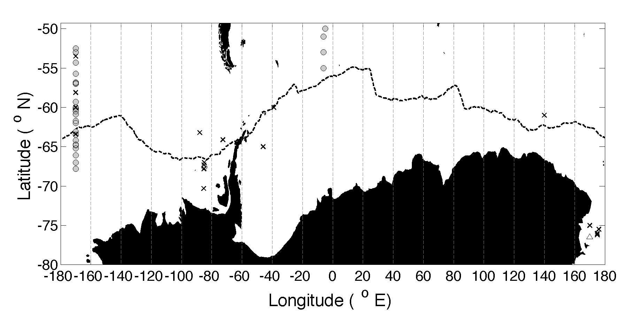
Supplementary Figure 1: Locations of data used to derive algorithms for export production. Positions of data from Henson¹ (grey circles), Dunne² (black crosses) and Laws³ (white triangle) are shown with reference to the maximum ice extent (black dashed line, 15% sea ice concentration during period October 1st-13th 1994-2014).

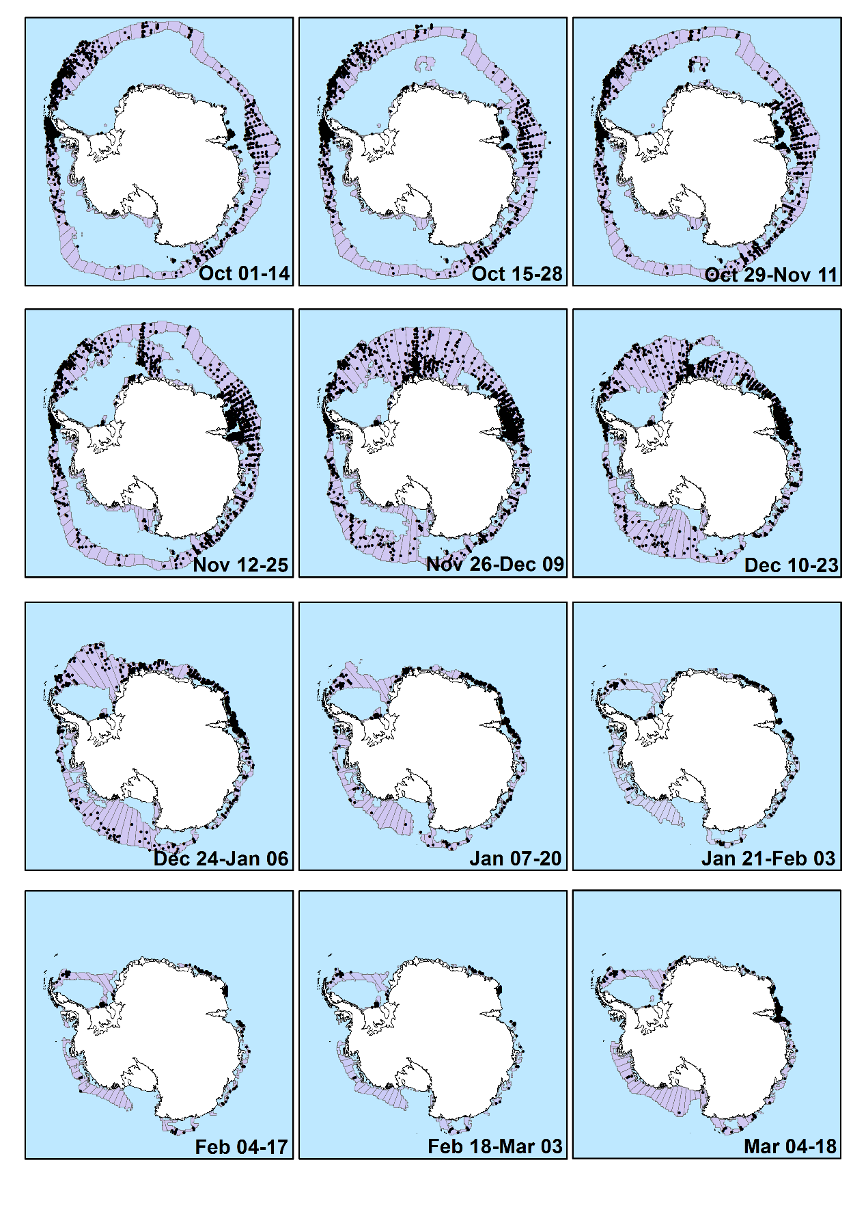
Supplementary Figure 2: Location of krill density estimates from KRILLBASE (black dots) (projected to each fortnightly period) within the marginal ice zone (grey), Antarctica. The marginal ice zone, from fortnightly sea ice concentration data (15-80% ice cover), is divided into 5 ° zonal cells. The Antarctic coastline was obtained from the SCAR Antarctic Digital Database.
Supplementary Table 1: Measurements of krill faecal pellet (FP) flux in the Southern Ocean.
Source | Region | Depth (m) | Season | Krill FP flux  (mg C m⁻² d⁻¹, or nFP m⁻² d⁻¹) ª | Notes
Belcher et al. (2017)⁴ | South Orkneys * | 64 | December | 66.7 | Station ICE1 JR291 (-60.21 °N, -46.34 °E)
Belcher et al. (2017)⁴ | South Orkneys * | 165 | December | 75.5 | Station ICE1 JR291 (-60.21 °N, -46.34 °E)
Belcher et al. (2017)⁴ | South Orkneys * | 76 | December | 33.0 | Station ICE2 JR291 (-59.96 °N, -46.16 °E)
Belcher et al. (2017)⁴ | South Orkneys * | 178 | December | 154.1 | Station ICE2 JR291 (-59.96 °N, -46.16 °E)
Belcher et al. (2017)⁴ | South Orkneys * | 61 | November | 68.0 | Station ICE2 JR304 (-59.96 °N, -46.16 °E)
Belcher et al. (2017)⁴ | South Orkneys * | 163 | November | 77.3 | Station ICE2 JR304 (-59.96 °N, -46.16 °E)
Cadée et al. (1992)⁵ | Scotia-Weddell seas * | 50 | December | 166 | Smaller size FP at 50 m
Cadée et al. (1992)⁵ | Scotia-Weddell seas * | 150 | December | 45
Cadée et al. (1992)⁵ | Scotia-Weddell seas * | 75 | December | 220 | Krill swarm observed
Cadée et al. (1992)⁵ | Scotia-Weddell seas * | 150 | December | 205 | Krill swarm observed
Wefer at al. (1988)⁶ ^{b} | Bransfield Strait | 494 | January | 281.2 | Productive period, krill FP dominant
Wefer at al. (1988)⁶ ^{b} | Bransfield Strait | 1588 | January | 139.9 | Productive period, krill FP dominant
Accornero et al. (2003)⁷ | Ross  sea * | 180 | Annual mean | 0.05 | Cylindrical faecal fragments – believed to be krill or large copepods
Accornero et al. (2003)⁷ | Ross  sea * | 868 | Annual mean | 0.03
Cavan et al. (2015)⁸ ^{c} | Scotia Sea * | 70 | January | 58.6 | Marginal ice zone station 12, krill FP dominant
Cavan et al. (2015)⁸ ^{c} | Scotia Sea * | 170 | January | 77.9 | Marginal ice zone station 12, krill FP dominant
González (1992)⁹ ^{d} | Scotia-Weddell seas * | 50 | December-January | 10 | Transect (I) (-57 to -62 °N at -49 °E)
González (1992)⁹ ^{d} | Scotia-Weddell seas * | 150 | December-January | 5 | Transect (I) (-57 to -62 °N at -49 °E)
González (1992)⁹ ^{d} | Scotia-Weddell seas * | 50 | December-January | 5.5 | Transect (II) (-57 to -62 °N at -47 °E)
González (1992)⁹ ^{d} | Scotia-Weddell seas * | 150 | December-January | 0.5 | Transect (II) (-57 to -62 °N at -47 °E)
González (1992)⁹ ^{d} | Scotia-Weddell seas * | 50 | December-January | 3 | Transect (III) (-57 to -62 °N at 49 °E)
González (1992)⁹ ^{d} | Scotia-Weddell seas * | 150 | December-January | 10.5 | Transect (III) (-57 to -62 °N at 49 °E)
González (1992)⁹ ^{d} | Scotia-Weddell seas * | 300 | December-January | 9 | Transect (III) (-57 to -62 °N at 49 °E)
González (1992)⁹ ^{d} | Scotia-Weddell seas * | 50 | December-January | 22.5 | Station 157 (-59 °N, 49 °E)
González (1992)⁹ ^{d} | Scotia-Weddell seas * | 150 | December-January | 1.5 | Station 157 (-59 °N, 49 °E)
ª All fluxes refer to the carbon flux, with the exception of Cadée et al. (1992)⁵ where fluxes are given in terms of the number of krill FP strings
* Observations made in the MIZ are marked with a star
^{b} Fluxes are for total particulate organic carbon
^{c} Fluxes are for all FP, but krill FP were dominant
^{d} Fluxes are FP in terms of FP dry weight, and have been estimated from Fig. 3, Fig. 5 of González (1992)⁹

Supplementary References
1. Henson, S. A. et al. A reduced estimate of the strength of the ocean’s biological carbon pump. Geophys. Res. Lett. 38, L04606 (2011).
2. Dunne, J. P., Sarmiento, J. L. & Gnanadesikan, A. A synthesis of global particle export from the surface ocean and cycling through the ocean interior and on the seafloor. Global Biogeochem. Cycles 21, (2007).
3. Laws, E. A., Falkowski, P. G., Smith, W. O., Hugh, D. & Mccarthy, J. J. Temperature effects on export production in the open ocean. Global Biogeochem. Cycles 14, 1231–1246 (2000).
4. Belcher, A. et al. The potential role of Antarctic krill faecal pellets in efficient carbon export at the marginal ice zone of the South Orkney Islands in spring. Polar Biol. 40, (2017).
5. Cadée, G. C., González, H. E. & Schnack-Schiel, S. B. Krill diet affects faecal string settling. Polar Biol. 12, 75–80 (1992).
6. Wefer, G., Fischer, G., Fuetterer, D. & Gersonde, R. Seasonal particle flux in the Bransfieid Strait, Antarctica. Deep Sea Res. 35, 891–898 (1988).
7. Accornero, A., Manno, C., Esposito, F. & Gambi, M. C. The vertical flux of particulate matter in the polynya of Terra Nova Bay . Part II . Biological components. Antarct. Sci. 15, 175–188 (2003).
8. Cavan, E. L. et al. Attenuation of particulate organic carbon flux in the Scotia Sea, Southern Ocean, controlled by zooplankton fecal pellets. Geophys. Res. Lett. 42, 821–830 (2015).
9. González, H. E. The distribution and abundance of krill faecal material and oval pellets in the Scotia and Weddell Seas (Antarctica) and their role in particle flux. Polar Biol. 12, 81–91 (1992).

