Supplementary Information
Deactivation of redox mediators in lithium-oxygen batteries by singlet oxygen
Kwak et al

Supplementary Figures

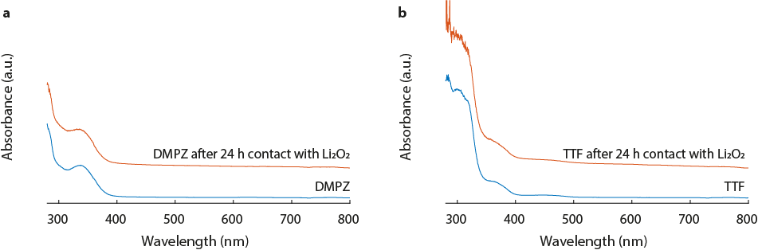
Supplementary Figure 1. Stability characterizations. Stability of DMPZ (a) and TTF (b) in contact with Li₂O₂. 60 µM DMPZ or 60 µM TTF solutions, respectively, in 0.1 M LiTFSI/TEGDME were stirred for 24 h with ~1 mg Li₂O₂. Spectra were taken before and after contact with Li₂O₂ and are offset for better visibility.

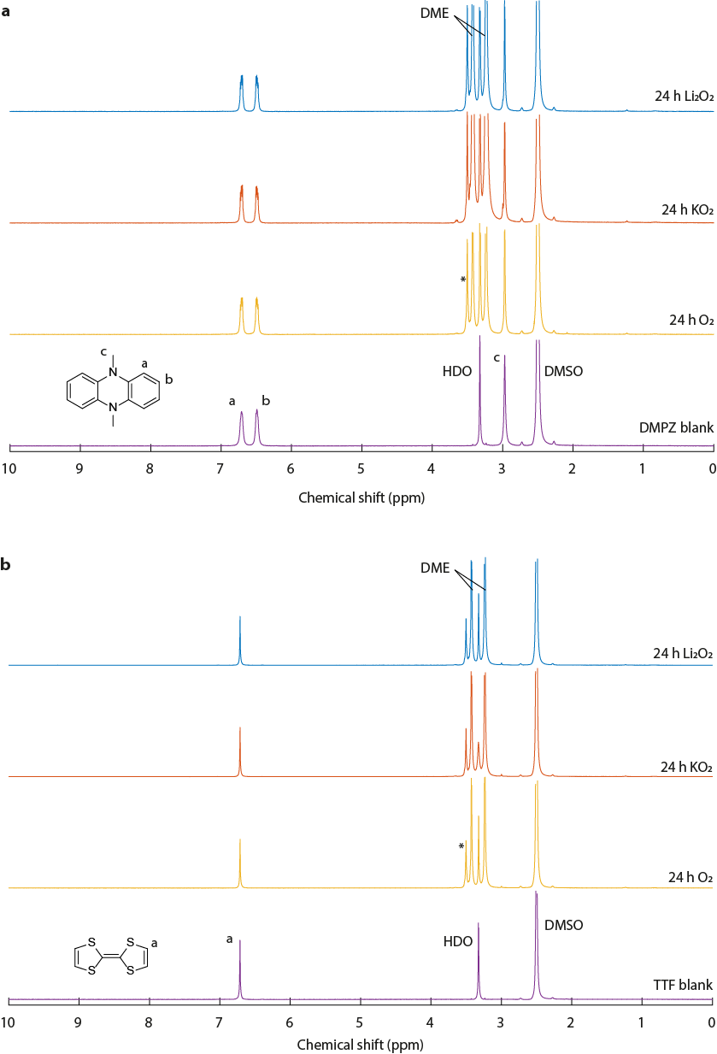
Supplementary Figure 2. Stability of DMPZ and TTF in contact with O₂, KO₂ and Li₂O₂. ¹H-NMR spectra (in DMSO-d₆) were recorded before and after 24 h of contact with the compounds. 1 mg DMPZ or TTF in DME were stirred under O₂ headspace, or stirred with ~1 mg KO₂ or Li₂O₂. The DMSO peak is taken as internal reference for quantitative comparison of spectra. The * denotes a residue from DME evaporation, which amounts to a content of ~1 ppm in the DME.
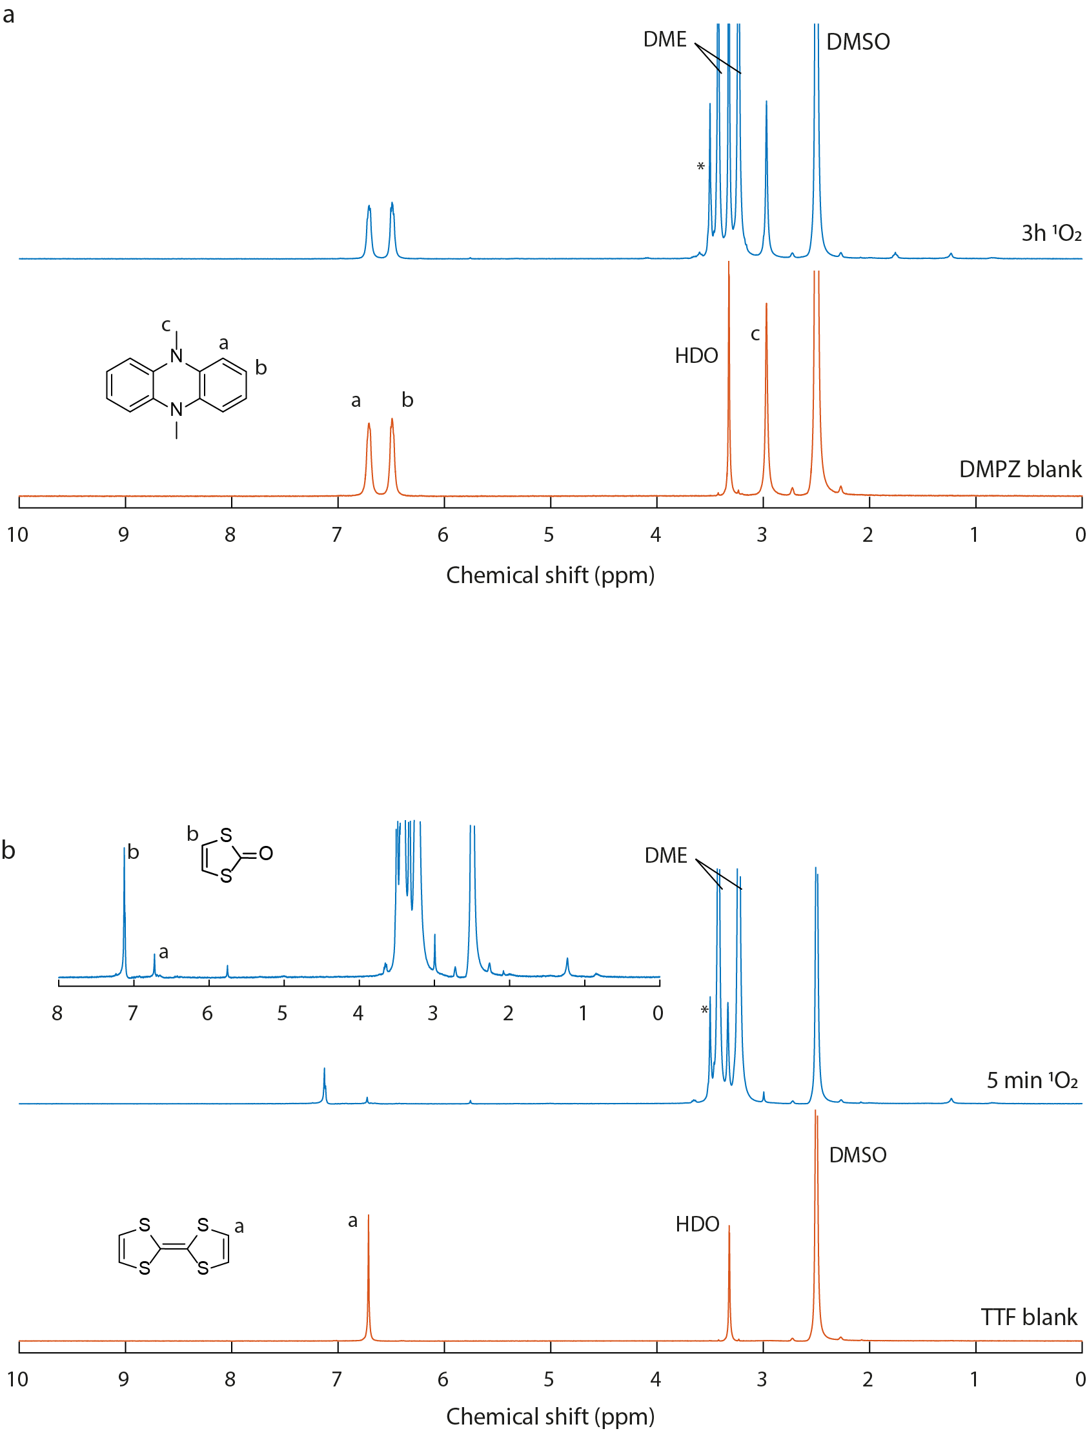
Supplementary Figure 3. Stability of DMPZ and TTF in contact with ¹O₂. ¹H-NMR spectra (in DMSO-d₆) were recorded before and after photooxygenation. 1 mg DMPZ or TTF in DME was stirred under an O₂ headspace. For photochemical ¹O₂ generation, 1 µM of the photosensitizer palladium(II) meso-tetra(4-fluorophenyl)-tetrabenzoporphyrin (Pd₄F) was dissolved in the solution and illuminated with 643 nm radiation. The DMSO peak is taken as internal reference for quantitative comparison of spectra. The * denotes a residue from DME evaporation, which amounts to a content of ~1 ppm in the DME.

Supplementary Figure 4. Decomposition of TTF to 1,3-dithiol-2-one according to the mechanism proposed in the literature¹.

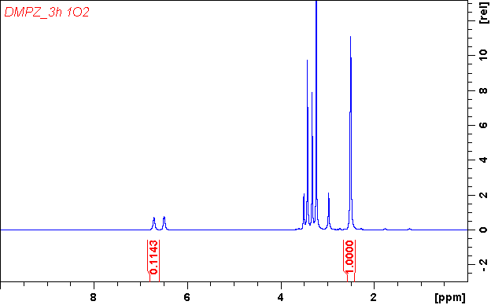
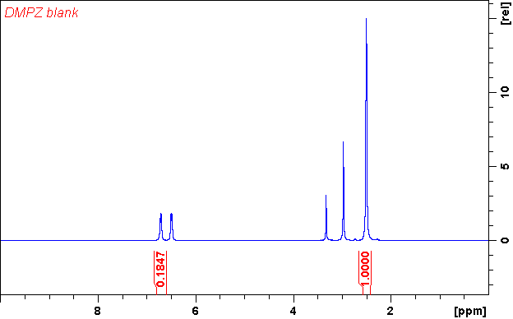
Supplementary Figure 5. Integrals of the ¹H-NMR spectra in Supplementary Fig 3a.

Supplementary Figure 6. Charge curves for the oxidation of the RMs to RM⁺. 50 μL electrolyte (0.02 M RM (DMPZ or TTF) and 0.1 M LiTFSI in TEGDME) were charged at 100 µA in a Swagelok-type cell using a Li_{1−x}FePO₄ counter electrode and a carbon paper working electrode with a diameter of 10 mm.

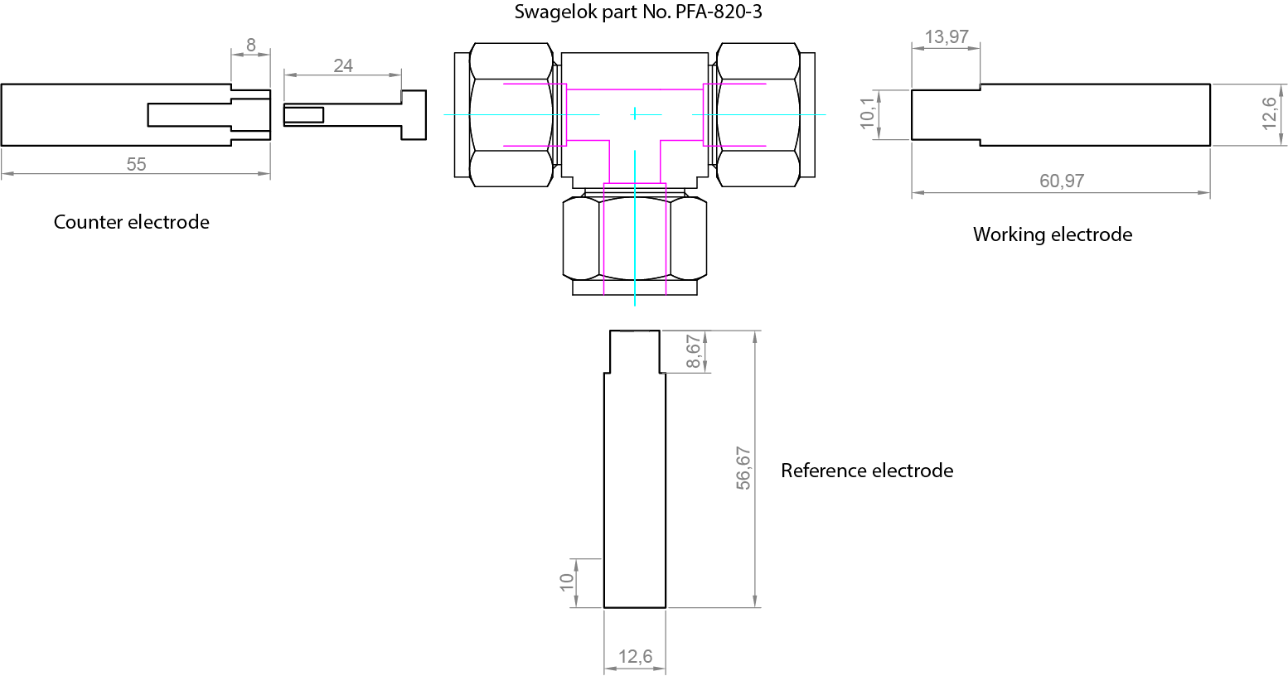
Supplementary Figure 7. The cell design used for electrochemically oxidizing the RM to RM⁺. The central piece is a union tee tube fitting from the company Swagelok (https://www.swagelok.com/en/catalog/Product/Detail?part=PFA-820-3) made from perfluoroalkoxy polymer (PFA). The plungers for counter, working and reference electrodes are made from stainless steel (grade SAE 316L).

Supplementary Reference
1. Zhang, X., Lin, F. & Foote, C. S. J. Org. Chem. 60, 1333 (1995)

