Identification of human D lactate dehydrogenase deficiency
Monroe et al

Supplementary Table 1: Page 2
Supplementary Table 2: Page 3
Supplementary Figure 1: Page 4
Supplementary Table 3: Page 5

Supplementary Table 1: Regions of homozygosity in the patient greater than 1 Mb. Genome build GRCh37/hg19.

Chromosome | Start Position | End Position | Size (basepair)
13 | 85802402 | 98498677 | 12696275
11 | 29651299 | 40817882 | 11166583
12 | 34512767 | 38651375 | 4138608
17 | 21770128 | 25568707 | 3798579
16 | 74873927 | 78363380 | 3489453
5 | 71489305 | 74242852 | 2753547
10 | 45556652 | 47593133 | 2036481
2 | 197129767 | 198962243 | 1832476
6 | 62415600 | 63936511 | 1520911
15 | 43344886 | 44847415 | 1502529
3 | 74479445 | 75974251 | 1494806
1 | 28211650 | 29665936 | 1454286
19 | 42001210 | 43372386 | 1371176
2 | 116014077 | 117364078 | 1350001
5 | 139188856 | 140519095 | 1330239
4 | 97935617 | 99214851 | 1279234
2 | 186218867 | 187481835 | 1262968
7 | 73909796 | 75166580 | 1256784
14 | 105904830 | 107146692 | 1241862
8 | 50265730 | 51469405 | 1203675
18 | 39796976 | 40996805 | 1199829
5 | 36716862 | 37892952 | 1176090
6 | 145800915 | 146972068 | 1171153
7 | 97136298 | 98233514 | 1097216
11 | 112040136 | 113133676 | 1093540
6 | 114860722 | 115944735 | 1084013
3 | 81988359 | 83039277 | 1050918
2 | 97595991 | 98629966 | 1033975
4 | 110000675 | 111030787 | 1030112
8 | 85474803 | 86493592 | 1018789

Supplementary Table 2: Genes present in the regions of homozygosity of the patient that are greater than 1 MB. Genome build GRCh37/hg19.

Chromosome | Start position | Stop position | Gene
16 | 74907468 | 75034071 | WDR59
16 | 75032928 | 75144892 | ZNRF1
16 | 75145758 | 75150669 | LDHD
16 | 75182390 | 75206134 | ZFP1
16 | 75237994 | 75241083 | CTRB2
16 | 75252898 | 75258822 | CTRB1
16 | 75262928 | 75301951 | BCAR1
16 | 75327596 | 75467383 | CFDP1
16 | 75446582 | 75498604 | RP11-77K12.1
16 | 75476952 | 75499395 | TMEM170A
16 | 75510949 | 75529282 | CHST6
16 | 75562430 | 75579326 | RP11-77K12.7
16 | 75562433 | 75569145 | CHST5
16 | 75572015 | 75590176 | TMEM231
16 | 75600249 | 75611779 | GABARAPL2
16 | 75630879 | 75657198 | ADAT1
16 | 75661622 | 75682541 | KARS
16 | 75681684 | 75795051 | TERF2IP
16 | 75728367 | 75734089 | AC025287.1
16 | 76311176 | 76593135 | CNTNAP4
16 | 76587314 | 76669520 | RP11-58C22.1
16 | 77224732 | 77236302 | MON1B
16 | 77233294 | 77247112 | SYCE1L
16 | 77281710 | 77469011 | ADAMTS18
16 | 77756411 | 77776157 | NUDT7
16 | 77822427 | 78014004 | VAT1L
16 | 78056412 | 78100658 | CLEC3A
16 | 78133310 | 79246564 | WWOX

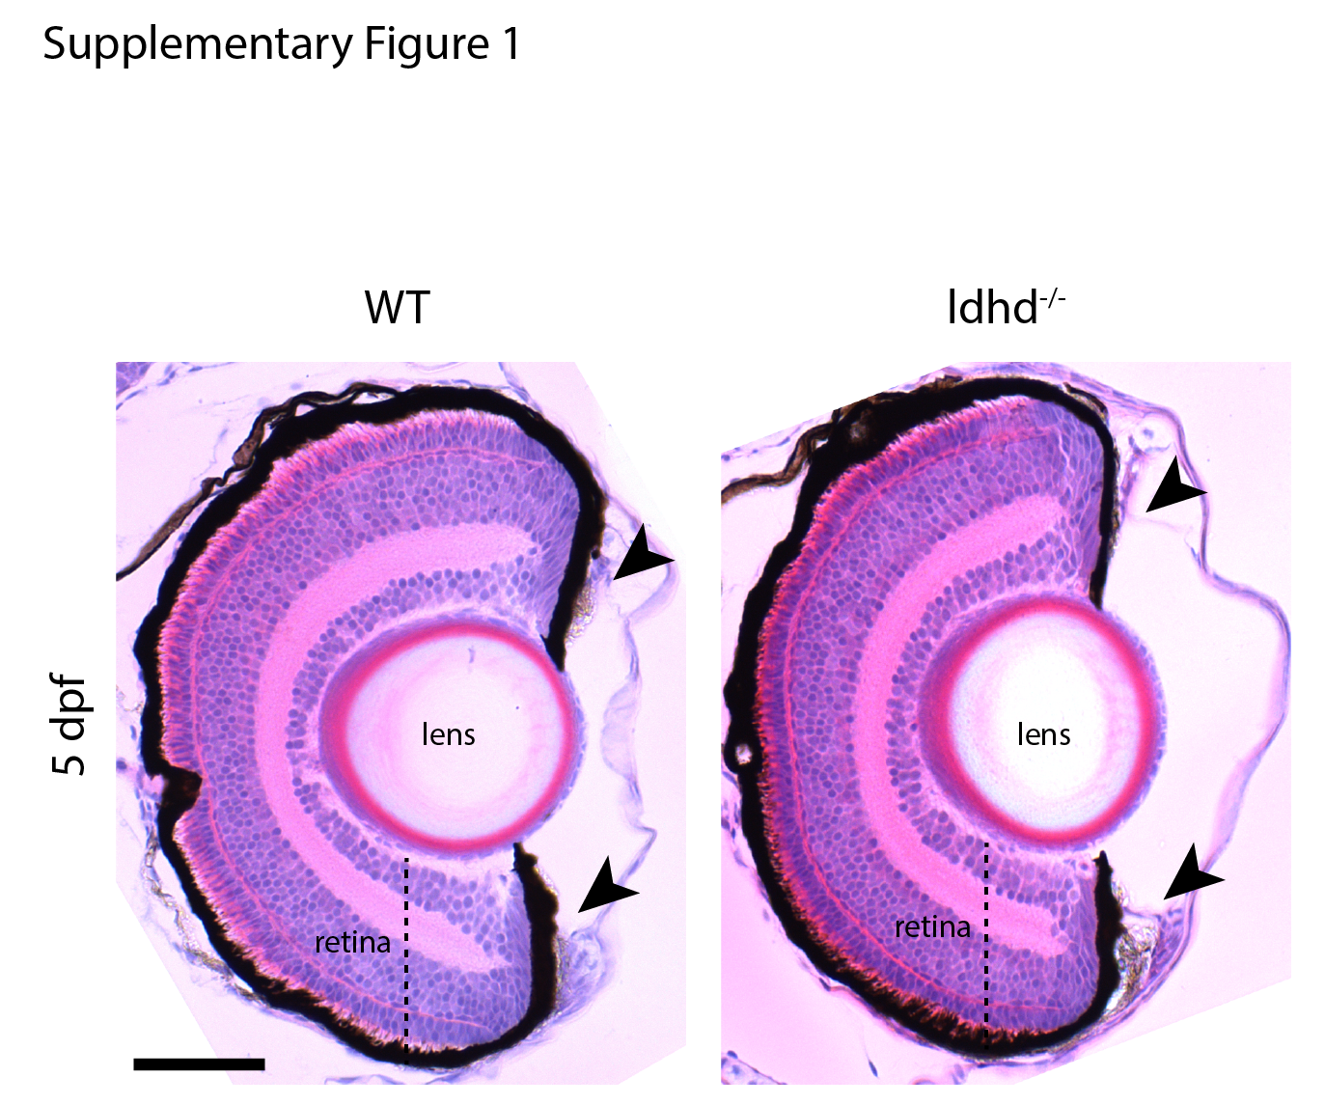
Supplementary Figure 1: MZ ldhd^{-/-} embryos show no defective developing iris. Comparison of H&E stained sections of Wildtype (left panel) and MZ ldhd^{-/-} (right panel) 5dpf embryos reveals no defects in the developing iris (arrowheads). Scale bar: 50 μm.

Supplemental Table 3: Primer sequences for Sanger sequencing of LDHD exonic and intron/exon splice regions.

Primer name | Sequence
LDHD_1F | TGAACCTCGCCTCTCCTTTA
LDHD_2F | TGGAAAAGAGGCATTTCTGG
LDHD_3F | CTCGCTTGCTGTAGCCTCA
LDHD_4F | GATGGTCCCAGCACACCTT
LDHD_5F | GGTTCAGGGGACCTTCCTC
LDHD_6F | TTGTGGAGCAGAAAGCACTG
LDHD_7F | CATTGGTGAGCTGAGGATGG
LDHD_8F | AGGTATGCTGGGGTGGAGT
LDHD_9F | GACCCATCCTCAGCCTTGA
LDHD_10F | GAGAGGTGGGGAGGTGTCA
LDHD_11F | CTGCTGCAGGAGGAGGTG
LDHD_12F | CAGCGAGCCCACTGTATCTG
LDHD_1R | CCAAGGTCAGGTCACTTGGT
LDHD_2R | TGAGTGAGGAGGAAGGCAAC
LDHD_3R | ATTCGGTCCATATGCGTCA
LDHD_4R | CGTACAGAAGGCAGCCTCA
LDHD_5R | GAAGCCTAGCCTGCCAAAC
LDHD_6R | CAGGCATCCATCATGACTTC
LDHD_7R | GTGCCGTGCTGTCCAAAG
LDHD_8R | CTGCAGCCCTTGTTTCTAGC
LDHD_9R | GTTCTGCAAAAGCCTTGACC
LDHD_10R | GTCAGGGAACTTGTGGGCTA
LDHD_11R | ACCAGGTGAAGGGGGAAG
LDHD_12R | CCTCCTCCCCAGGCTATAAG

