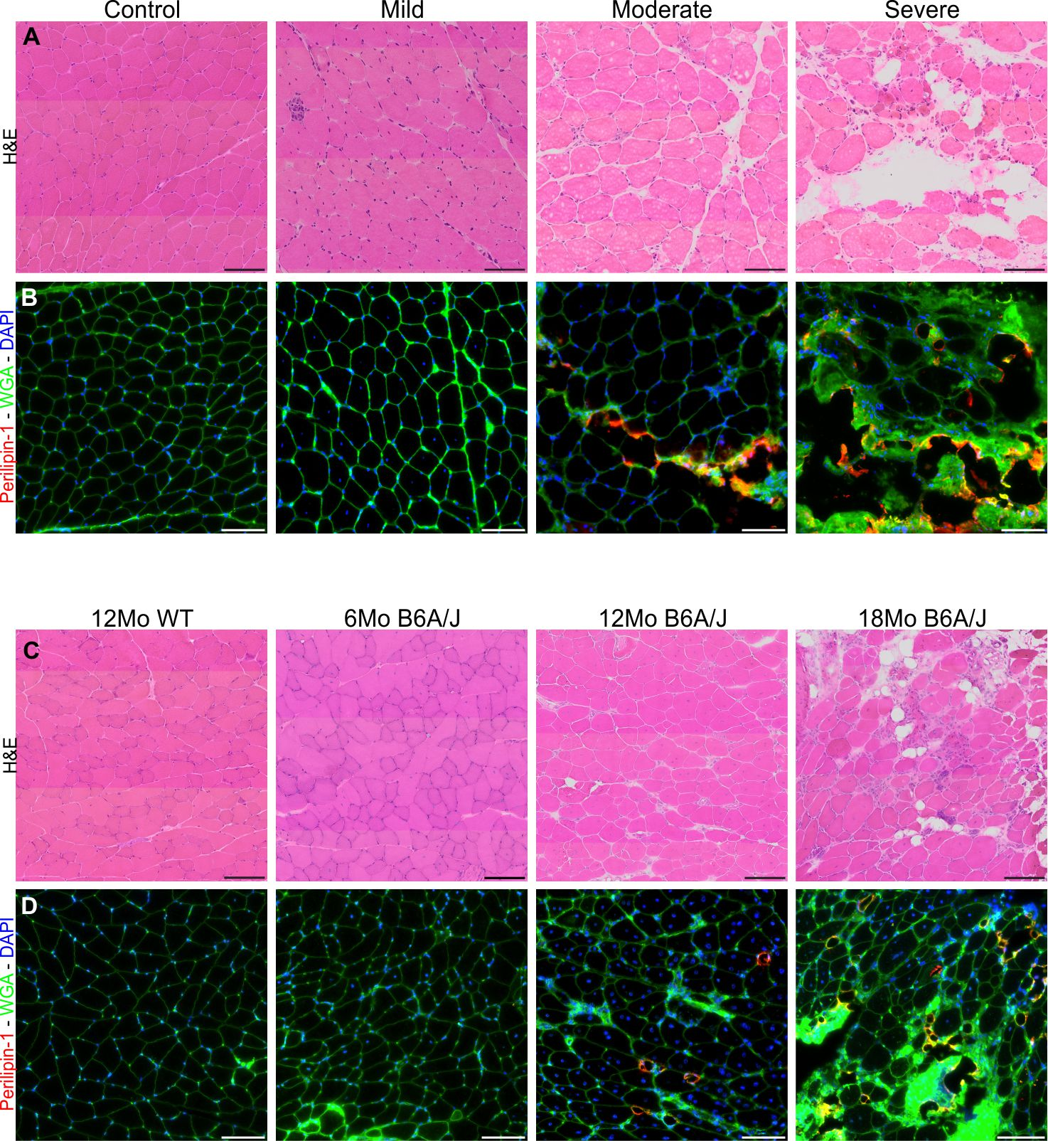
Supplementary Figure 1: Muscle histopathology and extracellular lipid deposition increase with clinical severity. (A) Hematoxylin and eosin staining of LGMD2B biopsies demonstrating increased muscle pathology with increasing clinical severity. (B) Perilipin-1 labelling from Fig. 1B, co-stained with wheat germ agglutinin to delineate myofiber membranes and demonstrate the extracellular lipid formation in LGMD2B patient muscle. (C) Hematoxylin and eosin staining of B6A/J gastrocnemius demonstrating increased muscle pathology with increasing age. (D) Perilipin-1 labelling from Fig. 1J, co-stained with wheat germ agglutinin to delineate myofiber membranes and demonstrate the extracellular lipid formation in B6A/J gastrocnemius with advancing age. Scales = 100µm.
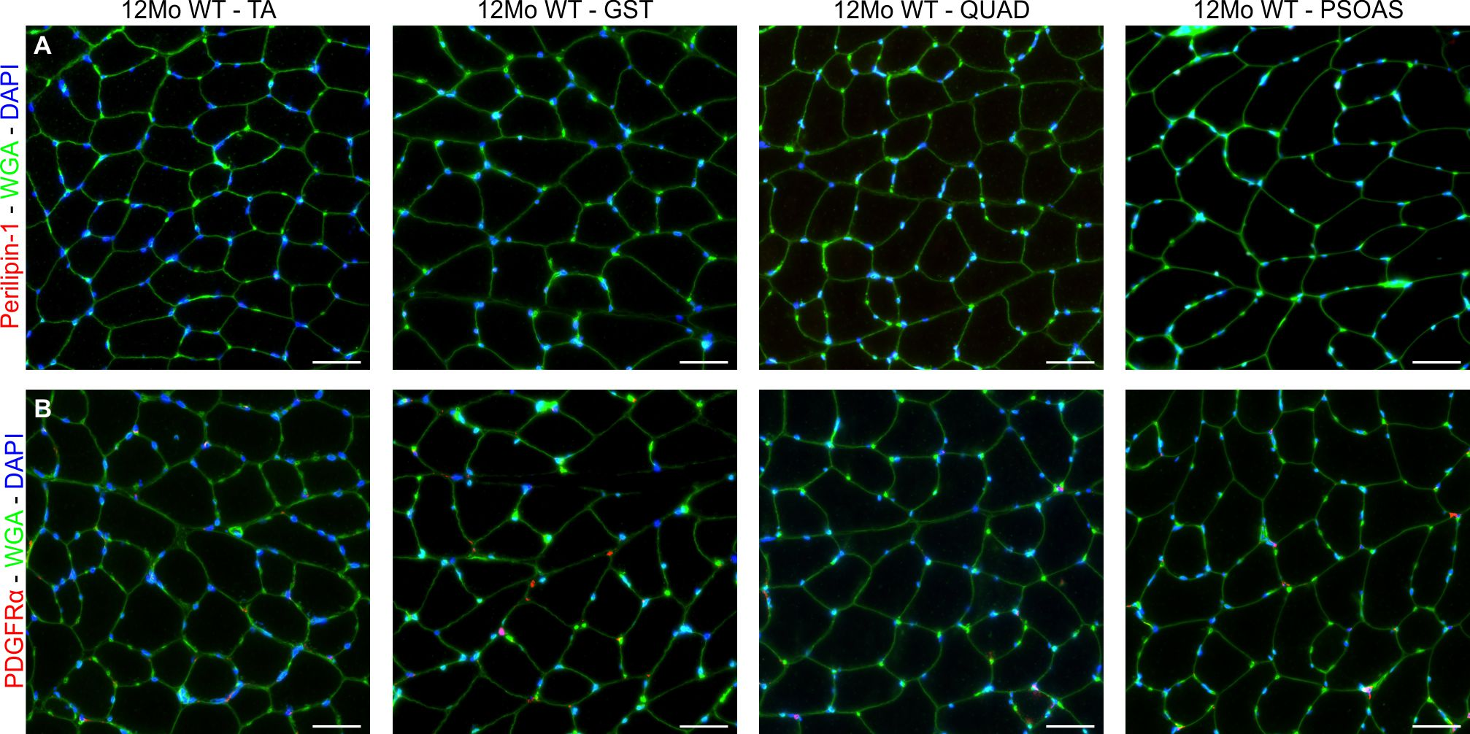 Supplementary Figure 2: Extracellular lipid formation and FAP accumulation is absent in WT muscle. (A) Perilipin-1 staining of tibialis anterior, gastrocnemius, quadriceps and psoas of 12Mo WT mice shows the absence of extracellular lipid across all muscles. (B) PDGFRα staining from 12Mo WT muscles shows only the presence of muscle resident FAPs (individual cells at the junction of myofibers). Scales = 50µm.

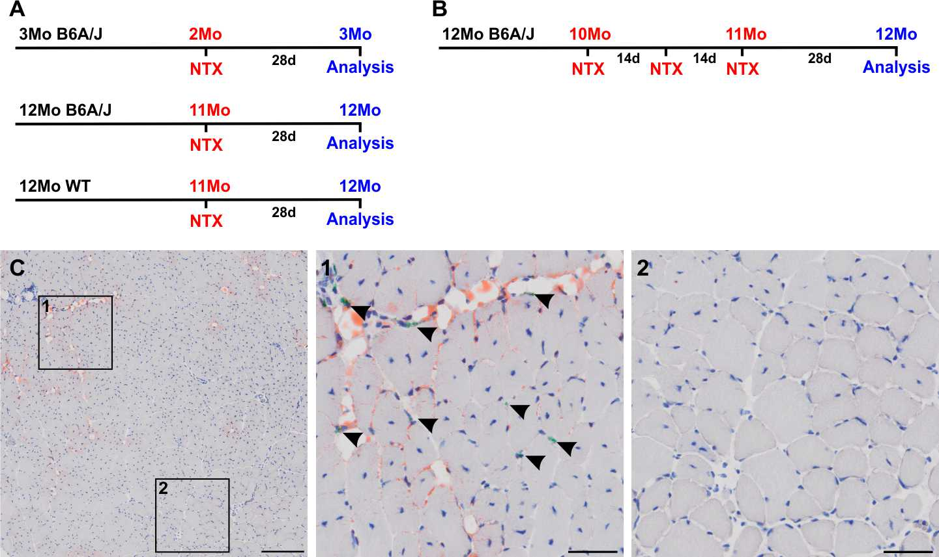
Supplementary Figure 3: Notexin causes lipid deposition at the site of injury in dysferlin-deficient muscle. (A) Schematic illustrating the single injury experimental procedure; a single 40µl injection of notexin (5μg/mL) was administered to the TA of B6A/J at 2 and 11Mo and 11Mo WT. Muscles were harvested 28 days later for analysis. (B) Schematic illustrating the repeat injury experimental procedure; B6A/J mice were injured by a series of 3 intramuscular notexin injections, each 14 days apart, from 10 to 11Mo. Muscles were harvested 28 days later for analysis. (C) Oil Red O staining of 12Mo B6A/J TA after a single notexin injury. Scale = 200µm. Shown are 2 regions approximately 900µm apart, which illustrate both injured and uninjured regions of the muscle. Region 1 shows the injury site as marked by green tattoo dye (indicated by arrowheads), where centrally nucleated myofibers and Oil Red O-marked lipid are evident. Region 2 shows an uninjured area without tattoo dye, where only spontaneous regeneration and the absence of lipid can be seen.

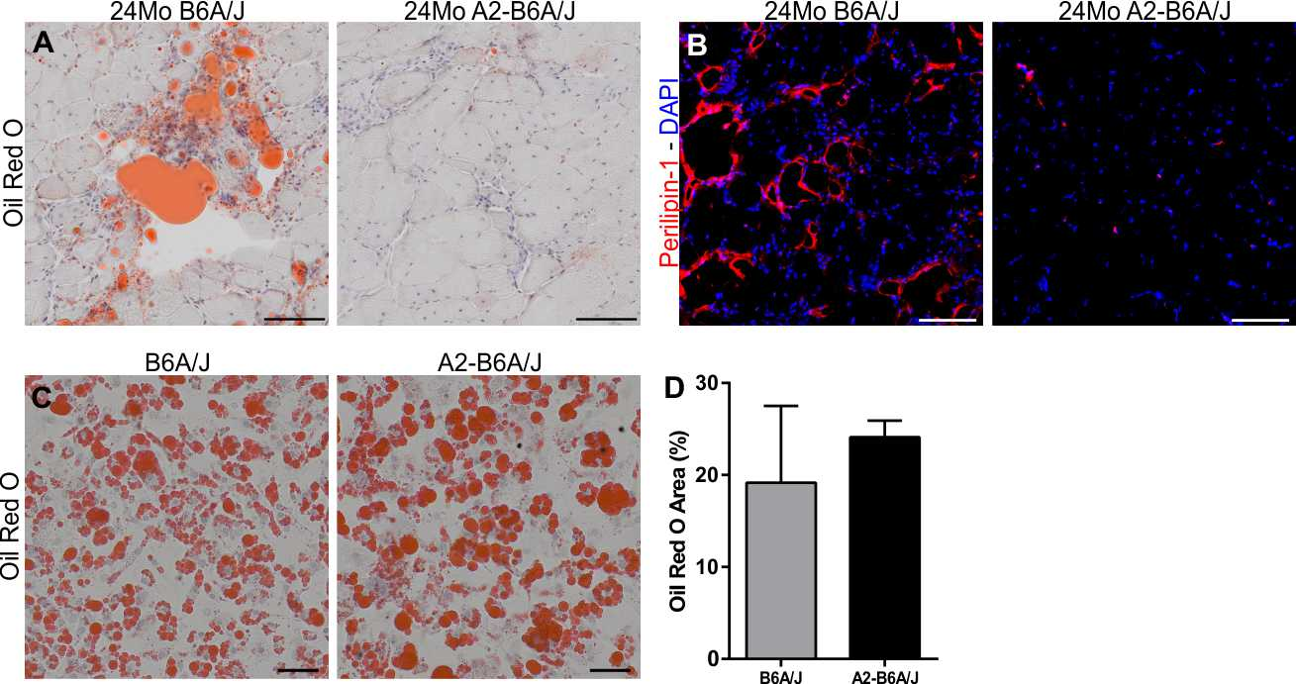
Supplementary Figure 4: Adipogenic conversion is blocked in A2-B6A/J muscle. (A) Oil Red O and (B) Perilipin-1 staining of quadriceps sections from 24Mo B6A/J and A2-B6A/J. Scales = 100µm. (C) Oil Red O staining of B6A/J and A2-B6A/J FAPs after adipogenic induction. Scale = 50µm. (D) Quantification of induced adipogenesis from 20,000 FAPs isolated from 24Mo B6A/J and A2-B6A/J. Data presented as mean ± SD.

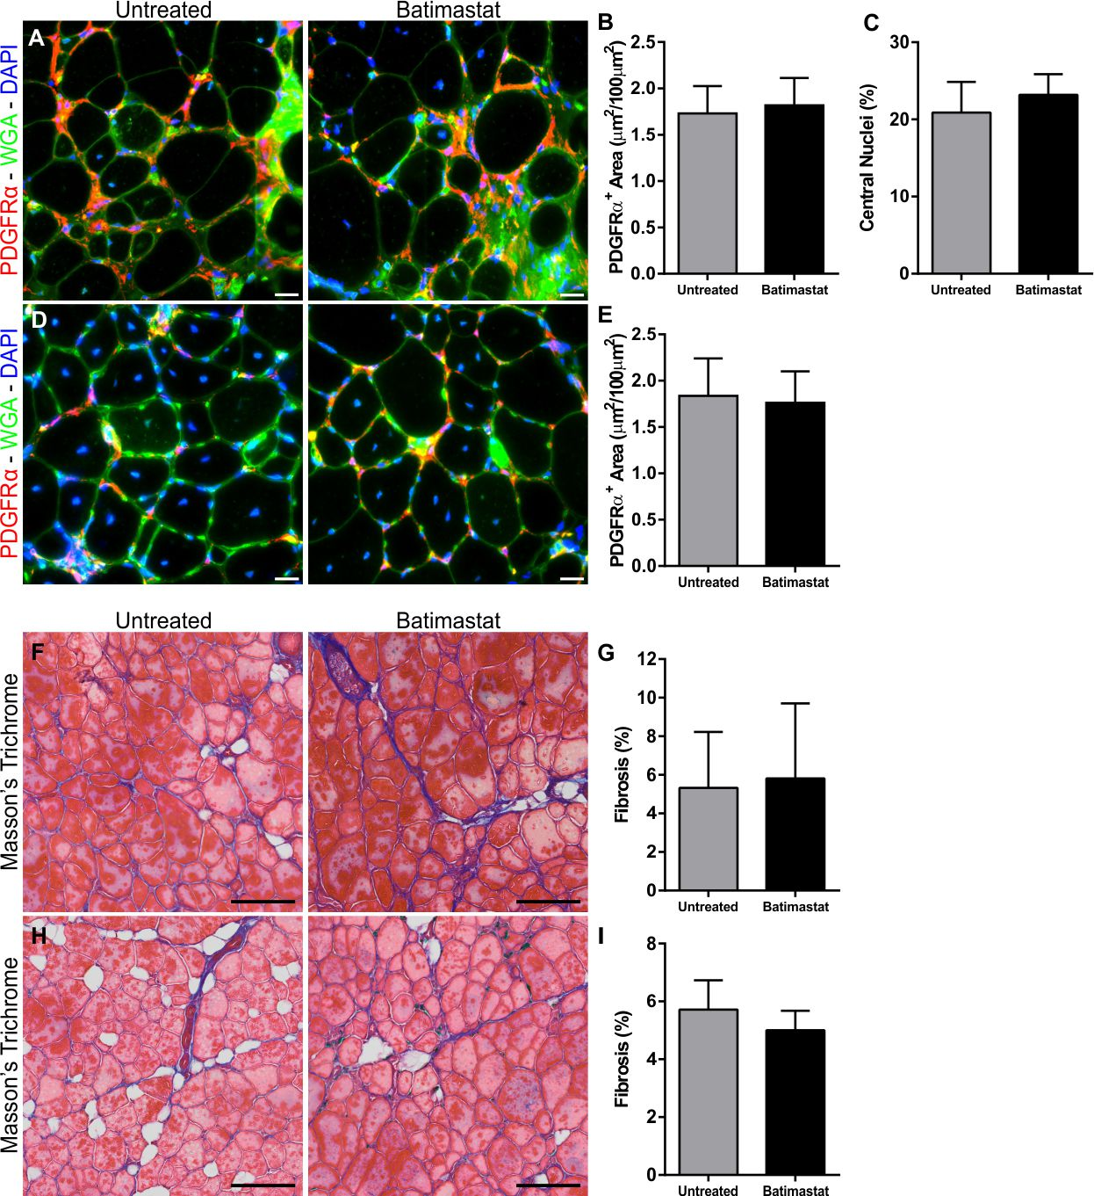
Supplementary Figure 5: Batimastat does not alter accumulation of FAPs or fibrotic deposition. (A) PDGFRα labelling and (B) quantification of PDGFRα area and (C) myofiber central nucleation from 14Mo gastrocnemius sections following 10 weeks of batimastat treatment. Scale = 20µm. (D) PDGFRα labelling and (E) quantification of PDGFRα area from 14Mo TA sections after 3 repeat notexin injuries and batimastat treatment. Scale = 20µm. (F) Masson’s trichrome staining and (G) quantification of fibrosis from 14Mo gastrocnemius sections following 10 weeks of batimastat treatment. Scale = 100µm. (H) Masson’s trichrome staining and (I) quantification of fibrosis area from 14Mo TA sections after 3 repeat notexin injuries and batimastat treatment. Scale = 100µm. All data displayed as mean ± SD.
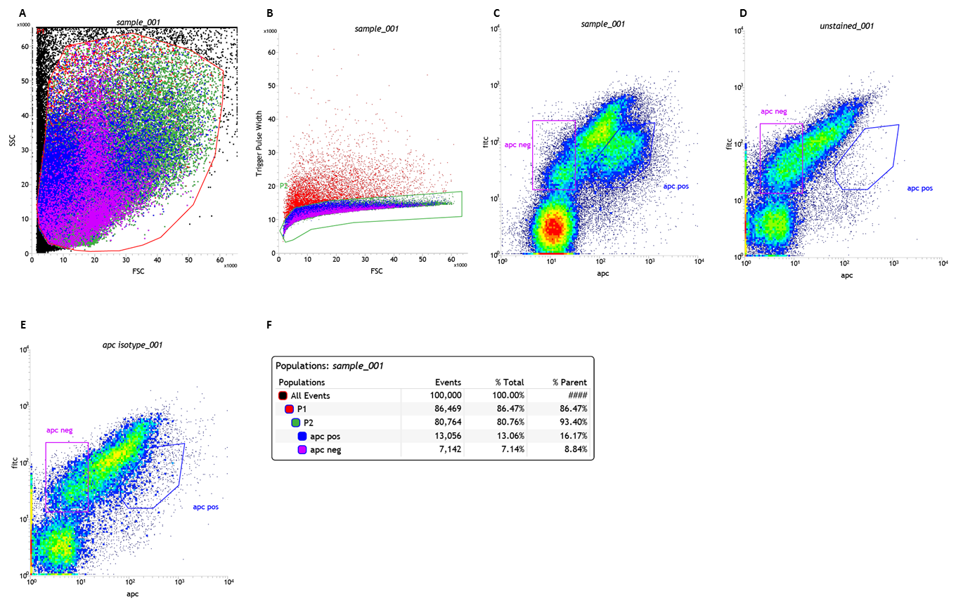 Supplementary Figure 6: Summary of FACS gating to enrich for FAPs. (A) Cells were first gated on size by Forward Scatter (FSC) by Side Scatter (SSC) to exclude dead cells and debris. (B) Next, singlets were selected by gating on Forward Scatter (FSC) by the trigger pulse width. (C) FAPs were identified using anti-PDGFRα conjugated to APC and FITC cell autofluorescence. Positive staining was confirmed by the absence of this APC-labelled population in (D) unstained and (E) isotype controls. (F) PDGFRα-labelled FAPs made up 13% of the total cell suspension obtained from 12Mo B6A/J muscle. Cells negative for anti-PDGFRα were also collected to serve as controls for in vitro experiments.

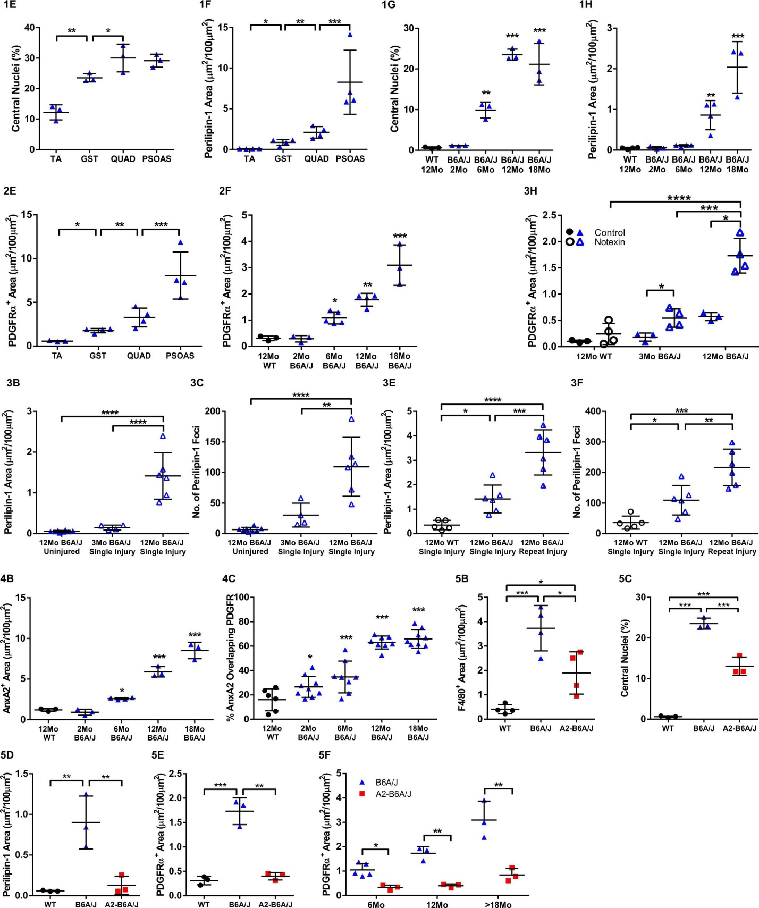
Supplementary Figure 7: Illustration of data distribution. Dot plots corresponding to the bar graphs presented in the manuscript. The figure panel labels here correspond to the bar graph presented in the main figures 1 through 5.

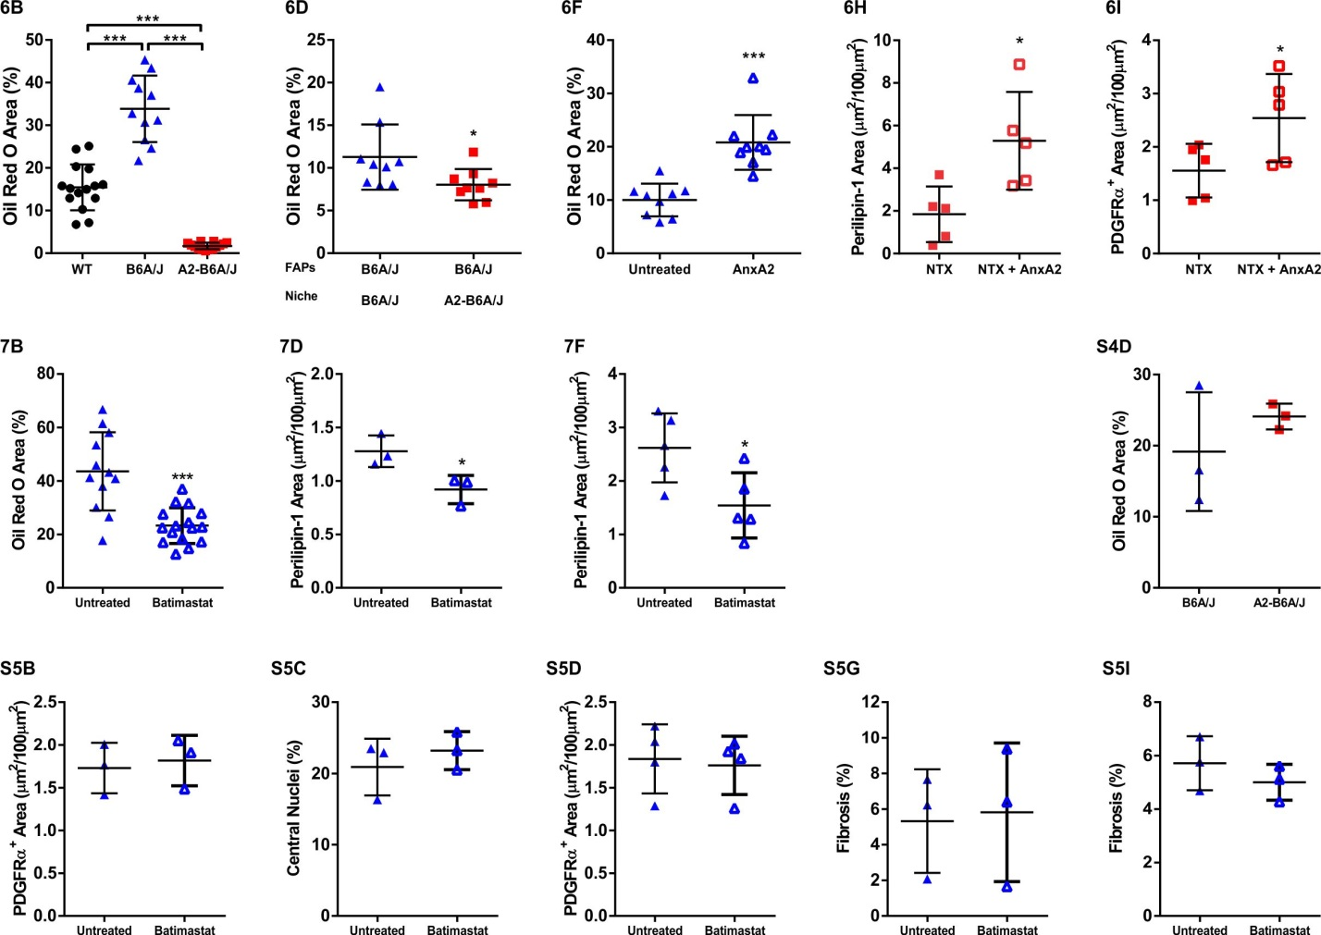
Supplementary Figure 8: Illustration of data distribution. Dot plots corresponding to the bar graphs presented in the manuscript. The figure panel labels here correspond to the bar graph presented in the main figures 6, 7 and supplementary figures.

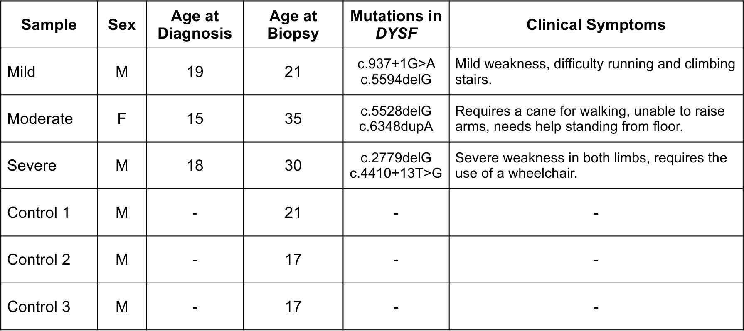
Supplementary Table 1: Summary of LGMD2B patient biopsies included for analysis.

