Paracrine control of α-cell glucagon exocytosis is compromised in human type-2 diabetes

Omar-Hmeadi et al.

Supplementary figures

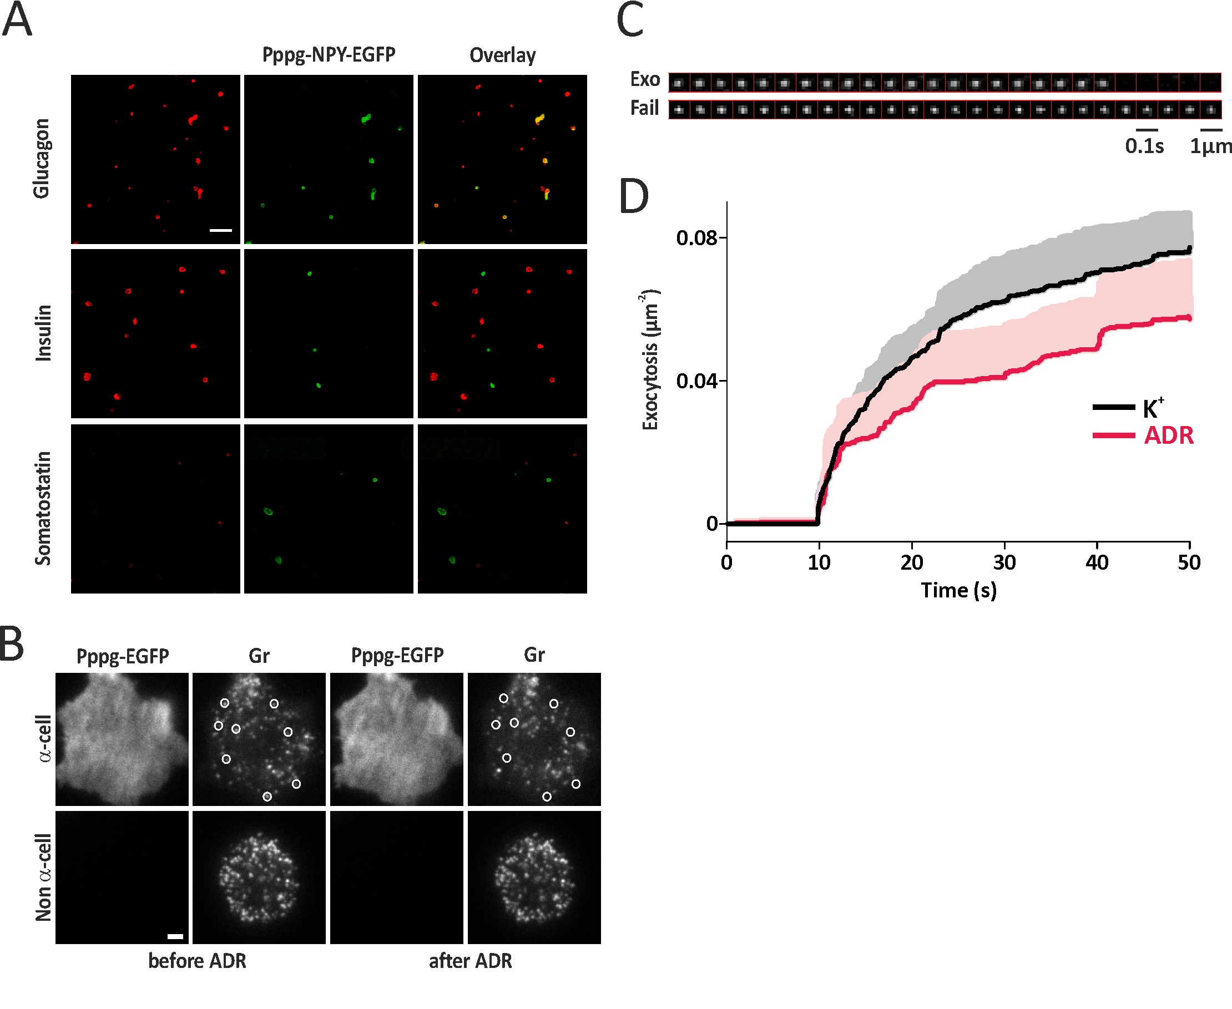

Supplementary Fig 1. Identification of human pancreatic α-cells.
(A) Confocal images of Pppg-NPY-EGFP (green) expressing cells immunostained for glucagon (upper, red), insulin (middle, red) or somatostatin (lower, red) positive cells in a dispersed human islet α-cells. Scale bar 50 µm. Representative for 40 images.
(B) TIRF images of α-cells (top) expressing Pppg-EGFP together with NPY-Cherry and non α-cells (bottom) expressing NPY-Cherry before (left half) and after stimulation (right half) with 5µM adrenaline for 40s. Granules lost by exocytosis are highlighted by circles. Scale bar 2 µm.
(C) Image sequences showing example of granules undergoing exocytosis (exo, top) or failing to exocytose (fail, bottom) during stimulation of cells as in (B). Images are 0.1s apart.
(D) Average timecourse of exocytosis (cumulative event count normalized by cell footprint area, mean+/-SEM) in adrenaline stimulation experiments (pink) or K⁺ stimulation experiments (black). Stimulation lasted from 10-50s.

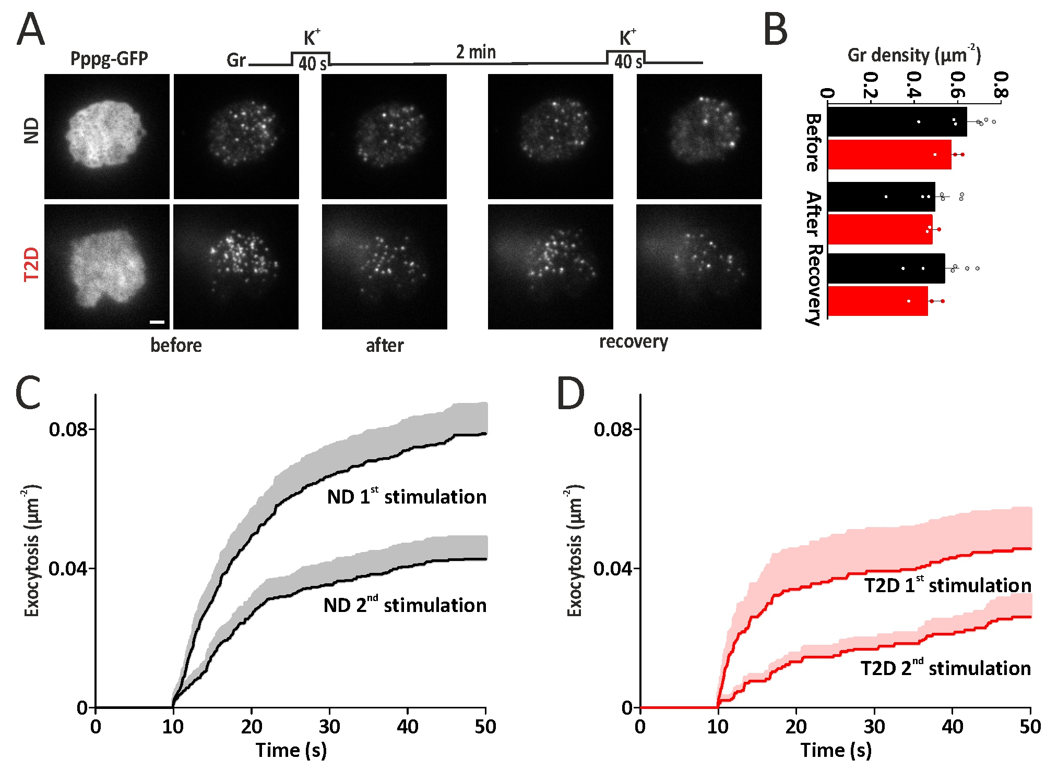

Supplementary Fig 2. Depletion and recovery of docked granules during K⁺ induced exocytosis
(A) Examples of ND (top, representative for 7 donors) and T2D α-cell (bottom, representative for 3 donors) at indicated times during the indicated dual pulse stimulation protocol. Scale bar 2 µm.
(B) Average granule density of cells as in A (ND, black; T2D, red) at times corresponding to those indicated in A. The initial density of docked granules was 0.62 gr*µm⁻² in ND and 0.57 gr*µm⁻² in T2D α-cells (p=NS; n=7 ND vs n=3 T2D donors with 5-15 cells each). The first depolarization released ~15% of the docked granules in T2D α-cells (n=17) and 24 % of the docked granules in ND cells (n=55; p<n.s by two-tailed t-test). After the 2 min resting period, recovery of docked granules was negligible in T2D α-cells, compared with 8% in ND α-cells. Data are presented as mean values ± SEM.
(C-D) Average time course of cumulative exocytosis (normalized event count, mean+/-SEM) in ND (C) and T2D (D) experiments as in (A), for first and second stimulation.

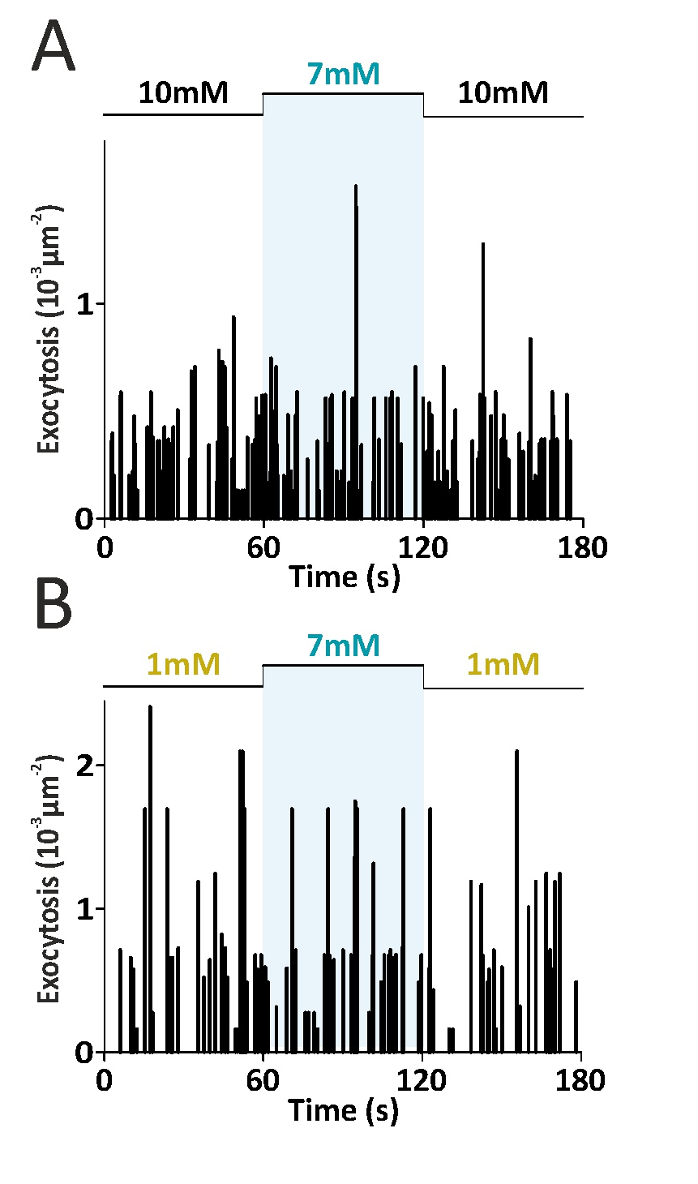
Supplementary Fig 3. Acute response of α-cell exocytosis to change in glucose
(A-B) Time course of exocytosis frequency in ND α-cells challenged with changes in glucose, from 10 to 7 mM and back (A) or from 1 to 7mM and back (B), as indicated.

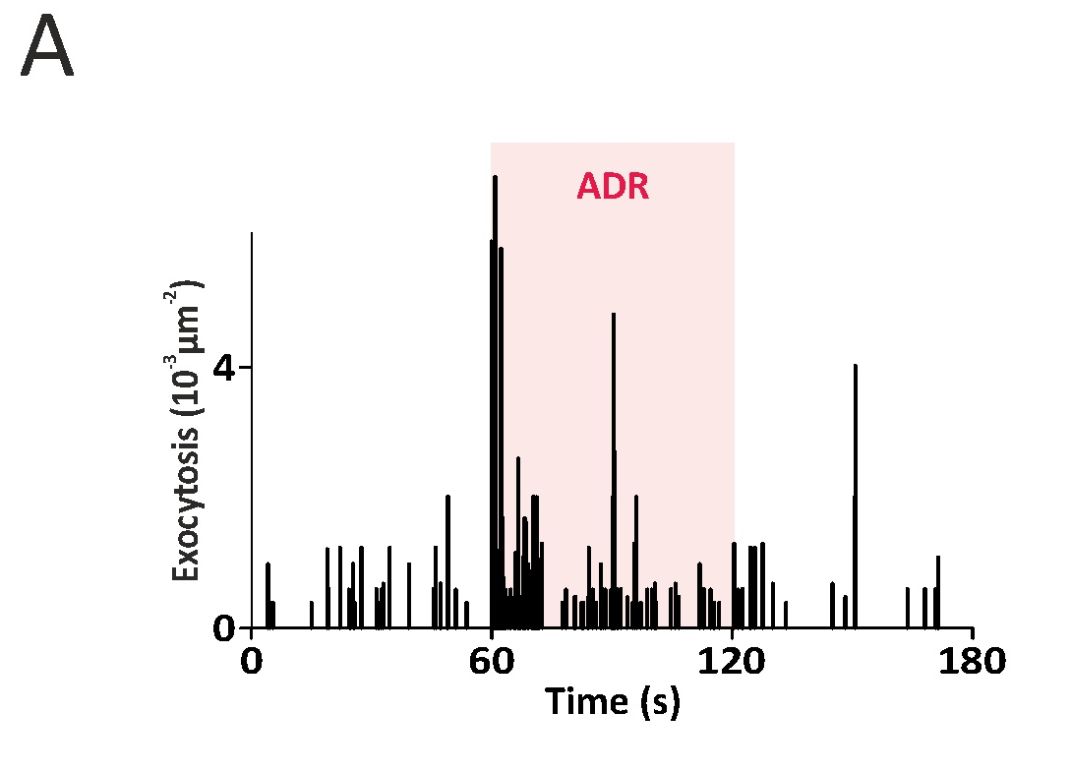
Supplementary Fig 4. Regulation of glucagon exocytosis by insulin and adrenaline.
(A) Time course of exocytosis frequency in ND α-cells challenged with adrenalin (ADR, as indicated), in presence of 10mM glucose.

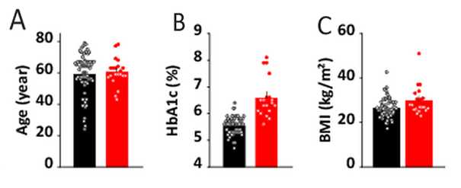
Supplementary Fig 5. Human donor information.
Distributions of (A) Age, (B) HbA1c, and (C) BMI for non-diabetic (black) and type-2 diabetic donors (red). The Isolation-IDs were: Non-diabetic Islets (42 male, 26 female). Uppsala: 2088, 2089, 2102, 2107, 2109, 2112, 2114, 2119, 2132, 2150, 2152, 2154, 2155, 2157, 2164, 2169, 2170, 2172, 2176, 2185, 2188, 2191, 2193, 2194, 2195, 2205, 2207 2209, 2217, 2218, 2225, 2228, 2232, 2233, 2245, 2246, 2247, 2253, 2254, 2255, 2258, 2275, 2278, 2295, 2298, 2301, 2309, 2310, 2317, 2326, 2327, 2334, 2337, 2344, 2346, 2389, 2398, 2400, 2402, 2403, 2431, 2460, 2467, 2472, 2478; Edmonton: R253, R249, R290; ND Sections (2 male, 3 female): Uppsala: 1396, 1484, 1784, 1921, 2108. Type-2 diabetic Islets (13 male, 8 female). Uppsala: 2133, 2151, 2199, 2202, 2203, 2211, 2219, 2238, 2240, 2274, 2299, 2350, 2395, 2438, 2465, 2471; Edmonton: R244, R192, R259, R307, R347. T2D Sections (1 male, 4 female), Uppsala: 1857, 1864, 1923, 2061, 2211.

KEY RESOURCES TABLE
REAGENT or RESOURCE | SOURCE | IDENTIFIER
Antibodies
Mouse anti-Glucagon (K79bB10) , dil 1/1500 | Sigma | G2654
Rabbit anti-Glugacon , dilution 1/200 | DAKO (Uppsala) | A0565
Guinea Pig anti-Insulin , dilution 1/200 | DAKO (Uppsala) | A0564
Rabbit anti-Somatostatin , dilution 1/200 | DAKO (Uppsala) | A0566
Rabbit anti-SSTR2 (UMB1), , dilution 1/100 | abcam | ab134152
Goat anti-Rabbit Alexa-546, dilution 1/500 | Invitrogen | A11035
Goat anti-Mouse Alexa-555, dilution 1/500 | Invitrogen | A21424
Goat anti-Guinea Pig Alexa-555, dil 1/500 | Invitrogen | A21435
Goat anti-Rabbit Alexa-488, dilution 1/500 | Invitrogen | A11034
Bacterial and Virus Strains
Adenovirus coding for NPY-mCherry | P Rorsman (Oxford) | n/a
Adenovirus coding for NPY-Td-Orange | This paper
Adenovirus coding for Pppg-GFP | A Tengholm (Uppsala) | n/a
Adenovirus coding for Pppg-NPY-GFP | This paper
Biological Samples
Human pancreatic islets (Goto et al., 2004) | Nordic Network for Clinical Islet Transplantation Uppsala
Human pancreatic islets (Lyon et al., 2016) | ADI Isletcore, University of Alberta (Edmonton)
Chemicals, Peptides, and Recombinant Proteins
Cell dissociation buffer | Thermo Fisher | 13150016
Trypsin solution | Thermo Fisher | 12604-021
Lipofectamine 3000 | Thermo Fisher | L3000015
Polylysine | Sigma-Aldrich | P5899
CMRL media | Thermo Fisher | 21530027
L-Glutamine | Hyclone | SH30034.01
Background sniper | Biocare Medical | BS966
Dako wash baffer | Dako | S3006
insulin | Sigma-Aldrich | I1507
Forskolin | Sigma-Aldrich | F6886
Somatostatin | Sigma-Aldrich | S9129
Polylysine | Sigma-Aldrich | P5899
GABA | Sigma-Aldrich | A2129
adrenaline | Sigma-Aldrich | Y0000882
Doxycycline | Sigma-Aldrich | D9891
Software and Algorithms
MetaMorph | Molecular Devices | RRID:SCR_002368
ImageJ | imagej.nih.gov
Origin 2018 | originlab.com
PatchMaster | heka.com

