Supplementary Information for “A Microsporidian impairs Plasmodium falciparum transmission in Anopheles arabiensis mosquitoes”

Herren et al.

Supplementary Figures

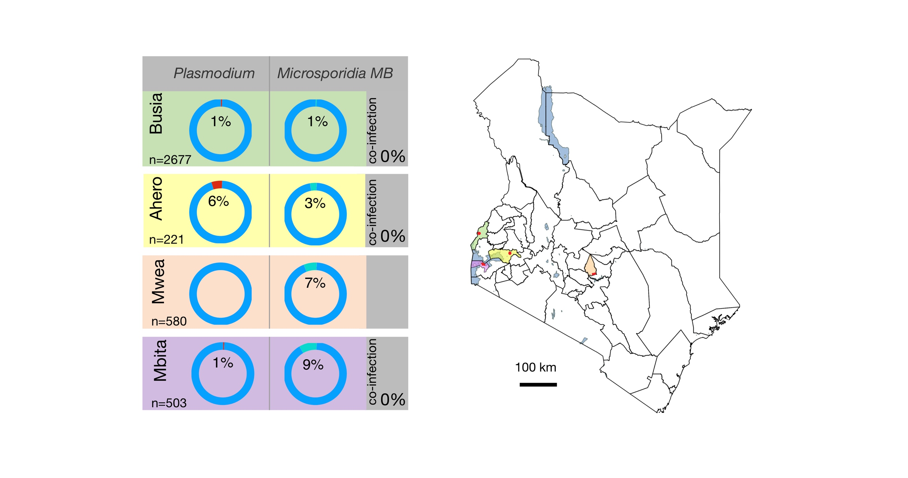

Supplementary Figure 1: Microsporidia MB is found in geographically dispersed An. arabiensis populations. Microsporidia MB is found at a prevalence range of <1-9% in An. arabiensis populations that also have Plasmodium sporozoite infections at a prevalence range of 1-6%. Microsporidia MB and Plasmodium sporozoite co-infections were not observed. The color-coded locations of sampling sites are indicated on the map of Kenya. Source data are provided as a Source Data file. Map generated using QGIS version 3.6.2 without any changes (QGIS Development Team, 2016. QGIS Geographic Information System. Open Source Geospatial Foundation Project. http://www.qgis.org/). Map is licensed under Creative Commons Attribution-ShareAlike 3.0 licence (CC BY-SA) https://creativecommons.org/licenses/by-sa/3.0/.

Supplementary Figure 2: The RNA polymerase B' subunit gene (rpoB) based phylogeny reveals that Microsporidia MB are in clade IV of the Microsporidia. Microsporidia MB rpoB gene sequence is available in Source Data file.

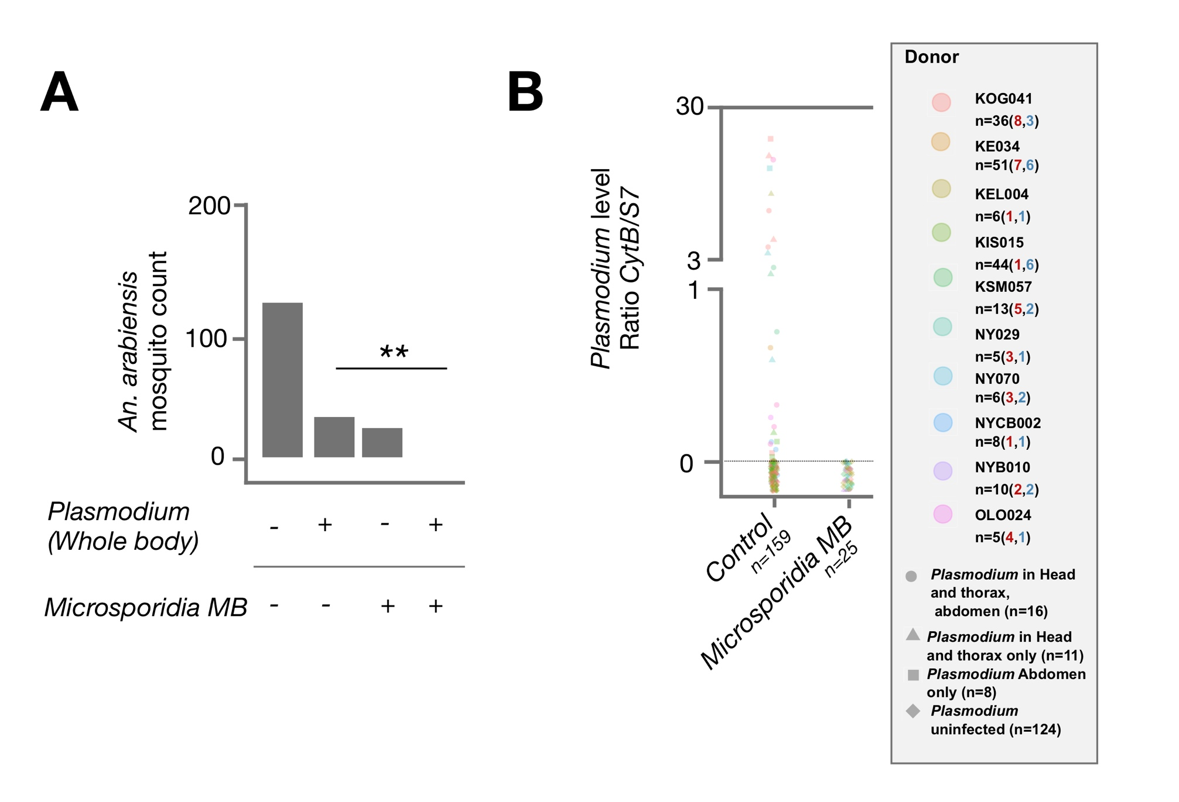

Supplementary Figure 3: Microsporidia MB impairs Plasmodium falciparum transmission in An. arabiensis after direct membrane feeding assay challenge. The Plasmodium infection rate in Microsporidia MB positive and Microsporidia MB negative mosquitoes was determined by qPCR. (A) The whole mosquito Plasmodium infection rate in Microsporidia MB positive and Microsporidia MB negative mosquitoes. There was a significant absence of co-infected mosquitoes (two tailed fisher exact test, P=0.005 n=184). (B) Plasmodium density quantified by qPCR in An. arabiensis. For An. arabiensis mosquitos infected in both head and thorax and abdomen, average Plasmodium density across both compartments is shown. If Plasmodium was detected in either head and thorax or abdomens or both compartments, the An. arabiensis was considered to have a Plasmodium infection. Source data are provided as a Source Data file.

Supplementary Tables
Mosquito ID | Donor ID | Microscopy Oocyst count | qPCR Plasmodium levels Ratio CytB/S7
AAKE002.29 | KE002 | 32 | 51.8660
AAKE002.27 | KE002 | 31 | 8.8097
AAKE002.17 | KE002 | 27 | 2.6563
AAKE002.20 | KE002 | 26 | 3.1649
AAKE002.22 | KE002 | 17 | 12.3944
AAKE002.26 | KE002 | 16 | 0.1170
AAKE002.32 | KE002 | 14 | 5.5038
AAKE002.13 | KE002 | 14 | 6.2848
AAKE002.25 | KE002 | 13 | 16.2045
AAKE002.12 | KE002 | 10 | 0.3178
AAKE002.18 | KE002 | 4 | 0.2263
AAKE002.16 | KE002 | 4 | 0.2646
AAKE002.30 | KE002 | 3 | 0.0000
AAKE002.11 | KE002 | 3 | 19.1503
AAKE002.23 | KE002 | 2 | 0.0192
AAAL106.19 | AL106 | 1 | 0.0000
AAAL106.7 | AL106 | 1 | 0.0291
AAKE002.24 | KE002 | 1 | 0.0381
AAAL106.11 | AL106 | 1 | 0.0723
AAAL106.18 | AL106 | 1 | 0.1401
AAKE002.21 | KE002 | 1 | 0.3971
AAAL106.1 | AL106 | 0 | 0.0000
AAAL106.2 | AL106 | 0 | 0.0000
AAAL106.3 | AL106 | 0 | 0.0000
AAAL106.4 | AL106 | 0 | 0.0000
AAAL106.5 | AL106 | 0 | 0.0000
AAAL106.6 | AL106 | 0 | 0.0000
AAAL106.8 | AL106 | 0 | 0.0000
AAAL106.9 | AL106 | 0 | 0.0000
AAAL106.10 | AL106 | 0 | 0.0000
AAAL106.12 | AL106 | 0 | 0.0000
AAAL106.13 | AL106 | 0 | 0.0000
AAAL106.14 | AL106 | 0 | 0.0000
AAAL106.15 | AL106 | 0 | 0.0000
AAAL106.16 | AL106 | 0 | 0.0000
AAAL106.17 | AL106 | 0 | 0.0000
AAAL106.20 | AL106 | 0 | 0.0000
AAAL106.22 | AL106 | 0 | 0.0000
AAAL106.23 | AL106 | 0 | 0.0000
AAAL106.24 | AL106 | 0 | 0.0000
AAAL106.26 | AL106 | 0 | 0.0000
AAAL106.27 | AL106 | 0 | 0.0000
AAAL106.28 | AL106 | 0 | 0.0000
AAGA034.1 | GA034 | 0 | 0.0000
AAGA034.2 | GA034 | 0 | 0.0000
AAGA034.3 | GA034 | 0 | 0.0000
AAGA034.4 | GA034 | 0 | 0.0000
AAGA034.6 | GA034 | 0 | 0.0000
AAGA034.7 | GA034 | 0 | 0.0000
AAGA034.8 | GA034 | 0 | 0.0000
AAGA034.9 | GA034 | 0 | 0.0000
AAGA034.10 | GA034 | 0 | 0.0000
AAGA034.11 | GA034 | 0 | 0.0000
AAGA034.12 | GA034 | 0 | 0.0000
AAGA034.13 | GA034 | 0 | 0.0000
AAKE002.1 | KE002 | 0 | 0.0000
AAKE002.2 | KE002 | 0 | 0.0000
AAKE002.3 | KE002 | 0 | 0.0000
AAKE002.4 | KE002 | 0 | 0.0000
AAKE002.5 | KE002 | 0 | 0.0000
AAKE002.6 | KE002 | 0 | 0.0000
AAKE002.7 | KE002 | 0 | 0.0000
AAKE002.8 | KE002 | 0 | 0.0000
AAKE002.9 | KE002 | 0 | 0.0000
AAKE002.10 | KE002 | 0 | 0.0000
AAKE002.31 | KE002 | 0 | 0.0000
AAKE002.33 | KE002 | 0 | 0.0000
AAKE002.34 | KE002 | 0 | 0.0000
AAAL106.21 | AL106 | 0 | 0.0016
AAAL106.25 | AL106 | 0 | 0.0026
AAKE002.15 | KE002 | 0 | 0.0516
AAKE002.28 | KE002 | 0 | 0.0588
AAKE002.14 | KE002 | 0 | 0.4775
AAGA034.5 | GA034 | 0 | 2.3810
AAKE002.19 | KE002 | 0 | 14.3188

Supplementary Table 1: Comparison between microscopy and qPCR-based identification of Plasmodium oocysts.

Transcript count
Vectorbase ID | Annotation | Control midgut | Microsporidia MB midgut
AARA001692-RA | |protein_coding|KB704673:1533830:1534351:1 | 4 | 1427
AARA001672-RA | serine protease|protein_coding|KB704673:1206862:1207866:1| | 0 | 863
AARA017919-RA | |protein_coding|KB704485:2440621:2441697:-1| | 0 | 684
AARA010474-RA | |protein_coding|KB704784:4788208:4788865:-1| | 0 | 668
AARA016538-RA | trypsin|protein_coding|KB704562:10018691:10019618:-1| | 0 | 606
AARA011947-RA | |protein_coding|KB704585:216071:219571:1| | 4 | 585
AARA009400-RA | female reproductive tract protease GLEANR_896|protein_coding|KB704429:955380:956226:-1| | 2 | 544
AARA016534-RA | Tryp1: trypsin serine protease|protein_coding|KB704562:10011635:10012589:-1| | 3 | 470
AARA015679-RA | CEC2 protein|protein_coding|KB704784:2597926:2598493:1| | 1 | 444
AARA010954-RA | GAM1: Gambicin|protein_coding|KB704562:4778215:4779020:-1| | 0 | 413
AARA008584-RA | chymotrypsin|protein_coding|KB704237:5970022:5970611:1| | 4 | 402
AARA005220-RA | Spink6|protein_coding|KB704374:4924358:4925022:1| | 0 | 389
AARA001662-RA | |protein_coding|KB704673:1151138:1152222:1| | 5 | 328
AARA010362-RA | cecropin anti-microbial peptide|protein_coding|KB704784:2593765:2594023:-1| | 0 | 299
AARA001649-RA | |protein_coding|KB704673:748599:749200:-1| | 3 | 279
AARA014775-RA | peritrophin|protein_coding|KB704452:1249892:1250418:-1| | 1 | 273
AARA002670-RA | |protein_coding|KB705117:892980:893603:-1| | 1 | 245
AARA003942-RA | |protein_coding|KB705006:5236596:5236931:-1| | 0 | 228
AARA009129-RA | peritrophin|protein_coding|KB704452:1244597:1245158:-1| | 1 | 210
AARA008305-RA | |protein_coding|KB704237:552614:554459:1| | 1 | 207
AARA004201-RA | |protein_coding|KB704451:2368184:2368990:1| | 0 | 191
AARA008319-RA | |protein_coding|KB704237:810943:812029:1| | 0 | 166
AARA015903-RA | |protein_coding|KB704451:6659776:6660325:-1| | 0 | 144
AARA016215-RA | |protein_coding|KB704407:3555520:3556405:1| | 1 | 136
AARA015784-RA | |protein_coding|KB704348:4256032:4258087:-1| | 0 | 126
AARA018436-RA | |protein_coding|KB704385:4202700:4205032:1| | 2 | 122
AARA017081-RA | |protein_coding|KB704418:4431242:4433340:1| | 0 | 119
AARA008295-RA | chitinase|protein_coding|KB704237:383112:384913:-1| | 0 | 111
AARA017523-RA | carboxypeptidase A|protein_coding|KB704562:8559544:8561224:-1| | 1 | 101
AARA008583-RA | Chymotrypsin-1|protein_coding|KB704237:5958609:5959617:1| | 1 | 95

Supplementary Table 2: List of genes with highest transcript count in Microsporidia MB-infected midguts. A full list of genes is provided as a Source Data file.

Transcript count
Vectorbase ID | Annotation | Control Ovary | Microsporidia MB Ovary
AARA016504-RA | LYSC2: C type lysozyme|protein_coding|KB704125:12997130:12997706:-1| | 0 | 145
AARA010742-RA | Tsf1: Transferrin|protein_coding|KB704784:9541677:9544708:-1| | 2 | 74
AARA000121-RA | |protein_coding|KB704629:627908:628999:-1| | 0 | 68
AARA001017-RA | SG6: salivary gland protein 6|protein_coding|KB704474:1139482:1139829:1| | 2 | 62
AARA001523-RA | |protein_coding|KB704126:5724349:5724921:-1| | 8 | 61
AARA002817-RA | |protein_coding|KB705117:5969995:5970243:1| | 0 | 57
AARA008387-RA | salivary gland protein|protein_coding|KB704237:1947776:1948202:-1| | 0 | 54
AARA018276-RA | |protein_coding|KB704629:1332902:1334509:1| | 0 | 52
AARA016177-RA | salivary gland protein 2-like|protein_coding|KB704237:1942298:1942986:-1| | 0 | 51
AARA014717-RA | salivary gland protein|protein_coding|KB704237:1948586:1949299:1| | 0 | 50
AARA015677-RA | |protein_coding|KB704485:351430:351866:-1| | 0 | 36
AARA017351-RA | translation initiation factor 4E|protein_coding|KB704125:10819264:10823225:1| | 5 | 32
AARA015944-RB | myosin heavy chain|protein_coding|KB704125:14151741:14196446:1| | 4 | 29
AARA008372-RA | |protein_coding|KB704237:1784410:1784685:-1| | 0 | 27
AARA014082-RA | |protein_coding|KB704348:4511294:4513913:-1| | 1 | 27
AARA016239-RA | D7 short form salivary protein|protein_coding|KB704562:10085174:10085895:1| | 0 | 25
AARA016236-RA | D7 short form salivary protein|protein_coding|KB704562:10086838:10087593:1| | 0 | 24
AARA005793-RA | zinc finger protein|protein_coding|KB704895:8632779:8633012:1| | 4 | 23
AARA017267-RA | serine protease snake|protein_coding|KB704607:1737540:1738867:1| | 0 | 22
AARA000154-RA | |protein_coding|KB704629:1260841:1267015:-1| | 2 | 22
AARA007305-RA | |protein_coding|KB704125:1421292:1422270:-1| | 2 | 22
AARA015678-RA | |protein_coding|KB704485:349362:349737:-1| | 0 | 21
AARA016439-RA | long wavelength sensitive opsin|protein_coding|KB704673:689026:690578:-1| | 0 | 21
AARA005456-RA | 5' nucleotidase, ecto|protein_coding|KB704895:1659094:1661257:-1| | 1 | 21
AARA007307-RA | serine/threonine-protein phosphatase dullard homolog|protein_coding|KB704125:1425530:1435778:-1| | 3 | 21
AARA005602-RA | |protein_coding|KB704895:5042392:5043204:1| | 3 | 20
AARA004183-RA | small nuclear ribonucleoprotein polypeptide F|protein_coding|KB704451:2078616:2079165:-1| | 2 | 19
AARA005298-RA | |protein_coding|KB704696:207749:208932:1| | 3 | 19
AARA015837-RA | DLP: Daxx-like protein|protein_coding|KB704485:337567:342065:-1| | 3 | 19

Supplementary Table 3: List of genes with highest transcript count in Microsporidia MB-infected ovaries. A full list of genes is provided as a Source Data file.
Species ID | Gene | Genbank Accession number
Conidiobolus osmodes | 18S | AF368510
Encephalitozoon intestinalis | 18S | XR_002670134.1
Nosema ceranae | 18S | XR_002966746.1
Vittaforma corneae | 18S | U11046
Crispospora chironomi | 18S | ﻿GU130407
Anncaliia algerae | 18S | HM216911
Edhazardia aedis | 18S | AF027684
Parathelohania anophelis | 18S | AF027682
Hazardia milleri | 18S | AY090067
Conidiobolus osmodes | rpoB | EF392431
Nosema ceranae | rpoB | XM_024473662
Vittaforma corneae | rpoB | XM_007605356
Encephalitozoon intestinalis | rpoB | XM_003073661

Supplementary Table 4: Accession numbers of sequences used for phylogenetic trees.
PCR | Organism | Forward primer | Reverse Primer | Reference
SSU rRNA | Microsporidia | CACCAGGTTGATTCTGCC | TTATGATCCTGCTAATGGTTC | 1
rpoB MB | Microsporidia MB | ACAGTAGGTCACTTGATTGAATGTC | TACCATGTGCTTAAGTCTTTGGT | This study
SINE S200 X6.1 | Anopheles | TCGCCTTAGACCTTGCGTTA | CGCTTCAAGAATTCGAGATAC | 2
MB 18S | Microsporidia MB | CGCCGGCCGTGAAAAATTTA | CCTTGGACGTGGGAGCTATC | This study
Ribosomal Protein S7 | Anopheles | TCCTGGAGCTGGAGATGAAC | GACGGGTCTGTACCTTCTGG | 3
CytB | Plasmodium | TGGTAGCACAAATCCTTTAGGG | TGGTAATTGACATCCAATCC | 4
FISH | Organism | Probe |  | Reference
MB probe | Microsporidia MB | CCCTGTCCACTATACCTAATGAACAT |  | This study

Supplementary Table 5: Primers used for PCR-based detection, quantification, gene expression analysis and Fluorescence in Situ Hybridization (FISH).

Supplementary references:

1. Ghosh, K. & Weiss, L. M. Molecular Diagnostic Tests for Microsporidia. Interdiscip Perspect Infect Dis. 2009, 926521 (2009).
2. Santolamazza, F., Mancini, E., Simard, F., Qi, Y., Tu, Z., della Torre, A. Insertion polymorphisms of SINE200 retrotransposons within speciation islands of Anopheles gambiae molecular forms. Malar. J. 7, 163 (2008).
3. Dong, Y., Taylor, H.E., Dimopoulos, G. AgDscam, a hypervariable immunoglobulin domain-containing receptor of the Anopheles gambiae innate immune system. PLoS Biol. 4, e229 (2006).
4. Xu, W. et al. SYBR green real-time PCR-RFLP assay targeting the Plasmodium cytochrome B gene - A highly sensitive molecular tool for malaria parasite detection and species determination. PLoS ONE 10, e0120210 (2015).

