Supplementary Materials

Neonatal antibiotic exposure impairs child growth during the first six years of life by perturbing intestinal microbial colonization

Authors: Atara Uzan-Yulzari, Olli Turta, Anna Belogolovski, Oren Ziv, Christina Kunz, Sarah Perschbacher, Hadar Neuman, Edoardo Pasolli, Aia Oz, Hila Ben-Amram, Himanshu Kumar, Helena Ollila, Anne Kaljonen, Erika Isolauri, Seppo Salminen, Hanna Lagström, Nicola Segata, Itai Sharon, Yoram Louzoun, Regina Ensenauer, Samuli Rautava, Omry Koren

Correspondence to: samuli.rautava@hus.fi, omry.koren@biu.ac.il

Supplementary Results

Prevalence of Bifidobacterium species and strains in the metagenomics samples
Community composition varied across the different metagenomics samples with members of four different phyla detected: Firmicutes, Bacteroidetes, Proteobacteria and Actinobacteria. Community composition varied significantly among the different samples with a total of at least 35 genera (Supplementary Figure 6) and 88 bacterial species detected across all samples (Supplementary Tables 8 and 10). As expected, the average number of species whose relative abundance is 0.1% or higher in the community is higher in the six-month samples compared to the one-month samples for both the antibiotics (20 vs 13 species/sample) and the control (15.8 vs. 10.4 species/sample) groups.
Multiple strains of the same species were identified in two samples, 126_CTR_6M, 166_ABX_6M and 179_CTR_6M, in all cases for B. longum. Comparing one- and six-month samples of the same babies revealed that the same strains were present in both samples in all four cases in which the same Bifidobacterium species was identified. For baby 126, the only B. longum strain that was detected in the one-month sample is the major strain in the six-month sample with an additional minor strain detected. For baby 128, the same B. breve, B. bifidum and B. pseudocatenulatum strains are present in both samples. This shows that initial colonizers of the infant gut also remain part of the population in the long term.
A
B

Supplementary Figure 1. Body mass index (BMI) Z-scores in children exposed to brief empirical antibiotic therapy (AB and no Inf, N=513) and children who had received antibiotics for confirmed or clinical bacterial infection (AB and Inf, N=638) as compared to children not exposed to antibiotics (No AB and no Inf, N=11,271). The BMI Z-scores between the ages of 2 and 6 years are presented for boys (A) and for girls (B). The x axis represents the age in years, the y axis represents the model-based Least Squares Mean (LSM) estimates. The whiskers represent 95% confidence intervals. The data were analyzed using a hierarchical linear mixed model for repeated measurements. Neonatal antibiotic exposure, gestational age, birth weight Z-score, mode of delivery, time, maternal prepregnancy BMI and intrapartum antibiotic treatment were included in the model as explanatory variables.

A B

C D

Supplementary Figure 2. The association between childhood antibiotic use and weight and height Z-scores during the first six years of life in boys and girls. The subjects have been categorized by quartiles (Q1, median and Q3) based on the cumulative number of antibiotic purchases at each point in time. The number of antibiotic purchases was associated with significantly higher weight Z-scores during the first six years of life in boys (A, p<0.001) but not in girls (C, p=0.71) in a hierarchical linear mixed model for repeated measurements adjusted for gestational age, birth weight Z-score, mode of delivery, maternal prepregnancy BMI and neonatal antibiotic exposure. No association between the number of antibiotic purchases and height Z-scores was detected in either boys (B, p=0.35) or girls (D, p=0.15). The boxes represent interquartile range (IQR) and the whiskers represent 1.5 times IQR. The circles represent outliers.

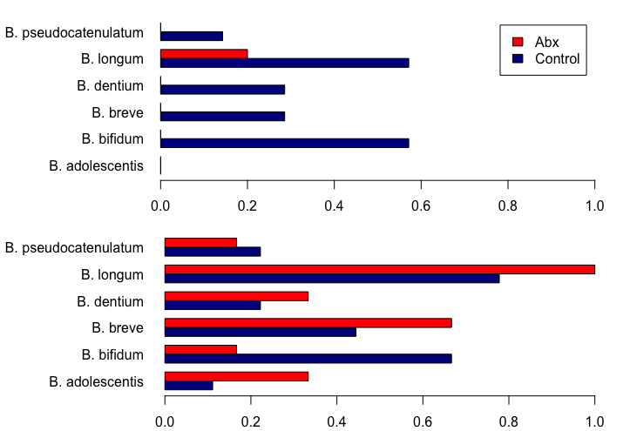

Supplementary Figure 3: Presence of Bifidobacterium species in the one-month (top) and the six-month (bottom) samples. Only species with relative abundance ≥ 0.1% were considered. One-month samples: 7 control, 5 antibiotics. Six-months samples: 9 control, 6 antibiotics.

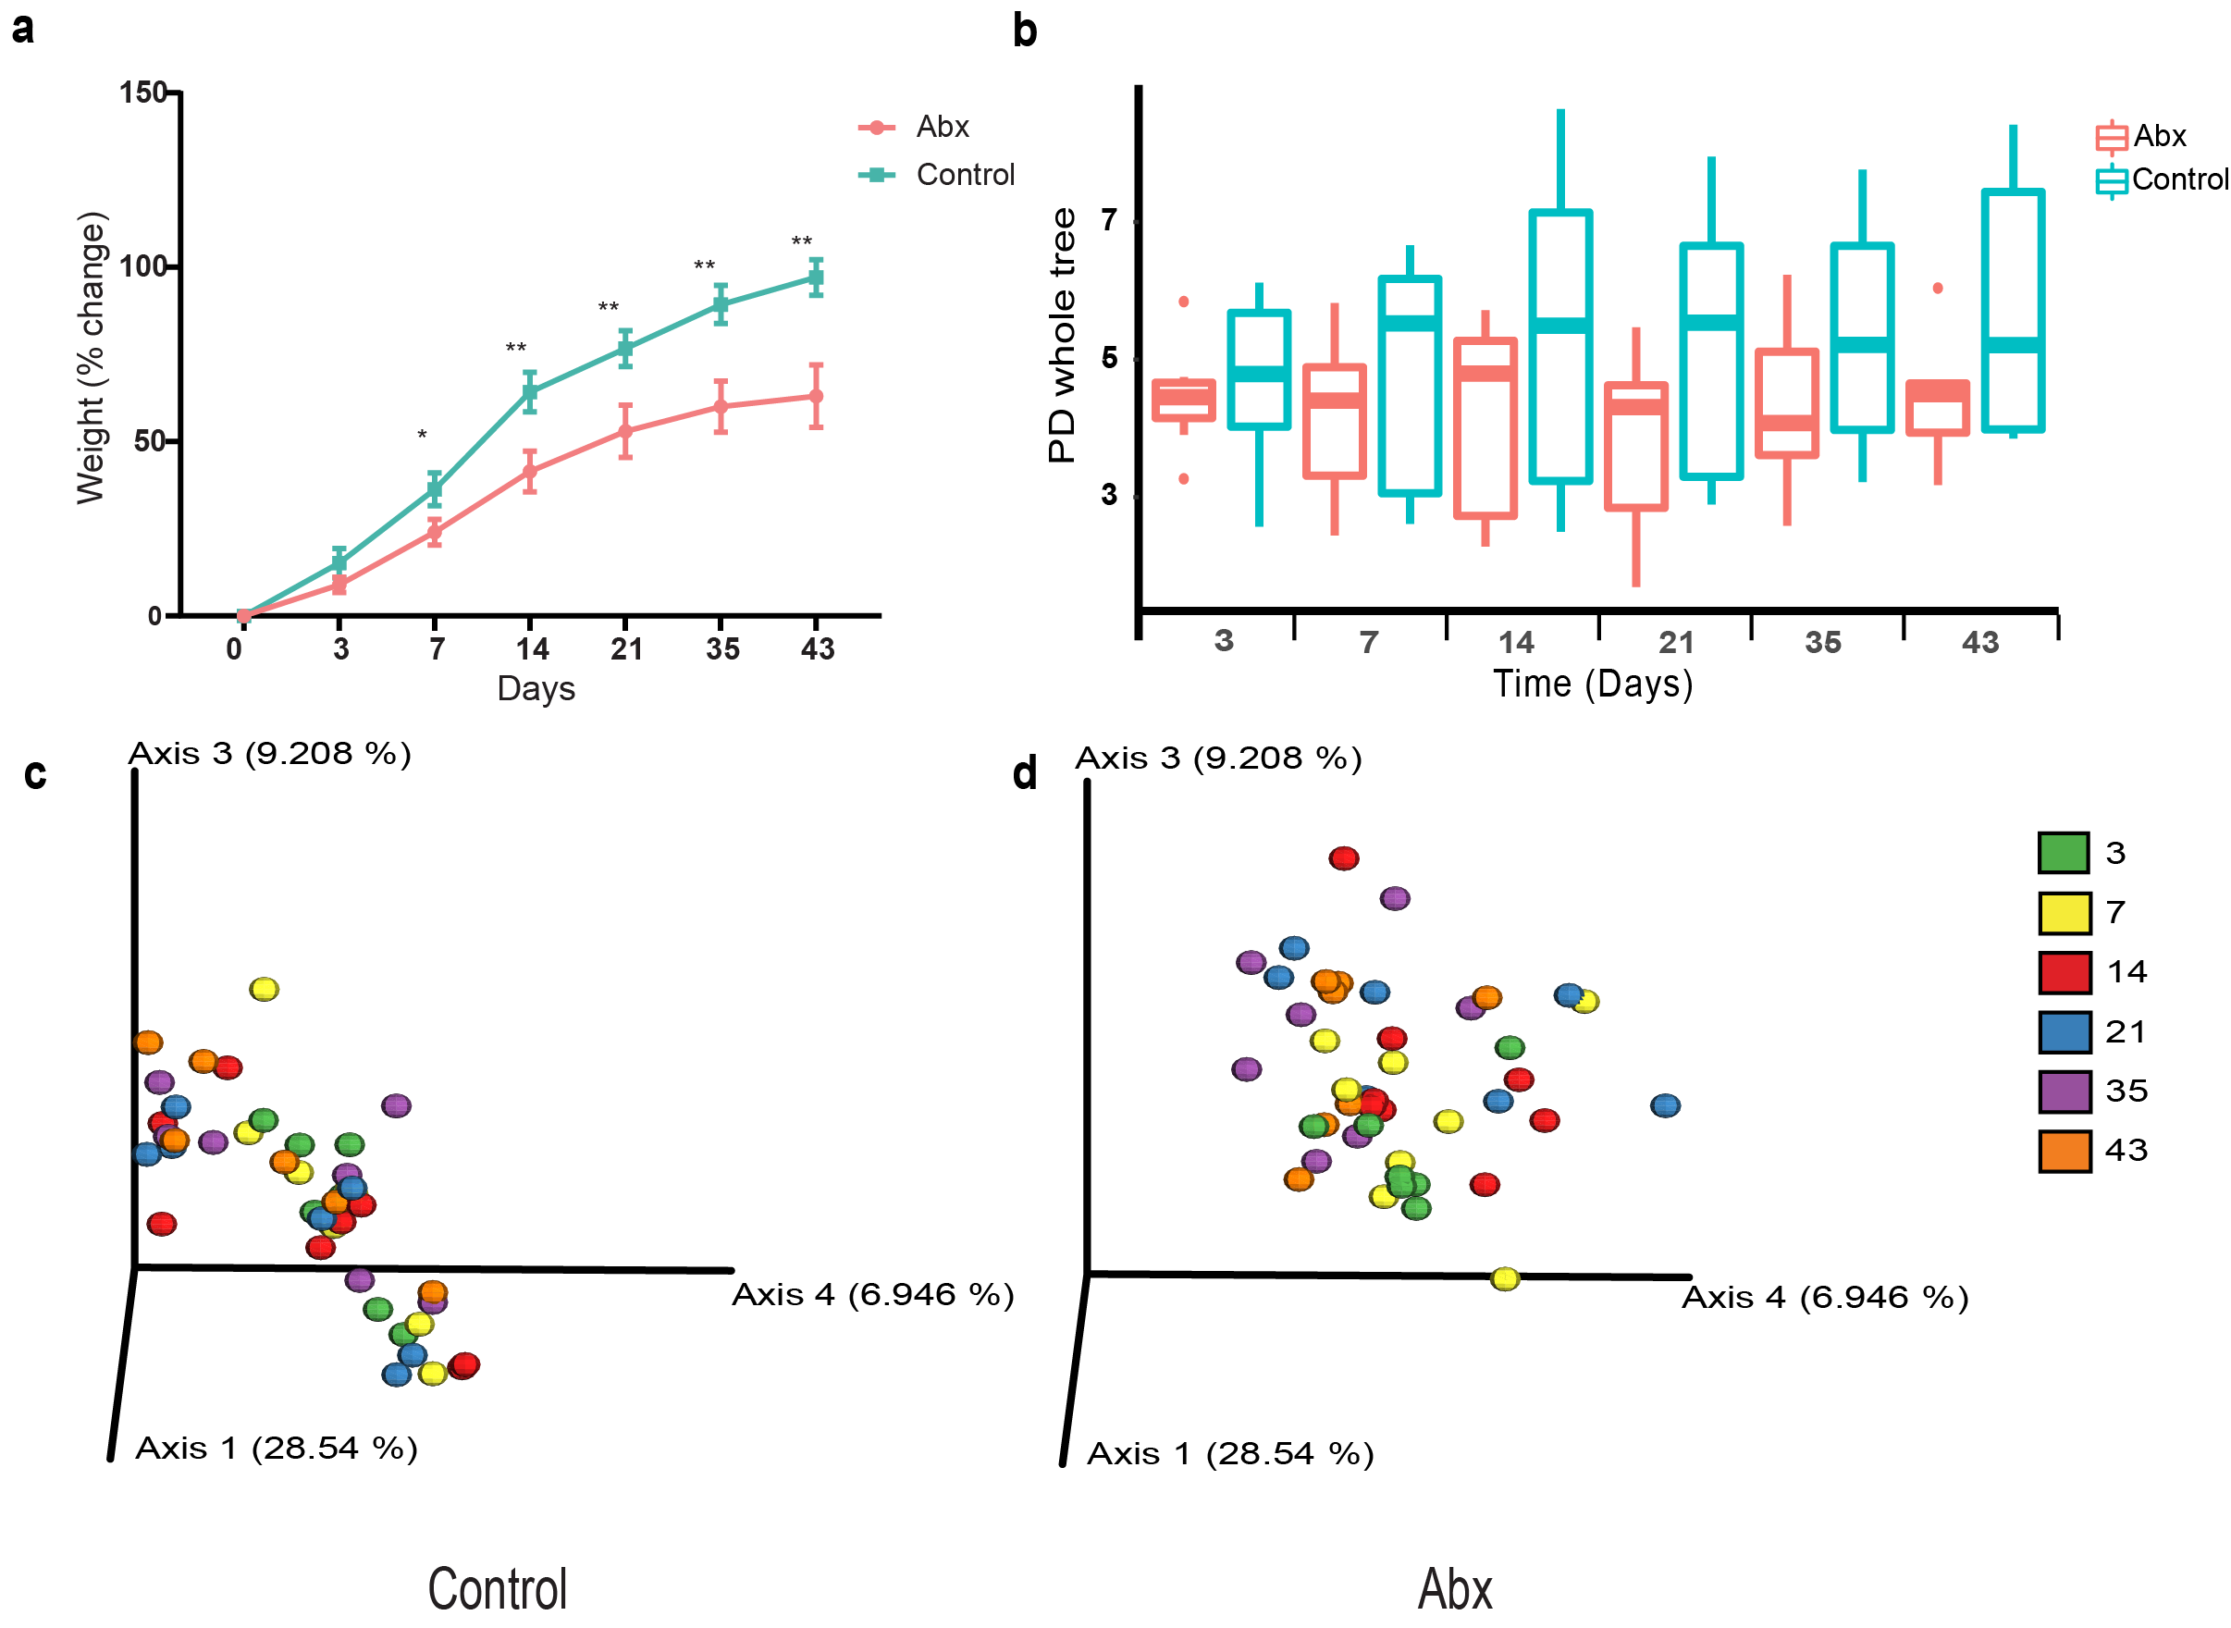

Supplementary Figure 4. FMT from antibiotic-treated infants, 24 months after exposure, to GF mice induces changes in weight gain and bacterial composition. (A) Mice receiving fecal transplantation from antibiotic treated infants (pink) gained significantly less weight (expressed as mean +/- SEM) compared to control animals (blue) starting from day 7. (B) No significant changes were seen in alpha diversity comparison based on phylogenetic diversity. (C) PCoA based on Unweighted UniFrac distance matrix in control, and (D) Abx mouse groups at six time points, 3 (green), 7 (yellow), 14 (red), 21 (blue), 35 (purple) and 43 (orange) days from FMT. (For (A) control and abx group, n = 7-8. for (B-D), control group, day 3,7 and 14, n = 8; day 21 and 35, n = 7; day 43, n=6. Abx group, day 3, 21,35 and 43, n=7; day 7 and 14, n = 8). Samples from 3 antibiotic-exposed infants and 7 non-exposed infants were used for fecal transplantation. (*p < 0.05, **p < 0.01).

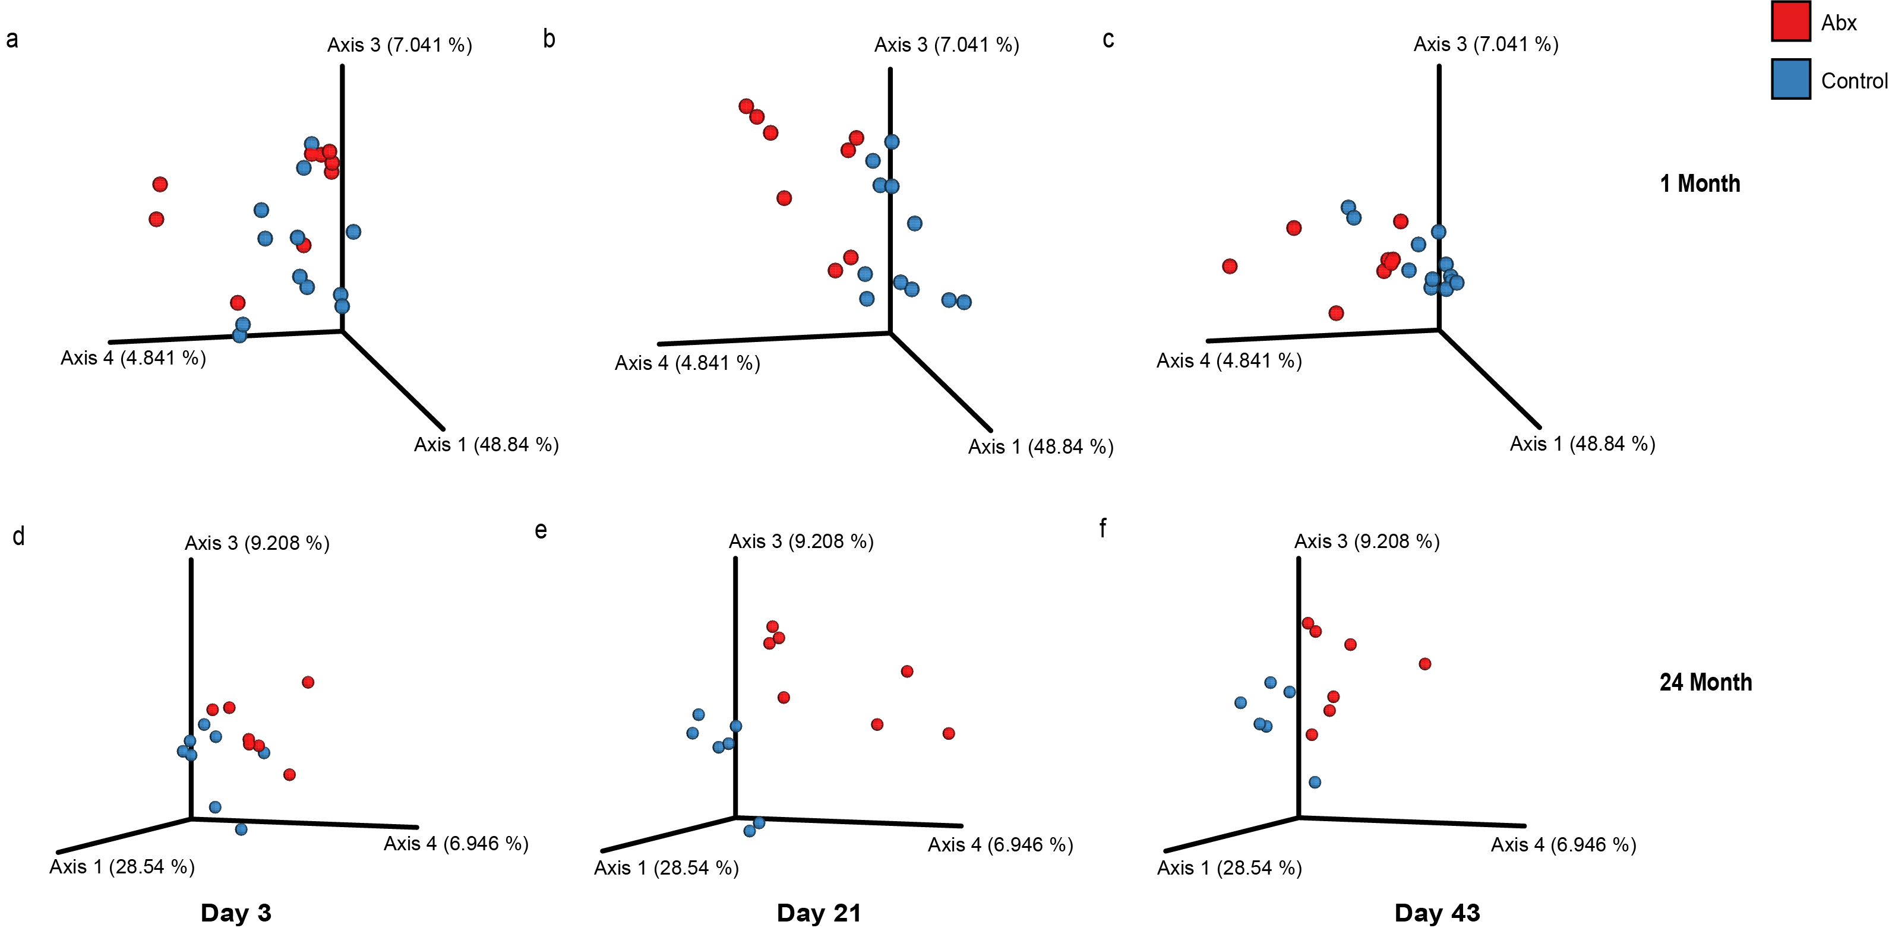

Supplementary Figure 5. FMT from infants to GF mice induces significant changes in bacterial populations. Phylogenetic beta diversity (unweighted UniFrac) of control (blue) and Abx (red) mice groups over time, 3 (A, control, n=12; abx, n=12 P=0.008, D, control, n=8; abx, n=7, P=0.024), 21 (B, control, n=12; abx, n=8, P=0.006, E, control and abx n=7, P=0.02 ), and 43 (C, control, n=12; abx, n=8 P=0.001, F, control, n=7; abx, n=6, P=0.09) days from fecal transplantation

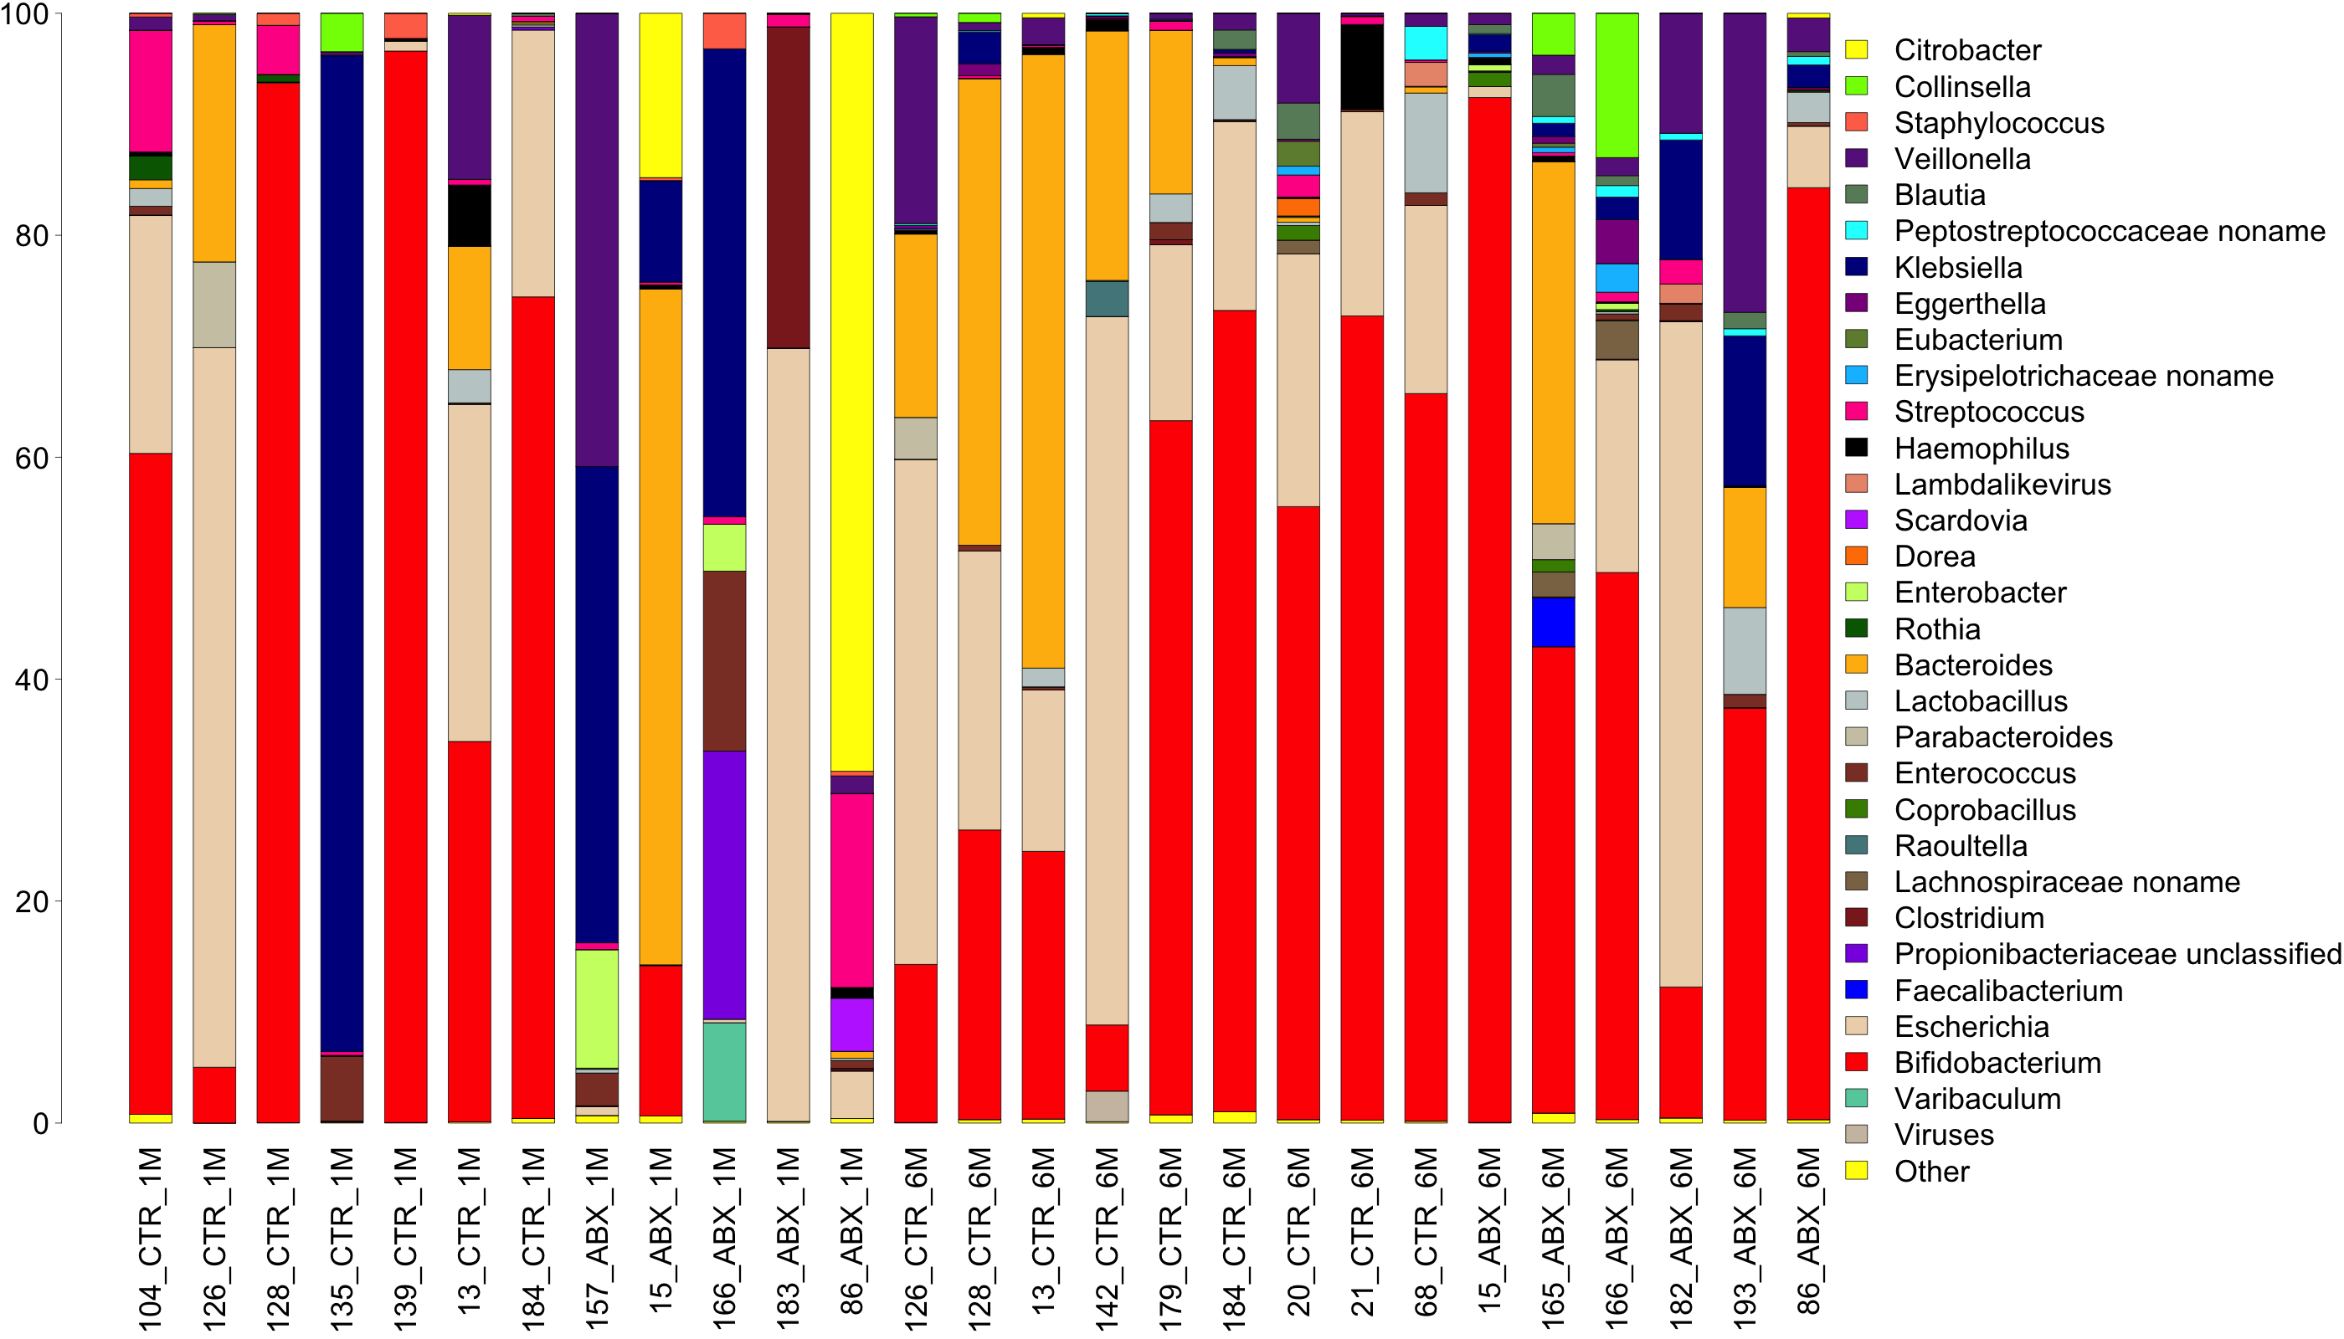
Supplementary Figure 6. Genus abundance across the different metagenomics samples. Only genera with relative abundance ≥ 1% in at least one sample are shown. Genus abundance was evaluated using metaphlan2.

Supplementary Figure 7 - A color scale heat map showing significant changes in bacterial composition between control and Abx mice groups on day 43, using Calour (q <0.05)

Supplementary Table 1. Clinical characteristics of the boys and girls in the Southwest Finland Birth Cohort.
 | Boys (N=6307) | Girls (N=6115) | p
Gestational age (weeks) | 40.0 (1.2) | 40.1 (1.2) | 0.0022
Birth weight (grams) | 3636 (469) | 3514 (450) | <0.0001
Birth weight Z-score | 0.03 (1.05) | 0.004 (1.06) | 0.15
Maternal prepregnancy BMI (kg/m²) | 24.4 (4.8) | 24.4 (4.7) | 0.70
Vaginal delivery | 87.2% (5500/ 6307) | 87.6% (5354/ 6115) | 0.56
Intrapartum antibiotic exposure | 10.8% (682/ 6290) | 10.8% (656/ 6092) | 0.89
Neonatal antibiotic exposure | 10.7% (673/6307) | 7.8% (478/6115) | <0.0001
Number of antibiotic prescriptions during follow-up* | 7 (4, 12) | 6 (3, 10) | <0.0001
The data are presented as means (SD) for continuous variables and as percentage (proportion) for categorical variables. Student’s two-tailed t-test was used for continuous variables and Chi-squared test for categorical variables. *Median (quartiles Q1, Q3) and Wilcoxon rank-sum test were used because of normal distribution.

Supplementary Table 2. Breastfeeding rates of the children in the PEACHES cohort^{a,b}.
 | No infection and no neonatal antibiotics (N=572) | Infection and neonatal antibiotics (N=37) | p
Never breastfed | 39 (6.8%) | 3 (8.1%) | 0.73
Breastfed at 1 month | 533 (93.2%) | 34 (91.9%) | 0.73
Breastfed at 2 months | 496 (86.7%) | 34 (91.9%) | 0.46
Breastfed at 3 months | 469 (82.1%) | 31 (83.8%) | 1.00
Breastfed at 4 months | 449 (78.8%) | 30 (81.1%) | 0.84
Breastfed at 5 months | 419 (73.5%) | 25 (67.6%) | 0.45
Breastfed at 6 months | 391 (68.6%) | 22 (59.5%) | 0.28
ª Rates are presented for all children in the PEACHES cohort who fulfilled the inclusion criteria for analysis and had data of at least one breastfeeding occurrence and information on neonatal infection and antibiotic therapy.
^{b} Dichotomous variables were assessed using the Fisher’s exact test.

Supplementary Table 3. Clinical characteristics of the neonates included in the gut microbiome study.
 | Neonatal antibiotics (N=13) | Control (N=20) | p
Gestational age (weeks) | 39^{5/7} (36^{0/7}-42^{1/7}) | 40^{4/7} (37^{4/7}-42^{0/7}) | 0.17
Birth weight (grams) | 3708 (2810-4660) | 3729 (2930-4460) | 0.90
Intrapartum antibiotic exposure | 71% (5/13) | 10% (2/20) | 0.052
Vaginal delivery | 92% (12/13) | 100% (20/20) | 0.17
Female | 31% (4/13) | 45% (9/20) | 0.41
5 min Apgar score | 7.9 (3-10) | 9.0 (8-10) | 0.10
Breastfed at 1 month | 100% (13/13) | 100% (20/20) | NA
Breastfeeding duration (months) | 7.7 (1.5 to 13.0) | 10.5 (6.0-14.0) | 0.031
Antibiotics before 6 months of age | 15% (2/13) | 5% (1/20) | 0.32
Continuous data are expressed as means with range, and the differences between groups were assessed using Student’s two-tailed t test. Dichotomous data are expressed as percentages (proportions) and were assessed using the Chi square test. NA not applicable.

Supplementary Table 4. Hotelling test results on the 3 first dimensions of the PCoA projection among groups
Timepoint (month) | 3 PCoA dimensions P value
1 | 0.002
6 | 0.003
12 | >0.05
24 | >0.05

Supplementary Table 5. Metagenomic analysis sample information
Sample | Baby | Age (months) | Control/Abx | # reads (raw) | # bps (raw) | # bps in scaffolds >= 500 bp | % of reads mapped to assembly | # species >= 0.1%
104_CTR_1M | 104 | 1 | CTR | 27,255,538 | 3,048,490,679 | 42,168,529 | 98.68 | 19
126_CTR_1M | 126 | 1 | CTR | 27,436,708 | 2,704,057,331 | 26,537,329 | 99.22 | 11
126_CTR_6M | 126 | 6 | CTR | 19,552,656 | 1,924,583,937 | 31,676,468 | 97.76 | 16
128_CTR_1M | 128 | 1 | CTR | 19,087,812 | 1,882,462,171 | 13,345,768 | 98.64 | 6
128_CTR_6M | 128 | 6 | CTR | 21,249,252 | 2,093,497,953 | 44,003,659 | 97.21 | 21
13_CTR_1M | 13 | 1 | CTR | 31,323,492 | 3,113,344,228 | 36,535,975 | 98.4 | 15
13_CTR_6M | 13 | 6 | CTR | 15,724,876 | 1,821,780,314 | 24,510,972 | 95.49 | 17
135_CTR_1M | 135 | 1 | CTR | 21,813,766 | 2,164,597,856 | 11,208,704 | 99.32 | 6
139_CTR_1M | 139 | 1 | CTR | 49,758,574 | 5,743,483,187 | 15,510,806 | 95.61 | 5
142_CTR_6M | 142 | 6 | CTR | 15,091,622 | 1,499,351,446 | 22,484,164 | 98.93 | 8
15_ABX_1M | 15 | 1 | ABX | 13,854,074 | 1,451,391,519 | 24,402,659 | 94.78 | 12
15_ABX_6M | 15 | 6 | ABX | 27,280,609 | 3,060,212,469 | 36,659,134 | 95.19 | 13
157_ABX_1M | 157 | 1 | ABX | 52,738,236 | 6,074,658,129 | 24,887,402 | 95.68 | 12
165_ABX_6M | 165 | 6 | ABX | 13,835,151 | 1,601,573,754 | 67,265,903 | 92.71 | 32
166_ABX_1M | 166 | 1 | ABX | 14,206,158 | 1,654,818,160 | 27,287,133 | 96.28 | 12
166_ABX_6M | 166 | 6 | ABX | 41,065,702 | 4,242,709,634 | 74,970,475 | 97.38 | 23
179_CTR_6M | 179 | 6 | CTR | 11,002,326 | 1,092,263,236 | 19,392,960 | 96.69 | 14
182_ABX_6M | 182 | 6 | ABX | 35,025,777 | 3,999,836,943 | 36,641,137 | 95.32 | 15
183_ABX_1M | 183 | 1 | ABX | 18,023,026 | 2,131,535,284 | 15,706,291 | 96.81 | 13
184_CTR_1M | 184 | 1 | CTR | 20,058,642 | 1,987,914,876 | 16,233,759 | 97.8 | 11
184_CTR_6M | 184 | 6 | CTR | 53,466,603 | 5,961,513,660 | 43,372,254 | 95.3 | 14
193_ABX_6M | 193 | 6 | ABX | 37,799,693 | 4,190,740,176 | 47,149,951 | 95.36 | 15
20_CTR_6M | 20 | 6 | CTR | 22,479,101 | 2,543,061,606 | 48,997,667 | 94.02 | 24
21_CTR_6M | 21 | 6 | CTR | 16,699,452 | 1,887,414,687 | 16,563,639 | 94.81 | 10
68_CTR_6M | 68 | 6 | CTR | 33,369,070 | 3,885,283,530 | 51,837,678 | 94.51 | 18
86_ABX_1M | 86 | 1 | ABX | 14,355,072 | 1,426,798,963 | 20,352,885 | 97.22 | 16
86_ABX_6M | 86 | 6 | ABX | 37,252,284 | 3,688,793,852 | 60,501,777 | 97.01 | 22
Reported number of reads refers to reads that passed trimming.

Supplementary Table 6. Information about genomes recovered in the study.
Sample | Genome name | Species | # scaffolds | Size | Completeness | Contamination | Present in other sample? | Metaphlan2 abundance
104_CTR_1M | 104_CTR_1M_60_470.B_longum | B. longum | 47 | 2,253,538 | 100 | 0 |  | 59.55401
126_CTR_1M | 126_CTR_1M_60_30.B_longum | B. longum | 138 | 2,683,561 | 100 | 1.04 | Same as 126_CTR_6M_60_57.B_longum | 5.02798
126_CTR_6M | 126_CTR_6M_55_5.B_longum | B. longum | 82 | 80,384 | 6.18 | 0.86 | No | 14.24287
126_CTR_6M | 126_CTR_6M_60_57.B_longum | B. longum | 121 | 2,680,149 | 100 | 0.58 | Same as 126_CTR_1M_60_30.B_longum | 14.24287
128_CTR_1M | 128_CTR_1M_63_61.B_bifidum | B. bifidum | 72 | 2,237,613 | 99.31 | 0.46 | Same as 128_CTR_6M_63_36.B_bifidum | 7.72694
128_CTR_1M | 128_CTR_1M_59_629.B_breve | B. breve | 32 | 2,323,178 | 100 | 0 | Same as 128_CTR_6M_59_42.B_breve | 85.95728
128_CTR_6M | 128_CTR_6M_63_36.B_bifidum | B. bifidum | 61 | 2,235,764 | 99.31 | 0 | Same as 128_CTR_1M_63_61.B_bifidum | 10.66277
128_CTR_6M | 128_CTR_6M_59_42.B_breve | B. breve | 63 | 2,313,448 | 99.77 | 0 | Same as 128_CTR_1M_59_629.B_breve | 13.73136
128_CTR_6M | 128_CTR_6M_57_14.B_pseudocatenulatum | B. pseudocatenulatum | 161 | 2,134,790 | 99.09 | 2.57 |  | 1.6977
13_CTR_1M | 13_CTR_1M_59_170.B_breve | B. breve | 230 | 2,345,256 | 99.73 | 0.96 |  | 22.81031
13_CTR_1M | 13_CTR_1M_60_58.B_longum | B. longum | 216 | 2,267,392 | 94.89 | 0.96 |  | 7.63968
13_CTR_1M | 13_CTR_1M_63_26.B_bifidum | B. bifidum | 103 | 2,275,200 | 99.31 | 2.88 |  | 3.25749
13_CTR_1M | 13_CTR_1M_58_6.B_dentium | B. dentium | 1,250 | 2,182,660 | 76.91 | 4.75 |  | 0.57315
13_CTR_6M | 13_CTR_6M_63_11.B_bifidum | B. bifidum | 156 | 2,190,750 | 95.23 | 3.01 |  | 4.0731
13_CTR_6M | 13_CTR_6M_59_30.B_breve | B. breve | 109 | 2,226,565 | 93.03 | 2.09 |  | 13.24834
13_CTR_6M | 13_CTR_6M_60_16.B_longum | B. longum | 152 | 2,121,967 | 91.11 | 2.15 |  | 6.35087
13_CTR_6M | NA | B. dentium | NA | NA | NA | NA |  | 0.44405
139_CTR_1M | 139_CTR_1M_63_983.B_bifidum | B. bifidum | 26 | 2,204,467 | 99.08 | 0 |  | 86.1316
139_CTR_1M | 139_CTR_1M_56_415.B_pseudocatenulatum | B. pseudocatenulatum | 16 | 2,169,171 | 100 | 0.68 |  | 10.35922
142_CTR_6M | 142_CTR_6M_60_10.B_longum | B. longum | 360 | 2,458,933 | 98.92 | 5.12 |  | 5.9558
15_ABX_1M | 15_ABX_1M_60_20.B_longum | B. longum | 51 | 2,171,246 | 96.34 | 0.32 |  | 13.52892
15_ABX_6M | 15_ABX_6M_63_14.B_bifidum | B. bifidum | 53 | 2,107,053 | 95.62 | 0.58 |  | 2.38693
15_ABX_6M | 15_ABX_6M_59_411.B_breve | B. breve | 37 | 2,289,829 | 95.99 | 1.84 |  | 84.7879
15_ABX_6M | 15_ABX_6M_60_31.B_longum | B. longum | 116 | 1,977,940 | 86.44 | 0.25 |  | 5.17153
165_ABX_6M | 165_ABX_6M_59_4.B_adolescentis | B. adolescentis | 94 | 255,422 | 4.17 | 0 |  | 1.46765
165_ABX_6M | 165_ABX_6M_59_51.B_breve | B. breve | 97 | 2,051,765 | 81.99 | 0.98 |  | 20.92734
165_ABX_6M | 165_ABX_6M_60_38.B_longum | B. longum | 114 | 2,186,260 | 92.91 | 2.09 |  | 13.31265
165_ABX_6M | 165_ABX_6M_56_33.B_pseudocatenulatum | B. pseudocatenulatum | 33 | 2,077,285 | 91.59 | 0.38 |  | 6.30968
166_ABX_6M | 166_ABX_6M_58_66.B_breve | B. breve | 116 | 1,786,283 | 82.32 | 1.27 |  | 8.73569
166_ABX_6M | 166_ABX_6M_59_206.B_longum | B. longum | 190 | 1,093,504 | 21 | 0 |  | 40.54609
166_ABX_6M | 166_ABX_6M_60_431.B_longum | B. longum | 273 | 2,183,475 | 78.34 | 2.22 |  | 40.54609
179_CTR_6M | 179_CTR_6M_60_119.B_longum | B. longum | 242 | 2,322,072 | 100 | 1.65 |  | 58.18272
179_CTR_6M | 179_CTR_6M_63_9.B_bifidum | B. bifidum | 589 | 2,221,156 | 94.37 | 6.81 |  | 4.36336
179_CTR_6M | 179_CTR_6M_57_21.B_longum | B. longum | 121 | 557,897 | 0 | 0 |  | 58.18272
182_ABX_6M | 182_ABX_6M_59_41.B_breve | B. breve | 125 | 2,007,736 | 90.26 | 0.69 |  | 10.06898
182_ABX_6M | 182_ABX_6M_60_296.B_longum | B. longum | 108 | 2,567,290 | 96.49 | 2.49 |  | 1.73043
184_CTR_1M | 184_CTR_1M_60_247.B_longum | B. longum | 57 | 2,585,388 | 99.77 | 9.79 |  | 41.16457
184_CTR_1M | 184_CTR_1M_63_198.B_bifidum | B. bifidum | 49 | 1,987,643 | 90.32 | 1.38 |  | 32.22095
184_CTR_6M | 184_CTR_6M_63_270.B_bifidum | B. bifidum | 29 | 2,131,794 | 99.08 | 0.46 |  | 18.36808
184_CTR_6M | 184_CTR_6M_59_30.B_dentium | B. dentium | 52 | 2,264,988 | 85.11 | 0.91 |  | 1.32606
184_CTR_6M | 184_CTR_6M_60_761.B_longum | B. longum | 34 | 2,296,474 | 99.77 | 0.46 |  | 52.50827
193_ABX_6M | 193_ABX_6M_58_31.B_dentium | B. dentium | 22 | 2,267,060 | 90.76 | 0.45 |  | 3.59905
193_ABX_6M | 193_ABX_6M_60_238.B_longum | B. longum | 14 | 1,858,493 | 80.55 | 0.46 |  | 33.56637
20_CTR_6M | 20_CTR_6M_60_150.B_longum | B. longum | 68 | 2,141,707 | 91.01 | 0.61 |  | 34.24537
20_CTR_6M | 20_CTR_6M_56_136.B_pseudocatenulatum | B. pseudocatenulatum | 16 | 1,946,461 | 76.73 | 0 |  | 20.98682
21_CTR_6M | 21_CTR_6M_63_133.B_bifidum | B. bifidum | 33 | 2,175,665 | 99.08 | 0 |  | 27.73302
21_CTR_6M | 21_CTR_6M_59_185.B_breve | B. breve | 67 | 2,465,640 | 99.68 | 2.79 |  | 44.71957
68_CTR_6M | 68_CTR_6M_61_290.B_bifidum | B. bifidum | 19 | 2,137,251 | 97.47 | 1 |  | 31.56724
68_CTR_6M | 68_CTR_6M_59_242.B_breve | B. breve | 132 | 2,371,135 | 96.31 | 7.97 |  | 28.40702
68_CTR_6M | 68_CTR_6M_60_54.B_longum | B. longum | 132 | 2,166,607 | 96.58 | 3.15 |  | 5.3631
86_ABX_6M | 86_ABX_6M_60_467.B_longum | B. longum | 58 | 2,282,026 | 100 | 0.12 |  | 49.99088
86_ABX_6M | 86_ABX_6M_58_194.B_dentium | B. dentium | 51 | 2,555,581 | 97.61 | 1.21 |  | 16.89689
86_ABX_6M | 86_ABX_6M_59_234.B_adolescentis | B. adolescentis | 46 | 2,282,883 | 97.46 | 1.21 |  | 17.07824
Completeness and contamination were determined using CheckM, abundance is based on Metaphlan2.

Supplementary Table 7. Summary of Bifidobacterium species presence/absence in the different samples
Sample | Age | Status | B. adolescentis | B. bifidum | B. breve | B. dentium | B. longum | B. pseudocatenulatum
104_CTR_1M | 1 | CTR | 0 | 0 | 0 | 0 | 1 | 0
126_CTR_1M | 1 | CTR | 0 | 0 | 0 | 0 | 1 | 0
126_CTR_6M | 6 | CTR | 0 | 0 | 0 | 0 | 1 | 0
128_CTR_1M | 1 | CTR | 0 | 1 | 1 | 0 | 0 | 0
128_CTR_6M | 6 | CTR | 0 | 1 | 1 | 0 | 0 | 1
13_CTR_1M | 1 | CTR | 0 | 1 | 1 | 1 | 1 | 0
13_CTR_6M | 6 | CTR | 0 | 1 | 1 | 1 | 1 | 0
135_CTR_1M | 1 | CTR | 0 | 0 | 0 | 0 | 0 | 0
139_CTR_1M | 1 | CTR | 0 | 1 | 0 | 0 | 0 | 1
142_CTR_6M | 6 | CTR | 0 | 0 | 0 | 0 | 1 | 0
15_ABX_1M | 1 | ABX | 0 | 0 | 0 | 0 | 1 | 0
15_ABX_6M | 6 | ABX | 0 | 1 | 1 | 0 | 1 | 0
157_ABX_1M | 1 | ABX | 0 | 0 | 0 | 0 | 0 | 0
165_ABX_6M | 6 | ABX | 1 | 0 | 1 | 0 | 1 | 1
166_ABX_1M | 1 | ABX | 0 | 0 | 0 | 0 | 0 | 0
166_ABX_6M | 6 | ABX | 0 | 0 | 1 | 0 | 1 | 0
179_CTR_6M | 6 | CTR | 0 | 1 | 0 | 0 | 1 | 0
182_ABX_6M | 6 | ABX | 0 | 0 | 1 | 0 | 1 | 0
183_ABX_1M | 1 | ABX | 0 | 0 | 0 | 0 | 0 | 0
184_CTR_1M | 1 | CTR | 0 | 1 | 0 | 1 | 1 | 0
184_CTR_6M | 6 | CTR | 0 | 1 | 0 | 1 | 1 | 0
193_ABX_6M | 6 | ABX | 0 | 0 | 0 | 1 | 1 | 0
20_CTR_6M | 6 | CTR | 0 | 0 | 0 | 0 | 1 | 1
21_CTR_6M | 6 | CTR | 0 | 1 | 1 | 0 | 0 | 0
68_CTR_6M | 6 | CTR | 1 | 1 | 1 | 0 | 1 | 0
86_ABX_1M | 1 | ABX | 0 | 0 | 0 | 0 | 0 | 0
86_ABX_6M | 6 | ABX | 1 | 0 | 0 | 1 | 1 | 0

Supplementary Table 8. Breakdown of species presence in the different groups.
Species | CTR/1M (n=7) | ABX/1M (n=5) | CTR/6M (n=9) | ABX/6M (n=6) | CTR/1M (Frac) | ABX/1M (Frac) | CTR/6M (Frac) | ABX/6M (Frac)
k__Bacteria|p__Actinobacteria|c__Actinobacteria|o__Bifidobacteriales|f__Bifidobacteriaceae|g__Bifidobacterium|s__Bifidobacterium_bifidum | 4 | 0 | 6 | 1 | 0.57 | 0.00 | 0.67 | 0.17
k__Bacteria|p__Proteobacteria|c__Gammaproteobacteria|o__Enterobacteriales|f__Enterobacteriaceae|g__Escherichia|s__Escherichia_coli | 5 | 1 | 9 | 4 | 0.71 | 0.20 | 1.00 | 0.67
k__Bacteria|p__Actinobacteria|c__Actinobacteria|o__Bifidobacteriales|f__Bifidobacteriaceae|g__Bifidobacterium|s__Bifidobacterium_longum | 4 | 1 | 7 | 6 | 0.57 | 0.20 | 0.78 | 1.00
k__Bacteria|p__Firmicutes|c__Negativicutes|o__Selenomonadales|f__Veillonellaceae|g__Veillonella|s__Veillonella_parvula | 4 | 1 | 8 | 5 | 0.57 | 0.20 | 0.89 | 0.83
k__Bacteria|p__Actinobacteria|c__Actinobacteria|o__Actinomycetales|f__Micrococcaceae|g__Rothia|s__Rothia_mucilaginosa | 2 | 0 | 1 | 2 | 0.29 | 0.00 | 0.11 | 0.33
k__Bacteria|p__Actinobacteria|c__Actinobacteria|o__Bifidobacteriales|f__Bifidobacteriaceae|g__Bifidobacterium|s__Bifidobacterium_breve | 2 | 0 | 4 | 4 | 0.29 | 0.00 | 0.44 | 0.67
k__Bacteria|p__Actinobacteria|c__Actinobacteria|o__Bifidobacteriales|f__Bifidobacteriaceae|g__Bifidobacterium|s__Bifidobacterium_dentium | 2 | 0 | 2 | 2 | 0.29 | 0.00 | 0.22 | 0.33
k__Bacteria|p__Actinobacteria|c__Actinobacteria|o__Coriobacteriales|f__Coriobacteriaceae|g__Collinsella|s__Collinsella_aerofaciens | 2 | 0 | 2 | 2 | 0.29 | 0.00 | 0.22 | 0.33
k__Bacteria|p__Firmicutes|c__Bacilli|o__Bacillales|f__Staphylococcaceae|g__Staphylococcus|s__Staphylococcus_hominis | 2 | 0 | 0 | 0 | 0.29 | 0.00 | 0.00 | 0.00
k__Bacteria|p__Firmicutes|c__Bacilli|o__Lactobacillales|f__Streptococcaceae|g__Streptococcus|s__Streptococcus_parasanguinis | 3 | 1 | 3 | 2 | 0.43 | 0.20 | 0.33 | 0.33
k__Bacteria|p__Firmicutes|c__Bacilli|o__Lactobacillales|f__Streptococcaceae|g__Streptococcus|s__Streptococcus_vestibularis | 3 | 1 | 1 | 0 | 0.43 | 0.20 | 0.11 | 0.00
k__Bacteria|p__Actinobacteria|c__Actinobacteria|o__Actinomycetales|f__Actinomycetaceae|g__Actinomyces|s__Actinomyces_neuii | 1 | 0 | 0 | 0 | 0.14 | 0.00 | 0.00 | 0.00
k__Bacteria|p__Actinobacteria|c__Actinobacteria|o__Bifidobacteriales|f__Bifidobacteriaceae|g__Bifidobacterium|s__Bifidobacterium_pseudocatenulatum | 1 | 0 | 2 | 1 | 0.14 | 0.00 | 0.22 | 0.17
k__Bacteria|p__Actinobacteria|c__Actinobacteria|o__Bifidobacteriales|f__Bifidobacteriaceae|g__Parascardovia|s__Parascardovia_denticolens | 1 | 0 | 0 | 0 | 0.14 | 0.00 | 0.00 | 0.00
k__Bacteria|p__Bacteroidetes|c__Bacteroidia|o__Bacteroidales|f__Bacteroidaceae|g__Bacteroides|s__Bacteroides_caccae | 1 | 0 | 1 | 0 | 0.14 | 0.00 | 0.11 | 0.00
k__Bacteria|p__Bacteroidetes|c__Bacteroidia|o__Bacteroidales|f__Bacteroidaceae|g__Bacteroides|s__Bacteroides_dorei | 1 | 0 | 4 | 0 | 0.14 | 0.00 | 0.44 | 0.00
k__Bacteria|p__Bacteroidetes|c__Bacteroidia|o__Bacteroidales|f__Bacteroidaceae|g__Bacteroides|s__Bacteroides_faecis | 1 | 0 | 2 | 0 | 0.14 | 0.00 | 0.22 | 0.00
k__Bacteria|p__Bacteroidetes|c__Bacteroidia|o__Bacteroidales|f__Bacteroidaceae|g__Bacteroides|s__Bacteroides_sp_3_1_19 | 1 | 0 | 1 | 0 | 0.14 | 0.00 | 0.11 | 0.00
k__Bacteria|p__Bacteroidetes|c__Bacteroidia|o__Bacteroidales|f__Porphyromonadaceae|g__Parabacteroides|s__Parabacteroides_merdae | 1 | 0 | 0 | 0 | 0.14 | 0.00 | 0.00 | 0.00
k__Bacteria|p__Bacteroidetes|c__Bacteroidia|o__Bacteroidales|f__Porphyromonadaceae|g__Parabacteroides|s__Parabacteroides_unclassified | 1 | 0 | 1 | 1 | 0.14 | 0.00 | 0.11 | 0.17
k__Bacteria|p__Firmicutes|c__Bacilli|o__Lactobacillales|f__Lactobacillaceae|g__Lactobacillus|s__Lactobacillus_crispatus | 1 | 0 | 0 | 0 | 0.14 | 0.00 | 0.00 | 0.00
k__Bacteria|p__Firmicutes|c__Bacilli|o__Lactobacillales|f__Lactobacillaceae|g__Lactobacillus|s__Lactobacillus_fermentum | 1 | 0 | 2 | 0 | 0.14 | 0.00 | 0.22 | 0.00
k__Bacteria|p__Firmicutes|c__Bacilli|o__Lactobacillales|f__Lactobacillaceae|g__Lactobacillus|s__Lactobacillus_gasseri | 1 | 0 | 0 | 0 | 0.14 | 0.00 | 0.00 | 0.00
k__Bacteria|p__Firmicutes|c__Bacilli|o__Lactobacillales|f__Streptococcaceae|g__Streptococcus|s__Streptococcus_mitis_oralis_pneumoniae | 1 | 0 | 1 | 0 | 0.14 | 0.00 | 0.11 | 0.00
k__Bacteria|p__Firmicutes|c__Clostridia|o__Clostridiales|f__Lachnospiraceae|g__Blautia|s__Ruminococcus_gnavus | 1 | 0 | 2 | 3 | 0.14 | 0.00 | 0.22 | 0.50
k__Bacteria|p__Firmicutes|c__Negativicutes|o__Selenomonadales|f__Veillonellaceae|g__Veillonella|s__Veillonella_atypica | 2 | 1 | 4 | 3 | 0.29 | 0.20 | 0.44 | 0.50
k__Bacteria|p__Proteobacteria|c__Gammaproteobacteria|o__Enterobacteriales|f__Enterobacteriaceae|g__Klebsiella|s__Klebsiella_unclassified | 1 | 0 | 1 | 1 | 0.14 | 0.00 | 0.11 | 0.17
k__Bacteria|p__Proteobacteria|c__Gammaproteobacteria|o__Pasteurellales|f__Pasteurellaceae|g__Haemophilus|s__Haemophilus_sputorum | 1 | 0 | 0 | 0 | 0.14 | 0.00 | 0.00 | 0.00
k__Bacteria|p__Actinobacteria|c__Actinobacteria|o__Actinomycetales|f__Actinomycetaceae|g__Actinomyces|s__Actinomyces_urogenitalis | 0 | 0 | 1 | 0 | 0.00 | 0.00 | 0.11 | 0.00
k__Bacteria|p__Actinobacteria|c__Actinobacteria|o__Bifidobacteriales|f__Bifidobacteriaceae|g__Bifidobacterium|s__Bifidobacterium_adolescentis | 0 | 0 | 1 | 2 | 0.00 | 0.00 | 0.11 | 0.33
k__Bacteria|p__Actinobacteria|c__Actinobacteria|o__Coriobacteriales|f__Coriobacteriaceae|g__Eggerthella|s__Eggerthella_lenta | 0 | 0 | 0 | 1 | 0.00 | 0.00 | 0.00 | 0.17
k__Bacteria|p__Actinobacteria|c__Actinobacteria|o__Coriobacteriales|f__Coriobacteriaceae|g__Eggerthella|s__Eggerthella_unclassified | 0 | 0 | 5 | 3 | 0.00 | 0.00 | 0.56 | 0.50
k__Bacteria|p__Bacteroidetes|c__Bacteroidia|o__Bacteroidales|f__Bacteroidaceae|g__Bacteroides|s__Bacteroides_cellulosilyticus | 0 | 0 | 1 | 0 | 0.00 | 0.00 | 0.11 | 0.00
k__Bacteria|p__Bacteroidetes|c__Bacteroidia|o__Bacteroidales|f__Bacteroidaceae|g__Bacteroides|s__Bacteroides_fragilis | 1 | 1 | 2 | 1 | 0.14 | 0.20 | 0.22 | 0.17
k__Bacteria|p__Bacteroidetes|c__Bacteroidia|o__Bacteroidales|f__Bacteroidaceae|g__Bacteroides|s__Bacteroides_sp_3_2_5 | 0 | 0 | 0 | 1 | 0.00 | 0.00 | 0.00 | 0.17
k__Bacteria|p__Bacteroidetes|c__Bacteroidia|o__Bacteroidales|f__Bacteroidaceae|g__Bacteroides|s__Bacteroides_uniformis | 1 | 1 | 3 | 2 | 0.14 | 0.20 | 0.33 | 0.33
k__Bacteria|p__Bacteroidetes|c__Bacteroidia|o__Bacteroidales|f__Bacteroidaceae|g__Bacteroides|s__Bacteroides_vulgatus | 0 | 0 | 1 | 2 | 0.00 | 0.00 | 0.11 | 0.33
k__Bacteria|p__Bacteroidetes|c__Bacteroidia|o__Bacteroidales|f__Bacteroidaceae|g__Bacteroides|s__Bacteroides_xylanisolvens | 0 | 0 | 0 | 1 | 0.00 | 0.00 | 0.00 | 0.17
k__Bacteria|p__Bacteroidetes|c__Bacteroidia|o__Bacteroidales|f__Porphyromonadaceae|g__Barnesiella|s__Barnesiella_intestinihominis | 0 | 0 | 0 | 1 | 0.00 | 0.00 | 0.00 | 0.17
k__Bacteria|p__Firmicutes|c__Bacilli|o__Bacillales|f__Staphylococcaceae|g__Staphylococcus|s__Staphylococcus_epidermidis | 3 | 3 | 0 | 0 | 0.43 | 0.60 | 0.00 | 0.00
k__Bacteria|p__Firmicutes|c__Bacilli|o__Lactobacillales|f__Enterococcaceae|g__Enterococcus|s__Enterococcus_casseliflavus | 0 | 0 | 1 | 1 | 0.00 | 0.00 | 0.11 | 0.17
k__Bacteria|p__Firmicutes|c__Bacilli|o__Lactobacillales|f__Enterococcaceae|g__Enterococcus|s__Enterococcus_durans | 0 | 0 | 0 | 1 | 0.00 | 0.00 | 0.00 | 0.17
k__Bacteria|p__Firmicutes|c__Bacilli|o__Lactobacillales|f__Lactobacillaceae|g__Lactobacillus|s__Lactobacillus_casei_paracasei | 0 | 0 | 2 | 1 | 0.00 | 0.00 | 0.22 | 0.17
k__Bacteria|p__Firmicutes|c__Bacilli|o__Lactobacillales|f__Lactobacillaceae|g__Lactobacillus|s__Lactobacillus_rhamnosus | 2 | 2 | 5 | 2 | 0.29 | 0.40 | 0.56 | 0.33
k__Bacteria|p__Firmicutes|c__Bacilli|o__Lactobacillales|f__Streptococcaceae|g__Streptococcus|s__Streptococcus_lutetiensis | 0 | 0 | 1 | 0 | 0.00 | 0.00 | 0.11 | 0.00
k__Bacteria|p__Firmicutes|c__Bacilli|o__Lactobacillales|f__Streptococcaceae|g__Streptococcus|s__Streptococcus_peroris | 0 | 0 | 1 | 1 | 0.00 | 0.00 | 0.11 | 0.17
k__Bacteria|p__Firmicutes|c__Bacilli|o__Lactobacillales|f__Streptococcaceae|g__Streptococcus|s__Streptococcus_salivarius | 5 | 5 | 4 | 1 | 0.71 | 1.00 | 0.44 | 0.17
k__Bacteria|p__Firmicutes|c__Bacilli|o__Lactobacillales|f__Streptococcaceae|g__Streptococcus|s__Streptococcus_sp_C150 | 0 | 0 | 0 | 1 | 0.00 | 0.00 | 0.00 | 0.17
k__Bacteria|p__Firmicutes|c__Clostridia|o__Clostridiales|f__Clostridiales_noname|g__Flavonifractor|s__Flavonifractor_plautii | 0 | 0 | 0 | 1 | 0.00 | 0.00 | 0.00 | 0.17
k__Bacteria|p__Firmicutes|c__Clostridia|o__Clostridiales|f__Eubacteriaceae|g__Eubacterium|s__Eubacterium_hallii | 0 | 0 | 1 | 0 | 0.00 | 0.00 | 0.11 | 0.00
k__Bacteria|p__Firmicutes|c__Clostridia|o__Clostridiales|f__Eubacteriaceae|g__Eubacterium|s__Eubacterium_limosum | 0 | 0 | 0 | 1 | 0.00 | 0.00 | 0.00 | 0.17
k__Bacteria|p__Firmicutes|c__Clostridia|o__Clostridiales|f__Lachnospiraceae|g__Blautia|s__Blautia_producta | 0 | 0 | 0 | 2 | 0.00 | 0.00 | 0.00 | 0.33
k__Bacteria|p__Firmicutes|c__Clostridia|o__Clostridiales|f__Lachnospiraceae|g__Blautia|s__Ruminococcus_torques | 0 | 0 | 1 | 2 | 0.00 | 0.00 | 0.11 | 0.33
k__Bacteria|p__Firmicutes|c__Clostridia|o__Clostridiales|f__Lachnospiraceae|g__Dorea|s__Dorea_formicigenerans | 0 | 0 | 1 | 0 | 0.00 | 0.00 | 0.11 | 0.00
k__Bacteria|p__Firmicutes|c__Clostridia|o__Clostridiales|f__Lachnospiraceae|g__Lachnospiraceae_noname|s__Lachnospiraceae_bacterium_2_1_58FAA | 0 | 0 | 1 | 1 | 0.00 | 0.00 | 0.11 | 0.17
k__Bacteria|p__Firmicutes|c__Clostridia|o__Clostridiales|f__Lachnospiraceae|g__Lachnospiraceae_noname|s__Lachnospiraceae_bacterium_3_1_57FAA_CT1 | 0 | 0 | 0 | 1 | 0.00 | 0.00 | 0.00 | 0.17
k__Bacteria|p__Firmicutes|c__Clostridia|o__Clostridiales|f__Lachnospiraceae|g__Lachnospiraceae_noname|s__Lachnospiraceae_bacterium_5_1_63FAA | 0 | 0 | 1 | 1 | 0.00 | 0.00 | 0.11 | 0.17
k__Bacteria|p__Firmicutes|c__Clostridia|o__Clostridiales|f__Lachnospiraceae|g__Roseburia|s__Roseburia_hominis | 0 | 0 | 0 | 1 | 0.00 | 0.00 | 0.00 | 0.17
k__Bacteria|p__Firmicutes|c__Clostridia|o__Clostridiales|f__Lachnospiraceae|g__Roseburia|s__Roseburia_intestinalis | 0 | 0 | 0 | 1 | 0.00 | 0.00 | 0.00 | 0.17
k__Bacteria|p__Firmicutes|c__Clostridia|o__Clostridiales|f__Peptostreptococcaceae|g__Peptostreptococcaceae_noname|s__Clostridium_bartlettii | 0 | 0 | 2 | 5 | 0.00 | 0.00 | 0.22 | 0.83
k__Bacteria|p__Firmicutes|c__Clostridia|o__Clostridiales|f__Peptostreptococcaceae|g__Peptostreptococcaceae_noname|s__Clostridium_difficile | 0 | 0 | 2 | 2 | 0.00 | 0.00 | 0.22 | 0.33
k__Bacteria|p__Firmicutes|c__Clostridia|o__Clostridiales|f__Peptostreptococcaceae|g__Peptostreptococcaceae_noname|s__Peptostreptococcaceae_noname_unclassified | 0 | 0 | 1 | 0 | 0.00 | 0.00 | 0.11 | 0.00
k__Bacteria|p__Firmicutes|c__Clostridia|o__Clostridiales|f__Ruminococcaceae|g__Faecalibacterium|s__Faecalibacterium_prausnitzii | 0 | 0 | 0 | 1 | 0.00 | 0.00 | 0.00 | 0.17
k__Bacteria|p__Firmicutes|c__Erysipelotrichia|o__Erysipelotrichales|f__Erysipelotrichaceae|g__Coprobacillus|s__Coprobacillus_unclassified | 0 | 0 | 1 | 2 | 0.00 | 0.00 | 0.11 | 0.33
k__Bacteria|p__Firmicutes|c__Erysipelotrichia|o__Erysipelotrichales|f__Erysipelotrichaceae|g__Erysipelotrichaceae_noname|s__Clostridium_innocuum | 0 | 0 | 1 | 0 | 0.00 | 0.00 | 0.11 | 0.00
k__Bacteria|p__Firmicutes|c__Erysipelotrichia|o__Erysipelotrichales|f__Erysipelotrichaceae|g__Erysipelotrichaceae_noname|s__Clostridium_ramosum | 0 | 0 | 1 | 3 | 0.00 | 0.00 | 0.11 | 0.50
k__Bacteria|p__Firmicutes|c__Negativicutes|o__Selenomonadales|f__Veillonellaceae|g__Megasphaera|s__Megasphaera_micronuciformis | 0 | 0 | 2 | 0 | 0.00 | 0.00 | 0.22 | 0.00
k__Bacteria|p__Firmicutes|c__Negativicutes|o__Selenomonadales|f__Veillonellaceae|g__Veillonella|s__Veillonella_unclassified | 2 | 2 | 3 | 4 | 0.29 | 0.40 | 0.33 | 0.67
k__Bacteria|p__Proteobacteria|c__Gammaproteobacteria|o__Enterobacteriales|f__Enterobacteriaceae|g__Klebsiella|s__Klebsiella_oxytoca | 1 | 1 | 2 | 5 | 0.14 | 0.20 | 0.22 | 0.83
k__Bacteria|p__Proteobacteria|c__Gammaproteobacteria|o__Enterobacteriales|f__Enterobacteriaceae|g__Raoultella|s__Raoultella_ornithinolytica | 0 | 0 | 1 | 0 | 0.00 | 0.00 | 0.11 | 0.00
k__Bacteria|p__Proteobacteria|c__Gammaproteobacteria|o__Pasteurellales|f__Pasteurellaceae|g__Haemophilus|s__Haemophilus_parainfluenzae | 2 | 2 | 5 | 3 | 0.29 | 0.40 | 0.56 | 0.50
k__Viruses|p__Viruses_noname|c__Viruses_noname|o__Caudovirales|f__Siphoviridae|g__Lambdalikevirus|s__Enterobacteria_phage_mEpX1 | 0 | 0 | 1 | 1 | 0.00 | 0.00 | 0.11 | 0.17
k__Viruses|p__Viruses_noname|c__Viruses_noname|o__Caudovirales|f__Siphoviridae|g__Siphoviridae_noname|s__Propionibacterium_phage_PAS50 | 0 | 0 | 0 | 1 | 0.00 | 0.00 | 0.00 | 0.17
k__Viruses|p__Viruses_noname|c__Viruses_noname|o__Viruses_noname|f__Partitiviridae|g__Alphacryptovirus|s__Vicia_cryptic_virus | 0 | 0 | 3 | 2 | 0.00 | 0.00 | 0.33 | 0.33
k__Viruses|p__Viruses_noname|c__Viruses_noname|o__Viruses_noname|f__Viruses_noname|g__Viruses_noname|s__Enterococcus_phage_EF62phi | 0 | 0 | 1 | 0 | 0.00 | 0.00 | 0.11 | 0.00
k__Bacteria|p__Actinobacteria|c__Actinobacteria|o__Actinomycetales|f__Actinomycetaceae|g__Actinomyces|s__Actinomyces_graevenitzii | 0 | 1 | 0 | 0 | 0.00 | 0.20 | 0.00 | 0.00
k__Bacteria|p__Actinobacteria|c__Actinobacteria|o__Actinomycetales|f__Actinomycetaceae|g__Varibaculum|s__Varibaculum_cambriense | 0 | 1 | 0 | 0 | 0.00 | 0.20 | 0.00 | 0.00
k__Bacteria|p__Actinobacteria|c__Actinobacteria|o__Bifidobacteriales|f__Bifidobacteriaceae|g__Scardovia|s__Scardovia_wiggsiae | 0 | 1 | 0 | 0 | 0.00 | 0.20 | 0.00 | 0.00
k__Bacteria|p__Bacteroidetes|c__Bacteroidia|o__Bacteroidales|f__Bacteroidaceae|g__Bacteroides|s__Bacteroides_massiliensis | 0 | 1 | 0 | 0 | 0.00 | 0.20 | 0.00 | 0.00
k__Bacteria|p__Bacteroidetes|c__Bacteroidia|o__Bacteroidales|f__Bacteroidaceae|g__Bacteroides|s__Bacteroides_thetaiotaomicron | 0 | 1 | 0 | 0 | 0.00 | 0.20 | 0.00 | 0.00
k__Bacteria|p__Firmicutes|c__Bacilli|o__Lactobacillales|f__Enterococcaceae|g__Enterococcus|s__Enterococcus_faecalis | 2 | 3 | 5 | 3 | 0.29 | 0.60 | 0.56 | 0.50
k__Bacteria|p__Firmicutes|c__Bacilli|o__Lactobacillales|f__Enterococcaceae|g__Enterococcus|s__Enterococcus_faecium | 0 | 1 | 1 | 2 | 0.00 | 0.20 | 0.11 | 0.33
k__Bacteria|p__Firmicutes|c__Clostridia|o__Clostridiales|f__Clostridiaceae|g__Clostridium|s__Clostridium_clostridioforme | 0 | 1 | 1 | 0 | 0.00 | 0.20 | 0.11 | 0.00
k__Bacteria|p__Firmicutes|c__Clostridia|o__Clostridiales|f__Clostridiaceae|g__Clostridium|s__Clostridium_perfringens | 0 | 1 | 0 | 0 | 0.00 | 0.20 | 0.00 | 0.00
k__Bacteria|p__Firmicutes|c__Clostridia|o__Clostridiales|f__Lachnospiraceae|g__Anaerostipes|s__Anaerostipes_unclassified | 0 | 1 | 0 | 0 | 0.00 | 0.20 | 0.00 | 0.00
k__Bacteria|p__Proteobacteria|c__Gammaproteobacteria|o__Enterobacteriales|f__Enterobacteriaceae|g__Citrobacter|s__Citrobacter_freundii | 0 | 1 | 1 | 1 | 0.00 | 0.20 | 0.11 | 0.17
k__Bacteria|p__Proteobacteria|c__Gammaproteobacteria|o__Enterobacteriales|f__Enterobacteriaceae|g__Citrobacter|s__Citrobacter_koseri | 0 | 1 | 0 | 0 | 0.00 | 0.20 | 0.00 | 0.00
k__Bacteria|p__Proteobacteria|c__Gammaproteobacteria|o__Enterobacteriales|f__Enterobacteriaceae|g__Citrobacter|s__Citrobacter_unclassified | 0 | 1 | 1 | 1 | 0.00 | 0.20 | 0.11 | 0.17
k__Bacteria|p__Proteobacteria|c__Gammaproteobacteria|o__Enterobacteriales|f__Enterobacteriaceae|g__Escherichia|s__Escherichia_unclassified | 3 | 4 | 7 | 4 | 0.43 | 0.80 | 0.78 | 0.67
k__Viruses|p__Viruses_noname|c__Viruses_noname|o__Caudovirales|f__Podoviridae|g__Epsilon15likevirus|s__Epsilon15likevirus_unclassified | 0 | 1 | 0 | 0 | 0.00 | 0.20 | 0.00 | 0.00
k__Bacteria|p__Firmicutes|c__Negativicutes|o__Selenomonadales|f__Veillonellaceae|g__Veillonella|s__Veillonella_dispar | 0 | 2 | 2 | 1 | 0.00 | 0.40 | 0.22 | 0.17
k__Bacteria|p__Proteobacteria|c__Gammaproteobacteria|o__Enterobacteriales|f__Enterobacteriaceae|g__Enterobacter|s__Enterobacter_cloacae | 0 | 2 | 0 | 2 | 0.00 | 0.40 | 0.00 | 0.33
k__Bacteria|p__Proteobacteria|c__Gammaproteobacteria|o__Enterobacteriales|f__Enterobacteriaceae|g__Klebsiella|s__Klebsiella_pneumoniae | 0 | 3 | 1 | 5 | 0.00 | 0.60 | 0.11 | 0.83
k__Viruses|p__Viruses_noname|c__Viruses_noname|o__Viruses_noname|f__Potyviridae|g__Potyvirus|s__Dasheen_mosaic_virus | 0 | 3 | 0 | 2 | 0.00 | 0.60 | 0.00 | 0.33

Supplementary Table 9. Characteristics of the infants whose fecal samples were used in the fecal microbiota transfer experiments
Neonatal | Sex | Gestational age (weeks) | Birthweight (grams) | Mode of delivery | Intrapartum antibiotics | Antibiotics before 6 months of age | Duration of breastfeeding (months)
antibiotics
1 | M | 40^{5/7} | 4190 | VD | None | No | 8
2 | M | 38^{1/7} | 3640 | VD | penicillin G | No | 9
3 | F | 40^{5/7} | 3600 | VD | penicillin G | No | 5
4 | M | 36^{0/7} | 2950 | VD | None | No | 9
5 | M | 36^{0/7} | 2810 | VD | Penicillin G | Yes | 8
Control
1 | F | 41^{4/7} | 3930 | VD | None | No | 8
2 | M | 40^{5/7} | 3720 | VD | None | No | 9
3 | M | 41^{3/7} | 4370 | VD | None | No | 9
4 | M | 42^{0/7} | 4260 | VD | None | No | 8
5 | M | 41^{1/7} | 4460 | VD | None | No | 14
6 | M | 41^{5/7} | 3795 | VD | None | No | 8.5
7 | F | 39^{2/7} | 3870 | VD | None | Yes | 14
8 | M | 39^{5/7} | 3860 | VD | None | No | 12
9 | F | 39^{5/7} | 2930 | VD | None | No | 8
10 | F | 41^{5/7} | 3020 | VD | None | No | 12
11 | F | 37^{4/7} | 3640 | VD | None | No | 10
M=male, F=female, VD=vaginal delivery.

