Supplementary information
High Oxide-Ion Conductivity through the Interstitial Oxygen Site
in Ba₇Nb₄MoO₂₀-Based Hexagonal Perovskite Related Oxides
Yashima M. et al.

Supplementary Figures

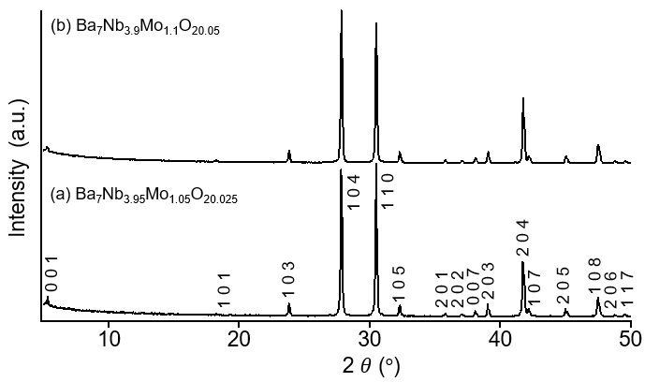

Supplementary Figure 1. X-ray powder diffraction patterns of (a) Ba₇Nb_{3.95}Mo_{1.05}O_{20.025} and (b) Ba₇Nb_{3.9}Mo_{1.1}O_{20.05}. hkl denotes the reflection index of the trigonal phase with the $P\overline{3}m1$ hexagonal perovskite related structure.¹ For both compositions, the 001 reflection is observed, which is a signature of 7H hexagonal perovskite.

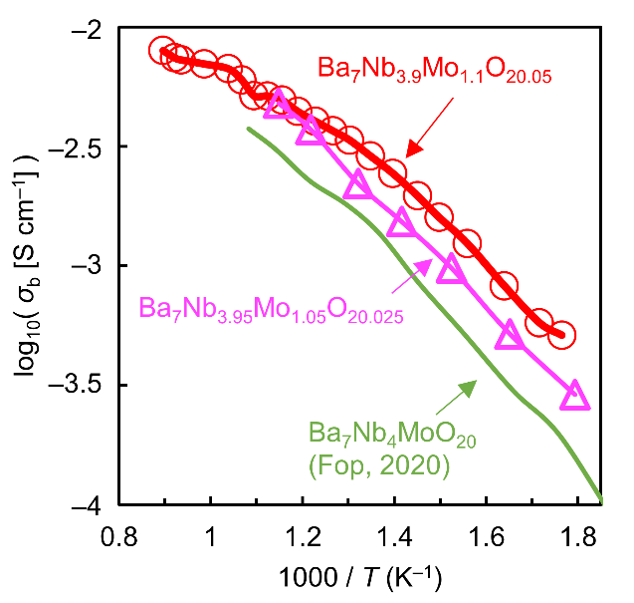
Supplementary Figure 2. Arrhenius plots of bulk conductivity σ_{b} of Ba₇Nb₄MoO₂₀ (reported by Fop et al. in 2020),² Ba₇Nb_{3.95}Mo_{1.05}O_{20.025}, and Ba₇Nb_{3.9}Mo_{1.1}O_{20.05}. Impedance analysis of Ba₇Nb_{3.9}Mo_{1.1}O_{20.05} is shown in Figure 1a,b. Impedance analysis of Ba₇Nb_{3.95}Mo_{1.05}O_{20.025} is shown in Supplementary Figure 6.
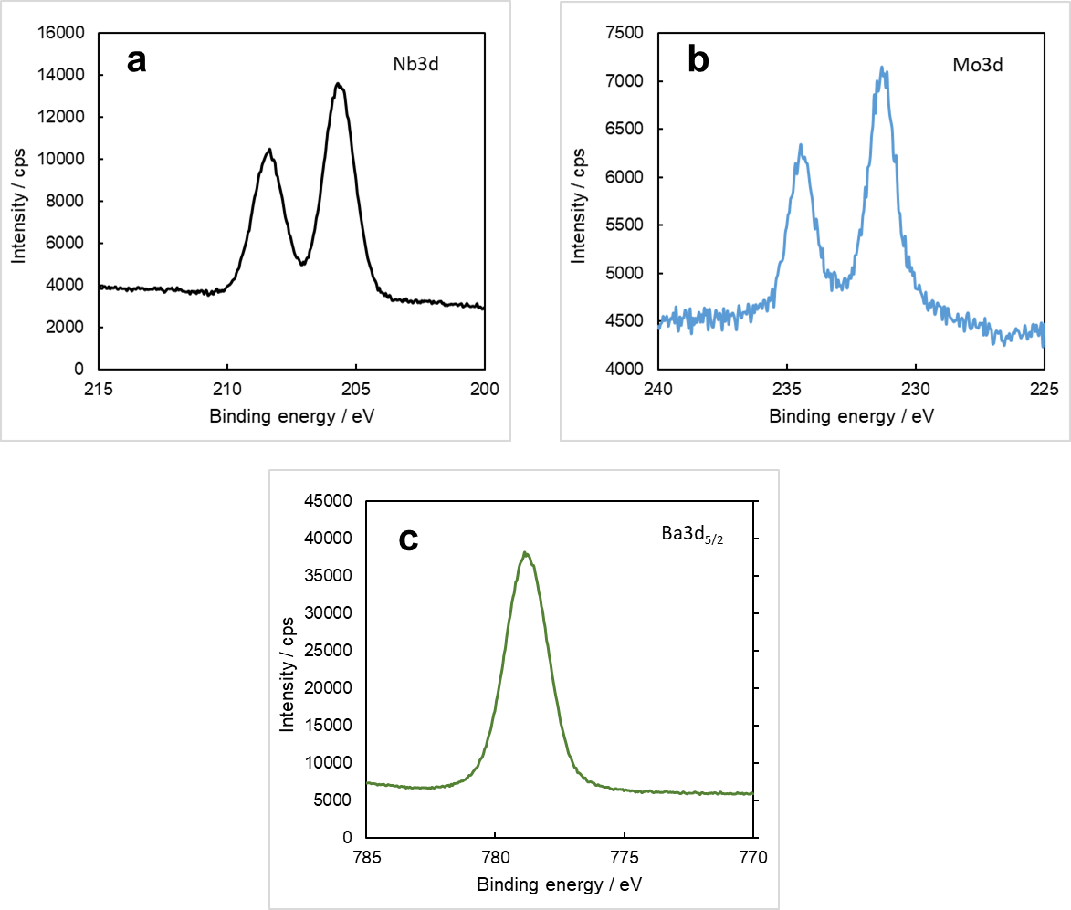

Supplementary Figure 3. XPS spectra of (a) Nb 3d, (b) Mo 3d and (c) Ba 3d in Ba₇Nb_{3.9}Mo_{1.1}O_{20.05}. Two peaks at 205.7 and 208.4 eV in (a) represent the Nb⁵⁺ 3d_{5/2} and Nb⁵⁺ 3d_{3/2} components, respectively. Two peaks at 231.3 and 234.5 eV in (b) indicate the Mo⁶⁺ 3d_{5/2} and Mo⁶⁺ 3d_{3/2} components, respectively. The peak at 778.8 eV in (c) represents the Ba²⁺ 3d_{5/2} component. Literature³⁻¹⁰ was referred to for the peak identification.

Supplementary Figure 4. Thermogravimetric data of a Ba₇Nb_{3.9}Mo_{1.1}O_{20.05} sample performed in dry air on (a) the 1st cycle and (b) the 2nd and 3rd cycles. Heating and cooling rates were 5 ºC min⁻¹. The small weight loss suggests small amounts of oxygen deficiency and/or water desorption. In this paper, we describe the composition as Ba₇Nb_{3.9}Mo_{1.1}O_{20.05} for simplicity. Smaller weight loss of Ba₇Nb_{3.9}Mo_{1.1}O_{20.05} than that of Ba₃MoNbO_{8.5–δ}¹¹ suggests the higher stability of Ba₇Nb_{3.9}Mo_{1.1}O_{20.05} at high temperatures.

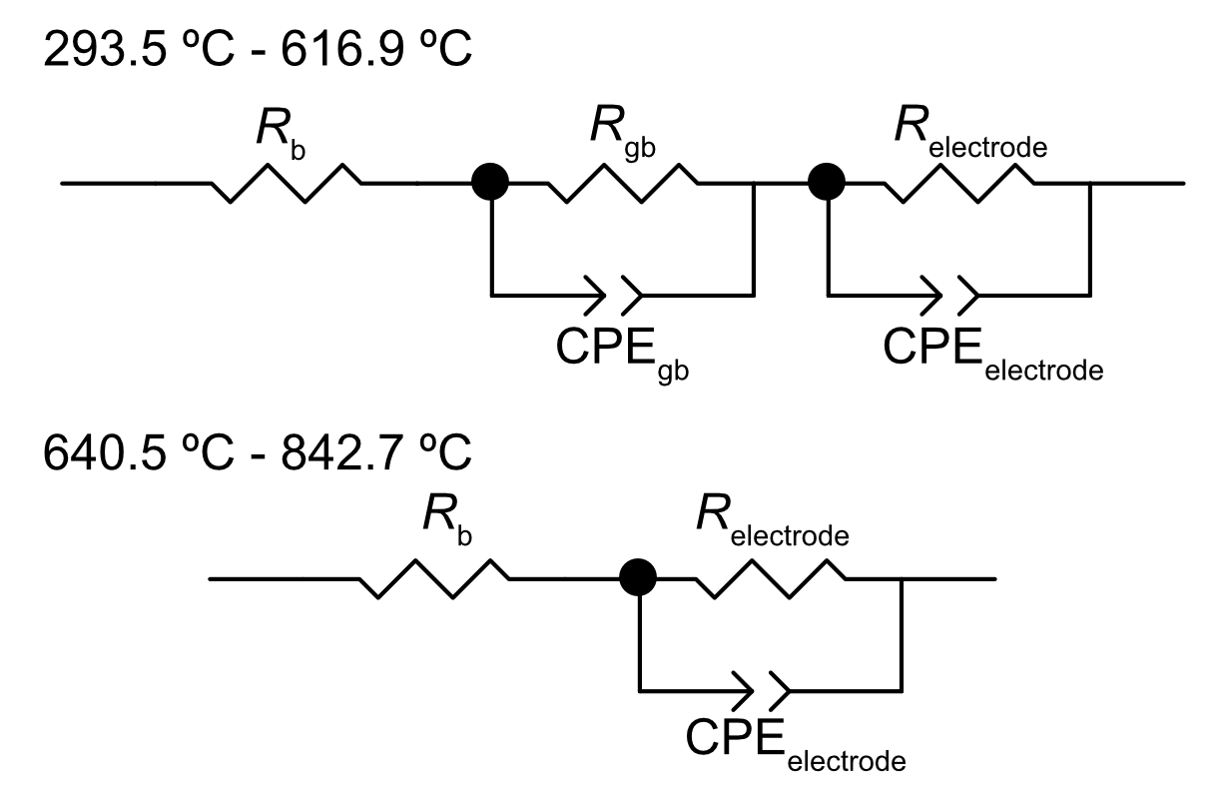

Supplementary Figure 5. Equivalent circuits used to model the impedance data of Ba₇Nb_{3.9}Mo_{1.1}O_{20.05}. R and CPE denote a resistor and a constant phase element, respectively, where the subscripts b and gb stand for the bulk and grain boundary, respectively. The fitting for the data of Ba₇Nb_{3.9}Mo_{1.1}O_{20.05} at 616.9 ºC gave the values of σ_{b} = 5.1×10^{–3} S cm^{–1}, σ_{gb} = 1.5×10^{–2} S cm^{–1}，and C_{gb} ≃ 1.1 nF cm^{–1}. ﻿With increasing temperature, the magnitudes of the grain boundary conductivity increase more rapidly than those of bulk conductivity. These results suggest that the grain boundary is more conductive than the grains above 630 ºC. ﻿Therefore, the intercept on the Z′ axis can be treated as the bulk resistivity, because R_{gb} is much less than R_{b} and R_{gb} + R_{b} ≈ R_{b}.¹²
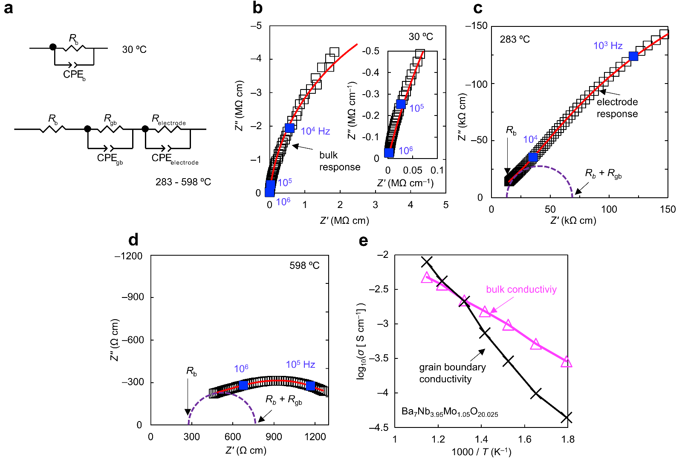

Supplementary Figure 6. Impedance analysis of Ba₇Nb_{3.95}Mo_{1.05}O_{20.025}. (a) Equivalent circuits for data analysis. (b-d) Complex impedance plots of Ba₇Nb_{3.95}Mo_{1.05}O_{20.025} measured at (b) 30, (c) 283, and (d) 598 ºC. (e) Arrhenius plots of bulk (pink) and grain-boundary (black) conductivities of Ba₇Nb_{3.95}Mo_{1.05}O_{20.025}.

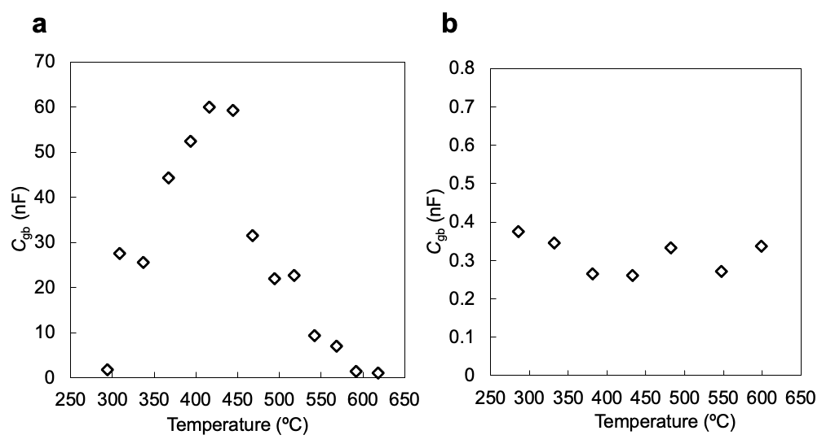
Supplementary Figure 7. Temperature dependencies of the grain-boundary capacitance C_{gb} of (a) Ba₇Nb_{3.9}Mo_{1.1}O_{20.05} and (b) Ba₇Nb_{3.95}Mo_{1.05}O_{20.025}.

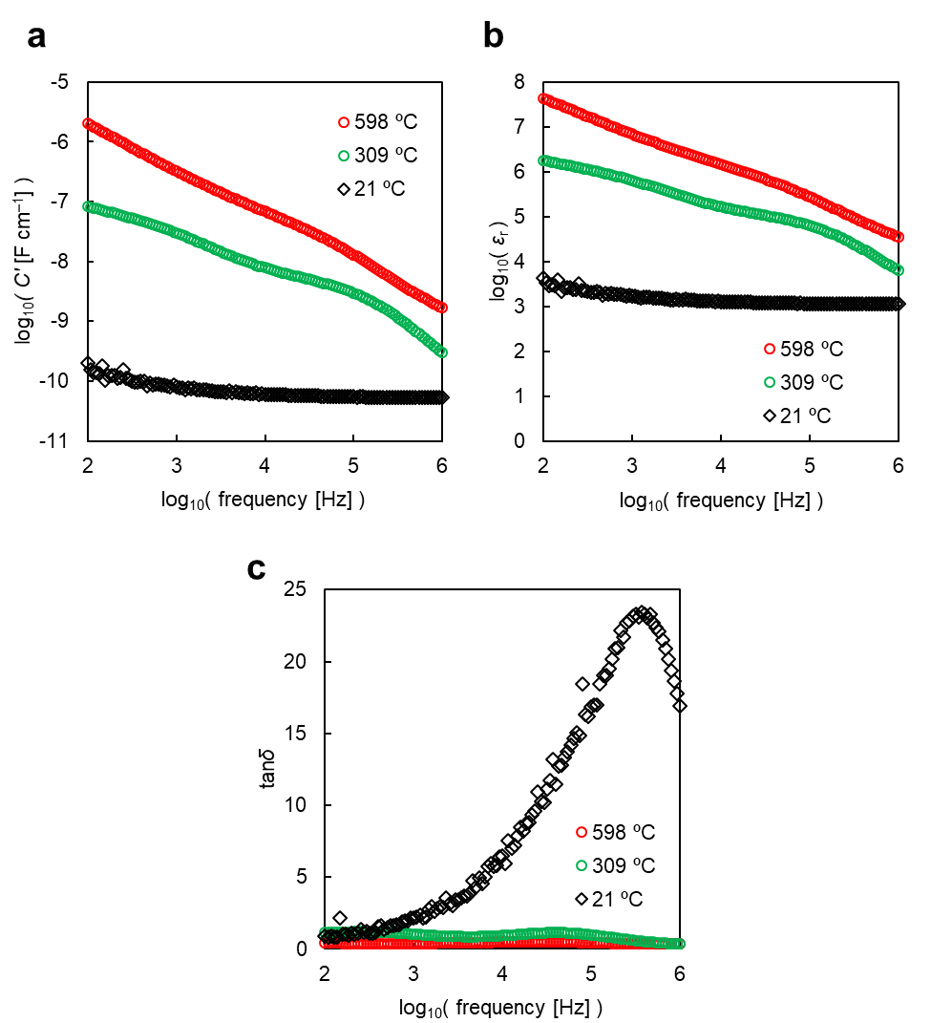

Supplementary Figure 8. Frequency dependencies of (a) capacitance C', (b) dielectric constant (relative permittivity) ε_{r}, and loss tangent tanδ of Ba₇Nb_{3.9}Mo_{1.1}O_{20.05}.
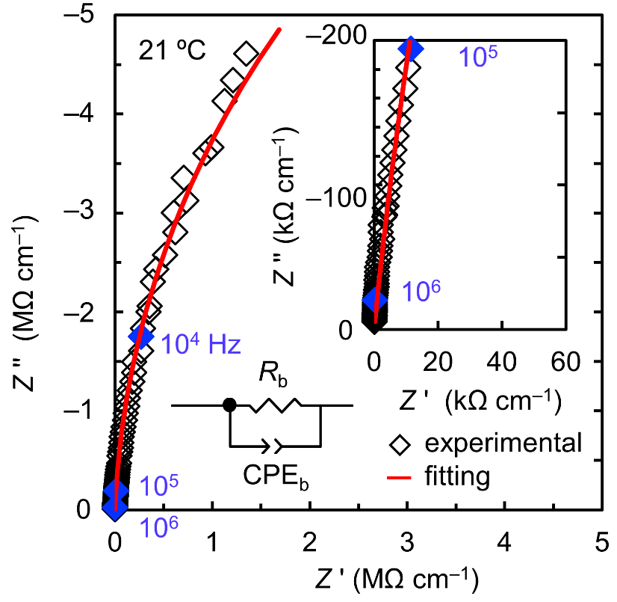

Supplementary Figure 9. Bulk conductivity of Ba₇Nb_{3.9}Mo_{1.1}O_{20.05} at 21 ºC. Complex impedance plot of Ba₇Nb_{3.9}Mo_{1.1}O_{20.05} recorded in dry air at 21 ºC. The fitting for the data of Ba₇Nb_{3.9}Mo_{1.1}O_{20.05} gave σ_{b} = 6.32(19)×10^{–8} S cm^{–1} and C_{b} ≃ 10.2(3) pF cm^{–1}.

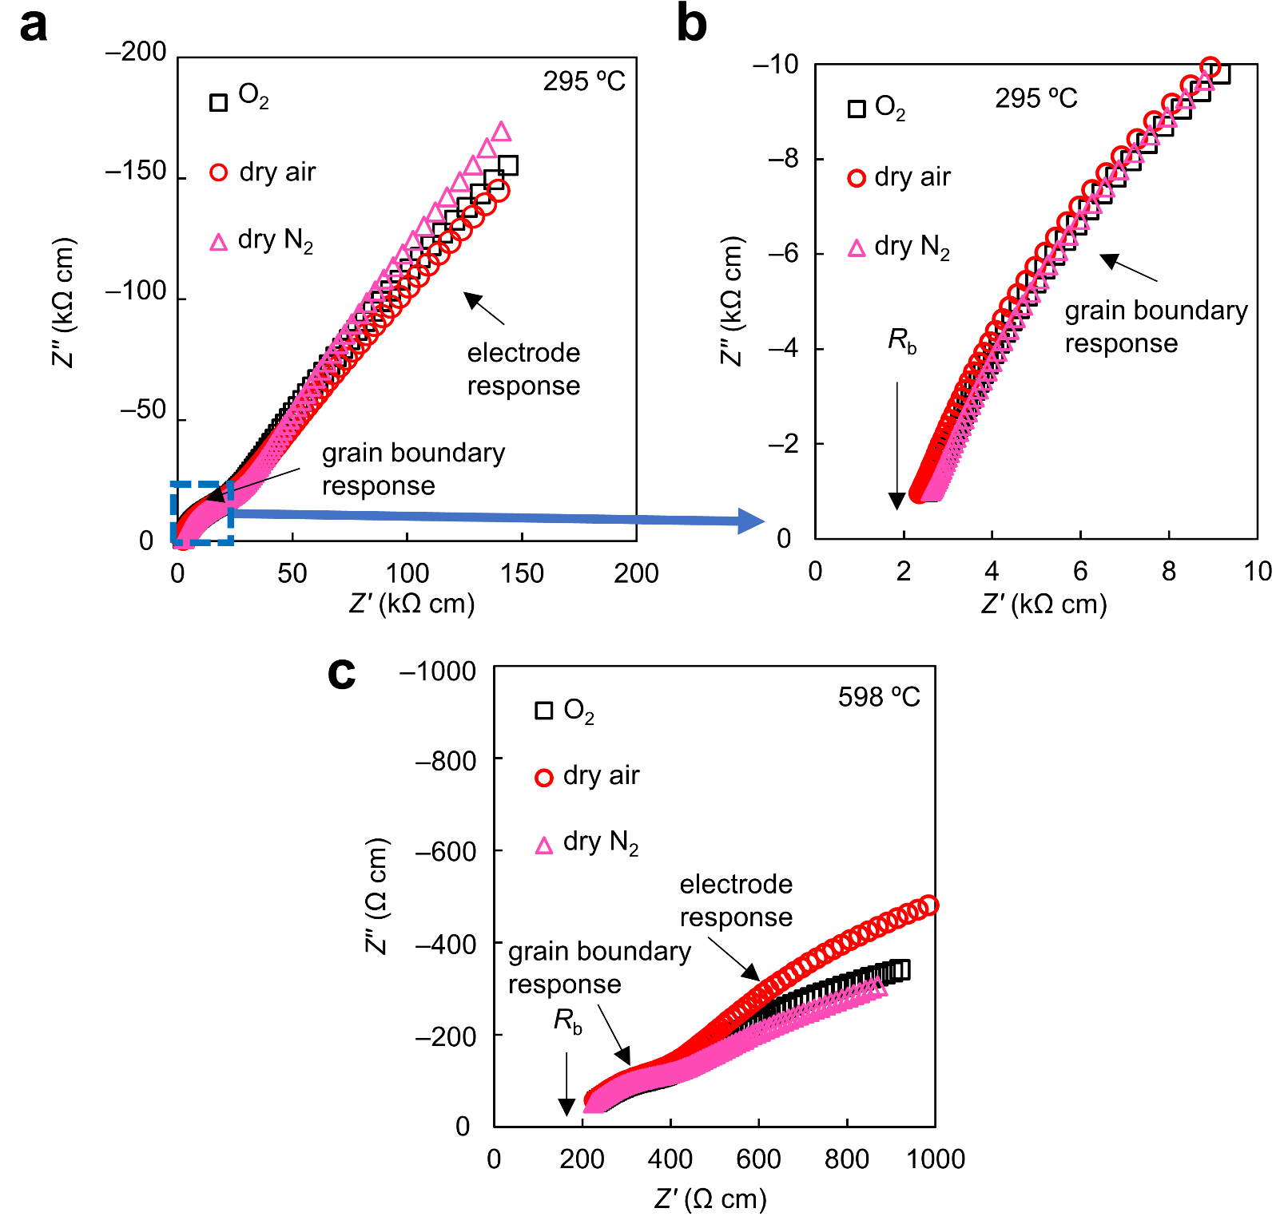
Supplementary Figure. 10 ﻿Complex impedance plane plots of Ba₇Nb_{3.9}Mo_{1.1}O_{20.05} recorded under different atmospheres. (a) Complex impedance plots at 295 ºC, (b) expanded scale for the high frequency data, and (c) Complex impedance plots at 598 ºC under O₂, dry air, and N₂ flowing.

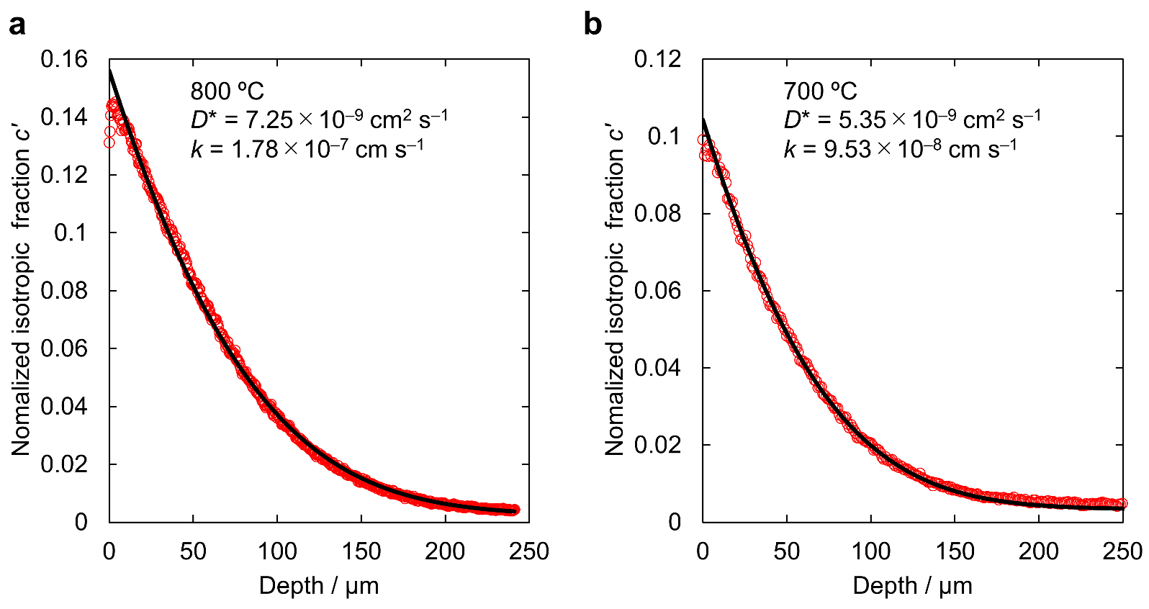
Supplementary Figure 11. ﻿¹⁸O tracer diffusion profiles for Ba₇Nb_{3.9}Mo_{1.1}O_{20.05}. Profiles after the exchanges at (a) 800ºC and (b) 700 ºC for ≃ 7200 s with p(¹⁸O₂) ≃ 179 mbar. Red circles denote experimental data. Black lines denote the lines of best fit.

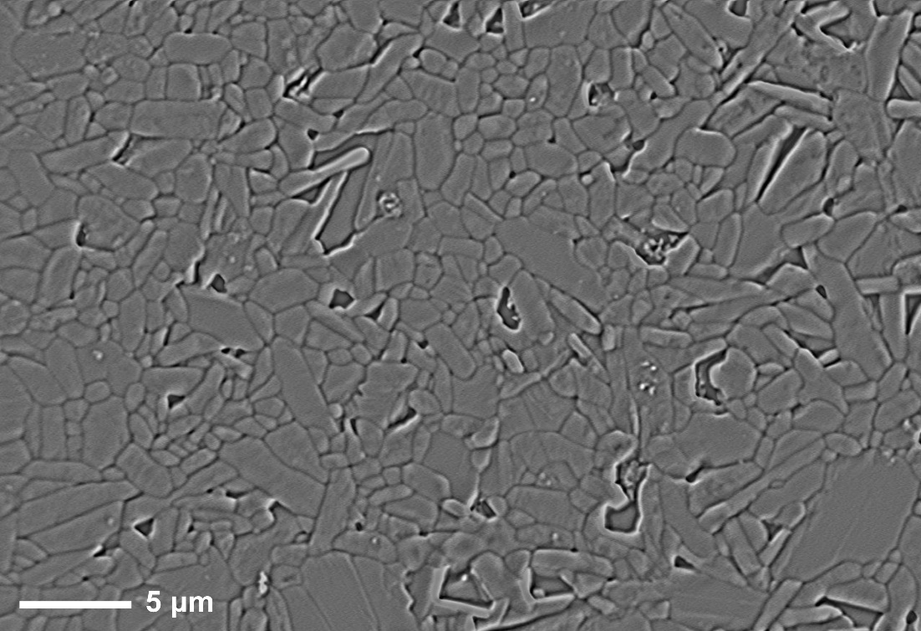
Supplementary Figure 12. ﻿ SEM micrograph of Ba₇Nb_{3.9}Mo_{1.1}O_{20.05} used in the ¹⁸O tracer diffusion experiment. The sample was polished and thermally etched at 1150 ºC for 2 h prior to the SEM observation.
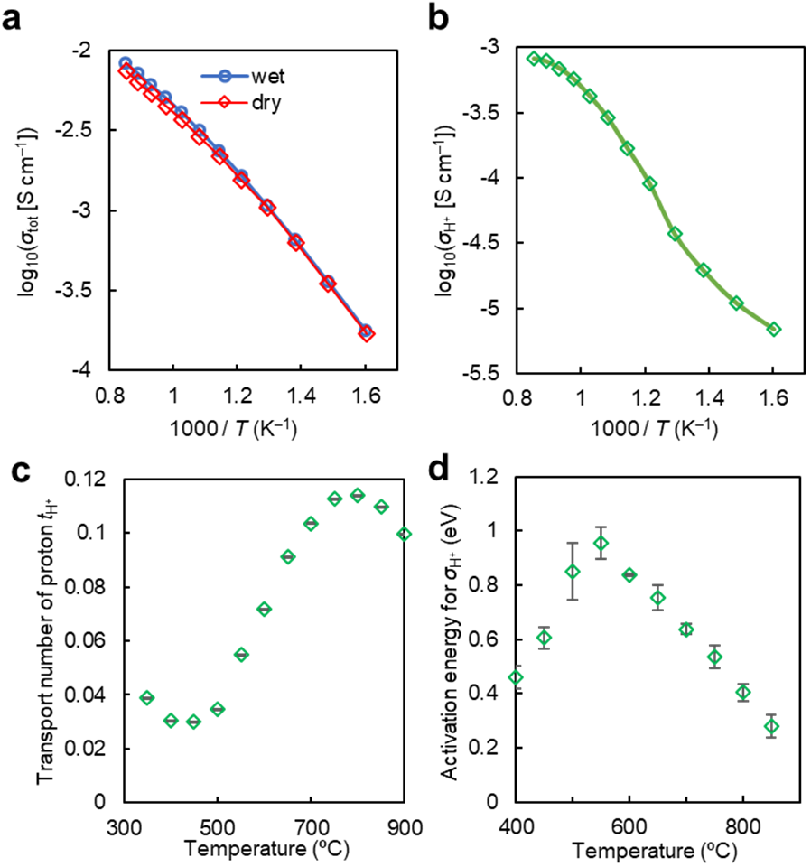

Supplementary Figure 13. Proton conduction of Ba₇Nb_{3.9}Mo_{1.1}O_{20.05} in wet air. (a) Arrhenius plots of total DC electrical conductivities of Ba₇Nb_{3.9}Mo_{1.1}O_{20.05} in dry air σ_{dry} (p(H₂O) < 2 × 10^{–4} atm; red line and diamonds) and in wet air σ_{wet} (p(H₂O) = 2.3 × 10^{–2} atm; blue line and circles). (b) Arrhenius plot of proton conductivity σ_{H⁺} of Ba₇Nb_{3.9}Mo_{1.1}O_{20.05} in wet air. Here the σ_{H⁺} was estimated using the equation σ_{H⁺} = σ_{wet} – σ_{dry}. (c) Transport number of proton t_{H⁺} for Ba₇Nb_{3.9}Mo_{1.1}O_{20.05}, which was estimated using the equation t_{H⁺} = σ_{H⁺} / σ_{wet}. The t_{H⁺} increases with temperature from 450 to 800 ºC. (d) Activation energy for σ_{H⁺} of Ba₇Nb_{3.9}Mo_{1.1}O_{20.05}, which increases between 400 and 550 ºC, while decreases with an increase of temperature between 550 and 850 ºC. Strictly speaking, Ba₇Nb_{3.9}Mo_{1.1}O_{20.05} is a mixed oxide-ion and proton conductor. Since the proton transport number is small (less than 12%; Supplementary Fig. 7c), the oxide ion is the dominant carrier and Ba₇Nb_{3.9}Mo_{1.1}O_{20.05} is an oxide-ion conductor. The proton conduction was confirmed also in the bulk and grain boundary conductivities. Error bars in panels (c) and (d) are the estimated standard deviations.
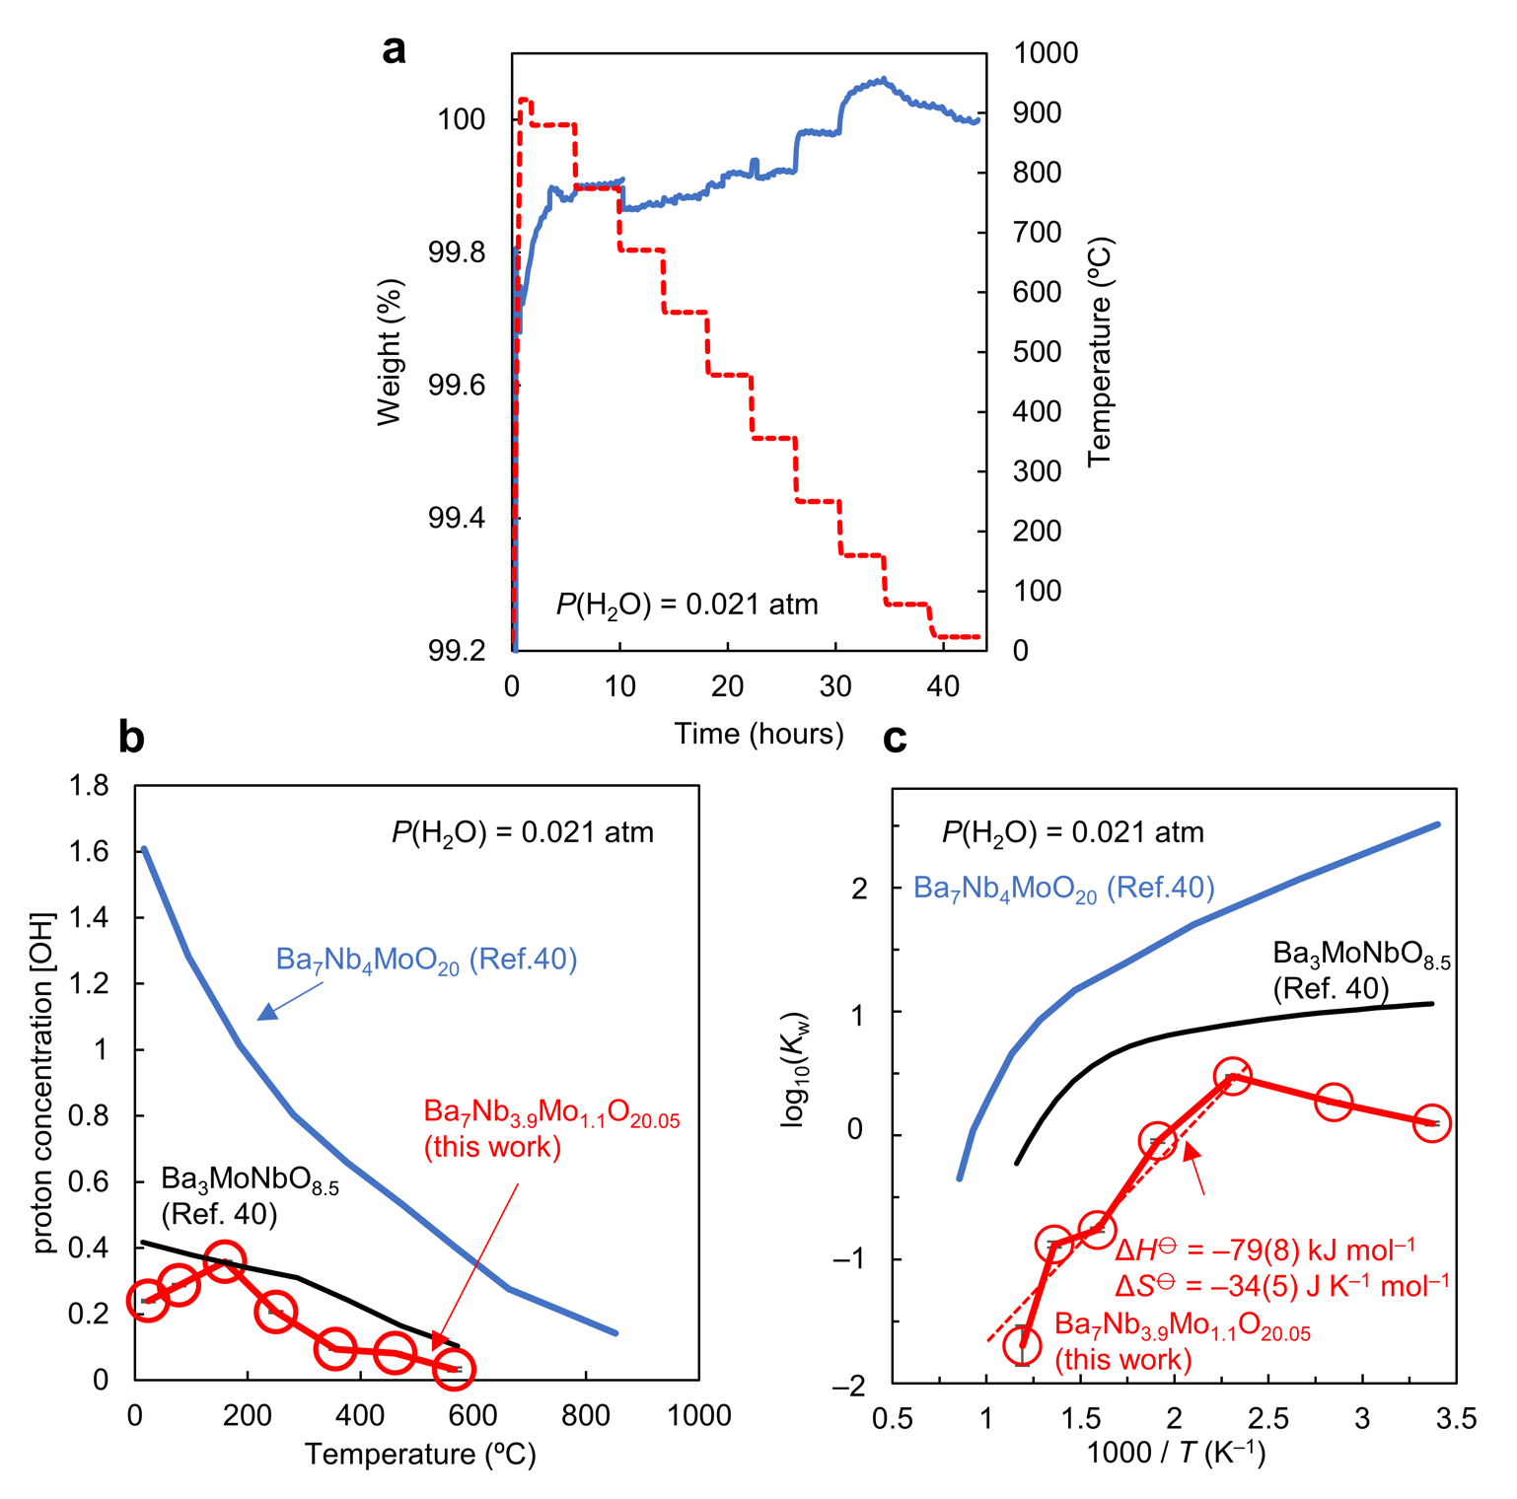
Supplementary Figure 14. Water incorporation of Ba₇Nb_{3.9}Mo_{1.1}O_{20.05}. (a) Weight change of Ba₇Nb_{3.9}Mo_{1.1}O_{20.05}・y H₂O and temperature as a function of time in wet air (P(H₂O) = 0.021 atm). (b) The proton concentration [OH] in Ba₇Nb_{3.9}Mo_{1.1}O_{20.05}・y H₂O was calculated from thermogravimetric analysis assuming that the weight gain was ascribed to the incorporation of water. The incorporated water amount, y, was ≃ 0.12 at room temperature. The data for Ba₇Nb₄MoO₂₀ and Ba₃MoNbO_{8.5} were obtained from Fop et al.² (c) The calculated equilibrium constant K_{w} for the water incorporation reaction. Derivation and definition of K_{w} are discussed in Supplementary Note 2.
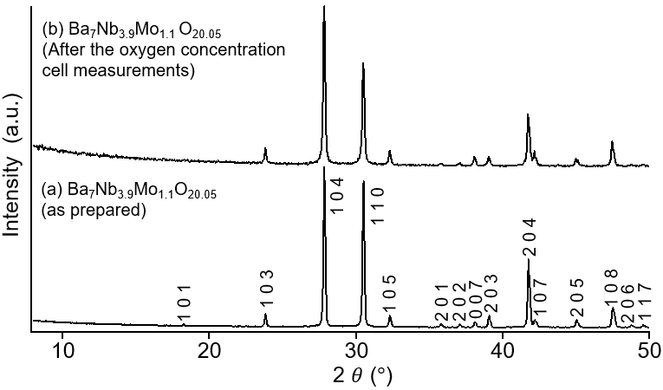

Supplementary Figure 15. X-ray powder diffraction (XRD) patterns of (a) as prepared sample of Ba₇Nb_{3.9}Mo_{1.1}O_{20.05}, and (b) Ba₇Nb_{3.9}Mo_{1.1}O_{20.05} sample after the oxygen concentration cell measurements (5% H₂ in N₂/air and O₂/air). Both XRD patterns are similar, which indicates the high phase stability of Ba₇Nb_{3.9}Mo_{1.1}O_{20.05}. The measured P(O₂) of 5% H₂ in N₂ was 1.2 × 10⁻²⁷ atm, thus, Ba₇Nb_{3.9}Mo_{1.1}O_{20.05} exhibits high phase stability in the wide P(O₂) region between P(O₂) = 1.2 × 10⁻²⁷ and 1 atm.

Supplementary Table 1. Refined Crystallographic Parameters and Reliability Factors in the Rietveld Analysis of the Neutron Diffraction Data of Ba₇Nb_{3.9}Mo_{1.1}O_{20.05} Measured at 800 ºC.
site s  atom label | atom X | site¶ | x | y | z | g(X; s) | U_{eq} or U_{iso}  / Å² | U₁₁ / Å² |  | U₂₂ / Å² | U₃₃ / Å² | U₁₂ / Å² | U₁₃ / Å² | U₂₃ / Å² | BVS
Ba1 | Ba | 1a | 0 | 0 | 0 | 1 | 0.0254(7) | 0.0267(9) |  | 0.0267(9) | 0.0228(17) | 0.0133(5) | 0 | 0 | 1.93
Ba2 | Ba | 2d | 1/3 | 2/3 | 0.82350(6) | 1 | 0.0197(2) |  |  |  |  |  |  |  | 2.04
Ba3 | Ba | 2d | 1/3 | 2/3 | 0.57329(8) | 1 | 0.0197(2) |  |  |  |  |  |  |  | 2.17
Ba4 | Ba | 2c | 0 | 0 | 0.28211(8) | 1 | 0.0197(2) |  |  |  |  |  |  |  | 1.76
Mo/Nb1 | Nb_{0.78}Mo_{0.22} | 1b | 0 | 0 | 1/2 | 1 | 0.01310(13) |  |  |  |  |  |  |  | 4.33
Mo/Nb2 | Nb_{0.78}Mo_{0.22} | 2d | 1/3 | 2/3 | 0.09369(5) | 1 | 0.01310(13) |  |  |  |  |  |  |  | 5.51
Mo/Nb3 | Nb_{0.78}Mo_{0.22} | 2d | 1/3 | 2/3 | 0.34940(5) | 1 | 0.01310(13) |  |  |  |  |  |  |  | 4.57
O1 | O | 6i | 0.3616 (5) | 0.7232(11) | –0.01132(7) | 0.3152(7) | 0.0548(13) |  |  |  |  |  |  |  | 1.89
O2 | O | 6i | 0.16848(16) | –0.16848(16) | 0.12997(5) | 1 | 0.0541(3) | 0.0534(5) |  | 0.0534(5) | 0.0554(6) | 0.0407(5) | –0.0003(3) | 0.0003(3) | 1.99
O3 | O | 6i | 0.16328(12) | –0.16358(17) | 0.43177(4) | 1 | 0.0234(3) | 0.0230(4) |  | 0.0230(4) | 0.0243(5) | 0.0127(4) | 0.0038(3) | –0.0038(3) | 1.78
O4 | O | 6i | 0.49295(10) | –0.49295(10) | 0.29512(4) | 1 | 0.0326(3) | 0.0300(4) |  | 0.0300(4) | 0.0376(5) | 0.0225(5) | 0.00445(19) | –0.00445(19) | 1.99
O5 | O | 3e | 1/2 | 0 | 0 | 0.0530(14) | 0.0548(13) |  |  |  |  |  |  |  | 1.08

*Crystal system: trigonal. Space group: P$\overline{3}$m1 (No.164, setting 1). Lattice parameters: a = 5.930754(2) Å, c = 16.70229(16) Å. Number of formula per unit cell: Z = 1. g(X; s): Occupancy factor of X atom at the s site. g(Ba; Ba1) = g(Ba; Ba2) = g(Ba; Ba3) = g(Ba; Ba4) = g(Nb_{0.78}Mo_{0.22}; Mo/Nb1) = g(Nb_{0.78}Mo_{0.22}; Mo/Nb2) = g(Nb_{0.78}Mo_{0.22}; Mo/Nb3) = g(O; O2) = g(O; O3) = g(O; O4) = 1; 2g(O1) + 3g(O5) = 2.05. ¶Wyckoff Position.
U_{iso}(Xn) Isotropic atomic displacement parameter of X atom at the Xn site. Linear constraints in the Rietveld analysis: U_{iso}(Ba2) = U_{iso}(Ba3) = U_{iso}(Ba4), U_{iso}(Mo/Nb1) = U_{iso}(Mo/Nb2) = U_{iso}(Mo/Nb3), U_{iso}(O1) = U_{iso}(O5).

Reliability (R) factors for the neutron diffraction data taken with both backscattering and 90º banks: weighted profile R factor R_{wp} = 2.26%. R factors for the neutron diffraction data taken with backscatterng bank: R_{wp} = 2.39%, profile R factor R_{p} = 1.70%, R factor based on the Bragg intensities R_{B} = 4.44%, R factor based on the structure factors R_{F} = 5.14%. Reliability factors for the neutron diffraction data taken with 90º bank: R_{wp} = 2.11%, R_{p} = 1.64%, R_{B} = 2.12%, R_{F} = 2.04%.
** BVS: Bond valence sums. Here the bond valence parameters after Gagné and Hawthorne¹³ were used for the calculations of BVSs.
Supplementary Note 1. Structure Similarity and Bond-Valence-Based Energy Barrier for Oxide-Ion Migration of Ba₇Nb₄MoO₂₀ and Ba₃MoNbO_{8.5–δ}
Energy barrier for oxide-ion migration of Ba₇Nb₄MoO₂₀ and Ba₃MoNbO_{8.5–δ} were estimated using the bond-valence-based energy landscapes (BVELs) calculated for the crystallographic data in the literature. The BVELs were calculated with SoftBV program¹⁴ and then the energy barrier for oxide-ion migration E_{b} was estimated from each BVEL. The E_{b} value of Ba₇Nb₄MoO₂₀, 0.21 eV, was lower than those of Ba₃MoNbO_{8.5–δ} (0.40, 0.35 and 0.33 eV using the crystallographic data reported by Yashima et al.,¹¹ Fop et al.¹⁵ and Auckett et al.,¹⁶ respectively).

Supplementary Note 2. The equilibrium constant for water incorporation reaction, K_{w}.
Similar to Fop’s report,² the equilibrium constant for the water incorporation reaction K_{w} was calculated using extended Kröger-Vink notation.¹⁷ It is assumed that hydration of Ba₇Nb_{3.9}Mo_{1.1}O_{20.05} occurs on two Ba2(O2)₃ layers and an oxide-ion conducting
Ba1(O1)_{2–x}O5_{0.05+x} layer, called the palmierite-like layer in Fop’s report.² Chemical composition of palmierite-like layers can be written Ba₃O_{8.05}□_{0.95} in Ba₇Nb_{3.9}Mo_{1.1}O_{20.05}, where □ is an inherent oxygen vacancy. By extended Kröger-Vink notation, the oxide ion and its effective charge can be written as $O_{O_{\frac{8.05}{9}}}^{\frac{1.95}{9} '}$. Therefore, the reaction of water incorporation is written as:
$H_{2}O(g)+O_{O_{\frac{8.05}{9}}}^{\frac{1.95}{9} '}+V_{O_{\frac{8.05}{9}}}^{\frac{16.1}{9}●}⇌2{OH}_{O_{\frac{8.05}{9}}}^{\frac{7.1}{9}●}$.
With electroneutrality and site occupancy conditions,² finally, equilibrium constant in terms of proton concentration [OH] is:
$K_{w}=\frac{4{\left[{OH}_{O_{\frac{8.05}{9}}}^{\frac{7.1}{9}●}\right]}^{2}}{p\left(H_{2}O\right)\left({\left[{OH}_{O_{\frac{8.05}{9}}}^{\frac{7.1}{9}●}\right]}^{2}–18\left[{OH}_{O_{\frac{8.05}{9}}}^{\frac{7.1}{9}●}\right]+31.9525\right)}$.
The regression line applied to the water incorporation data was used to estimate the standard hydration enthalpy (ΔH⦵) and entropy (ΔS⦵)¹⁸ according to the Van’t Hoff relation
$$RT\ln{K_{w}}=T∆S^{⦵} – ∆H^{⦵}$$
where R and T are the gas constant and absolute temperature, respectively.

Supplementary References
- García-González, E., Parras, M., & González-Calbet, J. M. Crystal structure of an unusual polytype: 7H-Ba₇Nb₄MoO₂₀. Chem. Mater. 11(2), 433-437 (1999).
- Fop, S. et al. High oxide ion and proton conductivity in a disordered hexagonal perovskite. Nat. Mater., 19, 752-757 (2020).
- Choi, J.-G., Thompson, L.T.. XPS study of as-prepared and reduced molybdenum oxides. Applied Surface Science 93, 143-149 (1996).
- Kuepper, K., Balasz, I., Hesse, H., Winiarski, A., Prince, K. C., Matteucci, M., Wett, D., Szargan, R., Burzo, E., Neumann, M. Electronic and magnetic properties of highly ordered Sr₂FeMoO₆. Physica Status Solidi (a), 201, 3252-3256 (2004).
- Fleisch, T. H., Mains, G. J. An XPS study of the UV reduction and photochromism of MoO₃ and WO₃. The Journal of Chemical Physics, 76, 780-786 (1982).
- Ozer, N., Rubin, M. D., Lampert, C. M. Optical and electrochemical characteristics of niobium oxide films prepared by sol-gel process and magnetron sputtering. A comparison.. Solar Energy Materials and Solar Cells 40, 285-296 (1996).
- Morris, D., Dou, Y., Rebane, J., Mitchell, C. E. J., Egdell, R. G., Law, D. S. L., et al. Photoemission and STM study of the electronic structure of Nb-doped TiO₂. Physical Review B, 61, 13445 (2000).
- Courths, R., Höchst, H., Steiner, P., Hüfner, S. X-ray and UV photoemission from defects in LiNbO₃ and BaTiO₃ surfaces. Ferroelectrics, 26, 745-748 (1980).
- Du, Y.; Kim, D. J.; Varga, T.; Wang, Z.; Szanyi, J.; Lyubinetsky, I. Formation of Single-Phase BaO Nanoclusters. Thin Solid Films, 519 (16), 5335–5338 (2011).
- Tsami, A.; Grillo, F.; Bowker, M.; Nix, R. M. Model NSR Catalysts: Fabrication and Reactivity of Barium Oxide Layers on Cu(1 1 1). Surf. Sci., 600 (17), 3403–3418 (2006).
- Yashima, M., Tsujiguchi, T., Fujii, K., Niwa, E., Nishioka, S., Hester, J. R., & Maeda, K. (2019). Direct evidence for two-dimensional oxide-ion diffusion in the hexagonal perovskite-related oxide Ba₃MoNbO_{8.5− δ}. J. Mater. Chem. A 7, 13910-13916 (2019).
- Kuang, X., Allix, M., Ibberson, R.M., Claridge, J.B., Niu, H., Rosseinsky, M.J. Oxygen vacancy ordering phenomena in the mixed-conducting hexagonal perovskite Ba₇Y₂Mn₃Ti₂O₂₀. Chem. Mater. 19, 2884-2893 (2007).
- Gagné, O. C., & Hawthorne, F. C. Comprehensive derivation of bond-valence parameters for ion pairs involving oxygen. Acta Crystallographica Section B: Structural Science, Crystal Engineering and Materials, 71(5), 562-578 (2015).
- Chen, H., Wong, L. L. & Adams, S. SoftBV – a software tool for screening the materials genome of inorganic fast ion conductors. Acta Crystallogr. Sect. B Struct. Sci. Cryst. Eng. Mater. 75, 18–33 (2019).
- Fop, S.; Skakle, J. M. S.; McLaughlin, A. C.; Connor, P. A.; Irvine, J. T. S.; Smith, R. I.; Wildman, E. J. Oxide Ion Conductivity in the Hexagonal Perovskite Derivative Ba₃MoNbO_{8.5}. J. Am. Chem. Soc. 138, 16764–16769 (2016).
- Auckett, J. E., Milton, K. L., Evans, I. R. Cation Distributions and Anion Disorder in Ba₃MNbO_{8.5} (M = Mo, W) Materials: Implications for Oxide Ion Conductivity. Chem. Mater., 31, 1715-1719 (2019).
- Norby, T. A Kröger-Vink Compatible Notation for Defects in Inherently Defective Sublattices. J. Korean Ceram. Soc. 47, 19–25 (2010).
- Quarez, E., Noirault, S., Caldes, M. T. & Joubert, O. Water incorporation and proton conductivity in titanium substituted barium indate. J. Power Sources 195, 1136–1141 (2010).

