Supplementary figures and tables

Supplementary Table 1. Participant characteristics regarding diabetes

Participant | Diabetes duration (years) | Diabetes medication
1 | 15 | Metformin 850mg, 3x/day  Gliclazide 80mg, 2x/day
2 | 14 | Metformin 500mg, 2x/day
3 | 15 | Metformin 1000mg, 2x/day  Gliclazide 30mg, 2x/day
4 | 6 | Metformin 1000mg, 3x/day
5 | 8 | Metformin 850mg 1x/day  Glimepiride 2mg, 1x/day  Liraglutide 6mg, 18eh, 1x/day
6 | 5 | Metformin 850mg, 2x/day
7 | 9 | Metformin 500mg, 2x/day
8 | 7 | Metformin 500mg, 3x/day  Gliclazide 30mg, 1x/day
9 | 1 | Gliclazide 80mg, 1x/day

Supplementary Table 2. Nutritional information of meal test shake

 | Content | Energy %
Energy | 755 kcal | 100
Fat | 50.8 gr | 60.6
Saturated fat | 26.1 gr | 31.1
Unsaturated fat | 23.8 gr | 28.4
Cholesterol | 0.9 gr | 1.1
Carbohydrate | 62.3 gr | 33.0
Protein | 10.9 gr | 5.8

Supplementary Table 3. Plasma levels and substrate kinetics measured during the hyperinsulinemic euglycemic clamps

 | HE-clamp before | HE-clamp after | HE-clamp  long term | p-value
Plasma Glucose (mmol l⁻¹)
Baseline | 7.77 ± 0.54 | 7.98 ± 0.45 | 7.91 ± 0.54 | 0.99
Low insulin | 5.99 ± 0.25 | 5.78 ± 0.31 | 5.63 ± 0.17 | 0.21
High insulin | 5.21 ± 0.12 | 5.11 ± 0.11 | 5.04 ± 0.08 | 0.69
Plasma Insulin (mU l⁻¹)
Baseline | 6.32 ± 1.992 | 6.99 ± 1.48 | 6.56 ± 1.71 | 0.69
Low insulin | 14.09 ± 1.87 | 12.64 ± 1.56 | 12.62 ± 0.88 | 0.57
High insulin | 62.50 ± 3.24^{C} | 59.34 ± 4.13 | 56.03 ± 2.68^{C} | 0.02*
Energy expenditure (kJ min⁻¹)
Baseline | 4.82 ± 0.25 | 4.91 ± 0.27 | 4.86 ± 0.20 | 0.79
Low insulin | 4.86 ± 0.34 | 4.92 ± 0.28 | 4.75 ± 0.24 | 0.24
High insulin | 4.67 ± 0.30^{B} | 4.89 ± 0.27^{B,D} | 4.67 ± 0.18^{D} | 0.02*
Carbohydrate oxidation
(μmol kg⁻¹ min⁻¹)
Baseline | 3.76 ± 0.47^{A} | 4.97 ± 0.68^{A} | 4.68 ± 0.68 | <0.01**
Low insulin | 7.27 ± 0.79 | 7.83 ± 0.84 | 7.15 ± 0.77 | 0.79
High insulin | 10.36 ± 1.15 | 11.07 ± 1.21 | 9.73 ± 1.41 | 0.30
Fatty acid oxidation
(μmol kg⁻¹ min⁻¹)
Baseline | 3.80 ± 0.17^{A} | 3.57 ± 0.17^{A,D} | 3.71 ± 0.19^{D} | <0.01**
Low insulin | 2.81 ± 0.23 | 2.86 ± 0.24 | 2.96 ± 0.16 | 0.87
High insulin | 2.14 ± 0.24 | 2.16 ± 0.21 | 2.39 ± 0.26 | 0.99
Abbreviations: HE-clamp, hyperinsulinemic euglycemic clamp; Ra, rate of appearance; Rd, rate of disappearance; S_{i}, whole body insulin sensitivity; EGP, endogenous glucose production; NOGD, non-oxidative glucose disposal; FFA, free fatty acids.
Data are expressed as mean ± SE. n=9. Data was analyzed with a two-sided Friedman test. **p<0.01, *p<0.05, ^{A}significant difference (p<0.01) between Clamp pre and Clamp post, ^{B}significant difference (p<0.05) between Clamp pre and Clamp post, ^{C}significant difference (p<0.05) between Clamp pre and Clamp post, ^{D}trend in difference (p<0.10) between Clamp post and Clamp longterm.

Supplementary Table 4. Plasma levels and substrate kinetics measured during the meal tests

 | Meal test  before | Meal test  after | p-value
Plasma Glucose¹
AUC | 4433 ± 236 | 4285 ± 170 | 0.43
iAUC | 860 ± 171 | 747 ± 159 | 0.25
Plasma Insulin¹
AUC | 15826 ± 1550 | 15640 ± 1458 | 0.65
iAUC | 9457 ± 1097 | 9060 ± 1119 | 0.36
Plasma Triglycerides¹
AUC | 1339 ± 109 | 1411 ± 123 | 0.50
iAUC | 655 ± 89 | 664 ± 67 | 0.36
Plasma Free fatty acids¹
AUC | 214852 ± 9104 | 202701 ± 10011 | 0.16
iAUC | 13182 ± 6077 | 23031 ± 7650 | 0.20
AUC first meal | 94228 ± 5115 | 86014 ± 4545 | 0.04*
AUC second meal | 120624 ± 5448 | 106486 ± 11976 | 0.30
Energy expenditure²
AUC | 2620 ± 145 | 2752 ± 168 | 0.03*
iAUC | 316 ± 37 | 355 ± 22 | 0.69
Carbohydrate oxidation²
AUC | 3328 ± 371 | 3866 ± 550 | 0.44
iAUC | 726 ± 152 | 998 ± 103 | 0.22
Fatty acid oxidation²
AUC | 1688 ± 92 | 1667 ± 78 | >0.99
iAUC | 611 ± 159 | 526 ± 63 | 0.94
Abbreviations: AUC, area under the curve; iAUC, incremental area under the curve.
Data are expressed as mean ± SE, ¹n=9 and ²n=7. Data was analyzed with a two-sided Mann-Whitney test. *p<0.05

Supplementary Table 5. Primer sequences

Gene | TaqMan AssayID
CHRNA1 | Hs00909664
CCDC39 | Hs00977326
MYH8 | Hs00267293
CCDC80 | Hs00277341
CHRND | Hs00897937
ACTC1 | Hs01109515
COL1A1 | Hs00164004
COL3A1 | Hs00943809
MYH3 | Hs01074230
THBS4 | Hs00170261
CHRNG | Hs00183228
SESN3 | Hs00914870
MYBPH | Hs00192226
IGFN1 | Hs01567410

Gene | Forward Sequence (5'-3') | Reverse Sequence (5'-3')
RPLPO | CCATTCTATCATCAACGGGTACAA | AGCAAGTGGGAAGGTGTAATCC

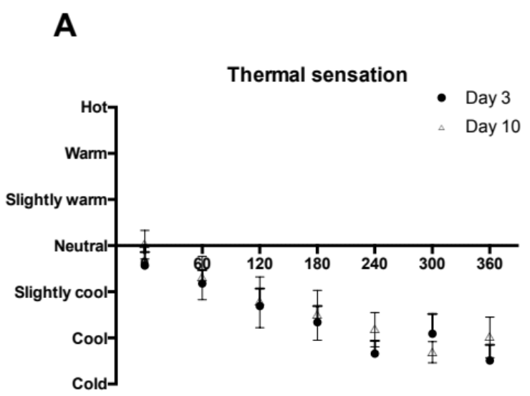
a

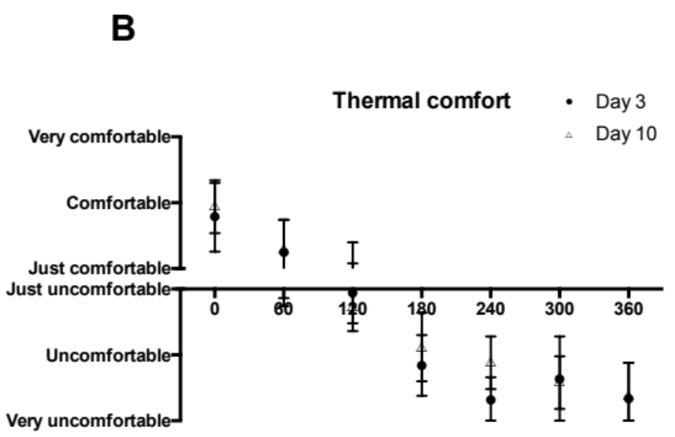
b

Supplementary Figure 1. Subjective responses to cold acclimation
a Self-reported thermal sensation and b thermal comfort measured with VAS scales at selected timepoints (from T=0 min until T=360 min) during day 3 and day 10 of the cold acclimation period, shown as AUC. Data are expressed as mean ± SE. n=9. Data was analyzed with a two-sided Wilcoxon matched-pairs signed rank test. No significant differences were observed (all p>0.05). Data

