Supplementary Information for "Formation of large low shear velocity provinces through the decomposition of oxidized mantle"
Wenzhong Wang^{1,2,*}, Jiachao Liu^{3,*}, Feng Zhu⁴, Mingming Li⁵, Susannah M. Dorfman³, Jie Li⁴, Zhongqing Wu^{1,6,7,*}
¹Laboratory of Seismology and Physics of Earth’s Interior, School of Earth and Space Sciences, University of Science and Technology of China, Hefei, China
²Department of Earth Sciences, University College London, London WC1E 6BT, United Kingdom
³Department of Earth and Environmental Sciences, Michigan State University, East Lansing, MI 48824, USA
⁴Department of Earth and Environmental Sciences, University of Michigan, Ann Arbor, MI 48109, USA
⁵School of Earth and Space Exploration, Arizona State University, Tempe, AZ 85287, USA
⁶National Geophysical Observatory at Mengcheng, University of Science and Technology of China, Hefei, China
⁷CAS Center for Excellence in Comparative Planetology, USTC, Hefei, Anhui 230026, China
*Correspondence should be addressed to Wenzhong Wang (wz30304@mail.ustc.edu.cn), Jiachao Liu (jiacliu09@gmail.com), and Zhongqing Wu (wuzq10@ustc.edu.cn)

Supplementary Notes
1. The fraction of low-spin B-site Fe³⁺ in (Mg_{0.5}Fe_{0.5})(Si_{0.5}Fe_{0.5})O₃ bridgmanite
The B-site Fe³⁺ in (Mg_{0.5}Fe_{0.5})(Al_{0.5}Fe_{0.5})O₃ Bdg undergoes a high-spin (HS) state to low-spin (LS) state transition with increasing pressure, while the A-site Fe³⁺ in both compositions maintain the HS state throughout the lower-mantle conditions¹. The molar Gibbs free energy for the mixed-spin (MS) state can be expressed as:
$G(P, T, n)=nG_{LS}(P, T)+(1-n)G_{HS}(P, T)+G^{mix}(P, T)$ (1)
where $n$ is the low-spin fraction, $G_{HS/LS}$ is the Gibbs free energy of pure HS/LS state, and $G^{mix}$ is the mixing Gibbs free energy. $P$ and $T$ are pressure and temperature, respectively. The Gibbs free energy for pure HS/LS state can be expressed as:
$G_{HS/LS}(P, T)=G_{HS/LS}^{stat+vib}(P, T)+G_{HS/LS}^{mag}(P, T)$ (2)
where $G_{HS/LS}^{stat+vib}$ is the part of Gibbs free energy that includes the internal energy and the vibrational contribution, and $G_{HS/LS}^{mag}$ is the magnetic contribution to Gibbs free energy.
The first term, $G_{HS/LS}^{stat+vib}$, is given by:
$G_{HS/LS}^{stat+vib}(V, T)=F_{HS/LS}(V, T)+PV$ (3)
where $F_{HS/LS}$ is the Helmholtz free energy of pure HS/LS state. Within the quasi-harmonic approximation (QHA), $F_{HS/LS}(V, T)$ can be expressed as:
$$F_{HS/LS}\left(V,T\right)=U_{HS/LS}\left(V\right)+\frac{1}{2}\sum_{q,m}{ℏω_{q,m}^{HS/LS}\left(V\right)}+k_{B}T\sum_{q,m}{ln⁡(1-exp⁡(-\frac{ℏω_{q,m}^{HS/LS}\left(V\right)}{k_{B}T}}))$$
(4)
where $U_{HS/LS}$ is the static energy at the equilibrium volume $V$, $ℏ$ and $k_{B}$ are Planck and Boltzmann constants, and $ω_{q,m}^{HS/LS}$ is the vibrational frequency of the i^{th} mode along the wave vector $q$. Thus, $G_{HS/LS}^{stat+vib}(V, T)$ can be calculated from the internal energy and vibrational density of state of pure HS/LS state
The second term, $G_{HS/LS}^{mag}$, is given by:
$G_{HS}^{mag}(V, T)=-xk_{B}Tln[m_{HS}(S_{HS}+1)×m_{HS}(S_{HS}+1)]$ (5)
$G_{LS}^{mag}(V, T)=-xk_{B}Tln[m_{HS}(S_{HS}+1)×m_{LS}(S_{LS}+1)]$ (6)
where $m_{HS/LS}$ and $S_{HS/LS}$ are the orbital degeneracy and total spin of Fe³⁺ in HS and LS state, respectively. $x$ is the Fe₂O₃ molar concentration. Thus, $G_{HS/LS}(V, T)$ can be calculated from $G_{HS/LS}^{stat+vib}(V, T)$ and $G_{HS/LS}^{mag}(V, T)$, and $G_{HS/LS}(P, T)$ can be converted from $G_{HS/LS}(V, T)$ using the equation of state.
The mixing Gibbs free energy, $G^{mix}(P, T)$, can be written as:
$G^{mix}(P, T)=k_{B}Tx[nln(n)+(1-n)ln(1-n)]$ (7)
By Minimizing the molar Gibbs free energy for MS state with respect to the LS fraction, the pressure- and temperature-dependent LS fraction can be expressed as:
$n(P, T)=\frac{1}{1+\frac{m_{HS}({2S}_{HS}+1)}{m_{LS}(2S_{LS}+1)}e^{\frac{{∆G}_{LS-HS}^{stat+vib}}{k_{B}Tx}}}$ (8)
where ${∆G}_{LS-HS}^{stat+vib}(P, T)$=$G_{LS}^{stat+vib}(P, T)-G_{HS}^{stat+vib}(P, T)$.
2. The elasticity of mixed-spin (Mg_{0.5}Fe_{0.5})(Si_{0.5}Fe_{0.5})O₃ bridgmanite
Similarly, the LS fraction under stress $σ$ can be calculated from the molar Gibbs free energy of pure HS/LS state under stress $σ$. Therefore, the LS fraction can be rewritten as:
$n(P, T, σ)=\frac{1}{1+\frac{m_{HS}({2S}_{HS}+1)}{m_{LS}(2S_{LS}+1)}e^{\frac{{∆G}_{LS-HS}^{stat+vib}}{k_{B}Tx}}}$ (9)
where ${∆G}_{LS-HS}^{stat+vib}(P, T, σ)$=$G_{LS}^{stat+vib}(P, T, σ)-G_{HS}^{stat+vib}(P, T, σ)$. The elastic compliance $S_{ij}$ of the mixed-spin (Mg_{0.5}Fe_{0.5})(Si_{0.5}Fe_{0.5})O₃ bridgmanite are given by:
$S_{ij}(P, T, σ)=-\frac{1}{V}\frac{∂^{2}G(P, T, σ)}{∂σ_{i}∂σ_{j}}$ (10)
Following Eq. (1), the derivative of $G(P, T, σ)$ with respect to $σ$ can be expressed as:
$\frac{∂G}{∂σ_{i}}=n\frac{∂G_{LS}}{∂σ_{i}}+(1-n)\frac{∂G_{HS}}{∂σ_{i}}+(G_{LS}-G_{HS})\frac{∂n}{∂σ_{i}}+\frac{∂G^{mix}}{∂σ_{i}}$ (11)
At equilibrium,
$\frac{∂G}{∂n}=[(G_{LS}-G_{HS})\frac{∂n}{∂σ_{i}}+\frac{∂G^{mix}}{∂σ_{i}}] \frac{∂σ_{i}}{∂n}=0$ (12)
Because $\frac{∂σ_{i}}{∂n}≠0$, we can obtain:
$(G_{LS}-G_{HS})\frac{∂n}{∂σ_{i}}+\frac{∂G^{mix}}{∂σ_{i}}=0$ (13)
Thus, the elastic compliance can be written as:
$S_{ij}V=nS_{ij}^{LS}V_{LS}+(1-n)S_{ij}^{HS}V_{HS}+(\frac{∂G_{HS}}{∂σ_{i}}-\frac{∂G_{LS}}{∂σ_{i}})\frac{∂n}{∂σ_{j}}$ (14)
Here volume $V$ in MS state is calculated using $V=nV_{LS}+(1-n)V_{HS}$. For $i, j=1, 2, 3$, using $\frac{∂}{∂σ_{i}}=\frac{∂}{∂P}\frac{∂P}{∂σ_{i}}=\frac{1}{3}\frac{∂}{∂P}$, we obtain
$S_{ij}V=nS_{ij}^{LS}V_{LS}+(1-n)S_{ij}^{HS}V_{HS}+\frac{1}{9}(V_{HS}-V_{LS})\frac{∂n}{∂P}$ (15)
For $i, j=4, 5, 6$, as $\frac{∂n}{∂σ_{i}}≈0$ for orthorhombic systems, the elastic compliances are:
$S_{ij}V=nS_{ij}^{LS}V_{LS}+(1-n)S_{ij}^{HS}V_{HS}$ (16)
Finally, the elastic constants, $C_{ij}$, can be derived from the inverse of $S_{ij}$, and the adiabatic bulk modulus K_{S} and shear modulus G can be obtained by computing the Voigt-Reuss-Hill averages² from $C_{ij}$.

Supplementary Table 1. The summary of the pressure-temperature-duration conditions and run products of the multi-anvil experiments for 10 mol% Fe₂O₃-90 mol% MgSiO₃ system.
Experiments | Pressure | Temperature | Duration | Fe-rich phase | Fe-poor phase
# | GPa | K | hours | Fe-rich phase | Fe-poor phase
D080716 | 10 | 1573 | 10 | Fe_{1.98(2)}O₃ | Mg_{0.97(3)}Si_{1.00(1)}O₃
D100616 | 15 | 1773 | 7 | (Mg_{0.33(7)}Fe_{0.49(4)})(Si_{0.87(2)}Fe_{0.13(4)})O₃ | Fe_{0.17(1)}Mg_{1.74(2)}Si_{1.00(2)}O₄
D100416 | 20 | 1873 | 6 | (Mg_{0.56(5)}Fe_{0.44(5)})(Si_{0.55(3)}Fe_{0.45(5)})O₃ | (Mg_{0.89(6)}Fe_{0.09(2)})(Si_{0.94(4)}Fe_{0.06(2)})O₃
D052116 | 24 | 1873 | 8 | (Mg_{0.52(1)}Fe_{0.48(1)})(Si_{0.53(1)}Fe_{0.47(1)})O₃ | (Mg_{0.91(3)}Fe_{0.08(1)})(Si_{0.95(2)}Fe_{0.05(1)})O₃
D062116 | 24 | 1873 | 24 | (Mg_{0.55(4)}Fe_{0.45(3)})(Si_{0.54(3)}Fe_{0.46(3)})O3 | (Mg_{0.92(1)}Fe_{0.08(1)})(Si_{0.96(1)}Fe_{0.04(1)})O₃

Supplementary Table 2. The first-order derivatives of elastic moduli and wave velocities with respect to pressure and temperature for (Mg_{0.5}Fe_{0.5})(Si_{0.5}Fe_{0.5})O₃, (Mg_{0.5}Fe_{0.5})(Si_{0.5}Al_{0.5})O₃ bridgmanite compared with those for MgSiO₃ bridgmanite.
Bdg | ∂K_{S}/∂P | ∂K_{S}/∂T MPa/K | ∂G/∂P | ∂G/∂T MPa/K | ∂V_{P}/∂P km·s⁻¹·GPa⁻¹ | ∂V_{P}/∂T km·s⁻¹·K⁻¹ | ∂V_{S}/∂P  km·s⁻¹·GPa⁻¹ | ∂V_{S}/∂T km·s⁻¹·K⁻¹
(Mg_{0.5}Fe_{0.5})(Si_{0.5}Fe_{0.5})O₃ | 3.47 | -20.7 | 0.74 | -11.4 | 0.0191 | -1.71×10⁻⁴ | 0.0054 | -1.24×10⁻⁴
(Mg_{0.5}Fe_{0.5})(Si_{0.5}Al_{0.5})O₃ | 3.21 | -18.3 | 0.84 | -13.1 | 0.0188 | -1.85×10⁻⁴ | 0.0058 | -1.40×10⁻⁴
MgSiO₃ | 3.27 | -14.6 | 1.04 | -12.5 | 0.0201 | -1.48×10⁻⁴ | 0.0070 | -1.23×10⁻⁴
The pressure and temperature used to obtain these parameters for (Mg_{0.5}Fe_{0.5})(Si_{0.5}Al_{0.5})O₃ and MgSiO₃ bridgmanite³ range from 70 GPa to 130 GPa and 300 K to 3000 K, respectively. For (Mg_{0.5}Fe_{0.5})(Si_{0.5}Fe_{0.5})O₃ bridgmanite, we only focus on the P-T ranges in which B-site Fe³⁺ is completely under LS state.

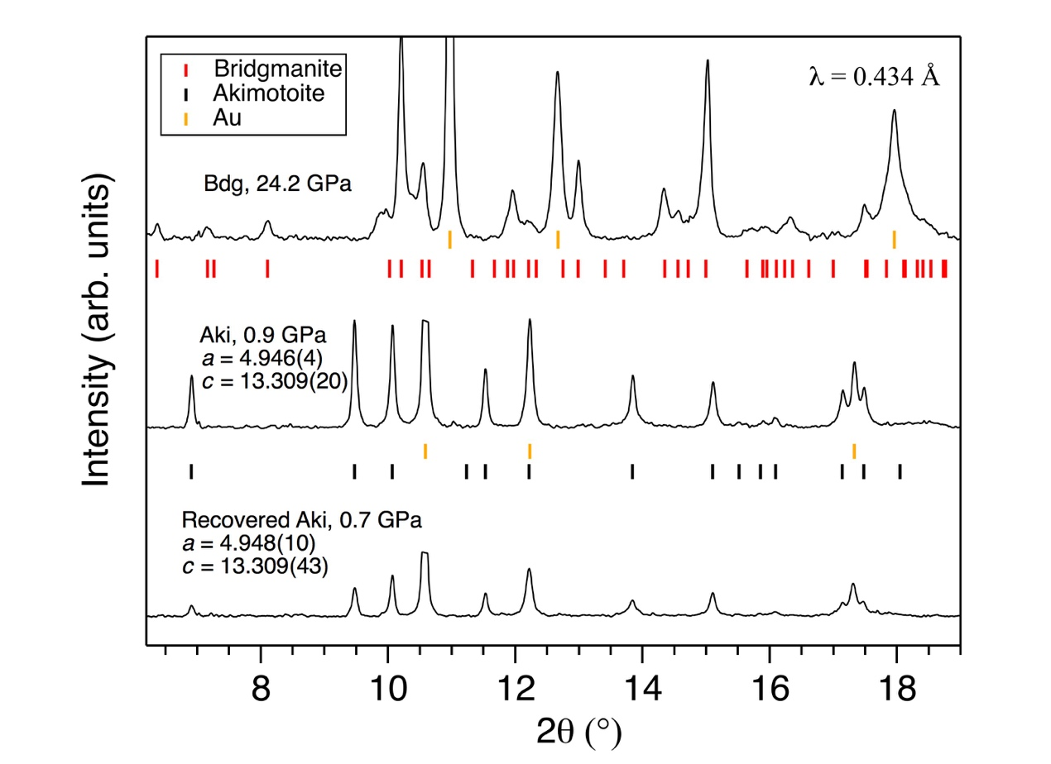
Supplementary Figure 1. Measured XRD data at 300 K for (Mg_{0.46}Fe³⁺_{0.53})(Si_{0.49}Fe³⁺_{0.51})O₃ akimotoite at 0.9 GPa and the transformed bridgmanite at ~ 24.2 GPa together with the recovered akimotoite at 0.7 GPa. The expected peak positions for akimotoite, bridgmanite and Au calibrant are shown as black, red and yellow ticks, respectively. The XRD intensity of Au (111) peak is truncated for clarity. The fitted lattice parameters for akimotoite spectra are listed aside the corresponding spectra.
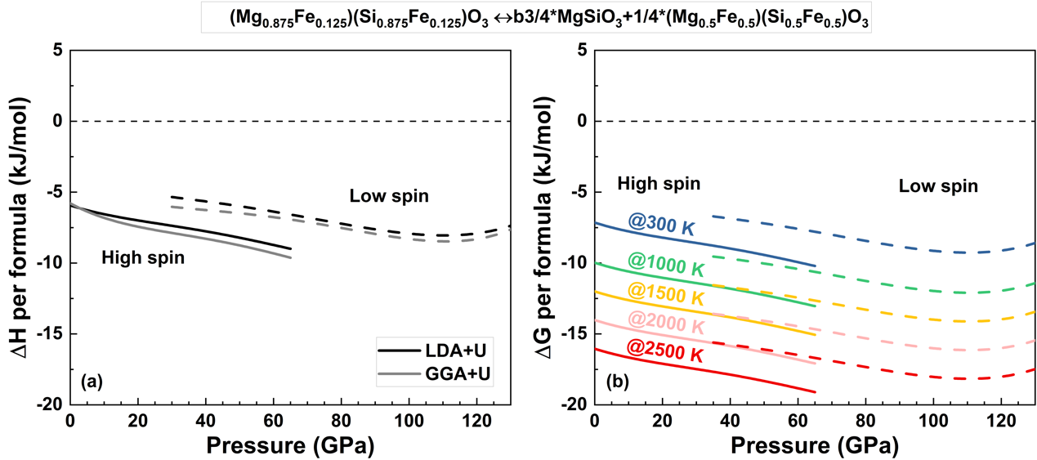
Supplementary Figure 2. Enthalpy change (ΔH) and Gibbs formation free energy (ΔG) of the decomposition of (Mg_{0.875}Fe_{0.125})(Si_{0.875}Fe_{0.125})O₃ into (Mg_{0.5}Fe_{0.5})(Si_{0.5}Fe_{0.5})O₃ and MgSiO₃ bridgmanite. The calculated results demonstrate that ΔG based on LDA+U is negative at lower-mantle conditions regardless of the spin state of B-site Fe³⁺ in (Mg_{1-x}Fe_{x})(Si_{1-x}Fe_{x})O₃ bridgmanite, suggesting that the assemblage of (Mg_{0.5}Fe_{0.5})(Si_{0.5}Fe_{0.5})O₃ and MgSiO₃ bridgmanite is more stable than single-phase (Mg_{0.875}Fe_{0.125})(Si_{0.875}Fe_{0.125})O₃ bridgmanite.

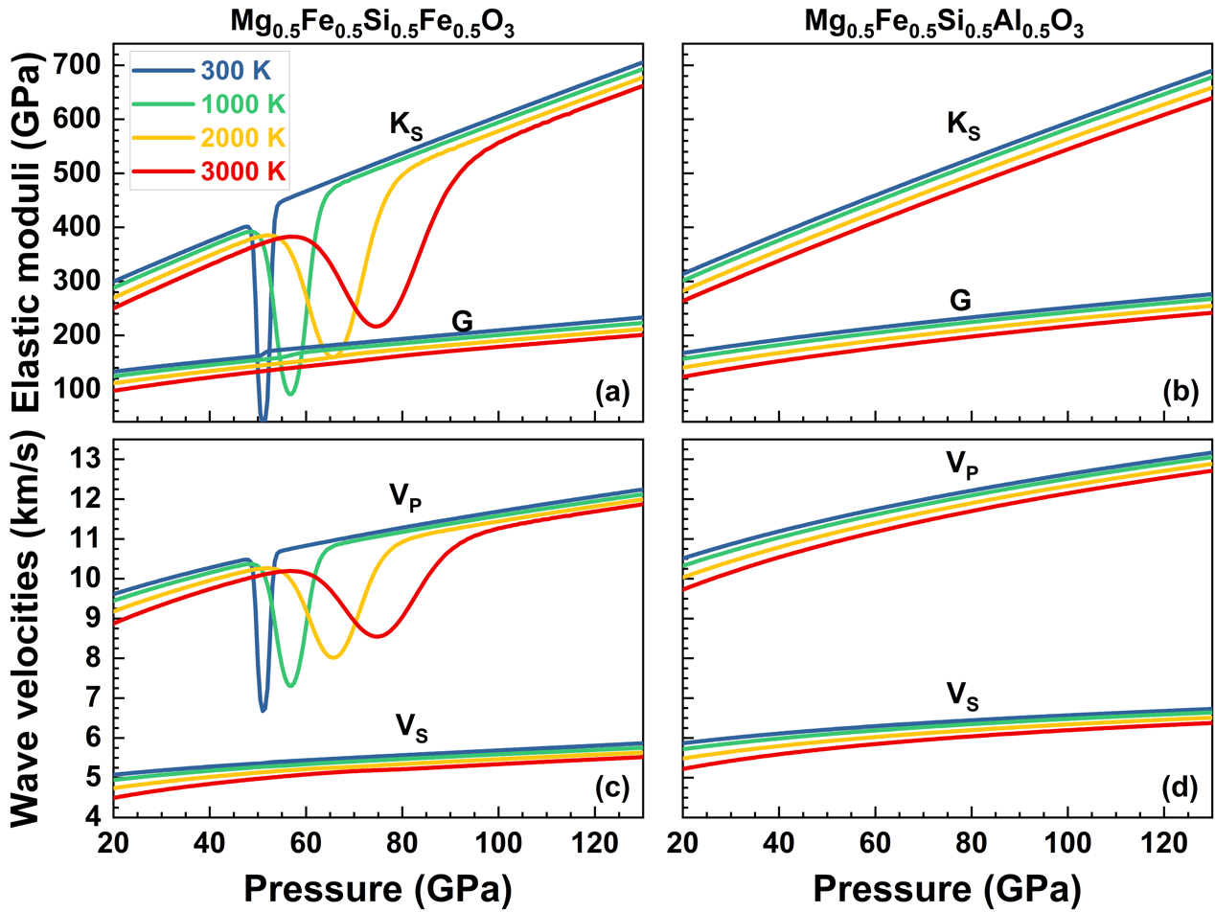
Supplementary Figure 3. Bulk moduli and wave velocities of (Mg_{0.5}Fe_{0.5})(Si_{0.5}Fe_{0.5})O₃ and (Mg_{0.5}Fe_{0.5})(Si_{0.5}Al_{0.5})O₃ bridgmanite. (a) (b) bulk and shear moduli (K_{S} and G), (c) (d) compressional and shear wave velocities (V_{P} and V_{S}) of (Mg_{0.5}Fe_{0.5})(Si_{0.5}Fe_{0.5})O₃ and (Mg_{0.5}Fe_{0.5})(Si_{0.5}Al_{0.5})O₃ bridgmanite at different pressures and temperatures.

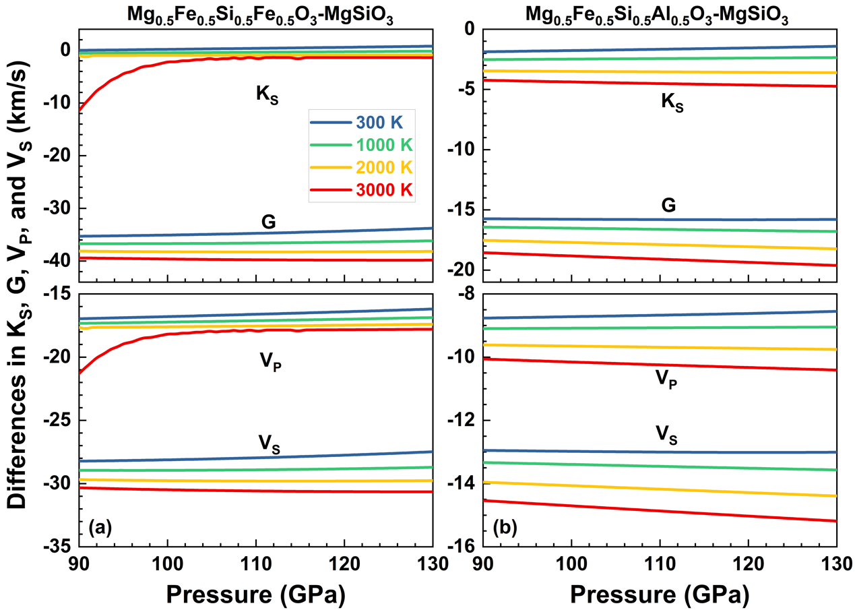
Supplementary Figure 4. The differences in elastic moduli and wave velocities between Fe³⁺-rich and MgSiO₃ bridgmanite. The K_{S}, G, density, V_{P}, and V_{S} between (a) (Mg_{0.5}Fe_{0.5})(Si_{0.5}Fe_{0.5})O₃ and MgSiO₃, (b) (Mg_{0.5}Fe_{0.5})(Si_{0.5}Al_{0.5})O₃ and MgSiO₃. Thermoelastic properties of (Mg_{0.5}Fe_{0.5})(Si_{0.5}Fe_{0.5})O₃ and (Mg_{0.5}Fe_{0.5})(Si_{0.5}Al_{0.5})O₃ bridgmanite are shown in Supplementary Figure 4. The elastic properties of MgSiO₃ were calculated using the same method in Shukla et al. (2016)³.

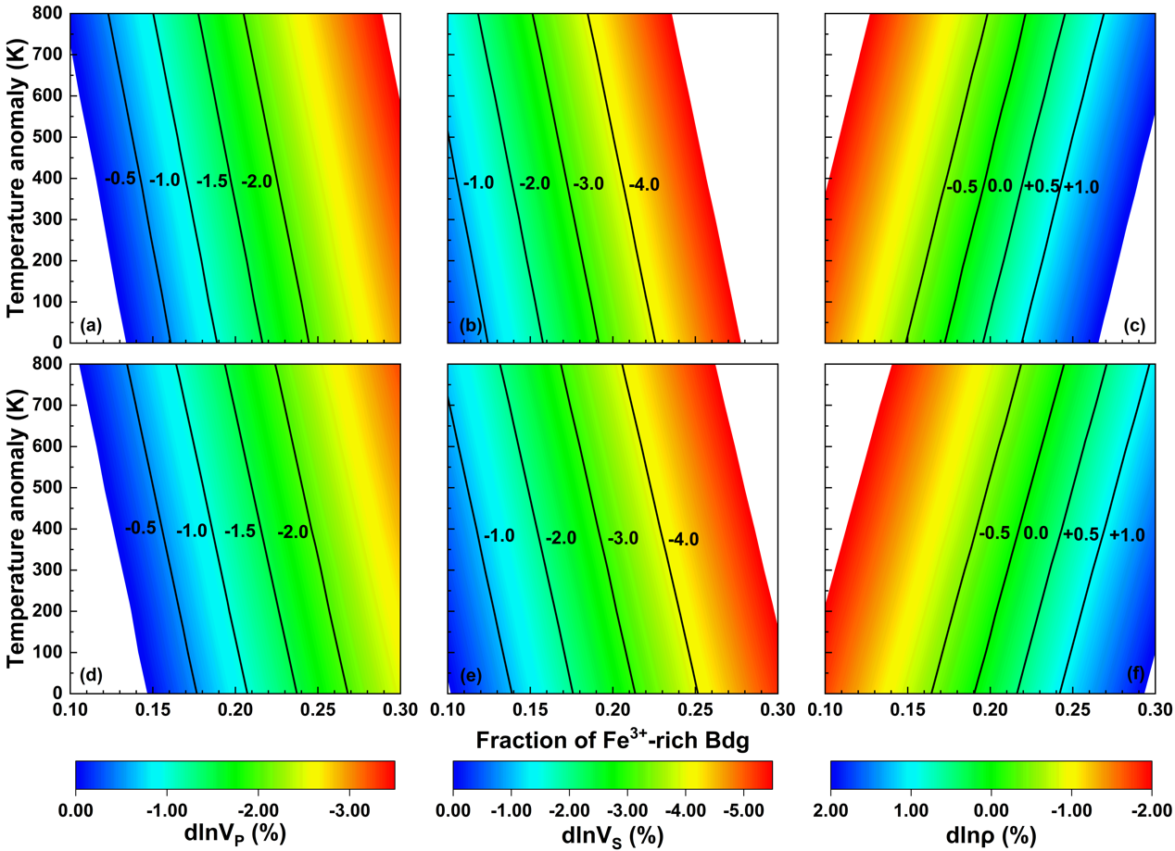
Supplementary Figure 5. Velocity and density anomalies caused by the enrichment of Fe³⁺-rich bridgmanite relative to the pyrolitic composition at 110 GPa without the presence of Fe²⁺. (a) (b) (c) the enrichment of (Mg_{0.5}Fe_{0.5})(Si_{0.5}Fe_{0.5})O₃ Bdg; (d) (e) (f) the enrichment of (Mg_{0.5}Fe_{0.5})(Si_{0.5}Fe_{0.4}Al_{0.1})O₃ Bdg if 5% Al₂O₃ would be incorporated into (Mg_{0.5}Fe_{0.5})(Si_{0.5}Fe_{0.5})O₃. Velocities and density of the pyrolitic lower mantle are calculated using the best-fit composition of the lower mantle (15% Mg_{0.82}Fe_{0.18}O Ferropericlase (Fp), 78% Mg_{0.92}Fe_{0.08}SiO₃ bridgmanite (Fe²⁺-Bdg), and 7% CaSiO₃ Ca-perovskite (CaPv))⁴. The modeling chemical assemblage has pyrolitic mineral fractions (15% ferropericlase (Fp) + 78% Bdg + 7% CaPv) in which a portion of Fe²⁺-bearing Bdg was substituted by (Mg_{0.5}Fe_{0.5})(Si_{0.5}Fe_{0.5})O₃ Bdg. The Fe²⁺ contents in Fp and Bdg are 0 mol%. The temperature anomaly of 0 K refers to the normal mantle temperature from Brown and Shankland (1981)⁵. Data sources for elasticity at high pressure and temperature: Fp, ref. ⁶; Fe²⁺-Bdg, ref. ³; Ca-Pv, ref. ⁷.

Supplementary References
1. Hsu, H., Blaha, P., Cococcioni, M. & Wentzcovitch, R. M. Spin-State Crossover and Hyperfine Interactions of Ferric Iron in MgSiO₃ Perovskite. Phys. Rev. Lett. 106, 118501 (2011).
2. Hill, R. The Elastic Behaviour of a Crystalline Aggregate. Proc. Phys. Soc. Sect. A 65, 349–354 (1952).
3. Shukla, G. et al. Thermoelasticity of Fe²⁺-bearing bridgmanite. Geophys. Res. Lett. 42, 1741–1749 (2015).
4. Wu, Z. Velocity structure and composition of the lower mantle with spin crossover in ferropericlase. J. Geophys. Res. Solid Earth 121, 2304–2314 (2016).
5. Brown, J. M. & Shankland, T. J. Thermodynamic parameters in the Earth as determined from seismic profiles. Geophys. J. Int. 66, 579–596 (1981).
6. Wu, Z., Justo, J. F. & Wentzcovitch, R. M. Elastic Anomalies in a Spin-Crossover System: Ferropericlase at Lower Mantle Conditions. Phys. Rev. Lett. 110, 228501 (2013).
7. Kawai, K. & Tsuchiya, T. Small shear modulus of cubic CaSiO₃ perovskite. Geophys. Res. Lett. 42, 2718–2726 (2015).

