Supplementary information

Supplement to: Effectiveness of ChAdOx1 vaccine in older adults during SARS-CoV-2 Gamma variant circulation in São Paulo

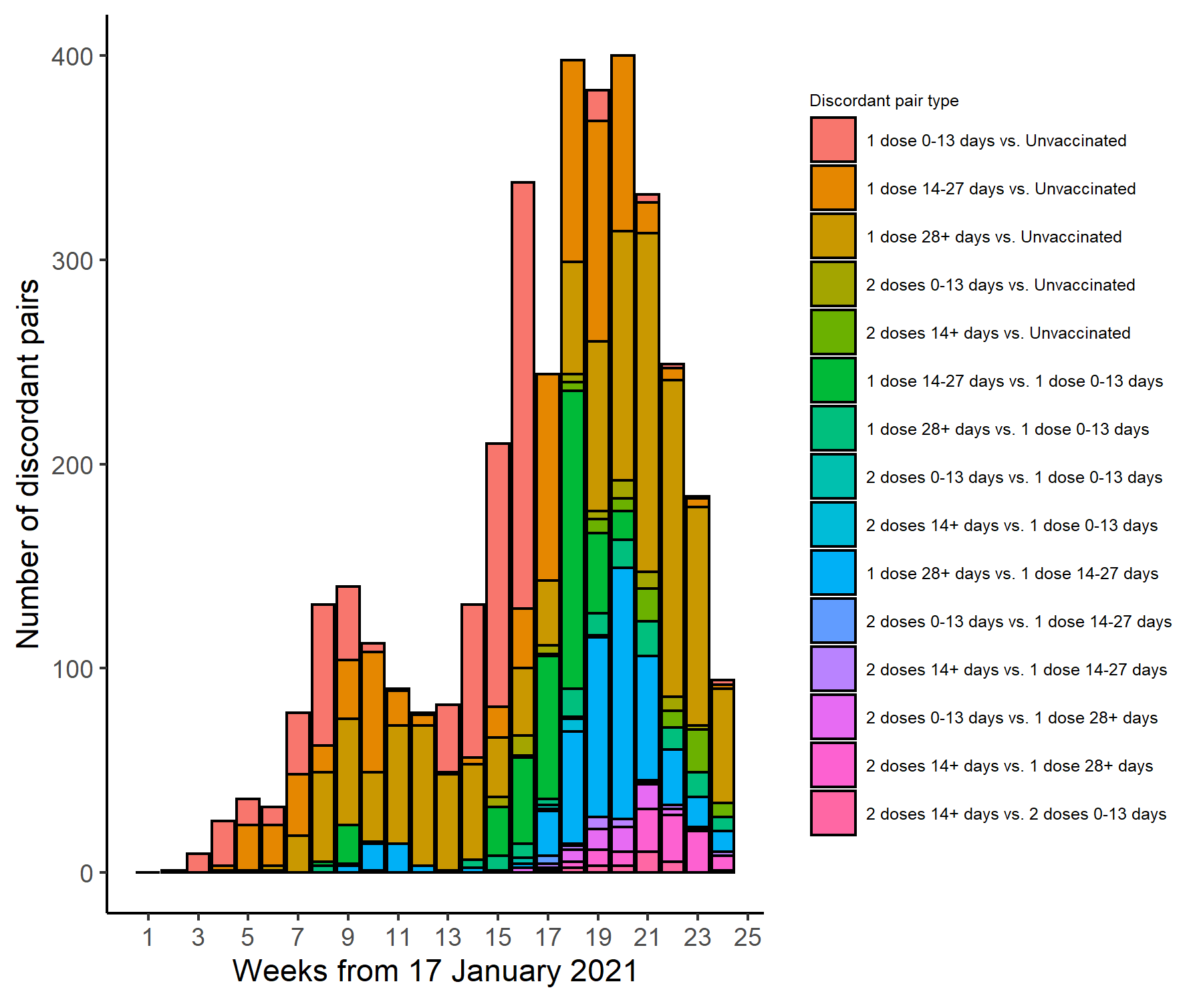
Supplementary Figure 1. Timing of discordant case-control pair selection. Timing of enrolment of discordant case-control pairs by vaccination category (n=4,046 discordant pairs). Source data are provided as a Source Data file.

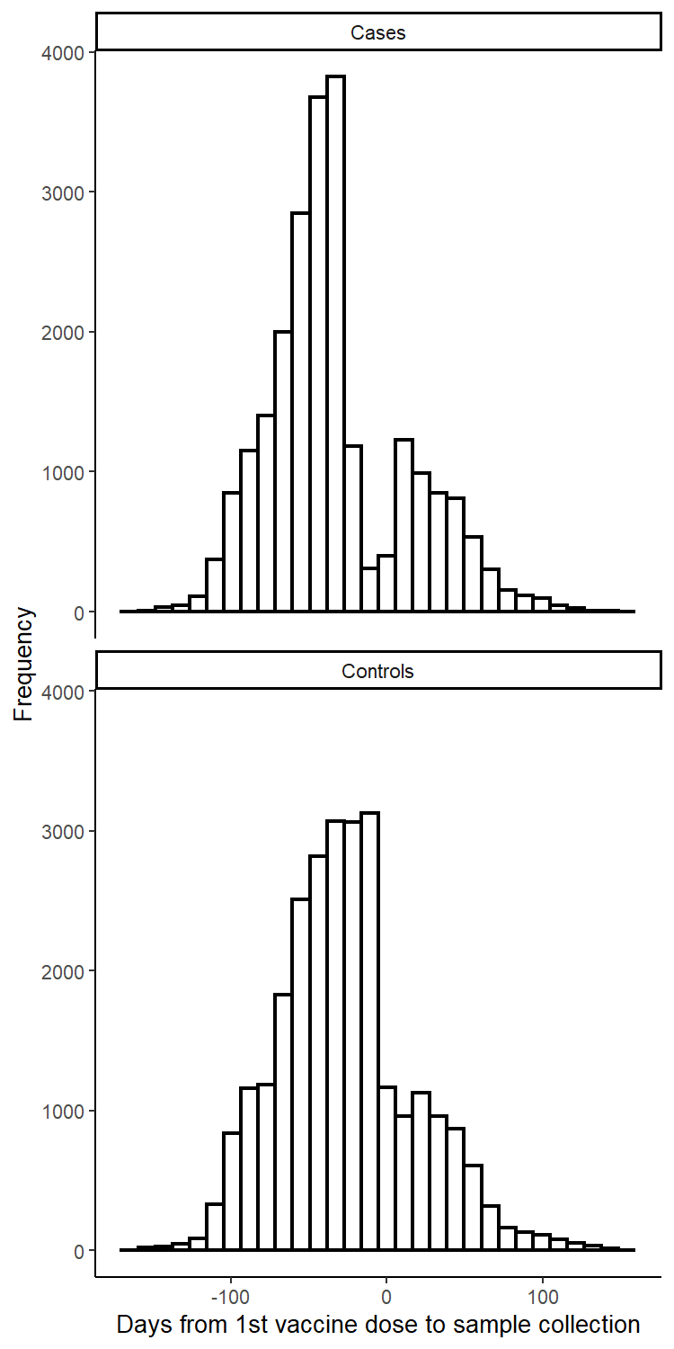
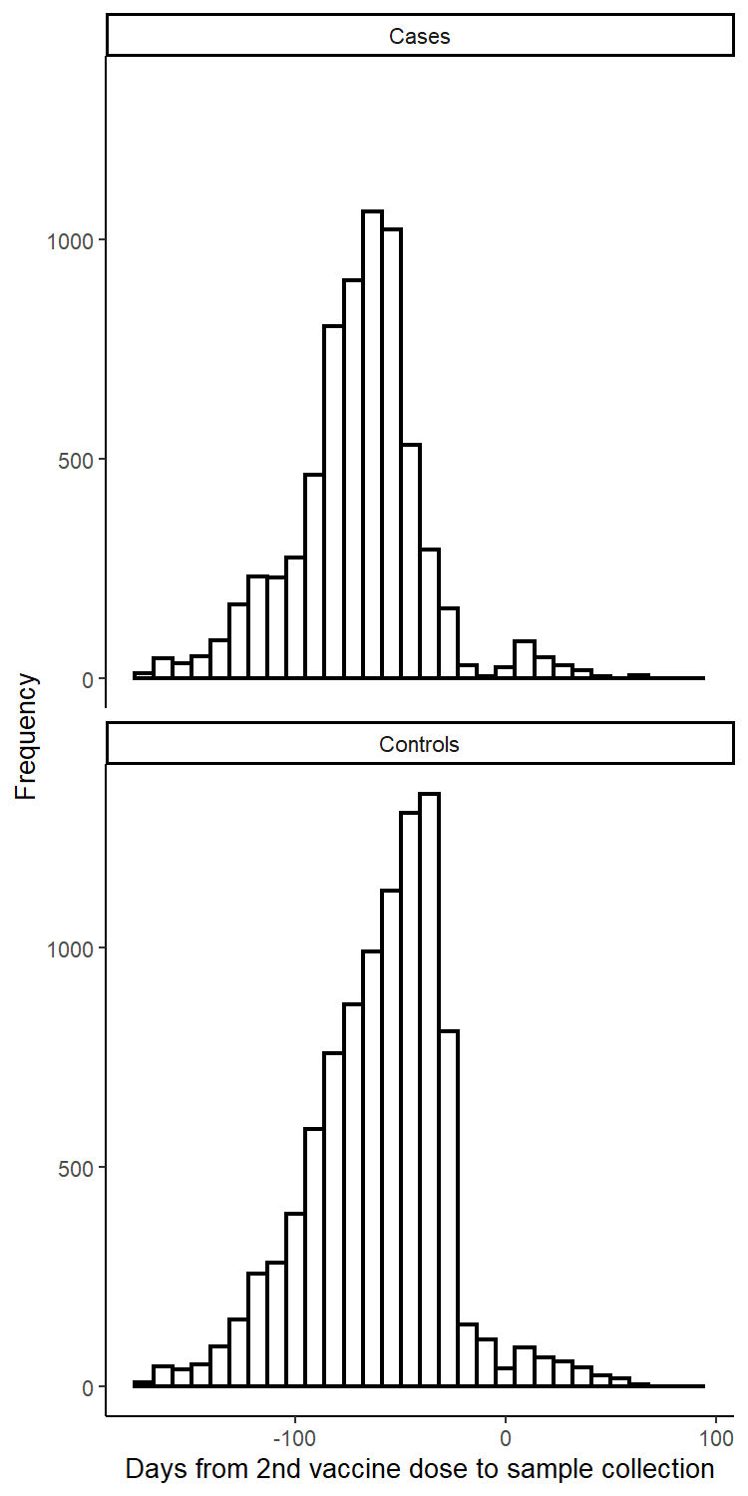
Supplementary Figure 2. Timing of RT-PCR sample collection date relative to vaccination. Timing of RT-PCR sample collection date relative to 1st (left column) and 2nd (right column) vaccine dose date, among cases (top row) and controls (bottom row) who were vaccinated during the study period. Source data are provided as a Source Data file.

Supplementary Table 1. Characteristics of adults ≥60 years of age who were eligible for matching and selected into case-test negative pairs.
 | Eligible cases and controls |  | Matched pairs
Characteristics* | Test-negative (n=56,676)^ | Test-positive (n=81,997)^ | Controls (n=30,680)^ | Cases (n=30,680)^
Demographics
Age categories, n (%)
60-69 years | 39,842 (70.3) | 58,181 (71.0) | 23,684 (77.2) | 23,684 (77.2)
70-79 years | 10,346 (18.3) | 15,963 (19.5) | 4,858 (15.8) | 4,858 (15.8)
80-89 years | 5,570 (9.8) | 6,949 (8.5) | 1,966 (6.4) | 1,966 (6.4)
≥90 years | 918 (1.6) | 904 (1.1) | 172 (0.6) | 172 (0.6)
Comorbidities
Cardiovascular disease, n (%) | 13,069 (23.1) | 24,456 (29.8) | 6,865 (22.4) | 9,429 (30.7)
Diabetes, n (%) | 8,078 (14.3) | 16,592 (20.2) | 4,308 (14.0) | 6,319 (20.6)
Clinical outcomes and vaccine timing
ARI-related hospitalization, n/n not missing (%) | 7,531/56,468 (13.3) | 30,189/81,515 (37.0) | 3,818/30,581 (12.5) | 11,250/ 30,502 (36.9)
ARI-related death, n/n not missing (%) | 2,571/55,495 (4.6) | 14,082/78,921 (17.8) | 1,321/30,144 (4.4) | 4,850/29,543 (16.4)
Interval between symptom onset and RT-PCR testing, median (IQR), days | 3 (2-5) | 4 (3-6) | 3 (2-5) | 4 (2-6)
Interval between symptom onset and hospitalization, median (IQR), days | 3 (1-5) | 7 (4-10) | 2 (1-5) | 7 (4-10)
Interval between symptom onset and death, median (IQR), days | 8 (4-15) | 16 (11-24) | 8.5 (4-16) | 17 (11-25)
Interval between 1st and 2nd dose, median (IQR), days | 85 (84-90) | 86 (84-92) | 85 (84-90) | 86 (84-92)
Interval between 1st dose and RT-PCR testing, median (IQR), days | 37 (21-57) | 28 (15-48) | 33 (18-50) | 30 (15-48)
Interval between 2nd dose and RT-PCR testing, median (IQR), days | 21 (12-33) | 13 (8-24) | 20 (10-34) | 13 (8-24)

*Continuous variables are displayed as mean (SD); categorical variables are displayed as n (%).
^These numbers refer to RT-PCR tests and represent 120,483 individuals for the eligible cases and controls and 53,495 individuals in the matched cases and controls.

Supplementary Table 2. Distribution of concordant and discordant matched case-control pairs.
 | Case unvaccinated | Case 1 dose,  0-13 days | Case 1 dose,  14-27 days | Case 1 dose, ≥28 days | Case 2 doses,  0-13 days | Case 2 doses, ≥14 days
Control unvaccinated | 23,575 | 471 | 313 | 475 | 23 | 11
Control 1 dose,  0-13 days | 463 | 381 | 155 | 41 | 2 | 0
Control 1 dose,  14-27 days | 353 | 205 | 658 | 206 | 1 | 4
Control 1 dose,  ≥28 days | 734 | 71 | 232 | 1922 | 25 | 25
Control 2 doses,  0-13 days | 30 | 6 | 6 | 22 | 41 | 9
Control 2 doses,  ≥14 days | 60 | 7 | 16 | 65 | 15 | 57

Supplementary Table 3. Distribution of concordant and discordant matched case-control pairs with hospitalized cases.
 | Case unvaccinated | Case 1 dose,  0-13 days | Case 1 dose,  14-27 days | Case 1 dose, ≥28 days | Case 2 doses,  0-13 days | Case 2 doses, ≥14 days
Control unvaccinated | 8,454 | 190 | 138 | 163 | 11 | 5
Control 1 dose,  0-13 days | 222 | 143 | 62 | 17 | 0 | 0
Control 1 dose,  14-27 days | 177 | 79 | 221 | 68 | 0 | 0
Control 1 dose,  ≥28 days | 369 | 25 | 77 | 632 | 17 | 10
Control 2 doses,  0-13 days | 20 | 4 | 5 | 11 | 21 | 4
Control 2 doses,  ≥14 days | 36 | 2 | 8 | 22 | 8 | 29

Supplementary Table 4. Distribution of concordant and discordant matched case-control pairs with cases who died.
 | Case unvaccinated | Case 1 dose,  0-13 days | Case 1 dose,  14-27 days | Case 1 dose, ≥28 days | Case 2 doses,  0-13 days | Case 2 doses, ≥14 days
Control unvaccinated | 3,734 | 77 | 54 | 54 | 4 | 2
Control 1 dose,  0-13 days | 103 | 55 | 16 | 7 | 0 | 0
Control 1 dose,  14-27 days | 75 | 30 | 90 | 25 | 0 | 0
Control 1 dose,  ≥28 days | 158 | 12 | 30 | 240 | 5 | 2
Control 2 doses,  0-13 days | 9 | 3 | 4 | 6 | 9 | 1
Control 2 doses,  ≥14 days | 13 | 2 | 3 | 12 | 4 | 11

Characteristics* | COVID-19 with positive RT-PCR or rapid antigen test (n=82,061)
Age, mean (SD), years | 67.7 (7.3)
Male sex, n (%) | 39,372 (48.0)
Self-reported race†: White/Branca, n(%) | 58,357 (71.1)
Self-reported race†: Brown/Pardo, n(%) | 18,649 (22.7)
Self-reported race†: Black/Preta, n(%) | 4,120 (5.0)
Self-reported race†: Yellow/ Amarela, n(%) | 919 (1.1)
Self-reported race†: Indigenous/Indigena, n(%) | 16 (0.0)
Reported number of comorbidities‡, n (%)
None | 46,500 (56.7)
One or two | 32,818 (40.0)
Three or more | 2,743 (3.3)
Not vaccinated, n (%) | 69,271 (84.4)
Single dose, within 0-13 days, n (%) | 3,643 (4.4)
Single dose, 14-27 days, n (%) | 4,518 (5.5)
Single dose, ≥28 days, n (%) | 4,305 (5.2)
2nd dose, within 0-13 days, n (%) | 255 (0.3)
2nd dose, ≥14 days, n (%) | 69 (0.1)
Hospitalization, n (%) | 33,034 (40.3%)
Death, n (%) | 15,611 (19.0%)

*Continuous variables are displayed as mean (SD); categorical variables are displayed as n (%).
^These numbers refer to RT-PCR tests and represent 120,483 individuals for the eligible cases and controls and 53,495 individuals in the matched cases and controls.
†Race/skin color as defined by the Brazilian national census bureau (Instituto Nacional de Geografia e Estatísticas).³⁵
‡Comorbidities included: cardiovascular, renal, neurological, hematological, or hepatic comorbidities, diabetes, chronic respiratory disorder, obesity, or immunosuppression.

Supplementary Table 5. Characteristics of adults ≥60 years of age who were eligible for inclusion in the cohort of individuals with RT-PCR- or antigen-confirmed COVID-19.

Supplementary Table 6. Unadjusted effectiveness of a ChAdOx1 against clinical Covid-19 outcomes in adults ≥60 years of age
 | Symptomatic Covid-19  (n pairs=48,452) | Covid-19 hospitalization  (n pairs=18,552) | ICU admission  (n pairs=7,444) | Invasive mechanical ventilation  (n pairs=4,391) | Covid-19-related death  (n pairs=8,109)
Vaccine doses and timing | VE (95% CI) | VE (95% CI) | VE (95% CI) | VE (95% CI) | VE (95% CI)
Single dose, within 0-13 days vs. unvaccinated | -5.1% (-17.2-5.8) | 13.7% (-2.0-26.9) | 4.2% (-24.4-26.3) | 18.7% (-14.0-42.1) | 19.0% (-4.9-37.5)
Single dose, 14-27 days vs. unvaccinated | 17.6% (8.0-26.3) | 29.5% (16.4-40.6) | 45.0% (26.3-59.0) | 50.9% (28.8-66.1) | 40.1% (20.9-54.6)
Single dose, ≥28 days vs. unvaccinated | 34.1% (27.3-40.3) | 52.9% (44.9-59.8) | 54.5% (40.8-65.0) | 71.1% (58.4-80) | 62.0% (50.8-70.6)
Two doses, within 0-13 days vs. unvaccinated | 39.0% (13.4-57) | 53.5% (25.6-71) | 41.8% (-38.9-75.6) | 72.4% (3.2-92.1) | 73.9% (44.2-87.8)
Two doses, ≥14 days vs. unvaccinated | 76.8% (67.8-83.3) | 83.6% (72.4-90.2) | 87.3% (66.4-95.2) | 95.6% (79.7-99.0) | 92.5% (80.0-97.2)

Supplementary Table 7. Adjusted effectiveness of a ChAdOx1 against clinical Covid-19 outcomes in adults ≥60 years of age, when controls were sampled with replacement.
 | Symptomatic Covid-19  (n pairs=48,452) | Covid-19 hospitalization  (n pairs=18,552) | ICU admission  (n pairs=7,444) | Invasive mechanical ventilation  (n pairs=4,391) | Covid-19-related death  (n pairs=8,109)
Vaccine doses and timing | aVE (95% CI) | aVE (95% CI) | aVE (95% CI) | aVE (95% CI) | aVE (95% CI)
Single dose, within 0-13 days vs. unvaccinated | -4.8% (-14.1-3.7) | 0.7% (-14.0-13.5) | -20.6% (-50.9-3.7) | 8.9% (-22.4-32.2) | 9.3% (-12.1-26.7)
Single dose, 14-27 days vs. unvaccinated | 13.2% (5.3-20.4) | 27.3% (16.0-37.1) | 33.4% (15.0-47.8) | 46.7% (26.0-61.7) | 35% (18.1-48.4)
Single dose, ≥28 days vs. unvaccinated | 34.4% (28.7-39.6) | 56.9% (50.2-62.7) | 54.9% (42.1-64.8) | 69.8% (57.5-78.6) | 62% (51.8-70.1)
Two doses, within 0-13 days vs. unvaccinated | 28.4% (5.3-45.8) | 47.4% (22.3-64.3) | 42.4% (-17.1-71.6) | 76.4% (26.7-92.4) | 69.5% (42.8-83.7)
Two doses, ≥14 days vs. unvaccinated | 74.4% (66.2-80.6) | 87.0% (79.4-91.8) | 89.7% (76.1-95.6) | 96.9% (87.8-99.2) | 92.2% (82.2-96.6)

aVE: Adjusted vaccine effectiveness. In all adjusted models, conditional logistic regression included age as a continuous variable, number of reported comorbidities (none vs. one-two vs. three or more), and prior positive SARS-CoV-2 PCR or rapid antigen test.

Supplementary Table 8. Adjusted effectiveness of a ChAdOx1 against clinical Covid-19 outcomes in adults ≥60 years of age, when two controls per case were sampled with replacement.
 | Symptomatic Covid-19  (n pairs=48,452) | Covid-19 hospitalization  (n pairs=18,552) | ICU admission  (n pairs=7,444) | Invasive mechanical ventilation  (n pairs=4,391) | Covid-19-related death  (n pairs=8,109)
Vaccine doses and timing | aVE (95% CI) | aVE (95% CI) | aVE (95% CI) | aVE (95% CI) | aVE (95% CI)
Single dose, within 0-13 days vs. unvaccinated | -5.9% (-15.3-2.8) | -2.1% (-16.7-10.7) | -14.7% (-41.7-7.1) | 14.4% (-14.0-35.8) | 15% (-5.2-31.4)
Single dose, 14-27 days vs. unvaccinated | 15.5% (7.7-22.6) | 34.4% (24.3-43.1) | 41.3% (25.5-53.8) | 50.0% (31.1-63.8) | 48.6% (35.0-59.4)
Single dose, ≥28 days vs. unvaccinated | 36.1% (30.6-41.2) | 58.4% (52.1-63.8) | 58.5% (47.7-67.1) | 66.3% (54-75.4) | 62.5% (52.7-70.3)
Two doses, within 0-13 days vs. unvaccinated | 28.6% (4.2-46.8) | 58.4% (38.6-71.8) | 52.6% (7-75.9) | 49.0% (-31.5-80.2) | 71.8% (47.2-85)
Two doses, ≥14 days vs. unvaccinated | 74.6% (65.7-81.2) | 85.4% (77.2-90.7) | 83.5% (65.2-92.2) | 93.5% (78.4-98.1) | 87.9% (73.7-94.4)

aVE: Adjusted vaccine effectiveness. In all adjusted models, conditional logistic regression included age as a continuous variable, number of reported comorbidities (none vs. one-two vs. three or more), and prior positive SARS-CoV-2 PCR or rapid antigen test.

Supplementary Table 9. Adjusted one- and two-dose effectiveness against progression to Covid-19 hospitalization, Covid-19 ICU admission, and Covid-19-related death among individuals testing positive for SARS-CoV-2 (n=102,842)
 | Covid-19 hospitalization within 21 days of symptom onset | Covid-19 ICU admission within 21 days of symptom onset | Covid-19 death within 28 days of symptom onset
Vaccine doses and timing | aVE (95% CI) | aVE (95% CI) | aVE (95% CI)
Single dose, within 0-13 days vs. unvaccinated | 1.9% (-3.1-6.6) | 6.0% (-2.3-13.5) | 14.9% (7.8-21.4)
Single dose, 14-27 days vs. unvaccinated | 27.7% (23.0-32) | 28.6% (20.4-36.0) | 35.2% (28.5-41.2)
Single dose, ≥28 days vs. unvaccinated | 36.7% (32.7-40.4) | 36.2% (29.2-42.5) | 43.0% (37.6-48.0)
Two doses, within 0-13 days vs. unvaccinated | 36.9% (22.9-48.4) | 40.2% (15.7-57.6) | 45.1% (26.2-59.2)
Two doses, ≥14 days vs. unvaccinated | 34.8% (-4.0-59.1) | 46.3% (-28.1-77.5) | 19.3% (-46.4-55.5)
aVE: Adjusted vaccine effectiveness. In all adjusted models, stratified Cox proportional hazards regression included age (restricted cubic spline), sex, self-reported race, number of reported comorbidities (none vs. one-two vs. three or more), and prior positive SARS-CoV-2 PCR or rapid antigen test. Baseline hazard was stratified by municipality of residence and week of symptom onset.

Supplementary Table 10. Adjusted single-dose vaccine effectiveness against symptomatic Covid-19, ≥28 days after first dose, within subgroups
 | aVE* (95% CI) | p-value for interaction†
Age
Age 60-69 years | 34.5% (26.6-41.5) | 0.83
Age ≥70 years | 29.7% (13.3-42.9) | 0.83
Sex
Females | 31.3% (21.6-39.9) | 0.39
Males | 36.0% (25.6-44.9) | 0.39
Comorbidities
None | 37.0% (29.6-43.5) | 0.02
One or more | 27.0% (17.2-35.6) | 0.02
CVD
Not reported | 34.9% (27.7-41.5) | 0.16
Reported | 28.7% (18.0-38.0) | 0.16
Diabetes mellitus
Not reported | 35.3% (28.3-41.6) | 0.03
Reported | 24.2% (11.0-35.4) | 0.03
Health regional area
“Grande São Paulo” | 28.3% (16.3-38.5) | 0.50
Not “Grande São Paulo” | 37.2% (28.4-44.9) | 0.50
* All models adjusted for age as a continuous variable, number of reported comorbidities (none vs. one-two vs. three or more) and previous positive SARS-CoV-2 RT-PCR test
† p-value from a two-sided likelihood ratio test comparing the primary model with a nested model with an interaction between each variable of interest and vaccination with a single dose ≥28 days before RT-PCR sample collection date.

Supplementary Table 11. Adjusted one- and two-dose effectiveness against Covid-19 hospitalization and Covid-19-related death by age
 | Adjusted one-dose VE* (95% CI) | p-value for interaction† | Adjusted two-dose VE* (95% CI) | p-value for interaction‡
Covid-19 hospitalization
Age 60-69 years | 60.7% (51.1-68.4) | 0.09 | 100.0% (N/A) | <0.001
Age ≥70 years | 41.9% (22.5-56.5) | 0.09 | 80.8% (65.2-89.4) | <0.001
Covid-19-related death
Age 60-69 years | 72.1% (57.6-81.7) | 0.12 | 100.0% (N/A) | 0.18
Age ≥70 years | 48.0% (22.1-65.3) | 0.12 | 89.9% (69.7-96.7) | 0.18
* All models adjusted for age as a continuous variable, number of reported comorbidities (none vs. one-two vs. three or more) and previous positive SARS-CoV-2 RT-PCR test
† p-value from a two-sided likelihood ratio test comparing the primary model with a nested model with an interaction between each variable of interest and vaccination with a single dose ≥28 days before RT-PCR sample collection date.
‡ p-value from a two-sided likelihood ratio test comparing the primary model with a nested model with an interaction between each variable of interest and vaccination with two doses ≥14 days before RT-PCR sample collection date.

Database acronym | Domain | Comment
“Vacina Já” | State COVID-19 vaccination registry | State vaccination system, transferred daily to the National Immunization System (SIPNI)
SIVEP-Gripe (“Sistema de Informação da Vigilância Epidemiológica da Gripe”) | National surveillance database of severe acute respiratory illnesses | Contains all suspected or confirmed COVID-19 hospitalizations and deaths. In São Paulo State, there is a protocol for post mortem RT-PCR SARS-CoV-2 testing for suspected COVID-19 deaths that are also notified to SIVEP-Gripe.
e-SUS | National surveillance system of suspected cases of COVID-19 from mild to moderate "influenza like illness" | Contains notifications from primary health care and specialty outpatient visits.
GAL (“Gerenciador de Ambiente Laboratorial”) | State laboratory testing registry of the network of public health laboratories | In São Paulo State, diagnostic tests performed in GAL are automatically merged into eSUS and SIVEP-Gripe
Supplementary Table 12. Description of data sources.

Supplementary Table 13. STROBE Statement—Checklist of items that should be included in reports of case-control studies
 | Item No | Recommendation | Page No
Title and abstract | 1 | (a) Indicate the study’s design with a commonly used term in the title or the abstract | 2
Title and abstract | 1 | (b) Provide in the abstract an informative and balanced summary of what was done and what was found | 2
Introduction
Background/rationale | 2 | Explain the scientific background and rationale for the investigation being reported | 3
Objectives | 3 | State specific objectives, including any prespecified hypotheses | 3
Methods
Study design | 4 | Present key elements of study design early in the paper | 9-10
Setting | 5 | Describe the setting, locations, and relevant dates, including periods of recruitment, exposure, follow-up, and data collection | 9-10
Participants | 6 | (a) Give the eligibility criteria, and the sources and methods of case ascertainment and control selection. Give the rationale for the choice of cases and controls | 10
Participants | 6 | (b) For matched studies, give matching criteria and the number of controls per case | 10
Variables | 7 | Clearly define all outcomes, exposures, predictors, potential confounders, and effect modifiers. Give diagnostic criteria, if applicable | 10-11;  protocol
Data sources/ measurement | 8* | For each variable of interest, give sources of data and details of methods of assessment (measurement). Describe comparability of assessment methods if there is more than one group | 9
Bias | 9 | Describe any efforts to address potential sources of bias | 9-11
Study size | 10 | Explain how the study size was arrived at | 4; Fig2
Quantitative variables | 11 | Explain how quantitative variables were handled in the analyses. If applicable, describe which groupings were chosen and why | 10-11; Protocol
Statistical methods | 12 | (a) Describe all statistical methods, including those used to control for confounding | 10-11
Statistical methods | 12 | (b) Describe any methods used to examine subgroups and interactions | 11
Statistical methods | 12 | (c) Explain how missing data were addressed | Protocol
Statistical methods | 12 | (d) If applicable, explain how matching of cases and controls was addressed | 11
Statistical methods | 12 | (e) Describe any sensitivity analyses | 11
Results
Participants | 13* | (a) Report numbers of individuals at each stage of study—eg numbers potentially eligible, examined for eligibility, confirmed eligible, included in the study, completing follow-up, and analysed | 4; Fig 2, Supp Mat
Participants | 13* | (b) Give reasons for non-participation at each stage | Fig 2
Participants | 13* | (c) Consider use of a flow diagram | Fig 2
Descriptive data | 14* | (a) Give characteristics of study participants (eg demographic, clinical, social) and information on exposures and potential confounders | 4; Table 1
Descriptive data | 14* | (b) Indicate number of participants with missing data for each variable of interest | Table 1
Outcome data | 15* | Report numbers in each exposure category, or summary measures of exposure | Table 1; Supp Mat

