Supplementary Information
Osseosurface electronics – Thin, wireless, battery-free and multimodal musculoskeletal biointerfaces
Le Cai¹⁺, Alex Burton¹⁺, David A. Gonzales², Kevin Albert Kasper¹, Amirhossein Azami¹, Roberto Peralta³, Megan Johnson¹, Jakob A. Bakall Loewgren¹, Efren Barron Villalobos², Ethan C. Ross¹, John A. Szivek^{1,2}, David S. Margolis^{1,2}*, Philipp Gutruf^{1,4}*

¹ Department of Biomedical Engineering, University of Arizona, Tucson, AZ 85721
² Department of Orthopaedic Surgery and Arizona Arthritis Center, University of Arizona, AZ 85721
³ Department of Aerospace and Mechanical Engineering, University of Arizona, Tucson, AZ 85721
⁴ Departments of Electrical and Computer Engineering, BIO5 Institute, Neuroscience GIDP, University of Arizona, 85721.

⁺These authors contributed equally
* These authors jointly supervised this work

Correspondence should be addressed to:
David S. Margolis (dsm@arizona.edu)
Philipp Gutruf (pgutruf@email.arizona.edu)
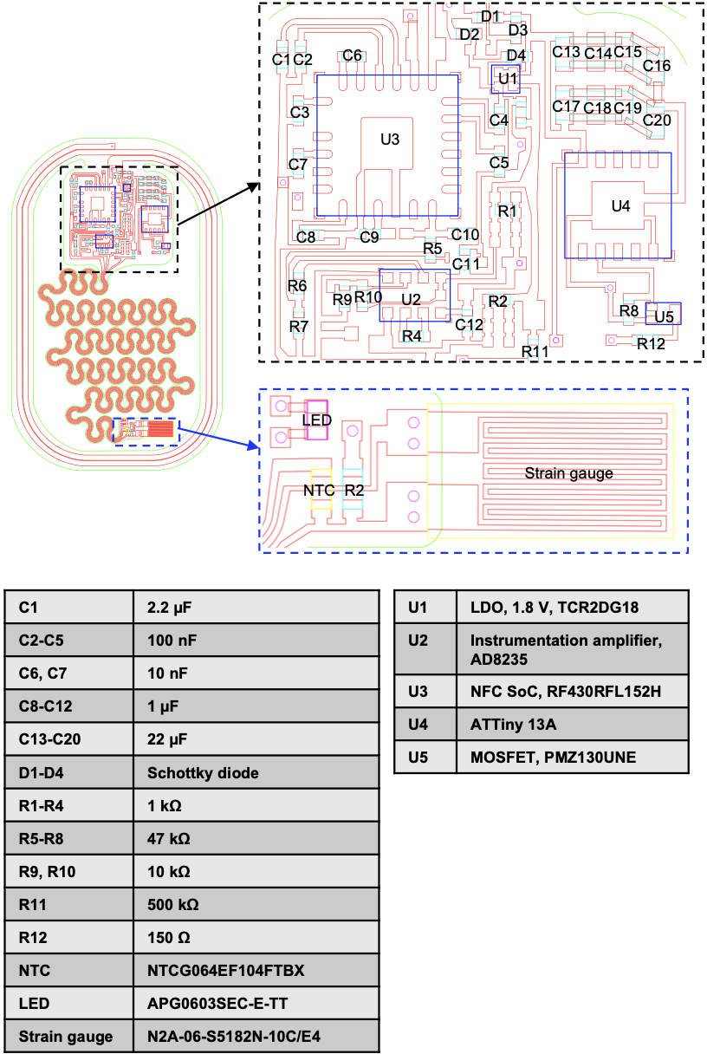
Supplementary Figure 1. Circuit layout including the main electronics and the biointerface, and list of components used.
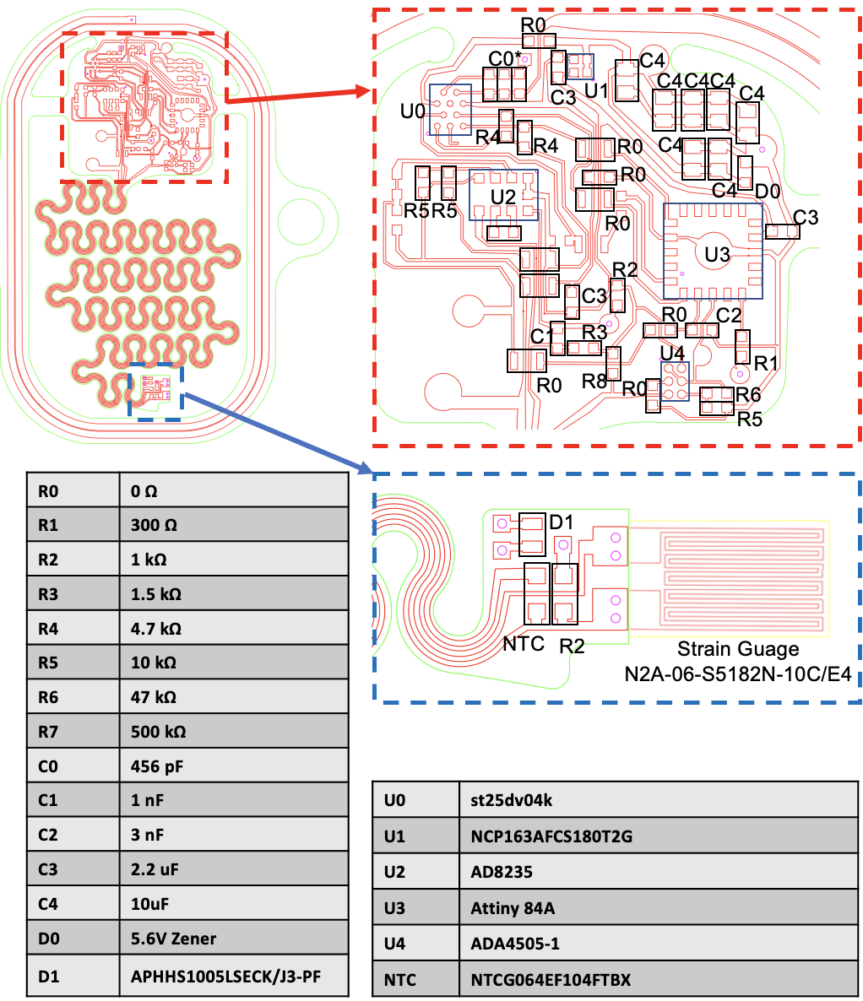
Supplementary Figure 2. Circuit layout including the main electronics and the bio-interface, and a list of components for the ST25DV04k NFC chip with dedicated power harvesting.
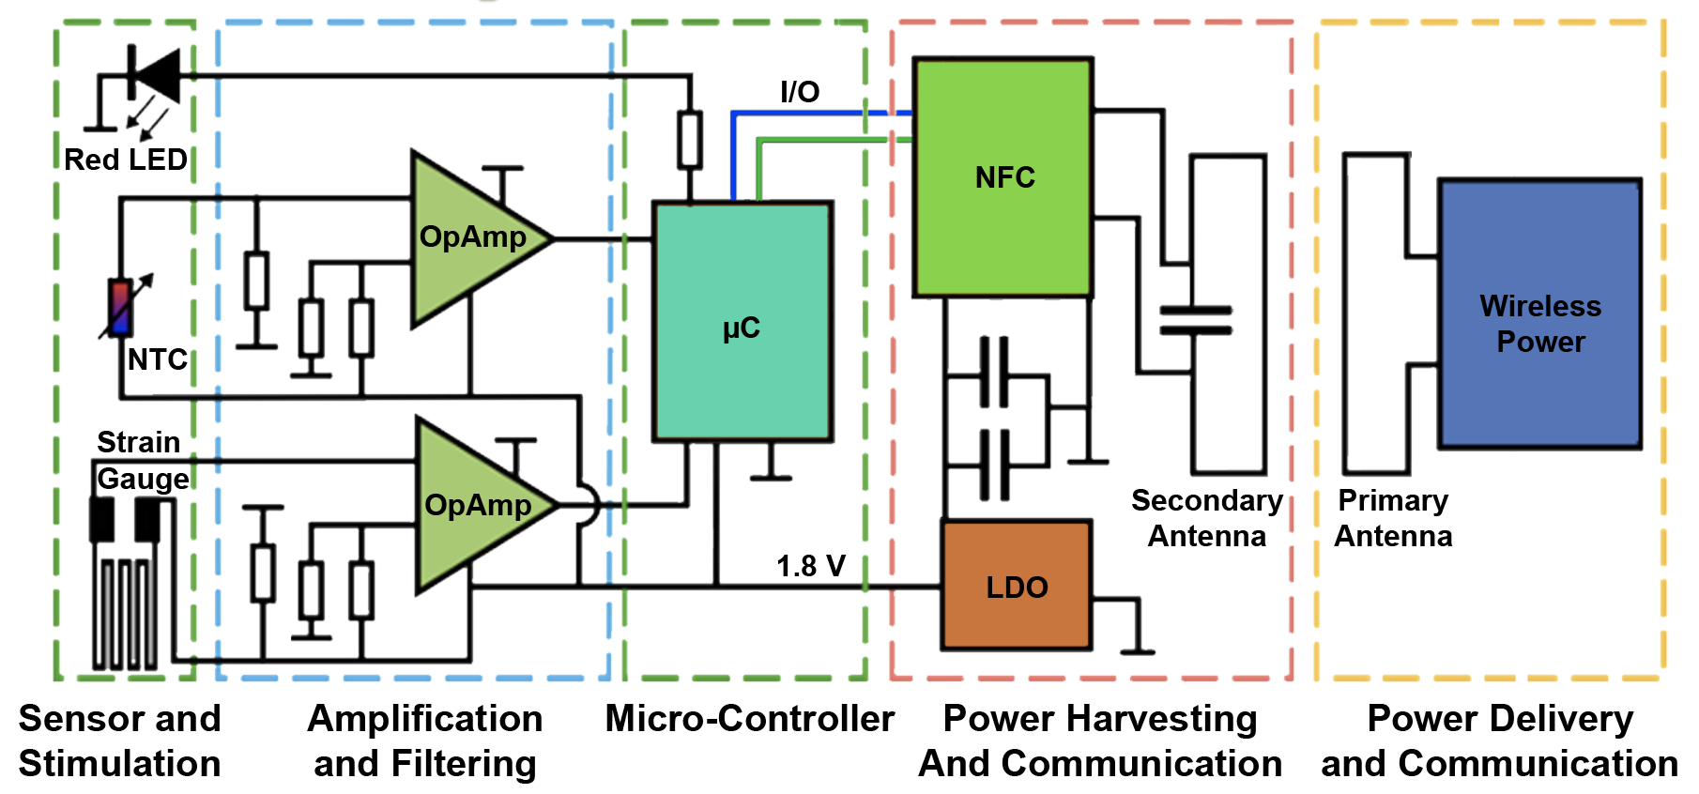
Supplementary Figure 3. Block diagram for devices using the ST25DV04K NFC chip.

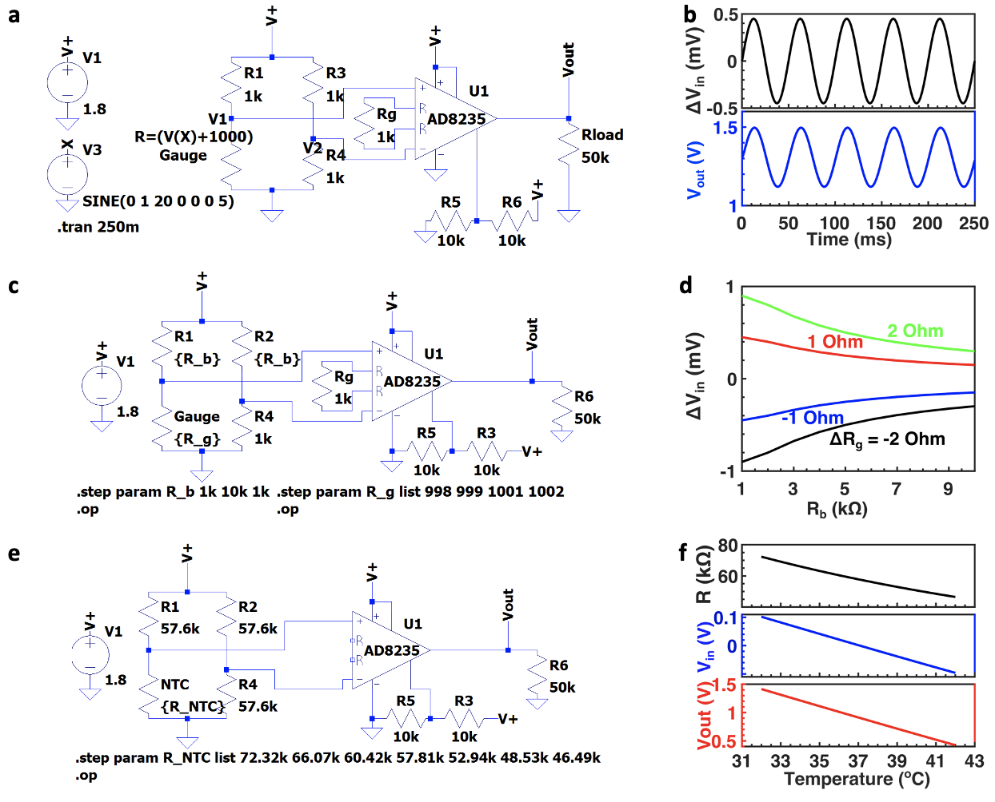 Supplementary Figure 4. Circuit simulation of the analog front end of strain sensor (a-d) and thermography (e-f). a-b Output voltages from the Wheatstone bridge and the instrumentation amplifier as the resistance of the strain gauge varies from 999 Ω to 1001 Ω (corresponding to strain from -500 με to 500 με) following a sinusoidal waveform (20 Hz): circuit diagram with simulation conditions (a) and simulation results (b). c-d Output voltage from the Wheatstone bridge as the bridge resistors, R₁ and R₂, vary from 1 kΩ to 10 kΩ for strain of 500 με and 1000 με: circuit diagram with simulation conditions (c) and simulation results (d). e-f Output voltages from the Wheatstone bridge and the instrumentation amplifier as the temperature varies from 32 °C to 42 °C: circuit diagram with simulation conditions (e) and simulation results (f).
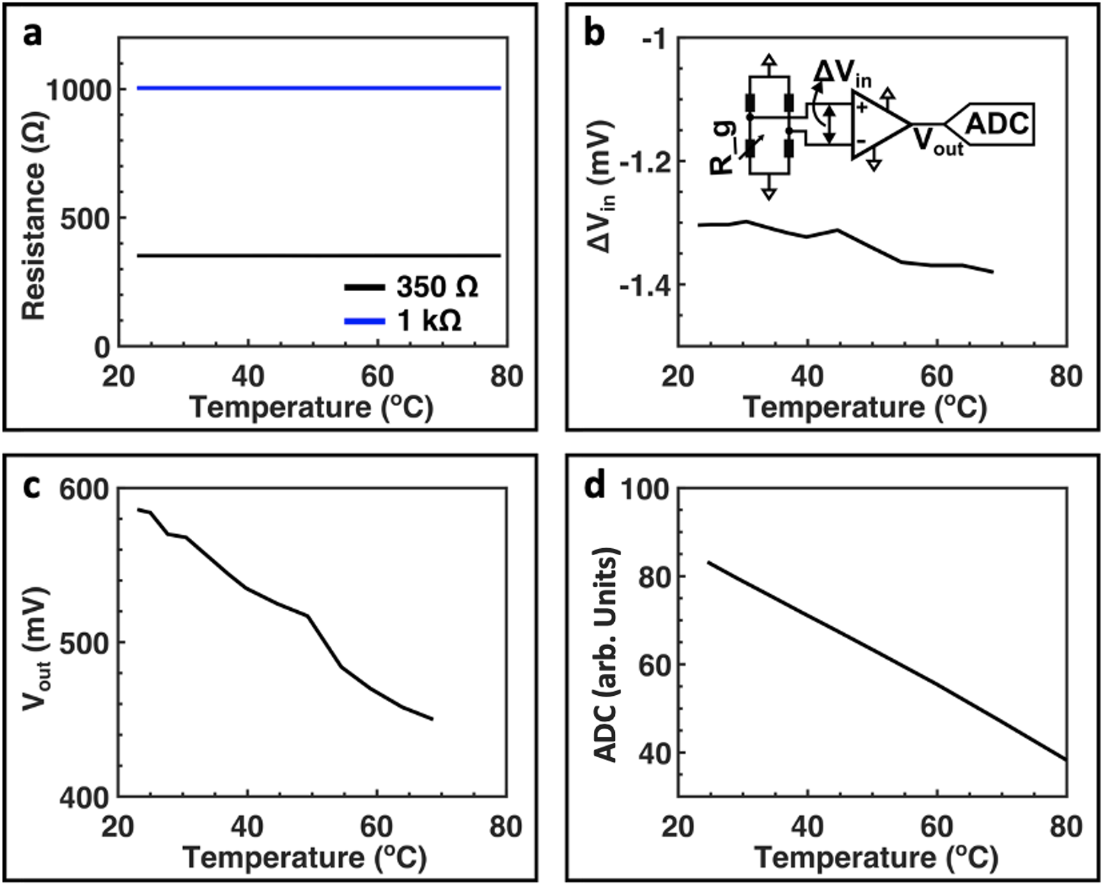
Supplementary Figure 5. Thermal stability of the strain sensor analog front–end. a Resistance of the 350 Ω gauge and 1000 Ω gauge as functions of temperature. b Output voltage from the Wheatstone bridge as a function of temperature. Inset, circuit diagram. c Output voltage from the instrumentation amplifier as a function of temperature. d Wirelessly recorded ADC reading as a function of temperature.

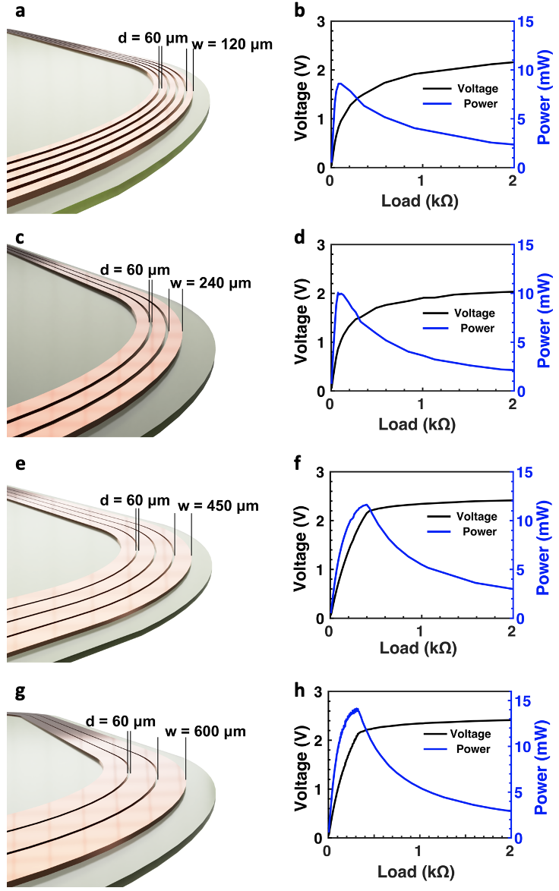
Supplementary Figure 6. Optimization of the secondary antenna. 3D rendering of secondary antennas with various geometries (a, c, e, g) and the corresponding power harvesting capabilities with NFC SoC (b, d, f, h).
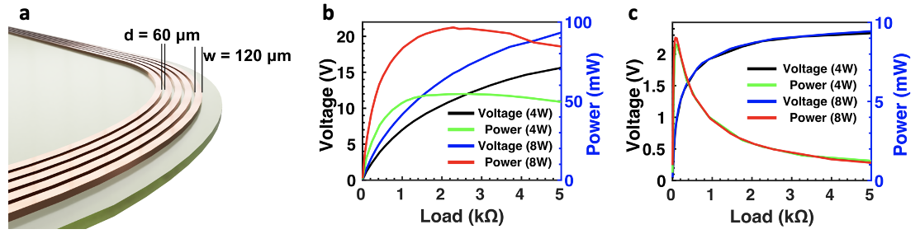Supplementary Figure 7. Comparison of the power harvesting capability of devices with and without NFC SoC. a 3D rendering of the secondary antenna with a copper trace width of 120 μm and inter-trace distance of 60 μm. b Power harvesting capability, i.e. rectified voltage and harvested power as functions of electrical load, of the device without NFC SoC. c Power harvesting capability of the device with NFC SoC, showing the voltage clamping by the NFC SoC.

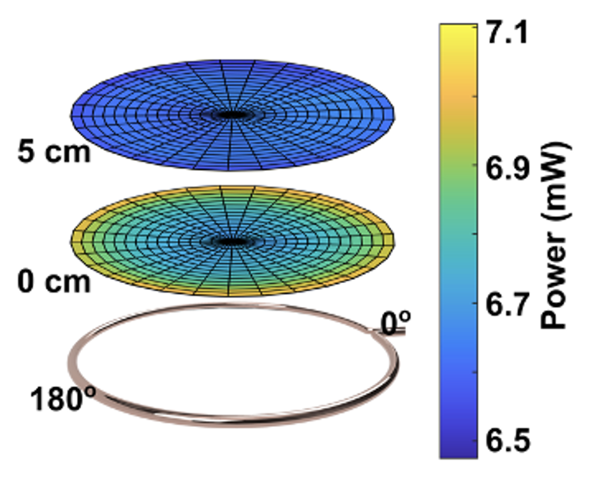
Supplementary Figure 8. Spatial distribution the harvested power with the large animal device at a load of 900 Ω from a handheld primary antenna (20 cm).

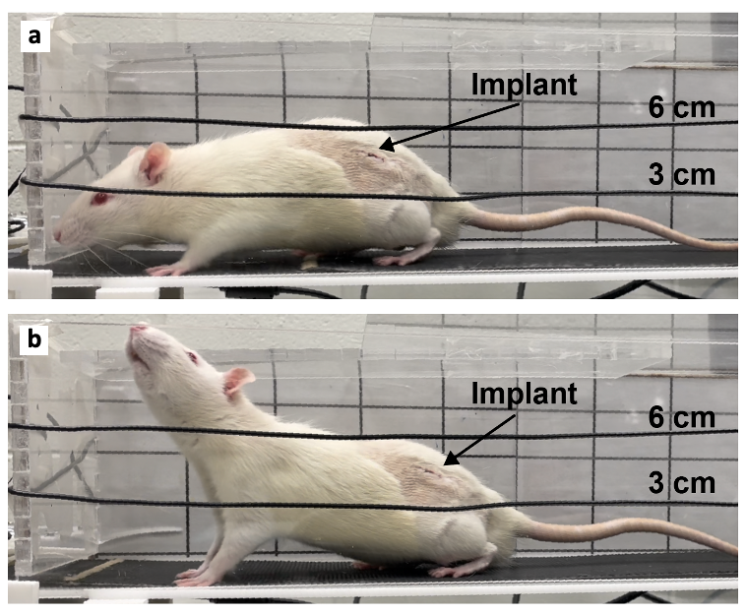
Supplementary Figure 9. Photograph of animal postures and height of device body relative to antenna position. a Photograph of animal walking on treadmill. b Photograph of animal during head raising.

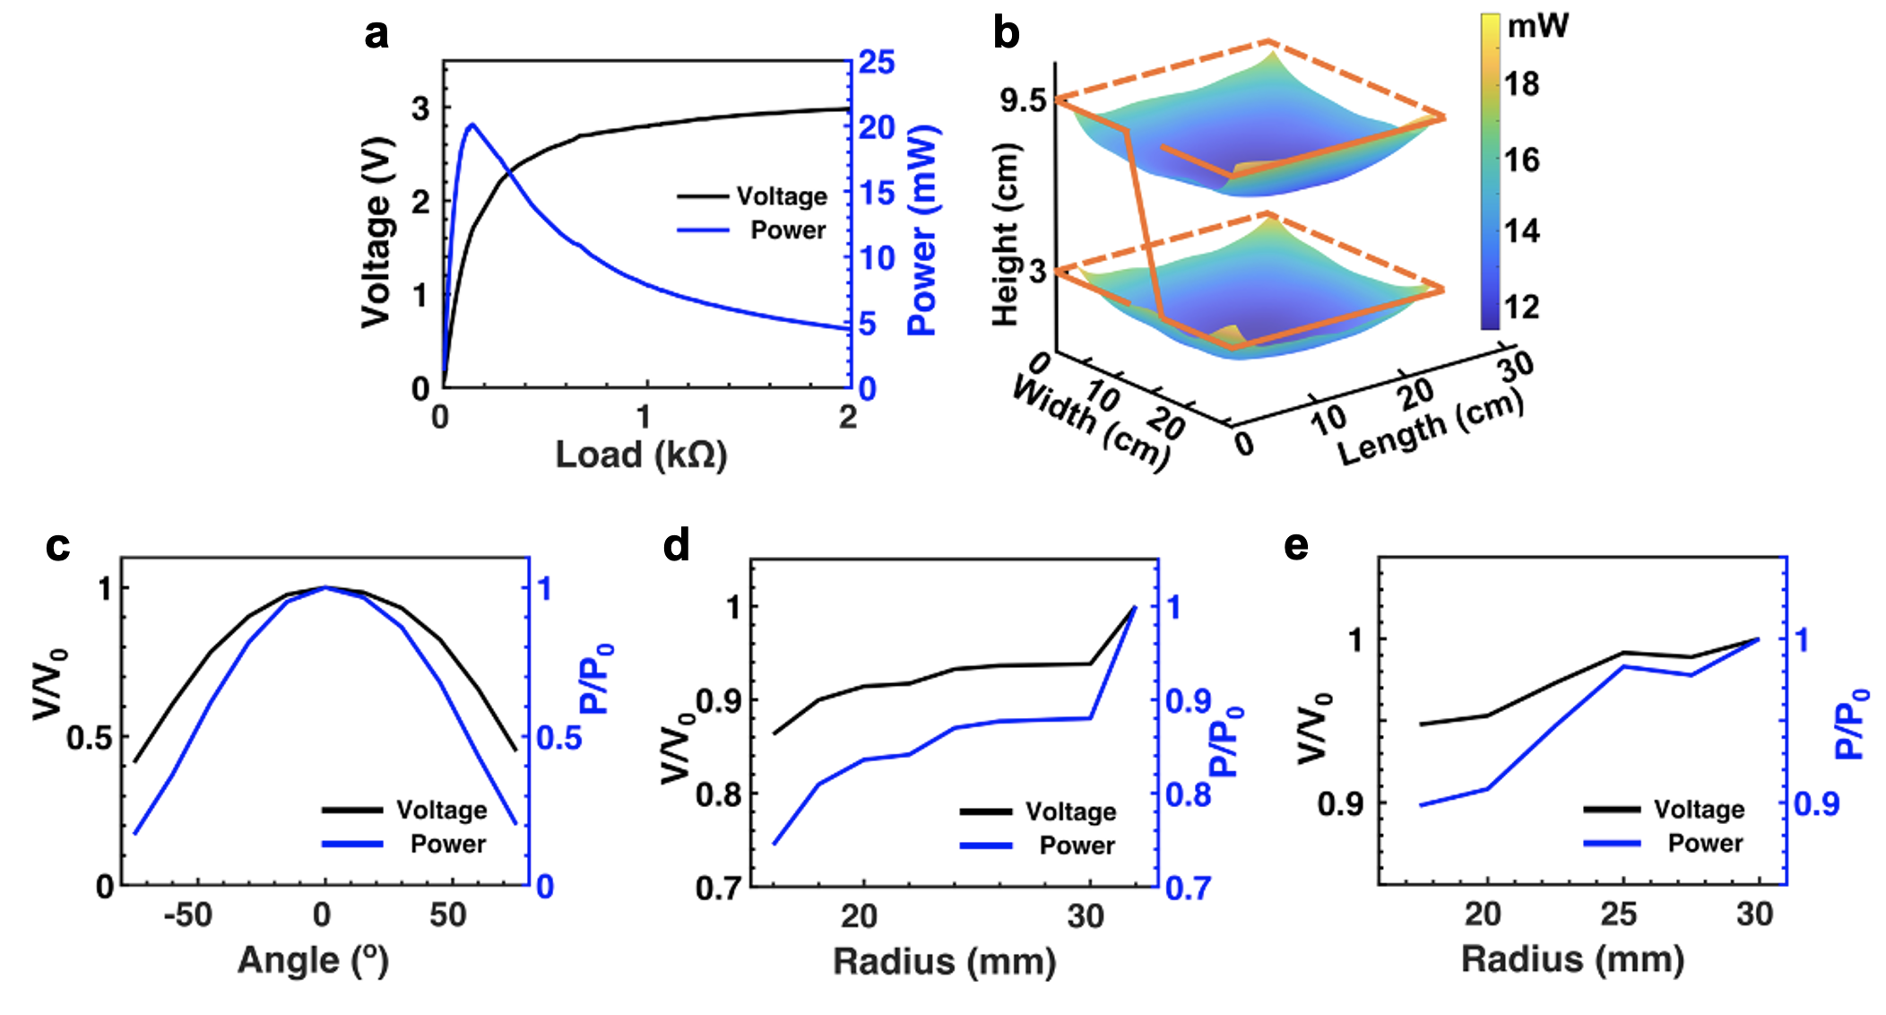Supplementary Figure 10. Power harvesting performance of the secondary antenna in various test arenas. a-b Power harvesting capability (a) and spatial distribution of harvested power (b) of the small animal device with a 2-turn 33 cm x 26 cm primary antenna that encloses the rat home cage. c-e Normalized power harvesting capability as functions of rotation angle (c), bending radius (d) and 3D bending radius (e) of the device.

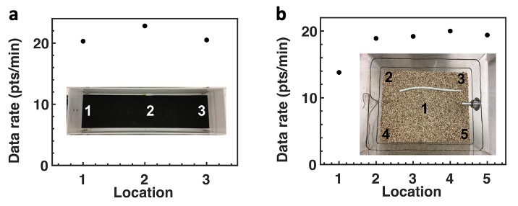
Supplementary Figure 11. Wireless communication performance. a Data rate of the rat device in various locations in the treadmill cage (2-turn, 45 cm x 12 cm). b Data rate of the rat device in various locations in the home cage (2-turn, 33 cm x 26 cm).
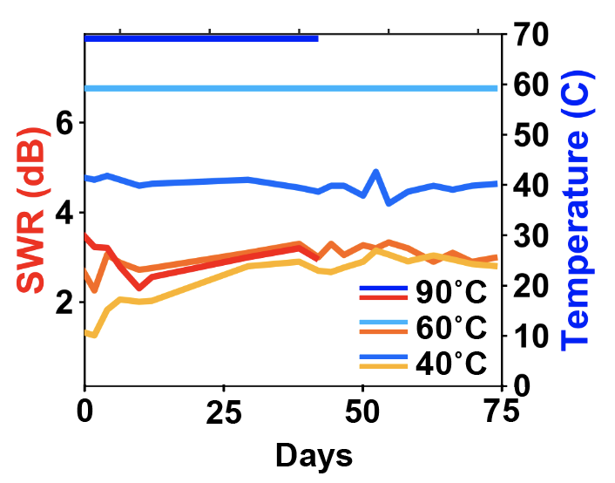
Supplementary Figure 12. Accelerated rate testing at 90˚C, 60˚C, and 40˚C in PBS, testing for wireless communication function, optical stimulation function, standing wave ratio of antenna (Red, Orange, Yellow), and wireless recording of temperature (Navy, Light blue, Blue).
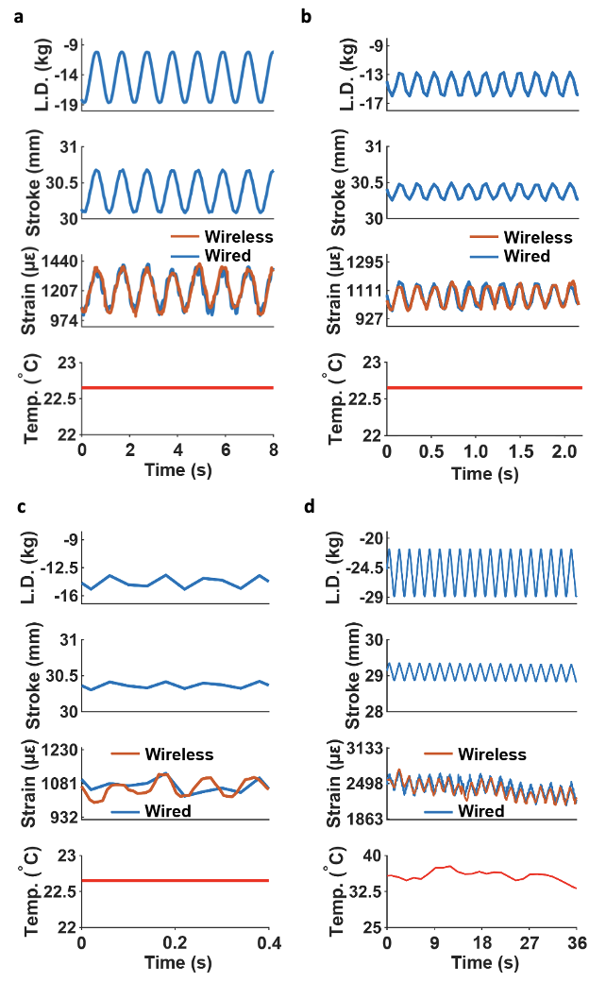
Supplementary Figure 13. Electromechanical benchtop testing of wireless device on sheep femur. a 1 Hz sine load cycle. b 5 Hz sine load cycle. c 10 Hz sine load cycle. d 1 Hz triangle load cycle with active convective heating is heat gun of the bone and device to match average body temperatures in a rat.
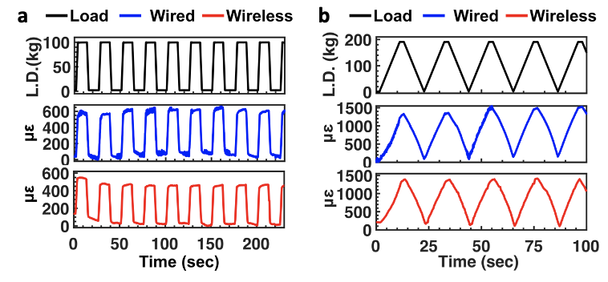
Supplementary Figure 14. Bench top tests of the wireless strain sensor attached on a sheep femur specimen. a-b Load, strain recorded by the wired sensor and wireless device when the femur is subjected to cyclic loads with square (a) and triangle (b) waveforms.
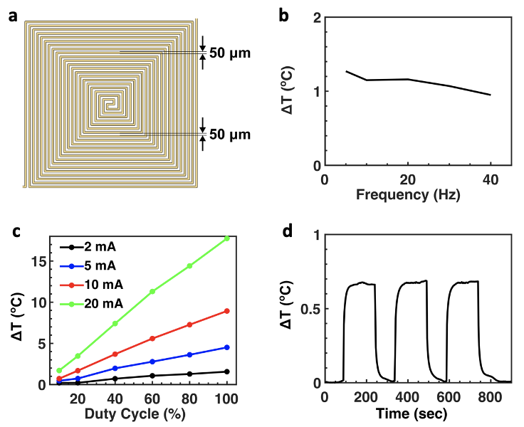
Supplementary Figure 15. Bench top characterization of the wireless thermography. a Design layout of the micro-heater. b Thermal impact of the μ-ILED in PBS as a function of operation frequency (duty cycle ~50%, optical power ~100 mW mm⁻²) recorded wirelessly by the co-located NTC thermistor. c Thermal impact of an LED as functions of driving current and duty cycle (frequency ~20 Hz) in air measured wirelessly by the co-located NTC thermistor. d Temporal profile of the thermal impact of an LED powered by the rectified voltage and controlled by a microcontroller with a duty cycle of 75% in PBS.
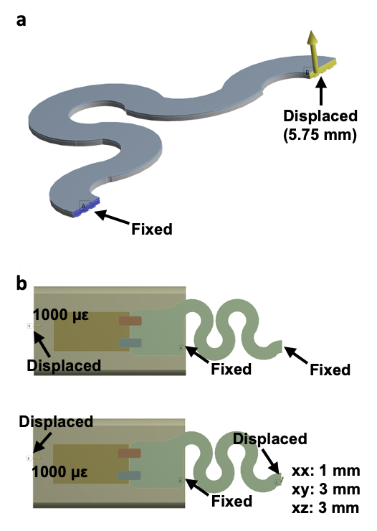
Supplementary Figure 16. FEA models and simulation conditions for the mechanical simulation. a Simulation of the strain in the copper traces while the serpentine interconnects are stretched. b Simulation of the mechanical isolation of the strain gauge provided by the serpentine interconnects.
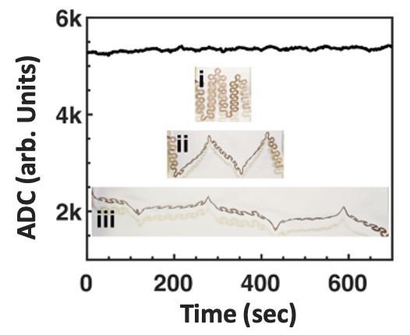
Supplementary Figure 17. Stability of serpentine interconnects. Wirelessly recorded ADC reading from the strain sensor (gain ~ 215, strain gauge unloaded) while the serpentine interconnects are cyclically stretched from 2 cm to 7 cm. Insets, photographs of the serpentine interconnects being stretched to different length: i. relaxed (2 cm); ii. 4 cm; iii. 7 cm.
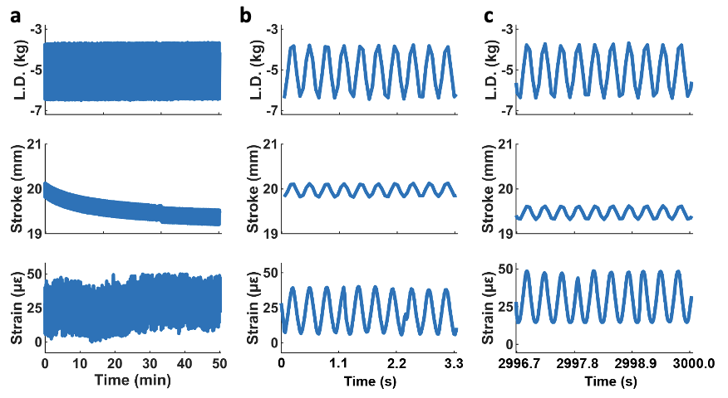
Supplementary Figure 18. Extended servo-hydraulic materials testing. a 10,000 cycle testing on an MTS (Series 810, MTS Systems Corporation). b First 10 cycles of testing procedure. c Last 10 cycles of testing.

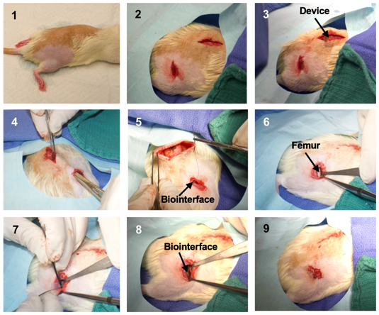
Supplementary Figure 19. Step-by-step images of the procedures to implant the osseosurface device in rats. 1. Rat under anesthesia with fur shaved on the back and hind limb; 2. Incision made into the skin on the back and the limb; 3. Device inserted subcutaneously on the back; 4. Bio-interface being tunneled subcutaneously to the hind limb; 5. Closing the skin on the back by suturing; 6. Femur exposed; 7. Attaching the biointerface on the femur; 8. Biointerface attached; 9. Incision on the limb closed by suturing.
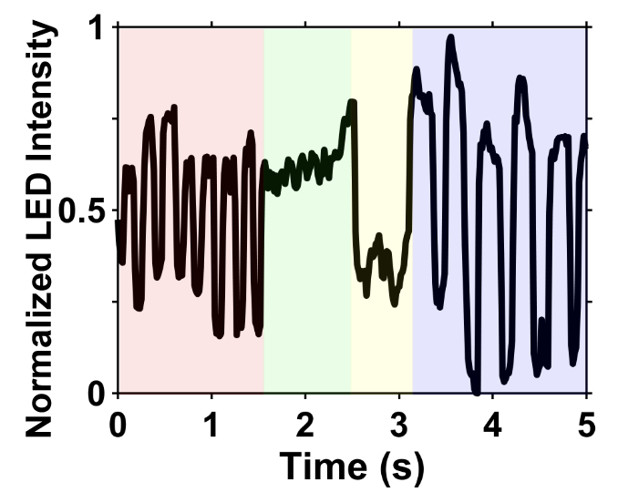
Supplementary Figure 20. Tracked red light intensity of optogenetic stimulation while implanted with control of frequency and duty cycle: 9 Hz, 50% (red); 9 Hz, 100% (green); Off (yellow); 5 Hz, 75% (blue).
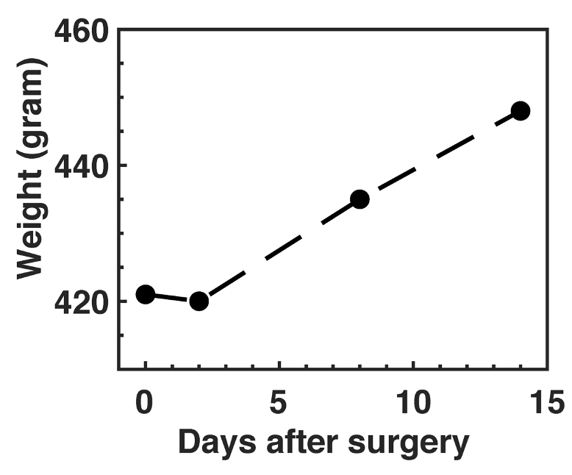
Supplementary Figure 21. Weight of the subject as a function of time post-surgery.
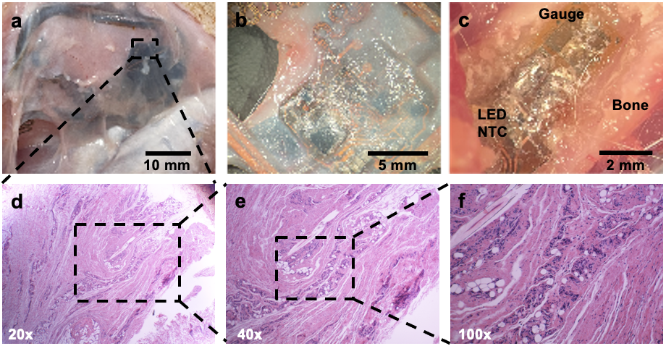
Supplementary Figure 22. Tissue analysis surrounding the device after explantation. a Photograph of tissue growth around device. b Photograph of tissue under microscope. c Photograph of strain gauge glued to the bone. d Histology of tissue sample surrounding device with 20x magnification. e Histology of tissue sample surrounding device with 40x magnification. f Histology of tissue sample surrounding device with 100x magnification.
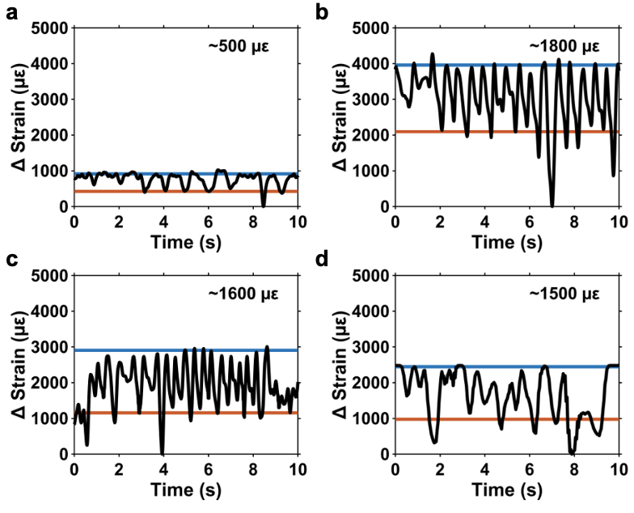
Supplementary Figure 23. Strain gauge data collected over 2 weeks post implantation with the average high (blue) and low (red) peaks in each recording session. a Stain recordings 0 days post-surgery. b 1 day post-surgery. c 7 days post-surgery. d 17 days post-surgery.
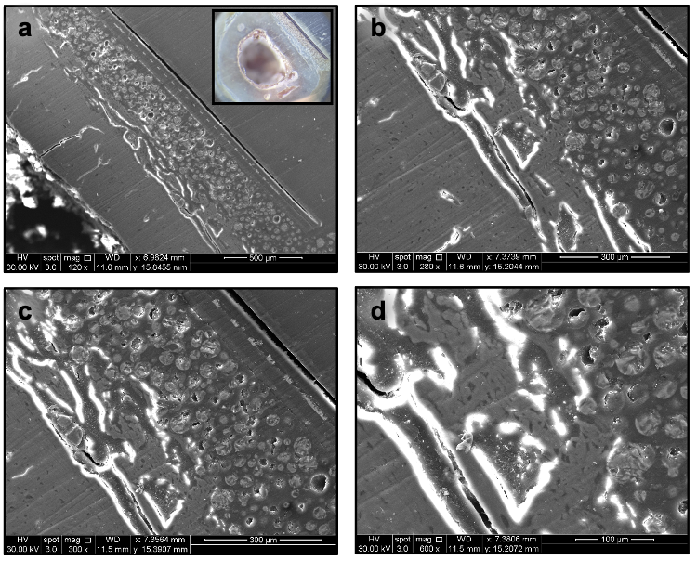
Supplementary Figure 24. Additional SEM cross section images of CPC bone bonding. a SEM cross section of strain gauge bonded to the bone using CPC particles with a magnification of 120x and a photograph image inset. b SEM cross section with a magnification of 280x, c 300x, and d 600x.
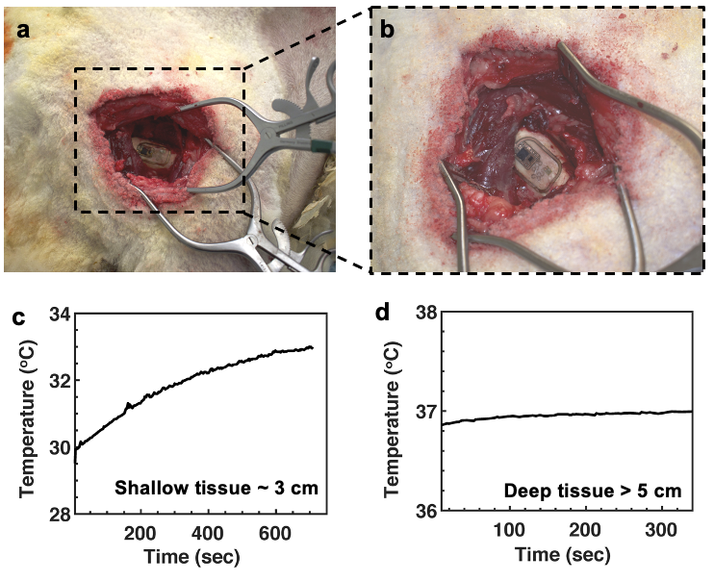
Supplementary Figure 25. In-situ study in sheep cadaver. a-b Photograph of the sheep left shoulder with an osseosurface electronic device attached on the surface of the humerus. c-d Temperature profiles wirelessly recorded from different depths in the sheep cadaver: ~3 cm (c) and > 5 cm (d).
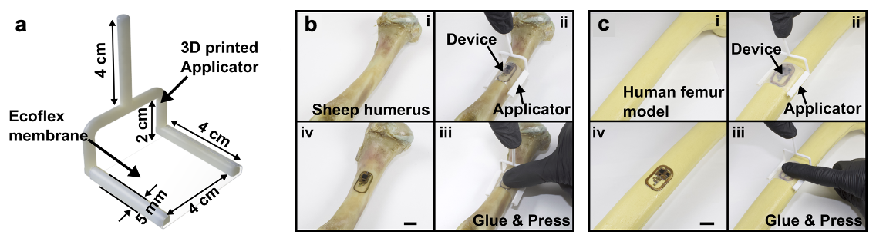Supplementary Figure 26. Strategy for attaching devices on the bone. a 3D rendering of the applicator with dimensions suitable for the sheep humerus and devices with footprint of 2.5 cm x 1.5 cm. b Step-by-step procedures of attaching a small footprint (1.5 cm x 1 cm) device on the sheep humerus. c Step-by-step procedures of attaching a device (2.5 cm x 1.5 cm) on the human femur model.
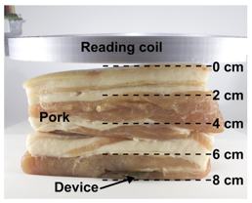
Supplementary Figure 27. Photograph of the setup for measuring the power harvesting capability and wireless data communication.

Supplementary Table 1. Record of device implant and failure mode analysis.

Device | Implantation Period (days) | Device Failure Mechanism
1 | 14 | Data recording was inconsistent with unknown device failure. (Unknown failure)
2 | 6 | Animal died under anesthesia
3 | 28 | Induced pre strain during surgery resulted in out-of-range strain recording. Device was recovered for analysis
4 | 21 | Device re-positioned and device body folded on itself while implanted resulting in diminished RF performance. Device was recovered for analysis
5 | 22 | Encapsulation failure
6 | 43 | High stresses in the tabs holding the device body showed wear and cracking in Parylene encapsulation resulting in circuit damage.
7 | 5 | Animal death due to undetermined cause.
8 | 25 | Defect in encapsulation on self-similar serpentine.
9 | Alive | Animal still alive
10 | 27 | Device recovered for SEM bone attachment analysis.

