Table S1. Composition of Diets
Research Diets Cat No:  Ingredient(g) | D11092301  5% Casein | D11051801  20% Casein | D11092308  HF-5%C | D11092309  HF-20%C
Casein | 50 | 200 | 50 | 200
L-Cystine | 0.75 | 3 | 0.75 | 3
Corn Starch | 485 | 375.7 | 134.1 | 0
Maltodextrin 10 | 150 | 125 | 125 | 125
Sucrose | 107.1 | 107.1 | 107.1 | 107.1
Cellulose | 50 | 50 | 50 | 50
Soybean Oil | 25 | 25 | 25 | 25
Lard | 75 | 75 | 242 | 242
Mineral Mix S10022C | 3.5 | 3.5 | 3.5 | 3.5
Calcium Carbonate | 8.7 | 12.5 | 8.7 | 12.495
Calcium Phosphate Dibasic | 5.3 | 0 | 5.3 | 0
Potassium Citrate | 2.4773 | 2.5 | 2.4773 | 2.4773
Potassium Phosphate | 6.86 | 6.86 | 6.86 | 6.86
Sodium Chloride | 2.59 | 2.59 | 2.59 | 2.59
Vitamin Mix V10037 | 10 | 10 | 10 | 10
Choline Bitrartrate | 2.5 | 2.5 | 2.5 | 2.5
FD&C Yellow Die #5 | 0 | 0.05 | 0 | 0.025
FD&C Red Dye #40 | 0.05 | 0 | 0.025 | 0
FD&C Blue Dye #1 | 0 | 0 | 0.025 | 0.025
Total | 984.8 | 1001.3 | 775.9 | 792.6
 | D11092301 | D11051801 | D11092308 | D11092309
Ingredient(g) | 5% Casein | 20% Casein | HF-5%C | HF-20%C
gm%
Protein | 5 | 18 | 6 | 23
Carbohydrate | 76 | 62 | 48 | 31
Fat | 10 | 10 | 34 | 34
kcal%
Protein | 4 | 18 | 4 | 18
Carbohydrate | 74 | 60 | 37 | 24
Fat | 22 | 22 | 59 | 59

Table S2. List of Primers
Oligonucleotides
Fgf21 Forward: CAAATCCTGGGTGTCAAAGC | Integrated DNA Technologies (IDT)
Fgf21 Reverse: CATGGGCTTCAGACTGGTAC | IDT
Fgfr1 Forward: AAAGATCTGGTATCCTGTGCC | IDT
Fgfr1 Reverse: TCGAGCTAAGCCAAAGTCTG | IDT
Klb Forward: CAGGGATATCTACATCACAGCC | IDT
Klb Reverse: GTAGCCTTTGATTTTGACCTTGTC | IDT
Fas Forward: GGGATCTGGTGAAAGCTGTAG | IDT
Fas Reverse: GTGTTCTCGTTCCAGGATCTG | IDT
Scd-1 Forward: CTGTACGGGATCATACTGGTTC; | IDT
Scd-1 Reverse: CGTGCCTTGTAAGTTCTGTG | IDT
Srebp1 Forward: AGATTGTGGAGCTCAAAGACC | IDT
Srebp1 Reverse: CACTTCGTAGGGTCAGGTTC | IDT
Ucp1 Forward: CACCTTCCCGCTGGACAC | IDT
Ucp1 Reverse: CCCTAGGACACCTTTATACCTAATGG | IDT
Phgdh Forward: ATTGTCGGCCTTCTGAGAGA | IDT
Phgdh Reverse : AAGACAGCTCCGTTGAGCAT | IDT
ASNS Forward: GGAGAGGGGTCAGATGAACTT | IDT
ASNS Reverse: CTCCTCCTCGGCCTTCTC | IDT
AdipoQ Forward: TGTCTGTACGATTGTCAGTGG | IDT
AdipoQ Reverse: AGTAACGTCATCTTCGGCATG | IDT
ppar-a Forward: CTGAACATCGACTGTCGAA | IDT
ppar-a Reverse: GCTCTCCATGTCATGTATGA | IDT
ppar-g Forward: TGTTATGGGTGAAACTCTGGG | IDT
ppar-g Reverse: CCAACTTCGGAATCAGCTCT | IDT
pgc-1 Forward: CCCTGCCATTGTTAAGACC | IDT
pgc-1 Reverse: TGCTGCTGTTCCTGTTTTC | IDT
Cidea Forward: ATCACAACTGGCCTGGTTACG | IDT
Cidea Reverse: TACTACCCGGTGTCCATTTCT | IDT

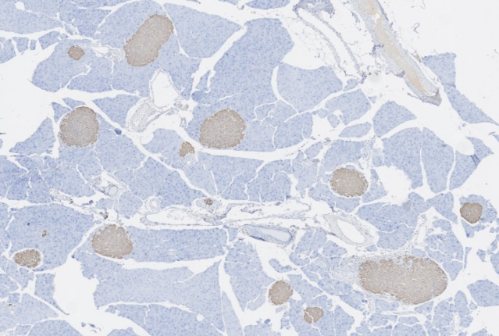
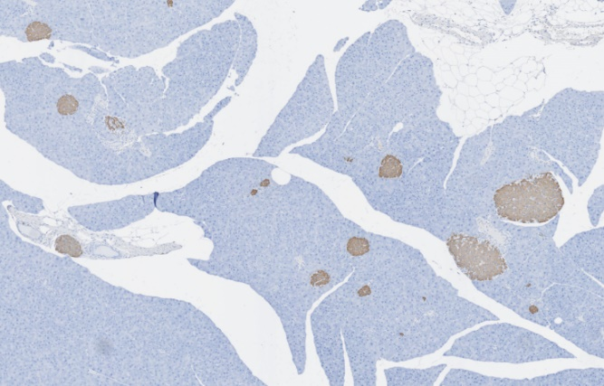
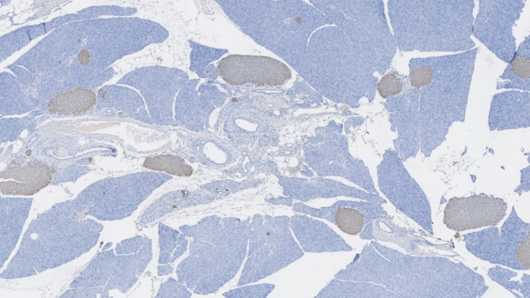
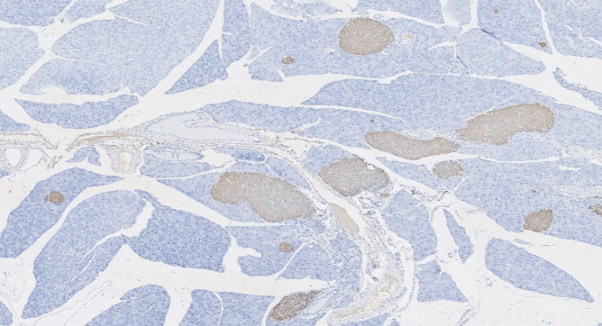
WT-CON
WT-LP
Fgf21 KO-CON
Fgf21 KO-LP

Supplemental Figure S1
Representative images of pancreatic tissue highlighting islet numbers and size, associated with insulin positive area and islet fraction data provided in Figures 4K and 4L. Final data in Figure 4 reflect the averaging of at least 10 sections per animal, with 5 animals per treatment group being used for final statistical analysis. Scale bar represents 500um.

WT-CON
Fgf21 KO-CON

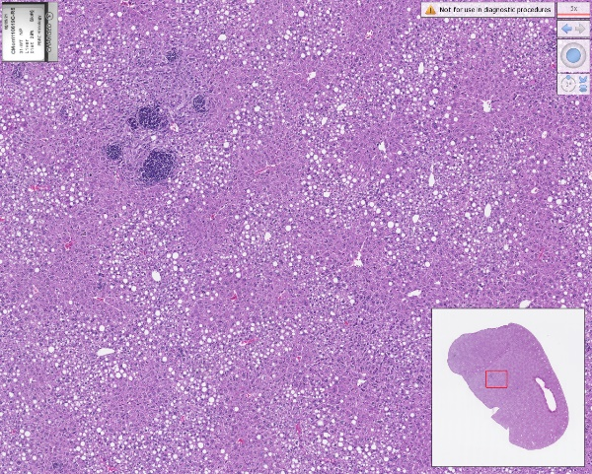
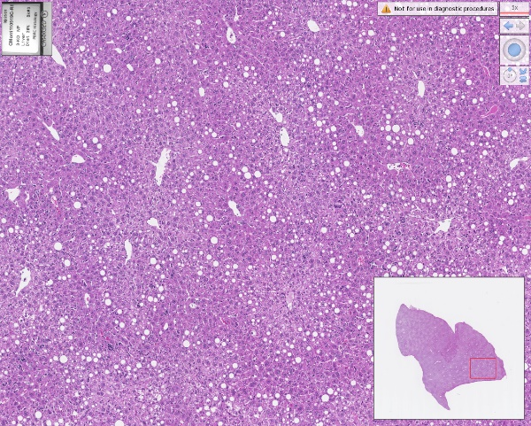

Fgf21 KO-LP
WT-LP

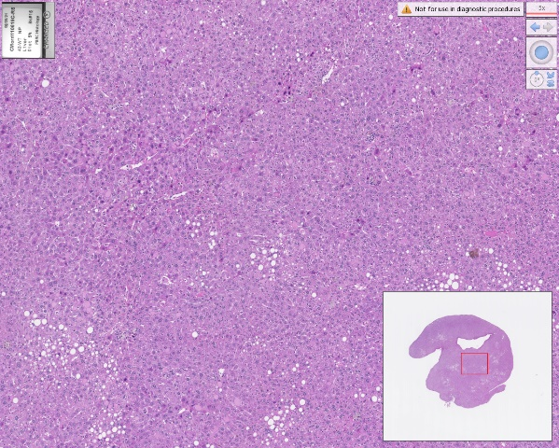
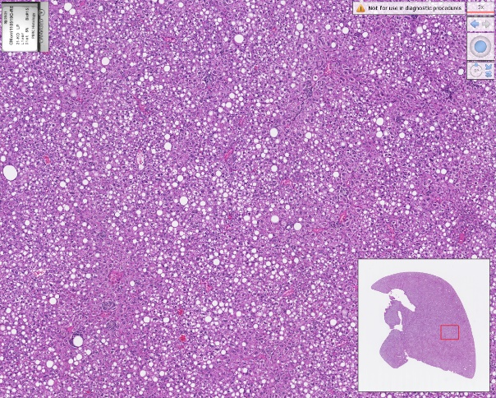

Supplemental Figure S2
Representative images of liver H&E staining in mice from the metabolic cohort, collected at sacrifice at 22 months of age. Images are for illustrative purposes and were not used in any subsequent analysis. Scale bar represents 500um.

Fgf21 KO-CON

