Supplementary Information for
Tectonically-driven oxidant production in the hot biosphere

This file includes:
Supplementary Discussion
Supplementary Figures
Supplementary Tables

1. Supplementary Discussion
Oxygen mass balance calculations
The μmol O₂ in the starting vials was estimated by summing together a) μmol of O₂ in the ball mill during grinding, b) the μmol of O₂ in the 6 mL vial headspace, and c) the added 4 mL of water.
To calculate the O₂ that could be added during grinding in the ball mill, we carried out triplicate blank runs using the same protocol as for rock samples with the omission of the rock and the grinding balls (the latter to avoid excessive wear on the agate ball mill). After placing in the Planetary Ball Mill for 30 min at 500 rpm, the ball mill was transferred to the glove bag (<0.1 ppm O₂) and a 1/8 inch Swagelok fitting containing a rubber septa was attached to the one of the ball lid valves. A 10 mL gastight syringe and needle was then used to sample 3 mL of gas from the ball mill, after pumping the syringe 6× to ensure the outlet valve gas was in equilibrium with the ball mill interior. This 3 mL of gas was injected into a 3 mL pre-evacuated Exetainer with double-wadded cap. The Exetainers were then removed from the glove bag and O₂ measured using a needle-type Presens O₂ sensor freshly calibrated against a 0% (sodium sulfite in water) and air. For comparison, the O₂ was also measured in three Exetainers to which 3 mL of 99.999% N₂ were added within the glove bag (Supplementary Table 1).
Supplementary Table 1. O₂ measurements of blank ball mills runs compared to starting N₂
 | % O₂ in Exetainers + 3 mL sampled from ball mill blank runs | % O₂ in Exetainers + 3 mL N₂
 | 0.30 | 0.27
 | 0.24 | 0.34
 | 0.35 | 0.32
mean | 0.30 | 0.31
stdev | 0.06 | 0.04

The small concentration of O₂ within the N₂ filled Exetainers (mean of 0.31%) is most likely due to residual air within the evacuated vials prior adding samples. The lack of any significant difference (± 1 × standard deviation) between starting N₂ gas and the gas measured in ball mill after blank runs indicates no detectable air contamination during grinding. However, due to the variation in the N₂-filled Exetainers, we cannot rule out a small amount of contamination; even a small percent contamination of O₂ in the ball mill could have an appreciable result given the relatively large volume of the ball mill (49.3 mL when filled with grinding balls and 45 g rock, assuming a rock density of 3.0 g mL⁻¹) relative to the incubation vials (4 mL headspace). We therefore conservatively use a value of 3 × standard deviations of the blanks (0.12 %) as a maximum estimate of O₂ contamination value during the ball milling. To calculate the nmol g⁻¹ O₂ equivalent, we use the ideal gas law (n = PV/RT), P = pressure of O₂ in atmospheres (0.0012), V = volume of vial headspace (0.048 L), R = Gas Constant (0.08314426 L⋅bar⋅K⁻¹⋅mol⁻¹), and T = temperature (293.15° K), and divide by 45 g to normalise to rock mass within the ball mill, to give 54.7 nmol O₂ g⁻¹.
To calculate the O₂ added in to vials in the headspace of the vials, we again use the ideal gas law (n = PV/RT), using an upper estimate of O₂ in the glove bag of 0.1% (see Methods), where V = volume of vial headspace (0.006 L), R = Gas Constant (0.08314426 L⋅bar⋅K⁻¹⋅mol⁻¹), and T = temperature (293.15° K), and divide by 2 g to normalise to rock mass to give 1.2 nmol O₂ g⁻¹. To calculate the O₂ added in the water we use the maximum dissolved O₂ measured in the experiments (0.268 mg L⁻¹, equivalent to 8.38 μmol L⁻¹), normalize to 4 mL, and divide by 2 g to give 16.8 nmol g⁻¹. We then add the O₂ from the vial headspace and water together (54.7 + 1.2 + 16.8) to give a total of 72.7 nmol g⁻¹. This conservative O₂ concentration is between 10 and 50 × smaller than H₂O₂ concentrations after 1 week at 104°C in rock experiments (Figure 2, 3).

2. Supplementary Figures

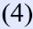
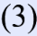
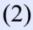
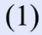
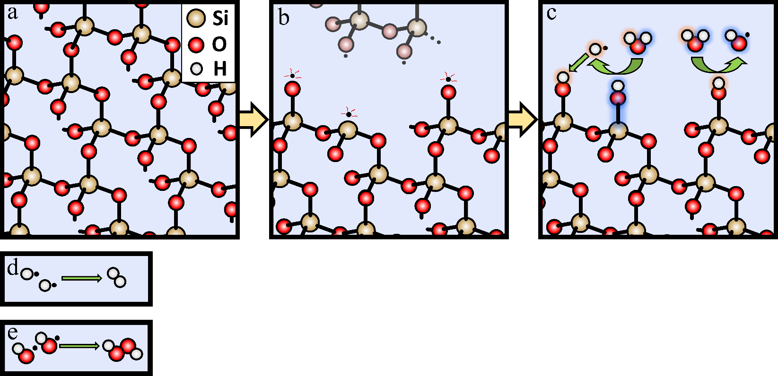

2≡Si• + 2H₂O → 2≡SiOH + 2H• (1)
2H• → H₂ (2)
≡SiO• + H• → ≡SiOH (3)
2≡SiO• + 2H₂O → 2≡SiOH + 2•OH (4)
2•OH → H₂O₂ (5)

Supplementary Figure 1: Mechanochemical reactions relating to H₂ and H₂O₂ production from cataclasis. (a) The structure of quartz. (b) Crushing rocks produces surface defects: Si• and SiO•. (c) Si• reacts with H₂O to produce SiOH and H•. SiO• reacts with H• to produce SiOH, but also reacts with H₂O to produce •OH and SiOH. (d) 2H• combine to form H₂ (e) 2•OH combine to form H₂O₂.

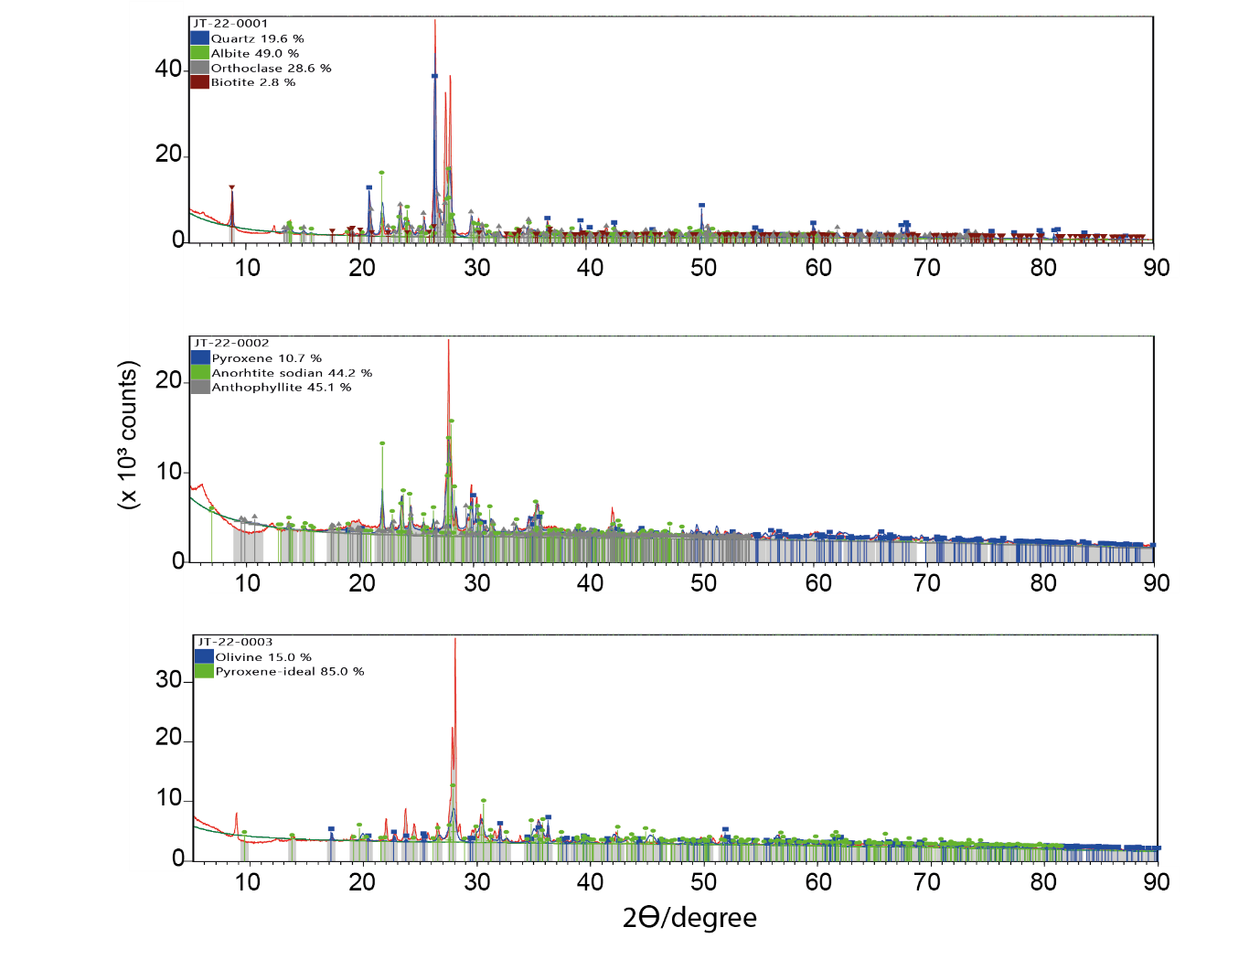
Supplementary Figure 2: Mineral composition of the three rock types used in the experiments. Figures show XRD scans and mineral identifications identified using the Rietveld method to identify major crystalline phases. Sample 1 (granite): quartz, albite, orthoclase, biotite. Sample 2 (basalt): pyroxene, anorthite, anthopyllite (amphibole). Sample 3 (peridotite): olivine, pyroxene.
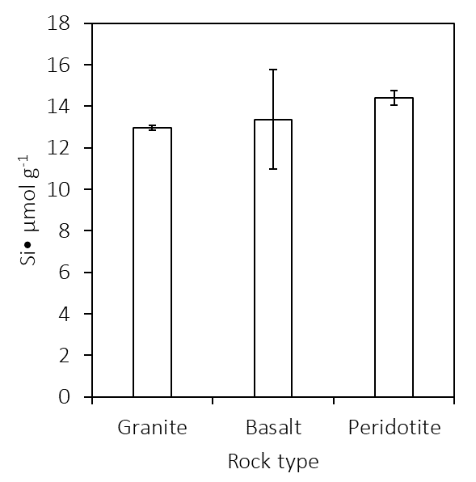
Supplementary Figure 3: The concentration of Si• on the surface of crushed granite, basalt, and peridotite crushed at 500 rpm for 30 min. The error bars are the standard error of the mean.

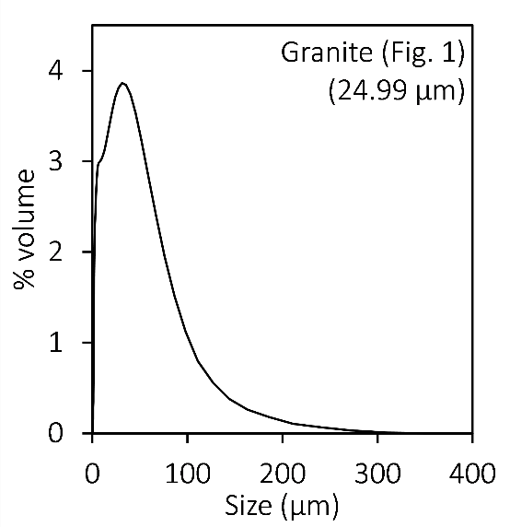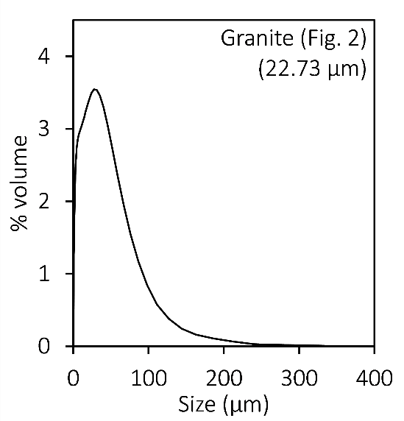
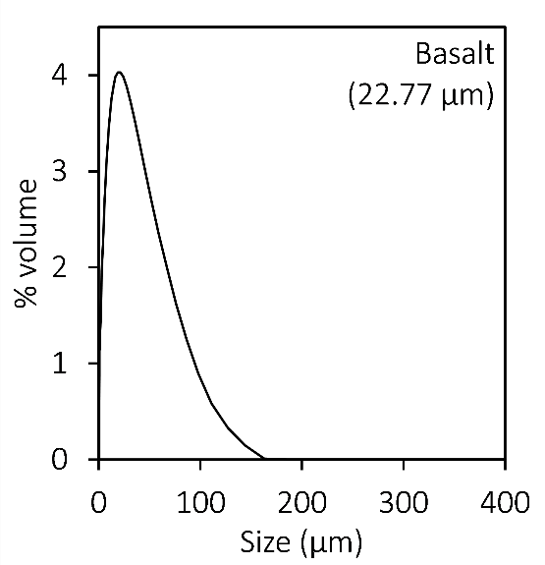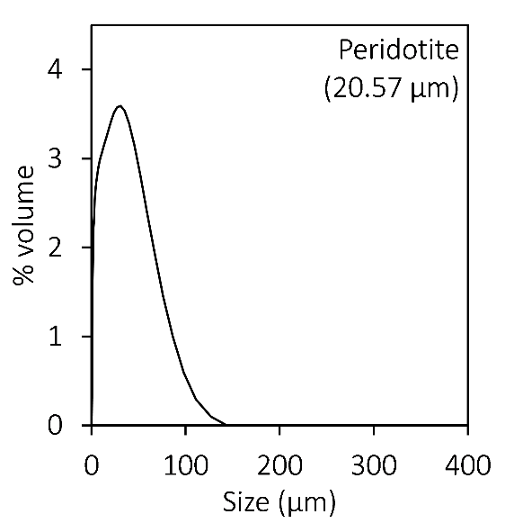
Supplementary Figure 4: The grain size distributions and mean grain sizes (volume weighted) for all the rocks used in these experiments. The granite in the top left is the grain size for the data shown in Figure 1. All other rocks correspond to the rocks crushed for the data presented in Figures 2 & 3.
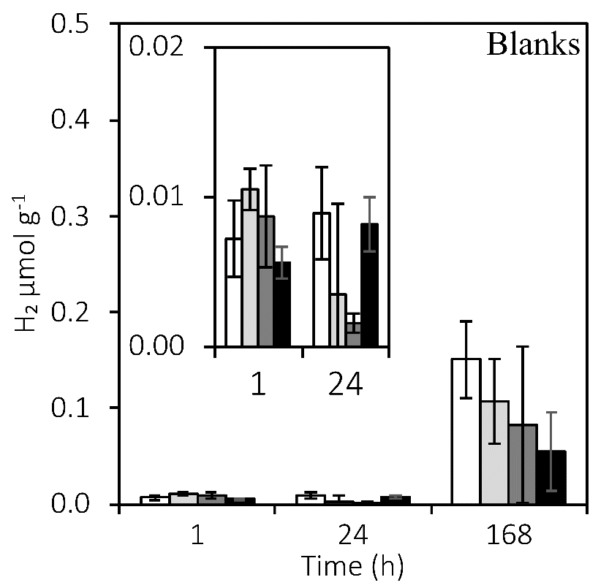

Supplementary Figure 5: H₂ production from the blanks corresponding to Figure 1. The vials were filled with 4 mL anoxic water and flash heated to 30, 60, or 121 °C and incubated at 0 °C for either 1, 24, or 168 hrs. Time points are accurate to ±2 hrs. Error bars represent the standard error of the mean. The inset utilises the same axis titles.
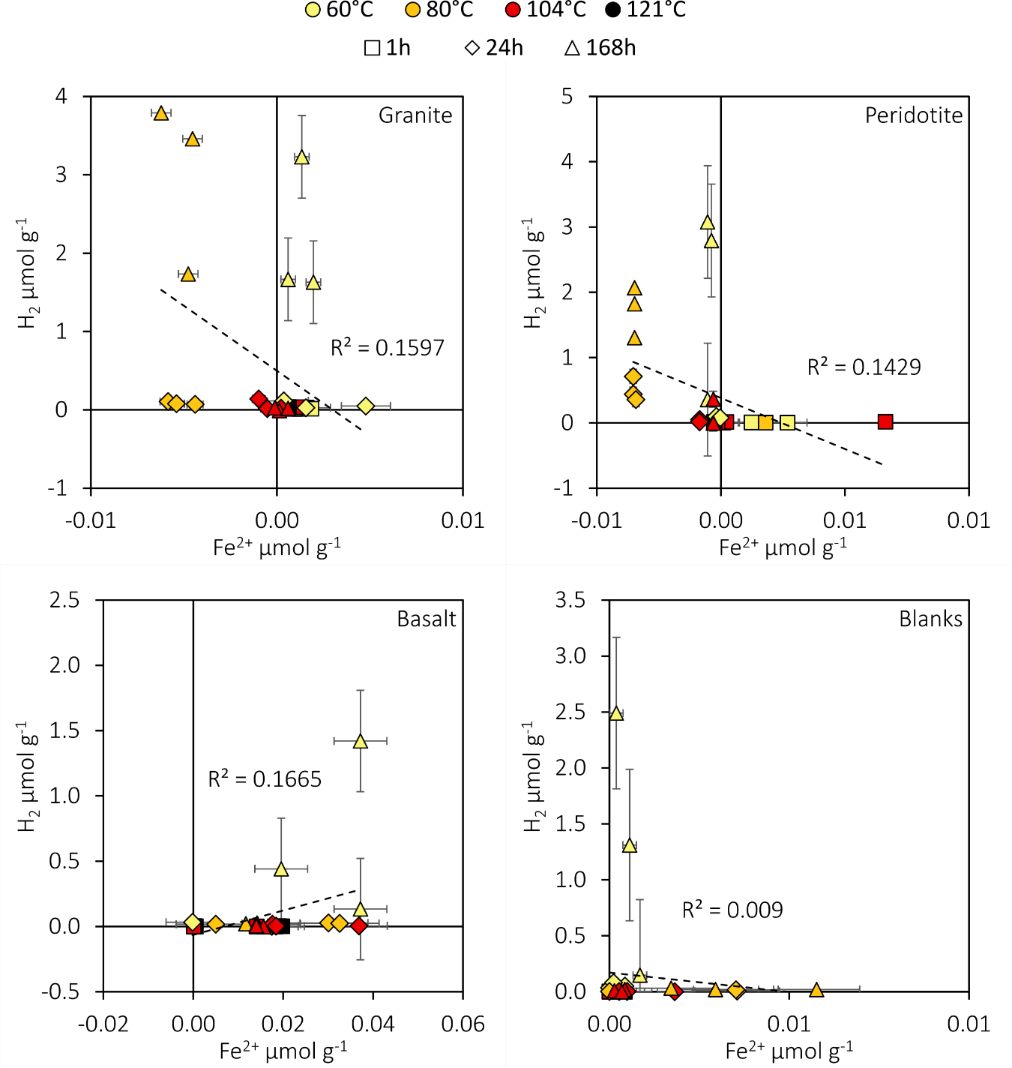
Supplementary Figure 6: Plots of Fe²⁺ and H₂ produced in experiments with crushed basalt, peridotite and granite in water. All data are blank subtracted. Error bars are the standard deviation of the blanks multiplied by two. The experimental detection limits for Fe²⁺ and H₂ are 0.004 and 0.00002 μmol g⁻¹, respectively.
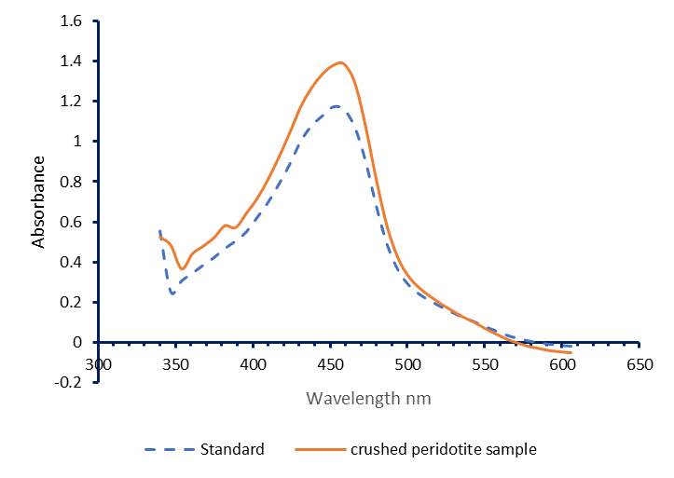
Supplementary Figure 7. Comparison of wavelength dependent adsorption spectra of a 200 μM H₂O₂ standard (blue dashed line) and aqueous extract of crushed peridotite crushed under N₂ and incubated at 104°C for 1 week (red solid line).
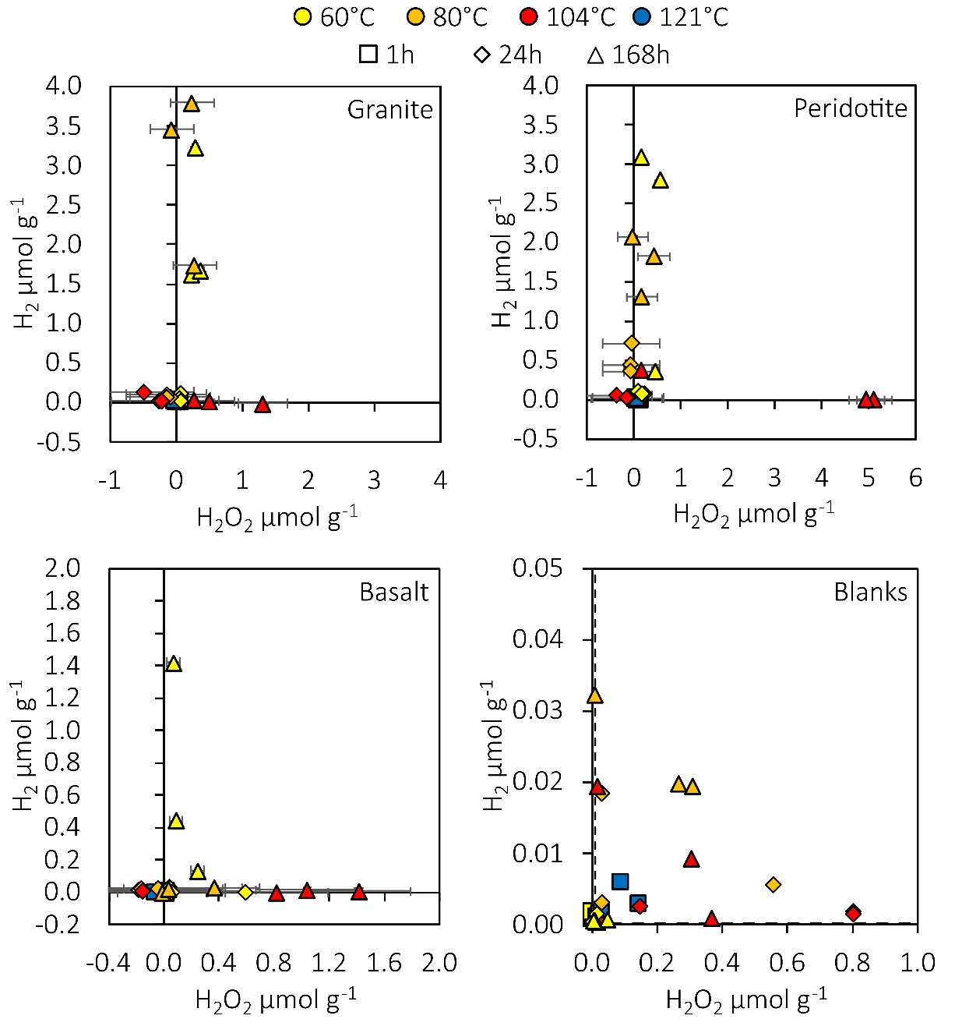
Supplementary Figure 8: Plots of H₂ and H₂O₂ production by each rock type, including the blanks. The detection limits for H₂ and H₂O₂ were to 0.0002 and 0.0092 μmol g⁻¹, respectively. The 121v°C experiment was only measured after 1 hour, while the other temperatures show three time points: 1, 24, and 168 hrs. The error bars are 2× the standard deviation of the blanks at each temperature and time point. All data (except the blanks) is blank mean subtracted. The detection limits for H₂ and H₂O₂ were 0.2 nmol g⁻¹ and 9.2 nmol g⁻¹, respectively.

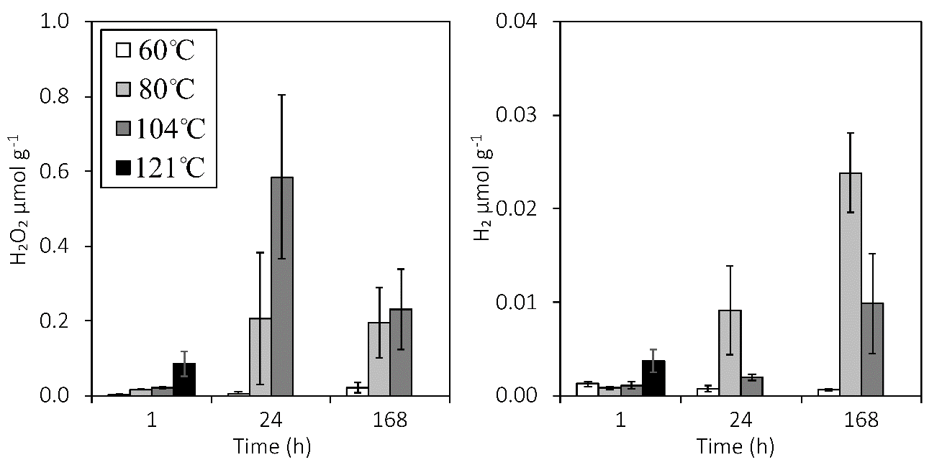
Supplementary Figure 9: The H₂O₂ and H₂ production from the blanks corresponding to Figure 2. Error bars are the standard error of the mean.
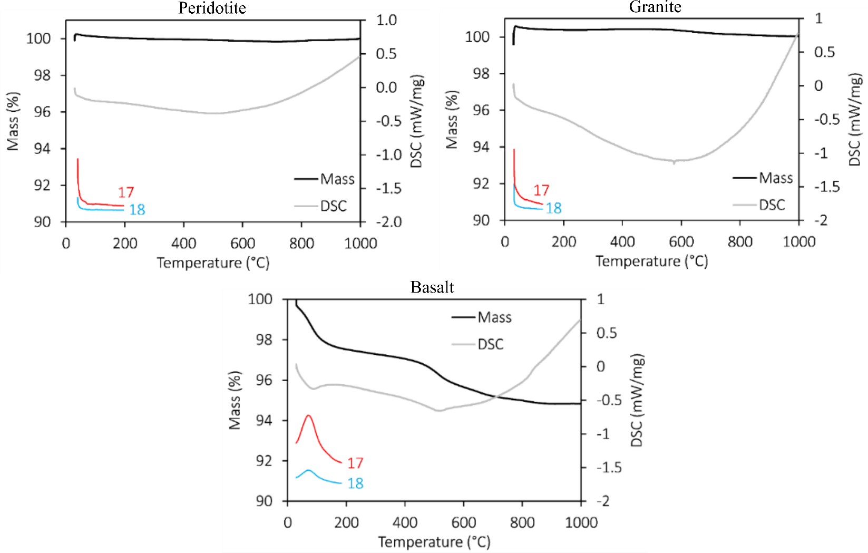
Supplementary Figure 10: TGA results for basalt, granite, and peridotite showing a mass decrease at ~100 °C in basalt, coinciding with the detection of molecules with molecular weights of 17 and 18 (most likely OH and H₂O within the structure of the rocks). DSC = Differential scanning calorimetry. The red and blue lines show the detection of molecules with molecular weights of 17 and 18, coinciding with a mass decrease of ~2%. The y axis for the DSC results (red and blue lines) is m/z (mass to charge ratio).
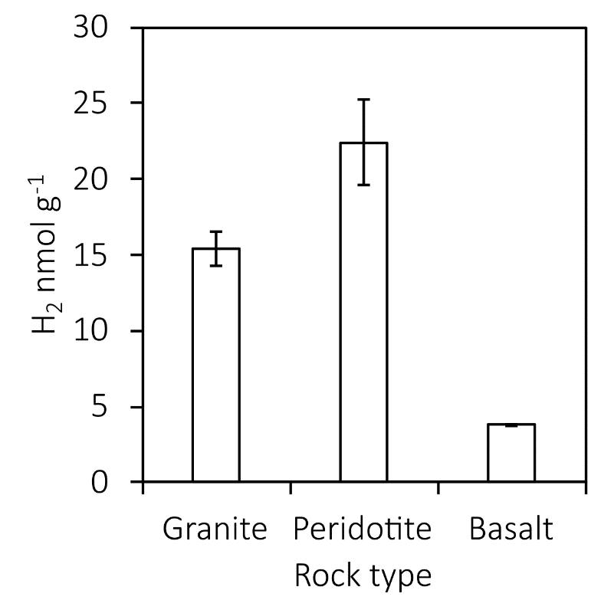
Supplementary Figure 11: Production of H₂ from crushed rocks in the Planetary Ball Mill. Error bars are the standard error of the mean of three separate experiments where 45g of rock was crushed under N₂ at 500 rpm for 30 min.
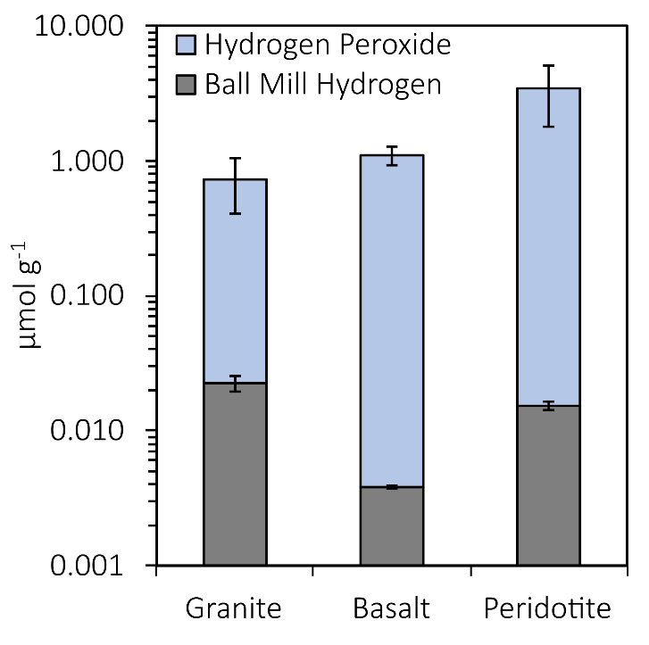
Supplementary Figure 12: Hydrogen production in the ball mill compared to the H₂O₂ production at 104 °C after a week – the ball mill H₂ production (from the inferred reaction of Si•) cannot explain the SiO• surplus required for net H₂O₂ production. H₂O₂ production after a week at 104 °C is in blue. H₂ production in the ball mill is in grey. Error bars are the standard error of the mean. Note the logarithmic scale.
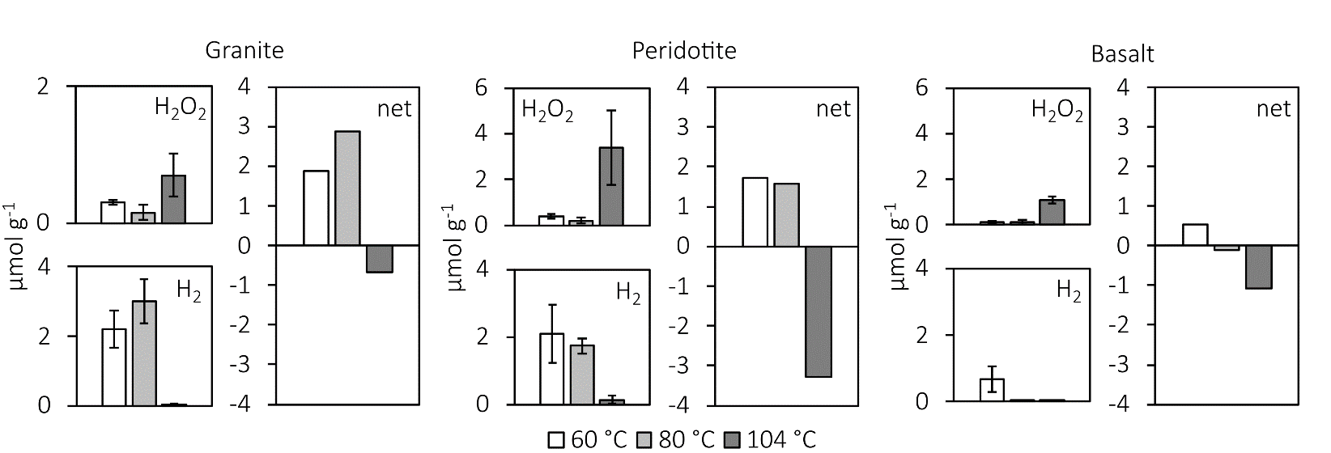
Supplementary Figure 13: The H₂O₂ and H₂ produced in continuous heating experiments for crushed granite, peridotite and basalt after a week, and the net oxidant production. The net oxidant production is negative (i.e. net excess of oxidant) for all rock types at 104 °C. Error bars are the standard error of the mean. All vertical scales are μmol g⁻¹.
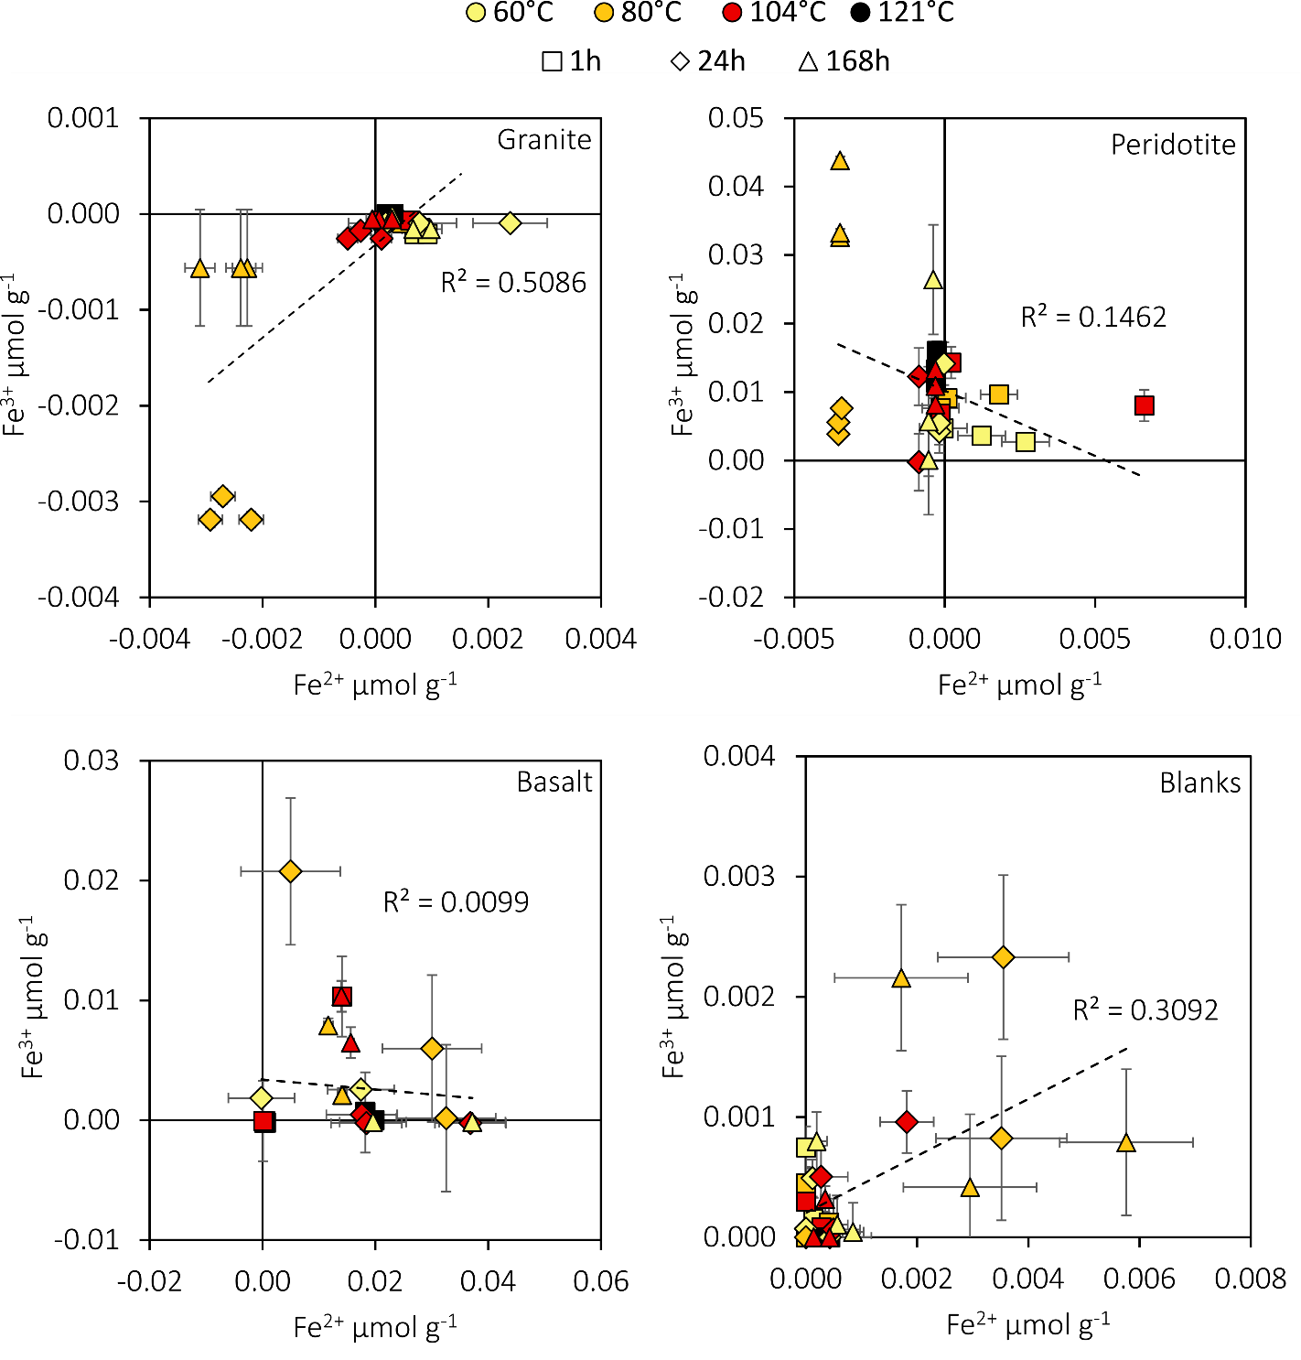
Supplementary Figure 14: Plots of Fe²⁺ and Fe³⁺ produced in experiments with crushed basalt, peridotite and granite in water. All data are blank subtracted. Error bars are the standard error of the mean. The experimental detection limits for Fe²⁺ and Fe³⁺ are 0.004 and 0.005 μmol g⁻¹, respectively.
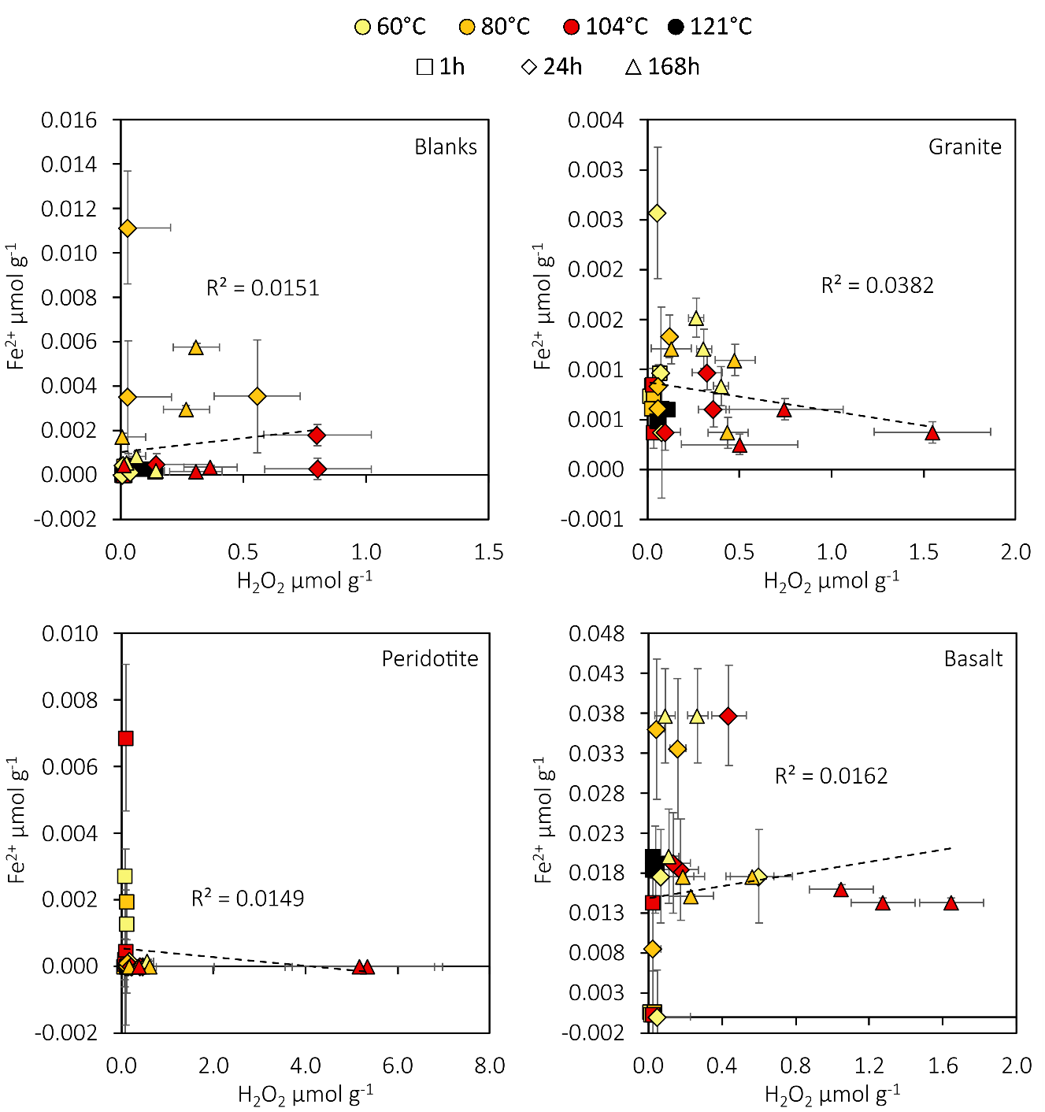
Supplementary Figure 15: Plots of Fe²⁺ and H₂O₂ produced in experiments with crushed basalt, peridotite and granite in water. All data are blank subtracted. Error bars are the standard deviation of the blanks multiplied by two. The experimental detection limits for Fe²⁺ and H₂O₂ are 0.004 and 9.2 nmol g⁻¹ μmol g⁻¹, respectively.

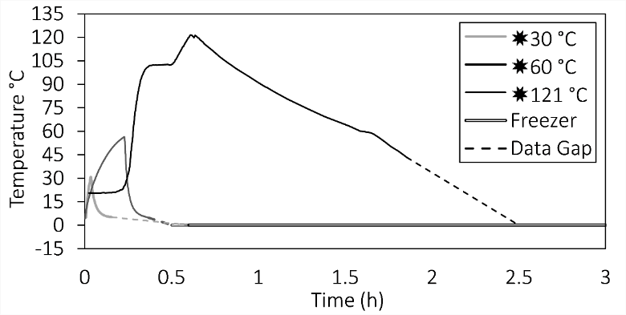
Supplementary Figure 16: A time series of the flash heating temperature changes. ✸ indicates flash heating. Temperature measurements were taken every two seconds for ✸30v°C and ✸60 °C and recorded manually for ✸121 °C every 30 sec.

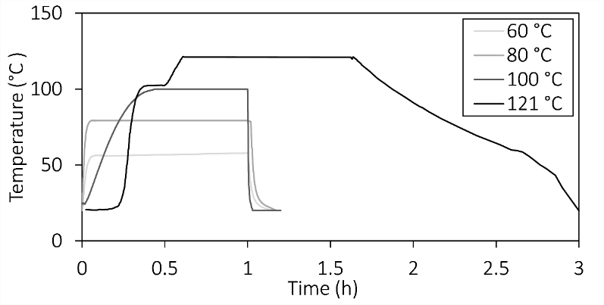
Supplementary Figure 17: Continuous heating temperature probe data for temperature change within the vials over the first hour. The data for 121 °C was not recorded for a 1 hr cycle of the autoclave, or for the decrease from ~60 °C down to 20 °C, so data from 80 °C and the flash heating experiment were used to fill in the gaps. For longer time points (24 and 168 hrs; excluding 121 °C), the time is prolonged at the respective temperature maximum. Variations in heating rate were caused by the use of different heating apparatus (water bath – 60 °C & 80 °C), oven (104 °C), and autoclave (121 °C).

3. Supplementary Tables
Supplementary Table 2: The mean concentrations and standard error of blanks. Detection limits (nmol g⁻¹): H₂O₂ = 9.2, H₂ = 0.2, •OH = 29.46, Fe²⁺ = 0.004, Fe³⁺ = 0.005.
Blanks Mean
Experiment | Time (h) | Temp (°C) | H₂O₂ | H₂ | pH | •OH | Fe²⁺ | Fe³⁺
Experiment | Time (h) | Temp (°C) | μmol g⁻¹ | μmol g⁻¹ | pH | μmol g⁻¹ | μmol g⁻¹ | μmol g⁻¹
Blanks (Fig. 2) | 1 | 60 | 0.003 | 0.001 | 7.7 | 0.008 | <0.0001 | 0.0004
Blanks (Fig. 2) | 1 | 80 | 0.018 | 0.001 | 8.7 | 0.017 | 0.0001 | 0.0002
Blanks (Fig. 2) | 1 | 104 | 0.022 | 0.001 | 8.0 | 0.008 | 0.0002 | 0.0001
Blanks (Fig. 2) | 3 | 121 | 0.086 | 0.004 | 9.0 | 0.009 | 0.0003 | <0.0001
Blanks (Fig. 2) | 24 | 60 | 0.007 | 0.001 | 8.0 | 0.009 | 0.0002 | 0.0002
Blanks (Fig. 2) | 24 | 80 | 0.206 | 0.009 | 9.0 | 0.008 | 0.0061 | 0.0064
Blanks (Fig. 2) | 24 | 104 | 0.584 | 0.002 | 10.0 | 0.016 | 0.0009 | 0.0005
Blanks (Fig. 2) | 167 | 61 | 0.022 | 0.001 | 7.2 | 0.010 | 0.0005 | 0.0003
Blanks (Fig. 2) | 168 | 80 | 0.195 | 0.024 | 8.8 | 0.009 | 0.0035 | 0.0011
Blanks (Fig. 2) | 168 | 104 | 0.231 | 0.010 | 9.0 | 0.008 | 0.0003 | 0.0001
Blanks (Fig. 1) | 1 | 0 |  | 0.004
Blanks (Fig. 1) | 1 | 30 |  | 0.006
Blanks (Fig. 1) | 1 | 60 |  | 0.005
Blanks (Fig. 1) | 1 | 121 |  | 0.003
Blanks (Fig. 1) | 24 | 0 |  | 0.005
Blanks (Fig. 1) | 24 | 30 |  | 0.009
Blanks (Fig. 1) | 24 | 60 |  | 0.001
Blanks (Fig. 1) | 24 | 121 |  | 0.005
Blanks (Fig. 1) | 168 | 0 |  | 0.088
Blanks (Fig. 1) | 168 | 30 |  | 0.063
Blanks (Fig. 1) | 168 | 60 |  | 0.049
Blanks (Fig. 1) | 168 | 121 |  | 0.032
Blanks Standard Error of the mean
Blanks (Fig. 2) | 1 | 60 | 0.002 | <0.001 | <0.001 | <0.001 | <0.0001 | 0.0002
Blanks (Fig. 2) | 1 | 80 | 0.002 | <0.001 | <0.001 | 0.009 | 0.0001 | 0.0001
Blanks (Fig. 2) | 1 | 104 | 0.003 | <0.001 | <0.001 | 0.001 | 0.0001 | 0.0001
Blanks (Fig. 2) | 3 | 121 | 0.033 | 0.001 | <0.001 | 0.001 | 0.0001 | <0.0001
Blanks (Fig. 2) | 24 | 60 | 0.004 | <0.001 | <0.001 | <0.001 | 0.0001 | 0.0002
Blanks (Fig. 2) | 24 | 80 | 0.176 | 0.005 | 0.005 | <0.001 | 0.0025 | 0.0048
Blanks (Fig. 2) | 24 | 104 | 0.219 | <0.001 | <0.001 | 0.007 | 0.0005 | 0.0003
Blanks (Fig. 2) | 167 | 61 | 0.014 | <0.001 | <0.001 | 0.001 | 0.0002 | 0.0002
Blanks (Fig. 2) | 168 | 80 | 0.094 | 0.004 | 0.001 | <0.001 | 0.0012 | 0.0005
Blanks (Fig. 2) | 168 | 104 | 0.108 | 0.005 | <0.001 | 0.001 | 0.0001 | 0.0001
Blanks (Fig. 1) | 1 | 0 |  | 0.001
Blanks (Fig. 1) | 1 | 30 |  | 0.001
Blanks (Fig. 1) | 1 | 60 |  | 0.002
Blanks (Fig. 1) | 1 | 121 |  | 0.001
Blanks (Fig. 1) | 24 | 0 |  | 0.002
Blanks (Fig. 1) | 24 | 30 |  | 0.004
Blanks (Fig. 1) | 24 | 60 |  | 0.000
Blanks (Fig. 1) | 24 | 121 |  | 0.001
Blanks (Fig. 1) | 168 | 0 |  | 0.023
Blanks (Fig. 1) | 168 | 30 |  | 0.026
Blanks (Fig. 1) | 168 | 60 |  | 0.048
Blanks (Fig. 1) | 168 | 121 |  | 0.024
Supplementary Table 3: The blank subtracted mean concentrations of the chemistry measured from crushed rocks experiments. All concentrations are reported in μmol g⁻¹. Detection limits (nmol g⁻¹): H₂O₂ = 9.2, H₂ = 0.2, •OH = 29.46, Fe²⁺ = 0.004, Fe³⁺ = 0.005.
All Blank subtracted means
Experiment | Time (h) | Temp (°C) | H₂O₂ | H₂ | pH | •OH | Fe²⁺ | Fe³⁺
Experiment | Time (h) | Temp (°C) | μmol g⁻¹ | μmol g⁻¹ | pH | μmol g⁻¹ | μmol g⁻¹ | μmol g⁻¹
Granite (Fig. 2) | 1 | 60 | 0.035 | 0.022 | 10.0 | 0.001 | 0.001 | <0.001
Granite (Fig. 2) | 1 | 80 | 0.029 | 0.016 | 8.5 | -0.011 | <0.001 | <0.001
Granite (Fig. 2) | 1 | 104 | 0.010 | 0.032 | 8.0 | -0.001 | <0.001 | <0.001
Granite (Fig. 2) | 3 | 121 | -0.008 | 0.031 | 9.0 | -0.004 | <0.001 | <0.001
Granite (Fig. 2) | 24 | 60 | 0.063 | 0.063 | 8.2 | 0.004 | 0.001 | <0.001
Granite (Fig. 2) | 24 | 80 | -0.125 | 0.085 | 8.3 | 0.001 | 0.001 | <0.001
Granite (Fig. 2) | 24 | 104 | -0.323 | 0.059 | 8.3 | -0.016 | 0.001 | <0.001
Granite (Fig. 2) | 167 | 61 | 0.303 | 2.175 | 9.0 | -0.001 | 0.001 | <0.001
Granite (Fig. 2) | 168 | 80 | 0.152 | 2.995 | 8.0 | 0.002 | 0.001 | <0.001
Granite (Fig. 2) | 168 | 104 | 0.701 | 0.011 | 8.3 | <0.001 | <0.001 | <0.001
Peridotite (Fig. 2) | 1 | 61 | 0.108 | 0.007 | 9.7 | 0.006 | 0.001 | 0.004
Peridotite (Fig. 2) | 1 | 80 | 0.071 | 0.007 | 9.5 | -0.006 | 0.001 | 0.009
Peridotite (Fig. 2) | 1 | 104 | 0.073 | 0.015 | 9.0 | -0.001 | 0.002 | 0.010
Peridotite (Fig. 2) | 3 | 121 | 0.047 | 0.014 | 9.0 | -0.002 | <0.001 | 0.014
Peridotite (Fig. 2) | 24 | 61 | 0.167 | 0.083 | 9.5 | 0.001 | <0.001 | 0.008
Peridotite (Fig. 2) | 24 | 80 | -0.062 | 0.503 | 9.0 | 0.002 | <0.001 | 0.009
Peridotite (Fig. 2) | 25 | 104 | -0.221 | 0.030 | 9.0 | -0.004 | <0.001 | 0.004
Peridotite (Fig. 2) | 167 | 61 | 0.383 | 2.076 | 9.3 | -0.005 | <0.001 | 0.011
Peridotite (Fig. 2) | 167 | 80 | 0.187 | 1.734 | 9.0 | <0.001 | <0.001 | 0.037
Peridotite (Fig. 2) | 167 | 104 | 3.408 | 0.119 | 9.0 | -0.001 | <0.001 | 0.011
Basalt (Fig. 2) | 1 | 61 | 0.013 | 0.003 | 7.8 | 0.001 | <0.001 | <0.001
Basalt (Fig. 2) | 1 | 80 | 0.014 | 0.002 | 7.7 | -0.010 | <0.001 | <0.001
Basalt (Fig. 2) | 1 | 105 | 0.009 | 0.002 | 8.2 | -0.002 | <0.001 | <0.001
Basalt (Fig. 2) | 3 | 121 | -0.053 | 0.003 | 8.0 | -0.003 | <0.001 | <0.001
Basalt (Fig. 2) | 24 | 61 | 0.234 | 0.013 | 7.5 | 0.002 | 0.012 | 0.002
Basalt (Fig. 2) | 24 | 80 | -0.129 | 0.023 | 7.3 | -0.002 | 0.026 | 0.012
Basalt (Fig. 2) | 24 | 105 | -0.335 | 0.008 | 7.7 | -0.010 | 0.025 | <0.001
Basalt (Fig. 2) | 168 | 61 | 0.135 | 0.665 | 7.5 | -0.002 | 0.032 | <0.001
Basalt (Fig. 2) | 168 | 80 | 0.134 | 0.016 | 7.5 | -0.002 | 0.017 | 0.005
Basalt (Fig. 2) | 168 | 105 | 1.092 | 0.006 | 8.0 | 0.001 | 0.015 | 0.009
Granite (Fig. 1) | 1 | 0 |  | -0.002
Granite (Fig. 1) | 1 | 30 |  | 0.006
Granite (Fig. 1) | 1 | 60 |  | 0.020
Granite (Fig. 1) | 1 | 121 |  | 0.115
Granite (Fig. 1) | 24 | 0 |  | 0.015
Granite (Fig. 1) | 24 | 30 |  | 0.174
Granite (Fig. 1) | 24 | 60 |  | 0.238
Granite (Fig. 1) | 24 | 121 |  | 0.087
Granite (Fig. 1) | 168 | 0 |  | 0.345
Granite (Fig. 1) | 168 | 30 |  | 0.335
Granite (Fig. 1) | 168 | 60 |  | 0.314
Granite (Fig. 1) | 168 | 121 |  | 0.073

Supplementary Table 4: The standard error of the mean of the chemistry measured from crushed rock experiments corresponding to the means presented in Supplementary Table 3.
All Blank subtracted standard error
Experiment | Time (h) | Temp (°C) | H₂O₂ | H₂ | pH | •OH | Fe²⁺ | Fe³⁺
Experiment | Time (h) | Temp (°C) | μmol g⁻¹ | μmol g⁻¹ | pH | μmol g⁻¹ | μmol g⁻¹ | μmol g⁻¹
Granite (Fig. 2) | 1 | 60 | 0.017 | 0.004 | 0.000 | 0.000 | 0.0001 | 0.0000
Granite (Fig. 2) | 1 | 80 | 0.016 | 0.003 | 0.408 | 0.002 | 0.0000 | 0.0000
Granite (Fig. 2) | 1 | 104 | 0.002 | 0.003 | 0.000 | 0.000 | 0.0002 | 0.0000
Granite (Fig. 2) | 3 | 121 | 0.017 | 0.003 | 0.000 | 0.002 | 0.0000 | 0.0000
Granite (Fig. 2) | 24 | 60 | 0.007 | 0.026 | 0.441 | 0.001 | 0.0007 | 0.0000
Granite (Fig. 2) | 24 | 80 | 0.021 | 0.011 | 0.333 | 0.001 | 0.0002 | 0.0001
Granite (Fig. 2) | 24 | 104 | 0.082 | 0.040 | 0.333 |  | 0.0002 | 0.0000
Granite (Fig. 2) | 167 | 61 | 0.040 | 0.527 | 0.577 | 0.001 | 0.0002 | 0.0000
Granite (Fig. 2) | 168 | 80 | 0.109 | 0.637 | 0.577 | 0.001 | 0.0003 | 0.0000
Granite (Fig. 2) | 168 | 104 | 0.317 | 0.010 | 0.333 | 0.002 | 0.0001 | 0.0000
Peridotite (Fig. 2) | 1 | 61 | 0.014 | 0.002 | 0.333 |  | 0.0008 | 0.0006
Peridotite (Fig. 2) | 1 | 80 | 0.016 | 0.000 | 0.289 | 0.001 | 0.0006 | 0.0006
Peridotite (Fig. 2) | 1 | 104 | 0.005 | 0.002 | 0.000 | 0.001 | 0.0022 | 0.0023
Peridotite (Fig. 2) | 3 | 121 | 0.010 | 0.001 | 0.289 | 0.002 | 0.0000 | 0.0014
Peridotite (Fig. 2) | 24 | 61 | 0.039 | 0.007 | 0.408 | 0.001 | 0.0001 | 0.0031
Peridotite (Fig. 2) | 24 | 80 | 0.006 | 0.108 | 0.000 | 0.001 | 0.0000 | 0.0011
Peridotite (Fig. 2) | 25 | 104 | 0.078 | 0.011 | 0.000 | 0.001 | 0.0000 | 0.0042
Peridotite (Fig. 2) | 167 | 61 | 0.118 | 0.863 | 0.167 | 0.003 | 0.0001 | 0.0080
Peridotite (Fig. 2) | 167 | 80 | 0.131 | 0.226 | 0.289 | 0.002 | 0.0000 | 0.0036
Peridotite (Fig. 2) | 167 | 104 | 1.626 | 0.122 | 0.289 | 0.001 | 0.0000 | 0.0015
Basalt (Fig. 2) | 1 | 61 | 0.002 | 0.001 | 0.167 | 0.001 | 0.0001 | 0.0000
Basalt (Fig. 2) | 1 | 80 | 0.002 | 0.001 | 0.167 | 0.001 | 0.0001 | 0.0000
Basalt (Fig. 2) | 1 | 105 | 0.004 | 0.000 | 0.441 | 0.003 | 0.0055 | 0.0034
Basalt (Fig. 2) | 3 | 121 | 0.009 | 0.000 | 0.000 | 0.001 | 0.0005 | 0.0002
Basalt (Fig. 2) | 24 | 61 | 0.181 | 0.010 | 0.289 | 0.003 | 0.0059 | 0.0002
Basalt (Fig. 2) | 24 | 80 | 0.042 | 0.003 | 0.333 | 0.001 | 0.0088 | 0.0061
Basalt (Fig. 2) | 24 | 105 | 0.094 | 0.005 | 0.167 | 0.000 | 0.0063 | 0.0002
Basalt (Fig. 2) | 168 | 61 | 0.056 | 0.388 | 0.289 | 0.001 | 0.0059 | 0.0000
Basalt (Fig. 2) | 168 | 80 | 0.119 | 0.008 | 0.289 | 0.001 | 0.0008 | 0.0019
Basalt (Fig. 2) | 168 | 105 | 0.174 | 0.005 | 0.000 | 0.002 | 0.0006 | 0.0013
Granite (Fig. 1) | 1 | 0 |  | 0.001
Granite (Fig. 1) | 1 | 30 |  | 0.010
Granite (Fig. 1) | 1 | 60 |  | 0.005
Granite (Fig. 1) | 1 | 121 |  | 0.007
Granite (Fig. 1) | 24 | 0 |  | 0.002
Granite (Fig. 1) | 24 | 30 |  | 0.009
Granite (Fig. 1) | 24 | 60 |  | 0.009
Granite (Fig. 1) | 24 | 121 |  | 0.009
Granite (Fig. 1) | 168 | 0 |  | 0.028
Granite (Fig. 1) | 168 | 30 |  | 0.069
Granite (Fig. 1) | 168 | 60 |  | 0.094
Granite (Fig. 1) | 168 | 121 |  | 0.033

Supplementary Table 5: Mass changes in agate ball mill (including lid and grinding balls) after milling for 30 min at 500 rpm in a Fritsch P6 planetary ball mill. Precision of weighing scales was ± 0.1 g. n = 1 for each material.
Milling material | Mass before milling (g) | Mass after milling (g) | Difference in mass (g) | % difference
45 g Granite | 1784.0 | 1784.0 | 0.0 | 0.0
45 g Peridoitite | 1784.0 | 1783.9 | -0.1 | -0.2
45 g Basalt | 1783.9 | 1784.0 | +0.1 | +0.2

