Supplement to Intermediate water circulation drives distribution of Pliocene Oxygen Minimum Zones

Catherine V. Davis^{1,*}, Elizabeth C. Sibert^{2,3}, Peter H. Jacobs^{4,5}, Natalie Burls⁶, Pincelli M. Hull^{2,7}

¹Department of Marine, Earth, and Atmospheric Sciences, North Carolina State University, Raleigh, NC, USA
² Department of Earth and Planetary Sciences, Yale University, New Haven, CT, USA
³ Yale Institute for Biospheric Studies, Yale University, New Haven, CT USA
⁴ Department of Environmental Science and Policy, George Mason University, Fairfax, VA, USA
⁵ Currently: Earth Science Division, NASA Goddard Space Flight Center, Greenbelt, MD, USA
⁶ Department of Atmospheric, Ocean & Earth Sciences, George Mason University, Fairfax, VA, USA
⁷ Yale Peabody Museum of Natural History, Yale University, New Haven, CT, USA

* catherinedavis@ncsu.edu

Information | Oxygen Only | Multi-variate | Description(s)
Variables | O₂ | O₂, SiO₃, PO₄, T, S, NO₃ | Environmental covariates used in model
Depth | 400 to 800m | 400 to 800m | Depth of environmental covariate(s)
Seed | 5000 | 5000 | Random seed
AUC | 0.87 | 0.92 | True Positive (TP) rate vs. False Positive (FP) rate (Sensitivity vs. 1 - Specificity)
Kappa | 0.56 | 0.68 | Observed accuracy vs. expected accuracy due to chance
Omissions | 0.42 | 0.34 | Percent incorrect absence predicted (False Negative (FN) / (FN + True Negative (TN)))
Sensitivity | 0.58 | 0.66 | Percent correct presence predicted (TP / (TP + FN))
Specificity | 0.94 | 0.97 | Percent correct absence predicted (TN / (TN + FP))
Percent Correct | 0.84 | 0.88 | Correct predictions vs. total samples

Supplementary Table 1. Selected MaxNet models are shown. The dissolved oxygen only model is compared to a model fit using a full range of World Ocean Atlas variables with performance statistics and their descriptions. Including more variables generally increases model performance statistics at the risk of overfitting. Here the oxygen-only model performs comparably to the full-variable model (e.g. 0.87 vs. 0.92 AUC). SDMs were run using a variety of common statistical and machine learning algorithms, including Logistic Regression, Gradient Boosting, MaxEnt, MaxNet (an open-source reimplementation of MaxEnt), and Random Forests. Each model was rerun multiple times using randomly withheld data for cross-validation (k = 5). While Random Forest models slightly outperformed the MaxNet models, this came at the expense of overfitting as evident in unrealistically discrete spatial patterns.

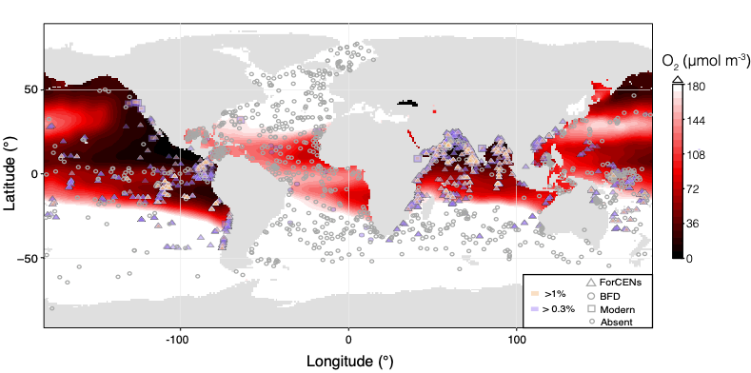
Supplementary Figure 1. Modern oxygen minimum distributions based on aggregated WOA18 oxygen data collected in years 1955-2010¹, with lower O₂ concentrations shown in darker red. Abundances of G. hexagonus > 0.3% of the assemblage are shown in purple, and > 1% in pink. Absences are shown as open grey circles. Shapes indicate different sources: ForCenS (triangles)², the Brown Foraminiferal Database (Atlantic Basin only; circles) and sediment trap and plankton tow data (squares)³⁻¹¹. Figure is meant to be illustrative of the potential to use a threshold such as >1% (or at least 3 individuals) to avoid ‘false positives’. However, small differences in relative abundance are not likely representative of differing environments.

Supplementary Figure 2. Oxygen at depth from WOA18. Each panel integrates over ~25-50 m with the midpoint labeled above the panel.

Supplementary Figure 3. Modern G. hexagonus distribution by data source. The presence (solid blue circles) and absence (open gray circles) of G. hexagonus from ForCENs (top), the Brown Foraminiferal Database (Atlantic Basin only; middle) and published sediment trap and plankton tow data (bottom). Base map made with Natural Earth (http://www.naturalearthdata.com).

Supplementary Figure 4. Comparison of oxygen at ~600 m between (A) modern aggregated WOA18 data (1950-2018) ¹ and (B) dissolved oxygen output from the Pre-Industrial CESM simulation. Lower O₂ concentrations are shown in darker red

Supplementary Figure 5. Oxygen at depth through the Pliocene-like simulation. Slices are chosen to best compare to Supplemental Figure 2 and the layer nearest to each slice is shown.

Supplementary Figure 6. Transects through the East Pacific (130°W) (A, C) and Central Atlantic (30°W) (B, D) show modern WOA18 data (1955-2010)¹ and (A, B), outputs from the Pliocene simulation (C, D).

Supplementary Figure 7. Minimum O₂ within the upper 1000 m from the Pliocene-like CESM simulation is shown with lower O₂ concentrations are shown in darker red. Regions where oxygen concentrations do not fall below 172 μmol m⁻³ are white.

Supplementary References

1 Garcia, H. et al. World Ocean Atlas 2018, Volume 3: Dissolved Oxygen, Apparent Oxygen Utilization, and Dissolved Oxygen Saturation (2019).
2 Siccha, M. & Kucera, M. ForCenS, a curated database of planktonic foraminifera census counts in marine surface sediment samples. Scientific Data 4, 170109, doi:10.1038/sdata.2017.109 (2017).
3 Birch, H., Coxall, H. K., Pearson, P. N., Kroon, D. & O'Regan, M. Planktonic foraminifera stable isotopes and water column structure: Disentangling ecological signals. Marine Micropaleontology 101, 127-145 (2013).
4 Davis, C. V., Hill, T. M., Russell, A. D., Gaylord, B. & Jahncke, J. Seasonality in planktic foraminifera of the central California coastal upwelling region. Biogeosciences 13, 5139 (2016).
5 Davis, C. V., Wishner, K., Renema, W. & Hull, P. M. Vertical distribution of planktic foraminifera through an oxygen minimum zone: how assemblages and test morphology reflect oxygen concentrations. Biogeosciences 18, 977-992 (2021).
6 Fairbanks, R. G., Sverdlove, M., Free, R., Wiebe, P. H. & Bé, A. W. Vertical distribution and isotopic fractionation of living planktonic foraminifera from the Panama Basin. Nature 298, 841-844 (1982).
7 Marchant, M., Hebbeln, D. & Wefer, G. Seasonal flux patterns of planktic foraminifera in the Peru–Chile current. Deep Sea Research Part I: Oceanographic Research Papers 45, 1161-1185, doi:10.1016/S0967-0637(98)00009-0 (1998).
8 Ortiz, J. D., Mix, A., Rugh, W., Watkins, J. & Collier, R. Deep-dwelling planktonic foraminifera of the northeastern Pacific Ocean reveal environmental control of oxygen and carbon isotopic disequilibria. Geochimica et Cosmochimica Acta 60, 4509-4523 (1996).
9 Rao, K. K., Jayalakshmy, K., Kumaran, S., Balasubramanian, T. & Kutty, M. K. Planktonic foraminifera in waters off the Coromandel coast, Bay of Bengal. (1989).
10 Rippert, N. et al. Constraining foraminiferal calcification depths in the western Pacific warm pool. Marine Micropaleontology 128, 14-27 (2016).
11 Smart, S. M. et al. Ground-truthing the planktic foraminifer-bound nitrogen isotope paleo-proxy in the Sargasso Sea. Geochimica et Cosmochimica Acta 235, 463-482 (2018).

