Supplementary Material for

Watching the release of a photopharmacological drug from tubulin using time-resolved serial crystallography

Maximillian Wranik¹, Tobias Weinert¹, Chavdar Slavov², Tiziana Masini³, Antonia Furrer¹, Natacha Gaillard¹, Dario Gioia³, Marco Ferrarotti³, Daniel James¹, Hannah Glover¹, Melissa Carrillo¹, Demet Kekilli¹, Robin Stipp¹, Petr Skopintsev¹, Steffen Brünle¹, Tobias Mühlethaler¹, John Beale¹, Dardan Gashi⁴, Karol Nass⁴, Dmitry Ozerov⁵, Philip J.M. Johnson⁴, Claudio Cirelli⁴, Camila Bacellar⁴, Markus Braun², Meitian Wang⁴, Florian Dworkowski⁴, Chris Milne⁴, Andrea Cavalli^{3,6}, Josef Wachtveitl², Michel O. Steinmetz^{1,7,*}, Jörg Standfuss^{1,*}

¹ Division of Biology and Chemistry, Paul Scherrer Institut, 5232 Villigen, Switzerland.
² Institute of Physical and Theoretical Chemistry, Goethe University, Frankfurt am Main, Germany.
³ Computational & Chemical Biology, Istituto Italiano di Tecnologia, 16163 Genova, Italy.
⁴ Photon Science Division, Paul Scherrer Institut, 5232 Villigen, Switzerland.
⁵ Scientific Computing, Theory and Data, Paul Scherrer Institut, 5232 Villigen, Switzerland.
⁶ Department of Pharmacy and Biotechnology, University of Bologna, 40126 Bologna, Italy.
⁷ Biozentrum, University of Basel, 4056 Basel, Switzerland.

*Correspondence to: michel.steinmetz@psi.ch and joerg.standfuss@psi.ch

This PDF file includes:

Supplementary Figures. S1 to S6
Supplementary Tables S1 to S2

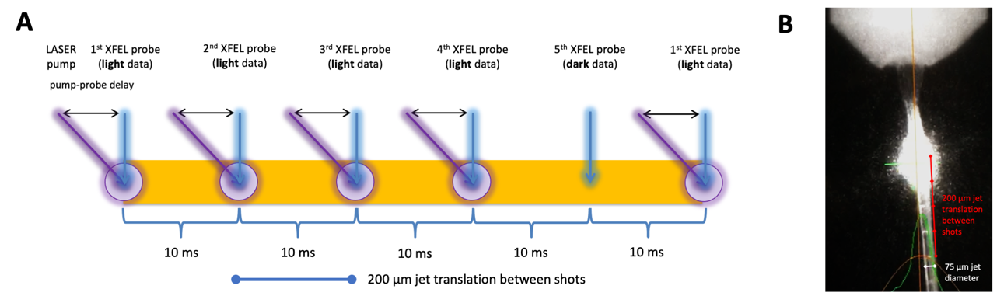
Supplementary Figure 1: Experimental setup. (A) The 4:1 pump-probe scheme used with the high-viscosity sample extruder⁴⁵ we introduced for crystal delivery time-resolved crystallography experiments⁴⁶ is depicted. Distance between shots taken at 100 Hz was about 200 μm and the laser spot size (1/e²) was about 65 μm (depicted as purple circle). Every 5th pattern was taken without the laser turned on. In this setup each time delay was collected in about 50 minutes measuring time and needed approximately 5 mg of tubulin. Notably, we suggest to optimize sample injection before the experiment to increase sample and time efficiency during the beamtime⁴⁷. Alternative sample delivery methods like solid-supports⁴⁸ or tape-drives⁴⁹ could be used to target longer time delays and thus measure ligands with longer residence times. (B) Image showing the laser on the jet and the penetration marks of the XFEL. Taking the 75 μm jet thickness to provide a scale in the picture it is evident that individual shots which are visible as white lines on the jet are evenly spaced. The laser glow in the image is overloaded and cannot be used to draw conclusions on the focal spot size of the laser, which was accurately measured using a knife edge scan at the sample position.
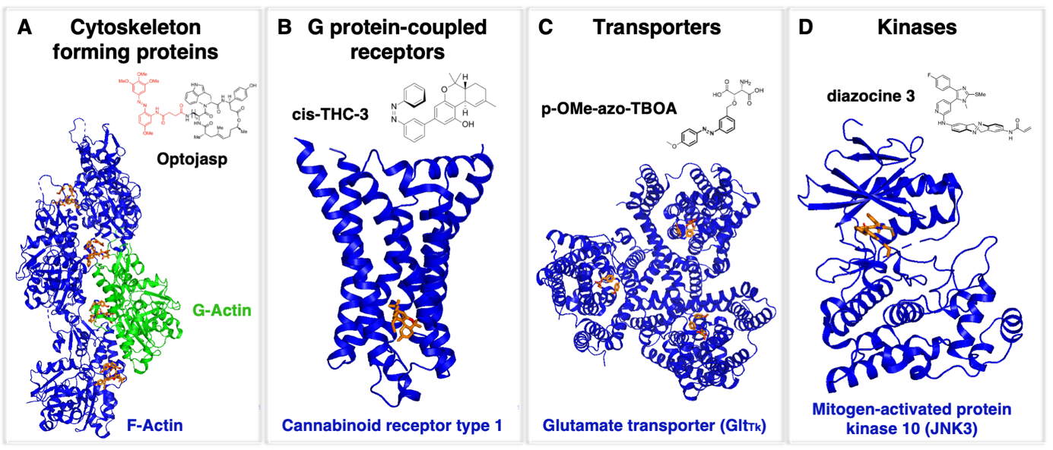
Supplementary Figure 2: Selection of protein classes that have been targeted with photopharmacological compounds. (A) A class of cytoskeletal proteins: Actin. Most abundant cellular protein and an essential component of the eukaryotic cytoskeleton^{50, 51, 52}. (B) A class of G protein-coupled receptors: Cannabinoid receptor type 1. One of the most widely expressed GPCR in the central nervous system. Its activation is associated with mood, motor coordination, memory, and recognition^{53, 54}. (C) A class of membrane transporters: Glutamate transporter Glt_{Tk}. Disruption linked to neurotoxicity under ischemic conditions and epilepsy⁵⁵. (D) A class of signaling kinases: Mitogen-activated protein kinase 10 (JNK3). A key signaling enzyme in the cellular stress response, targeted for the treatment of neurodegenerative diseases including Alzheimer’s, Huntington’s, and Parkinson’s disease⁵⁶. These examples suggest that the approach to employ photochemical affinity switches to study protein-ligand interaction dynamics could be expanded to a series of important targets from pharmacologically relevant protein families.

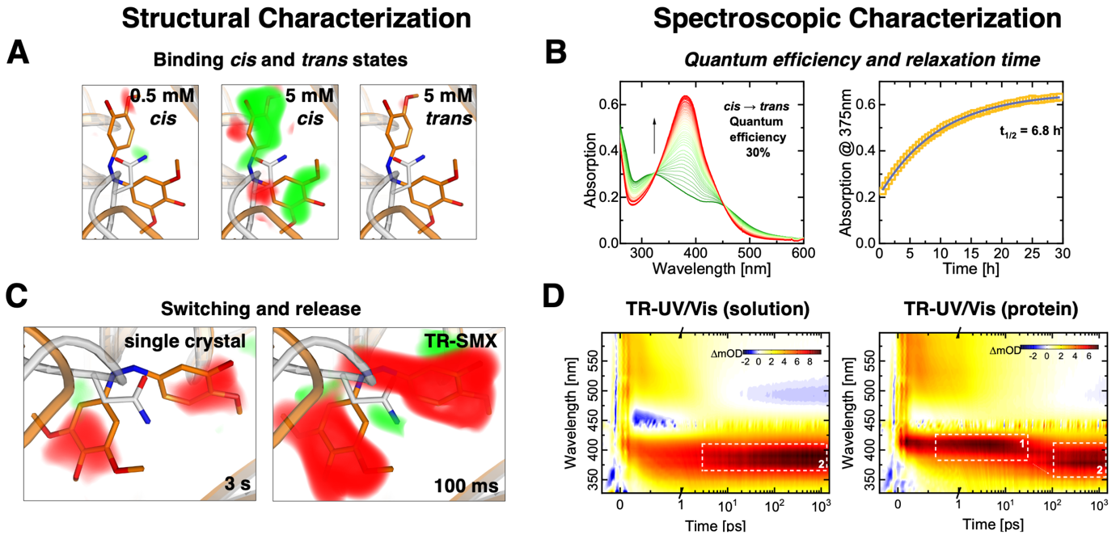
Supplementary Figure 3: Initial characterization of the azo-CA4 photoswitch. (A) Soaking of tubulin crystals with 0.5 mM cis-azo-CA4, 5 mM cis-azo-CA4, or 5 mM trans-azo-CA4. The binding pocket remained unoccupied up to azo-CA4 concentrations of 5 mM when the ligand was not exposed to light, suggesting that a light-triggered release of azo-CA4 should be feasible. (B) Titration experiments used to determine the quantum efficiency of conversion and relaxation of azo-CA4 over time in crystallization buffer. The quantum efficiency of 30% is large enough to reach sufficient activation levels in time-resolved serial crystallography experiments. We further confirmed that the cis-to-trans thermal relaxation is slow enough to maintain the cis conformation without constant illumination during a single sample injection of about 30 minutes. (C) Ligand release after photoinduced isomerization followed by a brief annealing of a single cryo-cooled crystal soaked with 1.25 mM of cis-azo-CA4, and ligand release after 100 ms in a time-resolved serial crystallography experiment. A single tubulin crystal was soaked with 1.25 mM of cis-azoCA4 before collecting a conventional cryo-dataset. Light data was collected by blocking the cryo-stream and illuminating the crystal before collecting a second dataset on a crystal position ~150 μm away from the first position. The isomorphous difference map between both datasets showed that azo-CA4 is released from the crystal upon photoswitching. We then moved on to a time-resolved serial crystallography experiment at the synchrotron and found that the ligand was fully released from its tubulin-binding site after 100 ms of illumination. (D) Time-resolved UV-Vis spectroscopy revealed that tubulin modifies the compound relaxation behavior up to the late picosecond range, suggesting that the ligand isomerization inside the binding pocket is finished after 1 ns. All panels show isomorphous difference maps that are displayed in red (negative) and green (positive) at 3 σ. The substrate free apo form of tubulin is shown in grey and the substrate bound form in orange.

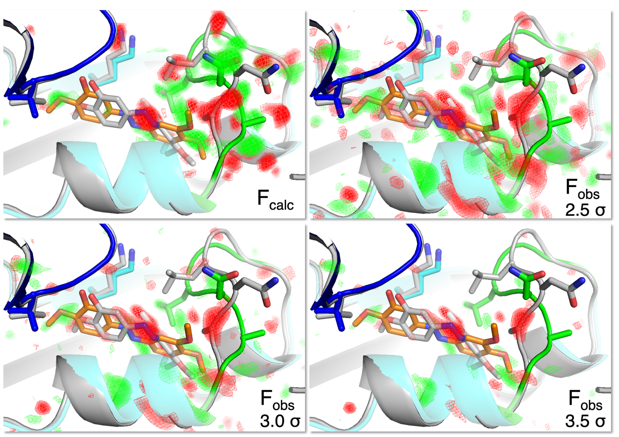
Supplementary Figure 4: Comparison of F_{obs} and F_{calc} difference maps. Experimentally observed F_{obs}(1ms)-F_{obs}(dark) and calculated F_{calc}(1ms-model)-F_{calc}(dark-model) difference density maps within the ligand binding site are shown. Positive and negative difference densities are displayed in green and red, respectively. The initial dark model is shown in grey and the 1 ms structure as blue (α tubulin), cyan (β tubulin), and green (βT7 loop). Selected side chains are displayed in stick representation. The F_{calc} difference density map (top) was calculated using B-factors of 30 for all atoms and is displayed at a sigma level of 3.5 sigma, while the F_{obs} maps are shown at levels from 2.5 to 3.5 sigma. The F_{calc} maps represent a full activation level and data without noise and even though this prevents direct comparison of sigma levels, there is an excellent agreement between the simulated and calculated difference maps.

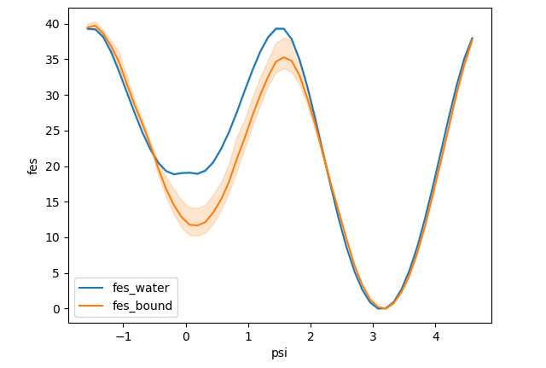
∆∆G_{cis-trans}
cis
trans
Supplementary Figure 5: Computational analysis of the binding energy landscape provides a rationale for how cis-trans isomerization initiates ligand unbinding. The plot indicates the energy gain of the cis vs. the trans azo-CA4 isomer upon binding to tubulin. A single WTM simulation was carried out with a custom protocol to sample conformations compatible to the XFEL-based time-resolved structures. Block analysis with block size of 50 ns was performed to assess convergence and to plot 95% confidence interval error bands around converged values.

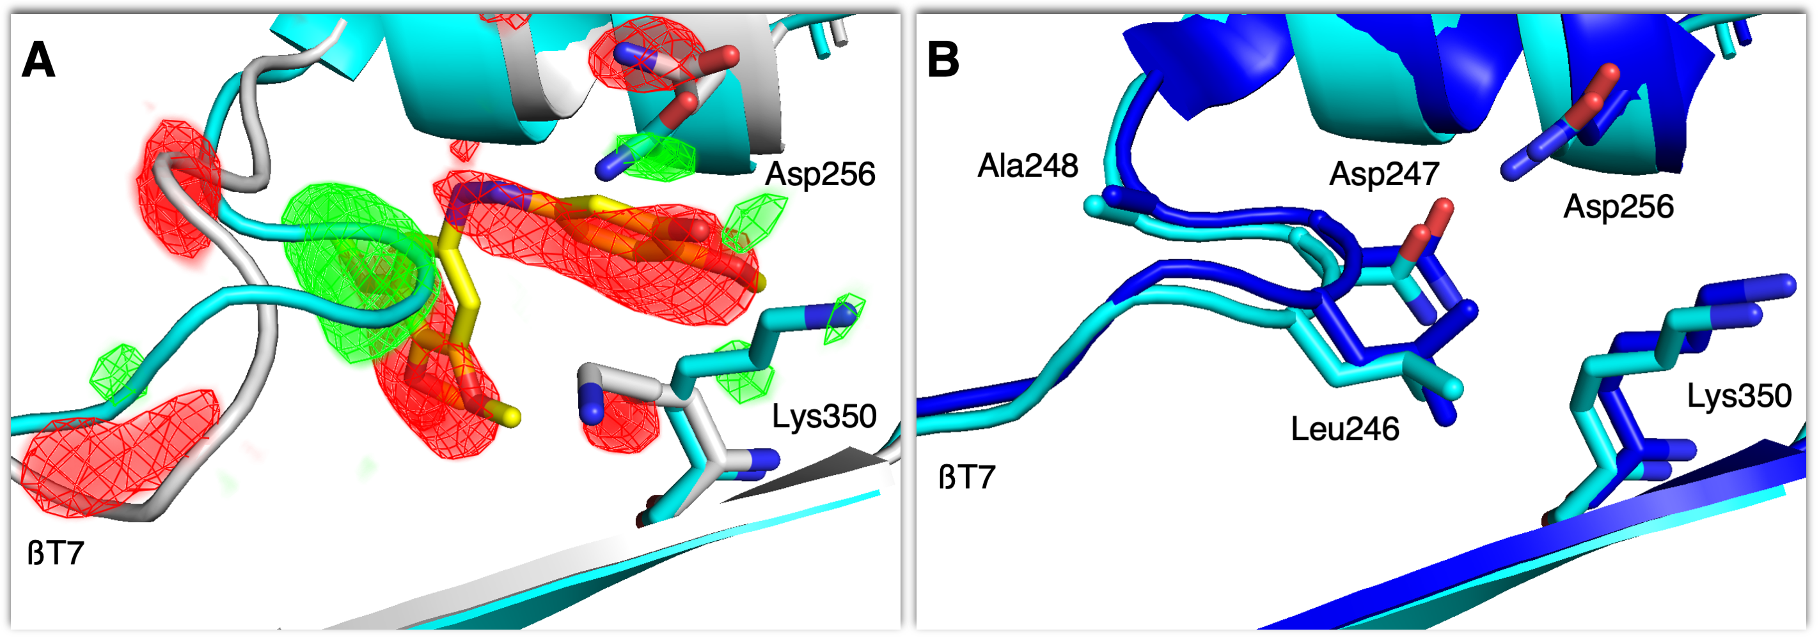
Supplementary Figure 6: Comparison of tubulin-azo-CA4 complex after photoinduced ligand release with a structure of apo-tubulin. (A) Overlay of liganded dark (grey) and 100 ms (cyan) tubulin structures obtained by serial synchrotron crystallography. The corresponding difference densities (positive in green, negative in red, F_{obs}(100 ms)-F_{obs}(dark), sigma level = 5.0) confirm the release of azo-CA4 and reorganization of the colchicine-site in tubulin. (B) Overlay of the 100 ms structure (cyan) and the one determined using data from apo-tubulin crystals (blue).

Supplementary Table 1: Crystallographic data statistics

 | Dark  (XFEL) | 1 ns  (XFEL) | 10 ns  (XFEL) | 100 ns  (XFEL) | 1 ms  (XFEL) | 10 ms  (XFEL) | 100 ms  (XFEL) | 1 ms  (XFEL) | 10 ms  (XFEL) | Apo  (XFEL) | 100 ms  (SYN) | Dark  (SYN)
Data collection
Space group | P2₁
a, b, c (Å) | 74.5, 92.6, 84.0 |  |  |  |  |  |  |  |  | 74.7, 92.7, 84.1 | 74.3, 91.9, 83.7
a, b, g (°) | 90, 96.7, 90 |  |  |  |  |  |  |  |  | 90, 96.4, 90 | 90, 96.82, 90
Indexed patterns | 370356 | 63970 | 69058 | 61091 | 73798 | 67496 | 57915 | 60644 | 89399 | 82666 | 41314 | 102238
Indexing rate (%) | 16.6 | 23.3 | 18.1 | 19.8 | 13.2 | 23.5 | 31.2 | 16.7 | 22.6 | 25.6 | 18.1 | 16.5
Overall statistics: 11.09 Å – 1.70 Å  (high-resolution statistics: 1.76 Å – 1.70 Å) |  |  |  |  |  |  |  |  |  | 11.09-1.80 Å  (1.86-1.80 Å) | 92.11-2.1 Å  (2.18-2.10 Å)
No. reflections | 123960 (12356) | 122155(12154) | 122150  (12154) | 122150  (12154) | 122150  (12154) | 122154  (12154) | 122150  (12154) | 122153  (12154) | 122152  (12154) | 104994  (10494) | 38945  (117) | 43965  (945)
Completeness (%) | 100  (100) | 100  (100) | 100  (100) | 100  (100) | 100  (100) | 100  (100) | 100  (100) | 100  (100) | 100  (100) | 100  (100) | 60  (2) | 67  (15)
Multiplicity | 2089.8  (1000.6) | 365.9  (188.4) | 347.5  (175.9) | 314.1  (164.8) | 404.2  (208.4) | 392.6  (207.5) | 309.1  (155.8) | 328.9  (161.2) | 586.1  (313.1) | 429.5  (194.3) | 274.2  (216.6) | 602.5  (504.6)
R_{split} (%) | 7.5  (78.85) | 16.9  (217.8) | 17.2  (204.3) | 18.1  (180.4) | 16.6  (268.7) | 16.7  (174.4) | 17.5  (299.0) | 18.1  (253.1) | 13.8  (106.5) | 14.2  (372.3) | 10.5  (69.48) | 8.0  (49.9)
CC_{1/2} | 0.992  (0.694) | 0.971  (0.265) | 0.968  (0.274) | 0.964  (0.323) | 0.972  (0.210) | 0.971  (0.343) | 0.969  (0.170) | 0.968  (0.217) | 0.979  (0.558) | 0.981  (0.14) | 0.992  (0.528) | 0.996  (0.660)
<I/σ(I)> | 9.53  (1.43) | 4.01  (0.50) | 4.16  (0.56) | 4.05  (0.62) | 4.05  (0.43) | 4.26  (0.64) | 3.68  (0.38) | 3.79  (0.45) | 5.36  (1.03) | 4.59  (0.32) | 7.87  (1.25) | 10.09  (1.62)
PDB Code | 7YYQ | 7YYV | 7YYW | 7YYX | 7YYY | 7YYZ | 7YZ0 | 7YZ1 | 7YZ2 | 7YZ3 | 7YZ5 | 7YZ6

Supplementary Table 2: Refinement statistics

 | Dark  (XFEL) | 1 ns  (XFEL) | 10 ns  (XFEL) | 100 ns  (XFEL) | 1 μs  (XFEL) | 10 μs  (XFEL) | 100 μs  (XFEL) | 1 ms  (XFEL) | 10 ms  (XFEL) | Apo  (XFEL) | ~100 ms  (SYN) | Dark  (SYN)
Resolution (Å) | 9.5 Å – 1.7 Å | 9.5 Å – 2.2 Å | 9.5 Å – 2.2 Å | 9.5 Å – 2.2 Å | 9.5 Å – 2.2 Å | 9.5 Å – 2.2 Å | 9.5 Å – 2.2 Å | 9.5 Å – 2.2 Å | 9.5 Å – 2.2 Å | 9.5 Å – 1.80 Å | 73.75 Å – 2.1 Å | 73.75 Å – 2.1 Å
No. reflections | 123591 (8816) | 53409  (3901) | 53221  (3910) | 52461  (3763) | 52234  (3710) | 53180  (3840) | 52580  (3778) | 53111  (3915) | 53134  (3657) | 102745  (1827) | 38921  (68) | 43943  (652)
R_{work} / R_{free} in % | 12.13 /  15.38 | 31.11 /  35.19 | 31.13 /  34.33 | 31.10 /  35.53 | 30.46 /  34.88 | 29.87 /  35.48 | 30.48 /  36.29 | 30.18 /  35.17 | 28.52 /  33.36 | 18.45 /  21.57 | 17.28 /  23.08 | 17.76 /  22.64
No. atoms | 8482 | 8284 | 8352 | 8211 | 8217 | 8228 | 8262 | 8274 | 8210 | 8358 | 8198 | 8646
Protein | 8392 | 7915 | 7945 | 7915 | 7909 | 7907 | 7912 | 7935 | 7931 | 7996 | 7986 | 8392
Ligands | 90 | 57 | 57 | 57 | 57 | 57 | 57 | 57 | 33 | 34 | 34 | 90
Water | 544 | 284 | 322 | 211 | 223 | 236 | 265 | 254 | 218 | 300 | 150 | 164
B-factors | 44.82 | 34.34 | 33.25 | 34.64 | 40.97 | 35.09 | 35.52 | 30.69 | 41.84 | 48.25 | 39.94 | 42.16
Protein | 44.27 | 34.43 | 33.34 | 34.69 | 41.10 | 35.17 | 35.60 | 30.77 | 41.89 | 48.32 | 39.08 | 42.30
Ligands | 36.79 | 26.95 | 32.38 | 29.40 | 32.34 | 28.44 | 31.26 | 24.09 | 28.41 | 32.19 | 21.95 | 36.13
Water | 54.51 | 33.47 | 27.06 | 34.37 | 38.62 | 33.88 | 34.30 | 29.50 | 42.22 | 48.88 | 35.76 | 38.15
Bond lengths (Å) | 0.008 | 0.001 | 0.001 | 0.002 | 0.002 | 0.001 | 0.001 | 0.004 | 0.001 | 0.003 | 0.001 | 0.002
Bond angles (°) | 0.885 | 0.414 | 0.424 | 0.455 | 0.436 | 0.409 | 0.426 | 0.673 | 0.422 | 0.670 | 0.417 | 0.469
Ramachandran favored / allowed / outliers in % | 98.71 /  1.29 /  0.00 | 96.73 /  3.17 /  0.10 | 97.23 /  2.57 /  0.20 | 96.93 /  2.77 /  0.30 | 96.73 /  2.87 /  0.40 | 97.23 /  2.57 /  0.20 | 96.82 /  2.68 /  0.50 | 96.04 /  3.47  0.50 | 96.13 /  3.57  0.30 | 98.13 /  1.77 /  0.10 | 95.97 /  3.54 /  0.49 | 97.72 /  2.08 /  0.20
PDB Code | 7YYQ | 7YYV | 7YYW | 7YYX | 7YYY | 7YYZ | 7YZ0 | 7YZ1 | 7YZ2 | 7YZ3 | 7YZ5 | 7YZ6

Supplementary References:
1. Hull K, Morstein J, Trauner D. In Vivo Photopharmacology. Chem Rev 118, 10710-10747 (2018).

2. Beharry AA, Woolley GA. Azobenzene photoswitches for biomolecules. Chem Soc Rev 40, 4422-4437 (2011).

3. Borowiak M, et al. Photoswitchable Inhibitors of Microtubule Dynamics Optically Control Mitosis and Cell Death. Cell 162, 403-411 (2015).

4. Gaspari R, Prota AE, Bargsten K, Cavalli A, Steinmetz MO. Structural Basis of cis- and trans-Combretastatin Binding to Tubulin. Chem-Us 2, 102-113 (2017).

5. Brouhard GJ, Rice LM. Microtubule dynamics: an interplay of biochemistry and mechanics. Nat Rev Mol Cell Biol 19, 451-463 (2018).

6. Dalbeth N, Lauterio TJ, Wolfe HR. Mechanism of action of colchicine in the treatment of gout. Clin Ther 36, 1465-1479 (2014).

7. Pettit GR, Singh SB, Hamel E, Lin CM, Alberts DS, Garcia-Kendall D. Isolation and structure of the strong cell growth and tubulin inhibitor combretastatin A-4. Experientia 45, 209-211 (1989).

8. Grisham R, Ky B, Tewari KS, Chaplin DJ, Walker J. Clinical trial experience with CA4P anticancer therapy: focus on efficacy, cardiovascular adverse events, and hypertension management. Gynecol Oncol Res Pract 5, 1 (2018).

9. Baytas SN. Recent Advances in Combretastatin A-4 Inspired Inhibitors of Tubulin Polymerization: An Update. Curr Med Chem 29, 3557-3585 (2022).

10. Barnette KG, et al. Oral Sabizabulin for High-Risk, Hospitalized Adults with Covid-19: Interim Analysis. NEJM Evidence 0, EVIDoa2200145 (2022).

11. Jerca FA, Jerca VV, Hoogenboom R. Advances and opportunities in the exciting world of azobenzenes. Nature Reviews Chemistry 6, 51-69 (2022).

12. Bozovic O, Jankovic B, Hamm P. Using azobenzene photocontrol to set proteins in motion. Nature Reviews Chemistry 6, 112-124 (2022).

13. Neutze R, Moffat K. Time-resolved structural studies at synchrotrons and X-ray free electron lasers: opportunities and challenges. Curr Opin Struc Biol 22, 651-659 (2012).

14. Tenboer J, et al. Time-resolved serial crystallography captures high-resolution intermediates of photoactive yellow protein. Science 346, 1242-1246 (2014).

15. Monteiro DCF, Amoah E, Rogers C, Pearson AR. Using photocaging for fast time-resolved structural biology studies. Acta Crystallographica Section D 77, (2021).

16. Steinmetz MO, Prota AE. Microtubule-Targeting Agents: Strategies To Hijack the Cytoskeleton. Trends Cell Biol 28, 776-792 (2018).

17. Branden G, Neutze R. Advances and challenges in time-resolved macromolecular crystallography. Science 373, 980-+ (2021).

18. Orville AM. Recent results in time resolved serial femtosecond crystallography at XFELs. Curr Opin Struc Biol 65, 193-208 (2020).

19. Gao L, et al. A Robust, GFP-Orthogonal Photoswitchable Inhibitor Scaffold Extends Optical Control over the Microtubule Cytoskeleton. Cell Chem Biol 28, 228-241 e226 (2021).

20. Gao L, et al. In Vivo Photocontrol of Microtubule Dynamics and Integrity, Migration and Mitosis, by the Potent GFP-Imaging-Compatible Photoswitchable Reagents SBTubA4P and SBTub2M. J Am Chem Soc 144, 5614-5628 (2022).

21. Kirchner S, Pianowski Z. Photopharmacology of Antimitotic Agents. Int J Mol Sci 23, (2022).

22. Pecqueur L, et al. A designed ankyrin repeat protein selected to bind to tubulin caps the microtubule plus end. Proc Natl Acad Sci U S A 109, 12011-12016 (2012).

23. La Sala G, et al. Structure, Thermodynamics, and Kinetics of Plinabulin Binding to Two Tubulin Isotypes. Chem-Us 5, 2969-2986 (2019).

24. Weinert T, et al. Serial millisecond crystallography for routine room-temperature structure determination at synchrotrons. Nat Commun 8, 542 (2017).

25. Weinert T, et al. Proton uptake mechanism in bacteriorhodopsin captured by serial synchrotron crystallography. Science 365, 61-65 (2019).

26. Abela R, et al. Perspective: Opportunities for ultrafast science at SwissFEL. Struct Dyn 4, 061602 (2017).

27. Wickstrand C, et al. A tool for visualizing protein motions in time-resolved crystallography. Struct Dyn 7, 024701 (2020).

28. Skopintsev P, et al. Femtosecond-to-millisecond structural changes in a light-driven sodium pump. Nature, (2020).

29. Pandey S, et al. Time-resolved serial femtosecond crystallography at the European XFEL. Nature Methods 17, 73-+ (2020).

30. Decherchi S, Cavalli A. Thermodynamics and Kinetics of Drug-Target Binding by Molecular Simulation. Chem Rev 120, 12788-12833 (2020).

31. Prota AE, et al. The Novel Microtubule-Destabilizing Drug BAL27862 Binds to the Colchicine Site of Tubulin with Distinct Effects on Microtubule Organization. Journal of Molecular Biology 426, 1848-1860 (2014).

32. Dorleans A, Gigant B, Ravelli RBG, Mailliet P, Mikol V, Knossow M. Variations in the colchicine-binding domain provide insight into the structural switch of tubulin. P Natl Acad Sci USA 106, 13775-13779 (2009).

33. Ravelli RBG, et al. Insight into tubulin regulation from a complex with colchicine and a stathmin-like domain. Nature 428, 198-202 (2004).

34. Muhlethaler T, Gioia D, Prota AE, Sharpe ME, Cavalli A, Steinmetz MO. Comprehensive Analysis of Binding Sites in Tubulin. Angew Chem Int Ed Engl 60, 13331-13342 (2021).

35. Knossow M, Campanacci V, Khodja LA, Gigant B. The Mechanism of Tubulin Assembly into Microtubules: Insights from Structural Studies. iScience 23, 101511 (2020).

36. Brouhard GJ, Rice LM. The contribution of alphabeta-tubulin curvature to microtubule dynamics. J Cell Biol 207, 323-334 (2014).

37. Gaillard N, et al. Inhibiting parasite proliferation using a rationally designed anti-tubulin agent. Embo Mol Med 13, (2021).

38. Mehrabi P, et al. Time-resolved crystallography reveals allosteric communication aligned with molecular breathing. Science 365, 1167-1170 (2019).

39. Pandey S, et al. Observation of substrate diffusion and ligand binding in enzyme crystals using high-repetition-rate mix-and-inject serial crystallography. Iucrj 8, 878-895 (2021).

40. Butryn A, et al. An on-demand, drop-on-drop method for studying enzyme catalysis by serial crystallography. Nat Commun 12, 4461 (2021).

41. Schmidt M. Reaction Initiation in Enzyme Crystals by Diffusion of Substrate. Crystals 10, (2020).

42. Ricart-Ortega M, Font J, Llebaria A. GPCR photopharmacology. Mol Cell Endocrinol 488, 36-51 (2019).

43. Velema WA, Szymanski W, Feringa BL. Photopharmacology: beyond proof of principle. J Am Chem Soc 136, 2178-2191 (2014).

44. Leippe P, Frank JA. Designing azobenzene-based tools for controlling neurotransmission. Curr Opin Struct Biol 57, 23-30 (2019).

45. Weierstall U, et al. Lipidic cubic phase injector facilitates membrane protein serial femtosecond crystallography. Nat Commun 5, 3309 (2014).

46. Nogly P, et al. Lipidic cubic phase injector is a viable crystal delivery system for time-resolved serial crystallography. Nat Commun 7, 12314 (2016).

47. James D, et al. Improving High Viscosity Extrusion of Microcrystals for Time-resolved Serial Femtosecond Crystallography at X-ray Lasers. J Vis Exp, (2019).

48. Schulz EC, et al. The hit-and-return system enables efficient time-resolved serial synchrotron crystallography. Nat Methods 15, 901-904 (2018).

49. Fuller FD, et al. Drop-on-demand sample delivery for studying biocatalysts in action at X-ray free-electron lasers. Nat Methods 14, 443-449 (2017).

50. Borowiak M, et al. Optical Manipulation of F-Actin with Photoswitchable Small Molecules. J Am Chem Soc 142, 9240-9249 (2020).

51. Pospich S, et al. Cryo-EM Resolves Molecular Recognition Of An Optojasp Photoswitch Bound To Actin Filaments In Both Switch States. Angew Chem Int Edit 60, 8678-8682 (2021).

52. Wang H, Robinson RC, Burtnick LD. The structure of native G-actin. Cytoskeleton (Hoboken) 67, 456-465 (2010).

53. Westphal MV, et al. Synthesis of Photoswitchable Delta(9)-Tetrahydrocannabinol Derivatives Enables Optical Control of Cannabinoid Receptor 1 Signaling. J Am Chem Soc 139, 18206-18212 (2017).

54. Hua T, et al. Crystal structures of agonist-bound human cannabinoid receptor CB1. Nature 547, 468-471 (2017).

55. Arkhipova V, et al. Structural Aspects of Photopharmacology: Insight into the Binding of Photoswitchable and Photocaged Inhibitors to the Glutamate Transporter Homologue. Journal of the American Chemical Society 143, 1513-1520 (2021).

56. Reynders M, et al. Controlling the Covalent Reactivity of a Kinase Inhibitor with Light. Angew Chem Int Ed Engl 60, 20178-20183 (2021).

57. Muhlethaler T, et al. Crystallization Systems for the High-Resolution Structural Analysis of Tubulin-Ligand Complexes. Methods Mol Biol 2430, 349-374 (2022).

58. Sugahara M, et al. Hydroxyethyl cellulose matrix applied to serial crystallography. Sci Rep 7, 703 (2017).

59. Nass K, et al. Pink-beam serial femtosecond crystallography for accurate structure-factor determination at an X-ray free-electron laser. IUCrJ 8, (2021).

60. Zeldin OB, Gerstel M, Garman EF. RADDOSE-3D: time- and space-resolved modelling of dose in macromolecular crystallography. Journal of Applied Crystallography 46, 1225-1230 (2013).

61. White TA, et al. CrystFEL: a software suite for snapshot serial crystallography. Journal of Applied Crystallography 45, 335-341 (2012).

62. White TA, et al. Recent developments in CrystFEL. J Appl Crystallogr 49, 680-689 (2016).

63. Gevorkov Y, et al. XGANDALF - extended gradient descent algorithm for lattice finding. Acta Crystallogr A Found Adv 75, 694-704 (2019).

64. Tickle IJ, Flensburg, C., Keller, P., Paciorek, W., Sharff, A., Vonrhein, C., Bricogne, G. . STARANISO.). Cambridge, United Kingdom: Global Phasing Ltd. (2018).

65. Adams PD, et al. PHENIX: building new software for automated crystallographic structure determination. Acta Crystallogr D Biol Crystallogr 58, 1948-1954 (2002).

66. Winn MD, et al. Overview of the CCP4 suite and current developments. Acta Crystallogr D Biol Crystallogr 67, 235-242 (2011).

67. Gorel A, Schlichting I, Barends TRM. Discerning best practices in XFEL-based biological crystallography - standards for nonstandard experiments. Iucrj 8, 532-543 (2021).

68. Nogly P, et al. Retinal isomerization in bacteriorhodopsin captured by a femtosecond x-ray laser. Science 361, (2018).

69. Emsley P, Cowtan K. Coot: model-building tools for molecular graphics. Acta Crystallogr D Biol Crystallogr 60, 2126-2132 (2004).

70. Bricogne G BE, Brandl M, Flensburg C, Keller P, Paciorek W, Roversi P, Sharff A, Smart O, Vonrhein C, Womack T BUSTER version 2.10.4.). Cambridge, United Kingdom: Global Phasing Ltd. (2021).

71. Salentin S, Schreiber S, Haupt VJ, Adasme MF, Schroeder M. PLIP: fully automated protein-ligand interaction profiler. Nucleic Acids Res 43, W443-447 (2015).

72. Smith RHB, Dar AC, Schlessinger A. PyVOL: a PyMOL plugin for visualization, comparison, and volume calculation of drug-binding sites. bioRxiv, 816702 (2019).

73. Chovancova E, et al. CAVER 3.0: a tool for the analysis of transport pathways in dynamic protein structures. PLoS Comput Biol 8, e1002708 (2012).

74. Slavov C, et al. The ultrafast reactions in the photochromic cycle of water-soluble fulgimide photoswitches. Phys Chem Chem Phys 18, 10289-10296 (2016).

75. Jacobson MP, Friesner RA, Xiang Z, Honig B. On the role of the crystal environment in determining protein side-chain conformations. J Mol Biol 320, 597-608 (2002).

76. Sastry GM, Adzhigirey M, Day T, Annabhimoju R, Sherman W. Protein and ligand preparation: parameters, protocols, and influence on virtual screening enrichments. J Comput Aided Mol Des 27, 221-234 (2013).

77. D.A. Case HMA, K. Belfon, I.Y. Ben-Shalom, S.R. Brozell, D.S. Cerutti, T.E. Cheatham, III, G.A. Cisneros, V.W.D. Cruzeiro, T.A. Darden, R.E. Duke, G. Giambasu, M.K. Gilson, H. Gohlke, A.W. Goetz, R. Harris, S. Izadi, S.A. Izmailov, C. Jin, K. Kasavajhala, M.C. Kaymak, E. King, A. Kovalenko, T. Kurtzman, T.S. Lee, S. LeGrand, P. Li, C. Lin, J. Liu, T. Luchko, R. Luo, M. Machado, V. Man, M. Manathunga, K.M. Merz, Y. Miao, O. Mikhailovskii, G. Monard, H. Nguyen, K.A. O’Hearn, A. Onufriev, F. Pan, S. Pantano, R. Qi, A. Rahnamoun, D.R. Roe, A. Roitberg, C. Sagui, S. Schott-Verdugo, J. Shen, C.L. Simmerling, N.R. Skrynnikov, J. Smith, J. Swails, R.C. Walker, J. Wang, H. Wei, R.M. Wolf, X. Wu, Y. Xue, D.M. York, S. Zhao, and P.A. Kollman. Amber 21. In: University of California, San Francisco) (2021).

78. Jorgensen WL, Chandrasekhar J, Madura JD, Impey RW, Klein ML. Comparison of Simple Potential Functions for Simulating Liquid Water. J Chem Phys 79, 926-935 (1983).

79. Maier JA, Martinez C, Kasavajhala K, Wickstrom L, Hauser KE, Simmerling C. ff14SB: Improving the Accuracy of Protein Side Chain and Backbone Parameters from ff99SB. J Chem Theory Comput 11, 3696-3713 (2015).

80. Allner O, Nilsson L, Villa A. Magnesium Ion-Water Coordination and Exchange in Biomolecular Simulations. J Chem Theory Comput 8, 1493-1502 (2012).

81. Meagher KL, Redman LT, Carlson HA. Development of polyphosphate parameters for use with the AMBER force field. J Comput Chem 24, 1016-1025 (2003).

82. Salomon-Ferrer R, Gotz AW, Poole D, Le Grand S, Walker RC. Routine Microsecond Molecular Dynamics Simulations with AMBER on GPUs. 2. Explicit Solvent Particle Mesh Ewald. Journal of Chemical Theory and Computation 9, 3878-3888 (2013).

83. Barducci A, Bussi G, Parrinello M. Well-tempered metadynamics: A smoothly converging and tunable free-energy method. Phys Rev Lett 100, (2008).

84. Van der Spoel D, Lindahl E, Hess B, Groenhof G, Mark AE, Berendsen HJC. GROMACS: Fast, flexible, and free. J Comput Chem 26, 1701-1718 (2005).

85. Tribello GA, Bonomi M, Branduardi D, Camilloni C, Bussi G. PLUMED 2: New feathers for an old bird. Comput Phys Commun 185, 604-613 (2014).

