Cryo-EM captures early ribosome assembly in action

Bo Qin¹†, Simon M. Lauer¹†, Annika Balke², Carlos H. Vieira-Vieira^{3,4}, Jörg Bürger^{1,5}, Thorsten Mielke⁵, Matthias Selbach^{3,6}, Patrick Scheerer², Christian M. T. Spahn¹* and Rainer Nikolay^{1,7}*

*Corresponding author. Emails: christian.spahn@charite.de, nikolay@molgen.mpg.de

SUPPLEMENTARY DATA
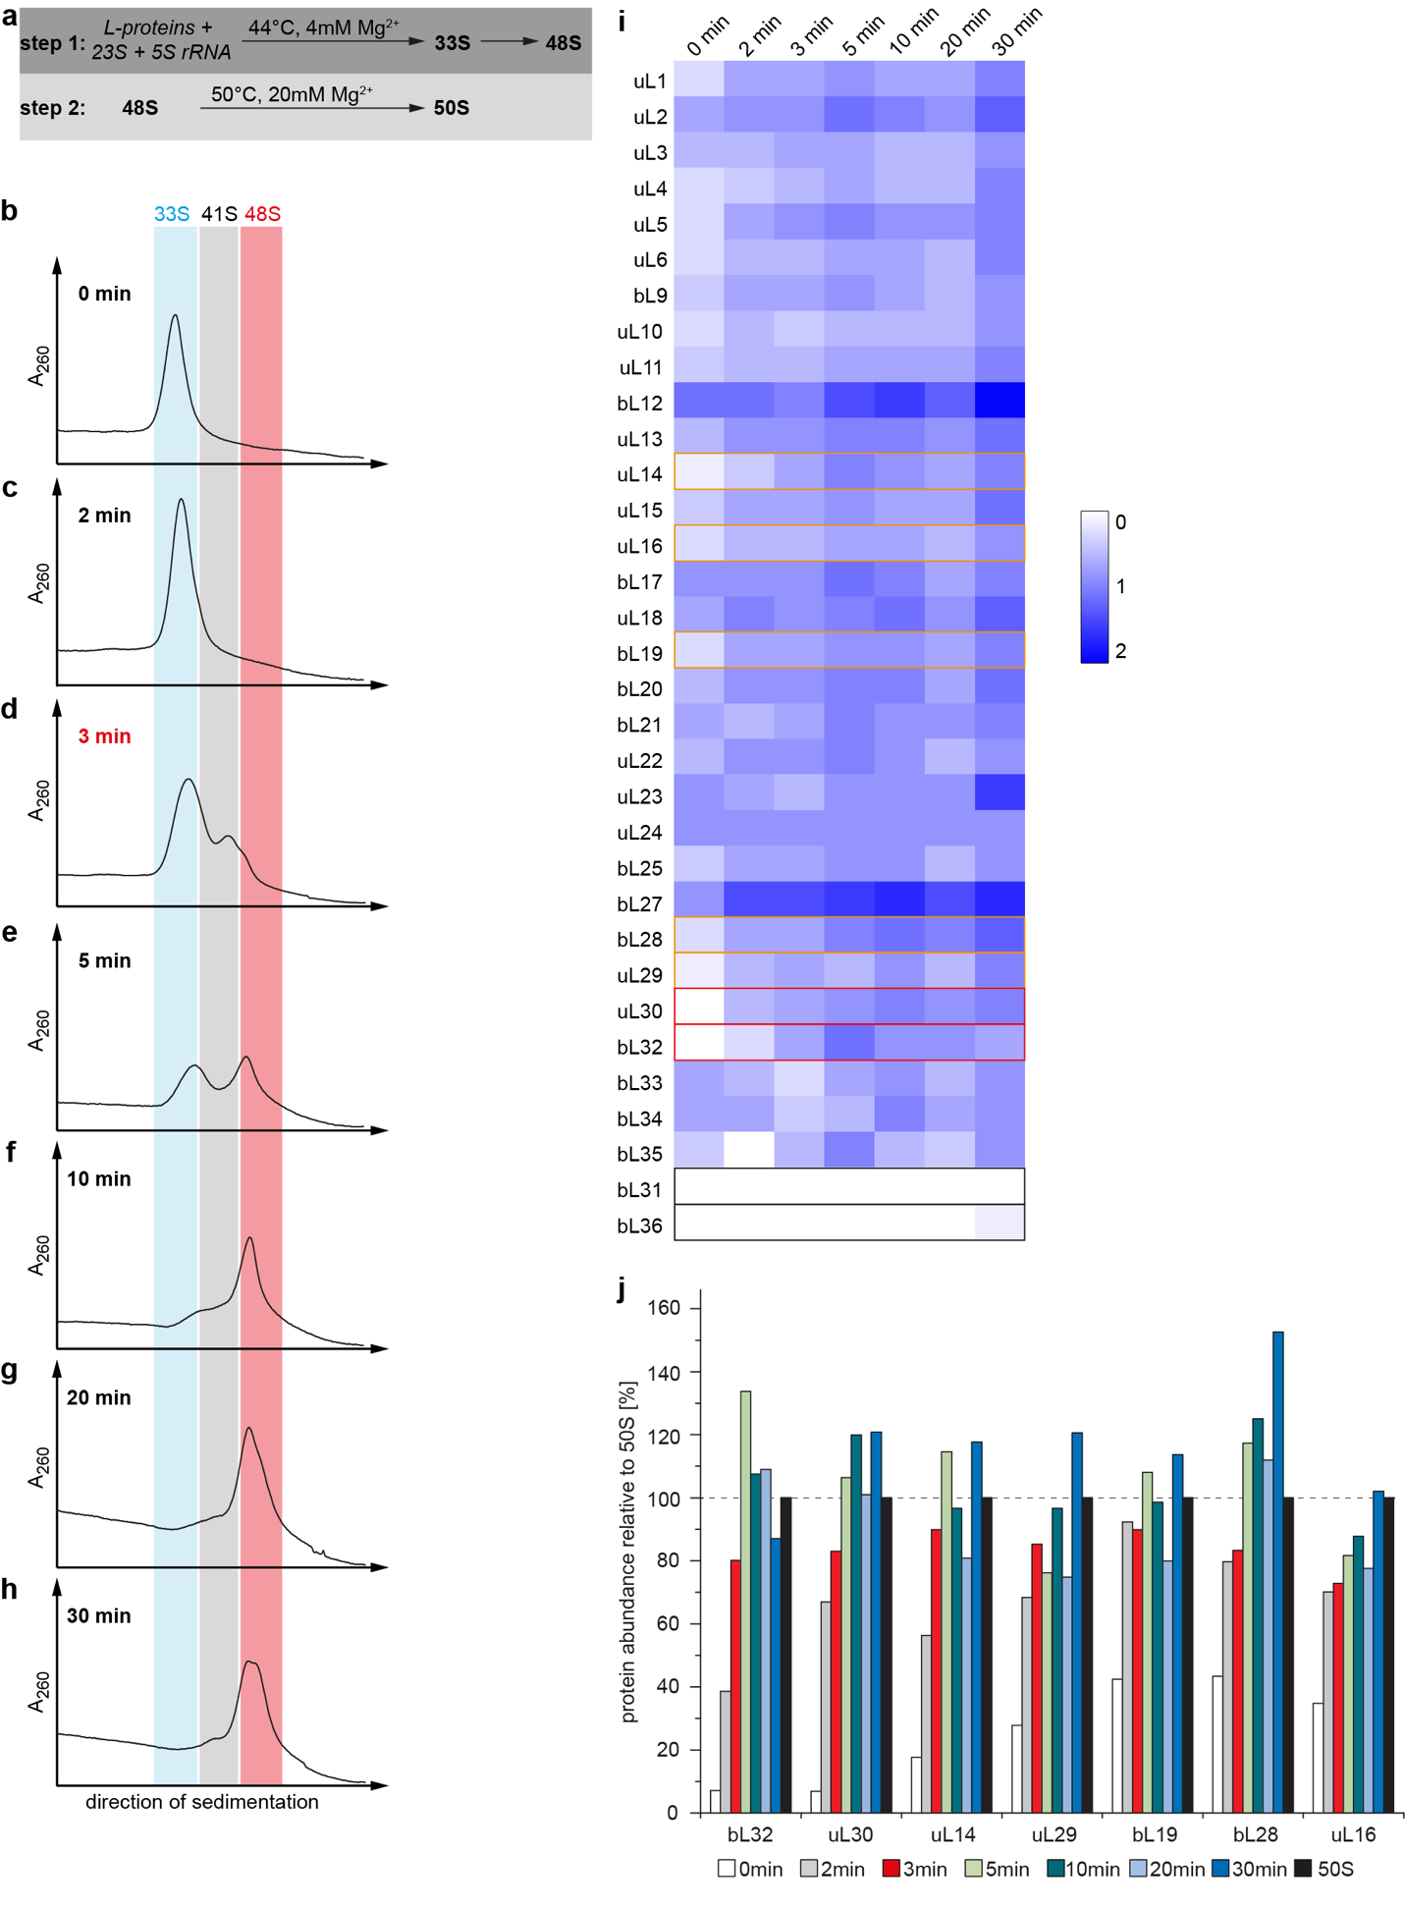

Supplementary Fig. 1: 50S in vitro reconstitution assay and subsequent analyses
a) Two step in vitro reconstitution assay of the 50S subunit. In step 1, 23S and 5S rRNA together with L-proteins incubate at 44°C for up to 30 min and are spontaneously converted into a 33S particle, which ultimately matures to 48S particles. During step 2, 48S particles (material in the red zone (b-h)) are quantitatively transformed into 50S like particles after 90 min at 50°C. b-h) step 1 time course reaction. Samples incubated under step 1 conditions as indicated were subjected to sucrose density gradient ultracentrifugation. i, j) quantitative mass spectrometry analysis of material incubated under step 1 conditions, subjected to sucrose cushion purification and LC-MS. Relative abundance of all L-proteins plotted as heat map in fold change (i) and selected L-proteins plotted as bar chart in % relative to 50S (j). Experiments were performed in technical duplicates (n=2) and results represent mean values. Source data are provided as a Source Data file.
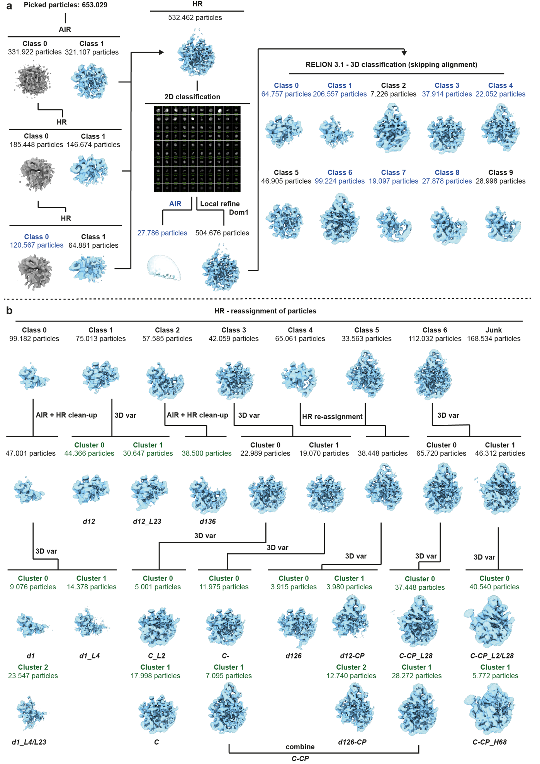

Supplementary Fig. 2: Sorting scheme
a) Sorting of particles and identification of initial classes. Extracted particles were subjected to an ab-initio reconstruction (AIR), followed by two rounds of heterogeneous refinement (HR) to recover ribosomal particles. Selected particles were refined to a consensus map, and remaining ice particles were sorted out using 2D classification. Particles were aligned to the 23S rRNA domain 1 region using local refinement and further sorted using 3D classification, skipping alignment in Relion 3.1. b) Re-assignment of initial classes, cleaning, and identification of final classes. Particles were re-assigned and re-aligned to previously identified classes. Templates used for particle re-assignment are labeled in blue. An additional bait template was generated using an AIR from selected non-ribosomal 2D classes. Further structural heterogeneity was identified using hierarchical 3D variability clustering. For d1 and d136 classes, assigned particles were cleaned using AIR followed by HR to identify the most defined subsets. Therefore, non-structured classes from AIR were used as bait templates, together with the starting ribosomal map in HR. Final classes are labeled in green. Sorting was performed at a pixel size of 3.75 Å. Final classes were refined at a pixel size of 1.25 Å (Supplementary Fig.3).
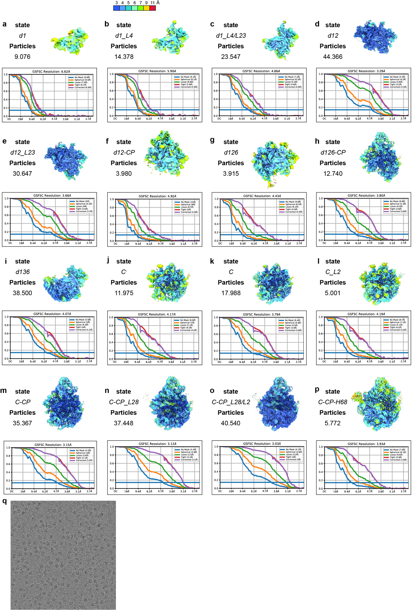

Supplementary Fig. 3: Final Cryo-EM maps, validation, and representative micrograph
Local resolution maps, total number of particles and gold-standard Fourier shell correlation (GSFSC) plots are shown for each state. States a) d1, b) d1_L4, c) d1_L4/L23, d) d12, e) d12_L23, f) d12-CP, g) d126 and i) d136 shown in back view, states h) d126-CP, j) C⁻, k) C, l) C_L2, m) C-CP, n) C-CP_L28, o) C-CP_L28/L2 and p) C-CP-H68 shown in crown view. Local resolution is shown using color keys from 3 Å (blue) to 11 Å (red). Overall resolutions were calculated from half-maps using the GSFC criteria cutoff of 0.143. q) Representative raw micrograph.
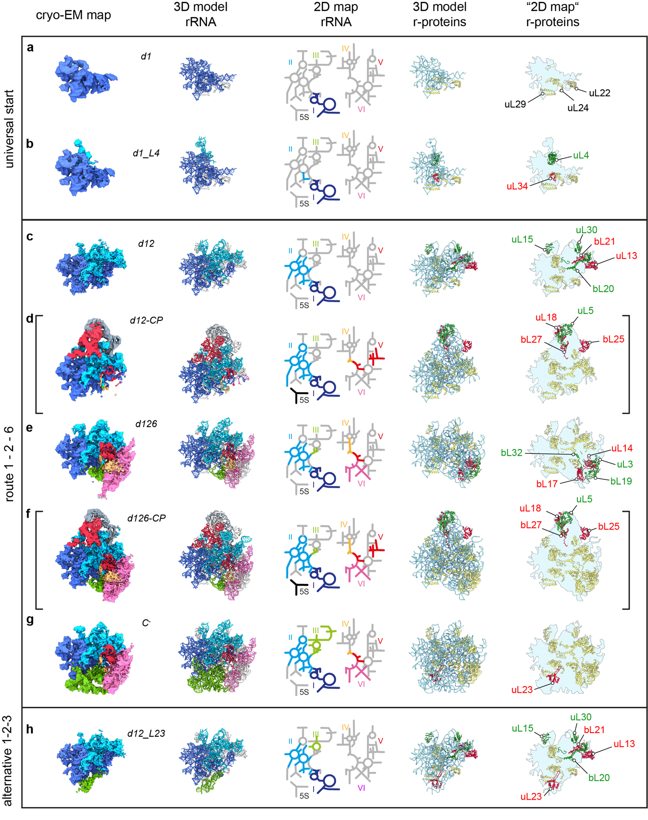
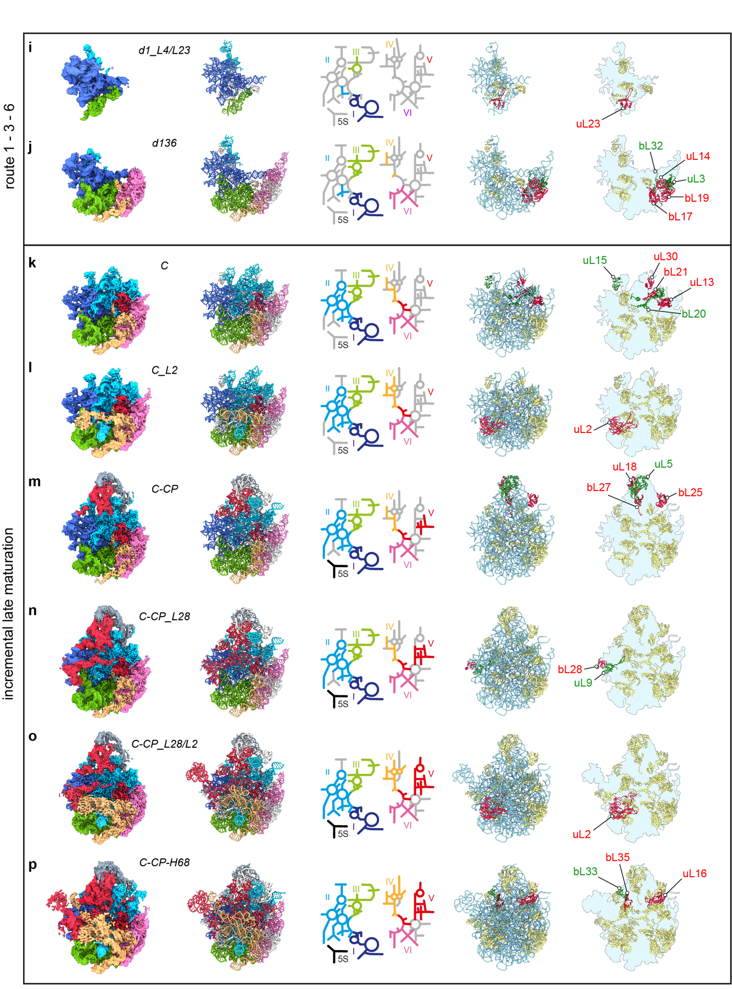Supplementary Fig. 4: Gallery of pre-50S states
a-p) States were lined up by their degree of structural completeness and their routes of maturation. Cryo-EM maps with rRNA and L-proteins color-coded according to the six architectural domains of the 23S rRNA they are part of. 3D PDB models, and 2D maps with the six rRNA domains color-coded. Colored regions indicate stably formed segments, for which cryo-EM densities were obtained. 3D PDB models, and “2D maps” with rRNA in pale blue and L-proteins in gold. Proteins for which density appears compared to the previous state are highlighted in red or green. d and f) Early assembly intermediates with cryo-EM density for the CP, d12-CP and d126-CP, respectively.
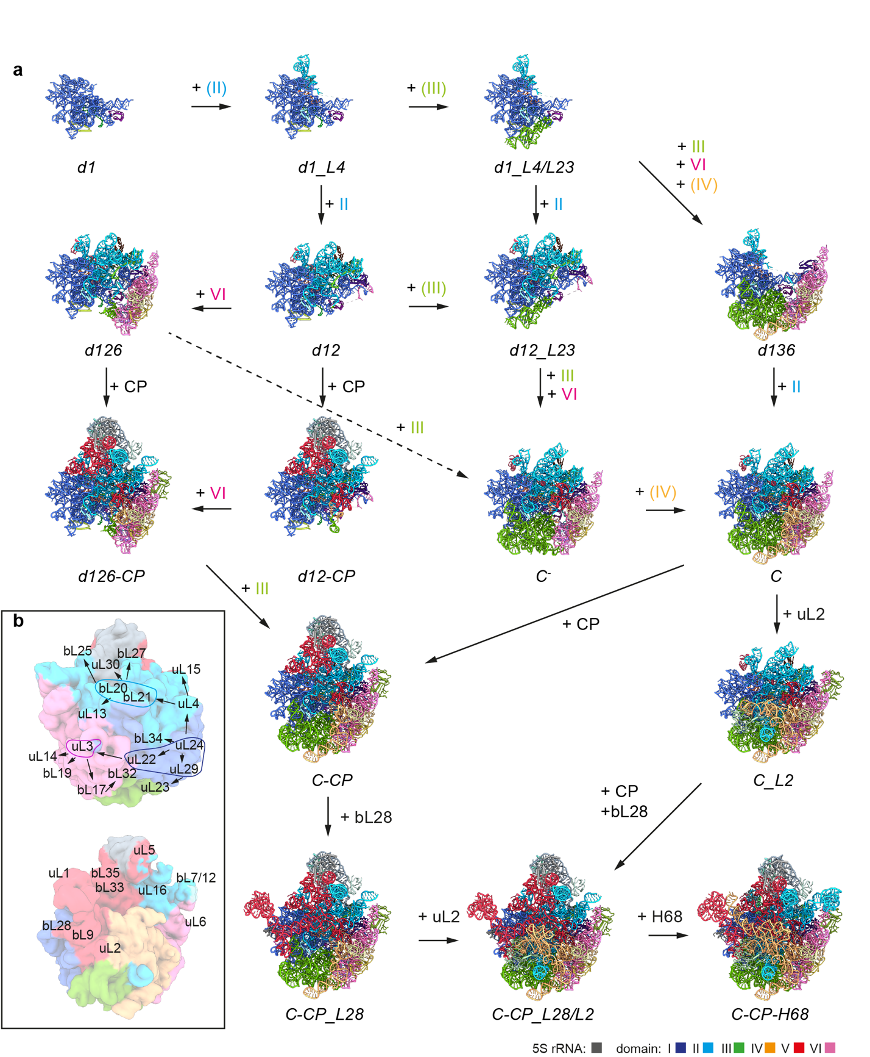

Supplementary Fig. 5: Interconversion of pre-50S states
a) PDB models of the individual states, with rRNA color-coded as specified. Sequences of appearing features (L-proteins or rRNA elements) are indicated. b) Possible order of L-protein binding, starting with uL24. The rRNA domains in brackets indicate partial formation of these domains.
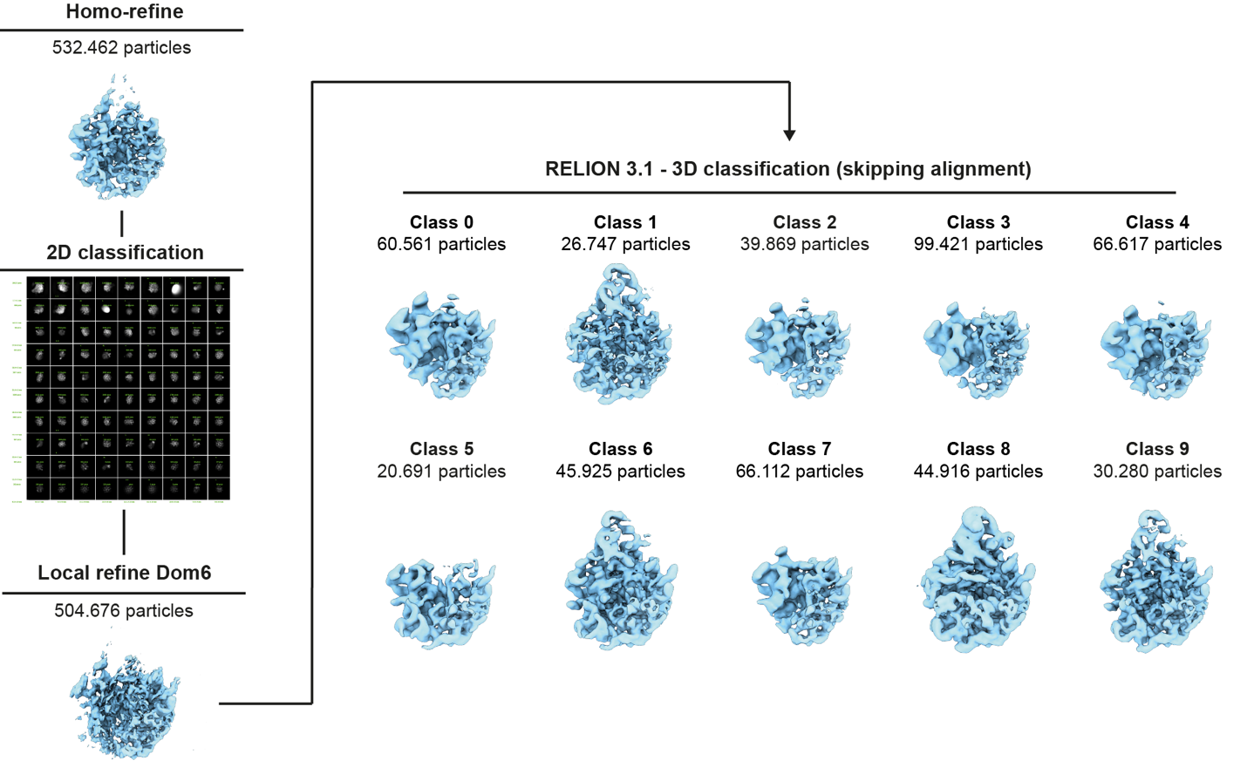
Supplementary Fig. 6: Control sorting scheme
Ribosomal particles from Supplementary Fig.2 were aligned to a consensus 50S map, cleaned by 2D classification and aligned to domain VI using local refinement. Subsequently, aligned particles were subjected to 3D classification skipping alignment in Relion 3.1.
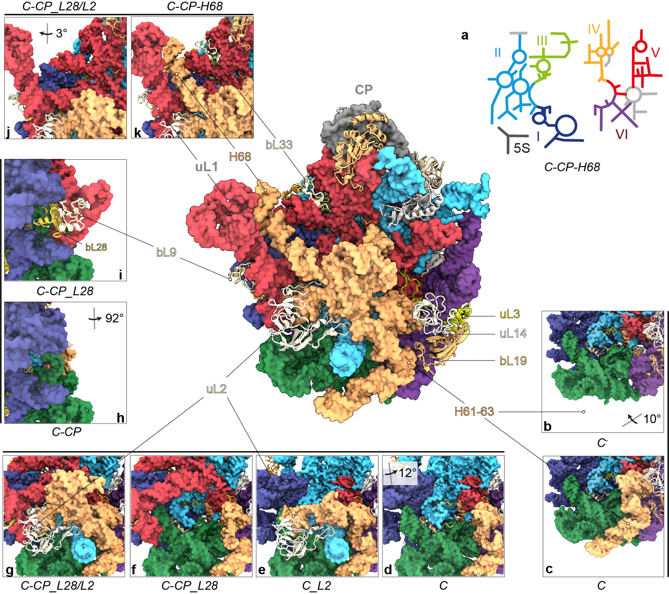
Supplementary Fig. 7: Incremental late 50S assembly
a) 2D rRNA map and atomic model of state C-CP-H68 in crown view. L-proteins appear as cartoons, rRNA as surface model (lowpass-filtered to 5 Å resolution), color-coded as in the 2D-map. Lower sections of states C⁻ (b) and C (c) lacking or exhibiting helices H61-63, respectively. d-g) Lower section of the individual states with absence or presence of uL2. Close-ups of states C-CP (h) and C-CP_L28 (i), lacking or exhibiting bL28, bL9 and L1-stalk, respectively. Close-ups of states C-CP_L28/L2 (j) and C-CP-H68 (k) lacking or exhibiting bL33 and H68, respectively. CP, central protuberance. Viewing angles in b), d), h) and j) are shown relative to the full model of C-CP-H68 (A).

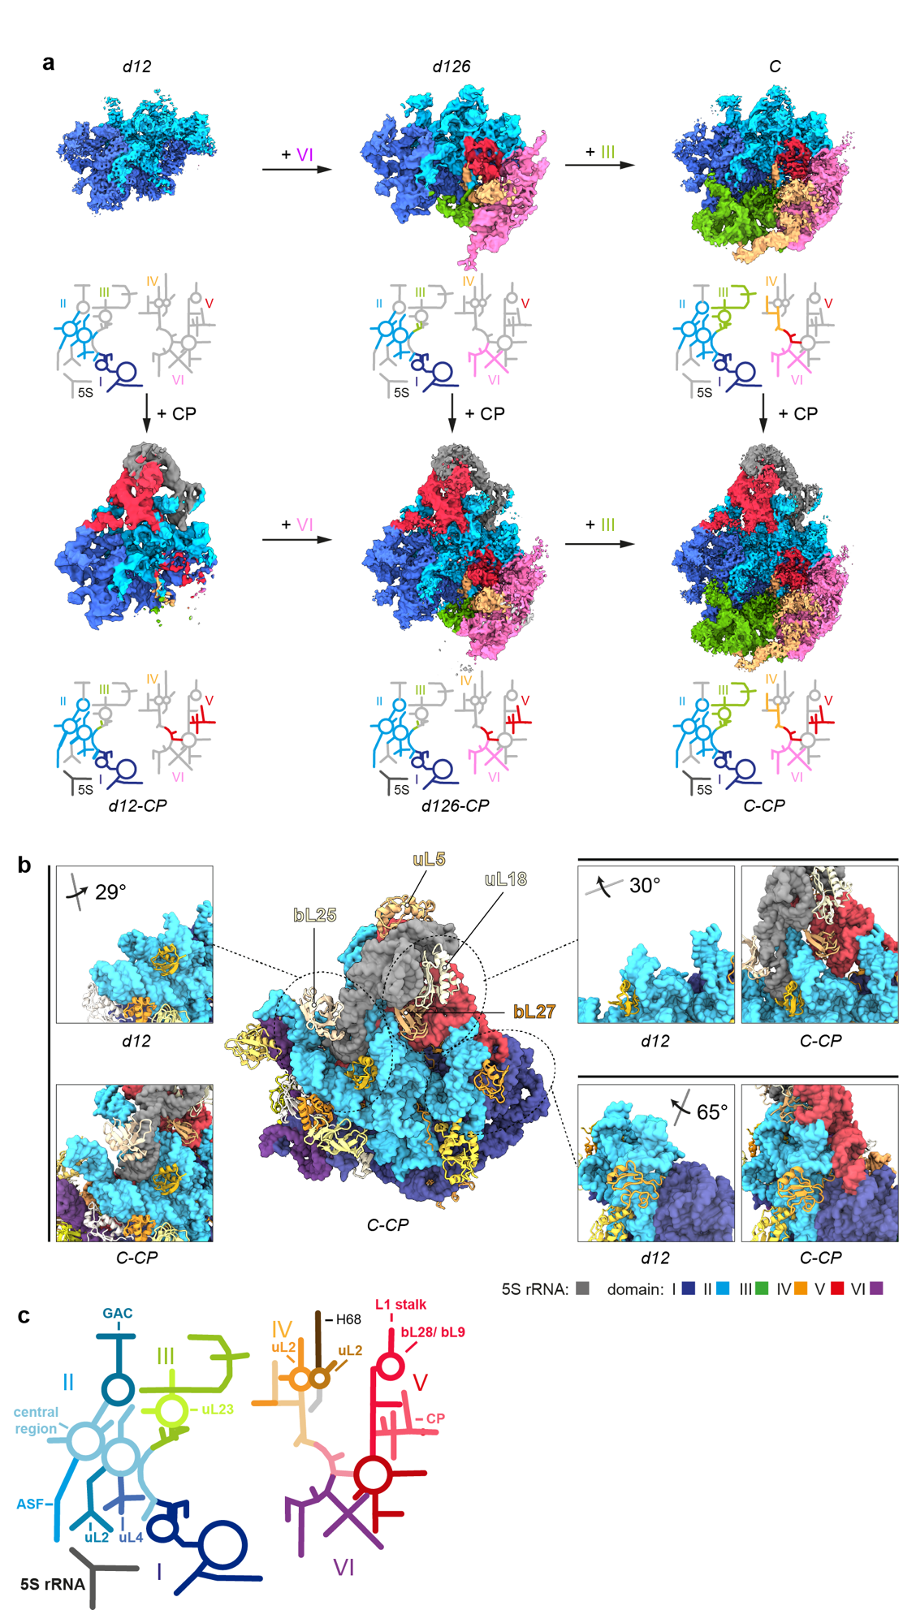

Supplementary Fig. 8: Docking of the 5S RNP
a) Cryo-EM maps of states d12 (-CP), d126 (-CP) and C (-CP), without and with cryo-EM density for the CP, dependent on docking of the 5S RNP, consisting of 5S rRNA, uL5 and uL18. b) Models of indicated states with rRNA as surface model (lowpass-filtered to 5 Å resolution), and L-proteins as cartoons. Selected regions are shown in detail, in absence and presence of the CP. Domains of the rRNA color-coded as indicated. Viewing angles shown relative to the full model (C-CP). c) 23S rRNA 2D map with the individual domains color-coded as indicated, binding sites of L-proteins and features of rRNA regions labeled. GAC, GTPase associated center (H42-44); CP, central protuberance (H80-88) and 5S rRNA; central region of domain II (pale blue); ASF, A-site finger (H38); L1 stalk (H 76-78).
 | #1  d1  EMDB-16509  PDB 8C9C | #2  d1_L4  EMD16508  PDB 8C9B | #3  d1_L4/L23  EMD-16507 PDB 8C9A | #4  d12  EMD-16506 PDB 8C99 | #5 d12_L23  EMD-16505  PDB 8C98 |  | #6  d136  EMD-16504  PDB 8C97 | #7  d126  EMD-16503  PDB 8C96 | #8  d12-CP  EMD-16502  PDB 8C95
Data collection and processing
Magnification | 31,000x | 31,000x | 31,000x | 31,000x | 31,000x | 31000x |  | 31,000x | 31,000x
Voltage (kV) | 300 | 300 | 300 | 300 | 300 | 300 |  | 300 | 300
Electron exposure (e–/Å²) | 62 | 62 | 62 | 62 | 62 | 62 |  | 62 | 62
Defocus range (μm) | -0.5-2.0 | -0.5-2.0 | -0.5-2.0 | -0.5-2.0 | -0.5-2.0 | -0.5-2.0 |  | -0.5-2.0 | -0.5-2.0
Pixel size (Å) | 0.625  (1.25) | 0.625  (1.25) | 0.625 (1.25) | 0.625 (1.25) | 0.625 (1.25) | 0.625  (1.25) |  | 0.625 (1.25) | 0.625 (1.25)
Symmetry imposed | C1 | C1 | C1 | C1 | C1 | C1 |  | C1 | C1
Initial particle images (no.) | 653,029 | 653,029 | 653,029 | 653,029 | 653,029 | 653,029 |  | 653,029 | 653,029
Final particle images (no.) | 9,076 | 14,378 | 23,547 | 44,366 | 30,647 | 38,500 |  | 3,915 | 3,980
Map resolution (Å) | 6.62 | 5.90 | 4.86 | 3.29 | 3.66 | 4.07 |  | 4.43 | 4.92
FSC threshold | 0.143 | 0.143 | 0.143 | 0.143 | 0.143 | 0.143 |  | 0.143 | 0.143
Map resolution range (Å) | 3.88-21.17 | 3.47-30 | 3.13-30 | 2.75-30 | 2.72-30 | 2.70-30 |  | 2.68-30 | 2.96-30
Refinement
Initial model used (PDB code) | 6GC7 | 6GC7 | 6GC7 | 6GC7 | 6GC7 | 6GC7 |  | 6GC7 | 6GC7
Model resolution (Å) | 6.5 | 5.8 | 4.8 | 3.3 | 3.6 | 4.0 |  | 4.4 | 4.9
FSC threshold | 0.143 | 0.143 | 0.143 | 0.143 | 0.143 | 0.143 |  | 0.143 | 0.143
Model resolution range (Å) | 6.2-8 | 5.6-7.3 | 4.6-5.7 | 3.2-3.5 | 3.6-3.9 | 3.9-4.5 |  | 4.3-5.5 | 4.7-7
Map sharpening B factor (Å²) | -272.1 | -218.6 | -150.9 | -70.9 | -73 | -96.5 |  | -47.9 | -101.4
Model composition  Non-hydrogen atoms | 13,032 | 15,782 | 18,061 | 27,988 | 30,289 | 36,169 |  | 44,218 | 40,174
Protein residues  Ligands | 256  0 | 441  0 | 525  0 | 987  0 | 1080  0 | 1077  0 |  | 1607  0 | 1460  0
B factors (Å²)  Protein  Ligand | -485  0 | -465  0 | -385  0 | -135  0 | -495  0 | -495  0 |  | -315  0 | -440  0
R.m.s. deviations  Bond lengths (Å)  Bond angles (°) | 0002 (0)  0.529 (3) | 0.002(0)  0.535 (0) | 0.002(0)  0.557(2) | 0.002(0)  0.535(0) | 0.002(0  0.522(1) | 0.002(0)  0.515(2) |  | 0.002(0)  0.519(0) | 0.002(0)  0.560(7)
Validation  MolProbity score  Clashscore  Poor rotamers (%) | 1.87  8.6  0.47 | 1.65  7.72  0.27 | 1.6  6.58  0.23 | 1.61  5.35  0 | 1.64  5.79  0 | 1.66  5.93  0 |  | 1.63  6.57  0.08 | 1.83  8.94  0.09
Ramachandran plot  Favored (%)  Allowed (%)  Disallowed (%) | 93.95  6.05  0 | 96.49  3.51  0 | 96.45  3.55  0 | 95.31  4.69  0 | 95.33  4.67  0 | 95.22  4.58  0.19 |  | 96.11  3.82  0.06 | 94.94  5.06  0

 | #9  d126-CP  EMD-16501 PDB 8C94 | #10  C⁻  EMD-16500  PDB 8C93 | #11  C  EMD-16499  PDB 8C92 | #12  C_L2  EMD-16498  PDB 8C91 | #13  C-CP  EMD-16497  PDB 8C90 | #14  C-CP_L28  EMD-16496  PDB 8C8Z |  | #15  C-CP_L28/L2  EMD-16495  PDB 8C8Y | #16  C-CP-H68  EMD-16494  PDB 8C8X
Data collection and processing
Magnification | 31,000x | 31,000x | 31,000x | 31,000x | 31,000x | 31,000x |  | 31,000x | 31,000x
Voltage (kV) | 300 | 300 | 300 | 300 | 300 | 300 |  | 300 | 300
Electron exposure (e–/Å²) | 62 | 62 | 62 | 62 | 62 | 62 |  | 62 | 62
Defocus range (μm) | -0.5-2.0 | -0.5-2.0 | -0.5-2.0 | -0.5-2.0 | -0.5-2.0 | -0.5-2.0 |  | -0.5-2.0 | -0.5-2.0
Pixel size (Å) | 0.625 (1.25) | 0.625  (1.25) | 0.625  (1.25) | 0.625  (1.25) | 0.625  (1.25) | 0.625  (1.25) |  | 0.625  (1.25) | 0.625  (1.25)
Symmetry imposed | C1 | C1 | C1 | C1 | C1 | C1 |  | C1 | C1
Initial particle images (no.) | 653,029 | 653,029 | 653,029 | 653,029 | 653,029 | 653,029 |  | 653,029 | 653,029
Final particle images (no.) | 12,740 | 11,975 | 17,988 | 5,001 | 35,367 | 37,448 |  | 40,540 | 5,772
Map resolution (Å) | 3.80 | 4.17 | 3.79 | 4.19 | 3.15 | 3.12 |  | 3.03 | 3.93
FSC threshold | 0.143 | 0.143 | 0.143 | 0.143 | 0.143 | 0.143 |  | 0.143 | 0.143
Map resolution range (Å) | 2.70-30 | 2.68-30 | 2.70-30 | 2.68-30 | 2.75-30 | 2.75-30 |  | 2.7-30 | 2.70-30
Refinement
Initial model used (PDB code) | 6GC4 | 6GC7 | 6GC7 | 6GC6 | 6GC4 | 6GC4 |  | 6GC4 | 6GBZ
Model resolution (Å) | 3.8 | 4.2 | 3.8 | 4.2 | 3.1 | 3.1 |  | 3.0 | 3.9
FSC threshold | 0.143 | 0.143 | 0.143 | 0.143 | 0.143 | 0.143 |  | 0.143 | 0.143
Model resolution range (Å) | 3.7-4.3 | 4.3-5.2 | 3.7-4.2 | 4.1-5.2 | 3.1-3.5 | 3.1-3.4 |  | 3.0-3.2 | 3.9-4.6
Map sharpening B factor (Å²) | -63.3 | -53.8 | -64.7 | -49.5 | -55.0 | -53.7 |  | -54.6 | -48.0
Model composition  Non-hydrogen atoms | 54,564 | 50,322 | 53,494 | 59,114 | 64,731 | 67,995 |  | 77,322 | 82,783
Protein residues  Ligands | 2,070  0 | 1,657  0 | 1,700  0 | 1,860  0 | 2,183  0 | 2,311  0 |  | 2,566  0 | 2,832  0
B factors (Å²)  Protein  Ligand | -165  0 | -290  0 | -175  0 | -250  0 | -135  0 | -110  0 |  | -65  0 | -170  0
R.m.s. deviations  Bond lengths (Å)  Bond angles (°) | 0002 (0)  0.563 (10) | 0.002(0  0.505 (0) | 0.002(0  0.511(0) | 0.002(0)  0.499(0) | 0.002(0  0.528(2) | 0.002(0)  0.556(14) |  | 0.002(0)  0.536(4) | 0.004(10)  0.539(10)
Validation  MolProbity score  Clashscore  Poor rotamers (%) | 1.77  7.44  0 | 1.67  6.07  0.07 | 1.63  5.69  0.00 | 1.57  5.51  0.07 | 1.64  5.55  0.11 | 1.82  6.67  0.05 |  | 1.67  4.85  0 | 1.69  6.35  0.3
Ramachandran plot  Favored (%)  Allowed (%)  Disallowed (%) | 94.71  5.29  0 | 95.11  4.89  0 | 95.42  4.52  0.06 | 96.08  3.75  0.17 | 95.04  4.92  0.05 | 92.96  6.96  0.09 |  | 93.7  6.22  0.08 | 95.09  4.83  0.07

Supplementary Table 1: Cryo-EM data collection, refinement, and validation statistics

