Supplementary Information
Mechanically robust and personalized silk fibroin-magnesium composite scaffolds with water-responsive shape-memory for irregular bone regeneration

Zhinan Mao^{1,2#}, Xuewei Bi^{1,2#}, Chunhao Yu², Lei Chen³, Jie Shen¹, Yongcan Huang¹, Zihong Wu⁵, Hui Qi³, Juan Guan⁴, Xiong Shu^{3*}, Binsheng Yu^{1*}, Yufeng Zheng^{2*}

Z.N. Mao, X.W. Bi, J. Shen, Y.C. Huang, B.S. Yu
¹Shenzhen Engineering Laboratory of Orthopaedic Regenerative Technologies, Department of Spine Surgery, Peking University Shenzhen Hospital, Shenzhen Peking University-The Hong Kong University of Science and Technology Medical Center,Guangdong province,China.
E-mail: hpyubinsheng@hotmail.com
Z.N. Mao, X.W. Bi, C.H. Yu, Y.F. Zheng
² School of Materials Science and Engineering, Peking University, Beijing, 100871, China.
E-mail: yfzheng@pku.edu.cn
L. Chen, X. Shu, H. Qi
³Beijing Research Institute of Orthopedics and Traumatology, Beijing Jishuitan Hospital, Capital Medical University, Beijing, 100035, China.
E-mail: shuxiong@jst-hosp.com.cn
J. Guan
⁴International Research Center for Advanced Structural and Biomaterials, School of Materials Science & Engineering, Beihang University, Beijing 100191, China.
Z.H. Wu
⁵Technical University of Munich, TUM School of Life Sciences, Maximus-von-Imhof-Forum 2, D-85354 Freising, Germany

#Zhinan Mao and Xuewei Bi contributed equally to this work.
*Corresponding author.
Email: yfzheng@pku.edu.cn (Y.F. Zheng); shuxiong@jst-hosp.com.cn (X. Shu); hpyubinsheng@hotmail.com (B.S. Yu)
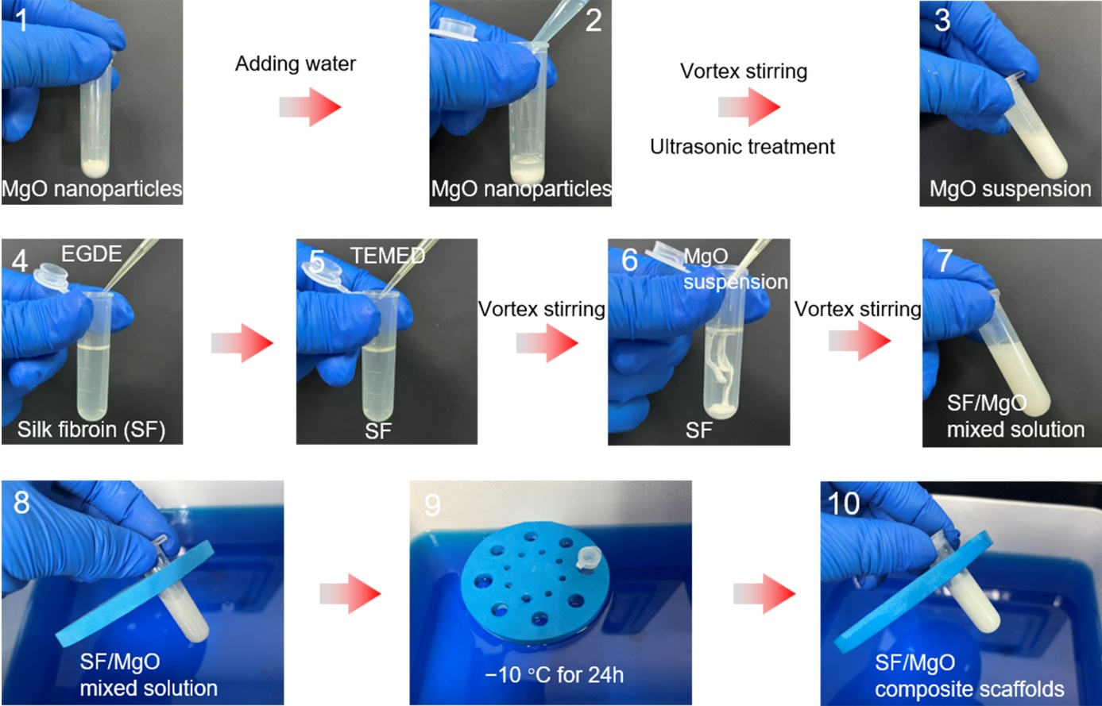
Supplementary Figure 1. Preparation process of the SF/MgO composite scaffolds. The SF solution (60 mg/ml) was mixed with aqueous ethylene glycol diglycidyl ether (EGDE, 2 mmol/g) and N,N,N',N'-Tetramethylethylenediamine (TEMED, 0.25 v/v%). Then, nano-MgO particles with different contents (0 wt%, 10 wt%, and 30 wt%, relative to the weight of the SF solute) were added to the SF solution, and the SF/MgO (SF, SF-1nMgO, SF-3nMgO) mixture solution was prepared. After 24 h of cryogelation (-10 °C), the SF/MgO composite scaffolds were constructed.

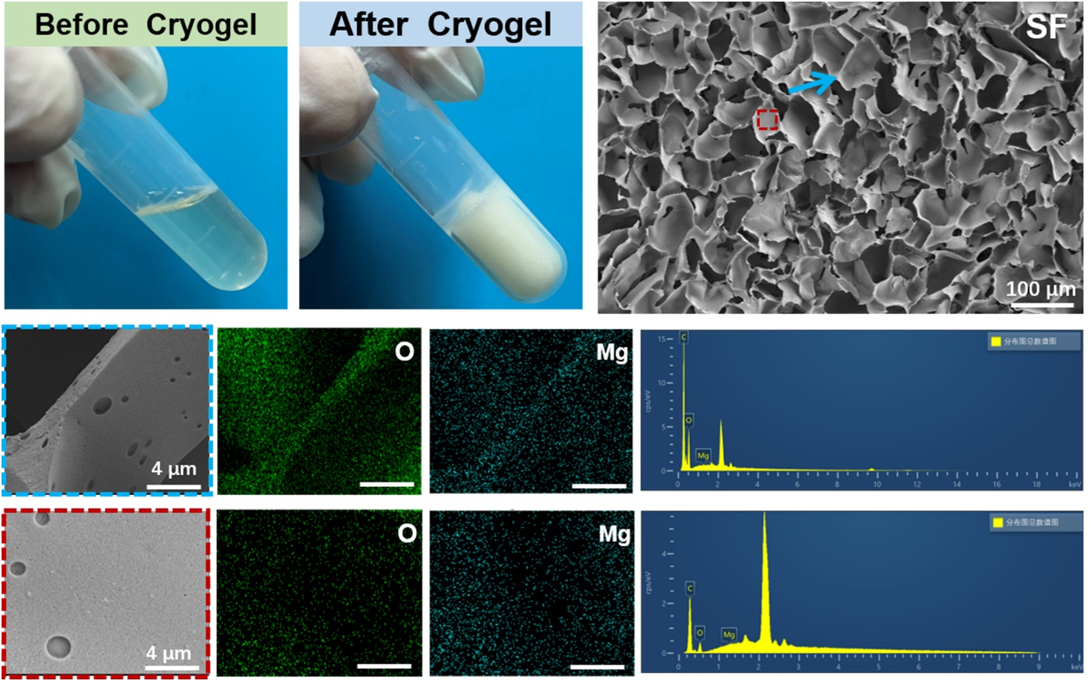
Supplementary Figure 2. Morphology and characterisation of SF scaffolds. Including macro-morphologies of SF solutions before and after cryogelation; SEM images of SF scaffolds cross-sections; energy-dispersive spectrometry maps and spectra of the SF scaffolds.

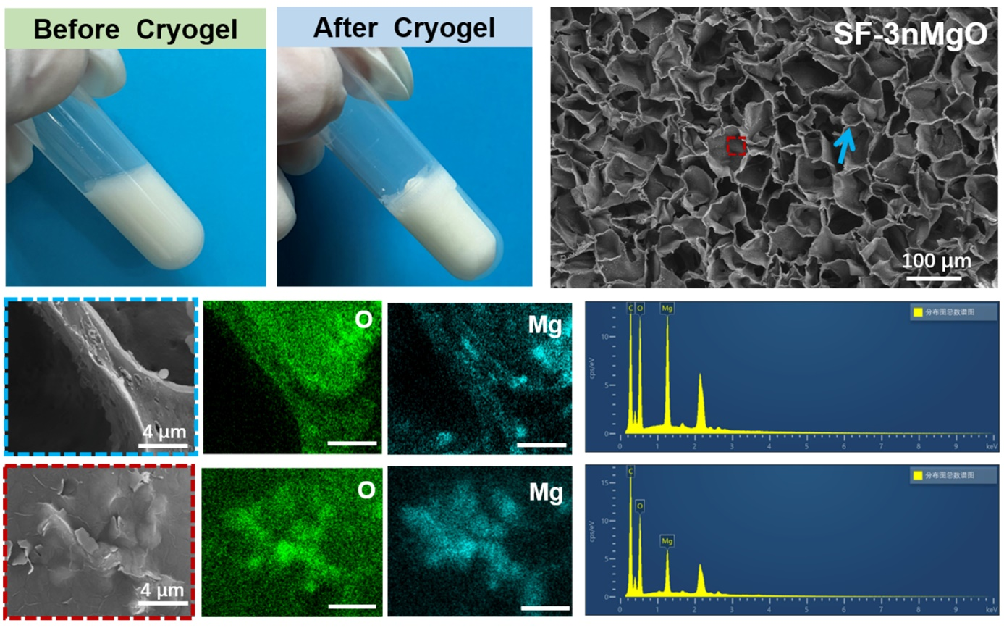
Supplementary Figure 3. Morphology and characterization of SF-3nMgO scaffolds. Including macro-morphologies of SF-3nMgO solutions before and after cryogelation; Scanning electron microscopy (SEM) images of SF-3nMgO scaffolds cross-sections; Energy-dispersive spectrometry maps and spectra of the SF scaffolds.

Supplementary Figure 4. Representative FTIR spectra after peak fitting. (a) SF scaffolds. (b) SF-1nMgO scaffolds. (c) SF-3nMgO scaffolds. Source data are provided as a Source data file. (n = 3 independent samples).

Supplementary Figure 5. Schematic illustration of water-responsive shape-memory effect of SF-1nMgO scaffolds. The SF-1nMgO scaffolds in the dry state were permanently deformed after being subjected to external force and had no shape-recovery ability. However, the deformed dry scaffolds that were in contact with water/blood gradually restored their original shape.

Supplementary Figure 6. In vivo histological assessment of subcutaneous implantation of SF, SF-1nMgO and SF-3nMgO scaffolds. Representative images of the H&E staining of different SF scaffolds after 1 week of subcutaneous implantation; scaffolds are labelled with “S”. n = 4 biologically independent replicates. Source data are provided as a source data file.

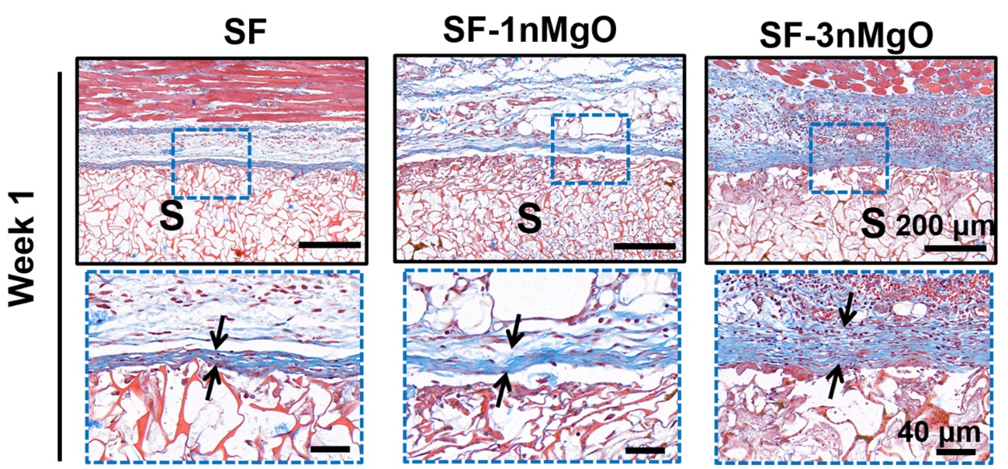
Supplementary Figure 7. In vivo histological assessment of subcutaneous implantation to of SF, SF-1nMgO and SF-3nMgO scaffolds. Representative images of the Masson's Trichrome staining of different SF scaffolds after 1 week of subcutaneous implantation; scaffolds are labeled with “S”. n = 4 biologically independent replicates. Source data are provided as a source data file.

Supplementary Table 1. Primer sequences used for quantitative RT-PCR
Target Name | Primer
GAPDH |  | F-5’-CTGGAGAAACCTGCCAAGTATG-3’
GAPDH |  | R-5’-GGTGGAAGAATGGGAGTTGCT-3’
RUNX2 |  | F-5’-GGAACCAAGAAGGCACAGACAG-3’
RUNX2 |  | R-5’-TGTCTGCCTGGGATCTGTAATCT-3’
OPN |  | F-5’-GATGAACAGTATCCCGATGCCA-3’
OPN |  | R-5’-GTCTTCCCGTTGCTGTCCTGA-3’
OCN |  | F-5’-TGACAAAGCCTTCATGTCCAA-3’
OCN |  | R-5’-CTCCAAGTCCATTGTTGAGGTAG-3’
COL1 |  | F-5’-AGAGGCATAAAGGGTCATCGTG-3’
COL1 |  | R-5’-AGACCGTTGAGTCCATCTTTGC-3’

