Supplementary Figure 1. Case validation for active cancer, hospitalization due to VTE, and major bleeding
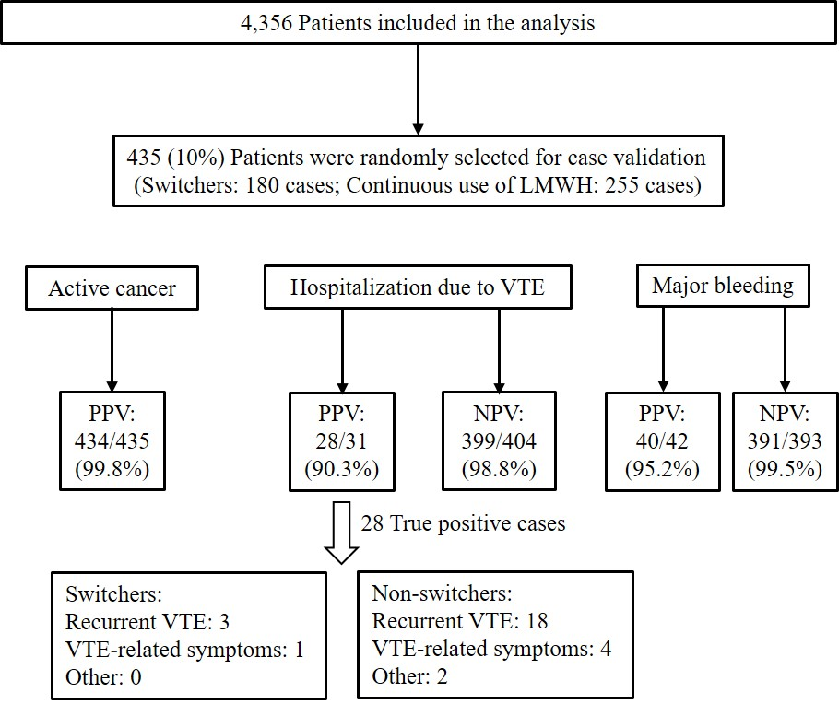
Electronic medical records of active cancer, hospitalization due to venous thromboembolism (VTE), and major bleeding acquired from the Clinical Data Analysis and Reporting System (CDARS) were validated against clinical notes from the Clinical Management System for a 10% randomly selected patient population in the study cohort. Positive predictive values (PPVs) and negative predictive values (NPVs) were calculated for data validation. Switchers were defined as patients who switched to DOACs (apixaban, dabigatran, edoxaban, or rivaroxaban) after receiving LMWH (enoxaparin, tinzaparin, or nadroparin) treatment for any duration. Non-switchers were defined as patients who consistently received LMWH.

Supplementary Figure 2. Patient selection flowchart in landmark analysis
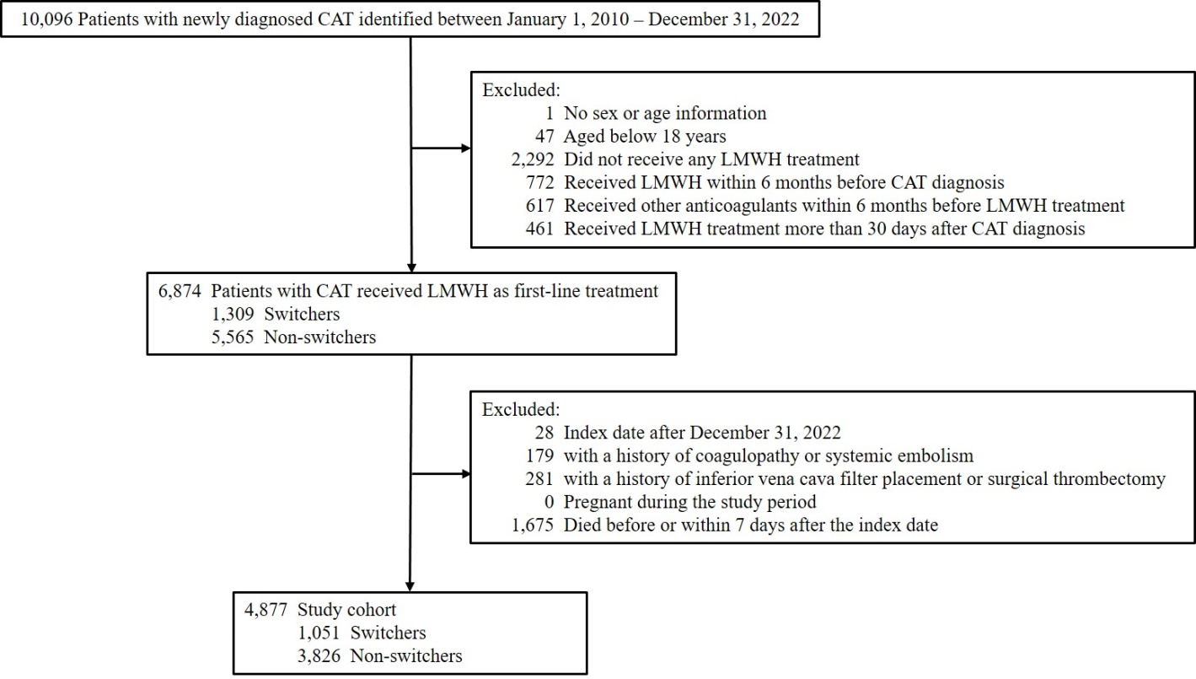
Cohort selection for landmark analysis for the effectiveness and safety of continuous low-molecular-weight heparin (LMWH) versus switching to direct oral anticoagulants (DOACs) among patients with cancer-associated venous thrombosis (CAT). Switchers were defined as patients who switched to DOACs after receiving LMWH treatment during the initial 30 days following the incident of CAT. Non-switchers were defined as patients who consistently received LMWH during the initial 30 days following the incident of CAT.

Supplementary Figure 3. Landmark analysis design
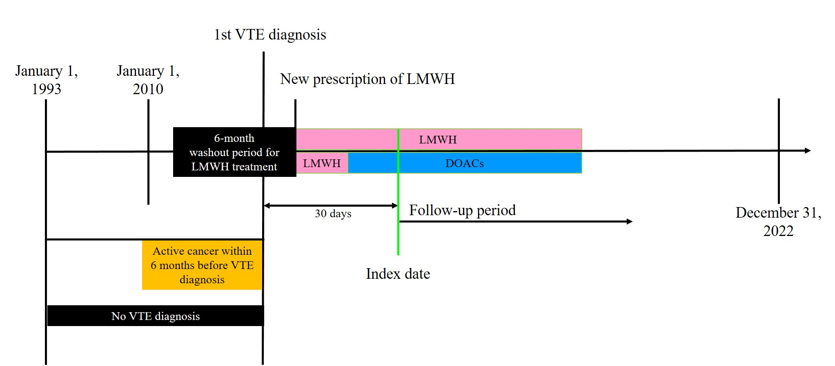
Patients with cancer-associated venous thrombosis (CAT) were identified as those with active cancer followed by an incident diagnosis of venous thromboembolism (VTE) between January 1, 2010, and December 31, 2022. Active cancer (yellow band) was defined as a new cancer diagnosis, recurrent cancer diagnosis, presence of metastasis, any cancer-related treatment, or palliative care within the six months prior to the first VTE diagnosis. The start of initial LMWH treatment was determined as the date of the first recorded LMWH prescription following the CAT diagnosis. Patients with a history of LMWH treatment within six months prior to the initial LMWH treatment were excluded as LMWH-experienced. In this landmark analysis, the study cohort was divided into two groups based on whether they switched to direct oral anticoagulant (DOAC, blue band) treatment from low-molecular-weight heparin (LMWH, pink band) during the initial 30 days following the incident of CAT or not. The index date (green line) in both groups was the 30th day after the incident CAT. Patients were followed up from the index date for six months or until the occurrence of the outcome, death, the end of anticoagulation treatment, or the end of the study period (December 31, 2022), whichever occurred first.

Supplementary Table 1. Sensitivity analysis: Extended the follow-up period to one year
Outcomes | Events/Incidence  (per 100 person-year) |  | Unweighted |  | Weighted |  | Competing risk
Outcomes | Non-switchers  (N=2,656) | Switchers (N=1,700) | Hazard Ratio  (95% CI) | P value | Hazard Ratio  (95% CI) | P value | Subdistribution  Hazard Ratio  (95% CI) | P value
Hospitalization due to VTE | 166/15 | 64/7 | 0.50 (0.38-0.67) | 2.79e-6 | 0.51 (0.38-0.69) | 1.13e-5 | 0.62 (0.47-0.83) | 0.001
Hospitalization due to DVT | 112/10 | 37/4 | 0.43 (0.30-0.62) | 8.86e-6 | 0.44 (0.30-0.65) | 3.07e-5 | 0.57 (0.39-0.82) | 0.002
Hospitalization due to PE | 58/5 | 29/3 | 0.67 (0.43-1.04) | 0.074 | 0.67 (0.42-1.07) | 0.092 | 0.77 (0.48-1.23) | 0.270
Major bleeding | 226/20 | 163/19 | 0.98 (0.80-1.20) | 0.852 | 1.01 (0.82-1.24) | 0.932 | 1.17 (0.95-1.44) | 0.130
ICH | 28/02 | 13/1 | 0.62 (0.32-1.20) | 0.158 | 0.64 (0.32-1.25) | 0.193 | 0.73 (0.37-1.45) | 0.370
GI bleeding | 56/5 | 49/5 | 1.17 (0.80-1.72) | 0.418 | 1.21 (0.81-1.79) | 0.352 | 1.45 (0.98-2.15) | 0.063
Bleeding of other critical sites | 145/13 | 107/12 | 1.00 (0.78-1.29) | 0.971 | 1.04 (0.80-1.35) | 0.779 | 1.20 (0.93-1.56) | 0.160
All-cause mortality | 1937/164 | 905/97 | 0.62 (0.58-0.67) | 5.65e-32 | 0.68 (0.62-0.73) | 8.41e-21 | - | -
N: Number of patients; CI: Confidence interval; VTE: Venous thromboembolism; DVT: deep vein thrombosis; PE: pulmonary embolism; ICH: intracranial hemorrhage; GI bleeding: gastrointestinal bleeding. All P values were from 2-sided tests and results were deemed statistically significant at P < 0.05.

Supplementary Table 2. Sensitivity analysis: Excluded patients with basal cell carcinoma, squamous-cell skin carcinoma, lymphoma, acute leukemia or myeloproliferative neoplasm before or during the study period
Outcomes | Events/Incidence  (per 100 person-year) |  | Unweighted |  | Weighted |  | Competing risk
Outcomes | Non-switchers  (N=2,503) | Switchers (N=1,597) | Hazard Ratio  (95% CI) | P value | Hazard Ratio  (95% CI) | P value | Subdistribution  Hazard Ratio  (95% CI) | P value
Hospitalization due to VTE | 132/20 | 51/10 | 0.52 (0.37-0.71) | 5.85e-5 | 0.52 (0.37-0.72) | 1.14e-4 | 0.62 (0.45-0.86) | 0.004
Hospitalization due to DVT | 87/13 | 26/5 | 0.40 (0.26-0.62) | 4.31e-5 | 0.41 (0.26-0.65) | 1.21e-4 | 0.52 (0.34-0.80) | 0.003
Hospitalization due to PE | 48/7 | 26/5 | 0.73 (0.45-1.18) | 0.202 | 0.71 (0.43-1.16) | 0.171 | 0.80 (0.48-1.33) | 0.390
Major bleeding | 189/28 | 132/26 | 0.97 (0.78-1.22) | 0.819 | 1.00 (0.80-1.26) | 0.979 | 1.13 (0.90-1.43) | 0.280
ICH | 24/3 | 11/2 | 0.63 (0.31-1.29) | 0.206 | 0.64 (0.30-1.34) | 0.233 | 0.72 (0.34-1.51) | 0.380
GI bleeding | 48/7 | 36/7 | 1.03 (0.67-1.58) | 0.905 | 1.07 (0.69-1.68) | 0.752 | 1.25 (0.80-1.95) | 0.330
Bleeding of other critical sites | 119/17 | 87/17 | 1.03 (0.78-1.36) | 0.843 | 1.05 (0.79-1.41) | 0.721 | 1.18 (0.88-1.57) | 0.260
All-cause mortality | 1560/222 | 700/133 | 0.62 (0.56-0.67) | 1.83e-6 | 0.67 (0.61-0.74) | 6.77e-17 | - | -
N: Number of patients; CI: Confidence interval; VTE: Venous thromboembolism; DVT: deep vein thrombosis; PE: pulmonary embolism; ICH: intracranial hemorrhage; GI bleeding: gastrointestinal bleeding. All P values were from 2-sided tests and results were deemed statistically significant at P < 0.05.

Supplementary Table 3. Sensitivity analysis: Excluded patients with a short follow-up period (index date later than July 4, 2022)
Outcomes | Events/Incidence  (per 100 person-year) |  | Unweighted |  | Weighted |  | Competing risk
Outcomes | Non-switchers  (N=2,626) | Switchers (N=1,525) | Hazard Ratio  (95% CI) | P value | Hazard Ratio  (95% CI) | P value | Subdistribution  Hazard Ratio  (95% CI) | P value
Hospitalization due to VTE | 148/21 | 51/10 | 0.49 (0.35-0.67) | 9.99e-6 | 0.49 (0.35-0.68) | 1.56e-5 | 0.59 (0.43-0.82) | 0.001
Hospitalization due to DVT | 99/14 | 27/5 | 0.39 (0.25-0.59) | 1.32e-5 | 0.40 (0.26-0.63) | 4.97e-5 | 0.50 (0.33-0.77) | 0.001
Hospitalization due to PE | 52/7 | 25/5 | 0.69 (0.43-1.12) | 0.132 | 0.65 (0.40-1.06) | 0.085 | 0.76 (0.46-1.26) | 0.290
Major bleeding | 192/27 | 124/24 | 0.96 (0.77-1.20) | 0.720 | 0.99 (0.79-1.26) | 0.961 | 1.14 (0.90-1.44) | 0.270
ICH | 24/3 | 10/2 | 0.61 (0.29-1.27) | 0.188 | 0.60 (0.28-1.29) | 0.192 | 0.70 (0.33-1.49) | 0.360
GI bleeding | 48/6 | 36/7 | 1.09 (0.71-1.68) | 0.697 | 1.16 (0.74-1.80) | 0.522 | 1.34 (0.87-2.08) | 0.190
Bleeding of other critical sites | 122/17 | 80/15 | 0.98 (0.74-1.31) | 0.914 | 1.02 (0.76-1.37) | 0.904 | 1.16 (0.86-1.55) | 0.330
All-cause mortality | 1612/215 | 665/125 | 0.60 (0.55-0.66) | 4.44e-28 | 0.67 (0.61-0.73) | 2.02e-17 | - | -
N: Number of patients; CI: Confidence interval; VTE: Venous thromboembolism; DVT: deep vein thrombosis; PE: pulmonary embolism; ICH: intracranial hemorrhage; GI bleeding: gastrointestinal bleeding. All P values were from 2-sided tests and results were deemed statistically significant at P < 0.05.

Supplementary Table 4. Sensitivity analysis: Excluded patients diagnosed with cancer-associated venous thrombosis on or after January 1, 2020
Outcomes | Events/Incidence  (per 100 person-year) |  | Unweighted |  | Weighted |  | Competing risk
Outcomes | Non-switchers  (N=2,347) | Switchers  (N=796) | Hazard Ratio  (95% CI) | P value | Hazard Ratio  (95% CI) | P value | Subdistribution  Hazard Ratio  (95% CI) | P value
Hospitalization due to VTE | 137/21 | 29/10 | 0.49 (0.33-0.74) | 5.75e-4 | 0.44 (0.29-0.67) | 1.26e-4 | 0.60 (0.40-0.89) | 0.012
Hospitalization due to DVT | 93/14 | 15/5 | 0.38 (0.22-0.65) | 4.93e-4 | 0.34 (0.19-0.60) | 1.78e-4 | 0.49 (0.28-0.84) | 0.009
Hospitalization due to PE | 47/7 | 14/5 | 0.71 (0.39-1.29) | 0.256 | 0.62 (0.33-1.16) | 0.133 | 0.72 (0.38-1.36) | 0.310
Major bleeding | 170/26 | 61/22 | 0.88 (0.66-1.19) | 0.410 | 0.96 (0.70-1.32) | 0.800 | 1.15 (0.85-1.56) | 0.360
ICH | 21/3 | 4/1 | 0.46 (0.16-1.35) | 0.159 | 0.47 (0.15-1.42) | 0.178 | 0.58 (0.19-1.78) | 0.340
GI bleeding | 38/6 | 18/6 | 1.14 (0.65-1.99) | 0.652 | 1.24 (0.67-2.30) | 0.490 | 1.44 (0.81-2.57) | 0.220
Bleeding of other critical sites | 113/17 | 40/14 | 0.88 (0.61-1.26) | 0.478 | 0.95 (0.65-1.41) | 0.813 | 1.16 (0.80-1.69) | 0.440
All-cause mortality | 1411/207 | 306/104 | 0.52 (0.46-0.59) | 1.39e-24 | 0.64 (0.56-0.74) | 1.70e-10 | - | -
N: Number of patients; CI: Confidence interval; VTE: Venous thromboembolism; DVT: deep vein thrombosis; PE: pulmonary embolism; ICH: intracranial hemorrhage; GI bleeding: gastrointestinal bleeding. All P values were from 2-sided tests and results were deemed statistically significant at P < 0.05.

Supplementary Table 5. Sensitivity analysis: The index year was included as a confounder
Outcomes | Events/Incidence  (per 100 person-year) |  | Unweighted |  | Weighted |  | Competing risk
Outcomes | Non-switchers  (N=2,656) | Switchers (N=1,700) | Hazard Ratio  (95% CI) | P value | Hazard Ratio  (95% CI) | P value | Subdistribution  Hazard Ratio  (95% CI) | P value
Hospitalization due to VTE | 148/21 | 53/10 | 0.48 (0.35-0.65) | 3.73e-6 | 0.50 (0.31-0.80) | 0.004 | 0.78 (0.53-1.14) | 0.200
Hospitalization due to DVT | 99/14 | 28/5 | 0.38 (0.25-0.58) | 5.73e-6 | 0.36 (0.21-0.61) | 1.35e-4 | 0.75 (0.46-1.22) | 0.250
Hospitalization due to PE | 52/7 | 26/5 | 0.68 (0.42-1.08) | 0.104 | 0.77 (0.36-1.61) | 0.481 | 0.80 (0.44-1.45) | 0.460
Major bleeding | 192/27 | 139/26 | 1.01 (0.81-1.26) | 0.931 | 0.96 (0.71-1.28) | 0.770 | 1.14 (0.87-1.49) | 0.350
ICH | 24/3 | 11/2 | 0.63 (0.31-1.29) | 0.205 | 0.50 (0.21-1.16) | 0.105 | 0.57 (0.25-1.30) | 0.180
GI bleeding | 48/6 | 41/7 | 1.17 (0.77-1.78) | 0.458 | 0.90 (0.55-1.47) | 0.669 | 1.12 (0.69-1.81) | 0.650
Bleeding of other critical sites | 122/17 | 89/16 | 1.02 (0.78-1.35) | 0.865 | 1.08 (0.75-1.57) | 0.674 | 1.31 (0.92-1.85) | 0.130
All-cause mortality | 1629/216 | 729/129 | 0.61 (0.56-0.67) | 6.53e-28 | 0.58 (0.50-0.67) | 9.92e-14 | - | -
N: Number of patients; CI: Confidence interval; VTE: Venous thromboembolism; DVT: deep vein thrombosis; PE: pulmonary embolism; ICH: intracranial hemorrhage; GI bleeding: gastrointestinal bleeding. All P values were from 2-sided tests and results were deemed statistically significant at P < 0.05.

Supplementary Table 6. Sensitivity analysis: The end date of anticoagulation treatment was added as a follow-up endpoint
Outcomes | Events/Incidence  (per 100 person-year) |  | Unweighted |  | Weighted |  | Competing risk
Outcomes | Non-switchers  (N=2,656) | Switchers (N=1,700) | Hazard Ratio  (95% CI) | P value | Hazard Ratio  (95% CI) | P value | Subdistribution  Hazard Ratio  (95% CI) | P value
Hospitalization due to VTE | 69/19 | 40/10 | 0.53 (0.36-0.79) | 0.002 | 0.54 (0.36-0.81) | 0.003 | 0.61 (0.41-0.91) | 0.015
Hospitalization due to DVT | 43/12 | 23/6 | 0.49 (0.30-0.82) | 0.006 | 0.50 (0.30-0.84) | 0.009 | 0.59 (0.35-0.97) | 0.037
Hospitalization due to PE | 28/8 | 18/4 | 0.60 (0.33-1.08) | 0.087 | 0.61 (0.33-1.11) | 0.103 | 0.67 (0.35-1.26) | 0.210
Major bleeding | 90/25 | 96/25 | 1.06 (0.79-1.41) | 0.695 | 1.10 (0.82-1.49) | 0.528 | 1.18 (0.88-1.59) | 0.260
ICH | 5/1 | 7/2 | 1.36 (0.43-4.30) | 0.604 | 1.67 (0.51-5.45) | 0.393 | 1.85 (0.53-6.44) | 0.330
GI bleeding | 21/6 | 25/6 | 1.14 (0.63-2.03) | 0.668 | 1.14 (0.63-2.06) | 0.662 | 1.30 (0.74-2.27) | 0.360
Bleeding of other critical sites | 64/18 | 66/17 | 1.04 (0.74-1.47) | 0.828 | 1.08 (0.75-1.55) | 0.675 | 1.13 (0.78-1.63) | 0.520
All-cause mortality | 642/174 | 332/83 | 0.49 (0.43-0.56) | 2.34e-25 | 0.54 (0.47-0.62) | 2.51e-18 | - | -
N: Number of patients; CI: Confidence interval; VTE: Venous thromboembolism; DVT: deep vein thrombosis; PE: pulmonary embolism; ICH: intracranial hemorrhage; GI bleeding: gastrointestinal bleeding. All P values were from 2-sided tests and results were deemed statistically significant at P < 0.05.

Supplementary Table 7. Sensitivity analysis: The landmark analysis
Outcomes | Events/Incidence  (per 100 person-year) |  | Unweighted |  | Weighted |  | Competing risk
Outcomes | Non-switchers  (N=3,826) | Switchers (N=1,051) | Hazard Ratio  (95% CI) | P value | Hazard Ratio  (95% CI) | P value | Subdistribution  Hazard Ratio  (95% CI) | P value
Hospitalization due to VTE | 92/30 | 25/13 | 0.57 (0.37-0.89) | 0.013 | 0.54 (0.33-0.89) | 0.015 | 0.60 (0.39-0.94) | 0.027
Hospitalization due to DVT | 59/19 | 12/6 | 0.43 (0.23-0.79) | 0.007 | 0.35 (0.18-0.68) | 0.002 | 0.43 (0.23-0.80) | 0.008
Hospitalization due to PE | 35/11 | 14/7 | 0.85 (0.46-1.58) | 0.604 | 0.90 (0.45-1.79) | 0.770 | 0.93 (0.48-1.81) | 0.830
Major bleeding | 93/30 | 48/26 | 1.07 (0.76-1.52) | 0.701 | 0.98 (0.68-1.41) | 0.919 | 1.08 (0.75-1.56) | 0.660
ICH | 6/2 | 1/1 | 0.35 (0.04-2.87) | 0.325 | 0.31 (0.04-2.62) | 0.283 | 0.33 (0.02-4.34) | 0.400
GI bleeding | 22/7 | 14/7 | 1.31 (0.67-2.56) | 0.432 | 1.27 (0.64-2.52) | 0.490 | 1.53 (0.74-3.14) | 0.250
Bleeding of other critical sites | 65/21 | 34/18 | 1.09 (0.72-1.65) | 0.694 | 0.96 (0.62-1.49) | 0.871 | 1.05 (0.68-1.61) | 0.840
All-cause mortality | 579/181 | 170/88 | 0.61 (0.51-0.72) | 1.09e-8 | 0.61 (0.51-0.73) | 1.18e-7 | - | -
N: Number of patients; CI: Confidence interval; VTE: Venous thromboembolism; DVT: deep vein thrombosis; PE: pulmonary embolism; ICH: intracranial hemorrhage; GI bleeding: gastrointestinal bleeding. All P values were from 2-sided tests and results were deemed statistically significant at P < 0.05.

Supplementary Table 8. Sensitivity analysis: The multiple imputation analysis
Outcomes | Events/Incidence  (per 100 person-year) |  | Hazard Ratio (95% CI) | P value
Outcomes | Non-Switchers  (N=2,656) | Switchers (N=1,700) | Hazard Ratio (95% CI) | P value
Hospitalization due to VTE | 148/21 | 53/10 | 0.45 (0.29-0.70) | 5.89e-4
Hospitalization due to DVT | 99/14 | 28/5 | 0.43 (0.24-0.77) | 0.005
Hospitalization due to PE | 52/7 | 26/5 | 0.50 (0.24-1.01) | 0.054
Major bleeding | 192/27 | 139/26 | 1.02 (0.74-1.42) | 0.886
ICH | 24/3 | 11/2 | 1.59 (0.35-7.15) | 0.537
GI bleeding | 48/6 | 41/7 | 1.07 (0.58-1.95) | 0.828
Bleeding of other critical sites | 122/17 | 89/16 | 0.99 (0.66-1.48) | 0.947
All-cause mortality | 1629/216 | 729/129 | 0.51 (0.44-0.59) | 6.66e-16
N: Number of patients; CI: Confidence interval; VTE: Venous thromboembolism; DVT: deep vein thrombosis; PE: pulmonary embolism; ICH: intracranial hemorrhage; GI bleeding: gastrointestinal bleeding. All P values were from 2-sided tests and results were deemed statistically significant at P < 0.05.

Supplementary Table 9. Sensitivity analysis: Excluded patients whose anticoagulation treatment duration <30 days or ≥180 days
Outcomes | Events/Incidence  (per 100 person-year) |  | Unweighted |  | Weighted |  | Competing risk
Outcomes | Non-switchers  (N=1,010) | Switchers  (N=763) | Hazard Ratio  (95% CI) | P value | Hazard Ratio  (95% CI) | P value | Subdistribution  Hazard Ratio  (95% CI) | P value
Hospitalization due to VTE | 74/27 | 29/14 | 0.52 (0.34-0.79) | 0.002 | 0.53 (0.34-0.82) | 0.004 | 0.56 (0.36-0.86) | 0.008
Hospitalization due to DVT | 45/16 | 13/6 | 0.38 (0.21-0.71) | 0.002 | 0.39 (0.21-0.73) | 0.003 | 0.41 (0.22-0.78) | 0.007
Hospitalization due to PE | 30/11 | 17/8 | 0.77 (0.42-1.39) | 0.381 | 0.76 (0.41-1.40) | 0.379 | 0.78 (0.41-1.47) | 0.440
Major bleeding | 87/32 | 72/35 | 1.12 (0.82-1.54) | 0.461 | 1.05 (0.76-1.45) | 0.751 | 1.07 (0.78-1.48) | 0.670
ICH | 11/4 | 3/1 | 0.37 (0.10-1.31) | 0.122 | 0.35 (0.10-1.30) | 0.117 | 0.41 (0.10-1.74) | 0.230
GI bleeding | 20/7 | 23/11 | 1.56 (0.86-2.85) | 0.144 | 1.55 (0.84-2.86) | 0.162 | 1.51 (0.78-2.94) | 0.220
Bleeding of other critical sites | 56/20 | 47/23 | 1.14 (0.77-1.67) | 0.520 | 1.02 (0.68-1.52) | 0.931 | 1.00 (0.66-1.51) | 0.990
All-cause mortality | 710/248 | 445/208 | 0.84 (0.75-0.95) | 0.005 | 0.84 (0.74-0.95) | 0.006 | - | -
N: Number of patients; CI: Confidence interval; VTE: Venous thromboembolism; DVT: deep vein thrombosis; PE: pulmonary embolism; ICH: intracranial hemorrhage; GI bleeding: gastrointestinal bleeding. All P values were from 2-sided tests and results were deemed statistically significant at P < 0.05.

Supplementary Table 10. List of diagnoses and procedure codes in this study
Comorbidities | ICD-9-CM diagnosis codes | ICD-9-CM procedure codes (details)
All malignancies | 140-209
Lip, oral cavity and pharynx | 140-149
Digestive organs | 150-159
Liver | 155
Respiratory system | 160-165
Bone skin and soft tissue | 170-173, 176
Breast and genital organs | 158, 174-175, 179-187
Urinary organs | 188-189
Eye, brain and other central nervous system endocrine glands | 190-194
Lymphatic and hematopoietic tissue | 200-209
Metastasis | 196-199
Obesity | 278.0, V85.3-4
Tobacco use disorder | 305.1, V15.82
Alcohol use disorder | 291, 303, 305.0, 357.5, 425.5, 535.3, 571.0-571.3, 790.3, 980, V11.3
Drug abuse | 292, 304, 305.2-9
Coagulopathy | 286, 287.1, 287.3-287.5
Systemic embolism | 444-445
Pregnancy | 630-679
Hypertension | 401-405, 437.2
Hyperlipidemia | 272.0-272.4
Atrial fibrillation | 427.3
Congestive heart failure (CHF) | 398.91, 402.01, 402.11, 402.91, 404.01, 404.03, 404.11, 404.13, 404.91, 404.93, 428
Ischemic stroke | 433, 434, 436-438
Vascular disease | 410-414, 443.8, 443.9
Venous Thromboembolism (VTE)
Pulmonary embolism (PE) | 415.1
Deep vein thrombosis (DVT) | 453.1,453.2, 453.4, 453.5, 453.7-453.9
Major bleeding
Intracranial hemorrhage (ICH) | 430, 431, 432
Gastrointestinal bleeding (GI bleeding) | 531.0, 531.2, 531.4, 531.6,  532.0, 532.2, 532.4, 532.6,  533.0, 533.2, 533.4, 533.6,  534.0, 534.2, 534.4, 534.6,  535.x1, 537.83, 562.02, 562.03, 562.12 562.13, 568.81, 569.3, 569.85, 578
Bleeding of other critical sites | 423.0, 459.0, 593.81, 599.7, 719.1, 784.7, 784.8, 786.3
Myocardial infarction | 410, 412
Peripheral vascular disease | 441, 443.9, 785.4, V43.4
Cerebrovascular disease (CVA) | 430-438
Transient ischemic attack (TIA) | 435
Dementia | 290, 294.0-294.2, 331
Chronic obstructive pulmonary disease (COPD) | 490-496, 500-505, 506.4
Connective tissue disease | 710, 714, 725
Peptic ulcer disease | 531-534
Liver disease
Mild | 571.2, 571.4-571.6
Moderate-severe | 456.0-456.2, 572.2-572.8
Diabetes mellitus | 250
Uncomplicated | 250.0-250.3, 250.7
End-organ damage | 250.4-250.6
Hemiplegia or paralysis | 342, 344
Renal disease | 403-404, 580-586, 588, 590.0, 753.1-753.3, V42.0, V45.1, V56
Moderate to severe chronic renal disease (CKD) | 582, 583.0-583.7, 585, 586, 588
End stage renal disease | 585.6
Acquired immune deficiency syndrome (AIDS) | 042, 079.53
Cancer-related treatment
Drug therapy | V58.1, V66.2, V67.2 | 99.25, 99.28 (or including chemotherapy, BRM)
Radiotherapy | V58.0, V66.1, V67.1 | 92.2, 92.3 (or including radiotherapy)
All Surgery |  | 01-86 (except description mentioned -scopy, care, biopsy, and diagnostic)
Inferior Vena Cava (IVC) Filter Placement |  | 38.7
Thrombectomy |  | 39.74 (or including thrombectomy)
Central venous catheters |  | 38.97 (or including central venous catheter)
Blood transfusions |  | 99.0
ICD-9-CM: International Classification of Diseases, Clinical Modification; BRM: Biologic response modifier

Supplementary Table 11. List of medication codes used in this study
Description | BNF codes | Medication names
Anticoagulants | 2.8
LMWH |  | Enoxaparin, Nadroparin, Tinzaparin
DOACs |  | Apixaban, Dabigatran, Edoxaban, Rivaroxaban
Cancer-related drugs | 8.x
Platinum treatment |  | Carboplatin, Cisplatin, Oxaliplatin
Antiplatelet (exclude aspirin) | 2.9
NSAIDs (exclude aspirin) | 10.1.1
Erythropoietin | 9.1.3
Thrombolytics | 2.10
EGFR inhibitor |  | Gefitinib, Erlotinib, Afatinib, Brigatinib, Icotinib, Cetuximab, Osimertinib
VEGF/VEGF receptor inhibitor |  | Pazopanib, Sunitinib, Bevacizumab, Sorafenib, Regorafenib, Cabozantinib, Ponatinib, Aflibercept, Axitinib, tivozanib, Ramucirumab
CYP3A4/P-glycoprotein inducer/inhibitor |  | Amiodarone, Verapamil, Ritonavir, Darunavir, Saquinavir, Itraconazole, Voriconazole, Posaconazole, Ketoconazole, Fluconazole, Erythromycin, Rifampicin, Tacrolimus, Phenytoin, Carbamazepine
SSRIs/SNRIs |  | Bupropion, Citalopram, Desvenlafaxine, Duloxetine, Escitalopram, Fluoxetine, Fluvoxamine, Paroxetine, Sertraline, Venlafaxine
BNF: British National Formulary; LMWH: Low molecular weight heparin; DOACs: Direct Oral Anticoagulants; NSAIDs: Non-steroidal anti-inflammatory drugs; EGFR: Epidermal growth factor receptor; VEGF: Vascular endothelial growth factor; CYP3A4: Cytochrome P450 3A4; P-gp: P-glycoprotein; SSRIs: Selective serotonin reuptake inhibitors; SNRIs: Serotonin and norepinephrine reuptake inhibitors

Supplementary Table 12. Charlson Comorbidity Index calculation list:
Factors | Specify | Charlson Comorbidity Index Score
Age | 50-59 | +1
Age | 60-69 | +2
Age | 70-79 | +3
Age | >=80 | +4
Myocardial infarction | Yes | +1
Congestive heart failure | Yes | +1
Peripheral vascular disease | Yes | +1
Cerebrovascular accident or transient ischemic attack | Yes | +1
Dementia | Yes | +1
Chronic obstructive pulmonary disease | Yes | +1
Connective tissue disease | Yes | +1
Peptic ulcer disease | Yes | +1
Liver disease | Mild | +1
Liver disease | Moderate to severe | +3
Diabetes mellitus | Uncomplicated | +1
Diabetes mellitus | End-organ damage | +2
Hemiplegia | Yes | +2
Moderate to severe chronic renal disease | Yes | +2
Solid tumor | Localized | +2
Solid tumor | Metastatic | +6
Leukemia | Yes | +2
Lymphoma | Yes | +2
Acquired immune deficiency syndrome | Yes | +6

