Supplementary Figures

Single-cell analysis of innate spinal cord regeneration identifies intersecting modes of neuronal repair

Vishnu Muraleedharan Saraswathy¹⁻³, Lili Zhou¹⁻³ and Mayssa H. Mokalled¹⁻³*

¹ Department of Developmental Biology
Washington University School of Medicine, St. Louis, MO, USA 63110.

² Center of Regenerative Medicine
Washington University School of Medicine, St. Louis, MO, USA 63110.

³ Hope Center for Neurological Disorders
Washington University School of Medicine, St. Louis, MO, USA 63110.

* Author for correspondence: mmokalled@wustl.edu

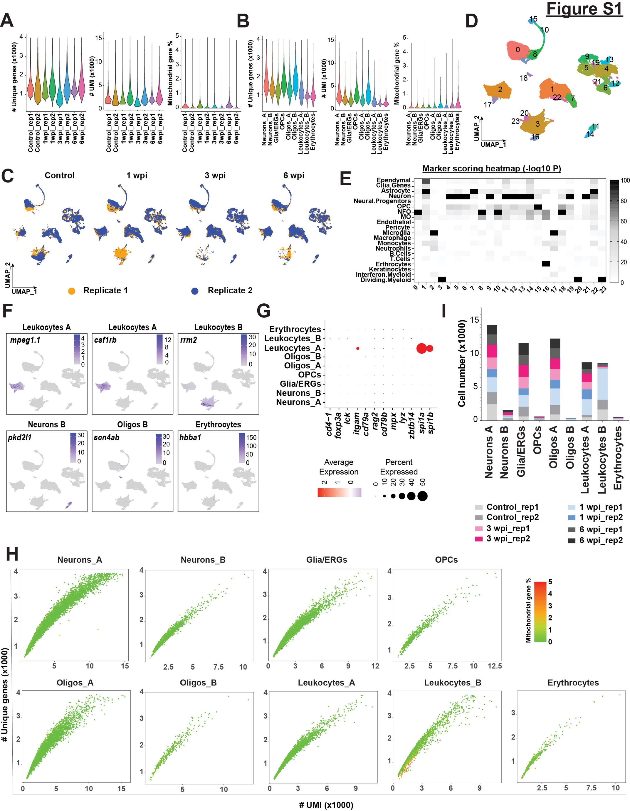
Figure S1. Quality control metrics, cluster identification of snRNA-seq data and raw cell counts (Related to figure 1). (A,B) Violin plots showing the distribution of cells based on their quality control metrics grouped by both replicates and cell types. Only cells that are retained after removal of low-quality cells are shown. The total number of unique genes found per cell, the number of unique molecular identifiers (UMI) per cell, and the proportion of UMIs that map to mitochondrial protein encoding genes per cell are shown. (C) UMAP plot represents the overlap between the two replicate pools at each time point, with 50 SC tissues pooled within each replicate. The number of cells present in each replicate at different time point are control (6432, 6965), 1 wpi (14312, 5416), 3 wpi (6533, 7211) and 6 wpi (5848, 6256). (D) Merged UMAP plot of the complete dataset showing 24 coarse clusters identified at 0.4 resolution parameter. (E) Heatmap depicting the -log10 P value for the marker scoring output from “DEMarkerScoring” algorithm after cross-referencing the top DE markers of each cluster with our assembled VNM marker database. One-tailed hypergeometric probability test was used to calculate the P value. P values are detailed in Table S2. -log10 P value for each cluster is scaled between 0-100. Cluster identity is predicted based on the maximum -log10 P value obtained, which represents the darkest quadrant in the heatmap. (F) Feature plots showing the distributions of canonical marker genes corresponding to major cell populations. (G) Dot plot showing the expression of different immune lineage genes in leukocytes A and B. Dot colors and diameters represent average gene expression and percent cells with at least one UMI detected per gene, respectively. (H) Scatter plots showing the distribution of nuclei within each cluster based on the total number of unique genes and total number of UMIs. Each nucleus is color-coded in a gradient of green to red (Green = 0% and Red = 5%) based on the percentage of mitochondrial genes expressed in it. (I) Bar graph showing the number of cells that mapped to different cell populations split by biological replicate across the time course of regeneration. Source data are provided as a Source Data file.
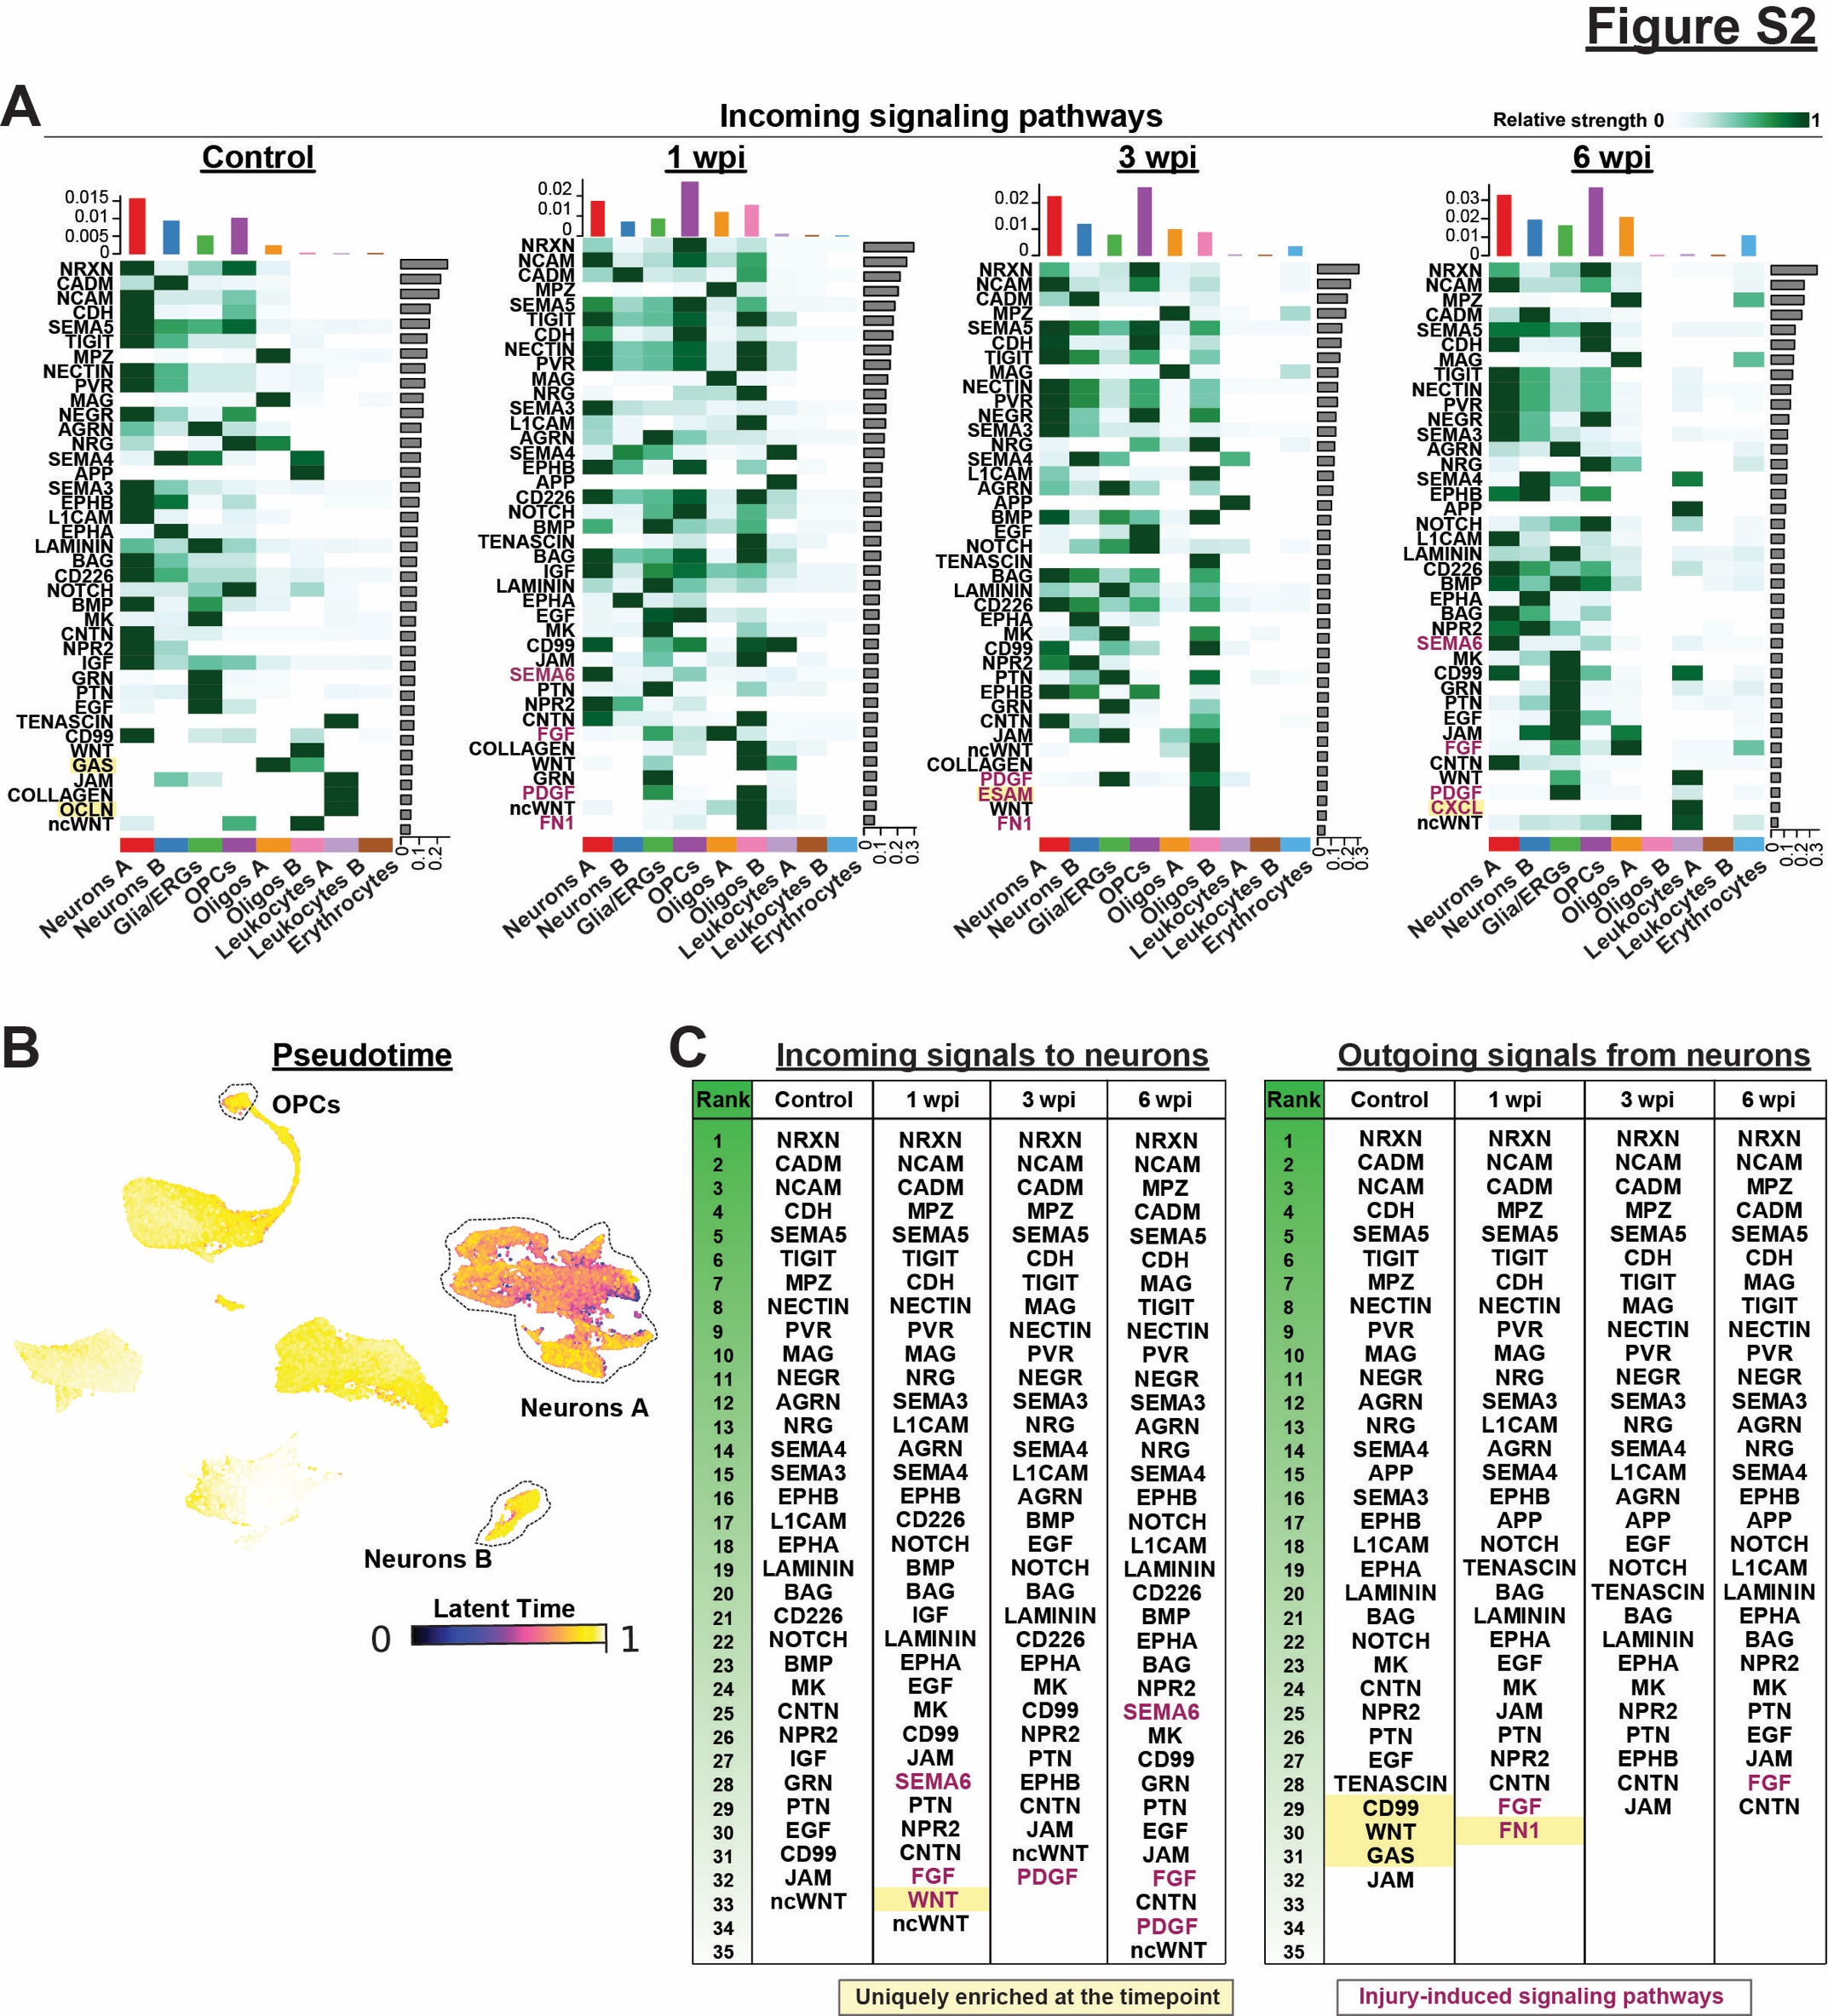
Figure S2. Injury-induced signaling pathways and pseudotime analysis (Related to figure 2). (A) Heatmap representation of the relative strengths of incoming signaling pathways in coarse cell populations at 0, 1, 3 and 6 wpi. Bar graphs at the top of each heatmap show cumulative signaling strengths per cell population. Bar graphs at the right of each heatmap show cumulative signaling strength per pathway. Pathways highlighted in yellow are specifically enriched at one time point. Pathways highlighted in magenta are enriched after injury. (B) UMAP plot with embedded pseudotime score was generated using the CytoTRACE algorithm in CellRank. Pseudotime scores are color-coded, with yellow dots representing cells with more differentiated status and blue dots representing cells with progenitor-like transcriptional status. (C) Tables show lists of incoming and outgoing signaling pathways activated and received by neurons based on CellChat analysis of the integrated dataset. Pathways are ranked in the descending order of their cumulative signal strengths. Pathways highlighted in magenta represent injury-enriched signaling. Pathways highlighted in magenta and yellow represent signaling pathways that are specifically enriched at the respective timepoint.
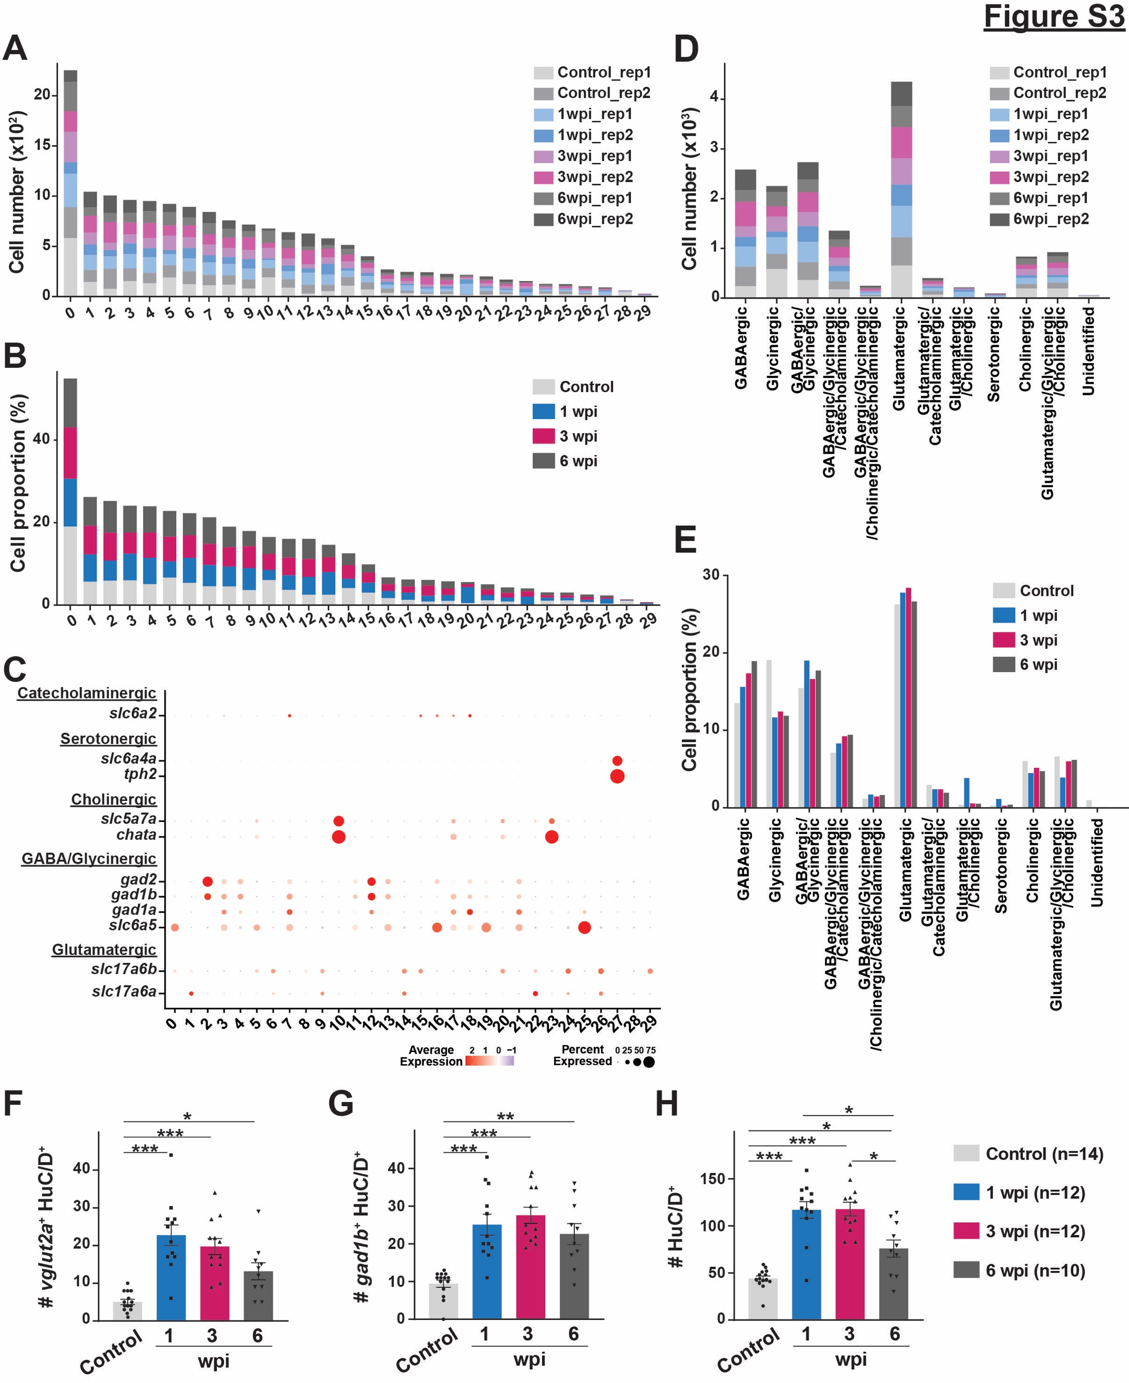
Figure S3. Neurotransmitter gene expression, cell proportion and top DE markers in neuron subclusters after SCI (Related to figure 3). (A-B) Split bar charts show the numbers and proportions of neurons that mapped to each neuron subcluster. Cell proportions for each cluster and time point in B were normalized to the total number of neurons analyzed at that time point. (C) Expression of canonical neurotransmitter genes was used to classify excitatory, inhibitory, cholinergic, serotonergic and catecholaminergic neuron populations. Clusters that show enrichment (gradient of red dots) for any of these marker genes are given a respective neurotransmitter identity. (D-E) The total numbers and proportions of different neuron subpopulations based on their neurotransmitter properties at 0, 1, 3 and 6 wpi. Cell proportions for each cluster and time point in E were normalized to the total number of neurons analyzed at that time point. (F-H) Quantification of glutamatergic and GABAergic neurons after SCI. Absolute numbers of vglut2a⁺ HuC/D⁺, gad1b⁺ HuC/D⁺ and HuC/D⁺ neurons are shown. SC cross-sections 450 µm rostral to the lesion were used for quantification at 0, 1, 3 and 6 wpi. Data points in all bar charts indicate individual animals and sample sizes are indicated in parentheses. Brown-Forsythe and Welch ANOVA test was performed on F, G and H. ANOVA p-value is <0.0001 for F-H. Dunnett’s T3 multiple comparisons test was performed across different timepoints with 95% CI. Data are presented as mean values +/- SEM. All the statistical tests used here are two-sided. *p≤0.05, **p≤0.01, ***p<0.001. Source data are provided as a Source Data file.
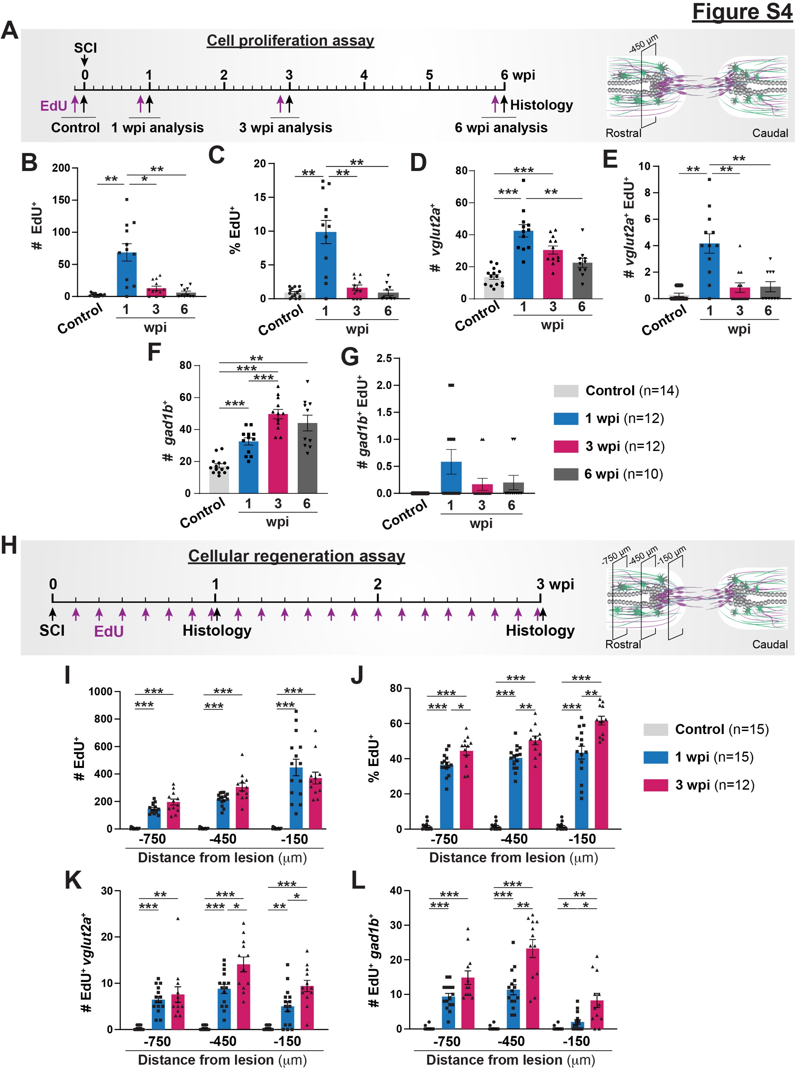
Figure S4. Quantification of regenerating excitatory and inhibitory neurons after SCI (Related to figure 4). (A) Experimental timeline to assess cell proliferation at 1, 3 and 6 wpi. Tg(vglut2a:RFP; gad1b:GFP) zebrafish were subjected to SC transections. Single intraperitoneal EdU injections were performed at either 6, 20, or 41 days post-injury. SC tissues were harvested for analysis at 1, 3, or 6 wpi and at 24 hours after EdU injection. Uninjured animals were injected with EdU and collected 24 hours after EdU injection as controls. SC cross-section 450 µm rostral to the lesion was used for quantification. (B-C) Quantification of the numbers (B) (ANOVA p-value <0.0001) and proportions (C) (ANOVA p-value <0.0001) of EdU⁺ cells at 0, 1, 3 and 6 wpi. Percent cells were normalized to the total number of nuclei per SC section in C. (D-E) Numbers of total (vglut2a⁺) (ANOVA p-value <0.0001) and newly formed glutamatergic neurons (vglut2a⁺ EdU⁺) (ANOVA p-value <0.0001). (F-G) Numbers of total (gad1b⁺) (ANOVA p-value <0.0001) and newly formed GABAergic neurons (gad1b⁺ EdU⁺) (ANOVA p-value: 0.0445). (H) Experimental timeline to assess the cumulative profiles of regenerating neurons at 1 and 3 wpi. Tg(vglut2a:RFP; gad1b:GFP) zebrafish were subjected to SC transections and daily intraperitoneal EdU injections. SC tissues were harvested for analysis at 1 and 3 wpi. Control SCs received daily EdU injection for 7 days before collection. Tissue sections 150, 450 and 750 μm rostral to the lesion were used for quantification. (I-J) Numbers (ANOVA p-value <0.0001) and proportions (ANOVA p-value <0.0001) of EdU⁺ cells in SC sections are shown at 0, 1 and 3 wpi. (K-L) Numbers of newly formed glutamatergic (vglut2a⁺ EdU⁺) (ANOVA p-value <0.0001) and GABAergic (gad1b⁺ EdU⁺) (ANOVA p-value <0.0001) neurons in SC cross sections at 0, 1 and 3 wpi. Brown-Forsythe and Welch ANOVA test was performed in B, C, D, E, F and G with Dunnett’s T3 multiple comparisons test performed across different time points having 95% CI. Two-way ANOVA was performed in I, J, K, and L with Tukey’s multiple comparison test having 95% CI. Data points in all bar charts indicate individual animals and sample sizes are indicated in parentheses. In all bar charts, data are presented as mean values +/- SEM. All the statistical tests used here are two-sided. *p≤0.05, **p≤0.01, ***p≤0.001. Source data are provided as a Source Data file.
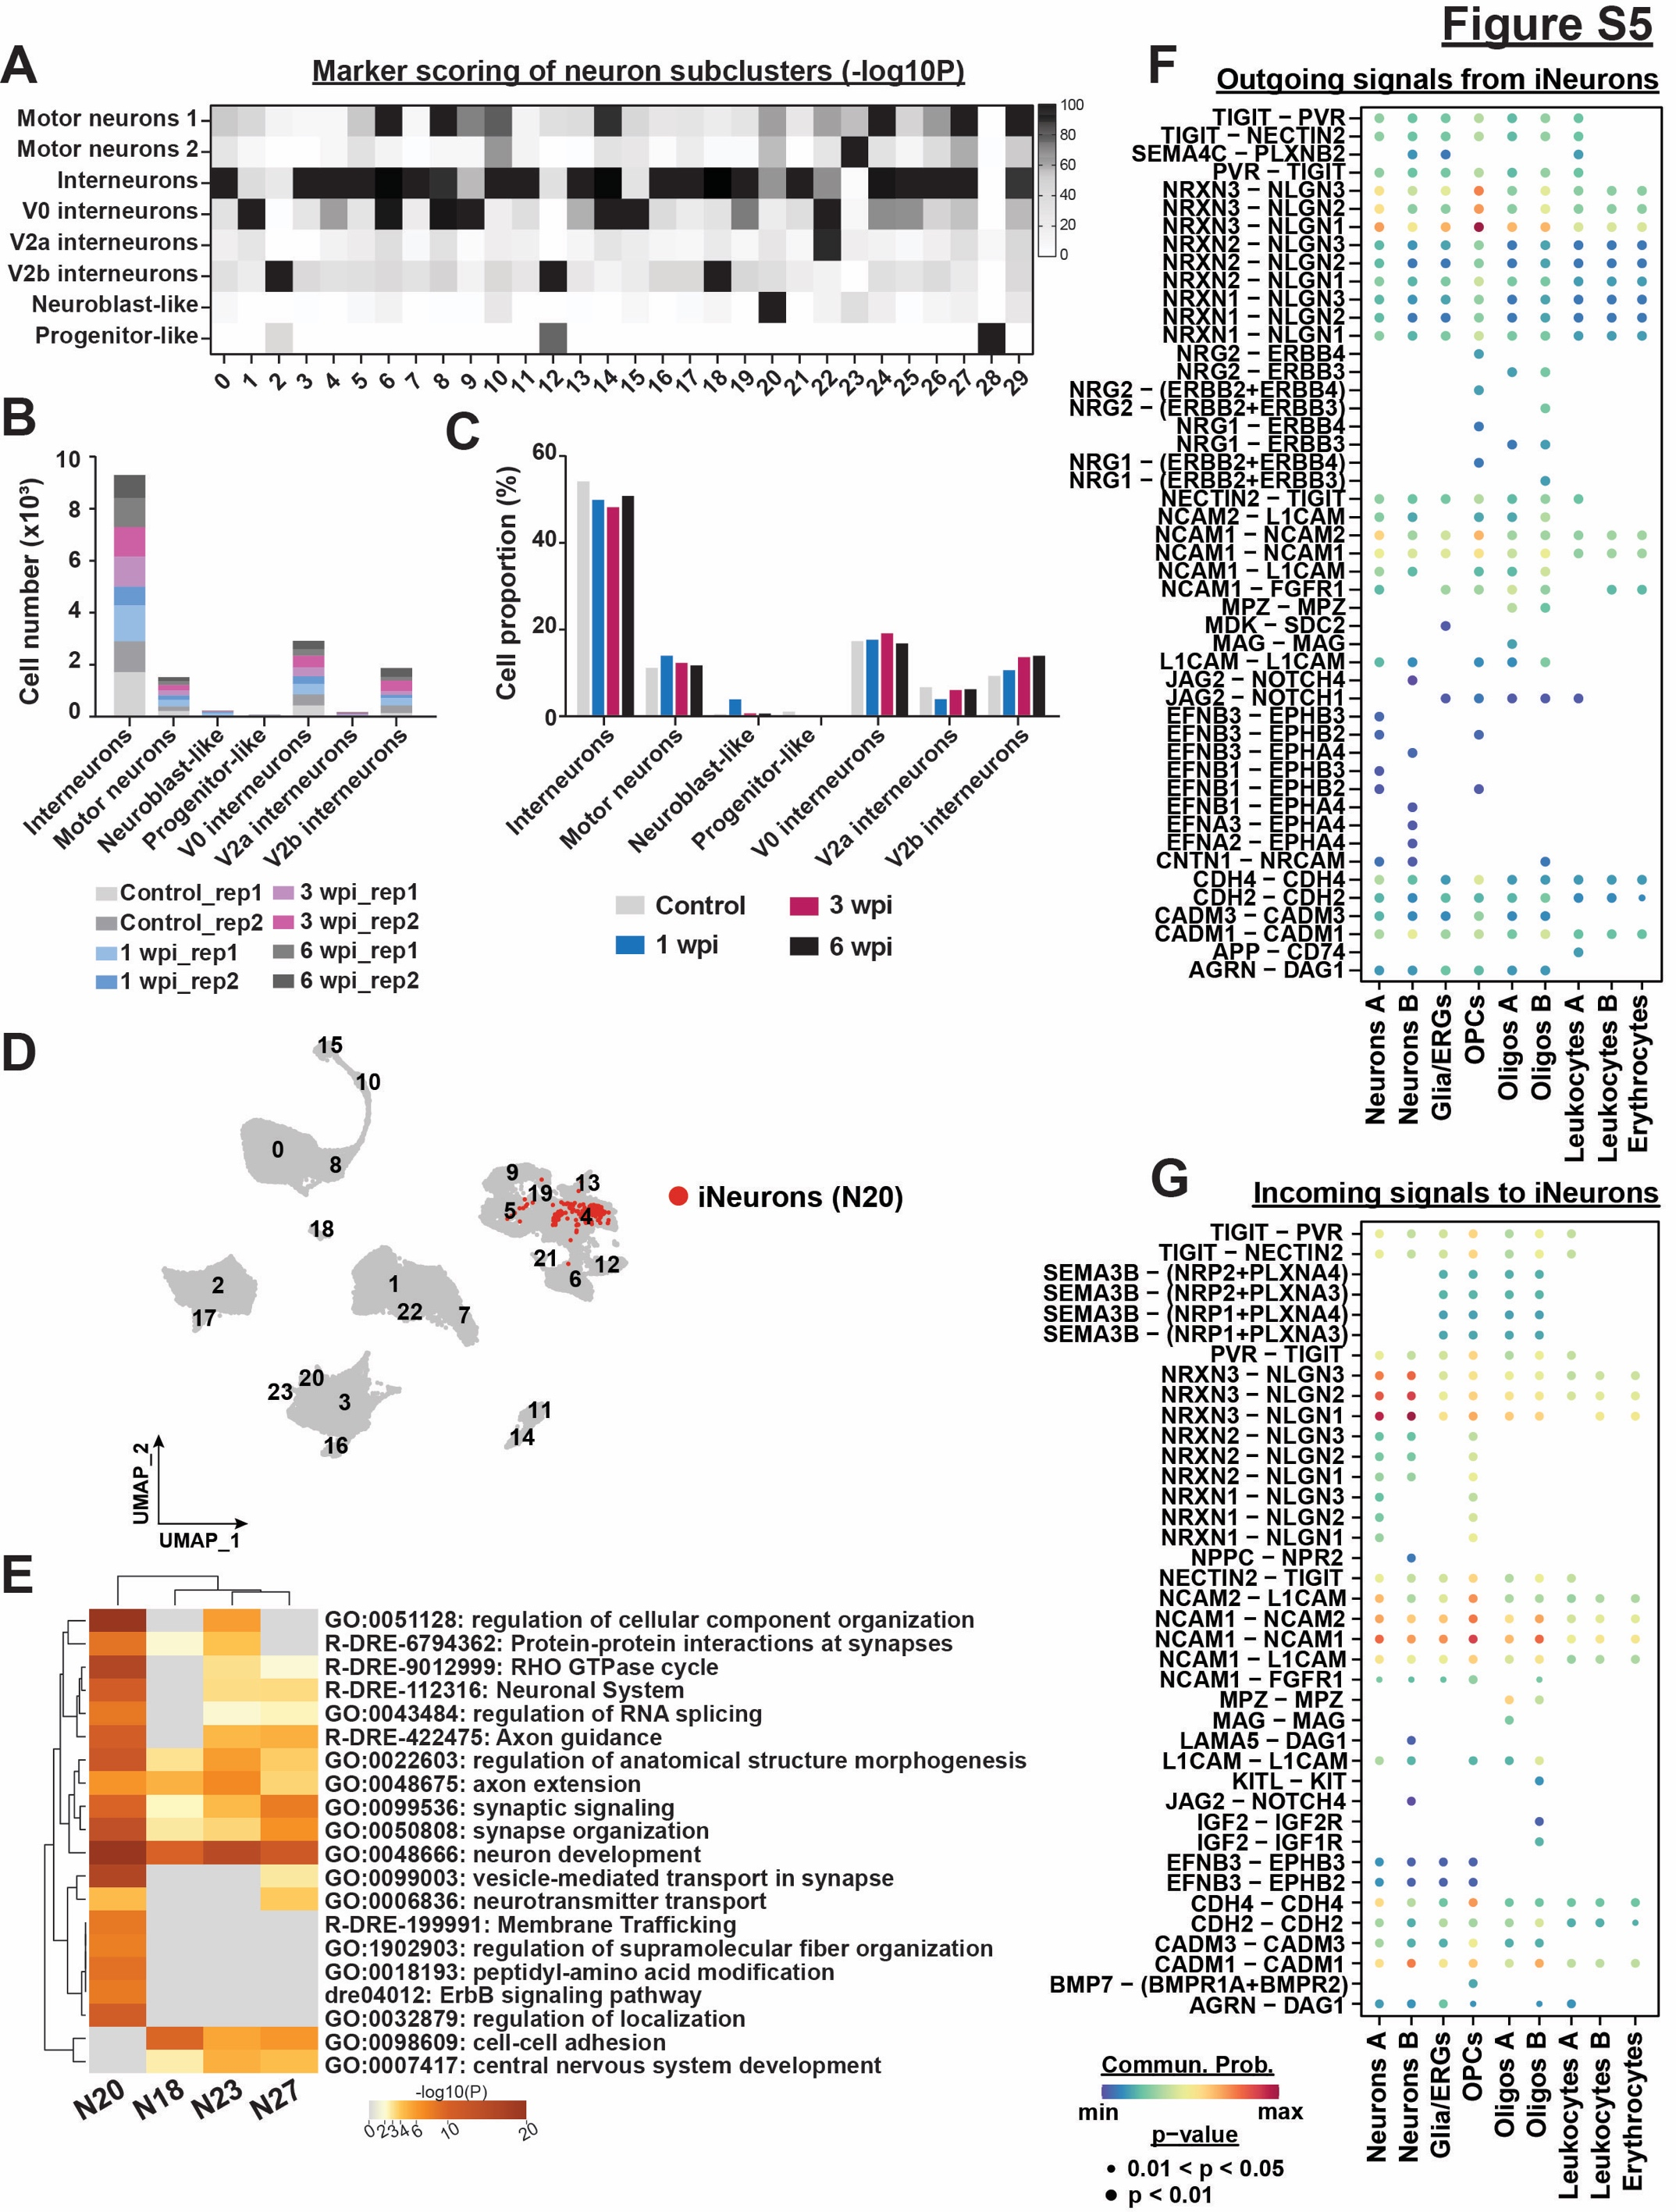
Figure S5. Cluster identification and proportion of neuron subclusters (Related to figure 5). (A) Heatmap depicting -log10 P value for the marker scoring output obtained from the “DEMarkerScoring” algorithm. Scoring was based on cross-referencing the top DE markers for each neuron cluster with the DE markers identified in Cavone et al, 2021. One-tailed hypergeometric probability test was used to calculate the P value. P values are detailed in the Table S7. -log10 P value for each cluster is scaled between 0-100. Cluster identity is predicted based on the maximum -log10 P value obtained, which represents the darkest quadrant in the heatmap. (B-C) The total numbers and proportions of different neuron subtypes at 0, 1, 3 and 6 wpi. Cell proportions for each cluster and time point in C were normalized to the total number of neurons analyzed at that time point. (D) UMAP plot showing iNeurons (cluster N20 cells) within the complete dataset. (E) Metascape gene ontology analysis for neuron clusters N18, 20, 23 and 27. Twenty of the most enriched terms are shown. The color gradient represents -log10(p-value) for each term and cluster. (F-G) Bubble plots showing significant Ligand-Receptor interactions for outgoing and incoming signaling pathways that are activated or received by iNeurons at 1 wpi. Dot colors and diameters represent interaction probabilities and p-values, respectively. Source data are provided as a Source Data file.
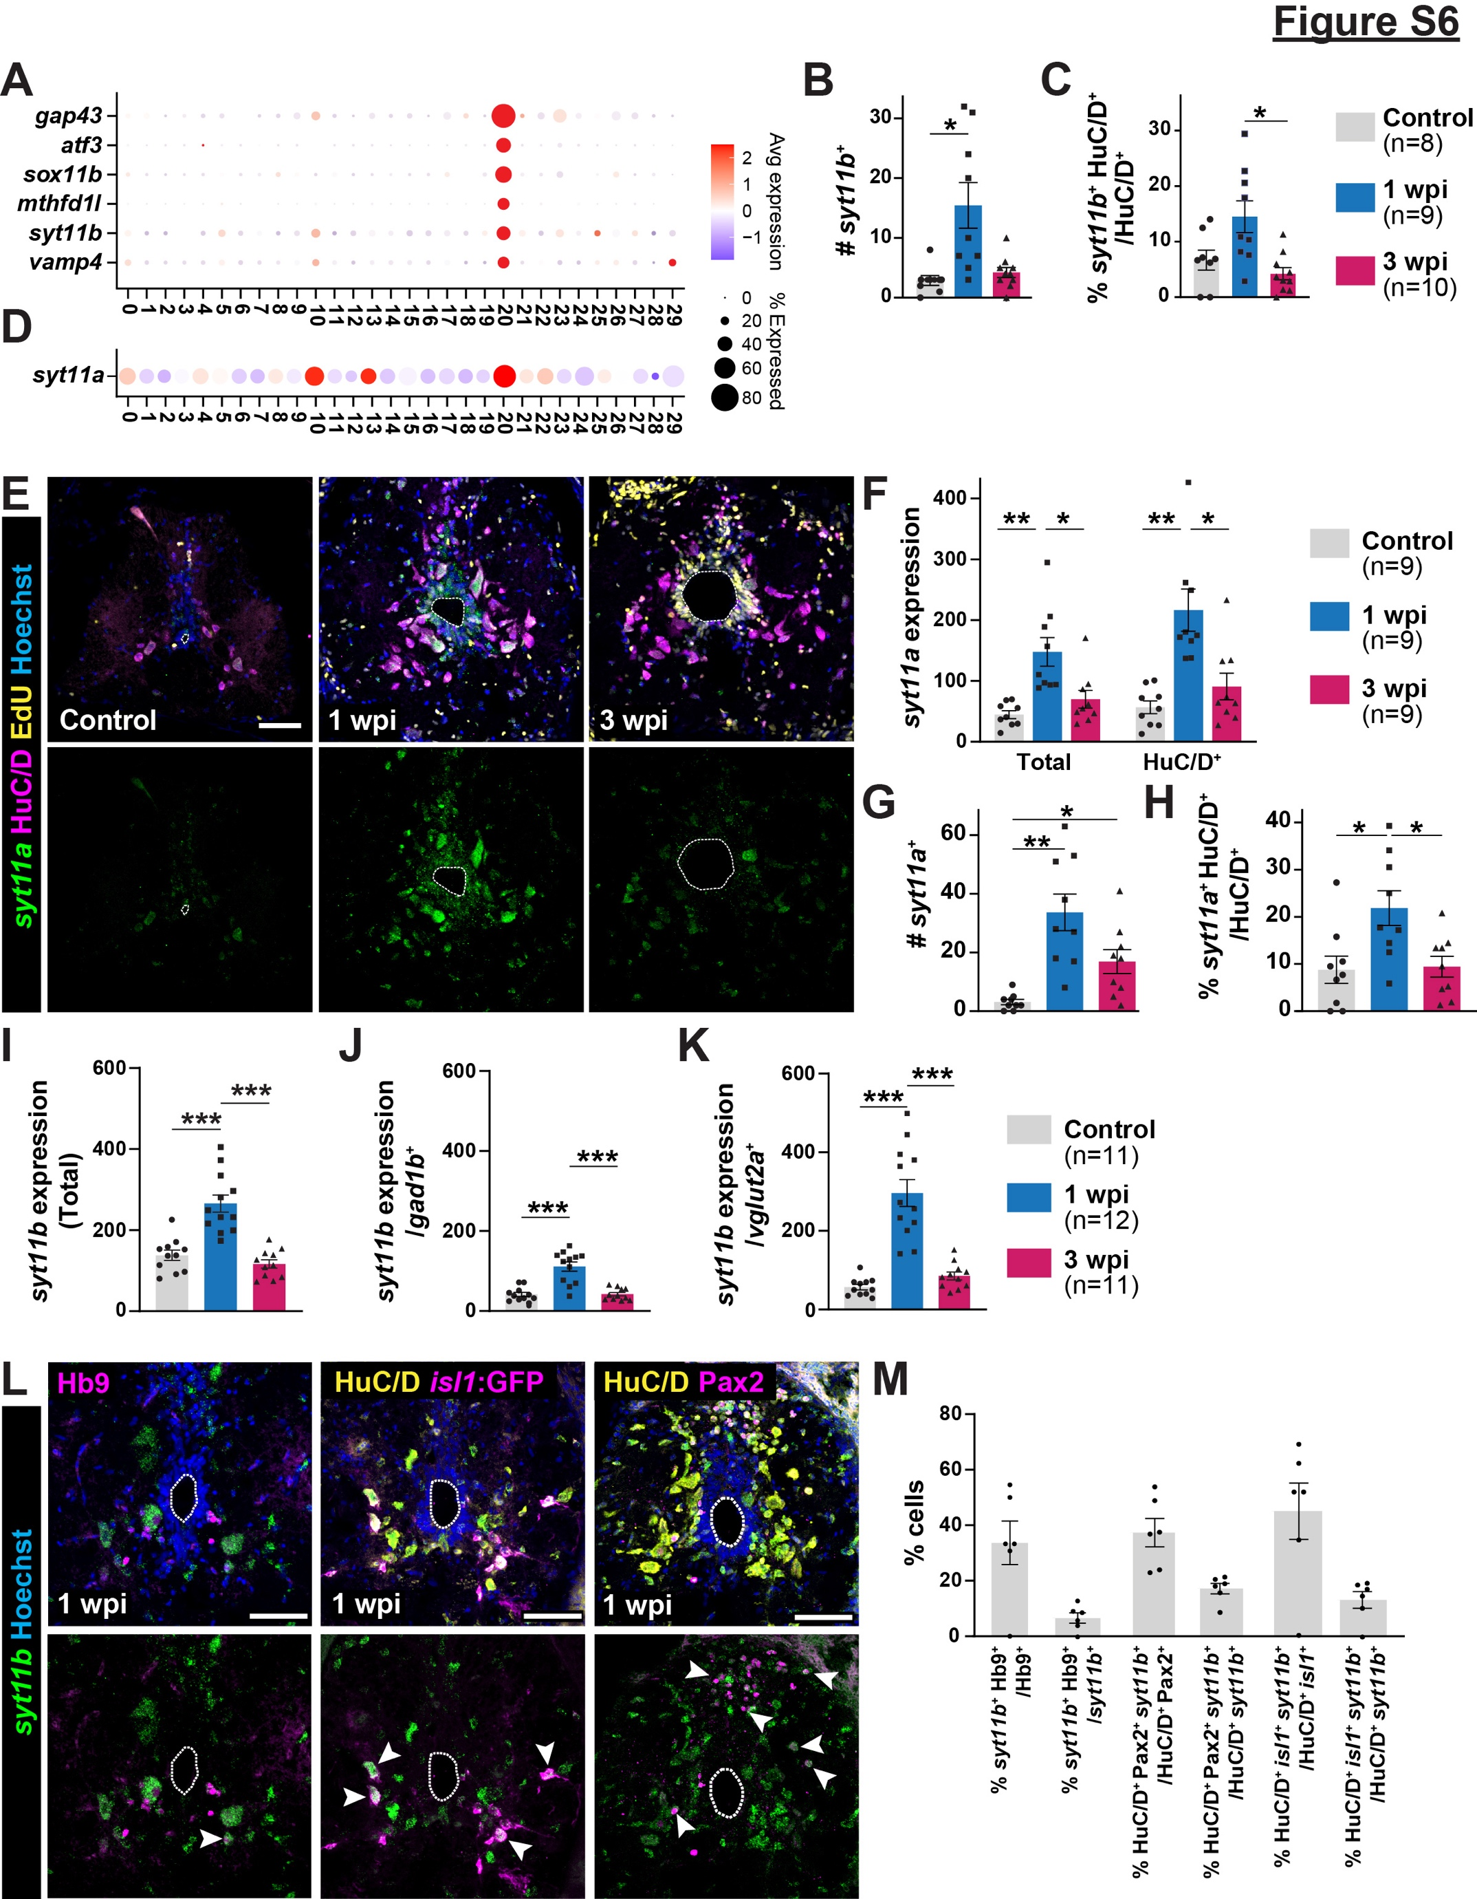
Figure S6. iNeuron marker gene expression (Related to figure 6). (A) Dot plot shows the top DE markers that were filtered based on their specific enrichment in iNeurons relative to all other spinal cell types. (B-C) Quantifications related to Fig. 6G-H. SC cross sections from wild-type zebrafish subjected to SC transections and daily intraperitoneal EdU injections are shown at 1 and 3 wpi. Control SCs received daily EdU injection for 7 days before collection. The numbers of syt11b⁺ nuclei (ANOVA p-value: 0.0066) and the proportions of iNeurons (syt11b⁺ HuC/D⁺ relative to HuC/D⁺) (ANOVA p-value: 0.0062) are shown. (D) Dot plot shows the expression of the syt11b paralog, syt11a, in all neuronal clusters. (E) HCR in situ hybridization for syt11a and staining for HuC/D, EdU and Hoechst were performed on wild-type SC cross sections at 0, 1 and 3 wpi. Dotted lines delineate central canal edges. Single channels show syt11a expression. (F) Quantification of syt11a HCR in situ hybridization. Integrated density was calculated in the whole SC cross sections (ANOVA p-value: 0.0013) and inside HuC/D⁺ neurons (ANOVA p-value: 0.0008) at 0, 1 and 3 wpi. (G-H) Quantification of syt11a expressing cells after SCI. Shown are the absolute numbers of syt11a⁺ cells (ANOVA p-value: 0.0008), and percent syt11a⁺ neurons (syt11a⁺ HuC/D⁺ normalized to the total number of HuC/D⁺ neurons) (ANOVA p-value: 0.0084). Analysis was performed on whole SC cross sections at 0, 1 and 3 wpi. (I-K) Quantification of the integrated density of syt11b HCR in situ hybridization signal in whole SC tissues (ANOVA p-value <0.0001), inside GABAergic neurons (ANOVA p-value <0.0001), and glutamatergic neurons (ANOVA p-value <0.0001). (L) HCR in situ hybridization for syt11b was co-localized with staining for HuC/D, Hb9, isl1:GFP or Pax2. Wild-type or isl1:GFP SC cross sections at 1 wpi were used. Dotted lines delineate central canal edges. Arrowheads point to double positive cells. (M) Quantification of syt11b expressing cells at 1 wpi. For all quantifications, Data points in the bar charts indicate individual animals and sample sizes are indicated in parentheses. SC cross sections at 450 µm rostral to the lesion were analyzed. Brown-Forsythe and Welch ANOVA test was performed in all graphs with Dunnett’s T3 multiple comparisons test performed across time points with 95% CI. In all bar charts, data are presented as mean values +/- SEM. All the statistical tests used here are two-sided. *p≤0.05, **p≤0.01, ***p≤0.001. Scale bars, 50 µm. Source data are provided as a Source Data file.
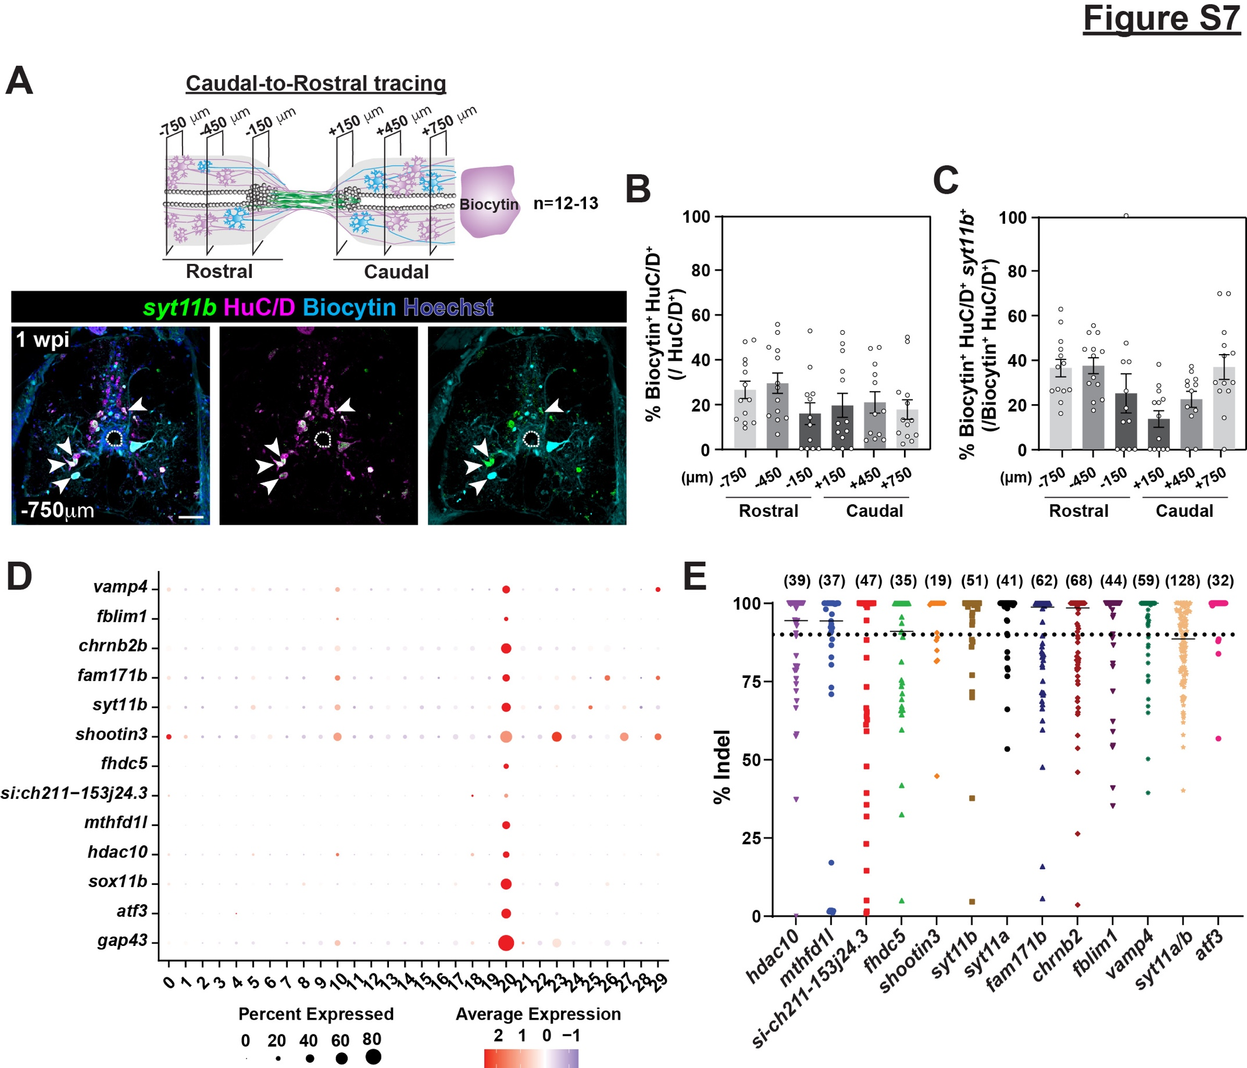
Figure S7. CRISPR/Cas9 mutagenesis and regeneration assay of N20 iNeurons (Related to figure 7). (A-C) Caudal-to-rostral tracing of neurons at 1 wpi. Biocytin was applied 4 mm caudal to the lesion and co-labeled with syt11b HCR in situ hybridization and HuC/D staining. SC cross sections 750 μm rostral to the lesion are shown in A. Dotted lines delineate central canal edges. The profiles of Biocytin-labeled neurons (Biocytin⁺ HuC/D⁺) were normalized to total neurons (HuC/D⁺) in B. The profiles of Biocytin-labeled neurons (Biocytin⁺ HuC/D⁺) were normalized to total neurons (HuC/D⁺) in B. The profiles of Biocytin-labeled iNeurons (Biocytin⁺ HuC/D⁺ syt11b⁺) were normalized to traced neurons (Biocytin⁺ HuC/D⁺) in C. (D) Dot plot showing expression of markers selected for mutagenesis in iNeurons. (E) Quantification of targeting efficiency using capillary electrophoresis. Percent indel represents the efficiency of indel amplicons relative to wild-type amplicons. For genes in which percent indel efficiency was >90% indel (e.g., shootin3), zebrafish were randomly selected fish required for swim endurance assay. For genes with lower targeting efficiency, only genotyped animals with percent >90% were used to assess SC regeneration. Solid line shows the mean efficiency and dotted line shows the 90% cutoff mark. Scale bars, 50 µm. In all bar charts, data are presented as mean values +/- SEM. Data points in graphs B, C and E indicate individual animal and sample sizes are indicated in parentheses. Source data are provided as a Source Data file.

